

An Evaluation of School Management System
“An Evaluation of School Management System”

Prepared By
Md: Rayhan Ferdous
ID: 111 152 079

Supervised by
Dr. Kawsar Ahmmed
Professor
School of Business & Economics

UNITED INTERNATIONAL UNIVERSITY
Date of Submission: February 3, 2020
Letter of Transmittal

February 3, 2020
Dr. Kawsar Ahmmed
Professor
School of Business and Economics
United International University

Subject: Submission of the internship report on “An Evaluation of School Management System.”
Dear Sir,
I am submitting my internship report on “An Evaluation of School Management System” that you are assigned me. It is a great pleasure for me to work on this. I did a lot of hard work for preparing my internship report. I gained huge practical knowledge while preparing this report; this will surely help for my future career.

I worked on the report in a way so that it can provide its actual purpose and if you have any question I am ready to give answer regarding this report.

Therefore, I pray and hope that you will admire my hard work.

Sincerely yours,
Md. Rayhan Ferdous
ID- 111 152 079

-----------------------
Signature

Letter of Declaration
I am Md. Rayhan Ferdous, Id no: 111 152 079 major in Marketing, student of UnitedInternational University declared that this is my internship report on “An Evaluation of School Management System” and it was completely prepared by me.

I assured that only for my academic purpose, this report is prepared. It will not use for any other purpose.

….………………………….
Md. Rayhan Ferdous
ID NO: 111 152 079
Bachelor of Business Administration
United International University

Acknowledgement
I had a great opportunity to work with the employees of ShurjoMukhi Limited during my internship period. As this is a software company, I gathered huge practical knowledge and experienced real life issues.
At first, I would like to thank my supervisor Dr. Kawsar Ahmmed Sir, Professor, School of Business and Economics, United International University for giving me the advises regarding this report. Without his guidance I cannot be able to prepare the report properly. When I faced any types of problems regarding this report sir always came forward to help me. Secondly, I want to thank all the executives of ShurjoMukhi Limited for helping me when I need them. In ShurjoMukhi Limited I worked as an intern under the Sales and Marketing department. Mr. Naimur Rahaman (Tech Team) who provide much information related to this report. Without his support I cannot collect that information and my report would remain incomplete. So I thanked Mr. Naimur Rahaman sir for giving his time and effort.
In this report I have tried my level best to give reliable information which is required to complete this report.
Executive Summary
School Management System is an all-inclusive education management solution at the school level that seamlessly integrates different departments of a school from classes, exams to the school events calendar. As a powerful system, it brings parents, teachers, and students on a common interactive platform. This study was done on the ShurjoMukhi Limited-a school management system.

ShurjoMukhi Limited is tied in with making and envisioning a future they need to endure and desert. A future where correspondence is as normal as chuckling, a future where framework power doesn't rely exclusively upon charging our PCs, cell phones, or getting lights and devices in our home. It's all about doing the necessary tasks like online banking, online bill payment and internet shopping from mobile or laptop, which are as easy and available as the sun on a bright sunny day. Modern business is extremely complex due to changing customer preferences and tastes etc. all the time for technical and high competition. So, every company should be of international quality.

We all know day by day all sectors of Bangladesh are going to digitalize for these purposes we take the initiative to digitalize the education system by providing the system. Using this system an institution can do their job effectively and efficiently. By using this system they do their daily job online and paperless way.

ShurjoMukhi Limited has a strong point that not only helps the market survive, but it also has weak points that can reduce the demand for its products as well as improve the market. It also has some threats but also opportunities, opportunities are stronger than threats.
Chapter 2

Keywords: School Management System, education management, interactive platform, ShurjoMukhi Limited.
Table of Contents
Executive Summary V
1.0 Introduction 2
1.2 Motivation of the study 2
1.3 Objective of the Report 3
1.4 Scope and limitation of the Study 3
1.5 Significant of the report 3
1.6 Organization of the remaining chapters 4
2.0 Company Overview 6
2.1 Formation and membership 6
2.2 Our Valuable Clients 6
2.3 Our Partners 7
2.4 Our Projects and In-house Products 7
2.4.1 shurjoPay E-Payment Gateway 7
2.4.2 Prominent Clients Using Our Payment Gateway shurjoPay: 7
2.5 ShurjoMukhi prniSheba (প্রাণিসেবা) 7
2.6 Cash Management Decision Support System with Over Draft Facility (CMDSS+OD) 8
2.7 Bangladesh Ansar and VDP Recruitment System (AVRS) 9
2.8 Join Bangladesh Army Recruitment Platform 10
2.9 shurjoEMS (Education Management System) 11
2.10 Bangladesh Public Interest Litigation (BD-PIL) Repository 11
2.11 In House Products 12
2.11.1 Hatekhori (হাতেখড়ি) 12
2.11.2 Universal Meter Reader App 17
2.11.3 মোবাইলে মুক্তিযুদ্ধ (Liberation War on Mobile) 17
2.11.4 payPoint 18
2.12 ShurjoMukhi Organogram 20
2.12.1 Organogram for praniSheba 21
2.13 Literature Review 21
2.14 Working Experience 22
3.0 Education Management Software Analysis 24
3.1 Introduction 24
3.2 System Engineering and Analysis 24
3.3 System Analysis 24
3.4 Requirement Analysis 24
3.5 System Requirements 25
Programming Language used to Develop SMS 25
3.6 Flow Chart 25
3.7 Data Flow Diagram (DFD) 26
3.8 ER Diagram 27
3.9 Relational Database 28
3.9.1 User 28
3.9.2 Administration 28
3.9.3 Student 29
3.9.4 Employee 29
3.9.5 Routine 30
3.9.6 User Table 30
3.9.7 User Group Table 31
3.9.8 Menu Table 31
3.9.9 Routine Table 32
3.9.10 Student Progress Table 32
3.9.11 Student Table 33
4.0 User Manual of EMS 35
4.1 Login 35
4.2 User Management 36
4.3 User Group 36
4.4 Group permission 37
4.5 User Entry 37
4.6 Administration 38
4.7 Shift 38
4.8 Class 39
4.9 Subject 39
4.10 Section 40
4.11 Student Group 40
4.12 Group Subjects 41
4.13 Designation 41
4.14 Attendance 42
4.14.1 Student Attendance 42
4.14.2 Employee Attendance 42
4.15 Holidays 43
4.16 Student Admission 43
4.17 Employee Registration 45
4.18 Student List 45
4.19 Employee List 46
4.20 Student Details Report 46
4.21 Student list Report 47
4.22 Employee Details Report 47
4.23 Employee List Report 48
4.24 Result 48
4.25 Students Marks Policy 49
4.26 Subject Wise Marks Entry 49
4.27 Routine 50
4.28 Routine Slot Entry 50
4.29 Routine Entry 50
4.30 Student Class Routine 51
4.31 Accounts 51
5.0 Introduction 54
5.1 Population and Sample for the present Study 54
5.2 Data collection Procedure 54
5.3 Data Analysis 54
5.4 Findings 65
5.5 Recommendation 66
6.0 Conclusion 67
Reference 68
Appendix 69

Chapter 1

1.0 Introduction
Now a day’s education plays a great role in development of any country. Many of education organizations try to increase education quality. One of the aspects of this improvement is managing of school resources.
Education Management System brought on by every individual or school required during offering services to students, teachers, guardians, and different persons are a intermediary person that conveys at least one of the accompanying functionalities – Student Admission, Employee Registration, Student List, Employee List, Student Attendance, Employee Attendance, Student Routine, Result Management, Payroll, and Accounts.
School Management System (SMS) is such service, that gives entire administrations to an educational institute to sort out your life progressively comfortable and faster by guaranteeing its performance. Simple User Management System, Easy Admission Process, Easy Attendance System. School Management System (SMS) is a framework that will give you a superior perspective on the working of the whole educational institution.
EMS is a system that will provide you a bird’s eye perspective on the functioning of the entire educational institution. It is a management information system aids to regulate the various processes in an educational system like General Administration, Staff Management, Academics, Student Management, and Accounts, etc. The information is delivered adopting the most advanced technologies help to perform basic decision a lot speedier, compelling and simpler than at any other time.
Generally Speaking, it is platform available for running on a Local Area Network (LAN).It is used for handling all teachers and students details, also has information about student and teacher details, personal details and other details. Here all the work is computerized.
In a nutshell, Education Management Software managed your education institution by rearranging and mechanizing processes and addressing the needs of all stakeholders helping them to be more efficient in their respective roles.

1.2 Motivation of the study
Traditionally all the school management process is done by manually and more time consumes then the automated system. For those purposes, it’s more dynamic and effective to use this software for school, college, and university.
It will give you a bird’s eye perspective on the functioning of the complete educational institution. It is a management information system helps to regulate the various processes in an educational institution like General Administration, Staff Management, Academics, Student Management, and Accounts, etc. The information is made utilizing the most recent technologies and helps to settle on basic leadership significantly quicker, powerful and simpler than any other time in recent future.
The information is made using the latest technologies and help’s to make decision making a lot faster, effective and easier than ever before. It also helps to improve the overall quality of education of the institution.
Also, it is a platform available for running on a Local Area Network (LAN). It is used for handling all teacher's and student's details, also has information about student and teacher details, personal details and other details. Here all the work is computerized.

1.3 Objective of the Report
Internship program is a realistic and practical subject to understand the situation nearly. It is a career development activity help a student to build their career. The internship program provides me the following things:

1.4 Scope and limitation of the Study
While preparing this report, I had an excellent chance to have an in-depth understanding of all the marketing activities as well as the education management system.
In preparing this report some limitations were faced:
- Absence of adequate sources limited verifying of data.
- The study shown here may differ from the views of specialists in this area.
- Some aspects of the report may be granted secret by the organization.

1.5 Significant of the report
Traditionally all school management processes are done automatically and then more time is spent on the automated system. This is why using this software is a more effective endpoint for schools, colleges, and universities.
It will give you a bird's-eye view of the effectiveness of the entire education system. It is built using the latest technology to help manage a diverse process of education, such as a management information system, general administration, staff management, academics, student management, and accounts, and make decisions much faster, efficient and easier than ever. It helps improve the overall quality of education in the organization.
Also, it is a platform available to run on a local area network (LAN). It is used to handle all teacher and student details, including information about student and teacher details, personal details and other details. All the work here is computerized.

1.6 Organization of the remaining chapters
The report is organized into three chapters. Chapter one begins with an introduction to the background of the study. It then describes the motivations of the study, specific report objectives, scope and limitation of the study and significance of the study.
In the second chapter, provides an overview of the organization, which includes core values, core strengths, core competencies, vision, mission, products and services, and organogram.
In the third chapter, provides an analysis of the education management software analysis which includes system engineering and analysis, system analysis, requirement analysis, system requirement etc.
In the third chapter, provides an overview of the school management system which includes login, user management, user group, group permission, user entry, administration etc.
In the Five chapter, the empirical results of the study are reported. It discusses data inspection processes such as demographics and samples for the current study, measurements, data collection methods, data analysis, results discussions, and recommendations.

Chapter 2

2.0 Company Overview

2.1 Formation and membership
ShurjoMukhi is one of the leading IT solution providers in Bangladesh. The company is dedicated to modernise public and private sector service delivery through the use of Information and Communication Technology (ICT) in Bangladesh. Since its inception in 2011, it has been tirelessly working to transform the Internet-based Service Delivery and Financial Services Sectors of Bangladesh. Being a proud recipient of ISO 9001:2008, CMMI Level 3, and Bangladesh Bank’s PSO license, ShurjoMukhi has successfully brought Dhaka WASA, Bangladesh Army, Bangladesh Ansar & VDP, Robi Axiata Limited, Bangladesh International School and College (BISC), BLAST, Bangladesh Red Crescent Society, The Daily Ittefaq, Grameenphone, Robi, Teletalk, Banglalink, Airtel, Symphony, Huawei etc. under its service delivery umbrella. Being an active member of BASIS and e-CAB, our MD & CEO is in the working committee of e-commerce development in Bangladesh and among other things, he is also working to draft an e commerce policy on behalf of Bangladesh Government.

2.2 Our Valuable Clients
- Bangladesh Ansar and VDP  - Bangladesh Army  - Robi Axiata Limited  - Dhaka Stock Exchange  - Dhaka WASA  - Ministry of Information and Communication Technology  - Bangladesh International School & College (BISC)  - BLAST  - Bangladesh Red Crescent Society | - Prime Insurance Company Limited  - Central Depository of Bangladesh  - Daily Ittefaq

2.3 Our Partners
- Grameenphone  - Robi  - Banglalink  - Airtel  - Teletalk  - BPL  - Edison Group  - Phoenix Insurance Company Limited | - City Bank Ltd  - Eastern Bank Ltd  - Dutch Bangla Bank Ltd  - BRAC Bank Ltd  - Trust Bank Ltd  - Islami Bank Bangladesh Ltd  - bKash  - Rocket  - T-Cash  - M-Cash  - Upay

2.4 Our Projects and In-house Products

2.4.1 shurjoPay E-Payment Gateway
As a Payment Gateway Services Provider, the company has been awarded the “PSO License” by Bangladesh Bank, under the Bangladesh Payment and Settlement Systems Regulation, 2014.

2.4.2 Prominent Clients Using Our Payment Gateway shurjoPay:
- Bangladesh Ansar and VDP: for collection of job application fee
- Bangladesh Army: for collection of job application fee
- Bangladesh International School & College: for collection of tuition fee
- Robi Axiata Limited: utility bill collection, mobile airtime recharge, railway ticket
- WASA: utility bill collection
- Dhaka Stock Exchange: collection of training fee
- Bangladesh Red Crescent Society: donation collection
- Daily Ittefaq: classified advertisement fee collection
- Prime Insurance Company Limited
- E-Commerce Merchants

2.5 ShurjoMukhi prniSheba (প্রাণিসেবা)
ShurjoMukhi Prnisheba, a DFID funded project, aims to design and develop a connected cows network using Radio-Frequency Identification (RFID) and IoT. This cattle wellbeing monitoring platform enables farm owners, insurance companies, MFIs, veterinary practitioners, relevant donor and government agencies to have required cattle health intelligence and its underlying risk factors for better decision making. Additionally, ShurjoMukhi Prnisheba intends to create a cattle insurance market in which farmers and other MSEs are offered an affordable insurance policy for their cattle.
Using RFID and IoT, it traces and identifies cattle uniquely for insurance companies to settle claims on one hand. On the other hand, using Artificial Intelligence, Machine Learning and Big Data, it helps dairy farmers with a handful of essential services like early warnings about illnesses, precision heat detection and calving information, vaccination calendar, Artificial Intelligence and pedigree related record keeping and an income/expense ledger.

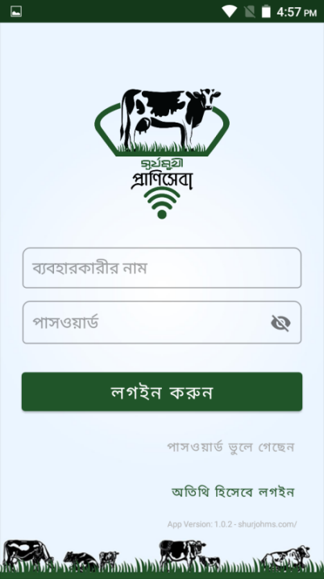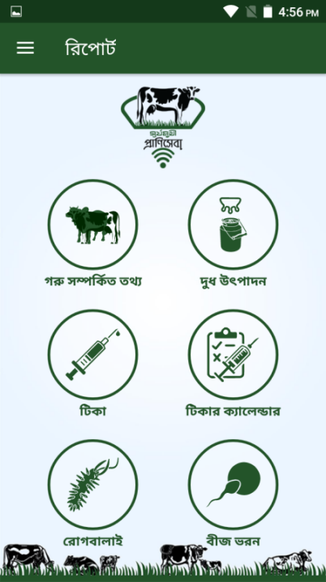
Illustration 2.5: ShurjoMukhi praniSheba app screenshots

2.6 Cash Management Decision Support System with Over Draft Facility (CMDSS+OD)
CMDSS+OD, a DFID funded project, is basically a business intelligence web portal and mobile app for Banks and MFS service providers. It enables MFSs and others in the value-chain to have better visibility of an agent's cash position and support them with overdraft facilities in the time of need via mobile application. This multilevel user app is equipped with a dashboard containing relevant analytic that allows every party in the value chain to communicate and manage cash management issues. The project will serve at least 10,000 SMEs and facilitate BDT 220 million micro-loans by December 2018.

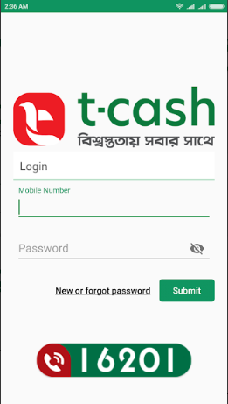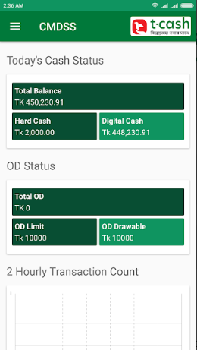
Illustration 2.6: CMDSS app screenshots

2.7 Bangladesh Ansar and VDP Recruitment System (AVRS)
AVRS is an online payment based application system introduced to general applicants for a hassle free application for various job and training circular. This system stores, displays various recruitment related circulars and offers application functionality. The system is equipped with a dashboard with real time analytic, online payment gateway and customer support mechanism.

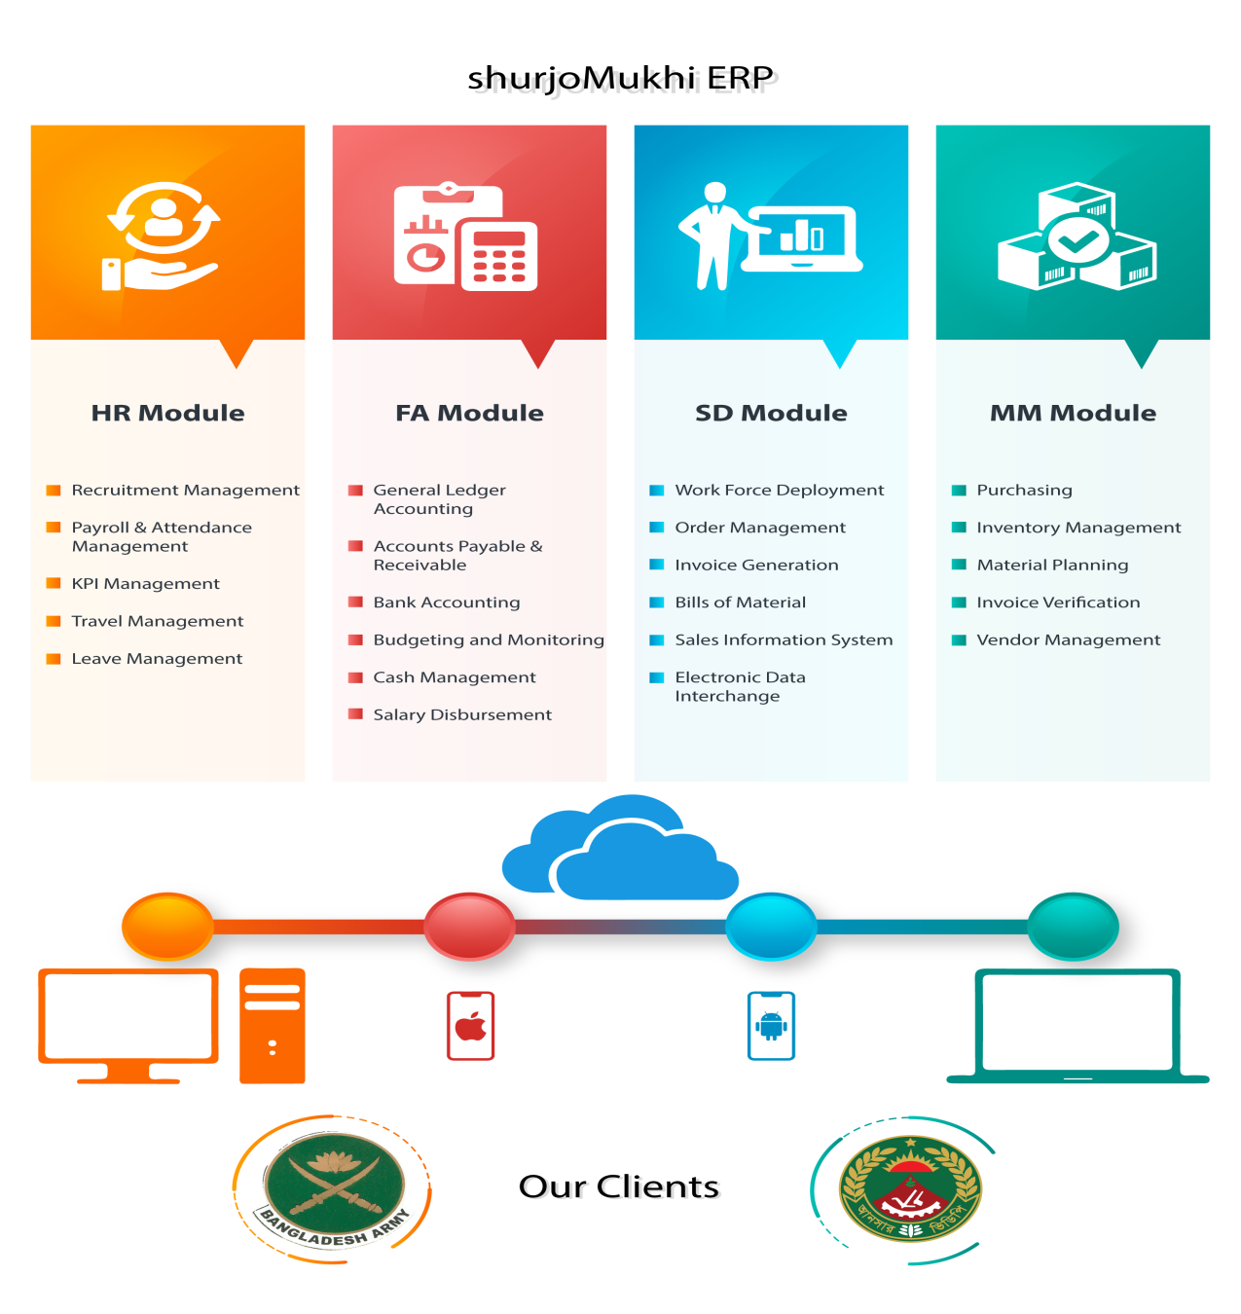

Illustration 2.7: ERP Modules of ShurjoMukhi

2.8 Join Bangladesh Army Recruitment Platform
The Join Bangladesh Army project, a vital module of its HRIS system, is an integrated user friendly online platform to facilitate complete application process including alternative payment options for applicant as well as build a robust Content Management System (CMS), Customer Relationship Management (CRM) system and Business Intelligence (BI) dashboard for authority.

2.9 shurjoEMS (Education Management System)
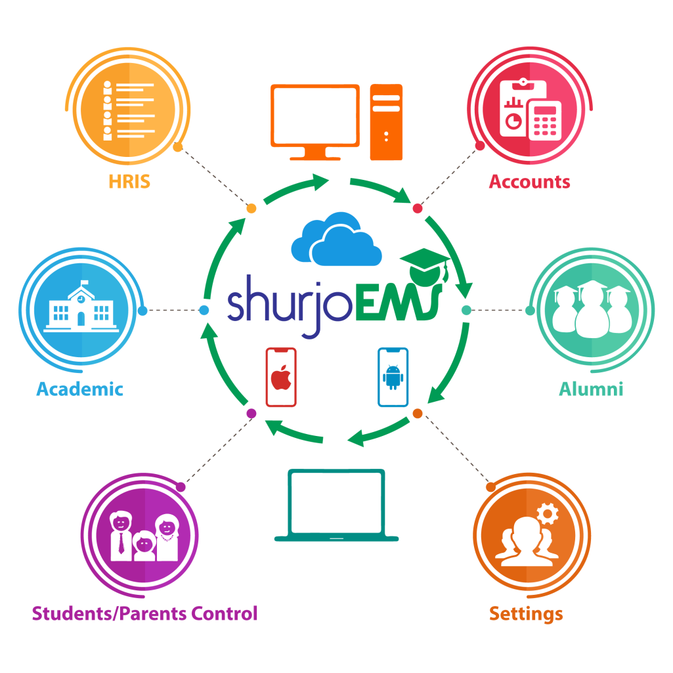
Illustration 2.9: shurjoEMS modules
ShurjoEMS is a powerful, fully Cloud based School Management System that is easy to use, fast to implement and effective to mobilize the school management system in a great way. Integrated e-payment system in shurjoEMS directly facilitates convenience for parents and in turns helps to improve quality of life. Currently, Bangladesh International School & College (BISC) is using the system and showing noticeable improvements in promoting transparency, displaying superior management efficiency and ensuring real time information dissemination.

2.10 Bangladesh Public Interest Litigation (BD-PIL) Repository
This is an easy to search database of Public Interest Litigation (PIL) filed before the Supreme Court of Bangladesh. The selected cases concern legal protection of fundamental rights under the Constitution of Bangladesh, in particular in relation to individuals and communities living in poverty or facing discrimination, and enforcement of constitutional and legal duties by state and public authorities. This system is developed in partnership with Bangladesh Legal Aid and Services Trust (BLAST) for UK Government funded Access to Justice for the Marginalised through Community Legal Services (CLS) project.

2.11 In House Products
ShurjoMukhi owned products and platforms are built by a very competent Technical Team. The Team is also in charge of enhancing and maintaining the platforms.

2.11.1 Hatekhori (হাতেখড়ি)
Hatekhori (হাতেখড়ি) is an engaging learning Android application which facilitates Bengali alphabet, number and conjuct learning in a fun filled way. This edutainment app aims to enhance learning capacity and improve soft skills at an early stage of life. Moreover, this systematic learning app activates better engagement between parents and children.
হাতেখড়ি (Bangla Alphabet), which is an App to figure out how to peruse and compose Bangla Alphabet with liveliness, intelligence, and sound, is here to assist youngsters with learning Bengali Bornomala. This Android App is the best response to the inquiry, "How to learn Bengali letters in order effectively?". It is a self-persuaded Bengali learning and understanding stage. Anybody, either kids or grown-ups, can gain proficiency with the Bengali letters in order with their right articulation and start to get the hang of perusing and composing Bangla in a fun and intelligent manner through the Hatekhori exemplary Android App.
Users can learn Bengali letters, as well as words and their spellings, sentence making and furthermore, can work on handwriting utilizing their fingers as a pen. The Hatekhori great Android App is particularly appropriate for preschool students, simply starting to get familiar with the language and for grown-ups, who wish to learn also. Additionally, you needn't bother with any sort of web association or portable web to utilize this application. You can utilize it disconnected. The best preschool learning applications for babies, likewise useful for any early youth training stage.

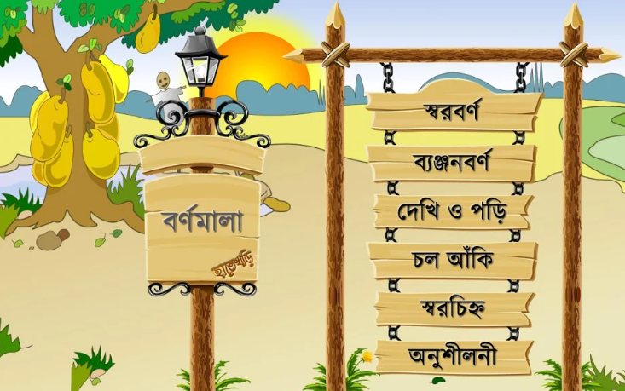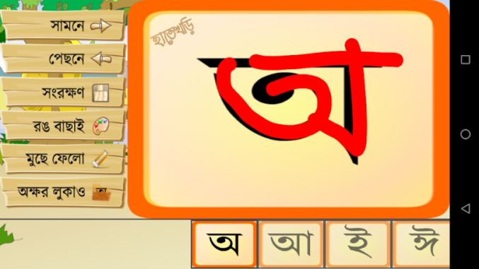

Illustration 2.11.1: Hatekhori Bangla Alphabet app screenshot

হাতেখড়ি যুক্তাক্ষর (Conjunct), Learning Conjuncts isn't troublesome any longer. Find the enjoyment and intuitive method for learning Bangla conjuncts utilizing this application. হাতেখড়ি যুক্তাক্ষর (Hatekhori Conjuncts) is the main application which is just centered around teaching juktakkhor, fola, and ref. Conjuncts are a basic part of Bangla language and by utilizing this application anybody can learn Bangla conjuncts effectively.
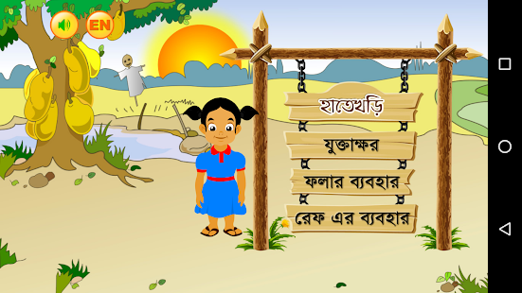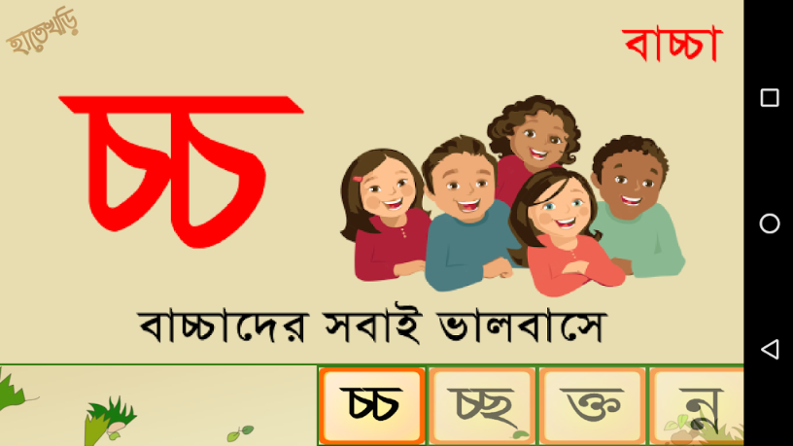
Illustration 2.11.1: Hatekhori Conjunct app screenshot

হাতেখড়ি সংখ্যা (Hatekhori Bangla Number) is a free child's Bangla Number (বাংলা সংখ্যা), 123 numbers learning application. Hatekhori Shonkha gives very much planned graphical substance to the pleasant understanding experience.

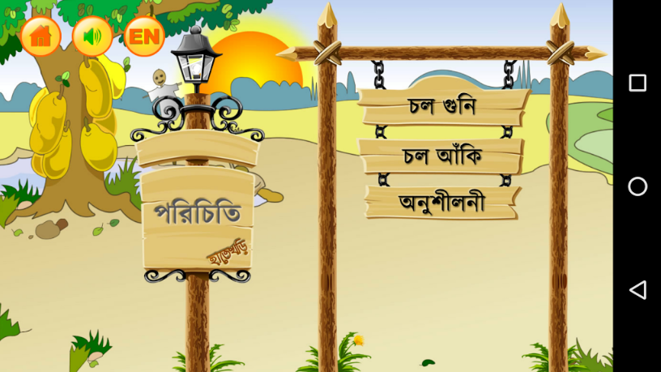
Illustration 2.11.1: Hatekhori Bangla Number app screenshot

With an average 1,500 daily downloads, “Hatekhori” app has a user base of 1.15 Million which signifies that this is one of the most popular learning apps in Bengali speaking communities all over the world.
Google Play store link for হাতেখড়ি (Bangla Alphabet): https://bit.ly/2HwKVkj
Google Play store link for হাতেখড়ি যুক্তাক্ষর (Conjunct): https://bit.ly/2B8KYAX
Google Play store link for হাতেখড়ি সংখ্যা (Hatekhori Number): https://bit.ly/2OKHTzd

2.11.2 Universal Meter Reader App
ShurjoMukhi built the Universal Meter Reader App after winning a competitive grant from the Innovation Fund of the Ministry of ICT, Bangladesh. Using the App, a Meter Inspector of any Utility Company takes a photo of the meter reading and types the reading as text. The App sends the information back to the Billing System of the Utility Company once the information is submitted by the inspector.
The Universal Meter Reader App won the Runner Up position in this year’s National Mobile Apps Contest in the Government and Participation category.
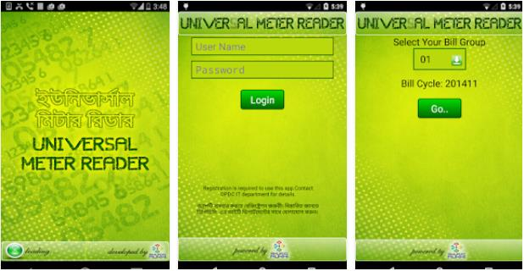
Illustration 2.11.2: Universal Meter Reader app screenshot
Google Play Store Link of Universal Meter Reader: http://bit.ly/2oNq087

2.11.3 মোবাইলে মুক্তিযুদ্ধ (Liberation War on Mobile)
This App is one of the best app for learning history of liberation war of Bangladesh. The App aims to teach the youth of the country about the great Liberation War of Bangladesh. The App is designed to teach war history in an interesting and engaging way by involving users in various contests, and providing check in options at historically important places. This application likewise incorporates pictures, sound, and video of the then occasions. This application has a natural inspiration for its clients to gain proficiency with the historical backdrop of the liberation war and test his/her insight by going to the test.
This application has a positioning and scoring framework which will give the client the inspiration to become familiar with the genuine history of the freedom war. This App development is financed by ICT Division.
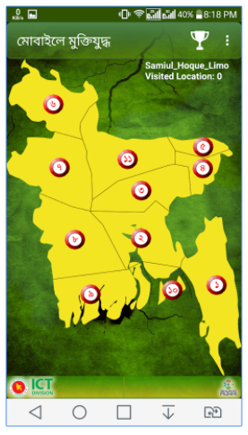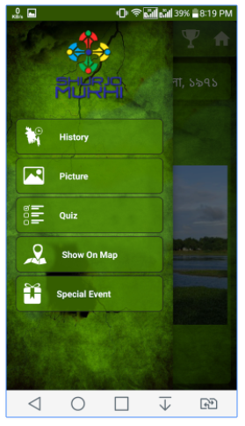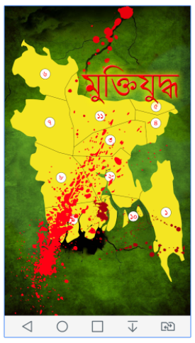
Illustration 2.11.3: Liberation War 1971 on Mobile app screenshot
Google Play store Link of Liberation War on Mobile App: https://bit.ly/2Q0pNGZ

2.11.4 payPoint
www.payPoint.com.bd is one of the largest b2c e-commerce portal in Bangladesh which is popularly used for purchasing telco related product such as mobile airtime recharge, internet subscription mobile handset, internet modem etc. Moreover, the platform is extensively used to purchase cricket match tickets, anti-virus software and newspaper classified ad space. Utility bill (WASA), government job (Bangladesh Army & Ansar) application fees are also processed through payPoint.
PayPointTM (payPoint.com.bd), which is used by the card and M-wallet holders to buy movie tickets, mobile top up etc by the help of internet. ShurjoMukhi PaypointTM Portal provides online mobile top-ups to Teletalk, Grameenphone, Robi, Airtel and Banglalink using credit or debit cards from the comfort of their home or office anytime. Other services (such as WASA, cadet college authorities, Bangladesh Army admission, BIM fees) and commercial companies have introduced online payment processing, which requires charging online using credit or debit cards, at PayPoint.com.bd portal.
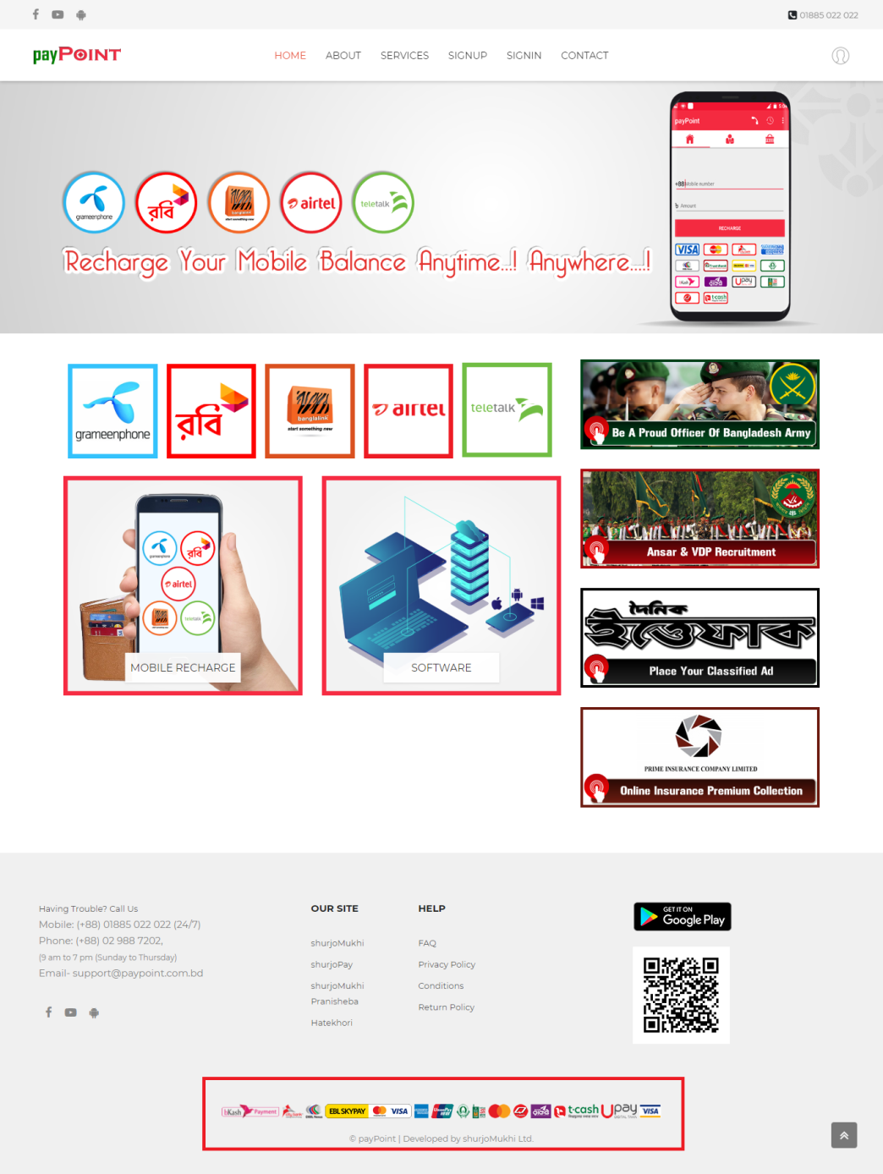
Illustration 2.11.4: screenshot of payPoint website

2.12 ShurjoMukhi Organogram
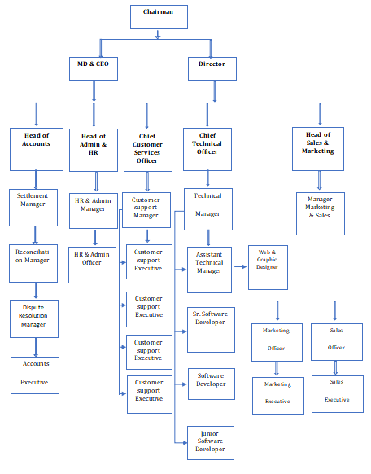
Illustration 2.12: Organogram of ShurjoMukhi

2.12.1 Organogram for praniSheba
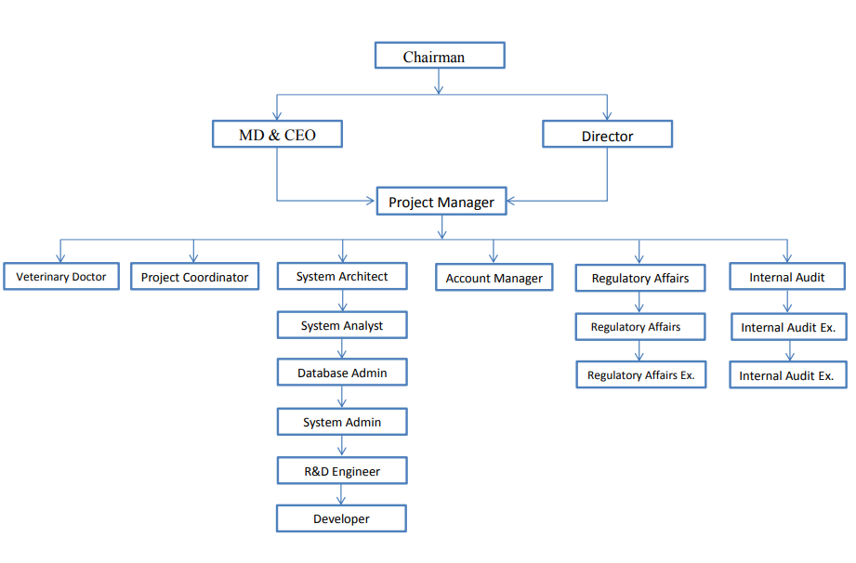
Illustration 2.4.1: Organogram of Pranisheba Unit

2.13 Literature Review
Schools have long been using digital technology to support the coordination of management and administrative processes - not least 'Management Information Systems', 'Virtual Learning Environments' and other 'institutional technologies'. In the past five years, these technologies have transformed into a unified rather than a separate system - allowing school leaders, administrators, teachers, students, and parents to access and use institutional-related data, resources, and other services. Many commentators see the perceived 'open' nature of these integrated systems as somehow democratizing and decentralizing the organization of schools. This paper, however, provides a detailed account of how schools constrain and limit the use of institutional technology in the social relations of schools and schools. This study discusses interview data from twelve 'primary adoption' schools in England as the application of integrated institutional technology is framed by a set of organizational, bureaucratic and disciplinary concerns. Specifically, the paper explains how these technologies strengthen existing 'top-down' patterns of social power and control through a series of data-driven processes. Studies have examined how systems are used to implement school-wide 'conservative modernization' - curriculum management, standardization of labor processes and intensifying education accountability. (Neil Selwyn)
Before you understand what the school management system is? Let's understand the term management is an array of different functions to successfully perform a task. Understand, in simple terms, management is the way things are done. However, it is the process and process of how a person achieves a goal or goal, that is, in this case, management is considered as an art and also a science.
What is a school management system? The School Management System is an enormous database framework that can be utilized to deal with your school's everyday tasks. Above all, the school the executives' framework permits clients to store practically the entirety of the school's data electronically, including data about clients, school employees, property, teaching materials, and so on. In particular, this data can be effectively imparted to authorized users, records can be effectively searched and reports can be effectively generated.
The school management system is configurable during school and can be arranged to address the issues of most individual schools. It is a multi-client framework and can be utilized by a few hundred or even a large number of clients simultaneously.
Generally speaking, the school management is a combination of different administrators and their roles in the management of the school. (Vaishali Malhotra)
The web-based school management application, she was attempted to utilize extraordinarily programming for this application. In her Application, she has utilized the cascade model since the cascade model is a successive structure process and in which process is viewed as streaming consistently downwards. Although likewise utilized use case and experiment approach for this application. Utilizing the use case she was attempting to characterizing the connections between a client and a framework to accomplish an objective. At last, she has utilized experiment approaches for deciding this application highlights are functioning as it is initially settled for to do it. Using this product approaches she has finished this application. (Aditi Sarker)
School Management Systems helps Teachers to complete grade book, track students' attendance, input class notes, create lesson plans and detailed reports and speak with other staff individuals, understudies, and guardians all by means of email.
School Management System default way to make it conceivable to create schedules and reports in minutes and to recover attendance records, grade checks, report cards, transcripts, and form letters in only a couple of clicks. (Khaled J.Awadallah)

2.14 Working Experience
I am working at surjoMukhi Ltd. as an intern executive sales and marketing. We are focused on our two main products/services, which are PraniSheba and EMS system. My basic responsibility is dealing with clients, visits client firms, collecting data via different sources and converting those client into customer.

Chapter 3

3.0 Education Management Software Analysis

3.1 Introduction
System analysis is a problem-solving procedure that subdivides a system inside its element to study how well this element works and associates with them to achieve their goal. As the software system requirements were anticipated, it was determined to follow the traditional system development life-cycle method. This technique requests an efficient, consecutive way to deal with programming advancement that starts at the framework level and advances through examination, plan, coding, testing, and upkeep. The steps that connect to all software engineering examples are supported by the program SDLC (Software Development Life-cycle).

3.2 System Engineering and Analysis
Programming is constantly a piece of a huge framework; work starts by setting up the necessity for all framework components and afterward assigning a few subsets of this prerequisite to programming. This framework see is fundamental when programming must interface with different components, for example, equipment, individuals and database. System engineering and analysis envelops prerequisites gathering at the framework level with a modest quantity of top-level design analysis.

3.3 System Analysis
The analysis involves determining requirements and specifying. System analysis is a problem-solving technique that divides a system into its components to study how well this part works and interacts with them to carry out their purpose. According to the Merriam-Webster Dictionary, system analysis is a method or process that identifies its goals and aims and creates a method and method that can make them efficiently. Analysis and synthesis, as a scientific method, always go hand in hand, they complement each other.

3.4 Requirement Analysis
Rules include system engineering and software engineering, requirements analysis, accounting for various or stakeholder constitution requirements analysis, documentation, validation, and moves to determine requirements or conditions for new or modified product or project applications.
Requirement analysis is critical to the success of any system or software project. Requirements should be defined in working, measurable, testable, traceable, relevant and sufficiently detailed for system design to find school needs or opportunities..

3.5 System Requirements
- Any Working Computers
- Internet Connection
- Any web browser (Such as Chrome, Firefox etc.)

Programming Language used to Develop SMS
- C# in front end
- .Net Framework
- MS SQL Server DBMS (backend database)

3.6 Flow Chart
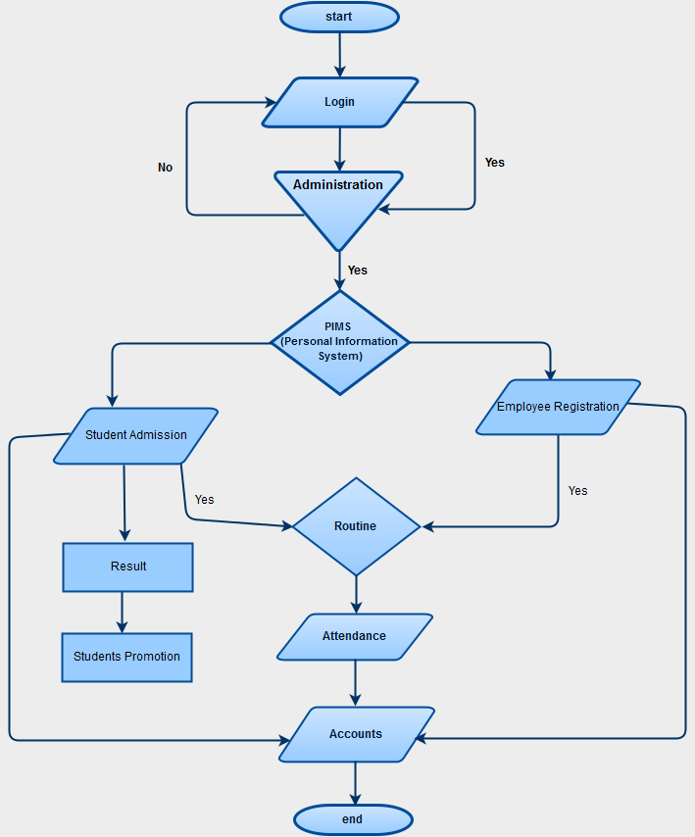
Illustration 3.6: DFD Diagram

3.7 Data Flow Diagram (DFD)
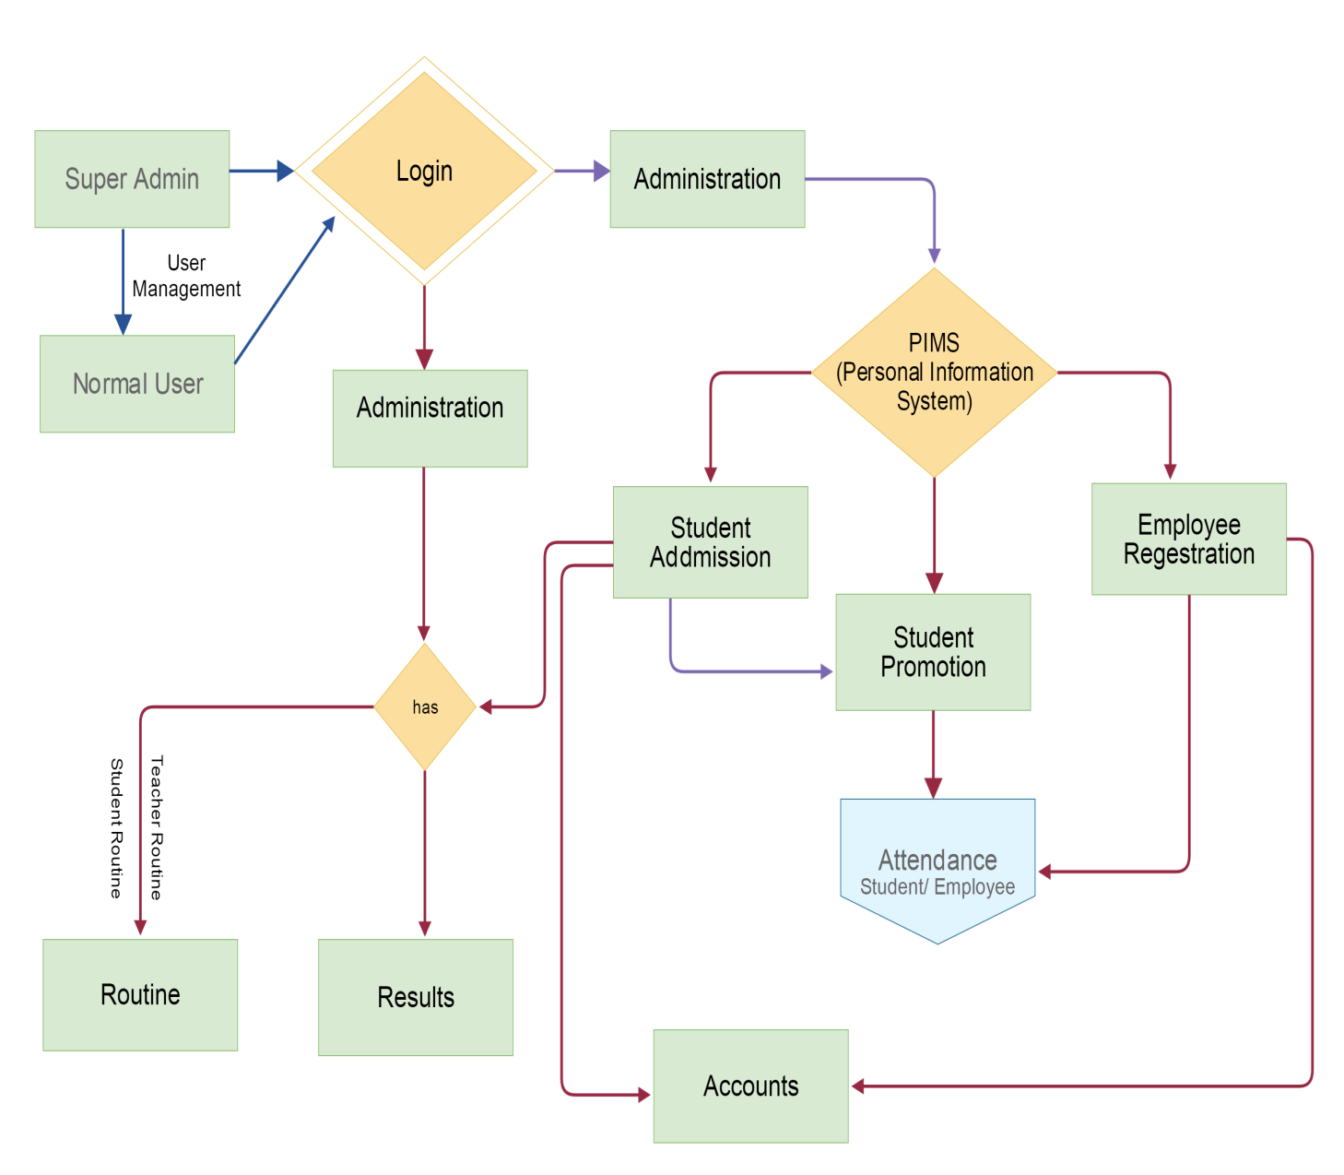
Illustration 3.7: DFD Diagram

3.8 ER Diagram

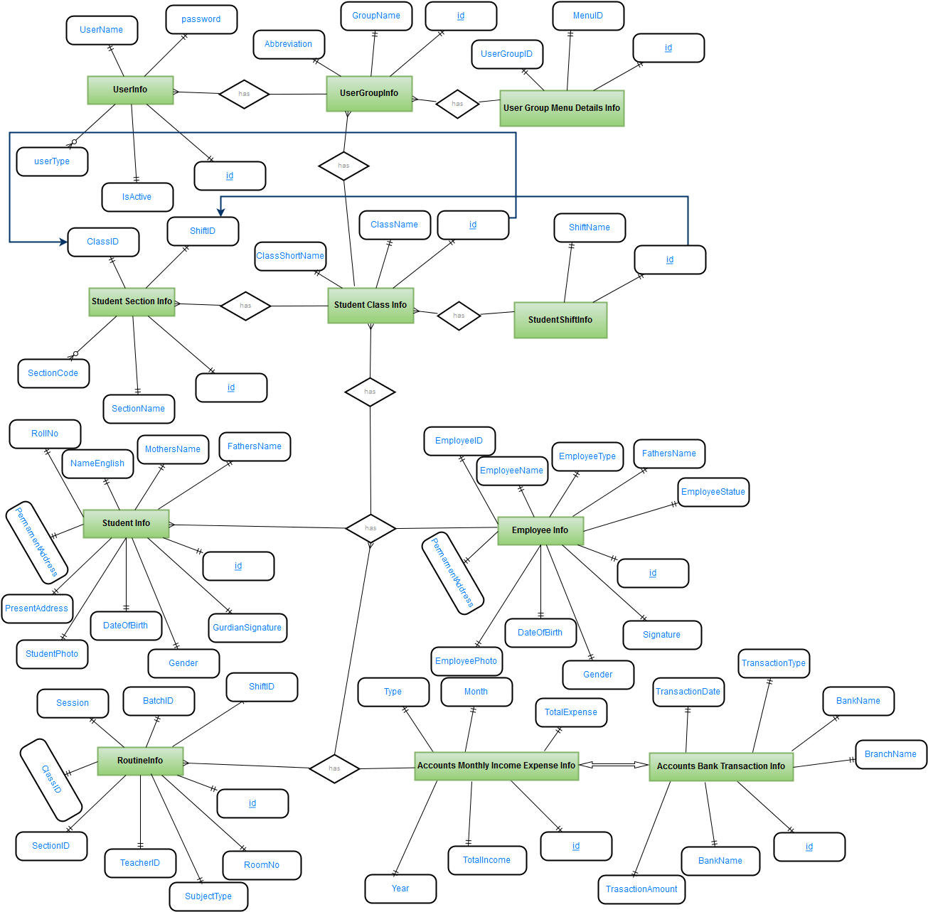
Illustration 3.8: ER Diagram

3.9 Relational Database

3.9.1 User

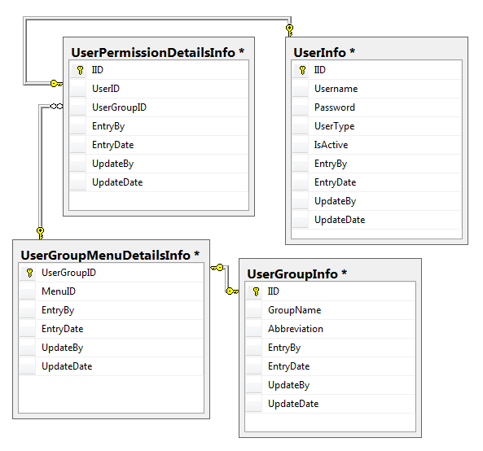
Illustration 3.9.1: User Relational Database

3.9.2 Administration
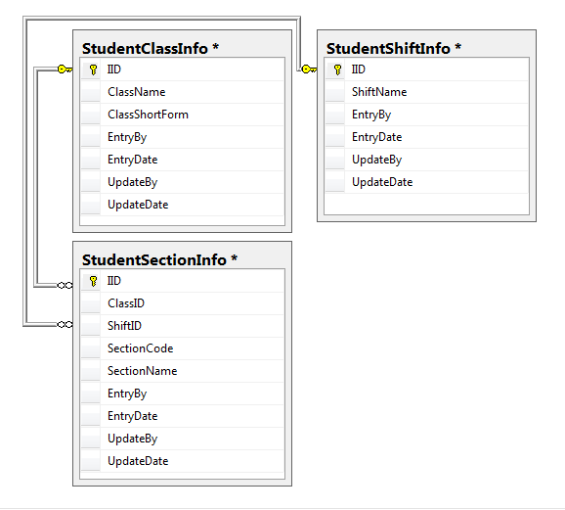
Illustration 3.9.2: Administration Relational Database

3.9.3 Student
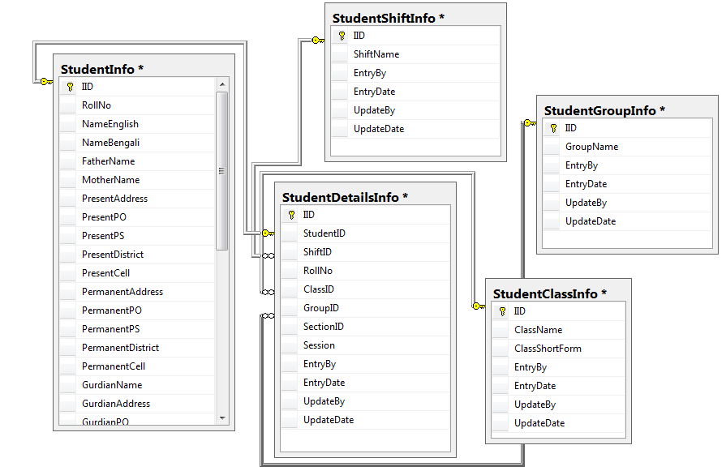
Illustration 3.9.3: Student Relational Database

3.9.4 Employee
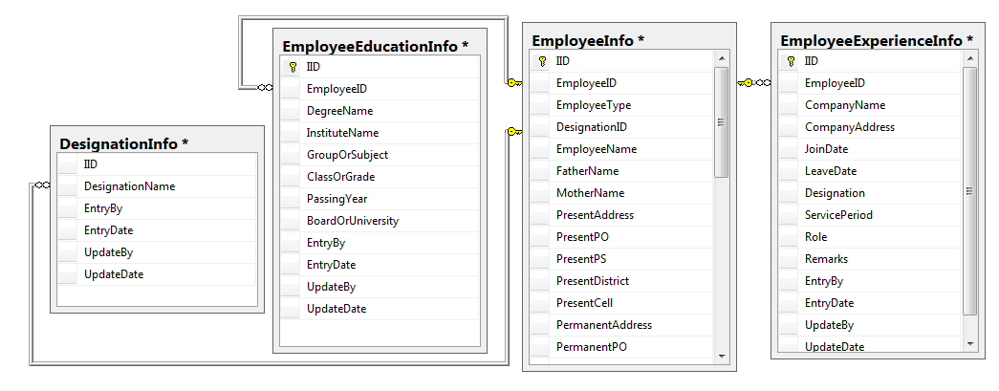
Illustration 3.9.4: Employee Relational Database

3.9.5 Routine
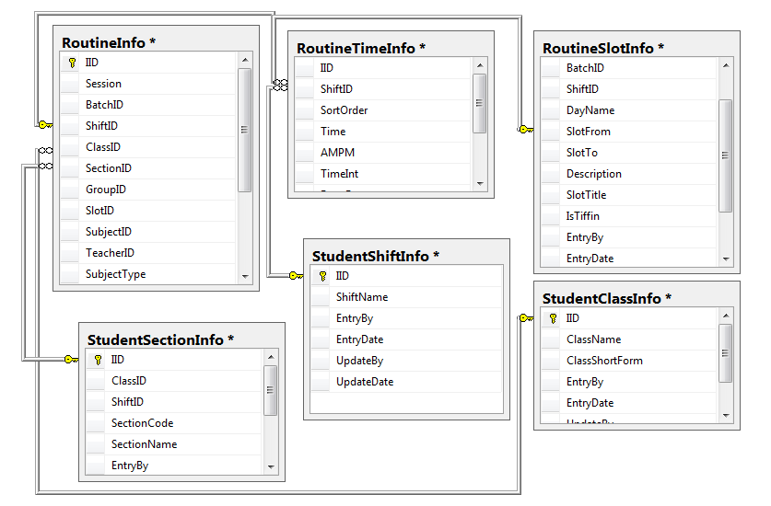
Illustration 3.9.5: Routine Relational Database

3.9.6 User Table
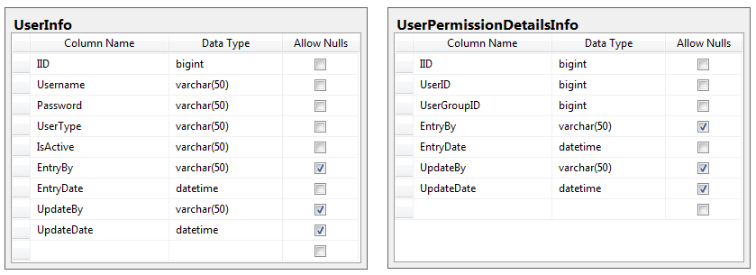
Illustration 3.9.6: User Table Database

3.9.7 User Group Table

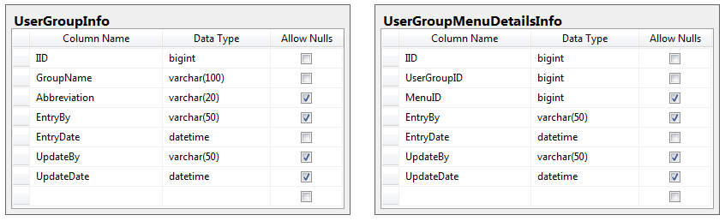
Illustration 3.9.7: User Group Table Database

3.9.8 Menu Table

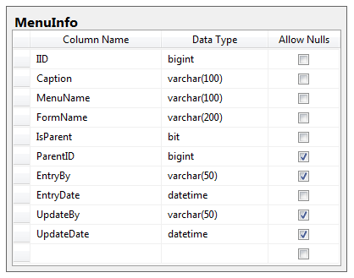
Illustration 3.9.8: Menu Table Database

3.9.9 Routine Table
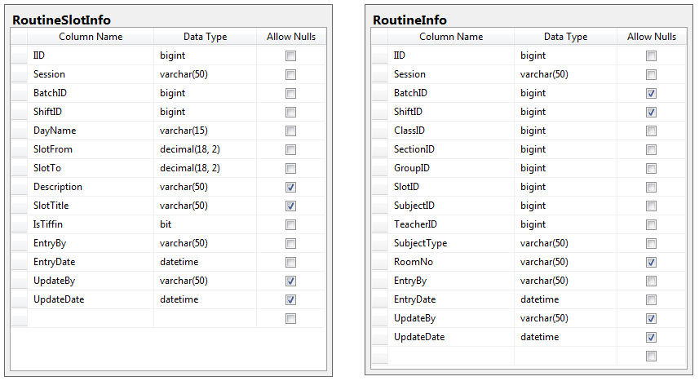
Illustration 3.9.9: Routine Table Database

3.9.10 Student Progress Table

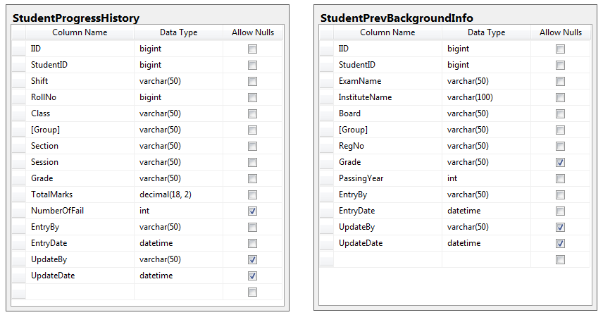
Illustration 3.9.10: Routine Table Database

3.9.11 Student Table

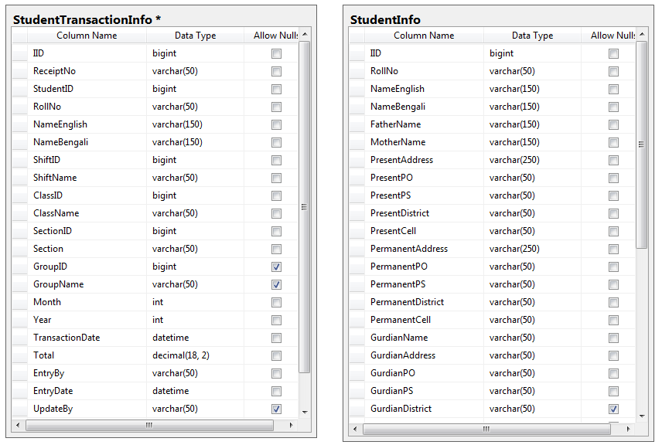
Illustration 3.9.11: Student Table Database

Chapter 4

4.0 User Manual of EMS

4.1 Login
After installing the software system user might be treated as a public user. The user only can see three functional tools bar named File, View and help. When the user clicks into option Login, A Login form appears there into interface. User has to enter the User-ID and Password to login. After typing all required info’s user have to enter login.
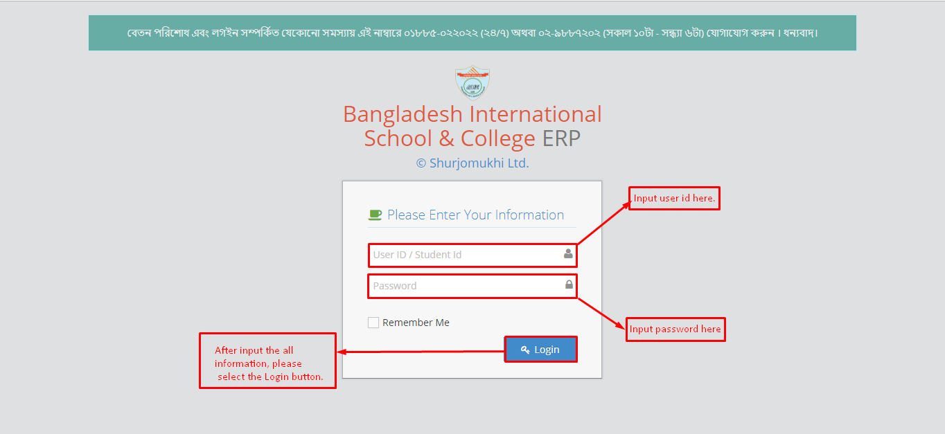
Illustration 4.1: Login Process
The user must have logged in into there to have the full access. Into File tools bar there are six objective options, where the first option is Login. After Login user can see and access with all other functionalities.

4.2 User Management
This system shows all the functionalities of a User. They Are user Group, Group Permission and User Entry.
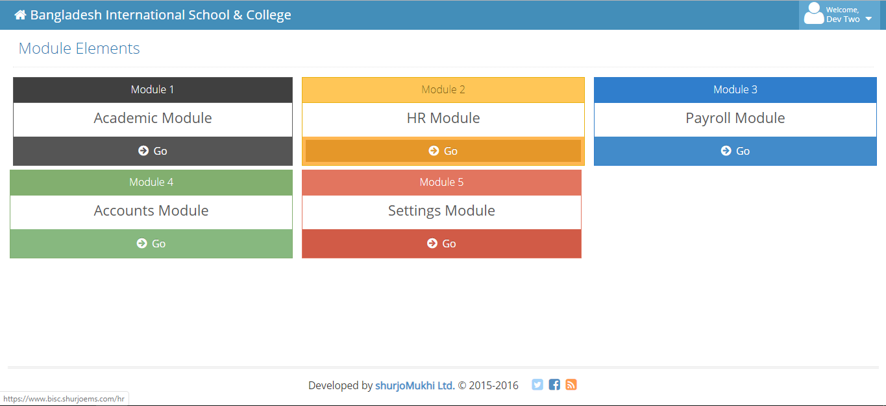
Illustration 4.2: Administration

4.3 User Group
The User can Create or Delete any User Groups. User can also Reset the existing user Groups. User needs just a Group name and abbreviation for Creating a User Group. When a User finished creating a User Group, It appears at the right side of the User Group Form with its Entry by and Entry Date.
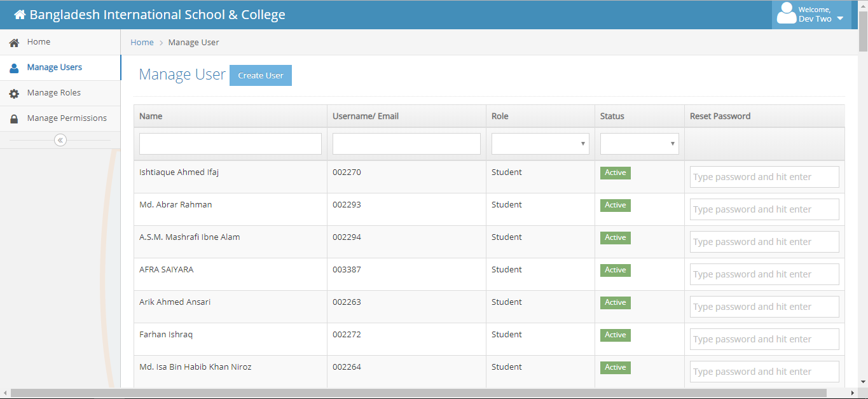
Illustration 4.3: User Group Entry

4.4 Group permission
The Groups, user created into the User group can’t access into all the sections. A User Group can access only those sections whose are given. All User Groups cannot access all sections. So How many sections and which sections are permitted to be accessed by a User Group is Decided here.
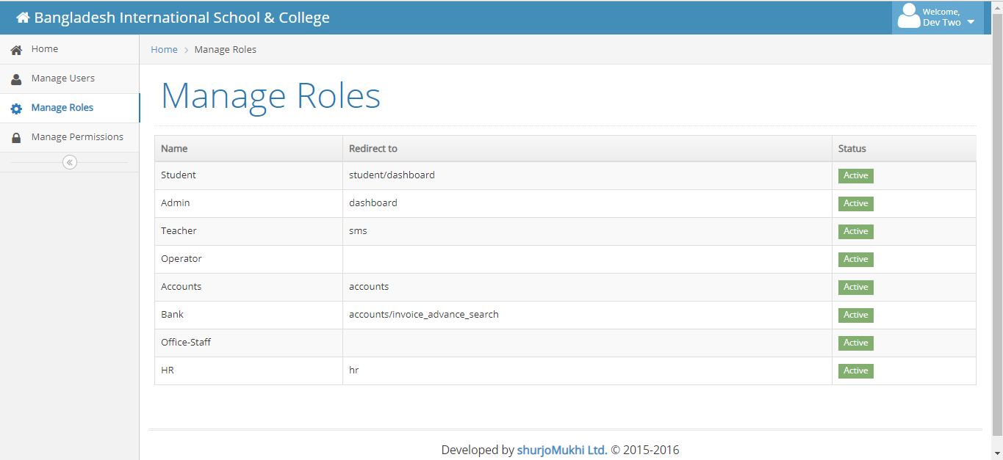
Illustration 4.4: Group Permission

4.5 User Entry
The Super admin can add other users into this system if necessary. It is quite foggy to manage all the systems alone, so user can add several users. There just needs a valid User-name and a password. User must select the Sections which are permitted to that New User.
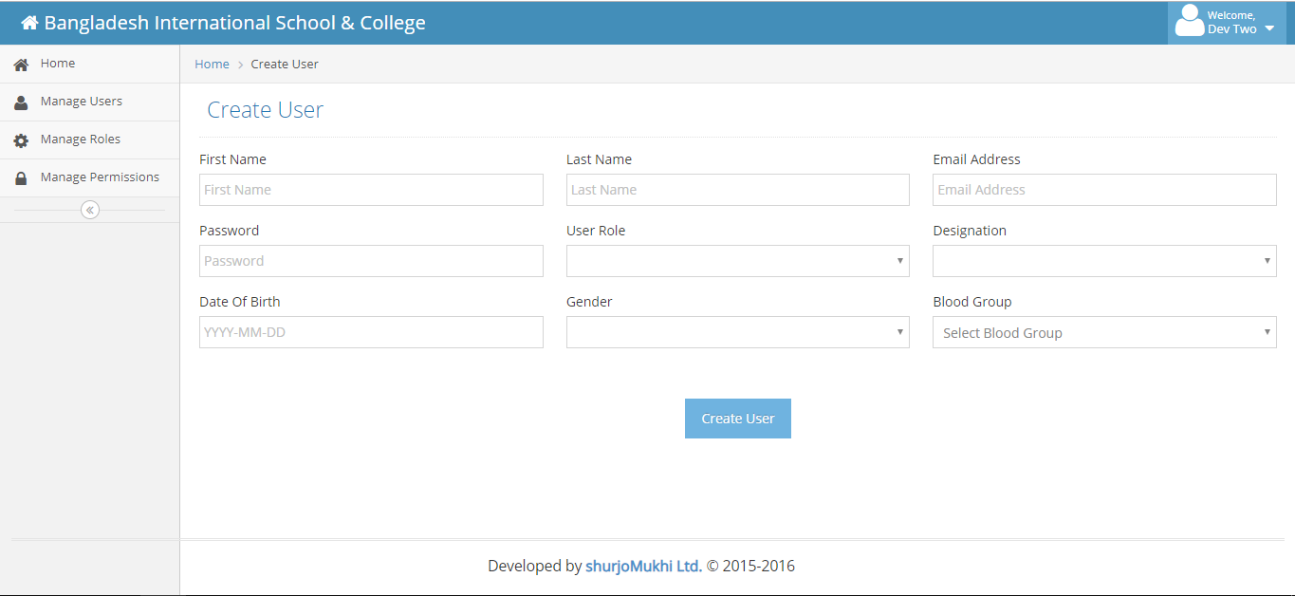
Illustration 4.5: User Entry
The User can be active or non-active. After creating the User-Ids, it will appear into the right side of the form with some relational information’s active, group permission, Entry By and Entry date. We can also reset/Update the info’s if needed.

4.6 Administration
The system management shows all the functionalities of arranging and organizing classes, shifts and sections in a polite and easy way. It shows shifts, classes, sections, subject groups, group subjects and designation when necessary to know.
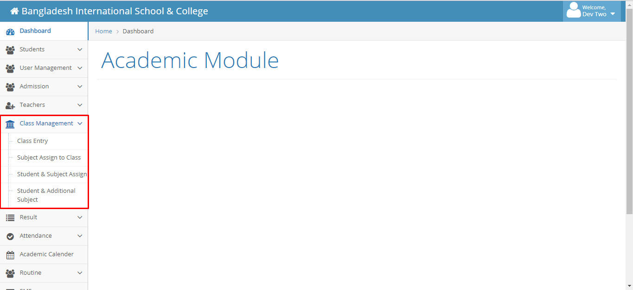
Illustration 4.6: Administration

4.7 Shift
It shows the shifts of any school management system. It May b Day or Morning. Nowadays some Institutions are now started night shifts also.
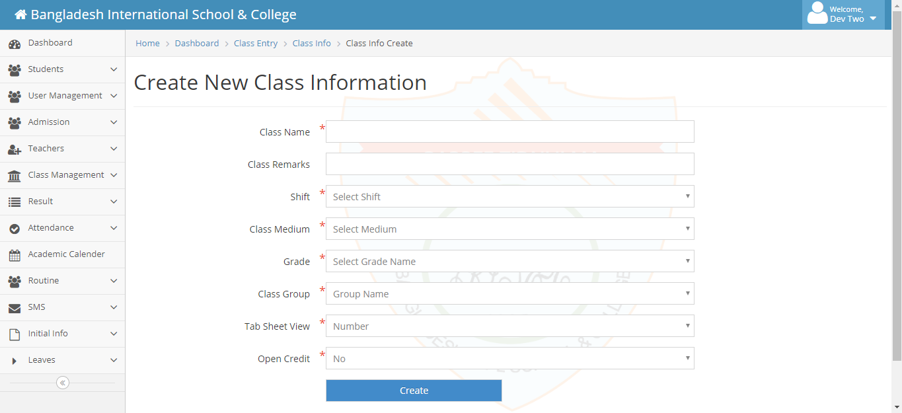
Illustration 4.7: Shift Entry

4.8 Class
This UI is for enter all existing class in an educational institute. We also assign a Class Short for easy handling.
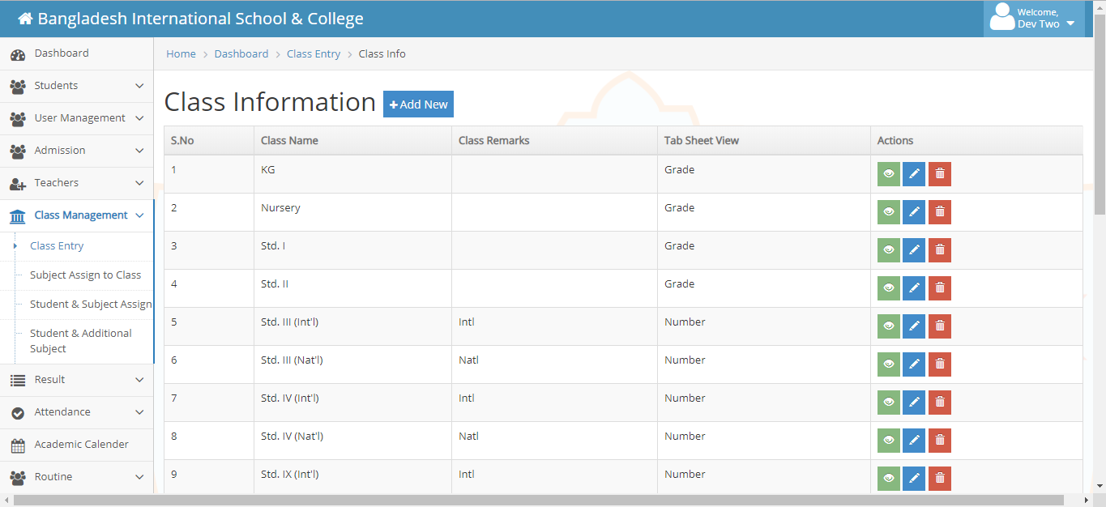
Illustration 4.8: Class Entry

4.9 Subject
This is Input screen for enlistment of subject with subject code and subject type alike – subjective/ selective.
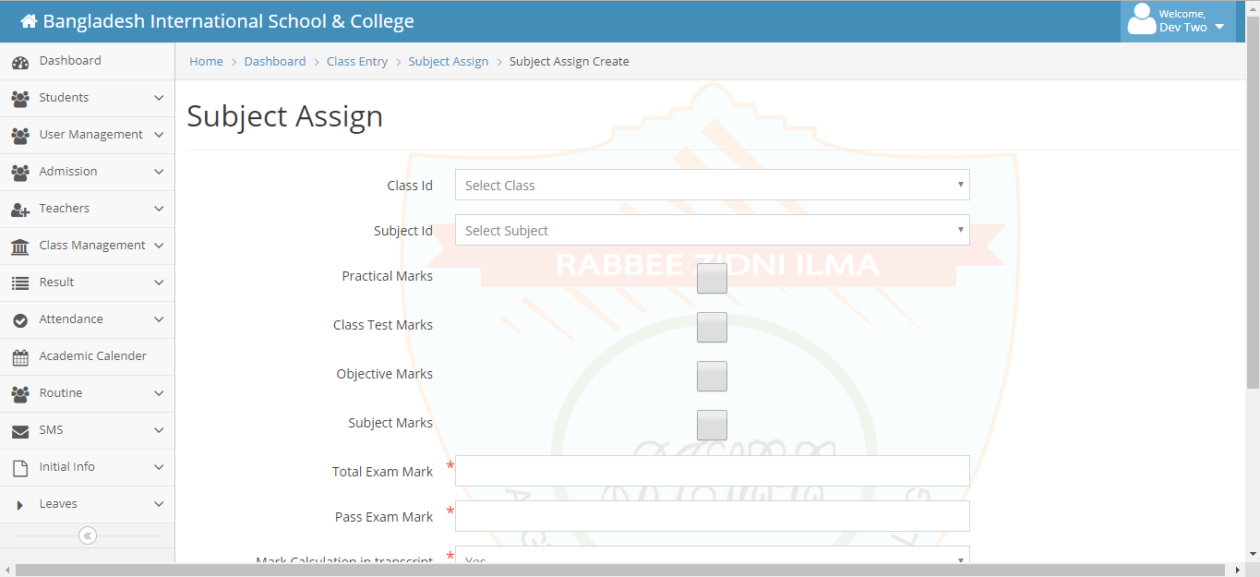
Illustration 4.9: Subject Entry

4.10 Section
User can see all the sections of all classes with their individual section codes. If the user wants to add a new section for any identical class and shifts it needs just a section name with its section codes. After saving it will appear into the right side of user interface. User also can delete or reset any section data if needed.
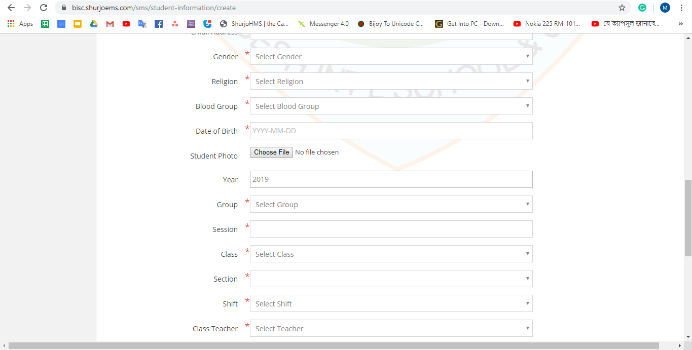
Illustration 4.10: Section Entry

4.11 Student Group
Student group shows the group of any student. User can create any user group with just only a Group-name. Usually there are 3 student groups named Science, Business Communication and Humanities.
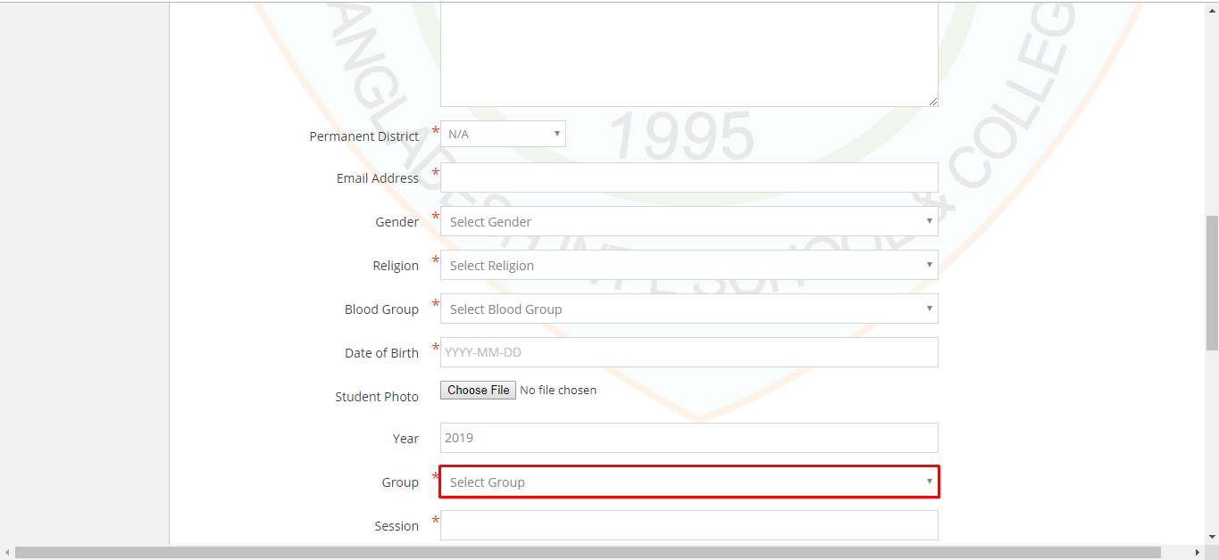
Illustration 4.11: Student Group Entry

4.12 Group Subjects
We assign subject name for under subjective, Selective and optional just select particular class and group.
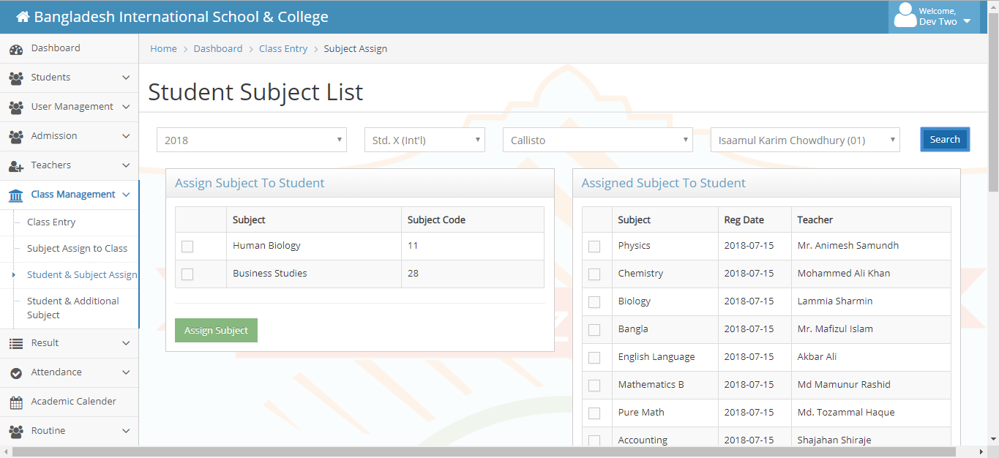
Illustration 4.12: Student Group Entry

4.13 Designation
Designation means those, with whose strong monitoring and love a institution runs properly. With the help of this, User could see the entire designations name at a time. User can add other designation name according to necessity. User also can reset or delete the previous data/record if needed.
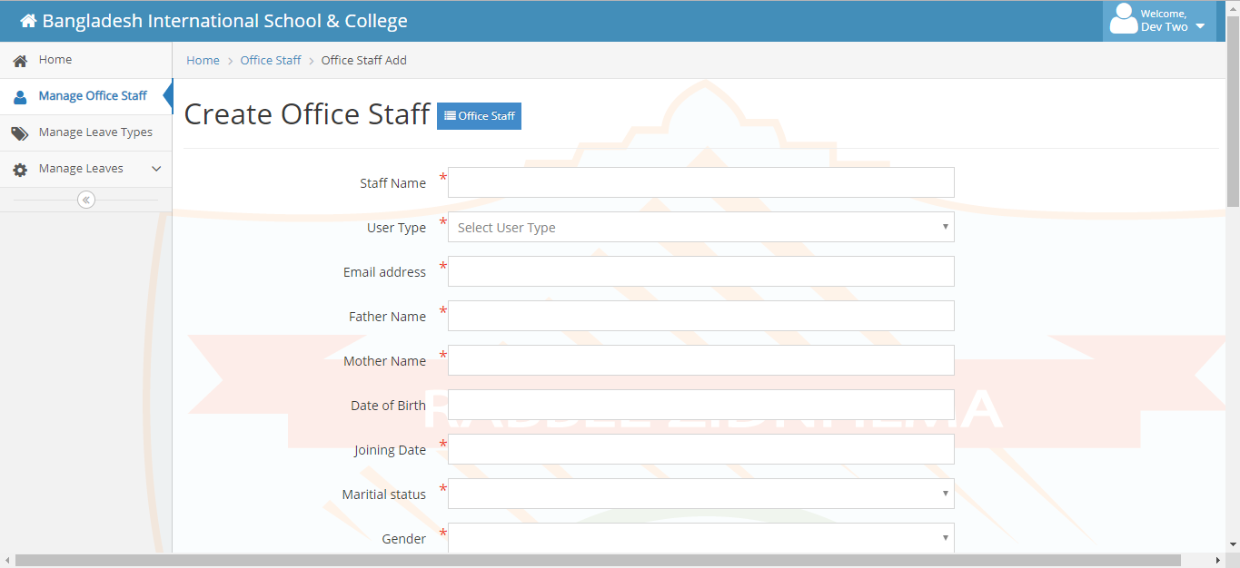
Illustration 4.13: Designation

4.14 Attendance

4.14.1 Student Attendance
This system shows the student attendance. If the User just want to check any required class’s and section’s students attendance of a desired day, User only have to enter the class name, section name and that date, Ant may b the attendance report of a huge number of students would be shown in a couple of minute. User can save, delete or reset the data if needed.
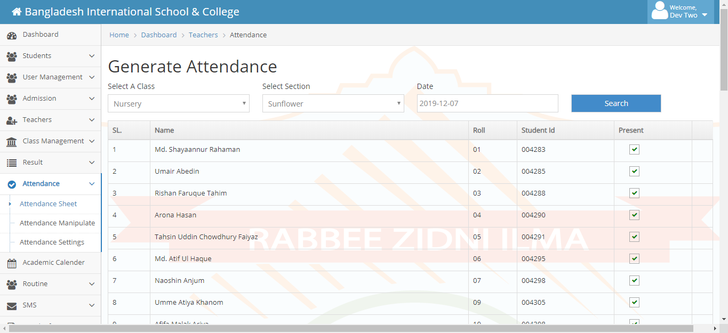
Illustration 4.14.1: Attendance Screen

4.14.2 Employee Attendance
This functionality shows all of the employee’s attendance as like students and input attendance.
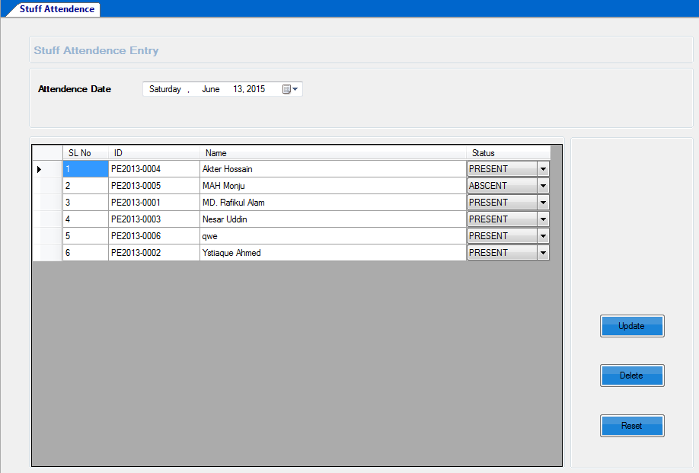
Illustration 4.14.2: Employee Attendance

4.15 Holidays
Holiday input screen is for institute can inputted their festival time and weekend for easy to concern anybody with short notes about it like remarks. Friday is by default holiday.
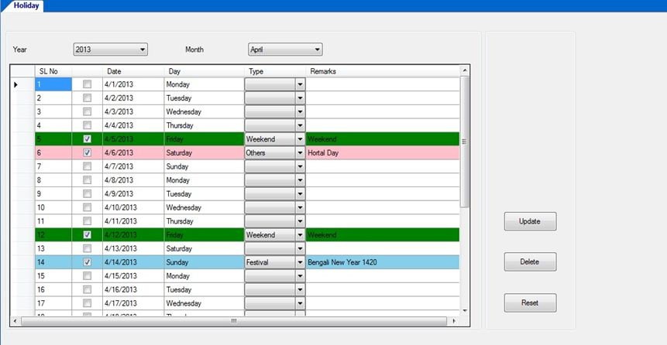
Illustration 4.15: Enter Holidays

4.16 Student Admission
As this is a School management System there must be students, and also there must have an organized way to admit them. At here, User can admit students with fulfilling this form. After getting into all information user can save them as students of that institutions. It also include Students photo on it. It’s easy to identify. Guardian’s information is available with mobile number and photo.
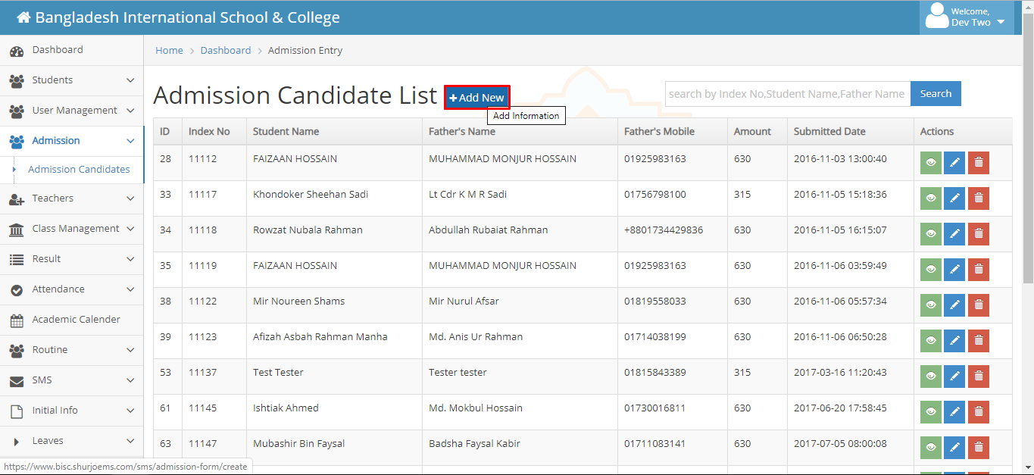
Illustration 4.16: Student Admission

4.17 Employee Registration
Admin can Register Employs according to necessity of management system. User can also update/Reset the old employ’s data’s if necessary. It saves the employs photo and digital signature which is more secure and identical.

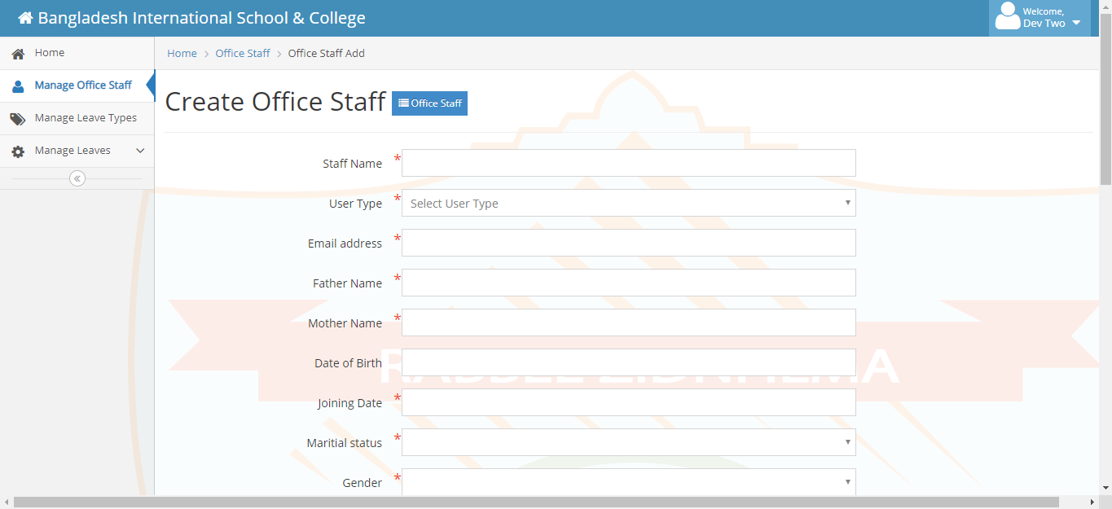
Illustration 4.17: Employee Registration

4.18 Student List
Admin / User can watch the student list. According to a School Management system, there are a lot of Students. So, may be User want to watch only some selective students list. As it, users have just input the required class and section onto it and here result comes. Admin can edit any information from here just click edit button and update data.
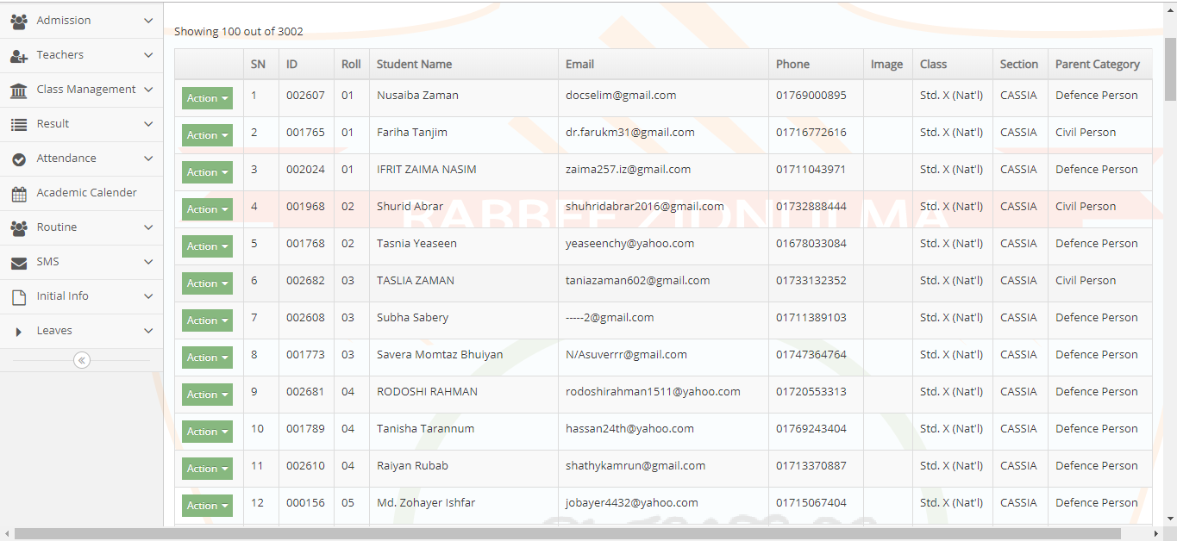
Illustration 4.18: Student List

4.19 Employee List
It shows the entire employee’s data and information with their photo and digital signatures.
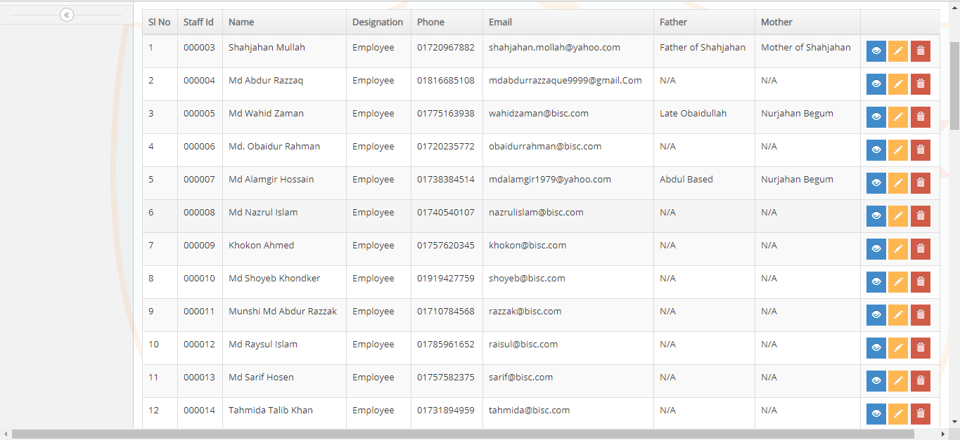
Illustration 4.19: Employee List

4.20 Student Details Report
User can see the full details report of any particular student if needed from student list. It is depicted into figure 22.
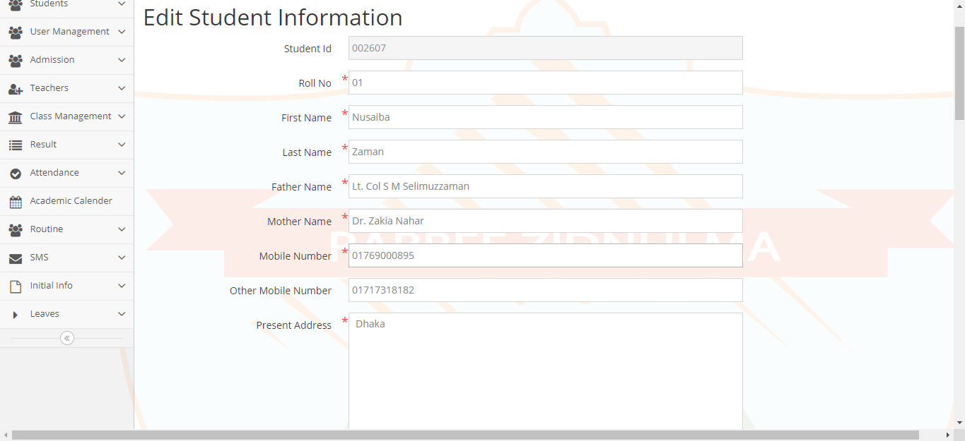
Illustration 4.20: Student Details Report

4.21 Student list Report
User can also see the Student list Report from student list report class wise.
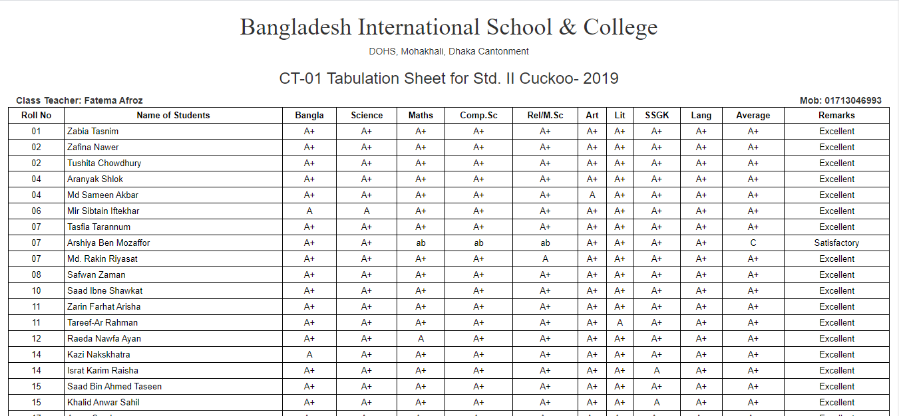
Illustration 4.21: Student list Report

4.22 Employee Details Report
User can watch a particular employ’s details report here like their Educational Information, Professional Information, Skill and training Info’s.

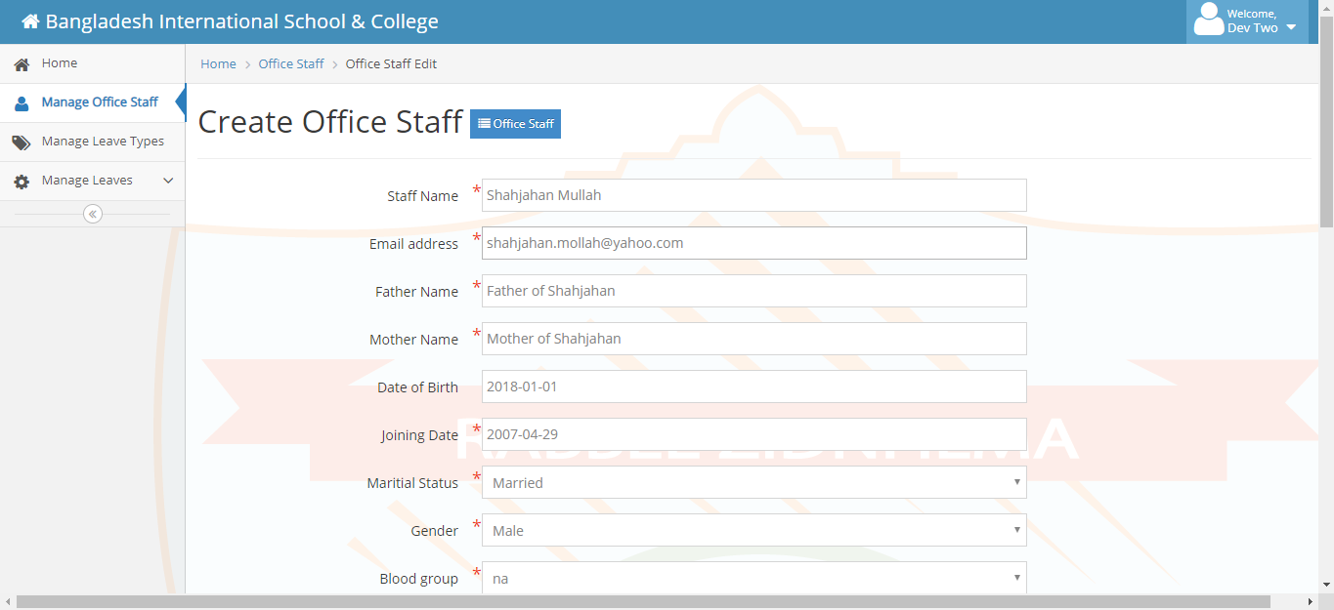
Illustration 4.22: Employee List

4.23 Employee List Report
Admin/ User can view employee list report from Employee List. It can be filtered by Designation, Marital Status or Blood group.
Illustration 4.23: Employee List report

4.24 Result
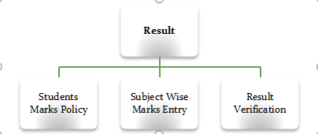
Illustration 4.24: Result Module

4.25 Students Marks Policy
Every Educational Institute has its own marks policy. So they can input their marks policy by this UI. Simply Select class, session and groups then show. Under all subject they can assign marks policy like – have class test or not, class test total marks, pass marks, is marks in hand writing/ spelling, written pass marks, total pass marks etc.

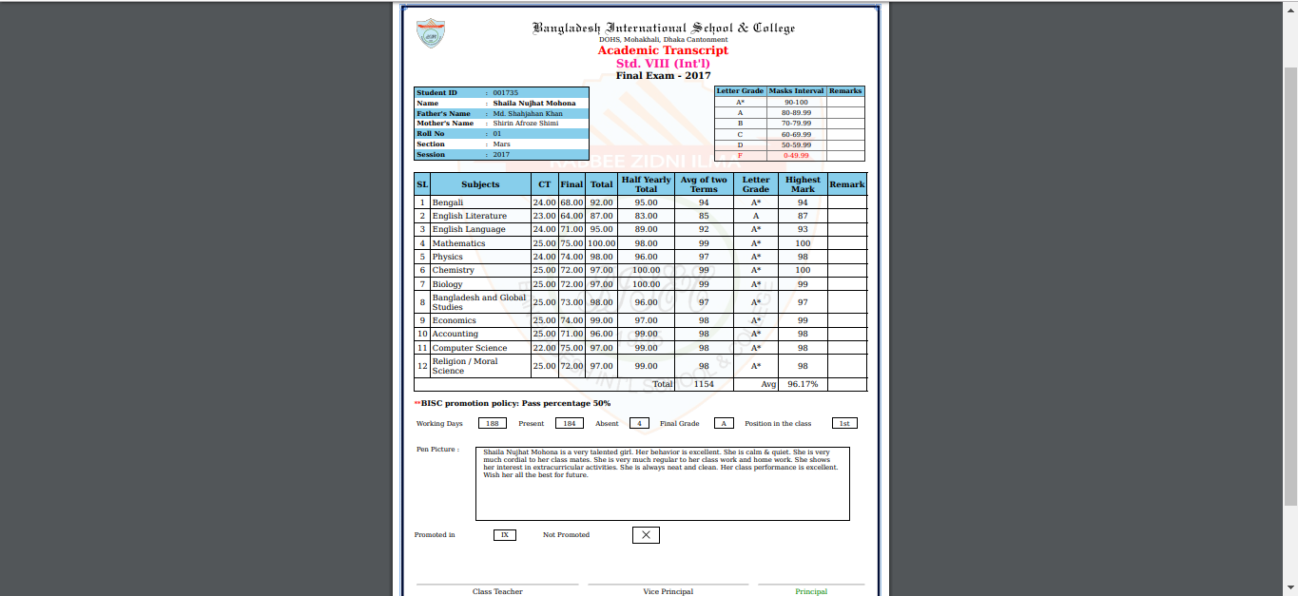
Illustration 4.25: Students Marks Policy

4.26 Subject Wise Marks Entry
Subject Wise Marks Entry is marks entry for individual subjects marks entry. When select particular shift, class, year, group, exam-term and subject then its show all student list in grid view. It’s an easy UI for user who entry the marks. He simply input the marks for particular student and save it. If anybody absent in exam then it should be marks in checkbox. When result is published those student result shows automatically absent in those particular subject.
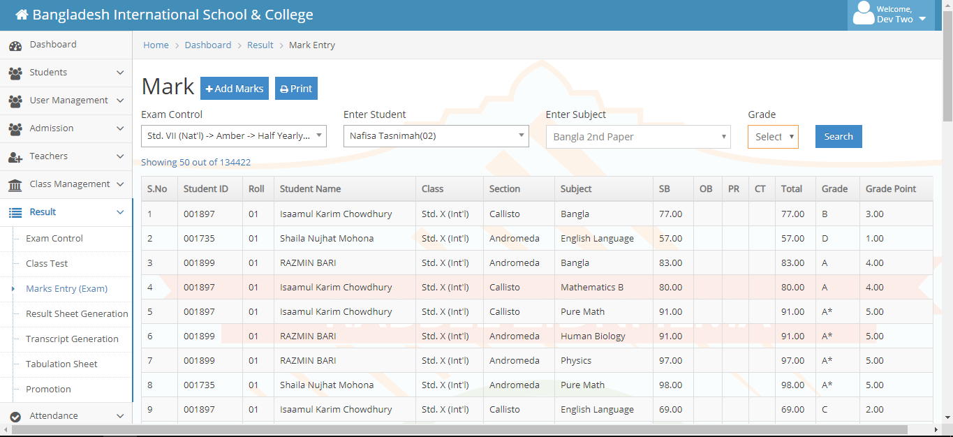
Illustration 4.26: Subject Wise Marks Entry

4.27 Routine

Illustration 4.27: Routine Module

4.28 Routine Slot Entry
It’s a slot for routine entry. It’s just easy to entry the routine. Just select Shift, Year, Day and Time From (7:00 AM) – Time To (7:30 AM) and Slot Title (1st period). Time Slot is individual period time (7:00 AM- 7:30 AM). Almost these period are generated in routine which we entry in Routine Slot Entry UI. Break Time is also assignable by mark the checkbox is break.
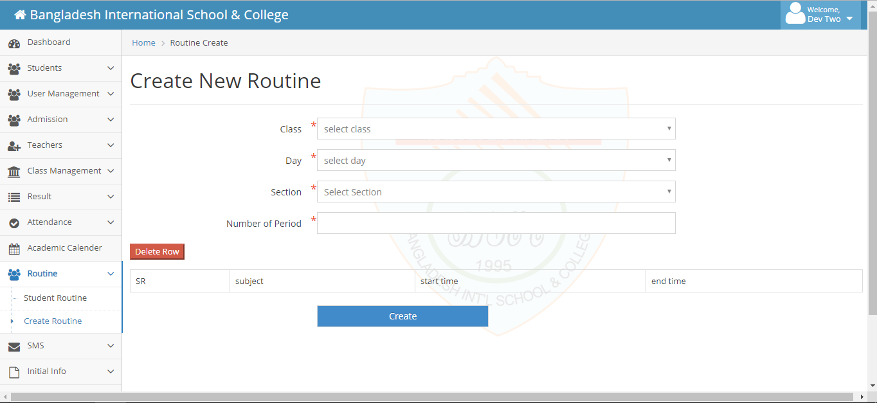
Illustration 4.28: Routine Slot Entry

4.29 Routine Entry
Routine Entry view’s as day and period wise routine for particular Class, Shift and Year. We just select Subject Name, Subject Type, Teacher’s Name and assigns room number for each and every period and individual day. It’s a weekly view. When all period’s and days are inputted correctly then save the data for next step.
Illustration 4.29: Routine Entry

4.30 Student Class Routine
It generated the student Class Routine. Just simply select Shift, Class, Section, Year and Group and then show. We can print this report from here for student use and also export to pdf and excel.
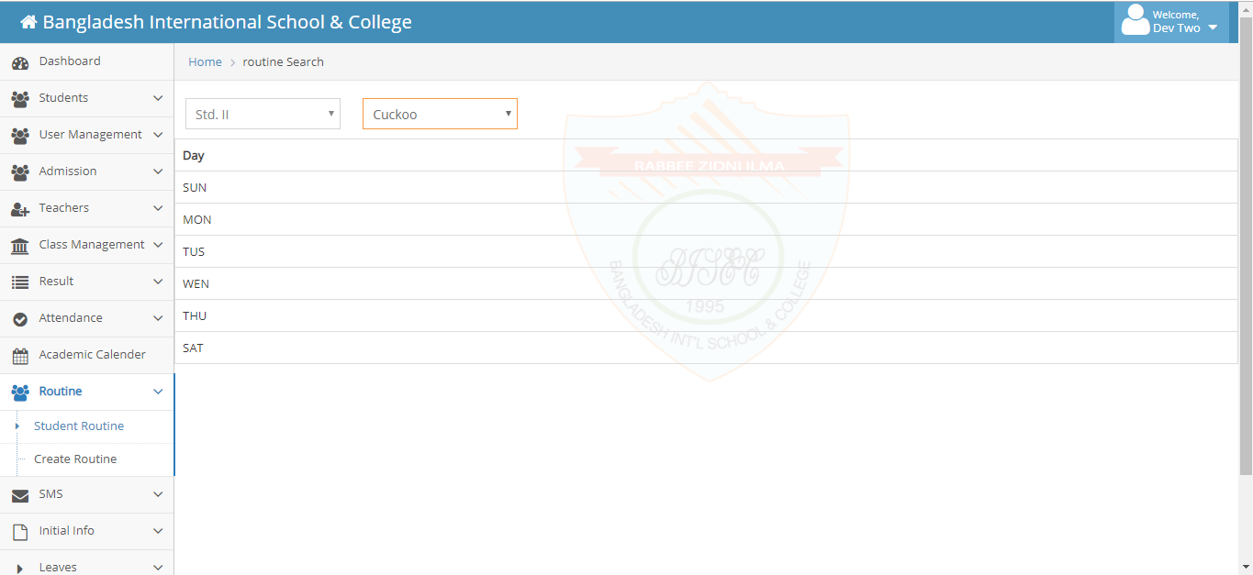
Illustration 4.30: Student Class Routine

4.31 Accounts

4.31.1 Salary particulars
We can create all expense head as Debit Head. We create debit head as parent head. If we have a child head under parent head then mark is parent head. If this head is linked with class then select linked with class and select class.
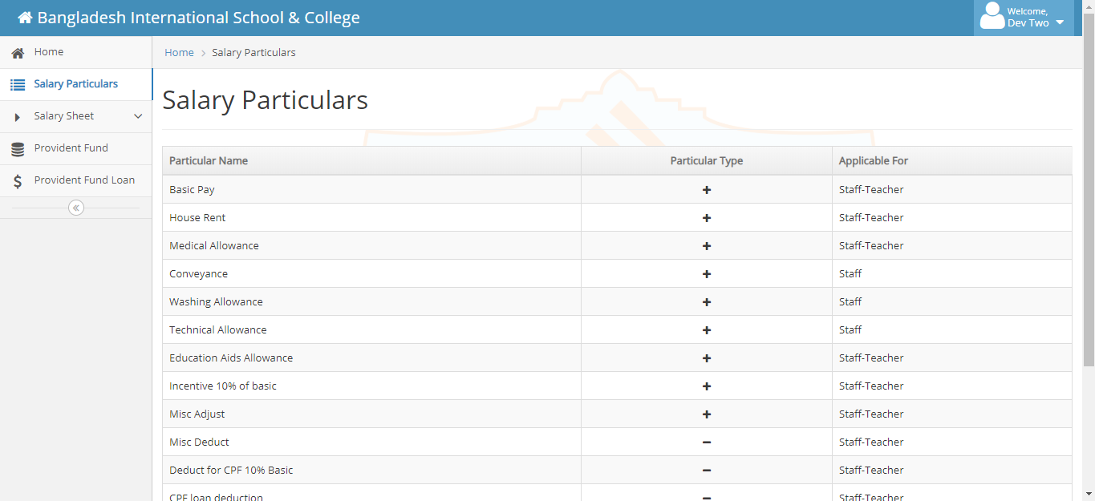
Illustration 4.31.1: Salary particulars

4.31.2 Provident Fund
We can create all income head as Credit Head. We create credit head as parent head. If we have a child head under parent head then mark is parent head and under parent head we create child head. If this head is linked with class then select linked with class and select class.
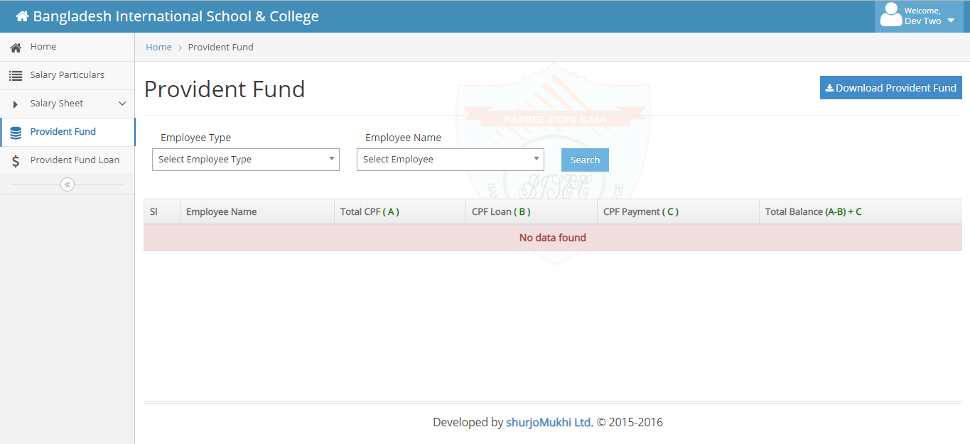
Illustration 4.31.2: Provident Fund

Chapter 5

5.0 Introduction
First of all, I would like to thanks the Bangladesh International School and College (BISC) Principal, administration, teachers, and staff. All of them are so helpful for completing the survey successfully. But the process of the school is so strict to me because of getting permission for doing the survey in the school I have to visit a couple of times to get permission. After all, it was a great experience for me to do the job done successfully.
The topic of my survey is “An Evaluation of the School Management System” and this is the final step for doing the internship report done. For this reason, I use some questionnaires to get the essence of the system. I try to get real information from the teachers, admin, staff, etc. All of them are extremely helpful to me for completing the survey.
We all know that in the last of December and the first half of January is the time of new student admission time and after that, the annual sports program is held. In the meantime, I am going to do the survey and that’s why I have to go to the campus several times to do the job done.

5.1 Population and Sample for the present Study
In this internship report, I use the quantitative method to collect the data from the targeted group. Basically, I targeted the Teachers of an institute "Bangladesh International School and College" which is used School Management System provide by "ShurjoMukhi Ltd".
For this purpose, I use a questionnaire to collect the data from a total of 33 individuals who are teachers, admin, and staff, etc. In this study, I am trying to find out the satisfaction and problem facing when they used this system in order to do their day to day activities.
The study is to find out the problem regarding the school management system. There are three criteria to select the sample material for this study.
- The participant should be a teacher, admin & stuff of the Bangladesh International School and College.
- The respondent age not less than 23-25 years.
The sample size of the study was 33 of school and college-level teachers, admin and staff.

5.2 Data collection Procedure
In this step, I go to the premises of the Bangladesh International School and College. For the data collection procedure, I used a set of questionnaire provides to an individual to fill up the questionnaire by them. They are so helpful and humble also they fill up the questionnaire for me.

5.3 Data Analysis
After collecting all data, questionnaires will be coded to identify the central tendency of the response using MS Excel and the data will be processed, analyzed and the descriptive statistics will be analyzed.

Data Analysis:
Individual Respondent’s Data Analysis and Interpretation shown by Table and Pie Chart:
- Gender
Parameters | Percentages
Male | 42%
Female | 58%
Total | 100%

Interpretation: Here 58% of the total respondents are female whereas the rest 42% are male of this survey. So we see of the most of the people are female.
- Age group
Parameters | Percentages
Below 25 | 42%
25-30 | 58%
30-40 | 33%
40-50 | 0%
50+ | 3%
Total | 100%

Interpretation: Here 58% of the total respondents belong to the 25 to 30 level and 33% to the age 30 to 40 level. The majority of the respondents are 25 to 30 years old.
- Employment Status
Parameters | Percentages
Permanent employee | 76%
Fixed term conrtact more than a year | 15%
Fixed term conrtact less than a year | 9%
Total | 100%

Interpretation:The survey result expresses that most of the teachers are permanent employee and according to this survey, 79% are permanent teachers and rest of the teachers are fixed term contractual teacher.
- Academic Qualification
Parameters | Percentages
Bachelor Degree | 18%
Masters Degree | 79%
Doctorate | 03%
Others | 00%
Total | 100%

Interpretation: Research result indicates most of the teacher’s academic qualification is Masters Degree which is 79%. Rest of the teachers is Bachelor Degree which is 18% and only one of the teachers is Hon’s.
- Teaching areas
Parameters | % | Parameters | % | Parameters | % | Parameters | %
Science and Mathematics | 22% | Rhymes | 03% | Physical Education | 03% | Social sciences and Electives | 03%
ICT | 06% | Spelling & Dictation | 03% | Agriculture | 03% | Computer Science | 06%
Computer Science and engineering | 03% | Business Studies | 03% | English second paper | 03% | English Literature | 03%
Religious Book | 06% | Economics | 03% | Admin | 03% | Bangladesh & Global Studies | 06%
Art and Music | 06% | Accounting | 03% | Bangla 2nd paper | 03% | Total | 100%
Career Education | 03% | English Language | 03% | Bangla 1st paper | 03%

Interpretation: Survey result expresses that most of the teacher’s teaching areas are Science and Mathematics subject which is 22% and rest of the teacher’s teaching areas is differ from one another.
- Service Length
Parameters | Percentages
Less than 1 | 22%
1-3 years | 06%
4-6 years | 03%
7-10 Years | 06%
Mote than 10 years | 100%
Total | 100%

Interpretation: Here 52% of the total respondents are in 1 to 3 years service length in this school/institure, whereas the rest 24%, 18% and 6% are belonging according to 4 to 6 years, less than 1 year and 7 to 10 years.

- Have you ever used School management system before?
Parameters | Percentages
Yes | 42%
No | 58%
Total | 100%

Interpretation: Here 94% of the total respondents are in not using school Management System before, whereas the rest 6% are belonging to use school management system before join this school.
- How often do you use the system information in this institution?
Parameters | Percentages
Occasionally | 94%
Frequently | 03%
More frequently | 03%
Total | 100%

Interpretation: Here 94% of the total respondents are in using this system is occasionally, whereas the rest 3% are using this system more frequently and rest of the 3% are using this system is frequently for the purposes of complete their daily task.
- How often do you use the system information in this institution?
Parameters | Percentages
High Safety | 94%
Search Quickly | 03%
More optimized | 03%
Others | 0%
Total | 100%

Interpretation: Here 58% of the total respondents think that search quickly is necessary to equip into this system, whereas the rest 36% are that high safety is needed to equip into this system, rest of the 3% are want a optimized system and last 3% are want to maintain proper documentation properly.
- Gender
Parameters | Percentages
Yes | 42%
No | 58%
Total | 100%

Interpretation: Here 97% of the total respondents think that the school management system is user friendly and reset of the 3% respondents think that this system is not user friendly.
- Teaching areas
Parameters | Percentages | Geo-location based attendance | 03%
Bus tracking | 08% | Reduced School period | 03%
System is ok | 18% | Online absent fines & penalties | 05%
Dynamic website | 10% | Integration of attendance module with access control system with RFID | 05%
Attendance mark | 02% | Hostel information should be include in system | 03%
Course evaluation system | 02% | Teacher should be careful to their class and carefully handle the student | 03%
Data encryption | 03% | Need some optimization for effectively use the system | 05%
Documentation | 03% | Need to maintain the system more accurately | 03%
E-library | 08% | Make more convenient System UI | 03%
Online exam | 10% | Total | 100%
Teachers evaluation | 03%

Interpretation: Here 18% of the total respondents think that the school management system is OK and next 10% respondents think that dynamic website, next 8% respondents think that E-library facilities will help more, next 10% respondents think that online exam will impact on performance and 8% respondents think that bus tracking system will help more for parents and School Administration.

5.4 Findings
It is impossible for me to find all the problems that the school is facing. I've got some things that are really helpful for system development. There are some problems with this school management system I find out from this survey.
According to the survey most of the respondents (18%) are think that the system is okay. But other respondents are talking about adding some modern feature to this School management system for the betterment of this service.
The new feature need to add into the school management system will mention in the below.
- Dynamic website will add extra value for improvement their service.
- Bus tracking facilities will help more for parents as well as school management.
- E-library facilities will help more in perspective of the students and teachers.
- Online exam taking facilities will help more for sick students or in unavoidable circumstances.
- Adding Online absent fines and penalties.
- Integration of attendance module with access control system with RFID.
- Teachers evaluation will help more for the administration to ensure better service.
- Geo-location based attendance will increase the efficiency of the teaches as well as tracking the student is become more easy.

5.5 Recommendation
It is very difficult for me to recommend a school management system because it is a technical product and I have been there for only three months. So from my point of view, I think that School management system can follow the steps for improved service.
- Create Dynamic Website
The current web site of “Bangladesh International School and College” is static. In this study, I find that most of the respondents talk about the dynamic website.
- E-library facility
The next important feature is e-library facility which are helping more for students to read more book from any kind of devices
- Bus Tracking facility
“Bangladesh International School and College” provides a school bus service for students, for this reason, they want bus tracking facilities. This facility helps a lot to ensure the parents about their children.
- Online exam taking facility
One of the most important features is the “Online exam-taking facility” help for the student when they are sick or unavoidable circumstances.
Personally I want to talk about some feature that is not given much important:
- Geo-Location based attendance
Geo-location attendance means geographical attendance, when students come near to the school premises system mark them as attended and when they leave school premises before the school period complete they also mark as absent automatically.

6.0 Conclusion
In recent years, withz6 the pace of technological development, people have become more demanding in terms of quality of life, and in recent years school administrators have sought to improve their school performance to achieve the highest rates Knowledge and their student experience.

Reference
- https://shurjomukhi.com.bd/ accessed on 15 October, 2019
- http://bisc.com.bd/ accessed on 12 December, 2019
- https://www.bisc.shurjoems.com/ accessed on 21 December, 2019
- https://www.freeprojectz.com/project-report/1656 accessed on 25 December, 2019
- https://www.academia.edu/36247893/School_Management_System_Project_D ocument.docx accessed on 29 December, 2019

Appendix
- Gender
- Male b) Female
- Age Group
- Below 25 b) 25-30
- 30-40 d) 40-50
- 50+
- Employment Status
- Permanent employee
- Fixed term contract of more than a year
- Fixed term contract of less than a year
- Academic qualification
- Bachelor Degree
- Master Degree
- Doctorate
- Others
- Teaching Areas
- Art and Music
- Physical education
- Science and Mathematics
- Social science and electives
- Religious Book
- Other, please specif_________
- Service length at this school/institute
- Less than 1
- 1-3 years
- 4-6 years
- 7-10 years
- More than 10 years

- Have you ever used Student Management System before?
- Yes b) No
- How often do you use the system information management system in this institution?
- Occasionally
- Frequently
- More frequently
- What performance do you think are necessary to equip in a system?
- High safety
- Search Quickly
- Humanized operation
- Other, please specify____________
- Do you think that the present system is user-friendly?
- Yes
- No
- Please write down your suggestion by which present system can be improved for better performance.

