Project Report
Health challenges in Bangladesh
Based on
Adulteration of food and beverages
Health challenges in Bangladesh based on adulteration of food and beverages

Prepared For
Dr. Khandoker Mahmudur Rahman
Associate Professor
School of Business & Economics
United International University (UIU)

Prepared By
Afroza Akter
ID - 111 121 271
School of Business & Economics
United International University

October 04, 2018
Letter of Transmittal
04 October, 2018

Dr. Khandoker Mahmudur Rahman
Associate Professor
School of Business and Economics
United International University

Subject: Submission of the Project Report

Dear Sir,

I would like to submit my project report titled “Health challenges in Bangladesh based on adulterations of food and beverages”, which has been prepared as a requirement for the BBA Program of United International University.
This paper seeks to estimate food safety problems along with necessary recommendations. The discussed matter here is important food safety issues and their precise possible impact on public health.

While working on the report, I have tried to follow every guideline that you have advised. It has been a good experience to work in this topic. I would be delighted to furnish you with any detail required.

Sincerely,
Afroza Akter
ID No: 111121271
ACKNOWLEDGEMENT
Preparation of a good report largely depends on the guidelines and support of many others. Apart from the effort of me, I will take opportunity to convey my thankfulness to the people who have been helpful in the successful finishing of this project.
I would like to thank the project Supervisor, Dr. Khandoker Mahmudur Rahman who has helped me in every step of my project work. I cannot say thanks enough for his remarkable encouragement and help. This project has been materialized with his support and guidance. I prepared report from my own point of view.
Finally, yet importantly, I shall be grateful to those people who read this report and who shall get benefit from this report at present and in future.

DECLARATION

I am Afroza Akter, student of School of Business and Economic (Marketing) of United International University, Bangladesh, do hereby declare that the project Report on “Health challenges in Bangladesh based on adulterations of food and beverages” is an original work and has not been previously submitted for any degree, diploma, title, or recognition.

________________
Afroza Akter
ID No: 111121271
School of Business and Economics
United International University

Table of contents

Part Page
Executive Summary 6

1 BACKGROUND OF THE REPORT 7
1.1 Introduction 8
1.2 Topic of the report 9
1.3 Origin of the report 9
1.4 Background of the Report 9
1.5 Objective of the Report 10
1.6 Scope of the report 10
1.7 Methodology of the report 10
1.8 Limitation 11
2 PROJECT PART 12
2.1Challenges in public health………………………………………………………...…12
2.2 Types of food adulteration………………………………………………………….16.
2.2.1 Unhygienic Food handling practice……………………………………………….17.
2.2.2 Formalin and DDT19 using in Foods……………………………………………...17
2.2. 3. Using Toxic Colors in Food……………………………………………………...17
2.2.4. Examples of Food Adulterations………………………………………………….18
3 FOOD SAFETY LAWS AND REGULATIONS IN BANGLADESH 20
4. PROBLEMS IN LEGAL AND MONITORING FRAMEWORK……………………24
5.Recommendation………………………………………………………………………26
6 Limitations 29
7 Conclusion 29
8.References 31

Executive Summary
Food and beverages which are manufactured or processed is mostly insecure for consumption because these are adulterated by different ways in Bangladesh. From preparation to consumption at every stage of food chain this problem involves. Fast food outlets, restaurants, food manufacturers, processors and so forth all involved in the dishonest application of food adulteration. Adulterated food and beverages include different harmful chemicals and toxic artificial colors. On the other hand rotten perishables turned into poisonous foods are stored, sold and served to consumers in an unhealthy ambiance. This hazardous food is dangerously impacting public health by causing different chronic and non-chronic diseases. Foods consumed in Dhaka are mostly adulterated and this needs actions by the industry, the consumers and the Government. The impact of adulterated food and beverages consumption on human health and responsible authority’s roles to remove it is described elaborately in this report. The main objective of this report is to identify the food safety issues, impact of adulterated food upon public health and actions of concerned regulatory authorities. I have tried to represent the current situation of food and beverage adulteration. By presenting these I want to bring fruitful change through appropriate actions which will be taken by the concerned regulatory authorities.

BACKGROUND OF THE PROJECT

Introduction
The Bangladeshi people are living on adulterated food. ‘Food and beverage adulteration’ means any ingredient or substance that added to a food item in order to increase quantity of food, preserve it for a long time, make it appealing or removing any costly ingredient. Adding or mixing any harmful, poor and unnecessary substances to food is also defined as adulterated food. This affects badly the nature and quality of food and beverages. It refers to add the adulterant in food items. Adulterated foods nature and quality are low standard.
Food safety is a global public health issue and it need to ensure that hazardous ingredient must not use in the food. Microbial dangers, chemical contaminants, pesticide residues, misuse of additives are the main food hazards. Considering public health issue it is important that food fraud and food adulteration must not be ignored. It is because chemical hazards and microbiological contamination have affect most and received most attention. Adulteration includes adding, lowering the food quality, selling or serving expired food and mixing poisonous ingredients. This problem affects all over the society. Two types of problem mainly can arise because of food and beverage adulteration and these are:
- Monetary loss because paying more for low quality foods.
- Addition of toxic substances or removal of an important component is cause of health hazard. Some adulterants may even lead to death.
Adulterated food is the reason for most of the diseases in the whole world. In Bangladesh it is a serious and vital threat to public health for last couple of decades. A survey conducted by the Institute of Nutrition and Food Science, Dhaka University, had discovered that intake of adulterated foods and inadequate diets are responsible for the malnutrition of sixty percent of the people of Bangladesh.
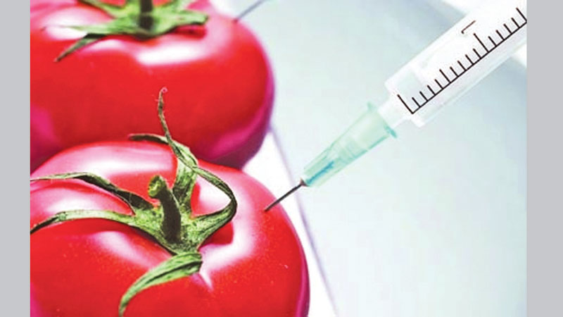
Food adulteration is a major warning to the health which has caused by poisonous chemicals reached an alarming level in the country. The anxiety for the consumers is at top because the top brand superstores bakeries and restaurants are also being penalized by the mobile coats for manufacturing substandard food item. District administration, Rapid Action Battalion (RAB), Directorate of National Consumer Rights Protection and City Corporation are conducting drives and mobile court for food safety. The mobile court drive discovered that many food item like vermicelli, puffed rice, bakery items, butter, sweetmeats and curd were being adulterated by various poisonous chemicals in a routine manner.
Adulterated food has various deadly affects. The National Taskforce on Food Adulteration (NTFS) made by the Government of Bangladesh discovered that adulterated food and beverages cause many fatal diseases including diarrhea, malnutrition and it may cause even death. By eating or drinking these food items, people are to succumb to ultimately death. Because these food causes problem of heart, liver, kidney, bone etc. But the truth is children are more affected than adults and that’s why adulterated food is a major cause of child mortality. Adulterated foods are a serious health hazard and it is a dynamic factor of malnutrition which is truly accepted in the whole world. In Bangladesh, there are lots of unsafe foods consist that is why malnutrition affects here more. A study recently conducted by the Government of Bangladesh shows a very sad picture of child mortality. Pointing the forefinger to the malnutrition as an important cause of child mortality, this report mention that in every 19 children 1 child die before they complete five years.

Topic of the report
A topic must be selected for preparing the report. A proper topic represents what is going to be discussed in the report. The topic assigned is “Health challenges in Bangladesh based on adulterations of food and beverages”.

1.3 Origin of the report
In today’s world academic education is not enough to capable student compete with confidence and achieve his/her goal without having experience of the outside world. The report has given the opportunity to gather knowledge about consumption of adulterated food and beverages which is a tremendous problem to public health in Bangladesh.

1.4 Background of the report
The project completion is an important part of the BBA program to complete the degree and exercise a significant importance. The student work with the project related activities closely. It enables a student to familiar with the practical project activities. It helps a student to develop his analytical skill and scholastic attitude. For the completion of this project, I have worked on the topic-“health challenges in Bangladesh based on food and beverage adulterations. ”

Objective of the Report
- To make concern about food and beverage adulteration
- Collection, analysis and dissemination of information and facts regarding food and beverage adulteration.
- To find out the ways of food adulteration and mitigation measures

1.6 Scope of the report
Food and beverage adulterations related topic was analyzed in detailed for preparing the report. While preparing this report, I had gone through different websites, newspapers, and magazines to collect information about food safety. I had enriched my knowledge about the topic very well.
1.7 Methodology of the report
For smooth and accurate study everyone has to follow some rules and regulations. A systematic procedure from selection of the topic to preparation of the final report is the requirement of this study. For performing the study the data sources were to be identified, collected, classified, analyzed, interpreted and presented in a systematic manner and key points were to be found out. The process of methodology has been given below:
A. Selection of the topic: The topic was assigned by the honorable project supervisor. While assigning the topic important recommendations and suggestions were provided by the faculty to make this report perfect and well organized one.
B. Identifying data sources and data collection: To carry on the study and complete this report essential data sources were identified that will be needed. The study inputs were collected from secondary data sources. These are: journals, reports, internet, newspapers, articles and blogs.
C. Final report preparation: Some corrections were made to present the paper in this form on the basis of the suggestions of faculty.

1.8 Limitations:

Some of the limitations of the report are:
- Deficiencies in Data required for the study.
- Lack of adequate sources prevented verification of information
- Secondary data will be accurate if secondary source is accurate.
- The analysis represented here may differ with opinions of experts in this field.
- Time lacking

PROJECT PART

Challenges in public health
As human rights has interdependence and interrelatedness, the right to safe food means the right to health, life and food. But the fact is human rights for safety food is ignored generally now. As per the news, features and articles circulated in different newspapers in Bangladesh, most of the foods and beverages manufactured or processed are unsafe for human consumption because of making food or drink less pure by adding or mixing another substance to it. Regular intake of an adulterated food can lead to vital health problems like chronic and acute diseases. A recent report by the ‘ Poribesh Bachao Andolan’ discovered that about 7.9 million(79 lakh) people in South Asia die by non-contagious diseases and food adulteration every year which is marked as one of the most vital reasons. The report also presented that our next generation’s mental growth will affected by food and beverage adulterations if this is not prevented immediately. (The Daily Observer, 22 June2014)
It is a massive issue which needs to be discussed in details. In its website, World Health Organization (WHO) has described its anxiety about the food safety issues and their precise possible impact on public health. Many chronic and non-chronic diseases affects because of adulterated foods. There are various diseases like diarrhea, cancer, heart diseases, various diseases and birth defects. There is a discussion below concerning the core food safety issues and their specific potential impact upon public:

Chronic diseases due to food and beverage adulteration
- Asthma
- Chronic fatigue syndrome
- Diabetes mellitus
- Chronic hepatitis
- Cardiovascular diseases: heart failure, ischemic cardiopathy
- Cancer
- Obesity
Adulterated food and beverages consumption may cause different diseases such as:
- Sore throat
- Larynx constriction
- Bronchitis
- Skin infections
- Diarrhea
- Dysentery
- Diabetes
- Allergic reactions
- Hematuria
- Circulatory failure
- Numbness
- Dizziness
- Kidney failure
- Stomach cancer
- Liver cancer
- Nervous disorders
Researchers identified that regular consumption of formalin through food can cause different types of cancers, like lung cancer. People are getting ill and damaging health by regular consumption of adulterated food where children are the worst victims. . During 2005-2009 about 3 million people suffered from diarrhea and 15% of children died in 2011 as reported by the Directorate General of Health Services.

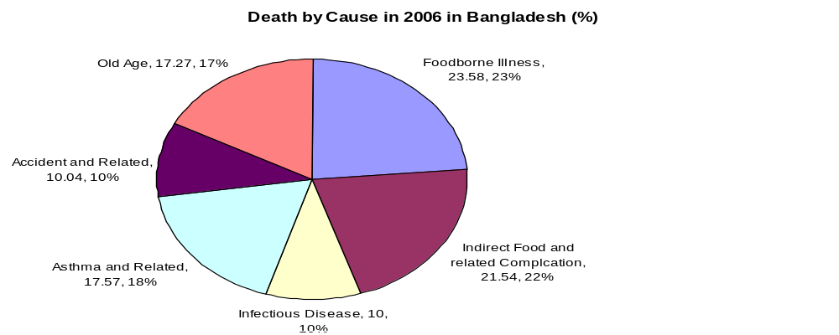
The chief reason for the addition of these adulterants is increasing the profit margin at the cost of the health of the general public or consumers. The long term effects of consumption of adulterated food and beverages are very cruel especially in case of renal failure, liver damage, cancer, heart attack, brain stroke etc. around the year. Heavy metals cause kidney damage, liver damage and increase abnormality among children. Lead, arsenic and chromium affects human body badly. Adulterants reduce the quality of the foods and damage the health of the consumers. Textile dyes cause diarrhea and gastrointestinal problems if taken for few times but if it is taken for long time then it can cause serious health hazards. Fishes and vegetables are adulterated by applying chemicals and other preservatives in order to make them look fresh. For adulterations children health are at high risk. This is hampering their immune system development by not breakdown the toxins and metabolize. Frequently cooking oil is burnt and that’s why this is strictly affecting the digestive system of human body. The general information regarding food risk which is published by WHO reveals that , human exposure to chemicals at toxic levels or nutritional imbalances are suspected to be involved in causing cancer, cardiovascular diseases, kidney and liver dysfunctions, hormonal imbalance, reproductive disorders, birth defects, premature births, immune system suppression, musculoskeletal diseases, impeded nervous and sensory system development, mental health problems, urogenital diseases, old-age dementia and learning disabilities and so on. So, to protect public health the protection of food from these unsafe situation is important. Food and beverage adulteration can make people very sick or even be life threatening. After taking adulterated food people get sick, weak and would have difficulty in working or focused at school. There are some infections make our bodies difficult to take in the nutrients they need to get healthy.
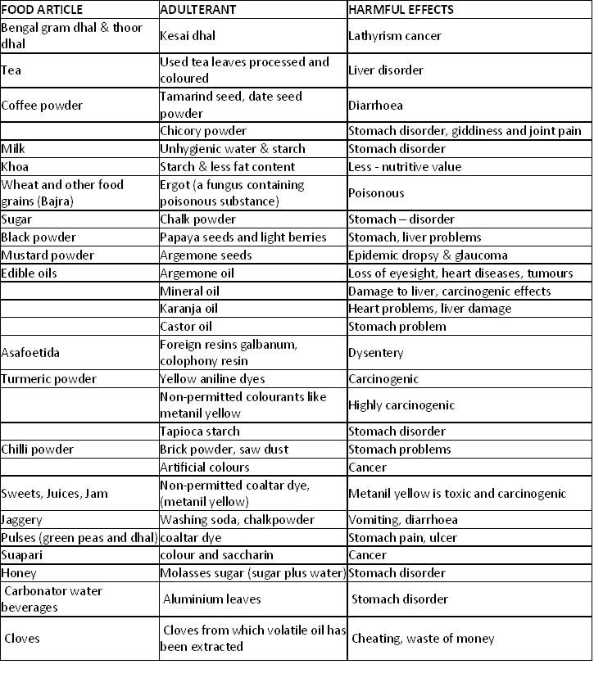

2.2 Types of food adulteration

2.2.1 Unhygienic Food handling practice

In Bangladesh, the food industry unhygienic practices in food handling become a common fact. Limitless restaurants, fast food outlets are cooking, baking and processing foods in extremely unhealthy environments. Unhygienic food is a major reason of diarrhea disease or malnutrition. According to the data of International Centre for Diarrhoea Disease Research (ICDDRB), WHO suggested that in Bangladesh at least 501 people visits hospital every day for diarrhoea diseases that are related to food adulteration. Especially for the last couple of years in Bangladesh, death and attacks from diarrhea has increased alarmingly. The magnitude of the diarrhea diseases is mirrored by the Directorate General of Health Services (DGHS) and ensure that this health problem is caused because of unsafe food and beverages in Bangladesh. The DGHS report reveals that from 2003 to 2009, 17,999,284 people were attacked by diarrhea and among them 4,674 people died, 16 which signifies that in average at least 3,850people die for diarrhea every year. NTFS report also revealed that 5.7 million people become disable due to diarrhea diseases in Bangladesh every year. This awful offence committed by the greedy businessman. Moreover, export services in Bangladesh is getting hampered because of unhealthy processing of food and beverages. For example, European Union banned importing shrimp from Bangladesh in 1997 due to the deficiency of preserving accurate hygiene criteria in the shrimp processing plants which is a bad news for the export sector of our country.
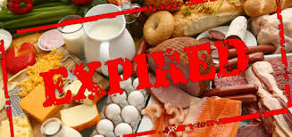

2.2.2 Formalin and DDT19 using in foodstuffs: In Bangladesh using formalin in foodstuffs is a critical problem and it is happening rapidly here. To keep fruits, fishes and vegetables fresh marketers use formalin and sell those openly. This extensive use of formalin in food and beverages are too much harmful for human health. Even in hotels and hotels, stale and rotten foods are mixed with fresh food and served to the customers. Scientific studies shows that formalin can cause cancer to the human body. Using DDT in foods is prohibited in 49 countries and restricted in 23 countries around the world. Like other countries, Bangladesh also banned DDT, but unfortunately its use remains out of control. DDT is used in dried fish processing which is locally called ‘sutki’. It can generate to human body through breast milk by saving its chemical features irrespective of the environmental conditions. DDT can cause several types of cancers like: pancreatic cancer, breast cancer and liver cancer. Fishes and vegetables are adulterated by applying chemicals and other preservatives in order to look them fresh. It has also some bad effects on different types of reproductive issues including unproductiveness; abortion, early menopause, weakens semen, birth defects and low weight birth of children. WHO reveals that almost 150,000 children die before fifth weeks of their lives because of food adulteration. WHO stressed about the frightening child mortality rate in Bangladesh. DDT increases neurological illness on human health like having trembling, seizures, nausea and dizziness etc.

2.2. 3. Using Toxic Colors in Food
Textile dyes are used to color different foods in Bangladesh though it is called unauthorized food colors. Textile colors which is not eatable and harmful for health is being used in different sweets. Not only in sweets, textile color is applied in some cultural foods named beguni, peaju, chop etc. This harmful colors is used in food to make it look like appealing and delicious but the truth is this is harmful to human body. In fact, all kinds of foods and food articles are adulterated by dishonest and greedy businessmen for a quick and larger profit. Research shows that these colors are poisonous to eat and can cause allergies, cancer, asthmas, indigestions, sleeping disorders, diarrhoea, vomiting, heart diseases, several neurological diseases and many more.
2.2.4. Examples of Food Adulterations:
In Bangladesh many types of adulterated food and beverages are made. There are some notable adulterations can be given below:
- The puffed rice which is known as ‘moori’ is impure by using urea fertilizer with it. Urea makes ‘moori’ whiter and bigger in size. But the fact is that it is unsafe for human health and can cause ulcers, even cancers. A recent doctoral research conducted by Al-Rmalli on Bangladeshi food discovered that, the level of cadmium in the puffed rice is twice than the uncooked rice. The researcher suggested that it is the result of using urea in the production of puffed rice. Al-Rmalli mentioned ‘contact to cadmium is linked with kidney disease and over 20 million people in Bangladesh suffer from chronic kidney disease.’

- Rice is adulterated by mixing stone particles, urea and artificial colors.

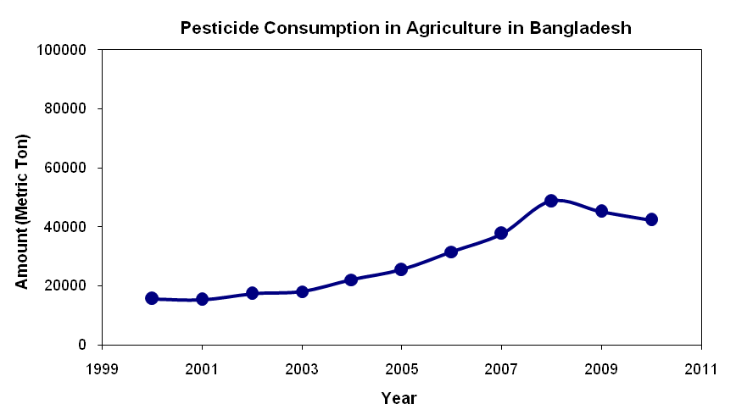
- Ghee is made from pure milk and it is a popular food item in Bangladesh. It is widely used in Bangladeshi cuisine. It is also used to produce various desserts. Ghee is being adulterated in many ways. It is made by rotten milk, palm oil, soya bean, animal or vegetable fat, potato paste and with artificial color flavors instead of milk which are impure.
- Fruits are adulterated with ethephon, formalin and calcium carbide. To make fruits attractive greedy businessman use injections of colors and sweeteners.
- Fish is adulterated with formalin and vegetables are adulterated by putting chemicals on them and other preservatives in order to look them fresh. Formalin is an aqueous solution of the chemical compound formaldehyde. Fish is pre-treated with formalin but these are at first kept in ice. Then formalin is used to keep the fish fresh for long.
- Ammonia is very dangerous for human health and consumption. It is generally used in textile industry and fertilizer. But many bakeries are using it to make the biscuits crispy.
- Mineral oil which is adulterated by adding edible oil and fats which can cause cancer.
- Turmeric powder and spices is being adulterated with mixing lead chromate with these which can cause anaemia, paralysis, brain damage and abortions.
- Lead poisoning due to lead adding into water and also to natural and processed foods. It may cause foot drop, insomnia, constipation, mental retardation and anaemia. Cobalt also added to water and liquors and can cause cardiac damage dangerously. Tin made with copper and zinc can cause colic, vomiting and diarrhoea.
- Mercury in mercury fungicide treated grains or mercury contaminated fish may cause brain damage, paralysis and death. Non-permitted color or permitted food color like metanil yellow, beyond the safe limit in colored food can cause allergies, hyperactivity, liver damage, infertility, anaemia, cancer and also birth defects.
- Milk is being adulterated with mixing dirty water with it, mixing wheat to make white, preservatives, removing fat from it, washing powder as a thickening agent and sorbitol. Melamine and banned pesticides are mix up with powder milk.
- Meat is adulterated by putting color to it and preservatives. In restaurants, super shops and markets most of the time mobile court found rotten meat which is prepared and ready to serve for the customers.
- Chili powder is contaminated with red color and brick dust.
- Black pepper is contaminated with papaya seeds.
- Honey is being adulterated with sugar syrup which is colored.

3. Food safety laws and regulations in Bangladesh
There are laws and regulations in Bangladesh to maintain proper food safety. From manufacturing to sale these regulations monitors. Different ministries and their concerned departments shared responsibility is enforcement of food laws, rules and regulations. Food laboratories of government in Bangladesh examine food samples several times. That is why the Consumer Right Protection Ordinance 2008 was passed in the parliament on 1 April 2009.

- Fruits are adulterated
- with calcium carbide, ethephon, formalin, injections of
- colors and sweeteners.
- Fruits are adulterated
- with calcium carbide, ethephon, formalin, injections of
- colors and sweetener
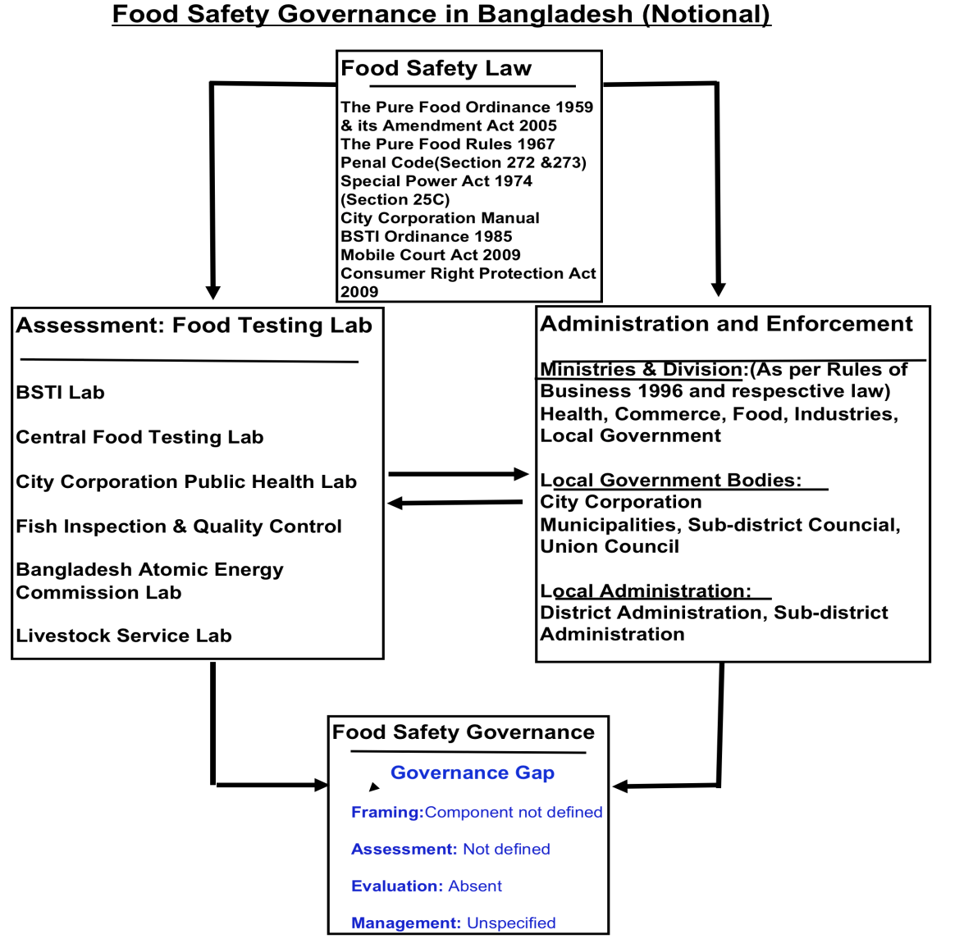

Food safety laws and regulations and food standards in Bangladesh
- The Bangladesh Pure Food Ordinance, 1959 (Bangladesh Ordinance No. LXVIII of 1959)
- The Bangladesh Pure Food (Amendment) Act, 2005
- The Bangladesh Pure Food Rules, 1967
- Bangladesh Standards and Testing Institution Ordinance, 1985 (XXXVII of 1985)
- Bangladesh Standards and Testing Institution (Amendment) Act, 2003
- The Food Grain Supply (Prevention of Prejudicial Activity) Ordinance, 1956
- The Essential Commodity Act, 1990
- The Iodine Deficiency Disorder Prevention Act, 1989
- The Animals Slaughter (Restriction) and Meat Control (Amendment) Ordinance, 1983
- Fish and Fish Products (Inspection and Quality Control) Ordinance, 1983
- Fish and Fish Products (Inspection and Quality Control) Rules, 1997
- The Radiation Protection Act, 1987
- Destructive Insects and Pests Rules, 1966 (Plant Quarantine) amended up to 1989
- The Pesticide Ordinance, 1971 and The Pesticide Rules, 1985
- Agricultural Produce Markets Regulation Act, 1964 (revised in 1985)
- Fish Protection & Conservation Act, 1950 (latest amendment in 1995)
- Marine Fisheries Ordinance, 1983 and Marine Fisheries Rules, 1983
- The Special Powers Act, 1974
- Agricultural Products Market Act, 1950 (revised in 1985)

Food safety laws and regulations will not be discussed here. In the report it will not discussed because it is saved for future endeavor. This huge issue have some part of legislation. This legislation are hardly used in statutory laws. Limited jurisdictions are covering some part. The limitation of current study are short therefore the acts that are commonly applied for safe food will be discussed in short. Different ministries and their subordinate bodies implement laws regarding food safety. The related key bodies are the Parliament, Rural Development and Co-operatives, Ministry of Industry, Ministry of Fisheries and Livestock, Ministry of Commerce, Ministry of Establishment, Ministry of agriculture , Ministry of Local Government and Ministry of Home Affairs.
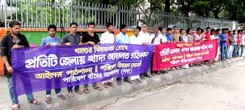

To check food and beverage adulteration and ensure safe food, the Government should take enough steps. This steps needs good synchronization between law administration and other concerned agencies. Ideal punishment must be included in the food act. There are different laws and regulations to control food and beverages adulteration in Bangladesh such Pure Food Ordinance, 1959 and Pure Food Rules, 1967; The Animals Slaughter (Restriction) and Meat Control (Amendment) Ordinance,1983; Bangladesh Standard and Testing Institution Ordinance 1985 (amended as Bangladesh Standard and Testing Institution Amendment Act 2003); Destructive Insects and Pests Rules (Plant Quarantine) 1966, amended up to 1989; Agricultural Produce Market Act 1964 (revised in 1985); Fish Protection and Conservation Act, 1950 (latest amendment in 1995); Marine Fisheries Ordinance 1983 and Rules 1983; Fish and Fish Products (Inspection and Quality Control Ordinance, 1983; Fish Products (Inspection and Quality Control) Rules 1997; The Essential Commodity Act 1957,58,64; The Food or Special Courts Act 1956; The Food Grain Supply (Prevention of Prejudicial Activity ) Ordinance 1956; The Pesticides Ordinance 1971 and The Pesticide Rules- 1985. Bangladesh Food and Nutrition Policy 1997 and National Policy of Nutrition 1997; Bangladesh Food Policy1998; Comprehensive Food security Policy 2001 and New National Food Policy 2006; National Agriculture Policy 1999; Bangladesh Health Policy 2002. Regarding food adulteration, Bangladesh Standards and Testing Institutions (BSTI) provide maximum three years imprisonment or Tk. 2 lakh fine or both as punishment from the existing act. But this is not adequate to stop food and beverage adulteration. Food security and safe food standards must be maintained for import and export food and beverages and the Government must implement all international agreements and protocols under this. (Dhaka Tribune, 15 March 2014). Bangladesh Government permitted the Formalin control Act 2014 on June 30 of 2014 with provision for fine of Tk. 20 lakh or maximum punishment which is lifetime jail or both to stop misusing of formalin. For traders of formalin, it is important to have license for all purpose regarding import, sell, and stock and distribute formalin according to the law. In the matter of breach of the terms of formalin license the law confirms maximum 7 years imprisonment punishment or 5 lakh taka fine or both. In case of storing formalin illegally at houses, offices, business establishments, and in vehicles are also have punishment according to law. Providing ingredients for producing formalin is also prohibited in the law and there is a provision of maximum 10 years imprisonment or Tk. 20 lakh fine. If a case is filed under formalin related act for a lawbreaker then police can arrest him without any court permission. Immediate implementation can be done by using mobile court by the authorities. Moreover, committees are formed to supervise the implementation of formalin act in each upozilla and district basis. (The Daily Star, 1 July 2015). Government is improving the Safe Food Act continuously to bring change to the situation.
4. Problems in the Legal and Monitoring Framework
Food and beverage adulteration is increasing day by day because the whole food industry is avoiding the rules and regulations willingly. This is happening and the reasons are: improper monitoring, expensive food ingredients, limited information about consumer, educational influence and cultural factors etc. Safe food factor is getting ignored in Bangladesh and it is affecting people’s health negatively. There are many reasons behind the food safety regulatory fall which are affecting the whole system and these reasons will be discussed below:
- Law diversity
Bangladesh food safety regulations contains a good quantity of law which is significant. Because food and beverage is a single factor but diversity of laws create misinterpretation among manufacturers, retailers, processors and other food industry related people. Even the administration do not understand properly that which law suits for particular safety food issue. In United Kingdom, a study reveals that 62% of small food business proprietors are not able to understand that which law deals with their business. But the truth is that most of the food industry related people do not maintain the laws cause they are ignoring those willingly. For that reason, Food safety laws and regulation should organize the full act properly so that people can understand which law suits which factors.
- Synchronization lacking and Partly covering of Governing bodies
It is revealed by the NTFS that Cabinet is the universal authority of synchronizing for every issues in Bangladesh. But the fact is that, the cabinet has too much work to do or they are overloaded with food safety issues activities. So they are not able to coordinate with the activities proficiently. After realizing this issue the PFO form a coordinating body in 2005 which is called National Food Safety Advisory Council. Another problem is that NFSAC have several weakness like inadequate working people or laborers and it is a dependent body. These problems have made it useless. After considering the problematic situation it is being discussed that an independent synchronizing authority must be set up like: USA, Australia, UK which can solve this problem.
- Clearness, Independence and Administration Matters
Generally it is appreciated that an effective and appropriate regulatory outline should be focus on accountability and transparency. Clearness in monitoring involves the total of a country’s governance infrastructure. Both externally and internally a regulatory body should be clear. Regrettably the government officials are also burdened with many members.
Apart from above, FSRRB regulatory bodies are dreadfully rigid. This inflexibility has made the Consumer Protection Law This useless bureaucracy has ultimately made such an important consumer protection law useless.
- Lack of punishments
Lack of punishments is a vital reason of legal and monitoring framework. Food and beverage adulteration scenario is getting worse day by day and that’s why today question arises whether the sanctions given in the statutes are satisfactory or not. But the SPA 1974 provides strict sanctions which are unlike the negligible penalties, for example lifetime jail and death punishments for these adulteration. This kind of punishment is not agreeable by all because it is too much brutal as a punishment for such crime. Death penalty is very vicious for any crime. Use of death penalty must be considered from the human rights point of view as the Second Optional Protocol to the International Covenant on Civil and Political Rights, recommended the elimination of death penalty from the civilized world.
- Implementation Difficulties
Penalties are the way of to show statutes implementation in Bangladesh. But in case of implementation mechanism no important actions are included which influences the whole act. Training caution notice, improvement notice etc. are involved in this part. Moreover, the administrative implementation mechanism is unstructured in Bangladesh. Regulations don’t have any clear way to identify non-compliance problem and no clear instructions of inspection policies. The important fact to set a strong implementation regulation is outlining clear enforcement approaches. It will help the authority to identify the non- compliance and take strong action against the offence. In Bangladesh, there is no specific authority or any legal officer who is extremely responsible to his job. Generally, the MOHFW is legally liable for the food safety throughout Bangladesh and the laws are imposed by Sanitary Inspector (SIs). But the fact is SIs has unlimited work to do and food safety is a minor part of their duties. On the other hand, SIs or any other inspectors under any regulatory body are for food safety cannot penalize the culprits except with the assist of executive magistrates, who work under the MOE. Moreover, executive magistrates are rarely interested in doing this due to their busy work schedule that is filled up with lots of administrative duties. Therefore not only are the enforcement actions but are the inspection activities to ensure food safety are consistently hampered too.

5. Recommendation
Food and beverage adulteration is an important matter to concern around the world. The concerned matter is how to handle this problem. Food Safety and Standard Authority in progressed functioning I in 2011 and Food and Drug Administration (FDA) which established in the United states in 1906 with expert workforces with the ability of execution of laws and understanding of its complications from contextual and technical knowledge. There are three major concerns to respond the food adulteration problem and these are: human rights question, precise crime recognition and also punishments level. Bangladesh Standard and Testing Institute (BSTI) were established in 1985 and consumer Right Act, 2009 was accepted by the parliament with the application of a department under the direction of a council headed by the ministry of commerce. Agencies which implement laws sometimes act strictly by hold strong attention to punish the cheats for their offence. They want to do lab tests and fight to implement the laws. But most of the time they cannot complete their task because of less workforce. In the early hours in June 2014, the Dhaka Metropolitan Police started an anti-formula drive in and around the capital to examine formalin in seasonal fruits and they found tons of fruits which are adulterated by chemical, formalin and colors. . DMP destroyed those tons of fruits. During Ramadan these activities are ongoing. But the matter of regret is every day food and beverage adulteration had found. Unfortunately the consumers cannot even depend on the superstores and top eateries or restaurants as they are also adulterating foods and beverages only to make some quick books. It is possible because unlike any other country of the world, it is very simple to open a restaurant in Bangladesh. The authorities alarmed should take strict action against the sinful businesses which are posing a dangerous threat to the public health.
Global Governance Food Safety model should be used to stop food and beverage adulteration that is given below:

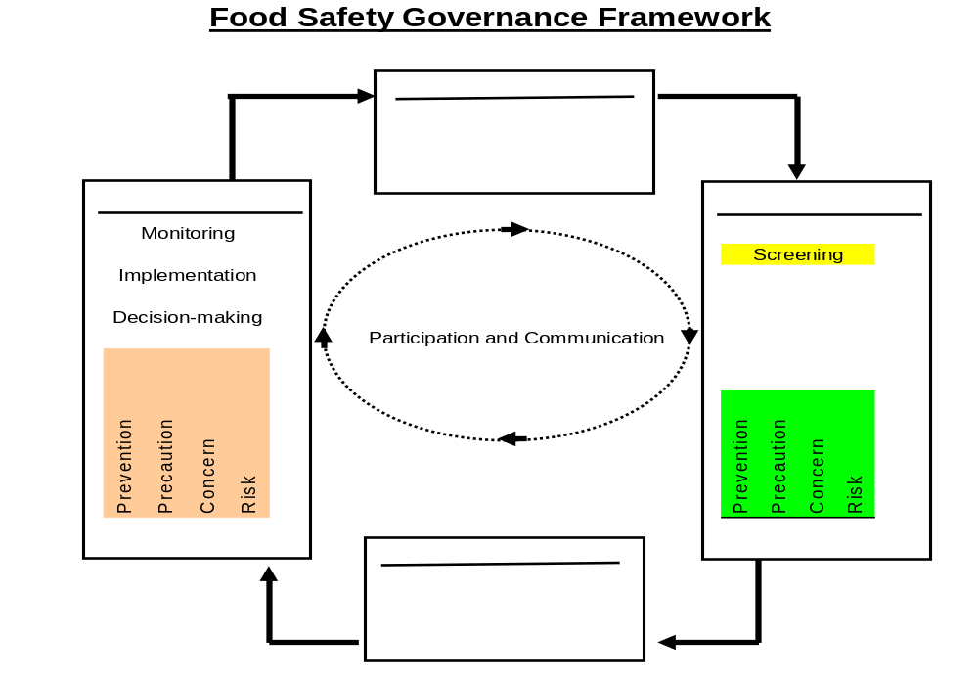

Formalin checking operation must be conducted properly by the joint team of mobile court and BSTI. Businessmen who adulterated food items, fruits and others can use more than 20 different chemicals to make the food poisonous. The dishonest people find their profit in adulteration. This type of activities can only be stop by strict monitoring of regulatory related agencies. FAO food safety project found gaps, intersections or overlaps, strengths and imperfections in the ongoing food inspection and implementation systems and recommended different ways to make strong the food inspection and enforcement services. It will be only for food products which is locally imported and produced. In reducing food adulteration there are many suggestions that have already been emerged. To stop food and beverage adulteration following efforts can be helpful:

- Creating mass awareness among people about the deadly effect of food and beverage adulteration.
- As per international guidance, pesticide must be used in a low amount and other toxicant remains in food and beverage items.
- Zone based agricultural department can provide nontoxic chemicals and they can also train the farmers that how to use alternatives.
- Government can declare reward if any one provide information about food and beverage adulteration and concerns others.
- With skilled manpower and suitable analytical tools, strengthening food inspection service as well as proper enforcement.
- If any adulterants found in any food products then consumer must play active role to get his rights against what hazards happen to him.
- Involvement of health related scientists to check the marketed products whether it is safe or not.
- All international agreements must ensure food items safety.

6. Limitations
This report has a number of limitations. A more all-inclusive scenario of adulteration could not be assessed because the problem is sensitive enough. Another reason is food testing reports information are not easily available. Though there are several laboratories for food testing, results were checked from a single laboratory. It is because of availability and time limits. On the other hand, a common thinking is that low economic group people are less concern about their food safety or good quality food. They don’t think about consumption of good quality food because they struggle daily for their live. Another problem is most of the consumers buy their daily food items from local marketplace on everyday basis. At last, more accurate information was not possible to collect due to time constraints.
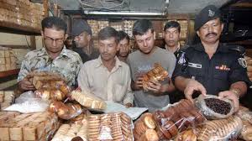

7. Conclusions
Food and beverage adulteration is increasing day by day and food industry related people are taking it easily. This is happening because safe food act are being ignored by them and laws and regulations are not well maintained in Bangladesh. So, the situation is getting uncontrollable. Different steps should be taken to stop or prevent excessive use of various colors, chemicals and dyes in food. But the fact is that, most of the consumers don’t have knowledge, attitude, view and practices which are relevant to food and beverage adulteration. Mass media can play a decisive role in case of new consumer protection law, different food adulteration related laws, and different aspects of food adulteration. Awareness can be built strongly among consumers for food adulteration by effective activities of mobile magistrate court. They can work together with media so that the results get announced properly. Strict enforcement of the approaching unified food law ‘Safe Food Act 2013’by the government would considerably decrease food and beverage adulteration in our country. Short term and long term opposite effects on health must be understand for creating more awareness. Adulterated food also effects nutrition and intellectual performance. For these reason, Epidemiologic and toxicologic studies helps better to evaluate risk if taking artificial food colors and chemicals which are used in food items. More studies on epigenetic should also be performed to examine the association of food and beverage adulteration and different types of cancer.
To ensure safe food for consumers, a useful food safety regulatory framework is very important for our country. In this report it is discussed that food and beverage adulteration is now a serious public health issue in Bangladesh because of ignorance. However the situation considered current matters and identified that Bangladesh Food Safety Rule needs an up to date regulation which will be simple and single. This regulations will not be dependent and has most food safety regulatory body to complete all type of coordination. Also the new regulatory will have transparency and responsibility which will be permitted from any type of governmental or administrative difficulties. Finally, an effective administrative implementation system need to be prepare on the basis of influential or powerful tools and laws should be modified by providing the difficult punishments or penalties for the wrongdoers.

References:
- http://bea-bd.org/site/images/pdf/080.pdf
- https://www.thedailystar.net/news-detail-198096
- http://www.theindependentbd.com/arcprint/details/75534/2017-01-07
- http://www.lawjournalbd.com/2015/06/food-adulteration-the-bangladesh-paradox-3/

