A PROJECT REPORT ON


An Analysis on Human Resource (HR) Operations of DBBL and UCBL

25th August 2019
UNITED INTERNATIONAL UNIVERSITY
DHAKA, BANGLADESH
A Project Report On
An Analysis on Human Resource (HR) Policies and Procedures of DBBL and UCBL

SUPERVISED BY
Ishrat Sultana
Assistant Professor,
School of Business and Economics
United International University

SUBMITTED BY
Supriya Rani Das
ID: 111 152 219
BBA Program
United International University
UNITED INTERNATIONAL UNIVERSITY

Letter of Transmittal

To,
Ishrat Sultana
Assistant Professor,
School of Business and Economics
United International University
Subject: Submission of Project report.
Dear Madam,
You will be glad to hear that I have recently prepared my project report as it is a pre-requirement of achieving the BBA degree from United International University. According to our previous discussion, I have selected the report title “An Analysis on Human Resource (HR) Policies and Procedures of DBBL and UCBL”.
As we know, any organization that deals with people require good human resource management and effective work. The banking sector has always been and will remain a "popular affair". The efficient and effective management of human resources in the organization makes it a success. For the banking sector, the importance of human resource management has increased due to the nature of the banking sector, which is mainly based on services. The management of people within the organization and the management of financial and economic risks at a broader level are the most important challenges that the banking sector has to face in a given period. An efficient and skilled workforce in the industry can only manage the financial risks that banks must take on a regular basis. The human resources department has the responsibility to find such talented staff and put them in the right positions in the banks.
However, the report questionnaire and outline that suggested me to prepare for the report proved very useful for me while preparing the report. I want to mention that all the information of this study are true and relevant. It will be kind of you if you accept my project report and oblige thereby.
Sincerely yours,
Supriya Rani Das
ID: 111 152 219
BBA Program
United International University
Preface
First of all, I want to thank my Almighty and my parents who supported me to be in the position where I’m standing right now. Without their help and effort, it could not be possible for me to complete these 4 years long BBA program from United International University.
Secondly, I would like to share my gratitude and respect to my honorable project supervisor Ishrat Sultana, Assistant Professor, School of Business and Economics, United International University for sharing his valuable time and effort to make my project report a standard one. She suggested me to create a questionnaire so that it could be easy for me to collect HR-related queries from the mentioned banks’ HR depts. The report outline, I had received from her, also helped me to understand how the steps of a project report should be.
Thirdly, I want to thank my respected senior Md. Sazzad Amin, Area Relationship Officer, Dutch Bangla Bank Limited and Rizwana Sultana, Manager of HRD, United Commercial Bank for sharing their valuable time with me. I have received various information from them about their banks and also received their answer through my questionnaire what I had sent them through the online platform LinkedIn.
Finally, I want to thank all my friends and seniors who continuously helped to manage and allocate information of HR department so that my report could touch the maximum standard.
Summary
This study examines an analysis of the human resource management policies of two famous commercial banks in Bangladesh. The first one is the Dutch Bangla Bank Limited (DBBL) and the second is United Commercial Bank Limited UCB/ UCBL). It proposes recommendations to improve these two commercial banks so that the banks can improve their human resources policy. Furthermore, the study evaluates and compares existing human resource management activities, such as hiring and selecting employees, job analysis planning methods, performance assessment, compensation and benefits, training and education programs. In this study, a survey questionnaire was prepared that contain 16 questions on five functions of human resource management policies and information was collected on these two banks. Human resources policies are described in the analysis section and the comparison of these human resources policies is presented in the results section of this report. The results focused on significant situations that are essential for employees and for the growth and development of the organization. Therefore, the recommendation will support the correct participation of the human resources management system in the banking sector of Bangladesh.

Table of Contents
Chapter One: Introduction
1.1 Origin of the report 2
1.2 Rationale of the report 2
1.3 Methodologies of the report 2
1.3.1 Methods of data collection: 3
1.4 Objectives of the report 3
1.5 Limitations 4

Chapter Two: Organizational Profile
2.1 Company Profile of DBBL 6
2.1.2 Vision 7
2.1.3 Core Values 7
2.2 Products and services of DBBL 8
2.3 Organizational organogram 9
2.4 Company Profile of UCBL 9
2.4.1 Mission 10
2.4.2 Vision 10
2.4.3 Core Values 10
2.5 Products and services of UCBL 11
2.6 Organizational organogram 12

Chapter Three: Literature Review
3.1 Concepts of Human Resource Management 14
3.2 Objectives of Human Resource Management policy 14
1. Functional Purpose: 15
2. Organizational Objectives: 15
3. Personal Goals: 15
4. Social Objectives: 15
3.2 Necessities of Human Resource Policy 16
3.2 Functions of Human Resource Management 17

Chapter Four: The HRM policies of DBBL & UCB Bank
4.1 The HRM Policies of Dutch Bangla Bank Limited 22
4.1.1 Human Resource Planning policies 22
4.1.2 Recruitment & Selection policies 22
4.1.3 Training policies 23
4.1.4 Performance appraisal policies 24
4.1.5 Compensation policies 26
4.2 The HRM policies of United Commercial Bank Limited 27
4.2.1 Human Resource Planning policies 27
4.2.1 Recruitment & Selection policies 27
4.2.3 Training policies 29
4.2.4 Performance appraisal policies 31
4.2.5 Compensation policies 32

Chapter Five: HR policies comparison
5.1 Comparison between the HR policies 35

Chapter Six: Recommendations and Conclusion
6.1 Recommendations 39
6.2 Conclusion 41
Reference 42
Appendix 43

Chapter one: Introduction of the Study

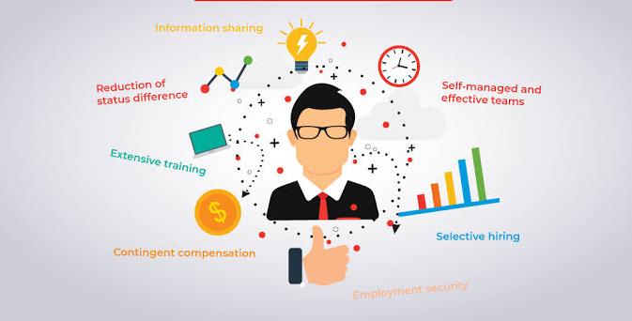

Origin of the report
Submission of internship or project report is a pre-requirement of attaining the BBA degree from United International University Bangladesh. Students who choose project program have to mention it at the starting of their end semester. They have to observe an organization of industry for three months to prepare a project report on their desired topic.
In accordance with my project supervisors’ suggestion, the topic I had chosen is “An Analysis on Human Resource Policies and Procedures of DBBL and UCBL”. The topic is very suitable for me as it is co-related to my field of study. Human Resource Management (HRM) is responsible for the human size of protected areas. In today's world, HR policies play a very important role to achieve its strategic direction. This study is an extension of a questionnaire to examine the human resource management practices followed by two eminent banks in the banking sector for the policies and procedures of the two banks. However, I have included almost all possible parameters for analyzing the policies and procedures for managing human resources of Dutch Bangla Bank Limited and United Commercial Bank Limited.

  - Rationale of the report
The commercial banks of the Bangladesh is going to face intolerably competitive market in their business in the upcoming days with the financial cost in banking. Human Resources Management is the management of people working in an organization. They can be directors, employees, project managers, field agents, coordinators. This is a "human business". "Just like a bank's funds for a project, the bank has to manage these" human resources "or" we have to use people ". It's not enough of a dedicated team for a single organization. It is fundamentally believed that the organization cannot achieve its goals and objectives that it is properly managed, motivated and performing well. Process of management, motivation, and creation of employees with systems and construction rules. These systems are covered by human resources management.

Methodologies of the report
The methodology identifies the methods that will be used and describes how research should be conducted. These methods define the means or methods of data collection or, sometimes, how to calculate a specific result. The methodology does not define specific methods, although much attention is paid to the nature and types of processes to follow in a particular procedure or to achieve an objective. The methodologies that are used in the report are shared below:

1.3.1 Methods of data collection:
An important aspect of any type of research study is data collection. Erroneous data collection can affect the results of a study and ultimately lead to invalid results. The methods of data collection to determine the effect differ in continuity. At one end of this continuum, there is a quantitative method and on the other end, there is a qualitative method of data collection. The data collection process of this report can be separated into two parts:
- Primary data:
- Face to face communication with few banks employees and staffs.
- Through informal messages to bank employees via LinkedIn.
- From the annual report of the bank.
- Through a survey questionnaire that is added in the Appendix section.

- Secondary data:
- Through online books and articles of several publishers.
- Through brochures and leaflets of both banks.
- From the online websites of the bank and other several blogs.
1.3.2 Data analysis process:
Information are collected through a questionnaire based on the Human Resource Management functions to collect the HR operations of DBBL and UCBL. After collecting the information from few personnel of each banks, the information are shared in the exploratory and qualitative way. All the data are analyzed and shared in the study through using MS Word and MS Excel.

Objectives of the report
The objectives are the actual purpose for why the report is prepared for in brief. The objectives of this report can be separated into two parts:
- Primary Objectives: The preliminary purpose of preparing the report is to achieve the BBA degree from United International University as it is a pre-requirement.
- Specific Objectives: The specific objectives are listed below,
- To analyze the Dutch Bangla Bank Limited and United Commercial Banks Limited.
- To prepare a questionnaire to find-out the HR operations of the organizations.
- To analyze the HR operation of both banks.
- To share few recommendations based on the analysis of HR operations.

Limitations
While preparing the questionnaire and the report, I have to pass through several difficulties that have various impact on this report. The limitations are listed below:
- The report was made in short period time as the project program was only three months of period.
- While collecting information through questionnaire, several questions were left black by the employees and staffs because they were unwilling to answer that questions. It was difficult to understand which one they don’t want to reply and which one their bank is not occupying.
- There were several confidential information which are requested not to share publicly by both bank.

Chapter Two: Organizational Overview



2.1 Company Profile of DBBL
The Dutch Bangla Bank was the first bank in Bangladesh to be fully automated. The complete automation was completed in 2003 and creates and inaugurates plastic money for the Bangladeshi masses. DBBL shares proved the highest share price on the Dhaka Stock Exchange in 2008. DBBL also operates the largest and largest fleet of ATM's in the country and has significantly reduced costs and fees for consumers of 80 %. Most local banks have joined the Dutch banking setup and framework of Bangla Bank Limited, instead of pursuing theirs. DBBL has been stabilized under the 1991 Banking Companies Act. The Bangladesh Companies Act of 1994 is the overarching and overarching goal of transmitting all kinds of banking activities or operations in Bangladesh. In June 1996, DBBL began its formal activities or functions in the banking sector. The bank is the most widely recognized for its donations to social causes and its investment. The bank also launched a co-branded ATM in Bangladesh, where it would provide free ATMs and networking at its branches. In 2010, DBBL introduced the "Fast Track" in the country, which is the first of its kind in the country. It's like a supermini branch.
DBBL is also well received by Internet Payment Gateway to facilitate electronic commerce in Bangladesh. Any visa holder/master (foreign/local) can use their card to pay DBBL e-merchants for their purchases of goods and services. DBBL also provides another whip hand, namely mobile banking solutions and provisions. It is very convenient and applicable to their customers. And this bank is the first to introduce the mobile banking service to enable poor people in remote areas to benefit from fast and efficient bank service. DBBL is the first runner among them. The bank operates its new innovation and innovative banking service through mobile phone operator Bangla link & City and manages its official agents throughout the country.

2.1.1 Mission
The DBBL is an engineering company that develops entrepreneurship and creativity in the areas of social responsibility. "BENEFIT ONLY" is not at the center of the bank's activities; because "man does not only live only from the brain and butter."

2.1.2 Vision
"Become a leading banking institution and play a key role in the development of the country"
DBBL dreams of a better Bangladesh, where music and entertainment, art and letters, a clean and free environment, health and hygiene, science and education, sports and athletics, it is worth experiencing the pollution and, above all, a society based on morality and about ethics. The essence and ethics of DBBL are based on a cosmos of creativity and the wonderful magic of a fascinating life full of elements of life and adventure that contribute to human development.

2.1.3 Core Values
DBBL has faith in its uncompromising commitment to meet the needs and satisfaction of its customers and become their first choice in the banking sector. Inspired by its esteemed collective clientele, Dutch-Bangla Bank intends to pave the way for a new banking era that defends and embodies its famous brands "Your Trusted Partner".
The other core Values of DBBL are:

2.2 Products and services of DBBL
The products and services Dutch Bangla Bank is providing are mentioning through a chart below:

2.3 Organizational organogram
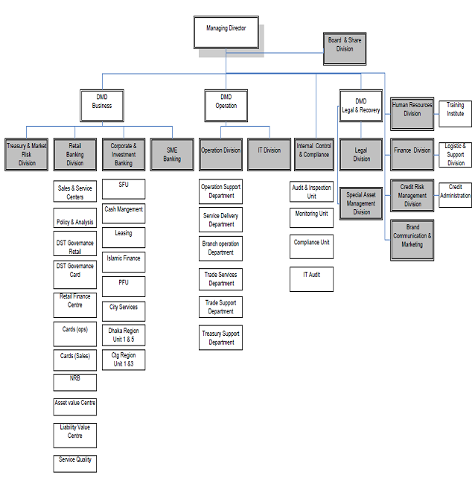

2.4 Company Profile of UCBL
In the early 1980s, some industry personalities and companies from around Bangladesh met to create a commercial bank. The result is one of the first generation private sector banks in the country. Therefore, United Commercial Bank Limited (UCBL) became a reality and the GOB was kind enough to participate as a shareholder. UCBL began operating as a commercial bank in 1983.
UCBL is committed to the sustainable development of Bangladesh. Visionary decision-makers and a dynamic management team bring UCBL to its goal. It has created a clear difference from the competition with its fast, intuitive and personalized services for its customers. World-class modern banks are available here in Bangladesh from UCBL.

2.4.1 Mission
The mission statement of the UCB bank is to offer financial solutions that create, manage, and grow the customers 'resources while improving the quality of Bangladeshi customers' lives.

2.4.2 Vision
The vision of the UCB bank is to be the preferred bank for the Bangladeshi customers, shareholders, and employees, contributing to the national economy with maximum profitability of its shareholders without compromising any social commitment.

2.4.3 Core Values
The core values of UCB banks are:

2.5 Products and services of UCBL

2.6 Organizational organogram

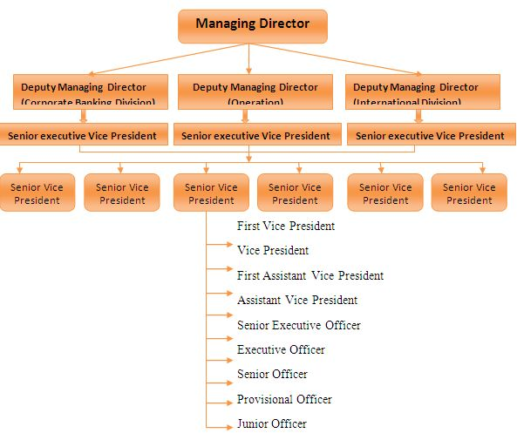

Chapter Three: Literature Review

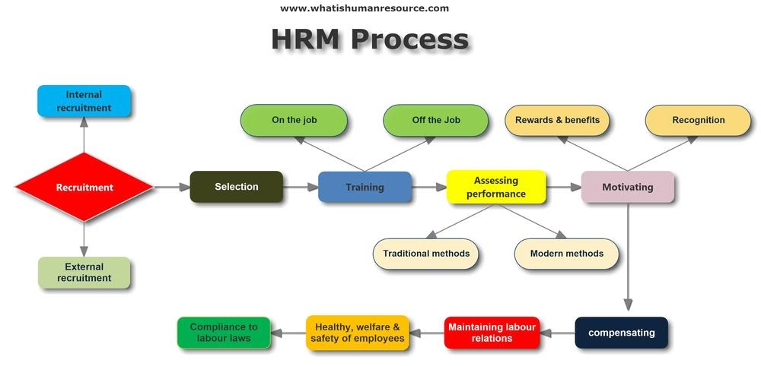

3.1 Concepts of Human Resource Management

Human resources management is often called human resources (HR) or Human resource policy and all these means to recruit, hire, distribute and manage organizational personnel. The human resources department of an organization typically creates, applies and monitors employee policies and how they use the term human resources related to employees, initially used in the early 1900s, and then describe the people who work on behalf of the entire organization. To elaborate on the concepts understanding, human resource management is a strategic approach to managing a business or employee organization effectively in order to gain a competitive advantage of the business. It is designed to optimize employees' performance to meet the employer's strategic objectives. Human resource management is primarily about the management of staff within the organization, with particular emphasis on strategy and management. The Human Resources Department oversees benefits management such as employee recruitment design, employee benefits, training and development, compensation and benefits management and evaluation process. Human resources also face a balance between organizational change and industrial relations or organizational practices and collective bargaining and government laws.
Human resource management is actually a type of employee management system that values ​​all the employees of an organization. In this case, workers are sometimes referred to as human capital. Like other corporate resources, the goal is to effectively benefit employees, reduce risks and maximize return on investment (ROI).
Human Capital Management (HCM) is a modern term used more than the term "HRM" in human resource technology, which is widely used by medium and large companies and other software companies to manage many activities of human resources.

3.2 Objectives of Human Resource Management policy
Several objectives Human resource management has to meet at a same time. These objectives are described below in detail.

The goals of human resource management can be divided into four categories:

Functional Purpose:
A guideline used to ensure that human resources are functioning properly throughout the organization. This ensures that all human resources are allocated to their full potential in the organization.

Organizational Objectives:
Measures taken to ensure the effectiveness of the organization. These include hiring, training, the right number of staff for a specific job or maintaining a high retention rate.

Personal Goals:
The resources used to support each employee's individual goals. These include training or professional development as well as opportunities to maintain employee satisfaction.

Social Objectives:
Effective measures to address the policy or social needs or challenges of the company and its employees. It includes legal issues such as the equal opportunity for equal work and equal pay.

3.2 Necessities of Human Resource Policy
Operating a company and hiring an applicant without a human resources policy basically tells employees that you are not interested in creating a structure that shows employees how to succeed in their job. Employees may not realize it strictly, but without the human resource policy provided by a company and its people, managing your business will be a challenge. The importance of human resources policies cannot be overemphasized: they are essential to maintaining a profitable business and provide employees with the advice they need to feel safe in a specific organization based on principles.
In addition, according to Jayasri Indiran (2009), human resources policy is the orientation of the performance and management of human resources. These policies help human resource managers as well as existing commercial and trade policies. They help establish themselves as an accountant ready to define terms, concepts, and accuracy in the event of a legal challenge. They help human resources staff to justify departmental decisions when recruiting employees, salary evaluations, training, integration, promotions, transfers, social assistance, separation, and so on. And they also help to take responsibility. In the absence of a new human resources officer, an old or experienced human resources policy. And check the systems. Formalize the activities of directors and human resources departments. In summary, a human resource policy is a standard tool for others, such as the Standard Operating Processors (SOPs) of the marketing department or operations of the human resources department.
Source: Jayasri Indiran, Ph.D Human Resource Management & Organizational Behavior, PSGCAS Coimbatore (2009)
- Strategic aspects
Human Resources policies support the strategic direction of the organization and, as a result, the ability to continue to grow and manage the organization.
- Employee confidence
Providing your employees with written human resources policies can improve your job satisfaction, your confidence and, ultimately, your morale and commitment. Your HR department asks you "When will I be paid?" Without an informed guide on the company's expectations regarding employee performance, pay practices and the code of ethics. Can the bomb explode in these national problems? "How can I be promoted?" Or "Who am I informing?
- Risk mitigation
Human Resources policies can protect your company from liability for unfair labor practices. This is important because many human resource policies are related to corporate responsibility under federal and local laws and regulations.

3.2 Functions of Human Resource Management
The function of human resources management is to plan, develop and manage policies and programs designed to quickly and efficiently use the human resources of an organization. It is this part of management that concerns people at work and their relationships within a company. The main functions of human resources are listed below:
- Planning & Job analysis:
Human resource planning based on human resource management. Human resources and predict future needs of human resources. The basic strategy for human resource planning is staff and employee development.
Subsequently, job analysis is the process that describes the nature of a job and the requirements should be fulfilled to perform the job responsibilities and final product of the job analysis process is the job description. A job description describes the tasks and work activities of employees in detail. Job descriptions are a vital source of information for employees, managers and staff.
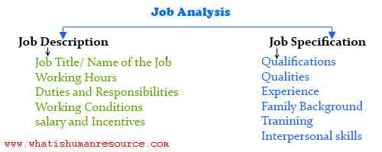
- Recruitment & Selection:
Human Resource Planning & Recruiting are required to conduct before the actual selection of people for the terms of an organization. Recruitment is the invitation process of eligible candidates to issue a notification to fulfill job offers in television media, newspapers, online and social media. Employee recruitment is governed by two main sources, which employ staff through internal sources and employ employees through external sources. Internal recruitment is the process of inviting or giving the opportunity to people in charge of the organization or giving prospects to existing employees.
After the appointment, the employee selection process begins to identify the right person using written tests of relevant topics, group discussions, oral tests, final job interviews and background checks to verify employees' credentials of the candidates.
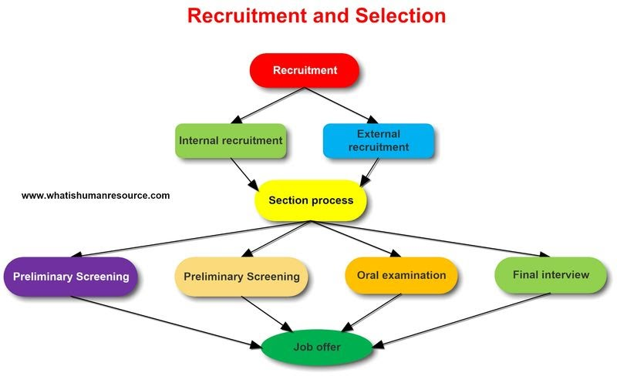
- Training:
This human resources management feature helps employees acquire the skills and knowledge they need to work effectively. Training and development programs are organized for new and old employees. Through training and development, employees are prepared to assume a high level of responsibility. There are two types of training.
- On-The-Job Training: It is the responsibility of the Human Resources Department. New and old employees may receive new training from some companies. This most recent training focuses on modernizing employees in their respective fields according to the needs of the company. This feature helps employees understand the process and makes it easy for them to find their work. During the training and development process, the results are monitored and measured to determine if new skills are needed in addition to the employees who possess them.
- Off-the-job training: It is a training method in which workers/employees learn to keep their professional role away from the real work plan. In summary, out of work training has been specifically assigned to training in an area closer to the actual workplace, where workers must acquire skills and acquire the tools and techniques used.

- Performance Appraisal
Human resource professionals need to perform this feature to ensure the organization that employees' performance is at a sufficient level. The performance of employees of any company will be evaluated by the human resources department. The purpose of this human resource management activity is to help the company determine whether the employee employed by it is meeting its goals. On the other hand, it helps the company determine whether employees need improvement in other areas. It helps the HR team to design some development plans for employees who do not meet the minimum work requirements.
- Compensation
The compensation is a systematic approach that provides employees with a monetary value in exchange for completed work. It also provide security for the future. Compensation can achieve several goals to help with recruitment, performance and job satisfaction.
While the work of lower-level compensation and benefits specialists typically focuses primarily on management tasks, the responsibilities of senior compensation and benefits officers are inherently more strategic. These HR professionals are involved in the creation and management of compensation and benefit plans. As a result, senior compensation and benefits specialists focus on compensation and benefits related to employee performance, corporate goals, sales incentives, and exclusive bonuses.

Chapter Four: The Human Resource Management policies followed by DBBL and UCB Bank



4.1 The HRM Policies of Dutch Bangla Bank Limited

4.1.1 Human Resource Planning policies
Like most other companies, DBBL's performance depends on the commitment and quality of its employees. As a result, the Bank's strategy is to attract, motivate and retain the most talented individuals in the industry. The total number of employees of DBBL was 5201 at the end of 2018. DBBL's corporate culture, which has developed over the last 20 years, is such that staff members have ample chances to take initiatives and responsibilities. The challenge is to maintain a committed corporate culture, consistent with DBBL's mission. Achieving results and taking responsibility are important elements of the culture in which we operate, where management and staff work together and are mutually responsible. DBBL follows the following problems for human resources planning:
- At first, the human resources managers analyzed the business trend of the previous year against the Bank's expansion plan for the following year;
- The Human Resources Department (HRD) assembles information on the human resource supplies of all bank’s responsible managers;
- HR managers also investigate the turnover rate of Bank employees;
- In light of the foregoing, HRD will organize the employee selection requested by the Bank with its qualities/experiences for the following year;
- At the end of the need of the employee of the bank, the case is submitted to the administration of the bank; and
- Lastly, the Board of Directors approves the employee requirements plan for next year.

4.1.2 Recruitment & Selection policies
Dutch Bangla Bank Limited uses two types of recruitment sources. They are 1. Internal source 2. External source.
1. Internal source: DBBL believes that current employees are an important source of recruitment for all positions, with the exception of entry-level positions. For both promotions and lateral job transfers, internal candidates already know the organization and have detailed information about their products, policies, and procedures. Promotions and transfers are generally decided by management with the participation of the human resources department.
2. External source: If job requirements cannot be met internally, the DBBL Department of Human Resources finds for candidates outside the organization. The best-known form of seeking new applicant is advertising. DBBL searches for interested applicants by publishing ads in newspapers.
DBBL also publish posts in several social media sites from where they know, they can easily reach to eligible candidates. These kinds of Social media sites are:
a. Facebook
b. LinkedIn
c. BDjobs.com

4.1.3 Training policies
Dutch Bangla Bank Limited attaches the highest importance to the development of its employees through some continuous process of training. DBBL believes in "on the job" and "off the job" training. The bank has established the training wing to facilitate the internal training program. In addition, the Bank's Retail Banking division, the SME division, and the IT division regularly organize training courses to present a new banking space to their managers. Competent and high-quality human resources are essential for the continued growth and success of the bank. This objective can be achieved by improving the skills, knowledge, and productivity of employees. As such, bank management insists on training its employees in the country of origin and abroad. My other important task is to organize the training of employees under the direction and supervision of my honorable head of the division. There are three categories of training. These areas are:
  - External training / Workshop / Seminar in the country:
In External training, DBBL actually receives invitation from several institutions of Bangladesh such as Bangladesh Bank Training Academy (BBTA), Bangladesh Bank Management Institute (BIBM), Peer Bank, and South Asian Business Development Fund (SEDF) or other financial institutions or training companies who invites to participate in various training courses/ seminars that are arranged by them.

- External training / Workshop / Seminar abroad:
Several international financial organizations invite DBBL to participate in training seminars/programs/workshops abroad. These training programs for bank managers are the same as those for external training /seminars. Moreover, DBBL provides a cash allowance for interested officials.
- In-house training / workshop / internal seminar:
The DBBL Training institute is directed and supervised by the HR Department, which conducts various training courses/workshops/ seminars for the bank staff according to the approved academic calendar. Usually the training are provided by in-house training are:
- Orientation training for new employees.
- General Banking activities related training
- General in-house training session on Banking rules and regulations
At the end of all employees there is few examination are taken by the training institute that employees have to pass so that they can achieve the training certificate on that training. These certificates shows the development of the employee to the bank in future.

4.1.4 Performance appraisal policies
Under the employment contract, the service of regular DBBL employees is governed by the rules and regulations contained in the "Rules for the service of employees of the Bengali Bank, 1999", or the service rules of the bank. As a result, DBBL administration uses the "Annual Confidential Report (ACR)" method to evaluate the performance of its human resources.
Method of the annual confidential report: Although this method is generally applied once per the calendar year, it can also be used quarterly, semi-annually in special cases. The immediate supervisor can be assigned for the ACRs to the employee in question. Finally, the ACR is approved by the immediate senior of the employee in question. If an employee works in multiple divisions/branches in one year, the ACR must be obtained from the supervisory authorities under which he works for at least for three months and an average ACR score is taken into consideration for the performance evaluation. In ACR, the report supervisor evaluates peers in twenty points, as shown below:
Particulars of Annual Confidential Report of an Employee | 1 | 2 | 3 | 4 | 5 | Total
- Personality
- Initiative and drive
- Ability to perform assigned work
- Intelligence & mental alertness
- Discipline
- Tact
- Perseverance & devotion to duty
- Judgment & sense of proportion
- Ability to plan to organize & supervise work
- Dealing with colleagues & superior officer
- Knowledge of rules & regulations
- Suitability in the present assignment
- Ability to implement decision
- Power of expression;
- Preserve the official record/ documents and maintenance of confidentiality
- Integrity
- Sense of responsibility
- Capacity of taking the independent decision
- Dealing with Bank’s client
- Punctuality
Total Score

Each of the categories mentioned above is numerically classified into points such as 1, 2, 3, 4 and 5. This means that the highest score in ACR an employee can reach is 100. In addition, the supervisor or declaring the approved supervisor can write comments & general information on an employee's ACR.

4.1.5 Compensation policies
- Compensation:
The remunerations are won by employees in exchange for their work. There are two types of compensation:
- Non-financial.
- Financial

- Non-financial:
Non-financial means that it is not linked to financing or money. It will provide non-financial materials.
    - Well-being
    - Goodwill
    - Safe work environment
    - Medical service

- Financial:
It is financially connected and provides money. It is called financial.
- Festival vouchers
- Annual bonus.
- Employee salaries.
- Staff wages.

- Core benefits:
The core benefits are also very expensive. The benefits are very useful and necessary for an employee. The benefits employees are receiving from DBBL are:
Reward and Benefits of DBBL
Rewards | Benefits
- Increment  - Performance  - Promotion  - Cash Benefit | - Gratuity  - Profit Bonus  - Incentive  - Provident fund

4.2 The HRM policies of United Commercial Bank Limited

4.2.1 Human Resource Planning policies
Planning through forecast
The objective of human resources planning is to anticipate human resources needs or human resources needs. To predict human resources needs, United Commercial Bank basically uses the scatter plot. Each year, they request to open a new branch in Bangladesh Bank. The number of new vacancies is different from where the branch will be opened. The amount is not fixed. They provide everything the branch needs for staff to function effectively. Therefore, they have to fill the new branches, they plan each year to determine the number of vacancies and the growing demand for existing branches since their level of activity has also increased at that time.

4.2.1 Recruitment & Selection policies
The UCB Limited Bank generally recruits new employees from different sources. The sources are:
- Recruitment from Internal and external sources:
Most of the new job vacancies announcements UCB bank goes for outsourcing because it does not have a significant source of internal recruitment. They organize 2 or 3 external recruitment seasons each year.

- External Sources of Candidates: To attract the best candidates, UCB bank uses the following sources for outsourcing,
- Post ads on online and social media sites. Such as bdjobstoday.com and bdjobs.com.
- Print ads in professional magazines
- Recruit through internal references.
- Print ads in a national newspaper

- Internal Sources of Candidates: UCB Bank basically do not follow any method, to predict the number of internal candidates, but follow a manual qualification system in which their employees are qualified for a promotion. Usually, this appraiser is the manager of the branch. Or sometimes, they promote the person for the vacant position, who has held this position and who has a good qualification and qualifications to do the job. It takes a while to promote employees at the 3-year management level and for non-managers at 2 years.

- Centralize or decentralize recruitment
UCB Bank follows centralized contracts because it makes it easier to apply company-wide strategic priorities to the entire company, as well as job specialization and cost reduction. They recruit employees from all branches across the country from the central office as part of the centralized recruitment process. It also eliminates duplication for almost all branches.
- Selection process
After the requirement advertising and gathering applications from the applicants, HR department of United Commercial Bank starts to call applicants based on their experience and skills of the related field of job. If the applicants are fresh graduate, than UCB takes a written and multiple choice examination which is taken by the reputed Institute of Business Administration (IBA) for UCB Bank. On the other hand, the applicants who have previous related work experience are directly be invited for the viva-voce conducted by the recruitment committee of the bank. The detailed selection process of UCB bank is described below through the chart:
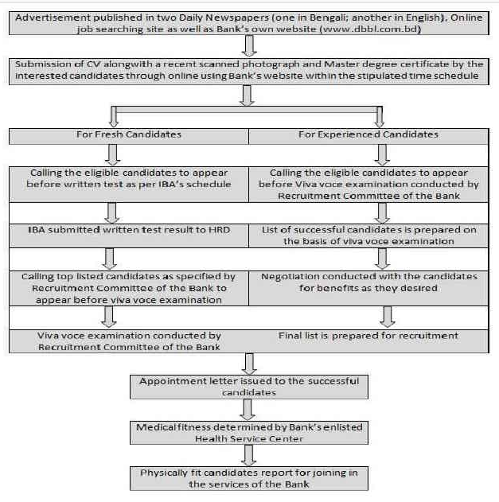

4.2.3 Training policies
UCB Bank is successful in the banking sector and trains qualified banking professionals through the application of good practices in human resources. They have made considerable efforts in their training department to better train their employees. UCB Bank has a well-developed training institution to better serve and train its employees with close supervision. Well-structured training is provided to employees to ensure optimal development of the employees in which they participate.

- Employee basic training and orientation
For new employees, UCB Bank offers an orientation program. Help new employees understand the goals, objectives, rules, and regulations of the job. A book containing detailed information about the company was also provided.
New selected candidates are usually sent for training. Each new candidate must follow a basic education which is essential for all new candidates. The duration of this training in 15 days. The main reason for this training is to build a base for the new candidate.
- Banks’ Internal vocational training:
- Informal learning: Most UCB Bank LTD employees learn informally how to do their daily work.

- Understudy approach: UCB Bank held two meetings per month with each employee. The division manager and the branch manager enquired the employees if they are facing any problem. They also discuss how to improve and what employees really wanted. The division manager and the branch manager act as a supervisor then.

- Job rotation: To expand employee’s knowledge, competence, and capabilities, UCB Bank often rotates its employees from one section to another.

- External professional training:
- Internal Training Centers
UCB Bank has its own training institute where it organizes training courses for its employees. Trainers use courses, realistic exercises, and meetings to train their employees. Many senior officials of Bangladesh Bank have invited there as teachers.
- The role of BIBM in the training of UCB Bank' employees:
The Bangladesh Institute of Bank Management (BIBM) is highly reputed for its nationwide training courses for Bangladeshi bankers. Even UCB Banks' employees follow this training to prepare for several banking tasks.

- Evaluation of the training effort:
For the evaluation of training session, UCB Bank Limited use the punctuality test and employees also have to pass a written exam after the training session. Training courses offered by UCB Bank to its employees are given below:
- Customer service information
- basic course
- Banking laws and regulations.
- Training in another institution.
- general banking
- Foreign exchange risk management.

4.2.4 Performance appraisal policies
Performance evaluation means evaluating the employee's current or past performance against their performance standards. It is mainly used for salary increase decisions and promotion. The evaluation also helps identify the strengths and weaknesses of employees which is also helpful for professional planning.
UCB Bank Limited has also used performance evaluations to evaluate its employees. They use performance evaluation once a year. At UCB Bank Limited, the account manager used this performance evaluation to evaluate employees.
Actually, UCB Bank use 360 degree feedback method to evaluate employee performance.
Types of tests used for performance evaluation:
- oral
- written or manually
- punctuality
- honesty
HR department usually asks their employees to write their daily activities in an official paper. Immediate superior usually perform these this type of performance evaluation.
- Feedback System:
The 360-degree feedback system is used by the UCB bank's HRD to evaluate employee performance. 360-degree feedback means that employees receive feedback from subordinates, colleagues, senior’s, supervisors, and external or internal clients.

4.2.5 Compensation policies
UCB Bank is committed to flexible, fair and competitive remuneration policy. The Board is the final authority for the approval of this policy and will periodically modify and review the policy on the recommendation of the Managing Director / Executive Committee.
The compensation of employees includes –

Salaries are reserved between the employees involved and management and the ranges of salary for these job categories are changed periodically. Temporary employment status is not assigned to temporary and outsourced staff members. The contracts receive a consolidated monthly payment and there are no other applicable fees, except a commission based on employment criteria.
- Basic Salaries: Basic salaries (BSR) are qualifications and are determined by the executive directors. The council examines the basic pay at least once every two or three years.

- Bonuses on Festivals: all regular and permanent employees receive two bonuses every year. One is Eid-Ul-Fitre and another is Eid-Ul-Azha.

- Allow housing allowance: the housing allowance can be paid to employees at the rates and conditions specified in the form of the competent authority.

- Medical allowances: medical services can be paid to employees based on their degree and the conditions defined by the competent authority from time to time.
There is also a performance bonus system managed by the compensation and benefits wing, but supervisors still decides the final evaluation.

Chapter Five: Comparison between the HRM policies followed the two banks: The findings of the study



5.1 Comparison between the HR policies
There are several differences exist between the human resource policies of Dutch Bangla Bank Limited and United Commercial Bank, as both banks are working independently in Bangladesh. These banks have huge workforce. Therefore, setting up their favorable Human Resource policies are also mandatory. The table below shows the basic HR differences between these two banks.

Variables | Dutch Bangla Bank Limited | United Commercial Bank Limited
- Planning | - DBBL usually plan for its human resource depending on its previous year’s requirement of employees.  - As being a highly reputed bank, which already have many branches, the HR department are comparatively more involve with the employee recruitment and retention planning. | - To predict human resources needs, United Commercial Bank basically uses the scatter plot each year  - HR department ask for permission from Bangladesh Bank to open new branches each year and plan each year to determine the number of vacancies and the growing demand for existing branches since their level of activity has also increased
- Recruitment and Selection | - Generally, the basic knowledge requirement is passing Bachelor in Business Administration (BBA) from any reputed university of Bangladesh.  - The recruitment sources of DBBL are two. External Sources and Internal Sources.  - From publishing the vacancy ad on newspaper to finally select an employee, DBBL have to follow 10 selection steps.  - Through in-house training program, DBBL arranges orientation program for its new employees. | - To apply top level post, UCB bank required MBA from any reputed university of Bangladesh.  - The recruitment sources of UCB Bank are four. They are external, Internal, Centralized and decentralized sources.  - From publishing the vacancy ad on newspaper to finally select an employee, UCB Bank have to follow 6 steps. Such as Personality tests, Aptitude tests, Achievement tests, Intelligence Tests, Situational Test, Physical Examination  - UCB Bank offer orientation program from their new employees and in the orientation program, the bank provides a book that describes all the job responsibilities, rules and regulation of the bank.
- Training and development | - DBBL believes in "on the job" and "off the job" training. The bank has established the training wing to facilitate the internal training program. In addition, the Bank's Retail Banking division, the SME division, and the IT division regularly organize training courses to present a new banking space to their managers. If any employee requires further training, DBBL send them to their internal training session/ workshop/ Seminars that are held both in the country and in the abroad. DBBL carry the transportation and other cost of these training.  - At the end of all employees there is few examination are taken by the training institute that employees have to pass so that they can achieve the training certificate on that training. These certificates shows the development of the employee to the bank in future.  - DBBL offer its training program to its employees whenever the bank feels that training is required. | - UCB Bank provides internal vocational training that consists of informal learning, understudy approach, job rotation. If employee needs further knowledge for any particular job, the bank send them to their own training school or Bangladesh Institute of Bank Management (BIBM) for special training.  - For the evaluation of training session, UCB Bank Limited use the punctuality test and employees also have to pass a written exam after the training session. Training courses offered by UCB Bank are:  - Customer service information, basic course, banking laws and regulations, training in another institution, general banking, foreign exchange risk management.  UCB Bank offer its training program twice in a year.
- Performance Appraisal | - The DBBL Administration uses the "Annual Confidential Reporting (ACR)" method to evaluate the performance of its human resources.  - This method is usually applied once a year. The immediate supervisor usually be assigned to the employee in question for ACRs. Finally, the ACR was approved by the seniors who are working on the issue. | - UCB Bank use 360 degree feedback method to evaluate employee performance. HR department usually asks their employees to write their daily activities in an official paper. Immediate superior usually perform these this type of performance evaluation.  - The 360-degree feedback system is used by the UCB bank's HRD to evaluate employee performance. 360-degree feedback means that employees receive feedback from their subordinates, colleagues, senior’s, supervisors, and external or internal clients.
- Compensation and benefits | - DBBL provides a few handsome compensation packages to its employees. The compensation packages are both financial and non-financial.  - The non-financial compensation are Well-being, Goodwill, Safe work environment, Medical facilities and the financial compensation packages are such as Festival vouchers, Annual bonus, Employee salaries. Staff wages. | - UCB Bank is committed to flexible, fair and competitive compensation policy. The Board is the final authority for the approval of this policy and will periodically modify and review the policy on the recommendation of the Managing Director / Executive Committee.  - The usual compensation packages of UCB Bank for their employees are basic salaries, medical facilities, bonuses on festivals, rentals of the house, etc.

Chapter Six: Recommendations and Conclusion



6.1 Recommendations
The project report have already shown the human resource policies of Dutch Bangla Bank Limited and the United Commercial Bank Limited in the analysis part. In this chapter of the report, I would like to share some recommendations for the betterment of both these banks so that the banks can improve their HR policies more.
- Promotion practices must be impartial and regular in both banks so that employees remain motivated.

- Encourage employees to participate in conferences and seminars based on their position and skills. Do not allow them to take training that is not related to the specifications and organization of their work. Also, ask them to briefly download the lecture they have already attended with their colleagues. There is absolutely no harm if others also benefit from your knowledge. Employees can also give a short presentation of everything they learned at the conference or seminar.

- Training and development should also include more than just improving their social behavior because they are in contact with many clients from various social backgrounds. How they have to mingle with different colleagues during transfers and delegations.

- HR professionals must provide manuals, guidelines, checklists, and organizational rules so that the employee knows what he or she is expected to do in the organization. Define key areas of responsibility for employees based on their areas of interest, education, specialization and background.

- The communication made in banks should be well channeled to avoid situations such as grape wine. It must be clear and complete that the tasks assigned are the tasks, responsibilities and authorities of the employees so that the right decision can be made at the right time.
- Decentralization of training will facilitate employee training. Senior managers are trained in a limited number of training centers outside of Dhaka City, making training impractical for remote employees.

- Employees may also receive additional responsibilities from their team leaders. Hold them responsible for their equipment. Each employee is looking for additional challenges in the organization. Once an employee has demonstrated their skills in a particular genre, assign additional tasks.

- Ask employees to work as a team. Each individual has his own area of ​​expertise. Let employees benefit from the knowledge and experience of others. Motivate employees to help each other learn new skills.

- Performance evaluations also contribute to employee development. On the basis of the 360-degree assessment, managers and supervisors evaluate the performance of their team members and provide them with the necessary feedback. The results of the evaluation help an employee to know their shortcomings and to understand how they can be addressed. Dutch Bangla Bank need to establish this performance evaluation in their bank.

- Encourage employees to sign up for several online courses and distance learning programs that will help them in their professional careers.

- Employees must participate in relaxing activities to achieve job satisfaction. These forms include listening to exercise, music, meditation, yoga to improve employee focus, counseling and the periodic realization of daily performance involving employees and their families.

6.2 Conclusion
The success of banks depends largely on the intellectual development of employees. In addition to intellectual development, the bank's technical infrastructure must be guaranteed to improve the efficiency of the employees and the bank. In general, the banking profession in Bangladesh is recognized with a standardized salary scale, greater social status and greater dignity. As can be seen in the study, human resources in banks had relatively better structures, according to the rules of the banking sector. Both DBBL & UCB Bank’s employees receive a good amount of bonuses and grants, including salary levels, housing & medical facilities, social security funds and losses resulting from injury or death, etc. Private bank employees are more satisfied with the work environment, salary scale, promotion system, but they are very concerned about working time and work pressure. Most employees are less satisfied with human resources management and work analysis policies, IT structures, work evaluation, and performance measurement techniques. Human resources were centrally managed by all the banks surveyed. The banks must decentralize their activities in the human resources sector in all branches and develop policies to guarantee solid human resources. Powers and responsibilities should be properly distributed to all human resources managers. The bank must assign an important power and role to the human resources director to empower human resources departments. Bangladesh's human resources department in the banking sector is relatively inefficient compared to India, Pakistan and Sri Lanka due to the lack of empowerment structures. The correct responsibility of the Human Resources Department means its participation in the preparation of management policies, the forecasting of the supply and demand of human resources, plans and programs, as well as the formulation and implementation of policies. This will help DBBL and UCB bank to recruit and maintain a skilled, competent and well-executed workforce to meet current and future organizational needs and individual needs.

Reference
(1) Annual report of Dutch Bangla Bank Limited, Available at: https://www.dutchbanglabank.com/investor-relations/financial-statements.html
(2) Annual report of United Commercial Bank Limited, Available at: https://www.ucb.com.bd/index.php?page=know-ucb/reports-and-statements/financial-statements
(3) Bhuiyan, Ahmed and Faruq, Hossen, Mohammad (2012), "Bangladesh Business Experiences in Strategic Human Resources Management", Journal of Business Studies, University of Dhaka, vol. XX111, No. 1, June 2012, ISSN 1682-2498. pp. 97-106.
(4) Price, Alan (2004). Human resources management in a commercial context. On /http://www.hr-opics.com/introduction-tohrm/frompersonnel.html last accessed August 29, 2005.
(5) Barney, J. and Wright, P. M. (1998). By becoming a strategic partner: the role of human resources to gain a competitive advantage. Human Resources Management, 37, 31-46.
(6) Becker, B. and Gerhart, B. (1996). The impact of human resources management on organizational performance: progress and prospects. Academy of Management Journal, 39, 779-801.
(7) Barney, J. and Wright, P. M. (1998). By becoming a strategic partner: the role of human resources to gain a competitive advantage. Human Resources Management, 37, 31-46.
(8) Jayasri Indiran, Ph.D Human Resource Management & Organizational Behavior, PSGCAS Coimbatore (2009)

Appendix
A Questionnaire

On human resource management policy and procedures

- Planning
1. How do you plan on how many people you need in the future? Please describe the planning process?
2. To what extent are HR personnel or departments involved in HR planning decisions?
- Recruitment and selection procedures
3. What kind of criteria/knowledge do you look for in the hiring process?
4. What criteria do you prefer for mid-level and top-level rentals?
5. What are the sources of recruitment policies?
6. How many steps does your organization follow in the selection process?
7. How do you define the effectiveness of elections?
8. Do you arrange an orientation program for newly elected employees?
- Training and development
9. How do you provide training for your staff?
10. How have you measured the training program to be successful?
11. How many times a year has your company arranged for this training program?
- Performance and evaluation
12. What are the key tools used to measure performance?
13. How many days in a year, have you measured your employee's performance?
- Compensation
14. What kind of compensation are you offering? Is it external or intrinsic?
15. How have you compensated your employees?
16. How satisfied are your employees with their compensation in these competitive market situations?

