
Financial Analysis on
“Manufacturing Industry of Bangladesh”
Project Paper

Submitted to:
Dr. James Bakul Sarkar
Associate Professor
School of Business & Economics
United International University

Submitted By:
Tanveer Habib
ID: 114 163 010
(BBA in AIS)

Date of submission: 16th October, 2020


Letter of Transmittal

16th October, 2020
Dr. James Bakul Sarkar
Associate Professor
School of Business & Economics
United International University
Cell No: 01716-599599
Email: jmssarkar@bus.uiu.ac.bd
Subject: Submission of the Project Paper.
Dear Sir,
I am presenting you with my project paper, where I have tried to prepare this report with all the available necessary information that I managed to gather and tried to imitate the guidelines which I was instructed to follow. I am thankful to you for the guidance you had provided me for this project’s accomplishment. I hope this report will fulfill your expectations.
Sincerely yours,
Tanveer Habib
ID: 114 163 010
Email: thabib163010@bba-ais.uiu.ac.bd
Table of Contents
Executive Summary 2
Introduction 4
Organizational Background and Industry Perspective 7
Objectives of the Study 11
Methodology of the Study 13
Literature Review 16
Findings and Analysis 22
1. Asset Management & Asset Quality Ratios 23
Total Asset Turnover 24
Net Fixed Asset Turnover 25
Equity Turnover 27
2. Cash Flow & Capital Adequacy 28
Operating Cash Flow to Sales 28
3. Efficiency & Productivity & Capital Strength 30
Receivables Turnover 30
Receivable Collection Period 32
Inventory Turnover 33
Inventory Processing Period (Days) 35
4. Liquidity & Leverage 36
Current Ratio 36
Quick Ratio 38
Cash Ratio 39
Debt to Equity 41
Debt to Total Assets 42
Equity Ratio 44
Interest Coverage 45
5. Profitability & Investment Return 47
Gross Profit Margin 47
EBITDA Margin 48
Net Profit Margin 50
Return on Equity (ROE) 51
Return on Assets (ROA) 53
Conclusion 56
Recommendation 57
References 59


Executive

Summary

Executive Summary

In Bangladesh, the manufacturing industry plays a huge role for the survival and growth of the country’s economy as a whole. Manufacturing is the production of products for the use or sale through the use of labor, machines, tools, and chemical or biological processing. Manufacturing industry consists of such companies that take in raw materials from a primary industry which are then transformed into finished goods on a large scale. This process begins with the product design, and materials specification from which the product is made. These materials are then modified through manufacturing processes to become the required part.
Bangladesh has seen significant economic growth and decreased poverty in the last decade and it is of no doubt that the country’s manufacturing industry is one of the biggest contributing factors. This report analyses about the performance of the manufacturing industry for Bangladesh on which a financial interpretation is done, to see how efficiently some of the companies are working inside the industry.



Introduction

Introduction

Bangladesh is a developing country in Southern Asia. Its economy is also a developing economy. Bangladesh has an estimated population of around 164.6 million people. Bangladesh is the 10th most densely populated country in the world. This country’s developing economy is growing at an annual rate of 7.4% which makes Bangladesh’s economy as the 3rd fastest growing economy in the world and the fastest growing economy in Asia. Bangladesh expects to reach middle-income country status by 2021. One of the primary and biggest contributing factors that is helping Bangladesh to reach this status is none other than their manufacturing industry.
The main industries for Bangladesh have been cotton, textiles, jute, garments, tea processing, paper newsprint, cement, chemical fertilizers, sugar and light engineering. The main export items that Bangladesh has done over the years are tea, leather and leather products, garments, seafood, paper, furnace oil, urea, ceramic products, raw jute and jute products. Bangladesh's textile industry is the number one export earner for the country. Bangladesh only ranks 2nd and is considered the most formidable rival to China, who ranks 1st.
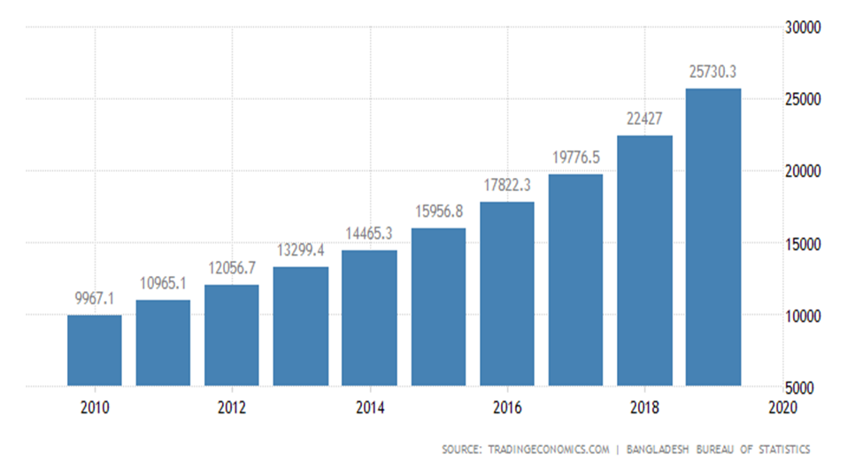
These are reasons why manufacturing industry is considered such a vital part for the economic growth of Bangladesh. Increase in manufacturing is the key to the question of the validity of growth rate of the economy of Bangladesh. GDP from manufacturing in Bangladesh averaged to an estimate of 14008.33 BDT Million from 2006 until 2019, reaching an all-time high of 25730.30 BDT Million in 2019 and a record low of 7383.40 BDT Million in 2006. This manufacturing sector has seen the highest increase among all the industries of Bangladesh. This is the reason why the manufacturing industry of Bangladesh has played such a key contributable factor for such an impressive growth for the economy of this country. (Wikipedia, 2020)
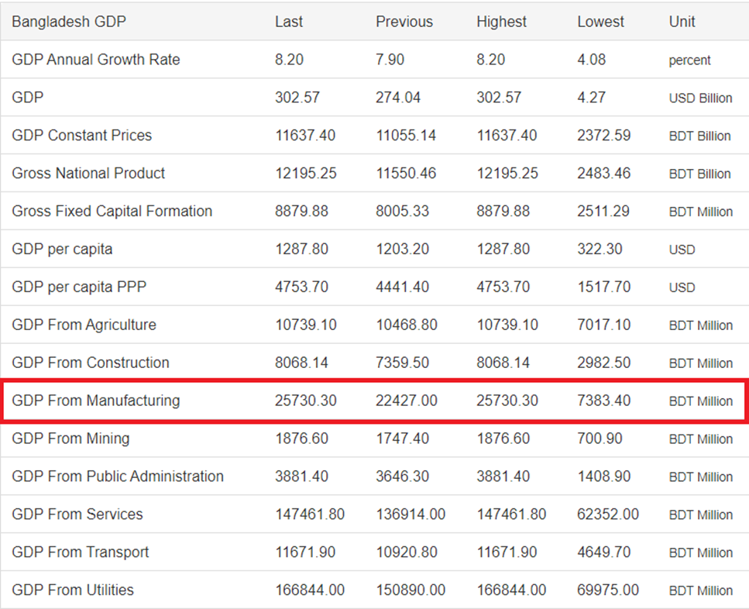
(GDP from Manufacturing, 2019)


Organizational

Background and

Industry Perspective

Organizational Background and Industry Perspective

Bangladesh has plans to become developed by 2041 and they have seen significant economic growth and decreased poverty in the last decade. Bangladesh has made manufacturing development a priority since independence in 1971. According to the International Labor Organization, the RMG sector dominates the industry with more than 5,000 factories nationwide. It is quite difficult to find a manufacturer in Bangladesh for a product outside of the garments or textile industry even though it is changing. The government is pushing for manufacturing diversity, focusing mostly on the leather industry. Bangladesh’s huge supply of livestock gives them a distinct advantage. They produce 50 million head of livestock a year, so sourcing is more direct and less expensive. The country is also prioritizing increased manufacturing in the automotive, agribusiness and pharmaceuticals sectors.
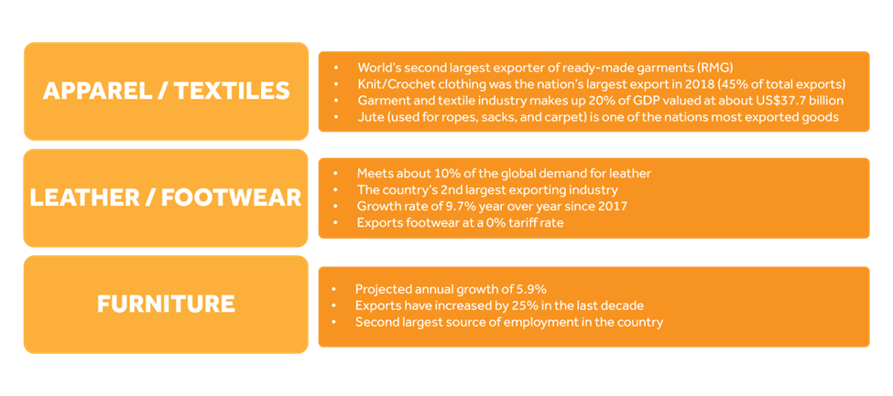
Introduction of new jobs have been created by the country's dynamic private ready-made garment industry, which grew at double-digit rates through most of the 1990s. By the late 1990s, about 1.5 million people, mostly women, were employed in the garments sector as well as Leather products specially the shoe manufacturing unit. During 2001–2002, export earnings from ready-made garments reached $3,125 million, representing 52% of total exports of Bangladesh. The country has even managed to overtake India in apparel exports in 2009. At the fiscal year 2018, Bangladesh has been able to garner US$36.67 billion export earnings by exporting manufactured goods, of which, 83.49 percent has come from the apparel manufacturing sector. In 2013, it accounted for around $21.5 which was 80% of Bangladesh's total exports, out of the $27 billion made in that calendar year. Bangladesh is standing 2nd in world textile exports. In 2009, the country exported around $120.1 billion worth of textiles. This industry employs nearly 3.5 million workers. Even the wages in the textile industry of Bangladesh were the lowest in the world according to the statistics done in 2010.
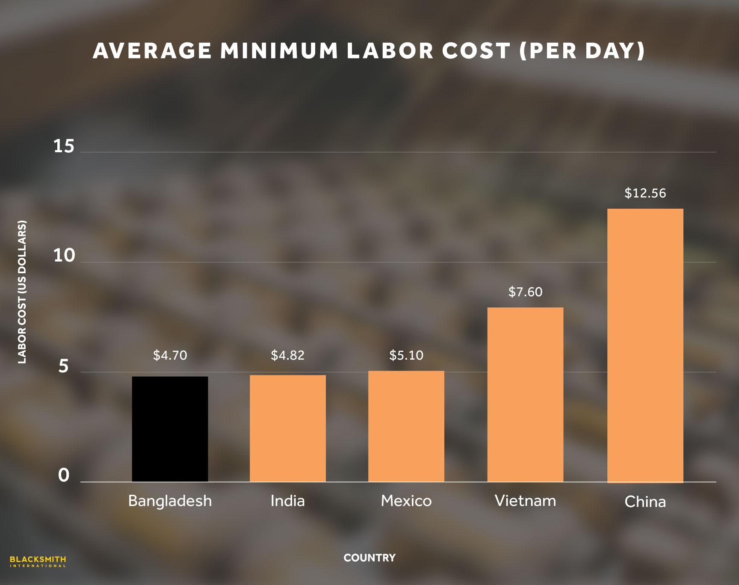
Bangladesh influences a very low cost of labor compared to China and other Asian countries. Bangladeshi garment workers make a minimum of US$94 per month while other non-industry-specific workers make a minimum of US$19 per month. This extremely low cost of labor is one of the biggest appeal to do manufacturing business in Bangladesh. Labor accounts for almost around 20% of the final cost. Thus, as a result, this low wages play a high significant role for cost reduction and cost controlling for the industry.
When working with Bangladesh, one might struggle with the ease of doing business like getting electricity or enforcing contracts. Bangladesh is ranked among the lowest in the EODB (World Bank’s Ease of Doing Business Survey). To counter this struggle, the government has set up the BIDA (Bangladesh Investment Development Authority). That might hopefully decrease the occurrence of bribery and red tape in the industry and create an easier environment to do the business. The language barrier can also create some struggles as the spoken language is Bengali and it is less likely for the factory management to have good command in English.
The 2017-2018 Global Competitiveness Report ranked Bangladesh 109th in overall quality of infrastructure, and 99th in transportation. The government is well aware of how poor infrastructure will hinder their manufacturing industry and they’re working actively towards improvements. The government plans to upgrade the roads from factory cities to ports, cutting travel time in half and decreasing transportation costs. They’re also working towards nationwide electricity access in 2021.
The most influenced part of the manufacturing industry of Bangladesh, that is, the RMG industry has also been known for its negative impact on the environment. The increasing levels of pollution, waste, and energy depletion caused by the industry are unsustainable. That is the reason why Bangladesh has started to take steps towards a greener future. This developing nation is leading the way in sustainable manufacturing. The country is home to 90 LEED green factories (Leadership in Energy and Environmental Design), 24 of which are considered platinum and 6 of which are in the top 10 in the world. The movement towards sustainability in Bangladesh has significantly improved the country’s reputation. Bangladesh is striving to make a positive impact within one of the most environmentally negative industries. (Manufacturing in Bangladesh, 2019)


Objectives

of

the Study

Objectives of the Study

Primary Objective
To accomplish the partial requirement of BBA in AIS Program from School of Business & economics, United International University.

Secondary Objective
A review on the Financial Statement Analysis of the Manufacturing Industry in Bangladesh has been done. Through which the following points have been learned:
- The financial health of the manufacturing industry’s companies.
- The influence of manufacturing industry for the economy of Bangladesh.
- The significant contribution done by the manufacturing company to the GDP of Bangladesh.
- The performance of the industry’s companies over the course of the years.


Methodology

of

the Study

Methodology of the Study

Types of Data
Due to quarantine restrictions, no primary data were collected. Only secondary data were collected.

Data Collection Process
All the required data for the preparation of the paper, have been collected from a number of internet sources. All the annual information, theoretical discussions, journals and all other information were gathered through the help of various websites and internet.

Sample Size
For the financial analysis, 4 years (2016, 2017, 2018 and 2019) of 5 companies from the same industry has been taken.

Sampling Techniques and Procedures
- Online method used to collect data.
- Judgmental and convenience used to collect bias free and representative sample from the population.

Scope
The report contents contains of information that are unchanged about the financial positions of the manufacturing industry of Bangladesh. All important areas of manufacturing companies’ financial statement and related ratios have been provided that will help to understand their overall financial performance. This report will also aid by providing:
- Idea about the manufacturing industry
- Important tools that are required for a company to evaluate their profitability, liquidity and leverage and solvency position.
- Which section of the companies require improvements and where they are striving to grow.

Limitation:
- There are also other analysis, other than ratio analysis, by which we could analysis an organization financial position more broadly.
- If any information, that are not true in real, has been manipulated or changed and has been published, then there is no way to sort out.
Despite of few limitations, this report has been made as informative and analytical as possible. Hopefully, all the information and analysis will give proper idea about the performances of the companies inside the manufacturing industry of Bangladesh.



Literature

Review

Literature Review

Financial Analysis
Financial analysis is the process of evaluating companies from their financial information to determine their performance of the companies. This analysis is used to analyze a company and understand whether the company is stable, solvent, liquid, or profitable enough for investments. Analysis are done by the help of financial ratios of the companies. Financial ratios are mathematical comparisons of financial statement that measures the relationships between the financial statement to help investors, creditors, and internal company management to understand how well a company is performing and what are the areas in which there should improvements for future growth. These ratios are the most widespread tools that are utilized to break down a business' financial presentation. These ratios are used to compare different companies in different industries based on the financial information. This financial analysis helps to identify their strengths and weaknesses. Financial ratios are often divided up into seven main categories: liquidity, solvency, efficiency, profitability, market prospect, investment leverage, and coverage.

Key Financial Ratios
Some of the important financial ratios include:.
- Liquidity Measurement Ratios: This measures whether a company is able to meet short-term financial obligations.
- Profitability Ratios: This measures how much of a company’s profit is derived from the cost of goods sold or the operating expenses.
- Debt Ratios: This measures how much debt a company has and the assets it possesses to pay debts off.
- Operating Performance Ratios: This determines the efficiency of a company as efficiency improves the profitability of a company.
- Cash Flow Ratios: This analysis whether the companies need to produce enough cash flow to pay the operating expenses, grow the business and generate sufficient net earnings.

Financial Interpretation
Interpretation of the ratio analysis make it better to understand for the more common audience to know what the numbers actually mean. The numbers may tell that a particular ratio has 1. This number is more clarified and refined with interpretation for better understanding of the financial analysis.

Benefits of Financial Ratios
- Analyses the financial information to create a measurement of that company and helps to compare with other companies in the same industry or with industry averages.
- It helps the company to monitor its key financial information over the course of years.
- This analysis help the company to create a general benchmark that helps them in planning for future financing requirements.

Limitations of Financial Ratios
- The financial ratios of a company are not comparable to the ratios of companies in different industries
- The financial ratios are a representation of previous data from past years. So, it cannot classify about the present situation.
- The financial statements reflect the cost principle and thus, some assets might not be included in the balance sheet of the company as it was developed by themselves.
- Financial ratios for accounts receivable and inventory (and others) are averages which can consist of some not-so-favorable information.
- Sometimes, a company's efforts to improve one financial ratio can lead to adverse effects on the business and on other financial ratios.
(Averkamp, 2020)

Analysis Frameworks
There are three critical frameworks, which are: Horizontal analysis, Vertical analysis, and
Ratio analysis.
- Horizontal Analysis: Horizontal analysis takes the amounts from the financial statements over a number of years. Then, these figures from the previous years are then presented as a percentage of the amounts from the base year. Thus, a side-by-side comparison of the financial results of a company for a number of years are done for a more in-depth analysis of financial results. (Vishal, 2015)
- Vertical Analysis: Vertical analysis states every amount on a financial statement as a percentage of another amount. The vertical analysis of a balance sheet shows every balance sheet amount as a percent of total assets. The vertical analysis of an income statement shows every income statement amount as a percent of net sales. (Vishal, 2015)
- Ratio Analysis? Ratio analysis is a quantitative procedure to understand the liquidity, operational capability, incomes and profits of a company from the information contained in its financial statements. Investors can use ratio analysis for the comparison between different companies in an industry. (Bloomenthal, 2020)

Companies for Analysis
In Bangladesh, there are thousands of manufacturing companies present at the present date. The notable name of some of the companies are:
- Akij Group
- Alim Industries Limited
- Apex Footwear
- Bangladesh Machine Tools Factory
- BEXIMCO
- BSRM
- Chittagong Dry Dock Limited
- Confidence Group
- Globe Janakantha Shilpa Paribar
- Habib Group
- KDS Group
- Kohinoor Chemicals Limited
- Maksons Spinning Mills
- Meghna Group
- Pragoti
- Sikder Group
- T K Group of Industries
- Unilever Bangladesh Limited
From thousands of companies, five companies have been taken into account for analysis. The companies are:
- Apex Footwear Limited: A leading manufacturer and exporter of leather footwear from Bangladesh to major shoe retailers in Western Europe, North Ame rica and Japan.The company has revenues of USD 42 million in 2006. AAFL pioneered the export of value added finished products export in the leather sector of Bangladesh and is also involved in the local footwear retail business with the second largest shoe retail network in the country.The company has a capacity of 5616582 pairs of sandals and shoes with a attainable capacity of 5616582 pairs.
- BEXIMCO Limited: The business activities of the company involve investment operation, agency and trading in other commodities, manufacturing and marketing of yarn and fabric. It is also involved in real estate & hospitality, marine food & commodities trading, ICT, ceramics tableware and aviation. platform now has operations and investments across a wide range of industries including textiles, pharmaceuticals, PPE, ceramics, real estate development, construction, trading, marine food, information and communication technologies, media, DTH, financial services, and energy. The Group sells its products and services in the domestic Bangladesh market as well as international markets. BEXIMCO is the largest employer in the private sector in Bangladesh and employs over 70,000 people worldwide.
- Meghna Cement Mills Ltd: Meghna Cement Mills Ltd. (MCML), the first manufacturing enterprise of Bashundhara Group, has started its commercial operation on 15th January 1996. The principal activity of the company is to manufacture and sell portland cement. It markets its products under the registered trade mark “King Brand”. The production capacity of MCML is 1.00 million MT/annum
- Maksons Spinning Mills Ltd: The Company was incorporated in Bangladesh on 25 September, 2003 with the Registrar of Joint Stock Companies and firms as a Private Limited Company Under the Companies Act 1994. Subsequently it was converted to public Limited company on 25th January, 2005.The Principal Activity of the company in the period under the review was that of production and sales of the high quality 100% Cotton Yarn through export. The company’s installed Production Capacity during the Year 2010-2011 remained same as previous Year, which is 45000 Spindles. The production during the year was 5,457 Tons which is 1,247 tons (18.60%) Lower than the previous Year.
- Kohinur Chemical Company: Kohinur Chemical Company are the pioneer amongst the soap, cosmetics and toiletries manufacturing industries of Bangladesh, producing highly value added products with quality in the center of focus.
(Financial Portal, 2020)


FINDINGS AND

ANALYSIS

- Asset Management & Asset Quality
- Cash Flow & Capital Adequacy
- Efficiency & Productivity & Capital Strength
- Liquidity & Leverage
- Profitability & Investment Return

Findings and Analysis

In this part of this report, with the aid of financial information gathered from the respective company’s annual statements, the financial situations will be discussed in depth to know how the manufacturing industry is performing based on these five companies’ performances.

Normally to conduct a performance analysis based on the financial statements, three types of analysis which are: Horizontal Analysis, Vertical Analysis and Ratio Analysis are used. But to conduct my assessment, Ratio Analysis has been used for analyzing. With the help of twenty various ratios, the financial statements has been analyzed (by taking financial information of Profit and Loss statements, Balance Sheet and Cash Flow Statements from the companies’ annual reports.

The financial information gathered from the annual reports consists of the records from the last four years (2016, 2017, 2018, and 2019) for every company. These are the list of ratios which I am going to interpret:

- Asset Management & Asset Quality Ratios
- Total Asset Turnover = Net Sales / Total Assets
- Net Fixed Asset Turnover = Net Sales / Average Fixed Assets
- Equity Turnover = Total Sales / Shareholders’ Equity

- Cash Flow & Capital Adequacy
- Operating Cash Flow to Sales = Operating Cash Flows / Sales Revenue

- Efficiency & Productivity & Capital Strength
- Receivable Turnover = Net credit sales / Average Accounts Receivable
- Receivable Collection Period (Days) = 365 / Receivable Turnover
- Inventory Turnover = Cost of Goods Sold / Average Inventory
- Inventory Processing Period (Days) = 365 / Inventory Turnover

- Liquidity & Leverage
- Current Ratio = Current assets / Current liabilities
- Quick Ratio = (Current assets – Closing Inventory) / Current liabilities
- Cash Ratio = (Cash and cash equivalents + Marketable securities) / Current liabilities
- Debt to Equity = Total liabilities / Total Shareholders' Equity
- Debt to Total Assets = Total liabilities / Total Assets
- Equity Ratio = Total Shareholders' Equity / Total Assets
- Interest Coverage = EBIT / Interest Expense

- Profitability & Investment Return
- Gross Profit Margin = Gross Profit / Sales Revenue
- EBITDA Margin = (EBIT + Depreciation + Amortization) / Net Sales
- Net Profit Margin = Net Profit / Sales Revenue
- Return on Equity (ROE) = Net Profit / Shareholder's’ Equity
- Return on Assets (ROA) = Net Profit / Total Assets

1. Asset Management & Asset Quality Ratios

Asset Management & Asset Quality ratios analyzes the level of efficiency of a company, whether the assets are being efficiently used so that the companies are getting proper return through their sales. This is important because is shows the determinant of risk that profoundly impacts liquidity and costs, analysts go to great lengths to make sure they issue the most accurate evaluations possible. This ratios can tell the industries’ asset management efficiency, whether the companies are in a good position with their sales and whether the trend can show if they will keep performing well enough in the upcoming years.

Total Asset Turnover

The asset turnover ratio measures the value of a company's sales or revenues in compare to the value of a company’s assets. This can be used to understand the efficiency with which a company is using its assets to generate revenue. The better and more the asset turnover ratio is, the higher is the efficiency of a company in generating revenue from its assets. Conversely, if a company has a low asset turnover ratio, it indicates it is not efficiently using its assets to generate sales.

Total Asset Turnover Ratio | Years
Company Names | 2016 | 2017 | 2018 | 2019
BEXIMCO Ltd. | 0.2952 | 0.2007 | 0.2068 | 0.1984
Meghna Cement Mills Ltd. | 1.6425 | 1.0643 | 0.8041 | 0.9499
Apex Footwear Ltd. | 0.9233 | 1.0324 | 1.1111 | 1.0428
Kohinoor Chemicals Ltd. | 1.9864 | 1.9573 | 1.8930 | 2.1037
Maksons Spinning Mills Ltd. | 0.1797 | 0.3540 | 0.4577 | 0.4891
Average Industry Ratio | 1.00542 | 0.92174 | 0.89454 | 0.95678

The statistics shows that Kohinoor Chemicals Ltd., Apex Footwear Ltd. and Meghna Cement Mills ltd. have maintained a good Asset Turnover Ratio over the years. They maintained a ratio of around 1 or above. In fact, Kohinoor Chemicals Ltd. managed to maintain a very healthy ratio with even an increasing trend of a ratio of close to 2.
Even though, the rest of the companies did not manage to concede a high ratio, but the average ratio of over 0.8 show that the companies of the manufacturing industry had been able to be quite efficient in using their asset to generate sales or revenue. This is a good sign as it speaks that the industry is not misusing their assets and are generating sufficient revenues.

Net Fixed Asset Turnover

The Net Fixed Asset turnover ratio, measures the level of efficiency of a company in using their fixed assets to generate revenues for them. Companies in the manufacturing industries does a relatively large amount of investment in their fixed assets. So, this ratio helps to understand whether their investment are generating a handsome level of sales. A high ratio will imply that the business is efficient in using its non-current assets to generate revenues while lower ratios will represent the inefficiency of any companies.

Net Fixed Asset Turnover Ratio | Years
Company Names | 2016 | 2017 | 2018 | 2019
BEXIMCO Ltd. | 0.8134 | 0.5775 | 0.6122 | 0.6179
Meghna Cement Mills Ltd. | 7.2877 | 4.7273 | 3.1937 | 1.9942
Apex Footwear Ltd. | 4.2382 | 4.4965 | 3.8927 | 3.5555
Kohinoor Chemicals Ltd. | 10.2055 | 9.3634 | 11.8942 | 12.7314
Maksons Spinning Mills Ltd. | 0.3102 | 0.5268 | 0.8773 | 0.9867
Average Industry Ratio | 4.571 | 3.9383 | 4.09402 | 3.97714

The above figures shows that 3 out of the 5 companies are very efficient in generating revenues from their fixed assets. Meghna, Apex and Kohinoor have managed to maintain a ratio of over 3.5 over the years. Kohinoor Chemicals Ltd. has been the impressive above all with an increasing trend over the years and with a ratio of above 10. But, BEXIMCO and Maksons had not been so efficient. These 2 companies have not been successful in turning revenues out from their non-current assets they have.
As a whole, it can be said that even though some companies have been efficient in generating revenues from their investments, but the manufacturing industry is doing quite good, with an average ratio of around 4, in generating returns from the investments they are making over the years in their fixed asset section.

Equity Turnover

Equity Turnover ratio is the proportion of a company’s revenue to its total shareholder’s equity. This ratio helps to understand whether the company is generating sufficient revenues to make sure it is worth for the shareholders to hold the equity of the company. In general, an increased ratio tells us that it is a positive indication for a company,

Total Asset Turnover Ratio | Years
Company Names | 2016 | 2017 | 2018 | 2019
BEXIMCO Ltd. | 0.5619 | 0.3853 | 0.4006 | 0.3956
Meghna Cement Mills Ltd. | 9.4272 | 6.0303 | 7.3861 | 9.3859
Apex Footwear Ltd. | 4.9435 | 5.5515 | 5.7998 | 5.6247
Kohinoor Chemicals Ltd. | 8.1287 | 5.4077 | 5.0301 | 4.5322
Maksons Spinning Mills Ltd. | 0.3003 | 0.5479 | 0.9188 | 1.0399
Average Industry Ratio | 4.67232 | 3.58454 | 3.90708 | 4.19566

Just like the previous ratios, Meghna, Apex and Kohinoor had been the most effective companies in generating revenues from the investments done by the shareholders. All of the three companies have been able to maintain a ratio of over 4 and Meghna being the highest with maintaining a ratio of 9 over the years. Even though, BEXIMCO and Maksons had not been so efficient with a ratio of less than 1, but still they had been able to generate money none the less. Thus, the average ratio of above 3.5 gives us an overall picture that the manufacturing industry of Bangladesh has been able to generate revenues from the money invested in them.

2. Cash Flow & Capital Adequacy

Cash is a very important part for any companies. It is needed for payments to suppliers, employees, shareholders, clearing the operating expenses and etc. Therefore, this ratio indicates the ability of a company to turn its sales into cash. This technique is provided to give a view to whether a company is being able to generate enough returns from its day to day cash encounters. The ratio that will be used is to analyze further is :

Operating Cash Flow to Sales

This ratio compares the operating cash flows a company to its sales revenue. It provides the information to the investors about the indications of the ability of the company to generate cash from its sales. In other words, it shows whether a company is efficient in turning its sales into cash or not.
The higher this ratio is the better it is for the company. Increased amounts of operating cash flows are always preferable. A consistent and/or increasing trend is a positive indication of good debtor’s management.

Operating Cash Flow to Sales | Years
Company Names | 2016 | 2017 | 2018 | 2019
BEXIMCO Ltd. | -0.0960 | -0.0910 | -0.0380 | -0.0360
Meghna Cement Mills Ltd. | 0.0090 | 0.1550 | -0.0140 | 0.1270
Apex Footwear Ltd. | 0.0660 | 0.0600 | 0.0570 | 0.0610
Kohinoor Chemicals Ltd. | 0.1500 | 0.1410 | -0.0320 | 0.0390
Maksons Spinning Mills Ltd. | -0.3010 | -0.2880 | -0.0160 | -0.0400
Average Industry Ratio | -0.0344 | -0.0046 | -0.0086 | 0.0302

However, the companies have not been quite impressive in translating their sales to cash. While Meghna, Apex and Kohinoor companies have only managed to attain a ratio below 0.15, BEXIMCO and Maksons has seen to be hit the negative side, or in other words they had not been successful at all in generating cash from their sales.
Therefore with the negative ratios over the span of years, it can be said that from the above information, the manufacturing industry of Bangladesh has not been quite efficient in generating cash from their sales revenue.

3. Efficiency & Productivity & Capital Strength

A quick understanding about the productivity and efficiency of a company can be determined by seeing how quick their debts are been recovered from their debtors and how quickly their inventories are being sold over time. More the money the debtors owe represents that a company is being deprived of the capital that can be used for business purposes. Also, more inventories stuck in hand represents how much a company maybe inefficient in selling off their inventories. More time the inventories are being held back, more the chances of obsoleting it. Thus, it may also give a sight whether wastages are occurring within the operations or not.

Receivables Turnover

The Receivables Turnover ratio is used to understand, how much is a company effective in collecting its receivables or money owed by its debtors. It shows how well a company uses and manages its debtors and how quickly their short-term debt is collected.
The Receivables Turnover ratio measures the efficiency of a company’s debt collecttion and measures how many times the receivables of a company have been converted to cash in the time period.

Receivables Turnover | Years
Company Names | 2016 | 2017 | 2018 | 2019
BEXIMCO Ltd. | 1.2588 | 0.7536 | 0.6092 | 0.4927
Meghna Cement Mills Ltd. | 8.5500 | 3.7511 | 4.0172 | 6.7859
Apex Footwear Ltd. | 6.8170 | 8.5898 | 8.5479 | 7.8068
Kohinoor Chemicals Ltd. | 0.7861 | 0.2640 | 0.2321 | 0.4151
Maksons Spinning Mills Ltd. | 1.1527 | 4.3938 | 2.1078 | 2.3101
Average Industry Ratio | 3.71292 | 3.55046 | 3.10284 | 3.56212

Meghna and Apex companies had been really effective over the years in terms debt recovery from their debtors. Ratios with over 4 and Apex even managed to maintain a ratios of 7 times over the time periods. BEXIMCO and Maksons has not been such effective as the other two. They have been moderate in their performances in debt collection. Whereas, Kohinoor debt collection performance had been extensively poor over the years as they had find it difficult to even reach a ratio of 0.5 times in recent years. With an average ratio of over 3, the industry has been able to recover its debt as a whole.

Receivable Collection Period

Receivable Collection period is used in measuring the number of days per year averagely required to collect its accounts receivable by the company. It gives an idea about a company’s efficiency in managing the accounts receivable management by showing how long it takes its debtors or clients take to pay they credit amount they owe to the company.

Receivable Collection Period | Years
Company Names | 2016 | 2017 | 2018 | 2019
BEXIMCO Ltd. | 290 | 484 | 599 | 741
Meghna Cement Mills Ltd. | 43 | 97 | 91 | 54
Apex Footwear Ltd. | 54 | 42 | 43 | 47
Kohinoor Chemicals Ltd. | 464 | 1383 | 1573 | 879
Maksons Spinning Mills Ltd. | 317 | 83 | 173 | 158
Average Industry Ratio | 234 | 418 | 496 | 376
For Receivables Collection Period, the smaller the bars in the charts are, the better it is for the respective company. As lower days the debtors take to pay back their credit amount the better it represents the company’s accounts receivable credit quality. BEXIMCO and Kohinoor companies’ debtors took an average around 500days and 1000days to pay back. While the other three companies had better credit management result with and average time taking less than 140 days. So, this can give and idea that some of the big companies in Bangladesh are doing their business with a high credit. But, it also shows that greater part of the manufacturing industry in Bangladesh are quite well getting their money back within their annual fiscal years.

Inventory Turnover

Inventory turnover ratio shows about the number of times a company had sold its inventory during a fiscal year. A high ratio represents strong sales while low turnover can tell us about a company’s weak sales and possibly excess inventory, also known as overstocking.

Inventory Turnover | Years
Company Names | 2016 | 2017 | 2018 | 2019
BEXIMCO Ltd. | 7.9829 | 6.0377 | 6.5468 | 6.2082
Meghna Cement Mills Ltd. | 9.3737 | 8.3541 | 6.6948 | 12.8806
Apex Footwear Ltd. | 1.3836 | 1.6710 | 1.7013 | 1.5754
Kohinoor Chemicals Ltd. | 3.6291 | 5.1419 | 4.0003 | 4.5838
Maksons Spinning Mills Ltd. | 0.7403 | 1.1979 | 2.0089 | 2.1833
Average Industry Ratio | 4.6 | 4.5 | 4.2 | 5.5

The results in the calculations shows that almost all the companies have been able to attain a satisfactory turnover over the years. BEXIMCO, Meghna and Kohinoor had been very effective in their approach to selling of their goods with a ratio of 6.2, 12.9 and 4.6 respectively for the year 2019. Apex and Maksons had achieved quite less turnover in compare to them. Overall, the average industry ratios of over 4 shows, that the companies of the manufacturing industry have been quite good in general to sell off the inventories that they are producing in a fiscal year.

Inventory Processing Period (Days)

Inventory Processing Period shows in general, how many days it takes for a company to sell the inventory they have in hand. Like inventory turnover, it similarly shows the efficiency of inventory management quality of a company in days.
Inventory Processing Period | Years
Company Names | 2016 | 2017 | 2018 | 2019
BEXIMCO Ltd. | 46 | 60 | 56 | 59
Meghna Cement Mills Ltd. | 39 | 44 | 55 | 28
Apex Footwear Ltd. | 264 | 232 | 215 | 218
Kohinoor Chemicals Ltd. | 101 | 71 | 91 | 80
Maksons Spinning Mills Ltd. | 493 | 305 | 182 | 167
Average Industry Ratio | 189 | 142 | 120 | 110

This information above, gives an overall idea about how efficiently the companies are selling their inventories. BEXIMCO, Meghna and Kohinoor has been very effective as they are selling their inventories under every 100days. Although, the other two companies has not been so impressive, but they also managed to lower down their processing days around 200days in the year 2019. This shows that the manufacturing industry is actively processing their inventories and selling it off.

4. Liquidity & Leverage

This part of the analysis will give an idea about the liquidity of the manufacturing companies in Bangladesh. How well they can turn their asset into cash, how much their debt is in compare to their assets and capital and how much interest they are paying in compare to their profits for the year. This analysis is important as companies with good liquidity and leverage can sustain in the long run as it ensures the survival of a company to keep on running in the competitive industry.

Current Ratio

The Current ratio takes all current assets and liabilities into accounts for calculation. It is a liquidity ratio that helps to measure the ability of a company to pay their short-term obligations or dues within the fiscal year. It tells about the liquidity of a company and in how well position the company is against the liability they are incurring, or in other words, whether the company has a satisfactory ability to pay off their debts in time or not.

Current Ratio | Years
Company Names | 2016 | 2017 | 2018 | 2019
BEXIMCO Ltd. | 3.3205 | 3.9926 | 5.0061 | 2.8217
Meghna Cement Mills Ltd. | 1.0656 | 1.0537 | 1.1002 | 0.8037
Apex Footwear Ltd. | 1.0711 | 1.0315 | 1.0053 | 1.0015
Kohinoor Chemicals Ltd. | 1.4261 | 1.8609 | 2.3005 | 2.4536
Maksons Spinning Mills Ltd. | 1.8765 | 0.8804 | 1.4712 | 1.2773
Average Industry Ratio | 1.8 | 1.8 | 2.2 | 1.7

A Current ratio of 1 represents that a company has 1 asset against their 1 debt or liability. So, from the above information we can observe that almost all companies have somewhat managed to roam around that position of maintaining a Current ratio of around 1. Meghna’s ratio has seen a to 0.8 in the recent year, 2019 from a consistent ratio of 1 from the previous years. BEXIMCO has been the most impressive among all the other companies. Even though, in 2019 their ratio dipped to 2.8 from a solid 5, but still it’s a very good position to be in. The average ratio is also around 1.9 mark. This ratios represent that manufacturing companies in the country’s industry have somewhat manage to maintain its asset and liability well over the years.

Quick Ratio

Quick ratio or the Acid Test ratio measures whether a company can pay its current liabilities with only its quick assets. Quick assets are those types of current assets that can be converted to cash within a short period of time (60 to 90 days). Cash, cash equivalents, short-term investments or marketable securities, and accounts receivable are considered to be termed as quick assets. The Quick ratio do not take the current assets that are difficult to liquidate quickly into account, such as inventory. Companies with a quick ratio of less than 1 represent that that company does not have enough liquid assets to pay their current liabilities. If the Quick ratio is much lower than the Current ratio, it means that a company's current assets are highly dependent on its inventory. . Thus, they should be treated with caution.

Quick Ratio | Years
Company Names | 2016 | 2017 | 2018 | 2019
BEXIMCO Ltd. | 3.1946 | 3.8484 | 4.8422 | 2.7317
Meghna Cement Mills Ltd. | 0.8520 | 0.8995 | 0.9418 | 0.7020
Apex Footwear Ltd. | 0.3414 | 0.3290 | 0.2785 | 0.3125
Kohinoor Chemicals Ltd. | 0.6308 | 1.1262 | 1.2386 | 1.3478
Maksons Spinning Mills Ltd. | 1.0321 | 0.2500 | 0.8920 | 0.8075
Average Industry Ratio | 1.2 | 1.3 | 1.6 | 1.2

Unlike Current ratio, a big change comes in the calculation Quick ratio for the companies. BEXIMCO’s performance tends to stay in a very healthy position by staying above a ratio of 2.5, which tells how effective they are in their liquidity position of the company and how stress free they can be in terms of thinking about paying off their short term liabilities. Whereas, all the other companies except Kohinoor seems to fall below the par ratio, which is 1. Apex seems to see a very drastic fall in compare to its current ratio, as they fall below the ratio of 0.4, which was around 1 for their Current ratio. This proves that most of the companies in the manufacturing industry of Bangladesh rely highly on their inventories. This side can be improved so that the companies can turn their assets into cash quick in order to pay their short term borrowings and be in a liquid position where they do not require to be in caution.

Cash Ratio

The Cash ratio is used to measures the ability of a company to pay off its short term liabilities with only cash and cash equivalents. Creditors tend to prefer cash ratio more as they identify whether a company can maintains proper cash balances to pay off all of their current debts when they come due. Inventories and accounts receivable are out of this equation as both of these accounts are not guaranteed to be available for debt servicing. It is because, inventory could take a long period of time to sell and receivables could take weeks to collect. Whereas, cash definitely is available for creditors within a shorter period of time.
Cash Ratio | Years
Company Names | 2016 | 2017 | 2018 | 2019
BEXIMCO Ltd. | 0.0140 | 0.0045 | 0.0042 | 0.0113
Meghna Cement Mills Ltd. | 0.0683 | 0.0570 | 0.1883 | 0.0846
Apex Footwear Ltd. | 0.0300 | 0.0357 | 0.0108 | 0.0081
Kohinoor Chemicals Ltd. | 0.0796 | 0.2592 | 0.3604 | 0.3645
Maksons Spinning Mills Ltd. | 0.0095 | 0.0342 | 0.0182 | 0.0034
Average Industry Ratio | 0.04 | 0.08 | 0.12 | 0.09

A higher Cash coverage ratio tends to speak for the company that it is more liquid and can more easily fund its debt. Vice versa, lower ratio speaks for a more risky position. Here, all the companies tend to rely highly on their current assets, except cash, to paying off their short term debts. Even BEXIMCO, which maintained a very good current and quick ratio, do not have a good cash reserve. All the companies have a ratio of below 0.4, which is quite a risk as this analysis shows that the manufacturing industry is highly relying on their current assets, except cash, to pay off their short term borrowings. With an average of around only 0.09 over the years, there is no doubt, this part of cash management required to be improved.

Debt to Equity

The Debt to Equity ratio is used to compare a company’s total debt to total equity. A high ratio indicates that more creditor financing or bank loans is being used than financing from the investors or shareholders. Whereas, a lower ratio conveys that the company is more financially stable. A Company with a high debt to equity ratio is considered to be more risk carrying to creditors and investors as it resembles that the investors have not invested for the operations as much as creditors have.

Debt to Equity Ratio | Years
Company Names | 2016 | 2017 | 2018 | 2019
BEXIMCO Ltd. | 0.9034 | 0.9192 | 0.9369 | 0.9942
Meghna Cement Mills Ltd. | 4.7395 | 4.6662 | 8.1856 | 8.8812
Apex Footwear Ltd. | 4.3542 | 4.3771 | 4.2199 | 4.3940
Kohinoor Chemicals Ltd. | 3.0922 | 1.7628 | 1.4192 | 1.1545
Maksons Spinning Mills Ltd. | 0.6717 | 0.9022 | 1.0073 | 1.1261
Average Industry Ratio | 2.75 | 2.53 | 3.15 | 3.31

A Debt to Equity ratio of 1 suggests that investors and loan providers have an equal stake in the business assets. The analysis has shown positive performance about the manufacturing companies. Almost all the companies have ratios of over 1. Even though, BEXIMCO’s ratio is the lowest but still they managed to stay around that 1 figure mark. Meghna have topped it all by achieving a ratio of 8.8 in the year 2019. This means that the investors want to fund the business operations in the manufacturing industry of Bangladesh. The companies are performing well as the ratio seems to speak that the companies in the manufacturing industry are not seeking out extra debt financing.

Debt to Total Assets

Debt to Total Assets ratio is used to determined what part of the total assets of a company are financed by its creditors. Both investors and creditors use this analysis to make decisions about the company. Creditors use the ratio to find out the amount of debt the company already has and whether they can repay its existing debt. This will make them take decision of whether additional loans will be provided to the firm or not.

Debt to Total Assets | Years
Company Names | 2016 | 2017 | 2018 | 2019
BEXIMCO Ltd. | 0.4746 | 0.4790 | 0.4837 | 0.4985
Meghna Cement Mills Ltd. | 0.8258 | 0.8235 | 0.8911 | 0.8988
Apex Footwear Ltd. | 0.8132 | 0.8140 | 0.8084 | 0.8146
Kohinoor Chemicals Ltd. | 0.7556 | 0.6381 | 0.5341 | 0.5358
Maksons Spinning Mills Ltd. | 0.4018 | 0.5828 | 0.5018 | 0.5297
Average Industry Ratio | 0.65 | 0.67 | 0.64 | 0.66

Investors want to make sure whether a company is solvent or not, whether they have sufficient cash to meet its current obligations, and whether they are successful enough to pay a return on their investment. From the analysis, we can see all the companies have ratios below 1 and an average ratio of below 0.7. This means that all the companies have enough assets against their liabilities.
This is a good sign as it shows that the manufacturing industry of Bangladesh has a good grip over their debts. This would mean that the creditors will not feel unsafe to borrow any company with money and investors and shareholders will not be discouraged to invest their money into the companies.

Equity Ratio

The Equity Ratio is used to compare the amount of assets that are financed by the investments of the owners to the total equity in the company. The equity ratio measures how much of a firm’s assets were financed by investors. Companies that have high equity ratios represents that the investors are interested in the company and are willing to put their money with their investments.

Equity Ratio | Years
Company Names | 2016 | 2017 | 2018 | 2019
BEXIMCO Ltd. | 53% | 52% | 52% | 50%
Meghna Cement Mills Ltd. | 17% | 18% | 11% | 10%
Apex Footwear Ltd. | 19% | 19% | 19% | 19%
Kohinoor Chemicals Ltd. | 24% | 36% | 38% | 46%
Maksons Spinning Mills Ltd. | 60% | 65% | 50% | 47%
Average Industry Ratio | 35% | 38% | 34% | 34%

BEXIMCO, Kohinoor and Maksons have managed to maintain a satisfactory Equity ratio over the years. They manage to attain a ratio of 50%, 46% and 47% ratio respectively. While, Meghna and Apex managed to attain only 10% and 19% respectively. The companies with high ratios tend to say that high investments has been made by the shareholders which shows that the company is worth investing as they are willing to finance the company. The lower ratios also shows that those companies’ potential creditors will not be willing to lend in future as it represents these companies are less sustainable and more risky to lend future loans.

Interest Coverage

Interest Coverage ratio is used to measure the ability of a company to make the payment of its interest on its debt within the time period. It understands if a company has the ability to afford the interest on the debt. This ratio also helps to understand company’s profitability and risk. A creditor takes the interest coverage ratio into account to see if a company can afford to pay the interest on its debt. So, the lenders use this ratio to calculate the risk associated in lending.

Interest Coverage | Years
Company Names | 2016 | 2017 | 2018 | 2019
BEXIMCO Ltd. | 0.1344 | 0.1724 | 0.2482 | 0.2949
Meghna Cement Mills Ltd. | 0.3308 | 0.3215 | 0.4470 | 0.3698
Apex Footwear Ltd. | 0.3377 | 0.3885 | 0.3995 | 0.3173
Kohinoor Chemicals Ltd. | 0.4697 | 0.4240 | 0.4697 | 0.4718
Maksons Spinning Mills Ltd. | 0.2608 | 0.2173 | 0.3191 | 0.4353
Average Industry Ratio | 0.31 | 0.30 | 0.38 | 0.38

An Interest Coverage ratio of less than 1 means that the company is not making enough money to pay its interest payments. This has been the case for these companies. All the companies has a ratio of below 0.5.This means all the companies are involved in high loans and thus, high interest expenses. This may put a question on to the creditors mind whether a company can afford to support any additional debts. As a whole, this findings can say that the creditors of the manufacturing industry in Bangladesh may find it hard to provide these companies with loans and the creditors who are indeed providing the loans, are associated with taking high risks in lending.

5. Profitability & Investment Return

Profitability and Investment Return part analysis the income statement accounts and represents the ability of a company to generate profits from its operations. Profitability ratios emphasizes on the return on investment in inventory and other assets of the respective company and finds out how well a company can achieve its profits from the operations.
This is the reason why investors and creditors take profitability ratios into accounts to check whether the company is making sufficient operational profit from their assets. This ratios basically shows how efficiently a company is using their assets to generate profits.

Gross Profit Margin

Gross Profit Margin is used to understand with how much profit a company can sell its inventory. This ratio can even help the manager to determine the value of the incremental sales and also help to guide them in pricing and promotional decisions. Gross Profit Margin with higher ratio tend to mean that the company is selling their inventories at a higher profit percentage.

Gross Profit Margin | Years
Company Names | 2016 | 2017 | 2018 | 2019
BEXIMCO Ltd. | 34.71% | 29.13% | 31.36% | 32.22%
Meghna Cement Mills Ltd. | 11.40% | 11.00% | 10.28% | 10.15%
Apex Footwear Ltd. | 20.15% | 19.93% | 20.90% | 22.09%
Kohinoor Chemicals Ltd. | 17.94% | 17.95% | 17.98% | 18.03%
Maksons Spinning Mills Ltd. | 21.97% | 20.48% | 17.37% | 17.21%
Average Industry Ratio | 21% | 20% | 20% | 20%

The analysis shows that almost all the companies are generating adequate percentage of gross profit from their sales. Meghna did not manage to attain a higher percentage like the rest other companies. Their declining trend hit a gross margin of around 10% at 2019. BEXIMCO had the most influence by staying above and below the 30% area of gross margin over the years. While the rest of the companies kept their percentage around the 20% mark.

EBITDA Margin

The EBITDA margin is used to understand how much cash profits a company makes per year. The EBITDA margin of a company can be used by the investors to see how well a company is using their operating cash compared to the revenue it generates. The EBITDA margin can help the owners to evaluate how efficiently the company is using their resources and operating cash by viewing them the correlation between their operating cash flow and the company’s revenue.
EBITDA Margin | Years
Company Names | 2016 | 2017 | 2018 | 2019
BEXIMCO Ltd. | 3.64% | 3.72% | 5.55% | 6.51%
Meghna Cement Mills Ltd. | 1.82% | 1.75% | 1.96% | 1.56%
Apex Footwear Ltd. | 1.52% | 1.44% | 1.53% | 1.38%
Kohinoor Chemicals Ltd. | 5.79% | 5.37% | 5.77% | 5.81%
Maksons Spinning Mills Ltd. | 5.74% | 3.01% | 3.25% | 4.02%
Average Industry Ratio | 3.7% | 3.1% | 3.6% | 3.9%

BEXIMCO, Kohinoor and Maksons have managed to keep their ratio above 4% over the years at an average. Whereas, Meghna and Apex’s ratios fell around only 1.5% over the years. Only BEXIMCO was successful to attain a respectable ratio of over 6.5% after the end of 2019. With an average of only above 3.5% over the years, it shows that the companies of the manufacturing industry have not been the most efficient ones in using their resources and operating cash to generate profits over the years.

Net Profit Margin

Net Profit margin is used to determine what portion of the revenue earned by a company ends up as profit at the end of the year. It measures how much net income is earned from each dollar of sales and how efficiently a company is managed. This ratio also forecast future profitability based on management’s sales forecasts as revenues goes to paying operating and non-operating expenses and what percentage is left over to pay shareholders or reinvest in the company. A high ratio is more preferred because it means that a company is able to transform more portion of its sales into profits at the end of the period.

Net Profit Margin | Years
Company Names | 2016 | 2017 | 2018 | 2019
BEXIMCO Ltd. | 3.14% | 4.26% | 5.20% | 5.84%
Meghna Cement Mills Ltd. | 1.37% | 1.31% | 1.22% | 0.94%
Apex Footwear Ltd. | 0.63% | 0.58% | 0.81% | 0.78%
Kohinoor Chemicals Ltd. | 4.33% | 3.98% | 4.22% | 4.36%
Maksons Spinning Mills Ltd. | 3.97% | 4.16% | 1.82% | 2.46%
Average Industry Ratio | 2.7% | 2.9% | 2.7% | 2.9%

From the analysis, it can be determined that BEXIMCO and Kohinoor managed to perform better than the rest of the companies. BEXIMCO managed an uprising trend and ended up with a net profit margin of around 5.8%. Kohinoor and Maksons ended up with 4.36% and 2.46% respectively at the end of 2019. Meghna and Apex’s ratio has been quite disappointing as they ended with only around the 1% mark after each year. This low percentage in compare to the gross profit margin shows that the companies of the manufacturing industry of Bangladesh are losing a lot of profit due to spending a lot in their expenses. The companies need to more efficiently control and manage their expenses in order to translate money from their revenues and enjoy greater profits.

Return on Equity (ROE)

ROE measures the ability of a firm to make profits from investments of the shareholders in the company. It tries to detect how efficiently a firm is using the money from the investors to generate profits which sees whether the company is growing as a whole or not. This ratio only measures how much money is generated based on the investment from the shareholders and investors of a company. ROE of 1 would suggest that every dollar of common stockholders’ equity is generating 1 dollar of net income.
ROE | Years
Company Names | 2016 | 2017 | 2018 | 2019
BEXIMCO Ltd. | 1.76% | 1.64% | 2.08% | 2.31%
Meghna Cement Mills Ltd. | 12.89% | 7.92% | 9.01% | 8.79%
Apex Footwear Ltd. | 3.13% | 3.21% | 4.72% | 4.37%
Kohinoor Chemicals Ltd. | 35.17% | 21.53% | 21.23% | 19.78%
Maksons Spinning Mills Ltd. | 1.19% | 2.28% | 1.68% | 2.56%
Average Industry Ratio | 10.8% | 7.3% | 7.7% | 7.6%

Manufacturing industry tend to see a lower percentage of returns with an average ratio of attaining 7.6% after the end of 2019. Still, investors will be happy to see a decent percentage because they want to see a company is using their money efficiently to generate net income. From the analysis, it can be seen that most of the companies had managed to maintain a decent percentage. After the end of 2019, BEXIMCO and Maksons managed only a return of 2.3% and 2.5% respectively. This may seem very low but for a huge industry with big investments, this statistics is not that bad. The other companies managed a more improving ratios. After the end of 2019, Meghna had 8.8%, Apex had 4.4% and Kohinoor had an impressive ratio of just below 20%. This shows that the investors are indeed getting returns on their investments.

Return on Assets (ROA)

ROA is used to see the profitability of the asset in a company. Capital assets are often the heaviest investment done by most of the companies. This ratio measures the return profits the companies get after investing the money into their capital assets. This show the level of efficiency of a company in managing its assets to produce profits during the fiscal year. As a result, ROA helps both management and investors see how well the company can convert its investments in assets into profits and how efficiently they can translate the money used to purchase assets into net profits.

ROA | Years
Company Names | 2016 | 2017 | 2018 | 2019
BEXIMCO Ltd. | 0.93% | 0.86% | 1.08% | 1.16%
Meghna Cement Mills Ltd. | 2.25% | 1.40% | 0.98% | 0.89%
Apex Footwear Ltd. | 0.58% | 0.60% | 0.90% | 0.81%
Kohinoor Chemicals Ltd. | 8.59% | 7.79% | 7.99% | 9.18%
Maksons Spinning Mills Ltd. | 0.71% | 1.47% | 0.83% | 1.20%
Average Industry Ratio | 2.6% | 2.4% | 2.4% | 2.6%

A high ratio shows that the company is more effectively managing its assets to produce greater amounts of net income. But disappointingly, this had not been the case for these companies with an average ratio of around 2.5% over the years. Only Kohinoor managed to get return on their assets above the 8% mark over the number of years. Except them, BEXIMCO, Meghna, Apex and Maksons only manage to stay around the 1% mark over the years. This shows, that the companies are not much efficient in managing their assets inside the manufacturing industry of Bangladesh. The investors are not getting much returns from their assets.

Recommendation

&


Conclusion

Conclusion

After the analysis of the manufacturing industry, many good and bad revelations came. The companies have been efficiently able to manage their capital. They are not misusing their assets and are generating sufficient revenues. The good asset turnover ratios represents they have been successful in generating returns from the investments they are making over the years. The overall good debt recovery ratios represent that the companies have been able to recover its debt as a whole. The manufacturing industry in Bangladesh were quite well in getting their money back within their annual fiscal years.
The inventory management of the industry has also been quite good. The companies were effective to sell off the inventories that they are producing in a fiscal year. They have also managed to maintain its asset and liability well over the years. The companies in the manufacturing industry are not seeking out extra debt financing. Thus, the shareholders of the respective companies will also not be discouraged to invest their money into the companies, which shows that the investors are indeed getting returns on their investments.
On the other side, the manufacturing industry of Bangladesh has not been quite efficient in generating cash from their sales revenue. Even though the companies registered good gross profit, but less percentage of net profit shows that the expenses within the industry need to be controlled more efficiently. The companies also need to make sure that they can turn their assets into cash quickly, in order to pay their short term borrowings and be in a liquid position where they do not require to be in caution.
The manufacturing industry is also highly relying on their current assets to pay off their short term borrowings. The industry’s cash management is required to be improved. They have not been the most efficient ones in using their resources and operating cash to generate profits over the years. This is vital to be recovered or else, the creditors will not be willing to lend in future as it represents these companies are less sustainable and more risky to lend future loans. They may also find it hard to provide these companies with as there are high risks associated in lending these companies.

Recommendation

The manufacturing industry of Bangladesh is one of the biggest contributor in the country’s economic growth over the last few decades. This sector has been prospering for quite a time period. No doubts, their garments sector has recorded with the highest export for the country. Not only this sector is prospering but it is also contributing in providing employment to the nation. Bangladesh has a huge workforce and the wages are also very low. The regulatory compliance of the country is more permissive than any other western countries of the world.
Few things, which the industry faces within themselves, can be improved for betterment. The manpower within the industry needs to gain more skills and the government should take the right initiatives to improve it. The government of Bangladesh know the importance of the industry and thus, they are working hard to improve the quality standards and add more business to their manufacturing industry. Bangladesh government took the huge projects of creating a digital directory of all of their garment factories. Their goal is to have all factories in Bangladesh digitized by 2021. Not a single country has even been able to complete such a project, which is to make all the factories in a country, searchable and digitally connected. If they become successful in their ambitions, Bangladesh could become a global manufacturing leader and they will be able to grab manufacturing prospect in the more competitive world in future.



References

References

- Averkamp, H. (2020). Financial Ratios. Retrieved from Accounting Coach: https://www.accountingcoach.com/financial-ratios/explanation/5
- Bloomenthal, A. (2020, May 14). Ratio Analysis. Retrieved from Investopedia: https://www.investopedia.com/terms/r/ratioanalysis.asp
- Financial Portal. (2020). Retrieved from LankaBD: https://www.lankabd.com/
- GDP from Manufacturing. (2019). Retrieved from TRADING ECONOMICS: https://tradingeconomics.com/bangladesh/gdp-from-manufacturing#:~:text=GDP%20From%20Manufacturing%20in%20Bangladesh%20averaged%2014008.33%20BDT%20Million%20from,7383.40%20BDT%20Million%20in%202006.
- Manufacturing in Bangladesh. (2019). Retrieved from: https://blacksmithint.com/sourcing-manufacturing-in-bangladesh/#:~:text=Production%20Capabilities&text=Bangladesh%20has%20made%20manufacturing%20development,more%20than%205%2C000%20factories%20nationwide.
- Vishal. (2015, October 05). Financial Statements Analysis Tools. Retrieved from Tofler: https://www.tofler.in/blog/indian-company-basics/tools-and-techniques-of-financial-statement-analysis/
- Wikipedia. (2020, October 09). Retrieved from Economy of Bangladesh: https://en.wikipedia.org/wiki/Economy_of_Bangladesh#Manufacturing_and_industry



