
Internship Report on
ACNABIN’s Engagement with Liaison Offices of International Retail Brands in Bangladesh

Submitted To (Supervisor)
Mohammad Amzad Hossain
Assistant Professor, AIS
School of Business & Economics,
United International University.

Submitted By
Mohammad Omar Faruque
ID: 114-151-048
Department: BBA in AIS

School of Business & Economics,
United International University.

Date of Submission: 05 May 2019

Letter of Transmittal

12 May, 2019

Mohammad Amzad Hossain
Assistant Professor, AIS
School of Business & Economics
United International University.

Subject: Submission of ‘Internship Report’ on ACNABIN’s associate to Liaison Offices of International Retail Brands in Bangladesh.

Dear Sir,
I am pleased to successfully submit my internship report on “ACNABIN’S associate to Liaison Offices of International Retail Brands in Bangladesh’’. This report has been prepared under your supervision.

I am thankful to you for allowing me to take this topic which is very much relevant with my practical work in my internship period in ACNABIN, Chartered Accountants.

Sincerely Yours,

Mohammad Omar Faruque
ID: 114-151-048
BBA in AIS

Acknowledgement
After all, I would like to acknowledge my sincere gratitude to Allah (SWT), the sincere and most charitable for my health, will and strength to complete this report. Then I must admit for my continuous attention and cooperation in contributing to my Interview supervisor Mohammad Amjad Hossain, Assistant Professor, School of Business and Economics, United International University of Accounting and Information System. I express my sincere gratitude and lending to my supervisor, which till this time, for its successful guidance, to conduct this education, valuable guidance, constructive criticism and for continuous help to continue this work. My sincere gratitude goes from my respected faculty and organization, Accounting and Information Systems Division, United International University, where I have actually got the opportunity to learn and learn about my inspiration and business and financial sector. In writing this report, Chaintech Accountants, ACNABIN Manager Shibalankar Sahra, expressed gratitude for patience and cooperation towards my work. Mr. Saddam has periodically answered many questions. I have to accept the contribution of Mujib Sheikh ACA, assistant director and Mozaharul Haque Manager of ACNABIN.
Thank my colleagues for my cooperation. Especially Mr. Monowar Hossain has helped many to write this report.
At least but not least, I am very indebted to my family, who helped me to express my gratitude, encouragement, medical help, financial support and more.

Executive Summary
Most international retail brands have recently opened their offices in UK to encourage fairly priced clothing items in UK at reasonable prices. Buyers say liaison offices will increase their capacity to follow supply chain management for ready-made Bangladesh made garments at relatively low cost compared to other countries.
The Report has been categorized into five chapters. In first chapter, talking about introduction where I have described industrial background. Objective of the Report to which have discussed critically evaluation of the association of ACNABIN with international retail brand Liaison offices. Methodology where is used two types of data primary and secondary data. Scope, where Permission to open communication liaison from the Board of Investment (Board of Investment) under the Prime Minister's Office .Limitation it was not enough to learn everything during the 3 (three) months. Therefore, time and knowledge were main limitations. Second Chapter where has been stated about liaison office in Bangladesh and its requirement of Operation, as well as tax and VAT issue for liaison office, remittance issue, foreign officials, and which financial statements are prepared by the liaison office. In Third Chapter to which narrated about audit service and audit procedure and non-audit services like preparing and submitting of quarterly statement, secretarial and other services. Taxation services-liaison office such as annual services, monthly and quarterly services and other services, taxation services-expatriates like country manager, taxation services-local employees like employees of Bangladesh and provides provident fund services and against services have different fees structure. Forth Chapter where is stated Clients, government, financial institutions, employees, investors, and business interests related to public interest and financial community and others who support the business's transparency and fairness, depending on the neutrality and honesty of the accounting profession. By analyzing ACNABIN's general linkage with the Liaison office, it is my finding that it is risky to the risk of ACNABIN self-review because ACNABIN provides several liaison and audit and the same company provides other non-audit services. The Fifth Chapter has been described about conclusion and recommendation.

ABBREVIATIONS
AY Assessment Year
BAS Bangladesh Accounting Standards
BB Bangladesh Bank
BLA Bangladesh Labor Law
Bn Billion
BoI Board of Investment
BSA Bangladesh Standards on Auditing
BSEC Bangladesh Security and Exchange Commission
DCT Deputy Commissioner of Taxes
FEID Foreign Exchange Investigation Department FER Foreign Exchange Regulations
IAS International Accounting Standards
ICAB The Institute of Chartered Accountants of Bangladesh IFAC International Federation of Accountants
ITO Income Tax Ordinance, 1984
LO Liaison Office
L/B Liaison/Branch
PF Provident Fund
TDS Tax deducted at source
TIN Tax identification number
USD US Dollar
VAT Value added tax
VDS VAT deducted at source

Table of Content
Chapter 1:
1.1 Introduction……….…………………………..……………………………1
1.1.1 Industrial Background…………………………………………………….….1
1.1.2Objective of the Report……………………….………………….……..……1
1.1.2.1 Primary Objective………………………………………………….1
1.1.2.2 Secondary Objective……………………………………………….1
1.1.3 Methodology………….………..……………………………………….…....2
1.1.4 Scope………………….……………………………………………………...2
1.1.5 Limitation………………………………………………………………….....2
Chapter 2:
2.1 Liaison Office in Bangladesh………….…………………….……………..3
2.1.1 Liaison Office………………………………………………………………......3
2.1.2 Requirement of Liaison Office for Operation…………………………...……..3-4
2.2.1 Tax and VAT issue for Liaison Office…………………………………………5
2.3.1 Remittance Issue……………………………………………………………….5-6
2.4.1 Foreign Officials…………………………………………………………….…6
2.5.1 Financial Statements…………………………………………………………...6
Chapter 3:
3.1 ACNABIN Associate with Liaison Offices…………………………………7
3.1.1 Audit Service…………………………………………………………………..7
3.1.2 Audit Procedure………………………………………………………………..8
3.2 Non-Audit Services………………..……………………………………….8
3.2.1 Preparing and Submitting of Quarterly Statement………………………….…..8
3.2.2 Secretarial and Other Services………………………………………………….8
3.3 Taxation Services-Liaison Office…………..………………………………9
3.3.1 A. Annual Services……………………………………………………………..9
3.3.2 B. Monthly and Quarterly Services…………………………………………….9
3.3.3 C. Other………………………………………………………………………...9
3.4 Taxation Services-Expatriates…………..………………………………….9
3.5 Taxation Services-Local Employees……………………………………….10
3.5.1 Provident Fund Services…………………………………………………………10
Fees Structure……………………………………………………………11-12
Chapter 4:
4.1 Findings and Discussion……………...………………………………...…13
4.2 Safeguard’s Application…………………………………………………..15

Chapter 5:
5.1 Recommendation…………………………………………………………16
5.2 Conclusions……………………………………………………………….16

Reference…………………………………………………………………….17

List of Table and Figure
Fees Structure………………………………………………………….11-12
Audit Procedure on Diagram……………………………………….….14

Chapter 1
1.1 Introduction
1.1.1 Industrial Background
Most international retail brands have recently opened their offices in Dhaka to encourage fairly priced clothing items in UK with reasonable prices. According to the buyers, the liaison offices will increase their capacity to follow supply chain management for Bangladesh-made garments at a comparatively lower cost compared to other countries. Textile and clothing industry provides fast developing economics units in the country. Foreign Currency Income in Textiles and Clothing Export Original Source Export of clothes, garments and ready-made garments (RMG) in 2002 is 77% of total exports of Bangladesh. 1972 World Bank's Global Domestic Product (GDP) reached $ 6.29 billionand by 2014, it stands at $ 31.3 billion, $ 173.82 billion, which produces 82% of ready-made garments. By 2016, China starts manufacturing garment production for the second place after China. Bangladesh is the second largest clothing exporter of western (fast) fashion brands. With the percentage of European export traders with European buyers and about 40% of American buyers. Only 5% of textile factories owned by foreign investors, most of the production is controlled by local investors. In the fiscal year 2016-2017, RMG industry has produced $ 28.14 billion, which is 80.7% of the total export earnings and GDP of 12.36%. The industry is taking green production practices. Since I joined ACNABIN as an intern, I engaged in a liaison office as well as a team with a consulting service provider so decided to create a report related to the approval about liaison offices.

1.1.2 Objective of the Report
1.1.2.1 Primary Objective
Liaison offices are established for good business in Bangladesh. . The main objective of the report is to critically assess the connection between the international retail brand and the liaison offices to ACNABIN and find out if there is a problem. In order to comply with local regulatory compliance related matters and other matters like income tax and VAT related matters, most liaison offices recruit local audit firms to conduct audit, non-audit services.

1.1.2.2 Secondary Objective
There are another certain objectives of the report that is given below:
- To find uncertainty and conflict in connection with ACNABIN, if any.
- Release of issues of remittance problems and financial statements.
- Display the rules and regulations that govern liaison offices in Bangladesh.

1.1.3 Methodology
This report basically tries to display relevant quality information in order to fulfill the purpose of the same report. The information or information originally collected from the original source, ACNABIN. The information collection and inclusion was available in ACNABIN and with the help of the authorized documents for the relevant use. Articles, journals, various research materials, news reports, internet, interviews with managers and liaison office staff, Discussions with team colleagues helped me to prepare this report.
- Primary Data like collected various data and information to the ACNABIN’s head office and extension office as well as liaison office of ACNABIN’s client.
- Secondary data which is gathered to different articles, journals, newspaper, internet etc.

1.1.4 Scope
Report published by the following documents and materials:
- Permission to open communication liaison from the Board of Investment (Board of Investment) under the Prime Minister's Office.
- Permission granted under Section 18B of the Foreign Currency Control Act, 1947 by the Bangladesh Bank (BB).
- Permission to work for foreign nationals from the Investment Board (BOI).
- Offer engagement between ACNABIN and liaison office.
- A connection office and a branch office financial statement.
- Income Tax Ordinance, 1984.
- The VAT Act, 1991
- ICAB Code of Ethic.

1.1.5 Limitation
For the full time of my internship period I have been involved in the activities of the ACNABIN related to the Connector or the liaison office, otherwise this report has some inherent constraints. Moreover, the accounting authorities of the Bangladesh Bank and the Investment Board did not have access to any of my interviews. To understand all the traits of selfishness, there was good knowledge about legal issues, income tax and VAT, but for internship, it was not enough to learn everything during the 3 (three) months. Therefore, time and knowledge were main limitations.

Chapter 2:
2.1 Liaison Office in Bangladesh
2.1.1 Liaison Office
Liaison office is an office where its activities have been controlled by the main office and there has no independent rules & reregulation. The liaison office have to obtain a TIN (Tax Identification Number) from income tax authority in Bangladesh and submit income tax return in every assessment year as well as receipt & payment statement and financial position of the liaison office. Here, all kinds of expenditure of liaison office have been carried by the principal office. Principal office provides remittance every month to the liaison office for bearing all expenses like expatriates salaries who observe and control the liaison office such as their designation country manager, merchandiser etc. Local employee salaries and other expenses such as office rent, utilities bill, visa charge, and office supplies etc. The liaison office has no income rather than expenditure that’s why it can only submit expense related statement other than revenue.

2.1.2 Requirement of Liaison Office for Operation
A retail brand that wants to open any liaison office in Bangladesh must submit an application to the Board of Investment (BOI) by applying for it. The matter comes in the inter-ministerial meeting of the BII and permission or rejection comes in that meeting. Generally, when allowed, the permission letter contains a list of provisions that limit the activity limits of a liaison office. Initially, Liaison office is allowed to work for 3 (three) years. Operation scope according to BoI guidelines is stated below:

- The activities of the Liaison office will be restricted from mainstream contact with the supplier, quality of inspection, supply of supplies, etc.;

- The parent company under the Article 18 (B) of the Foreign Exchange Regulation Act, 1947 will have to seek permission from the Bangladesh Bank;

- Parents must follow the government's foreign currency rules strictly;

- If the person wants to continue his office beyond the allowed time, then it must be renewed at least 2 (two) months prior to the prescribed form;

- If it wants foreign national recruitment in its office, the previous government should take it from the Board of Approval. In this context, 1 (one) foreigner should ensure the subject of appointment of 5 (five) local person to the manager and protocol office under the appropriate salary structure against the national;

- Rules, rules, orders and instructions given by the Government of Bangladesh will be agreed in time to business operations in this country;

- All effective, efficient and established costs including official and local employees will receive remittances from abroad;

- No external remittance will be permitted from Bangladesh sources;

- To get remittance to meet the expenditure mentioned in the conditional 7, an account will be opened in any fixed bank;

- Income and expenditure from receipt of remittances abroad have been submitted to Quarterly Return Board, Deputy Commissioner of Tax (DCT), Company Circle-17 and Bangladesh Bank;

- Before the change goes into effect, any changes to its current address have to be reported to the Board for necessary steps;

- Permission issued under this order is not free from the responsibility of receiving clearance from any other government. Organizations if required under existing laws / regulations of the country;

- There is no right to open a business organization approved under this order's coverage. If it wants to open another business, it must be applied separately;

- Under the provisions of the ITO, 1984, the housing loan, salary, the bill for the supply of goods, the service and the contract, and subsequent submission of government accounts, income tax should be spent;

- The government has to get security approval from the Ministry of Interior. Bangladesh

- Permission issued under this order can be withdrawn, suspended, or completely or completely changed and no conditions can be added at any time without any reason.

- In the event of establishment cost and 6 (six) months of operating cost, the internal remittance of at least $ 50,000 will be required to be taken within 2 (two) months from the issue date of the license.

- The company's local address must be submitted within 1 (one) month from the date of publication of this letter.

2.2.1Tax and VAT issue for Liaison Office
If any payment is made by reducing income tax deductions (TDS, in lieu of tax) and VAT reduction (VDS, i. e VAT deduction) of its vendors or employees in the Liaison Office and it is deposited with government deposits, it may apply under tax law, it can For example 35% of the payment (a current income tax rate for a company) income may be subject to income. In addition, it cannot be deducted and paid as income tax and VAT amounts.

2.3.1Remittance Issue
BoI permits Liaison office to bring transactions in the country. In this regard, we have to get permission from Bangladesh Bank. Permission is granted under section 18 B of the Foreign Exchange Act, 1947. There are several provisions according to the permit:
This permission will remain valid from the date.

- You cannot accept an investment letter from a business entity other than those mentioned on the board.
- All costs of the company will be met with remittance from foreign sources through ordinary banking channels, including workers' wages (both foreign and local). The company will not be allowed to reduce costs from local sources or from local sources or outside of debt.
- External remittance of any kind from Bangladesh source will not be allowed.

- Quarterly statement of the prescribed form (1st paragraph 5/74 of the directions of foreign currency transaction) will be shown in the internal remittance and effective expenditure received, return section, feed, Bangladesh Bank, Head Office and Dhaka.

- This permission cannot open any other company's office;

- This permission does not release the company from any other authority at any time required to obtain the necessary legislation / permission / approval by the country.

- This permission must be renewed from this department before the company's validity expires.

- Tax clearance certificate (income tax and other taxes, if any) must be submitted in this section at the appropriate time.
- Any changes or their current address must be forwarded to this department before possible changes will take effect.

- Bangladesh Bank has the right to suspend / withdraw the consent if it is considered necessary or violated by any company mentioned by the company.

2.4.1Foreign Officials
If any foreign national is employed in any of the Liaison Offices in Bangladesh, he has to get separate permission from the BOI and the same should be the same as an attachment while applying for remittance clearance to Bangladesh Bank. In the case of recruitment of foreign nationals in the office or industry, the proportion of BoI provisions should be maintained. In the office, they can hire 1 (one) foreign worker against 5 (five) Bangladeshi workers. The ratio of industrial cases is 1:20. All recruited foreign nationals will be covered under the Income Tax Act in Bangladesh. A foreign worker has to pay 30% tax on his income and there is no tax deduction limit for them. A work permit attachment has been attached.
2.5.1Financial Statements
The BOI or BB allows the statement of financial statements, Liaison offices should be followed. In this case, Liaison offices follow the policy of the parent company to report financial information. Generally, they follow IAS (i.e BAS in Bangladesh). Nevertheless, there is no separate IAS on Liaison office financial reporting. Contact Office 3 (three) statement prepared along with 3 notes. As follows:
- Balance sheet
- Statement of Revenue Expenditures
- Statement of Receipt and Payments
- Notes
Since, the activities of branch offices are different and the scope is greater, so the items in financial statements are higher in number. The elements of financial statements4 of a branch office are as follows:
- Balance sheet
- Statement of Expenditures
- Statement of Receipt and Payments
- Notes

Chapter 3
3.1 ACNABIN Associate with Liaison Offices
Relations between the ACNABIN and Liaison Offices start with the proposal between the two parties. Generally, when Liaison offices reach audit firms like ACNABIN, there are some informal meetings before the finalization of their engagement with them. When agreeing with the terms, ACNABIN sends a governmental proposal to the country manager of the concerned Liaison Office, referring to all the professional services supplied to the client. The offer contains details of the services provided to the client. The offer also includes provisions for professional service fee fees. Finally, the proposal is signed by the country's manager of ACNABIN and Liaison Offices and effective afterwards.
3.1.1 Audit Service
- As an observer of the Department of Communications in Bangladesh, the annual financial statements given to them at ACNABIN's office Liaison Office are to be examined. They will not be responsible for the preparation of accounts, or for the accounting records of the Liaison office, which are responsible for managing the liaison office according to the Bangladesh Standards in Auditing (BSA) and other statutes. Law.
- According to the law, according to their opinion, the Financial Statement of Liaison Office gives its true and fair view of the date of the accounting year and its revenue expenditure. That date has expired, and whether these accounts comply with the requirements of the office of Liaison Office.
- In order to reach the opinion, ACNABIN requires the management of Liaison Office to consider the following:
- Whether liaison office has the correct books of accounts.
- Whether Liaison Office is in agreement with the balance sheet and revenue expense accounts and income books.

3.1.2 Audit Procedure
Except for the consultancy team, ACNABIN's entire independent audit team (non-audit work) is involved in the audit of the total audit of Liaison and Branch Offices. Partners involved in auditing partners and consulting partners are completely different. The financial activities of the Liaison office and branch offices are not as big as any organization, so a 3-member audit team will take 3 weeks to complete the main curriculum such as vouching, checking and inspection, risk assessment of the client's office and the rest of the work is done at the ACNBIN office. However, from time to time, the audit team maintains proper communication with the client's office account manager and the country's director. The audit method develops by adopting the following audit methods:
- Analytical methods (ratio analysis and others)
- Investigation and confirmation
- Record and Property Inspection
- Monitoring
- Recalculation and re performance
After completing the audit work, the audit report is issued with audit opinion. The report is properly signed by the partner and the copy of the entire report is sent to the client's office and sent to the original company according to the scan copy.

3.2 Non-Audit Services
3.2.1 Preparing and Submitting of Quarterly Statement
- Preparation of Quarterly Statement;
- Depositors of quarterly statements of concerned banks, investment board (BOI) and deputy commissioner of tax (DCT);
- Collect copies of receipt of quarterly statement and send it to the management of Dhaka Liaison office.
3.2.2 Secretarial and Other Services
- Take a work permit from the Investment Board (BOI);
- Acceptance from Bangladesh Bank under section 18B for sending money from abroad;
- Special Branch, National Security Intelligence and Interior Ministry, security clearance system from the government. Bangladesh for expatriates;
- Renewal of Liaison office permission from the Investment Board (BOI);
- To do all the necessary things related to the passport and visa for expatriates.

3.3 Taxation Services-Liaison Office
3.3.1 A. Annual Services
- Preparation of income tax return along with relevant schedule and finalizing income tax assessment of tax authorities for filing and liaison office;
- In order to calculate the monthly tax liability of taxable local employees in exchange of tax on the source, advise to prepare the salary structure of local employees;
- Preparation and filing of 'annual returns' for paying the employees of the tax authority under section 108 of the Income Tax Ordinance;
- Withdrawal of income tax assessment by preparing and submitting the annual information of the office sent back IBRO 75B of IOO 1984;
- Follow the file to speed up the assessment process;
3.3.2 B. Monthly and Quarterly Services
- To submit sub-contractors, suppliers and tax levied by the zamindaris to the public treasury and to submit the return U / S 75A of quarterly guard tax of ITO, 1984;
- Preparation of Treasury invoice and submission of income tax and VAT to relevant income tax and VAT authorities;
3.3.3 C. Other
- In response to the notice issued by the tax authority, represent the company in relation to any tax related issue to the tax authorities;
- Advice on timely and liaison office tax at various points related to the account.
3.4 Taxation Services-Expatriates
- Receiving TIN Certificate for Workers;
- Separately assist with sitting with employees and preparing their annual income tax return;
- Employees return annual tax returns and their personal income tax assessment is finalized by the tax authority;
- In response to the notice submitted to the tax authority, no tax related matters are present to represent foreign taxpayers;
- Assessment Support collects separate tax clearance certificates, assessment orders and demand notice.

3.5 Taxation Services-Local Employees
- Receipt of TIN certificate for the staff.
- Help them to sit with employees separately and prepare them for their annual income tax return.
- Employee return the annual income tax and their personal income tax assessment is finalized by the tax authority.
- In response to a notice presented before the tax authority, no taxpayers will be present to represent them.
- Collection of separate tax clearance certificates, assessment orders and demand notice in support of valuation.
3.5.1 Provident Fund Services
- Preparation and maintenance of provident fund accounts according to Bangladesh Labor Law (revised in 2013);
- Preparation of various resolutions of the PF Trustee Board.

3.6 Fees Structure
Sl.# | Particulars of services | Amount CU⁶  (Proposed)
i. | AUDIT SERVICES:
 | Conducting statutory audit of the yearly financial statements of liaison office and submission of the same to Board of Investment (BoI), income tax authorities and Bangladesh Bank | As per ICAB Guideleines.
ii. | SERVICE RELATING TO PREPARATION AND SUBMISSION OF QUARTERLY STATEMENTS
a. | Preparation of each quarterly statements | 400-500  per quarter
b. | Submission the same to BOI, income tax authorities and Bangladesh Bank | 70-90  per quarter
iii. | SECRETARIAL AND OTHER SERVICES
a. | Obtaining L/B office permission from BoI | 2500-3000  excluding Govt. Fees
b. | Obtaining renewal of L/B office permission from BoI | 500-700  excluding Govt. Fees
c. | Obtaining permission from Bangladesh Bank under section 18B for remittance of money from abroad | 200-300  per permission
d. | Obtaining work permit for new expatriate employee from BOI and 18A permission from Bangladesh Bank. | 200-300  per expatriate
iv. | TAXATION SERVICES
a. | Preparation and submission of LO office's income tax return, attending hearing at the office of Deputy Commissioner of Taxes, level from time to time and finalization of income tax assessment | 900-1100  per annum
c. | Preparation and submission of LO office's quarterly withholding income taxes return u/s 75A of the ITO, 1984 to income tax assessment. | 150-250  per quarter

Sl.# | Particulars of services | Amount CU⁶  (Proposed)
d. | Preparation and submission of LO office's annual information return u/s 75B of the ITO, 1984 withholding income taxes return to Income Tax Assessment (if required) | 350-450  per annum
e. | Preparing and filing of ‘Annual Return’ of salary of the employees as required under Section 108 of the income tax ordinance with the income tax authority | 100-150  per annum
f. | Taxation Services – for each expatriate | 150-250  per expatriate
g. | Taxation Services – for each local employee | 50-70  per employee
v | PROVIDENT FUND SERVICES | 70-80  per month
vi | PROVIDING LEGAL AND OTHER SERVICES, IF REQUIRED | Negotiable; will be fixed on mutual understanding and case to case basis

Chapter 4:

4.1 Findings and Discussion
Professional accountants have a responsibility to consider public interest and maintain accounting career fame. The IFAC and the ICAB Code of Ethics assist the accountants to meet these obligations by setting up ethical guidelines to follow the followers. Clients, government, financial institutions, employees, investors, and business interests related to public interest and financial community and others who support the business's transparency and fairness, depending on the neutrality and honesty of the accounting profession. In short, then, the main reason the accountants should have a moral code depends on the people and their expertise. It is important that these dependencies extend beyond the client to the general community. The agreement with the client on a range of issues concerning the client they often have access to confidential and sensitive information. Auditors (and other assurance providers) claim to give an independent view. It is vital that the accountants (especially those who assures) are independent. ICAB member (and trainee) and member organizations are subject to the ICAB Code of Ethics. This is affected by the guidance of IFAC (International organizations' accounts, among which ICAB members). Here it is known as IFAC Code of Ethics. IFAC discusses international standards of auditing (ISA) received by ICAB.
The IFAC code has several basic principles. Then it outlines the core issues of liberty as freedom and highlights general and specific threats for freedom and security that can be implemented to reduce the threats. According to the IFAC code, it is necessary to evaluate the threat of independence and assess whether the threats are incomplete. If threats are not measurable, then auditors can protect and implement the requirements to eliminate threats or reduce them at an acceptable level. It acknowledges that there may be an occasion where there is no protection. In such a situation, eliminating threats or justifying activities is only appropriate. Reduce instinct or close it. The threats identified by code are six common sources:
- The threat of interest (for example, the client has financial interest).
- Self-review threat (for example, monitored financial statements prepared by the firm).
- Advocacy threat (for example, by distributing shares, promoting the client's position).
- Contact threat (for example, member of an audit team in the client's family).
- Threatened threats (for example, due to disagreements due to replacement threats).
- Management threats (for example, should be managed by management, such as the design and implementation of the IT system).
By analyzing ACNABIN's general linkage with the Liaison office, it is my finding that it is risky to the risk of ACNABIN self-review because ACNABIN provides several liaison and audit and the same company provides other non-audit services as mentioned in Chapter 3. The illustration below illustrates that. Often, the threat of self-review creates other types of threats such as prompting threats, threats of interest, and management threats.

Audit procedure on Diagram
`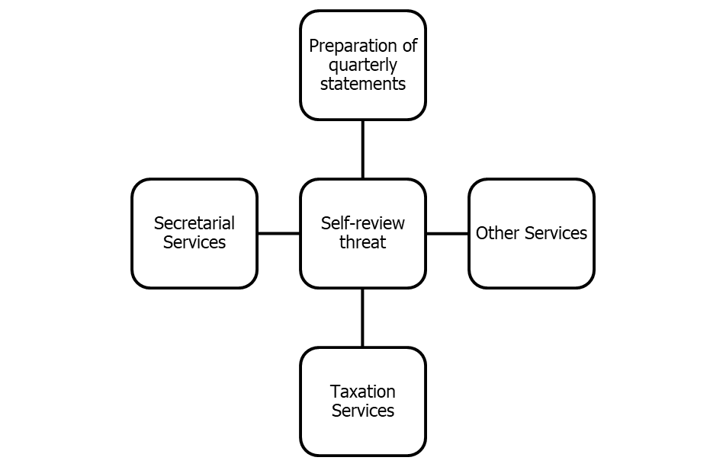

4.2 Safeguard’s Application
There are two general categories of security identified by code:
- Protection protected by occupation, law or regulation.
- Protection within the working environment.
Nonetheless, ACNABIN applies some protection guidelines related to instinct determined by ICAB. ICAB code of ethics is a policy based framework so there is no strict and fast rules to implement it but there are moral obligations. The code is more stringent when the client stock index is listed. BSESE sources on February 20, 2006 have stated that if there is no good explanation, the audit firms should not be involved in other services. Since L / B offices are not companies and being listed alone, there is no problem in such an article as described in ACNABIN3 legally. However, the protections enforced by ACNABIN are as follows:
The term 'taxation services' has a broader meaning. It can be broken into three general categories. ACNABIN:
- The client advises the audit client on one or more specific issues at the client's request.
- Audited has a significant proportion of tax planning or compliance work for the client.
- Audit promotes tax structures or products to clients, whose performance can be influenced by their account in financial statements.
Such services may cause self-review, self-interest, management and support threats. The protections to reduce these threats include:
- Financial statements are being provided by partner and staff by tax service with no partnership.
- Tax services are being reviewed by an independent tax partner and senior tax employee.
- Receiving external free consultation on tax work.
- Tax computations prepared by audit members are reviewed by a partner / staff member of appropriate experience who is not a member of the audit team.
- Audit partners involved in monitoring the financial statements are examined whether the tax work has been done properly and efficiently.
By enacting the above protection legislation, ACNABIN tries to reduce the threat of independence and especially self-review.

Chapter 5:
5.1 Recommendations
This allows an audit firm to provide various audit and non-audit services, which is not an organization and is not listed on the Stock Exchange in Bangladesh. However, if any agency is involved in the issue of providing services in both IFAC policy ethics such as ICAB ethics code, then any organization will be able to protect it. However, it should be noted here that after the collapse of US corporate giant in 2001, some accounting scandals were known as 'The Sarbanas-Oxley Act, 2002,' which was soon known as SOX, sent to protect investors. One of the SOX spirits is that the audit firm cannot provide advice or advisory services to its clients at the same time when it provides audit services. And at the same time, corporates were also prohibited from accepting audit and non-audit services from the same company. Although there is no proper law in Bangladesh which prohibits audit firms to provide audit and non-audit services to any other company outside the company, there should be some laws like Sarban-Oxley Law in Bangladesh. However, for business organizations to comply with corporate governance guidelines there must be some ambiguity in the implementation of communication or branch offices. Therefore, my recommendations are that audit companies should not be employed in the L / B office's non-audit services and the government has to form a high power committee to monitor the audit firms. The security system is working effectively and efficiently to ensure that its L / B office supplies audit services to the clients.

5.2 Conclusions
Garment products allow government and international retail brands to open and branch offices for efficient and efficient sourcing. Another advantage of enjoying the economy from L / B offices is that they send huge amounts of money to the US, which actually contribute to foreign currency reserves. L / B Offices are under the ITO of 1984 and the VAT Act, 1991. Therefore, to comply with the above laws, L / B offices are generally involved with local accounting firms for better services to reduce tax and VAT exposure. In that sense, local accounting and audit firms contributed to the economy by increasing the revenue of the Bangladesh government and developing transparency in L / B office financial activities. Apart from the conflict of providing audit and non-audit services by the same company, it is beneficial for all parties concerned with the involvement of local audit and accounting organizations with L / B offices.

Appendix:
- Reference
- Bangladesh Bank. 2015. Publications. [online] Available at: https://www.bb.org.bd/. [Accessed: 10 May 2016].
- Board of Investment. 2015. Business Law & License. [online] Available at: http://www.boi.gov.bd/. [Accessed: 10 May 2016].
- ICAB. 2009. Assurance, Professional Stage Knowledge Level. Dhaka: ICAB.
- IFAC. 2014. IFAC Code of Ethics. NY, USA: IFAC.
- Leahey, P. 2015. Bangladesh’s $50bn RMG export target by 2021. Dhaka Tribune, 04 May, p.
- Mala, D.A. 2013. Foreign liaison offices promote substandard RMG: NSI report. The Financial Express, 28 August, p.
- Mirdha, R.U. 2010. Top apparel buyers open offices in Dhaka. The Daily Star, 16 March,
- NBR. 1984. Income Tax Ordinance. Dhaka: Bangladesh Govt.
- NBR. 1991. VAT Act. Dhaka: Bangladesh Govt.

ANNEXURE
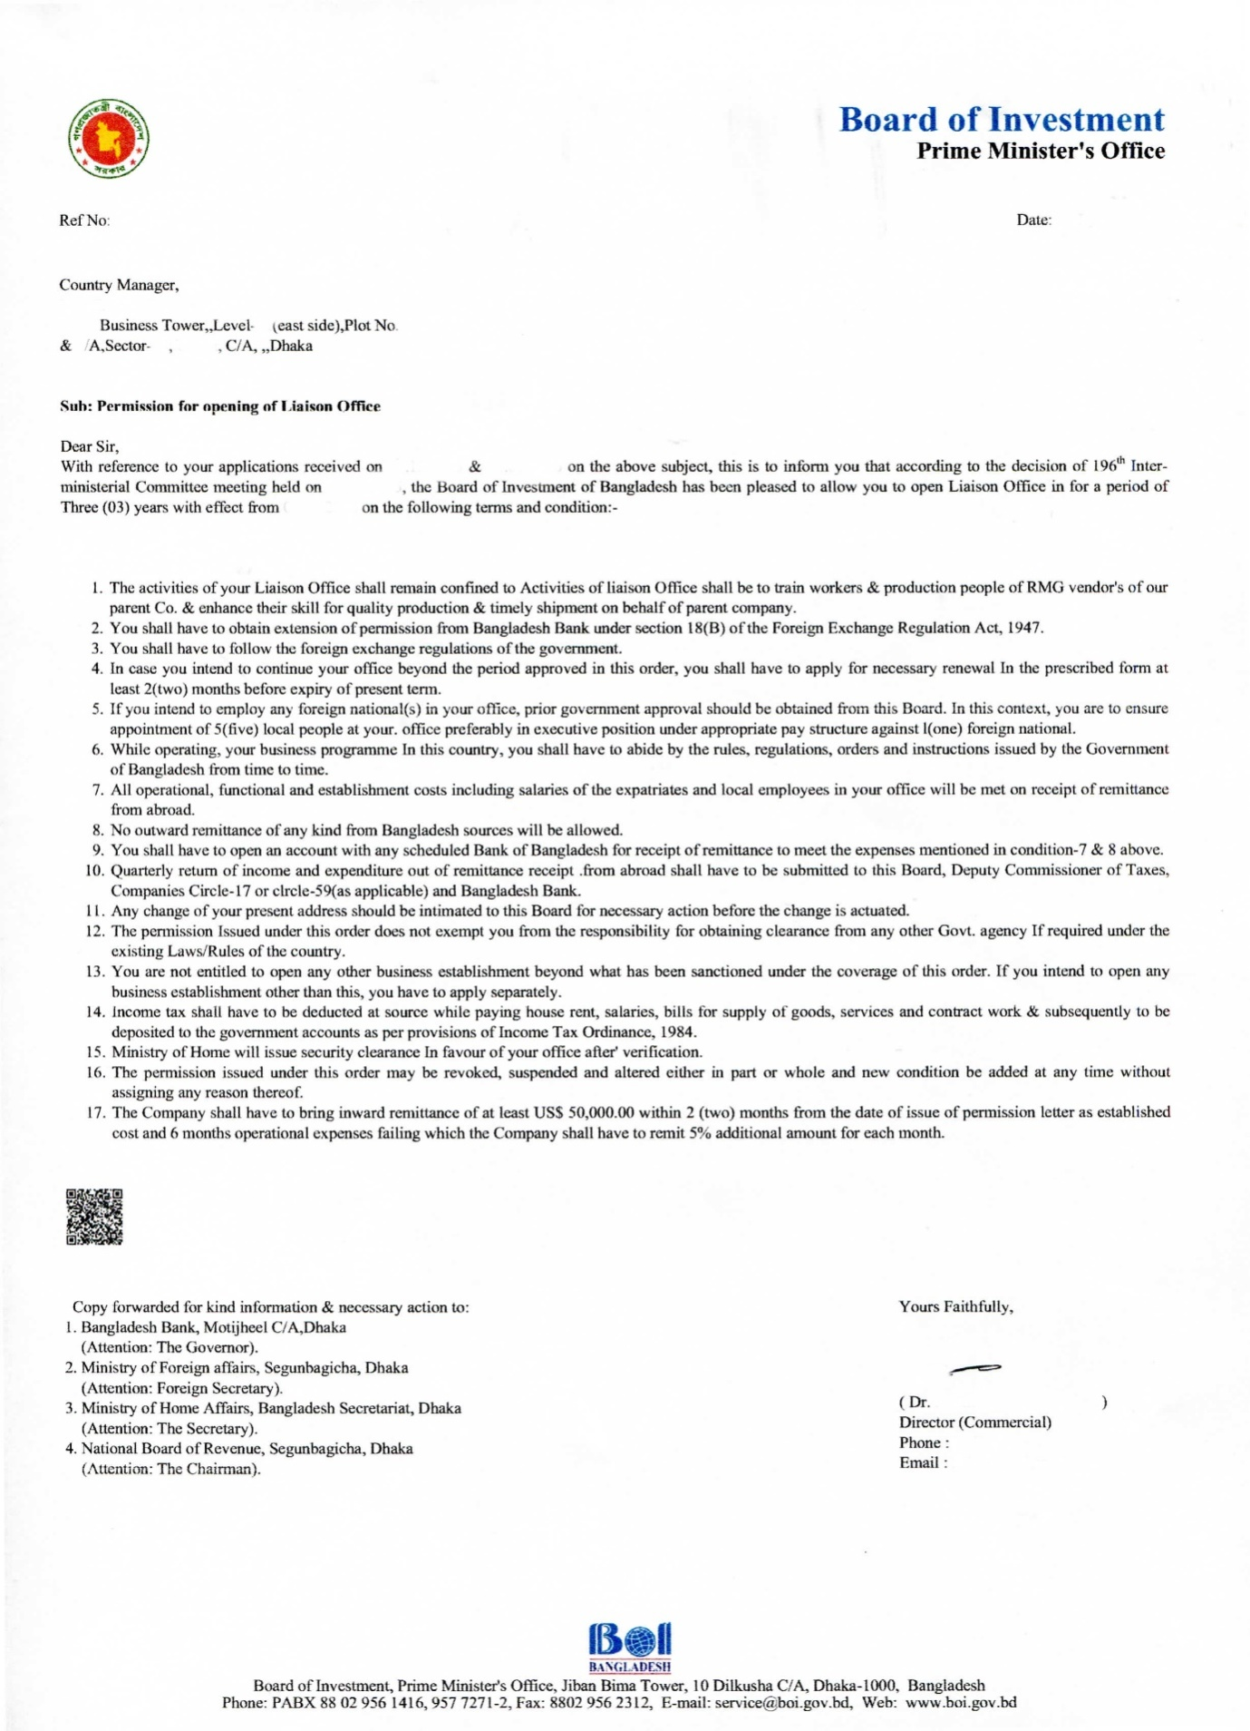
- Permission for opening of liaisonoffice

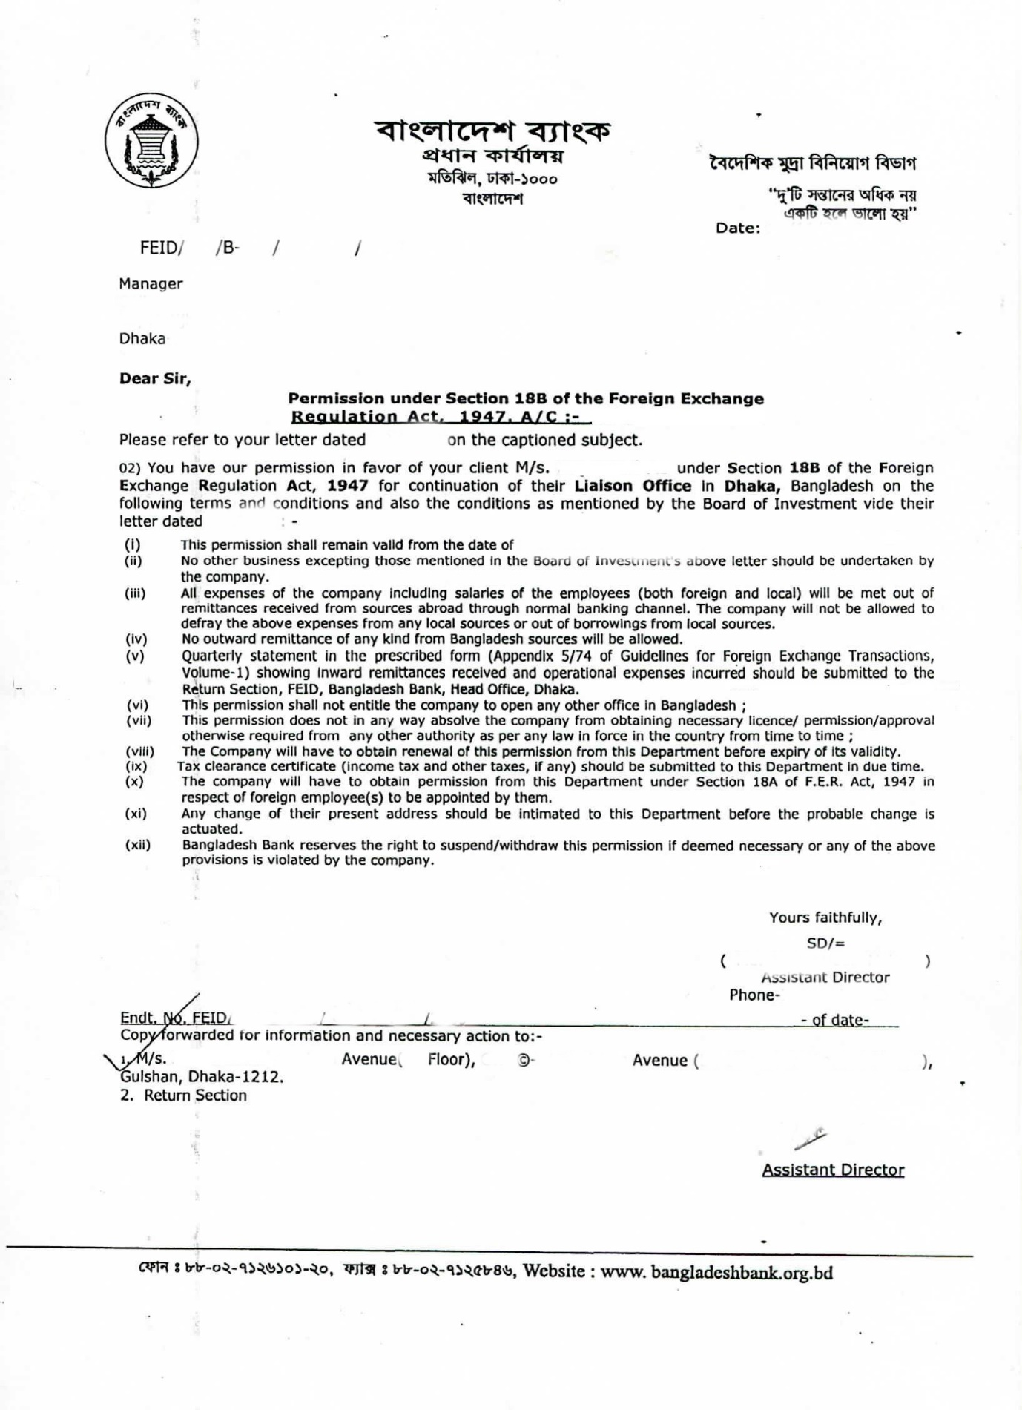
- Permission from Bangladesh Bank under foreign exchange regulation act for a liaison office.

- Extension of permission for liaisonoffice

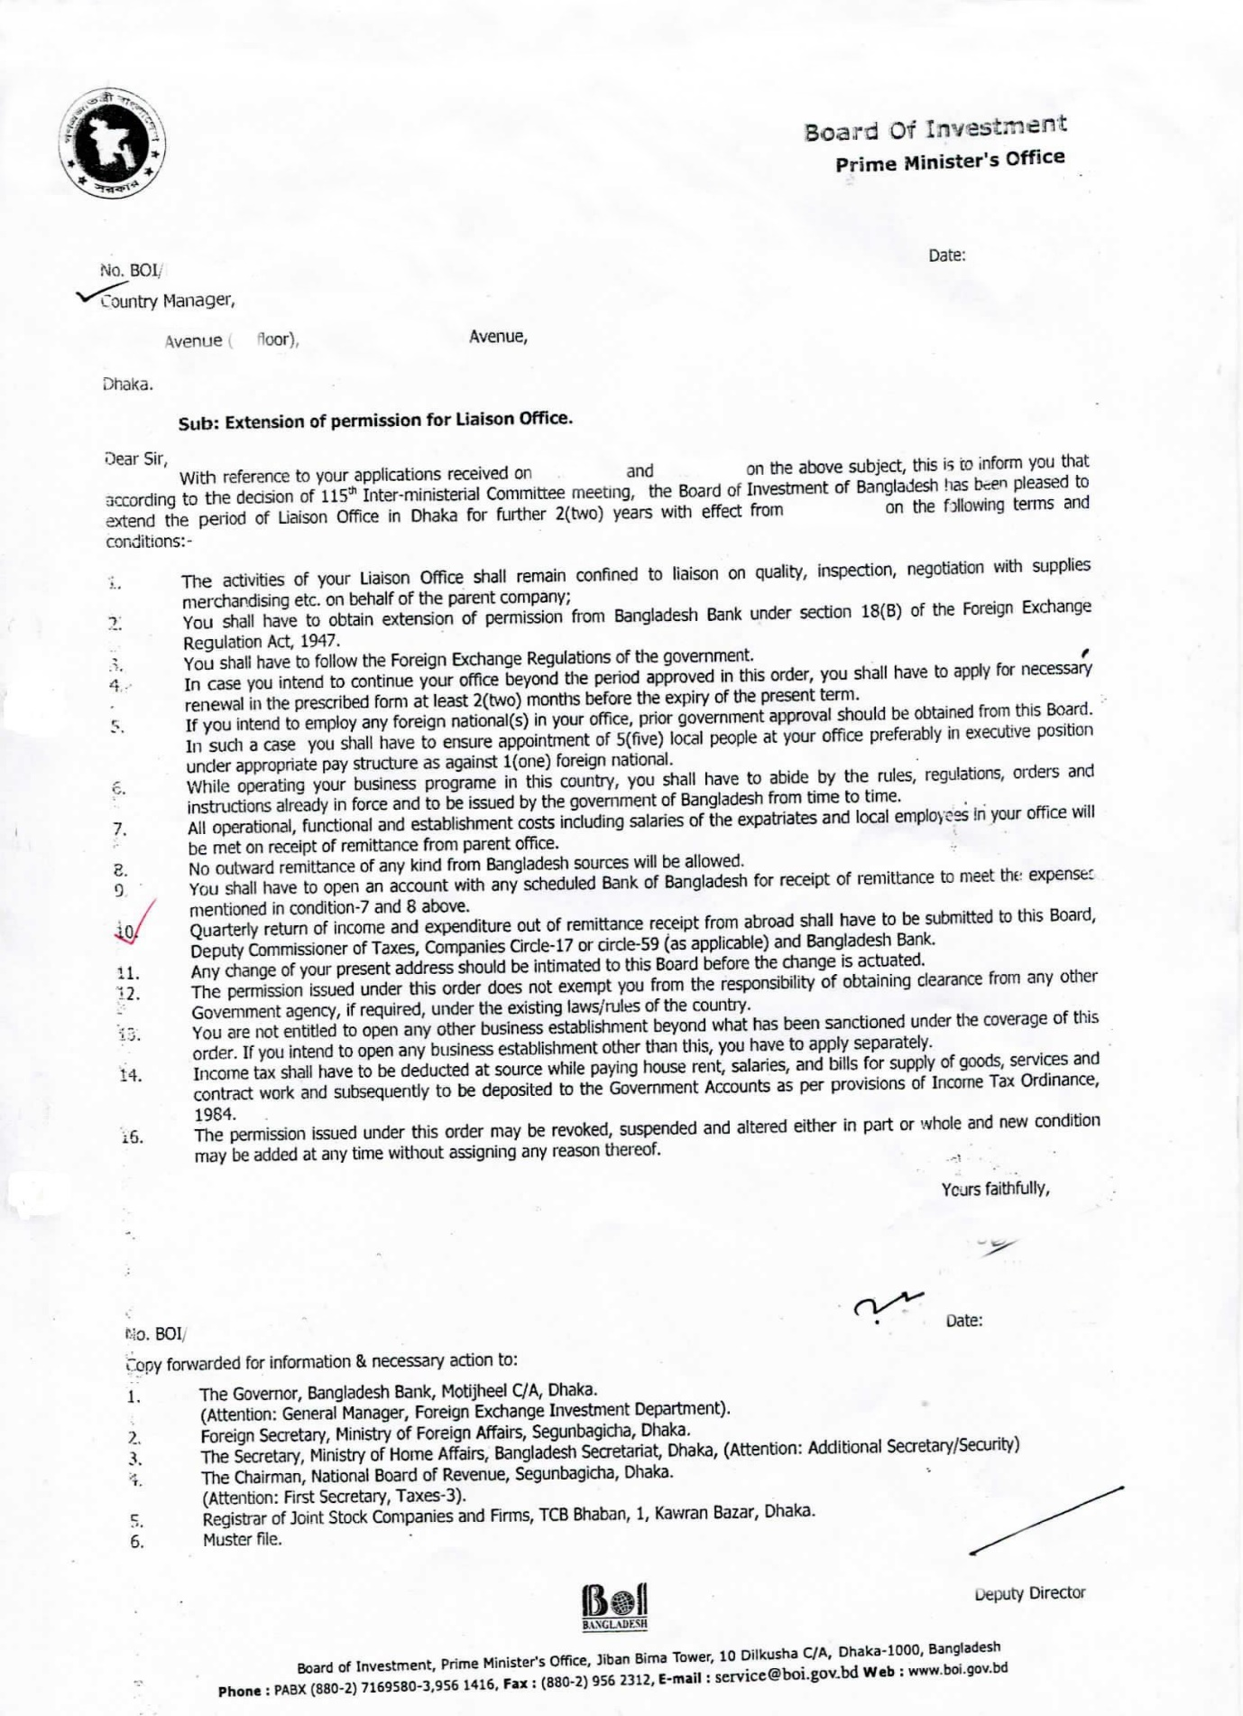
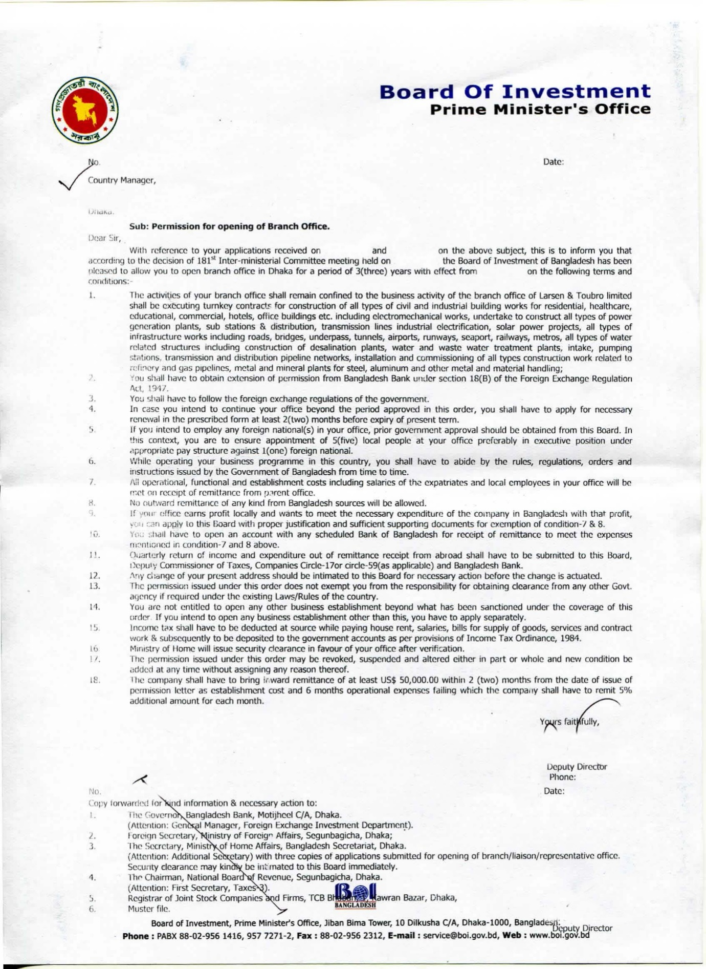
- Permission for opening of branchoffice

- Permission from Bangladesh Bank under foreign exchange regulation act for a branchoffice
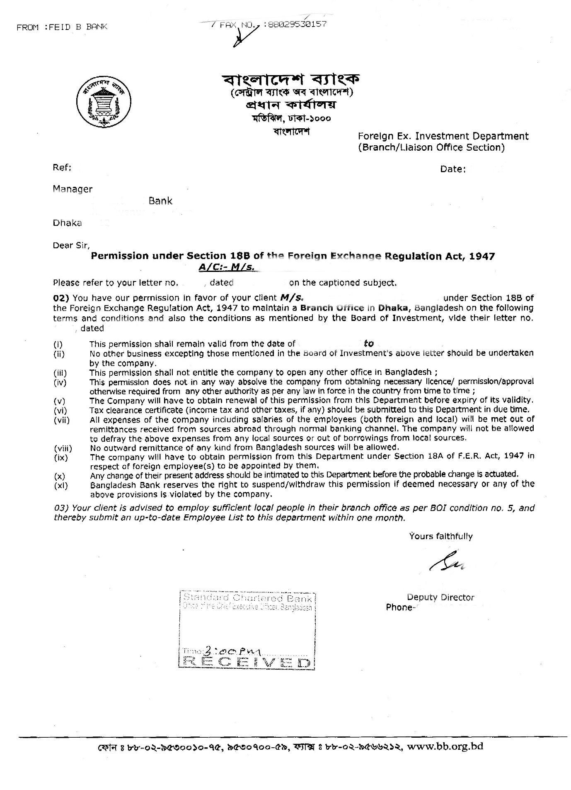

- Work permit for foreign nationals from BOI for branchoffice
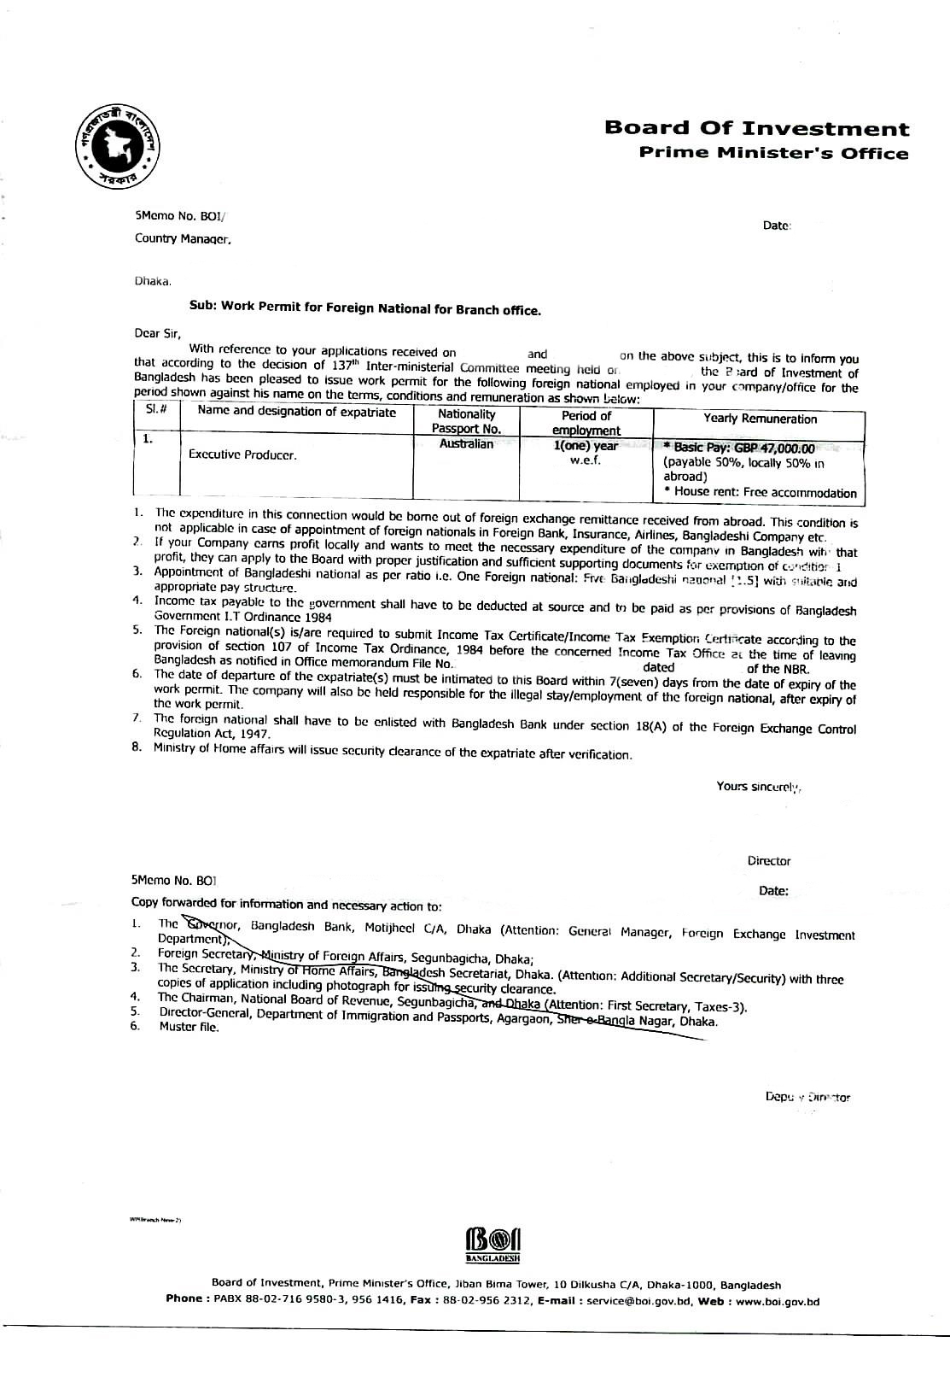

- Balance sheet of a liaisonoffice

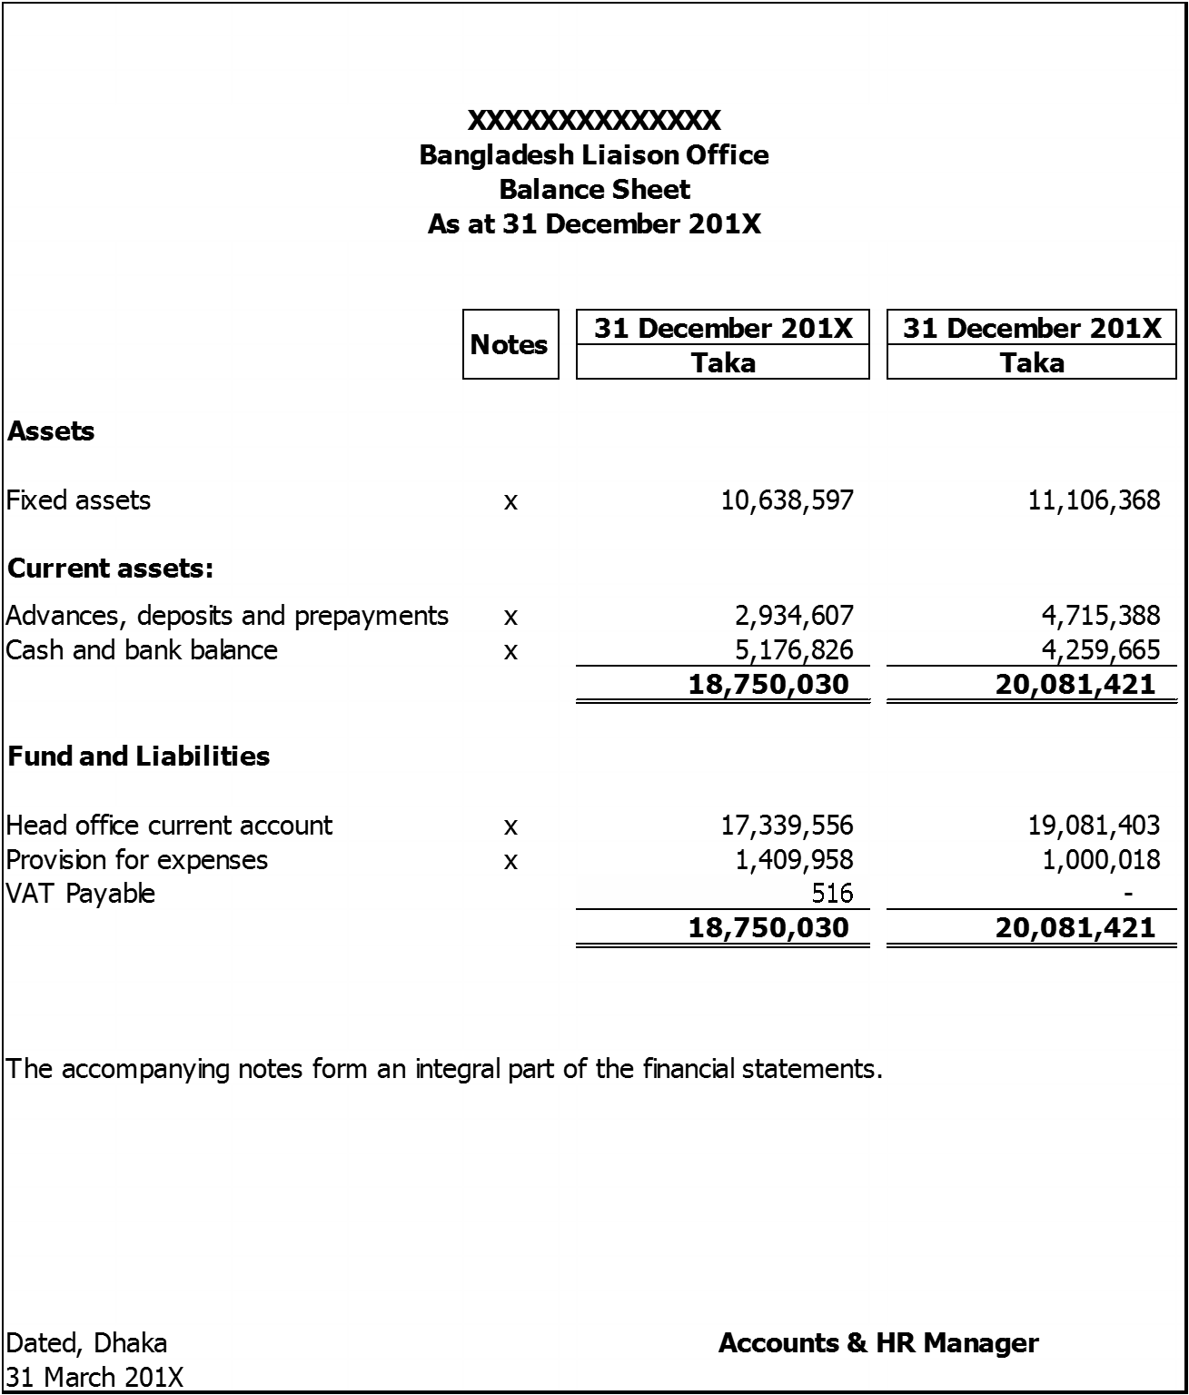

- Revenue expenditure account of a liaisonoffice

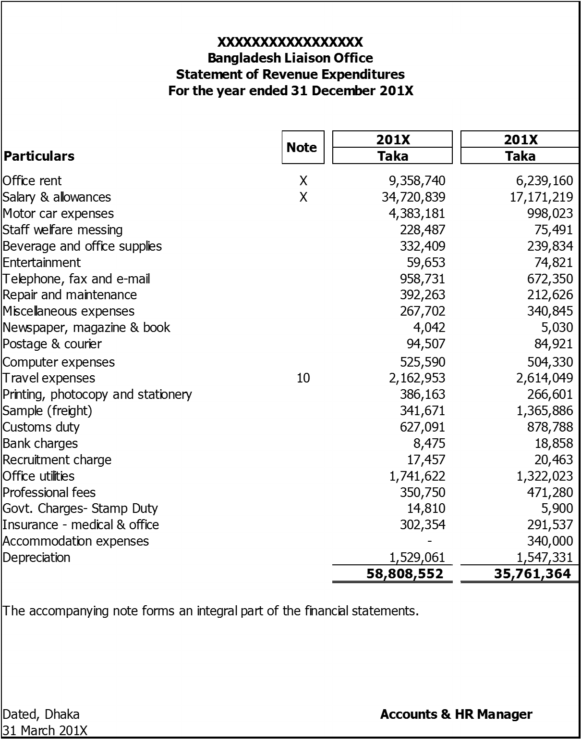

- Receipt and payment accounts of a liaisonoffice
