Financial Performance Analysis of IDLC

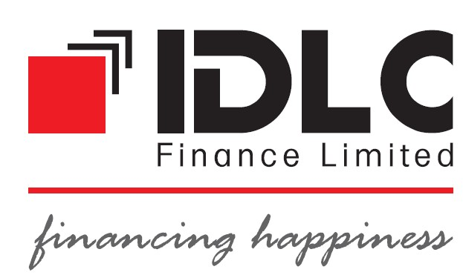


United International University

Topic: Financial Performance Analysis of IDLC
Course code: INT 4399
Fall 2018

Submitted To
Mohammad Ashraf
Associate Professor
School of Business and Economics
United International University

Submitted By
Md. Tauhidul Islam
ID: 111-151-425
School of Business and Economics
United International University

Date of Submission: 19 January, 2019

Letter of Transmittal
Date: 19th January, 2018
Mohammad Ashraf, (Ph.D.)
Associate Professor
School of Business and Economics
United International University
Subject: Submission of Project Paper
Dear Sir,
It is my great pleasure to submit my project paper on “Financial Performance Analysis of IDLC” as a requirement for BBA program. I have made sincere effort to make the report. In this report I have presented the brief overview of IDLC. For getting financial analysis I have prepared horizontal analysis, trend analysis, growth analysis, financial highlights. I also arrange ratio analysis, and margin analysis to evaluate financial performance of IDLC.
I have also identified some problems and given the solutions of these problems. This opportunity enhances my knowledge about some specific operating and financial aspects of financial institutions.
I will be glad to clarify any further quarries you may have regarding this report.

Sincerely yours
………………………………
Md. Tauhidul Islam
ID: 111-151-425
School of Business and Economics
United International University

Acknowledgement

Right off the bat I need to thank to god-like Allah without approval the report would not have been refined. I want to thank to my fair chief Professor Mohammad Ashraf, Ph.D., School of Business and Economics, United International University for his help to fruitful end of the report.

I would like to thank Mr. Md. Aminul Islam (SEO), Mr. Md. Mahmudur Rahman (BDO), for their help and direction for helping me finish my project paper.

At last I might want to thank to Md. Jahidul Islam (BDO) for providing information about IDLC. Without your support it can’t be possible.

Executive summary

Amongst many other well known, non-banking financial institution in Bangladesh, IDLC is one of them. IDLC Finance Ltd. was integrated as a public limited company in this country. The evaluation and the analysis of IDLC Finance Limited cover its performances as a whole. Based on the past data, the Horizontal Analysis predicts the future improvements of IDLC. The financial and operational performances of IDLC from the year 2013 to the year 2017 have been discretely shown in this report. The growth rates of the deposits have shown an increasing trend through the duration of this period. Through thorough analysis it has yield that the financial and operational expenditure of the bank shows a lower growth rate than that of the operating income over the years 2013 to 2017. Commendably and additionally performing are the ROA, ROE, EPS; which have increased the profitability of IDLC on a large scale. Any market is affected when the profitability of the bank goes down, majorly emphasizing the investors and creditors. However, the solvency ratios show that banks gradually increase the proportion of debt in comparison to its total assets and total equity in order to compensate for this matter. The risk ratios shows that IDLC has performed better during this period. It has been able to reduce the non-performing loan as a proportion, by decreasing the amount of loan per deposit ratio. The current ratio has been of an increasing trend over the period of time; simultaneously its growth rate has also been increasing. Conclusively, some problems have been identified and suggestions have been given in order for the management to overcome these issues. A conclusion on the overall performance of IDLC has been given at the end of this report.
.

Chapter 1

Introduction

1.1 Origin of the Report
This report has been prepared to satisfy the prerequisites for fulfillment of the Bachelor of Business Administration, (BBA) degree of United International University. This research project gives me a real life experience to analyze the activities of IDLC Investment Limited.
This report, named "Financial Performance Analysis of IDLC” is the outcome of a three month long work project on IDLC Investment Limited. I hope the report will give a clear idea and understanding about the activities and role of IDLC.
1.2 Objectives of the report:
- To present an overview of IDLC.
- To apprise the financial analysis of IDLC.
- To apprise the financial performance of IDLC
- To understand the problems of IDLC.
- To give basic solutions to the problems of IDLC. .

1.3 Scope of study
This report covers a brief overview of IDLC and description about and on their major activities. This report also highlights the financial performance of IDLC over the past five years. The financial time period or duration that has been analyzed for this study is from the year 2013 to the year 2017.
Finally, efforts were given to identify the factors that led to the successes or failures experienced by IDLC, in the non-banking industry. Some suggestions to management have also been provided in this regard.

1.4 Methodology of study
The nature of this study is exploratory. The financial performance’s analysis of IDLC has been done this study. Ratio analysis was predominantly used. Regarding the completion of this report the secondary data was invariably used. The secondary sources include-
- Annual Reports of IDLC over the past 5 years.
- For the industry average, financial information of 23 companies has been used and the data were collected from the main companies.
No survey was conducted for this report. I have gone through various secondary sources in order to gather data that are related to the basics of accounting exercises and also related to the problems of the accounting exercises.

1.5 Limitations of the Study:
I have found some limitations throughout the process of preparing this report. The limitations are given below-
- Some information needed to develop this report is highly privileged but IDLC Finance Ltd. did not allow full disclosure of these data.
- Though, there are convenient ways to get to know about the products of IDLC Finance Ltd. There are minute or very few written documents available for the operating procedures.
- There are some departments at IDLC Finance Ltd., which are regarded as intellectual assets of the organization. In those departments, proper entrance to get data about their principal activities or how they work could not be managed.
- Limited time is another barrier to preparing a quality report.
- Secret report is another barrier to preparing a quality report.

Chapter 2

An Overview of IDLC Finance Limited

2.1TCompanyTOverview
One of the biggest non-Banking financial organizations in Bangladesh is IDLC. It is composed of three fully owned subsidiaries.
IDLC competently serves over fifty thousand customers through 41 major touch points throughout 24 cities of the country. Every day, more than 1,300 people put their countless efforts together in Corporate Finance, SME Finance, and Consumer Finance and Capital Market segments of the Bank. IDLC has yet, till date, been a story of success and growth built on the trust and respect of their dependent customers, since 1985.
With IDLC, isolation has never been the keen achievement goal - rather it aims for inclusive growth as it has made its platform in the lives of the people with whom it has been privileged to come across and provide for.
IDLC has been serving customers with its products & services; it has also been through the initiatives taken to solve a few of their problems. This philosophy has actively prompted IDLC to launch the ‘IDLC Khushir Kheya’; it is a volunteering platform encompassing areas such as education, fitness, environment and populations projects where volunteers from all over Bangladesh are welcome to willingly contribute with us in the process of building a happier tomorrow, which took place last year.

2.2 Subsidiaries

2.2.1 IDLC Investments Limited
As per the requirement of the Bangladesh Securities & Exchange Commission (BSEC), IDLC has formed a separate subsidiary on May 19, 2010 with the name and style ‘IDLC Investments Limited’ in order to transfer its activities in merchant banking. The license of this company was obtained from BSEC on August 02, 2011 and commencement of its business was on August 16, 2011. The main businesses of IDLC are mainly portfolio management, issue management, underwriting of securities and advisory services.

2.2.2 IDLC Securities limited
IDLC securities Limited, is a well-managed and fully owned subsidiary by IDLC; it offers full-fledged international standard brokerage services for its retailing and institutional clients. It has predominantly reserved seats on both Dhaka Stock Exchange and Chittagong Stock Exchange Limited as well. It also has a Depository Participant (DP) of
Central Depository Bangladesh Limited (CDBL).

2.2.3 IDLC Asset Management Limited
IDLC Asset Management Limited is another fully owned subsidiary of IDLC Finance Limited with its headquarters in Dhaka, Bangladesh amongst many others. Asset management services are offered hers, which currently consist of Mutual Funds proposed to several individuals and institutions.

2.3 IDLC Philosophies – The Backbone of the Enterprise
2.3.1 Vision
Become the best financial brand in the country.
2.3.2 Mission
Focus is on quality growth, superior customer experience and substantial business practice.

2.3.3 Strategic Objective
- Grow and develop its talent pool.
- Fully leverage the core banking platform.
- Optimize distribution points.
- Grow and diversify funding sources.
- Grow sales and service capabilities in the consumer division.
- Sustainably grow SME portfolio.
- Focus on top-level customers in the corporate section.
- Consolidate capital market activities and improve capacities.
- Embrace globally acknowledged corporate administration and maintainable business rehearses.

2.3.4 Core Values
- Integrity
- Customer Focus
- Trust and Respect
- Equal Opportunity
- Eco-accommodating
- Passion Simplicity

2.3.5 Code of Conduct and Ethical Guidelines
- Act with trustworthiness, capability, poise and in a moral way when managing clients, prospects, associates, offices and general society.
- Act and urge others to act in an expert and moral way that will think about emphatically IDLC workers, their calling and on IDLC on the loose.
- Strive to keep up and enhance the ability of all in the business.
- Use sensible care and exercise free proficient judgment.
- Not limit others from playing out their expert commitments.
- Maintain learning of and agree to every material law, standards and controls • Disclose all irreconcilable circumstances.
- Deliver proficient administrations as per IDLC strategies and pertinent specialized and expert measures.
- Respect the classification and protection of clients, individuals and others with whom they work together.
- Not take part in any expert direct including deceitfulness, extortion duplicity or deception or confer any demonstration that considers unfavorably genuineness, dependability or expert fitness.

2.4 organogram T22.4 organogram.4 organogram
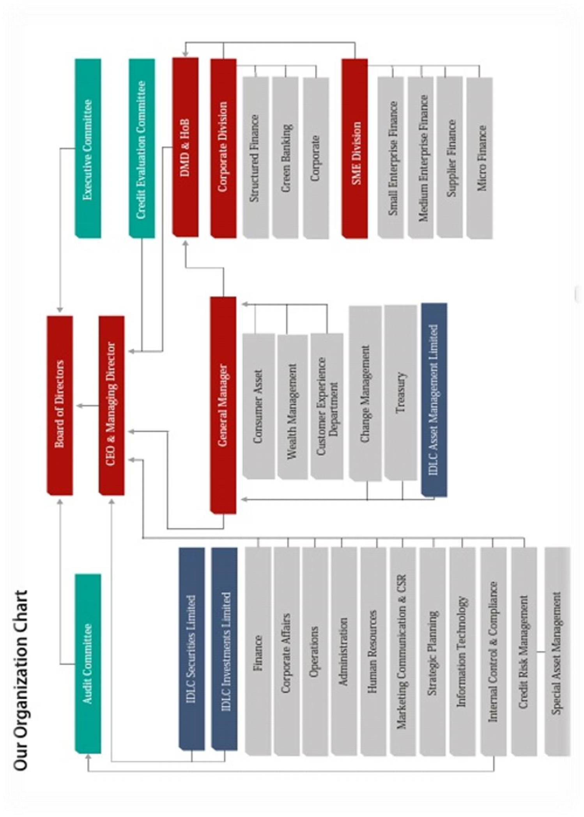

2.5 Shareholder Structure
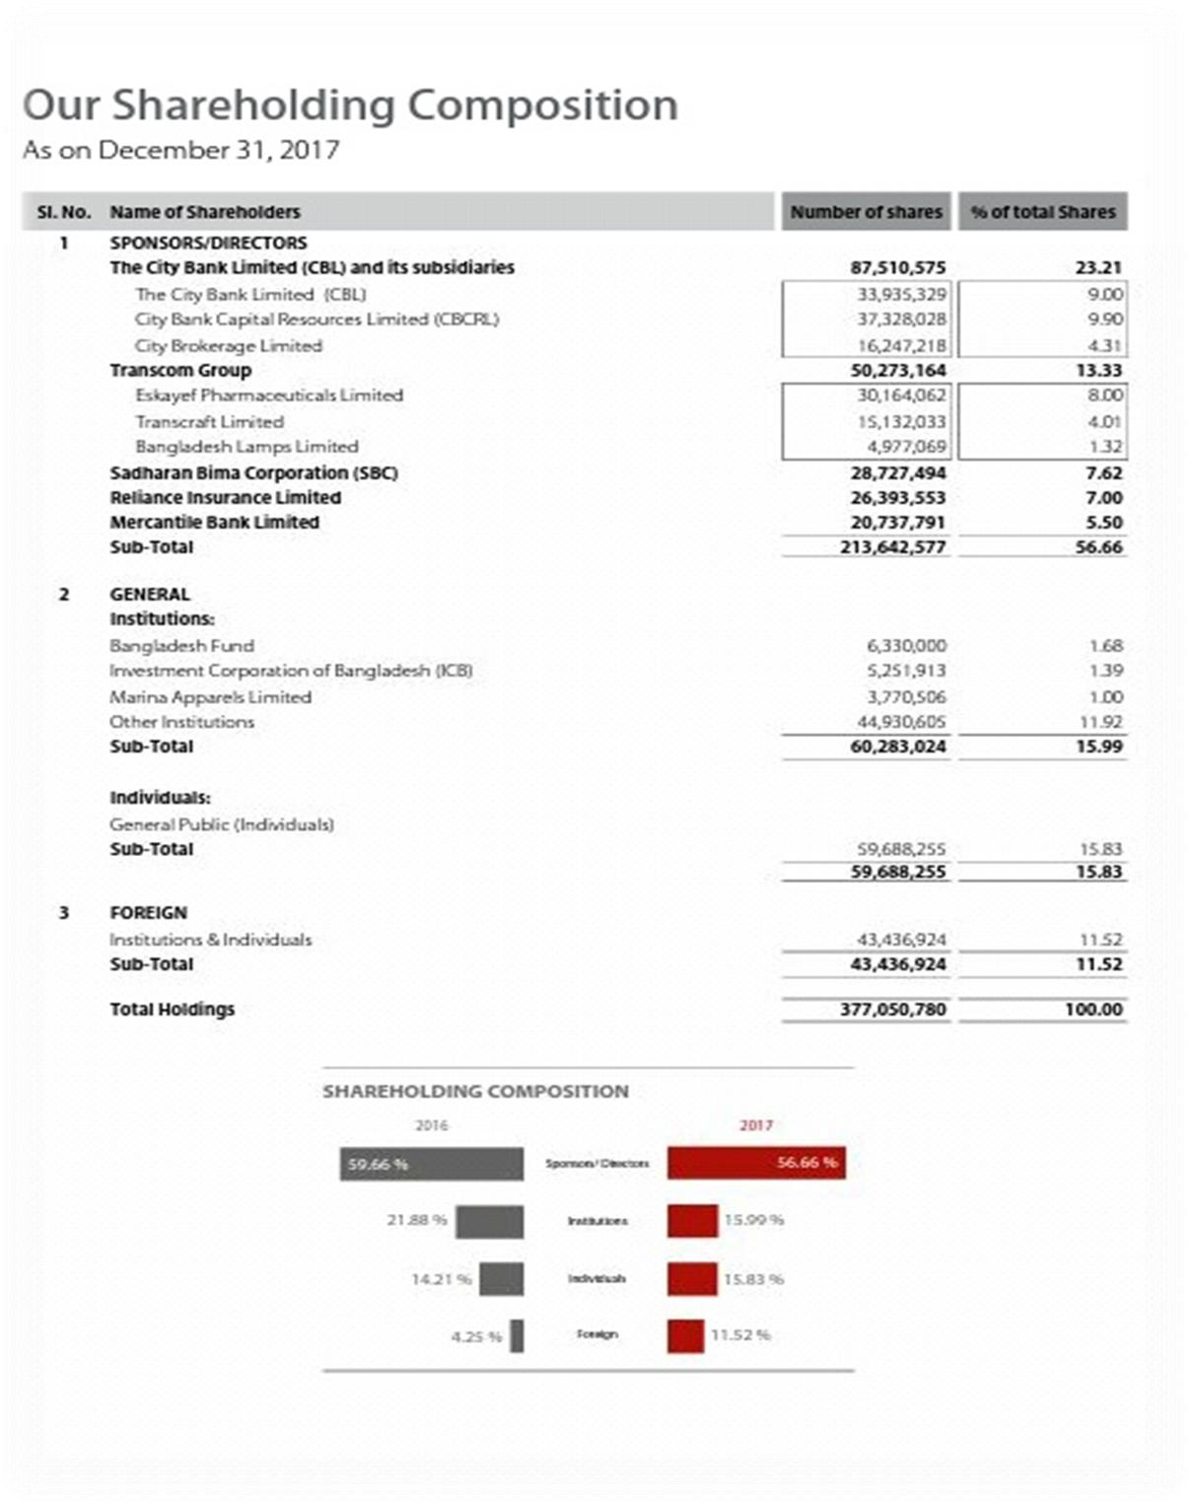

2.6 Product & Service Basket

2.6.1 Small and Medium Enterprises (SME) Finance
Small Enterprise Finance
- Small Enterprise Loan/ Lease
- Seasonal Loan
- IDLC Purnota – Women Entrepreneur Loan
- SME Shachal Loan
- Revolving Short Term Loan
- Commercial Space Loan
- Commercial Vehicle Loan
- IDLC Udbhabon
- SME Deposit
Medium Enterprise Finance
- Medium Enterprise Loan /Lease
- Commercial Vehicle Finance
- Machinery Lease
- Revolving Short Term Loan
- Commercial Space Loan
- Commercial Vehicle Loan
Supplier and Distributor Finance
- Factoring of Accounts Receivable
- Bill/ Invoice Discounting
- Work Order Financing
- Distributor Financing

2.6.2 Corporate Finance
Corporate Finance
- Lease Financing
- Term Loan Financing
- Commercial Space Financing

- Project Financing
- Short Term Loans (to meet working capital requirements)
- Specialized Products (for meeting seasonal demand)
- Green Financing
Structured Finance Solutions
- Debt Syndication (Local & Foreign Currency)
- Working Capital Syndication
- Agency & Trusteeship
- Fund Raising through Zero Coupon & Coupon Bearing Bonds
- Commercial Paper
- Arrangement of Private Equity n& Preference Shares
- Corporate Advisory for Mergers& acquisitions and Joint Venture Making • Preparation of Feasibility Study
Green Banking Solutions
- Over 50 products offered under Green Banking and Sustainable Finance department as per Bangladesh Bank Green Refinance scheme

2.6.3 Consumer Finance
Loans
- Home Loans
- Car Loans
- Personal Loans
- Loan against Deposit
Deposits
- Flexible Term Deposit Package
- Regular Earner Package

2.6.4 Capital Markets Operations

IDLC Securities Limited
Products
- Cash Account
- Margin Account through IDLC Investments Limited and other enlisted merchant banks • Easy IPO
- Premium Brokerage for High Net worth Individuals (HNIs) an institutional and foreign investment services
- Trade execution through the Dhaka and Chittagong stock exchanges
- Custodial and CDBL services
- Bloomberg terminal for foreign clients
- Research and Advisory Services

IDLC Investments Limited
Products
- Margin Loan
- Discretionary Portfolio Management Services
- Corporate Advisory
- Issue Management
- Underwriting

IDLC Asset Management Limited
Products
- Mutual Funds
- Portfolio Management

Chapter 3
Financial Analysis of IDLC

3.1 Financial Highlights (IDLC Finance Limited and its subsidiaries)
In BDT Million
Particulars | 2013 | 2014 | 2015 | 2016 | 2017 | Growth in 2017
Financial Performance
Lease and Term loans disburse | 16,895 | 17,473 | 22,140 | 29,807 | 35,511 | 19.14%
Housing finance disbursement | 4,421 | 5,896 | 5,954 | 5,646 | 7,893 | 39.80%
Short term finance (portfolio) | 604 | 735 | 1,079 | 1,079 | 778 | -8.01%
Lease Finance (portfolio |  | 6,282 | 6,016 | 4,950 | 4,629 | -6.49%
Real estate finance assets (portfolio) | 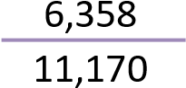 | 14,822 | 17,206 | 18,108 | 21,462 | 18.52%
Total assets | 48,535 | 57,160 | 71,769 | 76,505 | 92,611 | 21.05%
Long term liabilities | 42,884 | 50,471 | 63,591 | 67,446 | 80,540 | 19.41%
Term deposit balance |  | 35,241 | 46,174 | 47,564 | 60,538 | 27.28%
Net current asset | 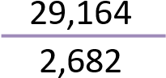 | 2,778 | 5,924 | 5,031 | 6,580 | 30.80%
Operational Performance
Operational income | 2,573 | 3,326 | 3,961 | 4,433 | 4,801 | 8.31%
Operational expenses | 1,021 | 1,237 | 1,394 | 1,679 | 1,934 | 15.23%
Financial expenses | 4,127 | 4,530 | 4,827 | 4,625 | 4,902 | 6.00%
Profit before tax | 1,406 | 2,029 | 2,276 | 2,581 | 2,639 | 2.25%
Net profit after tax | 811 | 1,154 | 1,244 | 1,496 | 1,582 | 5.72%
Financial Ratios
Debt equity ratio (Times) | 9.50 | 9.04 | 9.65 | 9.06 | 7.76 | (1.30)
Average effective tax rate (%) | 42.32 | 43.15 | 45.34 | 42.02 | 40.05 | (1.97)
Financial expenses coverage ratio (Times) | 1.34 | 1.45 | 1.47 | 1.56 | 1.54 | (0.02)
Current ratio (Times) | 1.14:1 | 1.13:1 | 1.22:1 | 1.17:1 | 1.18:1 | 0.01
Return on total assets (%) | 1.92 | 2.18 | 1.93 | 2.02 | 1.87 | (0.15)
Non-performing loan ratio (%) | 1.63 | 2.02 | 3.06 | 2.95 | 2.77 | (0.18)
Return on shareholders’ equity  (%) | 19.24 | 22.37 | 20.01 | 20.87 | 17.41 | (3.46)
Earnings per share* (BDT) | 2.50 | 3.56 | 3.84 | 4.62 | 4.26 | (0.36)
Dividend per share (BDT) | 3.00 | 3.50 | 2.50 | 3.00 | 3.00 | -
Dividend yield (%) | 4.77 | 4.69 | 3.93 | 5.26 | 3.52 | (1.75)
Dividend payout ratio (%) | 92.98 | 76.27 | 50.52 | 75.59 | 71.50 | (4.09)
Shareholders’ equity | 4,621 | 5,694 | 6,737 | 7,605 | 10,569 | 38.98%
Net interest income as a percentage (%) of working  funds | 6.13 | 6.78 | 6.44 | 6.14 | 5.77 | (0.36)
Operating Profit as percentage (%) of working fund | 4.46 | 4.97 | 5.18 | 5.79 | 4.35 | (0.44)
*Earning per share is required to be calculated based on adjustment factor, as there was issuance of right shares during the year.

3.2 Horizontal Analysis (IDLC)

3.2.1. Horizontal Analysis of Balance Sheet (IDLC)
Particular | 2017 | 2016 | 2015 | 2014 | 2013
Cash | 147.23% | 131.12% | 119.80% | 98.09% | 100%
In hand | 127.91% | 124.92% | 121.59% | 114.98% | 100%
Balance with Bangladesh Bank and its agent | 147.24% | 131.12% | 119.80% | 98.10% | 100%
Balance with other banks and financial institutions | 191.69% | 145.92% | 176.38% | 102.03% | 100%
Inside Bangladesh | 191.69% | 145.92% | 176.38% | 102.03% | 100%
Outside Bangladesh | 0.00% | 0.00% | 0.00% | 0.00% | 100%
Money at call and short notice | 0.00% | 0.00% | 0.00% | 0.00% | 100%
Investments | 1007.27% | 552.83% | 431.31% | 335.14% | 100%
Government | 0.00% | 0.00% | 0.00% | 0.00% | 100%
Others | 1007.27% | 552.83% | 393.17% | 297.00% | 100%
Loans and advances | 174.64% | 151.97% | 134.86% | 114.97% | 100%
Loans, cash credit, overdraft etc. | 174.64% | 151.97% | 134.86% | 114.97% | 100%
Bills purchased and discounted | 0.00% | 0.00% | 0.00% | 0.00% | 100%
Fixed assets including land, building, furniture | 167.49% | 165.34% | 135.73% | 97.84% | 100%
Other assets | 194.47% | 164.09% | 190.67% | 190.28% | 100%
Non-banking assets | 0.00% | 0.00% | 0.00% | 0.00% | 100%
Total Assets | 189.74% | 157.27% | 145.62% | 116.85% | 100%
LIABILITIES AND CAPITAL
Liabilities
Borrowings from other banks, financial institutions | 129.14% | 142.33% | 119.91% | 104.19% | 100%
Deposits and other accounts | 205.69% | 163.39% | 157.76% | 121.23% | 100%
Current accounts and other accounts etc. | 0.00% | 0.00% | 0.00% | 0.00% | 100%
Bills payable | 0.00% | 0.00% | 0.00% | 0.00% | 100%
Savings bank deposits | 0.00% | 0.00% | 0.00% | 0.00% | 100%
Term deposits | 205.94% | 163.35% | 158.41% | 121.25% | 100%
Bearer certificate of deposits | 0.00% | 0.00% | 0.00% | 0.00% | 100%
Other deposits | 199.26% | 164.60% | 141.15% | 120.58% | 100%
Other liabilities | 158.59% | 140.21% | 122.92% | 109.16% | 100%
Total Liabilities | 184.37% | 156.15% | 145.67% | 116.27% | 100%
Capital / Shareholders’ equity

Paid-up capital | 234.37% | 156.25% | 156.25% | 125.00% | 100%
Share premium | 33616.00% | 100% | 100% | 100% | 100%
Statutory reserves | 209.16% | 177.62% | 147.79% | 123.00% | 100%
General reserves | 123.27% | 123.27% | 123.27% | 123.27% | 100%
Dividend equalization reserves | 0.00% | 0.00% | 0.00% | 0.00% | 100%
Retained earnings | 234.03% | 190.12% | 144.99% | 118.18% | 100%
Total equity attributable to equity holders of com. | 234.91% | 166.66% | 145.19% | 121.73% | 100%
Non-controlling interest | 161.87% | 128.64% | 116.77% | 105.39% | 100%
Total liabilities and Shareholders’ equity | 189.74% | 157.27% | 145.62% | 116.85% | 100%

3.2.2. Horizontal Analysis of Profit and Loss Account (IDLC)
Particulars | 2017 | 2016 | 2015 | 2014 | 2013
Interest income | 143.09% | 134.51% | 132.77% | 119.58% | 100.00%
Interest on deposits and borrowings etc. | 118.38% | 111.78% | 116.81% | 109.80% | 100.00%
Net interest income | 192.32% | 179.79% | 164.55% | 139.07% | 100.00%
Investment income | 2024.0% | 890.0% | 695.7% | 91.56% | 100.0%
Commission, exchange and brokerage | 260.61% | 152.31% | 123.19% | 123.92% | 100.0%
Other operating income | 131.36% | 150.10% | 129.27% | 106.00% | 100.0%
Total operating income | 227.43% | 187.00% | 166.14% | 132.46% | 100.0%
Salaries and allowances | 223.25% | 179.90% | 155.00% | 129.23% | 100.0%
Rent, taxes, insurance, electricity etc. | 207.92% | 203.85% | 128.16% | 114.95% | 100.0%
Legal expenses | 317.07% | 229.10% | 197.46% | 105.86% | 100.0%
Postage, stamp, telecommunication etc. | 116.96% | 105.22% | 108.51% | 105.73% | 100.0%
Stationery, printing, advertisements etc. | 166.91% | 122.80% | 102.50% | 137.53% | 100.0%
Managing Director’s salary and benefits | 80.06% | 68.04% | 87.99% | 100% | 100.0%
Directors’ fees | 233.73% | 191.61% | 144.26% | 115.94% | 100.0%
Auditors’ fees | 205.15% | 148.71% | 103.45% | 103.45% | 100.0%
Charges on loan losses | 0.00% | 0.00% | 0.00% | 0.00% | 0.00%
Depreciation and repair of Company’s assets | 120.85% | 125.13% | 111.59% | 102.85% | 100.0%
Other expenses | 158.44% | 128.48% | 109.77% | 98.39% | 100.0%
Total operating expenses | 187.85% | 157.56% | 132.52% | 117.71% | 100.0%
Profit before provision | 259.85% | 211.1% | 193.68% | 144.53% | 100.0%
Provision for loans and investments
General provision | -498.6% | -392.2% | -396.2% | -362.8% | 100.0%
Specific provision | 86.31% | 85.00% | 139.98% | -28.0% | 100.0%
provision for diminution in value of investments | 0% | -748.6% | -168.0% | 221.0% | 100.0%
Other provisions | 0.00% | 0.00% | 0.00% | 0.00% |  | 0.00%
Total provision | 120.73% | 81.22% | 161.59% | 4.09% |  | 100.0%
Total profit before taxation | 280.10% | 230.0% | 198.35% | 165.00% |  | 100.0%
Provision for taxation | 218.79% | 193.48% | 178.32% | 143.51% |  | 100.0%
Current tax expense | 227.33% | 199.32% | 183.92% | 150.63% |  | 100.0%
Deferred tax income | -71.9% | -5.6% | -12.5% | -99.2% |  | 100.0%

Interpretations:
- Cash has increased over the duration of 2013 to 2017 except 2014 due to the growth in Cash deposits and other accounts. The causes which provoked this increase in the deposits, were due to:
  - Increase in the balance with other banks
  - Increase in investments with increasing trend
  - Increase in loans and advances with increasing trend
  - Increase in fixed assets from 2013 to 2017
- The total overall assets of IDLC increased which indicated a positive sign for the company.
- On the other hand, the interest income also increased during 2013 to 2017
- Total operating income increased which is composed of the investment incomes, commission income and other operating incomes.
- On the other hand, the total operating expenses increased which included the Interest expenses, provisions against non-performing loans, bad debts that were written off directly and administrative expenses also increased simultaneously. But the increase in income was more than that of the increase in expenses.
- Total profit before taxations and net profit after taxations also increased significantly from 2013 to 2017.

3.3 Vertical Analysis (IDLC)
3.3.1 Vertical Analysis of Balance Sheet (IDLC)
Particulars | 2017 | 2016 | 2015 | 2014 | 2013
PROPERTY AND ASSETS
Cash | 1.15% | 1.23% | 1.21% | 1.24% | 1.48%
In hand | 0.00% | 0.00% | 0.00% | 0.00% | 0.00%
Balance with Bangladesh Bank and its agent | 1.15% | 1.23% | 1.21% | 1.24% | 1.48%
Balance with other banks and financial institutions | 14.25% | 13.08% | 17.08% | 12.31% | 14.10%
Inside Bangladesh | 14.25% | 13.08% | 17.08% | 12.31% | 14.10%
Outside Bangladesh | 0.00% | 0.00% | 0.00% | 0.00% | 0.00%
Money at call and short notice | 0.00% | 0.00% | 0.00% | 0.00% | 0.00%
Investments | 8.28% | 5.48% | 4.62% | 4.47% | 1.56%
Government | 0.00% | 0.00% | 0.41% | 0.51% | 0.00%
Others | 8.28% | 5.48% | 4.21% | 3.96% | 1.56%
Loans and advances | 74.72% | 78.45% | 75.19% | 79.88% | 81.19%
Loans, cash credit, overdraft etc. | 74.72% | 78.45% | 75.19% | 79.88% | 81.19%
Bills purchased and discounted | 0.00% | 0.00% | 0.00% | 0.00% | 0.00%
Fixed assets including land, building, furniture | 0.69% | 0.82% | 0.73% | 0.65% | 0.78%
Other assets | 0.91% | 0.93% | 1.17% | 1.45% | 0.89%
Non-banking assets | 0.00% | 0.00% | 0.00% | 0.00% | 0.00%
Total Assets | 100.00% | 100.00% | 100.00% | 100.00% | 100.00%
LIABILITIES AND CAPITAL
Liabilities
Borrowings from other banks, financial institution | 11.91% | 15.84% | 14.42% | 15.61% | 17.51%
Deposits and other accounts | 64.89% | 62.19% | 64.85% | 62.10% | 59.86%
Current accounts and other accounts etc. | 0.00% | 0.00% | 0.00% | 0.00% | 0.00%
Bills payable | 0.00% | 0.00% | 0.00% | 0.00% | 0.00%
Savings bank deposits | 0.00% | 0.00% | 0.00% | 0.00% | 0.00%
Term deposits | 62.55% | 59.86% | 62.69% | 59.80% | 57.63%
Bearer certificate of deposits | 0.00% | 0.00% | 0.00% | 0.00% | 0.00%
Other deposits | 2.34% | 2.33% | 2.16% | 2.30% | 2.23%
Other liabilities | 10.03% | 10.70% | 10.13% | 11.21% | 12.00%
Total Liabilities | 86.83% | 88.73% | 89.40% | 88.92% | 89.37%
Capital / Shareholders’ equity
Paid-up capital | 3.94% | 3.17% | 3.42% | 3.41% | 3.19%
Share premium | 1.32% | 0.00% | 0.01% | 0.01% | 0.01%
Statutory reserves | 2.19% | 2.25% | 2.02% | 2.09% | 1.99%
General reserves | 1.05% | 1.26% | 1.36% | 1.70% | 1.61%
Dividend equalization reserves | 0.05% | 0.06% | 0.06% | 0.08% | 0.09%
Retained earnings | 4.62% | 4.53% | 3.73% | 3.79% | 3.75%
Total equity attributable to equity holders of com. | 13.17% | 11.27% | 10.60% | 11.08% | 10.63%
Non-controlling interest | 0.00% | 0.00% | 0.00% | 0.00% | 0.00%
Total liabilities and Shareholders’ equity | 100.00% | 100.00% | 100.00% | 100.00% | 100.00%
3.3.2 Vertical Analysis of Profit and Loss Account
Particulars | 2017 |  | 2016 |  | 2015 |  | 2014 |  | 2013
Interest income | 100.00% |  | 100.00% |  | 100.00% |  | 100.00% |  | 100.00%
Interest on deposits and borrowings etc. | -55.08% |  | -55.33% |  | -58.58% |  | -61.13% |  | -66.58%
Net interest income | 44.92% |  | 44.67% |  | 41.42% |  | 38.87% |  | 33.42%
Investment income | 12.17% |  | 5.69% |  | 4.51% |  | 0.65% |  | 0.86%
Commission, exchange and brokerage | 8.49% |  | 5.28% |  | 4.33% |  | 4.83% |  | 4.66%
Other operating income | 5.04% |  | 6.12% |  | 5.34% |  | 4.86% |  | 5.49%
Total operating income | 70.62% |  | 61.77% |  | 55.60% |  | 49.22% |  | 44.43%
Salaries and allowances | 14.56% |  | 12.48% |  | 10.90% |  | 10.09% |  | 9.33%
Rent, taxes, insurance, electricity etc. | 2.48% |  | 2.58% |  | 1.64% |  | 1.64% |  | 1.70%
Legal expenses | 0.29% |  | 0.22% |  | 0.20% |  | 0.12% |  | 0.13%
Postage, stamp, telecommunication etc. | 0.42% |  | 0.41% |  | 0.42% |  | 0.46% |  | 0.52%
Stationery, printing, advertisements etc. | 1.57% |  | 1.23% |  | 1.04% |  | 1.55% |  | 1.35%
Managing Director’s salary and benefits | 0.12% |  | 0.11% |  | 0.14% |  | 0.18% |  | 0.21%
Directors’ fees | 0.03% |  | 0.02% |  | 0.02% |  | 0.02% |  | 0.02%
Auditors’ fees | 0.02% |  | 0.01% |  | 0.01% |  | 0.01% |  | 0.01%
Charges on loan losses | 0.00% |  | 0.00% |  | 0.00% |  | 0.00% |  | 0.00%
Depreciation and repair of Company’s assets | 2.17% |  | 2.39% |  | 2.16% |  | 2.21% |  | 2.57%
Other expenses | 4.61% |  | 3.98% |  | 3.44% |  | 3.43% |  | 4.17%
Total operating expenses | 26.27% |  | 23.43% |  | 19.97% |  | 19.69% |  | 20.01%
Profit before provision | 44.36% |  | 38.34% |  | 35.63% |  | 29.52% |  | 24.43%
Provision for loans and investments | 0.00% |  | 0.00% |  | 0.00% |  | 0.00% |  | 0.00%
General provision | 0.70% |  | 0.58% |  | 0.60% |  | 0.61% |  | -0.20%
Specific provision | 1.92% |  | 2.00% |  | 3.35% |  | -0.74% |  | 3.17%
provision for diminution in value of investments | 0.00% |  | -0.72% |  | -0.16% |  | 0.24% |  | 0.13%
Other provisions | 0.00% |  | 0.00% |  | 0.00% |  | 0.00% |  | 0.00%
Total provision | 2.62% |  | 1.86% |  | 3.78% |  | 0.10% |  | 3.10%
Total profit before taxation |  | 41.74% |  | 36.47% |  | 31.86% |  | 29.42% |  | 21.32%
Provision for taxation |  | 16.13% |  | 15.18% |  | 14.17% |  | 12.66% |  | 10.55%
Current tax expense |  | 16.28% |  | 15.19% |  | 14.20% |  | 12.91% |  | 10.25%
Deferred tax income |  | -0.15% |  | -0.01% |  | -0.03% |  | -0.25% |  | 0.30%
Net profit after taxation |  | 25.61% |  | 21.30% |  | 17.69% |  | 16.76% |  | 10.77%

Interpretations:
Vertical Analysis of Balance Sheet:
- The Balance sheet shows that the balance of IDLC had increased during 2013 to 2017, which indicated a positive signal on behalf of the company.
- The percentage changes in the investments increased from 2013 to 2017.
- The percentage changes in the loans and advances decreased from 2013 to 2017.
- The borrowing from other financial institutions decreased from 17.51% to 11.92%, which was beneficial for the performance of the company.

Vertical Analysis of Income Statement:
- The percentage change in the net interest income increased from 2013 to 2017.
- The percentage change of the total operating income also increased from 2013 to 2017.
- The percentage change of the total operating expenses increased but did not have any effect on the net profit because the operating income of IDLC maintains a steady increase every year.
The percentage of total profit before taxation and net profit after taxation increased every year, which is very efficient for IDLC.

3.4 Growth Analysis

FINANCIAL PERFORMANCE

3.4.1 Total Asset

Year | 2013 | 2014 | 2015 | 2016 | 2017
Total assets ( taka in million) | 50,429 | 58,927 | 73,434 | 79,311 | 95,687
growth Rate |  | 16.85% | 24.62% | 8.00% | 20.65%

16.85
%

%
24.62

8.00
%

%
20.65

0.00
%
10.00
%
20.00
%
30.00
%
2014
2015
2016
2017
Total assets Growth

According to the table, it can be seen that in 2013 the amount of total asset was Tk. 50,429 million where as in 2014 it increased to Tk. 58,927 million, which was about 16.85% greater than the previous amount. In the year 2015, it increased by 24.62%. In the year 2016, the amount of the total asset grew at a slower rate; therefore the growth rate of total asset was just a mere 8%. In 2017, the total asset of IDLC grew up by 20.65%, which indicates that IDLC will generate more cash flow in the upcoming future that will yield in boosting the confidence of new investors.

3.4.2 Long Term Liabilities

Year | 2013 | 2014 | 2015 | 2016 | 2017
Long term liabilities (taka in million) | 43,951 | 51,371 | 64,154 | 68,931 | 81,548
growth Rate |  | 16.88% | 24.88% | 7.45% | 18.30%

16.88
%

%
24.88

7.45
%

18.30
%

0.00
%
10.00
%
20.00
%
30.00
%
2014
2015
2016
2017
Long term liabilities
Growth

In 2013 the long-term liabilities of IDLC were Tk. 43,951 million. From the year 2013 to 2017 IDLC gradually increased its long-term liabilities. The growth rate of 2014 and 2015 were 16.88% and 24.88%. But in 2016, the amount of long-term liabilities grew at a slower rate therefore the growth rate was just a mere 7.45%. In 2017, IDLC’s total long-term liabilities grew up by 18.30% and the amount reached Tk. 81,548 million. This indicated that IDLC might have preferred more debt in their capital structure.

3.4.3 Term Deposit Balance

Year | 2013 | 2014 | 2015 | 2016 | 2017
Term deposit balance (taka in million) | 29,064 | 35,240 | 46,039 | 47,475 | 59,854
growth Rate |  | 21.25% | 30.64% | 3.12% | 26.07%

21.25
%

%
30.64

3.12
%

26.07
%

0.00
%
10.00
%
20.00
%
%
30.00
40.00
%
2014
2015
2016
2017
Term deposit balance
Growth

From the table, it is seen that the term deposit balance was Tk. 29,064 million in 2013. The consecutive year, 2014 it had increased by 21.25% and continued to increase up to 2017 on average. In the Year 2015, it increased by 30.64%, but in 2016 it had a downfall by 3.12%. But recovered the downfall by 2017 where it increased by 26.07%. This indicated that IDLC had more money or funds acquainted for new investments.

OPERATIONAL PPERFORMANCE

3.4.4 Operational Income

Year | 2013 | 2014 | 2015 | 2016 | 2017
Operational income (taka in million) | 2,761 | 3,658 | 4,588 | 5,164 | 6,280
growth Rate |  | 32.49% | 25.42% | 12.55% | 21.61%

%
32.49

25.42
%

12.55
%

21.61
%

0.00
%
10.00
%
20.00
%
%
30.00
40.00
%
2014
2015
2016
2017
Operational income
Growth

From the table, we see that the operational income of the year 2013 was Tk. 2,761 million. In 2014 the growth rate of the operational income increased by 32.49% and it kept on continuously increasing. In 2015 and 2016 the growth rate grew at a slower pace by decreasing to 25.42% and 12.55%. In 2017 the rate efficiently increased by 21.61%. This indicated that IDLC had a good earning source from their operations.

3.4.5 Operational Expense

Year | 2013 | 2014 | 2015 | 2016 | 2017
Operational expenses (taka in million) | 1,243 | 1,464 | 1,648 | 1,959 | 2,336
growth Rate |  | 17.78% | 12.57% | 18.87% | 19.24%

17.78
%

12.57
%

%
18.87

%
19.24

0.00
%
10.00
%
20.00
%
30.00
%
2014
2015
2016
2017
Operational expenses
Growth

From the table, we see that the operating expense of IDLC in 2013 was Tk. 1,243 million. In the year 2014 the amount increased to Tk. 1,464 million and the rate increased by 17.78%. From the year 2013 to 2017 the operating expenses increased gradually. In the year of 2015 the amount grew at a slower rate of 12.57%. In the year of 2016 and 2017 the growth rate increased to 18.87% and 19.24%. It is evident from this graph that the operating expenses have shown a persistent increase except the year 2015. This can be considered as unpleasant to IDLC because increasing of the operational expenses implies a reduction in the profitability.

3.4.6 Financial Expense

Year | 2013 | 2014 | 2015 | 2016 | 2017
Financial expenses (taka in million) | 4,138 | 4,543 | 4,833 | 4,625 | 4,898
growth Rate |  | 9.79% | 6.38% | -4.30% | 5.90%

%
9.79

6.38
%

-
%
4.30

5.90
%

-10.00
%
-5.00
%
%
0.00
5.00
%
10.00
%
15.00
%
2014
2015
2016
2017
Financial expenses
Growth

In 2013 the financial expense of IDLC was Tk. 4,138 million. In 2014 it increased to 9.79% in comparison to that of 2013 and continued to increase up to 2017 except for 2016. In the year 2016 it sharply decreased and the growth rate fell to -4.30%. In 2017 IDLC‘s financial expenses grew up by 5.90% and reached to Tk. 4,898 million. Indicating that the financial expenses experienced a continuous downfall. Therefore signifies that the profitability may have been higher.

3.4.7 Net Profit after Tax

Year | 2013 | 2014 | 2015 | 2016 | 2017
Net profit after tax (taka in million) | 669 | 1,246 | 1,459 | 1,780 | 2,277
growth rate |  | 86.25% | 17.09% | 22.00% | 27.92%

%
86.25

17.09
%

%
22.00

27.92
%

%
0.00
50.00
%
100.00
%
2014
2015
2016
2017
Net profit after tax
Growth

It is seen that the net profit after taxation was Tk. 699 million in 2013. In 2014 it had increased to 86.25%. In 2015 the rate grew at a slower rate of 17.09%, which is significantly lower from 2014. In 2016 the growth rate increased by 22.00%. In 2017 it was 27.92%. Increasing the net profit appeared to have given IDLC a potential form. It imposed a positive overview to investor to invest on IDLC.

3.4.8 Numbers of Shares

Year | 2013 | 2014 | 2015 | 2016 | 2017
Number of shares | 160,875,000 | 201,093,750 | 251,367,187 | 251,367,187 | 377,050,780
growth Rate |  | 25.00% | 25.00% | 0.00% | 50.00%

%
25.00

25.00
%

0.00
%

50.00
%

%
0.00
20.00
%
40.00
%
60.00
%
2014
2015
2016
2017
Number of shares
Growth

In 2013, IDLC’s numbers of share peaked at Tk. 160,875,000. In the consecutive year 2014 there was an increase of 25% in comparison to that of 2013. In 2015 it grew up by 25% but in 2016 the number of shares of IDLC was same, so that there was no change in growth rate. In 2017 it grew up by 50% and reached at Tk. 377,050,780. Therefore, the number of shares of IDLC can be assumed to be increasing in the future.

3.4.9 Net Asset Value per Share

Year | 2013 | 2014 | 2015 | 2016 | 2017
Net asset value per share | 14.22 | 17.31 | 20.65 | 23.7 | 33.41
growth Rate |  | 21.73% | 19.30% | 14.77% | 40.97%

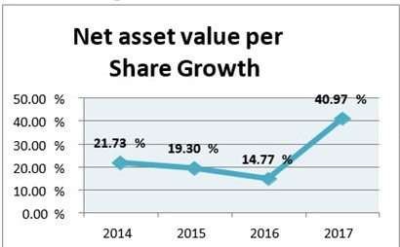
In 2013 IDLC’s net asset value per share was 14.22%. In the next year 2014 it grew up by 21.73% from the year 2014. In 2015 the growth rate decreased by 19.30%. In 2016 it grew up at a slower rate of 14.77%. In 2017 the growth rate grew up at an increasing rate of 40.97% and reached to Tk. 33.41. By observing the trend, it indicates that the net asset value of IDLC is slow .The higher the ratio is better for the firm. Increasing trend of net asset value per share indicates that assets of the company will increase day by day. It is a very good signal for its presentation to the market.

3.4.10 Market Capitalization

Year | 2013 | 2014 | 2015 | 2016 | 2017
Market capitalization (taka in million) | 10,119 | 15,022 | 15,987 | 14,328 | 32,162
growth rate |  | 48.45% | 6.42% | -10.38% | 124.47%

%
48.45

6.42
%

-
10.38
%

124.47
%

-50.00
%
0.00
%
50.00
%
100.00
%
150.00
%
2014
2015
2016
2017
Market capitalization
Growth

From the table it can be seen that in the year 2013 market capitalization was Tk. 10,119 million.
In 2014 it increased by 48.45% from the previous year 2013. In 2015 the growth rate decreased to 6.42%. In the year 2016 the growth rate become negative -10.38%. In the Year 2017 the growth rate grew up to 124.47% and reached to Tk. 32,162 million

3.4.11 Market Value Addition

Year | 2013 | 2014 | 2015 | 2016 | 2017
Market value addition (taka in million) | 29.57 | 42.24 | 32.63 | 21.44 | 51.89
growth Rate |  | 42.85% | -22.75% | -34.29% | 142.02%

%
42.85

-
22.75
%

-
34.29
%

142.02
%

-50.00
%
0.00
%
%
50.00
100.00
%
150.00
%
%
200.00
2014
2015
2016
2017
Market value addition
Growth

From the table it can be seen that the market value addition in 2013 was Tk. 29.57 million. In 2014 the growth rate increased to 42.85% from the year 2013. In the year 2015 the growth rate become negative that was -22.75%. In the year 2016 the growth rate was also negative that was -34.29%. In 2017 the growth rate grew up at increasing rate of 142.02% and reached to Tk. 51.89 million. It is indicate that IDLC may create substantial wealth for the shareholder in the year of 2017. The higher MVA is better for the company.

3.4.12 Shareholders’ Equity

Year | 2013 | 2014 | 2015 | 2016 | 2017
Shareholders’ equity (taka in million) | 5,363 | 6,528 | 7,786 | 8,938 | 12,597
growth rate |  | 21.72% | 19.27% | 14.80% | 40.94%

21.72
%

19.27
%

14.80
%

40.94
%

0.00
%
%
20.00
40.00
%
60.00
%
2014
2015
2016
2017
Shareholders’ equity
Growth

In 2013 IDLC’s total shareholders’ equity was Tk.5363 million. In the year 2014 it was increased by 21.72% and continues to increasing up to 2017. In 2015 the growth rate increased at a decreasing rate of 19.27%. In 2016 it reduced to 14.80%. But in 2017 the growth rate increased by 40.94%. The increasing trend of shareholders’ equity indicates that IDLC is substantially maximizing wealth of its shareholders.

CHAPTER 4

FINANCIAL PERFORMANCE EVALUATION OF IDLC

4.1 Ratio Analysis

PROFITIBILITY RATIOS

4.1.1 Return on Asset: Net income / Total Asset

 | 2014 | 2015 | 2016 | Mean
IDLC | 2.11% | 1.99% | 2.24% | 2.11%
Industry Average | 1.49% | 1.36% | 0.83% | 1.23%

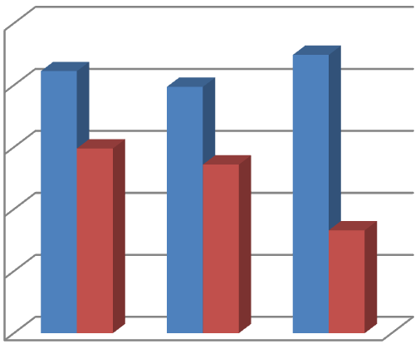

%
0.00
%
0.50
%
1.00
%
1.50
%
2.00
2.50
%
2014
2015
2016
2.11
%

%
1.99

2.24
%

1.49
%

%
1.36

0.83
%

Return on Asset

IDLC
Industry Average

In 2014 the return on asset was 2.11%. In 2015 the rate decreased by 1.99%. In 2016 the rate grew up by 2.24%. In 2014 the industry average was 1.99%. In 2015 and 2016 the rate were decreased by 1.36 and 0.83%.
It is calculated for measuring how efficiency IDLC manages its asset. Here mean return on asset of IDLC is higher than industry average. So it clean that it is more efficient to manage the banking asset.

4.1.2 Return on Equity: Net Income / Total Equity

 | 2014 | 2015 | 2016 | Mean
IDLC | 19.08% | 18.74% | 19.92% | 19.25%
Industry Average | 4.92% | 10.28% | 7.24% | 7.48%

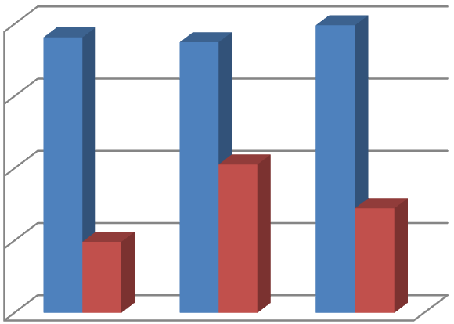

%
0.00
%
5.00
%
10.00
%
15.00
20.00
%
2014
2015
2016
%
19.08

%
18.74

%
19.92

4.92
%

10.28
%

7.24
%

Return on Equity

IDLC
Industry Average

From the table we see that in 2014 Return on equity of IDLC was 19.08%. In 2015 the rate decreased by 19.74%. In the year of 2016 the rate was increased by 19.92%. In 2014 the return on equity of industry average was 4.92%. In 2015 it was increased by 10.28%. In the year of 2016 the decreased by 7.24%.
Compering with the mean of industry average we see that IDLC’s Return on Equity is greater than industry average. It is calculated to measure how much return shareholder can get from the IDLC. So it is clean that IDLC is much attractive to its shareholder.

4.1.3 Earning per Share (taka): Net Income / Number of Share

 | 2014 | 2015 | 2016 | Mean
IDLC | 3.84 | 4.50 | 5.49 | 4.61
Industry Average | 1.56 | 1.76 | 1.72 | 1.68

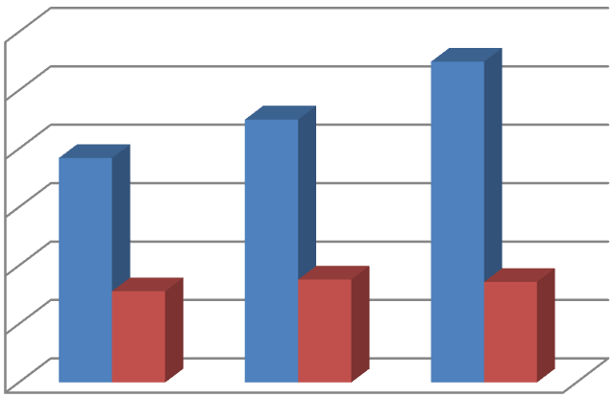

0
1
2
3
4
5
6
2014
2015
2016
3.84

4.5

5.49

1.56

1.76

1.72

Earnings per Share

IDLC
Industry Average

From the table we can see that the Earning per Share of IDLC’s in 2014 was 3.84 taka. From 2014 to 2016 the rate was gradually increased. In the year of 2016 the rate was 5.49 taka.
It is calculated to find out how much return IDLC can get when a shareholder can purchase single share. Here mean of earning per share of IDLC is greater than industry average. So it is good for IDLC because it knows that high earning per share is good for the organizations.

4.1.4 Dividend payout ratio: Dividend per Share / EPS

 | 2014 | 2015 | 2016 | Mean
IDLC | 91.15% | 55.56% | 54.64% | 67.17
Industry average | 71.57% | 59.21% | 56.37% | 62.38%

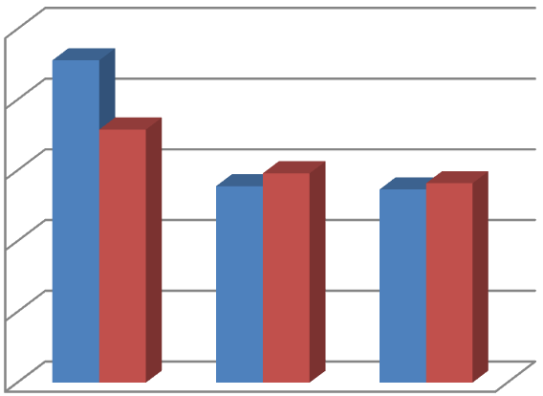

%
0.00
%
20.00
%
40.00
%
60.00
80.00
%
100.00
%
2014
2015
2016
91.15
%

%
55.56

54.64
%

71.57
%

%
59.21

%
56.37

Dividend Payout Ratio

IDLC
Industry Average
In 2014 the dividend payout ratio of IDLC was 91.15%. In 2015 it was decreased by 55.56%. In the year of 2015 and 2016 the dividend payout ratio was gradually decreased. In 2016 it was 54.64%. In 2014 dividend payout ratio of industry average was 71.57%. From 2014 to 2016 the dividend payout ratio was gradually decreased. In 2016 the rate was 56.37%.
The Mean of Dividend Payout ratio of IDLC is greater than its industry average. The increasing trend of dividend payout ratio indicates that earning is encouraging the dividend payment. So it is clean that it will encourage investors to invest in IDLC.

SOLVENCY RATIO
4.1.5 Debt to Total Asset: Total Liabilities / Total Asset

 | 2014 | 2015 | 2016 | Mean
IDLC | 88.92% | 89.40% | 88.73% | 89.02%
Industry Average | 81.56% | 82.88% | 86.67% | 83.70%
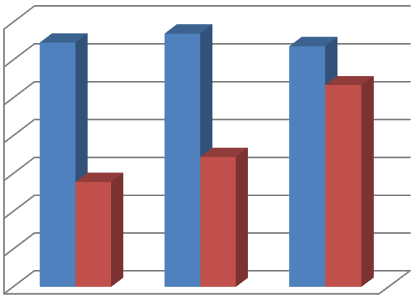

%
76.00
%
78.00
80.00
%
%
82.00
%
84.00
%
86.00
%
88.00
%
90.00
2014
2015
2016
%
88.92

%
89.40

88.73
%

81.56
%

82.88
%

%
86.67

Debt to Total Asset

IDLC
Industry Average

The Debt to Total asset of IDLC in 2014 was 88.92%. In 2015 it was increased by 89.40%. In 2016 the debt to total asset of IDLC’s is 88.73%. In 2014 debt to total asset of industry average was 81.56%. From 2014 to 2016 the debt to total asset was gradually increased. In 2016 the rate was 86.67%.
Comparing with the mean of industry average it indicates that debt ratio is greater than industry average. A debt ratio compares a company’s total debt to its total assets, which is work to achieve a common plan as to amount of leverage being used by organizations. So it cleans that IDLC highly depend on leverage. Its greater part of asset is claimed by its beneficiaries. So it is risky for IDLC.

4.1.6 Debt to equity Ratio (time): Total Liabilities / Total Equity
 | 2014 | 2015 | 2016 | Mean
IDLC | 8.03 | 8.43 | 7.87 | 8.11
Industry average | 4.54 | 4.64 | 7.02 | 5.4

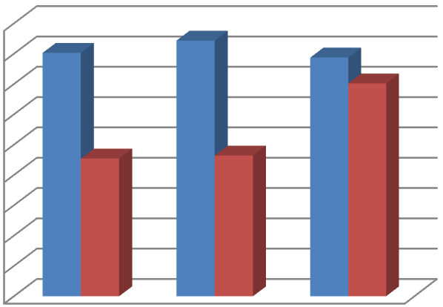

0.00
1.00
2.00
3.00
4.00
5.00
6.00
7.00
8.00
9.00
2014
2015
2016
8.03

8.43

7.87

4.54

4.64

7.02

Debt to Equity (Times)

IDLC
Industry Average

In 2014 IDLC’s Debt to equity ratio was 8.03 times. In 2015 it was 8.43 times. In the year 2016 the debt to equity ratio of IDLC is 7.87 times. From the table we see that debt to equity ratio of industry average was 4.54. From 2014 to 2016 the debt to equity ratio was gradually increased. In 2016 the rate was 7.02.
The Mean debt to equity of IDLC 8.11 times is higher than Mean debt to equity of industry average 5.4 times. So it clean that IDLC is more profitable, also more risky and less solvent than industry average.

4.1.7 Financial Expense coverage ratio: EBIT / Interest Expense
 | 2014 | 2015 | 2016 | Mean
IDLC | 1.48 | 1.54 | 1.66 | 1.56
Industry Average | 1.53 | 1.96 | 1.76 | 1.75

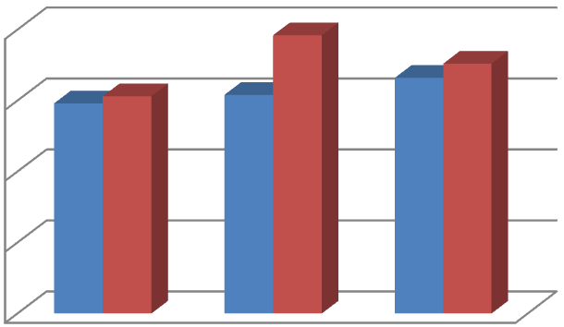

0
0.5
1
1.5
2
2014
2015
2016
1.48

1.54

1.66

1.53

1.96

1.76

Financial expense Coverage ratio
)
Times
(

IDLC
Industry Average

In 2014 the financial expense coverage ratio of IDLC was 1.48 times. From 2014 to 2016 this ratio was continuously increased. In 2016 the financial expense coverage ratio is 1.66 times.
Comparing with the mean of industry average the financial expense coverage ratio of IDLC is lower than industry average. Higher the ratio is good for the company. But here the ratio is lower than industry average. So it clean that IDLC face more credit risk problem than industry.

4.1.8 Capital Adequacy Ratio: (Tier 1 Capital +Tier 2 Capital) / Risk Weighted Asset

 | 2014 | 2015 | 2016 | Mean
IDLC | 14.50% | 14.80% | 14.50% | 14.6%
Industry Average | 14.40% | 15.33% | 15% | 14.91%

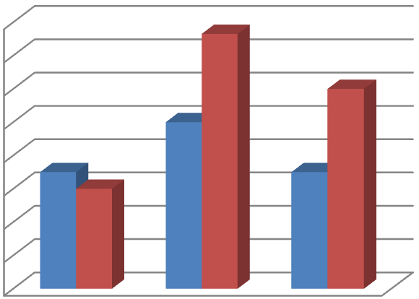

%
13.80
%
14.00
%
14.20
%
14.40
%
14.60
%
14.80
%
15.00
%
15.20
%
15.40
2014
2015
2016
14.50
%

%
14.80

14.50
%

14.40
%

15.33
%

%
15.00

Capital Adequacy Ratio

IDLC
Industry Average
Capital Adequacy Ratio of IDLC in 2014 was 14.50. In 2015 the rate was 14.80%. In 2015 the proportion was diminished by 14.50%. In 2014 capital adequacy ratio of industry average was 14.405. In 2015 it was increased by 15.33%. In 2016 the rate was decreased by 15%.
Comparing with the Mean of industry average we see that capital adequacy of IDLC is lower than industry average. So it cleans that IDLC is less good than industry average. Be that as it may, individually the proportion is over 10% as the requirement of Bangladesh bank that shows IDLC has enough money to support its business.

Market Ratio

4.1.9 P/E Ratio (time): Market Value per Share / EPS

 | 2014 | 2015 | 2016 | Mean
IDLC | 12.06 | 10.96 | 8.04 | 10.35
Industry Average | 16.59 | 9.37 | 12.65 | 12.87

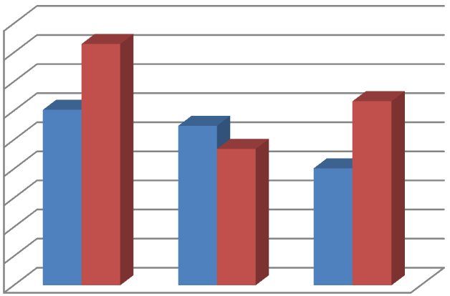

0
2
4
6
8
10
12
14
16
18
2014
2015
2016
12.06

10.96

8.04

16.59

9.37

12.65

Price Earnings Ratio (times)

IDLC
Industry Average
In 2014 the price earnings ratio of IDLC was 12.06 times. From 2014 to 2016 the earning per share of IDLC were decreased continuously. In 2016 it was 8.04 times. In 2014 the price earnings ratio of industry average was 16.59 times. In 2015 it was decreased by 9.37 times. In 2016 it was increased by 12.65 times.
Comparing with the Mean of industry average IDLC’s price earnings ratio is lower than its industry average. So it clean that IDLC is regarded more risky and their growth prospect is very poor.

Risk Ratios

4.1.10 Loan to Deposit: Total Loan / Total deposit

 | 2014 | 2015 | 2016 | Mean
IDLC | 1.29 | 1.16 | 1.26 | 1.24
Industry Average | 1.45 | 1.78 | 1.36 | 1.53

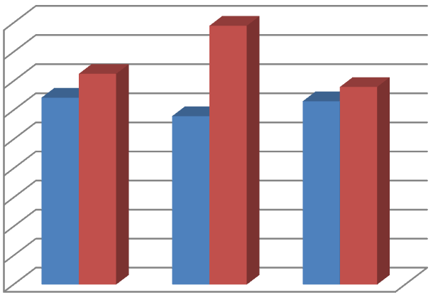

0.00
0.20
0.40
0.60
0.80
1.00
1.20
1.40
1.60
1.80
2014
2015
2016
1.29

1.16

1.26

1.45

1.78

1.36

Loan to Deposit Ratio (Times)

IDLC
Industry Average
In 2014 the loan to deposit ratio of IDLC was 1.29 times. It implies that total loan was 1.29times of total deposit. In 2015 the rate was 1.16 times. In the year 2016 the ratio grows up at increasing rate of 1.26 times. In 2014 the loan to deposit ratio of industry average was 1.45 times. In 2015 the rate was increased by 1.78 times. In 2016 the rate was decreased by 1.36 times.
Comparing with the Mean of industry average the Mean of IDLC is lower than industry average. The lower the ratio is better for the company. Higher the ratio demonstrates that association has insufficient assets to deal with the unexpected necessities.
Comparing with industry average it gives fewer loans than the others in the industry. As a result its profitability is less than other banks but its liquidity is high.

4.1.11 Non-Performing loan Ratio: NPL/ Total Loan

 | 2014 | 2015 | 2016 | Mean
IDLC | 2.02% | 3.06% | 2.98% | 2.69%
Industry Average | 7.47% | 6.88% | 5.13% | 6.49%

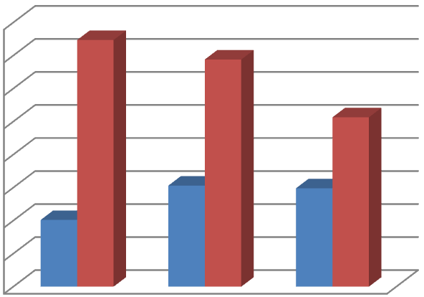

%
0.00
%
1.00
%
2.00
%
3.00
%
4.00
%
5.00
%
6.00
%
7.00
%
8.00
2014
2015
2016
2.02
%

%
3.06

2.98
%

7.47
%

6.88
%

5.13
%

Non-Performing loan Ratio

IDLC
Industry Average
From the table we see that the non- performing ratio of IDLC in 2014 was 2.02%. In 2015 the ratio grew up by 3.06%. In the year 2016 the ratio was declined by 2.98%. In 2014 nonperforming loan of industry average was 7.47%. From the year 2014 to 2016 the rate was gradually decreased. In 2016 the rate was 5.13%.
Comparing with the Mean of industry average we see that non-performing loan ratio of IDLC is lower than industry average. Lower NPL ratio is good for the company. So it cleans that IDLC is less risky and more solvent than industry.

Liquidity Ratio

4.1.12 Current Ratio: Current Asset / Current Liabilities

 | 2014 | 2015 | 2016 | Mean
IDLC | 1.26 | 1.24 | 1.26 | 1.25
Industry Average | 1.23 | 1.16 | 1.05 | 1.15

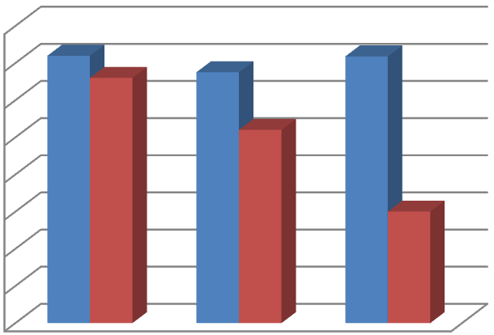

0.90
0.95
1.00
1.05
1.10
1.15
1.20
1.25
1.30
2014
2015
2016
1.26

1.24

1.26

1.23

1.16

1.05

Current Ratio

IDLC
Industry Average
From the table current ratio of IDLC in 2014 was 1.26. In 2015 the ratio was decreased by 1.24.
In 2016 the ratio was increased by 1.26. Current ratio of industry average in 2014 was 1.23. In 2015 the ratio was decreased by 1.26. In 2016 the ratio was also decreased by 1.05.
Comparing with the Mean of industry average current ratio of IDLC is higher than industry average. So we can clean that liquidity condition of IDLC is good from the other company of the industry.

4.2 Margin

4.2.1 Net Interest Margin

 | 2014 | 2015 | 2016 | Mean
IDLC | 4.65% | 4.71% | 4.17% | 4.51%
Industry average | 5.32% | 6.13% | 4.61% | 5.35%

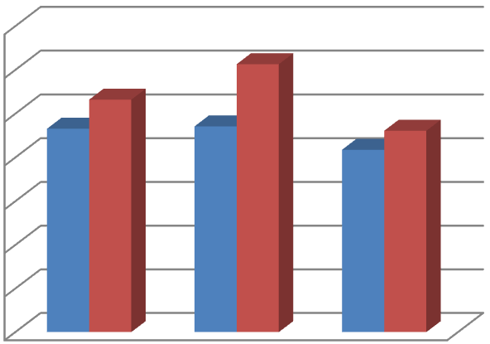

%
0.00
%
1.00
%
2.00
3.00
%
4.00
%
%
5.00
%
6.00
%
7.00
2014
2015
2016
4.65
%

4.71
%

4.17
%

%
5.32

%
6.13

4.61
%

Net Interest Margin

IDLC
Industry Average

From the table and graph we see that in 2014 IDLC’s net interest margin was 4.65%. In 2015 it was 4.71%. In 2016 the ratio increased by 4.17%. Net interest margin is fluctuating every year. Lower ratio is bad for short term. The negative figure of the ratio indicates the company cannot make effective investment decisions. So it cleans that IDLC makes good investment decisions and become profitable.
Comparing with the Mean of industry average we see that net interest margin of IDLC is less than industry average. It is bad for short term. It is good for long term because at the same time the industry average is 6.21%, which is higher than its net interest margin. So everyone avoid the other company and take it.

4.2.2 Net Operating Margin

 | 2014 | 2015 | 2016 | Mean
IDLC | 4% | 4.04% | 4.12% | 4.05%
Industry Average | 2.68% | 2.59% | 2.1% | 2.46%

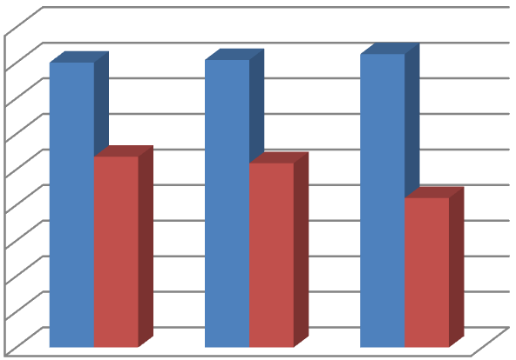

0.00
%
0.50
%
%
1.00
%
1.50
%
2.00
%
2.50
%
3.00
%
3.50
%
4.00
4.50
%
2014
2015
2016
4.00
%

%
4.04

%
4.12

2.68
%

2.59
%

%
2.10

Net Operating Margin

IDLC
Industry Average

From the table and graph we see that IDLC’s net operating margin in 2014 was 4.00%. From 2014 to 2016 this margin increases continuously. In 2016 it was 4.12%. In 2014 net operating margin of industry average was 2.68%. From 2014 to 2016 this margin of industry average increases continuously. In 2016 it was 4.12%.
The Mean of IDLC is 4.05% and the Mean of industry average is2.46%. It means its net operating margin is higher than industry average. So it cleans that IDLC well in positions because net operating margin always be high for the betterment of the company.

CHAPTER 5

Findings and Conclusions

5.1 Findings
- The total asset growth rate fluctuates every year. In 2017, the rate grew up from that of 2016.
- The long-term liabilities fluctuated during the period of 2013 to 2017. In 2017 the rate has increased than that of 2016.
- In case of term deposited, the growth rate indicates that IDLC has acquainted more currency for its new investments.
- IDLC’s operating income increases continuously.
- The operating expense of IDLC increases whereas the financial expense decreases yielding an inversely proportional scenario.
- Even after the deduction of its taxes, IDLC’s net profit increases persistently. So, it signals positive signs to the investors, to invest on IDLC.
- The number of shareholders of IDLC increases year by year.
- The net asset value per share increases every year. So it yields a positive sign for the market.
- In case of market capitalization, the growth rate has increased since the previous year.
- The market value addition of IDLC had become negative during the year 2015 to 2016.
- Equity of shareholders increases year by year and IDLC is substantially maximizing the wealth of its shareholders.
- ROA increased during the years 2013 to 2017 and was higher than that of the industry average. So it resulted that managing the banking asset was more effective.
- ROE is considered higher than the industry average. Therefore, IDLC appears much more attractive to its shareholder.
- EPS of IDLC increased during the years 2012 to 2016; resulting it to be beneficial to IDLC.
- Dividend payout ratio of IDLC decreased continuously and was accounted to be lower than that of the industry average. This discourages the investors to invest on IDLC.
- Debt to total asset of IDLC fluctuates every year and the ratio is higher than the industry average. So it is risky for IDLC since it highly depends on leverage.
- Debt to Equity of IDLC also fluctuated during 2012 to 2016 and the ratio was higher than the industry average. So IDLC became more profitable, as well as becoming more risky and less solvent than the industry average.
- Financial expense coverage ratio of IDLC lowered than that of the industry average. So it was a good signal for IDLC.
- Capital adequacy ratio of IDLC was less than the industry average. So it was less favorable than other company to the shareholders.
- P/E ratio of IDLC kept on continuously decreasing. So it was more risky and their growth prospect was very poor.
- Loan to deposit ratio of IDLC is less than the industry average. So the profitability of IDLC was less than that of the industry but its liquidity was high.
- NPL ratio is lower than the industry average. So it is beneficial for IDLC.
- Current ratio of IDLC is higher than the industry average. So it cleared the liquidity condition of IDLC, which was necessary.
- For net interest margin IDLC made good investment decisions and became profitable.
- Net operating margin of IDLC increased continuously. So it is beneficial in its position in comparison to other companies.

5.2 Recommendation
- IDLC should concentrate on increasing their corporate clients because corporate clients are the main source of earning profit.
- IDLC should control their operating and financial expenses and try to maximize profitability.
- IDLC should improve their market capitalization and market value addition indicators to improve their performance and overcome the concerns of their shareholders.
- IDLC should increase ROA in order to manage the banking assets efficiently.
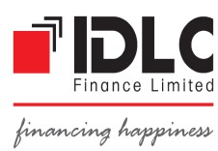
- To impress shareholders, IDLC should increase ROE. IDLC should also be careful about it because it is responsible as the main indicator of company’s performance.
- The bank management should be careful about EPS, as it is a major indicator of the company’s performance as well. To increase the EPS management IDLC must concentrate on increasing the profitability of the company.
- IDLC should increase their P/E ratio. If the P/E ratio becomes high it will invariably increase its shareholders confidence level and interest to invest in IDLC.
- IDLC should maintain a capital adequacy ratio for its unexpected possible requirements of funds.
- IDLC should increase their dividend payout ratio. If this increases then it will upgrade the confidence level of shareholders.
- IDLC must follow loan to deposit rules, provided by the Bangladesh Bank. Because of its crisis related to liquidity.
- IDLC always try to keep their NPL and Financial expense coverage lower than that of the industry to earn more profit.
5.3 Conclusions
In conclusion, it can be said that IDLC is one of the most promising financial institutions in Bangladesh. In this report, the overall performance of IDLC during the period 2012 to 2017 has been analyzed and evaluated. By analyzing its overall performance, various positive and negative findings of the firm, have come into light. The analysis shows that IDLC has performed very well over the past years. Some flaws have been identified throughout this study, which had arisen in the financial period and therefore have been provided with many compensatory solutions to help improve their future performance. Besides their core business, they should also try performing more corporate social responsibilities that will provide them with long-term sustainability. IDLC has the potential to become one of the most preferable and leading financial institutions in Bangladesh and will also to be able achieve their vision; to be the best financial brand in Bangladesh.

Bibliography:
- http://idlc.com
- IDLC Annual Report 2012 to 2017.
- https://www.google.com
- http://idlc.com/idlc-investments-ltd.php
- https://www.dse.com.bd/
- www.investopedia.com

Appendix:

 |  | Industry average of NBFI 2016
Company name
 |  | ROA | ROE | EPS | Dividend p | Debt to Tot | Debt to Equ | Financial E | Capital Ad | eP/E ratio | Loan to D | eNon-Perfor | current Ratio
1.IDLC |  | 2.24% | 19.92% | 5.49 | 54.64% | 88.73% | 7.87 | 1.66 | 14.50% | 8.04 | 1.26 | 2.98% | 1.26
2.Bay Leasing |  | 1.36% | 3.83% | 0.77 | 194.00% | 80.49% | 3.82 | 1.58 | 19.96% | 31.82 | 2.02 | 6.75% | 1.01
3.BD Finance |  | 0.85% | 7.75% | 1.11 | 90.01% | 86.25% | 7.73 | 0.41 | 11.15% | 13.24 | 1.54 | 2.40% | 0.21
4.BIFC |  | -6.63% | -67.68% | -6.77 | 9.53% | 96.91% | 31.82 | -0.83 | 3.08% | 0 | 1.71 | 15.00% | 0.32
5.DBH |  | 2.06% | 23.19% | 6.77 | 44.31% | 91.12% | 10.27 | 0.7 | 16.59% | 15.76 | 1.18 | 0.34% | 1.16
6.FAS Finance |  | 0.83% | 7.39% | 1.03 | 4.85% | 89.66% | 8.68 | 1.15 | 10.48% | 14.08 | 1.7 | 6.21% | 1.14
8.GSP Finance |  | 3.52% | 13.50% | 2.74 | 8.02% | 69.08% | 1.84 | 2.54 | 20.60% | 8.37 | 1.77 | 7.29% | 1.17
9.ICB |  | 2.49% | 9.71% | 4.96 | 60.52% | 71.95% | 1.56 | 1.14 | 29.61% | 22.76 | 0.25 | 2.00% | 1.16
10.ILFSL |  | 1.31% | 5.73% | 0.7 | 0.89% | 93.70% | 9.43 | 1.21 | 10.21% | 18.13 | 1.36 | 3.39% | 1.12
11.IPDC |  | 1.97% | 10.92% | 2 | 100.00% | 87.71% | 0.41 | 14.94 | 22.09% | 21.34 | 1.13 | 0.76% | 1.01
12.MIDAS Finance |  | 2.57% | 17.46% | 2.22 | 45.00% | 88.90% | 8.01 | 0.67 | 19.34% | 12.61 | 1.31 | 12.00% | 1.21
13.National Housing |  | 1.99% | 15.18% | 2.29 | 78.60% | 86.64% | 4.47 | 1.67 | 19.57% | 23.58 | 1.06 | 4.95% | 1.21
14.People LFS |  | -1.71% | -15.89% | -1.74 | 0.00% | 89.29% | 8.42 | -0.81 | 0.00% | -5.46 | 0.59 | 0.00% | 0.52
15.Phonix Finance |  | 1.16% | 11.05% | 2.33 | 85.84% | 89.50% | 8.54 | 0.53 | 11.04% | 11.54 | 1.31 | 3.76% | 1.18
16.Premier LFS |  | 0.91% | 16.00% | 1.29 | 77.52% | 90.48% | 2.89 | 1.29 | 10.90% | 7.36 | 1.55 | 5.38% | 1.07
17.Prime FL |  | -4.97% | 18.08% | -3.48 | 0.00% | 86.83% | 6.6 | 1.28 | 17.77% | -2.81 | 1.15 | 12.04% | 1.32
18. Union CL |  | 0.95% | 10.20% | 1.44 | 69.44% | 89.01% | 0.92 | 1.77 | 11.98% | 14.2 | 1.3 | 8.44% | 1.09
19.United FL |  | 1.51% | 11.10% | 1.84 | 54.35% | 85.81% | 6 | 1.43 | 18.92% | 12.45 | 1.05 | 3.00% | 1.25
20.Uttora FL |  | 2.74% | 15.15% | 6.62 | 45.31% | 81.15% | 3.44 | 1.6 | 20.13% | 13.82 | 1.54 | 2.77% | 1.48
21. LankaBangla Finance |  | 1.39% | 12.29% | 2.87 | 104.53% | 90.24% | 7.63 | 1.34 | 12.04% | 12.11 | 1.28 | 3.20% | 1.14
 | Average | 0.83% | 7.24% | 1.72 | 56.37% | 86.67% | 7.02 | 1.76 | 15.00% | 12.65 | 1.30 | 5.13% | 1.05

 |  | Industry average of NBFI 2015
Company name
 |  | ROA | ROE | EPS | Dividend p | Debt to Tot | Debt to Equ | Financial E | Capital Ad | eP/E ratio | Loan to D | eNon-Perfor | mCurrent Ratio
1.IDLC |  | 1.99% | 18.74% | 4.5 | 55.56% | 89.40% | 8.43 | 1.54 | 14.80% | 10.96 | 1.16 | 3.06% | 1.24
2.Bay Leasing |  | 1.65% | 3.50% | 0.73 | 205.47% | 75.53% | 2.82 | 0.37 | 18.93% | 13.69 | 2.03 | 17.05% | 1.14
3.BD Finance |  | 1.06% | 9.73% | 1.41 | 83.33% | 86.79% | 3.1 | 0.37 | 10.11% | 7.09 | 3.09 | 9.22% | 1.05
4.BIFC |  | -5.17% | -6.20% | -6.22 | 0% | 91.74% | 11.12 | -0.61 | 0% | -1.6 | 0.52 | 8.63% | 0.36
5.DBH |  | 1.97% | 23.53% | 5.9 | 0% | 87.84% | 1.36 | 0.64 | 16.32% | 13.76 | 1.18 | 5.30% | 1.18
6.FAS Finance |  | 1.22% | 7.75% | 1.03 | 0% | 87.67% | 7.08 | 0.53 | 10.20% | 11.07 | 1.67 | 6.05% | 1.19
8.GSP Finance |  | 3.02% | 11.56% | 1.8 | 86.11% | 67.55% | 2.9 | 1.8 | 0% | 8.32 | 1.66 | 10.22% | 1.15
9.ICB |  | 4% | 10.55% | 7.1 | 49.33% | 61.08% | 2.03 | 1.37 | 36.35% | 17.7 | 6.37 | 6.11% | 1.42
10.ILFSL |  | 1.31% | 5.59% | 0.72 | 70% | 90.55% | 6.35 | 0.44 | 12.16% | 12.7 | 1.54 | 6.89% | 1.18
11.IPDC |  | 3.01% | 9.70% | 1.9 | 105.26% | 69.82% | 1.2 | 1.71 | 49.15% | 14.03 | 1.41 | 1.98% | 1.21
12.MIDAS Finance |  | 0.65% | 7.53% | 0.41 | 0% | 86.08% | 6.18 | 0.62 | 18.45% | 1.24 | 1.58 | 21.73% | 1.31
13.National Housing |  | 2.61% | 15.01% | 2.17 | 78.34% | 82.16% | 4.47 | 1.77 | 0% | 4.61 | 1.31 | 5.55% | 1.32
14.People LFS |  | 4.75% | 18.61% | 2.38 | 52.62% | 81.25% | 4.33 | 1.25 | 19.04% | 9.3 | 3.38 | 0% | 1.08
15.Phonix Finance |  | 1.32% | 10.52% | 2.18 | 91.74% | 87.41% | 6.94 | 0.58 | 0% | 8.25 | 1.21 | 2.79% | 1.37
16.Premier LFS |  | 0.56% | 27% | 0.83 | 0% | 91.15% | 3.42 | 1.55 | 0% | 14.56 | 0.86 | 0% | 0.98
17.Prime FL |  | -2.19% | -9.40% | -1.53 | 0% | 77.03% | 3.35 | 0.12 | 19.99% | -7.46 | 1.5 | 10.20% | 1.1
18. Union CL |  | 0.97% | 10.89% | 1.4 | 85.71% | 87.69% | 0.64 | 1.6 | 13.34% | 10.33 | 1.32 | 8.41% | 1.02
19.United FL |  | 1.78% | 13.40% | 2.22 | 67.52% | 86.61% | 6.2 | 1.5 | 18.69% | 8.56 | 1 | 3.90% | 1.28
20.Uttora FL |  | 1.81% | 10.86% | 4.41 | 68.02% | 82.83% | 3.86 | 1.39 | 15.56% | 13.81 | 1.61 | 7.53% | 1.46
21. LankaBangla Finance |  | 0.94% | 6.81% | 1.76 | 85.22% | 87.41% | 7.04 | 1.24 | 13.41% | 16.44 | 1.19 | 3.02% | 1.11
 | Average | 1.36% | 10.28% | 1.76 | 59.21% | 82.88% | 4.64 | 0.99 | 14.33% | 9.37 | 1.78 | 6.88% | 1.16

 |  | Industry average of NBFI 2014
Company name
 |  | ROA | ROE | EPS | Dividend p | Debt to Tot | Debt to Equ | Financial E | Capital Ad | eP/E ratio | Loan to D | eNon-Perfor | mCurrent Ratio
1.IDLC |  | 2.11% | 19.08% | 3.84 | 91.15% | 88.92% | 8.03 | 1.48 | 14.50% | 12.06 | 1.29 | 2.02% | 1.26
2.Bay Leasing |  | 1.94% | 4.86% | 1.06 | 141.51% | 70.30% | 1.84 | 3.89 | 16.93% | 9.43 | 2.22 | 13.09% | 1.16
3.BD Finance |  | 0.51% | 4.31% | 0.6 | 70.92% | 83.21% | 2.36 | 2.36 | 11.23% | 16.67 | 1.62 | 6.25% | 1.12
4.BIFC |  | 0.47% | 3.40% | 0.55 | 0% | 85.92% | 6.1 | 1.36 | 0% | 18.18 | 0.57 | 9.05% | 1.18
5.DBH |  | 1.67% | 22.78% | 5.15 | 0% | 85.15% | 1.81 | 1.55 | 14.49% | 12.04 | 1.24 | 6.39% | 1.19
6.FAS Finance |  | 1.78% | 6.75% | 0.97 | 97.01% | 78.15% | 3.58 | 0.82 | 11.06% | 19.59 | 2.02 | 9.17% | 1.33
8.GSP Finance |  | 2.05% | 7.21% | 1.58 | 48.10% | 70.50% | 1.99 | 1.57 | 0% | 20.9 | 2.02 | 11.67% | 1.19
9.ICB |  | 3.76% | 11.97% | 5.99 | 61.14% | 66.96% | 1.56 | 1.23 | 29.68% | 25.67 | 0.41 | 7.85% | 1.26
10.ILFSL |  | 1.61% | 5.84% | 0.74 | 68% | 88.52% | 4.33 | 0.31 | 13.50% | 18.33 | 1.57 | 8.99% | 1.24
11.IPDC |  | 2.14% | 7.20% | 1.31 | 114.50% | 70.82% | 0.17 | 1.73 | 26.39% | 13.88 | 1.42 | 3.39% | 1.25
12.MIDAS Finance |  | -5.95% | -87% | -5.01 | 0% | 96.09% | 24.39 | 1.63 | 5.85% | -10.52 | 1.6 | 32.86% | 1.21
13.National Housing |  | 4.23% | 14.31% | 1.97 | 76.14% | 78.08% | 3.45 | 1.72 | 0% | 5.08 | 1.45 | 5.71% | 1.39
14.People LFS |  | 4.15% | 16.79% | 1.98 | 63.22% | 83.19% | 4.95 | 0.81 | 18.05% | 7.23 | 2.37 | 0% | 1.13
15.Phonix Finance |  | 1.13% | 7.95% | 1.64 | 121.95% | 85.83% | 6.06 | 2.58 | 0% | 12.81 | 1.17 | 4.73% | 1.22
16.Premier LFS |  | 0.31% | 9% | 0.28 | 0% | 86.89% | 1.92 | 1.25 | 0% | 39.29 | 0.39 | 0% | 1
17.Prime FL |  | 2.77% | 8.83% | 1.59 | 78.62% | 71.24% | 2.48 | 0.64 | 23.73% | 13.5 | 1.73 | 5.86% | 1.17
18. Union CL |  | 1.25% | 10.48% | 1.65 | 60.61% | 90.06% | 0.76 | 1.66 | 13.44% | 12.82 | 1.38 | 8.51% | 1.05
19.United FL |  | 2.04% | 14.10% | 2.1 | 71.42% | 84.69% | 5.5 | 1.53 | 21.03% | 10 | 1.26 | 4.70% | 1.32
20.Uttora FL |  | 0.62% | 3.53% | 1.41 | 212.76% | 82.62% | 4.16 | 1.23 | 14.77% | 53.13 | 2.0192 | 5.07% | 1.51
21. LankaBangla Finance |  | 1.27% | 7.02% | 1.84 | 54.34% | 84.06% | 5.38 | 1.26 | 17.26% | 21.77 | 1.18 | 4.05% | 1.42
 | Average | 1.49% | 4.92% | 1.562 | 71.57% | 81.56% | 4.541 | 1.53 | 12.60% | 16.593 | 1.44646 | 7.47% | 1.23

