INTERNSHIP REPORT
Credit Risk Management: A Case Study on ACI Limited

Submitted to
Mohammad Tariq Hasan, Ph.D.
Associate Professor
School of Business & Economics
United International University

Submitted by
Faiza Azad Proma
111 191 036
BBA, Major in Accounting
United International University

Date of Submission: 2nd December, 2023


Letter of Transmittal
2nd December, 2023

Mohammad Tariq Hasan, Ph.D.
Associate Professor
School of Business & Economics
United International University

Subject: Prayer for approval of Internship report on “Credit Risk Management: A case study on ACI Limited”

Dear Sir,
With due respect, the internship report on “Credit Risk Management: A case study on ACI Limited, including the segment analysis on the credit risk Management of ACI Limited, Bangladesh. Following the supervisor’s instruction, this report is being developed. This report is provided here in a very detailed manner, jam-packed with information. After working as an intern for three months at ACI, this internship report has been completed. To have participated in there had been a great experience. There are many things to learn from this report. It provided a means of distinguishing between theoretical and applied knowledge. I will be grateful, if you accept the report after considering the study’s limitations into account.

Sincerely yours,
Faiza Azad Proma
ID: 111 191 036
United International University

Declaration of the Student
Faiza Azad Proma, at this moment, declare that the report titled “Credit Risk Management: A case study on ACI Limited” is submitted in the partial fulfillment requirement for completing a BBA in accounting degree at United International University. This report is an original work I did under the guidance of Mohammad Tariq Hasan, Ph.D., faculty of School of Business & Economics, United International University.

Acknowledgement
I would like to express my sincere thanks to everyone who helped me to successfully complete internship at “ACI Limited”.

Firstly, I would like to say my gratitude to my respected supervisor Mohammad Tariq Hasan, Ph.D., Associate Professor, School of Business & Economics, United International University from the core of my heart for his kind support, supervision, instructions, and advice that motivated me to do this report and assigning this topic and guiding me during my internship.

Then I would like to thank Prodip Debnath, Assistant Manager of the Credit Department in Finance & Planning who supervised me and properly guide me on how to work here.

TABLE OF CONTENTS
Letter of Transmittal ii
Declaration of the Student iii
Acknowledgement iv
List of Figures vii
Executive Summary viii
CHAPTER ONE: INTRODUCTION 1
1.1 Background of the report 1
1.2 Objective of the report 1
1.3 Scope of the report 1
1.4 Limitation of the report 1
Chapter TWO: COMPANY AND INDUSTRY REVIEW 3
2.1 Company analysis 3
2.1.1 Introduction 3
2.1.2 History 3
2.1.3 Mission & vision of ACI Limited 4
2.1.4 Management Organogram of ACI Limited 5
2.1.5 Financial Highlights of ACI Limited 6
2.1.6 Products & services of ACI Limited 9
2.1.7 SWOT Analysis of ACI Limited 12
2.2 Industry analysis 14
2.2.1 Specification of the industry 14
2.2.2 Size, trend, and maturity of the industry 14
CHAPTER THREE: METHODOLOGY 15
3.1 Types of Data and Method 15
3.1 Data Collecting Procedures 15
CHAPTER FOUR: INTERNSHIP EXPERIENCE 16
4.1 Brief introduction of the credit in finance & planning department 16
4.2 Purpose of credit policy 17
1) Types of credit customers 17
4.2 Credit to government, autonomous and semi-autonomous Institutions 19
4.3 Credit analysis & management of ACI Limited 20
4.3.1 Supply on credit: 20
4.3.2 Central credit coding: 20
4.4 Extension of credit limit and days 20
4.5 Follow-up through payment reminder memos 21
4.6 Roles and responsibilities 22
CHAPTER V: RECOMMENDATIONS CONCLUSION 25
5.1 Conclusion 25
5.2 Recommendations 25
REFERENCES 26

List of Figures
Figure 1. ACI Limited Turnover & Cost 2020-2022 14
Figure 2. ACI Limited Turnover & Cost 2019-2021 15
Figure 3. ACI Limited Turnover & Cost 2018-2020 15
Figure 4. ACI Limited Turnover & Cost 2017-2019 16
Figure 5. Strategic Business Units 17
Figure 6. ACI credit Risk Policy Book 28

Executive Summary
The internship report focuses on the experience to an intern for gathered information or throughout the three months. This report describes on Credit Risk Management: A case study on ACI Limited, the key point focusing on work experience of the intern and influences the career goals and accumulated of the skills during this period. The report is mainly describing Finance-Credit Department roles and responsibility and credit policy was promoting to this organization. It covers the interaction of an interns with supervisor as well as coworker. In Bangladesh, ACI Limited is one of the biggest and largest local conglomerates. ACI is made up of several business divisions, including Pharmaceuticals, Retail banding, Agriculture. The goal of ACI is to attain business excellence via quality by comprehending, accepting, fulfilling and going above and beyond what customers demand. ACI follows to international standards for the quality management system to guarantee a constant level of quality in goods and services that satisfy customers.

Keywords: Credit risk management, credit analysis, ACI limited, Bangladesh.

CHAPTER ONE: INTRODUCTION

1.1 Background of the report
The credit granting process is an essential part of financial operations across all industries. Providing credit to customers and business partners helps generate income, but it also carries a certain risk that needs to be managed carefully. These are some of the main components of credit granting procedures, highlighting their significance and placing the evaluation in the context of ACI Limited’s business activities.

1.2 Objective of the report
Main objective:
The main objective of the research is to examine the Credit Risk Management: A case study on ACI Limited. To reach the main objective, there are a few additional objectives.

Specific Objectives:
- To know about the company’s credit risk management policies.
- To offer some recommendations concerning the credit division
- To outline the company’s organizational structure, management, background and functions
- To comprehend ACI Company Limited the short-term backing procedures
- To assess the efficacy of the financial performance of ACI Company Limited.

1.3 Scope of the report
The scope of this report involves in exploring the credit risk management procedure of ACI limited. In addition, the research discusses risk factors, challenges and solutions related to ACI Credit Management. This report is entirely based in the officials’ actual work experience and practical knowledge gained from working and monitoring their daily actions.

1.4 Limitation of the report
Every study has certain restrictions. The studies conducted are important and will need a lot of work. While conducting it encountered several issues. The following restricting circumstances made it difficult to function smoothly at the bank and prepare this report:
- The organization maintain strict confidentiality about its financial and other information.
- It takes a lot of time to complete any presentation. However, the study’s duration was too short to offer a comprehensive grasp of banking as a whole.
- Information collecting from employees was especially difficult because of the limitations imposed by their positions.
- A major brainstorming session was required when preparing this report due to the dearth of books, papers, and magazines.
- The lack of experience in conducting such a study is one of its main drawbacks.

CHAPTER TWO: COMPANY AND INDUSTRY REVIEW

2.1 Company analysis

2.1.1 Introduction
Advanced Chemical Industries (ACI) was established in 1968. But it is additional known as imperial Chemical Industries (ICT) then east Pakistan to form ACI. The company was formed as ICT Bangladesh manufacturers limited and as public limited company in Bangladesh on 24 January, 1973 after independence. Additionally, on 28 December,1976, ACI was listed with the Dhaka Stock Exchange and its first conducted trading od share took place in 1994. Later, ICT gave local management 70% of its stake in 1992. ACI was the name under which the company was registered. Also, the Chittagong stock exchange listed the company. One of the most well –known companies in Bangladesh is ACI Limited. It is the most reputable company brand and guarantees the highest quality of product provider. As a contributor to the state of the national economy, which ACI is significant. Additionally, they have made an impact on a global scale through joint ventures, overseas investments, and brand connections. ACI denotes that the company began by producing pharmaceuticals and it is subsequently spread several product lines and brunches around their company.

2.1.2 History
Advanced Chemical Industries (ACI) is one of the top and largest domestic companies in Bangladesh. ACI Has three business sectors that markup agro-business, Consumer brands and pharmaceuticals. In Bangladesh, ACI was the first business to receive accreditation for both the environment management system in 2000 and the quality management system in 1995. ACI is limited company corporation that listed on DSE and CSE (Hasan, 2009). In addition, the company has a large number of partners and networks in abroad with whom it has trade and business partnerships (Hasan & Huq, 2010). ACI is now quickest growth in Bangladesh’s companies. ACI is established in 1992. It is origin date back to 1926, when four companies joined Advanced Chemical Industry (ICI) in the United Kingdom. ICI plc has been globally operating as a multinational corporation. It was founded, ICI started doing business as ICI (India) Limited on the Indian subcontinent. The Pakistan office of ICI (Indian) Limited Changed its name to ICI (Pakistan) Ltd following the Partition of India and Pakistan in 1947.

2.1.3 Mission & vision of ACI Limited
Mission
ACI's Mission is to enrich the quality of life of the people through responsible application of knowledge, technology and skills. ACI is committed to the pursuit of excellence through world-class products, innovative processes and empowered employees, to provide the highest level of satisfaction to the customers.

Vision
To realize the Mission, ACI will:
- Provide products and services of high and consistent quality, ensuring value for money to the customers.
- Endeavour to attain a position of leadership in each category of businesses.
- Develop the employees by encouraging empowerment and rewarding innovation.
- Promote an environment for learning and personal growth.
- Attain a high level of productivity in all the operations through effective utilization of resources and adoption of appropriate technology.
- Promote inclusive growth by encouraging and assisting the distributors and suppliers in improving efficiency.
- Ensure superior return on investment through judicious use of resources and efficient operations, utilizing core competencies

Values
- Quality
- Customer Focus
- Fairness
- Transparency
- Innovation

2.1.4 Management Organogram of ACI Limited

Business Reporting
Balance Confirmation & Field Visit
Proposal Assessment
Document Preservation
Encashment
Credit Recovery
Credit Monitoring
Credit Administration
Legal Compliance
Payment Reminder
Senior Credit Executive
Manager
(Credit & Costing)
Manager
(Vat & Tax)
Manager (Treasury)
Manager (Accounts)
Corporate Relationship Manager
Senior Corporate Financial Manager
Director
Quality Assurance

Director
Business Development

Director
Corporate Affairs

Chief Operating Officer Pharmaceuticals
Chief Operating Officer
Corporate Communicate
Executive Director Consumer Brand
Executive Director Agribusiness
Financial Controller
Executive Director Financial Planning & Control
Managing Director
Chairperson

Hierarchy of ACI Limited

2.1.5 Financial Highlights of ACI Limited
Comparison of Turnover & Cost of ACI Limited from 2020 to 2022:
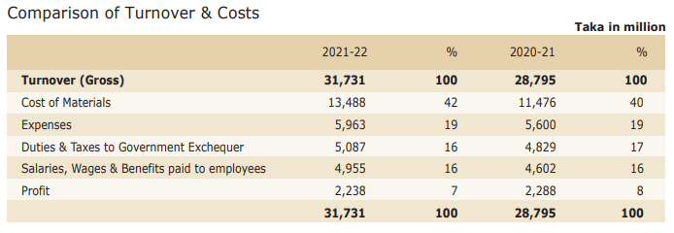

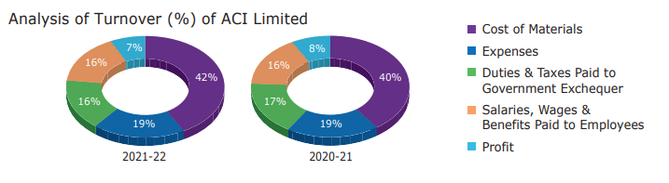
Figure 1. ACI Limited Turnover & Cost 2020-2022

Comparison of turnover & cost of ACI Limited from 2019 to 2021:
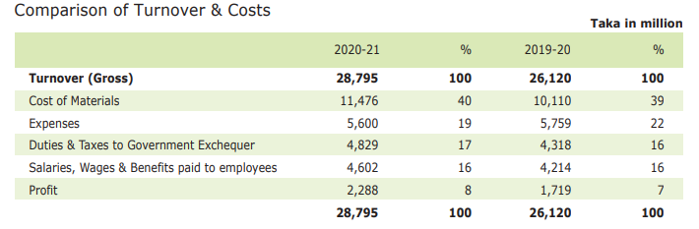
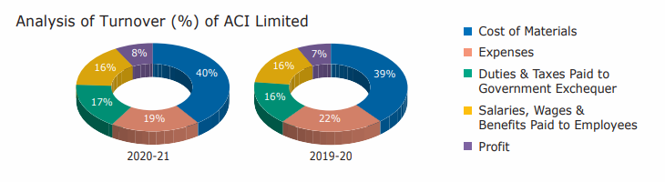
Figure 2. ACI Limited Turnover & Cost 2019-2021

Comparison of turnover & cost of ACI Limited from 2018 to 2020:
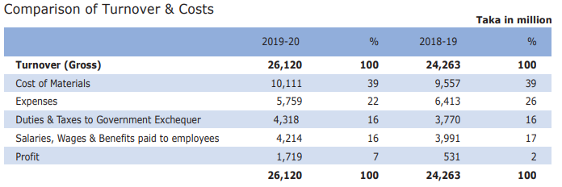

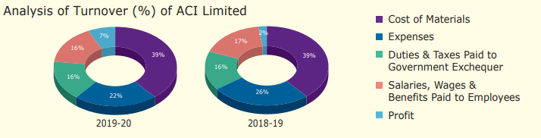

Figure 3. ACI Limited Turnover & Cost 2018-2020

Comparison of turnover & cost of ACI Limited from 2017 to 2019:

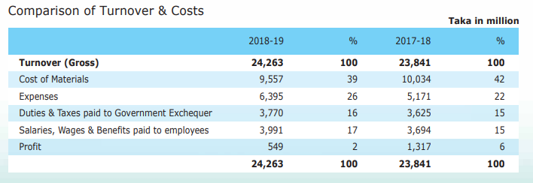

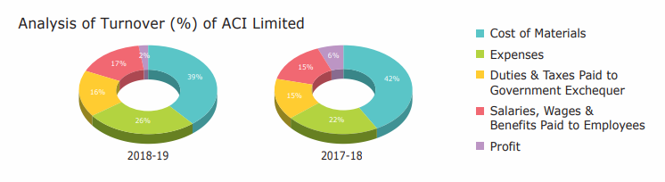

Figure 4. ACI Limited Turnover & Cost 2017-2019

Explanation:
- From the above graph, it sees the current assets in 2022 were 38500, which is increasing every year from 2014 to 2022.
- It sees the turnover in 2022 was 28427, which is increasing every year from 2014 to 2022, in ACI Limited.
- From the above graph, it sees the gross profit in 2022 was 11763, which is increasing every year from 2014 to 2022, in ACI Limited.
- From the above graph, it sees the dividend in 2022 was 399, which increased from 2014 to 2018 then it is decreasing every year from 2018 to 2022, ACI Limited.
- From the above graph, it sees the net assets per share in 2022 was 285, which is increase in every year from 2014 to 2022, in ACI Limited.
- From the above graph, it sees the number of employees in 2022 was 10233, which is an increase in every year from 2014 to 2022, ACI Limited.

The company contributed taka 14,845 million to the national exchequer during FY 2021-2022 in the form of corporate tax, customs duty, and value-added tax. ACI is dedicated to improving the health of the people of Bangladesh through the introduction of innovative and reliable products.

2.1.6 Products & services of ACI Limited
ACI Has expanded into three primary strategic business area:

Strategic Business Unit (SBU)

Figure 5. Strategic Business Units

Subsidiaries
- ACI Formulations Ltd
- ACI Salt Ltd
- ACI Food Ltd
- ACI Motors Ltd
- ACI Pure Flour Ltd
- ACI Logistic Ltd

Joint venture with foreign or other company
- Tetley ACI Ltd
- Asian Consumer Care (Pvt) Ltd
- ACI Godrej Agrovet Private Ltd

Business unit
- Pharmaceuticals
ACI is one of the biggest pharmaceutical firms in Bangladesh. It has almost three decades of experience partnering with life and inspiring hope. It employs more than 5000 people nationwide. ACI Pharma is forward-thinking firm committed to enhancing Bangladeshi’s citizen health through the introduction of cutting-edge and dependable pharmaceutical goods. ACI formulates and sells a wide selection of more than 550 SKUs, which includes approximately 100 therapeutic classes and more than 250 molecules in all major dosage forms.

- Consumer Brands
With market leaders including ACI Aerosol, ACI Mosquito Coil, and Savlon. The consumer Brands Division claims to hold an absolute position in consumers’ hearts. These are all the people who work hard to maintain the house clean, germ-free, and free of dangerous insects. The need for pure food among Bangladeshi customers, particularly in the commodity food market, has prompted ACI to fill the gap in the market by producing staples like salt, flour, and spices. Bangladeshi customers can purchase wheat, herbs, and salt that are all 100 percent pure under the “ACI Pure” brand. Through distribution and the formation of cooperative alliances, ACI also makes available in Bangladesh the well-known product lines of Colgate, Nivea, Teltey, Godrej and Dabur.

- Agribusiness
The largest integrator in Bangladesh for agriculture, livestock, and fishing, ACI Agribusiness deals with crop protection, seeds, fertilizer, machinery and animal health products. These businesses are well- represented in Bangladesh. CC & PH also provides seed supply and crop protection products. High-quality nutritional, veterinary, and poultry drugs and immunizations are provided by Animal Health, along with hybrid rice, vegetable and maize seeds and harvesters. Significant partnerships exist between ACI Agribusiness and universities, research organizations, and R&D companies on a national and worldwide scale. A product is carefully examined in a lab and a farmer’s field before being released. ACI offers solutions to farmers through a large group of scientists and skilled employees.

Subsidiaries
ACI Formulation Limited
ACI Formulation Limited is a division of ACI Limited which has located its headquarters in the Dhaka surburb of Gazipur. With the exception of the Pharmaceutical Division, most items manufactured by ACI Strategic Limited are produced by ACI FL. The manufacturing facility is equipped with machinery for new product development and innovation process.

ACI Salt Limited
In 2005, ACI Salt first become available. It is the best of its kind since it is free flowing, vacuum evaporated. It is also highly flowing and smooth. Iodine is found in all gains, which makes them crucial for kids whose diets may be lacking in the mineral and cause mental health issues.

ACI Foods Limited
Customers in Bangladesh, who purchase food commodities, needs pure food, which has promoted ACI. They produce products like spices, edible oils, snacks, and other items to satisfy consumer demand. In the food sector, ACI distributes and sells a variety of branded products. It is sure that products with the brand name “Pure” are entirely pure. This brand. Customers love Fun Candy and Fun Chanachur, which are produced with cutting-edge technology and premium imported raw materials. Furthermore, ACI seek to change and offering more items that ready to cook and consume. And it produces other service nations as well (Mahjabin, 2018).

ACI Motors Limited
In 2007, ACI Agribusinesses established a brand-new subsidiary firm called ACI Motors to distribute premium agricultural equipment and light commercial cars. Since introduction of Agri machineries, ACI Agribusinesses has offered farmers a complete package. Sonalika tractors are currently being promoted by ACI Motors in a variety of models. Assuring the highest quality after-sales services, repairs and replacement components are its sales and service centers in Bogra, Comilla, Jossore and Dinajpur. It also provides farmers with flexible financing terms to enhance customer satisfaction and service. To help farmers move agricultural goods, ACI Motors plans to build light commercial vehicles including pickup trucks and small trucks. Shortly, premium irrigation pumps and diesel engines will also be accessible. This business offers great potential to boost Bangladeshi’s agricultural productivity.

ACI Pure Flour Limited
ACI Pure Flour Ltd, uses cutting-edge technologies to produce the cleanest, healthiest, and most nutrient-rich flour. In addition to having two consecutive years of significant growth, the “Pure” brand has become a household name thanks to its success. In a relatively short time, “Pure” overtook all other industry participants to take second place and became the consumers’ morning bell. Customers of “Pure” flour can be informed that either ACI Pure or purity are equivalent.

ACI Logistics Limited
In 2008, ACI Logistics Ltd was established to develop “shwapno”-branded national retail stores to use ACI’s sizable presence in Bangladesh through international supply chain techniques.

2.1.7 SWOT Analysis of ACI Limited
A company’s SWOT analysis is a strategic tool that helps in identifying its internal strengths and weaknesses as well as threats and opportunities. By doing a SWOT analysis, an organization may examine its existing condition and while improving its performance in the future relative to the rivals (Haider, 2015). The organization’s recognized main advantages and disadvantages for ACI Limited are listed below:

Strengths
- Senior Management: ACI Limited is managed by top and senior management group. They have senior leadership to worked for respectable organizations and benefits from their decades of knowledge, skills and experience. It is the main strength to organized and maintainer the company.

- Company Culture: ACI’s Company Culture has an engaging corporate culture. It offers a very lively, welcoming and informal working environment. And also it is strong motivate for employees.

- A variety of goods and services: ACI customers can pick from wide range of products and services that fulfill their needs as a consequence.

Weakness
- Market Competition: ACI Limited faces strong competition in the market. They are continuously forced to consider their competitors and establish a cheaper price when determining how much to charge for and existing product. Therefore, it has a big impact on their income.

- Cost: In a manufacturing company, cost is a significant consideration. They have to remember their costs at all times. They all know regularly cut their costs each year, but ACI Limited has not been able to achieved.

Opportunities
- Growing Demand: the growing demand for ACI products presents a huge potential for ACI to deliver new items to its consumers. If they make the most of their next opportunity, their income will rise.

- Recent purchases: A consideration profit has been realized by ACI with the acquisition of many enterprises. They might ultimately make more money from this sector if they enter into deal with a well-known brand. New goods and services, their rivals also often launch new products and services.

Threats
- Labor costs have increased: Industrial firms are very concerned about labor expenditures. ACI has personnel costs more than their compactors do.
- Heightened market competition: In a market, ACI Limited competes with intense competition. As a result, ACI Limited has capacity to operate in a cutthroat market is compromised.

2.2 Industry analysis

2.2.1 Specification of the industry
In Bangladesh, there are many conglomerate companies such as Square Group, Renata Limited, Beximco Group, Navana Group, and Orion Group. These conglomerate companies work in different sectors like health care, textile, information technology, ceramics, etc. in this report, ACI Limited is a multi-sector company that operates that operates in pharmaceuticals, consumer brands, agribusiness and information technology. It varies depending on the specific segment of its business.

2.2.2 Size, trend, and maturity of the industry
ACI is one of the top and largest conglomerates in Bangladesh. It operates a multinational heritage across the country with three strategic business units.

- Size:
In ACI Limited, the size of the industry varies in the pharmaceutical industry. It is significant in Bangladesh which is growing in a sector that not only in the domestic market but it is also exported in various countries.

- Trend:
In these company, pharmaceuticals and consumer brands have been positive in increasing population, and growing demand for health care and consumer products. It has seen steady growth due to the country’s focus.

- Maturity:
Pharmaceuticals and Consumer Brands are relatively mature these companies in Bangladesh. Also agribusiness is diverse with crop care and animal farming.

CHAPTER THREE: METHODOLOGY

3.1 Types of Data and Method
There have been significant applications of data and information from two sources to improve the report’s significance and presentation (Mahmud, Hasan, & Ashif, 2014; Rabianski, 2003). The following are the “Primary Sources” of the data:
- Face-to-face conversation or discussions with the respective officers and staff.
- Experiences with practical work from the different center desks.
- A relevant file analysis that the concerned officers have supplied.
- Face-to-face communication with the relevant employees from each bank division.
- Relevant filed research as supplied by the officer concerned.

The following are the “Secondary Sources” of the data:
- Company Website
- Annual Reports of ACI Limited
- Different sources or document related to the company.
- Research paper, journals, etc. regarding the CRM of ACI Limited

Data Collecting Procedures
This report is prepared based in secondary data or sources of the company. By visiting the website & studying the annual report of ACI Limited.

Data Analysis
The analysis of the data from pharmaceutical exports has been calculated with help of formulas along with graph and charts. This software has helped to figure out the findings clearly:
MS Word
MS Excel
The information collected data were analyzed, separated and then added to tables and charts to be included in the report’s body.

CHAPTER FOUR: INTERNSHIP EXPERIENCE

4.1 Brief introduction of the credit in finance & planning department
Collect Credit Proposal: To use the tracking system to obtain credit proposals from the company.

Documentation Checklists: To record credit proposals that companies submit in the book register and to accept credit proposals through the proposal tracker.

Telephone Verification: The credit department verify to call the customer and guarantor for their provided information, security cheque information, credit facility information with other companies.

Historical analysis: if the credit proposal be approved, then the customer’s previous history will have analyzed for limit utilize, payment patterns, performance with ACI’s other substitute business units and credit performance with other business will be examined. Also, the new credit proposal, the customer’s history will be analyzed because of a customer will be worth after they have made cash sales to the business for a certain period of time.

Physical verification by sales manager: to visit the potential customer for assess or measuring creditworthiness by regional sales manager.

Information provided into customer database: to input relevant and essential customer data into the database. This involves maintaining client information safe in a digital archive or database system.

Balance confirmation: it refers to informing client of the amount owed and past due for each client of each company. In addition, the credit department uses a handwritten letter to procedure to send to welcome messages to the new clients.

4.2 Purpose of credit policy
At the company, credit cannot be the sole method of generating sales. Credit may be given to customers to facilitate the purchasing process. People with bad credit histories or those who cannot typically afford a purchase should not give credit. Credit should be offered with caution and consideration because it can be expensive if it turns inti bad debt. Credit given to the wrong person will result in a bad debt and collection efforts may ruin relations with the late-paying client. Selling fewer units or at a less profit margin in cash is preferable to selling a large volume of goods to unreliable clients.

Credit is a powerful marketing tool and cornerstone of all business relationships (Chakma, 2021; Hasan, Alam, & Huq, 2011). In light of this, the company recognizes the necessity of extending loans to potential customers in line with current industry standards. It is thought that without a sound lending strategy to help deserving consumers, achieving anticipated corporate expansion would have been challenging in the current economic climate. Credit facilities are designed to assist us in achieving corporate objectives. However, it is also important to make sure that field workers strike a healthy balance between increased sales brought on by better credit options and the risks posed by defaulted loans.

Types of credit customers
- Deposit credit customers:
The business offers these customers enticing bonuses against cash and extends credit up to the amount of their bank deposits. Financial returns will be accessible whenever the client has guaranteed complete security for the credit that has been given to him. For these deposit accounts, the bonus is only decided at a rate of 9% annually. Between juli and January, the bonuses are partially deposited in to the depositor’s account. The deposit may be returned by the client in full or in part at any time, without prior notification, and without incurring any penalties, provided that the full amount of outstanding credit has been adjusted.

- Credit to dealer:
Dealers aid in the business process but they are not customers. To run a business, they need to invest money. Such an updated MICR check payable to ACI Limited must be included with the credit to the dealer. Credit requests must be submitted on paper in form of a note. The proposal is subject to appropriate security checks, customer credentials checks, and credit worthiness checks. The process cannot be speed up; it must take at least a week. In the event that the credit facility is approved, a credit limit is set and the customer must submit an undated check for the credit limit amount. The bank must verify the signatures on the cheque. The credit agreement will be terminated for persistent lateness, and legal action will be taken to recover the entire amount owed. The first credit limit will be established based on potential of the customer. After several transactions, the sales manager could suggest changing the credit limit to a higher or lower level depending on the volume and frequency of transactions with the customers.

- Credit to small, medium and large Pvt. Organization:
The ability of private entities to offer blank check is constrained. In such cases, the typical credit procedure will be followed, and the requirement of provide ng a security check may be waived at the Executive Director’s discretion for specific clients by notifying Finance-credit. Customers in this category are given credit based on their work order or purchase order. The credit can be used for up to 30 days. It is immediately blocked when the work order’s bills are increased.
Before extending credit, a valid work order format must be provided, together with the signature of the staff member with the authority to issue purchase requisitions. A legitimate work order must include the following items:
- Date of order
- Quantity of the Order
- Total value of the order
- Date of payment
- Date of delivery
- Sill & signature authorized of personal company

- Tender credit:
The executive director will need to give special consent for tender credit. He will consider them individually, and all such credit approvals are in written and relevant to a particular tender, mentioning the bid bond required for the tender and outlining the entire tender procedure and schedule of follow-up and recovering the bid bond and obtaining payment to track the credit and pursue the bid bond, finance must receive a copy of this written authorization.

4.2 Credit to government, autonomous and semi-autonomous Institutions
Government entities may be given credit if the customer has a history of consistent payment. The maximum credit period would be 30 days, and it would depend on the value of the tender. Credit to government bodies might occasionally be overdue for so long that the cost of financing the debt can exceed the company’s profit from the transaction. It is necessary to persuade government organizations., who are infamous for their payment delays, to make cash purchases. Such an incentive to pay with check might be a discounted price, large amounts of supply contained with a single lot must be avoided as they may cause under-rating and high-volume leakage to dealers. Business must take extra care and make other efforts in each of these situations to encourage the early return of corporate funds.

Super market/ modern trade:
Credit to supermarket must be accompanied by an updated check drawn from the owner’s personal or business account in the amount of the agreed credit limit, made out to ACI Ltd. The credit limit for the supermarket in this instance will be equal to the amount of the provided updated check. An agreement with ACI Limited is attached and must be signed by the supermarket’s owner or his authorized representative.

Short term credit:
A specific pre-approved borrower with short term credit is one whose accounts rotated with a calendar month without the need of any security collateral. The client must have a storefront for an electrical business in a suitable area. The company wanted to choose these types of clients through staff recruiting in order to improve market share and sales volume, reach small consumers at the root level, pick up peripheral market, and accomplish the national sales aim with significant growth.

4.3 Credit analysis & management of ACI Limited

4.3.1 Supply on credit:
Based on a credit’s written order, the distribution department will issue a Credit Invoice or a Delivery Challan. The goods must be delivered directly to the client or his designated representative. The authorized agent’s signature and seal must be obtained on the delivery document. No business employee or outside party may receive materials from the distribution department. Either the distribution staff should pick up the goods from the customer or deliver them to the customer’s place of business. Client product delivery should not be handled by sales employees. The consumer will first get things with a stamp and signature if they need ACI’s help with Redistribution.

4.3.2 Central credit coding:
In order to enhance control over credit operations, central credit coding has been adopted. As instructed by the executive director, finance-credit will introduce each new credit code and adjust the credit limits of current credit clients. It should not be possible for single consumer to open more than one credit account. Expectation may only be made with the express consent of the executive director for institutions with multiple delivery sites or businesses.
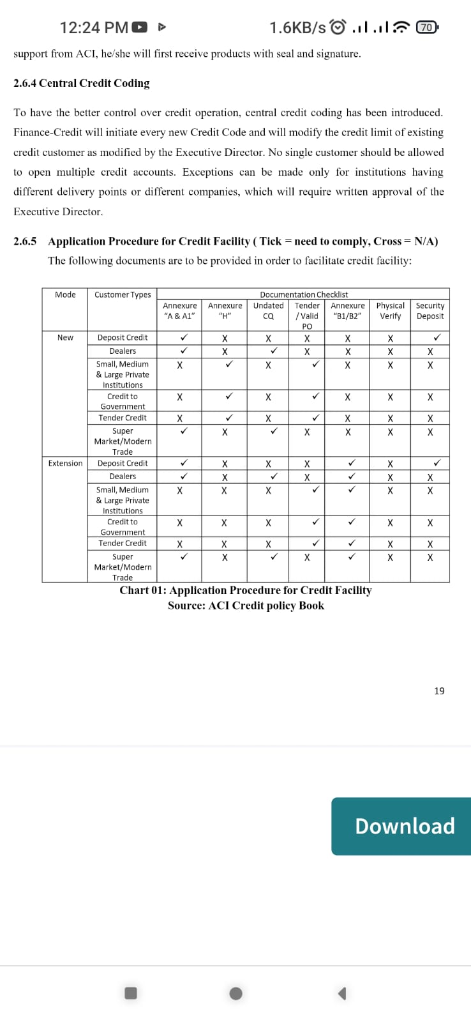
Figure 6. ACI credit Risk Policy Book

4.4 Extension of credit limit and days
Extension of credit limit:
Extensions of credit limits could be necessary due to business activities. The motivation to accomplish the goal shouldn’t be utilized to raise the restriction. The credit limit cannot be raised unless there is compelling justification for doing so. Depending on the customer’s prior performance and potential, SM may propose modifying the credit limit if the customer’s initial credit limit is insufficient or excessive.

- If the proposal includes a letter, credit application forms and extension forms, the proposal must also include the same documents. A fresh security check for the amount of the desired limit must also be provided, and the client must sign an agreement form. The restriction may raise just once every six months.
- If a deposit credit customer applies, the limit will be raised proportionately to the extra amount deposited.
- The amount of the purchase order will be used to establish the credit facilities for all other categories.

Extension of credit days:
Customers occasionally could request certain latitude in paying the outstanding balance. It would not be appropriate in the normal course of business to forbid outstanding clients from providing the flexibility when they so choose. Additionally, the idea of credit days’ extension is only established for institutional clients. Extension of credit days could benefit the company. However, giving erroneous clients excessive credit extensions and days extensions could wind up costing money. Therefore, it must exercise caution while approving the extension request. it should keep in mind that expansions are only intended for certain scenarios, thus it should not establish a practice of doing so.

4.5 Follow-up through payment reminder memos
Unpaid credit statement:
A timely explanation of what is accessible to the customer, the aging schedule, and the movement of debtors will be assembled and distribution to the designated parties by Finance-Credit.

Prior SMS notification:
When their outstanding receivables are set to mature, customers will receive an early notification through SMS that includes the entire amount owing as well as the amount that must mature within a specific length of time.

Sending late-paying customers an SMS reminder:
Finance-Credit will send a client the first SMS reminder when they are more than 14 days past the due date. After 15 days, clients who have not paid their obligation in full with in that time will receive a second SMS reminder.

Payment method:
- Credit should be provided to local clients by cheque or pay order, and to past-due clients through demand draft.
- When payments have been taken from one client and transferred to another, it is considered an offense of DD/PO.
- All the credit customers should be reminded that without proper receipts from ACI Limited confirming to their payment, it will be rejected.
- Income tax challan:
- If a third-party credit customer, every advance income tax challan related to source-deducted income tax must be collected and submitted to Finance by the appropriate staff member within the fiscal year.

4.6 Roles and responsibilities
Roles and responsibilities are include updating the Digital-KYC (spreadsheet) and providing the credit-facilitated clients with relevant information into the company’s database system. In addition, they need to reconcile the information that had previously been input into the database. Any addition tasks that supervisors have been given include replacing security checks, NID verifying the customer and guarantor on new loan proposals, etc. it was unusual that they had to perform the customer’s credit analysis.

4.6 Updating Database System:
To maintain all of the client’s essential data and papers, the MIS section of the business created a database system. The team, which consists of intern and a few executives, and tasked with updating the database by entering customer data into the system. Also, MICR/Non-MICR are among the details have entered into the database system. Scanned the customer’s information and pictures, signature of the invoice authority that provided the input into the database system.

Updating the Digital-KYC:
Digital KYC refers to the use of a spreadsheet to hold all the client codes, names, credit limit, due dates and ages of all firms. Through this spreadsheet, it is possible to verify if the client is using the service or not. In this spreadsheet, it also had to alter the NID number, replacement business code, and tracking number of the customer’s system entry.

Reconciliation:
It indicates to verifying information that has already been stored in the database system. It has balanced the data ACI’s Fertilizer division and CC & PH business. It made an effort to determine whether the hard copy customer’s document and the database system include any error. It attempted to match a lot of the mismatched data that has been submitted into the system. Also it has to enter appropriate information into the system, therefore it largely reconciled security check data.

NID Verification:
Valid NID information must be maintained of both consumers and guarantors in order to grant credit. Sometimes, client will submit a fake national identity number, in which case it will be unable to pursue legal action against them due to their lack of an official NID. The business has obtained a paid NID verification system from the electoral commission in order to identify the fake NID. By using this service, which requires a monthly fee, the company will receive real client identification, be able to avoid repeat customer times and be guaranteed accurate information.

Cheque Replacement:
The task has involved replacing security checks for customers, whereby the client must return the completed check and pick up the blank one. The policy was implemented in 2021 based on a decision made by the Head of Credit. The customer’s signature on the blank check has been confirmed by me using the signature verification page and the previously submitted amount check.

Cheque Return:
From among all the credit-facilitated motors clients, it has to be located the returned checks for ACI’s motor company. It has to be updated the customer code and name on the returned checks into an excel file. ACI is required to return a client’s security check in the event that the customer decides to discontinue doing business with the firm.

To Update the Newly Developed Apps:
The business sales admin will simply receive notifications of the status of cheque returns and check replacement, which will expedite the process overall. However, it has to update the work progress for these tasks in the newly designed apps.

CHAPTER V: RECOMMENDATIONS CONCLUSION

Conclusion
The largest FMGC company in Bangladesh is ACI Limited. It discusses ACI Limited’s credit risk management in this study. Beyond this, however, a further problem has emerged regarding the relationship between ACI Limited’s customers and employees. Because customer-retail and business to business are an organization’s lifeblood. Every business owner view customer satisfaction as a profitability issue, regardless of whether view it as a social responsibility issue. Understanding the viewpoint of the consumer is always a worthwhile investment of time and energy. Strong and prosperous customer relationships may be direct route to ling-term prosperity. One of Bangladesh’s largest companies, ACI Limited, continually prioritizes the satisfaction of its clients and employees. ACI Limited thinks its ultimate goals can only be accomplished by building positive relationships between its workers and its client. The majority of ACI Limited’s clients are satisfied with both the company’s customer service and the caliber of its goods. However, it is adequate for business. In the business sector, there is always more to be done to maintain the organization competitive. ACI customers and staff may be strengthened by a few changes, which may also cause ACI Limited to move to a new building where the connection between customers and employees are prioritized. Everyone is aware that a company’s customers and employees are its most precious assets.

Recommendations
- Get rid of spreadsheets
- Findings new partners
- Create prototype KPIs
- Training and development
- Risk and concern

REFERENCES
Chakma, A. (2021). Learning & development practices at ACI Limited.

Haider, T. (2015). Possibilities of promoting consumer brands through online: a study on ACI Ltd.

Hasan, M., Alam, M., & Huq, M. (2011). Credit Rating: A Tool for Evaluating Bank Performance. IST, Journal on Business & Technology, 3, 4(1-2), 184-197.

Hasan, M. T. (2009). An Evaluation of Capital Market in Bangladesh Through statistical measurement. The Bangladesh Accountant, 62(5), 48-56.

Hasan, M. T., & Huq, M. M. (2010). Quantification of qualitative parameters for performance appraisal: a case study. ASA University Review, 4(2), 39-48.

Mahjabin, N. (2018). ACI foods, analyzing company situation in terms of customer responsiveness.

Mahmud, M. T., Hasan, M. T., & Ashif, A. S. M. (2014). Determinants of job satisfaction: A comparative study in the banking sector of Bangladesh. International Journal of Economics and Empirical Research (IJEER), 2(1), 22-28.

Rabianski, J. S. (2003). Primary and secondary data: Concepts, concerns, errors, and issues. The Appraisal Journal, 71(1), 43.

Online references:
- ACI Annual Report 2021-2022
- ACI Annual Report 2020-2021
- ACI Annual Report 2019-2020
- ACI Annual Report 2018-2019
- ACI Annual Report 2017-2018
- Financial Management: Meaning, Scope, Objectives & Functions
- Investments Principles and Concepts International 12th Edition Jones Solutions Manual
- Dhaka Stock Exchange- Latest Share Price
- ACI Limited- Advanced Chemical Industries-Bangladesh
- Investopedia.com

