Migration and Remittances: Do Skilled Labor Remit More?

Rakib Bin Shahid
BRAC University

Supervisor: Dr. Farzana Munshi
Associate Professor, Department of Economics and Social Sciences
BRAC University

Abstract
Remittances has a significant role in the growth of an economy and the policy choice of exporting more skilled labor over less-skilled labor or vice versa could prove to be a decisive factor behind the growth. In spite of past studies there is still a lack of conclusive statements that could sway opinion to one side. This study attempts to provide an empirical analysis by accumulating data from a range of 160 countries for the year 2010, measuring an aggregate effect of skill level on remittance. The paper takes data from databank of World Development Indicators and the dataset published by DIOC in 2010/11. The results suggest that less-skilled labor indeed remit more than skilled labor. The study has contributed in the formation of opinion regarding skill level and remittances by conducting empirical analysis on a broader data.

- Introduction
Remittances play a big role in the growth of an economy. It can be even seen to contribute to up to 36% of a country’s GDP (Tajikistan’s remittance’s percentage of GDP in 2011). In the light of such significance, dialogues have stemmed into two categories regarding the effect of export of skilled or less-skilled labor on remittances. One being skilled labor remitting more and the other skilled labor remitting less.
The argument backing skilled labor remitting more is associated to returns on education where it is emphasized that skilled labor will earn more and consequently remit more (Ratha, 2003). Moreover, this increased remittance will create opportunities for skill level to develop in home countries. (Stark et al. 1997, 1998). Whereas, the argument behind skilled labor remitting less is associated with brain drain which is the emigration is of highly trained people from a particular country. This loss in human capital, according to Stalker (1994) was detrimental as the difficulty in retaining of skilled labor could not be compensated. And in countries like Jamaica, a point came where five doctors were needed to be trained only to retain one (Stalker 1994).
One distinct challenge in observing effect of skill level on remittances is the measurement of skill level itself. There exists no fully accurate indicator or measure to assess the skill of labor. However, income and in many cases education acts as widely used proxies for measuring skill level.
In this paper, we measure skill through education (ISCED index) and check the effect of export of skilled and less-skilled labor on remittances for 160 countries for the year 2010. The purpose of this paper is to provide an aggregate empirical analysis that includes over 160 countries with a comparatively recent data.
The paper is structures into five parts. This section is the introductory section. Literature review is under section 2; section 3 contains methodology. There are two subsections under methodology: 3.1 consisting of data sources and model estimation and 3.2 comprising of defining skilled labor and less-skilled labor. The results and discussions falls under section 4 and lastly, the concluding part is the section 5.

- Literature Review
Literature on effect of skill on remittances go back to 1970s. And since then, a lot of work has been done with arguments swaying over the course of time. According to Bhagwati (1976) even in the face of severe unemployment exporting less-skilled labor was harmful for the sending countries as even the less-skilled had above nil marginal productivity which if used in rural areas turned out as significant contribution to the economy. However, after more than a decade later the literature swayed to a new standpoint view. Mountford (1997); Stark et al. (1997, 1998) and Beine et al. (2001, 2003) say that the returns on education prove to be a strong ally when it comes to exporting skilled labor. This also offsets an increase in investment in education in the home country.
In the late 90s and early 2000s, the literature started to delve into the factors associated with brain drain. Borjas and Brastberg (1996) found that there exists strong evidence that skilled migrants tend to stay longer in the host country. Solimano (2002) conducted a study where he found that a large fraction of Ph.D. graduates from developing countries decided to settle in the US after their graduation. This echoed with the results found by Reagan and Olsen (2000); Gang (1998); Steiner and Veiling (1994). Moreover, a further study by Piracha and Saraogi (2011) in Moldova found significant evidence between remittances and duration of stay; motive to return; investment environment in home country.
A study conducted by Faini (2006) used the Docquier and Marfouk (2004) dataset, comprising data of 42 nations and found that higher skilled labor tends to remit less. He explains this with the idea that educated migrants are assumed to already come from a financially well off family for which the incentive to remit is relatively less. Moreover, due to better standard of living, migrants are more inclined to take their family living in home country to host country. Another study by Niimi, Ozden and Schiff (2010) is consistent with the evidence found by Faini (2006). However, a few studies by Schipou and Siegfried (2006) and Bollard et al. (2009) contradicts with the findings by Faini (2006) and Niimi, Ozden and Schiff (2010).
This paper aims to bolster research on these previous findings with a recent data and data that is comprised of a much higher number of countries.

- Methodology
  - Data Source and Model Estimation
The data used in this paper is a combination of data collected from databank of World Development Indicators and DIOC’s (Database on Immigrants in OECD and non-OECD Countries) dataset of the year 2010/11.
The model proposed in the paper is a log-log model. The equation is given below.

LnRm = β₀ + β₁ LnGDP + β₂ LnS + β₃ LnLS + β₄ LnGDPperK + u
(1)

Where, LnRm = Log of Remittances
LnGDP = Log of GDP
LnS = Log of Number of Skilled Migrants
LnLS = Log of Less-Skilled Migrants
LnGDPperK = Log of GDP Per Capita
However, due to high multicollinearity the proposed equation is split into two equations (2 and 3) with equation number 2 having Log of Skilled Labor and equation number 3 having Less-Skilled Labor ceteris paribus.

LnRm = β₀ + β₁ LnGDP + β₂ LnS + β₃LnGDPperK + u
(2)

LnRm = β₀ + β₁ LnGDP + β₂ LnLS + β₃LnGDPperK + u (3)

GDP Per Capita is a measure of standard of living. A very high GDP per capita is an indicator of low migration and consequently low remittances. GDP measures an overall state of the economy which if on the rise could enable people to bear the cost of migrating. GDP per capita also adds precision to this indicator.

  - Defining Skilled and Less-Skilled Labor
The variable for the skill level of labor was redefined in this paper as there was no recent data that could be used for the study of this paper. For skilled and less-skilled, ISCED 1997 levels of education were used to define. The ISCED codes for non-OECD countries are given below:
- ISCED 0/1 (Coded 1): People with no education, pre-primary and initial stage of organized instruction falls under this category.
- ISCED 2 (Coded 2): People with basic education and lower-secondary education are under this category.
- ISCED 3 (Coded 3): People who have attained upper-secondary education falls under this category.
- ISCED 4 (Coded 4): People who have completed post-secondary education falls under this category.
- ISCED 5/6 (Coded 56): People who have complete a first or second tertiary education are under this category.
The ISCED Codes for OECD countries are given below:
- ISCED 0/1/2 (Coded 12): Those who have attained Basic education.
- ISCED 3/4 (Coded 34): Those who have attained Secondary education.
- ISCED 5/6 (Coded 56): Those who have attained Tertiary education.
The DIOC dataset had data to the level of individuals and had over one hundred thousand observations. These observations were converted to percentages of individual countries where each country had migrants ranging from a few hundreds to thousands. Due to the large sample size, the percentages of education level of these migrants acted as a good proxy for the percentage of education for the entire migrant stock of the nation. This percentage was later multiplied with the total stock of migrants of nations to find an estimated total migrant stock divided in accordance to the ISCED education index.
After the number of migrants was found in accordance to education, skilled and less-skilled was required to be separated. Migrants who fell under ISCED 0 to 4 was assumed to be less skilled. Whereas, migrants with tertiary education were taken as skilled.

- Results and Discussion
Table 1: Regression results of Model 2 and 3.

 | (2) | (3)
VARIABLES | Log of Remittances  (current US$) | Log of Remittances  (current US$)
Log of GDP | 0.36345*** | 0.27201**
 | (0.10884) | (0.11028)
Log of Skilled Labor | 0.38171***
 | (0.11239)
Log of Less-Skilled labor |  | 0.52543***
 |  | (0.11890)
Log of GDP Per Capita | 0.48520*** | 0.45514***
 | (0.10719) | (0.10144)
Constant | 1.90404 | 2.02054
 | (1.42904) | (1.39647)
Observations | 163 | 160
R-squared | 0.61349 | 0.62510
Standard errors in parentheses
*** p<0.01, ** p<0.05, * p<0.10
The results of model 1, 2 and 3 are shown in Table 2 (See Appendix). In model 1, the results show that 1% increase in the migration of Skilled Labor would decrease remittances by 1.02%. Whereas, a 1% increase in the migration of Less-Skilled Labor would increase remittances by 1.55%.
However, model 1 suffered a high case of multicollinearity. For which model was split into two. Model 2 shows effect of Skilled Labor on remittances whereas model 3 shows effect of Less-Skilled Labor on remittances. By comparing model 2 and 3 we find that with 1% increase in Skilled Labor, there is an increase in remittances by .38% whereas, with 1% increase in Less-Skilled Labor, there is an increase in remittances by .53%. Less-skilled labor remits more than skilled labor. This result is consistent with the previous one in terms of relative remittances. (See Chart 1 and 2 for scatter graphs of Skilled and Less-Skilled Labor against Remittances)
For model 2, 61.35% of our x variables explain our y variable and for model 3, 62.51% of our x variables explain our y variable.
There exists no multicollinearity for the latter two models and also, all three models are heteroskedastic. For model 2 and 3, both skilled and non-skilled labor are significant at 1%.
- Conclusion
Faini (2006) explains the reason behind skilled labor remitting less very well. According to the author, these skilled people who have attained one or more tertiary education has had the capabilities to afford an education, whether in host country or home country. Even if we take it with a grain of salt, the chances that the migrant afforded one or more tertiary education and migrated to a different country implies that the migrant’s family is comparatively well off. Moreover, with the increased income from his returns of education in a host country with high standard of living would incentivize the skilled migrant to spend more. And finally, the migrant would be inclined to bringing the migrant’s family to the host country. These three reasons could be possible explanations for a rather counter-intuitive results of the study done in this paper.
However, researches done by Piracha and Saraogi (2011) tell us that tendency to remit also depends on factors like motive to return home, investment opportunities in home country, accessibility to banking facilities etc. So even if the results of this paper indicate that it is more fruitful to export less-skilled labors, policy makers could still use the findings of researches to maximize remittances from skilled labor. Perhaps, strong incentives for the migrant to return home via massive investment opportunities; developing community values to nurture culture and tradition etc. could turn the findings of this paper null.

References
Bhagwati, Jagdish, and Koichi Hamada. "The brain drain, international integration of markets for professionals and unemployment." Journal of Development Economics 1, no. 1 (1974): 19-42
Borjas, George, and Bernt Bratsberg. "Who Leaves? The Outmigration of the Foreign-Born." Review of Economics and Statistics, 1994
Docquier, Frederic, and Abdeslam Marfouk. "Measuring the International Mobility of Skilled Workers (1990–2000): Release 1.0." Policy Research Working Papers, 2004.
Martin, Philip, and Peter Stalker. "The Work of Strangers: A Survey of International Labour Migration." International Migration Review 29, no. 1 (1995): 264.
Mountford, Andrew. "Can a brain drain be good for growth in the source economy?" Journal of Development Economics 53, no. 2 (1997): 287-303.
Niimi, Yoko, Caglar Ozden, and Maurice Schiff. "Remittances and the Brain Drain: Skilled Migrants Do Remit Less." Annals of Economics and Statistics, no. 97/98 (2010): 123.
Piracha, Matloob and Saraogi, Amrita. 2011. “Migration for Remittances: Evidence from Moldova.” Discussion Paper Series. IZA, January.
Ratha, Dilip. "Workers’ Remittances: An Important and Stable Source of External Development Finance." In Global Development Finance Striving for Stability in Development Finance, 157-75. Vol. 2. Global development finance. The World Bank, 2003.
Reagan, Patricia B., and Randall J. Olsen. "You Can Go Home Again: Evidence from Longitudinal Data." Demography 37, no. 3 (2000): 339
Solimano, Andrés. 2002. “Globalization Talent and Human Capital. Implications for the Developing Countries.” Macroeconomía del desarrollo. ECLAC, UNECLAC, June 24–26
Stark, Oded & Helmenstein, Christian & Prskawetz, Alexia, 1997. "A Brain Gain with a Brain Drain," Economics Series 45, Institute for Advanced Studies.
Steiner, Viktor, and Johannes Velling. "Re-Migration Behavior and Expected Duration of Stay of Guest Workers in Germany." The Economic Consequences of Immigration to Germany Studies in Contemporary Economics, 1994, 101-19.

Appendix
Table 2: Regression of Model 1, 2 and 3.
 | (1) | (2) | (3)
VARIABLES | Log of Remittances (current US$) | Log of Remittances (current US$) | Log of Remittances (current US$)
Log of GDP | 0.28214** | 0.36345*** | 0.27201**
 | (0.10841) | (0.10884) | (0.11028)
Log of Skilled Labor | -1.02268** | 0.38171***
 | (0.39639) | (0.11239)
Log of Less-Skilled labor | 1.55173*** |  | 0.52543***
 | (0.41459) |  | (0.11890)
Log of GDP Per Capita | 0.32135*** | 0.48520*** | 0.45514***
 | (0.11233) | (0.10719) | (0.10144)
Constant | 1.26507 | 1.90404 | 2.02054
 | (1.40273) | (1.42904) | (1.39647)
Observations | 160 | 163 | 160
R-squared | 0.64054 | 0.61349 | 0.62510
Standard errors in parentheses
*** p<0.01, ** p<0.05, * p<0.10

Chart 1: Scatter Plot of Log of Skilled Labor and Remittances
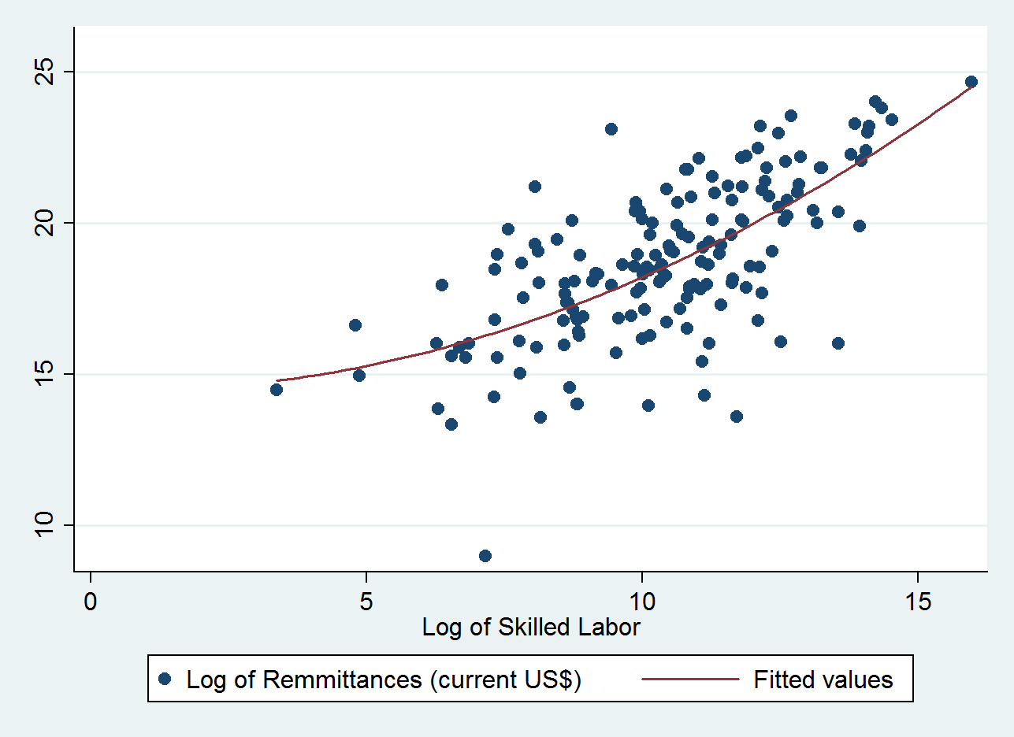

Chart 2: Scatter Plot of Log of Less-Skilled Labor and Remittances
