

Internship Report
On

Economic and Social Sustainability of Real Estate Company:Bangladesh Perspective.

Submitted to

Eliza Huq
Assistant Professor
School of Business and Economics
United International University

Submitted by

AnikaFerdous
ID: 111 143 296
BBA (Finance)
School of Business and Economics
United International University

Submission Date: April 30, 2019

“Economic and Social Sustainability of Real Estate Company: Bangladesh Perspective”



Internship Report
On

Economic and Social Sustainability of Real Estate Company: Bangladesh Perspective.

Submitted to

Eliza Huq
Assistant Professor
School of Business and Economics
United International University

Submitted by

AnikaFerdous
ID: 111 143 296
BBA (Finance)
School of Business and Economics
United International University

Date of Submission

30 April, 2019
Letter of Transmittal

Eliza Huq
Asistant Professor
School of Business and Economics

Subject: Submission of internship report.

Dear Madam,
With due respect, I would like to inform you that, it is a good pleasure to me for submitting the internship Report titled “Economic and Social Sustainability of Real Estate Company: Bangladesh Perspective.”
This study has allowed me to urge an extra profound comprehension regarding the Real Estate Sector of Bangladesh.
I would wish to inform you that, I actually have effectively completed my internship report. I actually have given my greatest exertion to create this report a helpful one. It has been sensible and academic comprehension on behalf of me. However, this has been plainly an enormous premise of learning on behalf of me to perform connected types of exercises afterward.
So, I will be able to be extremely inspired if you are kind enough to receive my report and pardon me for any errors and mistakes. I would wish to thanks for your monumental facilitate that impressed me to work enthusiastically.
Thank You

Sincerely yours

AnikaFerdous

Acknowledgement

At first, I might prefer to specific my heartfelt gratitude to Almighty Allah, the most merciful and beneficent, that blessed me with the information, gave me the courageousness and allowed me to accomplish the task.
Next, I’m deeply indebted to my supervisor Eliza Huq, Assistant Professor, School of Business and Economics, United International University (UIU) for his inspiration, guide, valuable suggestion, systematic recommendation, and spirited encouragement created throughout the work. She additionally helped me to decide on the topic for my internship report. As a result, I even have possessed the aptitude to carry on my work. The foremost effective accomplishable direction of her is value referencing.
Furthermore, I might prefer to convey my parents as a result for their inspirations I even have able to complete this work.

Declaration

I am Anika Ferdous, student of Business and Economics (Finance) of United International University, Bangladesh, do herewith declare that the report on “Economic and Social Sustainability of Real Estate Company: Bangladesh Perspective” is a bona fide work and has not been antecedently submitted for any degree, diploma, title, or recognition.

AnikaFerdous
ID: 111 143 296
School of Business and Economics
United International University

Executive Summary

Like any alternative country within the world, the housing sector plays important roles each within the context of the economy of Bangladesh and serving the basic right of shelter. Apart from providing physical shelter, housing might have important impact on the lives of the dwellers in terms of skills improvement, financial gain generation, inflated security, health, sureness and human dignity. Bangladesh, like several alternative developing countries, faces associate acute shortage of reasonable housing each within the urban and rural areas. Moreover, housing affordability is being eroded by poor land administration policies, which have resulted in very high land prices that make urban housing prohibitive for lower-income groups. Also, there's no active secondary marketplace for land, chiefly owing to the high transfer taxes associated an uninterrupted long-run increase in land costs. In spite of these, this sector has tough wide growth in past few decades.
With a rising population and increasing housing demand, flat culture has fully grown up in capital of Bangladesh sharply. Apartments were 1st introduced by the formal non-public developers in early 80s to the housing history of capital of Bangladesh. It 1st appeared in capital of Bangladesh close to Central Road and after wards town tough a boom in flat development all told residential areas as well as Paribagh, Maghbazar, Siddeshwari, Shantinagar, Dhanmondi, Mirpur, Banani, old DOHS, new DOHS, Gulshan and Baridhara, to calls imply many.
During the last decade, the overall volume of land, Renting and Business service sector increased every year which implies a positive growth in the sector every year. But, compared to overall value growth, this sector expanded at a slower rate. That is why in overall value the contribution of this sector encompasses a downward trend. Investment in the real estate sector has seen an increase in the past few years. In Bangladesh, GDP-investment ratio rose to 30.27% in FY 2016-17. This is an increase from 29.65% in the previous year. Around 10% of total remittance is being used to purchase lands and flats. On the other hand, 77.78% of the investment from foreign remittance is being used for reconstruction purposes of flats or buildings.
Through the analysis of economic and social sustainability and problems and prospects of this sector it was found that this sector is a good investment.
This was just one of the aspects of the growth of this industry. If we look from the bird’s eye view, we can see that this industry is still taking shape and there is fast-growing middle class. This large chunk of the population looks for affordable solutions to everything, thanks to increasing GDP per capita. Such economic conditions are termed as ‘emerging markets’ where industries are yet to take proper shape.

Table of Contents

Chapter One 1
Introduction 1
1.1 Background 2
1.2 PROBLEM STATEMENT 2
SUSTAINABILITY AND GLOBAL CHALLENGES 3
1.2.1 LACK OF SUSTAINABLE BUILDINGS BUILT BY REAL ESTATE DEVELOPERS 7
1.2.2 LACK OF PARTICIPATION OF REAL ESTATE DEVELOPERS IN DISASTER MANAGEMENT 8
1.3 OBJECTIVE OF THE STUDY 11
1.4 THE METHODOLOGY 11
1.5 DATA ANALYSIS 11
1.6 LIMITATIONS OF THE STUDY 11
Chapter Two 12
Literature Review 12
2.1 URBAN SCENARIO OF DHAKA CITY 13
2.1.1 OVERVIEW ON URBANIZATION IN DHAKA CITY 13
2.1.2 EFFECTS OF RAPID URBANIZATION IN DHAKA CITY 14
2.1.3 CONTRIBUTING FACTORS FOR RAPID URBANIZATION 15
2.2 HOUSING SECTOR IN DHAKA CITY 16
2.2.1 OVERVIEW ON HOUSING SECTOR 16
2.2.2 IMPACTS OF RESIDENTIAL BUILDINGS ON ITS SURROUNDINGS 18
2.2.3 OVERVIEW ON HIGH-RISEAPARTMENT BUILDINGS 19
2.2.4. 1IMPACTS OF HIGH-RISE APARTMENT BUILDINGS 19
2.2.5 CHANGES IN LAND USE PATTERN: EFFECTS AND CONSEQUENCES 20
2.2.6 VIOLATION IN BUILDING CODE 21
2.2. 7 HOUSING PRACTICE IN DHANMONDI RESIDENTIAL AREA 22
2.2.8. REAL ESTATE DEVELOPER IN DHAKA CITY 22
2.2.8.1 OVERVIEW ON REAL ESTATE DEVELOPER 22
2.2.9 RAJUK 24
2.2.9.1 OVERVIEW ON RAJUK 24
2.3 Future of Real Estate in Bangladesh 26
Chapter Three 28
Background of the Study 28
3.1 STUDY AREA 29
3.2 ECONOMIC VITALITY 29
3.3 RATIOS 31
3.4 PROFITABILITY RATIOS 31
Chapter Four 33
Data Analysis 33
4.1 RESEARCH FINDINGS 34
4.1.1RESEARCH FINDINGS ON ANALYSIS OF HOUSEHOLDS IN APARTMENT BUILDINGS 34
4.1.2 RESEARCHFINDINGS ON ANALYSIS OF BUILDINGS CONSTRUCTED BY SELECTIVE REAL ESTATE DEVELOPER COMPANIES 35
4.1.3 RESEARCH FINDINGS ON ANALYSIS OF REAL ESTATE DEVELOPERS VIEW ON SUSTAINABILITY AND DISASTER MANAGEMENT ISSUES 36
Chapter Five 38
Recommendations and Conclusion 38
5.1 RECOMMENDATIONS FOR REAL ESTATE DEVELOPER COMPANIES FOR ATTAINING SUSTAINABLE APPROACH IN BUILDING DESIGN 39
5.2 PROPOSALS TO ATTAIN SUSTAINABILITY IN RESIDENTIAL BUILDINGS OF DHAKA CITY 39
5.2 CONCLUSION 42
References 44

Chapter One

Introduction

1.1 Background

Bangladesh is a low-lying deltaic country situated in between 20°34' and 26°38' latitude and between 88°01' and 92°41 east longitude and formed by the Ganges, the Brahmaputra and the Meghna rivers. Urbanization worldwide has been found to be an efficient engine of economic process and socio-cultural development. Urbanization in the context of Bangladesh marks a long history possibly of over 2000 years. Dhaka being the capital and the only megacity of Bangladesh has experienced rapid uncontrolled urbanization. The evolution of Dhaka into a megacity has created many serious problems for the city and its surrounding regions. One of the quickest growing cities of the world, Dhaka, is facing issues of holdup, solid waste disposal, water work, housing, water, air and pollution, spring water depletion, lack of utility services, loss of wetlands, etc. Because of exceptional population growth,speedy increase in population, Dhaka city has faced tremendous crisis of housing and necessary infrastructures. Because of shortage of buildable land worth the inhabitants are forced to buy apartment units in mid or high-rise buildings. However the buildings created in Dhaka city by the individual land owners or by the Real Estate Developer companies did not follow the characteristics of sustainability resulting significant threats to successfulness. Uncontrolled and unplanned urbanization has also made Dhaka city vulnerable to many natural hazards such as earthquake, flood, and also fire incidents are increasing at greater rate. As a result it has become a necessity to understand the current situation of the housing sector in Dhaka city in terms of sustainability and disaster management. As the private Real Estate Developer companies play a vital role in providing thousands of residential apartment units in every year, therefore, the focus of this research will be on the roles of Real Estate Developer companies in disaster management in Dhaka city. The current practice trend in apartment building design by the developer companies will be analyzed to find out the problems faced by the apartment dwellers so that theseissues can be addressed in near future for more suitable and sustainable built-forms in Dhaka city. Also the national building code will be analyzed. The safety of the city dwellers should be the prime concern of the government and concerned stakeholders. One of the important issues of living in an apartment building is the safety issue which needs to be addressed in order to find out how well aware are the apartment dwellers and developer companies about fire, earthquake, and other associated hazards and their way of managing these disasters or reducing the risks of such threats.

1.2 PROBLEM STATEMENT

Dhaka is a very fast growing megacity. It is estimated that the total urban population will be 60 to 80 million, which is one and a half to nearly 2 times of the present urban population, by 2020. The main two reasons for the rapid growth of population in Dhaka city is firstly due to the natural growth of the city and secondly due to huge number of people (both rural and other urban areas) migrating into Dhaka city in order to make their lives better with greater opportunities and to enjoy the modern and civic facilities.
In order to accommodate the present and the future population Dhaka city in undergoing huge and rapid urbanization which are creating opportunities as well as challenges/ problems for the citizens. The haphazard urbanization or the unplanned growth of housing sector has given rise to many problems such as loss of wetlands, lack of open space, traffic congestion, pressure on utility services and community facilities, land speculation, lack of habitat of fauna-flora and biodiversity, loss of productive agricultural land, lack of air and sunlight, noise and air pollution, fire hazards, slum and substandard housing condition.
The demand of housing in Dhaka city is definitely increasing due to increasing population growth and its fast growth rate. At least 100,000 new housing units are required in every year. It is found that 30% of total population of Dhaka city has already covered 80% of residential areas with human settlement and systematic infrastructures. The housing deficit in urban areas grew from 1.13million units in 2001 to 4.6million units in 2010 and it is predicted that the deficit will reach to 8.5 million units in 2021 if the investment does not keep pace with the raise of population. There is an extensive need for the rapid increase in housing units which are partially being provided by Real Estate Developer companies besides government agencies.
My current research contributes to our understanding of sustainability measurement of Real Estate Company in Bangladesh. Growth of population and development of economic are the facts of sustainability of real estate sector. In Bangladesh, so many researches are conducted regarding real estate sector. As there is not having proper research for sustainability measurement in this sector, so that, basically this research is based on sustainability measurement of Real Estate Company in Bangladesh.

SUSTAINABILITY AND GLOBAL CHALLENGES

There area unit many issues within the economy and society, that ought to be solved. Numerous stable positive trends within the country, urban and economic development area unit necessary for property development. Throughout historical development, demographic factors have had a good influence on economic development of countriesand everyspecific society. These factors are particularly important now a day. Forecasts show population increase upto 8 billion until 2024 andupto10.85billionsuntil2100(Worldometers,2016);atthestartofagriculture,concerning 8000 before Christ, the globe population was just about five million, and important is that the undeniable fact that in 1970 there was roughly 1/2 world population as compared to these days. the rise of world population is shown below:
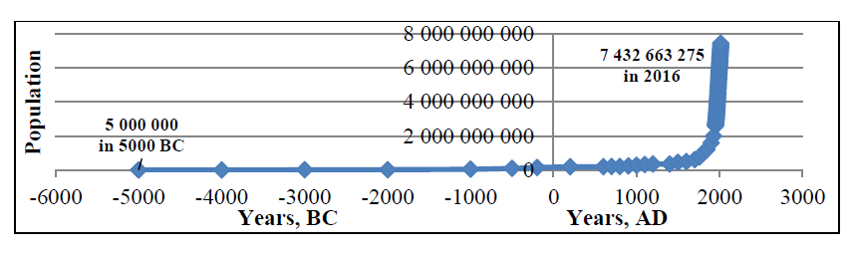
Fig. 1.The growth of world population from 5000 BC to 200 BC and from 200 AD to 2016 AD
The growth of population directly influences the development of real estate market, construction activities, real estate prices and housing affordability in general
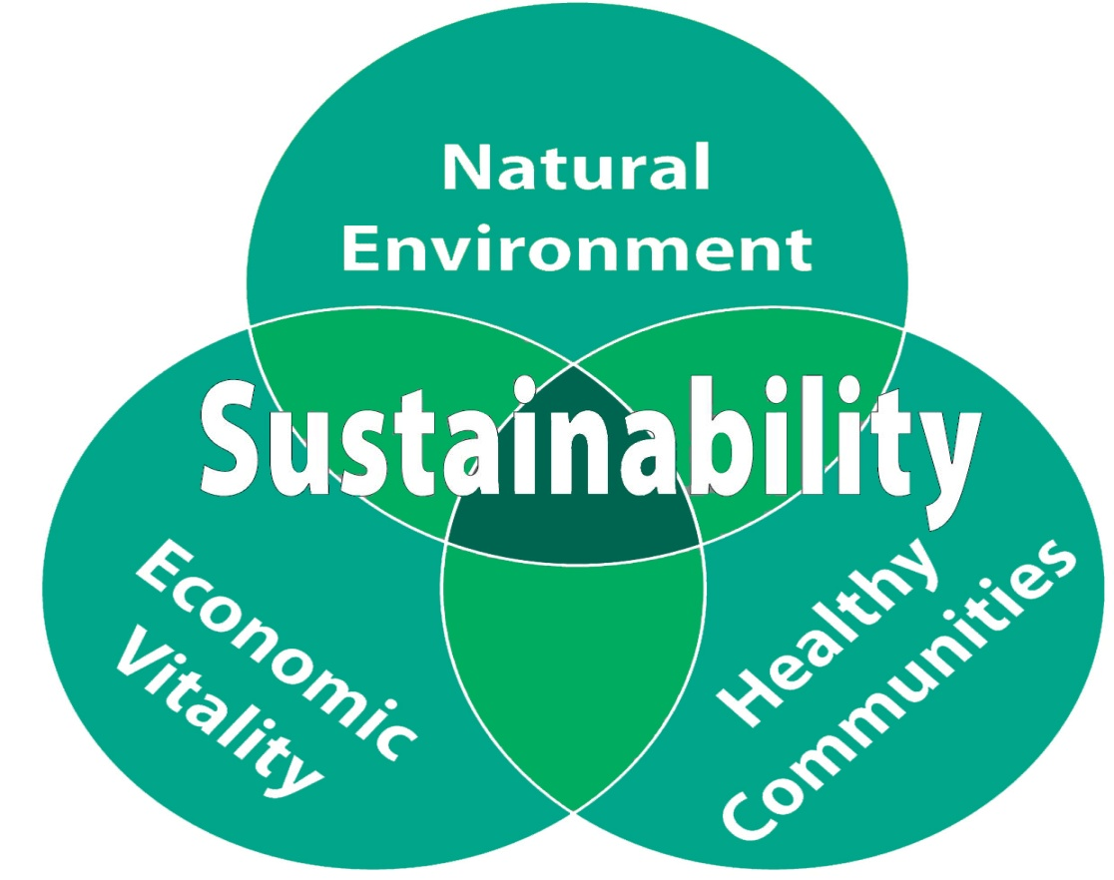

The pressure that the region’s rapid growth has placed on the world’s resources and therefore the setting is well documented.

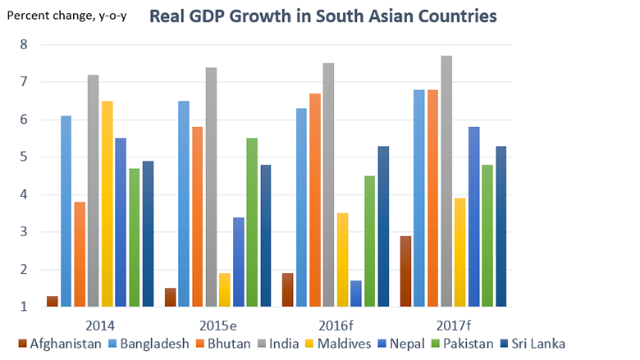
Sustainability is that the question of our ability to require care of this level of well-being insidethe long run. Recently, typical economic statistics area unitmerely inadequate to illuminate the difficulty and GDP as welfare live is questionable. GDPis largelyassociate in Nursingcombinationlive of production insidea rustic. Main factors that have vitalconcerning individual well-being, likefinancial gaindifference, social unitincome, environmental degradation, and changes in wealth, area unitomitted.The gap between our success considerationsnowadays and what we tend toarea unitmeasurement is thus sizable that GDP measures alone area unit deemed unsuitable onceproperty development is considered.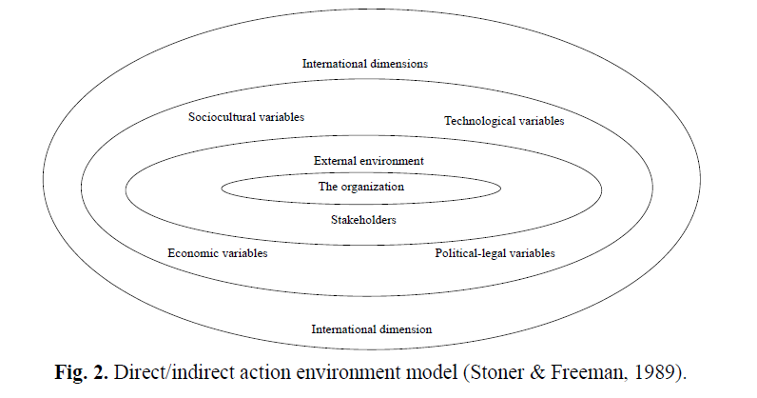
The society and its behaviour are dynamic with the course of time. Change is a problem of social science (Huntington, 1971). Especially important for society and market participants are changes in internal and external environment. Stoner and Freeman (1989) direct/indirect action environment model is given in Fig. 2. The direct/indirect force of environment model can influence also real estate and construction companies and the sector in natural.

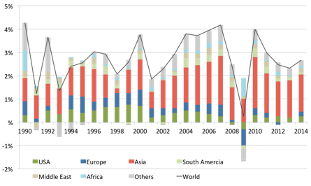
Asia’s persistency contribution to global growth

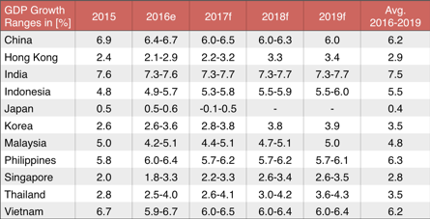
Ongoing positive estimates for real GDP growth rates in Asia

1.2.1 LACK OF SUSTAINABLE BUILDINGS BUILT BY REAL ESTATE DEVELOPERS

Real Estate Developer companies play an important role in providing accommodation by constructing mid-rise to high-rise apartment blocks with necessary services and infrastructure facilities. The huge unsatisfied middle-income class is habitual to be boosting market for the real estate business as middle and upper middle class people have started to show more interest in purchasing apartments due to increased and unaffordable house rent. The factors for the development of apartments:
- Desire to live within the city

- Increasing commercial market for apartments

- Profitable for both owners of land and developers

- Availability of loans from financial institutions

- Existence of flexible rules for development

- Reliable developers in the real estate

- Ownership of a few apartments and ready cash

High-rise buildings are becoming a common phenomena in Dhaka city to accommodate this huge population in comparatively small amount of space. Though high-rise apartments seem to be a good solution to tackle the housing problem in Dhaka city, it has been found to generate new challenges or problems which are:

- Puts pressure on utility services like water supply, gas and electricity.

- Increases traffic congestion and parking problems

- Creates problems of light and ventilation for adjacent small buildings.

- Fire fighting problem

- Problems related to inadequate number of lifts

- Inadequate parking space

- Lack of community space

- Lack of children play area

- Socio-psychological problem

1.2.2 LACK OF PARTICIPATION OF REAL ESTATE DEVELOPERS IN DISASTER MANAGEMENT

Along with the micro level problems associated with individual buildings constructed by these companies, city level damage is also caused by them. The Real Estate companies and RAJUK lack of monitoring, RAJUK failed to monitor the violation of building construction rules which resulted in congested and unhealthy city.

One evident source of law violation can be found in land use change which is very prominent in Dhaka city. Land use change such as commercialization of residential areas is dreadfully touching the habitable environment of the city. The defiance to follow land use plan creates traffic jam, inadequate provision of utility services, pollution, noise pollution, overcrowding, lack of privacy, insufficient parking facility, lack of accessibility, frequent water work and affects the price of providing public infrastructures and services like roads, schools, water and waste material, transport, and mail delivery. On macro level land use change can have adverse effects on Dhaka city.

Dhaka is a high-risk zone considering its high population density, poor physical structure, poor economic condition and least response and recovery capabilities. The threats for Dhaka city are found in:

- Vulnerability for flooding due to indiscriminate filling of water retention and flood flow areas.

- Presence of vulnerable and dilapidated buildings.

- Over dependency on ground water

- Fire hazards of theinterlocked development are high and the problem is multiplied by poor access.

- Filling and intrusion of flood plains and water bodies.

Dhaka is highly vulnerable to natural hazards such as floods, heat waves, earthquakes, fire, drainage congestion/ water logging, infrastructure collapse, ground water depletion, epidemic and surface water, air and sound pollution.

Floods of 1988 and 1998 were catastrophic. Poor drainage has been identified as the principal cause of flooding in Dhaka Metropolitan Area. Flooding in Dhaka is mainly caused due to heavy rainfall, drainage congestion, high surrounding water and overflow of rivers. The experience of the 1998 flood suggests that the city needs to be saved through structural and non-structural measures for flood mitigation. Eastern periphery including one in the north and those outside the embankment at the western periphery of the city suffered severe flood damage. Central wards along north-south strip were safe. Under a changing climate, extreme floods may increase, aggravating the situation for the citizens of Dhaka city. The disaster management of Dhaka city shows weakness in enforcement of protection policies for flood plains, hazard prone and low-lying areas, failure to execute building control regulations.

Rapid increment and unplanned development, uncontrolled land filling to develop new residential areas, uncontrolled and haphazard disposals of solid wastes and garbage into the prevailing system, and encroachment on lakes, canals and rivers with unauthorized construction area unit the final artificial physical and social activities associated with the disappearance of natural system leading to the water work in Dhaka city.
Encroachment on ecologically sensitive areas through unplanned housing engineered by individual landowners similarly as non-public developers, at the side of the discharge of waste water and solid waste into water bodies is accountable for the degradation of the landscape and associated loss of variety. several ponds that worked as runoff reservoir and met the domestic water desires besides being employed as community space area unit stuffed up to form area for housing and roads. The surface water quality of canals, rivers, ponds and muddy lands has deteriorated in Dhaka because of untreated disposal of sanitary waste and solid waste.
48% of the entire surface area is urban that cannot percolate water into well water, as a result the bottom water is depleting at and ireful rate. DWASA primarily depend upon well water extraction, and in recent years thanks to over extraction and reduced percolation, formation in Dhaka has presently born to below 1200´, that was regarding 10´ to 20´.The presence of major seismic sources around Dhaka city and rapid urbanization of Dhaka with unplanned high rise and multistoried buildings in congested communities, exposed and risky electric lines definitely pose a serious threat to the people with regard to earthquake disaster. High earthquake risk has surfaced in the newly developing low-lying areas due to land filling which may cause severe liquefaction during earthquake.

Scarcity of readily accessible water sources and open spaces in neighborhood can accelerate the fire hazards in Dhaka city.
With urbanization comes marginalization of the poor, who are compelled to the rather hazardous, unsafe areas of the cities and possibly to locations where construction may have been forbidden formerly. Due to rapid growth in population and unplanned urbanization, living conditions in Dhaka has deteriorated and the access to services is not socially just.

Lack of coordination among planning organizations at different tiers of government is a specific problem area of strategic urban management in Dhaka. Faulty planning, lack of coordination among various agencies and an overall disregard to environmental issues, also prevents Dhaka city from having a healthy growth. Almost all the alarming conditions in Dhaka city are due to the built-up areas. Thus, it has become crucial to manage the built-up areas in a way that the future of Dhaka city can sustain.

The problems associated with the housing sector especially the multi storey residential buildings provided by the Real Estate Developer companies lack sustainability issues and disaster sensitive design approach.

1.3 OBJECTIVE OF THE STUDY

For find out the roles of Real Estate Developer companies focusing on sustainability and disaster management issues in residential apartment buildings of Dhaka city.

1.4 THE METHODOLOGY

The report is mainly based on secondary data that we have collected from several sources, publications such as books, articles, journals, internet, reports, etc. Collecting data and analysis data is conducted here. The main source of information was internet. The other important source is articles.

1.5 DATA ANALYSIS

MS Office Excel 2013 is used to analyze the data.

1.6 LIMITATIONS OF THE STUDY

Due to lack of time, resources and money the study is focused on specific criteria. For this, extensive research could not be made possible which otherwise could have added more value to it.

Chapter Two

Literature Review

2.1 URBAN SCENARIO OF DHAKA CITY

2.1.1 OVERVIEW ON URBANIZATION IN DHAKA CITY

Bangladesh was a mostly rural society with only 10% of total population living in urban areas from 1950s to mid-1970s. In Bangladesh (at only 28% urban), this sector currently contributes to more than 65% of the national GDP (Forests, 2016). The censuses 1901-1974 treated all places within municipality or town committee or cantonment areas as urban and from 1981 onward development centers and Thana Headquarters have also been considered as urban (Khan, 2012).Bangladesh has some 570 urban place of which Dhaka is a megacity which spreads over 4 other districts covering an area of over 1400 sq.km with a population of 14.7 million. (Forests, 2016). 25 urban places are cities with a large population of over 100,000 each and the rest are small towns, 11 City Corporations and over 322 Municipalities administered under local government (Forests, 2016).

The rapid urbanization growth reached 11% per year during the period 1975-80 (GED, 2015). From 1980-2010 the urban population growth has averaged 4.4% per year (GED, 2015). In Bangladesh 28% of total population live in cities (43 million), of which one-third reside in Dhaka alone. Population of Dhaka is 5 times more than its capacity ( ideally 30 lakhs). The annual population growth rate of Dhaka city is projected to be 3.82% between the years 2014-2030. In Dhaka the rural-urban migration rate is 4.2% which is one of the highest in the . The population density is 20000-135000 people per sq.km and the average occupancy per residence unit is 7.5 persons. About 40% of the city resident are said to be poor, 50% is of middle income and the remaining 10% are more income group. 75% of land is below natural water level and 95% within 5-7m flood level, 62% residential area and 8% commercial area. Thepopulation of Dhaka is 1.5crore and it ranks 20th out of 27 most populated megacities in the world (Biswas et al. 2012). In the last two decades the development trend of Dhaka city is taking place in both vertical and horizontal direction in order to cope with overpopulation, scarcity of land and spiraling land prices, but by violating building rules and regulations in most cases. In the last 12 years (except 2000,2001,2005,2006,2011) the highest temperature recorded was more than 40°C and in 2012 rainfall was 137mm in Dhaka city which is normally 339mm. The way the urbanization is taking place in Dhaka city, soon the whole city will turn into a heat island making it unfit for human habitation.

Due to rapid growth in population and unplanned urbanization, living conditions in Dhaka has deteriorated (Biswas et al. 2012) and the access to services is not socially just (Rahman M. A., 2015).People in Dhaka are suffering from heat stroke, diarrhea, typhoid, cough, cold fever (Biswas et al. 2012). At present there are 6.68% roads of total land area in Dhaka Metropolitan Area (DMA) including 52% inaccessible road for motorized vehicles(Hasnat&Hoque, 2016).The surface water area (rivers, lakes and canals) of Dhaka city is about 10%-15% of total land area. Dhaka city creates huge vulnerability indices by concentrating a lot of population, buildings, infrastructure and economic activities in haphazardmeans (RAJUK R. U., 2015). The city’s water level has droppedregarding 20m over the last seven years (RAJUK R. U., 2015). The buildings in Dhakacitythatarea unitrecent and broken-down, freshlydesignedhowever faulty style and full weak buildings area unitextremelyin danger of being folded, and in a recent survey it is found that 78000 out of 326000 buildings are detected as risky (RAJUK R. U., 2015). Every year, at least 100,000 new housing units are required in Dhaka city.The community life of Dhaka city is under huge threat due to sharp violation of land use plan. The rainwater cannot be absorbed due to the unplanned construction of roads and housing development. About 40% to 50% of daily solid waste is collected and disposed by Dhaka City Corporation (DCC) and the rest is disposed of illegally by residents into the vacant lands, low lands, street, canals and drains. The surface water is being polluted by domestic and industrial sewage disposal without treatment directly into water bodies. The Real Estate Developer companies and RAJUK violated the Structure Plan by filling up the wetland of Dhaka city over the past 10 years ( 2007). If the water bodies are filled up at this present rate then there will be no water bodies after 2035 and the temperature of Dhaka city will increase by the reduction of water bodies. Therefore, the present condition of Dhaka city is very alarming capable of giving rise to many hazards, which ifnot taken necessary precautions will create huge disasters in the coming years. Almost all the alarming conditions in Dhaka city are due to the built-up areas. Thus, it has become crucial to manage the built-up areas in a way that the future of Dhaka city can sustain.

2.1.2 EFFECTS OF RAPID URBANIZATION IN DHAKA CITY

Dhaka is the most polluted city in the world with 30 types of pollution mainly water, air, sound and dust (Biswas et al. 2012). High earthquake risk has surfaced in the newly developing low-lying areas due to land filling which may cause severe liquefaction during earthquake ( 2015). Immense landuse and transport problems are occurring due to rapid scattered and unplanned development (73% fully unplanned). By filling up the wetlands, the drainage system of Dhaka city becomes ineffective and causes water logging situation (Islam et al. 2010). Every year severe water logging causes huge loss in social, physical, economic and environmental during monsoon season (al. 2010).The risk of flooding is also growing due to rapid urbanization and concurrent encroachment on retention areas by land grabbers, as a result the drainage system fails to drain out the water during heavy and unpredictable rainfall (Thiele-Eich et al. 2015 and Yahya et al. 2010). Health risks such as gastrointestinal disease, increase in vector borne disease, psychological effects and possibly death are increased by flooding (Thiele-Eich et al. 2015). Inadequacy of readily available water sources and open spaces in neighbourhood can accelerate the fire hazards in Dhaka city (RAJUK R. U., 2015). 48% of the total land area is urbanized which cannot percolate water into ground water, as a result the ground water is depleting at an alarming rate (RAJUK R. U., 2015). Loss of biodiversity has become a matter of concern . Improper solid waste management causes environmental pollution such as bad odour, degradation in air and soil quality, surface and ground water pollution, the creation of microbial breeding grounds and the inducement and land aggravation of health hazards . Dhaka is prone to environmental disasters due to high population, expansion, urbanization and financial growth. It isfound in a study carried out in Gulshan that the service facilities such as drainage, sewerage, gas, electricity might become inadequate if rapid development of apartment buildings and the eventual increase in density persist .

2.1.3 CONTRIBUTING FACTORS FOR RAPID URBANIZATION

The natural growth of Dhakacityand therefore the rural to urban migration led to the speedy urbanization (Khan, 2012). The natural growth of Dhakacity in terms of native urban population and extension of native urban areas by the conversion of rural centers to urban (Forests, 2016). Besides its natural growth, Dhakashouldaccommodatefour-hundredth of the agricultural to urban migrants in each year (2007). Dhakaincludes a population of eleven.2 million and it'sthe foremosturban district at ninety three (Forests, 2016). Not solelythe agriculturalindividualsar migrating to Dhakacityto seek out jobs howeverconjointlythe richindividuals from all around Bangladesh also aregoing inDhakaso asto form their lives higher with bigger opportunities and to fancythe fashionable and civic facilities. it's found that almost100 percent ( i.e. one hundred thousandindividuals in total) of the heads of the family of the most important slum in Korailspace of Dhakacity has migrated into the city (Forests, 2016). it's expected that Dhakacan become one in every ofthe ten largest cities of the world by 2020 with a population of concerning 20million. concerningtwenty fifth of total population of Bangladesh is residing in urban areas, thirty fourthare living by the year 2015 and five hundredthare living by 2025 and Dhakaareinhabited by twenty seven.4 million (Ahsan, 2016). it'scalculable that the full urban population aresixty to eighty million, that is one and a [*fr1]to just abouta pair of times of this urban population, by 2020 (GED, 2015). From 1961 to a pair of011 the full urban population multiplied from 2.6million to concerningforty three.43 million (i.e.1600%), whereas, the full population of the country multiplied from 55million to 150million (i.e. 273%) (GED, 2015).hr of the full urban population sleep intown Corporation areas and therefore the remaining population in Pouroshova areas and littlecities (GED, 2015). throughoutthe amount from 1981 to 2000 the population of biggerDhaka was concerningthree.44 million to ten million that's at a median rate of five.5%, however at that point the settledspacemultiplied from 104sqkm (39% of the entiretown) to 150sqkm (55% of the entire city. so as to deal with this growing population drawback, the govt. of Bangladesh has taken few steps to deal withthe matter by creating Draft National Housing Policy 2014 (GED, 2015). Most of towncoming up with initiatives didn'tpredict the growth and growth of town in terms of special boundary. Conjointly the in migration in Dhakatownremainsterribly high thanks to lack of national urban policy.

2.2 HOUSING SECTOR IN DHAKA CITY

2.2.1 OVERVIEW ON HOUSING SECTOR

As per Bangladesh Bureau Statistics 2011 report, there are 31.86 million housing units available in the country, out of which 7.3 million (27%) were in the urban areas and the remaining 24.59 million (78%) were in the rural areas (Forests, 2016). Semi-pucca and pucca housing together constitute about 64% of all dwelling units in the urban areas, the proportion of pucca housing went up from 22% to 32% from 2001 to 2011 which indicates that temporary housing structures are gradually being replaced by concrete or semi-pucca units (Forests, 2016).

The demand of housing in Dhaka city is rapidly increasing due to increasing population growth and its rapid growth rate.Dhaka Metropolitan Development Plan (DMDP) 1995-2015 outlined neighborhood as one of the smallest unit of Spatial Planning Zone (SPZ) where people live together and share the common facilities. DMDP also outlined that only about 70% land of the total residential project will be permitted to sell as residential plots and the rest of 30% of the land will be available for different community services and facilities. It is found that 30% of total population of Dhaka city already covered 80% of residential areas with human settlement and effective infrastructures (Barua et al. 2010).

As Dhaka is surrounded by rivers which make it difficult for the horizontal expansion of the city so to accommodate its residents the only solution is to go vertically up (Kamruzzaman& Ogura). Thus, the emergence of multi-storied residential buildings in Dhaka city.The concept of living in multi-storied residential apartment building is a new phenomenon among the residents of Bangladesh that evolved due to the structure of the cosmopolitan society and the job structure that created preference for nuclear family from the traditional joint family (Rashid). Those who are living in this kind of apartments are seen to have changed their life-styles, thus changing the urban and social fabric from the classic single storied independent house to sharing smaller living units side by side with numerous other families (Kamruzzaman& Ogura). Apartment living has gained much popularity in recent years (Kamruzzaman& Ogura). The growing population can only be accomodated by the constructions of multi-storey buildings since the land value in inner city is very high (Seraj&Seraj, n.d.). Therefore, the reasons behind the emergence of apartment buildings as mentioned by Kamruzzaman and Ogura, in their research are given below:

- Lack of proper maintenance of buildings

- Lack of flexibilty in addressing modern urban needs

- Change in cultural values

- Changes in local lifestyles

- Modern functional requirement developed

In Dhaka city, housing demand is approximated to be 60,000 units to be provided by Real Estate Developer companies and 200,000 units of replacement plus backlogs in every year (Barua et al. 2010). From a studyit is found that from 2013 to 2016 the single family house demand is estimated to be around 30,000 to 40,000 units and demand for flats is around 75,000 to 100,000 units, from 2013 to 2018 the house demand is around 60,000 to 80,000 and flats of 90,000 to 125000 units and from 2013 to 2026 the house demand is around 95,000 to 130,000 and flats of around 70,000 to 95,000 units. Therefore, it can be said that in the long run people are eager to build houses in 10years time and for the demand is increase for flat purchasing customers for short time period that is for three to five years. Due to rapid growth of city population, inadequate land for housing and high price of land are the main elements of housing problems which constitute 46%, 33% and 21% respectively (2012). Many government agencies and private developers are catering for upper and upper middle income groups, whereas, 98% of city population belong to lower and middle income groups with housing problems ( 2012).The mid income range group combined represents around 28% of the city population but cover approximately 65% of the residential lands in Dhaka city (Rashid).

High-rise residential buildings which are usually above 10 stories high are becoming very common now a days since there is a deficiency in service base in the fringe areas and some other factors that have forced people to live in high-rise apartments especially in high class residential areas and also these buildings are a sensible answer to urban housing problem. The buildings in Dhaka city have an unsustainable and inefficient energy consumption pattern such asPurbachal New Town and Uttara 3rd phase development plan lacks the provision of introducing modern futuristic amenities and sustainability. About 50% dwellers of Dhaka city live in slums. RAJUK has restricted around 1000 buildings in Dhaka as ‘visibly’ vulnerable and risky (RAJUK R. U., 2015). Also many in appropriate development practices are taking place such as housing growth without planning, informal practice, encroachment of environmental sensitive areas, violation of building rules.

The housing decrease in urban areas grew from 1.13million units in 2001 to 4.6million units in 2010 and it is assumed that the deficit will reach to 8.5 million units in 2021 if the investment does not keep pace with the growth of population (GED, 2015). Only 28% of the urban family live in pucca structures and rest in poor quality houses suggesting that in terms of both quality and quantity, urban housing presents a major policy challenge for Bangladesh (GED, 2015). Due to scarcity of land and parallelly increase in housing demand has escalated the land price to an unaffordable range (Forests, 2016). The low-income groups and the poor are ultimately remained left out in urban development strategies and programs (Forests, 2016).

2.2.2 IMPACTS OF RESIDENTIAL BUILDINGS ON ITS SURROUNDINGS

The haphazard growth of housing sector has given rise to many problems as mentioned by Ahamad&Hasan, 2010 are loss of wetlands, lack of open space, traffic congestion, pressure on utility services and community facilities, land speculation, fail of habitat of fauna-flora and biodiversity, fail of productive agricultural land, lack of air and sunlight, noise and air pollution, fire hazards, slum and substandard housing condition.

The character of residential area being lost due to rapid urbanization, it is turning into overcrowded dirty localities which creates unhealthy environment for living and damge the beuaty of the city. Motijheel and tejgaon turned into heat islands in 1995 due to cutting down of trees and filling up water bodies. Motijheel, Tejgaon, Banani, DOHS, Gulshan, Uttara, Mohakhali, Panthapath, Kawran Bazaar to Farmgate were found to have higher temperature by 3°C-4°C compared with rest of the area in Dhaka city due to high usage of air conditioner.Uttara Model Town project structure was inherently flawed with an over-concentration on the physical development of the residential estate for which it lacks open spaces in neighborhood scale, and no meaningful action was made to integrate social activities that resulted in the lack of pedestrian walkways, social gathering space, safe playing space for children.

2.2.3 OVERVIEW ON HIGH-RISEAPARTMENT BUILDINGS

The rapid influx of population resulted in sky rocketing land costs which eventually became the source for the evolution of high-rise buildings. Because of scarcity, speculation and increasing demand, the cost of land in the city is increasing at a phenomenal pace about 20 to 50 times since 1980s. High-rise apartment buildings have impacts related to economic, physical, social, cultural, psychological and other fields. Height has traditionally symbolized power and prestige; tall buildings showcase national technological progess and private economic status. In Dhaka city this type of residential buildings are becoming very purposeful as it seems very sensible solution to housing problems.There are about 60 tall buildings (residential and commercial mixed) in Motijheel commercial area, Eskaton, Mohakhali and Banani. Not much effort made to understand the functional situation of high-rise apartment buildings, their economic and social role and their present market price or rent structure. Also the non-engineered constructions of high-rise buildings are making these risky as few of the buildings have already collapsed or tilted. 90% of the high-rise residential buildings in Dhaka city do not meet the local construction standard as quoted by the government of Bangladesh.

2.2.4. 1IMPACTS OF HIGH-RISE APARTMENT BUILDINGS

In a survey it was found that high-rise buildings were constructed without keeping adequate space between the adjacent buildings for the free movement of air for which the temperature had risen due to lack of ventilation. The spiraling land prices that accompany high-rise buildings drive away the low income group and therefore, add to the acute slum conditions that are already prevailing in cities. Low height buildings adjacent to high-rise buildings are deprived of adequate sunlight and lacks cross ventilation. This type of buildings usually consume a huge amount of electricity as these are equipped with lifts, pumps, air coolers, geysers, ovens, etc. These type of buildings create immense pressure on water supply system in Dhaka city as a result the demand cannot be meet by Water and Sewage Authority (WASA) and also on the electricity suppply on the locality.These buildings pump out water with heavy pumps for which the surrounding households are deprived of water.

In the study by Seraj and Seraj, the following problems have been identified that arise from high-rise buildings are:

- Puts pressure on utility services like water supply, gas and electricity.

- Increases traffic congestion and parking problems

- Creates problems of light and ventilation for adjacent small buildings.

- Fire fighting problem

- Problems related to inadequate number of lifts

- Inadequate parking space

- Lack of community space

- Lack of children play area

- Socio-psychological problem

2.2.5 CHANGES IN LAND USE PATTERN: EFFECTS AND CONSEQUENCES

Dhaka town has inconsistent amendment in land use pattern that is making crisis in residential areas or neighbourhoods and affectingthe town life adversely.Vulnerability of the townwill increase by unauthorized usage of the buildings that's by dynamical the land use patter. Even within the planned areas of the town land use pattern is being modified by commercialisation of the residentital plots. Land use amendmentlikecommercialisation of residential areas is dreadfully affecting the livable surroundings of the town by makingholdup, noise, and glare and threatens the protection of community life. it's found that an honestvariety of residentital plots aredivided into variety of smaller plots that deviates set back rules throughout building construction, forces compression, provides excessive pressure on public services, reduces space for plantation. during a survey it's found that several residential structures in Gulshansquare measure occupied by non-residential functions thatplace pressure on offer of utility services .Violation in building height by adding a lot of floors deviating from approved set up reduces visibility of the town and air circulation and creates sun block. Transformation of residential areas causesinsufficient community services and amenities for a healthy neighbourhood, shortage of open house, cut back the scope of social interaction, increase social insecurities, conflicts conveyance and pedestrian movement (Nahrin, 2008). Land filling and encroachment are recognized to be the most reasons for dynamical wetlands within thetown.
The defiance to follow land use set up creates tie up, inadequate provision of utility services, pollution, sound pollution, overcrowding, lack of privacy, scant parking facility, lack of accessibility, frequent water work and affects the value of providing public infrastructures and services like roads, schools, water and waste matter, garbage pickup, transport, and mail delivery.

2.2.6 VIOLATION IN BUILDING CODE
Many land house owners violate the building codes by deviating from the RAJUK approved floor plans throughout construction amount without informing the involved authority border the changes detecteda number of the violations done by the individual land owners whereas constructing buildings are:
- Not maintaining the reverse distance of building from adjacent road
- Not maintaining the peak of the building as per the approved set upand much calculation
- Not maintaining reverse rules of building
- Changing the landuse of the building kind

In a survey it's found that the set back rules aredesecrated by ninety six in Khilgaon and Taltola, ninety two in Lalmatia and Shyamoli, ninety six in Mirpur and Kallyanpur, ninety six in Bangshal and Tantibazar, 100% in Sabujbag and Mugdapara, Nikunjaa pair of by ninety six, Gulshan and Banani by seventy eight, Uttara by eighty four (Mahmud, 2007).

2.2. 7 HOUSING PRACTICE IN DHANMONDI RESIDENTIAL AREA
Even within the early 80s, Dhanmondi was a awfully effective territorial dominion with freelance homes, lakes and a number of corner outletshoweverstep by step the amendment in land use pattern by non-residential uses extremely affected the standard and character of Dhanmonditerritorial dominion . From the study it had been found that out of 256 studied buildings thirty seven buildings desecrated the building height by building over six stories .over0.5the quantity of residential plots square measure used for non-residential functions, which incorporatesoutletsandstores, government and semi-government offices, show-rooms and warehouses of business companies, NGO offices, clinics, academicestablishments, and producing units (Nahrin, 2008). Subdivision of plots is very common practice of the land owners in Dhanmondi. Out of 1085 studied plots 360 plots were subdivided into 860 plots, which generated further problems, majority of which were subdivided into 2 to 3 plots by 80% and 13% respectively.

2.2.8. REAL ESTATE DEVELOPER IN DHAKA CITY

2.2.8.1 OVERVIEW ON REAL ESTATE DEVELOPER

The Real Estate sector in Bangladeshis that the growth center for the event of associate economy. In bangladeshthe real Estate sector is one in every ofthe key sectors that contributes to the financial system and serves the elementalright to shelter. RealEstate business took off in East Pakistan in 1970 with solely5 registered corporations. From the first1980s the business began to flourish and showed sturdy growth. By 1988, there have beenforty two developers in business in East Pakistan. At present, quite 1500 corporationsare active within thereal estate sector with 1081 of them registered with realty& Housing Association of Bangladesh (REHAB). This sector is one in every ofthe requiredand good arrangements required to tackle the ever increasing increment in capital of Bangladeshtown. It plays a crucial role in providing accommodation by constructing mid-rise to high-rise apartment blocks with necessary services and infrastructure facilities (Islam).The formal and informal developers square measure found to ownremodeled the building stock in many wayslike extension of original building, modifications, alterations and high-rise construction. These developers were the primary to introduce residential residences in early Nineteen Eighties in locations like areas close toeastern Plaza, Paribagh, Maghbazar, Siddeshwari, Shantinagar, Dhanmondi, Mirpur, Banani, recent and New D.O.H.S; Gulshan and Baridhara. The residential high-rise building construction magnified within the vary of 3-10%.This sector has met a tiny low proportion of the national housing demand that is sixty,000 lodging units within the last twenty years. the real Estate Developer corporations are presently activity 8000 to 10,000 apartment units each year, whereas, the demand is calculable to be sixty,000 lodging units in every year (Barua et al. 2010). It works on the idea of destruction the prevailing walk-up residential building(s) and constructing a replacement mid-rise or high-rise building(s) on the individual plot(Islam, n.d.).This is done by most usage of land in a very planned thanks to accommodate additional folks in a very relatively tiny place. These corporations endure a negotiation of 60-40 or 50-50 share counting on the placement of the land and provides 40-50% of the residences to the land house owners and sell the remainder of the residences to consumers .The most preferred locations in Dhaka for real estate business are Mirpur, Uttara, Dhanmondi, Mohammadpur and Bashundhara. The prime factors for selecting the location are budget, residential environment and community facilities which can be both in inner and outer city areas especially along the main thoroughfares. Other factors for the selection of location for buying flats are better communication with work place, near to educational facilities, biasness due to relatives living in the same area for long time and near to main road. It is found that the upper middle income group is in the highest number searching to purchase flats .The factors for the development of apartments are:

- Desire to live within the city

- Increasing commercial market for apartments

- Profitable for both owners of land and developers

- Availability of loans from financial institutions

- Existence of flexible rules for development
- Reliable developers in the real estate

- Ownership of a few apartments and ready cash

The not satisfied middle-income class is hoped to be boosting market for the real estate business as middle and upper middle class people have started to show more interest in buying apartments due to increased and unaffordable house rent.

The buildings constructed by the Real Estate Developer companies do not focus on sustainability and do not follow minimum standards of building codes during construction. Many developers take the opportunity of encroaching the wetlands as there is no a map or well-documented records of wetlands of Dhaka city. Due to rapid population growth, high land prices and socio-economic development, encroachment upon open space, vegetation, peripheral agricultural land, wetlands, fallow land and water bodies is becoming a common practice among Real Estate Developers in Dhaka city. Many developers are encroaching Kallyanpur canal for housing scheme, and rampant land filling has effects on the sub flood flow zone. They are additionally found to possess encroached Kallyanpur retention pool space furthermore that is reducing the effectiveness of the pump house leading to water work within the space. The land developers area unit violating the proposals of the structure arrange and concrete space arrange by land filling within the low land areas of Dhaka town .The Real Estate firms, public agencies and powerful people are violating the look rules and standards of the plan. Substancial increase in settled spaces by the development of buildings by real estate Developers created substancial increase in impervious area, obstructed natural emptying pattern and reduced detention basins that successively cause shortening of the escape concentration time and a rise of the peak flow.

2.2.9 RAJUK

2.2.9.1 OVERVIEW ON RAJUK

Town Improvement Act 1953 (TI Act 1953) states that RAJUK is that the legitimate authority to organize land use arrange for 590sq.km of Dhaka Metropolitan space (DMA) and to make surearrange implementation, management development and manage the expansion of Dhaka. the most purpose of forming RAJUK is to make sure a planned development, promotting healthy urban setting, reducing congestion and crowd, preventing development of conflicting land use and to realizeproperty development of Dhakatownnoticed the legal responsibilities of RAJUK in dominant land use and growth of town under:
DMDP 1995 that includes of Structure arrange, geographical region arrange and careful space arrange
Building Construction Rules 1996
Town Improvement Act 1953
Private Residential Land Development Rules 2004
Wetland Conservation Act 2002
Mahanagar (ImaratNirmanBidhimala 2006) within the Seventh 5 Year arrange, 2015 it's mentioned that to make sure environmentally property urban development the broad methods for RAJUK can include decentralization of activities to regional centers and sub-centers, building correct linkage between land use designing and transport designing, providing cheap housing to any or all categories of individuals, providing higher property, strengthening development management functions and protective environmentally sensitive areas (GED, 2015). It conjointly states the strategic targets to be pursued by RAJUK within the Seventh 5 Year arrange area unit as follows:
- To implement DAP

- To manage acute housing problem

- To protect flood flow zones

- Improvement of lakes, khals and other water bodies

- Construction of parking facilities

- Construction of apartment buildings

- Earthquake resilient urban development

Like many other Private Land Development Companies (PLDC), RAJUK is also implementing their housing project in the wetlands of Dhaka city ,also National Housing Authority (NHA) along with RAJUK are filling up the existing retention ponds violating the DMDP law. In September 1996, a seven storied framed structure completely collapsed at Kalabagan which indicates that RAJUK has failed to ensure the structural safety of the buildings under its jurisdiction. High profile corruption is also widespread for which rules and regulations are frequently violated under the jurisdiction of RAJUK, leading to a poor living condition in the housing projects .In a study it's found that the majority of the buildings and housing firms are developing lands by violating Natural Water Bodies, Open areas, Playground and Park Protection Law, 2000 that once more indicates the existence of corruption within RAJUK.People take the chance to violate the plans thanks to lack of law enforcement, strong watching throughout building constructions, shortage of building inspectors in RAJUK and its disposition to perform its duties per law . together with this drawback individuals additionally take the advantage of violating some necessary proposals of DMDP as RAJUK failed to prepare the DAP on time as per the rules of DMDP .RAJUK did not implement the design standards of DMDP and planning rules of DAP .The planned development of Dhaka city couldn't be achieved thanks to inappropriate designing permission method beginning with land use clearance until building permission, and corruption that exists in RAJUK .The arrange permission method in RAJUK is therefore advanced, extended and harassing that individuals choose to rent smuggled agents to subsume the procedures by giving extra cash to them instead of doing it by themselves and conjointly in some essential cases, purchasers or developers manage the authority for land use clearances for specific areas wherever development is restricted for specific functions . it's found that consumer rent deals to avoid necessary delay by fifty three, to avoid harassment by twenty second, to avoid disbursal time running once it by seven-membered, to avoid advanced method of arrange approval by thirteen and for different reasons by five-hitter . The files or plans don't seem to be approved properly and sites don't seem to be inspected as per given parameters. RAJUK is additionally defendantof fixing the land use pattern for 2 reasons-firstly below a mutual affection of RAJUK officers and therefore the plot homeowners and second generally besieged from the powerful persons of the state .Due to high corruption and weak watching, RAJUK did not management the violation of building construction rules that resulted in engorged and unhealthy city.

2.3 Future of Real Estate in Bangladesh

According to global organization, four-hundredth of the individuals in our country is going to be urbanized by 2020. Additional urbanization means that additional demand for shelter. This ultimately ends up in additional demand for real estates in this given quantity of your time. Moreover, there are a unit changes in human ecology furthermore since this flow of population shows a bent to make nuclear families instead of standard joint families. Hence, this may produce an issue impact on the factor mentioned higher than.
This was only 1 of the aspects of the expansion of this business. If we glance from the bird’s eye read, we will see that this business continues to be taking form and there's aggressive middle class. This huge chunk of the population hunt for cheap solutions to everything, because of increasing value per capita. Such economic conditions area unit termed as ‘emerging markets’ wherever industries area unit none the less to require correct form.
Emerging markets area unit a profitable selection for investors as a result of, despite the chance, growths area unit high in these sectors. Asian nation isn't any totally different as we've got FDIC flowing towards our country in recent years. One notable mention is that the China subsume our government wherever they heavily endowed in our country, chiefly for infrastructure development. If this continues, we will expect a promising way forward for this business.

Chapter Three

Background of the Study

3.1 STUDY AREA

Dhaka is located centrally in Bangladesh and lies between East Longitudes 90°20´ and 90°30´ and between North Latitudes 23°40´ and 23°55´. Dhaka Municipal Corporation and surrounding Thanas, usually known as Dhaka Metropolitan Area (DMA), have an area of 815.85sqkm with a population density of 14,608 person/sqkm. Dhaka is a megacity which spreads over 4 other districts covering an area of over 1400 sq.km with a population of 14.7 million. The annual population growth rate of Dhaka city is projected to be 3.82% between the years 2014-2030. The city enjoins a tropical wet and dry climate. In the monsoon season the annual average temperature is 25°C and closely 80% of the annual average rainfall of 1854mm occurs in between May and September. Dhaka city is an alluvial plain consisting of fine sand and silt deposits with shallow ground water table. The Buriganga in the south, Turag in the west, TongiKhal and Balu River in the east are the main streams that surround Dhaka. The major lakes are Dhanmondi Lake, Ramna Lake, Gulshan Lake and Crescent Lake. The major canals which are still used as open channel is BegunbariKhal, AbdullahpurKhal, DiabariKhal, MandaKhal, DigunKhal, Meradia- HazariKhal and KallayanpurKhal. The 8 principal ThanasareLalbagh, Kotwali, Sutrapur, Ramna, Motijheel, Paltan, Dhanmondi, Mohammadpur, Tejgaon and sixteen auxillaryThanasareGulshan, Mirpur, Pallabi, Shah Ali, Turag, Sabujbagh, Dhakacantonment, Demra, Hazaribagh, Shyampur, Badda, Kafrul, Kamrangir Cha, Khilgaon and Uttara. The elevation of Dhaka is merely 5m on top of the mean water level. the town is protected against stream flooding by associate degree encircled moundknown as Buckland bund and also the Western Flood Protection mound. downfall evoked flooding happens within the settled areas of the middle.

3.2 ECONOMIC VITALITY

Economic Vitality is the power that runs the economic strength in every country. In essence it is the sustainment of livable and viable communities. Security, both at a community and national level, plays an extremely important part of that to give confidence that investments today will be able to grow the future.
Dhaka is growing quick, which needs a growth management strategy for its orderly development in future. Dhaka’s dominance isn't in terms of population, howeveradditionally interms of economy, trade, commerce and administration facilities. There square measure fears there would be a maze of unplanned urbanization with its spill-over effects on all sectors of the city’s population. Dhaka city being the capital and largest metropolitan city of Bangladesh with its employment opportunities and alternative business activities has attracted the most important variety of migrants from all elements of the country. The speedy urbanization, the civic facilities of the town is nevertheless not developed in a very proportionate manner. Whole economic, political and cultural activities square measure targeted in Dhaka therefore, creating it additional vulnerable.
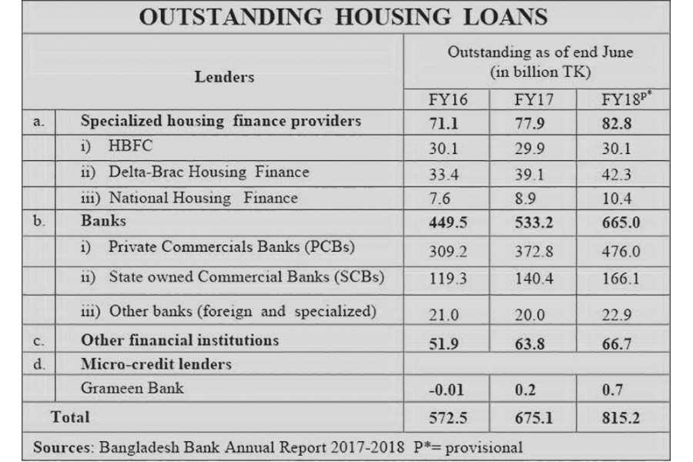
Bangladesh's socioeconomic situation has been very good since the beginning of this year. Due to this and a number of other factors, the real estate sector of the country seems to be turning around. Most of the companies in the sector have changed their strategies and are now they are focusing on the growing middle-income segment of the population.
At the same time, the confidence of buyers is apparently on the rise due to political stability and economic growth of the country. The government's plan to reduce registration fees and allow gas connections to households have also helped.
Earlier, the housing sector was facing many challenges. Most of the realtors had complained of a drop in sales by 30-70 per cent over the last couple of years. They suffered badly because of slothful trend in real estate business. Some developers were forced to sell apartments at lower profit margins to maintain their cash flow. It is believed that the slowdown in the sector was due to prohibition of black money injection, instability in the share market, overseas job crisis, self-indulgence of developers and political instability.
Over the past six months the real estate sector economically developed by 20 to 30 percent.
Maintaining profitable client relationship is crucial in business for dealing it with success. In fashionable business, it'sterribly essential. A gladclient is willing to pay additional for the merchandise with that he or she is glad. To satisfy the client, the businessesgot toprice the customer’s desiresand desires and in line with that they createproduct from thatthey will get their perceived price.
Contribution of assets in Bangladesh Economy
Over the last fifteen years the real Estate development sector has createdvital contribution to several sectors of our economy.
Gross domestic product at real estate and renting and alternative business Activities.
Year | Tk (In Millions)
2017-18 | 55546
2015-16 | 50337
2013-14 | 45683

Table: Gross Domestic Products at real estate and Renting and other business Activities.
Growth rate of construction sector.
Year | Tk (In Millions)
2017-2018 | 8.51
2015-2016 | 6.51
2013-14 | 6.01
Table: Growth rate of construction sector.
On the idea of the new rules, with a gain tax of 22 (which was 5% until 2007) and taxationof 3% a client is needed to pay registration fees to the govt., city-corporation and sub-registry workplacewithin the rates a pair of 2% (which was 2.5% until 2009), 2% and .05% severallydelivery registration expenses all the way down toa complete of 9.5%. A clientadditionallyhas to pay associate degree AIT of most Tk. 2000 for every Sq. meter of floor house and a VAT of 1.5% actuationprice of acquiring an apartment substantially up.

3.3 RATIOS

3.4 PROFITABILITY RATIOS

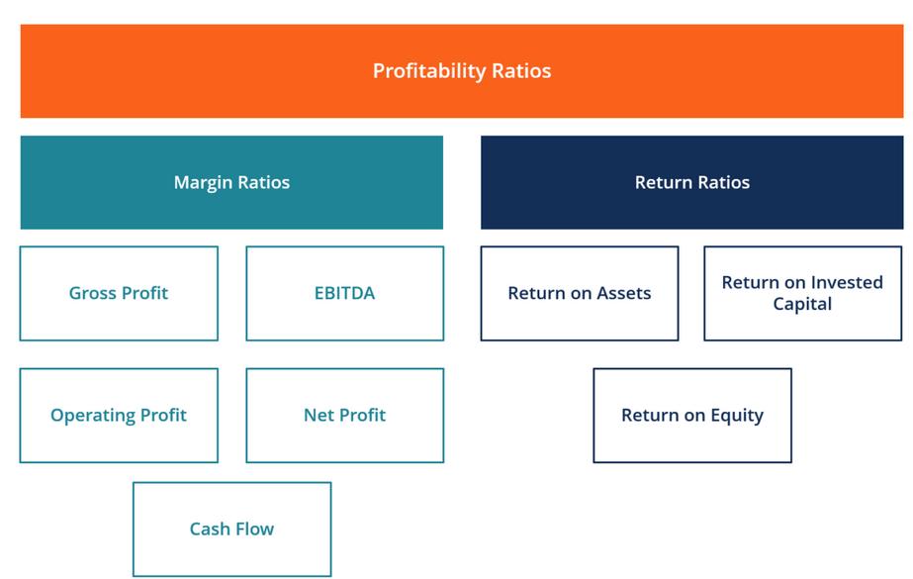
Profitability ratios of some real estate companies for the year 2018given below:
PROFITABILITY RATIOS | ESTERN HOUSING LIMITED (EHL) | BORAK REAL ESTATE LIMITED | Italian Real Estate Development Ltd | M/s MSC REAL ESTATE | sikder real estate Limited | ALLIANCE PROPERTIES LIMITED
Return on ASSETS | 1.60 | 1.37 | 8.94 | 11.05 | 13.34 | 0.53
Return on Equity | 5.84 | 4.24 | 9.01 | 16.21 | 19.00 | 10.33
Return on invested capital | 5.56 | - | 9.01 | 2.54 | 7.20 | 0.76
Gross Profit | 29.06 | 42.39 | 26.17 | 15.12 | 20.00 | 22.70
Operating Profit | 18.80 | 34.37 | 15.80 | 12.37 | 18.10 | 20.32
Net Profit | 9.49 | 83.79 | 15.80 | 10.06 | 10.67 | 11.97
EBITDA | 20.07 | - | 6.10 | - | 1.90 | 23.3
Cash Flow | 19.64 | - | 1.20 | - | - | -

Higher value is the better in profitability ratios; it means the company doing well. Here we see that Sikder real estate has the highest ROE, ROA.

Chapter Four

Data Analysis

4.1 RESEARCH FINDINGS

4.1.1RESEARCH FINDINGS ON ANALYSIS OF HOUSEHOLDS IN APARTMENT BUILDINGS

-60% of the households have suggested the need of community facilities such as community room, office room, care taker’s and driver’s waiting space.
- 50% of the households have suggested the need of security by the installation of cc cameras throughout the building, intercom, and burglar alarm system, grilled openings besides having a full time security guard.

-70% of the households have no firefighting system in their buildings and suggested the need of firefighting equipment such as fire extinguisher, hose reel, fire alarm system, sprinkler system in lobby, fire markings, and fire drills.

- 56% of the households have privacy problems with the neighboring buildings.

-66% of the households feel the need for breathing space such as non-grilled balconies, planter box in balconies, green rooftop, and well ventilated interior.
- 50% of the households feel that they have no parking problems and parking towers will not be feasible for them.
- 84% of the households feel that solar panels are very necessary and should be used more.
- 46% of the households feel that harvesting rainwater collected from the rooftop might be useful to reduce the water consumption from WASA.
- 50% of the households have problems in functional zoning, privacy between public and private zones inside an apartment, natural air and light, utility functions in their apartments

- 56% of the households feel that rooftop garden might reduce heat, can create a sense of living close to ground, can bear maintenance cost, and adds beauty to the building.
- 54% of the households said that they might have faced water-logging problems in their neighborhood. 66% of the households feel that kitchen waste disposal using the 3R’s system: Reuse, Reduce and Recycle might be a good solution for a clean and systematic way of waste disposal and might follow it if provided with proper and sufficient knowledge.
- 60% of the households are unprepared and unaware of possible hazards in their apartments.
- 56% of the households feel that earthquake and fire drills will be useful, knowledge about fire exits and use of fire extinguishers can be very helpful, contacting BFSCDA during emergency should be the wisest thing to do.

4.1.2 RESEARCHFINDINGS ON ANALYSIS OF BUILDINGS CONSTRUCTED BY SELECTIVE REAL ESTATE DEVELOPER COMPANIES

-46% of the buildings have acceptable building setbacks on one or two sides of the building which are used for parking or other non-roof functional purposes on the ground floor, which do not violate building code, but does not also fall under satisfactory level as these cover up the rain water soak able areas in the plot.
-70% of the buildings have dissatisfactory building core which will create problems at the time of emergency, no natural light and air can pass through, lack of fire exits and fire markings.

-44% of the buildings have satisfactory internal layout of buildings in case of room size, provision of natural light and air, privacy with surrounding buildings/units, functional zoning are analyzed based on building codes and design principles.

-60% of the buildings have satisfactory building FAR/MGC regarding building height, total built-up area, maximum ground coverage, FAR does not violate building code.

- 60% of the buildings have dissatisfactory fire safety systems: does not have any firefighting equipment, no fire drills conducted, lack of fire exits, the balconies are grilled for which during emergency people will be trapped inside.
-47% of the buildings are equipped with cc cameras, intercom, guard, at a satisfactory security level.

-51% of the buildings have satisfactory exterior treatment such as the condition of exterior façade is well painted, presence of shading device in strategic positions, maintenance of planter box is up to satisfactory level.
-56% of the buildings have dissatisfactory provision of community facilities: no community room or office room, not properly designed driver’s waiting and the care taker’s room is too small for habitation.

- 57% of the buildings have satisfactory parking facilities with provision of required number of car parking space with respect to number of apartments in the building, slope of ramp and parking grid as per building code.

-57% of the buildings have dissatisfactory sustainability pattern with no provision of solar panel, rooftop garden, planter box on apartment floors, 5” thick exterior wall, building orientation is also not satisfactory.

- 67% of the buildings have dissatisfactory level of disaster preparedness in their buildings with no fire or earthquake drills, the residents are unaware of the possible hazards and are highly unprepared.

4.1.3 RESEARCH FINDINGS ON ANALYSIS OF REAL ESTATE DEVELOPERS VIEW ON SUSTAINABILITY AND DISASTER MANAGEMENT ISSUES

-50% of the companies have said that more interactive roof tops activities and balconies can be provided for better social interaction among the residents and provision of more interactive spaces such as leaving more open (green) spaces on the ground, lobbies, etc. may not be possible to achieve in their buildings.
- 50% of the companies feel that sustainable issues such as rainwater harvest, more use of solar panel, east-west elongated building orientation, 10” thick outer wall, rooftop garden are hardly possible to incorporate these in their building designs except for vertical plantation.

-66.67% of the companies feel that introduction and construction of neighborhood parking towers instead providing parking facilities for individual buildings can hardly be achieved.

- 66.67% of the companies feel that provision of firefighting system inside building, fire and earthquake drills can be possible to achieve more than community-based disaster risk reduction, awareness buildup among the residents, provision of necessary training with the help of BFSCDA.
-83.33% of the companies feel that the provision of some sort of employment and living space can hardly be provided to one or two families from the slum area in each building for slum up gradation.

Chapter Five

Recommendations and Conclusion

5.1 RECOMMENDATIONS FOR REAL ESTATE DEVELOPER COMPANIES FOR ATTAINING SUSTAINABLE APPROACH IN BUILDING DESIGN
Policies and building code and regulations are considered as much as possible to suggest new design concepts to tackle the problems arising from living in the apartments and recommendations have been written down. Knowledge gained from literature review, mainly focusing those issues which are not directly covered during the survey, are also considered for recommendations for future development in housing sector in Dhaka city. Furthermore few of the proposals are discussed with the Real Estate Developer companies to understand their perspectives on the possibility of implementing these proposals and associated problems or challenges that can arise from the implementation of these proposals.

5.2 PROPOSALS TO ATTAIN SUSTAINABILITY IN RESIDENTIAL BUILDINGS OF DHAKA CITY
Sustainable construction is a approach for the building business to move towards achieving property development, taking into consideration the environmental, socio-economic and cultural problems like style and management of buildings, materials and building performance, energy and resource consumption. sensible and property buildings characterize sensible exercise in scheming, coming up with and building structures to create them additional in public, environmentally and fruitfully sustainable. All developments should be preceded by a detailed environmental impact study in order to achieve a sustainable urban development of Dhaka city. If due to global warming, sea levels actually rise by even a few feet the sustainability of most of the urban centers in Bangladesh will be seriously threatened. In such a situation sustainability of urban housing will be an extremely difficult concept unless new building materials are innovated and new technology is introduced.

- RAINWATER HARVEST

It is found that the entirewaterdemand in Dhakacity is 2,240 million liters per day whereas provide is2,150.About87% of this provide comes from groundwaterresourcesand therefore the remaining 13% from surface water. For the hugeextraction from the underground water supply, the bottomgroundwater levelisdeclining day by day. it's been found that the present groundwater depletion rate is 3.52 meter per annum.

Concept of rainwater harvesting:

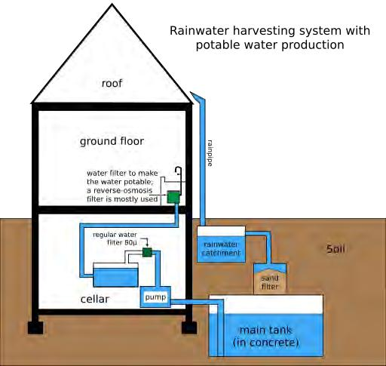

Source: Internet

Fig: Rainwater harvesting system in a building

Rainwater is a free supply of nearly pure water and rain harvest home refers to the assortment and storage of rain and different activities geared toward harvest ingsurface and well water. It conjointly includes the interference of loss through evaporation and flow and every one different hydrological and engineering interventions, geared toward conservation and economical utilization of the restricted water endowment of physiographic unit like a watershed..

If rainwater can be collected from every roof top of the residential buildings in Dhaka city and further used in household activities, then the pressure of supplying immense amount of water by WASA can be reduced significantly. Dependency on public utility services can be reduced and thus other issues such alarming ground water depletion can also be rectified.
None of the surveyed buildings have rainwater harvesting system in it which shows that all the buildings are highly dependent on WASA for meeting its water demand. 1 out of six developer companies are interested to harvest rainwater in their specific and exclusive residential projects.

b. ROOFTOP GARDEN

A rooftop garden is a garden on the roof of a building. Besides the decorative benefit, roof plantings may provide food, temperature control, hydrological benefits, architectural enhancement, habitats or corridors for wildlife, recreational opportunities, and in large scale may even have ecological benefits. For Dhaka city, this could be an alternative solution to tackle the heat island issues generating in the city. As the built up areas of Dhaka city has already created much damage to the environment such as lack of greenery and too much built form has created heat island scenario in few parts of Dhaka city, so this concept can help create a microclimate suitable for habitation. Apart from heat trapping by the plants, it can also help in solving dust pollutions in the city making the air more fresh and healthy. As there is shortage of recreational parks in the different neighborhoods therefore, this can be a positive solution for those who have little or no access to parks in the city. The desire of living close to the ground, while living in high-rise residential buildings, can also be achieved through rooftop gardens. Social interaction and mental health of the residents will be improved. Therefore, this is a good solution for healthy living in an apartment for all age groups of people.

Few of the surveyed buildings are found to have practicing rooftop gardening which a positive initiative is being taken by few developer companies. More companies need to practice this. The residents are more interested to have spaces like this but the developer companies are more concerned about the cost in making such rooftops. Also few residents have shown concern regarding maintenance cost that might be beyond their affordability range.

c. SOLAR PANEL

The choice of cooling, solar and ventilation system, for example, has a direct impact on a buildings energy efficiency and conservation potential. Few developer companies are found to have installed solar panels in their buildings. The residents are aware of the benefits of solar panels. Since the initial cost of solar panel is very high for which limited panels are installed in the buildings. More and more usage of solar panels will only make the energy consumption situation better in the long run.

- MISCELLANEOUS

  - Many buildings are constructed in north-south orientation rather than east-west for which the maximum length of the building facades are faced towards east-west directions, thus receiving maximum amount of heat. The buildings should be east-west elongated.
  - Almost all the surveyed buildings are found to have 5” thick exterior brick walls for which heat can easily penetrate through the walls into the interior. The exterior walls should be 10”thick brick walls.
  - Many buildings are found to have openings on the west side of the buildings without any louvre or sun heat cutting device for which the building traps all the heat from the west. No openings should be provided on the west façade of the building without shading device.

5.2 CONCLUSION

The compact, property and economical use of land in residential areawill increasethe general publicefficiency by minimizing public or sectoralprices of facility, sewage works, trash collection, firefighting, education, recreation, transportation et al. the most loophole within the disaster management space of the townis that the lack of coordination among public and personal organizations. fortunate public and personal collaboration will revitalize the urban setting of Dhaka. Participation of various stakeholders is that thebasic instrument for promoting smart governance thatis that the key to realize social justice. there's no differentvarious than maintaining the look standards and managing the town as per the commit tocreatethe townlivable . By introducing correct policy and coming up with for disaster management, community awareness build up and training, correct implementation of national code, well coordination among government organizations and infrastructures and non-government organizations, enrichment of well-equipped rescue team will limit the impact in a very manageable boundary.
The Real Estate Developer companies are not contributing to the economic growth of Bangladesh but is also involved in providing grave solutions to national level crisis: habitation for people and disaster mitigation by the construction of permanent and strong buildings. More active and sensitive participation of Real Estate Developer companies can create a sustainable built environment in Dhaka city. The public are conscious enough to prepare themselves for any disaster but developer companies should also consider the sustainable and disaster mitigation issues in their buildings as well. After all the real city is a safe city that ensures the safety and security of its citizens.

References

- Brigham, E. F., & Houston, J. F. (2019). Fundamentals of financial management. Boston, MA, USA: Cengage.
- BTI BD. (2019). Real Estate Industry in Bangladesh | bti Blog. [online] Available at: https://www.btibd.com/blog/real-estate-industry/ [Accessed 24 Apr. 2019].
- A blog about homes, trends, tips & life | Bproperty. (2019). REAL ESTATE INDUSTRY IN BANGLADESH: THE CURRENT SCENARIO. [online] Available at: https://www.bproperty.com/blog/real-estate-industry-bangladesh-current-scenario/ [Accessed 24 Apr. 2019].
- BTI BD. (2019). What are the challenges and trends in the current real estate sector of Bangladesh? Read the bti blog to find out. | bti. [online] Available at: https://www.btibd.com/challenges-trends-current-real-estate-sector-bangladesh-read-bti-blog-find/ [Accessed 24 Apr. 2019].
- Islam, M. (2019). Present Condition and Future Prospects of Real Estate in Bangladesh - ICE Business Times. [online] ICE Business Times. Available at: http://ibtbd.net/present-condition-and-future-prospects-of-real-estate-in-bangladesh/ [Accessed 24 Apr. 2019].
- Assignment Point. (2019). Problems and Prospects of Real Estate Sector in Bangladesh - AssignmentPoint.[online]Availableat:http://www.assignmentpoint.com/science/architecture/problems-and-prospects-of-real-estate-sector-in-bangladesh.html [Accessed 24 Apr. 2019].
- Noor, M. and Noor, M. (2019). Bangladesh Economy & Contribution of Real Estate - Bproperty. [online] A blog about homes, trends, tips & life | Bproperty. Available at: https://www.bproperty.com/blog/bangladesh-economy-real-estate/ [Accessed 24 Apr. 2019].
- Rehab-bd.org.(2019).[online]Availableat:https://www.rehab-bd.org/mis/attachment/upload/dynamic_notice_up_54.pdf [Accessed 24 Apr. 2019].
- Assignment Point. (2019). Role of Real Estate Sector in Economy of Bangladesh - Assignment Point. [online] Available at: http://www.assignmentpoint.com/science/architecture/role-real-estate-sector-economy-bangladesh.html [Accessed 24 Apr. 2019].
- Anon,(2019).[online]Availableat:http://dspace.daffodilvarsity.edu.bd:8080/bitstream/handle/20.500.11948/1202/Project%20Report.pdf?sequence=1&isAllowed=y [Accessed 24 Apr. 2019].
- Iosrjournals.org. (2019). [online] Available at: http://www.iosrjournals.org/iosr-jbm/papers/Vol16-issue7/Version-4/A016740107.pdf [Accessed 24 Apr. 2019].

