Internship Report

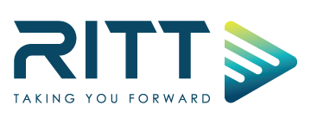
Ranks ITT Limited


INTERNSHIP REPORT
ON
“Facebook Analytics”
At

SUBMITTED TO
S.M Asif Ur-Rahman
Assistant Professor
School of Business and Economics United International University

SUBMITTED BY:
Mohosina Rahman
ID: 111 162 028
Program: BBA Major: Marketing
School of Business and Economics United International University
LETTER OF TRANSMITTAL

Date: September 09, 2021
Mr. S.M Asif Ur-Rahman
Assistant Professor
School of Business and Economics United International University
Subject: Submission of Internship Report
Dear Sir,
I am submitting my Internship Report, which is required as part of my BBA program. Working under your direction is a fantastic chance for me.
"Facebook Analytics" is the basis for this research. I had the opportunity to work in the "Digital Marketing Department" at Ranks ITT Limited (A Rancon Company) for three months under the direction of Mr. Abir Ahmed, Digital Marketing Strategist.
First, I learned about the culture of Ranks ITT Limited. Then, thanks to this project, I was able to get to know and build a network within the corporate environment. As a result, I can conclude that this project has provided me with practical experience.
I would be grateful if you could share your useful input on my report, and it would be an honor for me if you found it informative in terms of developing a clear understanding of the situation. Sincerely Yours
-------------------------------
Mohosina Rahman
ID: 111 162 028
Program: BBA
School of Business and Economics United International University

ACKNOWLEDGEMENT

First and foremost, I want to thank the almighty ALLAH for providing me with the opportunity to fulfill my responsibilities as an intern and complete the report within the deadline.
Mr. S.M Asif Ur-Rahman, Assistant Professor, United International University's School of Business and Economics, for his supervision during my internship period, I am extremely grateful. Mr. Abir Ahmed, my organizational supervisor, is also to be thanked. It would have been extremely difficult to complete this report without their assistance.
My gratitude goes to United International University's BBA Department for organizing an Internship Program that allowed me to integrate academic knowledge with real-life situations.
Finally, I want to express my appreciation to Kazi Sultana Razia, Marketing Communication Specialist, for her assistance in improving the report. In addition, I'd like to thank my Ranks ITT Ltd coworkers and Rancon British Motors-MG coworker who provided me with excellent advice, recommendations, inspiration, and support. I had to recognize this organization's fantastic working environment and group devotion, which has allowed me to deal with a wide range of issues.

EXECUTIVE SUMMARY

This report is based on my three-month internship at Ranks ITT Limited (A Rancon Company). This internship program assisted me in learning about the practical scenario of a Technology and Communication organization, particularly "Digital Marketing & Facebook Analytics." With over USD 4 million in investments, Ranks ITT Limited is the market leader in nationwide data communication network service. Since its inception in 2001, the company has grown to serve over 300 big and mid-tier commercial customers in the financial services, travel/hospitality, manufacturing, government, media/entertainment, technology, and retail industries. In Bangladesh, Ranks ITT has formed a strategic collaboration with SITA/Equant/Orange as its network provider, delivering carrier service to hundreds of clients. (ITT Ranks, n.d.) This document is a report on. The information in this report is based on my observations and experiences at the company. Although Rank ITT has numerous departments and divisions, the main focus is on customer happiness in the digital marketing area, where I have had the pleasure to work.
The study discusses what Facebook Analytics is, how it works, and how it assists Ranks ITT and their Digital Marketing Department in providing support to their client Rancon British Motors Ltd. (MG). The findings in this report are highly significant. In the following chapters, the outcome is described in detail.
Following the encounter, a slew of recommendations flooded the Facebook analytics arena. In addition, the report includes recommendations and findings that are in line with my viewpoints.

Contents
CHAPTER-1 8
INTRODUCTION 8
1.1 ORIGIN OF THE REPORT 9
1.2 OBJECTIVES OF THE REPORT 10
1.3 SCOPE OF THE REPORT 11
1.4 METHODOLOGY 11
1.4.1 Selection of the Topic: 11
1.4.2 Sources of Data 12
1.4.3 Collection of Data 12
1.4.4 Classification, Analysis, Interpretation & Presentation of Data 13
13
1.4.5 Finding of the Study 13
1.4.6 Final Report Preparation 13
1.5 LIMITATION 14
CHAPTER-2 16
FACEBOOK ANALYTICS 16
2.1 HOW CAN WE USE FACEBOOK ANALYTICS 16
2.1.1 WHAT IS FACEBOOK ANALYTICS 17
2.1.2 FACEBOOK ANALYTICS IS ABOUT ENGAGEMENT 17
2.1.3 LIFESTYLE DATA IS KNOWN AS STRATEGY DATA 18
2.1.4 “WHERE IS AS IMPORTAN AS WHO” 19
2.1.5 NEGATIVE DATA CAN BE REVEALING 19
2.1.6 FINAL THOUGHT 20
CHAPTER-3 22
THE ULTIMATE GUIDE TO MG’S FACEBOOK ANALYTICS 22
3.1 THE ULTIMATE GUIDE TO MG’S FACEBOOK ANALYTICS 22
22
3.1.1 FACEBOOK ANALYTICS: WHAT IT IS AND HOW TO ACCESS 23
3.2 FIND THE PAGE SUMMARY IN THE OVERVIEW 25
3.2.1 PAGE SUMMARY 26
3.2.2 MOST RECENT POSTS 29
3.2.3 PAGES TO WATCH 32
3.3 FOLLOWER INSIGHT 34
3.3.1 TOTAL PAGE FOLLOWERS 35
3.3.2 NET FOLLOWERS 35
3.3.3 WHERE OUR PAGE FOLLOWS HAPPEN 36
3.4 LIKES INSIGHT 37
3.4.1 TOTAL PAGE LIKES AS OF TODAY 37
3.4.2 PAGE LIKES 38
3.4.3 WHERE PAGE LIKES HAPPENED 39
3.5 REACH INSIGHT 39
3.6 PAGE VIEW INSIGHT 43
3.7 PAGE PREVIEW INSIGHT 46
46
3.8 ACTION ON PAGE INSIGHT 49
3.9 POST INSIGHT 51
3.9.1 TOP DAYS AND WEEKS ARE OUR AUDIENCE 51
3.9.2 A BREAKDOWN OF THE TYPE OF OUR POST AND HOW THEY WORKED IN TERMS OF ENGAGEMENT 51
3.9.3 Top posts from the pages you visit 52
3.9.4 ALL POST PUBLISHED 52
3.10 EVENTS INSIGHT 54
3.11 STORIES INSIGHT 55
3.12 PEOPLE INSIGHT 56
3.12.1 OUR FANS 57
3.12.2 OUR FOLLOWERS 58
3.12.3 PEOPLE REACHED 58
CHAPTER-4 60
FACEBOOK BUSINESS SUITE 60
4.1 FACEBOOK BUSINESS SUITE 60
4.2 FACEBOOK LAUNCHES FACEBOOK SUITE 65
4.3 4 TOOLS TO USE NOW THAT FACEBOOK ANALYTICS IS GONE 65
4.4 FACEBOOK ANALYTICS TOOLS (THAT WILL STILL BE AROUND) 66
66
4.4.1 FACEBOOK BUSINESS SUITE 66
4.4.2 FACEBOOK PIXEL AND FACEBOOK CONVERSATION API 67
4.4.3 CREATOR STUDIO 68
4.4.4 HOOTSUITE ANALYTICS 69
4.5 3 REASONS TO TRACK FACEBOOK ANALYTICS 70
4.5.1 UNDERSTAND ADVERTISING PERFORMANCE 70
4.5.2 PIN DOWN THE BEST CAMPAIGNS 71
4.5.3 CREATE COMPREHENSIVE REPORTS 71
4.6 INPORTANT FACEBOOK ANALYTICS METRICS 72
4.6.1 FACEBOOK PAGE ANALYTICS 72
36.1.1 Facebook Page Engagement Rate 72
4.7 FACEBOOK AUDIENCE INSIGHTS 73
4.7.1 GENDER AND AGE BREAKDOWN 73
4.7.2 TOP AUDIENCE LOCATIONS 74
4.8 FACEBOOK ADS ANALYTICS 75
4.8.1 CLICK-THROUHG-RATE (CTR) 75
4.8.2 COST-PER-CLICK (CPC) 76
4.8.3 COST-PER-THOUSAND-IMPRESSIONS (CPM) 76
4.9 FACEBOOK GROUP ANALYTICS 76
4.9.1 NUMBER OF NEW MEMBERS MONTHLY 77
4.9.2 TOP CONTRIBUTORS FOR THE LAST 28 DAYS 77
4.10 FACEBOOK LIVE ANALYTICS 77
4.10.1 PEAK LIVE VIEWERS 78
4.10.2 AVARAGE % COMPLETION 79
4.11 FACEBOOK VIDEO ANALYTICS 79
4.11.1 AUDIENCE RETENTION 79
4.11.2 VIDEO REACH OVER 28-DAYS 80
4.12 CONCLUSION 81
CHAPTER-6 85
CONCLUSION 85
References 87

CHAPTER-1
INTRODUCTION

CHAPTER-1

INTRODUCTION

"Facebook Analytics" provides marketers with the information they need to grow their social media presence.

A Facebook brand functions similarly to a personal user. Brands, on the other hand, have a page where visitors can read their posts, comments, images, and events instead of the Polish timeline.

On Facebook and through social analysis tools, brands and organizations may get information on engagement, post efficacy, reach, follower demographics, and more.

Marketers can create bespoke audiences on Facebook based on their interests, age, education, relationship status, or company. The Facebook ad's custom audience feature is frequently used to target users based on their email address.s

1.1 ORIGIN OF THE REPORT

For BBA students, the internship program at United International University needs a postgraduate degree. This research is part of the internship program for United International University's BBA program. The internship's primary goal is to introduce the student to the working world. Translating theoretical principles into real-life experiences was my biggest problem as an intern.
The internship program and the study have following purposes:
- To gain a thorough understanding of work tasks and to organize.
- To obtain real-world business experience.
- Real-life scenarios are compared to lessons taught at United International University.
- To complete the BBA program's requirements.

This report is the product of Ranks ITT Limited's (a Rancon Company) three-month internship program, which was required for completion of United International University's BBA degree. As a result, based on my work as an intern at the Ranks ITT Digital Marketing department, I am required to produce this report on "Facebook Analytics." The report also includes information on related topics, including "Facebook Analytics".

1.2 OBJECTIVES OF THE REPORT

The objective of the report can be described in two ways:
- General Objective
- Specific Objective
General Objective:
This internship report is primarily intended to satisfy the requirements for a Bachelor of Business Administration (B.B.A) degree from United International University's Faculty of School of Business and Economics.

Specific Objective:
More specifically, this study highlights the following aspects:
- To give an overview of “Facebook Analytics”.
- To focus on the Clients especially Rancon British Motors-MG’s ultimate Guide to Facebook Analytics
- Facebook Analytics has changed to Facebook Business Suite
- To discuss the Standards and Effects of Facebook Analytics and why it is important in Marketing.

1.3 SCOPE OF THE REPORT

The study's major goal is to gain a better knowledge of Facebook Analytics, including how it works with digital marketing and how important it is. The report contains information about Ranks ITT Digital Marketing's clients, particularly Rancon British Motors Ltd-MG. The examination of MG's 'Facebook Analytics' is the main topic.

1.4 METHODOLOGY

From the selection of the subject through the completion of the final report, the research is carried out in a systematic manner. The process included discovering and collecting data, which was then categorized, analyzed, interpreted, and presented in a methodical manner in order to find crucial points. I’ve further explained the overall process of the methodology.

1.4.1 Selection of the Topic:

My supervisor assisted me in deciding on the topic for my project report. Before I began to prepare it, we had a comprehensive discussion.

1.4.2 Sources of Data

1.4.2.1 Primary Sources

The primary data was gathered via practical deskwork. In addition, the poll enabled me to obtain information directly from staff.

1.4.2.2 Secondary Sources

- Internal sources- Various documents issued by my line manager and various circulars, manuals and files of the organization.
- External source- Various websites related to Facebook analytics sector and online resources.

1.4.3 Collection of Data

Because my topic is "Facebook Analytics," the majority of the information I've gathered has come from secondary sources. I primarily used the client's Facebook Pages and Websites as secondary sources.

1.4.4 Classification, Analysis, Interpretation & Presentation of Data

In this report, certain graphics and photographs were used to evaluate the obtained data and to better explain some ideas and outcomes. Furthermore, the data was more thoroughly evaluated to determine the precise level of "Facebook Analytics in Marketing."

1.4.5 Finding of the Study

The data was evaluated, and the significance of Facebook analysis was underlined and demonstrated at the conclusion.

1.4.6 Final Report Preparation

My supervisor provided me with important feedback, recommendations, and adjustments, which I included into the final report.

1.5 LIMITATION

Since most of the data collected is from Facebook. Some clients were reluctant to give access to their Facebook page. Some concerned may feel that information related to them was confidential enough to be disclosed to the outside world. So some inferences were made due to the limitations of the data. Another problem was changing Facebook Analytics to Business Suite during my internship period. This was somewhat speculated due to data limitations. So there may be some mistakes in the report. I have tried my best to report despite many limitations

CHAPTER-2
FACEBOOK ANALYTICS

CHAPTER-2

FACEBOOK ANALYTICS

This chapter emphasizes on what Facebook Analytics is, how it operates and Facebook insights, tools used in Facebook Analytics.

2.1 HOW CAN WE USE FACEBOOK ANALYTICS

Facebook is the most popular and widely used social networking platform for individuals all over the world to connect with family and friends as well as find new people with similar interests.
However, Facebook isn't always about keeping a social connection when it comes to business. The usage of social media networks as a marketing strategy is also possible. It enables businesses to reach their target demographics and perhaps acquire useful insights into customer behavior and preferences, but all that is frequently done is to identify more potential or possibly to convince them to buy a product or service.

All of these findings are knowledge that can be put to good use. Thankfully, Facebook focuses on connecting merchants to the platform. It's part of the Facebook research. But, first and foremost, what exactly is Facebook Analytics? What does this mean for us, and how can we begin to use it to our marketing and commercial efforts?

2.1.1 What is Facebook Analytics

The term "analytics" refers to the process of identifying patterns in data using various techniques such as mathematics, statistics, and predictive modeling. In a nutshell, it discovers meaning in a jumble of unrelated data.
The term "analytics" refers to the application of diverse methods such as mathematics, statistics, and predictive modeling to detect patterns in data. In a nutshell, it makes sense of seemingly random data.
"Facebook Analytics" sifts through the platform's data for interesting data patterns that may be used to generate marketing insights and actions. "Facebook Insights," which allows users to live the bustle and efficacy of their Facebook page and marketing initiatives, provides free statistics in the case of Facebook. Facebook may be a significant element of a company's online marketing efforts, depending on the target's age and lifestyle demographics. Facebook is the most popular social networking platform, with over 1.5 billion daily active users. As a result, both individuals and the software that tracks their behaviors generate a lot of data.
In terms of sales, it's a massive dataset that will yield a wealth of useful information, but only to those who know what to look for.

2.1.2 Facebook Analytics is all about Engagement

The degree of engagement with Facebook pages is one of the essential features that Facebook Insights provides to users for free. Engagement can be a useful metric for determining the performance of an online marketing campaign.
Finding techniques to boost interaction on Facebook, or any other online marketing platform, is a crucial tactic. However, the only way to determine if our efforts are raising engagement is to recognize the amount of involvement. These crucial figures can be obtained using "Facebook Analytics."

2.1.3 Lifestyle Data is known as Strategy Data

We're aware that some people are blending their content with ours, but do we know who they are and what their overall traits are? No, we don't know, but Facebook analysis can provide us with some of this crucial information. Demographics is the study of the characteristics that some people possess.
When we identify common characteristics among people who are involved in or interact with our marketing (product/service), we can begin to develop a strategy. Mutual relationships make it simple to focus and tailor our marketing for more engagement and outcomes. When we identify common characteristics among people who are involved in or interact with our marketing (product/service), we can begin to develop a strategy. Mutual relationships make it simple to focus and tailor our marketing for more engagement and outcomes.
For example, we see that our Facebook marketing is getting really high engagement from people in Dhaka who are more interested in buying cars. We obviously can't target these demographics but we will plan their marketing to increase our sales within them, as we know we are getting their attention.
By learning more about our demographics, we can establish a "customized persona" that lists the qualities of our greatest consumers or even future customers, allowing us to develop market-specific strategies.

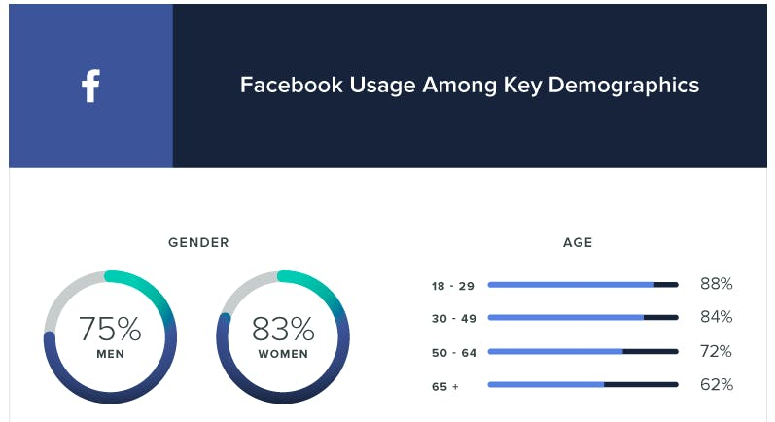

2.1.4 Where is as important as Who

Facebook analytics can show us “where” on Facebook our level of engagement is happening. And it a great feature of Facebook analytics. In some ways, we can also measure what’s working and what’s not. (Facebook Analytics, 2019)
For example, we navigate these metrics and compare the engagement levels of our Facebook pages. We will compare the level of engagement through the people posted on our Facebook page or even through our advertising efforts on Facebook.
With Facebook Analytics, we can also figure out where these preferences and interactions are coming from.
On the other hand, we can see that we've started advertising on Facebook aggressively, and when we look at where our engagement is coming from, we can see that the advertisements are generating a lot more interaction.

2.1.5 Negative data can be revealing

While it is unlikely to be the norm, considering the pros as well as the negatives indicated in the Facebook analysis is a good idea. User actions such as clicking the "Like" button or selecting "Hide posts" or "Report as spam" must not be overlooked.
If these figures continue to climb, we must do analyses to determine when and where undesirable behavior occurs, as well as why it occurs. We won't be able to stop them if we don't understand why they're happening.
Because so much data is collected every day, if Facebook alters its algorithm, it might have far-reaching implications. This is why, when algorithmic modifications are done, it's critical to keep an eye on Facebook analyses.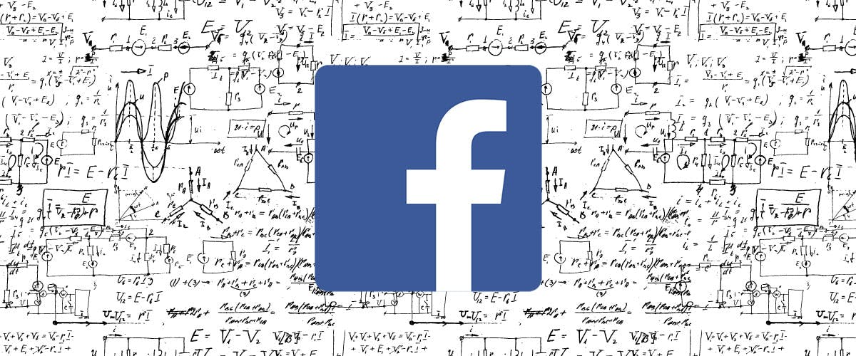

2.1.6 Final Thought

When it comes to digital marketing, Facebook is frequently an important route for reaching a specific target. For cash-strapped enterprises, however, the detailed insight afforded by technologies like Facebook Insights improves marketing efficacy by an order of magnitude.

CHAPTER-3
THE ULTIMATE GUIDE TO MG’S FACEBOOK ANALYTICS

CHAPTER-3

THE ULTIMATE GUIDE TO MG’S FACEBOOK ANALYTICS

3.1 THE ULTIMATE GUIDE TO MG’S FACEBOOK ANALYTICS

We briefly discussed Facebook Analytics before, and now we'll take a look at how it works.
For successful marketing efforts and social media planning, Facebook Analytics is an insanely useful resource.
Because Facebook Insights provides us with a wealth of information, we've broken it down into a simple guide that covers every area of "Facebook Insights."

3.1.1 What is Facebook Analytics and how to access it

Like Instagram, Facebook insight is a powerful tool. With metrics like Page View, Likes, Page Action, and more, it delivers a multitude of data points that we can monitor and use to better our publishing strategy.

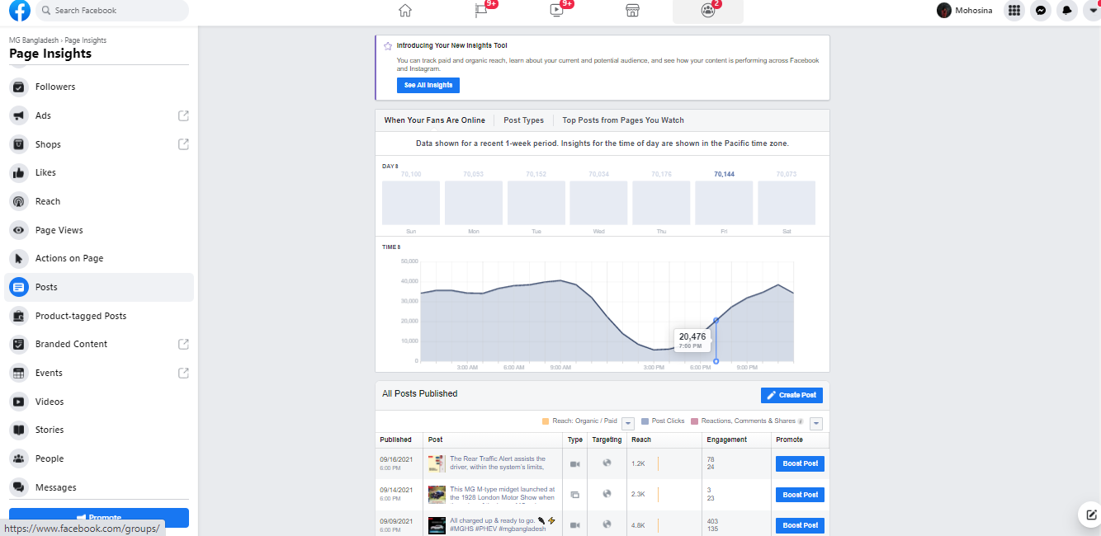

However, consider how useful this information is:
When we start looking at Facebook statistics, we'll most likely find some useful information that will help us plan our social media strategy and content.
We can understand what we're doing along with our audience, what's not recurring with the audience, and how to move forward by looking at analytics like our audience demographics, post view and reach, and story and video performance. Over time, we hope to expand our page.
To access the Facebook Insights page, go to our Facebook page and look for insights in the bar at the top of the page: but keep in mind that this was before the shift to Facebook Analytics in Business Suite.

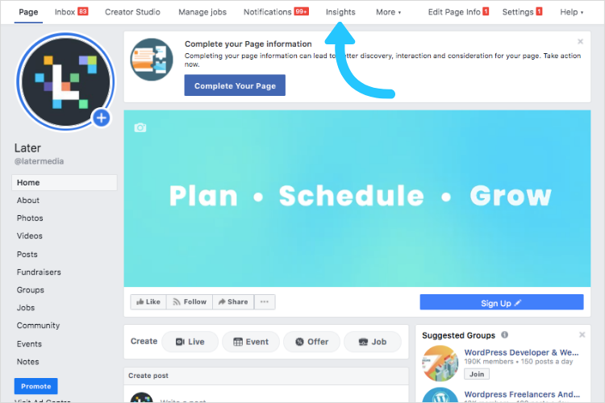

The tabs are located on the left side of the page under the tracking area. We'll enlist everyone's assistance in navigating Facebook Analytics.

Next, we'll plan, schedule, and post on Facebook to take our Facebook approach to the next level.

3.2 FIND THE PAGE SUMMARY IN THE OVERVIEW

When we click on the Insights Dashboard, we can see the Overview section displayed on the left column.
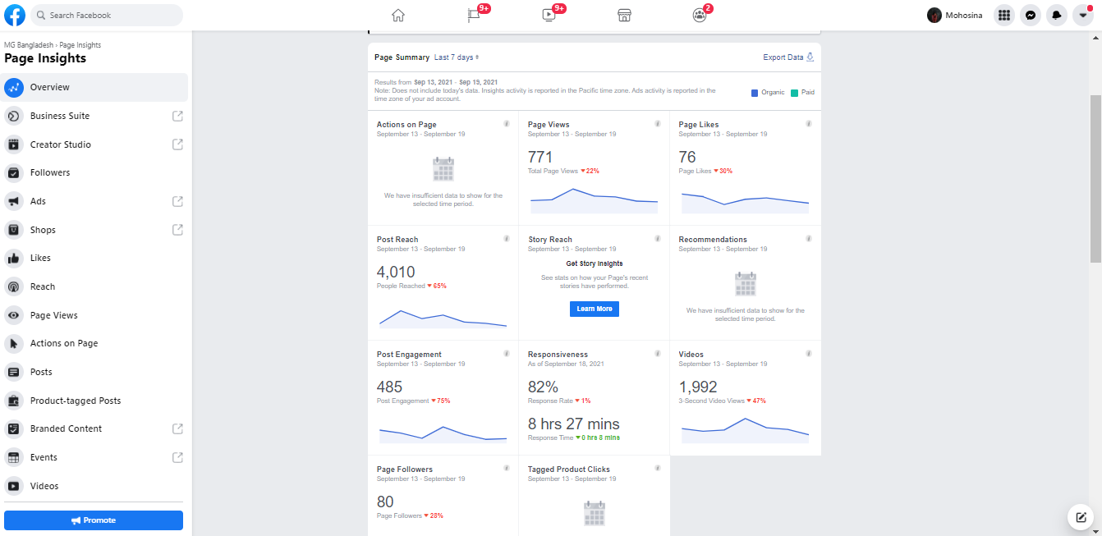
Following the name, the brief description section provides us with a wealth of information. To get started, follow these steps:

3.2.1 Page Summary

At the top of the page, there is a summary section where we can see certain metrics such as post interaction, likes, and reach.
We can easily alter the time frame next to the page summary if we want to see our analytics across a different time period. To alter the timeline options to include the previous 7 days or the last 28 days, select today or yesterday.
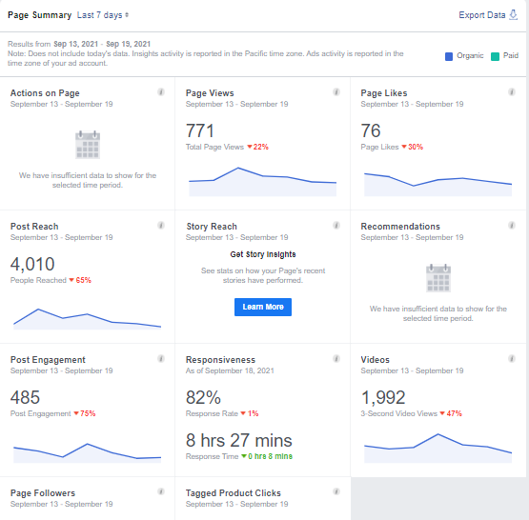

We can adjust the gray I of each area to see what each metric means.
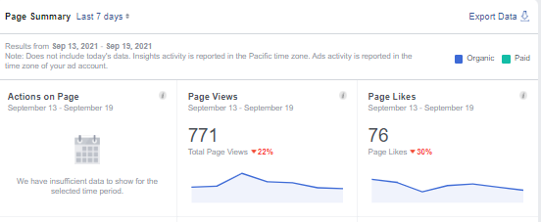

We look at our post-engagement stats to see where the surges are coming from. We revisit each point and examine exactly what we posted that day; this informs us about the material that our audience responds to the most.
Video stats can quickly demonstrate that we are generating traffic through views and clicks.

3.2.2 Most Recent Post

If we scroll down the Overview tab page, we'll notice the following section labeled "Our five recent articles."
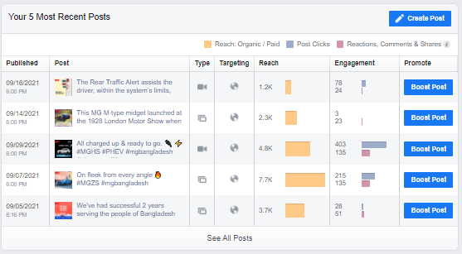

This useful section provides quick access to our most recent 5 posts, published photographs, frequent updates, and Facebook Stories posts.
Published, post, post type, targeting, reach, engagement, and promotion are all visible.
Perhaps we've only just given our first gift and announced a few advertising events. This section will assist us in better understanding how to improve our next strategy.

We may have the opportunity to go back and look at at least one of our previous 5 posts by clicking the view all the posts button.

When we click on a post's link, we'll be sent to an in-depth performance analysis of the original post, which includes all responses, comments, and any shared instances.
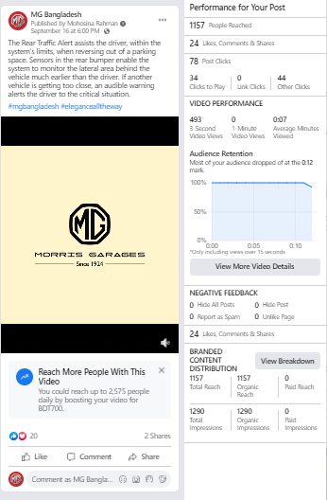

3.2.3 Pages to Watch

The feature of browsing pages is the last section of the overview page. This handy part creates a quick list of a few more pages that are almost identical to our own. Because MG is a car brand, it exemplifies the major automobile manufacturers in Bangladesh.
This allows us to track the progress of additional pages we wish to keep track of or preserve this section. When we go to the watch page, we can check how many likes they have.

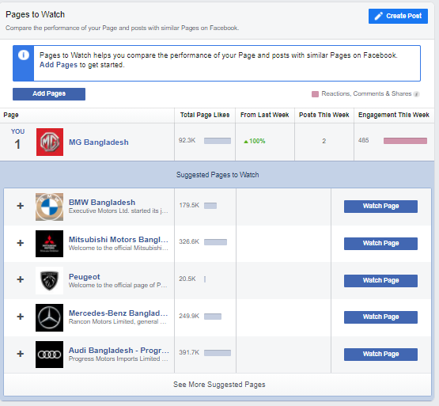

Here is some pros of using this feature:
- We may learn from our Facebook page coworkers and competitors.
- This is a fantastic place to look for ideas for our material.
- We may utilize it to get a sense of what's going on in our field of business. Observe
Basically it helps us to know better about our competitors.

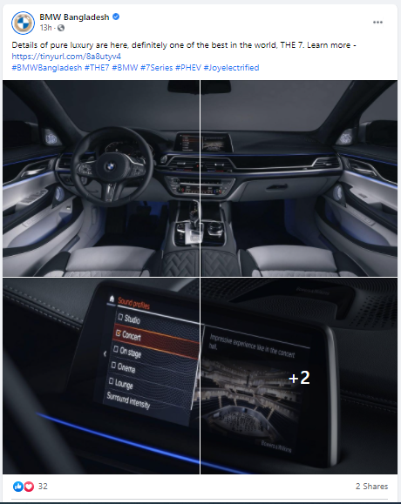

3.3 FOLLOWER INSIGHT

Follower Insight is the next section of our Facebook Insight. To get information from our followers, go to the followers tab.
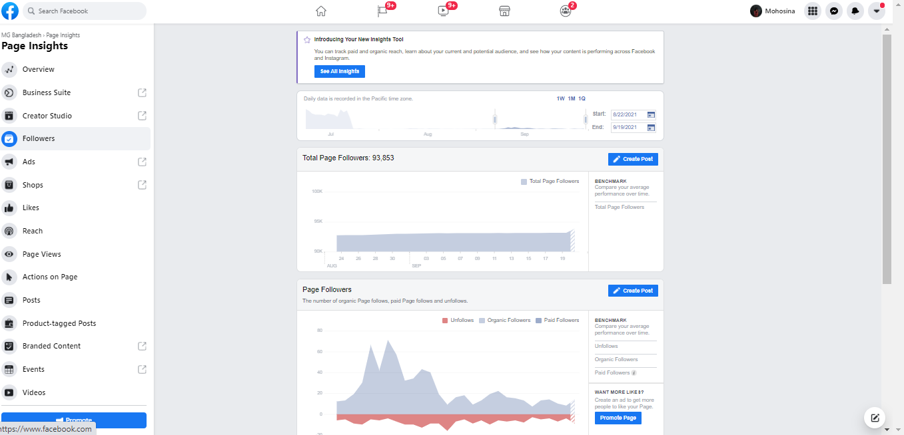

Today's total page follower, net follower, and where our page follows are the three criteria in this section.

3.3.1 Total Page Followers

The total number of page followers allows us to compare our average performance over time. We can readily tell which week received the most followers and why.

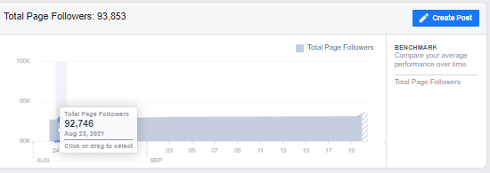

3.3.2 Net Followers
Under Benchmark, net followers subtract the amount of un-followers by displaying the number of new followers. We have access to detailed information and can choose among unauthorised, organic, or purchased followers.
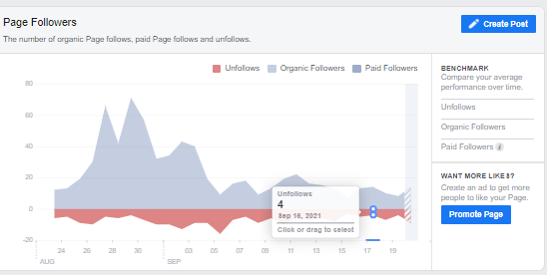

3.3.3 Where our page follower happen

It shows how many times our page has been visited, weakened by the location. We can partition our page by "Your Page," "Search," or "Uncategorized Desktop" to see followers from those sources.
If our Facebook page followers come through "search," the SEO of our page will improve.
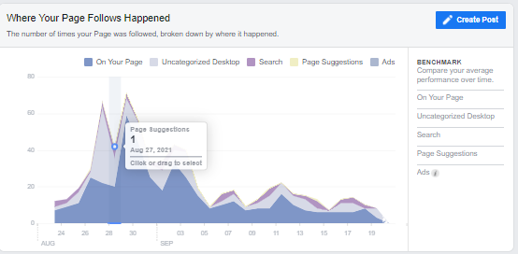

Our follower insights provide us with a wealth of information about our page's success and why people choose to "follow" us.
If our objective is to grow our following, it is worthwhile to devote time to analyzing all of the data available in order to develop a content strategy.

3.4 LIKES INSIGHT

The following part is the Like section. This section, on the other hand, delves into our decision-making calculations.
It reveals where our likes, growth, and averages originate, allowing us to better target our audience.
We'll start by setting the maximum date range, then look at three possible graphs:
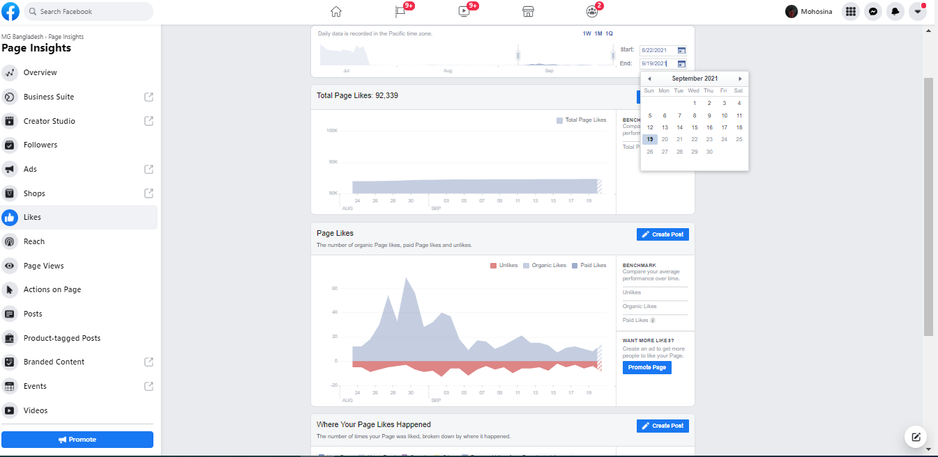

3.4.1 Total Page Likes as of Today

This information was used to create a graph of our page's popularity. For example, if we see a slight fall on the graph, we should investigate the cause.

3.4.2 Page Likes

We'll go over the entire page preferences as of today in more detail here. In this chapter, we'll look at the number of organic page likes, purchased page likes, and dislikes.

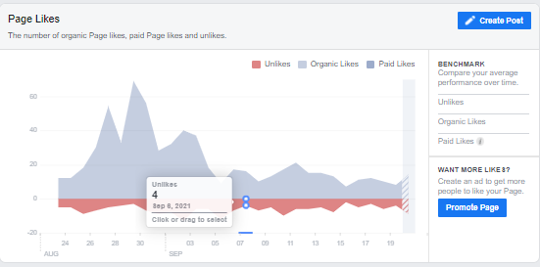

3.4.3 Where Page Likes Happen

This column, like "Where pages are followed," displays the amount of breaks based on how many times our page has been liked and where it happened.
We will strive to flatten the visual presentation of our page or distribute the content throughout the call-to-action if we detect a low digit of likes on our page.
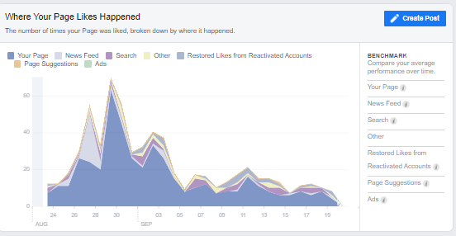

3.5 REACH INSIGHT

This is the place to put our material if we want it to be long limbed. We can locate data related to rich posts, such as recommendations, likes, comments, and shares, as well as much more.
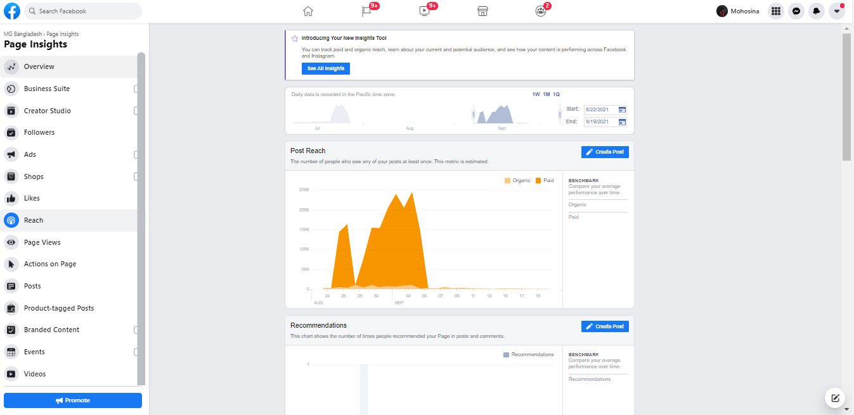

If we aren't particularly familiar with the term, the only way to grasp its meaning is to believe it because our post has the fewest individuals who have seen it once.
There may be a great desire to learn more. We can readily observe if our organic reach and campaigns are running over time if we keep track of our overall reach.
The graph depicts the percentage of users who found our post organically or via a search engine.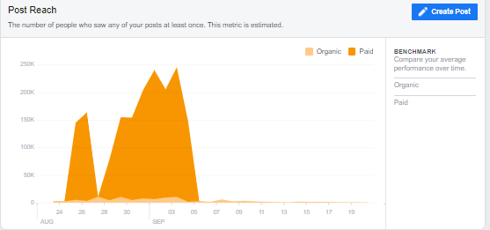

These actions, when added together, equal our bustle.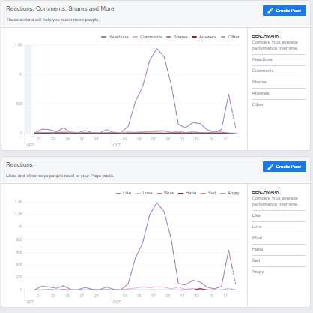

Facebook, like Instagram, is based on algorithms. The more popular our post becomes, the more probable it is that it will be discovered by other Facebook users.
This increase in discovery equals a possible lift.
We'll find a "Hide, Report as Spam, and Dislike" area if we scroll down.
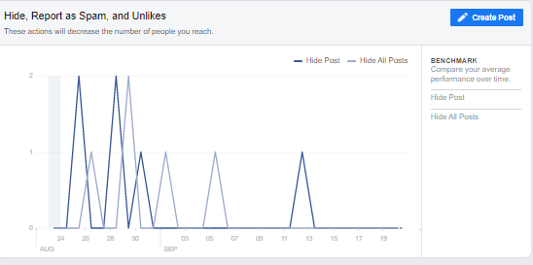
As a result, when a Facebook user sees one of these actions in our post, it signals to Facebook that the number of others who see it should be reduced.
If the actions are negative, we want the information to be low or zero.
Total Reach is the final area.
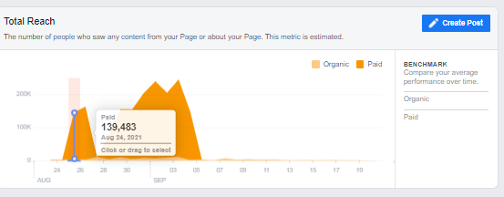
The total reach refers to the amount of people who have seen or heard about our page. This might include things like our posts, postings on our page, advertisements, mentions, check-ins, stories, and more.
This is a fantastic feature for seeing how our reach is growing.

3.6 PAGE VIEW INSIGHT

The page view tab displays us how many people have viewed which section of our page.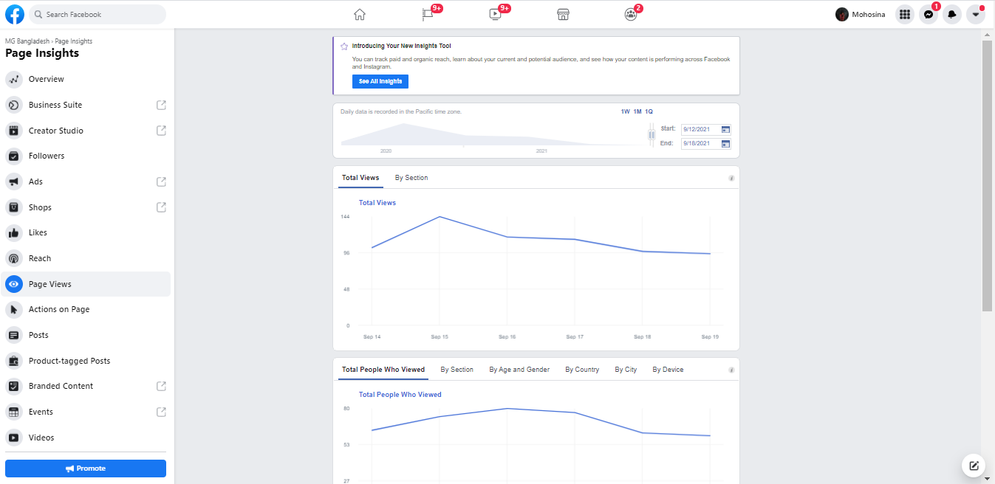

The Google Analytics tab is the same as the Page View tab. It investigates high-traffic sources, as well as where visitors came from and what they did once they arrived on our page.
In terms of gender, age, and city, this is also quite telling.
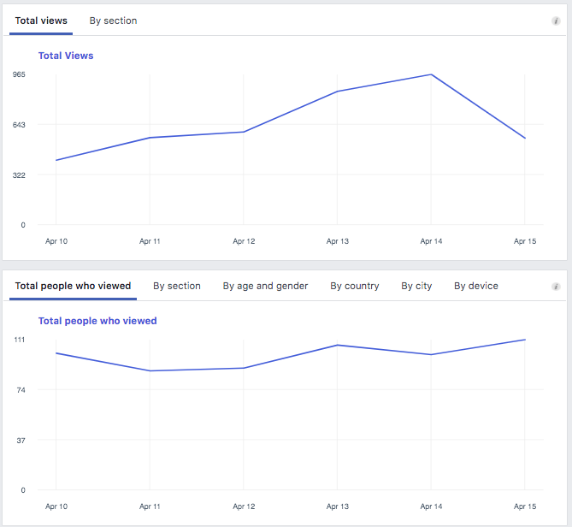
The profile of our page visited by visitors who have signed in and logged out is called total view.
We can categorize our total views to see which parts of our page visitors have been validated, such as our homepage, post, and page.
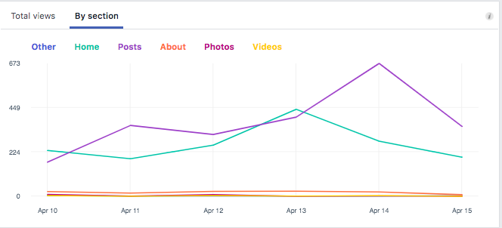
The total number of people who have visited our page shows the number of people who have viewed our page's profile on Facebook. This is where we acquire the majority of our demographic data.
By varying between gender and age, city, nation, and device options, we can better understand the characteristics of our visitors.
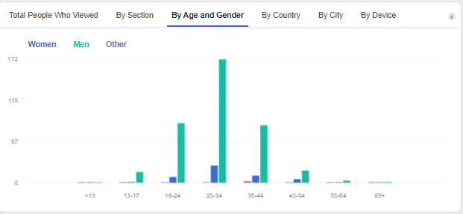

Finally, the best formula. The area gives us an inside look at where our page visitors are coming from, which is useful for marketing purposes. We can also see where our Facebook page appears on the internet.
The graph shows a maximum of 5 sources that identify people on our page by date. We'll see if these sources could be Instagram, Google or our brand's website.
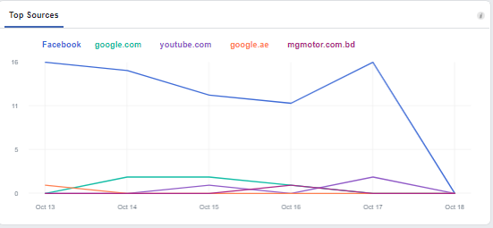

If one of our objectives is to get people to go from our website to Facebook, this is frequently an area where we test and develop in order to track our progress.

3.7 PAGE PREVIEW INSIGHT

Facebook's insights had already shifted to a commercial suite when I started this study in August. As a result, I was unable to locate the page preview insights. But I'm going to talk about it in broad terms.
Page previews refer to the length of time someone spends in the news stream on our page name, profile picture, and other places.
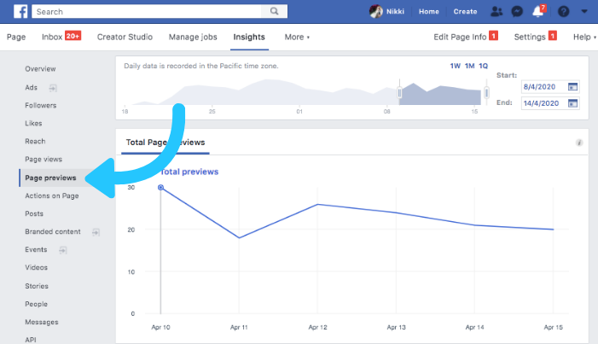

These two metrics show our reach and a sincere thank you for taking the time to see how many people are interested in our page. If someone comes to our page to see their preview, believe it or not, it signifies they were interested enough to see it.
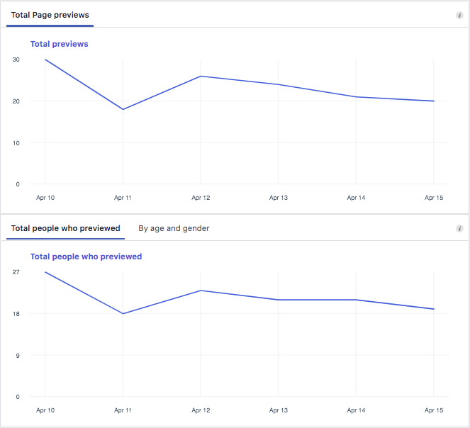

3.8 ACTION ON PAGE INSIGHT

This tab allows us to recognize what customers do when they visit our page, such as the percentage of visitors that follow our directions when visiting our website or calling our phone number.

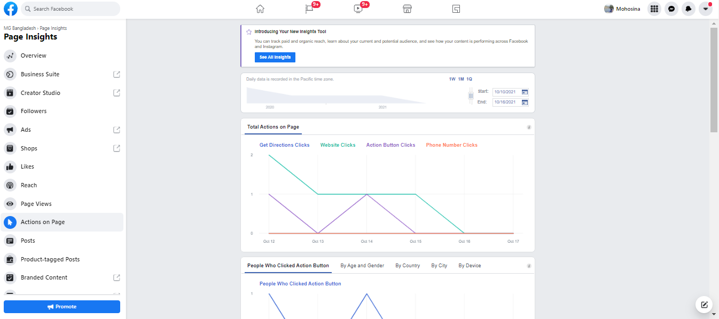
If we scroll down, we can see four metrics, each with a graph that delves into the demographics as determined by who clicked.
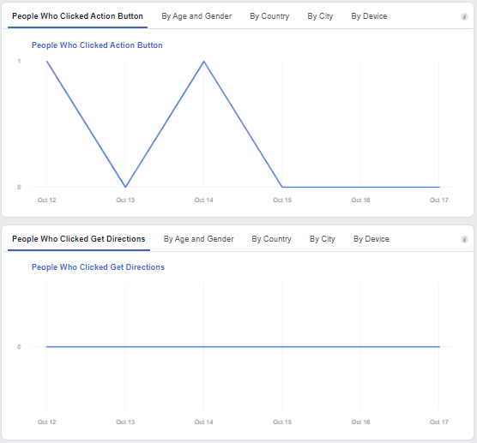
If we are a local company, we will receive a large amount of requests for directions and phone numbers. We'll explain the amount of people who clicked on the posts if we're only online.
If we are a local company, we receive directions and a large amount of phone number clicks. If we were only online, we would explain the number of people who clicked on the post
We can change the appearance of the action button. If we offer any form of subscription or subscription, for example, we will make our action button "sign up."

3.9 POST INSIGHT

We look at this page to see how we're doing with our posting.

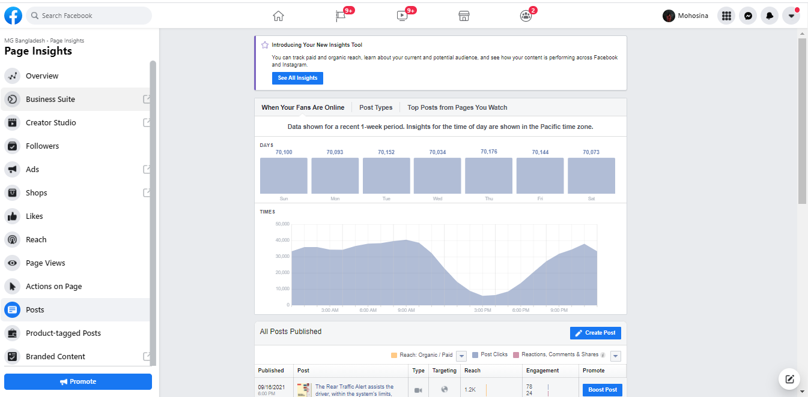

The Post Insight tab shows us:

3.9.1 Top Days and Weeks are our Audience

It tells us the best time to post. If the traffic is high we must post.

3.9.2 The type of our post and how they worked in terms of Engagement

It highlights the types of posts on which we should concentrate our efforts.
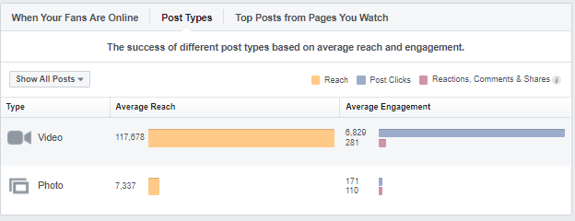

3.9.3 Top posts from the pages you visit

It's excellent for spotting new trends, as well as art ideas and inspiration.

3.9.4 All Post published
It contains information such as the date, time, post caption, post type, target, reach, and involvement for all posts and lists made on our page.
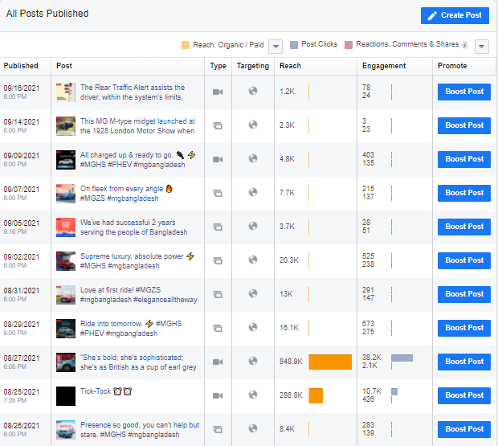

3.10 EVENTS INSIGHT

This tab displays the success rate of our event page as well as how we measure performance in one convenient location. Every day, we must check this tab. The following are some of the advantages we gain from the insights:
- Data we'll be able to acquire data-driven insights that will help us better our next event.
- We could see how our marketing approach is working;
- We could see how many people have viewed our program and their demographics; and we could see how effective our promotional plan is.
- With Ticket, we can see things like ticket clicks, ticket sales, and sign-ups in greater detail.
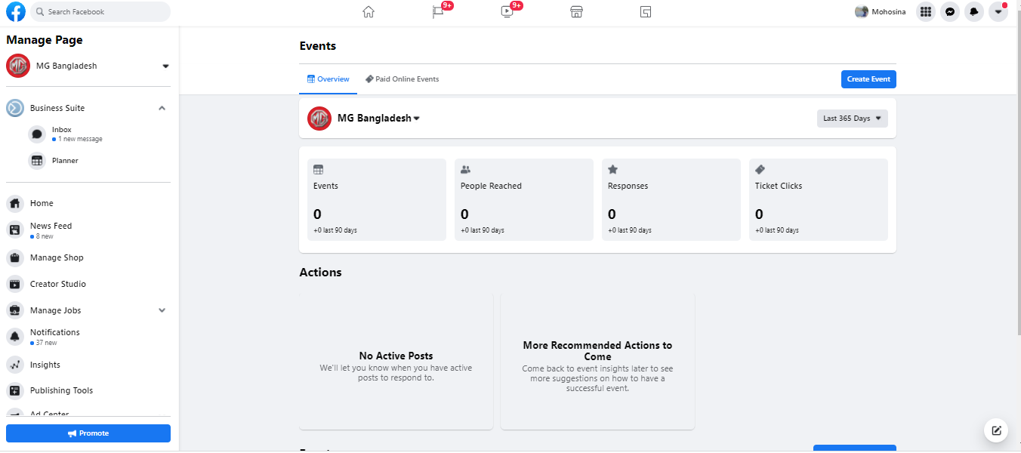

But as for now MG is not running any event that’s why it’s not showing anything.

3.11 STORIES INSIGHT

We use story insight to see how many people are watching our tales. The tab displays data on the performance of recent stories on our page. The stories will vanish after 24 hours, but they will remain viewable for another 28 days.
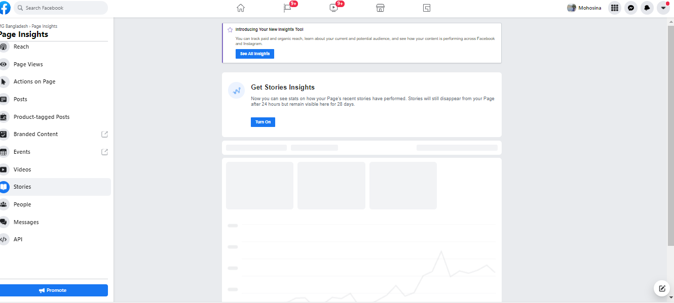
Again MG hasn’t post anything in the stories insight that is why it is black.

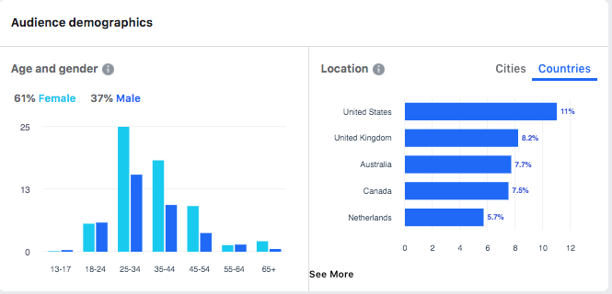
These details are useful to have on hand since they help us plan future material that will appeal to the target audience we've created.

3.12 PEOPLE INSIGHT

The People insight is the final one. It can be summarized as the number of individuals who have liked, watched, or linked to our posts or page.
When we access the insight, we find three options: our fans, followers, the amount of users we've reached, and how many of them are engaged.
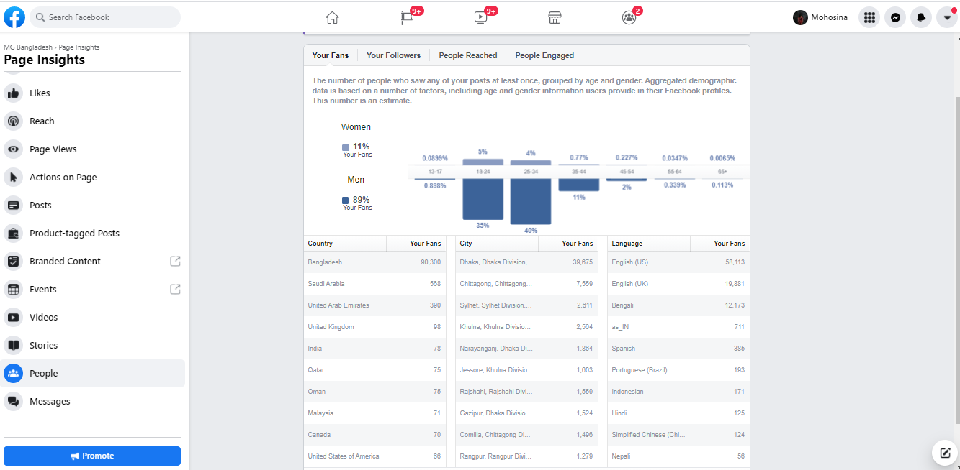

3.12.1 Our Fans

This term refers to visitors who enjoy our website. This information displays our followers by gender, age group, language, and geography, allowing us to better understand the many types of people that enjoy our page.

3.12.2 Our Followers

These are the people who like and share our page. We can see demographics such as age, gender, city, nation, and language, just like fans.

3.12.3 People Reached

This is the number of users, grouped by age and gender, who have any content on our screen or from our page.
Congratulations. We stepped right in and started analyzing Facebook data.
We intend to use this knowledge to expand our existing Facebook following, come up with new business ideas, and improve our social media marketing strategies.

CHAPTER-4

FACEBOOK BUSINESS SUITE

CHAPTER-4

FACEBOOK BUSINESS SUITE

Business Suite is a free application that allows us to manage our Facebook, Instagram, and Messenger profiles all in one location, saving us time and improving our customer relationships. Whether we're on the desktop or on the go, Business Suite makes it simple to reply immediately to notifications and communications.

4.1 FACEBOOK BUSINESS SUITE

The Facebook Business Suite allows us to manage all of our Instagram and Facebook profiles in one place. It offers a variety of tools that make it simple to do our business for no cost. Business suites can help us reach out to more people, stay current, and manage our online presence all in one location.
From our home screen, we can view a summary of our Facebook page and Instagram account. We may also check recent post updates, advertisements, and insights. From here, we may make a post and promote our company.
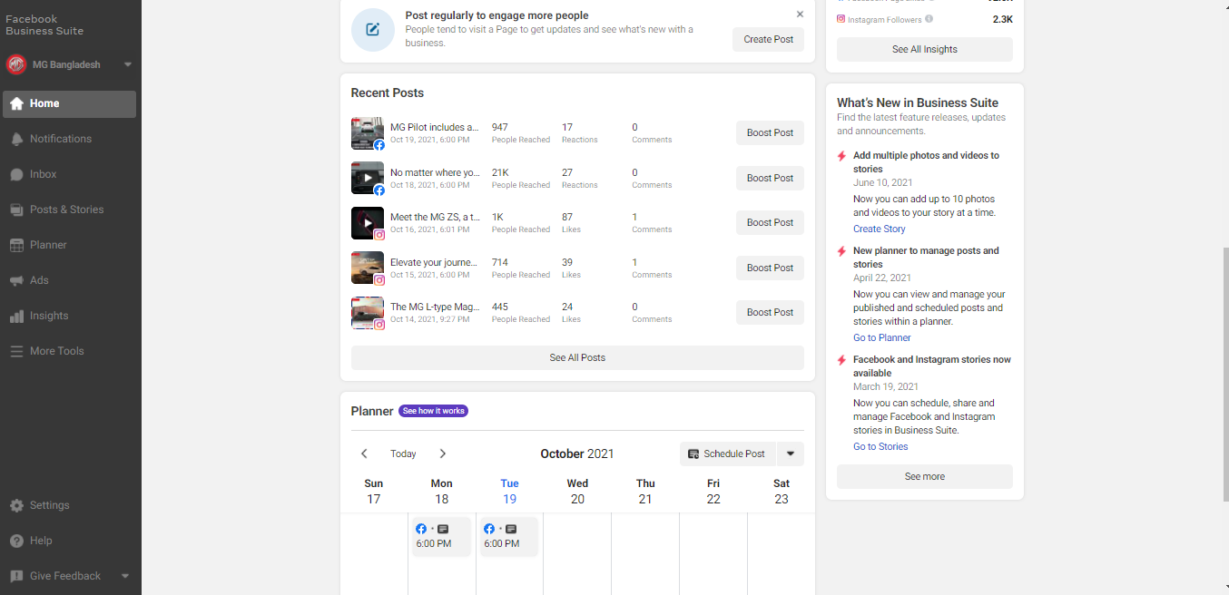

We can notice fresh notifications for our Facebook Page and Instagram account in the view activity section.
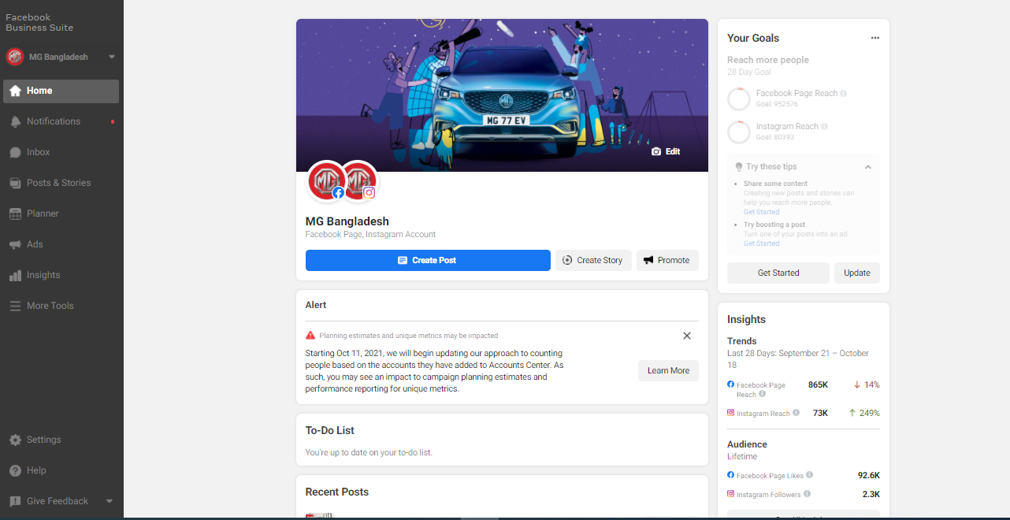
On the Notification tab, there is a red dot, as seen in the image. It indicates that a message has been received or that someone has recently commented on our post.

We may read fresh messages and comments from the messenger, Instagram, and Facebook page by using inbox. In the image below, we can see that there are several tabs, including all messages, which contains all messages from both Instagram and Facebook, message, which contains only Facebook messages, Instagram direct, and Facebook comments.
We may also construct Automated Responses to help save time when it comes to answering questions. For example, there is a tab labeled "Automatic Response" in the top right corner of the image, and in the inbox, we can see an automated response that was sent when the client clicked on the video or photo we shared on Facebook.

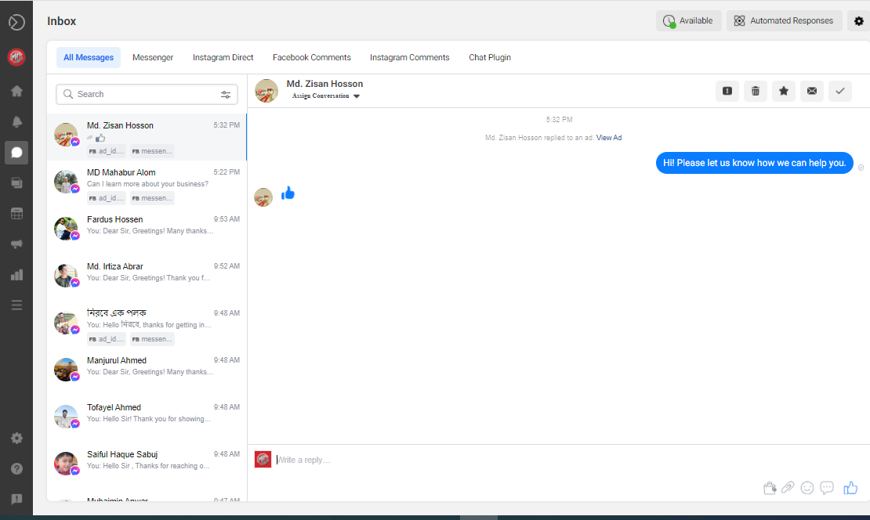

In the create post and tales section, we can also schedule or publish new posts and stories for our Facebook Page and Instagram account.

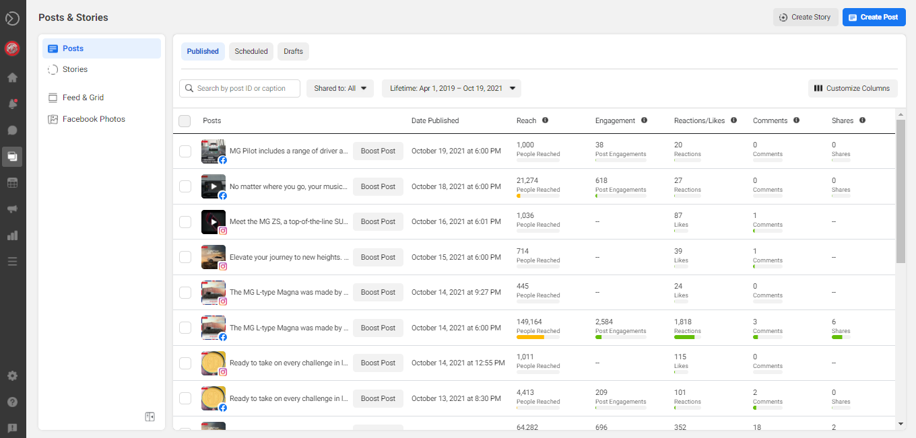

.
Then we may create new ads in the generate advertising area and post them on Facebook and Instagram. We may also advertise our Page and increase our posts. As may be seen in the following image, there is a create option. We can build advertisements using our calendar.
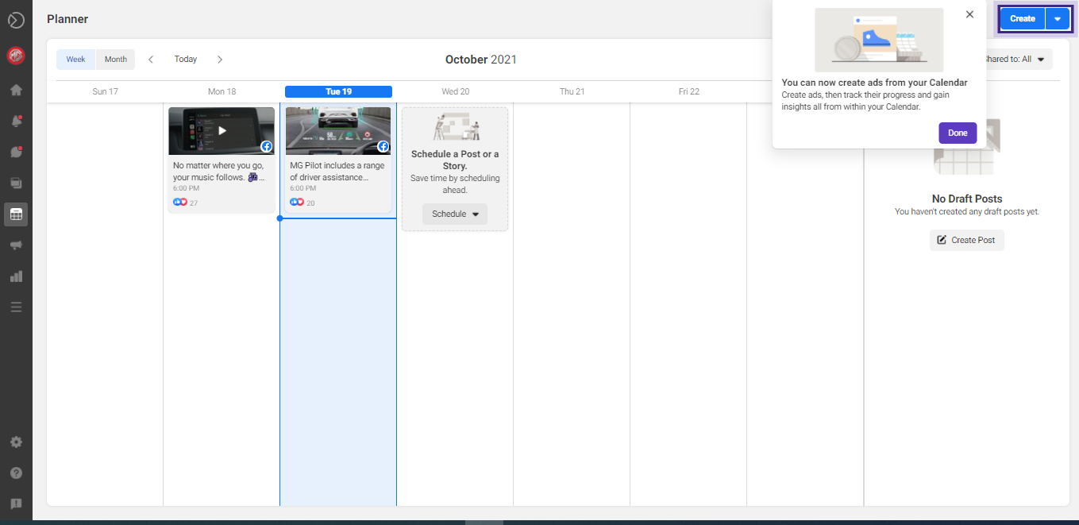
In the More Tools section of Business Suite desktop, we can find various Facebook tools and settings that we may utilize to manage our business presence. Other tools, such as Ads Manager, Business Settings, and Page Settings, are included. From here, we can also access our Facebook Page.
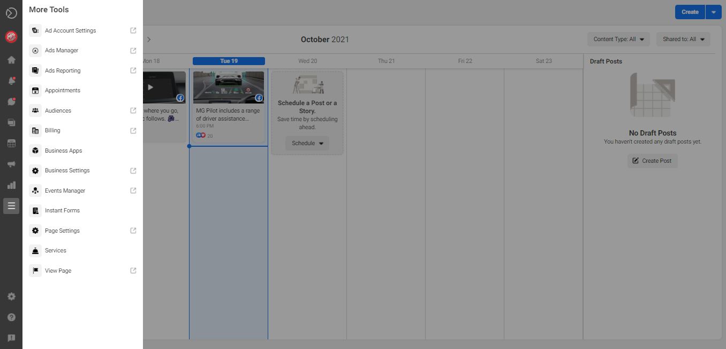

4.2 FACEBOOK LAUNCHES FACEBOOK SUITE

On September 1, 2020, Facebook announced a new tool for businesses to manage their profiles and pages across Instagram, Facebook, and Messenger. Create Facebook and Instagram feed postings, insights, and ads.
If we don't already have one, we'll need to link both our Facebook and Instagram business accounts to use the new app.
Business Suite will go to business.facebook.com on the desktop once you've logged in to Facebook.
The software includes features for producing Facebook and Instagram feed posts, scheduling posts, and gaining information into what's working. Businesses can see the reach, involvement, and performance of their Facebook and Instagram posts here. They'd also like to make a billboard in order to boost engagement and expand their audience.
As a result of several business outbreaks forcing customers to find new ways to prosper and sell online, Facebook says it originally designed the Facebook business suite with small business needs in mind. However, the long-term goal is to develop a set of tools that can be used by all enterprises, including large corporations.

4.3 4 TOOLS TO USE NOW THAT FACEBOOK ANALYTICS IS GONE

The Facebook Analytics tool will be decommissioned in 2021. Because Facebook Analytics has been helping businesses better their social media advertising for the past few years, the change came as a surprise to social media advertisers all around the world.
In 2021, Facebook Analytics will be deactivated. Because Facebook Analytics has been helping businesses improve their social media advertising for several years, the adjustment caught social media advertisers all across the world off guard.

4.4 FACEBOOK ANALYTICS TOOLS (THAT WILL STILL BE AROUND)

Facebook will not leave marketers without a way to see their ads if Facebook Analytics is shut down.
The strategy to integrate Facebook's marketing tools includes shutting down Facebook Analytics. You'll still be able to access the Facebook Business Suite, Facebook Pixel, Facebook Conversion API, and Creator Studio.
Here are four Facebook analytics solutions that will work even if Facebook Analytics is no longer available.

4.4.1 Facebook Business Suite

In late 2020, Facebook offered Business Suite for the first time.
For a moment, let's focus on the Facebook Business Suite's analytics features. Insights is a fanatical section within Business Suite that displays you metrics about your readership, our content, and our Facebook Page (s).
Through four important dashboards, Insights allows us to research our advertising:
- Overview, a one-page summary of all of our Facebook marketing analytics
- Trends, which tells us the reach of our Page over the course of a week.
- Content, which demonstrates how our individual posts and advertisements performed.
- Audience, which gives us a breakdown of our present and future audiences by age, gender, and location.
This is how the dashboard appears: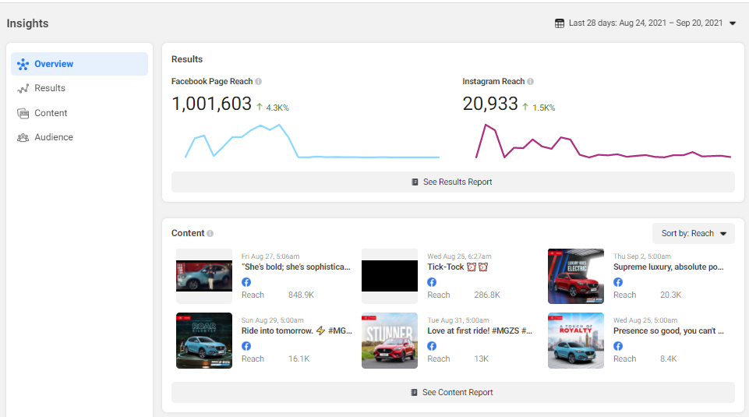

4.4.2 Facebook Pixel and Facebook conversation API

Although they are separate products, the Facebook pixel and conversions API work together.
Both of these analytics systems track what individuals do once they click on our ad on our website. This enables us to evaluate the effectiveness of your advertisement through the eyes of our target audience: Both of these programs monitor and evaluate what happens when a user clicks on an ad. It assists us in determining the effectiveness of our advertising by tracking our visitors' purchase and browsing histories. Their shopping cart activity, e-mail subscription preferences, and our procedure are all monitored.
The data collection procedure is the key difference between these two.
Conversions API collects data from the website's server-side tracking, whereas Pixel collects data from the audience's browser-side tracking). However, we must combine the two tools.

4.4.3 Creator Studio

Facebook Creator Studio is similar to Insights, except it provides more detailed analytics to businesses. We need to open the creative studio when we need to share something on Facebook. It also works on Facebook and Instagram.
We may calculate overall marketing performance, audience retention (including who recently followed and unfollowed our page), post engagement, earnings from instant articles, in-streamed live advertisements, fan subscription, and video performance using the creator studio.
The Insights area of Creator Studio looks like this: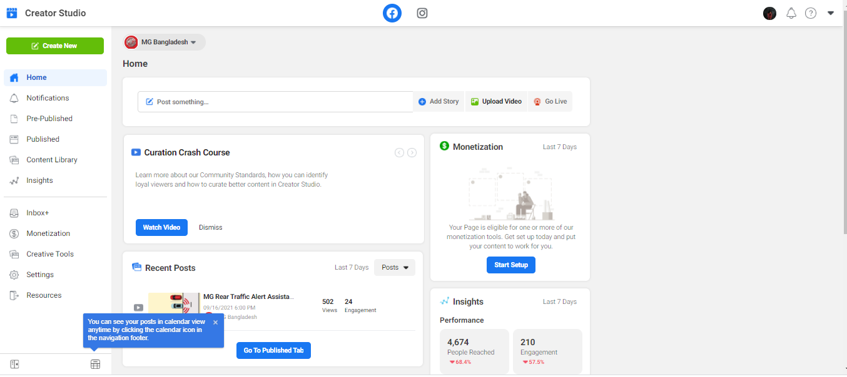

4.4.4 Hootsuite Analytics

Complement a social media management platform like Hootsuite with a comprehensive social media dashboard that includes scheduling, community management, and analytics tools.
- We can use Hootsuite Analytics to keep track of:
- Reach
- Clicks
- Comments
- Shares
- Video reach
- Video shares
- Follower stats
- Post performance
Hootsuite analyzes this data for us and aggregates it into easy-to-understand reports that make it simple to share our findings. We can personalize our reports and save them as CVS, PDF, or PowerPoint files.
Our social media team's effectiveness is also measured by response times, resolution times, and general productivity on the platform. Our social media team's effectiveness is also measured by response times, resolution times, and general productivity on the platform.
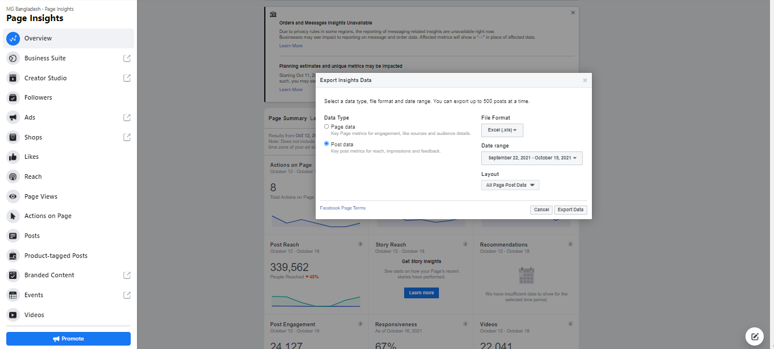

4.5 3 REASONS TO TRACK FACEBOOK ANALYTICS

Let's get into the why now that we've reviewed several viable Facebook Analytics alternatives. As in, why do we need to track our analytics in the first place?
It ultimately comes down to long-term results. Our organic techniques and Facebook advertising's long-term effectiveness.
It's simple to see the big picture and track our efforts on a daily basis. However, monitoring analytics is critical for getting a bigger picture because it will help us comprehend, compare, and report our long-term performance.
Let's take a closer look at that.

4.5.1 Understand Advertising Performance

In social media marketing, knowing how our audience reacts to our posts and adverts is crucial. As marketers, we must be able to tell when clients enjoy something, are ambivalent about it, or despise it.
The better we understand what our audience wants, the more likely we are to give it to them. That is why data analytics are crucial. Without asking, analytics tell us how our audience interacts with our advertising.
We'll employ analytics, for example, to highlight our best-performing advertising or those with the lowest engagement. This will help us figure out which advertising work best with our target demographic, giving us the information we need to make our marketing more efficient and profitable in the future.

4.5.2 Pin down the best Campaigns

While we may assume that our summer sale ad campaign was more profitable than our winter advertising, how can we be certain? This is where data analytics comes into play.
We'll employ analytics tools to link your advertising efforts to each other because they report data with a consistent definition.
We'll look at our total profit for both summer and winter advertising, for example. This metric would objectively and quantitatively inform us which of the campaigns was more profitable.

4.5.3 Create Comprehensive Report

It's difficult to communicate the complexities of social media management to folks who aren't familiar with digital advertising. However, there are instances when all we need to do is make it. This is where measures like ROI can be found.
We can use analytics to report our performance to folks who aren't familiar with social media marketing.

4.6 INPORTANT FACEBOOK ANALYTICS METRICS

Let's talk about some crucial analytics measures now that we've learnt about four analytics platforms and why they're significant. This section will go over six main categories as well as a few other specific indicators that we should be keeping note of.

4.6.1 Facebook Page Analytics

Our Facebook Page analytics tell us how well our page is doing. Our engagement is the focus of these measurements. All of the comments, likes, reactions, and shares that our Page receives from followers and other Facebook users are considered part of our engagement.
Here are two Page metrics to keep an eye on.

4.6.1.1 Facebook page Engagement rate

First and foremost, we must monitor the level of activity on our Facebook page. In comparison to our overall Reach, this indicator reflects the percentage of users who interacted with our Page. This equation can be used to calculate our engagement rate:
(Total Engaged Users / Total Reach) x 100 = Facebook Page Engagement Rate

36.1.1 Facebook Page Engagement Rate

4.6.1.2 Engagement Reach

The next step is to keep track of our involvement levels. The number of non-follower Facebook users who have engaged with our material is referred to as our engagement reach. This equation can be used to calculate our engagement reach per Facebook Page:
Engagement Reach = Total Post Engagement – Engagement From Followers

4.7 FACEBOOK AUDIENCE INSIGHTS

Facebook audience insights are a fantastic tool for keeping track of who is responding to our ads because they allow us to compare our audience stats to our audience. Here are two audience metrics that we should keep track of.

4.7.1 Gender & Age Breakdown

Our gender and age distribution could be a simple metric to track. It informs us about who views our material and allows us to tailor our strategy accordingly.
Insights or an analytics platform like Hootsuite can show us our audience's gender and age breakdown.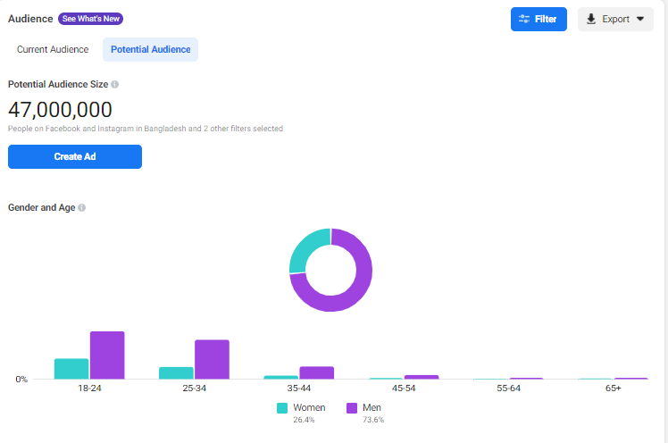

4.7.2 Top Audience Location

This measure is self-explanatory, but it's still worth mentioning for firms that have physical sites or a geographic focus. If that's the case, validate that we track if our material is being viewed and interacted with by locals.
Insights allows us to see where our audience is located:
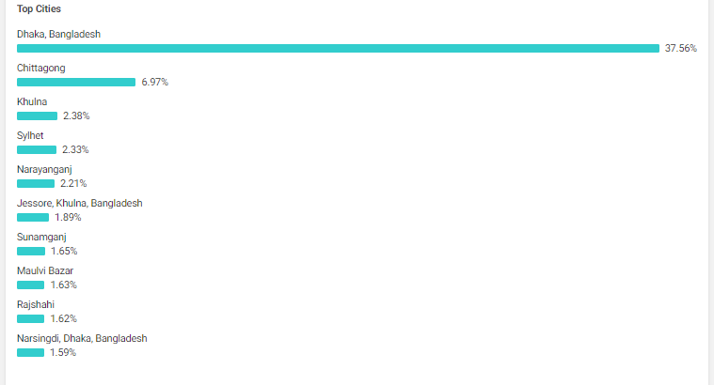

4.8 FACEBOOK ADS ANALYTICS

While it's critical to keep our advertising expenditure under budget, looking at our total bill doesn't tell us how much value we're getting for our money. Instead, keep track of these three parameters.

4.8.1 Clicks-through-Rate (CTR)

The CTR indicates how many people viewed an ad and clicked on it. This equation can be used to compute our CTR:
CTR = Clicks / Impressions

4.8.2 Cost-Per-Click (CPC)

The cost per click (CPC) shows us how much each click costs us. This indicator will show us whether we are investing more or less in our various Facebook advertising targets. The CPC is calculated here.
CPC = total cost per click / total number of clicks

4.8.3 Cost-Per-Thousand-Impressions (CPM)

The cost per thousand people (CPM) shows us how much it costs to reach 1,000 people. This statistic is ideal for analyzing our return on investment (ROI) over months, quarters, and years. This equation can be used to calculate our CPC:
CPM = Total Ad Spend / Total Impressions

4.9 FACEBOOK GROUP ANALYTICS

Facebook Group analytics allow us to monitor activity within a Facebook group. Brands are increasingly turning to Facebook Groups as a marketing medium. They offer a personal customer service experience as well as a location to meet new people.
Here are two metrics to measure Facebook Group’s success.

4.9.1 Number of new member monthly

New members should be joining healthy Facebook groups. We'll want to keep track of how many individuals join our Group on a monthly basis to make sure it fits into this category. We don't have to do this manually, thankfully. We'll be able to figure out how many new members we'll have in no time.
Insights > Group Insights > New Members.

4.9.2 Top Contribution for the last 28 days

It's worth keeping an eye on — and connecting with — our top contributors, as they're likely to be our most loyal consumers. This data can also be seen in Group Insights.

4.10 FACEBOOK LIVE ANALYTICS

The live feature was initially offered by Facebook in 2016. Since then, brands have utilized it to communicate with customers, interact with influencers, and promote products. Try using these indicators to measure the success of your Facebook sleep marketing.

4.10.1 Peak Live Viewers

This is the number of people who watched the live feed at its peak. As shown in the graphic below, Facebook calculates this amount for us and labels it Peak Live Viewers.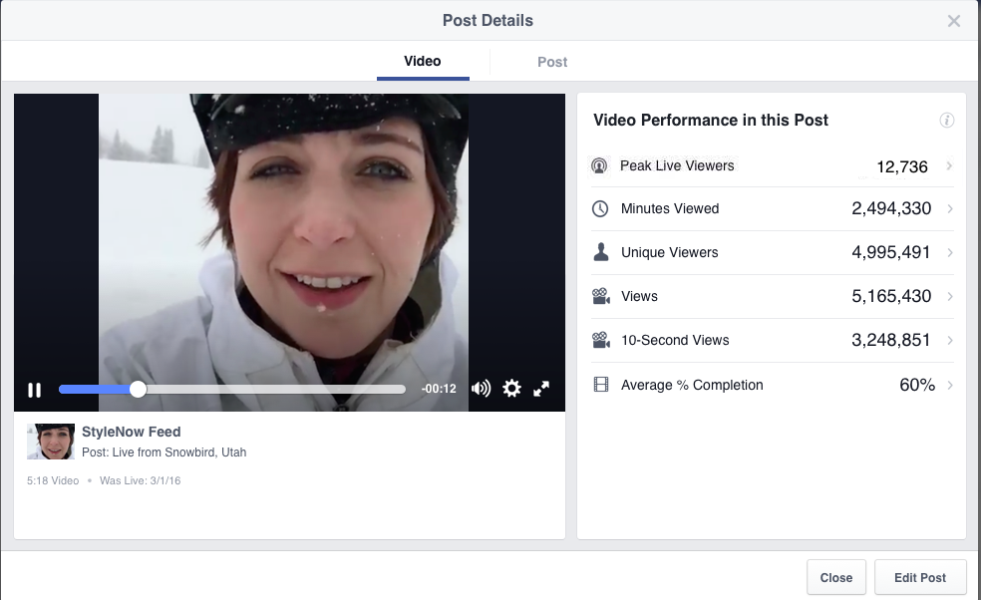

4.10.2 Average % Completion

This metric indicates how many of our viewers watched the entire Live. It'll help us figure out how interesting our stream was and how we might make it better in the future.

4.11 FACEBOOK VIDEO ANALYTICS

Facebook has been advertising video more and more in recent years, and it has caught on. If you're advertising on Facebook using video, make sure you keep track of your audience retention and video reach.

4.11.1 Audience Retention

The number of people who watch our films over time is measured by our audience retention rate. This metric is ideal for evaluating the quality of our video because it allows us to pinpoint the point where the majority of viewers leave. This metric can be found in Facebook Insights, as seen below.
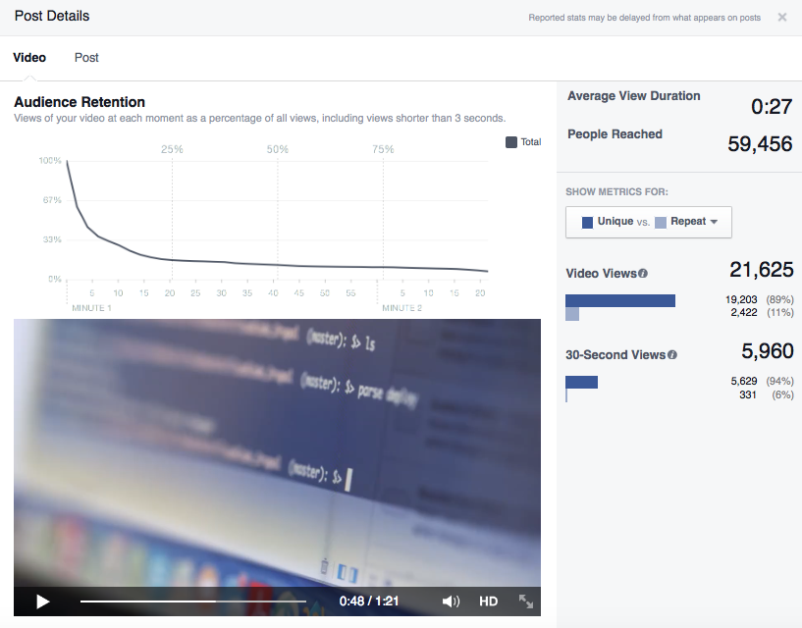

4.11.2 Video Reach Over 28-Days

The video reach measure indicates how many people saw our video over the course of 28 days. While it may seem weird to track reach over such a lengthy period of time, the 28-day timeframe allows the video to build traction. In Facebook Insights, we can track our video reach:

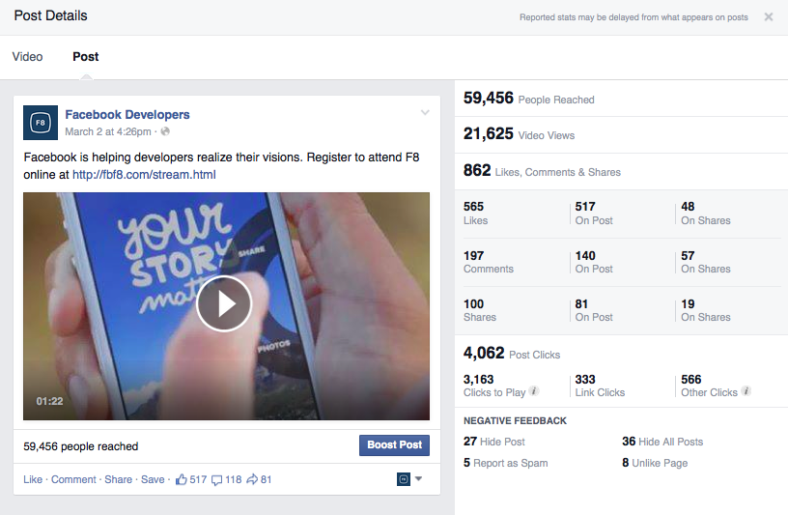

4.12 CONCLUSION

While many people will miss Facebook Analytics, Facebook isn't leaving advertisers in the dark. Other Facebook analytics tools or third-party social media management systems like Hootsuite will still be available to track our social media marketing performance.
Whatever choice we choose, we'll have the best chance of succeeding if we maintain a close check on our critical KPIs. Keep in mind that the most effective initiatives are data-driven.

CHAPTER-5
IMPORTANCE OF FACEBOOK ANALYTICS

CHAPTER -5

IMPORTANCE OF FACEBOOK ANALYTICS

There is one thing we will always count on with Facebook: new features.
Well, make these two things: "the new feature" plus "the occasional feeling of fear and insecurity in how to use and implement it successfully."
There's always something new coming up, something not always discovered before, and something that always asks us, "What does this button do?"
With this incredible amount of latest products and tools published every month, some people may miss launching Facebook Analytics.
However, it is an educational requirement that is small and small for all Facebook / Instagram marketers.
Facebook Analytics can be a comprehensive tool that allows us to see the full sales funnel, understand users' lifetime value, and see how our organic and payment strategies intersect.

CHAPTER-6
CONCLUSION

CHAPTER-6

CONCLUSION

As a free online analytics tool, and because of the way Facebook collects more user data, it can help us find new data points from which we can improve all aspects of our organization.
Whether we’re:
• Improving online advertising performance
• Identifying the most effective marketing channels
• Improving sales funnels
• Identifying data-driven possibilities

But it wouldn't be the simplest notion if we simply used Facebook Analytics for our online business's web analytics needs.
However, when we examine the overall benefits of having the Pixel installed on our website, having additional Facebook analytics reports can be quite beneficial for growth.
So, now that we've installed or are about to install the Pixel, we should examine Facebook Analytics and the numerous reports it generates to learn more about our website and how users interact with it.

CHAPTER-7
REFERENCE

CHAPTER-7

REFERNECE

References
Business Suite. (2021, June). Ad Express. Retrieved from Hootsuite: https://adespresso.com/blog/facebook-analytics/
Facebook Analytics. (2019). How to use Facebook Analytics. Retrieved from Digital Marketing Institute: https://digitalmarketinginstitute.com/blog/how-to-use-facebook-analytics
Facebook Analytics. (2020, July). Retrieved from IT Pro: https://www.itpro.co.uk/analytics/30417/what-is-facebook-analytics-and-how-can-businesses-get-value-from-it
Facebook Analytics. (n.d.). Later Blog. Retrieved from https://later.com/blog/facebook-analytics
Gilbert, H. (2020, 4 24). The Ultimate Guide to Facebook Analytics. Retrieved from Later Blog: https://later.com/blog/facebook-analytics
Meta for business. (2020, 11 17). Introducing Facebook-business-suite. Retrieved from Meta for business: https://www.facebook.com/business/news/introducing-facebook-business-suite
Ranks ITT. (n.d.). Retrieved from https://www.ranksitt.net/

