United International University

Internship Report
ON
Digital Marketing and Brand Communication
Of National Distributor of Xiaomi

Submitted to
Dr. Seyama Sultana
Assistant Professor,
School of Business and Economics
United International University

Submitted to
Md. Atikur Rahman
ID: 111 151 447
School of Business and Economics
United International University

Submission Date: 23thSeptember, 2019
Letter of Transmittal

23thSeptember, 2019
Dr. Seyama Sultana
Associate Professor
School of Business and Economics
United International University
Subject: Submission of Internship SEBL- National Distribution of xiaomi
Dear Ma’am,
I would like to present my internship report named SEBL- National Distribution of xiaomi. This internship report has been prepared for the fulfillment of BBA program under United International University.
SEBL-National Distribution of xiaomi is one of the largest state owned Multinational Corporate Company in Bangladesh. SEBL- National Distribution of xiaomi was formed in 2010. After that National Distribution of Xiaomi Smartphone & Accessories, which it was founded on August, 2016 in Bangladesh.
While I was preparing this report, I tried to follow the directions and guidelines that you have given me. It has been very exciting and interesting while I was working in SEBL- National Distribution of Xiaomi. I have enjoyed my internship period in Xiaomi. The management of SEBL- National Distribution of Xiaomi has helped me when I was needed.
Sincerely,

Md. Atikur Rahman
ID: 111 151 447

Acknowledgement
First I would to like to express my gratitude to Almighty Allah for successfully completing the Report. Then I would like thank my internship supervisor Dr. Seyama Sultana who has provided her valuable advice and guidelines in every step of my preparing the report.
Then, I also want to thank Sameur Rahman Sourov (Director)of SEBL- National Distribution of Xiaomi Gulshan-2 Corporate Head Office and Sheikh Faisal Amin (Assistant manager), Marketing and Brand and all the officers and employees of SEBL- National Distribution of Xiaomi Gulshan-2 Corporate Head Office for unconditional help towards me to prepare this report. To understand their perception, feelings and philosophy and procedure I have worked with them closely for 3 months. I have prepared this report on my own understanding. I will be thankful to those who will read the report and will get benefitted from this reporting both present and future.

^{Table of Content}
Topic Name Page No
Executive Summary ………………………………………………………………………..…...i
Chapter -01:
1.1 Introduction ……………………………………………………………………………….....1
1.2 Rationale of the Study……………………………………………………………….…........1
1.3 Background of the Study……………………………………….............................................2
1.4 Objectives……………………………………………………………………………………..3
Chapter -02:
2.1 Company Overview………………………………………………………………….….....6-9
2.2 Organization Wide……………………………………………………………………...10-11
Chapter -03:
3.1 Job Description……………………………………………………………………………12
3.2 Job Specification………………………………………………………………………..12-13
3.3 Job Satisfaction………………………………………………………........................…14-15
Chapter -04:
4.1 Important Issue in the Organization…………………………………………………..16-18
4.2 Academic preparation…………………………………………………………………..18-19
4.2.1 From Organization…………………………………………………………………..19-20
4.2.2 From University’s Internship Program…………………………………………...…20-21

Chapter -05:
5.1 Conclusion…………………………………………………………………………………22

Recommendation……………………………………………………………………....22-25
Reference:

Website References…………………………………………………………………….26
II. Books References……………………………………………………………………….26
III. Personal References………………………………………………………………………..26
Appendix:…………………………………………………………………………………...27-30

Executive Summary
SEBL- National Distribution of Xiaomi is one of the multinational Company in which the prosperity of a country. The SEBL Company sector in Bangladesh is huge and many skilled workers are working in this Group Company sector. I have prepared this report from my internship period of 3 months In SEBL- National Distribution of Xiaomi Gulshan-2 corporate Head Office. During the period of my internship I have learnt a lot from the employees of that branch. I have prepared this form my practical experience and knowledge from my working there for 3-month internship. This whole report is a pictorial report where I have briefly discussed Job Responsibility & Importance Issue of SEBL. To prepare this report more precisely I have used both the primary source of data and secondary sources of data. For primary sources I have taken the opinion of the customer and employees and staff of the Gulshan-2 corporate branch and for secondary data I have taken information from the Corporate Head office, HR Manager, Wikipedia and the prospectus and working manual of SEBL- National Distribution of Xiaomi. There are five chapters in this report. The first chapter of the report contains the introductory part including the topic of the report, origin of the report and background of the report, objectives of the report mainly general objective, broad objective of the report, and specific of the report. It also contains methodology of the report and limitations that I had to face while preparing the report. The second part of the report of the report is combined of information from organization in this report the Company overview is SEBL- National Distribution of Xiaomi mainly mission, vision. Corporate profile, growth of performance, growth of Subsidiary Group Company and logo of SEBL. The third section of the report contains the Job Responsibility analysis. The advantage and disadvantages of Job Responsibility analysis. The fourth section contain the Important Issue. And the Five and last section conclusion and Recommendation SEBL- National Distribution of Xiaomi. SEBL- National Distribution of xiaomi is one of the largest state owned Multinational Corporate Company in Bangladesh. SEBL- National Distribution of xiaomi was formed in 2010. After that National Distribution of Xiaomi Smartphone & Accessories, which it was founded on August, 2016 in Bangladesh. Their Corporate Business Concerns of SEBL grow up day by day for example: Renewable energy Division, National Distribution of Xiaomi, DX Tel Ltd, Global Unitrade BD Ltd, DX360, Quick Fix, National practical Training Institute, Dewan Traders, SEBL Properties.

Chapter - 01

Introduction:
Solar Electro Bangladesh LTD (SEBL) is one of the most top-level Solar Company in our Country, which it has inaugurate in 2010 Dhaka. It has developed numerous medium and large Solar System national wide. Solar Electro Bangladesh LTD (SEBL), is the National Distribution of Xiaomi Smartphone & Accessories, which it was founded on August, 2016 in Bangladesh. SEBL Apprehend the up to date idea and Standard Bangladeshi Customers that they apply to pick up. Our Corporate functions grub to provide all our sales Channels with also be spoken and absorb solutions that enables them to inflate their business potentials. We are perpetual Straining to satisfy consorts and stoners to serve with the caparison by providing them complete service with consumers Gratification and relish. We are frequently and forever at work to increase our consort’s happiness to fence their beleaguerment through quality ensure products and favors we deliver. The Chops administration of Solar Electro Bangladesh LTD is facing familiar for becoming the market penstock of Distribution Sector in Bangladesh.

1.2 Rationale of the Study:
This report is about the organization Solar electro Bangladesh limited. This report is focuses on the Marketing and Brand communication of SEBL. This report is based on the three months of Internship period of mine where I am working with the genuine working environment. I want to undertake this report because I want to show the real process of branding and marketing strategy of SEBL. To do the Internship program under this organization was a requirement for my BBA program. This Internship program is designed in such a way that as a trainee a student can experience the real-life working environment in a reputed company. While working in the company I implemented my theoretical knowledge, technical knowledge & extracurricular activities experience which I have gathered for last four years in my university’s learning period and compare this knowledge to the practical ground. This helps me also to find out the similarities and the differences between his theoretical knowledge and practical work. Learning and working is definitely a fun job especially when a student knows what he is doing and he is able to apply his learning in his work. The head office of SEBL is located at House no #07, Road no #54 Gulshan-2 Dhaka

1.3 Background of the Organization:
Solar electro Bangladesh limited (SEBL) has founded in 2010 at Dhaka, Bangladesh which is one of the leading Importer of Solar Panel, Consumer Electronics, CPVC Pipe & Fittings, Solar Charge Controller, Battery, On Grid & Off Grid Inverter, Solar Street Light & Solar related all Products, LED Bulb & Tube, Energy Saving FAN, Prepaid Meter etc. and also Exports Ship Breaking Products, Jute items to New Zealand, USA, Japan, Germany and England. SEBL was one of the first Solar Company in Bangladesh and it has installed numerous medium and large Solar Systems nationwide. SEBL is the National Distributor of XIAOMI Smartphone & Accessories in Bangladesh. For getting maximum result, SEBL recognizes the up-to-date idea & norm of Bangladeshi consumers that they apply to purchase. Their corporate functions strive to provide all our Sales Channels with customized and integrated solutions that enables them to maximize their business potentials. SEBL is continuously striving to satisfy our partners and users and also, to serve with the best by providing them complete service with customer satisfaction and delights. SEBL is constantly and consistently at work to maximize our partners’ satisfaction and to protect their investment through quality ensured products and services render. The expertized management of SEBL is looking forward for becoming the market leader of Distribution sector in Bangladesh. Within this one and half year of starting the distribution of Xiaomi, they expanded Their distribution network countrywide. There are about 100 local distributors, more than 115 Authorized Mi Stores, over 400 of Shop in Shop and more than 500 Brand Promoters working under a common platform. Moreover, our dedicated Field Sales Force ensuring sales growth & market development.
Golden Partner Award: Mr. Dewan Kanon, CEO, SEBL has received GOLDEN PARTNER Award from the CEO & Founder of Xiaomi, Mr. LEI JUN in recognition of outstanding contribution for Xiaomi.
Top Four Outstanding Global Partners: SEBL has been selected as one of the Top Four Outstanding Global Partners in Xiaomi Global Partner Conference 2017, Beijing, China to share the journey of Mi Bangladesh & successful distribution channel for Xiaomi in Bangladesh.
177 KW Solar Mini-Grid at Monpura, Bhola: Monpura Upazilla is an Island of Bhola District in Bangladesh. There are almost 100000 People living in this Island of them 3000 people are getting electricity facilities from 6. oo pm to 1.00 am in a day at present through Generator by WZPDCL and there are no elctricity facilities for the rest of the 97000 people.
In the year of 2015, 177 kWp Solar Mini-Grid was being open and that is why about 25000 people of this Island are getting solar grid electricity instead of oil lamp or funnel. The self-employment has been created commercially and the people who are affected by climate change have enabled to acquire livelihood for getting solar grid electricity.
50 KW Solar Mini grids at Noapara, Naria, Sariatpur: Noapara is the union of NariaUpazilla of Sariatpur District in Bangladesh. There are almost 80,000 People living in this union. 100% of the people are deprived from electricity facilities. In the January/2018, 250KWp Solar Mini-Grid was being open and that is why about 25000 people of this area are getting solar grid electricity instead of oil lamp or funnel.
Company Hierarchy Chart:
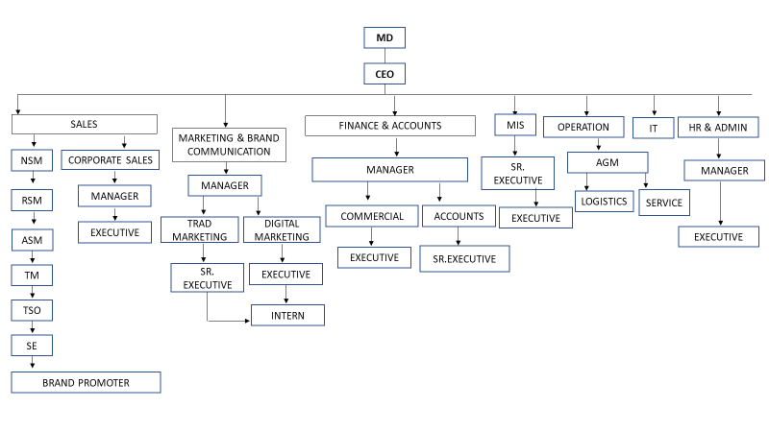

Mission
The company is passionate about contributing to a country, which does not depend on power from fossil fuels. The aim is to accelerate the adoption of solar technology across the world to conserve our environment and provide an environmentally friendly, sustainable and conflict-free power supply.

Vision
To provide the most compelling value in the solar energy industry. Value, as defined by their customers, means designing and installing the highest quality solar energy systems, on time, safely, with high customer satisfaction, at a low cost.

SEBL Products: Xiaomi Devices & Accessories
Product Name | Brand
Mi 8 Lite | Mi
Mi A2 | Mi
Mi A2 Lite | Mi
Redmi Note 7 Pro | Redmi
Redmi Note 7 | Redmi
Redmi Y3 | Redmi
Redmi 7 | Redmi
Redmi 6 | Redmi
Redmi Go | Redmi
Redmi 6A | Redmi
Pocophone F1 | Poco
Power Bank | Mi
Power Bank (Single Output) | Mi
Piston Basic Earphone | Mi
Xiaomi Colorful Mini Backpack | Mi
Waterproof Zipper Backpack (Level 4) | Mi
WNDR3400 Dual Brand Wireless Router | Mi
Xiaomi Wi-Fi Router 4c | Mi
Xiaomi Mi 4c Wireless Router (Chinese Version) | Mi
Mi Wi-Fi Amplifier Pro | Mi
11AC Mi Wi-Fi Router 1167 Mbps Smart App Control External USB Storage | Mi
Mi Micro USB Data Sync Cable 120cm – Orange | Mi
Xiaomi Band 3 Charging Cable | Mi
Mi Noise Cancellation In-ear Earphone Type-C Version | Mi
Mi Mini Portable Bluetooth Speaker | Mi
Mi In-Ear Headphone Pro – Black | Mi

Figure 2: Product Details: Solar Electro Bangladesh Limited - National Distributor of Xiaomi Mobile

1.4Objectives:
- To understand the Marketing activities and strategy of SEBL
- To identify the issues of the organization regarding Marketing.
- To recommend solution for the issues regarding the Marketing SEBL

Chapter-02

2.1 Company Overview:
I have got golden opportunity to work at Solar Electro Bangladesh Limited. I assigned for the position of Marketing and Brand communication of this organization. I did observe clearly all the marketing activity of SEBL. I am involving of marketing activities during my internship period time. On the first day of my joining I was introduced to my supervisor Mr. Faisal Amin who is key account Manager in Marketing Department. He assured me full assistance in case of any problems. I got chance to meet Mr. Tariq Raihan Mithu who is the Head of Marketing DX360 (Concern of SEBL) who provide the marketing solution of SEBL. He is the supervisor of Mr. Faisal Amin and all the other juniors and senior executives in marketing department. This department is providing all kind of marketing solution, organize online campaign, digital marketing and offline marketing to SEBL. All the senior executive, graphics designer, visualizer, senior assistance manager and key account manager follow the instruction comes from Mr. Tareq Raihan Mithu. He is responsible for all the marketing related activity and brand promotion. The CEO of SEBL MR. Dewan Kanon order the requirements (related marketing activity) and as per the requirement the marketing team run their marketing activity following the instruction of Mr. Mithu head of marketing and his team to provide marketing solution of Solar electro Bangladesh limited. Some of the work-related activity that I have conducted in SEBL marketing team:

Campaign Planning:
As I am working at marketing team so arranging online/offline campaign is the essential part of my job. At 26th June 2019 the CEO of SEBL informed us some of our products are unsold which are stored on logistics. The quantity is almost 1500 handset from 4 different model. The net worth of all the handsets is about 3 crore takas approximately. So, the CEO suggested us our main responsibility is to sell those unsold products anyhow. Our COO Mr. Mitu suggested us to brainstorming and submit some creative idea to arrange the campaign. I have submitted some ideas like:
- Confirm Discount in every purchase from 10-50 % for specific series
- If anyone change Profile photo + check in with MI banner/Event, he or he will get Free Headphone
- Wristband for check in those who only visit the fair would not purchase.
- For Bulk purchase – Gift voucher/Coupon card/ Loyalty card/membership avail authorized mi store.
- EMI facilities for monthly payment.

Concept Sharing:
Sometime the Manager ask for submitting different TVC idea, tag lines and I shared different advertising concept to manager.

Shop Managers meeting monitoring:
As I have discussed in chapter one there are more than 115 Authorized Mi Stores, over 400 of Shop in all over the county. In this month the head of sales ask for monthly meeting where all he shop managers are responsible for coming at head office and report their monthly sales statement. 25th June 2019 this meeting was held in SEBL head office where almost all the shop managers from different area comes up and I was taking the attendance and introduced with them about their sales procedure. Mr. shoriful shop manager of Rajshahi informed me their business is going well and they are potential about meeting their sales target. And if they face any difficulty, they inform it to our Head office and the head of sales try to solve those issues.

Assisting Executives:
In marketing unit there have 2 senior executive 3 visualizer graphics designer who are responsible to make banner, logo, billboard, posters and all the other graphical work. Sometimes they are responsible to find out the Communication line, Option/Creative, Campaign modality. I try my level best to help each and every activity by providing my personal idea, opinion which comes from brainstorming season. For example, graphic designer made a logo or banner and he is asking for feedback how it looking the font, color, size, overall outlook of that particular logo. If everything is ok, I said ok. If I think there have something for correction, I suggest from my personal opinion like ok change the font color, size or update the appearance etc.

Involving Branding and Sales Monitoring:
The authority EXPO maker of Bangabandhu International Conference Centre (BICC) has organized an event (Smartphone and tab expo fair-2019). Where all the International and well renowned brand (Apple, Samsung, Huawei, Oppo, Vivo, Motorola, Maximus) were participated supported by their mother. We also participated with our brand Xiaomi. We made all kind of Smartphone and Accessories available with special discounts. To be very honest, involving this fair has given me an in-depth overview and hands on practical experience how to do branding, conduct promotional activities and creating awareness by implementing different kind of marketing strategies. I am conducting a short description over here about the event below:
As I have discussed in previous chapter there were more than 1200 smartphones with more than 50 plus variant accessories in the fair. The top management arranged a meeting where they have informed the marketing and sales unit have to reach the sales target. The head of operation Mr. Saif DX TEL (authorized retail chain of Xiaomi) was responsible for operate the overall operation. There were total 50 employees from 4 different department- Trade marketing, MIS, Account and logistics. As I assigned from marketing department so I was responsible for managing marketing activities. I have been executed the overall manpower who directly associated with marketing and sales. I have observed the BP (brand promoter) who were responsible to convince the customers and make them purchase, if they face any difficulties regarding any information I was there for support. I also observe the Shop manager’s roles and responsibilities, if they have facing any problem or not. Our main responsibility was to provide different kinds of attractive offers, discounts making aware of customers etc. From locating the banner, to toughing leaflet each and every activity have been assisted by me. We announced the hourly deal via central microphone, we tried to do a successful branding at all which could be worth to customer. As their have more than 50 manpower so having food and breakfast was a major issue also. The head of operation Mr. Saif was assigned me to taking attendance and ensure food each of employees. Every day I was reported at BICC at 9 AM and took attendance of each employee whether they have reported on board timely or not. The HR of SEBL managed the food and I was ensuring and noted down wheatear everyone have their food or not. At the end of the day I was reported to my supervisor about my given task.

Checking the logistic stock:
For arranging the fair, we need lots of items like T-shirt, cap, stationary items and so many things. I checked it out after finishing the fair about how much remaining items has been returned on logistics.

Data entry:
In the smartphone and tab expo fair we have sold our more than 700 devices along with eco accessories. There were so many data IMEI number, Customer registration list which needed to input in the Excel file I was responsible to entrance all those data to excel sheet so that we can track those customers in near future in order to offering them more valuable incentives.

Marketing Plan Idea Generation:
Here my Boss ask me for generating creative idea out of the box. For successful market campaign this works very fast to grab the customer attention. For example, Xioami is going to launch a new ECO product that is air purifier so customer don’t know about the product. Here I was involvingto aware the customer about our new product. I was conduct different kind of digital marketing like Email marketing, tracking the customer from Facebook and push them by providing attractive discount offering.
- Scanning and Printing:
It’s a daily work of mine in office to scan and print important documents. There are lots of product is being sold by Xiaomi authorized shop all over the country. Here all the IMEI sticker and customer data needs to be updated with the mother monthly sales file. Sometime this sort of documents needs to do photocopy, and I was involved in taking this sort of action.
- Market Visit:
Monthly market visits to monitor the products availability & knowledge about different launched campaigns. During my internship period I have done market visit in several authorized shop with my supervisor.
- E- Mailing:
I was involved in emailing our valuable customer based on their community involvement by tracking social media platforms.
- Competitor Analysis:
There are lot of company doing same business in Bangladesh like Samsung, Nokia, Oppo, Vivo and so many brands who are our main competitor. We sometime track their market position how they are doing in the market; what sort of strategy they are following we can easily find out our SWOT by analyzing their portfolio over online or offline media.

2.2 Organization Wide:

Hr. Department:
The human resources department handles a range of different functions within the organization. The department is responsible for hiring and firing employees, training workers, maintaining interoffice relationships and interpreting employment laws.

Accounting Department:
The accounting department is responsible for recording and reporting the cash flow transactions of SEBL. This department has some key roles and responsibilities, including accounts receivable, accounts payable, payroll, financial reporting, and maintaining financial controls.

MIS:
The role of the management information system (MIS) manager of SEBL is to focus on the organization's information and technology systems. The MIS manager typically analyzes business problems and then designs and maintains computer applications to solve the organization's problems. Recording the IMEI, checking the available devices in the stock

Application Development:
Our Business Development team and Tech team working together to build CRM tool which can make the Marketing work more effective and efficient. Where we business development team suggest them to build this CRM app to work more actively and effectively. In this app we can easily keep our data more organized way and it would help us for further research and development.

Sales Team:
Sales department is responsible for making sales, growing our business and retaining existing customers. Ultimately, the most important function of our sales department is maintaining relationships with all of our customers. As I have conducted there have more than 408 official outlets and all the outlet has different Shop manager, Brand promoter here the main responsibility of sales team is communicating with their potential shop manager weather they are achieving their sales target or not. If there have any help or issue regarding sales our sales unit always help them.

Third Party Marketing:
SEBL works for third party marketing activities by their marketing team. For example- Karnafuli Group takes the franchise of Renault Car in Bangladesh. Now they are trying to promote the event and arrange social media campaign. SEBL visualization and graphics unit has launched this event successfully in last month.

Website Development:
SEBL creative content development team also create website for their several strategic business units like Dealbazar.com, DXTEL, Global Unitrade and so many business entities.

Business plan generating:
Top management authority held meeting at the end of every month where the next business procedure/Strategy has conducted. Through this monthly meeting that information flows from top management to low level management and based on the planning the next business process runs.

Chapter-03

Job Responsibility
3.1 Job Description: Solar Electro Bangladesh LTD (SEBL) is one of the most top-level Solar and National Distribution of Xiaomi Company in our Country already we know. There are employees job satisfaction and Specification must very good other company polices. So that,as anIntern I’m joining in the company. I can’t collect lot of information, But I’m gathering some Collection Company Information Polices. Official work is very hard work but my HR Manager Always support and help me How can do hard-work perfectly and a good employee in the Company. I was lots of official work. For Instance, we can see below:
- To visit Company Industrial Side, which it was name of ITD_ SINOHYDRO JV Chania Metrorail Corporation, for the purpose of Company an employee Dx Tel Ltd Concerns of SEBL.
- To audit, Research and Data Information collect MI Division Store in Dhaka City area as like, Bashundhara City, Jamuna future park and Eastern Plaza.
- To work Global Unitrade BD Ltd. their E-commerce Sector Side. It’s totally New Group of Company buildup 2019 in this year.
- To performance DX360 degree Sector Creative work, Adobe Illustrator and Adobe Photoshop Designing MI Logo, Global Unitrade BD Ltd. Product Photo Shoot, Data Input MS Excel and MS Word.
- To also work Bills paper work Document draft, Corporate Communication Letter draft etc.
3.2 Job Specification: Company roles and regulation policies are very Good. Concerns of SEBL Discipline is very Restrict raff and tuff, but their work system is flexible. Every employees are very helpful for their Coworkers. I’m very thankful to that my coworker Hafiz Mohammad Faruk Iqbal Bro. He is always helpful to my Difficult Situation work. And Some categories elements of Job Specification. We can See below:
- Job Qualification: Job qualification must be graduation qualify an employee in the company. Under graduation employee can’t apply in the high qualify upper level Section for the advantages.
- Experiences: Company experiences a lots of in myself, As I’m a management Intern join in this Company. So, my expectation is very high another multinational Company. Because, I will lots of Skills & Knowledge’s learn, which it helps my Upcoming Corporate future life style. For Example: Printer Machine Toner Change, Printer Setup and Junk files remove and many other Accessories work to gain in the Company.
- Training: My training work is very hard and suitable. Every employees help us me. Training Session.1st of all, Thanks to my nearest brother Faruk Iqbal Bro, 2nd of all, Kamalesh Roy Da and Mithu vai training officer MI Device Division. My training Session, I’m learning lots of Corporate Cultural and language. For example: Message text for client and properly reply to forward his / her. Guest maintain and How Should told to their? etc.
- Skills: In the University Period my Skills Knowledge just Academic knowledge. When I’m join National Distribution of Xiaomi, every day something new learn. For that, My practical Skills and knowledge grow up day by day.
- Responsibility: As,a I ‘m a Intern in the join of the company. my job responsibilities aren’t big. But In the Institution as like Corporate Organization, so my duties and responsibility are very strict forward and discipline maintain. For see my work responsibility, Company GM and AGM Sir thankful to my work or instance by Job offer. They will ask me after the Internship, I will continue in the company. I’m thanks to Allah As intern period I will gain to job offer letter.

3.3 Job Satisfaction: Company Roles and regulation police very good. For that, Every employees Job Satisfied in the organization. We can see below:
- To free provide Lunch and Snacks.
- To provide travel allowance.
- To provide Convince bill.
- To Provide health care safety.
- To Provide overtime salary early as soon as possible.

Job Satisfaction

Good Salary: Xiaomi good salary provides his/her employees position basis. So that, they will not switch another company. Even though, Extra Facilities Xiaomi Bangladesh provides to two festival bonuses their employees.
- Career Growth: Career growth objective must be hopefully in coming future. At first a new employee recruitment in the company his /her salary n’t expectable. But After 3 months provision period his/her salary grow-up day by day. I think, If an employee to build up his /her future, some days work in the company and otherwise He or She switch their job easily.
- Work life Balances: Company environment is very good any other corporate offices. Every employees are most helpfully their duties, responsibilities and their Co-worker helpful. So that, Company Senior and Junior level boss are so help new employee and trainee.
- Job Security: xiaomi Bangladesh Company their job Security systems are very good another corporate offices roles and regulations. For examples: if an employee to switch their job minimum one months ago HR Manager confirm, I will left my job next months. And other side, If Company to fire an employee job, HR Manager to notice the employees one month ago and provide his/her monthly salary.
- Challenges: Every Corporate offices are very challenges their roles and regulation sectors. An employee everyday their work duties and responsible properly schedule basis, other-wise they can fire the job or Company loss their big project miss.
- Recognition: Company employee recognition as per as company police basis. For that, company employee not lazy work or steal work otherwise he/she fire on job any time. If an employee good work for his /her responsibilities Senior management to wish thankful and bonus treat provide. For that every employees are to their work smoothly. So that, they can achieve bonus and increasing their promotion position.

Chapter-04

4.1 Important Issue in the Organization:
There is no such organization who is completely ok from each and every aspect. From my point of view SEBL has also some lacking’s on operate their business. But the thing is top management working with full of their effort to reduce their weakness: I am listing down those points below with bullet points.

IT Development
SEBL is undoubtedly one of the top successful company in Bangladesh. They have full corporate atmosphere with beautiful hierarchy of manpower for operation. But there is something is lacking with the organization I notices that implementing the IT issues. It has very good infrastructure for monitoring the organization and capability to make IT based organization. Some of work-related activities are conducted through written systems/ manual which can be possible to make it computerized. For this results the efficiency and effectiveness could be decreased.

Too many layers in employee hierarchy:
From the very root level to top a mass manpower working behind this company. If any employee faces problem or difficulty and notify to his immediate boss it takes long time to pass this information to top management. Chain of command need to develop as well.
- Slow internet:
The internet speed is not smooth in this organization. There have lots of employee using Wi-Fi connection for their work role. Either SEBL needs to improve the speed of internet or it should expand more Wi-Fi line.

No separate desk:
There is no separate desk for interns as a consequence interns sometimes get offense during conducting their given task.
- Centralized System:
Information Flow is the core / heart of any organization. This is where SEBL lacks the most. Because of no centralized system, the company operates with lots of data error and uncertainty. This manual system creates a massive work load for the company where human intervention into handling such large sets of data often indicate error, also lessen the level of efficiency. However, they are trying to develop in-house ERP solution for this but to take the ERP into effect requires time. Such centralized system should be maintained within the business from the beginning of its journey.
- Distribution Managing System Error:
Secondly, apart from the local communication and centralized flow problem, another challenge is from the mother brand Xiaomi. They have their own system for distribution and device management. But it limits access to premium features for Bangladesh. DMS (Distribution Management System), the web-app mentioned in previous article is another major challenge for SEBL. As it undertakes events of activities of the warehouse management, product disbursement and other logistics related support, this particular has to be very much accurate as the data has to be correct enough to analyze. But the system outputs data which disvaluing the analysis. One of the major problems of DMS is, it doesn’t updated manically when any product is being returned to the warehouse. As a consequence, upon selling the productMicroDistributorsandifitgetsreturnbytheGeneralRetailStoremanageritbothclashes.Because,if we break down the process, first the product is old to the MD(Micro Distributor),later the MD sell it to the GRT (General Retail Store). So technically the end owner of the product should be the GRT. But when a device is being sent back to the warehouse, that particular device IMEI claims it has two owners, both the MD and the GRT. Later, these data need to sort out manually for report generation which is time consuming and less efficient.

Low configuration devices
Due to low configuration of PCs posting and other procedures sometimes take too much time and for this lengthy processing time I get offended.

No additional cafeteria:
There is no cafeteria available in the office, so I have to go outside to have a cup of tea or snacks.

Intern do not get proper incentive for their internee:
Here one of the major problematic point is SEBL doesn’t pay proper incentives to their intern on time. Organization should focus on this point also.

No additional trainee personnel:
The organization personnel were very busy with their activities, sometimes they failed to cooperate me to complete this report and defend against any raising problems.

4.2 Academic preparation:

Theoretical knowledge:
During University curriculum we learned lot of theoretical things, which might be not applicable for practical life. For example, we learned about what is marketing but did not learned how to do marketing. The main problem is arising here most of the cases. In fact, in the interview season I faces this sort of difficulties like implementing the theoretical knowledge into practical life.

Team work:
while studying marketing at UIU I have been faces lot of group work such as presentation, case solving, poster competition and etc. But in the corporate atmosphere this scenario is little bit rather than academic team work or task. Here the work is given to each individual separately with deadline and target. So, within the given time have to submit the work output to respected supervisor. The fact here is academic task given by university is limited or not as much volume. Apart from this point we are familiar with that comfortable deadline and limited pressure given by university. When organization giving their task, it seems be like this is quite harder than the assigned task given by the university.

Course outline:
While studying at University we had taken some course which is not so much effective/useful in the practical job life. As I am a marketing student, student who taken marketing as major their courses should be designed in a way that focus strongly on marketing portion. Not only marketing student but also other major students course curriculum should be designed in a way so that he or she can apply his or her gathered knowledge on job life more precisely. Besides providing theoretical knowledge the university can designed some additional courses that focus on practical job life experience.

Computer skills:
Though, our university course outline is designed well but I think more computer courses need to implement in academic curriculum. Or the existing courses need to modify in a way so that the graduates can implement those skills in his or her corporate life. Because in corporate here computer knowledge is mandatory each and every department. On the other hand, university computer courses are designed easier way where only basic knowledge provide to the students.

4.2.1 From Organization:

Day-to-day Operations:
As an Intern, there were some day to day tasks in accounts management, creative department and most importantly in the digital platform. Inter-departmental follow up of ongoing campaign, upcoming campaigns, monitoring the projects etc. are most remarkable among the day-to-day tasks.

Time management:
Corporate culture follows strong rules about maintaining the time, our one is also follow this system. SEBL have a strong rule that you have to report before 9.30 AM. Punctuality is the most important things. Every day I basically report before 9.30 and noted down my name on attendance list. If someone failed to report within the schedule time, he or she needs to inform HR. Not only coming timely in office but also having lunch have to take within 2-3 PM one of the itineraries. So, those learning will help me in my near future for behaving well in the corporate culture.

Patience at working:
Most of the cases for the company requirement I had to work after finishing my schedule office hour. For the very first time it was a major issue to me to work additional hours but with the time passes by this is not a big issue to me now, I am now used to work additional hour in my office.

Adopting with different working culture:
SEBL does departmental rotation with their intern. That means you have to do multiple task within the organization. For example, I sometime assist digital marketing team and sometime trade marketing unit. Checking sales, inventory on logistics bringing product from different sources to logistics also is part of my job. So, its teache me to work with diverse culture adaptation.

Discipline:
One of the biggest issues for working at corporate culture. As intern I have to dress well. Wearing formal, shoe is mandatory. How to behave with which level of employee that has been clearly defined by SEBL as well. From entering office to exit in every step I have to be professional, polite, discipline with every single task.

Brainstorming:
As a marketing department internee my most important task here was to do brainstorming to generate exceptional ‘out of the box’ ideas for our brand and campaigns. For instance, to promote one of brand we had to find out the best digital marketing campaign using a campaign/offering for the brand. Here we had to find out different ways strategically to launch the campaign.

4.2.2 From University’s Internship Program:

Working under pressure:
Sometime I had to take additional work responsibility which creates a little bit pressure on me to do the job. For example, in smartphone and tab expo fair I was supposed to worked more than 12 hours a day. From the very morning to till night I have to execute all the small functions by myself which I have been added in my previous part of report. To be very honest "I work well under pressure because I don't panic. I enjoy working under pressure because I believe it helps me grow.

Self-dependent:
UIU teach me how to done any assigned task individually with efficiently way. Most of the cases to do the job at SEBL I had to work individually or without taking help from others. Here I have got confidence that I can do this because I have a prior experience on this portion.

Extracurricular activities:
I was involved in various kind of volunteer activities at UIU such as, ICSD volunteer, Social science poster competition volunteer, consumer behavior psychological games assessment volunteer and so many others. This sort of activity helps me to compete with the assigned task given by the organization. Those experience directly helps me to assist the events organized by the organization and helps me grow.

Presentation skills:
While studying at UIU I have done lot of presentation in every semester. I have taken on average 4-5 courses in every semester and most of the time I have given presentation 6-8 times in a single semester. This skills and experience give me fluency in delivering the speech in front of mass audience. Now I can deliver speech, talk to people with full of confidence.

Hardworking:
Most of the semester at UIU I have taken 5 courses at a time. Apart from this that time I need to go university 6 day in a week because of having additional make up or faculty make up class. Moreover, those academic course requirement was making TVC, poster, doing research, taking interview from various people as well. Those real-life experience has given me lots of advantage in my corporate life.

Chapter-05

5.1 Conclusion:
Taking everything under consideration, SEBL formally settled its name and fame within the star and itinerant business with their quality product and services. The deals are increasing and purchasers are more and more pleased with their item product and truthful value with official brad assurance. The organization is up so far in terms of recent technology, Friendly operating atmosphere protection, client satisfaction, company social responsibilities, marketing, and services. with none doubt SEBL Ltd is at its high and one among the leading firms for commerce the official Xiaomi devices. throughout office amount at SEBL I actually have seen the foremost capable, tough and friendly colleagues and within the meanwhile friendly and dynamic moreover. the entire association cooperates belong sort of a friend. I actually have created the foremost of my time here with the assistance of the SEBL cluster and my supervisors. I will be able to end by expressing being a part of such vast and previous organization enabled to realize innumerable sensible information that reciprocally will support me for my future work.

Recommendation:

Recommendation for organization:
The affiliation institute of this internship program has some major draw backs which lessen the organization’s efficiency as stated in previous chapters, ultimately hampers the working hours of operations. Some recommendation for SEBL:
- Top management employee should monitor or audit each and every department so that if employee have any problem regarding their work role, they can report directly to solve the issues.
- Develop an ERP system to automate the organizational wide activities which ultimately will enhance the company efficiency.
- Solve logistic problem to minimize the DMS confusions. If not support found from the mother, then the company may develop an in-house inventory management system for their own good.
- Allocate space for the interns to work. Without sitting area, it is difficult to share table both for the supervisor and the interns.
- Work on the internet connectivity and if possible, allocate budget to facilitate high performing.
- Installing cafeteria can reduce the time gap for having tea and snacks for employees and interns both.
- Centralize system can implement in the organization so that the information can flows from one department to another department easily. As a result, the working efficiency get increase rather than before.
- DMS issue can be solve by implementing updated application software or can be solve by insisting in-house ERP solution. So that the distribution management procedure will enhanced to sustainable position.
- Organization should provide better configuration devices to their employees. The organization efficiency can enhance if they provide better and fast devices.
- Involving additional trainee personnel is one of the most vital part for interns. Interns could get hands on experience if the additional training executive conducted by organization.

Implications to University’s Internship Program
As a Business student, I have learnt a lot of things from . But after working in a professional environment I have identified my gaps and areas I need to work on. So, to encourage students to develop these skills and traits in them there are some initiatives the university can take. Some are,
- Arrange office or factory visit:
If the organization takes initiative to factory visit several times during his or her academic life the students can able to generate idea about the company or how a company or corporate is going with corporate culture. Share knowledge with the students and motivate students:
This initiative can take by the faculties during delivering the lecture at class room. There are lots of experienced teacher who have experienced with corporate culture they can share their real-life experience or learning from his or her personal life with the student as a consequence student will be motivated to work with full of potential.
- Involve students more in different extra-curricular activities:
Students should involve different types of extracurricular activities organized by the University. So that that student can learn how to work under pressure or he or she can take additional load during his or her job life which is so much positive side of an employee.
- Need to give students some sort of practical knowledge about the official work software:
university course outline should implement N/C courses, arranging more workshop, Microsoft tool hands on learning seminar where the student can gather practical experience that can be applicable his or her job life.
- Engage more seminars by professionals, where they will share their experiences, real life:
As I have conducted my previous part of report engagement of more seminar or extracurricular activities can help a student to meet with dynamic environment.
- Professional Communication:
And the professional mailing conventions are also important to teach students. Business Communication course was a very important course in my university life. But the interview that needs to attend to complete the course should be more professional.

More corporate visit: More corporate visit needs to be done for gathering more real life experience. At least in every particular semester there needs to be one course that ensures a corporate visit. More and more corporate seminar can be arranged where successful corporate persons will share their experiences through that student Relevant course need to be offered: University should glance at the overview of BBA lessons because some classes are not appropriate to BBA and need to concentrate on qualified courses’ can relate their goal and the way to purse it.

Existing Problem/Weak Areas of the Organization as identified in the AR | Actions to be Taken/Proposed Solution | Strategy (Mode of implementation or ways of addressing the problem) | Office/Personnel Involved | Resource Requirements (Manpower and Financial) | Expected Concrete Result/Outcome
1.No Centralized System | Implement an  ERP and adopt IT development for internal process automation. | Purchase such enterprise solution from vendor or hire someone to develop in-house ERP system. | The top management should approve and the rest of the team will be on follow up to implement such system. | Financial (to purchase and develop money is needed) & Manpower (for developing in-house ERP). | Improved efficiency and better work flow with more positive output.
2.Lack of sitting space for interns | They should try to give interns enough sitting space. | Allocate a permanent desk for interns. They can expand their sitting area by renting additional space, constructing new cubicles with dedicated desk. | Interior personnel, admin & Accounts, HR department. | Financial & Manpower. | Interns can have their own personal space. They can focus more deeply on their assign task.
3.Absence of initial training program | The company should arrange training programs for their interns. | Company can take Initiative to arrange training for interns by existing employees or Jr. executives. | Human Resource Team | Manpower. | Intern can have a clear view of the overall company operation.

I. Website References

- Dxtel limited. (2019, July 28). Retrieved from DXTEL: https://www.dx.com.bd/
- Mi Bangladesh. (2019, July 23). Retrieved from https://www.mi.com/bd/
- Solar Electro Bangladesh Limited. (2019, July 15). Retrieved July Sunday, 14, 2019, from Solar Electro Bangladesh Ltd.: https://www.solarelectrobd.com/

- Books Reference
- Naresh K Malhotra. (2017). Marekting Research an applied orientation (7th ed., Vol. ||). Georgia . Retrieved July 10, 2019
- Philip kotler. (2015). Brand communication. In S. R. Prentice Hall, Marketing management (pp. 50-60).
- Stephen P. robbins, Timothy A. Judge. (2017). Organizational Behavior Chapter 2, Personality and Values (Vol. ||). England. Retrieved July 28, 2019

- Personal Reference
- Tariq Raihan Mithu, Chief operating officer Brand communication [Solar electro Bangladesh Limited]
- Sheikh Faisal Amin, Assistant manager, Marketing and Brand [Solar electro Bangladesh Limited]

Appendix:
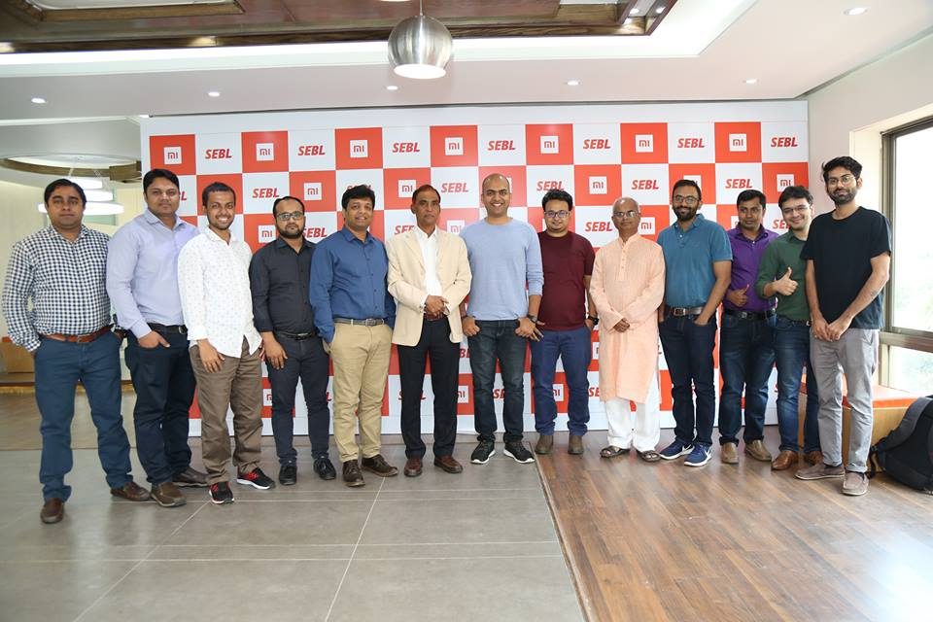
SEBL- National Distribution of Xiaomi Group Picture with Solar Board of Chairman

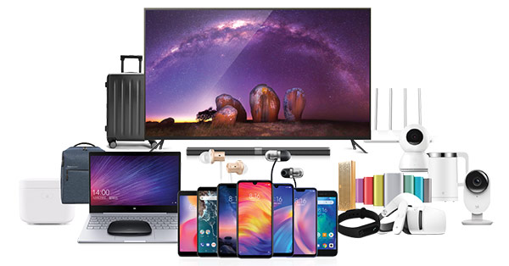
Xiaomi Division Device Electronic Accessories

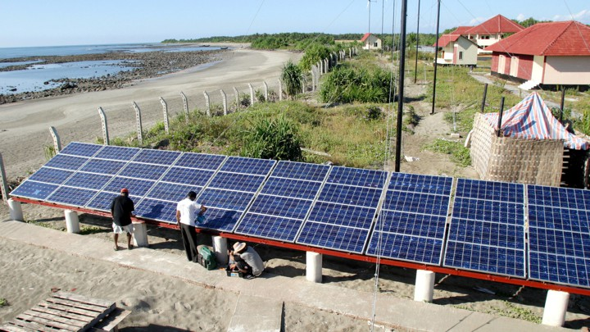

Monpura 177Kw Solar Mini Grid Project, Monpura, Bhola
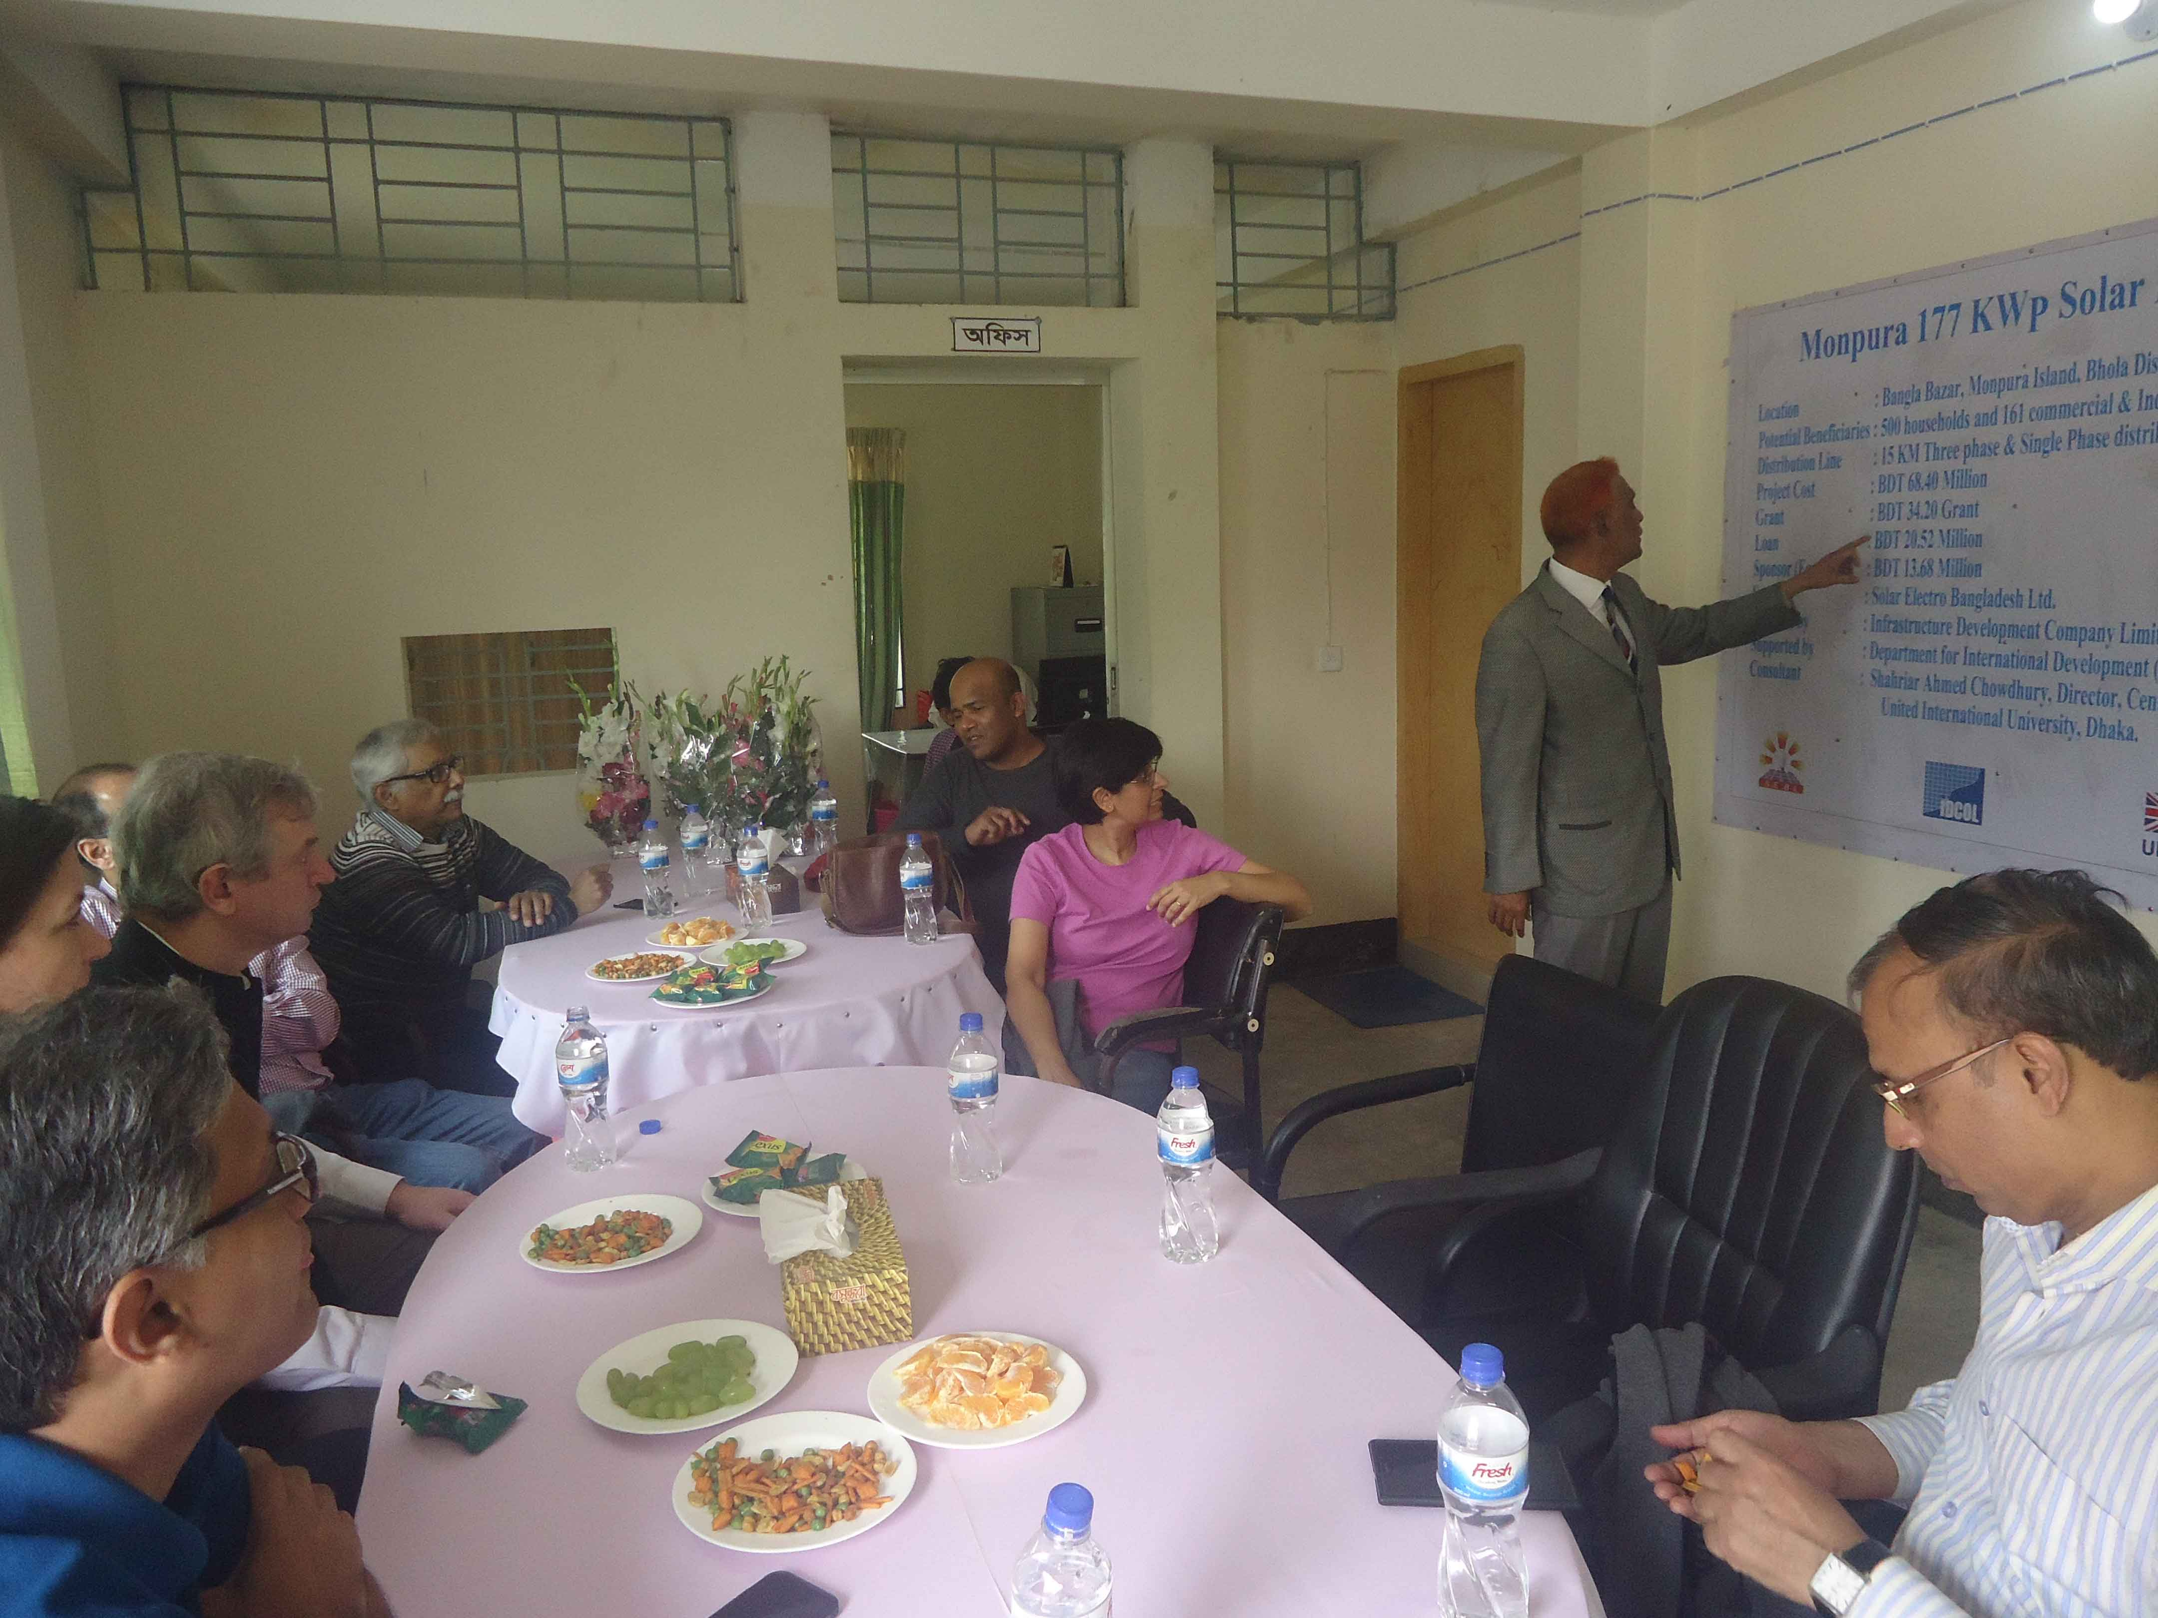

Solar Member of Washington DC, World Bank, South Asian region in Monpura Solar mini-gird Visit.
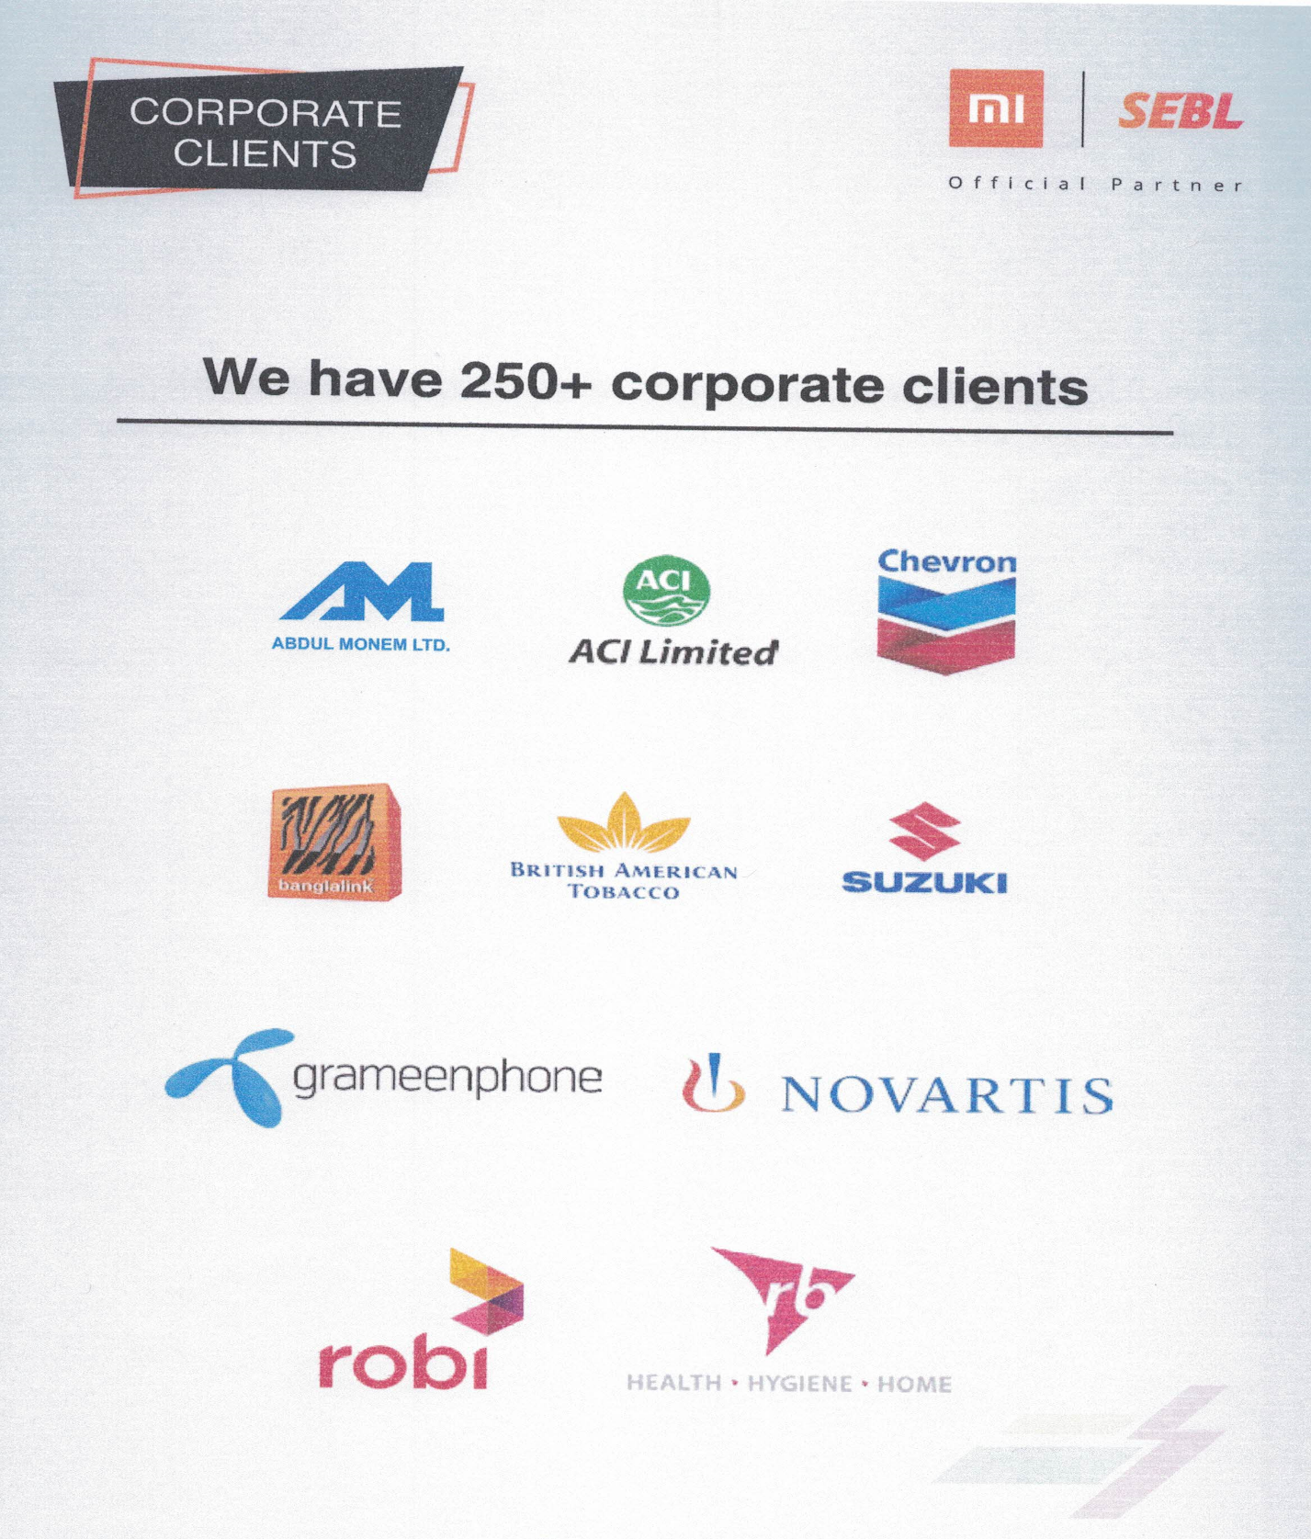 Corporate Client SEBL- National Distribution of Xiaomi

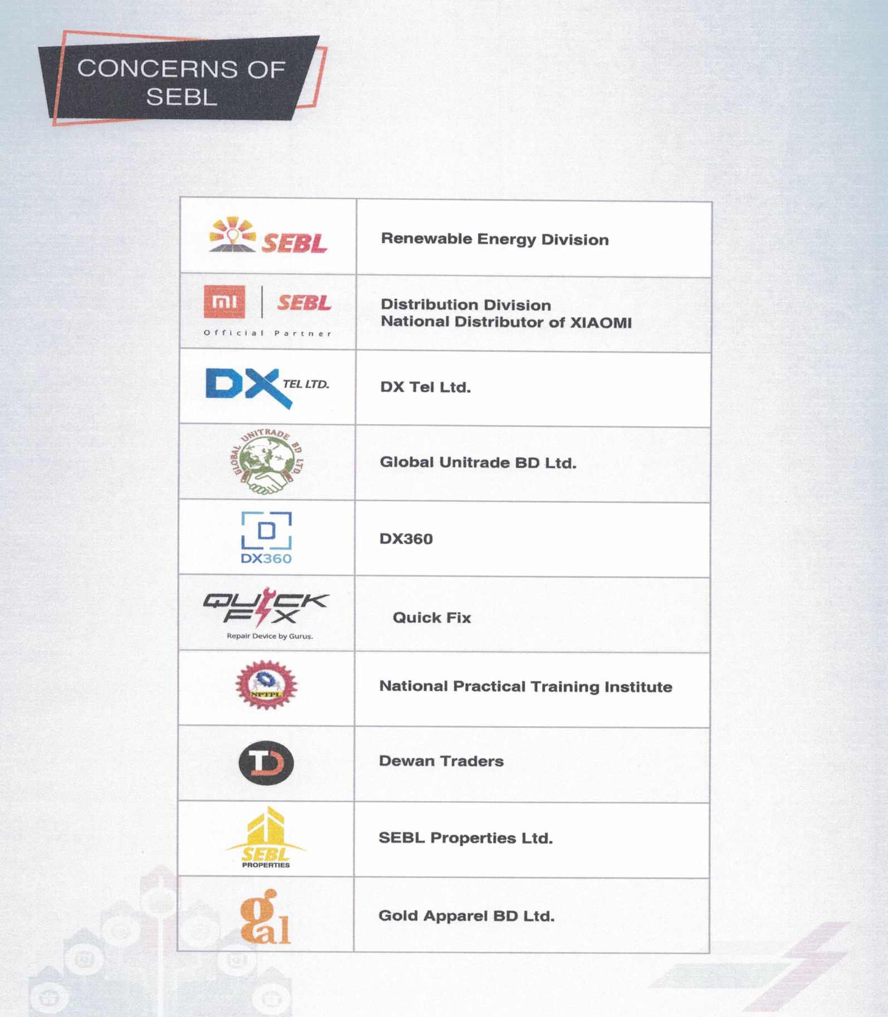

Concern of SEBL- National Distribution of Xiaomi

