
United International University
Research Paper on “Conflict between HR & Generation Z”

Prepared For
Shayla Khanam
Assistant Professor
SOBE, UIU

Prepared By
MD. Mahfuz Hossain Evan
111-163-083

Submission: 04-09-2020

Letter of Transmittal

To
Shayla Khanam
Assistant Professor
SOBE, UIU.
Subject: A project report on “Conflict between HR & Generation Z”

Dear Maa’m,
With due respect, I have prepared a project report on “Conflict between HR & Generation Z”. This report has enabled me to gain much important knowledge about “Conflict between HR & Generation Z”. So it becomes an extremely challenging and interesting experience. Thank you for your supportive consideration for formulating an idea. Without your inspiring this report would have been an incomplete one.
Lastly, I would be thankful once again if you please give your judicious advice on effort.

Sincerely yours

Md. Mahfuz Hossain Evan
111-163-083
Table of Contents
Letter of Transmittal 2
Abstract 4
Introduction 5
Objectives of the Study 6
Primary (or Academic) Objective 6
Secondary (or Study) Objective 6
Respondent Sample 6
Methodology of the Study 7
Types of Data 7
Primary Data 7
Secondary Data: 7
Scope: 7
Limitations: 7
Time: 7
Literature Review 8
International Perspective View 10
Asian Perspective View 12
Findings and Analysis of the Study (GEN Z EMPLOYEE) 13
Interpretation of Gen Z Employee Survey 17
Finding Analysis of “HR GROUP” Survey 18
Interpretation of HR GROUP Survey 22
Conclusion and Recommendation 23
Bibliography 24
Appendix 25
Questioner for Survey 25

Abstract

In Today's workplace, we can see that, there are multigenerational workforces. Those are identified by different mentalities, styles, priorities, work ethics, dissimilar values and many more. There are gloomy and confusing predictions of the difficulties the organizations are going to face because of the multigenerational workforce. The result shows age diversity is about how generational differences will impact the whole organization including from the core to top of the management.
The purpose of the research was to find the conflict between Generation Z with the HR Group. Organization requires balancing the work-environment to achieve the competitive advantage over other organizations. This research paper will help to enlighten all the factors that create conflict between generation Z and HR. To understand the actual fact of the current scenario, I had to look for some survey data and other research papers from various publications. I also believe that this paper will help to find out the problems with possible solutions in the future.

Introduction

“Who was born in-between 1995 to 2015 belongs to “Generation-Z”. It means that the oldest are about twenty five and those are just entering the workforce” (kasasa, 2020). These young people have faced the “Great Recession” at their early age. It indicates that, the short period of their lives may have been defined by struggles. They also look for the uniqueness and most importantly look for the potential growth. They are mentally strong and capable of handling tons of task at the same time.
On the other hand “Gen-Y” people minds are very sophisticated in terms of technology. Gen Y members are much more diverse and they are much more segmented as an audience aided by the rapid expansion in radio, Cable TV channels, WEB-01, e-zones, etc. They are less loyal to their brand. Gen Y kids often raised in dual income or single parent families have been more involved in family purchase everything from groceries to new cars. They are much more traditional than Generation Z.
In job market we can see different group of workforce. Due to age difference we can see the position hierarchy and conflicts in job. Those who belongs to “Generation Y” most of them are in the management position because of their work experience and the duration of time. Problem occurs when any new employee take a job as an executive in an organization. Some people may say that these problems occurs due to not having the knowledge of work process of an organization which is partially right but there are some other factors behind the conflicts that need to be considered. Such as employee mindset, background, environment, real life experience, surroundings and many more. To avoid the conflict it is very much essential to create a suitable job environment and bring greater output for the organization. To achieve the sustainable competitive advantages of an organization key essential part is collaboration among all employees. To know more we need to understand all the factors related to it.

Objectives of the Study
Objective of the study can be classified into two categories; primary and secondary objectives. It describes knowledge that a researcher wants to learn from the study. It is finalized after the research problem is finalized. The purpose is to find answers to the research problem. The objectives are given below

Primary (or Academic) Objective
As a student of United International University, the primary objective of the study is to complete the partial requirement of the awarding of the “BBA” degree from the school of business & economics. This particular report was the part of equivalent to 3 credits courses, which is essential for completing the degree.

Secondary (or Study) Objective
In the organization there is some organizational conflicts between HR / GEN Y and GEN Z. organizational conflicts may create problems in performance, productivity and the overall organizational processes. So it is require to understand the fact and take necessity steps to avoid the conflict. But as a third world country like Bangladesh there was never conduct a research to solve this matter. This report is a small step to work on the related factors to avoid the conflict. I also believe that this paper will play positive role for the purpose it was developed.

Respondent Sample
Number of Survey | 2
Total Selected Questions | 15
Survey 1 Participants ( Newly-Entrants) | 20
Survey 2 Participants (Top-Management/ HR) | 20
Total Participants | 40
Category Of Participants | 2

Methodology of the Study

Types of Data
Two types of data has been used for developing the research paper.
- Primary Data
- Secondary Data
Primary Data:
Primary Data defines the data collection was done physically. Due to covid-19 pandemic I had to use the data survey program using https://www.surveymonkey.com . At First I developed the question format on the website then I forward the link on the superior participants of the survey. It was difficult to reach so many people of different categories due to the pandemic. After completing survey I generated the auto graph chart and collect the information to the research paper.

Secondary Data:
Secondary data means that I have used other papers as a reference on my literature review. Various article, Bookish knowledge, website, video link was used to develop the research paper.

Scope:
The Experience was quite great. I got lots of opportunities to increase my knowledge and networking with corporate people. It may help in my near future and bring opportunities for me. It also helps me to prove myself as a hardworking person in under pressure.

Limitations:
It was quite challenging for me due to the covid-19 pandemic. The whole country was in the lockdown and it made difficult for me to complete the data survey in efficient way. Communication through online and other media it caused me a lot. Specially while developing the “Data Survey 2” among on the HR Group.

Time:
It took me around three months to develop this paper. All the results and future outcomes of this paper are the reflection of my nonstop efforts and hard work. I also believe that these three months of study will helps to fulfill its purpose.

Literature Review

“Generation Y” is often seem idealistic, and motivated towards its purpose than a paycheck, “Generation Z” may lean toward security and money. This is “The Generation” who care about making a difference, but ultimately motivated by ensuring that, they maintain a secure life outside the work. The “Generation Y” is focused to work in collaborative way. They prefer to work as team and fulfill their goals is their main priority. They want to work in such environment where inclusion is priority, and where everybody works together to advance goals. On the other hand “Gen Z” is may defined by its competitiveness. They want to work for their own and want to judge based on their own merits rather than as their team. “Gen Z” employees also understand the importance of continuous skill development in order to being advanced. They were aware of the importance of hard work. They have willingness to work hard but also want to be recognizing for their own capabilities.
At their work “Generation Z” employees are also search for the independence. Many of them prefer to have own office space rather than collaborative workplace. They want to accomplish their work by own so that their skills and capabilities can be spotted. They don’t prefer to depend on others to get their job done. While working “Generation Y” employees get easily distracted. They made conflict between texts and emails and get stuck in their work when there is more pressure than normal hours. But the “Gen Z”, these are young people who have been always lived in a connected virtual world and they prefer to constant updates through dozens of apps. It helps them being capable of multitasking at the same time.
Nowadays due to competitiveness importance of multitasking is immeasurable. If anyone is looking for employees who can deeply focus on a task for a long period of time, make sure that’s communicated to potential Gen Z employees. Gen Z employees don’t want to save their works for later hour rather they prefer to get the job done and enjoy the leisure time later.
“Researcher has found that, “Generation Z” has more tendencies to be an entrepreneur person. A research was conducted among some school students and around 72% of them want to establish their own business. These people are highly motivated and willing to work hard to fulfill their dreams. These budding entrepreneurs can make great employees” (Deep Patel, 2017).
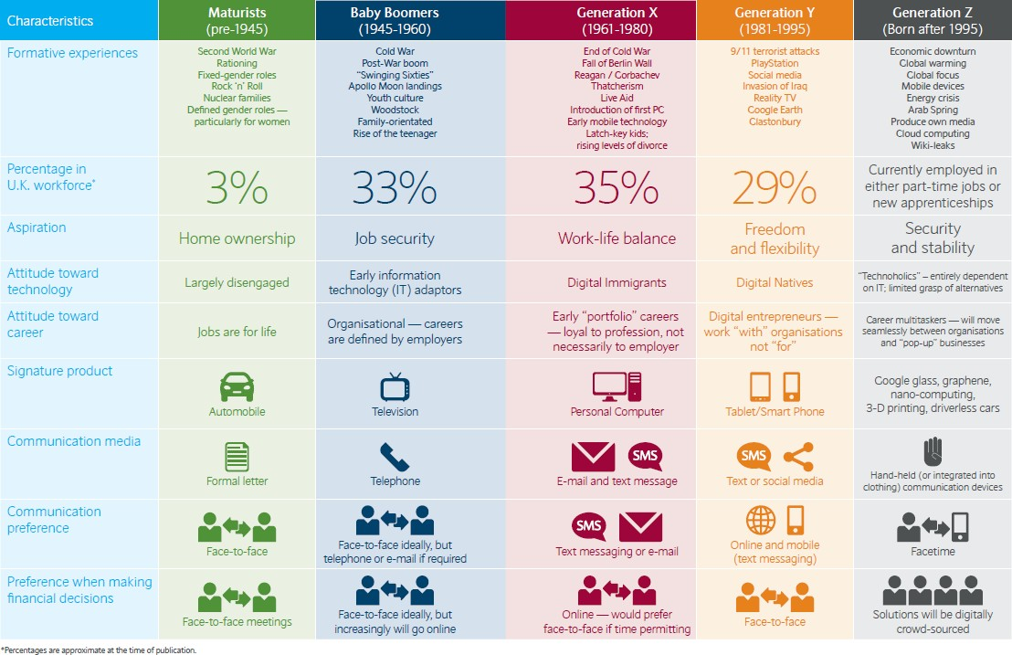
Figure 1 : Characteristics of Generations and the gap
If we look at their characteristics Gen Y was the beginning period of growth of Internet, whereas Gen Z had the fully operational knowledge of the Internet. Internet is something that removes the distance of the world, increased the connectivity and most importantly increased the transparency. So definitely we can say that it has the vital impact on the Gen z mindset. That is why Gen Z people are mostly depends on the practicality not on the probability.
“We also found that around the world, to become a leader it is important to 61% of Gen Y, 61% of Gen Z. But responses varied by country. Such as, in the Nordic countries respondents were significantly low likely to covet leadership roles than those in Mexico” (Henrik Bresman, 2017). “From Gen Y respondents, 76% of Mexicans informs that attaining a leadership role is important, but only 47% of Norwegians said the same, 77% of American Gen Y professionals said that achieving a leadership was important to them” (Henrik Bresman, 2017). Moreover we can say that “Gen Y” and “Gen Z” conflicts due to the environment that they have grown up and also all the related surroundings that has an impact on them.

International Perspective

Researchers have found that, “Without the work experience new employees may often have unrealistic expectations of work, which in turn fosters lower levels of commitment and higher turnover” (Schroth, 2019). Providing new employees a realistic job preview increases motivation and decreases turnover because employees have realistic expectations of both the positive factors and difficulties of the job. This makes them mentally ready to tackle any obstacles that they may encounter.
Marinating expectations of Gen Z employees are crucial and often have an idealistic picture that the work will turn into interesting and meaningful. Their managers may want to hear and implement ideas. They will have flexibility in the schedule, and enjoyable for everyone they work with. Many students may have some internship experience, but more frequently than not, their experience was nothing like their “real job” and quickly disillusioned wanting to quit within three months.
New employees may have expectations about the employment relationship, which greatly impacts on their attitudes, feelings, and behaviors. Like as, management is expected to pay commensurate with performance; give opportunities for training, development, and promotion; give feedback on performance; and treat employees respectfully. “Employees try to work hard, develop new skills, follow directions, and be courteous to the boss, clients, and colleagues. Violations of the psychological contract can lead to poor performance and productivity, low satisfaction, high turnover, and theft” (Schroth, 2019). The psychological contract differs from employee to employer relationship because it depends on individual perceptions and cognitions shaped by past interactions
Sometimes positive outcomes resulting from an effective onboarding practices for both new employees as well as the organizations. These include better performance, retention, satisfaction, commitment, and self-efficacy. Onboarding practices helps to reduce uncertainty, anxiety newcomers experience, bring greater clarity and help them make sense of their new environment. It also provides them with the necessary tangible and intangible resources to become fully functioning organizational members effective in their new role. “Gen Z’s higher level of fear and uncertainty about the workplace increases the necessity of good onboarding practices. Top companies begin the onboarding process when the offer is accepted and continue to track and report the process of new hires” (Schroth, 2019).
“The top learning method for 59% of Gen Z’s is YouTube” (Schroth, 2019). Having an orientation program with other new hires to facilitate socialization and get to know coworkers. Reinforcing the existing culture applying success stories, importantly that communicate effort and persistence, learning from mistakes, growth and achievement. The more personalized are the better.
Nowadays Managers trying to relate their team members to maximize their engagement, well-being, and performance with also facilitating personal change. Mentoring provides emotional support and to reduce stress of employees. It helps in goal attainment and psychological workplace well-being. Generation Z employee prefers collaborative learning rather than a “telling approach”. Consultative coaching helps employees explore alternatives and challenges the employee’s thinking by asking the employee questions rather than telling them what to do. The mentoring process helps goal attainment by helping employees.
Modifying action plans are necessary where mentoring may be a short “hallway” conversation or lengthy formal session. Mentoring can focus on developing a specific skill set to improve performance. It also helps to enhancing emotional competencies to increase engagement and well-being. Companies prefers those employees who has enough ability to communicate and interact with others. Communication skills includes with “what is delivered during a social interaction” and how it was delivered”. It includes words and phrases, appropriate facial expressions, tone of voice, body language, and eye contact and many more things. “Employees’ social effectiveness depends on their ability to read, understand, and control social interactions, and it is related to job performance” (Schroth, 2019). The advancement of the smart phone has significant impact on social interaction among on “Generation Z”. The introduction of smart phones has been shown the reduction amount of face-to-face
Technology plays important role in Gen Zers’ lives. Socializing to schoolwork, entertainment to exercise, relaxation to reference in everywhere there is an impact of technology. It improves their ability to communicate effectively and interact with each-others, including the previous generation, in the workplace. It was asked on a typical day “whether they communicate more in person or digitally, Gen Z and Millennials reported they communicate 74% digitally and 26% in person” (Schroth, 2019).Face 2 Face communication helps to understand the facial expression and as well as the intention of other party. “Depending on text messaging primarily for their interaction” “Generation Z” have missed out on learning some vital rules of conversation. “It includes listening, ask questions, interject in a way that is seen as respectful to others, build relationships, problem solve in real time, and resolve conflicts” (Schroth, 2019). However, “Generation Z” are comfortable with using technology to communicate whenever there is an limitation of using technology. Smartphone-related patterns of communication will continue into the workplace unless the manager helps the new employee adapt to different modes of workplace communication and understand relying on e-communication is not the most effective. Managers would be wise to inform when and how to use each of the different communication methods.

Asian Perspective

Generation Z priorities career opportunities while selecting a job with generous pay, financial rewards, positive workplace culture, flexibility and opportunities of continuous learning are the top priorities. “The nature of job along with work life balance matter the most in search for a potential future employer among in Generation Z” (Jana fratričová, 2018).
Generation Z work preferences is motivation factors. The level of consistency in survey results is remarkable. The pattern on top three motivating factors tends to be versatile. The growth factor and opportunity for further development seems to be an overlapping factor identified as very important for “Generation Z” in most of the studies.
However, it is important to allow the members of individual generations to express their feelings and perceptions without providing a qualitative menu of generational characteristics. Our current effort within Gen Z intends to excavate the traits of Gen Z itself prior to any cross generational work. “Studying the work motives of “Generation Z” we need to remember that great deal of its members are yet in the process of education and it can be expected that some new generational traits will emerges they will move on to the labor market” (Jana fratričová, 2018).

Findings and Analysis of the Study (GEN Z EMPLOYEE)
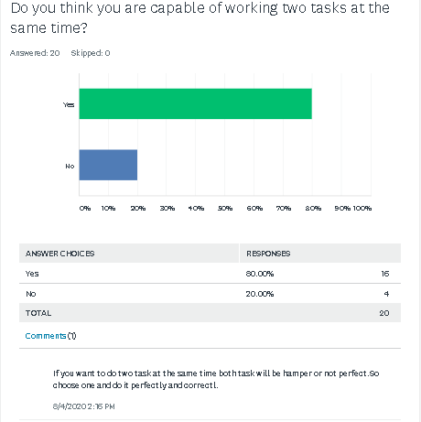

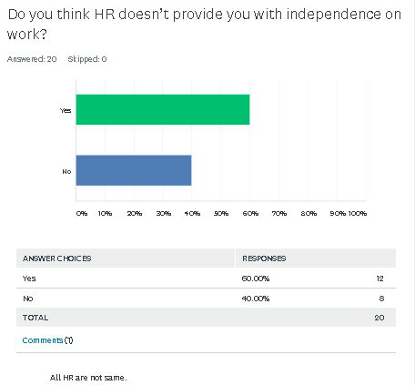
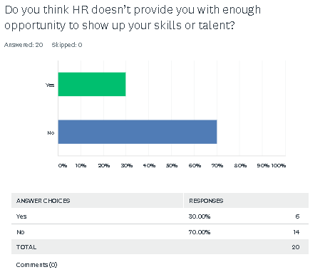

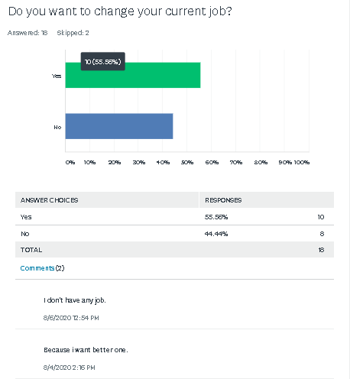
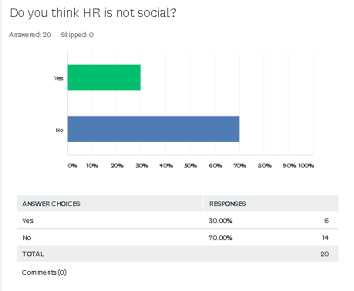
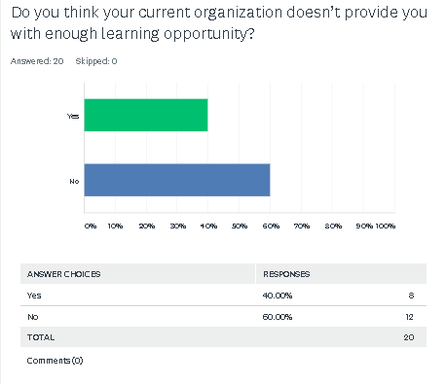
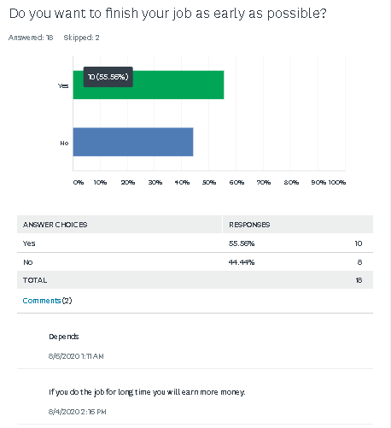

Interpretation of Gen Z Employee Survey

To understand the fact there was a survey was done among the Generation Z employee about multitasking, work independence, skills reflection, and possibility of changing job, HR Socialness, learning opportunity and early finishing of task.
In terms of Multitasking around 80% of GEN Z employee said that they are capable of Multitasking and 20% employee said that they may not capable of doing more than one job at a same time . 5% employee said that, they prefer to focus one job at a time because they feel that working on more than one job will hamper both job and it maybe not done correctly.
Around 60% of employees believe that there organization HR doesn’t provide them the proper independence on work and 40% employee feel that they get their independence on their job.
30% of Gen Z employees have said that their HR Does provide enough opportunity to show up their skills on the other hand majority of 70% employee said that they appreciate their HR to provide the opportunity to show up their skills.
As like same 30% employees believe that heir HR is not social and 70% of employees believe that they are very much socialized.
When it comes to learning opportunity 40% employee believe that their current organization doesn’t provide them enough opportunity to learn. On the other hand 60% of employees believe that they are learning so many factors from their current organization which is helping them to gain more experiences.
55.56% employee said that they want to finish their job as early as possible and other 44.44% employee said that the do not have any intention to finish the job as early as possible. 5.00% employee said that, their earliness depends on the criteria of job. It should be take also consideration where employee work as an hourly base they prefer to finish the job by using so many time because 5% employee feel that when time gives them money why should they hurry to finish their job.
Considering all these factor to understand their current mental situation about their “job” had a query was done .where more than 55% employee want to change their job to get a better one and 44% employee are satisfied with their current job, so they prefer to stay in the existing organization and want to get promoted in a higher position.

Finding Analysis of “HR GROUP” Survey

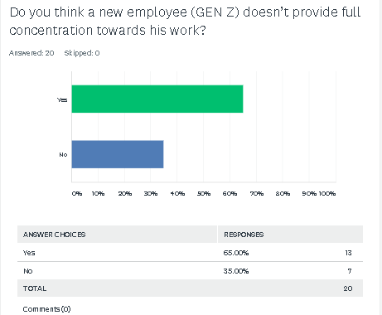

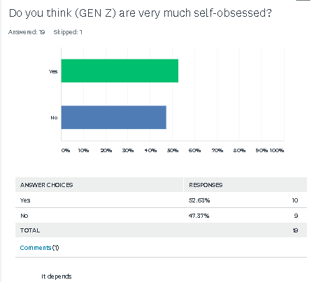
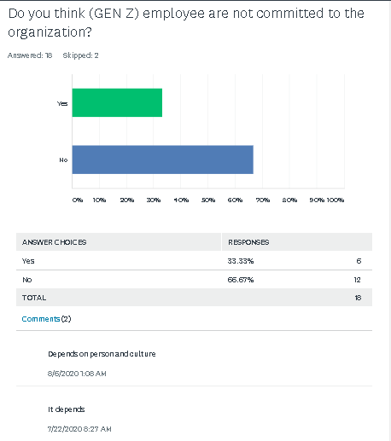
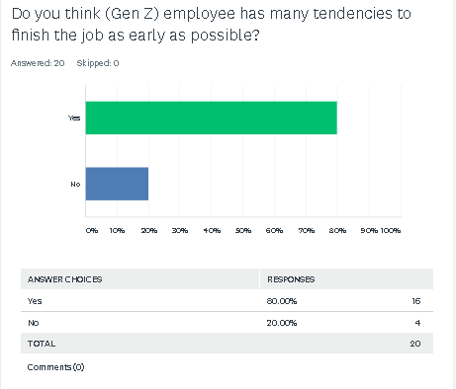
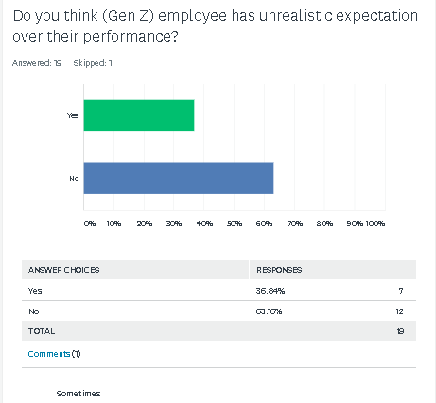

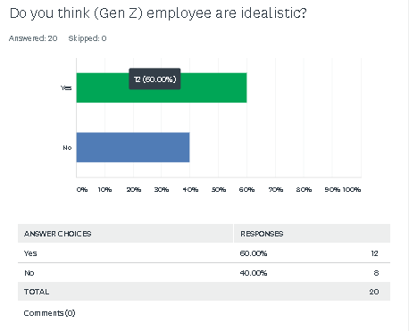
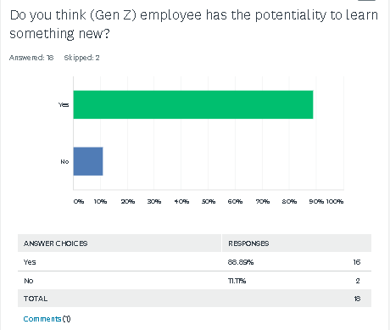

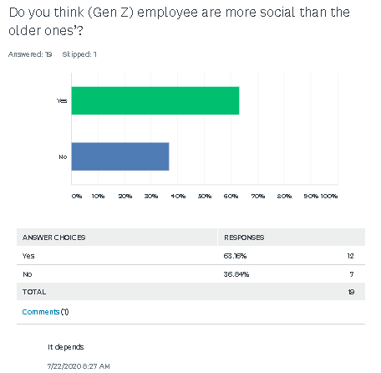

Interpretation of HR GROUP Survey

To understand the opinion of HR towards the employee another survey was done among on the HR and Top management. 65% HR group believes that Gen Z employee doesn’t provide full concentration towards their work also added that while working most of their employees have tendencies to avoid the critical task which was given by the top management. Rest 35% HR said their employees are sincere towards their work.
More than 52% HR believes that their employees are very much self-obsessed and 47% HR has positive view on their employees.
33.33% HR said that GEN Z employee are not committed towards their organization and rest 67.67 % HR said that their employees are committed towards their organization.
The majority of HR group has found that their employees have the tendencies to finish the job early as possible. 80% Of HR and the top management have appreciated on this issue but other 20% employee doesn’t agree with the statement.
36.64% HR said that their employee has unrealistic expectation over their job 63.36% HR doesn’t agree with the statement. They believe that that their employee may sometimes have some rewards expectation but not always.
More than 63% HR have said that their employees are more social than the previous generation also there is some introvert personality who doesn’t like to be social that is why 36% TOP management and HR group has denied with this statement.
Almost 90% HR believes that employees from Generation Z have very much interested to learn something new. They also believe that they have the potentiality to learn.
When it comes to ideology most of the time it varies how the job was done and smartly done. 60% of HR Group people said that their employees are much idealistic and 40% HR Group has denied the statement. However the organization varies. For IT Company being idealistic is very much essential where some other sectors may not require the same.

Conclusion and Recommendation

To come up with a conclusion is as not easy as like other cases. HR and Gen Z employees both have different mind, mentality, aspects and different phases. Only based on this data it will be very much inappropriate to conclude the paper. However it may be very much essential to understand the view of both side (HR & GEN Z) employees. These data may not solve the 100% conflict between HR and Generation Z employee but may solve certain cases. HR and Generation Z employee both have to overview those discussions to avoid the conflict.
I strongly recommend this both HR and Gen Z employee must have the adaptability of understanding the opposite party’s. Both parties must gain some knowledge to understand the opposite mind, mental behavior and point of view. It will be very wise for those who have recently entered into the job market before they make any judgment about the organization or the HR they must learn the organizational processes. Employee must have to engage with the organization from the core part. It is not possible for an HR to trust a newcomer of the organization there is lots of factor varies. Moreover we can say that every organization must make an environment where both group can interact with each other. Sometimes orientation may not enough. Collaboration makes both parties to understand their motive and it will also bring the positive vibe for the organization as well.

Bibliography

Deep Patel. (2017, sep 21). 8 Ways Generation Z Will Differ From Millennials In The Workplace. Retrieved from https://www.forbes.com/: https://www.forbes.com/sites/deeppatel/2017/09/21/8-ways-generation-z-will-differ-from-millennials-in-the-workplace/#71b8a7bb76e5
Eden King, L. F. (2019, August 1). Generational Differences At Work Are Small. Retrieved from Harvard Business Review : https://hbr.org/2019/08/generational-differences-at-work-are-small-thinking-theyre-big-affects-our-behavior
Henrik Bresman, V. D. (2017, August 25). A Survey of 19 Countries Shows How Generations X, Y, and Z Are — and Aren’t — Different. Leadership Ambitions, p. 1.
Jana fratričová, Z. K. (2018, november 3). Journal Of human resource management. Barriers to work motivation of generation Z, p. 5.
Kar, D. S. (2018). Managing Generation Y Employees- HR Challenges and Opportunities. MYSORE: https://www.researchgate.net/publication.
kasasa. (2020, june 18). Retrieved from https://www.kasasa.com: https://www.kasasa.com/articles/generations/gen-x-gen-y-gen-z
Schroth, H. (2019). Are You Ready for Gen Z In Workplace? In California Management Review (p. 7). California: SAGE Journals.
https://www.surveymonkey.com/results/SM-JLLHC7YB7/?fbclid=IwAR2Stp5-kbsNRRN4PlpjMplXK6uKmjYr5v6VjubExwnesxe_G-OU7z9Cyw8
https://www.surveymonkey.com/results/SM-7SW2RK7B7/?fbclid=IwAR3nYbVeS4_9HVc0hKsvc3jcnx72WVCgwLeiYs_AI2mU9FImAD2kX4_1E3s

Appendix

Questioner for Survey
For HR
- Do you think new employee (GEN Z) doesn’t provide full concentration towards his work?
- Do you think (GEN Z) employees very much self-obsessed?
- Do you think (GEN Z) employees are not committed to the organization?
- Do you think (Gen Z) employees has much tendencies to finish the job as early as possible?
- Do you think (Gen Z) employees has unrealistic expectation over their performance?
- Do you think (Gen Z) employees are idealistic?
- Do you think (Gen Z) employees has the potentiality to learn something new?
- Do you think (Gen Z) employees are more social than the older ones’?

For (Gen z) Employee
- Do you think you are capable of doing more than one task at a same time?
- Do you think HR doesn’t provide you the independence on work?
- Do you think HR doesn’t provide you the enough opportunity to show up your skills or talent?
- Do you want to change your current job?
- Do you think HR is not social?
- Do you think your current organization doesn’t provide you enough learning opportunity?
- Do you want to finish your job as early as possible?

