

Internship Report
“Analysis of the City Bank Limited and the private commercial banking industry in Bangladesh”

Submitted to:
Dr. Md Mohan Uddin, PhD
Professor
School of Business & Economics
United International University

Submitted by:
Imtiaz Ahmed
ID: 111 153014
BBA Program
School of Business & Economics
United International University

Date of submission: 28.02.2022

Letter of Transmittal
Date: 28.02.2022

To
Dr. Md Mohan Uddin, PhD
Professor
United International University
School of Business and Economics

Subject: Report Submission “Analysis of the City Bank Limited and the private commercial banking industry in Bangladesh.”

Dear Sir,

I am pleased to present you my internship report “Analysis of the City Bank Ltd and the private commercial banking industry in Bangladesh” which I have done under your instruction. I am grateful to you for giving me the opportunity to work on such a topic for which I have learned so many things and gathered an enormous knowledge about our banking industry. This internship and my report are a part of my BBA program, so it is very important for me.

To make this report I have conducted discussion with some of the officers of the “The City bank LTD” Shaymoli branch and also used my personal observation. I have collected my required data, documents and info from them and tried my level best to put it on my report.
Your acceptance and appreciation are very important and it will motivate me a lot. I would like to clarify all the things if there is a need of any explanations. Would you please accept my internship report and oblige me thereby?

Thank you.

Sincerely yours,


Imtiaz Ahmed
Id: 111 153 014
BBA
United International University

Acknowledgement
At first, I would like to express my gratitude to almighty Allah for special blessings in completing my internship report. The Internship report titled as “Functions of the private commercial banking industry” -which has been prepared for the requirement of BBA degree.
I am very pleased to my supervisor Dr. Md Mohan Uddin, PhD Professor, School of Business and Economics, United International University, for his instructions and support in completing my internship report and suggestions from the very beginning of starting this report.
Lastly, I would like to express my gratitude to all the employees of The City Bank Limited, Shaymoli Branch. Specially MS Bilkis Akhter (Branch Manager), Mst Jannatul ferdous (CSM), Md. Shafiqur Rahman (Branch Operation Manager) who helped me throughout my internship period and taught me about corporate life.

Executive summary:
Now a days, private commercial banking (PCB) industry plays a vital role in the economy of Bangladesh by posting a profitable number at the net profit. In the last 6-10 years PCBs successfully gained the trust of general people of the Bangladesh by providing wide range of financial services and product. “Digital Banking” is the USP for the private commercial banking (PCB) industry. Recent years PCB industry plays important to minimize funding gap & create investment options for the people of Bangladesh.
Currently, 52 private commercial banks are operated in the industry of private commercial banking industry in Bangladesh. The primary objective of these private commercial banks (PCBs) is to provide satisfactory services & financial products to the customers. This sector works to increase financial inclusion in Bangladesh that’s why PCBs open their branches, ATM & CRM, agent banking at rural areas. As per the data of 2022, 53% adult population have their bank accounts. PCBs contribute a lot to gain the number. But still 47% adult population don’t have the bank account, so PCBs now working on minimizing the gap. They are focusing on the 100% financial inclusion for the adult population. In this mission mobile banking can be a game changer for the PCB industry. Due to the rise of the economic activities in Bangladesh seasonality of the PCB industry shifts its pace. Diversified financial products attracts various kind of customers that’s why seasonality in the industry creates its own color in every season. As there is a lot of segments in the industry, PCB industry is well organized in terms of competition. Some banks are focus on credit cards, some are into loans and some are into commercial loans. So, Banks are not grabbing the market share and profit share of other banks.
This report also describes that the City bank limited(CBL) has a robust business model that focuses on delivering value to its customers while maintaining a sustainable and profitable business. The bank's strategy is to expand its customer base by providing excellent customer service, innovative products, and leveraging technology to enhance the customer experience. The bank has also invested in its digital capabilities, enabling customers to perform transactions online, through mobile devices, and self-service kiosks.
Looking ahead, The City bank limited (CBL) is well-positioned to capitalize on the opportunities in Bangladesh's rapidly growing economy. The bank has identified key growth areas, including digital banking, SME lending, and trade finance, and is investing in building the necessary capabilities to support its growth ambitions. CBL's strong brand, customer-centric approach, and innovative product offerings provide a solid foundation for the bank's continued success in the future.
This report also states the real-life experience of the real financial world. At real world people are more sensitive about their money. PCBs provide services to the people to utilize their money in the best possible ways. That’s why PCBs open various departments. I have worked on these departments to take the real experience as an intern. All departments gave me a message that “No mistakes are accepted in the financial world”. That’s why departments arrange various trainings & sessions to avoid the mistakes. As an intern I have been through the training sessions which helps me to understand the banking operations in real life.
I believe reading this report will provide the full picture of private commercial banking industry of Bangladesh and the city bank limited. Beside that you can picturize my 3 months journey of internship.
Table of Contents
Letter of Transmittal ii
Acknowledgement iii
Executive summary: iv
1. Introduction 8
1.1 Background: 9
1.2 Objectives: 14
1.3 Significance: 14
2. Analysis of the industry 16
2.1 specification of the industry: 17
2.2 Size, trend and maturity of the industry: 18
2.3 Seasonality: 23
2.4 External economic factors: 27
2.5 Technological factors: 29
2.6 Political, legal and regulatory factors: 32
2.7 Barriers to Entry: 33
2.10 Threat of substitutes: 36
2.11 Industry Rivalry: 38
2.12 Summary of Challenges and opportunities 41
3. Analysis of the organization 44
3.1 Overview & History 45
3.2 Trend and growth 46
3.3 Customer Mix 48
3.4 Product and Service Mix 53
3.5 Operations of the city bank Limited: 59
3.6 SWOT analysis for the city bank limited 61
3.7 Step and strategies to meet the challenges and opportunities 64
4.Internship experience 66
4.1 Position, duties and responsibilities & contribution to the departmental functions 66
4.2 Trainings 70
4.3 Evaluation of Internship performance 76
4.4 Skills Applied 77
4.5 New skills developed 78
4.6 Application of academic knowledge 79
5. Recommendations 80
5.1 Recommendations for improving the departmental operations 81
5.2 Recommendation for improving self-performance 82
6. Conclusion 83
References lxxxv
Appendices lxxxvi

List of Figures
Figure 1.1: list of largest commercial banks worldwide (by assets) 10
Figure 2.1: Risk Weighted Asset of private commercial banking sector 22
Figure 2.2: Interest rate on lending of 2022 24
Figure 2.3: Interest rate on deposit 25
Figure 2.4: Interest amount as per the different time frame 26
Figure 2.5: External Factors for the PCB Industry 28
Figure 2.6: Technological Factors in the PCB industry 31
Figure 2.7: Substitute goods in the PCB industry 36
Figure 2.8: Market share of card segment 39
Figure 2.9: PCBs operating profit amount 40
Figure 2.10: Amounts of Non-performing Loans 42

List of tables
Table 1.1: Bank ratio comparison based on the country 11
Table 1.2: Regional ROC data 12
Table-2.1: Banking Industry data of BD (Asset & Deposit in million TK) 18
Table 2.2: Market Size of the Private Banking Industry in Bangladesh 19
Table 2.3: Mobile Banking Transactions in Bangladesh (2019-2021) 21
Table 3.1: Performance Card of the city bank limited 47
Table 3.2: Demographic Segment of The City Bank LTD 50
Table 3.3- Income segmentation CBL 51
Table 3.4: Financial need segment of CBL 52

1. Introduction

1.1 Background:
The term bank is originated from the Italian word banco, that means "desk/bench," which was utilized by Florence bankers during in the Italian Renaissance era, who conducted their transactions on a desk covered with a green tablecloth. Yet, evidence of financial transactions may be discovered extending back to antiquity.
Modern banking methods may be traced back to the Medieval Italian towns of Florence, Venice, and Genoa. Italian bankers finance to rulers to fund wars and their extravagant lives, as well as to merchants involved in international commerce. In reality, these early banks were typically established by trade families as part of their larger commercial operations. In the 14th century, the Badri and Peruzzi families dominated Florence and created branches throughout Europe to support their commercial activity. Both of these banks made large loans to Edward III of England in order to fund his 100-year war against France. But, Edward failed, and the banks went bankrupt.
The Medici bank, founded by Giovanni Medici in 1397, may have been the most famous of medieval Italian banks. The Medici had a longstanding experience as money changers, but it was Giovanni who relocated the trade from a green-covered desk in the market place to the hall of a palace he had constructed for himself. He broadened the reach of the company, opening outlets as far north as London. While the Medici bank provided traditional loans to businessmen and royalty, it also served as the pope's primary banker. The papal business generated more revenues for the banks than any other activity and was the main inspiration behind the development of branches in other Italian cities and across Europe. https://drpramodkm.Ahistoryofbanking.pdf.
Because of variations in bank regulation, the term commercial bank was frequently used in the United States to distinguish it from an investment bank. Following the Great Depression, the Glass-Steagall Act mandated that commercial banks only participate in banking activities, while investment banks may only engage in capital market activities. The Gramm-Leach-Bliley Act of 1999 effectively removed this split.
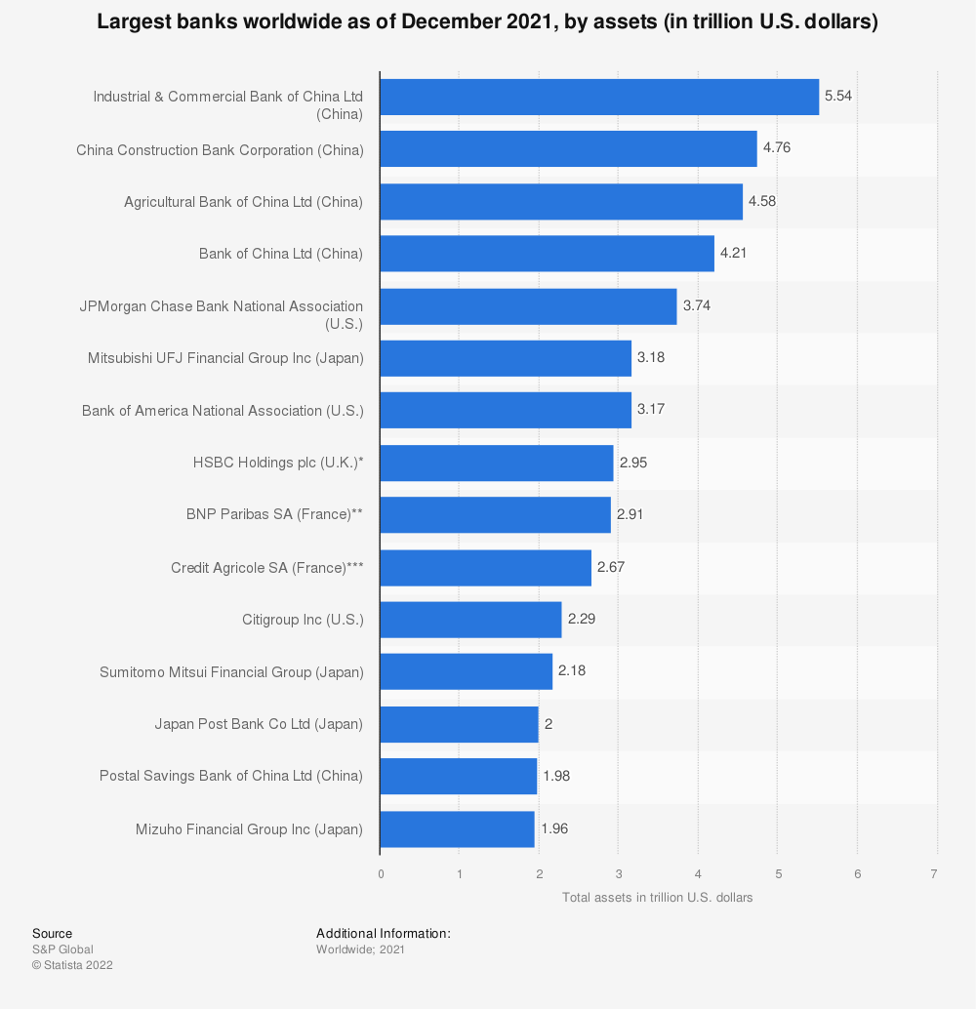
Figure 1.1: list of largest commercial banks worldwide (by assets)
We can identify 4 Chinese banks lead the commercial banking sector worldwide from figure-1.1. Other major players are located in USA, UK, France and Japan. As per figure-1 Five Chinese banks have the asset of 21.07 trillion USD. American banks and Japanese banks dominate the commercial banking market with respectively 9.2 & 9.30 trillion USD asset shows at table 1.1.
Table 1.1: Bank ratio comparison based on the country
Country | Number of Banks | ROA (%) | Return on Capital (%)
China | 136 | 0.89 | 12
USA | 169 | 1.24 | 14.5
Japan | 87 | 0.22 | 4.26
UK | 25 | 0.42 | 8
Germany | 25 | 0.09 | 2

We can see from the table-1.1 that banks of USA making more ROA, so we can say the asset quality of USA bank is more efficient than the Chinese banks. On the side of ROC, we can see banks of USA earns more by investing their capital. It means owner’s get a good return on their invested equity. Chinese banks are close competitor of the USA banks. In the ROA & ROC sector both countries are doing well as per the table-1. After these two countries the world commercial banking market dominated by Japanese, British, French, Italian & German banks.
Now we are going to present the return on capital table by using the region-based table. Here, we will find the return based on the capital invested by the stockholders of commercial banks. We can understand the invested capital quality.

Table 1.2: Regional ROC data
Region | Return on Capital
Central Asia | 23%
Africa | 20%
Caribbean | 19%
South America | 18%
Central America | 17%
CEE (Central & Eastern Europe) | 16%
North America | 15%
Middle East | 13%
Asia | 10%
Europe | 8%

We can see that central Asian banks make more return against their capital investment. Here ROC=Net Income/ (owner’s equity+liabilities). So, we can say that central Asian banks are more efficient in making profit by investing their money in a right place. African countries are also doing very good at measure of ROC which is 20%. Asian countries & European commercial banks are less efficient by the measure of ROC. Net income of these regions is very low against the equity and liabilities. https://www.thebanker.com .
Commercial banking in Bangladesh began after independence (1971) with two branch offices of the erstwhile state bank of Pakistan and 17 significant commercial banks, two among them held by Bengali interests and outsiders other than west Pakistanis. There were 14 smaller commercial banks. Virtually all banking services were concentrated in urban areas. The newly independent government effectively appointed the Dhaka branch of Pakistan's state bank as the central bank, renaming it Bangladesh Bank. The bank was in charge of currency regulation, lending and monetary policy management, and exchange control and foreign exchange reserves. Initially, the Bangladesh government nationalized the entire domestic banking sector and issued legislation to recognize and rename the numerous banks. Foreign-owned banks were allowed to continue operating in Bangladesh. The insurance industry was likewise nationalized and consequently became a potential source of investment cash. Comparatively tiny and rural accounts are serviced through co - operative credit networks and postal savings offices. The new banking system was successful in developing relatively efficient procedures for credit and foreign exchange management. Throughout the 1970s, the major role of the credit system was to support commerce and the public sector, which absorbed 75% of all loans. Throughout the late 1970s and early 1980s, the government's backing of agriculture and private business resulted in shifts in lending tactics. Lending to farmers and fishermen increased considerably under the management of Bangladesh Krishi Bank, a specialized agricultural banking institution. Between 1977 and 1985, the number of rural bank branches more than quadrupled to over 3.330. Due to denationalization and private industry growth, the Bangladesh Bank and the World Bank have shifted their lending priorities. on the emerging private sector. www.bb.org.bd

1.2 Objectives:
I worked as an intern of City Bank limited at Shaymoli branch. Here, I have gained knowledge & skill about functions of commercial banking. I have implied my theoretical & practical knowledge to understand how a branch banking works. The primary objective of the report is to analyze the functions of commercial banking. To fulfill the primary objective, there are some additional objectives come along. These are given below:
- Analyze the environment of the city bank limited in bd.
- Assessing the global perspective of the commercial banks.
- Analyze the commercial banking industry competitiveness.
- Describe the experience of internship at the city bank limited.
- Identifying the banking industry environments.

1.3 Significance:
This report provides significance to the four parties. A) Commercial bank regulators and policy makers. B) Management of the city bank limited. C) Academicians. D) Myself.
After reading the report commercial bank regulators and policy makers can understand the current situation of the industry like size, trend & status of the private commercial banking industry, seasonality of the industry, factors behind the industry, threats of substitutes etc. It provides assistance regarding policy making.
The city bank management will be benefited by this report. As they can understand the current situation of the private commercial banking industry. Beside that they can find their strengths, weaknesses, opportunities & threats from this report. There are also recommendations in the report for taking further necessary steps.
Academicians can use the report for their research purpose & references. As a generator of the report, I can use this report at my professional career & further research purpose.

2. Analysis of the industry

2.1 specification of the industry:
A new era of Private Commercial Bank started at 1980, when Bangladesh GOVT along with Bangladesh Bank permitted private investors to invest in the Banking Industry. AB(Arab-Bangladesh) Bank was the first private commercial bank of Bangladesh. Private Commercial Banks are operated under the Bangladesh Bank order,1972. At this moment, 33 conventional PC Banks, 10 Islamic PC Banks and 9 foreign banks are operated in Bangladesh. www.bb.org.bd .
The industry is regulated by the Bangladesh Bank, which is the country's central bank. The Bangladesh Bank has put in place a series of regulations to ensure the stability and safety of the industry. These regulations include minimum capital requirements, liquidity ratios, and asset quality standards. The Bangladesh Bank also regularly monitors the industry to ensure that the banks comply with the regulations and that they are operating in a safe and sound manner.
The private commercial banking industry of Bangladesh is an important contributor to the country's economy. The banks provide credit to businesses and households, which helps to stimulate economic growth. The banks also provide employment opportunities for thousands of people in the country. The private commercial banks have been able to achieve significant growth in recent years, which has been driven by the growth in the country's economy and the increasing demand for financial services.
The private commercial banking industry of Bangladesh is an important part of the country's financial sector. The industry is well-regulated, provides high-quality customer services, and contributes significantly to the country's economy. The industry is poised for further growth in the coming years, as the demand for financial services continues to increase.

2.2 Size, trend and maturity of the industry:
Private banking industry in Bangladesh is experiencing significant growth in recent years, driven by increasing wealth and demand for customized financial solutions. The industry is estimated to be worth around $1.3 billion in 2021 and is expected to continue growing at a steady pace over the next five years.
The private banking sector in Bangladesh is relatively new compared to its developed counterparts in Asia. However, the industry has come a long way in recent years and is now offering a wide range of services and solutions to its customers. The industry is primarily made up of commercial banks and a small number of specialized institutions that offer private banking services.
There are 53 banks are operational in the private commercial banking industry. These banks have 5395 operational branches all over their operational areas. PC banks hold 67.3% shares of the asset in the banking industry. The asset size of the BD’s banking industry is 18406.0 billion BDT. PC banks lead the banking industry with the asset of 12378.3 billion BDT. As per the deposit size of the total industry is 13,797.9 billion BDT. Here PC banks also hold 67.3% shares and the deposit amount is 9287.0 billion BDT.
Table-2.1: Banking Industry data of BD (Asset & Deposit in million TK)

The private banking industry in Bangladesh can be segmented into two main segments – corporate private banking and retail private banking. Corporate private banking is aimed at providing financial services to large corporations and businesses, while retail private banking is aimed at providing financial services to individual clients. Retail private banking is the largest segment in the industry and accounts for a significant share of the market.
Table 2.2: Market Size of the Private Banking Industry in Bangladesh
Year | Market size (in BDT billion)
2016 | 375.40
2017 | 400.60
2018 | 435.40
2019 | 473.60
2020 | 511.80
2021 | 535.60
In last 6 years, private banking industry grows due to the rise of the middle, upper middle & upper class in the economic system of Bangladesh. According to the Bangladesh Bank, the country's central bank, the size of the private banking industry in Bangladesh was estimated to be around BDT 535.60 billion in 2021. The industry has experienced a steady growth over the years, with a CAGR (Compound annual growth rate) of 8.5% between 2016 and 2021.
The private commercial banking industry in Bangladesh is dominated by these key players, with Islami Bank Bangladesh Limited, Dutch-Bangla Bank, The City Bank Limited, Brac Bank, Standard Chartered Bank, Eastern Bank Limited, and Dhaka Bank accounting for the majority of the market share. These banks are known for their strong reputation, extensive networks, and comprehensive range of products and services, and they are considered to be the leading providers of financial services in Bangladesh. As the industry continues to grow, these key players are expected to maintain their dominance and play a crucial role in the development and growth of the private commercial banking industry in Bangladesh.
The private commercial banking industry in Bangladesh has experienced significant growth over the past decade, with a number of trends emerging that are shaping its future. In 2021, the sector saw a number of key developments that are likely to have a lasting impact on the industry.
One of the key trends in the private commercial banking industry in Bangladesh is the increasing focus on digital banking services. With the rise of mobile and internet banking, banks are investing heavily in digital technologies to improve their customer experience and reach new audiences. According to data from the Bangladesh Bank, the number of mobile banking transactions in Bangladesh reached over 150 million in 2021, up from just over 50 million in 2019. This demonstrates the growing popularity of digital banking services among consumers and businesses alike. PC banks in Bangladesh tend to digital financial services now a days. All PC banks try to focus on internet-banking Like the City Bank Limited launched an app which is called “City Touch”. Eastern Bank Limited launched “SKYBANKING” as digital banking service. United Commercial Bank launched “U-net “digital banking services. IFIC bank has launched “IFIC Amar Bank” as digital banking and Brac Bank launched Aastha-Smart Bank. Due to digital Banking services PC banks can reduce their operational cost and acquire more customer. Financial Inclusion increases due to digital banking services. Banks are also investing in new technologies to make their services more accessible and convenient, such as the use of artificial intelligence and machine learning to automate certain tasks and make the banking experience smoother for customers.
Table 2.3: Mobile Banking Transactions in Bangladesh (2019-2021)
Year | Number of transactions
2019 | 50 million
2020 | 100 million
2021 | 150 million
Day by day internet banking & mobile banking become popular among the people of Bangladesh. Due to technological advancements financial inclusion becomes easier. Private commercial banking industry tries to implement technology to expand the market size.
Another trend in the industry is the increased competition among banks for customers. With the number of private commercial banks growing in recent years, banks are looking for ways to differentiate themselves and attract new customers. This has led to a focus on offering more attractive products and services, such as personal loans, credit cards, and investment products. This trend of PC banking industry of Bangladesh is to provide risky loans to establish their brands in the banking industry. Due to risky loans the amount of NPL increases. As per the daily star “Non-performing loans (NPLs) in the country's banking sector increased 16.38 per cent year-on-year to Tk 103,274 crore in 2021 despite a relaxed loan classification policy taken by the Bangladesh Bank.www.thedailystar.net. Due to NPL depositors lose their money and Banks lose their capital. The problem is lack of adequate governance.
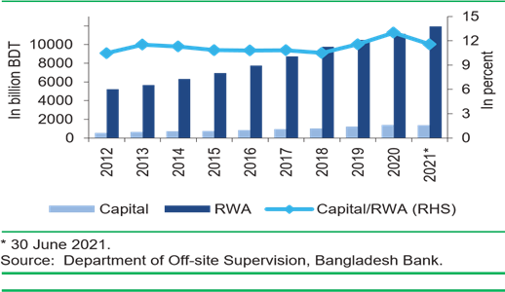
Figure 2.1: Risk Weighted Asset of private commercial banking sector
We can observe from the graph that the amount of the Risk Weighted Asset is increasing and the Capital to RWA ratio is decreasing it means amount of capital decreasing and RWA increasing, it is a clear indication of capital shortfall of the PC banks. As per the IMF the ratio should be above 10% but here, we can see that Capital to RWA ratio is below 10%. Financial Health of the PC banks are not well in the economy.
As per the industry analysis, we can say that PC banks are in Shakeout Stage, at the industry life cycle, Shakeout usually refers to the consolidation of an industry. Some PC banks are naturally eliminated because they are unable to grow along with the industry like Farmer’s Bank, NRB Global Bank and many other banks are still generating negative cash flows like Basic Bank, Union Bank, Jamuna Bank, Padma bank etc. Some banks merge with competitors or are acquired by those who were able to obtain bigger market shares at the growth stage like ICB bank, Padma Bank etc. At the shakeout stage, the growth rate of revenue, cash flows, and profit start slowing down as the industry approaches maturity. Alternatively, we can say PC banking industry is in the early stage of maturity stage in the industry life cycle as the number of PC Banks increasing day by day. A regulated governance can lead this industry at its best position. BB can play that role. The private commercial banking industry in Bangladesh is also facing increased regulatory scrutiny, as the Bangladesh Bank works to ensure that banks are operating in a safe and stable manner. This has led to a number of changes in the sector, including the introduction of new rules and regulations aimed at improving transparency and accountability. Banks are also being required to implement stronger risk management practices and maintain higher levels of capital to protect themselves against potential losses.
Despite these challenges, the private commercial banking industry in Bangladesh is poised for continued growth in the coming years. With a growing population and a growing economy, there is a growing demand for banking services in the country, which is expected to drive further expansion in the sector. Additionally, with the continued growth of digital technologies, there is a growing opportunity for banks to reach new audiences and offer new services to customers.

2.3 Seasonality:
Seasonality refers to regular fluctuations in economic activity that occur in specific time periods. In the context of the private banking sector in Bangladesh, seasonality is evident in the form of fluctuations in loan disbursement, deposit mobilization, and overall performance of banks. The private banking sector in Bangladesh experiences two main seasons: the peak season and the lean season.
Every Industry has its own season. But the banking industry is different, it is not working Like Ice-cream industry. We can identify a special season increases the demand of the ice cream. Seasonality of the banking industry depends on the several national and international factors. The main factors are inflation rate, stability at stock market, investment options etc. Banking Industry booms when economic conditions are getting well. Amount & number of depositors increases when economy booms, Income of general public also increase. As a result, people tend to spend more. Businessmen tend to increase their capacity to fulfill the demand of the general people and move towards the banks to take loan in order to invest in capacity building. General people’s fund is channelized through banks to fulfill their demands. Political stability is a reason of bank’s seasonality. Politically unrest society can not involve in the economic activities actively because people cannot go out for work and businessman cannot open their business institutions. The economy cycle can be disrupted due to political disruption. Interest rates could be a salient driving force for the seasonality of banking industry. In Bangladesh central bank maintain the interest rate for private commercial banks to ensure a competitive environment in banking industry.
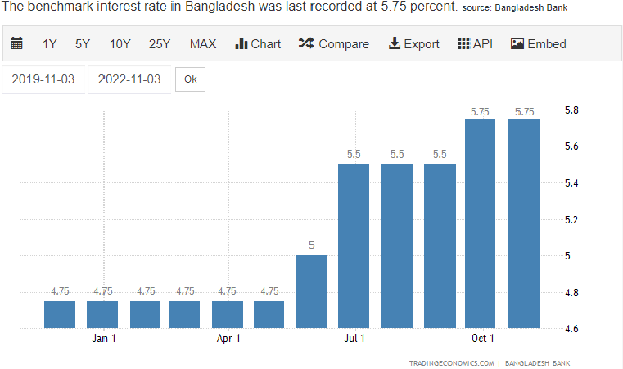

Figure 2.2: Interest rate on lending of 2022
Here, we can overserve the lending rate of last one year here. The benchmark interest rate in Bangladesh was recorded at 5.75%. The raise of interest rate begun at the month of June, it was 5%, But the rate was previously at 4.75%. It means people took more loan at the lower rate. So, banks disburse more loan at lower rate, we can say January 2022-May 2022 is a season to take more loans from the PCBs. Vice versa for Deposit rate, As the deposit rate goes up and people tend to deposit more fund rather spending it. Deposit interest rate and lending interest rate varies due to various external factors. Due to pandemic the rates are varies a lot.

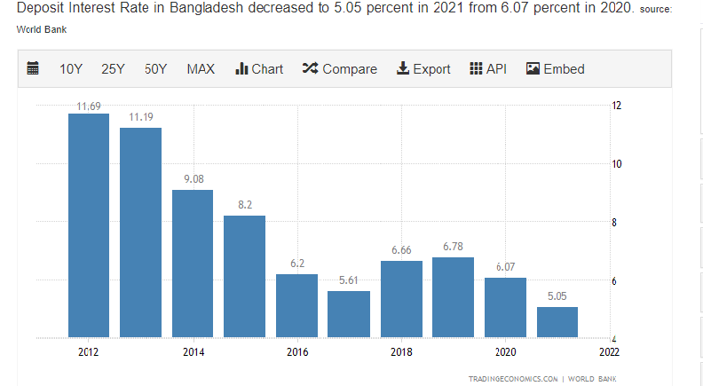
Figure 2.3: Interest rate on deposit
As per the statistics we can identify that deposit interest rate was higher at the year 2012, At that time rational people tend to deposit more. But at the recent year 2021 the rate becomes lower at 5.05%. It represents that people are looking more investing option to increase the value of the money.
The basic seasonal pattern of the banking industry is a period of annual lows in late January and February, followed by an increase in loans that begins in March and rises sharply through July, usually peaking in August or September. We can justify the statement by below figure.

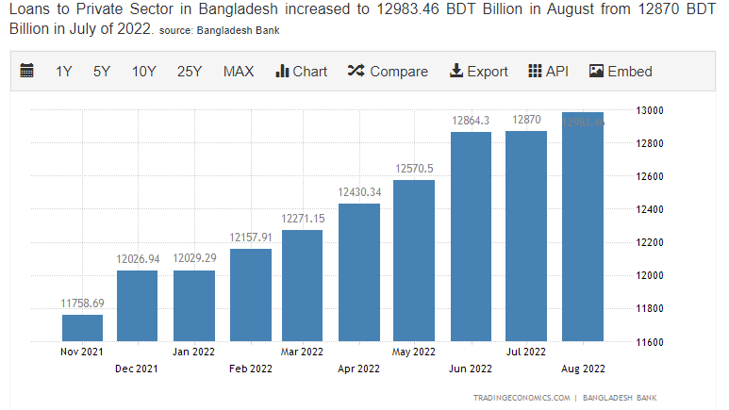

Figure 2.4: Interest amount as per the different time frame

Here we can observe that loan amount is lower in the month of July to December and higher in the month of January to June. Due to various factors the seasonality of the banking industry varies time to time & situation.
The peak season in the private banking sector in Bangladesh is from January to June. During this period, loan disbursement increases due to higher demand for credit for business expansion, consumer spending, and other purposes. Deposit mobilization also increases during the peak season as people tend to have more disposable income and are more likely to deposit their savings in banks. As a result, the overall performance of banks in Bangladesh is better during the peak season.
The lean season in the private banking sector in Bangladesh is from July to December. During this period, loan disbursement decreases due to reduced demand for credit, and deposit mobilization also decreases as people tend to spend more during the festive season. As a result, the overall performance of banks in Bangladesh is weaker during the lean season.
Seasonality in the private banking sector in Bangladesh is largely driven by the agricultural cycle and the monsoon season. The agricultural cycle is a major contributor to the seasonal fluctuations in the banking sector as the majority of the population in Bangladesh is engaged in agriculture. The monsoon season also plays a crucial role in the seasonality of the private banking sector as the monsoons have a direct impact on the crop yield, thereby affecting the demand for loans.

2.4 External economic factors:
Banking industry is inter-linked to all the economic factor. National and International economic factors affect the banking industry, Like inflation rate, Interest rates, price of foreign currency, commodity price in international market, housing demands & all activities of GNP (Gross National Product).
Famous economist “Kotler” says, “Business environment means such type of surrounding situation or influencing power that influences an organization’s activities, operations, and decisions”.
From the definition of Kotler, it is clear that the environment influences the whole social and economic activities. In this way, the success or failure of a business is largely influenced by the environment. The bank is a special type of business organization. Bank collects money from a group of people as deposits and lends those to another group of people for profit. When the environment is not favorable, a shortage of deposits and investment is not profitable for the bank. As customers of the banking industry also belong to this environment. If there is no demand for housing people would not take any kind of home loans from the banks. On the other hand, the inflation rate is also a hinge for the banking industry, if the inflation rate is higher than the deposit rate, people would not like to deposit their money in banks. As we said earlier that banks invest depositors’ money to earn profit. Decreasing amount of deposit drive the banking industry in a loss-making situation. Banks can increase the deposit rate then the interest rates will be affected too. To Maintaining a level of spread, banks have to disburse loan in a higher interest rate. As a result, people will take less loan from the banks and the industry might face loss. So, we can say the inflation rate has both way effect in the banking industry.

Figure 2.5: External Factors for the PCB Industry
Banks are profitable when BB pursuing expansionary monetary policy. BB come out with the monetary policy by understanding the global growth, inflation, trade environment, liquidity situation, environment of money and credit market. As a central bank BB also comes with open market operation to maintain the money supply in the economy. Banking industry also depends on the CRS (Cash Reserve Ratio) policy of the central bank. Central bank’s lending rate is also very important for the banking industry, if the rate is low then banks can make more profit.
Commodity pricing is also an impactable indicators for the banking industry. If the price is lower in the economy, the demand for the goods and services would be higher. The business institutions need more fund to increase their production capacity. There is a chance for banking industry to minimize the funding gap by providing loans. But at higher price the picture might be opposite.
GNI (Gross National Income) is a foremost factor for the banking industry. As banking is connected to domestic and international business, so it is better for the banks having large number of GNI. GNI is a measure of both domestic and national income of a country. In BD the GNI increase by 13.06% by year of 2021. The amount of GNI is 435.35 bn. As GNI increase banks get more funds for disburse the loan. BD remittance fighters send foreign currencies which is beneficial for the banking industry and our economy as well. Bank can provide Letter of Credit(L/C) service easily having a foreign currencies reserve.

2.5 Technological factors:
“Digital Bangladesh” this slogan has entirely change the thinking pattern of the citizen of Bangladesh. After 2008, people of BD gained the technological advancements. Bangladesh achieved 111th position in ranking of technological inclusion. At 2022 BD ahead 8 steps than the previous rankings. Financial inclusion accelerates by the development of the technological development. Due to internet people can avail the banking services at their fingertips through the smart devices. Inter Bank money transfer becomes time efficient due to technological usage. Technological factors fasten the banking services which leads the bank’s profitability and customer’s satisfaction. The banking complex procedure becomes simpler due to the advancement. There are other technological factors like MFS (Mobile Financial Services), digital payment system, digital fund transfer provides a new dimension to the banking industry. Most of the banks in Bd has their own MFS service or banking App, for example- Brac Bank has Bkash, The City bank LTD has City Touch mobile App, Dutch Bangla Bank has Rocket, etc. Through this app customers can transfer their money without visiting banking branch. Customers can pay their bills by using these apps from their bank account. Another biggest technological for banking industry is the invention of CRM (Cash Recycler Machine). Customers can deposit and withdraw money 24/7 by using this CRM. A CRM accepts cash, counts the notes, authenticates them, and credits the amount to accounts on a real-time basis, helping banks do away with the manual labor needed for the service. The new technology is also allowing users to deposit and transfer cash in others' accounts. In Bangladesh, banks started setting up CRMs in 2017. As of July, this year, the number of machines was 1907, up from 208 three years ago, data from Bangladesh Bank shows.
KYC (Know your customer) is a foremost matter for the banks, without KYC customers cannot access to any sort of banking services. Customer has to fill up KYC form for opening bank accounts and lending money from the bank. Previously, these KYC takes minimum one day or maximum three days and customers have to present in the bank premise. In January 2020, the Bangladesh Financial Intelligence Unit rolled out the electronic Know Your Customer (e-KYC), facilitating clients to bank accounts in just five minutes. E-KYC is also used for identifying the credit score of a customer and banks can measure the credit risk of a customer & institution.

Figure 2.6: Technological Factors in the PCB industry
Bangladesh Bank introduced agent banking in the country by issuing a guideline in 2012, for providing a safe alternate delivery channel of banking services to the underprivileged and under-served population who generally live in geographically remote areas beyond the reach of traditional banking networks. The agent banking sector saw rapid growth as an alternative to the branch-based banking model in Bangladesh, especially in rural areas, where setting up full-fledged offices is not commercially viable because of their low business volume. Usually, basic banking services such as cash deposits, cash withdrawals, and receipt of remittances are provided through agent banking. Apart from that, banks have also started disbursing loans through their agents. Transactions through agent banking accounts rose 43 per cent year-on-year to Tk 5,64,844 crore in fiscal year 2021-22 as a growing number of people are now using the new banking window, shows Bangladesh Bank data. In fiscal year 2020-21, the amount passing through these accounts, opened through agent banking services, stood at Tk 3,94,068 crore. Bank Asia introduced the country's first agent banking services in January 2014.
The journey of Internet banking started at the year 2010, Banks encourage their customers to adopt the digital window. Due to internet banking customers visit less to the bank physical branches. In this way bank can reduce their operational cost and increase the productivity of the bankers. Beside that internet banking can be used for paying the bills, rent and utility charges. The outbreak of Covid-19 in early 2020 could not affect the banking service because of the internet banking. People did their banking virtually. In fiscal 2021-22, transactions shot up 122.60 per cent year-on-year to Tk 224,958 crore, as per data from Bangladesh Bank. As per the data of BB, the number of customers using internet banking stood at 5.35 crore in June, an increase of 47 per cent from a year earlier in Bangladesh.

2.6 Political, legal and regulatory factors:
A bank can influence the lifestyle of people & as well as some part of the economy, but government has a great influence in the banking sectors. In Bangladesh, we are following the democratic political system, GOVT of BD bound the banking sector by legal and regulatory framework to ensure a win-win situation for the banking sector & people of BD. Banks can takeaway citizen’s money without a proper governing body. That’s why Government creates central bank to monitor the overall banking system. Government imposes tariff rates, embargo, sanctions etc. To control the activities of the economy and these activities have direct and indirect effect on the banking industry.
Political stability is one of the important conditions for economic prosperity. Business institutions, factories, offices, Banks, transportation cannot function properly due to political unstable situation, as a result, economic cycle cannot complete properly. Last one decade in BD, the political conditions were stable rather than the previous period that’s why economic conditions are improving. But the burning question is the corruption of internal and external regulatory body of banking sector. Sometimes political parties put pressure on the bank officials for rescheduling the NPL (Non-performing Loan). Political leaders influence the bank industry for disbursing the industrial loans.
Bangladesh A political party runs the government. Apart from the political party the government govern the banking industry by passing banking acts. BB acts as the Central Bank of Bangladesh which was established on December 16, 1971 through the enactment of Bangladesh Bank Order 1972- President’s Order No. 127 of 1972 (Amended in 2003).http://www.bb.org. Govt of BD later brought “Bank company act 1991” to regulate the PCBs. Size of governing body, RJSC license procedure, lending procedure, deposit procedure, transaction hours for the banking industry each & all guidelines are provided by the government. Government body has direct control over banking industry of the country. Parliament, Bangladesh bank, Finance Ministry combinedly run the economic show of the Bangladesh. So, Political, legal and regulatory factors are inter linked for the banking industry.

2.7 Barriers to Entry:
Barriers to entry decide the attractiveness of a particular industry. Higher barriers to entry indicate less competition in the industry. Barriers to entry in the banking sector of Bangladesh is higher due to various requirements and rules are imposed by regulatory body like, Bangladesh Bank. The allure of high profitability is available in the banking industry, but new entrants cannot enter in this industry due higher rules, regulations & requirements.
New entrants have to submit application to the Bangladesh Bank in order to achieve the license. According to Section 31 of the Banking Companies Act, 1991, no company shall carry out banking business in Bangladesh without obtaining a license from Bangladesh Bank. Based on the application Bangladesh Bank evaluates some factors which are given below:
- Status of the new commercial bank. The company must be a public limited company incorporated in Bangladesh.
- Paid up capital requirements for a bank to be established. The paid-up capital shall not be less than taka 400.00 Crore as required under Bank company Act 1991. The share capital will be formed with ordinary shares only.
- Mode of Payment. The capital contribution made by the sponsors and subscribers of the proposed bank shall be in a liquid, unencumbered form (such as cash or approved securities), held in a verified bank account under the Bangladesh Bank lien.
- Sponsors and share capital contribution: Capital taka 400.00 crore shall be provided by the sponsors of the proposed banks. Bank has to issue public shares within the three years from the date of formation. Public share shall be equal to sponsors’ share amount. Minimum shareholding stake of each sponsor shall be taka 1.00 crore and maximum should be 10% of the proposed share. The ceiling of 10% applies to an individual company or family member, either personally, jointly or both. “Family” is defined herewith to include spouse, father, mother, son, daughter, brother, sister of the individual or anyone dependent on that individual. 10% may be relaxed in the case of the bank setup as a joint venture with a foreign financial institution.
Economies of scale are available in banking industry. Cost of fund is the cost for providing the loans towards the customer of the bank. When the number of loans increases the cost of fund decreases. Banks get the economies of scale when operations increase and it covers the most geographical locations. For new entrants it’s costly to cover the maximum geographical locations. As a result, they provide less loan at a higher cost. Bangladesh bank set the interest rate so they cannot charge more interest than the set one. So, Economies of scale work like a barrier for the new entrants in the banking industry.
Product & service differentiation is another reason of barrier to entry for the new entrants in banking industry. As financial sector is a sensitive issue because it directly deals with the monetary aspect of people’s life. So, new brands in banking sector are not acceptable always, new banks have to operate for a long period of time in a break-even point. Another issue of new banks is limited financial products. New banks do not have that resources to introduce new financial products as a result, they fail to fulfill the existing demand of the market.
New entrants in the market do not understand the market very well, on the other hand old players in the banking industry understands the economic situation and the market soundly. As a result, new entrants have a lack of confidence in order to invest mega projects and fail to gain the competitive advantages.
Money market is a complex market to maintain the distribution channel, like gaining deposit and disbursing the loans. Banks have to follow rules, regulations & guidelines to maintain the channel follow. The guidelines are provided by the Bangladesh bank. The old major players have their control in these distribution channel, so it’s difficult for the new players to enter in the market & do the business in the banking industry.

2.10 Threat of substitutes:
A substitute, or substitutable good, in economics and consumer theory refers to a product or service that consumers see as essentially the same or similar-enough to another product. Put simply, a substitute is a good that can be used in place of another.www.investopedia.com.

Figure 2.7: Substitute goods in the PCB industry
NBFIs:
Non-bank financial institutions (NBFIs) are providing substitute services against the banking industry. Some NBFIs providing maximum 10% interest rate on the term deposit, on the other hand banks are providing maximum only 6% interest. So, customer tends to deposit their money on the NBFIs. There are some well-known
SME businesspersons are very much comfortable to take loan at NBFI as the rules and guidelines are very relaxed at the NBFIs. The loan processing time is not time consuming and easy banking process. As per the guidelines of BB, Bank has to prepare a huge documentation process to pass a loan. This time-consuming process discourage SME businessperson to take loan from the banks.
On the other hand, NBFIs are less complex in terms of providing loans. They need less time & documentation and interest rates are less than the bank. Customers have cost-time benefits switching to substitute services. NBFIs carry a potential substitute threat to the banking industry in BD.
MFIs:
MFI means Micro finance Institutions. In 1970 micro financing was introduced by Grameen Bank under the excellence of Dr. Muhammad Yunus. Microfinance concept was introduced to help needy people by providing funds. Now a days, MFIs have covered a lot of rural area and provide micro-credit to the banks. Micro-Credits are very popular at the rural area. Agents of the MFIs collect deposit and installments of loan by visiting the customers personally. Other than that, agents introduce various community-based business model to the customers. Customers take the loan and invest in the community-based business and return the money to the MFIs. MFIs do not take any kind of collateral from there customer and there is less documentation system in MFIs. Because of these reasons MFIs become potential substitutes for the banking industry. MFIs are eating the market share of PCBs in the rural and under-developed area.

Others:
Now a days, MFS (Mobile Financial Services) becomes very popular in BD. MFS are not limiting their service at level of transferring funds only, they introduced the depositing system at MFS & customer can take loans at Bkash app. www.bkash.com. MFS also provide Islamic saving options in their apps.nagad.com.bd. MFS increases slowly but surely the substitute threat for the PCBs.
Now a days in Bangladesh, people like to invest in share markets, various businesses, real states, rather than depositing money in the banks. These sectors become indirect substitute for the PCBs. As a result, Banks could not get the deposit as they expected because the return is higher in other sector than interest return. It’s a threat from the indirect substitute towards the PCB industry. Banks open their own brokerage houses & MFS to mitigate the threats arises from the substitute. PCBs also launch various financial products like credit cards, home loan, car loan, personal loan & various loan packages to grabbing the market share from the substitutes available in the market.

2.11 Industry Rivalry:
There are various division in the PCBs. Banks compete with each other in every sector. Due to scarcity of resources, A PCB cannot lead in every division. In this part we are going to discuss the market share of PCBs in the card division to understand the market rivalry. Both credit and debit card are included in this section. We can see that The City Bank Limited is leading in this section with 27% market share. Followed by SCB by grabbing the 21% market share. Brac Bank, Eastern
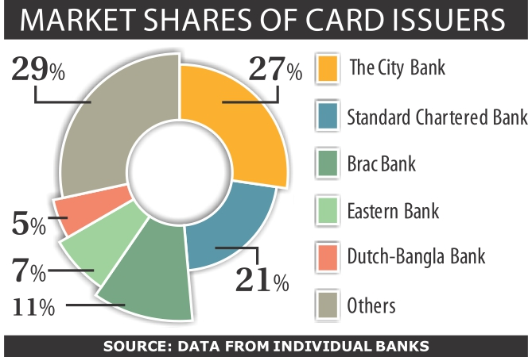
Figure 2.8: Market share of card segment
Bank & DBL holds 23% market share combinedly and rest of the share 29% is holding by others banks.
We can see The City Bank Limited is market leader in the card division. SCB, Brac Bank, Eastern Bank & DBL is major Rivals in the card segment of banking Industry.
Another parameter to understand market rivalry is understanding the operating profit the PCBs income. Because closer operating profit indicates they are fighting in the same segment and their operating cost is near to the rivals of the industry. Operating profit also indicates the sales of financial products by the banks. We can see from the picture that, Pubali, The City Bank ltd, Eastern bank, Southeast bank, Bank Asia posted same amount of operating profit in the year 2020-2021. Ismali bank is leading in the market as per the amount of operating profit, in tire 2, there are premier bank, Exim bank, IFIC Bank, AL-Arafa bank, Jamuna bank etc.
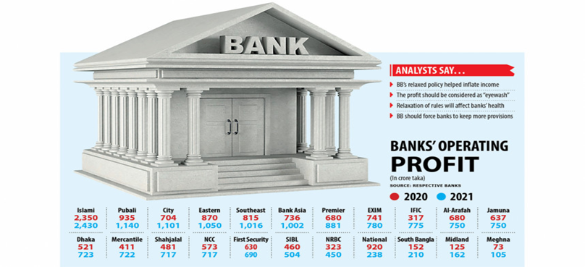
Figure 2.9: PCBs operating profit amount
New banks find themselves in the tire 3, As their operating area is less than the 1st & 2nd tire banks, so the operating cost & profit both are less than the other banks. Now a days, new banks are focusing on the retail customers with various newly designed financial products to grab the market share. But these banks fail to disburse the corporate loans because the amount of corporate loans are much bigger than the retail loans. New banks have little access of fund to disburse as a loan. If they disburse big amount of loans, they may fall into liquidity crisis. Banks like Dhaka bank, Mercantile Bank, NCC bank, SIBL etc. always focus on the urban area to run their operation, so they have different financial product segment and competition in their areas. Pubali bank, The City Bank ltd, Eastern bank, Southeast bank, Bank Asia these bank target urban, sub urban areas. So, they have a different customer base and competition in the banking industry.

2.12 Summary of Challenges and opportunities
Banking sector including PCB industry is facing a huge challenging situation in Bangladesh. Due to irregular lending activities, lack of monitoring, increase of inflation rate, dollar crisis, increase of bad debt, non-performing loans banking industry facing challenges to run the economic activities & banking business in Bangladesh.
Recently a business group has taken 33,000 Cr loan from a single bank, despite of being a major shareholder of that bank. As per the guideline of BB major shareholder of a bank cannot take more than 512 Cr. The particular bank should arrange a syndicated loan to disburse 33,000 Cr as loan. Due to irregular lending activities a huge amount of taka passes to foreign countries for laundering. As a result, banks are facing liquidity crisis, credit risk & could not recover the principal amount and spread.
Another challenge for the banking industry is the inflation rate. In the month of November monthly average inflation rate is 7.48% https://www.bb.org/inflation .It means the value of money decreases by 7.48% against this rate depositor get 6% on their deposit. Which is lower than the inflation rate. So, the investment incurred loss for the depositor. On the other hand, Sanchayapatra provides 9% interest on the investment which is higher than the inflation rate. That’s why people tend to buy sanchayapatra rather than depositing the money in the banks. Banks faces challenges to attract the deposits. Now a days, depositors withdraw their money from the bank due to economic crisis. So, banks face challenges to provide the unpredictable withdrawal of the money. are not able to provide the L/C (Letter of Credit) service to the customers of the banks due to dollar crisis, that’s why banks are losing service fee, deposit amount & charges to maintain the current accounts.
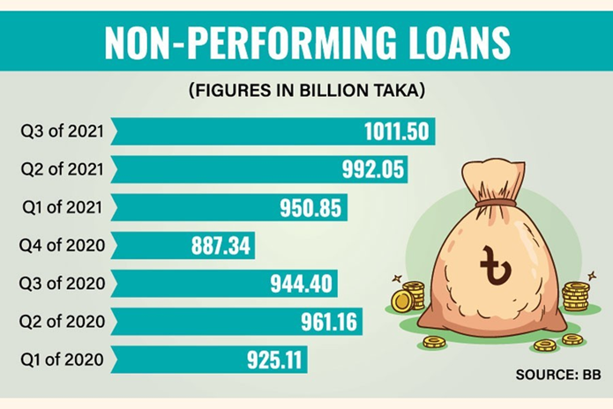
Figure 2.10: Amounts of Non-performing Loans

Another challenging situation for the banking sector is non-performing loans which is increasing by 16% in the year 2022. Due to NPL banks are not able to achieve their projected profit in fiscal years. NPL leads the loan amount at the bad debt. NPL has a positive relationship with the bad debt. As NPL rises the amount of bad debt also rises. So, we can say higher NPL leads to higher amount of bad debt.
Digitalization of Bangladesh is a major opportunity for banking sector. Banking industry can expand their business by using these technologies. Banks can attract more customer by using the concept of “Mobile Banking”. Banks can disburse their loan by using fintech. As a result, banks can spread their operations to rural area & it impacts the financial inclusion for the people of Bangladesh. It creates a win-win situation for both the parties. Banks can acquire more customers and customers can access the financial channels & more financial products.
Young people can be a door of opportunity for the PCBs because 66.38% of Bangladeshi young people aged 14-24 don’t have bank accounts. It means there is a great opportunity for the PCB industry for financial inclusion. On the other hand, modernized financial products can be traded to youth easily. PCBs can introduce various digital products after financial inclusion of the youth. Another opportunity for the PCB is school banking. As per the statistics of BB, there are almost 30 lakh student banking accounts with deposits worth Tk2147.8 crore. But only 28 students know about this service among 100 students, So PCBs can cash the opportunity & create financial awareness by arranging seminars, webinars, roadshows, day long training program etc. PCBs can assist entrepreneurs by not only providing funds but also proving trainings & expert suggestions. PCBs can revise their collateral related policy for the entrepreneurs because they face difficulties due to not owning any kind of properties. Relaxing policy can take the youth to the entrepreneurial environment where PCBs can extend their business.

3. Analysis of the organization

3.1 Overview & History
The City Bank Limited is one of the prominent banks in the private banking sector in Bangladesh. The Bank has been operating since 1983 with an authorized capital of Tk. 1.75 billion under the entrepreneurship of twelve prominent & leading businessman of the country. The noble intention behind starting this Bank was to bring about qualitative changes in the sphere of Banking and Financial management. The City Bank currently has total serves its customers at home & abroad with 112 branches spread over the country & about three hundred oversea correspondences covering all the major cities and business center of the world. The services encompass wide diversified areas of trade, commerce & industry which tailored to the specific needs of the customers and are distinguished by an exceptional level of prompt and personal attention. Over the years the Bank has expanded the spectrums of Its Services. The extensive and ever-growing domestic network provides and carries various products and services to the doorsteps of millions. The City Bank Limited has already introduced some new Banking products like dual currency Credit Cards, ATM and Online services which has created attraction among the clients. The Bank is going to introduce real time Internet, SMS and Phone Banking systems which is known as “City Touch” with all modern delivery channels at an early date. Special banking experience is designed for women is introduced known as “City Alo”.
Vision, Mission and Values are important components to understand an organization. Three components are given below:
Vision of The City bank Limited “The Financial Supermarket with a Winning Culture Offering Enjoyable Experiences”
Mission of “The City Bank Limited”; we can separate the mission of the city bank limited into four parts; Parts are given below:
a) Offer wide array of products and services that differentiate and excite all customer segments
b) Be the “Employer of choice” by offering an environment where people excel and leaders are created.
c) Continuously challenge processes and platforms to enhance effectiveness and efficiency
d) Promote innovation and automation with a view to guaranteeing and enhancing excellence
in services.
e) Ensure respect for community, good governance and compliance in everything we do.

Values
▪ Result Driven
▪ Accountable & Transparent
▪ Courageous & Respectful
▪ Engaged & Inspired
▪ Focused on Customer Delight

3.2 Trend and growth
City Bank Limited is a leading commercial bank in Bangladesh that was established in 1983. It is one of the largest private sector banks in Bangladesh and has become a trusted financial partner for millions of customers. In recent years, City Bank Limited has grown at a rapid pace and has become a prominent player in the financial market of Bangladesh. In this report, we will examine the growth and trend of City Bank Limited.
The first notable growth of City Bank Limited was seen in the year 2003 when it reached the 100 million dollars mark in its asset base. This was a significant achievement for the bank and reflected the confidence of the customers in its services. In the next few years, City Bank Limited continued to grow and expand its services. It was the first bank in Bangladesh to launch a debit card and also launched its first ATM booth in 2004.
Table 3.1: Performance Card of the city bank limited
Year | Profit after taxation (BDT mn) | Earnings/share | ROA | ROE | Leverage Ratio | Dividend/share | Market Cap (BDT mn)
2019 | 2,472 | 2.4 | 0.7% | 9.9% | 5.5% | 15% cash | 21,446
2020 | 4,012 | 3.9 | 1.1% | 14.8% | 6.1% | 17.5% cash, 5% stock | 25,206
2021 | 4,743 | 4.4 | 1.2% | 15.8% | 5.6% | 12.5% cash, 12.5% stock | 29,135

The trend in the bank’s operating income and net profit has also been positive. After analyzing the pervious performance, we can see that CBL make 2 times more profit in the year 2021 than the year 2019. EPS also increased in the year 2021. ROA increased by 0.5% & ROE increased by 5.9% in the year2021
So, we can say CBL has a positive growth in every sector and trend is upwards moving.
City Bank Limited has grown significantly in terms of assets, deposits, and loans and advances. The total assets of the bank have grown from BDT 70.12 billion in 2015 to BDT 120.24 billion in 2019, showing an increase of 70.32%. During the same period, the bank’s total deposits grew from BDT 53.83 billion to BDT 96.56 billion, showing an increase of 79.67%. Similarly, the bank’s loans and advances have grown from BDT 37.24 billion to BDT 67.48 billion, showing an increase of 81.24%. These numbers demonstrate the bank’s strong growth and its ability to attract more customers and generate more business.
City Bank Limited has also been successful in maintaining its capital adequacy ratio, which is a measure of a bank’s ability to meet its financial obligations. The capital adequacy ratio of the bank has remained above the minimum regulatory requirement of 10% over the past five years. The capital adequacy ratio of the bank was 11.62% in 2015, which increased to 12.22% in 2019. This demonstrates the bank’s strong financial position and its ability to meet its financial obligations.
The bank has also been successful in reducing its non-performing loans (NPLs) over the past few years. The NPLs of the bank were 7.38% in 2015, which decreased to 5.54% in 2019. This shows that the bank has been able to improve the quality of its loan portfolio and reduce the risk of loan default.
City Bank Limited has demonstrated a strong growth and trend over the past few years. The bank has been successful in increasing its assets, deposits, loans and advances, operating income, and net profit. The bank has also maintained its capital adequacy ratio and reduced its non-performing loans, which shows its strong financial position and ability to meet its financial obligations. The bank’s strong growth and trend is a testament to its ability to provide quality financial services to its customers and generate sustainable business.

3.3 Customer Mix
The customers of the city bank can be segmented by geographics, demographics, psychographics, behavioral patterns. As per the 2021 annual report there are 2.2+ million customers take product and services from CBL.

Geographics
Country
As per country The City Bank limited only operational in BD, Citizens & Residents of Bangladesh are the customer of the city bank limited, but AMEX (American Express Credit Card) users can avail their banking services at abroad. Other than that, Customers from any geographical location can avail the financial services through City Touch mobile banking App. So, we can conclude that Bangladeshi, Non-Resident Bangladeshi & resident of Bangladesh (foreigner but lives in Bangladesh).
City & Area
As per the statistics City Bank Limited has a total of 132 branches located in 38 districts of Bangladesh. Out of 132 branches 41 branches are located in Dhaka District. So, we can say that the city bank limited has a great customer mix in Dhaka Districts. Besides that, CBL has their branches at first tire cities like Chittagong, Comilla, Bogura, Rangpur, Mymensingh, Rajshahi, Faridpur, Khulna, Barisal etc. The CBL targeted the mega cities, Urban areas & Sub-Urban areas of Bangladesh. CBL did not target the rural area people as their customer base.
Demographics
Age
As per the guideline of BB, People can access to banking services at the age of 18. Students who are below 18 can take deposit services from the city bank Limited. In the customer mix CBL target various age group. Like new born savings account for infants. Their parents open savings accounts for the future of the infant. This sort of financial products creates a customer base for CBL in a long run. CBL has facilities for the senior citizens of Bangladesh. In their customer mix they add the people of 50-avobe by senior’s savings account. The table below shows the demographic segmentation of City Bank's customers:
Table 3.2: Demographic Segment of The City Bank LTD
Demographic Segment | Percentage of Total Customers
Age 18-25 | 15%
Age 26-35 | 30%
Age 36-45 | 25%
Age 46-55 | 20%
Age 56 and above | 10%

As per the table 3.2 we identify that 75% customers of CBL lies in the range of 26-55 years age.
Gender
Based on the gender, CBL provides financial services towards both Male & Female. For female there is a special banking side “City Alo” & there is a woman banking branch situated in Gulshan. Only women can take services from the branch. But there are no barriers for the transgenders to open a bank account in CBL.
Income
CBL provides financial services for every income group people. Bank officers suggests financial products based on the income. There is a minimal savings options for the school students. Though maximum school students do not have stable income source. But they can still save from their pocket money
Table 3.3- Income segmentation CBL
Income Segment | Percentage of total customers
Low Income | 25%
Medium Income | 50%
High Income | 25%

As per the table 3.3, we can say that middle income group people are very much interested in the retail financial products of CBL.
Occupation
Customer mix of the CBL determines by occupation also. CBL has introduced financial products for the freelancers. Now a days freelancing occupation becomes popular worldwide. Based on that CBL designed their financial product for the freelancers. To avail that service, freelancers have to submit their valid freelancing ID.
CBL also designed financial product for the garment’s workers. Garment’s worker can avail special facilities from CBL. It is a non-checking account, Cash Withdrawal facility with Cash Withdrawal Slip, no minimum balance requirement, Opportunity to open account with only BDT 100, No Account Maintenance fee, Call Center service will be avail by the garment’s worker.
Entrepreneurs get special services in CBL. CBL provides facilities in current & savings account for the entrepreneurs. Entrepreneurs can avail small & quick loan facilities as per their requirements. “City Alo” special banking provides special debit & credit cards to the women job holders & employees.
Religion
City Bank Islamic has introduced financial products which are approved by the shariah board. This section of banking enriches the customer base of the CBL. Customers who want to take loan & deposit their money based on shariah can avail service from the CBL Islamic. These products can attract customers from the Islamic Banks of Bangladesh.
Business groups of Bangladesh are also significant customers for the CBL. CBL offers wholesale banking services towards those business groups and corporate house.
Financial Needs Segmentation
Financial needs segmentation is the process of dividing the market into different groups based on the customer's financial needs. The table below shows the financial needs segmentation of City Bank's customers.
Table 3.4: Financial need segment of CBL
Financial Needs Segment | Percentage of Total Customers
Savings Account | 30%
Current Account | 20%
Loan | 25%
Investment (Islamic Products) | 25%
From the above data, it can be observed that City Bank's customer base is diverse and well-balanced. The bank has a significant number of customers in all age groups, income levels, and financial needs segments. This diversity of the customer base provides the bank with stability and reduces the risk of relying on a single segment. The bank serves a wide range of customers, including individuals, small businesses, and large corporations. The bank's customer base is diverse, with customers in all demographics age groups, income levels, and financial needs segments. This report provides a detailed understanding of City Bank's customer mix, which can be used to make informed decisions on the bank's future marketing and product development strategies.

3.4 Product and Service Mix
City Bank Limited is a renowned private sector bank in Bangladesh, with a rich history of providing quality financial services to its customers. The bank has a wide range of financial products to meet the diverse needs of its customers, including individuals, small and medium-sized enterprises, and corporate clients. In this report, we will discuss the product mix of City Bank Limited, including the different types of financial products offered by the bank.
Deposit Products:
City Bank Limited offers a variety of deposit products to its customers, including savings accounts, current accounts, fixed deposits, and call deposits. These products are designed to cater to the varying financial needs of the bank's customers, and offer attractive interest rates, convenient banking services, and easy access to funds.

Savings Accounts
City Bank Limited offers a range of savings accounts to its customers, including regular savings accounts, premium savings accounts, and youth savings accounts. These accounts offer a range of benefits, including attractive interest rates, free debit cards, free internet banking, and more.
Current Accounts
City Bank Limited also offers current accounts to its customers, which are designed for businesses and individuals who require frequent transactions and access to funds. These accounts offer a range of benefits, including free cheque books, free internet banking, and overdraft facilities.
Fixed Deposits
City Bank Limited offers fixed deposit accounts to its customers, which provide a safe and secure means of investing funds for a specified period of time. These accounts offer attractive interest rates and the option to choose from different tenures.
Loan Products
In addition to deposit products, City Bank Limited also offers a range of loan products to its customers, including personal loans, home loans, car loans, and educational loans. These loans are designed to meet the various financial needs of the bank's customers and offer attractive interest rates, flexible repayment options, and easy processing.

Personal Loans
City Bank Limited offers personal loans to its customers, which can be used for a range of purposes, including debt consolidation, medical expenses, and more. These loans offer attractive interest rates, flexible repayment options, and easy processing.
Home Loans
City Bank Limited also offers home loans to its customers, which can be used for the purchase of a new home, renovation of an existing home, or for the construction of a new home. These loans offer attractive interest rates, flexible repayment options, and easy processing.
Car Loans
City Bank Limited offers car loans to its customers, which can be used for the purchase of a new or used car. These loans offer attractive interest rates, flexible repayment options, and easy processing.
Educational Loans
City Bank Limited also offers educational loans to its customers, which can be used to finance the cost of education, including tuition fees, books, and other related expenses. These loans offer attractive interest rates, flexible repayment options, and easy processing.
Card Facilities
City Bank offers several card facilities to its customers, including debit cards, credit cards, and prepaid cards. These cards are designed to make transactions more convenient, secure, and accessible for customers, whether they are shopping online, making purchases in-store, or withdrawing cash from ATMs.

Debit Cards
City Bank's debit cards are linked to customers' deposit accounts, allowing them to make transactions and withdraw cash without having to carry large amounts of cash. These cards offer customers a convenient and secure way to access their funds, whether they are shopping or paying bills. Master Card: CBL issued the master card as default card for any account holder, so there for it has no specific categories as compare to debit cards; VISA Electron: This is also others debit card issued by the CBL with some special privileges.
Credit Cards
City Bank's credit cards offer customers a flexible line of credit, allowing them to make purchases or withdraw cash without having to pay upfront. These cards come with a range of features and benefits, including rewards, discounts, and cashback, as well as insurance protection. American Express: From 2010 CBL has franchise the AMEX into the Bangladesh through 3 categories and also available in dual currency mode. These are I. Silver II. Gold III. Platinum; VISA: An international and it issues in both Local Currency (Taka) & Foreign Currency (US Dollar) in 2 categories and also available in dual currency mode, I. Gold II. Silver
City Bank Limited offers a comprehensive product mix that meets the financial needs of its customers, including deposit accounts, loans, investment products, and card facilities. These products are designed to help customers achieve their financial goals and make their transactions more convenient and secure. With its range of card facilities, City Bank provides its customers with a flexible and secure way to manage their money and make transactions, whether they are shopping or paying bills.

SME Banking Service:
CBL have wide range of SME banking services through 3 individual wings:
• Medium Segment SME Service.
• Small Segment SME Service.
• Agriculture SME Service.

Wholesale Banking Service
CBL also offered wide range of services under the wholesale banking service, those are defined as, a) Long term Finance b) Midterm Finance c) Structured Finance d) Cash Management d) Project Management
Despites all those services there are lot of servicers also offered by CBL which can be listed as below a) Priority Banking Service b) Sephira service c) Corporate Banking Servicer d)City Touch (Advance Internet Banking) e) Trade Services (Foreign and Local) f)City Alo (women banking)

City Islamic Accounts
- Islamic Current Account: Features & benefits
- BDT 10,000 only for opening balance
- Unlimited transactions
- City Maxx debit card facility
- Cheque book facility
- E-Statement
- City touch digital banking facility

- Islamic Savings Account: Features & benefits
- BDT 5,000 only for opening balance
- Half-yearly profit payable
- Minimum balance for earning profit is BDT 5,000 only
- Instant debit card & instant transaction facility
- Free half yearly statement
- Cash back facility on spending amount through City Maxx card
- City touch digital banking facility

- Islamic High Value Savings Account: Features & Benefits:
- Minimum account opening balance BDT 5,000
- Daily profit calculation and monthly profit accommodation
- Attractive profit rate
- Discounted locker facility
- Cheque book facility
- City Maxx Debit Card
- Internet banking

City Alo Islamic:
Islamic Alo General Savings Account. Features & Benefits:
- Minimum account opening balance BDT 1,000
- Monthly profit sharing
- Cheque book facility
- Debit card facility
- City touch digital banking facility

City Islamic Financing & features:
- Islamic Auto Finance: Features & benefits
- Finance amount: Minimum amount of BDT 3,00,000 and maximum amount of BDT 40,00,000
- Tenure: Minimum 12 months – Maximum 72 Months
- No compound calculation
- Maximum 50% financing
- Islamic Home Finance: Features & Benefits:
- Finance amount: Minimum amount of BDT 5,00,000 and maximum amount of BDT 2,00,00,000
- Tenure: Maximum 25 years
- No compound calculation
- Takaful facility
- Affordable installments

- Islamic Personal Finance: features & benefits
- Finance amount: Minimum amount of BDT 50,000 and maximum amount of BDT 20,00,000
- Tenure: Minimum 12 months – Maximum 60 Months
- No compound calculation

CBL Subsidiaries
The City Bank limited have subsidies two different individual business organizations, those are
1. City Capital Resource.
2. City Brokerage.

3.5 Operations of the city bank Limited:
City Bank Limited is a leading commercial bank in Bangladesh that operates with a mission to provide innovative and reliable financial services to its clients. The bank was established in 1983 and has since then expanded its operations to various parts of the country. City Bank Limited offers a wide range of services to its clients including deposit accounts, loans, remittances, trade finance, card services, and digital banking services.
Here are ways that City Bank Limited carries out its daily operations:

Customer service
City Bank Limited has a strong focus on customer service and strives to provide prompt and efficient service to its clients. The bank has a network of branches and ATMs that are easily accessible to customers. Additionally, the bank also has a customer service center that operates 24/7 to handle customer inquiries and complaints.
Deposits and withdrawals
The bank accepts deposits in various forms such as savings accounts, current accounts, and fixed deposits. The bank also provides its clients with the option to withdraw their funds from ATMs, cash deposit machines, or by visiting a branch.
Loan disbursement
City Bank Limited provides loans for various purposes such as personal loans, vehicle loans, and home loans. The bank has a streamlined loan disbursement process that ensures a quick and hassle-free experience for its clients.
Trade finance
The bank provides trade finance services such as import and export financing, letters of credit, and bills for collection. These services help businesses to manage their cash flow and reduce their risk when conducting international trade.
Remittances
City Bank Limited provides remittance services to its clients to help them send and receive money quickly and securely. The bank has partnerships with several international money transfer operators that allow its clients to make transactions globally.
Digital banking services
City Bank Limited offers digital banking services to its clients through its mobile banking and internet banking platforms. These platforms provide customers with access to their accounts 24/7, the ability to make transactions, and view their account balances and transactions history.
Card services
The bank provides debit cards, credit cards, and prepaid cards to its clients. These cards provide customers with the convenience of making transactions at ATMs, merchants, and online platforms.

Cash management
City Bank Limited provides cash management services to its corporate clients to help them manage their liquidity and optimize their cash flow. The bank's cash management services include collections, disbursements, and electronic funds transfer.
Investment services
The bank provides investment services such as portfolio management and mutual fund services to its clients. These services help clients to grow their wealth and achieve their financial goals.
Corporate banking
City Bank Limited provides a wide range of corporate banking services to its clients. The bank's corporate banking services include trade finance, loan syndication, and project finance. These services help businesses to access funding and grow their operations.
City Bank Limited carries out its daily operations by providing a wide range of services to its clients. The bank's focus on customer service, digital banking services, and investment services has enabled it to remain competitive in the market and provide its clients with innovative financial solutions. With a strong commitment to serving its clients, City Bank Limited continues to be one of the leading commercial banks in Bangladesh.

3.6 SWOT analysis for the city bank limited
The city bank LTD has been serving its customers for over four decades and has built a strong reputation for providing quality services. In this report, we will conduct a SWOT analysis of City Bank Limited to understand its strengths, weaknesses, opportunities, and threats.
Strengths
- Strong Brand Image
City Bank has built a strong brand image over the years, which has helped the bank to establish a loyal customer base. The bank has been consistently delivering quality services to its customers, which has helped to maintain its reputation and increase customer loyalty.
- Wide Network of Branches
City Bank has a wide network of branches across Bangladesh, which makes it easier for customers to access its services. This has helped the bank to reach a large number of customers and has allowed the bank to serve customers in remote areas of the country.
- Diversified Product Portfolio
City Bank offers a wide range of financial products and services, including deposit accounts, loans, investment products, and card facilities. This diversified product portfolio allows the bank to cater to the different financial needs of its customers.
- Experienced Management
City Bank has an experienced management team that has a deep understanding of the banking industry and the market. This has helped the bank to make informed decisions and has allowed the bank to remain competitive in the market.

Weaknesses:
- Lack of Digitalization
Despite the increasing trend towards digitalization in the banking industry, City Bank has not yet fully embraced digitalization. This has made it difficult for the bank to keep pace with its competitors, who are investing in digital technologies to improve their services.
- Limited Reach
City Bank's network of branches is limited to Bangladesh, which restricts its ability to reach a larger customer base. This has limited the bank's growth potential and has made it difficult for the bank to compete with international banks.
- High Operating Costs
City Bank's operating costs are relatively high, which has reduced its profitability. This has made it difficult for the bank to remain competitive in the market, especially as its competitors are investing in cost-saving technologies.
Opportunities
- Digitalization
City Bank has the opportunity to invest in digital technologies to improve its services and keep pace with its competitors. This will allow the bank to reach a larger customer base and increase its efficiency.
- Expansion into International Markets
City Bank has the opportunity to expand its operations into international markets, which will allow the bank to reach a larger customer base and increase its growth potential.

- Increased Demand for Financial Services
With the increasing population and growing economy in Bangladesh, there is a growing demand for financial services. This provides City Bank with the opportunity to increase its customer base and grow its business.
Threats:
- Competition from Other Banks
City Bank faces intense competition from other banks in Bangladesh, which has reduced its market share and profitability. This has made it difficult for the bank to remain competitive in the market.
- Regulatory Changes
The banking industry is subject to regulatory changes, which can affect the operations of City Bank. These changes can increase the cost of operations and reduce the profitability of the bank.
- Economic Uncertainty
The economy of Bangladesh is subject to fluctuations, which can affect the operations of City Bank. Economic uncertainty can reduce the demand for financial services and negatively impact the bank's profitability.

3.7 Step and strategies to meet the challenges and opportunities
Analyzing the weaknesses, it seems that CBL face challenges to retain the talented employees, it means people culture is not motivating at CBL that’s why churn rate is higher. Higher Management should create a learning-based goal-oriented culture to retain the talented employees. HR & People department should be run by the efficient people & efficient manner.
- Pressure on yields could be manage by minimizing the procedural steps.
- Financial inclusion needs blend of technological & classical approach.
- After analyzing the customer mix, we find out that CBL operates in the Mega Cities & Urban areas only. There is a huge opportunity for CBL in the rural areas & sub-urban areas. CBL can expand their branch operation in these areas to enrich their customer base.
- Customer satisfaction can be increase by minimizing the lead time of attending a customer. Usage of digitalization can solve the problem. First world countries have introduced paperless banking system worldwide to decrease the lead time of financial products, as a result customer satisfaction increases.
- CBL has to introduce new-technology to minimize the market risk, so they have to invest more in R&D department for the future generation banking.
- CBL has to predict the changes in policy making by analyzing the Macro-Micro environments.


WEAKNESSES
STRENGTHS
•• Trust built with customers
•• Specialist knowledge and skills
•• Governance and compliance
•• Strong institutional shareholding
•• Consistent financial track record
- Talent retention
- Highly competitive intensity exerting pressure on yields.

OPPORTUNITIES
THREATS
• Expanding banking franchise in the classic approach to financial inclusion
• Enhance coverage in rural areas
•Improve customer satisfaction scores etc.
• Competition from fintech and digital-first banks
• Abrupt regulatory changes
• Sub-optimal resource utilization

4.Internship experience

4.1 Position, duties and responsibilities & contribution to the departmental functions
I had the opportunity to complete my internship program at City Bank Limited; Shaymoli branch, one of the leading private commercial banks in Bangladesh, from June 8, 2022 to September 7, 2022. During my time there, I was able to gain hands-on experience in various aspects of the banking industry and gain a deeper understanding of the inner workings of a successful financial institution.
My main responsibilities during the internship included assisting the department with various tasks such as preparing client reports, updating customer information, conducting market research, assist customer service managers, relationship managers and branch operations manager (BOM). Additionally, I was also responsible for assisting the team with various administrative tasks and providing support to the senior bankers.
The first week of my internship was dedicated to orientation and training. I was introduced to the bank's culture, values, and the different departments that operate within the bank. I also learned about the various services that the bank offers to its customers, such as savings accounts, loans, credit cards, and investment services. Additionally, I received training on the bank's policies, procedures, and banking software.

Assist Customer Service Managers
As an intern I assist facilitate account opening process by filling up the various account opening form and colleting various documents from the customers; like NID, photograph, CIB etc. In addition to working with the loan processing team, I also had the opportunity to assist in various customer service tasks. This included
- handling customer inquiries and complaints
    - Facilitate Dollar Endorsement process & Account Service process.
    - Identifying Dormant Accounts, identifying deceased Accounts after receiving application from the nominee.
    - Facilitate the process of opening sanchayapatra
    - Convey knowledge to the customers about the financial products & delivered the requested cheque books to the customers.
    - Assist actively at Clearing Cheque process.

Assist Relationship Managers (RM)
One of the highlights of my internship was the opportunity to work with the loan processing team. This gave me the chance to observe the loan approval process from start to finish, and gain a better understanding of how a bank assesses the creditworthiness of its clients. I was also able to assist in reviewing loan applications and making recommendations for approval or denial. The most valuable aspect of my internship was the exposure to various financial products and services offered by City Bank Limited. I learned about different types of loans, such as consumer loans, car loans, and mortgages, as well as various savings and investment products. I was able to observe and assist with the loan processing procedures, from the initial application to the final disbursement. This gave me a good understanding of the various steps involved in the loan process and the documentation required.
    - Assist RMs for processing loan file & provide documentation support to the customers.
    - Visiting Clients for measuring the credit risk & verify the required loan documents.
    - Visit various office for customer acquisition & provide them financial products.

Assist Branch Operation Manager (BOM)
The operations department was the first department I was assigned to. I was introduced to the day-to-day operations of the bank and how they process transactions. I have learned how to use the bank's software and how to maintain records of all transactions.
    - Assist BOM in terms of finding out the documentational error.
    - Facilitate BOM regarding administrative work.
    - Circulate the circular of Bangladesh Bank (BB) & Arrange sessions with the bank officer.
    - Assist in order to maintain undisrupted daily Banking Operations.

Assist Branch Manager (BM)
    - Assist BM in terms of drafting various official documents.
    - Maintain vendors & Suppliers on behalf of BM.
    - Assist BM for preparing reports in MS-Office.
- Assist Customer Experience department at Head office by providing weekly survey report.
Overall, my internship experience at City Bank Limited was a great learning experience. I was able to gain practical knowledge of the banking industry and the various tasks that are performed in a bank. I also had the opportunity to work with a team of highly skilled professionals who were always willing to share their knowledge and experience. I am grateful for the opportunity to work at City Bank Limited and would like to thank the management and staff for their support and guidance throughout my internship.

4.2 Trainings
The internship program is designed to provide students with a comprehensive understanding of the banking industry, as well as hands-on experience in various areas of banking operations. During the internship period, students are given the opportunity to work alongside experienced professionals, attend training sessions and workshops, and observe various banking activities. The internship program at City Bank Limited is highly competitive and is offered to a limited number of students each year. During the program, students are expected to demonstrate a strong work ethic, a commitment to learning, and an eagerness to contribute to the bank's operations. As an intern I obtained training on account opening process through workshop session. After this training I attended the customers personally. Beside that I gained training on cheque clearing process.
The cheque clearing process in Bangladesh is as follows:
Depositing the cheque: A customer deposits a cheque into his/her account either at the bank branch or through an ATM.
Processing by the bank: The bank verifies the details on the cheque, such as the date, signature, and account number. If everything is in order, the bank sends the cheque for clearing.
Clearing House: The Bangladesh Bank operates a Clearing House in Dhaka, which acts as a hub for the exchange of cheques between different banks.
Interbank Transfer: Banks send their cheques to the Clearing House for clearing, where the cheques are matched with the accounts of the payee's bank.
Clearing and Settlement: The Clearing House settles the cheques between the banks and transfers the funds from the payer's bank to the payee's bank.
Credit to Account: Once the funds have been transferred, the payee's bank credits the amount to the payee's account.
Return of Cheque: If the cheque is not cleared, the Clearing House returns it to the depositing bank, who then returns it to the depositor with a reason for non-payment.

Trained at processing loan files:
Application: The first step is to submit a loan application to the city bank limited. The application should include personal and financial information, such as income, expenses, and employment history.
Verification of Information: The bank will then verify the information provided in the loan application, including credit history and employment status. This may involve obtaining additional documentation, such as pay stubs, bank statements, and tax returns.
Approval or Denial: Once the information has been verified, the bank will make a decision on the loan application. If the application is approved, the bank will provide an offer letter detailing the loan amount, interest rate, repayment terms, and other details.
Documentation: If the offer is accepted, the borrower will be required to sign a loan agreement and provide additional documentation, such as collateral or a guarantor.
Disbursal: Once all documentation has been completed and the loan agreement has been signed, the loan amount will be disbursed to the borrower's account.
Repayment: The borrower will then be responsible for making regular loan repayments to the bank, typically in the form of monthly payments, until the loan is fully repaid.
It is important to note that the loan processing time may vary depending on the bank and the complexity of the loan application.

Then, I have gained knowledge on banking operations and understanding the guidelines of Bangladesh bank on banking operations. Branch Operations manager always assist me regarding understand the day-to-day banking operations and software posting.

Trained on anti-money laundering process & combat against money laundering:
The anti-money laundering (AML) process at City Bank Ltd. is a comprehensive system aimed at identifying and preventing illegal activities such as money laundering, terrorist financing, and other financial crimes. The following is an overview of the AML process followed by City Bank Ltd.
Customer Identification: City Bank Ltd. verifies the identity of its customers through a Know Your Customer (KYC) process. This involves collecting and verifying personal information, including name, address, and identification documents, before opening a new account.
Transaction Monitoring: City Bank Ltd. uses advanced transaction monitoring systems to detect suspicious activities. The system identifies unusual transactions based on predetermined criteria and flags them for further investigation.
Risk Assessment: City Bank Ltd. assesses the risk associated with each customer and transaction. This helps to determine the level of monitoring required for each customer and transaction.
Suspicious Activity Report (SAR): If any suspicious activity is detected, the bank is required to file a SAR with the relevant regulatory authorities. The SAR includes details of the customer, transaction, and the reason for the suspicion.
Investigation: City Bank Ltd. investigates all SARs and takes necessary actions based on the outcome of the investigation. This may include closing an account, freezing funds, or reporting the matter to the authorities.
Compliance Program: City Bank Ltd. has a comprehensive compliance program in place to ensure that its AML policies and procedures are followed by all employees. This includes regular training, monitoring, and reporting to ensure that the bank remains compliant with AML regulations.
Record Keeping: City Bank Ltd. maintains accurate and complete records of all transactions and customer information for a minimum of five years. This helps to ensure that all relevant information is available in case of any investigation.
City Bank Ltd. is committed to implementing effective anti-money laundering controls to protect its customers and prevent financial crimes. The bank's AML process is reviewed and updated regularly to ensure that it remains effective and compliant with regulatory requirements.

Trained at dollar endorsement process:
The process for dollar endorsement at Passport at the City Bank Limited is as follows:
- Gathering Documents: Before starting the endorsement process, the customer must gather all the necessary documents, including a passport, proof of address, proof of income, poof of visa grant, transportation tickets, letter for the purpose of the visit.
- Applying for Dollar Endorsement: The customer visits a City Bank Limited branch and submits a request for dollar endorsement. They will be given a form to fill out, which requires personal information and details about the purpose of the endorsement.
- Verification Process: The bank will verify the information provided by the customer and perform a credit check to ensure that they are eligible for the endorsement.
- Approval or Rejection: If the customer is approved, the bank will endorse their passport, allowing them to carry and use US dollars abroad. If the customer is rejected, the bank will inform them of the reason and provide alternative options if possible.
- Collecting the Endorsed Passport: Once the endorsement process is complete, the customer can collect their passport from the bank, along with any additional documents or information needed for their trip.
- Using the Endorsed Passport: The customer can now use their endorsed passport to carry and use US dollars abroad, in accordance with the laws and regulations of the country they are visiting.

Training at measuring the credit risk on field & managing customers:
The credit risk measuring process at City Bank Limited involves several steps:
Customer Information Collection: The first step is to gather information about the potential borrower, including their credit history, financial status, and overall financial behavior.
Credit Assessment: The bank will assess the creditworthiness of the borrower based on their credit history and financial status. This includes reviewing their credit score, income, and outstanding debts.
Risk Evaluation: Based on the information gathered, the bank will evaluate the borrower's credit risk by determining the likelihood that they will default on a loan. This is done by using various credit risk models and algorithms.
Portfolio Management: The bank will also consider the impact of the loan on its overall portfolio. This includes evaluating the concentration of loans in specific industries or regions, and ensuring that the portfolio is well-diversified.
Approval or Rejection: Based on the credit risk assessment, the bank will make a decision to approve or reject the loan. If the loan is approved, the bank will set the terms and conditions of the loan, including the interest rate and repayment schedule.
Continuous Monitoring: The bank will continuously monitor the borrower's credit risk over the life of the loan. This includes reviewing the borrower's financial performance, payment history, and overall financial behavior.
The credit risk measuring process at City Bank Limited is a crucial part of its lending operations, as it helps to ensure that the bank is lending to borrowers who are capable of repaying their loans and managing the bank's overall credit risk exposure.

Training obtained on banking procedure & electronic fund transfer like RTGS & BFTN:
BEFTN (Bangladesh Electronic Fund Transfer Network) and RTGS (Real-Time Gross Settlement) are two important payment systems in Bangladesh that are offered by City Bank Limited.
BEFTN: This is an interbank electronic fund transfer system that enables the transfer of funds between two banks within the country. The system is operated by the Bangladesh Bank, the central bank of Bangladesh. To make a transfer, the customer needs to provide the necessary information such as the beneficiary's name, account number, and bank details to the bank. The bank then confirms the transaction and sends it to the Bangladesh Bank for processing. The transfer is completed within a few hours and the funds are credited to the beneficiary's account.
RTGS: This is a real-time interbank electronic payment system that allows customers to transfer large amounts of money quickly and securely. The system operates 24/7, making it convenient for customers who need to transfer money outside of regular banking hours. To make a transfer, the customer needs to provide the necessary information such as the beneficiary's name, account number, and bank details to the bank. The bank then confirms the transaction and sends it to the Bangladesh Bank for processing. The transfer is completed in real-time and the funds are credited to the beneficiary's account immediately.
Both BEFTN and RTGS services are available at City Bank Limited branches throughout Bangladesh. The bank offers these services to individuals, businesses, and organizations who need to transfer money quickly and securely.

4.3 Evaluation of Internship performance
My internship performance was evaluated internally. As I have worked under three departments these are branch operations, customer services & credit department. These department’s In-charges submitted my performance evaluation to the branch manager. At the last day of my internship branch manager sent my overall evaluation report to the head office of the city bank limited. Then they provide a certificate by e-mail.
I have attached the certificate at appendix.

4.4 Skills Applied
I have applied theoretical, technical & soft skills in my internship period. Due to these skills my survival was easier at my internship period. I got appreciation from the bank employees because of my applied skills.
- Skills of MS-Word applied in order to documentation drafts, assist bank officers in order to draft official documents, loan applications, letters etc. Writing skills also applied.
- Skills of MS-Excel applied in order to identify the ratio of a borrower & tenure of the loans, determining the installments amount, created invoices, analyzing DBR, analyzed the financial statements of customers.
- Communication skills applied in order to complete customer experience survey by the customers. Public speaking skills also applied while I was briefing the customers about new procedure, process & product.
- Leadership & management skills applied while I was managing the attendants, security guards, suppliers & vendors.
- Time management Skills applied as I managed to report myself before banking hour at SBM.
- Idea generation skills applied by providing new ideas to the mid-level management.
- Networking skills applied to acquire new customers for the bank.

4.5 New skills developed
Here are some of the skills that are generally developed during an internship at the City Bank Limited BD:
Banking Operations:
This internship will help you understand the various operations carried out in a bank, from deposits to loan processing, transactions and wealth management services.
Customer Service:
Working in a bank, I handled various types of customers, and I have learned how to handle their queries, complaints, and provide solutions to their problems.
Teamwork
As an intern, I worked closely with the bank employees and learn to work in a team, communicate effectively and share my knowledge.
Financial Analysis
City Bank Limited is a financial institution. I have learned to analyze financial statements, perform risk assessments, and make investment recommendations.
Problem Solving
As an intern I exposed to real-life challenges faced by the bank, and I have learned to find creative solutions to these challenges.
Leadership
I assigned in various tasks and projects that helped me to develop leadership skills, decision-making abilities, and time management skills.
Communication Skills
As an intern I worked with customers, bank employees, and other stakeholders, and it helped me to learn communication effectively & professionally in various situations.

4.6 Application of academic knowledge
At my academic life I have done various academic courses like MFI (Management of Financial Institutions), banking & Insurance, Organizational behavior, Business communication, management course & marketing courses. I have applied my gained academic knowledge at my internship. These are given below:
- At my MFI course I have learnt 10 risks that faced by a financial institution. After joining CBL, I was trying to identifying the risk in real life.
- I have applied spread calculation method from MFI & determine financing gaps.
- I have done financial statement analysis by using the knowledge of FSA & Financial modeling.
- To identify the revenue model of bank I used my Banking & Insurance knowledge.
- To managing the vendors and suppliers I used my supply chain & accounting knowledge.
- Business Communication academics knowledge helped me to write e-mail, official documents, applications on behalf of the bank officers.
- Marketing related subjects helped me to positioning the financial products as per customers need. It also helped me to upselling the product.

5. Recommendations

5.1 Recommendations for improving the departmental operations
As an intern I worked at various departments at the City Bank limited Shaymoli branch, based on my experience, I write this part of the report
Customer service department
- Lead time and waiting time is higher. Customers had to wait for a long time, Due to inefficient system and employee. Regular employee training & digitalization of banking system can minimize the lead time & waiting time. As I motivated customers to deposit money at depositing machine. That’s why pressure reduced at the cash counter.
- Bank officers should address their customers more politely. It can boost the customer satisfaction level.
- Customer service department should take regular feedback from the customers & take actions based on the feedback.
Credit Division
- Credit Division should accelerate the credit processing and documentation time & risk analysis time.
- Credit division should express terms & conditions of loans to the customers properly.

Operations division
- Employees should obtain more training regarding operations. Customer service should be more coordinated with operations department. Branch operations manager should participate in the appraisal process of the bank employe.

5.2 Recommendation for improving self-performance
Beside the regular tracking of the performance of the city bank, I also tracked my regular performance.
- I have to gather more knowledge on banking sector by attending higher studies on banking.
- I have to work on my decision-making skills, in banking sector an employee has to take
prompt decision. My decision-making skills can be improved furthermore by taking various
important decision of my professional life.
- I can improve my communication skills by practicing it. I can apply this skill in various different fields.
- I can enroll myself in various learning program to enhance my knowledge.
- Learning various technology like IOT, Big data, AI can accelerate my further career.

6. Conclusion

The private banking sector in Bangladesh has experienced a significant growth in recent years, and the City Bank Limited is one of the leading players in this industry. The bank has been successful in meeting the needs and demands of its customers by offering a wide range of products and services, innovative technology solutions, and exceptional customer service.
The City Bank Limited has demonstrated a strong commitment to ethical business practices, social responsibility, and sustainable development, which has helped to build a loyal customer base and enhance its reputation in the market. The bank has also implemented several initiatives to support the growth of SMEs and contribute to the overall economic development of the country.
There are some areas where the City Bank Limited can further improve to maintain its competitive edge in the market. The bank can focus on enhancing its digital banking services to provide a more seamless and user-friendly experience to its customers. Additionally, it can invest in employee training and development programs to enhance the skills and capabilities of its workforce, which will enable them to provide better services to the customers.
Furthermore, the City Bank Limited can consider expanding its operations in other countries in the region to tap into new markets and diversify its revenue streams. This will require strategic planning, risk management, and strong execution capabilities, but it has the potential to yield significant benefits for the bank in the long term.
At the end of the discussion, the private banking sector in Bangladesh is a promising and growing industry, and the City Bank Limited is well-positioned to capitalize on the opportunities in this market. By focusing on enhancing its digital banking services, investing in employee training, and expanding its operations in other countries, the bank can continue to grow and thrive in this competitive industry

References
- https://drpramodkm.Ahistoryofbanking.pdf
- https://www.thebanker.com/Top-1000-World-Banks/Top-1000-World-Banks-2019-The-Banker-International-Press-Release-for-immediate-release.
- https://www.bb.org.bd/en/index.php/about/bbinb_dtl
- https://www.thedailystar.net/business/news/banks-non-performing-loan-rises-16-2974021
- https://www.bb.org/inflation
- https://www.thecitybank.com

Appendices
