
United International University

Internship Report
on
“Quantanite’s Internal Control System in Fraud Prevention”

Supervised by
Dr. James Bakul Sarkar
Associate Professor, School of Business & Economics (SoBE)
United International University
Prepared by
Asif Khan
ID- 114 193 002
BBA in Accounting Information System
School of Business & Economics
United International University

Submission Date: April 3rd 2024
Letter of Transmittal
15th March 2024
James Bakul Sarkar
Associate Professor
Department of Accounting & Information Systems
School of Business & Economics
United International University.

Subject: Internship Report on “Quantanite’s Internal Control System in Fraud Prevention”.

Dear Sir,
It is my great pleasure to submit my Internship Report on the role of “Quantanite’s Internal Control System in Fraud Prevention”. I sincerely worked to navigate through relevant papers and other materials and watch what processes were done. Considering the support of all the members, I had to work really hard and contribute an extensive amount of effort in order to write this report.
I have tried to prepare this report as comprehensive as possible with all appropriate information and investigation to make the assessment paper inclusive also useful. I believe that the report objective will meet your expectation.
Therefore, I would like to share this report for your thoughtful consideration and valuable suggestion.

Yours Sincerely,
Asif Khan
ID: 114 193 002
BBA in Accounting Information Systems (AIS)
School of Business & Economics
United International University.

Acknowledgement
Firstly, I would like to thank my honorable internship supervisor Dr. James Bakul Sarkar, Associate Professor of Department of Accounting & Information Systems, School of Business & Economics, United International University. He has given me the opportunity to complete an Internship Report on the role of “Quantanite’s Internal Control System in Fraud Prevention”, without his continuous support and supervision, it would not be possible for me to complete this report. Also, the HR Department of Quantanite has helped me a lot regarding the information I needed. My supervisors were really helpful as well throughout my internship journey and while I have collected my data for the report.
I am thankful to both Nisa Nur Majumder (HR) and Afsana Akhi (Line Manager) who has guided me so well during my internship period. I would like to thank Sajjad Hossain as well my supervisor who has helped me a lot in my working process and giving me the access of Quantanite’s sensitive data as well. All of them have supported me from the first day of my work, I have got a lot of helpful advices and insightful details about the industry. They have shared their experiences, values, some work ethics etc. I really appreciate all of them for helping me creating this report and to use all the information properly. I am glad that I got the opportunity to work among those experienced persons.

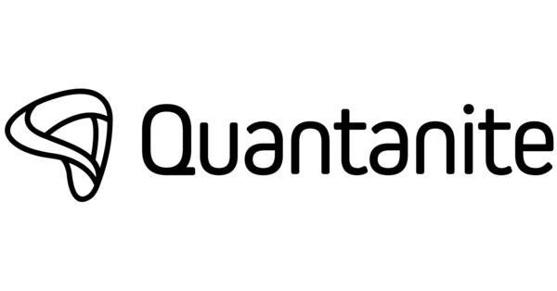
Internship Report
on
“Quantanite’s Internal Control System in Fraud Prevention”
Table of contents

Executive Summary 7
Key Words 8
Chapter-1 9
Introduction 9
1.1 A Brief introduction of the work 9
1.2 Importance of internal control in case of fraud prevention 9
1.3 Objectives of the study 9
Chapter-2 11
Overview of the company 11
2.1 Company at a glance 11
2.2 Mission and Vision 12
2.3 Meet the team Quantanite 13
Chapter-3 15
Recognizing fraud in BPO companies 15
3.1 Definition of Fraud 15
3.2 Types of Fraud in BPO 15
3.3 Impact of fraud in Business Processing Operations 17
Chapter 4 18
An overview of the internal control system at Quantanite 18
4.1Risk Assessment 18
4.2 Control Activities 19
4.3 Communication and Information 20
Chapter 5 21
Fraud prevention measures at Quantanite 21
5.1 Implementation of Fraud Risk Assessment procedures 21
5.2 Enhancing the effectiveness of Control Activities against fraud 21
5.3 Strengthening Channels of Communication and Information against fraud 22
Chapter-6 23
Case Studies and their best practices 23
6.1 TECHNOLOGY 23
6.2 LOGISTICS, DELIVERY 24
6.3 FINANCIAL SERVICES 25
Chapter 7 26
Methodology of the Study 26
7.1 Type of data: 27
7.2 Data collection processes 28
Chapter-8 29
Findings and Analysis 29
Chapter-9 31
Conclusion and Recommendation 31
Conclusion 31
Recommendation 32
References 33

Executive Summary
Quantanite is the leading Business Process Operations (BPO) company, operating in a high-risk environment where every client’s data is very sensitive and can cause potentially fraudulent activity anytime soon. This report gives an overview of the company’s Internal Control System (ICS) and the role it is following in order to prevent different sorts of fraudulent activities. The report is based on numerous research which I have gained from the internship and through practical experiences, with the goal of evaluating Quantanite’s ICS how strong and threating it is in terms of tacking fraud and areas for improvement.
BPO companies like Quantanite, has to go through these types of troubles which includes the fraud with an aim of harming the stakeholders and for their own benefits as well. These fraudulent activities include theft of data, billing fraud, misconduct of the vendor and false records of data. All of these frauds can harm the company into a bigger level, each type of fraud carries significant operational, reputational, and financial consequences, affecting the company's stability and relationships with clients and stakeholders.
Quantanite’s Internal Control system was always their top priority in order to effectively stand against the fraud risk. On a daily basis in order to have a regular check they have been developing their control activities, communication channels and assessment of risk. The IT team also contributes in enhancing the ICS of the company. Operational excellence and conformity to industry standards are guaranteed by supervisors and certified IT teams.
This report gives Quantanite with practical advices and recommendations to strengthen their ICS and reduce fraud risks. By prioritizing fraud prevention efforts, maintaining open communication channels, and adopting an open and trustworthy culture.

Key Words
Abbreviation | Full Form
BBA | Bachelors of Business Administration
AIS | Accounting Information Systems
BPO | Business Process Operations
ICS | Internal Control System
AI | Artificial Intelligence
CX | Customer Experience
HR | Human Resources
IT Systems | Information Technology Systems
CEO | Chief Executive Officer
COO | Chief Operating Officer
CCO | Chief Commercial Officer
CFO | Chief Financial Officer
CSAT | Customer Satisfaction
LOB | Line of Business
KPI | Key Performance Indicator

Chapter-1

Introduction

1.1 A Brief introduction of the work
Quantanite is a leading Business Process Outsourcing (BPO) company renowned for its effective service delivery in a wide variety of sectors. This company operates in a high-risk environment where fraudulent possibility is also very high, because its workforces handle sensitive data and vital operations. The content of this paper, which covers almost all of my internship. It also shows the essence of broad, practical instructions that is a component of the real-world practical application of my Bachelor’s degree. Both the report and the fieldwork experience center on the close inspection and assessment of selected elements related to Internal controls at Quantanite BD. The importance of this report supports the academic knowledge which I have gained in my BBA in AIS program which likely helps to understand better how internal controls are being operated in better ways inside a company.

1.2 Importance of internal control in case of fraud prevention
When it comes to fraud it is a significant threat to any organization and a BPO company like Quantanite are no exception. The most crucial initial line of security against fraud is an internal control system that helps in the detection, prevention and prohibition of fraudulent behavior. For the company to successfully reduce the risks, Quantanite needs to develop strong internal control processes, especially considering how open BPO companies are to fraud. It poses a serious threat to a company because it can result in the losses of money as well as one’s reputation and might even fall into legal consequences. This report will dive into the role of Quantanites internal control system (ICS) in fraud prevention.

1.3 Objectives of the study
The primary objective of this report is to evaluate the existing ICS of Quantanite in order to understand it’s strengths, weaknesses and the areas for improvement in preventing fraud. Enabling Quantanites information about the nature, types and effects of fraud that are very common inside the BPO industry, so that they can adjust their internal control systems (ICS) more accurately. Reviewing and explaining the importance of major components in the prevention of fraud, including the control environment, risk evaluation, control operations, information and communication and other monitoring operations. Illustrating practical strategies and real-world examples of successful internal control instances of fraud incidents in BPO firms, from which Quantanite can learn significant facts and best strategies.
The value of ongoing internal control monitoring, assessment and improvements in order to alter the changing fraud risks and regulations and to maintain the long-term effectiveness of fraud prevention plans. This report seeks to offer Quantanite with practical knowledge and suggestions to enhance their ICS and successfully to reduce the ongoing risks related to fraud in their operations by carefully addressing these objectives.

Chapter-2

Overview of the company

2.1 Company at a glance
The company was established in 2014 and has its headquarters in the UK, involvement of 2,000 people across four continents. It provides businesses with a high-tech, customized strategy for providing outstanding full-lifecycle customer engagement and supporting back office digital services more quickly, efficiently and at a lower cost. The past 10 years of the company till now are given down below:
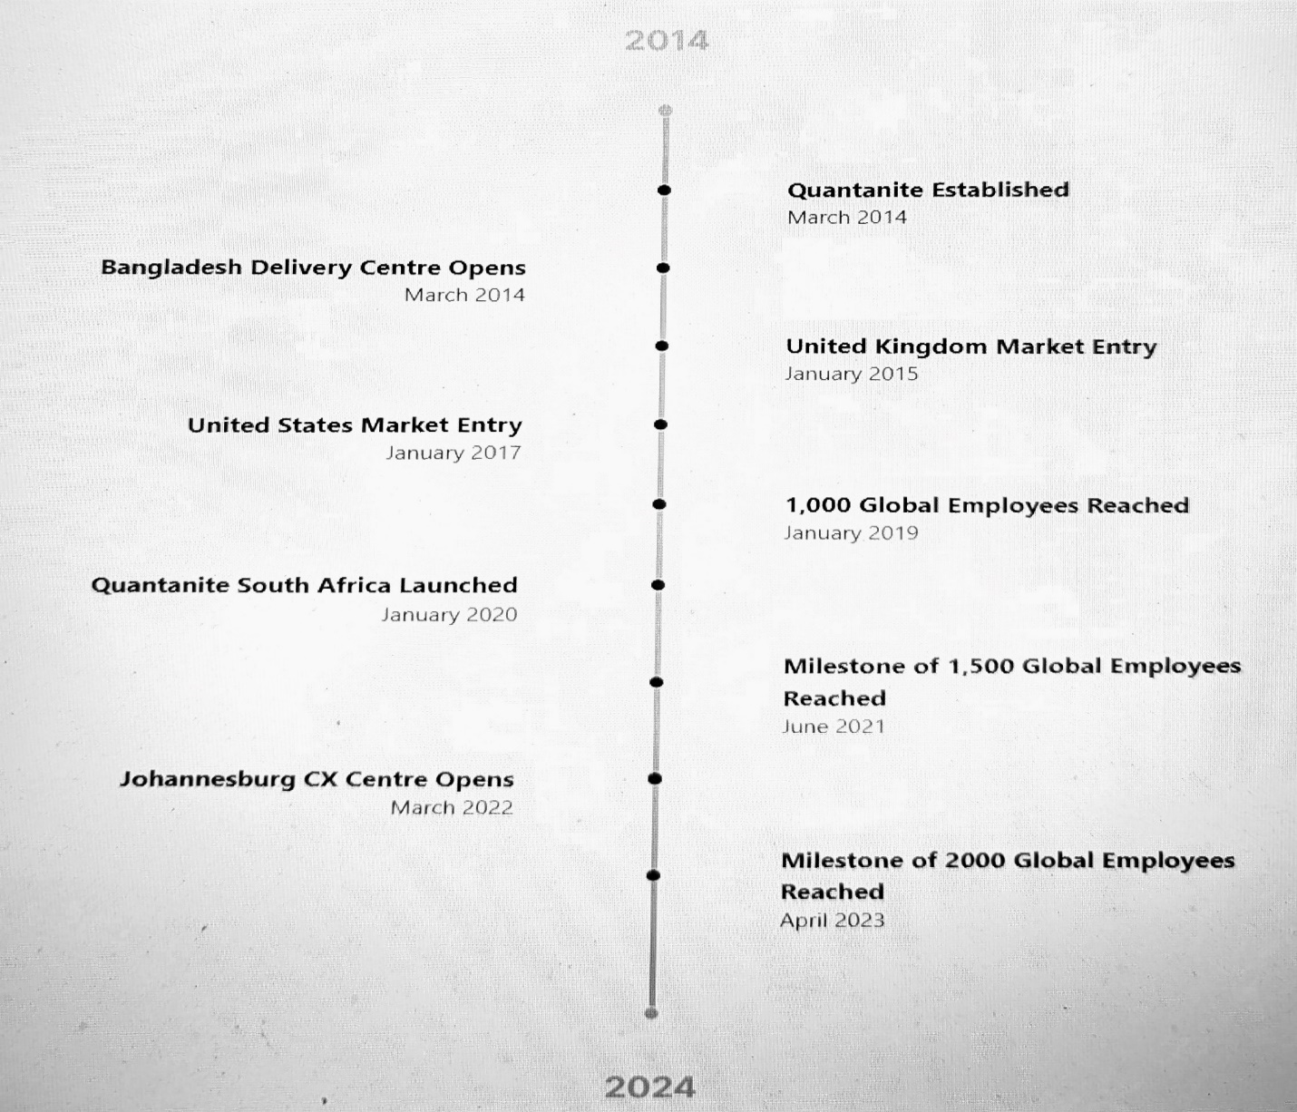

2.2 Mission and Vision
Built for Service
“Our Values Guide
Our Decisions and Actions”
Quantanites Mission and Vision are being discussed more elaborately down below:
We are super driven, pushing our limits and others to constantly go above and beyond what our clients request or anticipate for each of us.
We think about growing on all fronts, expanding our business, expanding our client base, and encouraging the individual growth of each employee.
We are entrepreneurial, seek them with ambition, and distribute the value we deliver because we are enterprising.
We deliver a unique service to our clients, they provide a special service to our clients, their customers, and our fellow employees.
We hold ourselves accountable, improving results for every individual involved by providing our employees the tools they need to do effectively.
They appreciate each interaction as a chance for insightful talks and worthwhile conversations, and we actively promote positive experiences for both clients and staff. This is effortlessly accomplished by the conversational Gen AI through complete automation, improving agent effectiveness and understanding.

2.3 Meet the team Quantanite
Arteya joined as the group’s newest Chief Executive officer (CEO) in January 2022. Since, mid 2020 he has been serving as an advisor to the company.
Rachel began started her career as a call center representative, invested herself in diversity of customer interactions. She led an outbound short-term insurance campaign over 18 years, growing its staff of associates, CX agents, and underwriters from 5 to over 70. Currently, she is the director of client services. Anirban senior executive with 25 years of global experience, adeptly manages risks and leads diverse teams. He is a successful operations house guy, who has been delivering positive outcomes for the company.
Fuzi served 9 years in financial services sector in various lines of businesses, after that she transitioned herself into the BPO industry, focusing on customer experience and shared services. Currently, she is working as a HR Director for the company. The big transition she took from financial services being a HR at Quantanite made her the best suitable woman for this position. David Earlam is an industry veteran with more than 30 years of contact center experience. In his Chief Operating Officer (COO) role at Quantanite he is being recognized for delivering outstanding commercial performance and compelling client value. Aulia Rehnuma joined at the year of 2015 as an analyst. Aulia has risen to Director of operations in Bangladesh, overseeing the company’s progressive growth. She works closely with the leadership team.
Andrew Hall as a Chief Commercial Officer (CCO) has focus on working with clients to develop relationships and solutions that truly matters and creates significant outcomes for both the company and customer experience. Maesha Hasnat as a DOP manages more than 500 team members and over 40 client accounts out of service for delivery in the Dhaka, Bangladesh. She has returned to Quantanite and formed a 24/7 support content moderation campaign. Atif Hafeez is the (CFO) Chief Financial Officer with an additional quality, who is also the board member with a wide range of international experiences from other companies. Mikko Tamminen who founded the company in 2014, he wanted to do BPO in a very different way by focusing on supporting ambitious organizations. He developed a warm, friendly culture which helped Quantanite a popular employer today, something which Mr. Mikko was passionate about. The following organization members are given down below with their following positions:
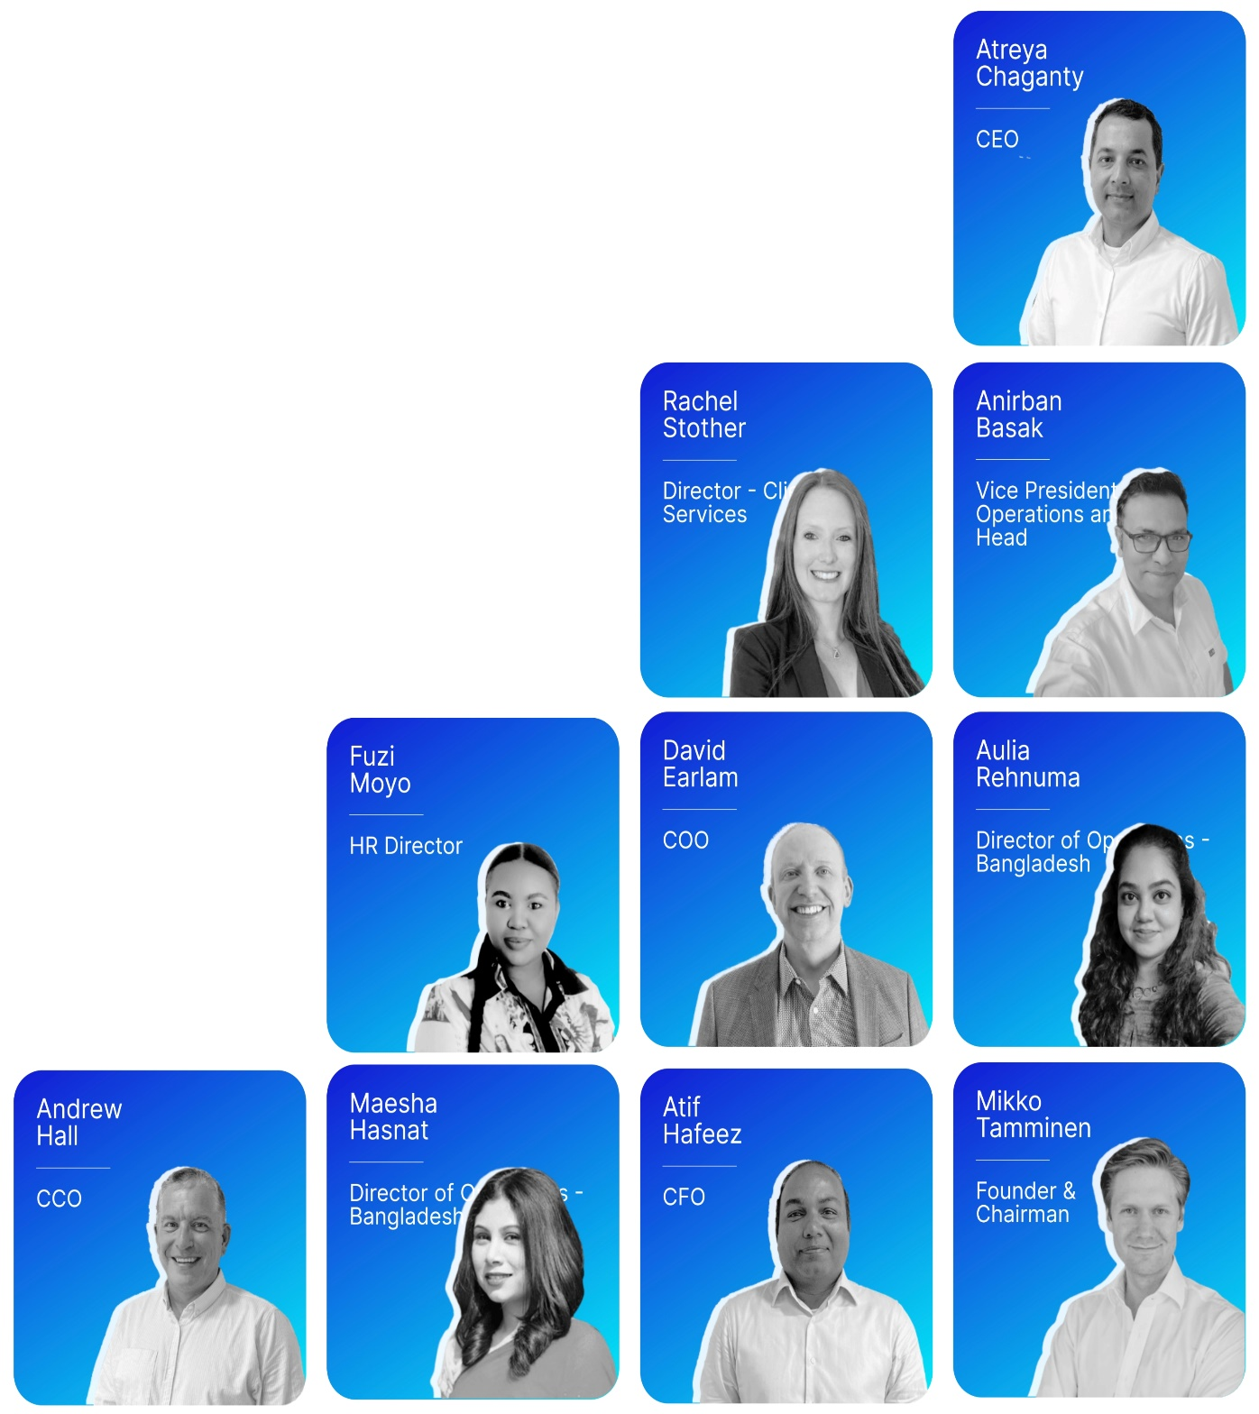

Team Quantanite

Chapter-3

Recognizing fraud in BPO companies

3.1 Definition of Fraud
Fraud inside Business Process Outsourcing (BPO) companies can be defined as an intentional and dishonest act carried out by the people of the company it could be done both from inside and outside. The main aim is to earn a huge sort of money by doing fraud. Sometimes it is also done in order to harm their fellow stakeholders could be of their personal or no-personal reasons. The activity of fraud can be of many variations, it could be done with sensitive data, asset utilization, misrepresentation of financial data set, services linked to Quantanite or other BPO company services, manipulation among clients, operations etc.

3.2 Types of Fraud in BPO
Frauds in BPO companies are of various form which can have significant operational, reputational and financial consequences, which likely affects company’s other situations such as the regulatory board, profitability factor, client connections and other business sustainability issues. The following fraudulent types are given below:
Theft of data, inside BPO companies sensitive data misuse or unlawful access are illegal activities planned to obtain or utilize exclusive business information or intellectual property. These would cause serious risks to the company’s security, laws and reputation. For example, our main client is Door Dash currently. It is strictly prohibited that the information of our clients on whatever the project is running cannot be shared to the other project holders and the other clients. This would breach the contract of sharing data and lawful regulations are being placed for these sorts of activities. Such breaches can cause loss of financial, reputation and client’s trust as well.
The fraud of billing, in BPO firms like Quantanite billing fraud refers to the unethical practice of billing clients for services that were not actually provided or paying ridiculous charges for services which actually occurred. This type of fraudulent activities breaks the clients trust and eventually, makes the documentation of financial information as a false statement and may causes a loss for the company as well as the client. Invoices do not mean anything to the company as fraudulent activity eradicates its worth. For example, the project associates of the company receive their bill through NAGAD application and with that they are given a certain invoice number. However, at the end of every month a bill sheet is being given in order to match the invoice number with the transferred money through the application. The matching of the invoice number will prove that if there is any fraudulent activity related to it or not.
Fraudulent actions by vendors, at BPO companies, vendor misconduct refers to unethical conduct when it comes to the interaction of outside vendors. This could involve setting up a wrong invoice detail for the service, manipulation in the bidding and negotiating process for any particular project, bribes for setting up a project deal that was out of reach for the company etc. These dishonest activities harm the client and vendor’s trust, which likely leads to a cancellation of the project contracts. For example, if a certain project of Door Dash, which is Quantanite’s client is not likely meeting the demands by the working procedures of Quantanite, the project might end up into a failure contract, however if there is bribe offered as an incentive for taking the project, when it is not suitable, then it goes against the ethical laws of the company which likely results in a fraudulent act as well.
Maintaining records fraud, the fraudulent deception and modification of documents, paperwork, or financial statements is well known as maintenance of recording false data in BPO companies. This type of unethical practices intent to mislead the stakeholders, hiding illegal activities, alteration of the financial performance. Disclosure is compromised, disorganized when it comes to decision making and eventually, they might face legal issues as well. For example, Door Dash and Quantanite makes a deal for 1 year of running 24 projects and they gain a huge amount of revenue from it. In the following year the stakeholders from another company might approach for an investment and the particular investment will be done after reviewing the income statement of that company, as it shows the performance of the company. So, if the statement is misrepresented it gives a false idea to the stakeholder about the company which likely gives a misleading idea about the capacity of the company as well.

3.3 Impact of fraud in Business Processing Operations
Quantanite being a BPO company, the consequences of fraud are very severe as it affects the financial stability, company’s reputation and legal conditions. The financial losses can occur into two different ways it could happen directly and indirectly as well. The direct losses are mainly the frauds occurred in investments or fundings for the company. The losses that come directly are hard to regain and with it the company needs to bear the indirect losses as well which is hiring an external investigator, regulatory fines are being imposed, cost of rectifying fraudulent transactions etc.
When it comes to the reputation of BPO companies, it is the most crucial factor for them as they are handling client’s sensitive data, the backhand work before handling the final ending data. So, they will be attracting different businesses by their reputation of work, fraud can tarnish the whole reputation of the company. If the client loses its integrity and reliability, they might stop handling projects with the company and eventually the company will suffer from gaining their targeted revenues. And lastly, the brand value can also be affected which would likely make the company less competitive in the market place.
The fraudulent activities will drag the company to legal consequences, where the clients will file a lawsuit against the fraud acts and the victims of those actions will also have to face those troubles. There will be fines, sanctions and maybe the license can also get dismissed forever. Investigations will be there in many terms where the company need to bear those extra charges for those fraudulent acts.
Dealing with overseas client is very sensitive when it comes to the protection of data and the records of the company. So, it is highly risky when it comes to fraud, in order to prevent those controlling measures needs to be taken very cautiously to fight against any small or big fraudulent activities.

Chapter 4

An overview of the internal control system at Quantanite

4.1Risk Assessment
In order to identify and assess the potential risks that might prevent the achievements and goals of Quantanite, they need to frequently conduct thorough risk assessments as part of its commitment to strong risk management. The whole process of risk assessment starts with analyzing the company’s internal details, external environment and functional landscape.
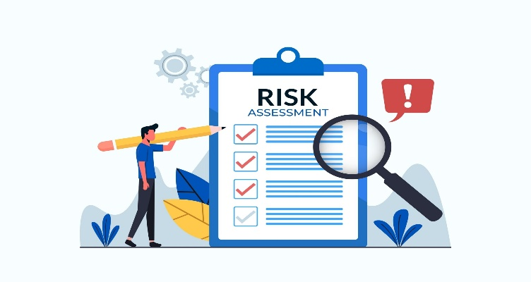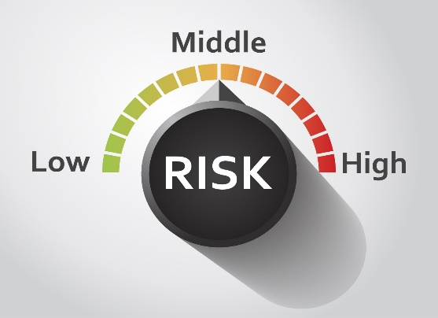
Recently, Quantanite have introduced a chip similar to pen drive named “yubico” where the internal details of an employee are very much visible to the authority. In order to, detect and monitor their activities so, that they do not engage themselves into any sort of misconduct or does not break any code of work ethics, which might hamper the work system of Quantanite and their clients Door Dash will stay up to date about their project as well.
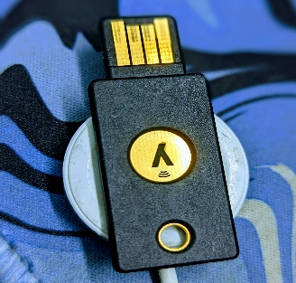
Then, every risk that has been identified goes through an intense assessment procedure, where its probability of occurring and its potential impact on the goals of the organization are thoroughly investigated. Using the current data and past data of all employees, financial data, yearly project data all of them are being examined and predictive analytics is being done to determine the likelihood of each risk happening and the extent of its effects.

4.2 Control Activities

Now moving to the control activities, they are the foundation of Quantanites internal control system consisting of 3p’s which are an extensive range of policies, procedure and processes that are carefully designed, in order to reduce the risks and advance the company towards their strategic goals. To achieve the operational excellence, Quantanite have their own certified IT team who does the research for maintaining a positive financial reporting, following complex web laws, work according to their industry standards (BPO) and ensures constant compliance. There are supervisors who are constantly monitoring the work for each department, to have a safe ground when it comes to control activities. Quantanite has a complex control framework with an assortment of examples of control activities, all carefully planned to address specific threats and maintain organizational integrity. A division of duties is one such important control procedure that prevents a centralization of power and reduces the risk of fraud or error by clearly organizing and assigning responsibilities across various people or departments. Maintaining a check on the possibility of inappropriate influence or manipulation, this basic principle provides safeguards and checks within the organization's structure.

4.3 Communication and Information
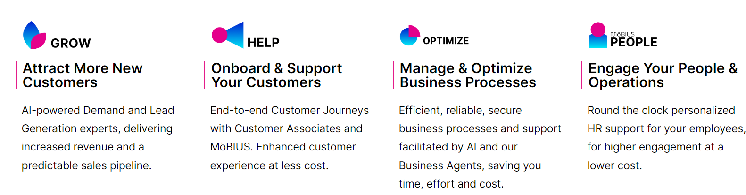
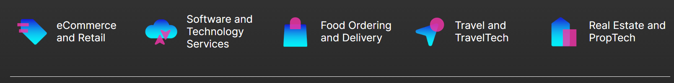
Quantanite encourages accountability and transparency by offering employees frequent training, awareness campaigns, and reporting channels. Effective channels of communication guarantee that relevant information about fraud risks and solutions is shared throughout the entire company. The organizational ecosystem at Quantanite depends on the smooth flow of information, which additionally enhances the effectiveness of internal control system and decision-making processes as well. For example, Quantanites client Door Dash introduced about the yubico chip usage how they can be connected with all the detailed information regarding their project with Quantanite, the details include such as employers working on their projects, the number of projects running inside the company for Door Dash, the financial information, reporting data etc. Quantanite has established a strong framework that includes sophisticated databases and a variety of communication channels because it understands the critical role that accurate and timely information transmission plays in ensuring that important information, insights, and instructions circulate freely and efficiently to the all levels of the company. On top of that, Quantanite makes sure that use of developed spectrum of communication channels and information systems that allows the smooth sharing of information between stakeholders which includes clients, customers, government officials, auditors, and external partners. These information systems have been optimized to collect, handle, and distribute a wide variety of data types, from operational KPIs and financial metrics to market research and customer reviews.

Chapter 5

Fraud prevention measures at Quantanite

5.1 Implementation of Fraud Risk Assessment procedures
Quantanite conducts a thoroughly examination of its internal control systems and business processes, in order to identify areas vulnerable to fraud. This may include high risk areas such as financial transactions, recruitment process, handling data systems, employer’s activities etc. Once the likelihood risks are identified, Quantanite will start working on it as they already have the historical data, which would help them to act well on their potential fraud risk. As mentioned earlier they have yubico chip where they have certain information which includes both internal and external data, it would likely help them in tackling their potential fraud risk and they will be cable enough to overcome these risks through a positive risk assessment. Following the assessment process, Quantanite ranks fraud risks according to importance considering things such as like potential financial impact, potential chances of occurrence, legal consequences and negative brand image of the company. Quantanite would be able to concentrate and give more attention to the most serious fraud threats first, because of prioritization of the fraud risks. The fraud risk assessment is an ongoing process at Quantanite and they have made it a necessity for them to have a safe BPO environment for their stakeholders. The company makes sure that maintaining a dynamic and flexible approach to fraud risk assessment would result in strong prevention against fraud.

5.2 Enhancing the effectiveness of Control Activities against fraud
A key element of Quantanites internal control framework for stopping and identifying fraudulent activity is known as the control activity. As it has been mentioned earlier that by putting out the 3p’s which is the process, procedure and policies into their places where the company can more effectively reduce identified fraud risks, which is going to reinforce these control activities. Quantanite utilizes strong approval and authorization processes to guarantee that all decisions, transactions, and activities follow the rules and guidelines that have been set out. Quantanite implements physical controls as well to safeguard against theft and misappropriation. In order to track properly they use measures such as installation of the surveillance system, management procedures and adequate track of their company’s project. Lastly, Quantanite enhances its IT controls in consideration of the growing reliance of the business operations on modern technology to reduce the risks related to any sort of cybercrime, breaches of data, unauthorized access to information etc. By comparing and verifying these data sets the company can detect and address the potential frauds in timely manner. Quantanite IT control is well known for it’s work inside the organization; they have skilled IT workers who have the control to stand against any type of potential fraud incidents.

5.3 Strengthening Channels of Communication and Information against fraud
Communication and information sharing are one of Quantanite’s most important prevention strategy against fraudulent activities and enables detection in timely manner. Enhancing external and internal information flow and promoting trust and openness within the company are all part of strengthening information and communication channels. Quantanite gathers, processes, and distributes relevant information to stakeholders quickly and efficiently by utilizing innovative information systems and communication technologies. They have high quality of e-commerce and retail work with their clients, which likely helps them to stay connected with their clients and stay updated as well. In a way they are avoiding potential fraud risks by staying connected with their clients, as there will be no third party who is going to make any sort of intervention. Channels of open and honest communication with outside parties, such as customers, suppliers, authorities, and auditors these are some of the ways creating strong communication channels reduces the potential fraud risks. Quantanite encourages feedback from staff members and other stakeholders. To provide channels for people to voice concerns anonymously and without fear of harm. Quantanites provides regular reports and updates on fraud prevention efforts, internal control effectiveness. These reports represent advancements, draw attention to problematic areas, and request feedback for future growth.

Chapter-6

Case Studies and their best practices
The success stories of Quantanite are huge in numbers a few of the 1000+ clients they have helped so far to grow. However, the official website has listed the top 28 success stories of the client. Some of them are shared down below:
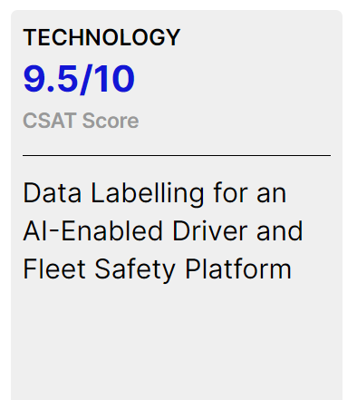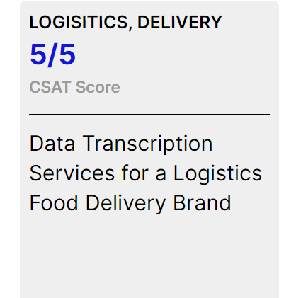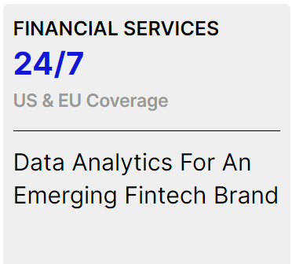
The following case studies and their practices include clients overview, their challenges with the solution and the final results they have achieved throughout the work are all given down below:

6.1 TECHNOLOGY
Client Overview | The Challenge | The Solution | The Results
Through the use of AI, client's platform can identify and prevent high-risk situations for companies and people in real time. With over 1 billion video miles analyzed, their machine learning continuously enhances driver behavior to prevent incidents. | - Reviewers get knowledge about handling infinite complex situations, traffic rules, and 24 steps.  - Customer needs reviewers from different countries and time zones, and support 24/7.  - 99% accuracy ratings should be maintained in all operations. | As an internal quality assurance (QA) team, a 20-person "buffer team" covers delays, audits and coaches’ current members, and deals with wastage. In-house training and internal escalation teams work together to review complex events, speed up onboarding, and offer feedback. While analyzing human behavior helps in reaching accurate conclusions, specialized training in data labeling, including multi-dimensional labeling, refines accuracy. | - 80% growth in team size since inception  - KPI’s Achieved based on team performance, quality and overall partnership  - Acquired additional LOB, formerly handled by a separate vendor  - 24/7 support provides superior customers success rates

6.2 LOGISTICS, DELIVERY
Client Overview | The Challenge | The Solution | The Results
The client is an online food delivery business and leading the largest food delivery network. Our client is the largest food delivery network and operates an online meal delivery service. In addition to serving a key role in the growth of the technology sector in the Canadian Prairies, they are still pushing the boundaries of technological innovation necessary to shape the future of food delivery. | - Fast-paced provider needed for handling time and volume challenges.  - During the COVID pandemic, they hired more people to better assist their customer base.  - Selecting appropriate assignments from large queues.  - Restricted to work on corporate tasks. | AHT analysis and client communication are essential. Track skimming for additional liquid activities. Week after week volume issues is settled by the reinforcement team. Google Homeroom is utilized to guarantee exclusive expectations in preparing and meets. Administrative center administrations effectively handle a variety of data processing needs by including menu creation and updates, ad hoc project work, data entry and management, transcription, and document indexing and archiving. | - Consistently achieving 5/5 for CSAT.  - Grew the account from 10 associates to 105 in a very short period of time.  - Quantanite was retained as an outsourced vendor despite our client being acquired and removing other vendors from their preferred list.  - Other corporate project LOB wins.

6.3 FINANCIAL SERVICES
Client Overview | The Challenge | The Solution | The Results
Our client is an analytics platform developer that uses artificial intelligence (AI) to navigate through millions of corporate, commercial, and other financial data sources each day with the goal to assist users in making better investment decisions. | - Analysts that are outsourced clean data and create insights for financial projects.  - Extremely data-heavy industry  - Struggling to aggregate data quickly enough, whilst still managing day-to-day workloads | Specialist finance and accountancy team undergoes thorough training and monitoring, which promotes continuous improvement and a customer-centric mindset. The solution expands to include project managers and team leaders, improving proficiency. Services span data entry, management, analytics, transcription, and document indexing, meeting diverse needs with quality and efficiency. | - Quantanite became a natural extension of our Client’s Company without having to deal with the hassles of recruiting, supervising, and training staff.  - 24/7 coverage supporting both US and European markets.

Chapter 7

Methodology of the Study
In this section, I have provided a detailed description of the methodological framework that formed the basis for the in-depth examination of internal controls at Quantanite Bangladesh. This methodology was not picked at random rather, it was a conscious decision made with the goal of guaranteeing a methodical and challenging approach to each and every aspect of data collection, analysis, and interpretation. This methodological accuracy is not just a matter of procedure rather, it closely aligns with the high level of academic quality required for a BBA in AIS internship.
The methodology of this study highlights the thoughtful placement of components for a strong structure, much like the blueprint of an academic building. In order to acknowledge the crucial relationship between data consistency and insight quality, accuracy in data collection, analysis, and interpretation is highlighted. A blend of primary and secondary data sources enhanced the study's depth and scope. Primary data, obtained directly from Quantanite Bangladesh, is acquired through structured interviews, questionnaires, document reviews, and observation. This direct engagement ensures an intimate understanding of internal control mechanisms from those involved, surpassing mere theoretical understanding. The methodology's secondary data component includes a thorough examination of research papers, industry reports, and company records. By ensuring an interconnection of data where insights from primary and secondary sources converge this two-tiered approach strengthens the study's reliability and accuracy. Another integral aspect of the methodology involves a legislative benchmarking exercise. A comparison between a number of legal and regulatory requirements and Quantanite's internal control and fraud prevention measures was a part of this analysis. These include recognized international standards such as the U.S. Sarbanes-Oxley Act of 2002, as well as domestic laws in Bangladesh such as the Companies Act of 1994 and the Corporate Governance Guidelines of the Bangladesh Securities and Exchange Commission (BSEC) of 2012. Maintaining efficient internal controls depends in large part on compliance with these regulations.
In addition to conducting interviews, distributing structured surveys to a wider range of staff members expands the collection of available data. This approach guarantees an accurate representation and adds a quantitative part to the experiences and perceptions surrounding internal controls. Moreover, document reviews provide a thorough analysis of internal documents, such as policies, procedures, risk assessments, and audit reports, which add to a thorough theoretical understanding of the company's internal control framework.

7.1 Type of data:
The study applied an ethical combination of both primary and secondary data sources, delivering a variety of viewpoints of Quantanite BD’s internal framework.
Primary data
Interviews | Questionnaires
Interviews with key personalities such as the management, staff and auditors were conducted to gain insight into the effectiveness and some practical applications of internal controls. | Structured questionnaires provided an in-depth knowledge of the company's culture by collecting employee insights on internal controls, policy interest, and problems with reporting.

Secondary data
Industry Reports | Company’s data
Studied documents included diagrams of operations, financial statements, annual reports, and other relevant company records that served as a framework for the analysis. | Quantanite’s best practices of internal control along with their prevention strategies against fraud by consulting published report and studied other sources.

7.2 Data collection processes
The data collection process of Quantanite was done through proper planning and cautiousness. As I have mentioned earlier both primary and secondary data collections ways were applied, in order to gather information. Starting from interviews, to virtual meeting with the HR and Supervisor to gain the insights of BPO industry and some company insights. A documentation was also provided where I did my own research from those documents. Random sampling has been done in order to go through for surveys, where I picked individual supervisor from the supervisor’s group in order to gain my information. The secondary data set I have collected was from numerous sources which includes company’s websites, articles, statements as well as the sensitive data set of the company which was handed by the HR. All of these things were primarily focused in internal control and the strategies to prevent fraud by making the internal control system strong for the company. Data collection occurred from February to mid-March 2024, followed by analysis and report writing to ensure a timely conclusion. Overall, the methodology aimed for depth, relevance, and comprehensive examination of internal controls within the specified scope and timeframe.

Chapter-8

Findings and Analysis
A SWOT analysis of Quantanite has revealed its internal strengths and weaknesses, as well as the external opportunities and threats in its operating environment. The table below shows a swot analysis for Quantanite.
STRENGTHS  Skilled workforce  Strong Internal Control System  Strong IT Team  Employee Well Being | WEAKNESS  Challenges in expanding activities  Skill Alignment with the emerging industries  Enhancement needed in internal communication
OPPORTUNITIES  Expansion in Emerging Sectors  Automation Technologies  Partnership | THREATS  Risks in cybersecurity and data privacy  Increase in new market entrants

Strengths
Quantanite excels when it comes to the skilled, diverse workforce delivering the highest quality BPO services to their foreign clients their journey, records and yearly revenues speaks their company’s resume. Their strict internal controls ensure their regulatory compliance and data security. Their initiatives to develop their employes and goes for talent hunt as well. Their global presence through their BPO service has been phenomenal so far in the market which likely gives an assurance to their clients, in order to rely on them and maintain their loyalty towards them. And lastly, Quantanite’s IT support is the backbone of their company, with rigorous talent in IT department of Quantanite. One of the reasons where Quantanite is right now is because of their talented enthusiast IT team.

Weakness
Quantanite has certain drawbacks despite its strengths. These could include the expanding activities where they face a budget orientated issue. As they are dealing with each client in each year, but with more than 2 projects. So, if expansion is done, they could have start dealing with multiple clients with more multi projects which would likely raise their profitability level for the company. There has been a lot of BPO services coming in the way of Quantanite has a competitor so, its high time Quantanite start looking for people in their company with diverse skill set of people or people from all sorts of profession. The internal communication of Quantanite is not up to the mark as different teams have their own team leader and their supervisor running the projects, but each team does not have any idea about one another, neither about their project nor about their team members or supervisors.
Opportunities
Growth and diversification are available in the BPO industry. It is possible to generate additional revenue by diversifying service offerings into new industries. Service efficiency and creativity can be increased by utilizing automation. It can further strengthen its capabilities and market position through partnership.
Threats
The BPO industries are exposed to a lot of external threats. Data privacy and cybersecurity is one of the most important risks they are with, as the company provide services are all related to sensitive data of their clients. To reduce potential breaches and compliance issues, cybersecurity risks and data privacy regulations require constant monitoring and investment. Lastly, a threat to Quantanite’s market share is its increase in competition among the other BPO companies.

Chapter-9

Conclusion and Recommendation

Conclusion
After examining Quantanite’s internal control in detail. It has been discovered that the company’s strengths and areas for development are all built artwork that is being undone. The company’s effort to strengthen internal controls are outstanding. However, there are some drawbacks that needs close attention as well. The company's resilience against potential risks must be ensured by addressing risks even in the face of strong controls and established procedures. Quantanite BD needs to constantly strengthen its internal controls in order to navigate challenges effectively and maintain its success.
The importance of Internal control system, in the prevention of fraud in BPO companies like Quantanite has been highlighted in this report. The aim of this research intends to improve Quantanite's capacity to identify, prevent, and reduce fraudulent activities by evaluating the company's current ICS and identifying areas for improvement. By using realistic methods, real case studies, and continuous evaluation and observation. Quantanite may strengthen its fraud prevention measures, safeguarding its resources and sustainability over an extended period of time. The aim of this research intends to improve Quantanite's capacity to identify, prevent, and reduce fraudulent activities by evaluating the company's current ICS and identifying areas for improvement. By using realistic methods, real case studies, and continuous evaluation and observation. Quantanite may strengthen its fraud prevention measures, safeguarding its resources, positioned and sustainability over an extended period of time. Through the implementation of this goals, Quantanite will able to reduce its fraud risks by upholding a strong internal control and structure the company in the most demanded list inside the BPO industry.
In summary, Quantanite has established a strong strategy against the fraud by putting all the measures in right control. The company strengthens its defenses against fraudulent activities by strengthening communication channels, improving control activities, and conducting thorough evaluations of fraud risk. Quantanite protects its operations, assets, and reputation by reducing the risks related to fraud through early detection and continuous monitoring. Lastly, Quantanite is approaching with a commitment to its stakeholders with a safe and reliable BPO environment by prioritizing in the elimination of all sorts of fraudulent activities.

Recommendation
The main focus of Quantanite should be on enhancing its internal control polices and procedure. Strengthening approval and permission systems to guarantee that the proper levels of evaluation and supervision are applied to all decisions, transactions, and activities. The risk of illegal activity can be reduced by setting up multiple levels of verification processes for large transactions. Improving IT security measures to reduce the risk of cyberattacks and unwanted access to private data. To protect against cyber threats, this may require setting up surveillance systems and other online safety measures.
Another focus should be on the regular check of the fraudulent activities. Where the risk assessment procedure, control activities and communication channels are all running well or not. Implementation of continuous monitoring in fraud risk would guarantee a safe non-fraud working environment. Moreover, it would be matter of appreciation if they could settle a complete separate department for the company in order for the detection of fraud as well as making sure if the internal control system is running positively.
Lastly, Quantanite should change their working procedures to AI automation as the work they are handling right now puts up a lot of research and analysis and then input of data is being done for the end user which is our clients. Advance technology would really make the work easier and less time consuming. So, if the new automation set up is being done for the company, then the upcoming employees who will be working for Quantanite in the near future will get the training of it and eventually, they can help the company grow with more sustainable projects.

References

- Quantanite. (n.d.). Insights | Quantanite. https://www.quantanite.com/blog/
- Quantanite. (2024a, February 21). MÖBIUS grow | Attract More New customers | Quantanite. https://www.quantanite.com/grow/
- Quantanite. (2024c, March 19). About us | Quantanite. https://www.quantanite.com/about-us/
- Quantanite. (n.d.-a). Case Studies Archive | Quantanite. https://www.quantanite.com/case-studies/
- Quantanite. (2024, March 4). People and technology UNLEASHED | Quantanite. https://www.quantanite.com/
- Quantanite. (2024b, March 4). 10 years of Quantanite | Quantanite. https://www.quantanite.com/10-years-of-quantanite/
- Quantanite. (2024a, February 5). Fraud detection and prevention for a digital-first brand | Quantanite. https://www.quantanite.com/case-studies/fraud-detection-and-prevention-for-a-digital-first-brand/
- Fraud detection and prevention for a digital-first brand | Quantanite. (2023, June 1). Quantanite. https://staging.quantanite.com/case-studies/fraud-detection-and-prevention-for-a-digital-first-brand/
- Bloomenthal, A. (2024, February 22). What is Business Process Outsourcing (BPO), and how does it work? Investopedia. https://www.investopedia.com/terms/b/business-process-outsourcing.asp
- Gillis, A. S., Pratt, M. K., & McLaughlin, E. (2023, December 21). business process outsourcing (BPO). CIO. https://www.techtarget.com/searchcio/definition/business-process-outsourcing

END

