
An Analysis of the Human Resource Management Practices of ACI Limited

Submitted To:
Ms.Farhana Rashid
Assistant Professor
United International University

Submitted By
Khadizatul Kubra
ID: 111 143 147
United International University

Date of Submission: 27th August 2019

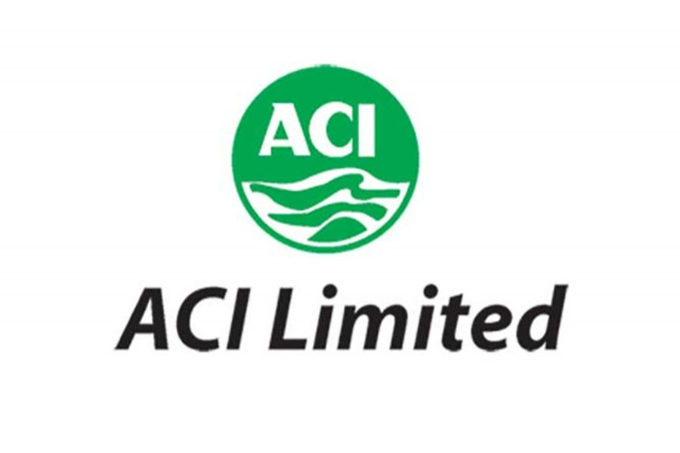

Letter of Transmittal

August 27, 2019
Ms. Farhana Rashid Assistant professor,
School of Business and Economics
United International University.
Subject: Submission of an analysis on the HRM practices of ACI Limited
Dear Madam,
It is with great honor I am submitting this report “An analysis of the Human Resource Management Practices of the ACI Limited.” which I have been capable to prepare with your kind leading. This report is a mandatory part of my BBA degree so I have tried my best to analyze & explain my learning & experience of 4 years through this. I hope that it will successfully convey my effort and induction towards this topic. I have tried my best to display my honest efforts and induction towards my work through this report. I would like to thank you for providing me with this unique opportunity and unconditional support. I therefore request you to accept this report as per the requirement of our University. I would be pleased to refine any and all sort of search regarding this report.

Sincerely yours
______________
Khadizatul Kubra
111 143 147

Declaration

I declare that this report under the title “An analysis of the Human Resource Management Practices of the ACI Limited.” Is an actual work and has been decorated by me for the fulfillment of my BBA degree under the supervision of Ms. Farhana Rashid Assistant professor, School of Business and Economics, United International University.
No part of this report has been taken from any other work that has been submitted to any other University for any bookish certificate.
This report does not contain any part that ecstasies any copyright.

__________________

Khadizatul Kubra
ID: 111 143 147

Acknowledgement

We would like to extend our gratitude to Miran Hossain, HR executive, ACI Ltd. Tejgaon, Dhaka, Bangladesh) for consulting with us and the great cooperation.
I oblige United International University for giving me
This report has been an eye-opener for us and I have been lucky to have the support, assistance and encouragement of a number of individuals while preparing this report, without their support it would be hard to finished this study. We express my sincere thanks to my Institutional Supervisor Farhana Rashid, School of Business & Economics, United International University, for guiding me in completing this study.
With this rich opportunity to take up this chance of practical association with corporate world and I am also thankful for this outstanding journey of 4 years.

Executive Summary

The report “An analysis of the Human Resource Management Practices of the ACI Company Limited.” Has been prepared with the keenness to fulfill the requirement of BBA (Bachelor in Business Administration) degree. It contains an elaborate report on the HR practices of ACI Limited. ACI is the private company of Bangladesh. It has a wide spread operation that runs throughout Bangladesh and outside of it as well. One of the most prominent reasons of success for ACI is its HR department. HR with its many functions ranging from planning of HR to managing changing needs of the modern world creates a flow that keeps ACI ready for any and all of its challenges. This report contains both theoretical and practical information regarding human resource management. Initial chapters include different HR related information that is ideal for any organization and is taught in curriculums. Then there is a very brief representation of the organization, its members, the products and services it provides, different areas it works in and locations in which its branches are situated. There is information about how ACI plans its HR needs and supplies for it, where it recruits candidates from and how employees are selected, the compensation package ACI provides, the types of training ACI arranges for its employees and its orientation method, How ACI appraises its employees, the laws it follows and the way it manages the onslaught of changes thrown in its way. The report then originates to end through a short recommendation and conclusion part. The entire theme and overall ambience has been set to give an idea about what we acquire and how it reflects in the actual course of action. I hope that this report is as perceptive as I have felt while studying for it.

Table of Content

Contents
Chapter 01 1
Company Overview 1
Company Profile: 2
Mission and Vision 9
Chapter 02 10
Analysis of Human Resource Management Practices 10
2.1.0 Human Resource Planning 12
2.1.1 Importance of HRP 13
2.2.0 Recruitment and Selection 14
2.2.1 Recruitment method 14
2.3.0 Training & Development 16
2.3.1 Significance of training & development in organization 17
2.3.2 Motives for training in an organization 18
2.3.3 The belongings of ongoing training on the organization 18
2.3.4 The purposes of Training and Development of an organization 19
2.4.0 Performance Appraisal 19
2.4.1 Significance of performance appraisal 20
2.4.2 Motive of the performance appraisal: 22
2.5.0 Compensation Management 22
2.5.1 Significance of Compensation in the Workplace 23
2.5.2 Motive to consider compensation & Benefit 25
2.6.0 Industrial Relation and Labor Law 26
2.6.1 Three parties of Industrial relationship. 27
2.7.0 Strategic Human Resource Management 29
Chapter 03 30
HR Practice in ACI Company Limited 30
3.1.0 Human Resource Department of ACI 31
3.1.1 HR management design of ACI Company 31
3.1.2 Measuring demand & supply of ACI Company 31
3.1.3 Succession planning 32
3.2.0 Recruitment & Selection of ACT Ltd. 34
3.2.1 Recruitment source of ACI Ltd. 34
3.2.2 Recruitment method of ACI Ltd. 34
3.2.3 Selection Process of ACI: 35
3.3.0 Training & Development: 37
3.3.1 ACI Company’s Training & Development method: 37
3.3.2 Training process: 38
3.4.0 Performance Appraisal 41
3.4.1 Source of information: 41
3.5.0 Compensation Management 43
3.5.1 They provide several things provide: 43
3.5.2 Benefit plan of ACI limited 44
3.6.0 Industrial relations in ACI: 45
3.7.0 Strategic human resource of ACI 45
Chapter 04 47
Findings & Analysis 47
Chapter 05 50
Recommendation & Conclusion 50
Recommendation 51
Conclusion 53
Bibliography 54
Appendix 56
Attached Visiting Card: 59

Chapter 01

Company Overview


Company Profile:
ACI was established as the subsidiary of Imperial Chemical Industries (ICI) in the then East Pakistan in 1968. After independence the company has been incorporated in Bangladesh on the 24th of January 1973 as ICI Bangladesh Manufacturers Limited and also as Public Limited Company. This Company also obtained listing with Dhaka Stock Exchange on 28 December, 1976 and its first trading of shares took place on 9 March, 1994. Later on 5 May, 1992, ICI plc divested 70% of its shareholding to local management. Subsequently the company was registered in the name of Advanced Chemical Industries Limited. Item with Chittagong Stock Exchange was completed on 22 October 1995.
Advanced Chemical Industries (ACI) Limited, being one of the main conglomerates in Bangladesh with a multinational inheritance functions across the country through its four expanded strategic business unit. ACI Pharmaceuticals is dedicated to progress the health of people of Bangladesh through overview of innovative and dependable Pharmaceuticals products.
ACI Consumer Brands is addition value to the regular life of consumers through its Toiletries, Home Care, Hygiene, Electrical, Electronics, Mobile, Salt, Flour, Foods, Largest integrator in Bangladesh in Agriculture, Livestock, Fisheries, Farm Mechanization, Infrastructure Development Services and Motorcycles. ACI retail chain is the largest retail chain in the nation functioning through its 73 SHAWPNO outlets crosswise the country by moving the lives of over 35000 households each day. The corporation donated Taka 3,625 million to the National Exchequer during FY 2017-2018 in form of corporate tax, custom duty and value additional tax.

- Strategic Business Units:
•Pharmaceuticals
•Consumer Brands & Commodity Products
•Agribusinesses




Pharmaceutical Product





Agribusinesses Product

- ACI has the following subsidiaries:
•ACI Formulations Limited
•Apex Leather crafts Limited
•ACI Salt Limited
•ACI Pure Flour Limited
•ACI Foods Limited
•Consolidated Chemicals Limited
•Premiaflex Plastics Limited
•Creative Communication Limited
•ACI Motors Limited
•ACI Logistics Limited





ACI Food
- Joint Ventures:
•ACI Godrej Agro vet Limited
•Tetley ACI (Bangladesh) Limited
•Asian Consumer Care (Pvt.) Limited
•ACI Consumer Electronics

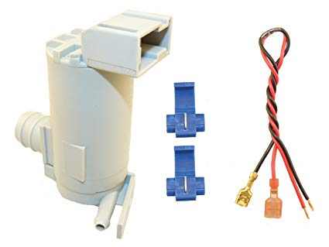



ACI Electrical Product



Antiseptic Product

Mission and Vision

Mission: According to the statement of ACI Limited the explanation of their mission is. “To enrich the quality of life of the people through responsible application of knowledge, technology and skills.” The company also devoted to use the quest of brilliance through producing world class products, original process and authorized employees, they strongminded to provide the highest level of satisfaction to their customers.
Vision: ACI will follow –
- ACI will provide products and services of high and consistent superiority, guaranteeing value for money to our customers.
- Endeavour to achieve a place of leadership in each class of their businesses.
- Develop their employees by inspiring authorization and rewarding invention.
- ACI will support a situation for learning and personal growth.
- Attain a high level of efficiency in all their processes through effective use of assets and adoption of suitable technology.
ACI will promote comprehensive growth by encouraging and supplementary our providers and dealers in improving proficiency.
Values: ACI ensure
- Quality
- Customer Center
- Upgrading
- Fairness
- Transparency
- Continuous Improvement

Chapter 02

Analysis of Human Resource Management Practices



HRM is a strategic approach to handling employment relations which highlights that leveraging people’s capacities is thoughtful to reaching competitive advantage, this being accomplished through a distinguishing set of combined service policies, programs and practices. (Bratton and Gold, 2007). "I highlight this - no matter how good or actual you are or how ingenious or cunning, your commercial and its future are in the pointers of the people you employ". - Akio Morita (Late) (Businessman and co-founder of Sony Corporation. Japan) Ref: The Book : MADE IN JAPAN. Page.No.145 In other words, Human Resource Management (HRM) is a process through which personnel are hired, taken, developed as assets to the success of organizational goals. Personnel are the key element in the structural mix. Without personnel there is no organization, so development them is one of the most momentous tasks of any association. There are different branches of HRM that donates to the overall operative management.

2.1.0 Human Resource Planning
Human Resource Planning or manpower planning is the system which accurate persons are appointed at the accurate place at the accurate time.
Manpower planning is the technique by which a firm approves that it has the accurate number of people and the accurate kind of people, at the correct places, at the correct time, responsibility things for which they are economically post beneficial.
In order to design the human resource, HR Forecasting is directed. Human resource forecasting is a procedure through which an organization approximations its necessity in terms of personnel to reach its strategic goals. HR forecasting includes creating the places the corporation wants to fill, what categories of skills personnel necessitate for places and what challenges the company will appearance as it works to understand its staffing wants.

Factors Affecting HRP

2.1.1 Importance of HRP
- Human resource planning encounters the organization essential for precise type of people in precise number at precise times.
- By keeping a balance between demand for and supply of human resources, human resource planning creates optimum use of human resources, on the one hand, and reduces labor cost considerably, on the other.
- Cautious deliberation of likely future events, through human resource planning might main to the discovery of superior means for managing human resources. Thus, foreseeable drawbacks might be escaped.
- Manpower deficits and excesses may be avoided, to a large amount.
- Human resource planning aids the organization generate and progress training and succession planning for personnel and managers. Thus, it provides enough lead time for internal succession of employees to higher positions through promotions.
- It also delivers multiple gains to the personnel by way of promotions, rise in emoluments and other perquisites and fringe benefits.
- Some of the problems of handling change may be predicted and their significances mitigated. Consultations with affected groups and individuals can take place at an early stage in the modification process. This may evade resistance for change.
- Human resource planning forces management to asses critically the strength and weaknesses of its employees and personnel guidelines on constant basis and, in turn, take corrective measures to progress the situation.
- Through human resource planning, repetition of efforts and conflict among efforts can be evaded, on the one hand, and coordination of worker’s efforts can be enhanced, on the other.
- Last but no means the least, with rise in skill, knowledge, potentialities, productivity and job satisfaction, association becomes the main recipient. Association is helped in terms of rise in prosperity/production, growth, development, profit and, thus, an advantage over its contestants in the market.

2.2.0 Recruitment and Selection
Recruitment is the method of learning potential applicants for real or expected organizational vacancies. Or from another perception, it is a linking action—bringing together those with jobs to fill and those looking for jobs.
Selection is the showing and filtering procedure of job interviewees who have been requested to smear for the vacant places through which the procedure comes to an end”.
This means that recruitment is the process of pursuing out potential people who can turn into resource or asset for the organization. And selection is the method through which the right people are taken from the bunch.
The major difference between the two is recruitment is bulk gathering of people who have the essential skills and competency and selection is hiring the ones best suitable for the company needs.

2.2.1 Recruitment method
There are two methods of recruitment.
1. Internal Recruitment
2. External Recruitment

Internal Recruitment: Internal recruitment is signing people from within the organization. Sometimes in order to escape the whole recruitment procedure, Organizations hire internally. There is no definite system for that. If workers want to join a free spot they have to collect the experience essential for that point, be it through formal degree obtaining or any training technique.
External Recruitment: It is the most common form of recruitment. Whenever a vacancy arises organizations hire employees from different source.
Informal method: Informal way of recruitment is recruitment through the worker recommendation or word of mouth advertising. Sometimes, higher up retain prospective candidates without disclosing the post to the common people, other times employees mention people they deem fitting for the empty place. It is relatively low-cost, since no advertisement is specified.
Formal method: It is the correct way of recruitment. There are many sources of formal recruitment. It is a costly and prolonged process. The sources are:
• Recruitment Advertising
• Employment Agencies
• Public Job Service Agencies
• Private, For-profit Agencies
• Unions
• Campus Recruiting
• Executive Search Firms etc.

2.3.0 Training & Development
Training and Development is a subsystem of an association which highlight on the development of the performance of individuals and groups. Training is an educational procedure which includes the improving of skills, concepts, changing of attitude and gaining more knowledge to improve the performance of the personnel. Good & effective training of employees aids in their skills & knowledge development, which eventually supports a company progress.
Training is about meaningful where you are in the present and after some time where will you feast with your abilities. By training, people can absorb new data, new methodology and revive their current knowledge and skills. Due to this there is much development and enhances up the effectiveness at work. The reason behind giving the training is to make an influence that lasts beyond the end time of the training itself and worker grows updated with the new wonder. Training can be obtainable as skill development for persons and groups.
Training is a prearranged work to simplify the maximum effective usage of individuals through the process of structure job related competency. Development is “an event constituting a new stage in a changing situation.”
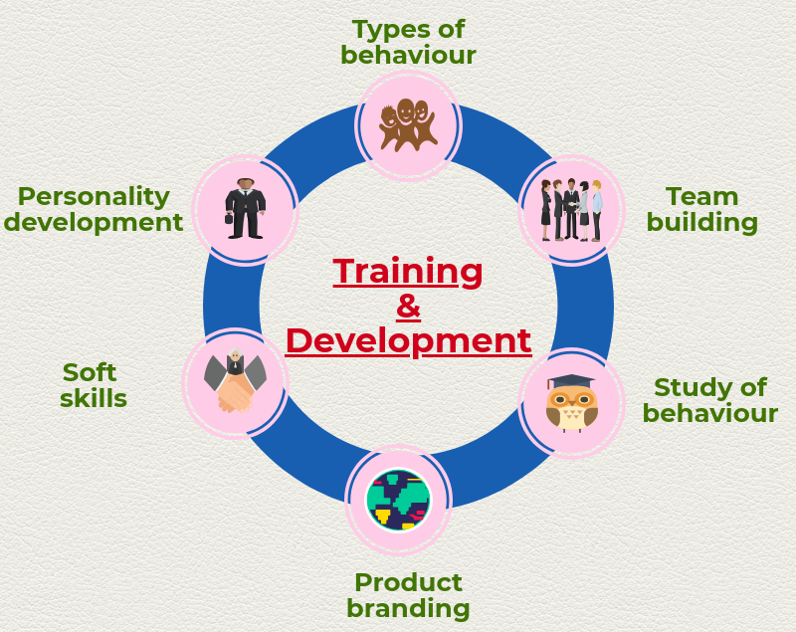

2.3.1 Significance of training & development in organization
Every day a modernization originates into the market. This prepared the association to be energetic in their business procedure and retain on implementing the alterations so that they will be competitive in the market the business owner or HR manager must necessities be energetic and appearance out for the several strategies which aid the organization to raise in the future.
Large administrations usually deliver training to their personnel for better consumption of their services. Also, they identify the importance of training and development effect on the organization. While in case of SME’s they don’t touch much value because they concentrate on every sole amount fill on the business.
In training and development process the personnel don’t concentrate much on project in order to appear the training sessions. That may delay the deadline for the projects. Despite this fact, a large organization owner doesn’t touch for that, because as workers acquire highly skilled the procedure would be much quicker and they can be competitive in the market. With absence of skilled personnel, the procedure and strategies utilize will create the overall procedure slow and the quality may also get affected.

2.3.2 Motives for training in an organization
- Enlarged production and loyalty to quality values
- Growing structural constancy and flexibility
- Diminished observation and direction
- Efficient custom of resources & Delicate morale
- Growth in productivity & Well industrial relations
- Role & career athleticism & Diminished erudition time
- Upcoming manpower requirements
- Diminished accidents at factory
- Globalization & speed of alteration
- Different appraisal techniques
- Decrease of mistakes & accidents
- Decrease of turnover and absence

2.3.3 The belongings of ongoing training on the organization
- It supports the employee to feel confident in carrying from their end, even when technology alterations.
- It supports the personnel to actively reply to the alterations that formed out of organizational rearrangement.
- Work to simplify career progress.
- Deliver the personnel with a capability to respond to modifications occurred due to diversity in the manpower.
- Assistance to meet worker’s need for continued growing.
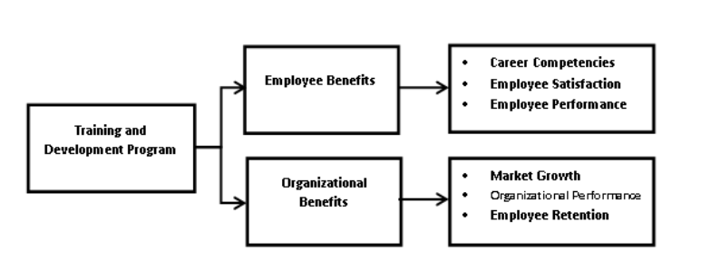

2.3.4 The purposes of Training and Development of an organization
Every business expressions for productivity, quality improvement, Industrial safety, decrease of turnover and learning time and capability to continue an effective management team. These are the key objectives of any training and development program in an organization.
- To deliver job-related knowledge to your staff.
- To deliver skill, knowledge thoroughly
- To improve the output of the personnel and the association
- To continue security morals
- To increase equipment management performs
- To improve the personnel for development

2.4.0 Performance Appraisal
Performance appraisal is a regular, episodic and so far as humanly conceivable, the neutral rating of an operative’s superiority in matters relating to his present job and to his potentialities for a better job.
In modest positions, performance appraisal is matching a workers’ modern sporadic performance against the pre-determined administrative goals. It is how organizations arise to know whether a worker is doing what he has been borrowed to do and how creatively he is doing it. A workers’ bonus, increment, promotion depends on helpful completion of performance appraisal.

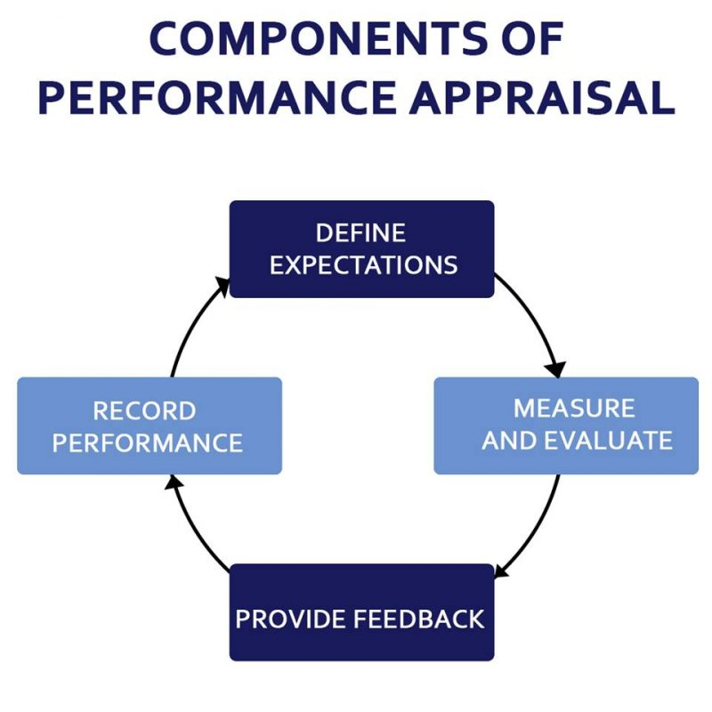

2.4.1 Significance of performance appraisal
The performance appraisal may be one of the little times during the year where a worker and the reviewer, naturally the servant's administrator, can be seated and have a prolonged face-to-face conversation about all aspects of the job. Thus, the appraisal can help a number of important purposes. If done efficiently, the appraisal can provide a large degree of satisfaction for both the employee and the reviewer.
Giving and Receiving Response
An effective employee appraisal delivers an opportunity to give feedback as well as receive it. The employee receives significant data as to what zones of the job she is performing well and those that need development, so she tells exactly where she stands. The reviewer can also receive feedback from the worker that can aid her create improvements in the work environment. The reviewer may also expose issues that could be hindering employees from performing their best, and she can take corrective actions if necessary.
Set Objectives
In addition to reviewing performance centered on previously recognized goals, the performance appraisal is also a good time to create new goals. If lacks are known during the appraisal, the reviewer and employee can work together to create new goals as well as develop a plan to reach them. For example, if a salesperson missed his sales proportion for the year, he and the reviewer can create a plan to reach next year's proportion by cumulative call activity by a certain percentage.

Enlightening Communication
Personnel appraisals are significant for improving communications between the personnel and assessor. By speaking flexibly about the job performance and matters that may be touching it, the personnel and reviewer can progress a sense of trust that may have been deficient. Personnel who previously did not touch comfortable approaching the reviewer with a problematic may become more possible to speech her concerns, which can stop a small issue from rising into a major problem over time.
Calculating Recruitment Energies
Performance appraisals can deliver vital data that can aid evaluate recruiting practices. For example, if a high percentage of staffs who were appointed within a recent time surround scored well on their appraisals, the company may settle that its recruiting procedure is working effectively. On the other hand, the attendance of many poor performers may specify that the recruiting efforts are missing the mark and the hiring procedure may need a refit.

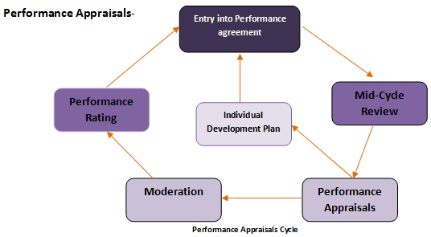

2.4.2 Motive of the performance appraisal:
- To deliver response
- To identify the strength & weakness
- To deliver teaching & counseling
- To improve optimistic superior subordinate relation
- To aid research
- To check the effectiveness recruitment
- To offer a legal file

2.5.0 Compensation Management
Compensation is such an action through which association on the foundation of its aptitude and within law sensibly measures the influence of personnel straight and circuitously for the delivery of financial and non-financial payment.
Basically, compensation is the extreme motivational instrument in order to acquire workers to work just the method the association wants them. Be it gratitude or bonus, compensation is not just about salary rather it covers all the institute has to deliver to the workers for working in the association. There are various benefits of having a well-proportioned compensation bundle, like
1. Works as a driving force for personnel. Personnel come from several backgrounds, for some the monetary aspect is significant, fsor some the respect is motivational while others are concerned to work in a diversified and challenging environment. Compensation management works as a driving energy for everybody by giving them something to effort up to.
2. A great advantage for the association. An association that standards its workers is logically a desired place to work for. A good compensation management make an intellect of safety for workers so it habitually arises as a benefit for the company.
3. Retains and attracts talent. Brilliant workers pursue administrations that compensate their skills and abilities therefore whether they are employed in the institute or viewing for one. Compensation package aids retain and attract brilliant individuals.
4. Aids operations run smoothly within the association. If an association compensates its workers correctly and to their satisfactory level, workers co-operate extra and don’t make any problematic in their work rather deliver 100% effort for the welfare of the business.

2.5.1 Significance of Compensation in the Workplace
Smart employers know that keeping quality employees requires providing the right compensation and benefits package. Compensation includes wages, salaries, bonuses and commission structures. Employers shouldn't ignore the benefits portion of employee compensation and benefits, because the benefits sweeten employment contracts with the priorities that most employees need.

Inviting Top Talent
People are always watching to set themselves in the best possible place financially. Those who are value an exact salary amount often recognize their value and will pursue a position that pays accordingly. Do investigation on what your competitor's compensation and benefits packages appearance like. Make sure you offer a like package to your possible personnel so that you attract the best applicants for your company. Hiring the right candidate the first time decreases recruiting charges and aids free up business owners for other tasks.
Widened Personnel Motivation
Properly compensating worker’s displays you value them as personnel and as human beings. When people touch valued, they feel better about approaching in to work. Overall corporation morale rises and people are motivated to come to work and do a good job. Additionally, when personnel know there are bonuses or commissions, they are gradually motivated to deliver grander results. Bonus and commission compensation plans become a central point for success.
Enhancement Personnel Loyalty
When personnel are being salaried well and are happy, they're likely to stay with the company. Proper compensation is one factor why employees persist with employers. Loyalty means that business proprietors don't need to continue to expend time, money and energy on recruiting new applicants. Personnel retention and low-turnover rates are great for employers who support a team that recognizes what to do. That team is also interested to be part of the team, and they get the job done well.
Enlarged Output and Effectiveness
Happy personnel are productive personnel. Productivity in relation to compensation jerks with personnel feeling appreciated which rises motivation and faithfulness. Not only are employees more motivated to do a good job, but also, the longer people are with the company, the more they know and the more effective they developed. All of this centrals to increased efficiency.
Job Pleasure So Individuals Stay
Making the right compensation plan centrals to stronger job satisfaction. The right compensation plan contains benefits, along with all the other bonuses accessible. Personnel often claim about holiday bonuses or they intensely watch how the company stock completes because they have stock options. The right compensation program spends personnel into the work being done, which gives them a stronger sense of happiness when the company succeeds. They see they will be rewarded for their efforts; everyone enjoys to be valued.

Types of Compensation

2.5.2 Motive to consider compensation & Benefit

  - To be definite programs still maintenance purposes
Over time, organizational purposes may modification and compensation and benefits programs may no longer maintenance new purposes. Therefore, unintentional consequences from compensation plans may rise. For example, a bonus plan that highlights top line revenue may make a lot of sales but could inspire deep discounting that leads to poor bottom line performance.
  - To formulate for growth or development
As you make to change to new markets understanding competitive practices in those markets will aid you attract and hold talent. It will also aid you create sustainable costs relative to your competitors. Compensation practices in one place can be very dissimilar from those in another—particularly across international borders. You don’t want to proposal too little or pay too much.
  - To confirm competitive practices
It is important to review your compensation and benefits program periodically. If you have very high or very low employee turnover, it’s a sign that compensation and benefits programs are not competitive.
  - To confirm lawful compliance
Countries about the world have laws and rules impacting compensation and benefits plans. New laws and rules are passed all the time, making it easy to fall out of compliance and risking fines and consequences. As a result, an episodic review can aid manage this risk.

2.6.0 Industrial Relation and Labor Law
The term Industrial relation clarifies the association between personnel and management which stem straight or ramblingly from union- owner relationship.
Industrial relations are the relations between workers and the management within the business buildings.

2.6.1 Three parties of Industrial relationship.
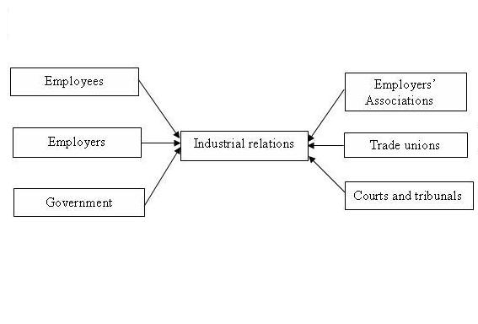
Employees: People who really work in the organization, through whom manufacture is done, services are delivered.
Employer: Employers can be fretful and respectful of employees’ conditions or be self-absorbent and abusing in nature.
Government: Government’s intrusion in employee action of an organization or political impact in the business sector.
Mixture of all three features chooses the working environment of an organization. A good industrial relation makes safe and a productive environment for workers and management and can also be useful for the customers as blooming because the chemistry of the residents of a company clearly reflects in their product or service. There are other benefits too.
1. It generates opportunity for workers to rapid their attitude and have a say in the decision making process which they perform.
2. It rises organizational competence and productivity which can contribute to achieve competitive advantage for the economy as a whole.
3. It’s a good inspiration for workers to have a cordial relationship with their higher authority and not touch like slaves.
4. When workers reflect the organization as their individual they themselves work for the maximum possible achievement of it which means they create less wastage and attempt to make appropriate use of the available resources.
5. It discourages both workers and management to do somewhat unethical against each other.
6. It confirms a smooth production procedure as everyone engage are considerate and accepting of each other’s situation.
7. It diminishes any argument within the company even if it is not current but has a potential of brewing.
8. It creates positive mindset for people to facilitate change which otherwise would have taken a lot of persuading.
9. It is a great benefit for an organization to have against entrants as suppliers, retailers, customers even potential applicants would a company with good relation among their workers and management.
Currently in Bangladesh, Labor Law 2006 is being followed to defend the concentration of the workers or blue collar job holders. It is also measured as standard construction for the white collar job holders as they are paid proportionately to the labor law. Some sections of this law include:
- Terms and conditions linked to employment and service, who can work in an organization, how they can be terminated or retire voluntarily, how they can cabin an objection and such.
- Benefits that should be assumed to an expectant worker, when it should be specified and how.
- Safety defenses that an organization must follow in terms of fire, weighty machinery, lifts, and cranes and so on.
- Health and hygiene issues that a company must confirm for the improvement of the workers working there.
- Restrictions and correct processes of working hours, altered leaves, off days of the organization and overtimes.
- Payment structures, rules about deductions and etc.

2.7.0 Strategic Human Resource Management
Strategic human resource management is a method to the exercise of human resources that statements business challenges and create a straight impact to long-term purposes. The primary standard of strategic human resource management is to progress business performance and support a culture that encourages invention and works incessantly to increase a competitive advantage. It’s a stage above traditional human resources and has a broader spread throughout the organization.
- For strategic HRM, there must be actual collaboration between the top management and the HR head. Some of the experiments faced in contemporary day HRM are as follows:
- - Cross cultural concerns and communication
- - Internationalization
- - Altering possession due to increased M & A
- - Quickly altering business environments
- - Technical developments

Strategic Management Process

Chapter 03

HR Practice in ACI Company Limited



3.1.0 Human Resource Department of ACI
Manpower Planning” is Human Resource Planning. HR planning collecting and applying of human resource at right place and in right number talented to execution the job. Some are the cause need of HRP given below,

3.1.1 HR management design of ACI Company
a) Define the company vision. To begin with, develop a concrete vision for the company.
b) Establish the human resource department’s role
c) Develop company overview.
d) Investigate company needs
e) Evaluate HR process
f) Implement the plan
g) Measure success

3.1.2 Measuring demand & supply of ACI Company
- Evaluating organizational objectives
Organizational objectives are short-term and medium-term goals that an organization pursues to achieve. ACI Company’s will show a large part in rising organizational policies and defining the allocation of organizational resources. Achievement of objectives aids an organization touch its overall strategic goals.
- Inventory of current human resource
From the updated human resource information storage system of ACI Company, the current number of personnel, their capacity, performance and potential can be evaluated. To block the various job necessities, the internal sources and external sources can be assessed.
- Estimating Demand and Supply of Human Resource
The human resources required a various positions affording to their job profile are to be assessed. The available internal and external causes to justify those requirements are also measured. There should be accurate matching of job description and job specification of one exact work, and the profile of the person should be fit to it
- Demand Estimating
Demand forecasting is a practice of defining future needs for HR in terms of quantity and quality. It is completed to meet the future personnel requirements of the organization to attain the desired level of output. Future human resource essential can be estimated with the support of the organization's current human resource situation and analysis of organizational plans a processes.
- Supply Estimating
Supply estimating is concerned with assessment of supply of manpower assumed the analysis of current resource and future accessibility of human resource in the organization. It assessments the future causes of HR that are possible to be obtainable from within an outside the organization. Internal source contains promotion, transfer, job enlargement and enrichment, whereas external source contains recruitment of fresh candidates who are proficient of performing well in the organization.
- Similar Demand And Supply
It is concerned with carrying the forecast of future demand and supply of HR. The matching procedure refers to convey demand and supply in an equilibrium situation so that shortages and over staffing position will be solved.
- Assessing Manpower Gaps:
Contrast of human resource demand and human resource supply will deliver with the excess or shortage of human resource. Shortage characterizes the number of people to be employed, whereas excess characterizes termination. Extensive use of proper training and development programmed can be completed to upgrading the skills of employees.
- Formulating the Human Resource Action Plan:
The human resource plan relies on whether there is shortage or excess in the organization. Accordingly, the plan may be confirmed either for new recruitment, training, interdepartmental transfer in case of shortage of termination, or voluntary retirement schemes and redeployment in case of excess.

3.1.3 Succession planning
ACI Company maintain succession planning. It is a continuing procedure that recognizes necessary capabilities, then works to evaluate, develop, and hold a talent pool of employees, in order to confirm a continuity of leadership for all critical situations. Succession planning is an exact strategy, which incantations out the specific steps to be followed to attain the mission, goals, and initiatives recognized in workforce planning. It is a plan that managers can follow, implement, and customize to see the needs of their organization, division, and department.

Process of Succession Planning

3.2.0 Recruitment & Selection of ACT Ltd.

3.2.1 Recruitment source of ACI Ltd.
ACI Ltd are recruited to employee in both side
a) Internal – This contains personnel now on the payroll of an institute somebody within the organization fills in or is upgraded when there is a vacancy
b) External – Outside the organization is source of external.

3.2.2 Recruitment method of ACI Ltd.
The possible recruiting methods can be divided into three categories:
a. Direct – Recruiters visit colleges and technical schools, it maintain continuous relationship with institutions to hire students for responsible positions.
b. Indirect – This involves advertising in newspaper, website, online job site. Advertising can be very effective if its media is properly chosen.
- Newspaper Advertise

- Prothom Alo

- ACI official website

- Online job site

- BD jobs site
- BD job career
- CV Bank

- Internship program for university student

- This contain usage of commercial or private employment activities, placement officials of schools, recruitment companies etc.

3.2.3 Selection Process of ACI:
1. Advertising about the vacancy: Firstly HR department sends the circular to several ad assistances or newspapers and online portals.
2. CV collection and screening: After the company has accept the many CVs from several emails, they gather it all and screen through them for the ones that appear best appropriate.
3. Interview call: The applicants who’s CVs has been eligible are called for interviews for additional process.
4. Initial interviews: These are basic interviews that let recruiter see the applicant in person and evaluator their personality.
5. Formal written exams: After the worker has effectively crossed interview, they have to be seated for written exam which will test their knowledge.
6. Viva: This interview is the core interview where recruiter really measures whether the applicant can actually carry something to the company
7. Verification and Appointment letter: Here the applicant drives through verification where rationality of his certificates are tested, his referrals are queried and if everything goes well appointment letter is agreed for a probationary period of 1 year.
8. Medical examination: Medical examination is a must for each worker as it will confirm their fitness and aptness to be able to work in the association.
9. Orientation program: ACI arranges a official orientation program for the newly recruited employees to inform well with the institute.
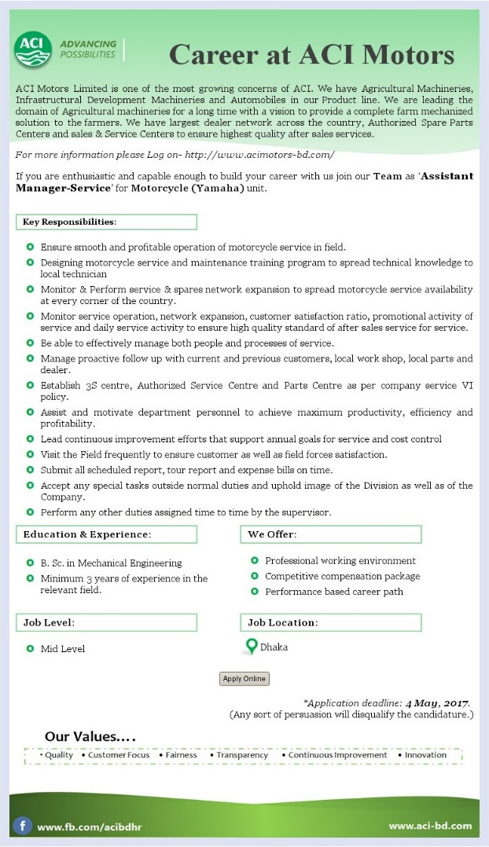
Here job circular by ACI Company Ltd

3.3.0 Training & Development:

3.3.1 ACI Company’s Training & Development method:
There are many methods of providing training and development to workers. They provide:-
a) On the job training
b) Off the job training
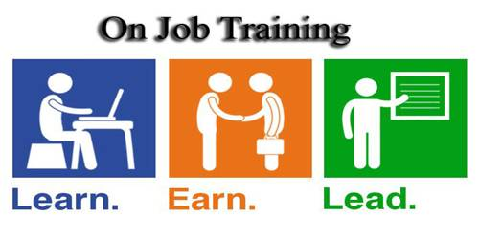
a) On the job training: On the job training provide by personnel work and at the similar period learn. There’s an insufficient ways to do that
i. Job rotation: There are two types of job rotation, vertical and horizontal.
1. Vertical Job rotation: It is the accurate of each worker. In this situations change in a straight line. Where staffs are given fresh positions and with it fresh responsibilities, by handling which workers learn about their jobs.
2. Horizontal Job rotation: In this technique workers are referred to different departments other than their own to acquire how they effort. Here the level of work remainders the same just the ability fluctuations.
The difference have between vertical and horizontal job rotation. In vertical job rotation, employees obtain knowledge in only one area. In horizontal job rotation, they collect knowledge in several areas of the organization.
ii. Assistant to position: In assistant position, someone work under mentor, facilitator cum coach. Here, mentor is somebody straight explains and facilitator is somebody who offers support empathically or sympathetically.
iii. Committee Assignment: This technique contains construction a team with cross-functional memberships. This team must include 5 memberships and cannot beat 21 memberships.
b) Off the job training: Off the job training requires putting the right individual with the right technique for the right training. It includes:-
i. Classroom lectures: It is the most traditional method of training. It can be either
1. One way communication or
2. Interactive learning
ii. Simulation training: Here staffs emphasis on knowledge both practically and theoretically. It includes:
1. Case Analysis: Here actual circumstances are in front of the staffs to solve difficulties. It is how they collect knowledge to be more correct and detailed when it arises to result making.
4. Experimental experience: This method is for training for different mechanisms.

3.3.2 Training process:
When it arises to training process, ACI follows the ADDIE model. ADDIE stances for Analysis, Design, Development, Implementation and Evaluation phase.

Analysis phase:
Analysis phase is the gathering of information phase. Here employee training need is analyzed through training need form.
Design phase:
Design phase generally means as planning phase. Here how to train an employee that will be planed, what type of training should be delivered to them, what would be motivational for their effort life phase and such is taken into deliberation to come up with the best potential training program for each individual.
Development Phase:
It is a pilot study or experimental study is directed to understand how employees will respond to the plan and whether the plan is accurate, only then the plan will be applied in reality. If the result is negative then the procedure will drive to either design phase or back to analysis phase.

TNA Form
Name of the Employee: Immediate Reporting Supervisor:
Position of the Employee: Date of joining:
Department of the employee: Year of Experience:
Job  Responsibility | Required job  Skill &  Competencies | Actual Job  Skill &  Competencies | Gaps | Remarks
Employee Head of Department Head of HR

Implementation Phase: Here is where the actual implementation is done.
Evaluation Phase: This is the last phase. Here it is noticed whether the training procedure was successful or not. If the procedure failed to create any alterations in the performance of the employees, the whole process will be repetitive again starting from the analysis phase.

3.4.0 Performance Appraisal

3.4.1 Source of information:
ACI gathers information from immediate supervisor of an employee.
Appraisal Form:
As the organization has several posts, each of them has its own form of BARS. Here is a sample of BARS form that is used by ACI

Performance Appraisal Form
Name of Employee: Date:
Department: Position
Performance Category:
Rating | Behavioral Anchors
Very Good
Good
Average
Poor
Unacceptable
Employee Divisional Manager

Here, marks distribution is: Very Good = 5, Good = 4, Average = 3, Poor = 2 and Unacceptable = 1. [The higher the employee’s marks, the better their performance.]
Usually appraisal is directed by an evaluation team. As the appraisal is conducted on every performance category confined in a multipage form, employees essential to sign every page to show entire faith in the system along with divisional manager who favors the appraisal. Lastly it is directed to the HR department for the final evaluation. Besides the actual performance employees also acquire extra marks based on their educational qualification such as MBA holder, MA pass and Graduate, all have different levels of extra marks that are get together with the total performance marks.

3.5.0 Compensation Management

3.5.1 They provide several things provide:
1. Pay for work and performance:
- Base pay for an employee
2. Pay for time not worked:
- Employee at holidays
- Company give vacations.
- Give time for election official.
- Give maternity leave for women worker
3. Deferred income for employee:
- Give social security.
- Doing savings plans.
4. Health, Accident, Liability protection:
- Provide medical, Hospital and surgical insurance,
- Provide social security protection

3.5.2 Benefit plan of ACI limited
- Short term benefits plan:
  - Offer Leave Fare Assistance for Yearly
  - Give two festival bonuses for Yearly
- Long Term benefits plan:
  - Provident Fund.
  - Gratuity.
  - Group Insurance Policy.
  - Medical Benefits.

- Provide various leave with pay
- Casual Leave:
ACI Company is paid 24 days causal leave for a year. When he is joined, from that time he is applicable.
- Earned Leave:
An employee is considered qualified for earned leave in ACI, when he/ she has operated in ACI at least for a year. Employees acquire 1 day earned leave for every 33 days. It is an entirely salaried leave that is not movable to the next year.
- Festival Leave:
Festival leave rely on the Government approved official holidays.
- Sick Leave:
Sick Leave in ACI is 15 entirely remunerated days. Similar casual leave, it is also appropriate from the joining date of a worker.
- Maternity Leave:
In ACI, a woman must work for at least 6 months to be suitable for maternity leave. The maternity leave is of 4 months specified only once at the expediency of the employee. Employee must smear for such leave earlier to be fit for it.

3.6.0 Industrial relations in ACI:
ACI Company follow the labor law of Bangladesh. Their organizational environment are suitable for employees. As a result they enjoy some benefit:
- Defense of Employee
Employment Act are intended to balance out the relationship so that the employer cannot exploitation or differentiate against the employee. Under these and additional labor laws, workers have the right to fair compensation, an equal chance for hire and a safe work environment.
- Defense of Employer
Employers don't have to hire someone they don't sense is qualified, and it is within the employer's rights to think that employees display on time and execute the duties for which they were hired. These laws ultimately defend the employer's productivity and, therefore, profits, as well as the capacity to continue competitive in the marketplace.
- Economic Constancy
Labor laws reserve the right of the employer to profit and the right of the employee to compensation that can be expended and financed, labor laws are vital to a healthy economy. Phases of economic growth reflect healthy businesses with employees who are getting enough to join as consumers.

3.7.0 Strategic human resource of ACI
ACI Company follow strategic human resource management. It think employee as an asset. It enjoy some benefit for following SHRM
- Enlarged job gratification
- Enhanced rates of customer gratification
- Effective resource management
This way which it follow as strategic human resource management
- Develop thorough understanding of company’s objectives
- Evaluate your HR capability
- Analyze current HR capacity in light of your goals
- Estimate company’s future HR requirements
- Determine the tools required for employees to complete the job
- Implement the human resource management strategy
- Evaluation and corrective action

Chapter 04

Findings & Analysis


The best way to analyze the performance of an organization is to perform a SWOT analysis, which clearly states the current position of the organization both internally and externally. Since this report focuses on the HRM functions of ACI Company Limited, the SWOT analysis will also be directed to that.

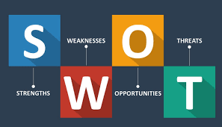

S = Strengths
- ACI is measured as countries’ one of the leading conglomerates because of performance.
- Efficient, capable & honest workforce
- ACI has strong demand of their product which aids them to expand their business.
- Significant financial resource to produce the business.
- Exclusive technology & importance patents
- Aptitude to take advantage of economic of scale
- Improved product quality comparative to rivals
- Goodwill of the company
- Different SBU’s aid them to diversify their risk

W = Weakness
- Developed unit cost relative to key entrants
- Group acquiescence due to group policy the company has to ingress raw materials form neighbor nations (other than those which are products locally) resultant in higher cost production
- Little pack Size
- Deficiency of sufficient promotional effort
- ACI has weaker distribution network & sales force are relatively low relate to entrants
O = Opportunity
- ACI as a local conglomerate has opportunity for enlarges its outlay and has possible growth in Bangladeshi market
- Increasing the company’s product line to see a boarder range of customer needs
- Target and obtain unused marketing for vaccines
- Market is significantly large and growing
- Appropriate use of vaccines may result in higher in profit
- Sophisticated confidence brand name and quality
T = Threats
- Hostile movement of competitors
- Go-slow in market growth
- Rising bargaining power of the end consumer
- Expensive new regulatory supplies
- Entrants lower prices
- Growing threats from local entrants

Chapter 05

Recommendation & Conclusion





Recommendation

ACI is one of most high operative, highly category after company of our country. I may not be the finest individual to advise many a major alteration for this company but as student of HR, I would like to advise little recommendations that will optimistically derive in handy for the department if they think it fit to contain in their strategies for altering of the HR department.
- ACI pension/ retirement plan is average.
- The organization should rise its compensation associated benefits which are providing to the employees.
- The organization should provide effective/acceptable insurance coverage to their employees.
- The organization’s pension/ retirement plan should be modified in favor of their personnel.
- The organization may rise current salary construction of their personnel.
- They should provide same employment opportunity to female workers same as they do with male workers to participate in an economic development which is highly be contingent on both group of people.
- There should be correct way about the different ways of the working areas counting different services like lifts, potable water, dustbins and spittoons.
- ACI Company should confirm correct people in the correct places.
- ACI Company should shape the isolate policy for requirements & selection
- The policy should be updated so that it can contest with other organization as well.
- Most time training delivered in terms of performance deficiency documentation. But the world is changing continuously with the help of technology. So training should be given following with new technology
- To evade suspicions and other complications in future, it is significant to organize future role play training. Through this procedure employees would develop an idea about their responsibilities in future.
- Manager or supervisor should have sufficient experience to know which worker need what kinds of training to execute well.
- Supervisor should know various strategies and ways to create the training effective. Certain level of information is needed to entree and properly select the training centered on training need valuation of their dependents.

Conclusion

It is understood that each ending marks the start of a new beginning. This has been such a satisfying expedition for me. For myself it looks like a rollercoaster cycle with its ups and downs both emotionally and physically. Through the grounding of this report, I have come across numerous condition and issues which even though nothing new, looked quite strange. This was the first chance where I had to possess my eyes on every feature of a research and report groundwork without the aid and assistance of a group. This has assumed me additional responsibility and opportunity of learning things I didn’t identify how to do before. This whole report has showed itself as a contest which I would gratefully take upon once again if the situation rises. I have had such an enjoyable experience in terms of meeting newfangled persons, observing at new viewpoints, getting leadership in a new way, working on my own that it has specified me motivation to retain this spirit up further in my life. This report is a deduction to my graduation degree, from here onwards new challenges and new beginnings will originate, I hope to implement each lesson that I have erudite in my University life into my personal as well as professional life.

Bibliography

Assignment Point. (2019). Relationship between the ACI Limited Employees with their Customers - Assignment Point. [online] Available at: https://www.assignmentpoint.com/business/management/relationship-aci-limited-employees-customers.html [Accessed 6 Apr. 2019].
Scribd. (2019). Labor law practice in ACI Ltd | Trade Union | Employment. [online] Available at: https://www.scribd.com/document/250478964/Labor-law-practice-in-ACI-Ltd [Accessed 20 Apr. 2019].
Aci-bd.com. (2019). Welcome to ACI. [online] Available at: http://www.aci-bd.com/training.php [Accessed 29 Apr. 2019].
The Lawyers & Jurists. (2019). Recruitment and selection process of Human Resources in ACI Limited - The Lawyers & Jurists. [online] Available at: https://www.lawyersnjurists.com/article/recruitment-and-selection-process-of-human-resources-in-aci-limited/ [Accessed 26 May 2019].
Papon, M. (2019). Recruitment & selection process of human resources in aci limited. [online] Issuu. Available at: https://issuu.com/md.papon/docs/recruitment___selection_process_of_ [Accessed 26 May 2019
Husys Ltd. (2019). Importance of Training and Development in HR. [online] Available at: https://husys.com/blogs/importance-of-training-development-in-organizations/ [Accessed 9 Jun. 2019].
Husys Ltd. (2019). Importance of Training and Development in HR. [online] Available at: https://husys.com/blogs/importance-of-training-development-in-organizations/ [Accessed 9 Jun. 2019].
Smallbusiness.chron.com. (2019). Importance of Compensation in the Workplace. [online] Available at: https://smallbusiness.chron.com/importance-compensation-workplace-38470.html [Accessed 15 Jul. 2019].
Assignment Point. (2019). Relationship between the ACI Limited Employees with their Customers - Assignment Point. [online] Available at: https://www.assignmentpoint.com/business/management/relationship-aci-limited-employees-customers.html [Accessed 10 Aug. 2019].
Your Article Library. (2019). Steps in Human Resource Planning (explained with diagram). [online] Available at: http://www.yourarticlelibrary.com/human-resources/steps-in-human-resource-planning-explained-with-diagram/32358 [Accessed 17 Aug. 2019].

Appendix
Question
- Can you shortly speak what ACI is about? What are its goals and objectives and a whole thoughtful of the people working here?

- What is your position, tasks, duties and responsibilities in the organization?

- How long have you been working in this organization?

- Can you explicate the overall Human Resource Management practice of this organization?

- Human Resource Planning

- How do you design your overall HR Management?

- How do you confirm the proper HR planning?

- Which method you monitor of HR planning for measuring demand & supply?

- Do you follow succession planning?

- Have HR software in your organization?

- Selection & Recruitment

- What is the recruitment and selection process of your organization?

- What is the method of selection?

- What are your sources of recruitment?

- Performance Appraisal

- Who does evaluate the performance of employees?

- What is their performance standard?

- What process is followed for appraising the performance of the employee?

- What methods do you use to apprise the employees of your organization?

- Industrial relation labor law

- Does your organization follow the Labor Law of Bangladesh?

- Is organizational environment are suitable for employees & what do you provide facility as suitable environment?

- Does your organization give maternity leave & how many days?

- Compensation Management

- Which compensation, you provide?

- How do you provide incentive pay to your employee?

- As pay level policy, which you follow?

- What the financial & non-financial benefits they offer to employee to maintain proper labor relation?

- Training & Development

- Do you finance in any training package to recruit fresh talent?

- What type of training your organization provide?

- Is the development is happening along with the training?

- Do you practice TNA form for employee?

- Strategic Human Resource Management
- Which method follow in your organization between traditional view of HR & strategic view of HR?

- Do you think to employee as an asset?

- How follow strategic HRM?

Attached Visiting Card:
Miran Hossain

HR Executive

Human Resources

ACI Lltd .
Tejgaon Branch,Dhaka -1208, Bangladesh.

