

Project Report on
“Recruitment and Selection Process of IT Personnel in Synesis IT Ltd.”

Submitted To
Shayla Khanam
Assistant Professor
School of Business & Economics

Submitted By
Mayeesha Mursalin Chowdhury
111-153-038
Bachelor of Business Administration

Date of Submission: 27th of September, 2020

Letter of Transmittal
27th of September 2020
Shayla Khanam
Assistant Professor
School of Business & Economics
United International University

Subject: Submission of Project Report on “Recruitment and Selection Process of IT Personnel in Synesis IT Ltd”.

Dear Mam,
With due respect, I would like to thank you for assisting me to prepare this report. I did my project report on “Recruitment and selection process of IT personnel in Synesis IT Ltd”. I tried to do the best to complete the report on time with the quality of your expectation.

I am thankful to all the individuals of the company ‘Synesis IT’ who has provided me with all the important information and gave me valuable advice. I will try to answer all the questions that you have about the report.

Yours obediently,
……………………
Mayeesha Mursalin Chowdhury
111-153-038

Table of Contents
Executive Summary................................................................................................................Iv
CHAPTER-1 Introduction 1
11 )Introduction of Recruitment and Selection......................................................................2
1.2)Identification of Research Gap. 10
CHAPTER-2 Organizational Background and Industry Perspective 11
2.1) Historical Backgroud of Synesis IT 12
2.2) Industry Senario 14
CHAPTER-3 Objective of the Study 17
3.1) Objective of the Study....................................................................................................18
3.1.1)Primary Objective: 18
3.1.2) Secondary Objectives: 18
CHAPTER-4 Methodology of the Study 19
4.1) Research Methodology 20
4.1.1) Type of Data 20
4.1.2) Data Collection Process 20
4.1.3) Sample Size ..............................................................................................................20
41.4) Sampling Technique....................................................................................................20
4.1.5) Scope...........................................................................................................................20
CHAPTER-5 Literature Review 21
5.1) Literature Review..........................................................................................................22
CHAPTER-6 Findings and Analysis of the study 24
6.1) Data Analysis and Interpretation...................................................................................32
6.2) Findings 42
CHAPTER-7 Conclusion and Recommendation 43
7.1) Conclusion 44
7.2) Recommendation 44
CHAPTER-8 Appendix 45
8.1) Quesionnaire 46
8.2) Reference 48

Executive Summary
Recruitment and selection is an important operation in HRM, designed to maximize employee strength in order to meet the employer’s strategic goal and objectives. It is a process of sourcing, screening, short listing the right candidates for the required vacant positions. Therefore, in order to identify the process of recruitment and selection, this project report has been constructed on “Recruitment and selection process of IT personnel in Synesis IT”. Here the object is to know the perception of employees regarding recruitment and selection process as well as how the recruitment and selection process is followed in Synesis IT. Both Primary and secondary data was collected to prepare this report. Survey was conducted for the further analysis of the study where the sample size was. The initial observation has already proven that Synesis IT has done great job. Employees of Synesis It Ltd feel that the HR department is good enough. Through survey I have found that 90% of employees are very much satisfied with the total recruitment and selection process and they also comfortable enough to work with the whole HR process but only 10% want some changes in some particular sectors. Synesis IT has to add more employees in their HR team so that they can do their job faster and more effectively than before. The recruitment and selection procedure should be brief and timesaving. It is better to use the internal recruitment process first because it results less cost and acts as a motivational factor to the employees. Besides they should play some vital role in selection process by following innovative techniques where stress management can be a good example.

Chapter- 1
INTRODUCTION

1.1 Introduction of Recruitment and Selection

Recruitment and Selection:
Recruitment is the process of attracting individuals with appropriate qualification and on a timely basis in sufficient numbers. A company’s recruitment process should be strong enough so that they can select and attract the right candidate. Human resource planning is the very first step of recruitment process where the last section is about selection , manager and HR play a vital role in this whole process. The basic principle in recruitment and selection is “Right person for the right job”. Managers should give attention to the selection of its manpower. Manpower is a very essential asset that can carry different business activities smoothly and efficiently. Human resource management in an organization is quite possible if unsuitable persons are selected and employment in a business unit.
RECRUITMENT
Recruitment is all about estimating valuable vacancies and making suitable arrangements for their selection and appointment. A formal definition states, “It is the process of finding and attracting capable applicants for the employment. The process begins when new recruits are sought and ends when their applicants are submitted. The result is a pool of applicants from which new employees are selected”. In recruitment process, information is collected from interested candidates.
Definition: According to EDWIN FLIPPO, “Recruitment is the process of searching for prospective employees and stimulating them to apply for jobs in the organization”.
Purpose and importance of Recruitment:.
- Help to reach the organization’s all necessary legal and social obligations regarding its work force.
- Help to identify and build potential job applicants who will be appropriate candidates.
- It helps to sustain organizational and individual effectiveness in the short term and long term.
Recruitment Process:
Recruitment process includes five interrelated stages,
- Planning
- Strategy development
- Searching
- Screening
- Evaluation and control
STAGE 1: RECRUITMENT PLANNING:
Planning is the very first step of recruitment process. Planning is a target that specifies the (1) Numbers and (2) Types of applicants.
Numbers of contact: Organization always, plans to attract more applicants so that it can fill all vacancies with the qualified people.
Types of contacts: In this stage people got informed with the job circulars. Tasks, responsibilities, qualifications and experience are the criteria to initially judge the right candidates for the right job.
STAGE 2: STRATEGY DEVELOPMENT:
This stage is all about Make or Buy and Technological Sophistication
STAGE 3: SEARCHING:
Search includes two steps –
- Source activation and
- Selling.
STEP 4: SCREENING:
Screening is a vital part of the recruitment process; many view it as the first step in the selection process.
Purpose of Screening: The purpose of screening is to eliminate the recruitment process, at an early stage, those applicants who are visibly unqualified for the job. Effective screening can save money and time too.
STAGE 5: EVALUATION AND CONTROL:
The costs generally incurred are:
- Recruiters Salaries.
- Time spent on preparing job description, job specifications, advertisements, agency liaison and so many.
- Cost of advertisements or other costs of recruitment methods.
- Administrative expenses.
- Overtime , outsourcing costs
- Cost for recruiting unsuitable candidates.
Sources of Recruitment:
SOURCES OF MANAGERIAL RECRUITMENT:
Internal Recruitment | External Recruitment
- Promotion | - Management Consultancy Service
- Transfer | - Campus Recruitment
- Internal Notification | - Press Advertisement
- Formal employees | - Walk-ins, write-ins, talk- ins
- Retirement | - Deputation of personnel otherwise transfer from one enterprise to another.
- INTERNAL RECRUITMENT:
Basically internal recruitment seeks applicants from within the company. The various internal sources include:
Promotions and Transfers: Promotion is a viable method utilizing work posting and personnel records. Job posting requires advising empty situations by posting notices, coursing distributions or declaring at staff gatherings and welcoming representatives to apply. Personnel records help find representatives who are doing tasks beneath their instructive capabilities or ability levels. Promotions has numerous preferences like it is acceptable advertising, constructs resolve, supports skill full people who are goal-oriented, improves the likelihood of good choice since data on the person's presentation is promptly accessible, is less expensive than going outside to enlist, those picked inside know about the association consequently decreasing the direction time and vitality and furthermore goes about as a preparation gadget for creating mid level and top level supervisors
Employee referrals: Here employees would bring only those referrals that will best fit with the organization. In this way, company can fulfil their social duties and create goodwill.
Former Employees: These include employees who are retired and able to work on a part-time basis, individuals who left work and want to come back for higher compensations. Even retrenched employees can also get the chance to join.
Dependents of deceased employees: Actually this policy is followed by banks. If an employee dies for any uncertainty or anything, his / her spouse or son or daughter is recruited in their place. This is usually a kind way to fulfil societal responsibility and create goodwill.
Retirements: Here management can also call retired managers with new extension.

- EXTERNAL RECRUITMENT: External recruitment is simply recruiting candidate from outside the company. The sources include -
Professional or Trade Associations: Associations carry employers interested in recruiting their members through classified advertisements. These are very useful specially for attracting highly educated, experienced or skilled individual.
Advertisements: It is a well known and popular method of seeking recruits. Ads basically cover the job benefits, identify the employer and tell those interested how to apply. Newspaper is the most common medium but only for specialized recruits. Professional or business journals are also very good platforms to place advertisement.
Campus Recruitments: Colleges, universities be the best ground for the recruiters, particularly the institutes. Every year companies (not all) generally recruit a given number of candidates from these institutes.
Walk-ins, Write-ins and Talk-ins: From employees‟ viewpoint, walk-ins are highly preferable as they are free from any sort of hassles associated with other methods of recruitment. Write-ins are basically sending written enquiries. Talk-ins involves the job that aspirants meeting for detailed talks
Head Hunters: Head hunter companies help candidates to find suitable jobs for them. Candidates can also be a working person.
Radio, Television and Internet: Actually there is nothing special about using radio and television for recruitment. Internet has become a popular option for recruitment today.

SELECTION
Employee selection process is all about finding that one person who would be the best fit for a particular position. By selecting the appropriate candidate for the required job, the organisation will get quality performance of employees. Besides, organisation will face less absenteeism and employee turnover issues. By selecting right candidate for the required job, organisation will also save a lot of time and money. Proper screening of candidates takes place during selection procedure. All the potential candidates who apply for the given job are tested.
The difference between recruitment and selection: Recruitment is basically identifying and encouraging the right employees to apply for a job and Selection is selecting the right candidate from the pool of applicants.
SELECTION PROCESS: Selection is actually a long process, commencing from the preliminary interview of the applicants and ending with the contract of employment.
- Selection decision
- Physical examination
- Job offer
- Employment contract
- Analysis

- Preliminary test
- Selection test
- Employment interview
- Reference
- Background

STEP- 1 PRELIMINARY INTERVIEW:
Here the purpose is more or less the same as scrutiny of application, that is, eliminate of unqualified applicants. Based on the information supplied in the application forms, the scrutiny can enable the HR specialists to eliminate unqualified jobseekers.

STEP -2 SELECTION TEST:
Followings are examples of tests taken –
- Projective test
- General knowledge test
- Perception test
- Graphology test
- Medical test
- Ability test
- Aptitude test
- Intelligence test
- Interest test
- Personality test

STEP-3 INTERVIEW:
this all about an interview. Interview is a formal and in- depth conversation conducted to evaluate the applicant’s acceptability. It is basically face-to-face exchange of each point of view, ideas and opinion between the candidates and interviewers. Interviews can be of different types. Following are the various types of interview –
- Panel interview
- Sequential interview
- Structured interview
- Unstructured interview
- Mixed interview
- Telephonic interview.

- Informal interview
- Formal interview
- Non directive interview
- Depth interview
- Stress interview
- Group interview

Step-4 REFERENCE CHECK:
Candidate’s personal data like name, addresses, and telephone numbers are needed for verification. Although references are not usually checked until an applicant has successfully reached the fourth stage of a sequential selection process.
STEP- 5: SELECTION DECISION:
After obtaining information through the above steps, the next critical step would be selection decision. The other stages used to narrow the number of the candidates. The final decision has to be made the pool of individuals who successfully pass the tests, interviews and reference checks. The view of the line manager will be generally considered in the final selection as he/she is responsible for the performance of the new employee.
STEP 6: JOB OFFER:
Job offer is basically a letter of appointed. The letter which generally contains a date by the appointee must report on duty. The appointee must give a reasonable time for reporting. It is particularly necessary only when he or she is already in employment, in this case the appointee is also required to obtain a relieving certificate from the previous employer.
STEP 7: CONTRACT OF EMPLOYMENT:
It is necessary to prepare a contract of employment. Following information should be there-
- Job Title
- Employee’s Duties
- Starting date
- Various payments method- allowance, overtime etc
- Lunch time, shifting schedule.
- Payment plan for Holidays.
- Holidays

STEP -8: CONCLUDING THE SELECTION PROCESS:
The selection process will not end with executing the employment contract. There is another step which is more sensitive one reassuring candidates who have not selected because their profile did not match the requirement of the organisation
STEP-9: EVALUATION OF SELECTION PROGRAMME
Recruitment and Selection (Differences):
- Recruitment is all about searching the prospective candidates and motivating them to apply for job in the organization. Whereas, selection is all about choosing most suitable candidates, who are both interested as well as qualified for job.
- In recruitment the purpose is to attract maximum numbers of candidate’s applications. In selection, the purpose is to find out the best candidate out of those qualified and interested in the appointment.
- Recruitment is comparatively short and easy process. Here publicity is given to vacancies and applications are collected from different sources. Selection is a lengthy process. It involves scrutiny of applications, giving tests, arranging interviews and medical examination.
- In selection, services of expert are required but in recruitment services of expert are not required.
- Recruitment is not that costly. Expenditure is required mainly for advertisement of the posts. Selection is a costly activity, as expenditure is needed for testing candidates and conduct of interviews.

1.2. Identify Research gap
Information Technology (IT) gives fast, easy access to information which is essential for the development of a nation. Asian countries are also doing a great job in IT sector. According to the website of Bangladesh Association of Software and Information Service (BASIS) 2018, they have now more than 1087 registered members in their website.
Most of the research about recruitment and selection process is based on banking and companies like telecom, pharmaceuticals etc. There is hardly research about Bangladesh IT industry. The number of researches on HRM for IT is scarce and many of the studies that are available from the beginning of the 2000’s, which clearly demonstrates the need for more research in this field.
This research aims to fill the gap regarding recruitment and selection, particularly of IT industry. We need more and more research on the recruitment and selection process of IT sector for the development of our nation.
As the world continues to be more digitally connected and industries become more automated, technology will remain a massively growing market in the beginning of the new decade, especially as companies focus less on cost reduction and more on innovation. If we want to be recognized as a successful or developed country, we definitely need more development in the IT sectors. Recruitment and selection process is more or less same in other industries like telecom, pharmaceuticals and consumer product based companies but the thing is bit different in terms of IT personnel. Initial screening more or less the same but in the selection phase candidates have to attain some technical interview sessions as well as several coding tests. So, in general the candidates have to attain several phases in recruitment and selection process to grab their opportunity as IT personnel.
We need sufficient research based on the recruitment and selection process of IT personnel in Bangladesh so that we can get better knowledge as well as some better ideas to make the whole process even more effective as it is going to be the massive market in the beginning of new decade. Bangladesh has done a great job in IT sector in last few years. Now it’s our responsibility to develop this sector more and more as our country’s national income is highly depends on IT and software industries.

Chapter -2 ORGANIZATIONAL BACKGROUND

&

INDUSTRY PERSPECTIVE

2.1 Historical Background of Synesis IT Ltd.


Synesis IT Ltd is a private limited company and social change producer association utilizing data innovation with more than 11 years of strong encounters in multi-dimensional business areas through expanded techniques and conveying vigorous solutions for its well-regarded customers and accomplices including Government through expansion of qualities to their organizations and successful administrations.
Their key strategies and core areas are-
- e- Governance
- e- Health & m-Health
- Call Center Solutions
- Business Facilitation with Tender Bazar
- High quality monitoring, evaluation & research for following business and services to population.
e- Governance: Synesis has been a pioneer IT arrangement organization in Bangladesh with in excess of 60 enormous scope e-Governance ventures. By its tasks, it has been contributing in broadened fields of the nation and adding critical qualities to individuals' life. Synesis IT has indicated wonderful presentation of mechanical angles in structuring, creating and executing private and open robotization ventures in the field of horticulture, wellbeing, training, nearby administration, vitality, power, open acquisition, telecom and so on.
Some of their e-Governance projects are- Central Biometric Verification Monitoring Platform, Dynamic Wed Application for Bangladesh Bureau of Statistics, Decentralized Education Management Information System, Online GD Application, Online E- Tin Registration System.
e- Health: The e-Health is the operation of Information and Communication Technologies (ICT) for wellbeing. Synesis IT conveys all day, every day administrations for clinical advices, advising, treatment, referral, linkages with wellbeing administrations and advancement of preventive wellbeing data at a most minimal expense with quality from qualified Medical specialists, Psychiatrists, Psychologists, Counsellors and other specialist organizations for all age population.
Their projects are- Shastho Batayon 16263, Mindtale, Aponjon 16227
Call Center Solution: Synesis IT has been leading in Bangladesh for using the most up to date call center solutions with latest technologies. This customer driven assistance is profoundly productive and guarantees greatest rate of return. Our customers can turn up at fitting objective gathering, track contacts and accumulate significant information so as to make sure about best client relationship the board.
Their projects are- Tottho Apa ( Jatiyo Mohila Sogstha), Probash Bondhu Call Center, Establishment of Union Porishad Helpline- 16256, WASA Helpline 16162.
Tender Bazar: Tender Bazar, an activity of Synesis IT Ltd. which is the biggest stage that brings the bidders and inviters together to trade business obtainment data. Best in class innovation and profoundly qualified experts devoted from assortment to distributing of delicate data guarantees that no part misses his/her favored delicate warnings. It guarantees that individuals get the warnings by 12:00 pm around the same time with no monotonous postings. TenderBazar.com fills in as an information center on delicate data through "Delicate Analytics" that encourages bought in individuals to comprehend delicate related market patterns. Currently 1000+ Business houses depend on Tender Bazar.com.
Mobile Vas: Synesis IT has made an exceptional position at conveying profoundly dependable and intuitive Mobile worth included administrations (VAS). Right now, Synesis IT is working effectively with prestigious media transmission administrator Banglalink, Robi just as Airtel (from the earliest starting point). The generally requested arrangements like: IVR and SMS, call focus arrangement, wellbeing tips, content administration and so on are being met by us with complete fulfilment according to customers need. Our specialized specialists and imaginative division brings your answer a sharp edge to contend in the business and start to lead the pack.
Some of their projects are- Banglalink Mindcare 7899, Robir Gyan 360, Airtle Health Link 789, Teletalk Shastho Sheba 789.


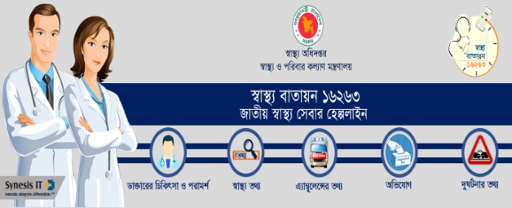
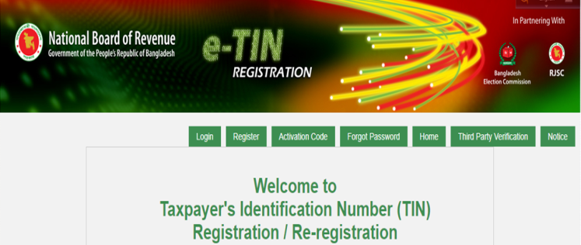

Clients are- Ukaid, Bangladesh Government, Ministry of Health, Ministry of Education, Bangladesh Post office, WASA, Grameen Phone, Robi, Banglalink, Airtle, Teletalk, Citycell, Dnet, Bangladesh Army, BGB, Bangladesh Navy, ICMH, IDCOL, UCB.
Partners: They sail along with first rate sailors to make the excursion wonderful and to settle our goal in Infinity. Our accomplices bring a striking norm through which Synesis IT has had the option to get special case quality and assembled profound trust in individuals'mind.
Partners are- WatchGuard, Vmware, Veritus, Triceret, Trend Micro, Packeteer, Oracle, Microsoft, Appsense so many.

2.2 Industry Scenario

Industry Perspective:
Information Technology has totally changed the world because of its fast and easy access to information. Asian countries are also doing a great job in IT sectors. Bangladesh has done a great job in IT sector in last few years. Now our country’s national income is hugely depends on IT and software sectors.
There is huge contribution of IT sectors for building 'Digital Bangladesh'. Bangladesh should take good initiatives for further development so that they can grab the attention of foreign investors and for that we should encourage our entrepreneurs of launching more and more IT and software farms. After all our country’s development is hugely depends on this and will help us to become middle- income country by 2021
RMG sector has a great contribution in this sector to accelerate the growth of Bangladesh. It significantly increases foreign exchange.
Asian developing countries like India, China, Malaysia, etc. have already started doing great job to exploit opportunities offered by the Digital Age and catch up with technologically advanced countries. These countries have heavily invested in IT sectors, taking considerable benefits in higher employment/income, and accelerating growth. For example, IT sector of Malaysia, where continuous growth is fully supported by the government, has created 800 new IT companies with over 98,000 new jobs, while 200 foreign companies have set up regional centers in Malaysia, bringing billions of dollars in investment and creating significant new jobs. Indian IT industry receiving huge foreign investment that contributes significantly to India's GDP growth. It is estimated that the outsourcing sector has a worldwide market of USD 500 billion; India's share is USD 140 billion compared to Bangladesh's USD 700 million.
Bangladesh can consider experiences of these countries to design and implement a rapid IT promotion strategy to build her own resources/objectives.
Moreover, this could also have a great contribution to the creation of high income jobs that would encourage foreign trained Bangladeshis to return (thereby reversing the brain-Drain), who can contribute to R&D, and help to attract foreign companies to come. This IT farm also uses higher skill, pay better, can be more stable with greater potential for growth than the RMG sector, which is more vulnerable to lower cost regions in Asia and Africa. As we know that the mobile phone sector in Bangladesh is well-developed, ICT-related service trade will progress, particularly in business process outsourcing (BPO). Development of other businesses and industries through computerization of the business process can lower the costs significantly, increasing productivity and profitability.
The government can speed up investments in English and IT education starting at primary schools to scale up this industry. Conditions such as, improving transportation, communication, physical infrastructure of major IT hubs, installing work ethics, transparency, accountability laws, strengthening regulatory roles, and ensuring homeland security can turn Bangladesh into a popular investment destination.
There is huge contribution of IT sectors for building 'Digital Bangladesh'. Bangladesh should take good initiatives for further development so that they can grab the attention of foreign investors and for that we should encourage our entrepreneurs of launching more and more IT and software farms. After all our country’s development is hugely depends on this and will help us to become middle- income country by 2021

Chapter: 3
OBJECTIVE OF THE STUDY

3.1) Objective of the Study

3.1.1) Primary Objective:
The primary objective of the study is to complete the partial requirement of the awarding of the BBA degree from the school of business & economics, United International University
3.1.2) Secondary Objective:
- To know the different perceptions of employees regarding recruitment and selection process.
- To know how the recruitment process is followed in Synesis IT.
- To know how the selection process is followed in Synesis IT.
- To analyze the policy of HR towards recruitment and selection.

Chapter 4
METHODOLOGY OF THE STUDY

4.1 Research Methodology

Human activity that based on rational investigation of any issue is known as research. Scientific research actually provides scientific information as well as theories for the explanation of the nature and also the properties of the world. Historical research is mainly personified in the historical method. Different classifications of academic and application disciplines are there in scientific research.
4.1.1 Type of Data:
Both Primary and secondary data was collected.
4.1.2 Data Collection Process:
- Primary Data: Questionnaire
- Secondary Data: Journal, Articles
The data that does not exist is called primary data. Questionnaires and telephone interviews etc can be some example of data collection.
The data that collects from various journals, magazines, articles to know about particular subject matter.
4.1.3 Sample Size: 8
4.1.4 Sampling Technique: Convenient Sampling
4.1.5 Scope: Area- Dhaka, Bangladesh

Chapter 5
LITERATURE REVIEW

5.1 Literature Review

The process of coordinating, planning, organizing, directing, and controlling is the main functions of Human Resource Management. To recruit the best people an organization, must develop a proper recruitment and selection process and definitely that should be in a structured way so that it can choose the people who are the best fit for the organization.

Recruitment refers to the process where potential applicants are searched for, and then encouraged to apply for an actual or anticipated vacancy. Selection is the process of hiring employees among the shortlisted candidates and providing them a job in the organization. Edwin B. Flippo defined recruitment as “the process of searching for prospective employees and stimulating them to apply for jobs in the organization”. McKenna & Beach 2008 also defined recruitment and selection as “the process of getting human resources into the organizations' departments, sections, and jobs”. Recruitment and selection process in an organization is important in order to attract an effective workforce. This is important because it would determine the business success and would affect the whole organization operations. There is a general process of recruitment and selection that more or less the same. In Bangladesh perspective many company does not follow any specific process for recruitment and selection. There are lots of limitations a company face in case of recruitment and selection process. But the recruitment and selection process must be developed, modern and fair. Almost every well known companies in Bangladesh are now following a specific process in recruitment and selection which is very much modern like, adopting latest technologies- online portals, outsourcing, mobile recruitment etc. Recruitment and selection process is more or less same in other industries like telecom, pharmaceuticals and consumer product based companies but the thing is bit different in terms of IT personnel. Initial screening more or less the same but in the selection phase candidates (e.g. Software Engineer, programmer) have to attain some technical interview sessions as well as several coding tests. So, in general the candidates have to attain several phases in recruitment and selection process to grab their opportunity as IT personnel.

As the world continues to be more digitally connected and industries become more automated, technology will remain a massively growing market in the beginning of the new decade, especially as companies focus less on cost reduction and more on innovation. If we want to be recognized as a successful or developed country, we definitely need more development in the IT sectors. We need sufficient so that we can get better knowledge as well as some better ideas to make the whole process even more effective as it is going to be the massive market in the beginning of new decade.

Chapter 6
FINDINGS
&
ANALYSIS OF THE STUDY

Recruitment and Selection Process of Synesis IT Ltd
The HR Team of Synesis IT Ltd. always try to focus on the process of recruitment which is the sequence of steps to have the attracting, short listing, selecting and appointing suitable candidates.

The first step in their recruitment process is establishing objectives. One of their most important decisions will be establishing what type of work experience and skills they are looking for. In establishing recruitment objectives, the HR professionals of Synesis IT make sure to seek input from others who may have valuable insight to contribute. They always consider the values they are seeking in recruits—values that match those of their organization. But to use their employment brand effectively, they believe in authenticity. If it lacks authenticity, new hires they are likely to feel deceived, creating morale problems and new employee turnover. In addition to describing accurately what employment with their firm means, it is also critical that the brand be visible to prospective recruits. Then They follow the process which has been described below.
- Identify the hiring need/Job Requisition Form:
The hiring process begins by identifying a need within their organization. This need could vary from filling a vacated position, better managing a team’s workload, or expanding the reach of organizational tasks. Positions are, in other words, either newly formed or recently vacated. By preparing the job requisition form they start the recruitment process. The job requisition Form of Synesis IT limited for the position of Medical Officer, Health Information Officer and Psychological Councillor has been attached.
- Devise Recruitment Plan
After identify the hiring need, they start recruitment. For newly formed positions, organizations must need to identify how the new role aligns with its goals as well as the business plan. They try to much the internal teams and employees apprised of the new position at each of the stage of the hiring process. They also strategize how to publicize the new position, both internal well as external and who will conduct interviews.

3. Write a job description
Job description is all about requirements, special qualifications, desired characteristics, and requisite experience. Information regarding salary and benefits are also included in job description.
Attracting
Here Synesis IT always believe that a company’s most important asset is its people, so they always try to make sure they’re hiring the best candidates. Placing the right employee for the right job will have an immediate effect on their business by attracting the candidates. It is very important to know that exactly what attract the best candidates and what motivates and inspires them to invest in a company. After all they work quite hard to promote the company brand image, company values and opportunities.
Internally they first attract highly-qualified potential candidates. External publicity will likely consist of utilizing a combination of our company’s website and social media platforms, job posting sites like Facebook, software developer’s job portals as well as word-of-mouth recruitment.
Advertisement published on job portals and social media for Recruitment
Position: Senior Programmer
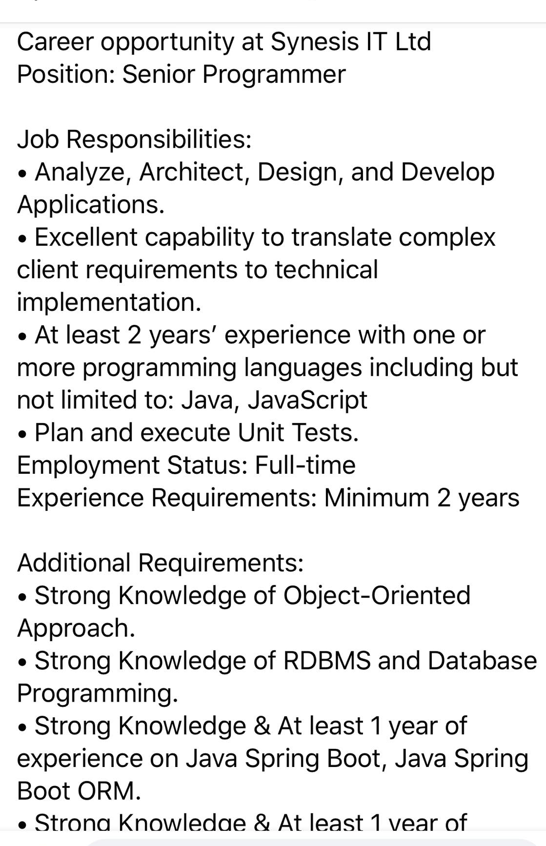
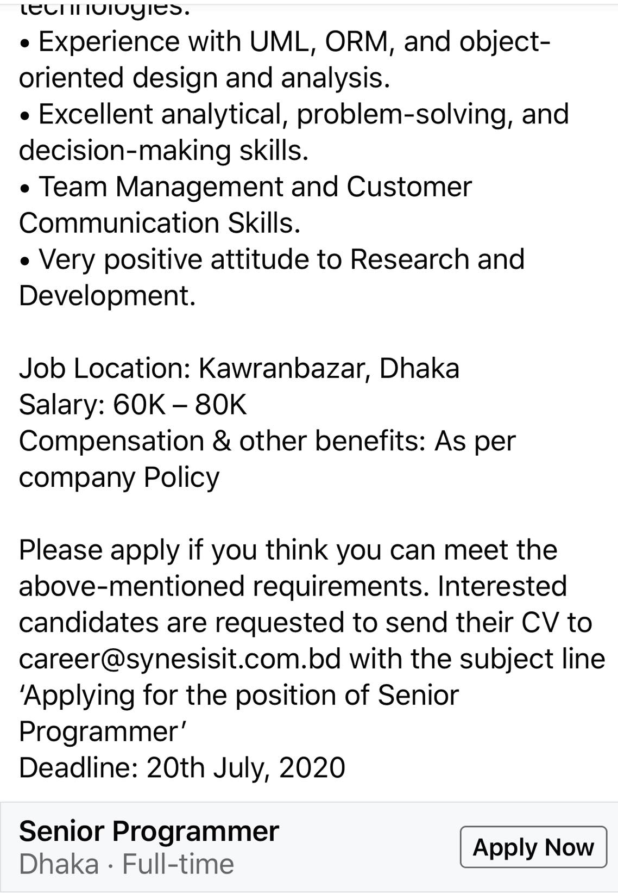

Short-listing & Selecting
Followings are the essential and desirable criteria that Synesis IT follows to do the job and level that the shortlisted candidate should have.
Our shortlist criteria are mainly depends on:
- The qualities and traits of top performers
They must make sure that our criteria don’t discriminate against any legally protected classes in the first place. The important thing here is to apply our criteria consistently, fairly, and objectively across all candidates.

Shortlist criteria can include:
- Education
- Work experience
- Skills and knowledge
- Personality traits
- Criteria Competencies
Based on these criteria they shortlist our candidates.
- Review: It starts with Human Resource representatives/ Executives of our company who reviews the applications and eliminates any candidate who does not meet the minimum requirements for the position or the company more generally
- Phone Interview/Initial Screening: Through phone calls they can initially judge the candidates.
- Invitation for Interview: After the Initial Screening/Phone Interview for software developer.
  - Office HR representatives send interview invitation through Mobile SMS or Email.
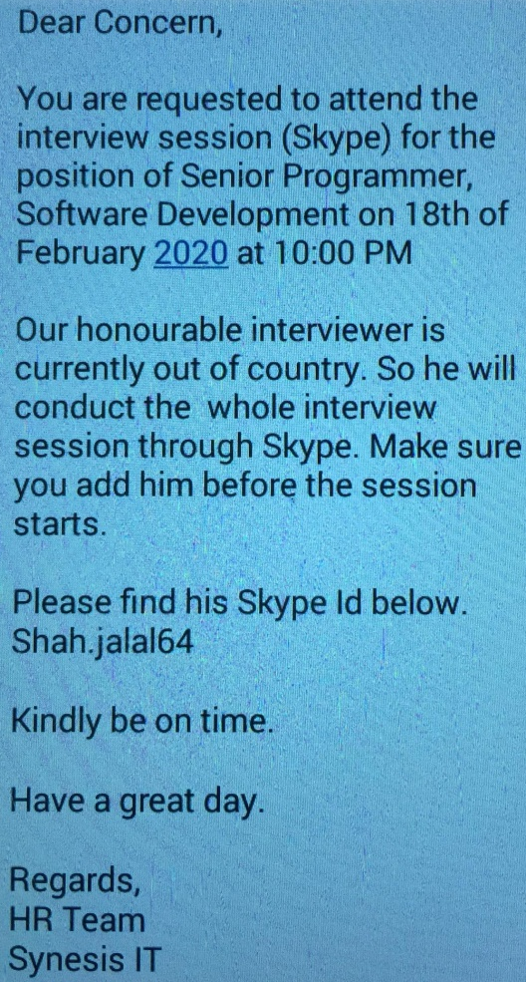
- Interviews: After the Initial Screening/Phone Interview for the position of software developer, 3 several technical interviews are scheduled for those selected candidates. First Interview generally taken by 2 or 3 system analysts, if the candidate got selected in first phase, the second technical interview session will take place. After passing the second technical interview successfully, they will attend the final technical interview session.
- Training Sessions (On the job training): They also have several on and off the job training for all of their employees.
Appoint
After conducting interviews and training sessions, the hiring staffs identify their top choice. Offer them the job and if they accept it they (Synesis IT) send the candidate an email to send them all the necessary documents of the candidate.
- Job offer/Appointment Letter: Once they get all our required documents, they issue Appointment letters. The appointment letter should include the position’s salary, benefits, paid time off, start date, potential severance pay, working remotely policy, included company equipment and other terms and conditions of employment. The Appointment Letter/ Offer Letter also have been attached. The samples of the Job Offer Letter and Appointment Letters have been attached.
- Hiring and On-boarding: Synesis IT always tries to ensure that job culture is perfectly prepared, cleaned, equipped . They also arrange orientation session for them too and always try to make sure that their employee has a clear understanding of the expectations and scheduling of the events. Lastly, assigning a mentor, who will help them settle in to their new position and organization, and properly set them up for long term growth and success.

Recruitment During COVID-19
Today’s job market is a complex place as the Covid-19 pandemic takes its toll on the economy. The process for hiring and recruiting new employees has changed drastically due to Covid-19. Covid-19 has changed the world to upside downs, which has altered the recruiting of new employees and obviously that’s a big challenge for all of us. As Synesis IT Ltd always focus on hiring best talents and it is always attracting large pool of candidates to create a strong pipe line and one of the biggest changes in recruitment during pandemic is managing a very different hiring process. Job interviews now are being conducted remotely, by phone or video conferencing (Skype, Zoom). Our people and culture team adapted and implemented this process to ensure the candidate experience isn’t disrupted by the ongoing situation, so their team is able to continuously deliver to clients by filling vacancies. After identifying the gaps they actually go for phone screening followed by 3/4 virtual interviews (Skill based & Behavioral) via Zoom/Skype. As Synesis IT is highly concern about the health of employees. Virtual recruitment is now the go-to method, while protecting recruiters and candidates from the virus.

During this pandemic they come with a unique on-boarding experience for new hires. Candidates who are virtually on-boarding have become the new normal for their company and as well as around the world. Now in Synesi IT the most important thing is maintaining social distancing and keeping new and current employees safe Synesis IT. On the first day of new hire’s, they are doing virtual orientation sessions, with the Head of concerned Department, Team Lead and with Head of People & Culture and share each other’s thoughts and ask them to be in on the call and to introduce themselves so that they can know more about each other. Along with it, they are checking in regularly and remain open to support the new hires. They understand starting a new job can be a daunting time for some, by remaining in contact with their very new employee who may feel reluctant to call with questions; they are basically certainly putting them at ease. They also believe that preparation is the key and this is why they are making sure that the office equipments and other resources are posted and received by the new hire’s starting date. They always check in the week before the new hires start their (employees) new journey. They are also including our new employees in company updates and news, sharing positive things that are happening within the business to make them feel included and at ease ahead of their start date knowing the company is doing well. They believe that it’s also a great way to introduce them (employee) to their company culture.

The Corona virus outbreak has caused them (Synesis IT Ltd) all to evolve and adapt in many ways.They’ve been left with uncertainty, a lot of questions and they’ve been speaking to clients who are curious to know how this will impact their ability to hire. Not all employers are in a position to put recruitment on hold and wait for this strange time to be a distant memory. In fact, Synesis IT is using this as its chance to have the strongest candidates in the market.

6.1 Data Analysis and Interpretation
DATA ANALYSIS AND INTERPRETATION

- Which sources are used in Synesis IT for recruitment and selection process?

- Internal
- External
- Both
Table: 1
Options | Internal | External | Both | Total
Responses | 1 | 3 | 4 | 8
Percentage | 12% | 38% | 50% | 100%
Chart: 1

Interpretation: Internal and external sources (50%) are used for recruitment and selection. Job portals, advertisement, online/Internet recruitment etc are the highly preferable for external sources.

- Are there any external sources that they used for recruitment in Synesis IT?

- Advertisement
- Internet/Online recruitment
- Campus recruitment
Table: 2
Options | Advertisement | Internet/Online recruitment | Campus Recruitment | Total
Responses | 3 | 4 | 1 | 8
Percentage | 37% | 50% | 13% | 100%
Chart: 2

Interpret: 37% of the employees marked the advertisement position. 50% selected Internet and 13% selected campus selections. Internet is the major source which provides eligible candidates for the hiring in Synesis IT.

- Do they follow centralized or decentralized for recruitment and selection?

- Centralised
- Decentralised

Table: 3
Options | Centralized | Decentralized | Total
Responses | 8 | 0 | 8
Percentage | 100% | 0 | 100%
Chart: 3

Interpretation: It was found that recruitment is fully centralised.

- Is the recruitment process satisfying?

- Yes
- No
Table: 4
Options | Yes | No | Total
Responses | 7 | 1 | 8
Percentage | 85% | 13% | 100%

Chart: 4

Interpret: 87% of employees are satisfied with the recruitment whereas 13% respondents feel that there should be some changes in the existing recruitment process of the organisation.

- Which of the following methods does Synesis IT prefer during selection?

- Written
- Group discussion
- Personal interview
- All of the above
Table: 5
Options | Written | Group discussion | Personal interview | All of the above | Total
Responses | 2 | 1 | 2 | 3 | 8
Percentage | 32% | 16% | 32% | 20% | 100%

Chart: 5

Interpretation: Personal Interview and written test are mostly used method for selection and 12% for group discussion.
- Is the selection process satisfying?

- Yes
- No
Table: 6
Options | Yes | No | Total
Responses | 7 | 1 | 8
Percentage | 87% | 13% | 100%

Chart: 6

Interpretation: About 87 % of the employees are satisfied with the selection process whereas the remaining feel that there should be some change in the recruitment and selection process of the organisation.
- Do you think it is necessary to use innovative techniques like stress test, psychometric test and personality test for selection?

- Yes
- No
Table: 7
Options | Yes | No | Total
Responses | 6 | 2 | 8
Percentage | 75% | 25% | 100%

Chart: 7

Interpretation: 75% agree with the necessity of using stress test and personality tests, while the others said they are quite satisfied with the existing recruitment and selection process.
- Does your company follow any guideline for different grades of employment for different recruitment process?

- Yes
- No
Table: 8
Options | Yes | No | Total
Responses | 8 | 0 | 8
Percentage | 100% | 0 | 100%

Chart: 8

Interpretation: 100% said that they follow guideline for different grades of employment for different recruitment process.

- How do you rate your company’s HR practices?
Table: 9
S No. | Options | Respondents | In percentage
1 | Excellent | 5 | 56%
2 | Good | 2 | 33%
3 | Average | 1 | 11%
4 | Bad | 0 | 0
 | Total | 8 | 100%

Chart: 9

Interpretation: 33% of the employees rated HR department as good, 56% said that its very good and other 11% says its average.

- Is there any contract signed by employees while joining the organization?

  - Yes
  - No
Table: 10
Options | Yes | No | Total
Responses | 0 | 8 | 8
Percentage | 0 | 100% | 100%

Chart: 10

Interpretation: The chart clearly represents that almost 100% employees said no to sign a bond while joining the organization.

- Are HR policies comfortable/ understandable for you?

- Yes
- No
Table: 11
Options | Yes | No | Total
Responses | 7 | 1 | 8
Percentage | 87% | 13% | 100%

Chart: 11

Interpretation: The chart clearly shows that 13% employees are dissatisfied and 87% are satisfied with the current HR practices of the company.

6.2 Findings

Findings
After analysis I have found that Synesis IT has done quite good job in its Human Resources Management field.
Follows are some of the findings:
- HR department is good enough in Synesis IT.
- Synesis IT follows centralized recruitment and selection process.
- Employees like 90% are satisfied with the recruitment and selection process.
- Personal interviews are mostly preferred by managers.
- External sources are mostly used for recruitment.
- 90% are comfortable with the present HR policies of the company and other 10% are not that satisfied the HR process of Synesis It. They need some changes.

Chapter 7
CONCLUSION
&
RECOMMENDATION

7.1 Conclusion

Conclusion

Recruitment is actually the process of seeking the right candidate/employee and motivates them to apply. Selection is selecting that one person who would be the best fit for the company.

Employees are pretty satisfied with recruitment and selection process of Synesis IT Ltd.

To recruit their employees Synesis IT mainly follow advertisement and Internet/Online recruitment.

Synesis IT recruits their employees in a centralized way. Employees are very much known and conscious about the various sources and methods but they should play some vital role in selection process by following innovative techniques where stress management can be a good example.

7.2 Recommendation

Recommendation
Followings things should take with good consideration-
- Synesis IT has to add more employees in their HR team so that they can do their job faster and more effectively than before.
- It (recruitment & selection) should be brief and timesaving.
- Internal recruitment should be first choice because of less cost and motivational factor.
- Sufficient training programs should be there for further development of employees.
- For better effectiveness they must improve some HR practices.
- They should play some vital role in selection process by following innovative techniques like, stress management

Chapter 8
Appendix

8.1 Questionnaire
Questionnaire:
This questionnaire survey is just for the academic purpose not for other official purpose. All Information collected through this survey is highly confidential and shouldnot be shared with anyone individual than the people involved in this.
Name: ...............................................................................................................
Designation: ............................................. Age: ..............................................
Department: ..................................... Qualification: .....................................

Answer the following questions: (kindly give your unbiased response)

- Which sources are used in Synesis IT for recruitment and selection process?

- Internal
- External
- Both

- Are there any external sources that they used for recruitment in Synesis IT?
- Advertisement
- Internet
- Campus recruitment
- All of the above

- Do they follow centralized or decentralized for recruitment and selection?
- Centralised
- Decentralised

- Is the recruitment process satisfying?

- Yes
- No

- Which of the methods does Synesis IT prefer in the selection process?

- Written
- Group discussion
- Personal interview
- All of the above

- Is the selection process satisfying?

- Yes
- No

- Do you think it is necessary to use innovative techniques like stress test, psychometric test and personality test for selection?

- Yes
- No

- Does your company follow any guideline for different grades of employment for different recruitment process?

- Yes
- No

- How do you rate your company’s HR practices?

- Is there any contract signed by employees while joining the organization?

  - Yes
  - No

- Are you comfortable with the HR policies of the company?

- Yes
- No

8.2 Reference
Reference
Ekwoaba, Ikeije & Ufoma (2015), "The Impact of Recruitment and Selection Criteria on Organizational Performance”, ‘European Centre for Research Training and Development UK’, No.2 Volume 3, 22-33
The following web site was accessed on August 31, 2020:
www.synesisit.com
The following web site was accessed on August 31, 2020:
www.tutorialspoint.com
(2016, December). Bangladesh’s It Industry. The Daily Star, pp. 1, 2

