INTERNSHIP REPORT
ON
“GENERAL BANGKING ACTIVITIES & CUSTOMER SERVICE SATISFATION
OF
DUTCH BANGLA BANK LTD.”

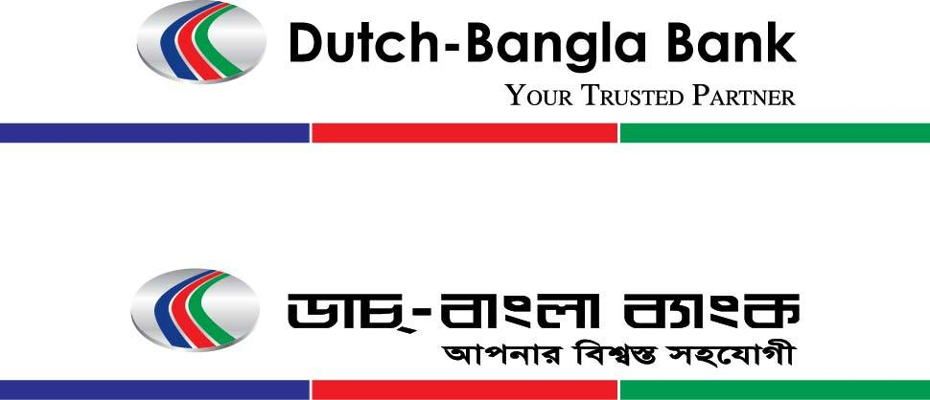


UNITED INTERNATIONAL UNIVERSITY
Internship Report
On
“General Banking Activities & Customer Service Satisfaction
Dutch Bangla Bank Limited”

SUBMITTED TO:
Dr. James Bakul Sarkar
Associate Professor
School of Business & Economics
United International University

SUBMITTED BY:
Aurpa Mahjabeen
ID: 111 132 109
BBA Program
United International University

Date of Submission: 30th September, 2018

Letter of Transmittal
30th September, 2018.
Dr. James Bakul Sarkar
Associate Professor
School of Business & Economics
United International University

Subject: Submission of Internship report on “General Banking Activities & Customers Service Satisfaction of Dutch Bangla Bank Limited”.

Dear Sir,
I am pleased and greatful to submit the internship report on “General Banking Activities & Customer Service satisfaction of Dutch Bangla Bank Limited” of Dhanmondi branch a particle requirement of course of INT 4399.
In this report, I have tried to focus some key terms of Dutch Bangla Bank and their activities and responsibilities on Bangladesh. While preparing this report, I tried my level best to follow and obey your instructions and the instructions that have given to me by my organization supervisor.
In spite of assorted inadequacies, I even have tried to cover the relevant data that you have given to me. It’s quite worthy to say that, without your kind hearted guidance and cooperation, it might not be possible on behalf of me to demonstrate this paper. I will be able to be happy and grateful to you to answer if you’ve any queries concerning this report.

Sincerely Yours,

__ __ __ __ __ __ __ __
Aurpa Mahjabeen
ID: 111 132 109
BBA Program
Acknowledgement

At the very first, I would like to praise my gracious and beneficent almighty due to provide us enough strength, patience, courage and ability to work on for this internship report.
After that, I would like to show the biggest gratitude to my honorable faculty, Dr. James Bakul Sarkar for his sincere guidance and valuable advice throughout the internship program. I am thankful to him for how he guided me with his extreme consistency in every aspect makes the report.
Furthermore, I’d prefer to impart who I even have interviewed and asked opinion for the report. I’m additionally grateful to the opposite worker of Dutch Bangla Bank Limited of Dhanmondi branch who have shared their expertise with me which enlightened me noticeably and additionally helped to find out regarding the banking service.
Eventually, I need to mention the wonderful operating setting environment and group commitment of this bank that has change me tons of deal to try and do observe the banking activities throughout my internship period of three months.

Table of Content

Chapter 01 1
INTRODUCTION 1
1.1 INTRODUCTION 2
1.2 A Brief Introduction of Dutch Bangla Bank Ltd. 2
1.2.1 Origin of the report 3
1.2.2 Scope of the Report 3
1.2.3 Limitations of the Report 4
CHAPTER 02 5
ORGANIZATIONAL BACKGROUND 5
2.1 Historical Background of Dutch Bangla Bank 6
2.2 DBBL Scenario 7
2.2.1 Nature of Business 7
2.2.2 Dutch Bangla Bank at a Glance 8
2.2.3 Hierarchy of Dutch Bangla Bank LTD. 9
2.2.4 Mission 10
2.2.5 Vision 10
2.2.6 Objectives 10
2.2.7 Corporate Division of DBBL 10
2.2.8 Operational Relation 11
2.2.9 Social Responsibility & Economic Performance 12
Chapter 03 13
OBJECTIVE OF THE REPORT 13
3. Objective of the Report 14
3.1 Primary Objectives 14
3.2 Secondary Objectives 14
CHAPTER 04 15
METHODOLOGY OF THE STUDY 15
4. Methodology of the Study 16
CHAPTER 05 18
FINDINGS OF THE STUDY 18
5.1 GENERAL BANKING ACTIVITES OF DUTCH BANGLA BANK LIMITED 19
General Banking 19
5.1.1 Components of General Banking 19
5.1.2 The Process of Account Opening 20
5.1.3 To Shut an Account 22
5.1.4 Deposit Account 22
5.1.5 Cheque Book Issuance 24
5.1.6 SMS Banking 25
5.1.7 Internet Banking 26
5.1.8 Clearing 26
5.1.9 Section of Remittance 29
5.2 CUSTOMER SERVICE SATISFACTION OF DUTCH BANGLA BANK LIMITED 32
5.2.1 Methods to Find Customer Service Satisfaction 33
5.2.2 Questionnaire 33
5.2.3 Survey Analysis 34
5.3 Analysis & Findings 45
5.4 Result of the Survey 46
CHAPTER 06 47
RECOMMENDATION & CONCLUSION 47
6.1 Recommendation for Dutch Bangla Bank Limited 48
6.2 Conclusion 49
CHAPTER 07 50
APPENDIX 50
7.1 References 51
7.2 Questionnaire 52
7.3 Related Documents 53

Executive Summary

In the present situation of the banking sector, is walking competitive advantage, impressed method, similar to a panorama of a race to achieve the leading position of the banking. Most of the bank currently concentrates on promoting feasibleness to earn and generate opportunity chance to carry existing to stay loyal customers, because the business humanity believed that loyal customers increased the forthcoming profitable revenue. The report has centered on the wide client expectations, perceptions, and its implementation risk and general banking of the DBBL to beat all types of client objections for the service failure and weakness.
First part of this report is predicted on introductory part which incorporate topic like organizations origin, objective, background, limitations of the study. Essentially it defines the manner and background of the study to arrange the report. Future part of the report highlights a short outline of all general banking offered by the Dutch Bangla Bank Ltd.
Next half is organized with the outline of the tasks done by me throughout my internship period and a survey supported on the service of Dhanmondi branch and on customers’ satisfaction. This report put together consists of all the findings of the report given some recommendations so on enhance consumer service, quality still as consumer satisfaction level based on the observation and work expertise throughout the internship period.

Chapter 01

INTRODUCTION

1.1 INTRODUCTION

Mostly through the globe, “Bank” we can effortlessly perceive that the economic association deals with money. However there are totally different classes of banking concern like Fundamental Banks, Profitable Banks, Reserves Banks, Investment Banks, Manufacturing Banks, Co-operative Banks, etc. However we tend to use the word “Bank” with none preface or essentials; it refers to the “Commercial Banks”. Commercial Banks are the key provides to the economy of a country. Everywhere the world, the dimension of banking has been dynamic speedily because of release, Technological innovation and Globalization. Banking in Bangladesh has to keep step with the global modification. Currently banks should compete both as native establishment and foreign one.
The declaration of Government’s daring and far-sighted selections to permit banks within the non-public sectors to play its due role within the economy of Bangladesh, have started the method of making new and dynamic monetary establishments. One such institution is that the Dutch Bangla Bank Ltd. (DBBL). At present, it emerges of Dutch Bangla Bank Ltd. is a very vital event at intervals the private banking arena of Bangladesh.

1.2 A Brief Introduction of Dutch Bangla Bank Ltd.

The organization offers deposit products together with savings, deposit accounts, current deposit accounts, and short term deposit accounts, and resident foreign currency deposits, foreign currency deposits, convertible and non-convertible take accounts, exporter’s FC deposits, and term deposits. It conjointly provides loans and advances, like personal credit facilities, loan against trust receipts, transport loans, real estate loans, loans against accepted bills, industrial and agricultural term loans, lease finance and other term loans, and different term of loans, also as foreign currency loans and overdrafts.
The Bank offers corporate banking service, as well as project finance and working capital finance, syndications and structured finance, trade finance, equity finance and social and environmental infrastructure finance and small and medium enterprise banking service consisting of money credit, term loans, pageant loans, women entrepreneurs financing, distributor financing and small shop financing schemes.
Further, it provides import and export finance, foreign remittal and treasury service, debit and credit cards, net mobile and SMS banking service and automated teller machine (ATM) agent banking service. As of December 31, 2017 the organization operated a hundred seventy five branches, 4467 ATMs and 780 fast tracks furthermore as student electronic booths and purpose of sales terminals.

1.2.1 Origin of the report
The internship program is an obligatory demand for the scholars who want to be a BBA graduate from United International University. I used to be with a number of the organization named Dutch Bangla Bank Ltd. for this intern program. This report has been equipped with my partial experiences on the day to day banking activities, educational information and underneath shut direction of my core support additionally as my official supervisor. The report entitled “General Banking Activities & Customers Service Satisfaction of Dutch Bangla Bank Limited” has been completed as a partial fulfillment of BBA program licensed by the department of Business Administration of United International University.
This report created for the internship program of United International University as BBA department. This internship program lasted for three months from 10th July. United International University help to get internship in Dutch Bangla Bank Limited by dropping my CV and Dutch Bangla Bank offers me the chance to get a lot of sensible practical experiences from this bank.

1.2.2 Scope of the Report
I have plenty of scope to induce plenty of expertise as a result of those bank’s Manager, Supervisor and Officers, who helped me and report enclosed the customers with the general banking system of Dutch Bangla Bank Limited and conjointly includes a relationship with the customers with the bank also because the principals lined by the bank as a general banking system.

1.2.3 Limitations of the Report
The officers were terribly cooperative, however typically they were too busy to seek out a while to inform me the reasons behind their regular activities.
As I had to organize this report all on my own, I faced some constraints throughout the period of my internship as follows:
Shortage of time:
I had to finish this report at intervals three months and here may be a terribly shorter amount of time. Therefore, it’s a limitation of the report that hampered the course of monumental vary.
Busy operating environment:
Bank is a busy organization with comparison to others. There have been rushes of individuals for concerning whole day and officers got to handle them. Therefore it had been noticeably tough for them to allot time for an internee.
Inadequate opportunities:
All needed explicit data isn’t out there in any explicit outgrowth of the bank, and there have been additionally little opportunities to go to over one branch.
Lack of sufficient well informed officials:
Several staffs and members of the branch weren’t well informed about different systems of Dutch Bangla Bank. They grasp however less. I had to face several difficulties to gather this data.

CHAPTER 02

ORGANIZATIONAL BACKGROUND

2.1 Historical Background of Dutch Bangla Bank

Dutch Bangla Bank restricted to be a regular bank. The bank is established conjointly by native Bangladesh parties’ spearheaded by M Sahabuddin Ahmed (Founder & Chairman) and thus the Dutch company FMO. And together established below the bank companies act 1991 and incorporated as a public Ltd. below the business act 1994. In Peoples’ of Republic Bangladesh, with the primary objective to carry on all types of banking business in Bangladesh. The bank is listed with Dhaka exchange restricted and town exchange restricted. DBBL could be an Asian nation European personal venture scheduled bank commenced formal operation from June 3, 1996.
DBBL is public Ltd by shares, incorporated in Asian country within the year1995 below company act 1994. With half hour equity holding, European nation development no depository financial institution (FMO) of European country is that the international co-sponsor of the bank. Out of the rest seventieth, hour equity has been provided by distinguished native entrepreneurs and industrialists and thus the remainder 100% shares is that the general public issue. Throughout the initial operative year (1996-1997) the bank received talent augmentation technical facilitate from ABN Amor Bank of Bangladesh.
DBBL has started its business with foreign bank DBBL commenced its business as scheduled bank with impact form Gregorian calendar month 04, 1995 with one branch Motijheel, Dhaka, with a proverb to grow as leader at intervals the banking arena of land of Asian country through higher guidance and impact services to purchasers and so to revitalized the economy of the country. All branch of unit of measurement presently providing very On-Line banking facility. DBBL resumed its operational activities at the beginning with a licensed capital of Tk. Four hundred million and paid up capital of Tk. 202.14 million.

2.2 DBBL Scenario

2.2.1 Nature of Business
- The bank conducts every kind of economic banking operations.
- The organization offers deposit products as well as savings deposit accounts, current deposit accounts, short term deposit accounts, resident foreign currency deposits, foreign currency deposits, convertible and non convertible take accounts, exporter’s FC deposits, and term deposits.
- The company offers company banking services, as well as project finance and working capital finance, syndications and structured finance, trade finance, equity finance and social and environmental infrastructure finance.
- The bank is additionally providing individual credit, facilities associated with native and foreign remittances and several products related services.
- The definition of the bank that is taken into account to support the fixed income group in nurturing the quality of living is competitively priced and has wide appreciated by the consumers.
- The banking services consisting of money credit, term loans, fest loans, women entrepreneurs funding distributor financing and small shop financing schemes.
- Is additionally provides import and export finance, treasury service, debit and credit cards, net mobile, and SMS banking services, and Automated Teller Machine (ATM) agent banking services.

2.2.2 Dutch Bangla Bank at a Glance

NAME | DUTCH BANGLA BANK LTD.
Founder | M Sahabuddin Ahmed
Types of financial institution | Foreign Commercial Bank, Second generation private sector com. Bank
Date of incorporation | July 23, 1995
Date of starting operation | July 04, 1996 with one branch
Registered office | Senakalyan Bhaban 3rd, 195, Motijhil C/A, Dhaka- 1000, Bangladesh
Name of the chairman | Mr. Abul Hasnat Md. Rashidul Islam
Slogan | Your Trusted Partner
Number of branches | 175 (up to 2017)
Service provided | Deposit Scheme, Loan & other banking
Diversification of products & services | Corporate Banking, Retail banking & Consumer Banking
Paid up capital | 202,135,000
Publicity traded company | Share quoted daily in DSE & CSE
Available cards | DBBL Master, Visa, Nexus
Banking operation system | Both conventional and Islamic Banking System
telephone | (88020)7176390-93
Fax | (8802)9561889
E-mail | dbbl@bdmail.net
Web site | www.dbbl.com.bd
SWIFT | DBBL BD DH

Table 1: DBBL at a Glance

2.2.3 Hierarchy of Dutch Bangla Bank LTD.

First Vice President
Chairman
Managing Director & CEO
Trainee Assistant Officer
Assistant Officer
Executive Officer
Senior Executive Officer
Principle Officer
First Assistant Vice President
Assistant Vice President
Senior Vice President
Executive Vice President
Senior Executive Vice President
Deputy Managing Director
Vice President
Additional Managing Director

2.2.4 Mission
Dutch Bangla Bank is engineer’s enterprise and creative thinking in business and business with an advertisement to social responsibility. “Profits Alone” don’t hold a central focus within the banks operation, as a result of “Man does not live by bread and butter alone”.

2.2.5 Vision
DBBL’s essence and attribution rest on a cosmos of ability and so the marvel magic of a charmed life that abounds with spirit of life and adventures that contributes towards human development. Dutch Bangla Bank dreams of butter Bangladesh, where arts and letter, sports and athletics, music and recreation, science and education, health and hygiene, clean and pollution, free atmosphere and specifically a society supported morality and ethics build all our lives value living.

2.2.6 Objectives
The objective of core DBBL believes in it hard-line commitment to satisfy its client desires and satisfaction and to become their initial alternative in banking. Taking cue from its pool honored business, Dutch Bangla Bank intends to pave the means for a brand new era in banking that upholds and epitomizes its vaunted marquees “Your Trusted Partner”.

2.2.7 Corporate Division of DBBL
Dutch Bangla Bank Limited basically deals with the three separate departments to provide banking service. They are:
- General Banking Division
- Foreign Exchange Division
- Investment Division



Remittance of Funds
Import
Export
Account Opening
Cash
Clearing
Investment
Foreign Remittance
General Banking

Table2: Corporate Division of DBBL

2.2.8 Operational Relation
It is thought about as an important part for business institutes because it has the power to bind the organization along. The culture and values of Dutch Bangla bank Ltd have proven as a competitive advantage for the bank and are acting as a key part to establishing the link between the bank and workers and, in term between workers and customers. Culture and values conjointly encourage customers and workers to join with the bank and stick with them. This bank is one in every of the foremost disciplined banks with a particular corporate culture. Dutch Bangla Bank Ltd believes in shared which means, shared understanding and shared sense creating. Bank’s workers can see and perceive events, activities, objects and scenario in a very distinctive means. They mould their manners and rule, character singly to suit the aim of the bank and also the desires of the consumers who are of paramount importance to the bank. Dutch Bangla Bank Ltd has been able to improve organizational performance via improving the performance of individual contributions, acknowledges existing abilities to fill up the higher vacancies within the organization or place them within the right position.

2.2.9 Social Responsibility & Economic Performance
Corporate social responsibility is turning into more and more necessary activity to business in our country also as alternative countries around the world. Several of the companies have more and more recognized the advantages of providing CSR programs in their various locations. In recent years CSR has become a basic business follow and has gained a a great deal of attention from all the concerned companies of our country. The ethics of Dutch Bangla Bank Limited for following its activities in social arena possesses further momentum at the side of enthusiasm and support. Dutch Bangla Bank Foundation (DBBF) is consistently following its objective of being active in those social areas where it’s needed most. The review carries out varied social and philanthropic activities among the sphere of education, health, conservation of nature, creation of social awareness, rehabilitation of distressed folks and such different programs to redress human sufferings. Its put together promotes all completely different socio responsibilities in an passing larger perspective continued its contribution amounting to 5% of banks profit once charging loan loss provision to Dutch Bangla Bank Foundation (DBBF). DBBL is socially responsible in varied says. It’s serving to the society among the following ways:
Information Technology
Disaster
Health
Donation
DBBL Sector of CSR
Education

Chapter 03

OBJECTIVE OF THE REPORT

3. Objective of the Report

The Fundamental purpose of the report is to adjust the necessity of Dutch Bangla Bank Limited. However the aims of this report are rather broader. The objectives are classified in the following:

3.1 Primary Objectives
The main objective of this report is to assess the General Banking performance and client service satisfaction of the Dutch Bangla Bank Limited in Bangladeshi banking sector in providing products and services to the consumers.

3.2 Secondary Objectives
- To apply educational data within the sensible field.
- To observe the operating atmosphere in commercial banks.
- To explore present banker- client affiliation.
- To understand the overall to operate general function of the bank.
- To establish a bridge between the theories and hands on processes day to day banking operations.
- To gain sensible data by operating in several desks of Dhanmondi Branch of DBBL.
- To have possible exposures that may be useful for my job career.

CHAPTER 04

METHODOLOGY OF THE STUDY

4. Methodology of the Study
a. | Types of Data | - Primary Data  - Secondary Data
b. | Data Collection Process | - Observation  - Interview  - Questionnaire  - Documents & Record
c. | Sample Size | 123
d. | Sampling Technique or Procedure | Non- Probability (Convenience Sampling)
e. | Scope | - Area: Dhanmondi  - Time: Three months of Internship period

- Types of Data:
Primary and Secondary plays a really crucial role within the research analysis of the report. In this analysis, there are a unit completely different ways to gather data as:
- Primary Data: primary data, which was collected by me with the method of surveying, observation, Questionnaire, Interviews etc.
- Secondary Data: Data collected by the documents that are exist in the web site of the bank, and records which are available in Google.

- Data Collection Process:
First of all, I have been learned by observing many things by working in the bank. Then I have taken some of interviews from some officers and executive officers of Dhanmondi branch office. Made some questionnaire for the survey and collected rest of the data form their official web page and also by Google.

- Sample Size
Sample size 123 and survey has taken online by using Google form.

- Sampling Technique or Procedure:
In this sampling technique, the members are being selected as who are the users and take services from the bank and for my convenience; I was working in the bank and took online survey regarding the issue within dhanmondi area people.

- Scope

- Area: As I was working for three months in Dhanmondi branch, so I decided to working on this report within Dhanmondi area people.
- Time: The time was so short, and time of three months of internship period, I had to complete the report.

CHAPTER 05

FINDINGS OF THE STUDY

5.1 GENERAL BANKING ACTIVITES OF DUTCH BANGLA BANK LIMITED

General Banking
All business considerations build a profit through commercialism either a product or service. A bank doesn’t turn out any tangible product to sell withal will supply a spread of monetary service customers.
General banking deportment is taken into account because the direct client service center. It’s the start line of all the bank procedure. This department portrays one amount the foremost necessary roles within the industrial banks. And this department provides some ancillaries services and daily service to the client moreover a day it receives deposits from the consumers and meets their demand for money by conformity cheques. It opens new accounts, remit funds, issues bank drafts, clear cheques, and pay orders etc.
A banker and client relationship to establish the primary step is account gap. However a gap account is incredibly crucial for a bank to choice of client. The banker associate degreed client written agreement relationship becomes produce gap of a checking account.

5.1.1 Components of General Banking
General banking consists of the subsequent sections within the branch. This area unit as follows:
- Account Opening
- Account Closing
- Deposits Account
- Issuance of Cheque Book
- Payment Order
- Issuance of Debit Card and Solve the issues connected with the client.
- SMS Banking
- Internet Banking
- Clearing Cheques
- Provide Foreign Remittance Services.

5.1.2 The Process of Account Opening
It’s said that there’s no manager client relationship if there’s no account of an individual in this bank. Opening an account, banker and client produce a written agreement relationship. But selecting a client for opening an account is incredibly hard for a bank. This bank opens some kinds of account: Savings Account, Student Account, Salary Account, and Business Account.
Before opening of savings and business account, the subsequent formalities should be completed by the consumers:
- Applicant fills up the relevant form within the prescribed manner.
- Applicant is needed stock up the specimen signature card if required.
- For individual info is required by associated account holder.
- The licensed officers examine the documents submitted.
- Issuance of slip and also the deposit should be created in money.
- After depositing the money, one cheque book issued.
- Now account is opened.
Opening a student account formalities are same as savings account, however cheque book don’t seem to be issued during this account.

General Demand for Opening Savings/ Business Account
There are few general rules for opening all style of account that are as follow:
- Account opening type to be crammed in and signed by the account holder.
- Introduced by associate existing an account holder with valid account number, signature, and relationship with an account holder, mobile no. or the other person acceptable to the bank.
- 1 copy passport size photograph and NID card photocopy on the nominee.
- 2 copies of recent passport size picture of each account holders which should be signed by the introducers and NID card photocopy.
- Utility bill copy wherever account holder resides.
- If the account holder is working somewhere, job ID card or TIN certificate is needed.
Additional Documents that Needed to Open an Account
The rules and laws to open a replacement account might take issue from person to person relying the sort of account client desires to get. Initial of all, completely different of consumers like individual, joint, ownership, partnership, non- public Ltd., associations, club, societies, trusts etc will open their varied forms of accounts in line with their needs that are as follows:

Individual & Joint Account
- Passport copy or NID card or driving license or work place ID or word commissioner certificate and any type of ID acceptable to the bank.
- Attested copy of passport with visa for foreign currency account.
- Joint account declaration type for the joint account
- TIN certificate.

Account of Proprietorship
- Bank should be filled up the declaration kind of sole ownership form.]
- TIN certificate.
- Submission of a duplicate trade license.
Account of Partnership
- Copy of registered partnership deed.
- Submission of a duplicate partnership deed.
- Associated letter punctually signed by all partners.
- A copy of a trade license.
- Company TIN photocopy.
- List of partners with full address & signaling.

5.1.3 To Shut an Account

- Account holder needs applying during a explicit type with full signature.
- He or she or they need to surrender the remaining cheque book and card issued by the bank.
- Verified the signature and approved by operational head.
- Shut the account.

5.1.4 Deposit Account

The bank deposits 2 sorts of account. One is DPS which is deposit plus scheme wherever is sporadically like three years, five year and ten years. And this rate is 5%. This is often terribly low rate different then banks in Bangladesh. Extra demand is one copy passport size image and NID card or permit or passport copy to account holder and nominee’s one copy image with documented to the account holder and NID copy and clearly account holder should be open bank account. Then he or she can open or produce deposit account.

Amount of Deposit | Effect before 2009 | Effect from 2009 | Effect from 2015 | Amount Deposit | Effect from 2017
Twenty Thousand one to One Lac | 120 | 120 | 150 | Twenty Thousand One to One Lac | 0.00
One Lac One to Ten Lac | 250 | 350 | 500 | One Lac One to Five Lac | 150
Ten Lac One to One Crore | 550 | 1000 | 1500 | Five Lac One to Ten Lac | 500
One Crore One to Five Crore | 1000 | 5000 | 7500 | Ten Lac One to One Crore | 2500
Above Five Crore | 5000 | 10000 | 15000 | One Crore One to Five Crore | 12000
 |  |  |  | Above Five Crore | 25000

Table 3: DPS (Deposit Plus Scheme)

Another is Fixed Deposit account, wherever is sporadically like one month, three months, six months, one year, three years, five years and ten years. And this rate is fluctuating in sporadically. It’s further demand is one copy passport size image and NID card or driving license or passport copy to the account holder and nominee’s one copy image with genuine to the account holder and NID card copy. Then he or she open or produce fixed deposit account. Use this licensed exchange house to receive remittal with one% further bonus. Biometric fixed deposits are now available at this bank.

5.1.5 Cheque Book Issuance
Only account holder requisite on the prescribed request slip contemporary cheque nook is delivered to the account holder, within the cheque book issued antecedently, bank officer check the account holder signature and verified. The bank deputy manager licensed there correct acknowledgement.
The In charge of general banking division officers can receive the request and permit coming into the division cheque books issued register, and separate foils within the register offer account holder signature. The present account and bank account cheque books area unit around of twenty, fifty pages. Produce an opening such account, the officers take the client signature to needed a cheque book requisition slip. He or she can receive a cheque book solely three working days if the account open kind is found complete all told respects. The officer enters the name and account range of the client within the DCBIR, the actual cheque book, and keeps a record within a file in the PC information. The request slip ought to preserve as vouchers of the account holder. And once three operating days later bank give cheque book to the client, and bank account cheque request rate is 145tk with the VAT. These quantity reductions from their own account.

Bank issuing the new cheque book, if everything is that the right type.

Banker Verifies the Slip

Request Slip occupied up accurately alongside the account range

Enter the cheque book variety within the register book of the precise client name

The Procedure for Subsequent for Provision of a cheque Book
- In the start, the client ought to refill the cheque requisition.
- The In- Charge officer enters the name, account range of the clients within the cheque book register against the fastened cheque book series.
- Later the In- Charge officer from the deposit department, signs the register cheque book and also the request slip.
Then the client receives the cheque book from the bank of the deposit department when the acknowledgement on the request slips and register book.

5.1.6 SMS Banking
The bank launched SMS banking services to produce immediate contact to consumer account data at any time. Any portable operator having associate account of this bank will get the service through the portable upon registration.

Advantage of SMS banking
- Quick management over the standing of the account that the message concerning the dealings is received forthwith.
- SMS information service is accessible for each people and company clients and every one cards issued by the bank.
- Avoid fraud, quick data within the case of felony or the cardboard is being employed while not correct authorized.
- Unlimited electronic messaging service received regardless the quantity of transactions.
- Controls over transactions created exploitation secondary card.
- SMS data services is accessible in everywhere, all told areas lined by mobile operators having roaming agreements.

5.1.7 Internet Banking
This bank has proudly introduced the ground breaking “2 issue Authentication” (2FA) security solution that protects a clients identity associated degree account information from access by an unauthorized person. This security answer is meant for net banking 3rd party fund transfer transactions within the bank account holders. Only 2FA registered clients can performs the 3rd party fund transfer human action through net business.
2FA is an additional layer of security that provides a second verification of online identity, will get a token that generate a different and unpredictable in every 60 seconds. Combine this vary together with your existing user name and word to make human action exploitation internet service. This verification is finished exploitation secured ID token. Use of secured ID tokens is as simple as coming back into a word, but way more secured. This new feature can increase the security of an account. There are combine of sort of token that have a tendency to tend to providing to make a secure human action. These hardware and package token.

5.1.8 Clearing
Clearing may be a coordination by that a bank will assemble purchasers fund from one bank to a different through a financial institution. It’s an area wherever the representatives of various banks get along to receive and deliver cheques with another bank. Generally, Bangladesh bank performs the financial institution in Dhaka, Chottogram, Rajshahi, Khulna, and Bogura, wherever there’s no branch of Bangladesh Bank, Sonali Bank arranges this operate.
As so much security is bothered client get crossed check for the dealing. The principlal purpose of clearing section is to work with safety and security of economic dealing of the money instrument like Demand Draft, PO, Cheque on behalf of the client through B.B financial institution (BCH), outside bank clearing (OBC), Inter Brunch Clearing (IBC). This section examines within the following way:

- Remuneration within the Dhaka.
- Remuneration bank outside Dhaka, then these cheques cleared by OBC, OBC stands for assortment.
- Remunerating their branch, cheques cleared by IBC (Inter Branch Bill for collection)

Clearing Types
1. Inward Clearing
&
2. Outward Clearing
Clearing House

When the banks receives cheques drawn on them from different banks within the financial institutions, it’s in ward clearing. Once the cheques of its client receive for assortment from different banks, the subsequent ought to be monitored terribly fastidiously.
- Cheque should be crossed.
- Quantity each in words and figure in deposite slip ought to be same, and it ought to be custom made to the number mentioned in words and figures within the cheques similarly.
- Cheques shouldn’t carry a date older than the receiving date for quite months.
- The assembling bank should check whether or not the endorsement is completed properly or not.
- Entry in inward register.
- Checking within the PC.
- Pay individual order register.
- Sign within the register by approved officer.
- Cancellation of instrument.
- Send IBCA to native workplace for honored instrument.
- Send come memoranda, showing cause to workplace for discredited instrument.

Outward Clearing
When a bank receives a cheque from its client drawn on the opposite banks inside the native clearing zone for assortment through financial institution, it’s outward clearing. Once specific branch collects the monetary instrument like PO, DD, Cheques inside Dhaka and not of their branch, then the outward clearing are going to be useful. The procedures of outward clearing as follows:
- Instruments with schedules to the principal within the event of DBBL when provision an Inter Branch Debit Advice (IBDA).
- Clearing stamps ought to be connected to the instruments.
- The approved signature endorses instrument.
- Client receives the duty signed instruments and conjointly branch code range mounted on the instruments.
- Entries within the outward clearing register.
- Instrumented with paying slip.
- Attested of seal.
- Special cross seal.
- Clearing seal.
- Endorsement seal with sign.
- Separate instrument from paying slip.
- Sort the instrument bank wise and branch wise.
- Prepare schedule as per branch.
- Prepare banking program.
- Prepare financial institution sheet.
- Detailed of the instruments and vouchers that recorded within the outward clearing register.
- Send instruments to the branch with the schedule.

5.1.9 Section of Remittance
“Remittance” suggests that the distribution of cash from one place to a different place through a post and transmits. Money creating banks represents this facility to its client victimization unloading cash from one branch of the bank and creating a neater arrangement for payment to a different branch inside the country.
The main operate of remittal department is to transmit money from one place ro a different place to attenuate the chance accompany handling cash. There are three ways of paying funds:
- Payment Order (PO)
- Demand Draft (DD)
- Telegraphic Transfer (TT)

Payment Order (PO)
Payment order (PO) is a non negotiable acclaim document. It’s typically used as a substitute for money. It can even be recycled because the safety of the loan. Bank considered pay order in term of a quantified charge safely fracas of cash. For sending cash, pay order my be used as cheques wherever the client of different banks will simply credit through clearing the pay order.
The appliance assigned by the branch of a bank for allowing the client to remuneration certain quantity of cash to the order of individual or association or branch or geographic point among identical financial organization space of the pay order issuing branch.
Pay order varied sorts of options:
- Provision branch and therefore the paying branch should have to be compelled to be same.
- Application for payment among the financial organization space of the provision branch.
- This could also be open or may be crossed.

Pay order payments procedures
- Examine genuine of the pa order.
- Enter pay order register and provides contra entry.
- Debit the fund if its ok for payment.

Demand Draft (DD)
It is comparable to the telegraphic transfer except mistreatment an applicant note for moving cash from branch to branch of the bank of DBBL. Demand draft may be a reasonably bill of exchange. It’s the foremost normally used method of landlocked remittal. It’s a whole instruction of the bank to pay a precise quantity of cash from one branch to a different branch as per application. Whereas transferring the cash safely from one town to a different town, people use DD since it will transfer the cash between the various branches of a similar bank simply and quick. If a big is needed to be stirred from one place to different, then a client will request to try to the DD and bear to the destination rather than money.
Procedure of issuing Demand Draft
- Acquiring demand draft from that is properly stuffed in and signed by the somebody.
- Receiving the quantity of transfer as per advised the commission and postage charge.
- Inserting take a look at variety.
- Entering within the DD register.
- Issuing recommendation to the receiver branch.

Procedure payment of Demand Draft
- Examine typically of the DD the amount; verify the signature, request, test, series, etc.
- Getting into within the DD owed register.
- Valedictory with the IBCA
- Passing necessary voucher.
Telegraphic Transfer (TT)
Its associate instrument for transferring cash by a telecom message or telex from one bank to different of in contrast to vicinity or from one branch to a different branch of altered place of constant bank. Mostly, it’s associate instruction from importers bank to the exporter’s bank or another bank within the exporter’s country to a named person. And it’s not out there currently.
Telegraphic transfer is that the most speedy and convenient however big ticket technique. They are various types of TT as fax, mobile, telephone, telex, and telegram.

5.2 CUSTOMER SERVICE SATISFACTION OF DUTCH BANGLA BANK LIMITED

Customers are the lifetime of any reasonably business. Most of the business organizations within the nowadays client driven, making an attempt to satisfy the customer’s expectation within the best means. They invariably try and grab their most potential customers to extend their market share. Once the product and service provided by the business meet the expectations of the client then the client are going to be glad and can repurchase product and are going to be loyal client to its company. Within the banking sector in Bangladesh client satisfaction is additionally important as a result of the competition during this sector has been increasing. To retain their most loyal and to draw in potential client banks ought to provide what the client need and expectation. DBBL restricted is additionally client targeted and invariably committed to supply best service to its client that is 1st priority of this bank.
As an intern of DBBL (Dhanmondi Branch) that I have used to be assigned to resolve client drawback of general banking and observe the client expectation and demand. From this I got interest to seek out the client satisfaction level of DBBL. I made a decision that my report are going to be also on clients satisfaction level of Dutch Bangla Bank Limited. Finding the client satisfaction level is additionally necessary for an organization to require correct and effective call. This can indicate the client repurchase intention, limitation on the service provided by the corporate, and customers’ expectation, points to boost which can play an necessary role to require important call by the management. Client service is an especially necessary a part of maintaining in progress client relationships that necessary to continuous revenue. For this reason, several corporations have worked exhausting to extend their client satisfaction level. Customer’s satisfaction primarily depends on numerous factors. Clients are going to be proud of the bank after they can get nice and quality administrations from representatives of wager a continuing premise.

5.2.1 Methods to Find Customer Service Satisfaction

- Made Questionnaire
- Online Survey
- Analyze Survey Data
- Finding from the Analysis
- Interpret

To find our the client satisfaction level of DBBL first of all I even have created a online form of 10 quarries which can be rated by the prevailing client of Dhanmondi branch of DBBL 1-4 or 1-5 which can represent very poor to excellent, strongly disagree to strongly agree, and not sure to yes definitely. The surveys are conducted by response of one hundred twenty three customers of the bank.
After this survey, I am able to analyze survey knowledge and create a outline of the analyzed knowledge that is finding from the analysis. Then finally I am able to provide the survey result supported the findings from analysis of survey knowledge.

5.2.2 Questionnaire
Questionnaire is created supported some variables that have directly or indirectly influence on the client satisfaction level. Here for this survey I ever have taken with 123 random people online of the Dutch Bangla Bank client. Then I asked the however long they were being with DBBL and are they glad with their overall service. A number of them said they’re absolutely glad with their services therefore a few not look so. Then I questioned them to stock up these quarries considering their thus far experiences in the bank and mark these one to five or one to four. The quarries are given as followings:
Questions | Rating
1. Worker behavior with the client | Very Poor | Poor | Fair | Good | Excellent
2. Reasonable service charge | Strongly Disagree | Disagree | Neutral | Agree | Strongly Agree
3. give prompt and correct service | Not Sure | Probably Not | Probably | Yes Definitely | ____
4. Problem solving skills of the workers | Poor | Fair | Good | Excellent | ____
5. Branches availability | Poor | Fair | Good | Excellent | ____
6. Service on time | Poor | Fair | Good | Excellent | ____
7. Modern and updated technology | Strongly Disagree | Disagree | Neutral | Agree | Strongly Agree
8. ATM booth availability | Not Sure | Possibility Not | Possibility | Obviously | ____
9. Client feels safe by making transaction | Strongly Disagree | Disagree | Neutral | Agree | Strongly Agree
10. Guarantee smart online service | Not Sure | Probably Not | Probably | Yes Definitely | ____

5.2.3 Survey Analysis
In following I am going to describe about the questionnaire that I surveyed and described about the percentage:

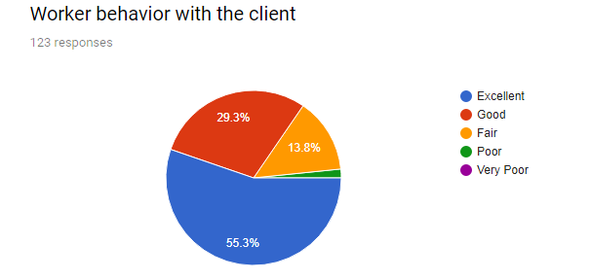
Chart No: 1

Behavior of the worker operating within the bank is one in all the vital factors for the client to be happy. In my survey, there was a question regarding the workers behavior with the client within the bank providing banking service. From the survey, I was able to see that at the most 55.3% clients appreciate with the “Excellent” service, 29.3% were agreed as “Good”, 13.8% says “Fair” with their behavior and few customer says poor and very poor behavior.
It implies that they’re very happy with the behavior of the worker of Dutch Bangla Bank Ltd.

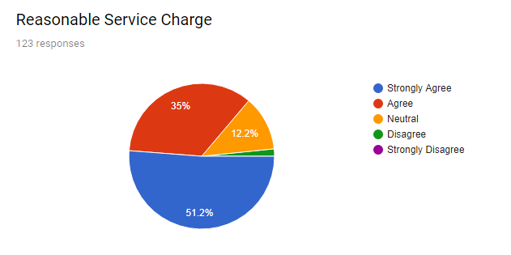
Chart No: 2
Service charge taken by the bank is usually a substantial issue to the client to be happy with. Clients were asked that full service bank charges fairly for the service they’re providing to the client. Among 123 client, 51.2% were “Strongly Agreed”, 35% were “Agreed”, 12.2% were “Neutral” about the statement.
This means the service fee taken by the bank is cheap than the alternative banks in operation within the country.

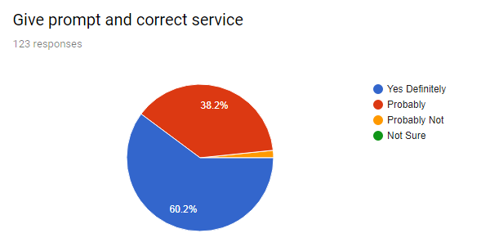
Chart No: 3
Getting prompt and correct service is one amongst the foremost vital factors of client satisfaction. If a bank fails to supply prompt and correct service, then it’ll clearly lose its valuable client and result of this could be devastating for the prospect of the bank and it’ll be criticized. Thus it’s substantially vital for each the bank to think about as primary priority to supply. Survey indicates that 60.2% says “Yes Definitely” 38.2% says “Probably” and rests says probably not and not sure about the statement.
Moreover, it means they are definitely giving their service with prompt and correct way.

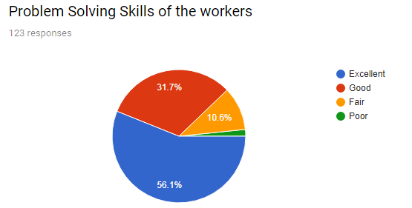
Chart No: 4
Problem determination skills of worker of the bank may be a important bear on suppose once they try to justify performance of the bank that resulted in satisfaction or discontentment of the client of the bank. Client usually face totally different drawback once creating dealing, taking loan, depositing cash and taking alternative service provided by the bank. It’s vital bear on suppose what quantity disposition or avidity shown by worker and tome taken to resolve the matter.
The largest percentage shows that 56.1% (Excellent) were satisfy with their workers problem solving skills. 31.7% says “Good” and 10.6% says “Fair” with their problem solving skills.

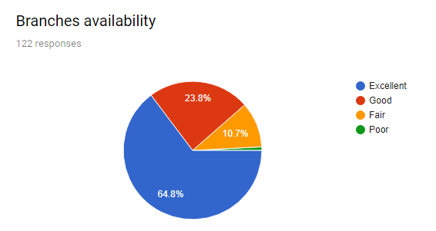
Chart No: 5
Making banking service irresistible has got to be convenient to every individual door step. Among 123 respondents, I actually have asked these quarries whether or not the branches assessable or not.
64.8% were said with the “Excellent” marks that means branches are available near to their clients, 23.8% says “Good” and 10% says “Fair”. That means they are excellent in the performance of the availability of the branches.

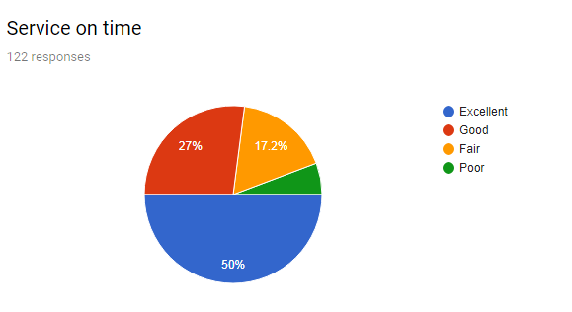
Chart No: 6
Clients continuously selected those banking service from whom they realize a straight forward and quick service. If a bank checks that this are providing well then it’ll create client happy.
Here able to see that 50% says with “Excellent” on their timing of service, 27% says “Good” and 17.2% says “Fair” at their timing of service. It means it’s found that they are providing their services as fastest as possible and clients are too glad with their given service

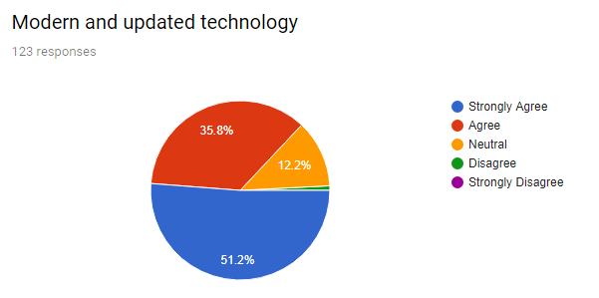
Chart No: 7
Technology is incredibly necessary within the gift world in any business. Within the industry it’s obvious. To record dealing the software system, they are using and devices the use also are sizeable to seek out the client satisfaction level. If the bank uses latest reliable software system and devices then it’ll have an effect on conjointly on client satisfaction. It’ll create simple for the bank to try and general banking activity and this may have a sway on the client.
Here can see 51.2% were “strongly Agree”, 35.8% were “agree”, 12.2% were “neutral” about the statement.
It means the bank is using modern and updated technology and their clients are highly satisfied.

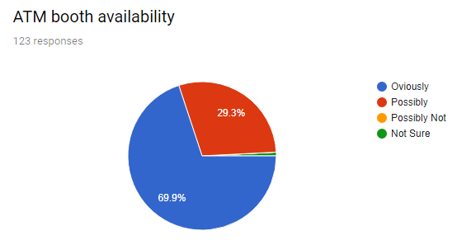
Chart No: 8

Network provides for ATM service by the bank is part to justify a banks quality service. I a bank guarantee quality network for ATM service then the client are going to be glad. If there’s smart network then there’ll be no drawback to withdraw and deposit cash from ATM machine.
DBBL survey information shows tremendous positive sign, 69.9% clients says “Obviously” ATM booths are available and 29.3% says “Possibly”. It shows that ATM booth availability at quiet satisfactory.

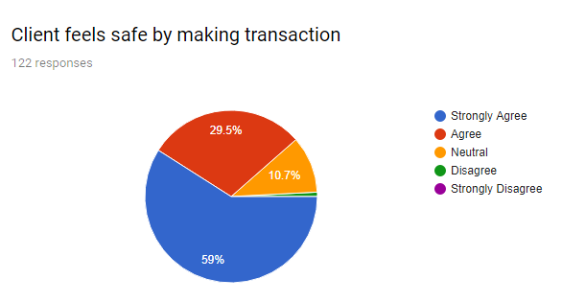
Chart No: 9

When the client feels safe regarding their cash transacted through the bank, it able to say that clients are glad of the service that bank provided. It’s vital issue for client satisfaction level of a corporation.
The survey shows here, 59% people says they are “Strongly Agree” with the statement, 29.5% “Agree” and 10.7% “Neutral”. It means the customers are absolutely feel safe by making any transaction and it means they are highly satisfy.

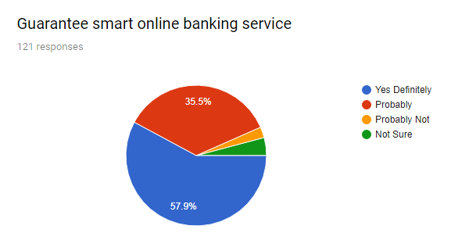
Chart No: 10

Online banking could be a new dimension for the fashionable industry. This can be one among the worth superimposed service given by totally different bank save time and value for the client. With facilitate of net association client are ready deposit cash and build payment by sitting reception.
Dutch Bnagla Bank Ltd. offered online banking also. The survey says that 57.9% people says “Yes Definitely” they are given guarantee smart online banking service and they are satisfy with that.

5.3 Analysis & Findings
Here I divide the findings from analyzed knowledge in 2 sections. They are:
- Positive Findings.
- Negative Findings.
On the basis of positive and negative feedback, I will decide and results the customer service satisfaction of Dutch Bangla Bank Limited.

Positive Findings
- 55.3% of the clients very glad with the workers behaviors.
- 51.2% clients happy with the reasonable service charges.
- 60.2% are glad with prompt and correct service.
- 56.1% finds the matter of skilled workers.
- 64.8% find availability of branches around them.
- 50% they find their services on time.
- 51.2% says modern and updated technology been using
- 69.9% finds ATM booths are available.
- 59% they find safe transaction within the branches.
- 57.9% says they found grantee in smart online banking service.

Negative Findings
- 38.2% people think this bank doesn’t give prompt correct service.
- 10.7 % people things that branches are available but not that much available.
- 17.2% thinks that, they are not poor in fasten their service but fair.

Opportunities for Dutch Bangla Bank Ltd.
Opportunities on the market for this bank to explore itself as followed:
- They are going to expand their promotion facet ro street out the branch.
- Furthermore of these things, the bank will announce superior company pattern from the business consumer or provide who have a complicated financial gain level from the service holder.
- Growth of world economy and Bangladesh’s foreign exchange the approaching years will offer tremendous growth opportunities.
- Online banking facilities will create the operation of the bank additional economical.

5.4 Result of the Survey
Between positive findings and negative findings from the survey clearly recommend those positive findings much more than the negative findings. Thus able to say that almost all of the clients are happy regarding the service and facility provided by the bank Dhanmondi branch. But the bank has several areas wherever they’ll improve the standard of the service and atmosphere. Moreover the have to place confidence in the client demand, want and expectation and will work per this. The must build a powerful relationship with the client by giving best service. The have to line goal to form the client absolutely happy by up all the lacking they need. All the variables mentioned like worker behavior, charges, network, services, correct service, skills, and workplace etc. are vital components for the bank.

CHAPTER 06

RECOMMENDATION & CONCLUSION

6.1 Recommendation for Dutch Bangla Bank Limited

In reality, banks service administrations. This bank has bound complications normally banking events. I might prefer to bid many proposals and endorsements to overwhelm the difficulties relating the subject mentioned on top of the bank additionally boost the performance of the bank relating general banking and their customer service. The subsequent recommendations aren’t choices; rather they’re solely propositions to reposition to progress the performance to accomplish clients satisfaction, so the clients pay a lot of attention to the bank. Now in following some recommendations are given:
- Branches ought to introduce a power tool perform to modify the client.
- A totally processed adding to general banking to satisfy the clients by providing quicker service.
- Establishing a network system within the branches to transfer knowledge among a brief amount.
- Remove the introducer system to gather a lot to deposit through the new account which can result satisfying the purchasers.
- Upgrade the final banking conveniences instead of the traditional industry ro easy to understand.
- Set up suitable technology and formulate applicable programs to develop the captioned activities.
- Bank ought to increase their workers in keeping with clients demand.
- Bank should deliver speedy consumer service flee irregularity.
- There isn’t any facility of figuring out for the internee students. They’ll introduce space or seminar for brief them for associate intern which will enrich and recital and informative for the students.
- Every branch ought to have their capability concerning the facility system and web property for decreasing the service down time.

6.2 Conclusion

Every bank has their distinctive strategy that has jump cable to their aim. Some desires to develop faster and attain some long vary mountains of growth. On the opposite hand, some can’t wish to guide a silence life history minimizing the chance of infection and convey a representation of a sound bank. The bank remains quite new in its operation. The money analysis of the bank is playing well seems the bank is doing ok within the banking sector of Bangladesh and has comfortable.
Dhanmondi branch of the bank is functioning well as an authorized dealer (AD). There some downsides in realizing the various tasks manually, it are often overcome through the involvement of additional specialists in higher process and utilizing the tools to evaluate the integrity of the clients. Lastly it often mentioned that over the results accomplished thus far aren’t affordable why the bank isn’t increasing a contemporary systematic procedure for enticing its quality and there’s the probabilities to form it additional actual within the future for his or her profit.
As it is one amongst the highest level banks in Bangladesh. It’s earned an honest name around the Bangladesh. Dutch Bangla Bank Limited has created exceptional progress, much in each spheres of its activities. The intention of the program of internship is to expand information of sensible banking and to check its concrete information with tutorial expertise. Throughout the three months of an office program, it’s not probable together of all knowledge or every activity of division due to time limitation. So objective of office program haven’t been consummated with complete satisfaction. However, the best effort has given by me to realize the aims of the office program.
This report might show a suggestion to Dutch Bangla Bank Limited for future designing and eminent operation to accomplish its goal within the competitive business surroundings.

CHAPTER 07

APPENDIX

7.1 References

- "Brief History". (2018). Retrieved march 25, 2018, from Dutch-Bangla Bank Limited [BD]: https://www.dutchbanglabank.com/about-us/brief-history.html

- B. (2018). Retrieved from http://www.assignmentpoint.com/arts/sociology/social-responsibility-of-dutch-bangla-bank.html

- Credit Definition | Investopedia, http://www.investopedia.com/terms/c/credit.asp

- Cheque. (n.d.). Retrieved from Wikipedia, the free encyclopedia:
https://en.wikipedia.org/wiki/Dutch_Bangla_Bank

- Dutch-Bangla Bank Limited, All Forms, Untitled-5-deposit_plus.pdf, http://www.dutchbanglabank.com/forms/retail/deposit_plus.pdf

- Dutch-Bangla Bank Limited, All Forms, Auto Line [Converted] ai-Auto_line.pdf, http://www.dutchbanglabank.com/forms/retail/Auto_line.pdf

- Dutch-Bangla Bank Limited, All Forms, Untitled-5-home_line.pdf, http://www.dutchbanglabank.com/forms/retail/home_line.pdf

- https://www.dutchbanglabank.com/schedule_charge/schedule-of-charges.pdf (2017, February 3). Retrieved from

- http://dspace.bracu.ac.bd/xmlui/bitstream/handle/10361/4709/Shabnam%20Shirin_13164014.pdf?sequence=1&isAllowed=y
(2015, December 20). Retrieved from

- (n.d.). Retrieved from https://www.academia.edu/3217128/Internship Report Dutch Bangla Bank Limited Operation Evaluation and Credit Management
- Online banking. Retrieved from https://www.dutchbanglabank.com/internet-banking/2fa-guidelines.html

- Press Releases · Sponsorship & Events · Download Forms · Request for Proposal · EMI Calculator. (n.d.). Retrieved from http://bankinfobd.com/banks/17/Dutch_Bangla_Bank

- T. (2017, December 27). Retrieved from http://www.assignmentpoint.com/business/internship-report-on-customers-satisfaction-towards-ific-bankltd.html

7.2 Questionnaire

Questions | Rating
1. Worker behavior with the client | Very Poor | Poor | Fair | Good | Excellent
2. Reasonable service charge | Strongly Disagree | Disagree | Neutral | Agree | Strongly Agree
3. give prompt and correct service | Not Sure | Probably Not | Probably | Yes Definitely | ____
4. Problem solving skills of the workers | Poor | Fair | Good | Excellent | ____
5. Branches availability | Poor | Fair | Good | Excellent | ____
6. Service on time | Poor | Fair | Good | Excellent | ____
7. Modern and updated technology | Strongly Disagree | Disagree | Neutral | Agree | Strongly Agree
8. ATM booth availability | Not Sure | Possibility Not | Possibility | Obviously | ____
9. Client feels safe by making transaction | Strongly Disagree | Disagree | Neutral | Agree | Strongly Agree
10. Guarantee smart online service | Not Sure | Probably Not | Probably | Yes Definitely | ____

7.3 Related Documents
SAVINGS ACCOUNT OPENING FORM

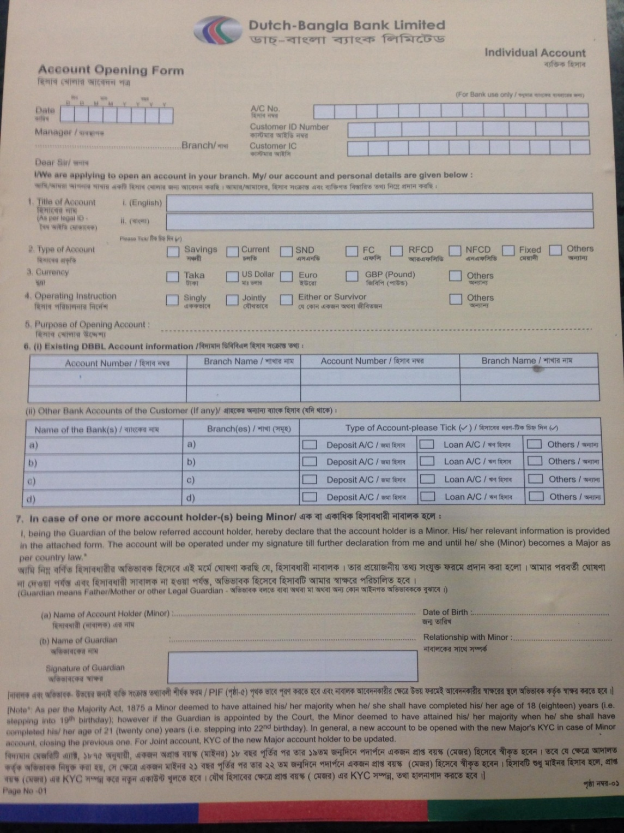

CURRENT ACCOUNT OPENING FORM
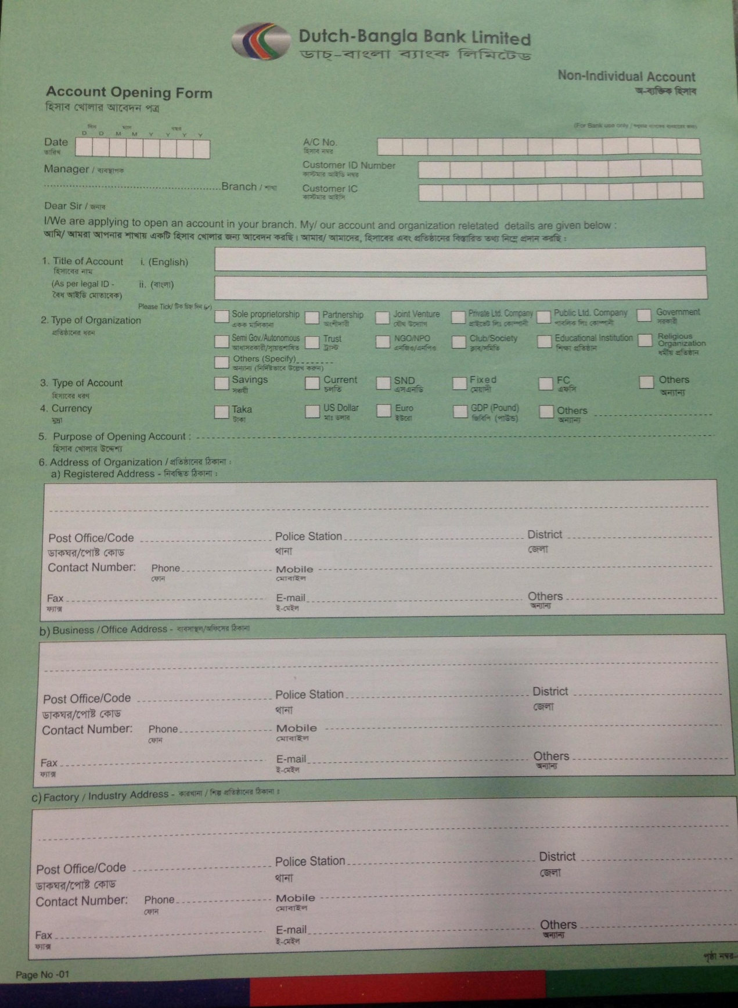

ROCKET ACCOUNT OPENING FORM
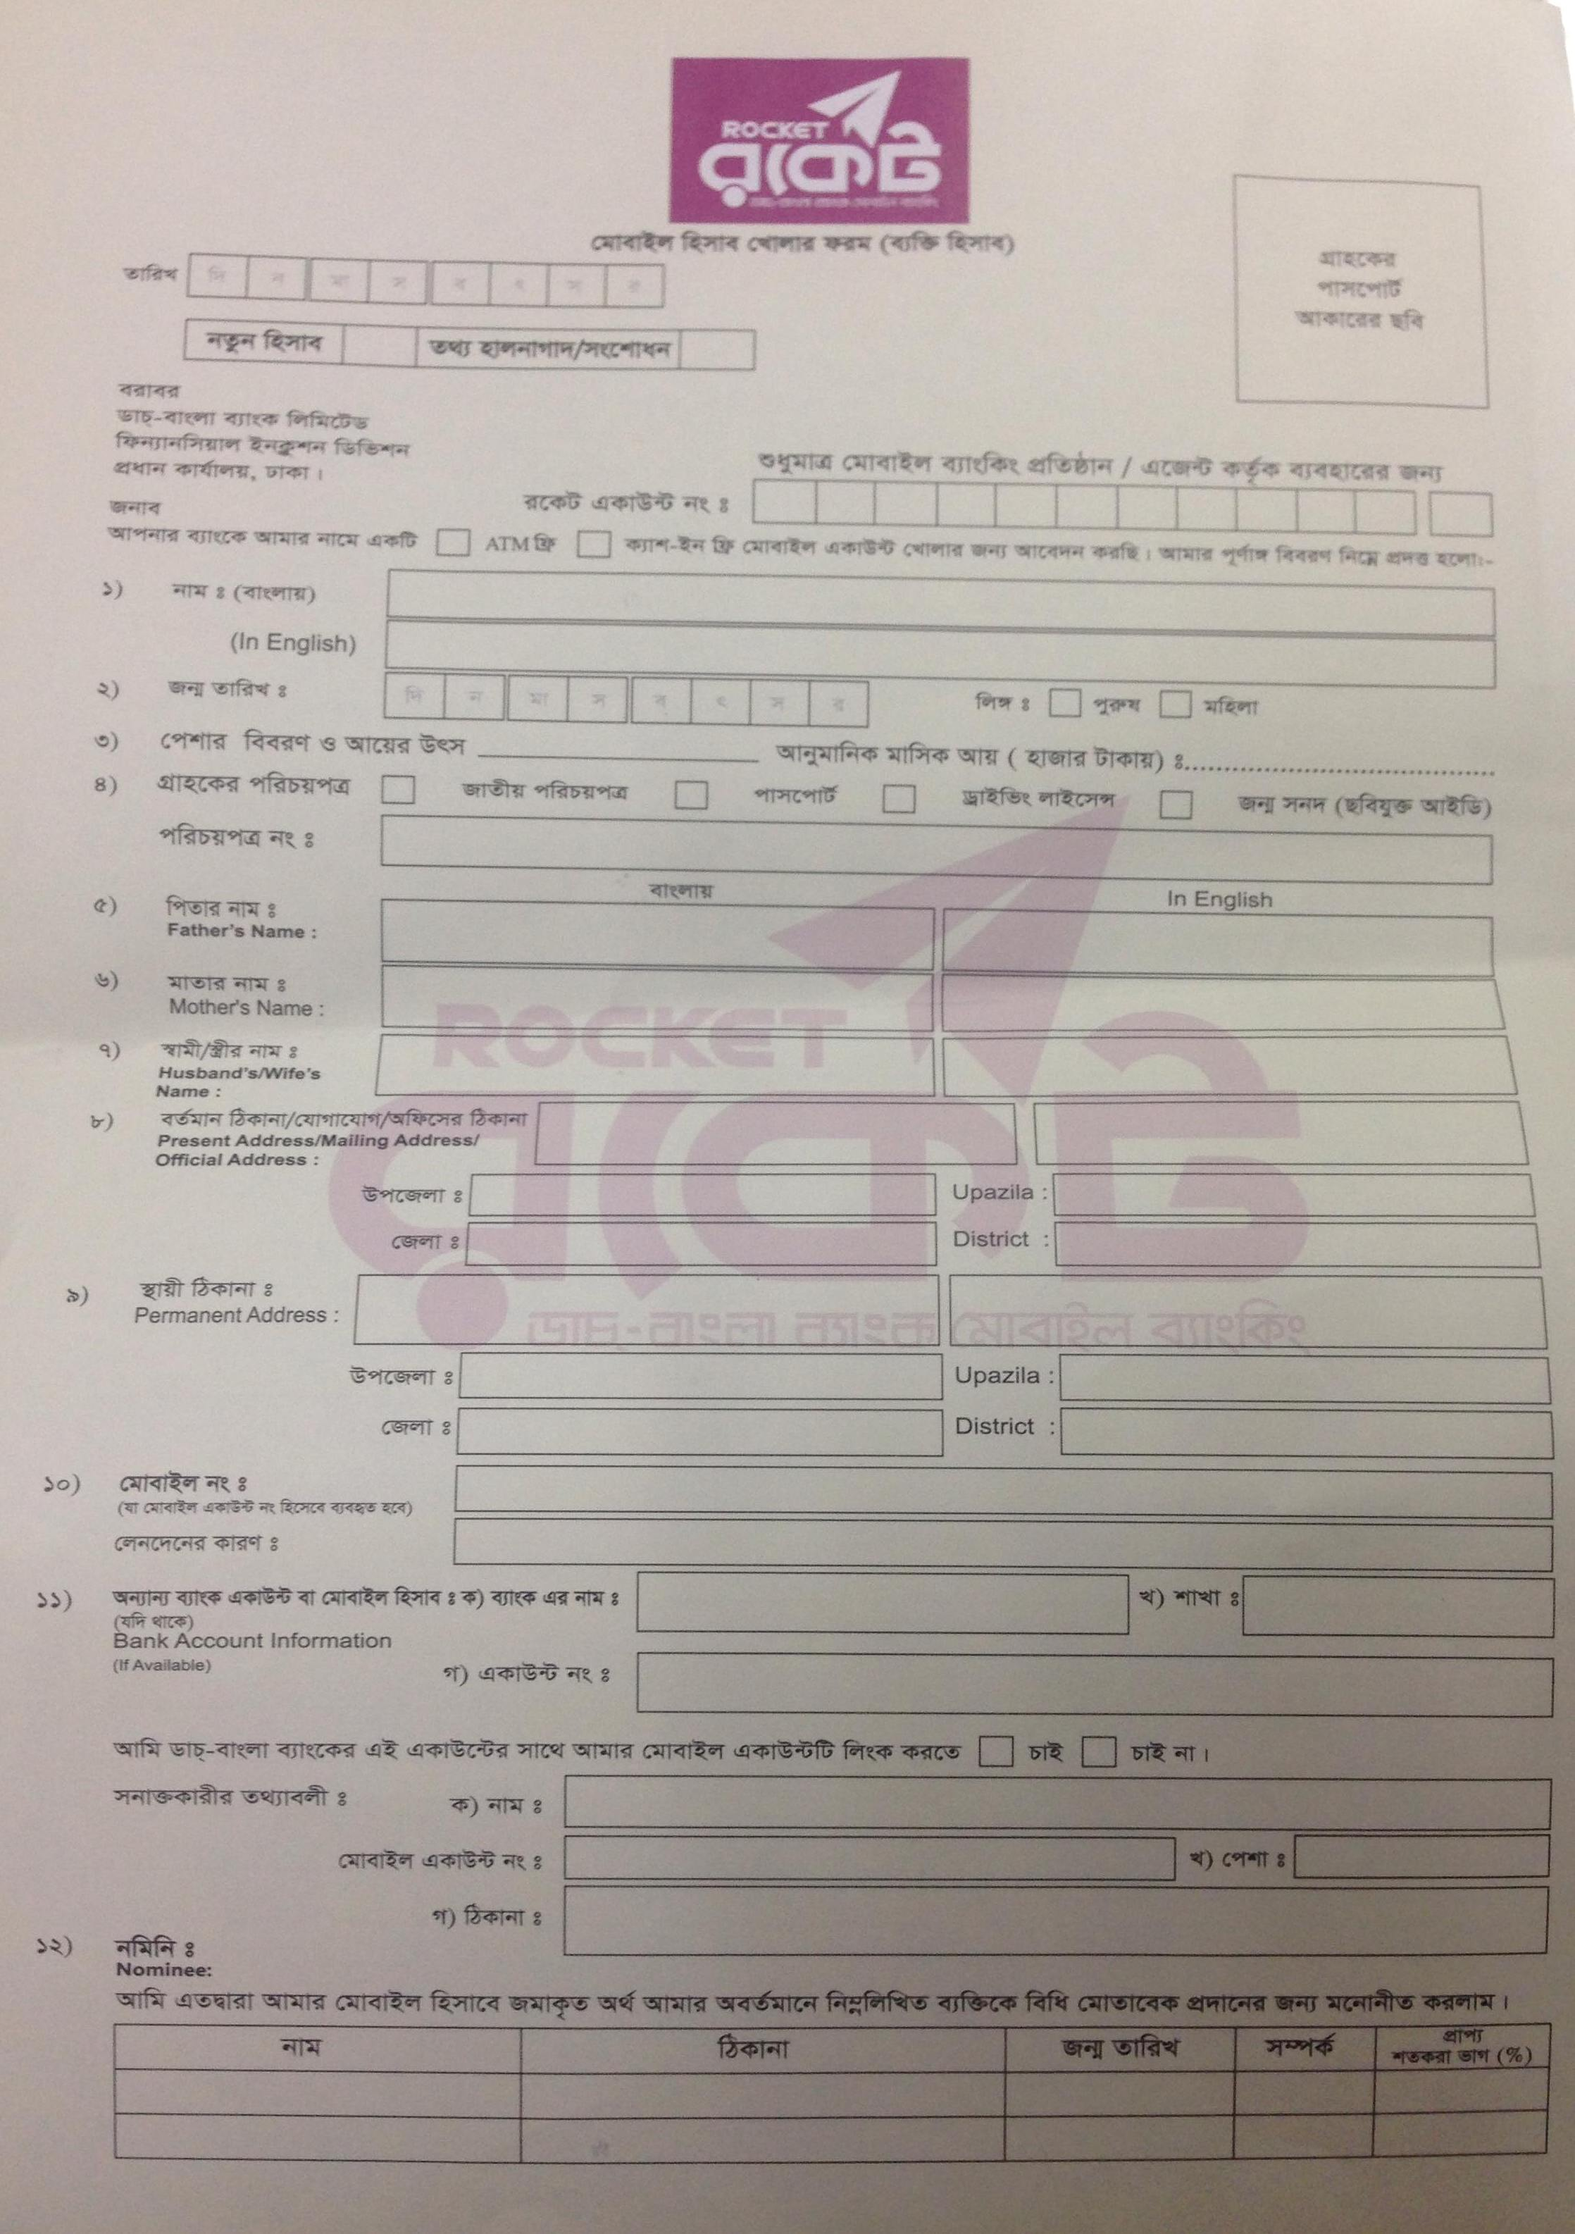
DPS OPENING FORM
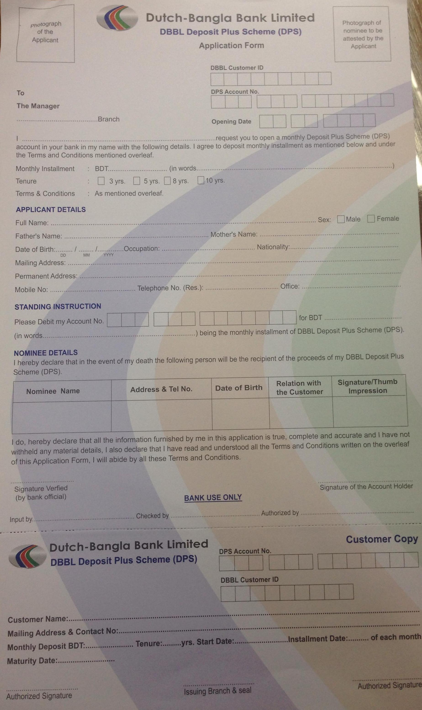

FDR OPENING FORM
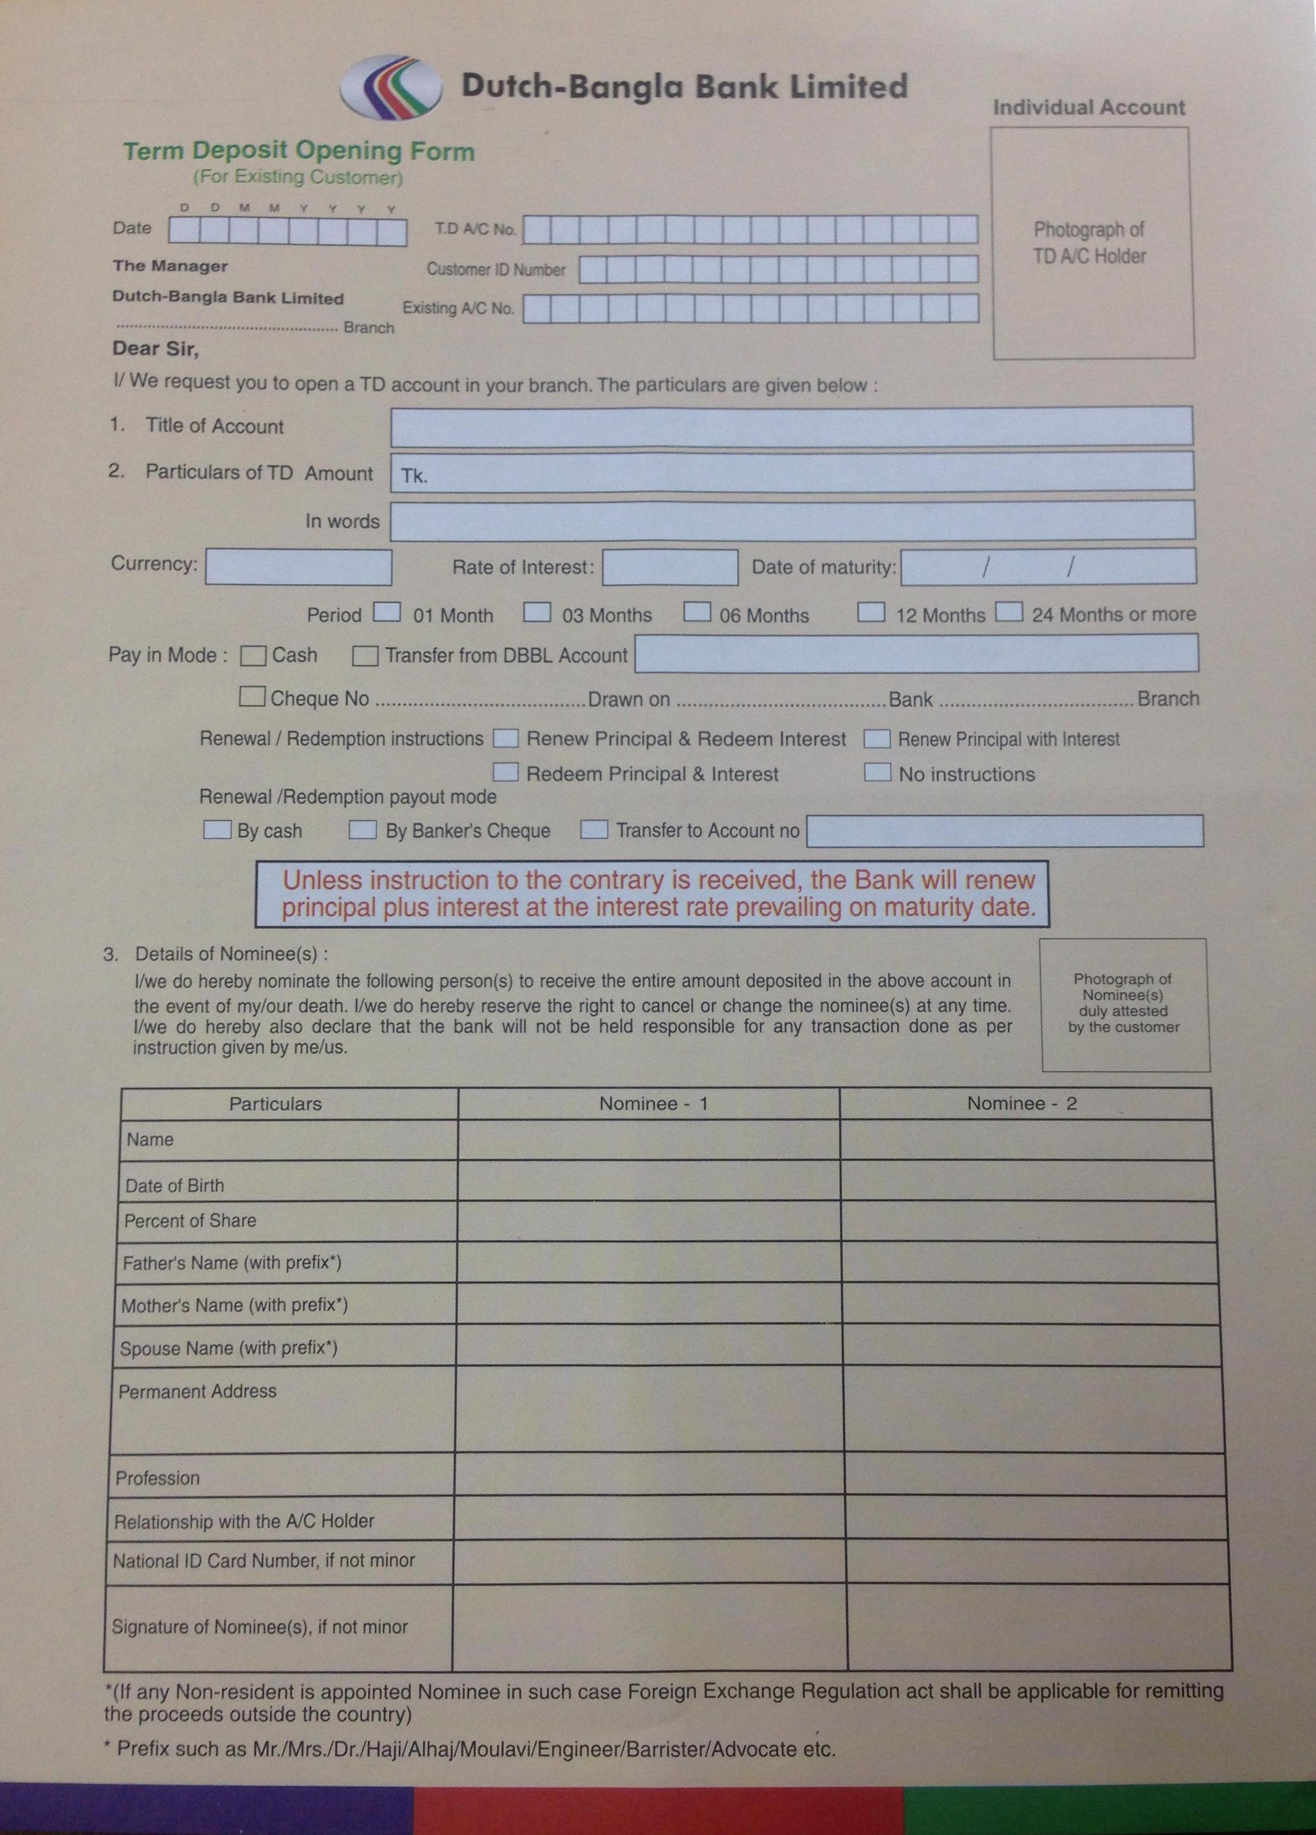
PAYMENT ORDER FORM
