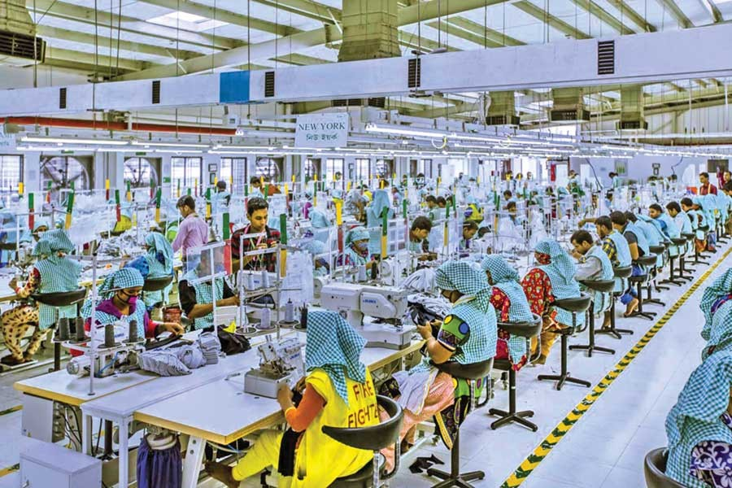
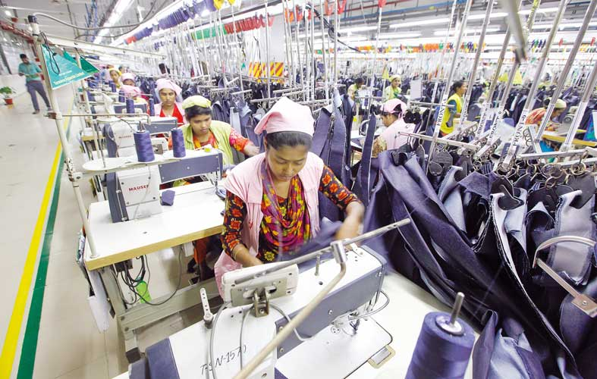


Corporate Characteristics of Listed Textile Industries (Evidence from Bangladesh)

Submission To
Mofijul Hoq Masum
Assistant Professor
School of Business & Economics
United International University

Submission By
Zia Uddin
ID: 111 151 624

Date of Submission: 16th October, 2019

Letter of Acknowledgement

At the beginning of the report, I would like to thank my internship supervisor Mofijul Hoq Masum (Sir), Assistant Professor at United International University (UIU) for his continuous leading and assistance in the preparation of this report. His valuable advice has helped me a lot in making this report.
Finally, I also thankful to my friends who were helped me a lot in preparing my internship report.

Letter of Transmittal

11/10/2019
Mafijul Hoq Masum
School of Business & Economics
United International University

Subject: Report on “Corporate Characteristics of Listed Textile Industries” evidence from Bangladesh

Dear Sir,
I feel good to show you in my internship report on corporate characteristics of listed textile industries of Bangladesh. I have tried my level best to arrange the report according to you and your given guidelines and procedures.
My hardest thank for you in the contexts of the guideline that you have given me and helped me to fulfill my report in a more organized way.
Therefore, I expect that this report will meet your expectation as I have tried my level best to give it accurately.
Sincerely yours,
Zia Uddin
ID: 111 151 624
School of Business & Economics
United International University

Declaration

I declare here my internship report is the “Corporate Characteristics of Listed Textile Industries of Bangladesh”. First of all, this internship report has made by me without any copy from any internet sources or somewhere else. I have tried to cover all things which are required to fulfill my internship report, and give me full guidance by Mofijul Hoq Masum Sir.
Therefore, I strongly believe that you will accept me and my internship report.

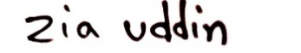
-------------------------
Zia Uddin
ID: 111 151 624
United International University

Executive Summary

This report makes based on “Corporate Characteristics of Textile Industries” evidence from Bangladesh. We collect 55 textile industries annual report which are listed at DSE. First of all, we analyzed all financial report like financial position, comprehensive income statement of 2018then we describe top five company’s ROA, ROS, EPS, Leverage ratio and also least five companies. We also show their market capitalization. We describe ownership structure and also describe age of listing of all textile companies. We discuss about market category. The most important things are we described all things by graph, chart, and table if it shows their results very clearly to all.

Key Words: Textile Industries, Return on asset, Earning per share

List of Acronyms

- DSE= Dhaka Stock Exchange
- ROA= Return on Assets
- ROS= Return on Sales
- CSR= Corporate Social Responsibility
- EPS= Earnings Per Share
- BTMA= Bangladesh Textile Mills Association
- GDP= Gross Domestic Products
- mn= Million

Table of Content

Contents
Submission To ii
Letter of Acknowledgement iii
Letter of Transmittal iv
Declaration v
Executive Summary vi
List of Acronyms vii
Table of Content viii
Contents viii
Chapter- 01 1
Introduction 1
1.1 Introduction to the Topic: 2
Chapter- 02 4
Methodology of the study 4
2.1 Data Design 5
2.2 Sample Design 5
2.3 Analytical Tools 5
Chapter- 03 6
Organizational Background and Industry Perspective 6
3.1 Industry Scenario: 7
Chapter- 04 12
Findings and Analysis of the Study 12
4.1 Top 5 Textile Industries (ROA, ROS, EPS, Leverage Ratio) 13
4.2 Least 5 Textile Industries (ROA, ROS, EPS, Leverage Ratio): 15
4.3 Market Capitalization 18
4.4 Age of Listing 20
4.5 Market Category 22
4.6 Ownership Structure of the Textile Industries 24
4.7 The Average ROA, ROS, EPS, Leverage ratio 25
Chapter- 05 26
Conclusion 26
5.1 Conclusion: 27
Recommendation: 28
References: 29

Chapter- 01

Introduction

Introduction to the Topic:

Corporate Characteristics of Textile Industries (Evidence from Bangladesh) is the main topic of the report. Textile industry is the oldest industry in Bangladesh. After that textile industry increased rapidly in our country. It created lots of opportunities for people. Now Bangladesh is the second place in the world in the context of textile. Only China is top in this sector. Local investor’s exports cloth items product to the Europe in every year. Textile industry helps to grow our GDP. Only 5% foreign investors invest this sector.
1.2 Introduction of the Organization:
Its conduct their industry according to BTMA (Bangladesh Textile Mills Association).BTMA is the national trade organization which maintain Yarn, clothing textile organization. BTMA was registered in 1983.
1.3 Objectives of the Study:
There are two types of objectives these are Broad Objective, and Specific objective.
- Broad Objective:
- To completes BBA degree requirement and
- To gain knowledge about overall textile industries.
- Specific Objective:
- Able to know top 5 textile industries ROA, ROS, EPS, Leverage ratio.
- To obtain the least 5 textile industries ROA, ROS, EPS, Leverage ratio.
- We will know their market capitalization.
- Age of listing at DSE.
- We will show their market category.
- To know the ownership structure of the textile industries.
- To identify the average ROA, ROS, EPS, Leverage ratio.

1.4 Rational of the Study:
Textile industry in Bangladesh has good reputation. Textile industry contributes in GDP. Yarn and clothing sectors are the highest exporting products in our country.
1.5 Scope of the Study:
First of all, about textile industries I know all things from the internet and also from my honorable supervisor. I collected all information’s from their annual report in 2018. Some companies’ information was missing. All companies are listed in DSE.
1.6 Limitation of the Study:
In case of collected all listed textile industries information I have faced some limitations like:
- Missing some companies annual report in 2018
- Some company’s annual report is maintenance that’s why I didn’t collect all information.
- I have faced their website problem.
- I was not visited any textile company so that I have no practical knowledge.

Chapter- 02

Methodology of the study

2.1 Data Design:
- Data Collection Process: I collected all data from internet. First of all, I go to the DSE website because they are listed company then I collected market capitalization of the company, market category of the company, ownership structure of the company etc. After that I organized all information in excel sheet. Then I have searched their website and download their annual report of 2018. Then I calculate ROA, ROS, and Leverage Ratio.
- Types of Data: There are two types of data which are Primary Data and Secondary Data. Details are as follows in the below:
- Primary Data: Primary data which are collected from first hand or original data obtained by the research. Example: Survey
- Secondary Data: Secondary data which has been collected in the past by someone. Example: Information collected by the Internet, Newspaper.

2.2 Sample Design:
- Sampling Techniques: I used systematic sampling techniques.
- Sample Size: I was collected 55 textile companies’ information from their website.
2.3 Analytical Tools:
- MS Excel: I used MS Excel for preparing this report.

Chapter- 03

Organizational Background and Industry Perspective

Industry Scenario:

I worked with 55 textile industries in Bangladesh and here I will discuss top 5 (ROA) industries and least 5 (ROA) industries.
- DSSL (Dragon Sweater and Spinning Limited) is the first company of Return on Assets.
ROA | 31.23%
EPS | 2.25
ROS | 21.05 %
Market Capitalization | 2507.46 (mn)
Age of Listing | 2016

- DULAMIACOT (Dulamia Cotton Spinning Mills Ltd.) is the second company of ROA
ROA | 21.14 %
EPS
ROS | 12.25 %
MC | 355.16 (mn)
Age of Listing | 1989

- ALLTEX (Alltex Industries Ltd.)
ROA | 12.01 %
EPS
ROS
MC | 486.922 (mn)
Age of Listing | 1996

- QUEENSOUTH(Queen South Textile Mills Limited)
ROA | 8.48 %
EPS
ROS | 7.67 %
MC | 2743.109 (mn)
Age of Listing | 2018

- KTL(Kattali Textile Limited)
ROA | 7.79 %
EPS
ROS | 21.1 %
MC | 1566.4 (mn)
Age of Listing | 2018

Now I will discuss about least 5 (ROA) industries:
- SONARGAON (Sonargaon Textiles Ltd.)
ROA | 0.42 %
EPS
ROS | 2.902 %
MC | 46.77 (mn)
Age of Listing | 1995

- SAFKOSPINN (Safko Spinnings Mills Ltd.)
ROA | 0.79 %
EPS | 42.72
ROS | 15.93 %
MC | 47.95 (mn)
Age of Listing | 2000

- MAKSONSPIN (Maksons Spinning Mills Limited)
ROA | 1.19 %
EPS | 16
ROS | 17.6 %
MC | 41.33 (mn)
Age of Listing | 2009

- ZAHINTEX (Zahintex Industries Limited)
ROA | 1.28 %
EPS | 22.3
ROS | 22.49 %
MC | 35.42 (mn)
Age of Listing | 2011

- AL-HAJTEX(Al-Haj Textile Mills Limited)
ROA | 1.67 %
EPS | 164.13
ROS | 0.85 %
MC | 1061.411 (mn)
Age of Listing | 1983

- Background of Industry: Textile industry is the oldest and more successful industry in Bangladesh. It is based on yarn, fabrics productions. There are fifty-five companies listed at DSE. Local investors dominated this sector only five percent foreign investors invest in this sector.
- Contribution in Economy: Textile industry helped our economy like 13% contribute in our GDP. 86% earnings from textile industries. Garments industry is the most profitable industry in our country.
3.2 Historical Background of the Organization:
- Vision: To established the company as the most admired institution in the textile industry of Bangladesh by producing and supplying quality products to customers at affordable prices while following an ethical business process so that the stakeholders and society at large are benefited.
- Mission:
- Use innovation and speed as the driving factor for progress.
- To be a good corporate citizen.
- Ensure environment friendly and ethical process flow.
3.3 Operational Activities of the organization:
- Product: The product of the textile industries is Yarn, Fabrics productions. Yarn and fabrics products are the national trade products.

3.4 SWOT Analysis:
SWOT analysis is the important factor for an organization. It shows the organization strengths, weaknesses, opportunities, and threats in future.

Figure: SWOT Analysis of the Textile Industry

- Strengths:
- Very low labor cost.
- To keep largest industry in this country, only 5% foreign investors invest in this sector.
- Almost 13% contribute in GDP.
- Weaknesses:
- Lack of Marketing.
- Foreign buyers are dissatisfied in case of political issues.
- Lack of efficient workers.
- Opportunities:
- It has high opportunity to beat china and take place in number one in the world of the textile industry.
- To creates lot of working place for unemployment people.
- Threats:
- Political threats in future.
- Employee safety threats.

Chapter- 04

Findings and Analysis of the Study

4.1 Top 5 Textile Industries (ROA, ROS, EPS, and Leverage Ratio):

ROA represent company’s return on assets that means how income came from company’s assists. Here, I have shown in the below top 5 company’s ROA. Square Textile Ltd, and Esquire Knit Composite Ltd are the same value (3.95%) and this is the highest return on top five textile companies in 2018.

Figure: ROA of Top 5 Textile Industries

Sales are important for all companies. ROS is representing the company’s sales on profit that means return on sales. Here I tried to find out top 5 textile industries ROS. Detail is as follows with a chart.

Figure: ROS of Top 5 Textile Industries

EPS stands for Earning per Share that means which company’s share is how much in the share market. Company’s share price is important in the share market like here Shepherd industries limited share price is 34.6 taka that in 2018 this company’s share is more valuable than other company’s share.

Figure: EPS of Top 5 Textile Industries

Leverage ratio or debt ratio or gearing ratio of the company. How much capital comes in the form of debt (loans).

Figure: Leverage Ratio of Top 5 Textile Industries

4.2 Least 5 Textile Industries (ROA, ROS, EPS, and Leverage Ratio):

This is the least 5 companies ROA. Their ROA return is lower than other industries.

Figure: ROA of least 5 Textile Industries

Figure: ROS of Least 5 Textile Industries

Figure: EPS of Least 5 Textile Industries

Figure: Leverage Ratio of Least 5 Textile Industries

4.3 Market Capitalization:
Market Capitalization means how much capital a company has in the market. Here there is top 5 textile company’s market capitalization shown in the below as chart:

Least 5 Textile Industries Market Capitalization shown in the below:

Tunghai is the least market capitalization then Mithun Knit, DACCADYE, Talluspin, and the fifth one is Dulamiacot.

4.4 Age of Listing:
There are 55 listed textile industries in Bangladesh. Some industries are very old and some industries also are new. Here I will introduce 5 oldest industries and 5 newest industries.
Five newest Textile Industries:

Five oldest Textile Industries:

4.5 Market Category:
There are 55 textile industries which are listed in DSE and they have market category. Now I will show 55 textile industries market category:
ACFL(Aman Cotton Fibrous Limited) | A
AIL(Alif Industries Limited) | A
AL-HAJTEX(Al-Haj Textile Mills Limited) | A
ALIF (Alif Manufacturing Company Ltd.) | A
ALLTEX (Alltex Industries Ltd.) | Z
ANLIMAYARN (Anlimayarn Deying Ltd.) | A
APEXSPINN(Apex Spinning & Knitting Mills Limited) | A
ARGONDENIM(Argon Denims Limited) | A
CNATEX(C& A Textiles Limited) | Z
DACCADYE (The Dacca Dyeing & Manufacturing Co. ltd) | Z
DELTASPINN (Delta Spinners Ltd.) | Z
DSHGARME (Desh Garmants Ltd.) | A
DSSL(Dragon Sweater and Spinning Limited) | A
DULAMIACOT (Dulamia Cotton Spinning Mills Ltd.) | Z
ENVOYTEX(Envoy Textiles Limited) | A
ESQUIRENIT(Esquire Knit Composite Limited) | N
ETL(Evince Textiles Limited) | Z
FAMILYTEX(Familytex (BD) Limited) | B
FEKDIL(Far East Knitting & Dyeing Industries Limited) | A
GENNEXT(Generation Next Fashions Limited) | A
HFL(Hamid Fabrics Limited) | A
HRTEX (H.R. TextileLtd.) | A
HWAWELLTEX (Hwa Well Textiles (BD) Limited) | A
KTL (Kattali Textile Limited) | A
MAKSONSPIN (Maksons Spinning Mills Limited) | B
MALEKSPIN (Malek Spinning Mills Ltd.) | A
MATINSPINN (Matin Spinning Mills Ltd.) | A
METROSPIN (Metro Spinning Ltd.) | B
MHSML (Mozaffar Hossain Spinning Mills Ltd.) | B
MITHUNKNIT (Mithun Knitting and Dyeing Ltd.) | Z
MLDYEING(M.L. Dyeing Limited) | A
NEWLINE(New Line Clothings Limited) | N
NURANI(Nurani Dyeing & Sweater Limited) | A
PDL(Pacific Denims Limited) | A
PRIMETEX(Prime Textile Spinning Mills Limited) | A
PTL(Paramount Textile Limited) | A
QUEENSOUTH(Queen South Textile Mills Limited) | A
RAHIMTEXT (Rahim Textile Mills Ltd.) | A
REGENTTEX(Regent Textile Mills Limited) | B
RNSPIN(R.N. Spinning Mills Limited) | A
SAFKOSPINN (Safko Spinnings Mills Ltd.) | B
SAIHAMCOT (Saiham Cotton Mills Limited) | A
SAIHAMTEX (Saiham Textile Mills Ltd.) | A
SHASHADNIM(Shasha Denims Limited) | A
SHEPHERD(Shepherd Industries Limited) | A
SIMTEX(Simtex Industries Limited) | A
SONARGAON (Sonargaon Textiles Ltd.) | Z
SQUARETEXT (Square Textile Ltd.) | A
STYLECRAFT(Stylecraft Limited) | A
TALLUSPIN (Tallu Spinning Mills Ltd.) | Z
TOSRIFA(Tosrifa Industries Limited) | A
TUNGHAI(Tung Hai Knitting & Dyeing Limited) | Z
VFSTDL(VFS Thread Dyeing Limited) | A
ZAHEENSPIN(Zaheen Spinning Limited) | A
ZAHINTEX(Zahintex Industries Limited) | B

4.6 Ownership Structure of the Textile Industries:
Ownership structure includes five things which are as follows:
- Director Share
- Govt. Share
- Institute Share
- Foreign Share
- Public Share
Director Share: When the company director buy share for his / her own then it is called director share.
Govt. Share: Whenever the Govt. buy share then this is called govt. share. In case of our 55 textile industries there is no govt. share.
Institute Share: Any institution buy share for their own then it is known as institute share.
Foreign Share: Whenever a foreigner invests outside his/ her country then it is called foreign investment and here when foreigner buy any share from our stock market then this is called foreign share.
Public Share: Which shares are offering for general people it is called public share. Public is the most important part for any organization.

4.7 The Average ROA, ROS, EPS, Leverage ratio:
Here I will discuss about the average of return on assets, return on sales, earning per share, leverage ratio, and market capitalization. First of all, the average of return on assets is 4.56%, the average of return on sales is 11.25%, then the average of earning per share is 26.22, then the average of leverage ratio is 33.92%.
I will show the total average of these components in the below by graphically:

Chapter- 05

Conclusion

5.1 Conclusion:

This report is conducted on corporate characteristics of textile industries. We calculate many things like ROA, ROS, EPS, Leverage ratio. In case of top ROA company is Square textile limited (3.95%), top ROS is Shashadnim textile limited (15.34%), top EPS is Shepherd industry (34.6%), and top leverage ratio are Esquire knit composite limited and square textile limited (29.57%). The oldest textile company is Al Hajtext. It is listed in 1983. The newest company is Esquire knit composite limited in 2019. The highest market capitalization of the company is PTL (Paramount textile limited) 7872.54 million. We try to compare with top five companies and also least five companies. According to our financial performance analysis we can say that the textile industry in Bangladesh has a good position in the market.

Recommendation:

- No compromise about labor safety in workplace
- Proper training should be organized for labor
- Should be increased salary
- Reduce working hour then feedback will come very efficient way
- Increased CSR activities

References:

- The following website was assessed on February1, 2019
- http://www.btmadhaka.com/textile-policy/
- The following website was assessed on June1, 2019
- https://www.dsebd.org/companylistbyindustry.php?industryno=17
- https://www.dsebd.org/by_industrylisting1.php

