Influencing Buyer Readiness Stages through Marketing Strategies: A Study at the AFBL

- R. B Fahim

This internship report is submitted to the School of Businesses & Economics, United International University as a partial requirement for the fulfillment of Bachelor of Business Administration Degree

Influencing Buyer Readiness Stages through Marketing Strategies: A Study at the AFBL

Submitted by
A. R. B Fahim
111 171 193
Major in Marketing
Bachelor of Business Administration

Supervised by
Dr. Kawsar Ahmmed
Professor
School of Business & Economics
United International University

Date of Submission

14 November, 2022

Letter of Transmittal

14 November, 2022

To,
Dr. Kawsar Ahmmed
Professor, Marketing
School of Business & Economics
United International University (UIU)

Subject: Submission of Internship Report.

Dear Sir,
It is my great pleasure that I am going to submit the report on “Influencing Buyer Readiness Stages through Marketing Strategies: A Study at the AFBL.” I have tried my best to follow the guidelines you provided to prepare my internship report. I believe that the information, I have collected is the most essential and necessary to know for me to learn about the “Marketing Strategies at AFBL to influence buyer readiness to buy Clemon.” I really enjoyed the challenges of preparing the report because it gave me an opportunity to enhance my understanding of brand marketing activities.
I am so grateful for your guidance to prepare this report. I will be thankful to you if you grant the report, and all of your support in this matter will be extremely appreciated.

Sincerely yours,
A. R. B Fahim
ID: 111 171 193
BBA, United International University

Declaration
I, A. R. B Fahim, a student of Bachelor of Business Administration (BBA), Major in Marketing at United International University (UIU), hereby declare that the internship report entitled “Influencing Buyer Readiness Stages through Marketing Strategies: A Study at the AFBL” is entirely prepared by me after three months of my internship at Akij Food & Beverage Limited.
I also declare that all the resources used in this report are collected by me and are completed all by me. This report is prepared for my academic requirement only, not for any other purpose.


A. R. B Fahim
ID: 111 171 193
Major in Marketing
BBA, United International University (UIU)

Acknowledgment
At the beginning of this report, I would like to express my gratitude to Almighty Allah who has given me the opportunity to go through the total process of BBA as well as the internship program. It was a great opportunity for me to work on the topic “Influencing Buyer Readiness Stages through Marketing Strategies: A Study at the AFBL.”
First of all, I would like to express my gratitude to my respected Internship Supervisor, Professor Dr. Kawsar Ahmmed, School of Business & Economics, United International University, whose guidance, support, and direction provided me the ability to complete such a long report.
My deepest appreciation and special thanks go to Md. Maidul Islam Sir, General Manager; Abdul Aziz Sir, Brand Manager; and Md. Hosney Mobarak Bappy Sir, Assistant Manager, HR at Akij Food & Beverage Limited is a concern of Akij Group for giving me the time from their busy schedule to collect data to enrich my report with a lot of relevant information on my internship topic.
Finally, I express my sincere thanks to all of them who inspired me, in all the ways to complete the report as well as the internship program.

Executive Summary
Buyer Readiness Stages refer to a particular state which denotes the willingness of any individual customer for buying a specific product or service. To influence the buyer readiness stages marketer plans for attaining a company's objectives by identifying and maintaining a strong competitive advantage and knowing the needs of consumers. To this end, this report aims at exploring how AFBL follows CBBE Model (Customer Based Brand Equity) for its Clemon Brand to influence buyer readiness. The report contains about Akij Group and company history Akij Food & Beverage Limited profile and data about the brands & products. Especially, the report is about the brand Clemon. Buyer Readiness Stages are commonly listed as awareness, knowledge, liking, preference, conviction, and purchase. The importance of each stage is to help the company is identifying its targeted consumers who belong to the buyer readiness stages. Also, by segmenting people on the basis of their willingness to buy their products, they will be able to advertise their products focusing on the demands and the needs of target consumers.

Clemon is following CBBE Model (Consumer Based Brand Equity) as a marketing strategy for capturing their targeted and potential consumers. They create awareness of the product, this is the first and most crucial step and starting point for purchase. Awareness is the stage where consumers have a vague idea of the product. Here, the factor of the product such as Clemon is the Brand of AFBL. Consumers are less aware of the product. Meanwhile, Clemon developed their marketing strategies so that awareness is created such as Above the Line (ATL), Below the Line (BTL), and Through the Line (TTL) promotional strategies to attract the maximum number of consumers who are potential to buy. At the knowledge stage, Clemon provides knowledge related to the benefits through social media posts, magazines, and newsletters to their target group of consumers so that they can attain more consumers. Create initial factors of the interest of the customers in that product. A preference is given to that particular product over the other brands in the competitive market. Conviction of that specific product in terms of its suitability and also its purchasing power, and finally consumers are willing to purchase Clemon. Based on the study, several recommendations are forwarded for improvement.
Keywords: Buyer Readiness Stages, CBBE Model, FMCG Industry, Akij Food & Beverage Limited, AFBL, Clemon.

Contents
Letter of Transmittal 1
Declaration 2
Acknowledgment 3
Executive Summary 4
CHAPTER-1 7
Introduction 7
1.1 Origin of the report 8
1.2 Objective of the report 8
1.3 Methodology 8
1.4 Limitations 9
CHAPTER-2 10
Analysis of the Food & Beverage Industry in Bangladesh 10
Introduction 11
2.1 Specification of the Industry 11
2.2 Size, Trend, and Maturity of the Industry 12
2.3 Technological Factors 14
2.4 Political, Legal, and Regulatory Factors 14
2.5 Industry Rivalry 15
2.6 Summary of Challenges and Opportunities 16
CHAPTER-3 18
Analysis of the Akij Food & Beverage Limited 18
Introduction 19
3.1 Overview and History 19
3.2 Customer Mix 20
3.3 Product Mix 23
3.4 Quality Assurance 25
3.5 SWOT Analysis of Clemon 25
3.6 Strategies to meet the Challenges & Opportunities 26
CHAPTER-4 27
Buyer Readiness Stages and Marketing Strategies 27
Introduction 28
4.1 Awareness 29
4.2 Knowledge 29
4.3 Liking 30
4.4 Preference 30
4.5 Conviction 30
4.6 Purchase 30
CHAPTER-5 35
Internship Experience 35
5.1 Position, Duties and Responsibilities 36
5.2 New Skill Developed 36
5.3 Application of Academic Knowledge 38
5.4 Assisting in Promotional Activities of CLEMON 39
Recommendation 40
Conclusion 41
References 42

CHAPTER-1

Introduction

Origin of the report
The internship report is mandatory for completing the Bachelor of Administration degree program. When selecting a topic for the internship report, my internship supervisor, Professor Dr. Kawsar Ahmmed, School of Business & Economics, United International University, allowed me to choose the topic “Marketing Strategies at AFBL to influence buyer readiness to buy Clemon.” I was interested in it. Since I am doing my internship at Akij Food & Beverage Limited as an intern in the marketing department.

Objective of the report
Primary Objective
The overall objective of this report is to learn and analyze how AFBL developed its brand marketing strategies and implemented its promotional activities to influence make potential consumers.

Secondary Objective
- To analyze the brand position of Clemon.
- To know about the marketing activities of Clemon.
- To learn about the promotional activities of Clemon.

Methodology
I used primary and secondary data to create this report. However, most of the data come from primary sources. I was involved in various activities at AFBL, especially in Brand Clemon.
Primary Data
The following sources were used to collect secondary data:
- Interacting & discussing with my colleagues, and supervisor.
- Direct observing the current brand promotional activities in AFBL.

Secondary Data
The following sources were used to collect secondary data:
- Magazines, newspapers, articles, and annual reports.
- Official website of AFBL, and its social media.

Limitations
Some limitations to the conduct of the study are following:
- Most information and data are confidential.
- Current data are not available on the internet.
- Restricted access to department service information.

CHAPTER-2

Analysis of the Food & Beverage Industry in Bangladesh

Introduction
The food & Beverage Industry is one of the fastest-growing industries around the world. Food is basic necessity things in human life. In Bangladesh, this industry contributes around 26% of the economy and around 4.5% of the total workforce. Bangladesh is being an agricultural nation with an extensive population that can contribute greatly to the food & beverage industry.

Specification of the Industry
The FMCG industry is one of the fastest-growing segments of the market. Its annual turnover of around Tk. 30,000 crore. For the past few decades in the FMCG industry of Bangladesh, international brands like Unilever, Nestle, and Marico as well as several domestic brands such as Pran, Randhuni, Ruchi, Teer, Fresh, and Pure are successfully conducting business by fulfilling the needs of consumers. Once the multinational companies of this sector met the needs of the country's consumers through imports currently 95% of the product portfolio of multinational companies like Unilever is being produced in the country. Again, the products of brands like Pran, Randhuni, Ruchi, Teer, and Fresh are being exported abroad to satisfy the needs of the people of the country.
The FMCG industry can be classified into three major categories:
- Food & Beverage,
- Personal Care and
- Household Care.

Food & Beverage includes all food & beverage products such as snacks, carbonated soft drinks, energy drinks, fruit drinks, dairy products, bakery products, frozen foods, ice cream, tea, coffee, baby foods, tobacco, and others.
Personal Care includes the products which are used for personal care such as perfume, cosmetics, toiletries products, and others.
Household Care includes products that are useful to maintain the house like cleaning and decorating. It includes room fresher spray, detergent powder, liquid detergent, soap, and others.
Akij Food & Beverage Limited is a Fast-Moving Consumer Goods (FMCG) industry. It provides six category product lines to its consumer in a competitive market. The following product lines are given below:
- Snacks,
- Carbonated Soft Drinks,
- Energy Drinks,
- Aseptic Fruit Drinks,
- Dairy,
- Drinking Water.

Size, Trend, and Maturity of the Industry
Size
In Bangladesh, currently the revenue of food industry is $127.20 Billion in 2022. And the market is expected growth annually by 9.88%. And the Beverage Industry amounts to $5.16 Billion. The market is expected growth annually by 7.02%.

Trend
The demand for clean-label products is rapidly increasing in awareness of healthy eating. Clean-label products contain no additives, artificial flavors, artificial colors, and preservatives. Many manufacturers and producers are also extensively using natural ingredients and have reduced the use of artificial colors and flavors. Another key trend is the growing demand for functional beverages, with many people looking for specialized drinks to stay hydrated and maintain nutritional balance. Many companies are introducing fortified drinks such as aseptic fruit drinks, and balanced mineral water with health benefits, weight management, and improved digestion.
And there are current following trends to maintain healthy lifestyle:
- More consumption of organic food
- Less consumption of fast food
- Halal food consumption
- Encourage plant based processed food
- Sustainable packaging
- More Sugar free diet beverage consumption

Maturity
The industry of food and beverage faces a dynamic mass consumer market with competitors. And its products must be innovative and cost-competitive. The maturity of product life cycle has sustainable position in the market. Meanwhile, sales are stable on a per capita basis because of market saturation. The market has been saturated. Whereas, the absolute level of sales starts to decline than consumers are begin switching to other brands.

Technological Factors
Now-a-days technology plays an important role in every sector of the food & beverage production. The industry can utilize technology to meet various challenges and make it easy. Modern technology has transformed food & beverage production can see exactly how technology is transforming the sector.
- Level of transparency in food & beverage processing
- Enterprise Resource Planning (ERP) Solution
- Eco-friendly packaging
- Recycling & waste reduction

Political, Legal, and Regulatory Factors
Political Factors
It refers to rules and regulation and standard lead by government and can affect it food and beverage industry. Government policies may change over time of the area where this industry operates. Taxation affects the purchase and quality also influences the industry.

Legal Factors
It refers to consumer rights, advertising, health concern, and product safety factors. The food & beverage industry has high standards for safety concern. The industry has to follow very strict food safety and health protocols like storage system, expiration date, cleanliness, and transportation.

Regulatory Factors
The regulatory factors of food and beverage industry is product safety, accurate labeling, advertising, and food export/import regulations. The laws are including contract, business laws, distribution networks, agricultural laws, labor laws, international trade laws, and others. The industry must be responsible for make sure their products are carefully regulated, safely produced, and properly labeled.

Industry Rivalry
The food & beverage industry plays a vital role in increasing economic opportunity. The industry operates at many levels of society. In this world, billions of people grow, process, and sell food, especially in developing countries where agriculture dominates all other economic sectors. Food processing in Bangladesh has always been small-scale, with domestic or family businesses using general processing knowledge and raw agricultural products to make them usable as food. Although commercial-scale food processing through the use of modern technology, especially for wheat and rice milling, cooking oil, mustard seed milling, bread & biscuits, and beverage manufacturing represented growth in this sector.
In Bangladesh, the top most food & beverage companies who are dominating in this sector rivalry:

- Akij Food & Beverage Ltd.
- ACI Foods Ltd.
- Ahmed Food Products Ltd.
- Arla Foods Ltd.
- Bashundhara Food Products Ltd.
- BD Foods Ltd.
- Bombay Sweets & Co. Ltd.
- British American Tobacco Ltd.
- Cocola Food Products Ltd.
- Dhaka Tobacco Ltd.
- Globe Beverage Ltd.
- Haque Food Products Ltd.
- Ifad Foods Ltd.
- Ispahani Foods Ltd.
- Japan Tobacco Industries Ltd.
- Meghna Group of Industries
- Nabisco Biscuit & Bread Factory Ltd.
- Nestle Bangladesh
- New Zealand Dairy Products Ltd.
- Olympic Food Products Ltd.
- Pran RFL Group
- Partex Beverage Ltd.
- Square Food & Beverage Ltd.
- Sajeeb Food Products Ltd.
- Transcom Beverage Ltd.

Summary of Challenges and Opportunities
Challenges
- Highly Competitive Market: The food & beverage industry is highly competitive in our country. Most of the global and multinational companies are available in this market. There are a large number of brand category are existing for a single item. So most of the local companies of our country are unable to convince their potential customer toward their products.

- Lack of R&D Sector: Most of our companies rarely have Research & Development department. So, they cannot innovate any new brand product. And this is a big problem of our industry.

- Unstable Political Condition: Political issues may affect to the distribution channel. Products distribution can be delay by this condition.

- Unavailability of Products in Rural Area: The large number of potential customers are living in rural area. But most of the branded products cannot be found in this market.

- Consumer Variety Seeking Behavior: Consumers are always looking for better brand. Their mind tendency to seek variety and switch to another brand.

Opportunities
- Increase Purchasing Power of Consumers: Highly income people are increasing rapidly in our country. Food & Beverage are essential daily necessity in human life for living.

- Capturing Rural Market: Consumption in rural areas is considered as one of the major growths of the industry.

- Serve Large Number of Population: Bangladesh is highly populated country. So, this industry can serve the potential consumer by proper strategic planning and market research.

- Government Cooperation: Government is encouraging to expend this industry for increasing national GDP and economic growth.

- Create Brand Awareness to consumers by digitally: there are different types of medium like TV channels, FM radio, and social media to create brand awareness to consumers.

CHAPTER-3

Analysis of the Akij Food & Beverage Limited

Introduction
Akij Food & Beverage Ltd. a unit of Akij Group Started its operation in the year 2006. AFBL manufactures a wide range of Food and Beverages for both national & international Market. It’s net worth $70 million and founded by the Parental Company Akij Group. Akij Food & Beverage Ltd. has been established at Krishnapura, Dhamrai of Dhaka.

Overview and History
Akij Group is one of the largest conglomerates in Bangladesh. Akij Group was established in the 1940 by industrialist Sheikh Akij Uddin as a jute trading business, before moving into tobacco and others. Akij Group has new ventures and presently 15 units of industries under different diverse companies include textiles, tobacco, food & beverage, cement, ceramics, plastics, printing and packaging, pharmaceuticals, health and hygiene, Insurance, welfare, consumer products and others. It also provides services in healthcare (Ad-Din Foundation), information and communication technology (iBOS).

Mission
The mission of AFBL is striving to be a sustainable business through:
- Consistent quality products
- Employee that is empowered & motivated
- Technology that is state of the art
- Society that is benefited

Vision
To be the most respected Food and Beverage Company in Bangladesh, AFBL needs to be first choice, most preferred, trusted, admired for its consumers and stake holders and be the best among the competitors, maintaining international food & beverage standards. By commitment to quality this mean consistency in good quality of product and services to the consumers, business partners and stakeholders.

Customer Mix
Customer Mix is a framework that helps to focus on customer lifetime value by evaluating the previous transaction and thinking about what’s required to be sold or needs to be changed to keep the customers' loyalty for repeating purchases.

Who
It refers to the different target group of customers. It helps to understand who the potential customers are so that company can create key customer segments. AFBL has different product line to serve numerous customers. Every product has separate target group of customers. For example:
Mojo: Mostly Young
Clemon: Mostly Young
Speed: Young and Adult
Frutika: All
Farm Fresh: All
Cheese Puffs: Mostly Kids

Why
It helps to become more relevant to their customers. If the customer segment is getting poor then it can be led to add some premium services to engage them better or changing the product range is required.

What
It refers to the customers want can include value, convenience and personalization of the offer.

Where
It considers location for fulfillment of purchase of any other aspects like physical store or online store by taking home delivery as well.

When
It defines when customers can meet their requirements within a certain period of time.

What’s Next
It’s an idea of ​​modern commerce, customer loyalty is rarely earned in a single transaction. Retailers have already strategized how they will continue to engage them in customer relationship management (CRM).

Product Mix
Product mix is the set of various products offered by a company. It has certain product length, width, depth, and consistency. Akij Food & Beverage Ltd. (AFBL) has an extensive product mix which is targeted at different segments of the market.
AFBL has divided its products into six product lines and each line contains different brands. The product lines are differentiated by the company based on the machines used to manufacture the products. AFBL plans to introduce more diverse and unique products into their product line and they are also planning to diversify their product line.

No. | Product Line | Brand Name
1 | Snacks | - Cheese Puffs Chips  - Cheeky Monkey Chips  - O’Potato Chips  - Aafi Chanachur  - Aafi Mango Bar  - Aafi Puffed Rice
2 | Carbonated Soft Drinks (CSD) | - Mojo  - Clemon  - Clear UP  - Lemu  - Twing
3 | Energy Drinks | - Speed  - Houston
4 | Aseptic Fruit Drinks | - Frutika (Mango, Orange, Grape)  - Aafi (Mango, Orange)
5 | Dairy | - Farm Fresh (UHT Milk, Chocolate, Mango, Elaichi)  - Farm Fresh Yogurt  - Shake (Chocolate, Mango)
6 | Drinking Water | - Spa  - Rivera
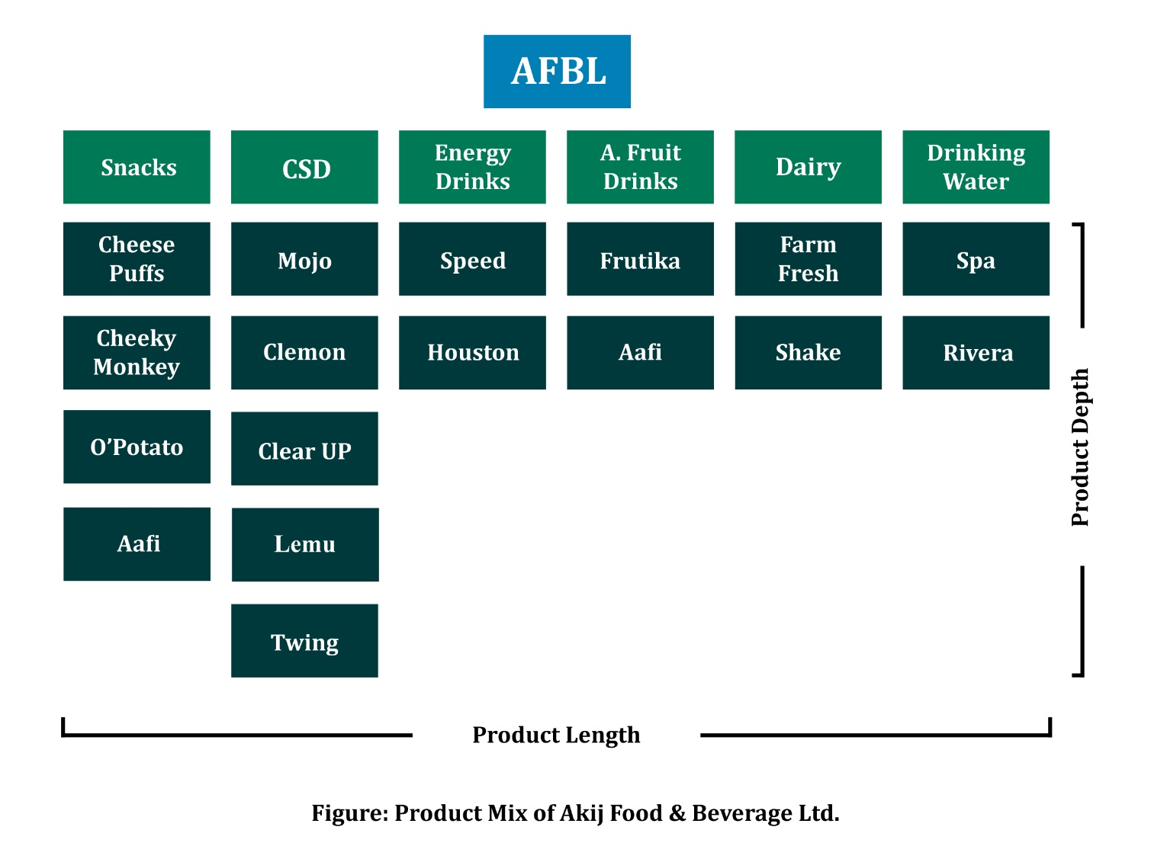
Product mix refers to the complete set of products offered by a company. It has four dimensions are following bellow:
Width: Total number of product lines offered by a company. AFBL product lines consist of Snacks, Carbonated Soft Drinks (CSD), Energy Drinks, Aseptic Fruit Drinks, Dairy, and Drinking Water.
Length: Total number of products in a company’s product mix. AFBL has six product lines and 2-5 products each under those product line.
Depth: The total number of product variations in a product line. AFBL six product lines may offer several variations such as Cheese Puffs, Mojo, Clemon, Speed, Farm Fresh, Aafi, and Spa.
Consistency: Indicates how product lines relate to one another. AFBL is focusing more on consistency for reducing the production cost of the products.

Quality Assurance
Akij Food & Beverage Ltd. (AFBL) provides optimal quality products to value their customers. All high-tech machines and factories are set up to enhance the ability to meet consumer needs. AFBL has classified its products into six lines and each line is listed with different brands on the market. The product lines are distinguished from the company by the machines used to manufacture the products. AFBL has plans to introduce more diverse and unique products into its product line and also planning to diversify more in this.

SWOT Analysis of Clemon
Strengths  - Product of AFBL.  - Strong lemon essence.  - Strong established and good quality of product.  - Strong distribution channel over 850 distributors.  - State of art production setup. | Weaknesses  - Scarcity of production capacity.  - Shortage of production raw materials.  - Product distribution support in peak season.  - Lack of products availability to consumers.  - Lack of automation.
Opportunities  - Huge market demand.  - Growing category in industry which is 8%.  - Exported in overseas market around 14 countries.  - Scope of attaining maximum market share in beverage sector.  - Strong brand awareness. | Threats  - Increased trade barriers.  - New regulations.  - Early winter effect.  - Consumers shift in other brands in terms of taste.  - Emergence of substitute brands  (Coca-Cola, Pepsi, 7UP).

Strategies to meet the Challenges & Opportunities
Challenges
- Trade Barriers: In Bangladesh, new market entrants face significant restrictions and the process for establishing legal entities is subject to strict regulatory requirements.

- Government Regulations: The safety and quality of food products remain a primary requirement for the consumers and also concern for the manufacturers. The government regulations can help them to manage the quality and safety of their products and meet the strong regulatory requirements.

- Consumer Switching to other Brands: There are six reason why consumer may switch to other brands like affordability, quality of customer service, variety seeking, adaptation, innovation, and convenience.

- Availability of Substitute Brands: Consumers try a new product because they're seeking variety in trying something different from what they usually purchase.

Opportunities
- High Market Demand: The industry has been the processing of increasingly diverse products to meet the changing high market demands in Bangladesh. The major food & beverage industries include snacks, carbonated soft drinks, energy drinks, dairy, drinking water, cooking oil, sugar, rice, wheat, tea, vegetables, fruits, and spices.

- Economic Growth: The industry is an economically growing sector in Bangladesh. The Food & Beverage market is expected annual growth accordingly 9.88% and 7.02% in 2021-22.

- Modern Technology: Using modern technology in food & beverage industry, Enterprise Recourse Planning (ERP) provides critical aid support to management, batch scalability, reverse bill of materials (BOM), flexible and dynamic packaging options, and others.

- Scope of Introducing New Segment: This industry has huge scope of introducing new product segment like malt beverage, mojito, plant based dairy free product for vegan consumer, sparkling water and others.

CHAPTER-4

Buyer Readiness Stages and Marketing Strategies

Introduction
Fast Moving Consumer Goods (FMCG) is experiencing gradual growth in our country and goods such as beverages are booming. Thousands of drinks are consumed every day. Many local companies and foreign franchises have developed an extremely competitive environment in the beverage market. These product lines are commonly referred to as soft drinks. The concept was developed for many decades. Initially, it was consumed with a doctor's prescription, but over time the concept has refined to make it a product for general consumption at any time. The water is treated with various flavors as well as carbon dioxide (CO2) to create a flavorful carbonated drink that provides refreshment. Carbon dioxide is used to maintain the fizziness that contains refreshment in the human body.
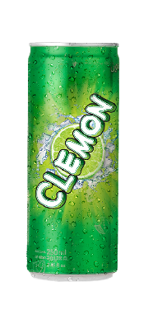
CLEMON is a carbonated soft drink (CSD) brand of Akij Food & Beverage Limited (AFBL). It is distinguished as a clearly lemon drink in the country. It was launched in 2006 at the time of the beginning of AFBL. Clemon's tagline is "Clearly Lemon". The people of Bangladesh are sports enthusiasts. In particular, most of the people are young people between the ages of 15 and 25. Sport has an important emotion for them. Being an international emerging country that dominates cricket, people find their happiness and pain in cricket. Clemon is also related to cricket. It has a special wing called Clemon Sports which includes several outdoor sports-related arrangements with the "Clearly Lemon" theme.

Here I can explain, the marketing strategies at AFBL to influence buyer readiness to buy Clemon. Buyer Readiness Stages are usually listed as awareness, knowledge, liking, preference, conviction, and purchase. The six stages faced by the buyer's awareness of the product, knowledge of benefits, liking factor of interest for the product, preference given to the product over the competition, the conviction of the product at the level of suitability, and purchasing power for potential buyers. Understanding these steps will help to determine how promotional activities will be used and what medium would be best for a marketing campaign. A large area is covered by the marketing campaign to reach the potential consumer through the buyer preparation stages.

Awareness
Before we can sell a product or service, we need to find and reach our potential buyers and those who want to buy our product or service. The consumer may have a vague idea or even not have heard of our product or service. The first step is to develop marketing strategies that will promote our business.
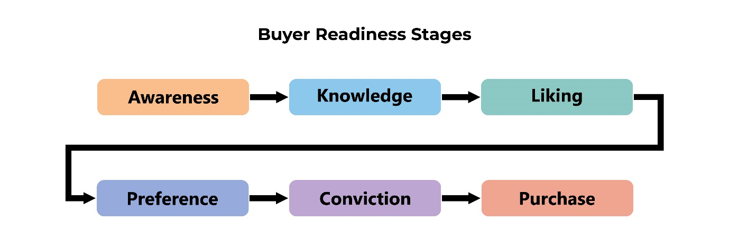
At this point, the customer has a vivid idea of ​​Clemon, the product, and other factors. When customers aren't as aware of the product, it falls to marketers to come up with strategies to create awareness. Marketers use promotional and advertising strategies to attract more customers who can be potential consumers.

Knowledge
Once potential customers get to know our company, they begin the process of acquiring knowledge about what we offer. Give customers reasons to do business with us by providing them with information on why they should buy our products. Our strategies should act as an expert or reference point for the products or services we sell.
In the second stage where consumers have some awareness of Clemon as a clear carbonated soft drink, but consumers have some lack of knowledge of the product offer. Here the marketer's motive is to spread more knowledge about the product. They build advertising efforts to develop the customers as a specialist or expert in one or more of their products.

Liking
This is the stage where the customer begins to relate to the product and develop connections with it. We all tend to buy from people or companies that we feel positive about. Our efforts to make our company cheerful, inviting, and accessible.
In this stage, customers are aware and full knowledge of Clemon. Then consumers start relating them to this product and develop a connection and marketers develop strategies accordingly.

Preference
If customers prefer our product over what are the competitors' offering. Performance statements are essential in influencing potential customers to choose our company over another. Focus on features of our product that are different or unique and that provide significant benefits to consumers.
This stage involves evaluating with the consumer base whether they prefer a company's product over its competitors such as Sprite, 7UP, Fizz UP, Pran UP, Fresh UP, and others.

Conviction
Let our customers know they need our products by persuading them to buy. The best way to convince consumers is to educate them through personal selling and advertising. Customer testimonials, product demos, influencer marketing, and product testing are some of the creative strategies we can use.
At this point, marketers are giving consumers a very strong reason and influence to believe and buy the product rather than the competitors. While convincing the minds of customers.

Purchase
After building trust and confidence in the product, the last stage is to lead the consumer to purchase it. Build a strong relationship by helping customers make the right purchase. The relationship between a seller and a buyer rarely ends in a sale.
In this stage, the product is developed for the consumers and the motive of the marketers leads the buyers to buy the product.
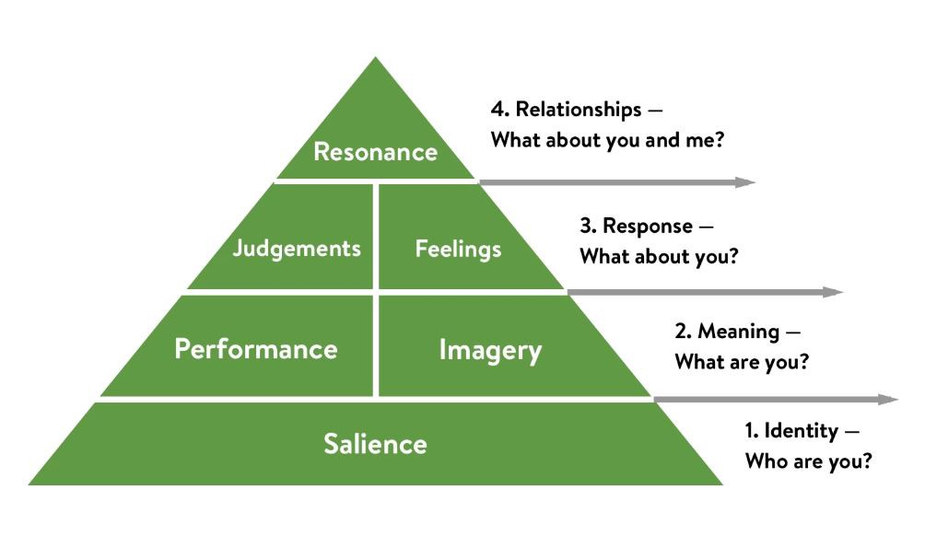
Akij Food & Beverage Limited (AFBL) for CLEMON Brand, their marketing strategies are following CBBE Model (Customer Based Brand Equity):
There are four levels in the CBBE Model-
- Brand Identity (Salience)
- Brand Meaning (Performance & Imagery)
- Response (Judgements & Feelings)
- Relationship (Resonance)

Brand Identity
This is the first level where the brand Salience or awareness is established to brand identity. Clemon need to create brand awareness to ensure their brand perceptions are correct key stages of buying process. They are able to sell their product because it satisfies a particular set of customer needs that is the Unique Selling Proposition (USP). For create brand awareness, CLEMON developed their marketing strategies so that awareness is created such as Above the Line (ATL), Below the Line (BTL), and Through the Line (TTL) promotional strategies to create the large number of potential consumers who are willing to buy.
Below the Line (BTL)
Above the Line (ATL)
(Through the Line) TTL
Above the Line (ATL)
ATL strategies focus on direct communication towards the mass market. All promotional messages are untargeted. This marketing activities are most used to build brand awareness. They are widespread campaigns largely untargeted at a general level. Basically, ATL Marketing approach through the television, radio, print media advertising campaign where is shown across the country to people of all demographics.
Television Advertising: It’s a good medium to increase the brand visibility. This medium of advertisement provides both video and audio to attract potential consumers. Recently, Clemon is launched two categories TVC; Clemon clearly lemon thematic advertisement and Clemon Vorti Fridge Campaign related advertisement.
Radio Advertising: It’s one of the oldest and highly effective mediums of advertisement. Radio advertising are generally well known to consumer recall for brand name.
Print Media: It’s including newspapers or magazines. The main purpose of using print media is to reach rapidly a large number of people.

Below the Line (BTL)
BTL activities are more focused on directed communication towards specific groups of people. BTL strategies include sponsorship, outdoor advertising, retail marketing, direct marketing to reach the highly targeted customers.
Sponsorship: Clemon often decide to sponsor specific events to reach out to their target consumers. They are attached their brand name as title sponsor or co-sponsor with the events where they are promoted by the organizers. For example, Clemon Indoor Uni Cricket Tournament. If the audience attending a specific event is the target audience, they can reach out to them and persuade them to check out their offerings through the event.
Outdoor Marketing: Billboards, Banners, Bus branding and CNG Stickers, Traffic booth branding and road safety awareness.
In-store Marketing: This activity refers to different sales promotion offers, discounts, buy one get one free and others.
Press Conference: Clemon Indoor Uni Cricket Tournament, Clemon Corporate Social Responsibility (CSR) Campaign along with DNCC.

Through the Line (TTL)
TTL is the integrated marketing approach of ATL and BTL marketing activities. It’s a more holistic way of reaching out to the consumers and persuading them to purchase offerings.
360-Degree Marketing: it’s a combination of ATL and BTL activities for advertisement.
Digital Marketing: Social Media such as Facebook, Instagram, and YouTube.
Brand Meaning
When consumers become aware of the brand Clemon then they will want to know more about the product like taste, packaging, branding, color and other specifications. Through the performance indicates how well the product satisfies the needs of their consumers. Clemon provide their brand knowledge regarding product primary characteristics, packaging style and design, product price, color and taste as well.
After that imagery refers to the brand appear to consumers how they talk about the product. It deals with the overall brand image in the consumers’ mind and Clemon meet the expectation of consumer satisfaction by their product. Consumers are liking their product by their own experiences.

Response
Customer evaluate brand preference by their judgement of the product quality of other competitors are offering. Clemon offers extra lemony essence clearly lemon carbonated soft drinks to their consumers. It distinguished the real lemony taste in our country.
Feelings can be refreshed, fun, thrill, adventure, security on associating with the brand. Clemon makes consumers feel refreshed has a strong impact on whether they buy the product. Clemon associated with youth and sports. They are engaging with cricket so that people make a positive conviction to their brand.

Relationship
In this stage, customers are highly engaged with the brand and they are ready to participate in online forums, social media, similar communities, and any events relating to the brand.
Clemon analyze the brand resonance that can measure how consumers feel they are connected with brand. Consumers with a high brand resonance for the brand, they are happy to share their positive review and recommended to others. Clemon organized numerous events and campaigns such as Clemon Indoor Uni Cricket Tournament, Clemon Vorti Fridge Campaign so that people are willing to participate those events and win some attractive gifts and they are recommended to their friends and family, relatives and continue making purchase in the future.

CHAPTER-5

Internship Experience

Position, Duties and Responsibilities
During my internship period, I was assigned as an Intern of Brand Team (CLEMON) in Marketing Department at Akij Food & Beverage Limited.
Duties and Responsibilities
- Analyzing brand positioning
- Analyzing customer insights, reactions and experiences
- Monitoring market trends and competitors’ activities
- Communicating with advertising agencies
- Communicating with distribution channel and market visit
- Assisting to organize promotional campaigns and events

New Skill Developed
Teamwork
The majority of my tasks is associated on teamwork. The priority has given to regular communication with coordinators, updating everyone to provide daily work information. My ability to adapt to change and learn new things so that I can operate all those things by this experience effectively.

Communication Skill
Working for three months in a Food & Beverage company where communication has helped me to improve my communication skills. It gave me a broader view of corporate culture that I didn't have during my academic years.

Professionalism
I have developed my professionalism in the workplace. My internship helped me to establish a sense of professionalism including how to attire subtly to look smart and confident, how to be on time, how to keep confidentiality, and how to work with responsibly.

Ability to Work Under Pressure
I usually had to manage multiple tasks at once while working under pressure. It helped me to learn how to utilize time properly, complete my task productively and efficiently as well.

Knowledge in the New Sector
At the beginning of my internship at Akij Food & Beverage Limited, I had no idea how a Food & Beverage company worked. After working for three months, I have sufficient knowledge of this sector. how each department contributes to the realization of a successful product and the chain of command maintained in a particular way.

Understanding Career Goal
I have gained a thorough understanding of the FMCG sector after working as an intern for three months, making it easier to decide on career objectives. Working at Akij Food & Beverage Limited gave me the opportunity to achieve real corporate world experience, understand the value of the sector to our economy.

Understanding the Corporate Culture
For a young professional like me, working in a corporate office is a new experience. Through this internship program, I was able to put the theoretical knowledge that I had learned in academics to use in the workplace. Learning an organization's culture takes time. People must stay in the environment for some time in order to understand the culture. Knowing the company culture gives interns like me an edge to treat others with respect.

Application of Academic Knowledge
In my academic curriculum, I took a Brand Management course, which taught nearly all the practical knowledge needed to understand everything about brand marketing, including advertising across ATL, BTL, and digital platforms. This course was extremely useful, the practical knowledge during each session would have been more useful to me now that I work in the marketing department of the CLEMON brand. More experiential learning from this course would have helped me get the job done efficiently and effectively.

Assisting in Promotional Activities of CLEMON
Campaigns
- Clemon Clearly Lemon Thematic Campaign
- Eid-ul-Adha Clemon Vorti Fridge Campaign
- Clemon Corporate Social Responsibilities (CSR) Campaign

Events
- Clemon Indoor Uni Cricket Tournament 2022
- Clemon Helicopter Ride Activation 2022

Prize Giving Ceremony
- Clemon Do It Yourself Contest
- Clemon Freshness Boosters Contest
- Spa Tour De Rainbow Photography Contest

Press Conference
- Clemon Indoor Uni Cricket 2022

Recommendation
- The brand needs to be more careful and active about marketing activities to attract their consumer. Because consumers want to see new brand activities so that they can recall the brand identity.
- They should build a strong distribution channel compared to their competitors.
- The should increase their production capacity and raw materials suppliers. AFBL is already on it so that increase of factory machineries for more production.
- Need to more careful about competitors’ activities so that AFBL can cope-up with them.
- Consider how to increase brand equity. It will help to reach an extra-ordinary destination.
- Current brand activity campaign is not sufficient for sustaining long term brand equity in the market. Need to more strategies apply and develop in order to survive along with competitors in the market.

Conclusion
The Bangladesh market has a huge demand for consumer goods considering its population. In the highly competitive FMCG industry, consumers play the main role. In marketing, consumers are the kings of the industry. Consumer insight and pressure from the reference group on consumers to buy non-alcoholic beverages. It seems that the marketers of various soft drink companies are adopting innovative strategies to deal with dynamic consumers. The company conducts various market research to gather consumer insights. And take action to fulfill their mission. The purpose of this study is to better understand the influence of reference groups on the purchase decision of clear soft drinks. Different marketing strategies play an important role in consumers deciding to purchase CLEMON Clear Soft Drink.

References
- Akij Food & Beverage Ltd. (n.d.). p. https://www.akijfood.com/.
- Akij Group. (n.d.). p. https://www.akij.net/.
- Customer Based Brand Equity. (n.d.). pp. https://www.clootrack.com/knowledge_base/what-is-customer-based-brand-equity.
- MBA Skool CBBE Model. (n.d.). pp. https://www.mbaskool.com/business-concepts/marketing-and-strategy-terms/18250-cbbe-model.html.
- MBA Tutorials Buyers Readiness Stages. (n.d.). pp. https://mba-tutorials.com/what-are-the-buyer-readiness-stages/.
- Mind Tools Keller CBBE Model. (n.d.). pp. https://www.mindtools.com/pages/article/keller-brand-equity-model.htm.

