UNITED INTERNATIONAL UNIVERSITY

EFFECTS OF FOREIGN DIRECT INVESTMENT ON GDP, EXPORT & INTERNAL INVESTMENT IN BANGLADESH: A CASE STUDY
Submitted by
SHOJAN KOSTA
ID:124162004
Department of economics
A Graduate Research Paper Submitted to United International University as a Fulfillment of Degree Master of Science of Economics
Supervisor
MOHAMMAD ALI ASHRAF, PhD
Associate Professor
School of Business and Economics
United International University

ACKNOWLEDGEMENT
First, I recognized the blessings and mercy of Almighty God. I am deeply in debt to Mohammad Ali Ashraf, Associate professor, department of economics, united international university, who is my paper supervisor for Continuously support & guide. His valuable idea given me the strength to finish my research paper. I want to provide this research brochure to my family and friends to give me the sinew to build my career & life.

ABSTRACT
Foreign direct investment plays an important role in the growth of Bangladesh's economy, GDP, exports and local investment and overall economic growth. It’s therefore important that developing countries such as Bangladesh take effective measures to protect potential foreign investors so that they can get a good investment climate. They must feel that their role in Bangladesh's trade policy is respected. In this sense, friendly regulation, regulatory enforcement, incentives, investment and elimination of inefficient bureaucracy must be ensured.

CONTENTS OF TABLE

TITLE Page
Acknowledgement………………………………………………………….02
Abstract……………………………………………………………………....03
Table of Content………………………...……………………………...…04-06
List of figures……………………………………………………...……….07
List of table… .……………………………………………………………....08

Chapter 1
Introduction
1.1 Background of the study…………………………………………………09-10
1.2statement of issues……...…………………………………………………..11
1.3 Research questions of the study…………………………...……………11
1.4Objective of the study.……………………………………………….…12
1.5 significance of the study………………………………………………12-13
1.6 Degree of industrial investment…………………………………………13
1.7 scope and limitations of the study……………………………………13-14

Chapter ii
2.1 literature review ………………………………………………………14-19
2.2 present FDI status ………………………………………………………19-20
2.3 sectoral FDI flows…………………………………………………….23-25
2.4 FDI Inflows by countries………………...……………………………….25-26
2.5 Investment flows from the country……………………………………….26-28

Chapter iii
Methodology
3.1Research framework and Model…………………………………………29-30
3.2 Hypothesis of the study…………………………………………………30
3.3 operational definition …………………………………………………...30
3.4 Variable dependencies ………………………………………………....30
3.4.1 GDP…..................................................................................................30
3.4.2 Exporting…………………………………………………………….31
3.4.3 Domestic investments……………………………………………….30
3.5 Independent variables………………………………………………....30
3.5.1 FDI flows……………………………………………………………31

Chapter iv
Introduction
4.1 Impact of FDI on GDP………………………………………………….31
4.2 Impact of FDI on export…………………………………………………33
4.3 Impact of FDI on private Investment…………………………………….34
4.4 Analysis…………………………………………………………………35
4.5conclusion and recommendation……………….……………………34-35
Reference…………………………………………………………………35-37

LIST OFFIGURE
FIGURE TITLE EPAGE
2.2.1 inflow FDI trend (million in USD) by during 2003-2017in Bangladesh……...17-19
2.2.2 inflows FDI (USD in million) by components during 2003-2017in Bangladesh …….21
2.2.3 inflows FDI (USD in million) by in 2013components………………………………21
2.2.4 inflows FDI (USD in million) by in 2016components……………………………….22
2.3.1 inflows FDI (USD in million) by sectors in during 2003-2017Bangladesh………….23
2.3.2 inflows FDI (USD in million) by sectors in during 2003-2017Bangladesh…………24
2.3.3 inflows FDI (USD in million) by sectors in Bangladesh during 2003-2017………….24
2.3.4 inflows FDI (USD in million) by sectors in Bangladesh 2006-2010…………………25
2.5.1 inflows FDI (USD in million) by countries during 1996-2010.....................................26
2.5.2 inflows (USD in million) by countries during 2003-2017...........................................27
2.5.3 inflows FDI (in million USD) by country during 2001-2005……………………….27
2.5.4FDI inflows (in million USD) by countries during 2006-2010…………………….28

List of Table
Table Title page
4.1.1 Model summary & ANOVA(f)…………………………………………………………………32
4.1.2 Coefficients(a)……………………………………………………………………………………….32
4.2.1Model summary & ANOVA(F)………………………………………………………………33
4.2.2 Coefficient(a)…………………………………………………………………………………………33
4.3.1 Model summary & ANOVA(f)…………………………………………………………………34
4.3.2 Coefficients(a)……………………………………………………………………………………….35

Chapter 1
Introduction
1.1 Background of the study.
According to the 2006 UNCTAD investment report, FDI is defined as long-term investments and reflects long-term interest rates and the management by an economic unit (investor) of foreign or major enterprises) in enterprises of an investor in the economy other than direct investment abroad (enterprise or investment firm Directly from foreign or foreign branches of companies). Foreign direct investment means that investors have a huge impact on the management of another business that lives in other economies. Foreign direct investment in Bangladesh rose by USD 770.0 in September 2017, compared with an increase of USD 624.0 million in the previous quarter. Investments in Foreign Direct Investment in Bangladesh: The USD net flows data are updated quarterly and are available from September 2003 to September 2017. Data reached US $ 859.0. in March 2017, and the lowest was -119.0 USD in December 2005. CEIC is expanding its history of quarterly FDI. Bangladesh Bank to provide foreign direct investment in US dollars on the basis of BPM6. Foreign direct investment before the third quarter of 2011 is (based on BPM5).

With the exception of some reservations, foreign investors are free to invest in Bangladesh in industrial enterprises. An industrial unit can be set up in cooperation with local investors or can be wholly owned by foreign investors. They do not need to be created if entrepreneurs use their own resources. However, to get support from institutions and entrepreneurs / sponsors, it is recommended to apply for Board Membership (BOI). For the Checklist, the Import and Export Bureau (CCI & E) describes the import rights conditions.

Warehouses can be used to inflate foreign investors against bulldozers imported to Bangladesh. For issue of securities against foreign investment in the form of securities firm, passport, bill, evidence of capital mechanism, personal authorization, copy of import and transport permits. Ballada is try to create a favorable investments climate. Economic policy, investor motivation, privatization, etc. Thus, direct investment (FDI) contributions are crucial to boosting the country's economic growth.
Researchers note that FDI is the key to boosting economic growth and wealth, as well as job creation, economic coordination and creating an approximate environment and contribution to the production of machinery.
Bangladesh play an important role in the increase in direct investment and development (BPL 2007). FDI has contributed for the modernization of Bangladesh's in economy of two decade. This country's infrastructure is built, the creation of more jobs in the host countries, creating skilled employment opportunities, knowledge and technology management, and transfer of regional and global economic. Positive benefits from Bangladesh are now attracting investors from developing and developing countries. Some skilled workers are available in Bangladesh. Apart from this, the macroeconomic environment is stable. Two main reasons Bangladesh will be an attractive destination for foreign investors. Minimum wage, fair inflation is appropriate among Asian countries
(Excluding the previous year), exchange rate, investment order, and enthusiasm package make Bangladesh a better investment destination. In the last decade, Bangladesh has expanded with FDI policy and will support the recent rise in FDI in Bangladesh.
In 2008, foreign direct investment in Bangladesh was small and focused on banking and other sectors. Bangladesh started to attract foreign direct investment since 2003 in energy and power sectors, supporting and supporting economic and foreign economic reforms of oil and gas. In 2004, foreign direct investment rose to 0.09 million. The dollar in 2004 reached 231.61 million in 2005, up from 1086 million in 2008. To 913 million dollars. $ 32 million. Dollar. 2010

1.2 Statement of Issues
A broader scope of services provided, including incentives and facilitation of investments, including ongoing maintenance, provision and maintenance of investors. Bangladesh faces the biggest challenge to accelerate investment, especially in the private sector, to achieve GDP. The government is trying to increase GDP. Since 2003, the average gross domestic product (GDP) is about 5.8%, notably associated with the semi-low of 80s in the second half of the last century when the rate is about 3.1%. Gross domestic product (GDP) is an average of 7.2% in the fiscal year 2017, generally due to rising food and food prices.

Goods production and exports can plays an important roles in addressing the deficit in Bangladesh. However, the study of the impact of total exports and its impact on GDP. In Bangladesh, major export goods and services are RMG agriculture and migration. No one has analyzed the impact of these factors on Bangladesh's capital of the economy of Bangladesh's gross domestic product. There is little about the relative implications of these exports on economic activity in the capital, in the latest economic crisis in the world market caused by high prices, once again a concern at On how to improve exports, countries expand to contribute to the growth process. Higher prices hinder demand, and exports from developing countries can be reduced. Given that imports of capital goods and other products for development are determined in part by the size of the foreign currency generated by this export, it is necessary to analyze the structure of export markets to predict the outcome. Side effects of future events
1.3 Research Questions of the Study
- What is the impact of FDI?
- What is the impact of FDI on Export?
- What is the impact of FDI on internal investments?

1.4 Objective of the study
The broad objective of the paper is to examine the impact of FDI on the economy of Bangladesh. However, the specific objectives are as follows:
1. To examine effect of FDI on GDP.
2. To evaluate the effect of FDI on exports.
3. To analyze the effect of FDI on internal investment.

1.5 Significance of the study
Prospects of FDI Private sector development
In the private and private markets, the private sector is considered the main driver of growth. The current government has taken concrete steps to expand private sector participation in joint development activities. In addition, efforts have been made to implement reform and liberalization programs to strengthen the structure of the free market economy and to create a more efficient and competitive private sector. Strengthen direct government intervention in production and commercial activities. The government determines its role as regulator, moderator, and partner. To make the private sector more transparent, dynamic and dynamic, the Royal Government of Cambodia will make changes to private policy reform. It is also set to privatize state-owned enterprises that are transparent in maintaining prosperity.
Staff. In addition to traditional investments, the initiative is also available to encourage private entrepreneurs in services such as energy, gas, mining, transport and health education. Initiatives made in the framework of a number of policies developed and implemented in support of this objective have a positive impact on overall development of country.
The recent global economic downturn and political turmoil on the international scene has had a negative impact on the economy of Bangladesh. However, government measures to boost investment, production and exports, as well as the promotion of a strong market share, have succeeded in stimulating the economy and, as a result, the GDP has grown steadily. In this respect, the private sector has created a brand.
- Developing a private environment
- Reform of industrial policy
- Setting up a personal data protection committee
- The role of the Investment Council
- Development of the capital market

1.6 Degree of industrial investment
Bangladesh's economy has attracted investor interest since the early 1990s. Production is constantly rising, claiming that this is an integral part of total investment. During 1991-92 to 2002-03, private investment increased in BOI, a private investor and brokerage intermediary with $ 25,933 million. Registered investment is 47.65% and 52.35% are foreign (100% and jointly). The data sheet follows from 1991-92 until the fiscal year 2002-03. In the fiscal year 1991-92, total private investment recorded $ 116 million in 2002-03 from $ 2,395 million.
In 2002-2003, increased 31% in joint ventures, increasing 32% in domestic market and 22% in foreign investment. In addition, the analysis of FDI projects registered in Fiscal Year 2002-03 shows that the largest investor is Japan (28.8%), English (24%), Netherlands (11.6%) South, 4 %).

1.7 Scope &Limitation of the Study
In this study I am discuss about “FOREIGN DIRECT INVESTMENT IN PROSPECTS AND CHALLENGES “This is affected by many factors like-

- Exploring the positive and negative of FDI and economic growth.
- Foreign direct investment in Bangladesh.
- FDI management techniques for host countries.
- The impact of FDI inflows on GDP & exports on Bangladesh.

But in this study paper all relevant data source are not available at all. BB, BBS, WB, IMF all sources are not fully reached by relevant information. Bangladesh bureau of statistics (BBS)has no historically data so that before 2003 data has been very scared. Before 2017 data collect form each year economic review of Bangladesh, so it was very difficult and complex, also it is mentionable that at present there is no available research paper about the impact of GDP per capita forming these economic activities.

Chapter II

2.1 Literature review
Global State of Foreign Direct Investment (FDI)can contribute to maintaining the economic development of the country?
Atkins and Harrison (2006) of Foreign Direct Investment have made a positive impact on the FDI contribution to domestic productivity and economic growth. Then, Levin et al. (2007) The results of negative economic development were found.
Rothzhib (1996) temporarily defines the effect of the development of FDI in developing countries. The effects of short-term events have a positive impact on growth. Rothzhib (1996) uses its model to understand the impact on foreign investment of Bangladesh's development and shows that FDI has a positive impact on development. Changes in the level of domestic investment have a positive impact on development.

V.N. Balasubramanyam, M. Salisu and D. Sapsford (1996) conducted an exam on the impact of foreign direct investment on economic growth in developing countries using the smallest square. By implementing export promotion strategies, they determine the positive and positive effects of foreign direct investment on economic growth in developing countries. At the same time, it also shows that these links are not in developing countries that are implementing alternative import strategies. Benga and Sanchez Rabalasa (2004) showed positive relationship between FDI and economic development. In this context, long-term economic stability does not require the market of the host country to benefit from the flow of foreign direct investment. Potama (2005) analyzes long-term relationships between FDI & local investment in Thailand. They found that long-term impact on local investment in Thailand has long been affected.
In spite of positive relations between FDI and economic development, evidence shows negative ties between them.
The principles in the development of addiction company have long-term capital assertion of plots and technology, and development has negative effects, because the market has less access to communication, good governance, and communication skills (markasuna space than a modern network of modern, ayagosina and MP Mayor 2000, Kumar and President in 2002). FDI can have a negative impact on the distribution of energy related revenues (Mesela and Europe 2006), dependent on theory, sovereignty and independence. Bogwat (2004) established a link between direct investment and economic development in Sri Lanka.
For the period 2001-2007, Sri Lanka analyzes the relationship between the GDP and the expansion of domestic investment and trade policy. This test shows a strong impact on foreign direct investment in economic development.
Motaleb (2007) defines FDI in developing countries and its impact on economic development. Skill from developing countries.

Yang Wang Li, Gulzada S Baimukhamedova, Sharzada Akhmetova (2008) analyze the relationship between foreign direct investment and economic growth in Kazakhstan and multiple regression models with minimal dimensions. The results show the minimal impact of foreign direct investment on Kazakhstan's GDP.
The data collected in the analysis of Pakistan's influence on FDI in foreign direct investment for Abdel-Anar, Ooranjajp Ali Rajar (2009) 1996-121 and positive GDP growth rate and Pakistan's gross domestic product through several statistical test flows Analyzed. Apart from this, these results show that opening volumes / reach and opening markets in international markets is a major factor in influencing the flow of foreign direct investment. It also says that it does not affect market conditions and potential direct investment contacts in Pakistan.
There is full competition for FDI, but can it support the economic development of the country?
AT & Harrison (2006) assessed FDI contribution in regional productivity and had a positive impact on foreign direct investment in economic development. Then Levin et al. (2007) The results of negative economic development were found.
Rathjib (1996) defines the effect of FDI flow in developing countries. Short-term effects will have a positive impact. Rathjib (1996) used his example to understand the impact of foreign investment in the development of Bangladesh, and realized that direct investment would have an impact on economic growth. There is a positive impact on the growth of domestic investment levels

V.N Balasubramanyam, M. and D. Salisu Sapsford (1996) examined the impact of foreign direct investment on economic growth in developing countries with the smallest square. By implementing the export promotion strategies they have identified positively and the impact of foreign direct investment on positive growth in developing countries. At the same time, it also shows that these links are not in developing countries that are implementing alternative import strategies.
Bengoa Sanchez-Robles and (2004) showed a positive correlation between rising FDI and foreign direct investment. In this regard, in order to benefit from the influx of foreign direct investment for long-term economic stability, it is imperative to demand markets in host countries.
Bornjeszina and others (2006) explore direct investment flows in 69 developing countries in the regulatory region and noted that foreign investment is important as a way to transfer technologies that have contributed significantly to local investment.
Potamas (2005) analyzes the long-term relationship between FDI and local investment in Thailand. They saw Thailand as a long-lasting and lasting impact on local investment.
Despite the positive relationship between FDI and economic development, the evidence shows a negative relationship between them. The forecast is based on the principle that dependence on foreign investment has a negative impact on economic growth and income distribution.

the theory of addiction has said that players from overseas can have a negative impact on the company's growth and development in the high-tech capital for a long time due to low access to a large market. Modern Connectivity and Good Management and Communication Skills (Marksun Place and 1997, Agosinand Mayer 2000 and Kumar Pradhan 2002). According the theory of reliance on foreign direct investment, there could have been a negative impact on the distribution of labor income associated with sovereignty and independence (Musila and Sigue 2006).
Bogahawatte (2004) has established a link between FDI and economics growth in Sri Lanka
SriLanka for 2001-2007 analyzed the relationship between GDP and domestic investment and the expansion of trade policy. The exam shows the impact of foreign direct investment on economic growth.
Mottaleb (2007) teaches definition of FDI & its impact on economic growth on the developed countries. It explores foreign direct investment in low-income and low-level foreign direct investment, it has been found that 60 has a significance impact on the economic growth, creating a bridge between shortages of Local third-party savings and investment, and high technology awareness and management skills from developed countries.

Yang Wan Li, Gulzada with Baimuhamedova, SharzadaAkmetova (2008) analyzed the relationship between foreign investment and economic growth in Kazakhstan and several regression models with a minimal dimension. This shows the minimal impact of foreign direct investment on Kazakhstan's gross domestic product.

Abdul Reman, Orangazab Ali Raza (2009) was analyzed using the data collected in and identified on 1996-2011.foreign direct investment & its impact on gross domestic price, growths on Pakistan statistical testing, type of detection and foreign direct investment, a positive impact on GDP growth in Pakistan. In addition, these results suggest that large quantities / access to international markets and the openness of trade in the market are the main factors affecting FDI inflows. The survey also noted that it did not affect the potential market and communications center to attract foreign direct investment to Pakistan.
Sincerely, Mr. Perspective (2009) is used to analyze the flow of foreign investment in Bangladesh. They found that foreign investment and domestic investment had a positive impact on economic development.
By using Pyramidimal (2010) Vivant Autorrection (VAR) model in 2000-2009, Romania examined the effect of direct investment on economic development and established links between FDI, FDI and economic development.
Mohammed Asam (2010) examines the impacts of foreign direct investment on exports and economic development in South Asian countries including India, Bangladesh, Srilanka,and Pakistan.with a light-based adjustment based on data between the years 1980 and 2009, export growth will increase. It also found that foreign direct investment also reflected a 1% positive level needed to pay for Bangladesh and Pakistan, but for India, it is more important than in the case of Sri Lanka, though significant. But it is a negative sign for speculation.
This approach is an average economic and statistical model, and easy for every difference. This is entirely based on other information. Contextual data monetary review collected by the Federal Statistical Office of Bangladesh (Internet Wiki Leaks, Central Bank, Bangladesh Bank): Internet Convention Council Wiki Leaks, and Economic Trends on Internet Wiki Leaks, Competition Report of Charles Bangladesh, UNCTAD published worldwide

2.2 Status of FDI
Since the last decade, significant changes have been made in trade and financial flows, including an increase in FDI. Despite many important new phenomena, contributing to the increase in foreign direct investment inflows into Bangladesh, trade liberalization and current account liberalization focus on private management of the development of open investment liberalization.
Infrastructure and Services: Who Bangladesh are Foreign Investors (FDI) for their continued development in Bangladeshi investors? When the liberty of the, Bangladesh is trying to favorable sense, as of fact and went to the foreign direct investment. To increase economic growth, Bangladesh's goal is to attract and facilitate foreign investment (Mondol 2003). The government strengthened capital and profit bans and almost all parts of foreign and local partners were opened. Apart from this, the government also provided financial and non-financial incentives like low cost, low cost and new tax on developers for import costs
tax on profits, machinery and spare parts, 100% export industry export orientation, restrictions on how to reduce bureaucratic complications to get the approval of the project abroad. With all these encourages, Bangladesh is an attractive destination for FDI in South Asia since late 2003.

The trend of direct investment flows in Bangladesh has increased in 2003 compared to the previous period and the same inertia continued in 2007. Total foreign investment flow has increased for many years. During the total period of FDI of US $ 8927.9 million, which was total FDI inflows in 2006-2010 amounted to USD.
In 1977, 4158.63 million, the inflow amounted to $ 7 million, & in 2008 total foreign direct investment amounted to $ 1086.31 million. Unfortunately, the fall of FDI inflows in 2010 was $ 913.32 million. (source: Observation Bangladesh bank report Bureau of Statistics).
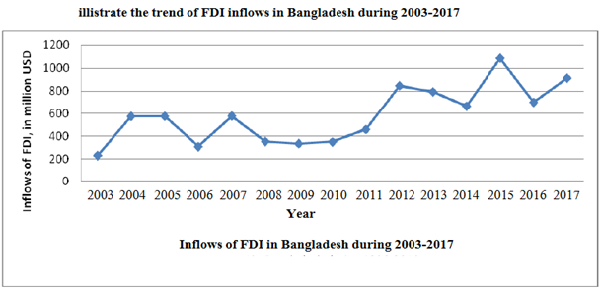
Figure: 2.2.1: inflows FDI (million in USD) in during the Bangladesh 2003-2017.
Source: report survey, Bangladesh Bureau of FDI in 2003-2017 Investment organization.
Figure 2.2.1 shows the process of unforeseen foreign direct investment. In 2005, there was a slowdown in IDE, and the downward trend continued again in 2008-2009 and 2010. Serious political turmoil during this period has prevented foreign investment and is sometimes needed to gain confidence from foreign investors. There are others factor that make this autumn possible. Then there is the Gospel for Bangladesh. FDI inflows increased from 2010 to 2012. Its reached $ 1086.3 million in 2011, but fell to $ 700.16 in 2012 & reached $ 913.32 per year
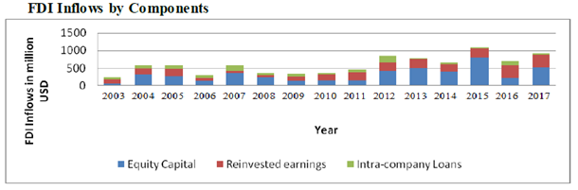
Figure 2.2.2: FDI proceeds (in millions of US dollars) in the components of Bangladesh during the period 2003-2017
Source: Study Report, Division of Bangladesh bank Statistics, and FDI in Bangladesh the pried of in (1971-2017), Directors of organization.

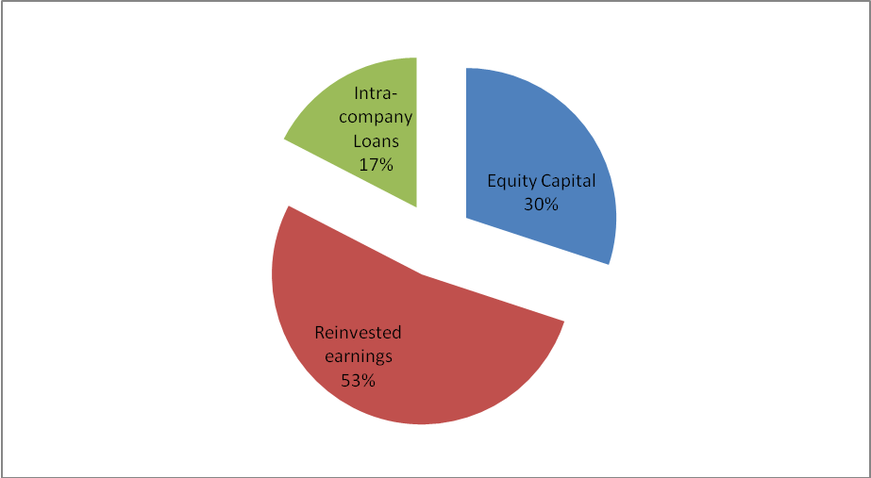
Figure 2.2.3 Inflows FDI components in USD during by 2013


Figure 2.2.4 Inflows million in FDI of USD by during 2016
source: Observation Report, bank of Bangladesh. Bangladeshi Bureau Bangladesh Statistics and FDI in (1971-2017), Board of organization.
Foreign direct investment in Bangladesh has three elements: capital, corporate loan capital. These things have changed dramatically over the last two decades. In the first year of 1996, the flow of foreign investment was only US $ 210 million. The trend continued until 1998. Then, the decrease in overall flow and direct flow of investment. Apart from the slight increase in 2000, the downward trend continued until 2003. As volatility in the yen continues to rise, it has been rising and falling. Market share remains an important part of FDI flows. In 2008, the total amount of inflow was $ 1100 million, the highest amount so far.

The appropriate flow of FDI in Bangladesh is clear in 2.2.2& 2.2.3. the amount of years FDI inflows in Bangladesh have been share. In 1996, the total FDI increased by 30% to 57% in 2010. In 1996, return on investment dropped 53% from 40% in 2010. On the other hand, corporate loans were 17%, which later fell to 3%. This shows that there are a variety of resources coming from Saudi Arabia. Direct investment (FDI) contributions are minimal in case of technology transfer

2.3 Sectoral FDI flows
FDI analysis shows that foreign investors have changed their investments in Bangladesh (Annex 3.4). This table display the trend of direct investment (FDI) for energy & telecommunications, energy production and other sectors that do not care, agriculture, services and trade. In 2005, investment ware concentrated by manufacturing sector. Success in clothing sector through RMG is an important part of the investment. The graphs show changes in FDI in the Bangladesh sectors. The peak scheme clearly illustrates the inflow of foreign investment that has changed in recent years. Reducing FDI inflow shows that their strong position on foreign investment is declining. In other words, in the current period, the telecommunications sector is becoming more and more popular. In 2008, the telecommunication sector overcame the manufacture sectors such a recipient of foreign direct investment. Thanks to effort to privatize telecommunications has grown with a government emerging as part of the fastest growing sector in Bangladesh's economy By attracting most foreign direct investment and increasing their competitiveness with expensive private firms, can be explained by getting their skills and expensive technology. Session In addition, the energy sector is used by the country's natural gas reserves, which includes foreign direct investment. Another reason is very heard in producing electricity lacks of productive capacity has given the governments "power generation"
To achieve high energy use, power cutting is necessary in low energy areas. There is no government capital and power generation power in the country, which has opened the power generation doors of foreign investments
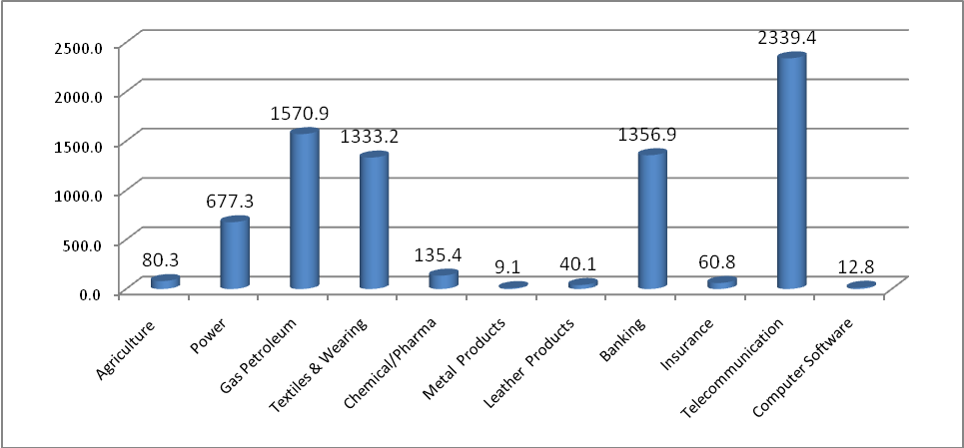
Figure 2.3.1: inflows FDI (USD million in) by sector in Bangladesh during 2003-2017
Source: Report of Bangladesh bank, department of statistics & FDI in Bangladesh the period of (1971-2017), Investment board.

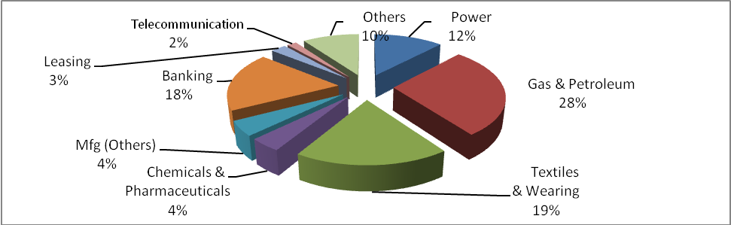
Figure 2.3.2: Inflows FDI (USD in million) by sectors in Bangladesh during 2003-2017.
Source: Report of Bangladesh bank department of statics & FDI the period of (1971-2017), Investment board.
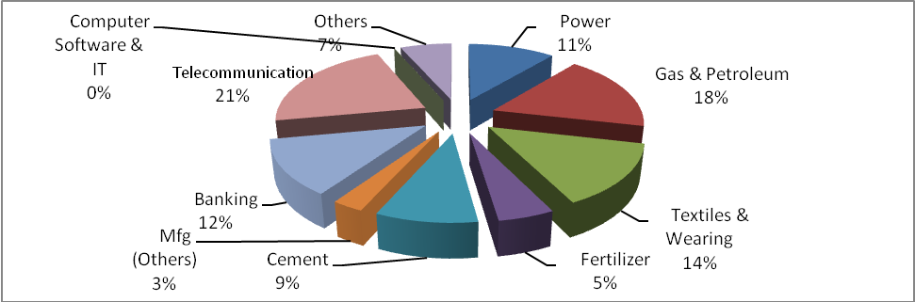
Figure 2.3.3: Inflows FDI (USD million in) sector of Bangladesh during 2003-2007.
source: report of Bangladesh bank department of statistics& FDI the period of Bangladesh (1971-2017),Investment board..
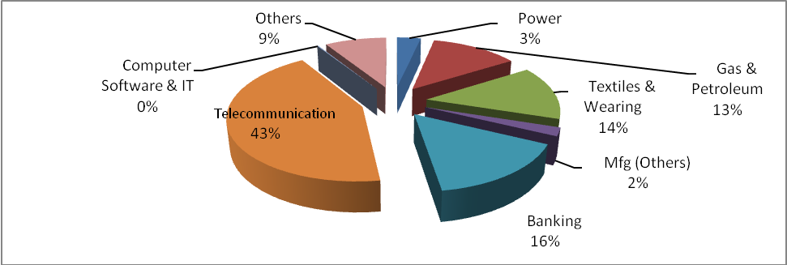
Figure 2.3.4: FDI earnings (millions of dollars) across different sector in Bangladesh in 2006-2010.
Source: Survey Report, Bangladesh Bank Statistics Division and Foreign Direct Investment in Bangladesh (2003-2017), Investment Board.
Statistics 2.3.3 and 2.3.4 It is clear that there are many sectors are changing of investments 32007 investment in telecom increased by 2%, only 2%, which was 21% in 2003-2007 and 43% in 2006-2010. On the contrary, oil and gas emissions are continuously decreasing with investment from 1996 to 2010. 28-2% in 1996-2000, in 2003-2007, and 18% and 13% in 2006-2010.the serious concern that investments of energy sectors fell from 3% to 12%, that is dangerous.

2.4 Proceeds of FDI from the country
Useful flows of FDI in Bangladesh from ten investment countries over the period 2003-2017 are shown in Figure 2.5.1
There have been many changes in many sectors. The investment rate in telecommunications is 2% in 2003-2007, only 2%, which increased to 21% in 2003-2007 and finally to 43% in the period 2006-2010. Conversely, investments in oil and gas missions are steadily decreasing over the period 1996-2010. This is 28% in1996-2000, 18% in 2003-2007 & 13% in 2006-2010. This also a serious cover that investments in the energy sector have dropped from 12% to only 3%, that is alarming. The government should carefully address this issue and take the necessary steps to identify the factors and improve the situation to improve the state of our current energy sector.

2.5 Investment flows from the country
Useful flows of FDI in Bangladesh from ten investment countries over the period 2003-2017 are shown the Figure: 2.5.1

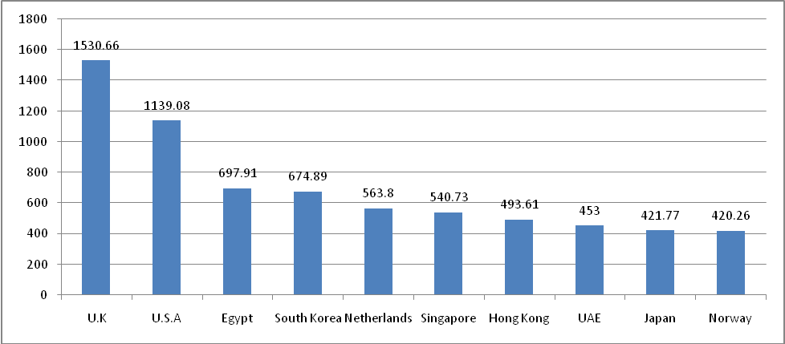
Figure 2.5.1: inflow FDI in (millions of dollars) from the country over the period 1996-2010. Source: Bangladesh Board of Directors.

Figures 2.5.1 show that the UK ranks among the ten investment companies in Bangladesh during the period 2003-2017 investing in various sectors of the economy. Among the top 10 direct investment flows during this period,17.4% from the United Kingdom, 13% from the United States, 8% from Egypt, 7.7% from South Korea, 6.4% from the Netherlands, 62% from the Netherlands, 5.6% from Hong Kong, 3.5% from Japan, 3.5% from Denmark, 3.2 from Denmark % And 1% from Switzerland

Figures 2.5.1 show that during the 2003 decade, while investing in different sectors of Bangladesh's economy, one of the top ten investment companies in the United States is in place. Within this period, within the top 10 direct investment flows,
United Kingdom are provides17.4%, 13% the United States, 8% & Egypt, 7.7% are South Korea,
From Switzerland, from the Netherlands 6.4%, 6.2%, Singapore 5.6%, 5% Hong Kong, United Arab Emirates, Japan 4.8% 3.5%, 3.2% Malaysia and Australia 2.1%
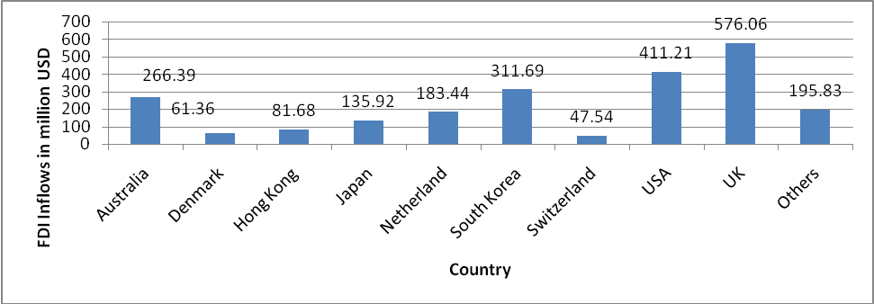
Figure 2.5.2: inflows FDI (millions of dollars) from the country over the period 2003-2017
Source: Survey Report, Bangladesh Bank Statistics Division and FDI in Bangladesh (1996-2010), Investment organization
Figure.2.5.3: FDI Inflows (in million USD) by country during 2001-2005.
source: Report of Bangladesh bank department of statics & FDI in Bangladesh the period of (2003-2017), Investment board.

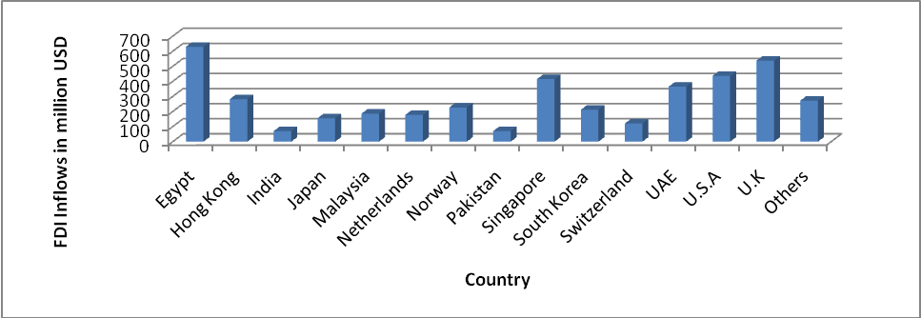
Figure 2.5.4: Inflows FDI (million in USD) by country during 2006-2010.
Source: Observation Reports, Bangladesh Bangladeshi Bureau of Statistics and Foreign Direct Investment in Bangladesh (1971-2017), Director of the board.
Figures 2.5.3-2.5.4 show number of FDI flows that have changed over the years. According to statistics, the world's largest investor in the developed world during 1996-2005, but between 2006-2017, at its highest point in the Middle East. It has shown a change in investment administration. To increase FDI in Bangladesh, it was important to maintain regular business relations with developed countries. Asian countries have to pay more attention to creating the necessary investment environment. In recent years, it is so important to maintain tepid relationship with the Middle East, an important part of FDI. Apart from this, Bangladesh does not have to lose faith in the Asian Development Bank (ADB) and International Finance Corporation (IFC) for Foreign Direct Investment. They have a great place to invest in Bangladesh

Chapter iii
Methodology
3.1 Research Framework and Model
In order to study the impact of foreign direct investment on gross domestic product, which is assumed that

Y1=a+b1x1
Where Y1 =GDP millions of US dollars.
a = fixed duration,
b1 = coefficient of regression for independent variables,
x1 = FDI flows in millions of dollars
Here Y1 (GDP) Depends on the is dependency, while X1 variable independent.
This test is used to determine whether there is a relationship in dependency variables& independent variables. The data collected was analyzed &procedure using SPSS.
In order to study the impacts of FDI on exports,
Y2 = a + b2x2
When Y2 = exports in millions of dollars,
a = fixed duration,
b2 = coefficient of coefficient for independent variables,
x2 = FDI flows in millions of dollars
Y2 here (eg Export) depends on the variable, which x2 is indicated that is independent.
The test is use to determine whether the relationship among dependency variables & independent variables. The data collected was processed & analyzing using SPSS.
In order to study the impact of FDI on local investment,
Y3=a+b3x3
Where Y3 = an internal investment in millions of dollars.
a = fixed duration,
b3= that is represent the regression coefficient for independent variables,
x3= FDI flows in millions of dollars

Here Y3 (ie, local investment) depends on the variable, that is x3 is independent.
The test is use to determine whether the relationship between dependency variables and independent variables. The data collected was processed and analyze using SPSS.

3.2Hypothesis of the study
H1: Proceeds from FDI have a positives and positive effect on gross domestic product.
H2: FDI inflows have a positives and positive impacts on exports.
H3: FDI flows have a positives and positive impacts on local investments.

3.3 Operational Definition

Today, Bangladesh are trying to attracting FDI to boost economy. Bangladesh has some political liberalization to attracts FDI in the country.
that is widely believed inflows of foreign investment may increase local capital. Foreign direct investment is believed to accelerate economic activity and ultimately lead to economic growth. This will increase job opportunities. FDI produces high productivity in the recipient economy. This has a positive effect on job creation, not only in attracting foreign direct investment, but also in the domestic industry.

3.4 Variable dependencies
3.4.1 GDP
The Gross domestics product (GDP) is the market value in the latest generation of goods and services produced over a period of time.
There are many factors to accelerate gross domestic product growth. It is assumed gross domestic product is affected by Foreign direct investment flows. If the power sets the flow of FDI, the variable flow is higher than the variable assumption.
3.4.2 Export
There are some factors, which can affects exports. that is assumed that the flow of foreign investment is a major factor affecting exports. If the power explains the flow of independent variables, more FDI shifts will depend on the assumption that they will be displayed.
3.4.3 Domestic investment
There are some factors that can affects on local investment. which is assumed that FDI is a major factor influencing domestic investment by increasing competition. If the power explains the flow of foreign direct investment, the independent variable is higher than the investor of the internal variable depending on the assumption to be displayed.
Independent variable 3.5.

3.5.1 Flow of FDI.
The long-term investment in a foreign country of FDI. There are 3 components in this: investment, investment and capital corporate debt

Chapter IV
Introduction
This chapter is very important of my study paper. In this chapter first explain descriptive summery, then find-out the correlation among the variables ,5 percent significant level among the variables and overall model discussion.

4.1 Impact of FDI on GDP
The regression getting the equation,
Y1 = FDI×158.757+56987
Here Y1 = million USD in (GDP)

Table:4.1.1 Model summary & ANOVA(F)
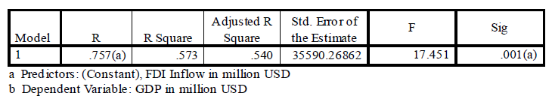
The table above shows the higher value of F.001. This shows that changes made by GDP FDI flow are important.
Displays the advantages of the variable ratio (R) and the sample is shown in the table corresponding to the insert (class and rectangular R square). Coefficient are co-operative .757 and square.573. This indicates that the reference value is relatively high in the bottom-left dynamic GDP ratio
.

Table:4.1.2Coefficients (a)
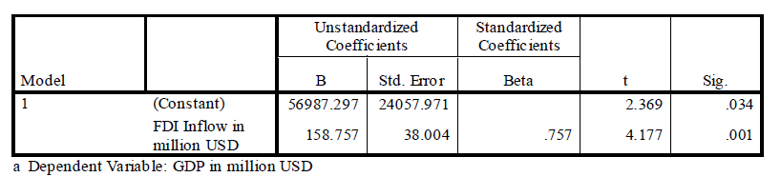
The table above shows a regression coefficient derived from a regression model indicating that independent FDI flows have an adverse effect on gross domestic product.
It is expected that FDI flow has a positive and important relationship to GDP.
4.2 million in USD of Export
Regression equation is found,
The regressions equation is showing,
Y2=934.8+15.7*FDI1
Y2 = in million USD of Export
Table:4.2.1Summery of Model and ANOVA (F)
The table 4.2. 1 above shows that the value F is important at .000.It shows That volatility is important because of the direct foreign direct investment (FDI) of exports. Related balance value (R) and sample defined (square area and rectangular correction) are shown in co-operative tables. Relationship coefficient value .811 and square .658 They show that there is an independent, independent FDI flow for exports.
Table 4.2.2 Coefficients (a)

The table above shows the reaction room from the regression model. It was noted that foreign investment had significant impact on the export of independent investment.
Expected to have positives and significances’ relationship with export from direct investment flows (FDI).

4.3Impact FDI on Private Investment
regression equation is funding,
Y3 = FDII× 15.7 +934.8
hereY3 = in million US (Domestic investment)
Table;4.3.1 Model Summery and ANOVA (F)
The table above shows the high value of F at .001. This shows that fluctuations in FDI in local investment are significant.
The standard general equilibrium (R) and the number of samples (square root and rectangular correction) values are shown in the table. Multiplexer standard 750 and class R 5.63 shows that foreign direct investment flows for local investment are very important.

Table 4.3.2 Coefficient (a)

The above table shows the feedback association from the model of regression. It has been observes that the flow of independent investment has a profound effect on domestic investment.
It is believed that the expected FDI flows have a positives and positive relationship with local investment.

4.4 analysis

The results indicate that statistical data of this model has significant impact on R2 and F FDI flows, GDP, exports and private investment. On the basis of case-by-case, positive impact of the support of foreign subsidiaries and the positive impact of domestic product growth on exports and private investment

4.5 Conclusions and recommendations

Foreign Direct investment in Bangladesh plays a significant role to achieving the expected economics growths. FDI boosts gross domestic product. Meanwhile, foreign direct investment has also contributed to increasing income in Bangladesh.
Foreign direct investment can ensure that Bangladesh can develop and utilize its resources to maximize its viability. Due to the positive impact of our stimulus and changes in our economic policies, there is a growing trend of foreign investment. There is a positive link between direct investment with gross domestic product, exports and private investment.
With the growth of economic development and the expansion of foreign investment, some effective steps should be ensured. The country's administrative system should be appropriate and effective. There is a need to rearrange the office. The office should be reduced.
By providing an enabling environment, the government must review the legal situation. Social awareness is required to ensure the rules of law and reduce the consequences of corruption. In this area, the public and private sector will be more cautious. They must invest in infrastructure development. The appropriate policy has been introduced to work properly for the private sector. When economic reforms and the private sector work together in economic reforms, Bangladesh will strengthen its position. Likewise, regular cleaning can help improve the current state. To encourage domestic and foreign investment, special activities such as Bangladesh could be initiated. It is important to invest in investment rules and business rules. Applies to international practice. The new industrial sector can play an important role in attracting new foreign investment in Bangladesh. The government can consider making apa export export. Foreign countries have taken steps to improve the picture. Investment promotion agencies should provide facilities such as investment and feedback. Through international trade through globalization, attracting foreign currency, promoting Bangladesh, economic and trade sectors. Potential investors need to improve bilateral relations.
Bangladesh needs immediate action to improve reforms, financial institutions, capital markets and other banks. Good governance and political stability must be ensured. Companies play an important role in improving the investment environment in Bangladesh. That is why we need good management in our economic field. Corporate tax rate for non-existent institutions is 40%. They are a great people in Asia. This ratio is useful for investors. Departments and organizations must work together to address the concerns of this region.
In the future, the initiative to promote the proposed reforms, hope will be assured in the economy of Bangladesh. Bangladesh has now taken steps to establish the 25th Summit

Many processes encourage FDI. At the end of the decade, the government, the financial sector and foreign investors must work together to make Bangladesh prosperous.

Reference
Agosin, Manuel R. and Meyer, Ricardo, 2000, "Foreign Investment in Development
Countries: Are there neighbors in local investment? "Discussion UNCTAD Report 146Geneva.
2. Aitken, Brian J. and Harrison, Ann E, 1999, "Household Companies Benefit from DirectForeign Investments? Evidence from Venezuela, "US Economic Review, vol.
89, pp. 605-18.
3. Alfaro, L., Chanda, Kalemli-Ozcan, S. and Sayek, S., 2006, "Is Direction Does investment accelerate economic growth? Find out what the effects of the financial markets areLink ", NBER 12522: Work Series: 1-58.
4. Athukorala P. A W., 2003, "Influence of Foreign Direct Investment on the Economy"Growth: Case Study in Sri Lanka Ninth International Conference of Sri Lanka28 to 30 November 2003, Sri Lanka, Document No 092.
5. Balamurali, N. and Bogahawatte, C., 2004, Foreign Direct Investment and
Economic Growth in Sri Lanka, Journal of Agricultural Economics, Vol.6, No. 1, pages 37-50.
6. Balasubramanyam, V.N. Salisu, M., and Sapsford, D., 1996, &quot; Foreign DirectInvestments and Growth in EP and IS ", The Economic Journal Vol 106, p.
92-105.
7. Bengoa, M. and Sanchez-Robles, B, 2003, "Foreign Direct Investment, EconomyFreedom and Growth: New Evidence from Latin America ", European Journal ofPolitical Economy 19, pp. 529-545.
8. Bhavan T, XuChangsheng, ZhongChunping, 2011, "Determinants and Growth Effect"From Foreign Direct Investment in South Asia: Evidence from the analysis of panel data,International Business Research, vol. 4, Issue 1, pp. 48-55.
9. Borensztein, E., De Gregorio, J., and Lee, J.W. 1998, "How do you deal with foreign directInvesting in Economic Impact? "International Economic Journal VolKirkovich, Maria and Levin, Ross.2002 "There are direct foreign investments. Accelerating Economic Growth? ",
10.University of Minnesota, Ministry of Finance,Working document.
11. Chowdhury, A., and Mavrotas, G., 2006, "FDI and Growth: What are the Causes?"World Economy Vol. 29.
12. Johnson, 2006, "Impact of FDI flows on the economic growth of host countries"CESIS Research Paper Series on Economics and Innovation, vol. 58, p.
1-57.
13. Kumar, N., and Pradhan, J.P. 2002, "Foreign direct and foreign direct investment"Economic Growth in Developing Countries: Certain Research and Development
27
14. Impact on WTO Investment Negotiations "Documentation for RIS Analysis 27/2002NewDelhi.Lee Jung Wang, BaimukamedovaGulzada S, AhmetovaSharzada, 2009, "TheImpact of foreign direct investment on the economic growth of the developing country:From Kazakhstan "International Conferences, Allies, SeminarsEconomics and Education Economics. Vol. 12 questions. 2 pages 22-27.
15. Levine, R., Loayza, N. & Beck, T., 2000, Financial Brokers and Growth:
Cause and Reason ", Monetary Economic Diary, Issue No. 46, pp. 38-77.
16. Markusen, James R. &Venables, Anthony J., 1997, Part of Foreign Investment
Catalysts for Industrial Development ", Work Files NBER 6241, National Office
Economic Research, Inc.
17. Mottaleb, K., 2007, defining foreign direct investments and their impact on
Growth in Developing Countries, MPRA Paper 9457, University Library
Munich.
18. Mohammed Azam, 2010 "Obviously an analysis of the impact of exports
Direct foreign investment for economic growth in South Asia. Cross-border level "
Journal of Contemporary Research in Business, Vol. 2 problemsPage 7, pages 249-58.
19. Musila, J.W. And Sigua, P.S. ,2006, "Increasing flows of foreign direct investment to
Africa: Of 32 policies, financial policies, financial success, financial (7),
577-593.
20. Misztal, Piotr, 2010, "Foreign direct investment, a factor for economic growth
In the Romanian newspaper "Advanced Studies in Finance". Vol. 1 piece. 1, pp. 72-82.
21. Quader, Syed Manzur, 2009, Foreign Direct Investment in Bangladesh: ExperimentAn Analysis of its Impacts and Impacts, "comes from http: // mrraunimuenchen.De / 26134 / MPRA paper number 26134.
22. Rehan Abdul, Orangazab, Raza Ali, 2011, "The definition of foreign direct
Investments and their Impact on GDP Growth in Pakistan, Intergovernmental Discipline ofContemporary Studies 2 Questions. Page 9, pp. 198-205.

