Success through Social Media Promotion: A Study on Akij Food and Beverage Ltd

Prepared by:
Md. Golam Kibriya
ID: 111-122-145
BBA Program
Major in Marketing
School of Business & Economics
United International University

Supervised by:
Dr. Kawsar Ahmmed
Associate Professor
School of Business & Economics
United International University

Date of Submission: 23th May, 2018

Letter of Transmittal

23th, May, 2018
Kawsar Ahmmed
Ph.D. in KAM, MBA&BBA in Marketing
Post Doc. (CUB, Hungary)
Associate Professor
School of Business & Economics
United International University

Subject: Submission of internship report on “Success through Social Media Promotion: A Study on Akij Food and Beverage Ltd”

Sir,
It is my pleasure to submit the internship report, which is done as a part of academic Curriculum, to you for your kind evaluation. The report is prepared on “Success through Social Media Promotion: A Study on Akij Food and Beverage Ltd”I have put my best effort inPreparing this report and to make it a worthy one.

If any confusion arises or any further explanation is needed, I will be readily available to explain the matter to you.

--------------------------------
Md.Golam Kibriya
ID: 111 122 145
BBA - Marketing
School of Business &Economics

Supervisor’s Certificate

I hereby declare that Md. Golam Kibriya has worked under my supervision, prepared the internship report entitled with ““Success through Social Media Promotion: A Study on Akij Food and Beverage Ltd””. After successfully completed the internship report, Golam Kibriyasubmitted in fulfillment of the requirement for the award of degree of Bachelor of Business Administration in the School of Business & Economics, United International University. This report is prepared with sincerity and dedication carried out by Md.Golam Kibriya alone and to the best of my knowledge.

Kawsar Ahmmed
Ph.D. in KAM, MBA & BBA in Marketing
Post Doc. (CUB, Hungary)
Associate Professor
School of Business & Economics
United International University

Acknowledgement

At first, I express my gratefulness to almighty Allah as I have completed this internship report on the topic “Success through Social Media Promotion”” successfully. I would also like to thanks my honorable supervisor Dr. Kawsar Ahmmed, Associate Professor, School of Business &Economics, United International Universityfor whom I have prepared this report. I would like to acknowledge and extendmy heartfelt gratitude to him because of his vital encouragement, support and assistance.

I would also like to thanks Mr. Adnan Shafiq, Senior Executive Brand of Akij Food and Beverage limited who is my supervisor in the Akij Food and Beverage limited. I would also like to thanks Mr. Abdullah Al kafe, Senior Executive (Brand Marketing) of Akij Food and Beverage limited for his sincere cooperation in the organization. Finally, I would like to thank all of my coworkers for their support at Akij Food and Beverage Limited.

Executive Summary

FMCG industry has always an intention to produce a large number of goods and offer these goods at low cost to final consumers. AFBL is one of the renowned FMCG Company in the domestic marketplace of Bangladesh.

AFBL has verities types of good for their target group. Also, they ensure the quality product for their consumers. Among many goods, MOJO is one of the best product of AFBL house. It’s a carbonated soft drink. MOJO started its journey in 14th April. In 2018, AFBL will celebrate its birthday in upcoming April 14, 2018.

MOJO plays a great role in the marketplace and able to acquire a great portion of the share of the market. Now the recent tagline of MOJO is “ONTOR IS ON”. MOJO own a great brand value in the marketplace. For this, MOJO has huge promotional activities. Most popular promotional activities are – MOJO Pitha Uthsob, MOJO Pohela Boishak, MOJO Ontorer Dak, MOJO Ticket Is On, MOJO Humba Is ON etc.

To communicate with the consumers, MOJO follows some general promotional strategy. Those are advertising, direct marketing, and sales promotion. Basis on the promotional activities, the promotional strategy can be changed for better to capture the consumer’s value. Nowadays Mojo more interested in promotion through social media.

MOJO has the most popular promotional activity which is MOJO Pitha Utshob. And this activity held in many different districts to promote the cultural value. In every Program mojo live on Facebook show the life of Pitha Utsob through Social Media promotional strategy AFBL try to reach the actual and potential consumers. Through a questionnaire and post evaluation process, I tried to show that how the promotional strategy they do by social media.

Keywords: Advertising, Sales Promotion, Brand Awareness, Social Media Success of AFBL.

Table of Contents
CHAPTER– ONE 1
Introduction 1
1.1 Introduction 2
1.2 Motivation of the Study 3
1.3 Significance of the study 3
1.4 Background of the report 3
1.5 Objective of the report 4
1.5.1 Broader objective 4
1.5.2 Specific objective 4
CHAPTER - TWO 5
Overview of AFBL and Literature Review 5
2.1 About AFBL 6
2.2 AFBL – Mission and Vision 6
2.2.1 Mission 6
2.2.2 Vision 6
2.3 Literature Review 7
2.4 Success 7
2.5 Why Success is need? 7
2.6 Need Success promotion through social Media 7
2.6.1 Inform 8
2.6.2 Remind 8
2.6.3 Persuade 8
2.7 Factors of success promotion through social media 9
2.7.1 Target Market 9
2.7.2 Content 9
2.7.3 Proper Channels 9
2.7.4 Use videos and photos 9
2.7.5 be social 10
2.7.6 Show Smart in Post 10
2.7.7 Closer, more Human and Honest 10
2.7.8 Emotions as a Driving Force 10
2.7.9 Interact 10
2.7.10 Lead with Your Brand 11
2.7.11 Commitment 11
2.7.12 Creating Pathways 11
2.7.13 Power to leverage others' audiences 11
2.7.14 Push action 12
2.7.15 Spiral of silence 12
Chapter- Three 13
Study Methodology, Findings and Analysis 13
3.1 Research approach 14
3.1.1 Data collection method 14
3.1.2 Measurement instruments 14
3.1.3 Survey area 14
3.1.4 Analysis Tools 15
3.1.5 Sample Questionnaire 15
3.2 MOJO (A CSD product of AFBL) 16
3.3 Marriage between Porter’s five forces and AFBL 17
3.3.1 Threat of New Entrants: Low Pressure 18
3.3.2 Threat of Substitute Products: Medium to High Pressure 18
3.3.3 The Bargaining Power of Buyers: Low Pressure 18
3.3.4 The Bargaining Power of Suppliers: High Pressure 19
3.3.5 Rivalry among existing Firms: High Pressure 19
3.4.1 Strength 20
3.4.2 Weakness 20
3.4.3 Opportunities 20
3.4.4 Threat 20
3.5 MOJO VS. Competitors (COLA category) 20
3.6 Segmentation, Targeting and Positioning 21
3.6.1 Segmentation strategy 21
3.7 Marketing Mix of Akij Food and Beverage Ltd 24
3.7.1 Product 24
3.7.2 Price 26
3.7.3 Place 26
3.7.4 Promotion 29
3.8 Promotional Strategies 31
3.9 Social media Promotion 32
3.10 Recent Campaign on social Media through Facebook of MOJO 33
3.11 MOJO Pitha Utshob 35
3.12 Survey overview 38
3.13 Data Analysis 39
3.13.1 Aware about the program 39
3.13.2 Program name and Sponsorship 40
3.13.3 Pitha Utsob Program 41
3.13.4 Awareness about MOJO Pitha Utshob and Sponsorship 42
3.13.5 Medium to know about the program 43
3.13.6 MOJO Pitha Utshob Advertising 45
3.13.7 Medium to know about MOJO Pitha Utshob 46
3.13.8 Recall 47
3.13.9 Insight of Audiences behavior 48
3.13.10 Participation in program 49
3.11 Findings 50
3.12 Limitations 50
3.13 Conclusion 50
3.14 Recommendations 51
3.15 Reference …………………………………………………………………………………………………………………………………… 52
3.16 Appendix……………………………………………………………………………………………………………………………………..53

CHAPTER– ONE

Introduction

1.1 Introduction

Fast moving consumer goods industry is one of the most competitive marketplace. Also, among many different industries FMCG is one of the faster growing industry in the market. This industry captures value in every aspects. Even in the fluctuating economic conditions of Bangladesh the FMCG market continues to grow at a satisfactory rate of over 9%. FMCG marketers need to observe the each and every selling performance of different product line through professional business research process.

The fast moving consumer goods industry covers the household items that we buy when shopping in the supermarket or a pharmacy. Fast moving implies that the items are quick to leave the shelves and also tend to be high in volume but low in cost items.

Each and every day we are consuming different types of beverage products. These beverage products make available to consumer through business research. Through business research, marketers able to know the consumers’ needs and demand. In Bangladesh, there have many local and foreign franchises and helps to develop a very competitive environment in marketplace. AFBL is one of the leading company in the FMCG industry. AFBL has product variation basis on the consumers need. According to consumers need AFBL also have beverage products for present and potential consumers?

Basis on the different types of attributes beverage can be different. The refreshment advertise is essentially an arrangement of extensive variety of mineral items with certain attributes joined with it. The significant item classifications that are the center determinates of market are carbonated soft drinks (CSD), mineral water, organic product juice, caffeinated drinks, enhanced water, Non – Alcoholic beer.

The soft drinks market in Bangladesh is more than a Tk. 8000 million (US $114.28 million; 1 US dollar is equivalent to Tk. 70.00) market, which is expected to reach Tk.10,000 million (US $142.86 million) soon, and company insiders believe that there is a huge prospect of this product for the market to expand.

To complete my internship program, I have concentrated on the topic which is “Success through Social Media Promotion: A Study on Akij Food and Beverage Ltd”. Throughout the internship program Iworked at Akij House in AFBL (Brand Department), which is stand as head office of Akij Limited. So, from here I got to know about “Promotional strategy of MOJO social media and itsimpact on brand awareness”. Respectively I will try to discuss on the concentrated topic.

1.2 Motivation of the Study
This report is very interesting and innovative &social media now use the large area in business. Now the brand manager are more interested about social media. Now day’s social media is very popular. So the marketer use it for their promotion. So by this new platform we can create a direct communication with customer. Customer can give their opinion directly. So it’s very import to catch up the new innovation social & use for the business.

Significance of the study

Akij Food and Beverage Ltd. (AFBL) is always trying to provide the quality food to the consumers. At the same time they have to compete with other organizations.

This study helps the company to know the greater insight about how much promotional strategy helps to increase the brand awareness. Also, company will able to know which strategy is more effective and efficient for the promotional activities.

Background of the report

FMCG industry is a very competitive marketplace in the world. Also when it is about Bangladesh marketplace then it is necessary to say that FMCG industry is the most competitive place to reside in the consumers mind. Because in Bangladesh has many more FMCG company to meet the consumers need. Specially, the foreign franchises make the marketplace more competitive to domestic FMCG Company.

AFBL is one the most renowned domestic FMCG Company in Bangladesh. It has variety of products. Also it is more popular for beverage products in marketplace. MOJO is one of the best beverage product of AFBL.

For the competitive marketplace each and every company need to go for the promotional activities and promotional strategy to reside in the consumers mind. Also to know the impacts of promotional strategy on brand awareness, research and development team need to go for the post evaluation research.
So, based on my practical knowledge I choose to concentrate on “Success through Social Media Promotion”.

Objective of the report

Broader objective

The broader objective of the report is
- To understanding the promotional strategy though social media of MOJO.
- To know about impacts on success & brand awareness.
.

Specific objective

- To know about the promotional strategy social media of MOJO.
- To find out what kind of promotional medium is effective to reach the consumer.
- To know about the competitors stand.
- To know about the brand awareness.

CHAPTER - TWO

Overview of AFBL and Literature Review

AFBL is a renowned organization in our country. Now days it’s spared its business country trough world. It’s one of the major product is MOJO. Social media is now became very popular and AFBL using it and they think its activities are very important to operate the social media promotion. Here we discuss about the key activities of social media.

2.1 About AFBL

Akij Food and Beverage Ltd. introduced their beverage products in 2006. This company not only introduced beverage products but also different types of snacks in the marketplace. But, all these manufactured products produced for local market as well as for the international market. AFBL is a part of Akij group of company and Akij group, itself invested on Akij Food and Beverage. Akij Food and Beverage has strong resource to provide the quality products to consumers. If there will be any need then parent company will support to conduct the business procedure without any problem. So, AFBL has tagline which indicates the believe system about their work. Their tagline is ‘BRINGS QUALITY IN LIFE’

AFBL – Mission and Vision

2.2.1 Mission

The mission of AFBL is to be a market leader in FMCG industry through discovering new things and meet the satisfaction level of consumers. Also, they will try to build a good communication relation among consumers, employees and those business partners.

Vision

AFBL has to be the most respected Food and Beverage Company in Bangladesh by commitment to quality.

According to Late Mr. Sheikh Akij Uddin regarding AKIJ Food and Beverage Limited (AFBL), "We will manufacture and introduce those high quality products in the market that we ourselves and our family will always use, we will NOT just produce products for the consumers in the market and let our family consume other foreign products ".

2.3 Literature Review
Our topic here success through social media promotion. So we need something to study for it. Here is all the term we describe here. Here is the key term we discuss here by these key activities a product can successfully operate promotion in social media.

2.4 Success
While studying the business world one can come to know that most of the business success is to enhance their sales as well as their profits. For this purpose organizations try to encourage people towards its products and services for purchase and customer lifetime value means steam of purchases over the life time period.
Success is Achievement of an action within a specified period of time with a specific parameter. Success can also mean completing an objective or reaching goal. Success can be expended or encompass an entire project or be restricted to single component of a project or task.

2.5 Why Success is need?
In every sector people want success. In personal life to an organization all are wanted the success. Like here by using social media the organization want to connect with the consumer. Its new thing which is now essential in our daily life. By using social media an organization can easily connect with their consumer. If they connect their targeted group then it will be the success. And here the success add value of the organization brand positioning

2.6 Need Success promotion through social Media
By promotion the organization deliver their message to their consumer. Now social media make it very easier. The three general ad objective are to inform, to remind, to persuade. Within these broad goals, companies normally have more specific, quantified objective, as well.

- Inform
- Remind
- Persuade

2.6.1 Inform
An informative ad is used to introduce a brand new company, product or service to the marketing. Before you can convince customers that you have the best option, they have to know what your product does on a basic level. Additionally, companies with complex solutions might benefit from informing customers of how their products work and how the products help the customers. Informative ads normally have more copy centered on explaining features of the solution and benefits to the customer

Remind
Reminder ads simply reinforce your brand message to a well-established marketplace. The general idea is to maintain top of mind awareness and protect against competitors coming along and stealing your customers. Charmin, for instance, comes up with creative ways to emphasize the softness and durability of its toilet paper, even though most consumers know about the brand and its quality. This keeps the brand and its central message in the forefront of the customers' minds.

Persuade
Persuading customers is a prominent ad objective of companies in competitive markets. Once customers have a basic understanding of your industry and product offerings, you must show them why your brand is elite. Companies use a lots of approaches, including emphasis on product quality, service, unique features, environmental friendliness, the cool factor, cutting-edge technology and low costs. Emotional appeals are common in persuasive ads because you want to tug at the heart strings of customers by building up their experience. The organization can do it by social media.

2.7 Factors of success promotion through social media

2.7.1 Target Market
Simply put, good marketing is the statement is simple No matter what kind of marketing you do, knowing your target market is paramount once you know who you need to reach, and you can make the correct message. So it is very important to identify the target market .Once you know where you need to reach, and once you know both of these things you do not need to be on every social media platform you need to be the ones on your target market and in the places where your target market is looking.

2.7.2 Content

It's your compelling content that will engage your audience and cause them to interact with your business or brand. And people will pay for your knowledge and expertise if you package it up and distribute it in ways they can easily consume it. It may be a product, but it also may be a service or other format. If you have content that answers a question or solves a problem that others have, you have a hub of knowledge to grow your business. Don't just think about promoting your product or service on social media. Think holistically about your content. How can you help people? How can you answer their questions? How can you help them save time, be more effective, reduce costs, have more fun, etc.

2.7.3 Proper Channels

Analyze where your target audience really is. Use Fan pages, blogs as the backbone of your campaign. By The fan pages or blog the customer are closer to the product

2.7.4 Use videos and photos
Visual content gains attention on crowded social media platforms. The data show the most engaging Facebook posts are now videos, ahead of photos and status updates. Not only is visual content eye-catching, a picture really is worth a thousand words. People are looking to consume information quickly and easily. Sometimes that is seeing a picture or watching a short video or listening to a podcast while traveling or driving.

2.7.5 be social
In recent years there was tremendous attention on increasing your number of followers or fans. That didn't necessarily produce business results. While you want to increase the number of potential customers you interact with, the critical success factor is engaging your audience with your business and brand. Being social makes your business human. People do business with other people who can help them. When your audience interacts, they will see more of your posts organically. They also are more likely to share your compelling content with their friends and followers to extend your reach.

2.7.6 Show Smart in Post
When it comes to formulating a posting strategy this means respecting what is realistic for volume and frequency of your posts. If you are into your total workload, be realistic about a posting schedule that will push you to communicate as frequently but you have to end up years for sustainability. Once you know that frequency, you can start again. Remember too many more Instead, focus as much as you're building on your brand, your values, your products / services / programs, and your tone of voice.

2.7.7 Closer, more Human and Honest
Social media relations need close and interpersonal relationships. Here is the connection of organization with product and customer very nearer.

2.7.8 Emotions as a Driving Force

It is recommended to create emotions to reach people and provoke reactions.

2.7.9 Interact
What really builds on most platforms Engagement is what the maximizes the impressions you get on the posts you do This means that you need to have conversations on social media The more you interact on other pages and your own page, the more you attract new people to see. It is entirely possible to build an audience on if you are willing to be social and be patient,

2.7.10 Lead with Your Brand
One of the advantages of social media is the fact that you get your brand on display ideally, you will set your business name as the profile name you use (the exception being for network marketing companies where you are not licensed to do so). From there, all of the posting you do should give your audience an impression of your business: values, tone of voice, and why you do business Visitors to your page should be able to scroll through and have an idea of ​​what your company stands for. How do you communicate and how you do business are two things that may inspire your audience

2.7.11 Commitment
The click is an elusive success. What you need are recommenders, counselors and commentators

2.7.12 Creating Pathways

While you generate posts that attract your audience, you can also create pathways for sales. This can be planted all over Make sure your profile is included in links to websites, products, services, donating, or whatever other options you have. If you have a newsletter sign-up or shopping tab, do it! Run posts that have a good reason to link to your website or blog, and then make sure you include those links. If someone is on a post of yours, you will have the ability to find more and more content and resources.

2.7.13 Power to leverage others' audiences
Beyond being social on your own Facebook page or Pinterest Board, host or participate in social media groups. Demonstrate your expertise, compassion, and humor. Your reputations and abilities become visible to the audiences of others hosting the group.

2.7.14 Push action
This was important Moment for me when I heard from someone running a YouTube channel. He shared that in the beginning he assumed listeners would subscribe to his channel if they listened to the programs and liked them and got value. It wasn't happening. So he added an explicit call to action asking his viewers to subscribe to his channel. Immediately there was a spike in subscribers. People don't take action unless you ask them to! In past job roles I was sometimes amazed working with sales people. I would get the prospect engaged with some compelling content and the sales people would not think to ask for the order as the next step. Sometimes I had to prompt them and then the sale would be made. Don't assume people will take action on their own. Always have a question, next step, or call to action - visit a web page, share the post, subscribe to the channel, etc.

2.7.15 Spiral of silence
Only one to three percent of the users provide posts, hence, encourage them to participate.

Chapter- Three

Study Methodology, Findings and Analysis

Research approach

3.1.1 Data collection method

Theoretical data was collected through primary and secondary sources. Specially, to collect the data I interviewed with the official Adnan Shafiq, Sr. Executive, Brand, AFBL to know about insight. Also, to know the brand awareness impact, data was collected from respondents using questionnaire to evaluate the brand awareness. The questionnaire was distributed in college, university students and mother.

3.1.2 Measurement instruments

The data was extracted and put in MS Excel and SPSS. All the further analysis was then carried out using SPSS. And using the social media analytical software.

3.1.3 Survey area

MOJO is one of the best beverage drinks of AFBL. To promote MOJO in the marketplace, AFBL has different types of promotional activities. One of the best promotional activities of MOJO is known as “MOJO Pitha Utshob”. This promotional activities held in different places those are Dhaka, Barisal, Comilla, Khulna, Rangpur, Rajshahi, and Chittagong.

In the study, I will try to give the insight about the brand awareness situation in Comilla through questionnaire. The targeted respondent was College, University and Mothers.

Survey Method: One to One survey.

Sampling size: 178 respondents from Comilla district.

Sampling technique: Convenient sampling

Sampling respondents: College, University and Mothers

Analysis Tools

To analysis the research data I used to cross tabulation and frequency tools (SPSS) to get the appropriate outcome of the respondents.

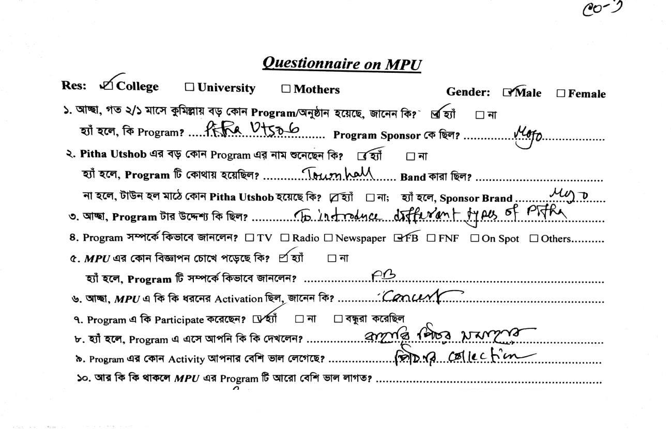
Sample Questionnaire

3.2 MOJO (A CSD product of AFBL)

Since the establishment of the brand MOJO, it’s creating the concept of enjoyment while drinking MOJO. Very specifically the MOJO is a brand of fun and enjoyment. The brand MOJO was launched in 14th April (Pohela Boishak), which is the first day of the year as per Bangla calendar.

In every year at this day they celebrate with different types of activities and programs. In 2018, they will organize a grand celebration for the purpose of MOJO. MOJO, it’s a carbonated soft drinks for all but the communication theme is targeted for the youth group. The communicational theme of MOJO is “ONTOR IS ON”. But, they were started with the tagline was “ONTORE ONTORE – IT’S INSIDE U”.

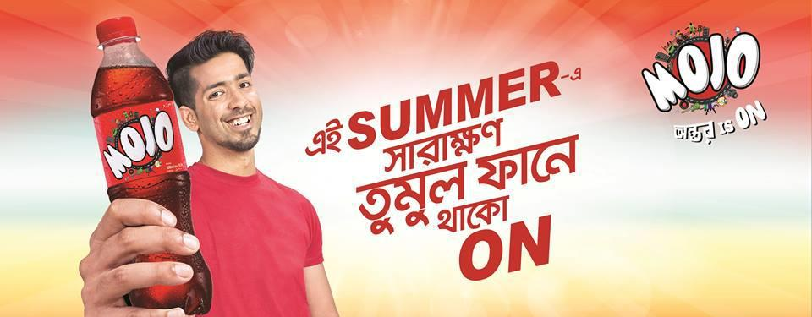

Image 01: MOJO Digital Promotion on Facebook

3.3 Marriage between Porter’s five forces and AFBL

Michael Porter has identified five forces that determine the intrinsic long run attractiveness of a market or market segment: industry competitors, potential entrants, substitutes, buyers and suppliers. AFBL uses Porter’s five forces model to identifying the position of MOJO. His model is shown in below –

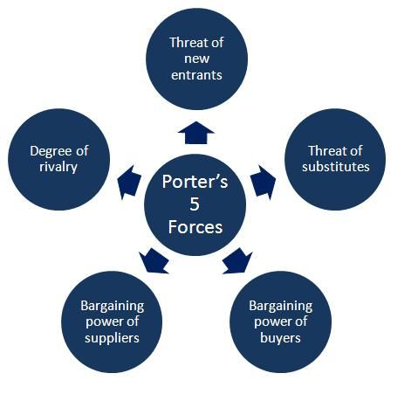

Threat of New Entrants: Low Pressure

The most attractiveness segment is one in which entry barriers are high and exit barriers are low. Few new firms can enter the industry and poor performing firms can easily exit. Entry barriers are relatively low for the beverage industry. There is no consumer switching cost and zero capital requirements. MOJO is seen not only as a beverage item, but also as a brand. It has held a very significant market share within a short time and loyal customers are not very likely to try a new brand.

Threat of Substitute Products: Medium to High Pressure

A Segment is unattractive when there are actual or potential substitutes for the product. Substitutes place a limit on prices and on profits. There are many kinds of energy drinks (Speed/Tiger/Black Horse/Power/Red bull), juice (Pran Frooto, Frutika) products are available in the market as substitute product. MOJO doesn’t really have an entirely unique flavor. In a blind taste test, it is really tough one for people to identify the difference among Coke, MOJO, and Pepsi. Here, the substitutes play a big role to become a threat for MOJO.

The Bargaining Power of Buyers: Low Pressure

A segment is unattractive if buyers possess strong or growing bargaining power. Buyers bargaining power grow when they become more concentrated or organized, when the product represents a significant fraction of the buyers costs, when the product is undifferentiated, when buyers switching costs are low, when buyers are price sensitive because of low profits or when they can integrate upstream. If we consider “MOJO” we can observe that they are price sensitive and buyers have no require for bargaining. As a result, there is less bargaining tendency of the buyers.

The Bargaining Power of Suppliers: High Pressure

A segment is unattractive if the company’s suppliers are able to raise prices or reduce quantity supplied. The main ingredients for soft drink include carbonated water, phosphoric acid, refined sugar, and caffeine. The suppliers are not concentrated or differentiated. Considering “MOJO”, AFBL works with Switzerland based suppliers. So, if the supplier poses high demand in future then it is becoming a challenging issue for MOJO.

Rivalry among existing Firms: High Pressure

A segment is unattractive if it already contains numerous of strong, aggressive competitors. It is even more unattractive if it is stable or declining. Currently, the main competitor is Coke and Pepsi. Both Coke and Pepsi are the predominant carbonated beverages and committed heavily to sponsoring outdoor events and activities. That’s why those are become a strong threat for MOJO because they established a strong position in market.

3.4 Findings the Strength, Weakness, Opportunities, and Threat

SWOT analysis involves the finding of a firm’s strength, weakness opportunities, and threats. It helps to evaluate firm’s strategies to exploit its competitive advantages or defend against its weakness. Strength and weakness involve identifying the firm’s internal abilities or lack thereof. Opportunities and threat includes external situation such as competitive forces discovery and development of new technologies, government regulations and domestic and international economic trends. AFBL create a SWOT analysis for MOJO to know their position in the market. The SWOT analysis is given below:

Strength

- Available distribution of 250 ml pet bottle.
- Competitive price.
- Good market share.
- Strong advertisement.

Weakness

- Lack of branded fridge in market.
- No regular glass bottle.
- Brand acceptability.
- Less number of product visibilities at outlets

Opportunities

- Tag with Hotel, restaurant, and cafeteria.
- Increase brand image and acceptability.
- Focus on higher SKU.

Threat

- Retailer based activation by competitor.
- Increase RGB consumption.
- Coke offerings.
- Threat of substitute product like sports drink, energy drinks, and juice.

3.5 MOJO VS. Competitors (COLA category)

As it is already mentioned that MOJO cola has a good brand image in the local market and also they have chosen young aged people for their target market. So, the competition is increasing day by day. In Bangladesh, MOJO has to compete with international brands as well as local brands. The Coca-Cola Company is one of the largest manufacturers, distributors and marketers of non-alcoholic beverage in the world as well as Pepsi. In the local market, MOJO have to compete with some other products like RC Cola, Maxx Cola, and Uro Cola.

But these local brands still are not as much popular as Mojo has achieved in few years. The beverage market is basically a compilation of wide range of mineral products with certain attributed affixed with it. If consumers are familiar with the attributes of a product, they will be less likely to rely on brand image as one of the extrinsic cue on what consumers usually depend.

Sometimes soft drinks companies try to introduce new attributes by changing taste, color, or packing. But it does not seem that always new attributes can attract consumers mind. For example, when Pepsi Company introduced Blue Pepsi in Bangladesh market, consumers did not like the flavor/ taste. That means, sometimes consumers prefer the old attributes of the product with which they are habituated. In Bangladesh, soft drinks industry follows some innovative, strong and continuous improving production and marketing technique.

Although quality is not the prime concern of our people, they mainly prefer cost effective soft drinks. The local companies (MOJO, RC COLA, MAXX COLA, and URO COLA) are competing with global brands (COCA COLA, PEPSI) on the basis of lower cost. They are capturing the urban markets by offering some innovative marketing plan and offer. In rural areas they are very strong in distribution strategy and price effectiveness.

3.6 Segmentation, Targeting and Positioning

3.6.1 Segmentation strategy

At present, market is not a single homogenous group. Mass markets are breaking up into dozens of mini markets each with its own special needs. Market segmentation is a technique based on the recognition that every market consists of potential buyers with different needs and different buying behavior. Akij food and beverage has segmented according to the homogenous segmentation where the consumer represents the same type of demographical, psycho graphical, cultural and social factors. Their attitude, status, and lifestyle focuses on same perspective. According to the following factors the segmentation of MOJO has been done-

- Age: Primary target of MOJO is only the young generation where the age mayvary from 15-30. But it is not limited within this age. It has also spread out among the children noticeably as well as the people below 40 years.

- Gender: Both young boys and girls are the target market for the MOJO. It isnot specially made for any particular gender what actually happens for any type of cola drink.

- Occupation: Occupation is not clearly defined for the target market of MOJO,however where the age varies within the young generation as well as children so it can easily be understood that most of them will be whether student or doing any job or business.

- Income: Actually MOJO has emphasized on the lifestyle and behavior ofconsumers more rather than the income. They think that it is really affordable to buy a MOJO (especially 250 ml) for their target market where their income is minimum 5000 and for the students it may be less than that.

- Lifestyle: The targeted market of MOJO is basically young generation wholike gossiping, chatting, hanging with friends, making fun, watching movies,

Listening music etc. MOJO has also focused on their customer’s lifestyle in product, advertising and packaging.

- Location: Almost all the places of urban and rural area are under the MOJO’sdistribution. Especially in each and every part of the Dhaka, Chittagong, and Comilla MOJO is available. The company has emphasized on Dhaka where only more than half of total sales (58%) comes from Dhaka.

- Social Class: MOJO is targeted for the upper part of the lower class, middleclass, upper middle class, and lower part of the upper class of the society.

 |  | Geographic
Continent |  | Asia
Country |  | Bangladesh
City |  | Dhaka (Main Focus)
Size/Population |  | Approximately 16 core
 | Demographic
Gender |  | Male and Female
Age |  | Basically 15 – 30, below 40
Income |  | Minimum 5000
Occupation |  | Students, Businessman, Professionals
 | Psychographic
Social Class |  | Middle class, Upper middle class
 |  | Behavioral
User Status |  | Potential users, Regular users
Benefits |  | Better service and quality
Attitude toward product |  | Positive

Table 01: Segmentation Strategy

Marketing Mix of Akij Food and Beverage Ltd

3.7.1 Product

Akij Food and Beverage Ltd believe in providing optimum quality products to value its customers. All the high-tech machineries and factory site is established to enhance the capability to satisfy consumer needs in a profound quality processed manner. The product MOJO cola has come with the following variations in the market -

Product | Brand | Size
Cola | MOJO | 250 ml pet bottle
 |  | 250 ml CAN
 |  | 500 ml pet bottle
 |  | 1000 ml pet bottle
 |  | 2000 ml pet bottle

Table 02: Product Details of MOJO

The product MOJO cola first came with the various product sizes in the market like 250 ml bottle, 500 ml bottle, 1 liter, and 2 liter bottle. Although the company was launched with various sizes and quantities, now it is focusing more on 250 ml bottle and it is massively producing it. Thus, MOJO Cola has been made with a proper technology. So there is no chance to occur fluctuation in taste. The cola drinks contain a very strong taste which can compete with the market leader Coca- Cola as well as Pepsi. The following attributes helps a product to added extra value:

- Brand:

Mojo has a good brand image in local market. Immediately after the introduction of the brand it became very popular among its consumer because of the high quality and intensive distribution in every nook and corner of the country.

- Packaging:

The packaging of the product is very attractive because of its color combination which is majority red. AFBL is the first company to introduce full silver bottle packaging and this makes its product more attractive than other competition brands. The two most critical job of packaging are:
- Capture Attention: The colorful packaging catches the attention instantly.

- Convey Meaning:The colorful packaging convey the meaning that Mojo is ayouthful product.

- Serviceability: The service system is efficient, competent, and convenient. Theconsumers of MOJO deserve safe, refreshing and high-quality products, and MOJO works hard to meet the highest standards of product safety and quality. It is the goal to offer safe and refreshing beverages to all of the consumers around the country.

- Performance:Already shows good performance in the local market.

Price

The price of the product is very much affordable to the target market. The pricing policy of Mojo has been done very carefully. Mojo has many competitors (e.g. Coca Cola, Pepsi) in the market. The pricing of Mojo is discussed below:

 | Product | Brand | Size | Price
 | Cola | MOJO | ▪ 250 ml pet bottle | ▪ | BDT. 15
 |  |  | ▪ 250 ml CAN | ▪ | BDT. 25
 |  |  | ▪ 500 ml pet bottle | ▪ | BDT. 25
 |  |  | ▪ 1000 ml pet bottle | ▪ | BDT. 50
 |  |  | ▪ 2000 ml pet bottle | ▪ | BDT. 85

Table 03: Price category of MOJO

Place

Akij Food and Beverage Ltd considered having one of the best distribution channels around the country. This profound distribution channel was specially been made to make the beverage products available to the consumer in each and every part of Bangladesh. By inheriting the advantage, AFBL is able to use the wide network distribution channel to promote and provide its products in each and every niche across the country. The strongest point of MOJO is their intensive distribution channel. They make this thing possible because Akij Group of industries especially their beverage sector has a profound logistic and supply chain management system. So they can easily go to door to door of their target consumers. They believe that delivering products to consumer hands is not sufficient or convenient enough that is why for near future betterment they are trying to develop their distribution channel in such manner that they can easily make their potential customer in to actual customer. And we must say that the dealer of a particular territory is really expert and the do their job on the time. The graphical presentation of MOJO‟s distribution channel is shown below:



Factory

Warehouse

Dealers
Point

Retailers

Figure 03: Distribution Channels

The production of MOJO from AFBL‟s factory is stored in the warehouse. For Dhaka, the warehouse is at Panthapath (AFBL office). Then the distribution department at AFBL allocates the products to the dealers around the country. After the products are delivered from

The warehouse to the distribution point, the distributing companies accordingly distribute them among the retailers to be sold to the final consumer. Here, the distribution companies are individual entities who are considered to be the business partner of AFBL. AFBL has segmented the entire Bangladeshi market into 9 regions and 27 areas for its distribution purpose. This region and area are shown in below:

Region | Area
Dhaka South | Dhaka – 1, Dhaka – 3, Zinzira, Narayanganj
Dhaka North | Dhaka – 2, Dhaka – 4, Gazipur, Narshingdi
Mymensingh | Mymensingh, Tangail
Chittagong | Chittagong – 1, 2, 3
Comilla | Comilla, Chandpur, Noakhali
Sylhet | Sylhet, Moulavibazar
Jessore | Jessore, Khulna, Kustia
Barisal | Barisal, Faridpur
Bogra | Bogra, Rajshahi, Rangpur, Dinajpur

Table 04: Distribution Areas

Promotion

It is one of the important facts of a company which it has to nourish in a very proper way to achieve optimum outcome. AFBL values the importance of promotion, because it believes no matter how high quality, good taste, attractive packaging the product avails, it has to be properly communicated to the customer to pursue the final purchase. Here, the promotion of MOJO is designed for fun loving young adults. Both ATL (Above the Line: TV, Radio, Newspaper, Internet), and BTL (Below the Line: Sponsorship, Sales promotion, Direct Marketing) is using for promotional purpose. This type of promotion focuses on advertising to a large number of audiences. Promotional Activities:

- MOJO Pitha Utsob.

- MOJO Pohela Baishakh.

- MOJO Ticket is on.

- MOJO Intra University Football.

- MOJO Utvot Offer.

- MOJO Humbaa in on

- MOJO Ontor is on (Thematic campaign).

- MOJO Notun Jama Offer.

- MOJO Car Tumi Kar.

- MOJO FM Dosti
- Ontorer Daak

- My life, My Mojo (Thematic campaign)
To promote MOJO, AFBL has most two recent activities which has very much responsive feedback from the audience side. “ONTORER DAAK” and “My LIFE, MY MOJO” are the recent activities tagline.

“ONTORER DAAK” came up on the valentine day in 2018 to celebrate the day of love.


Image 02: ONTORER DAAK

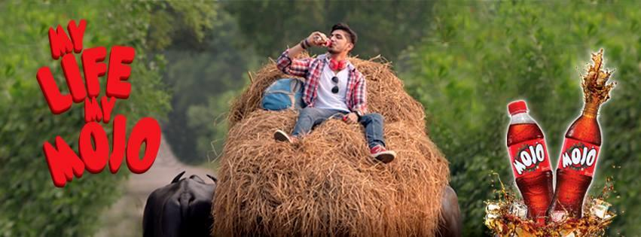

Image 03: MY LIFE, MY MOJO

3.8 Promotional Strategies

MOJO started campaign of their cola drink through fun and entertaining communications. “ONTORE ONTORE” was the first tagline of MOJO. Now the tagline is “ONTOR IS ON”. It grabs its market share within a few years. It also created a lot of attention among people. Coke is the market leader of cola industry in Bangladesh. When you are competing with a market leader, you should have a very strong promotional strategy. You also need to focus on your budget and try to increase your brand equity. The promotional strategy of MOJO in shown below:

- Advertising

AFBL has done their researches before advertising. For example: Sampling Test, Product development, Focused group discussion. They also use task objective method for determining advertising budget such as they determine advertising budget to reach the specific goals they have outlined for the advertising campaign. As already MOJO create a positive brand image in youths mind so their advertising campaign strategies call for heavy spending upfront in order to win long-term customers. For any kind of advertising issue Adcomm Ltd.; Grey and Addon (Agency) works with AFBL. For any promotional campaign of MOJO, AFBL generally use three types of advertisement tools.

- Newspaper Advertisement:MOJO uses different newspaper of Bangladesh topromote any kind of promotional campaign or activities.

- Billboard Advertisement: To reach their consumers they use billboard in differentroads of Bangladesh.

- Electronic media Advertisement:MOJO uses different Bangladeshi televisionchannels like Ntv, Rtv, Banglavision, Baishakhi TV, Channel I etc. to promote their campaign.

In 2015, MOJO cola gave a funny ad (Bamboo is on) in almost every Bangladeshi channel and the purpose was Bangladesh VS India One day cricket 2015 Series. As MOJO’s target customer is young aged people, so they have running a program named MOJO FM DOSTI at DHAKA FM 90.4. This is a popular program and MOJO grab the attention of young generation in an easy way.

- Direct marketing

As it is the era of internet, Mojo manages gave special importance to promote the campaign through their Facebook page (@mojomasti), YouTube, and their official website.

- Sales promotion

Different companies use different method to promote their product. Mojo make sales promotion by different types of sampling and point of purchase display to promote their product. For example: To promote “MOJO UTVOT OFFER” campaign, Mojo visit all the main roads across Bangladesh with 3 camels for sales promotion. Also MOJO successfully launched different project based marketing promotions. For example the campaigns like MOJO: Eider Chand Offer, Bucher offer, Big Bat Wish etc made a great and positive impression on public for MOJO. Local customers welcomed these types of innovative marketing ideas.

3.9 Social media Promotion

In the survey show that internet user of school going 48%, college going are 59% & university going 68%. So the mojo targeted group are youth, teenage who are always use the internet and use social media. So the brand planner are now changes their IMC activity. They are interested to more connect to engage with social media then traditional media. Because the targeted group are highly internet oriented.

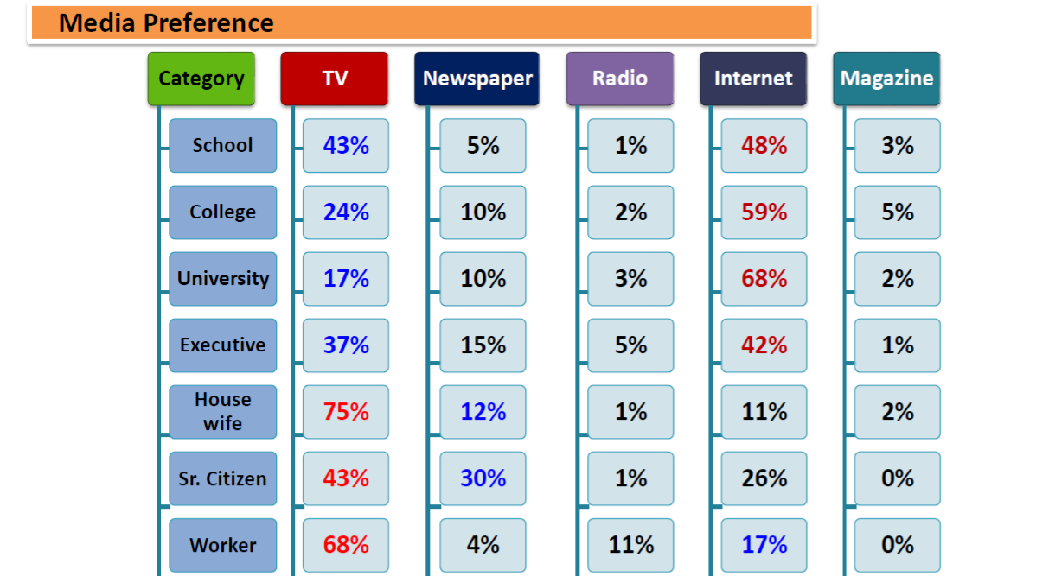

Now days mojo most program actively done in social media. Now day’s lots of campaign do in social media. Mojo fan pages total liked member is 377,484 and the follower is 3, 81,007. This member are directly involve with mojo. So when mojo post a photo, video or any announcement all the liker and follower will get the notification. This kind of involvement is directly happened with the consumer.
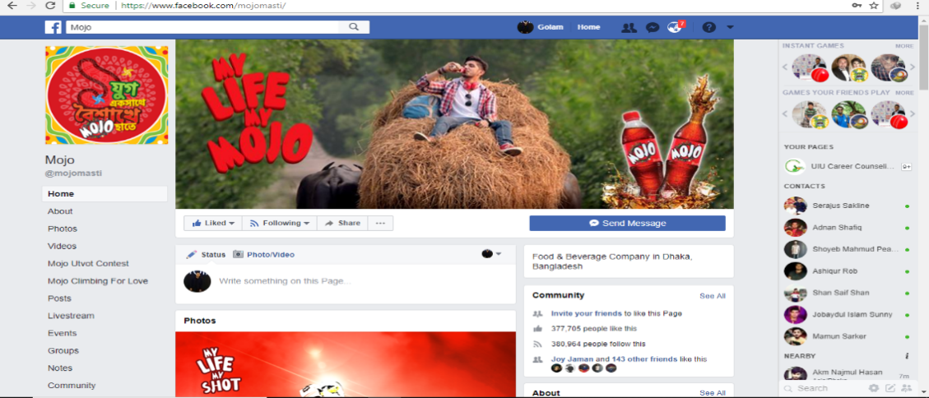

3.10 Recent Campaign on social Media through Facebook of MOJO
Recent Mojo done 3 campaign and all are directly involve with social media. One of the campaign “Mojo Ontorer Dak ”is only the social media based campaign. In the campaign. By this campaign consumer enwove with it directly. It was a contest also. Because here the participant mention their favorite person call by their own giving name. The best name will be win the contest. Lots of people are participate with it.
Now Mojo keep the thematic campaign which name is my life my mojo. Which is major boost up in social media for promotion.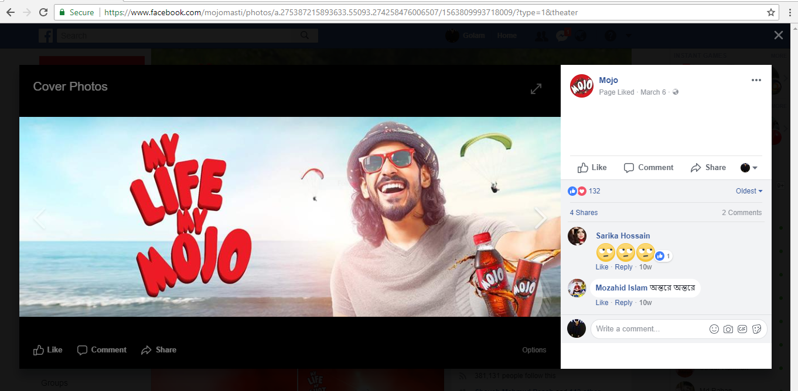
This thematic campaign mojo done by traditional media and also social media.
Ek Jug Ek Boishake mojo hate is one of anotherprogram which is busted by social media. 50k targeted consumer it reach by social media. They done a quiz contest through social media.
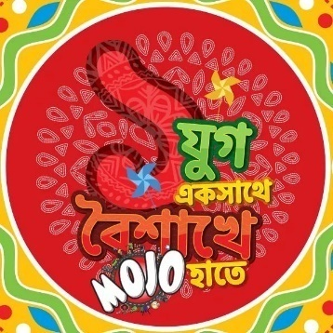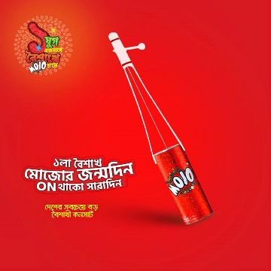
This is the mnemonic of baishaki program. They done quizcontest.

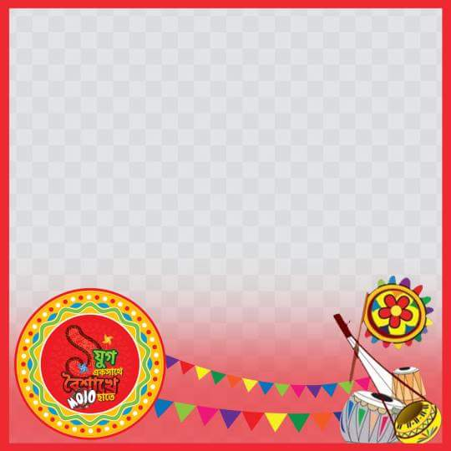

They did campaign which is change profile picture in Facebook wall. If The participate will win they can gift from mojo.
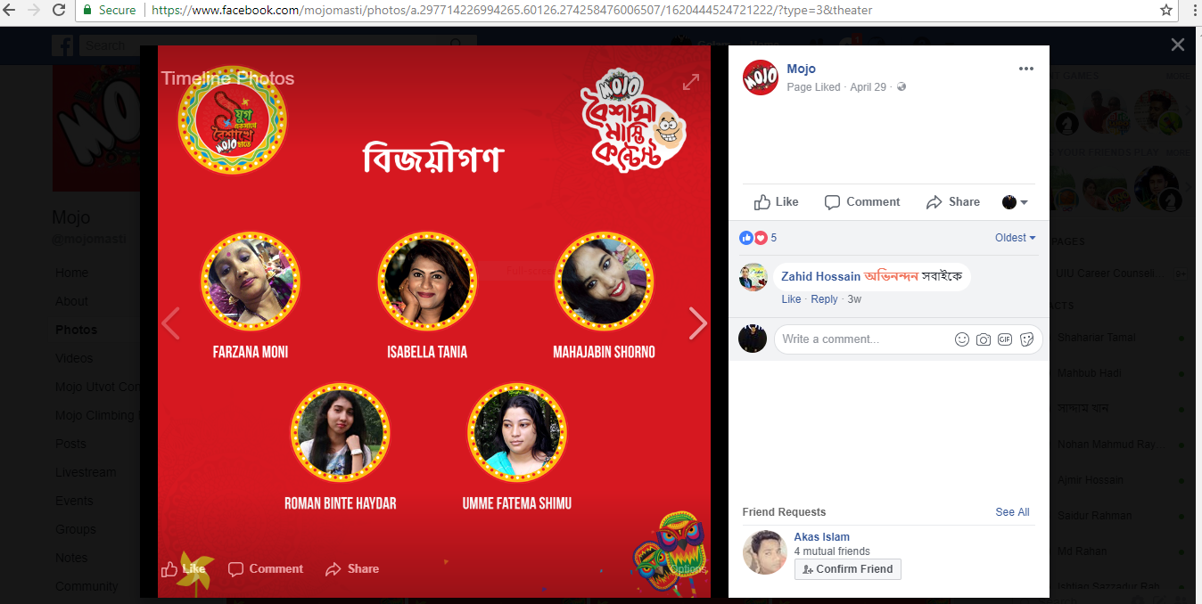

3.11 MOJO Pitha Utshob

Already we all get idea about the promotional strategy to promote MOJO. One of the most popular brand activities is MOJO Pitha Utshob. It started its journey 8 years before. This MOJO Pitha Utshob program come up to promote the cultural moral, value of own country.

I am covering the MOJO Pitha Utshob of Comilla. According the brand department they did miking, billboard, Digital media support, domestic press, National TV (NTV, RTV). Also they did celebrity endorsement to promote MOJO Pitha League. MOJO Pitha League is most popular segment at MOJO Pitha Utshob promotional activities.

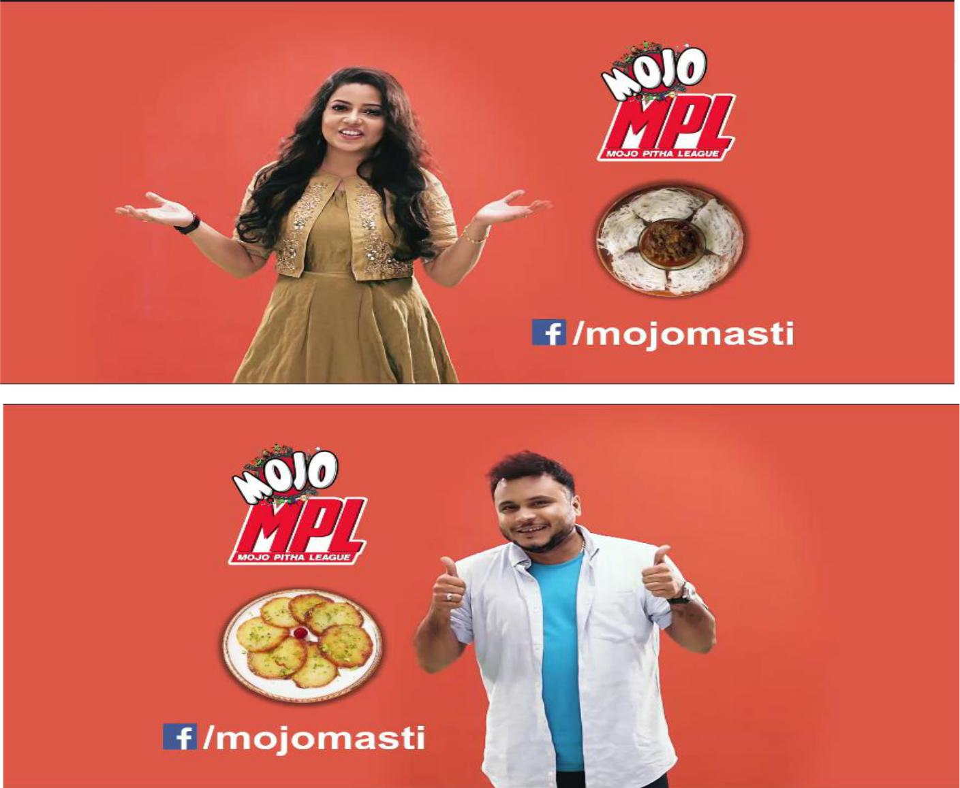

Image 04: Celebrity Endorsement

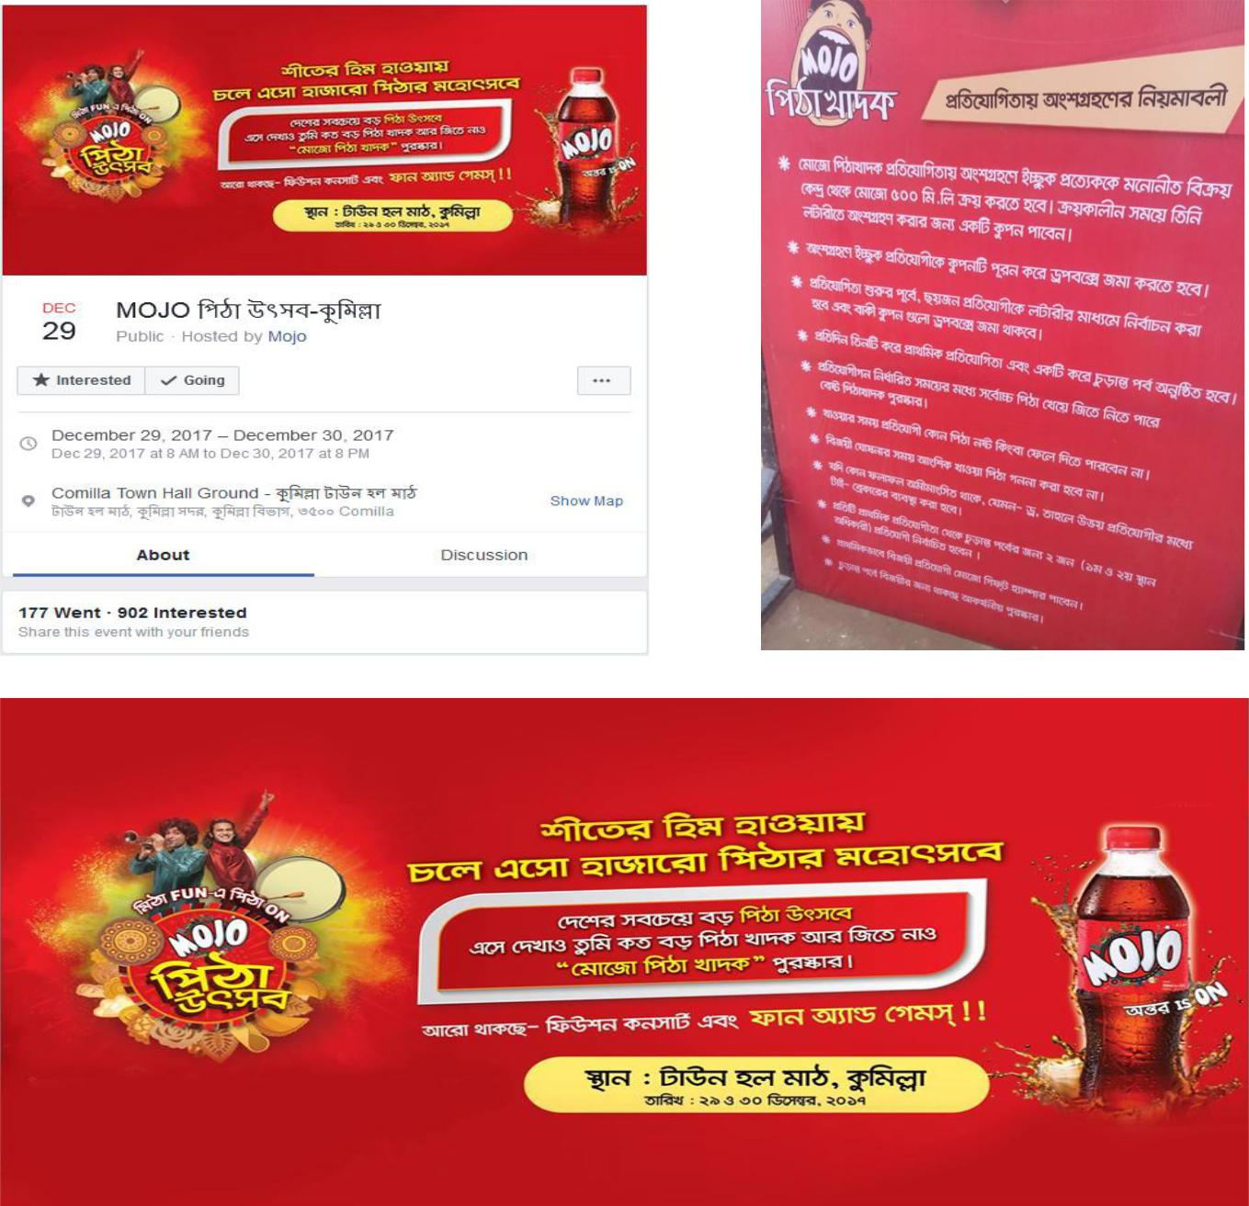

Image 05: Facebook Event Page and Poster at Comilla

Here is the Facebook event page. From this page they interact with the actual and potential audiences to promote the cultural heritage of Bangladesh.

3.12 Survey overview

MOJO Pitha Utsob is one of the most popular promotional activities of MOJO. In Comilla, MOJO Pitha Utsob held in 29th December, 2017 to 30th December, 2017 at Townhall field, Comilla. Basis on the topic MOJO promotional strategy helps to get the brand awareness. So, in this data analysis and findings part, I will try to show how much brand awareness created through promotional strategy. Besides I will show the consumers preferences and level of satisfaction in the MOJO Pitha Utsob.

All the survey data was collected to know the actual result on brand awareness of MOJO Pitha Utsob. MOJO Pitha Utsob held in different districts those are - Dhaka, Barisal, Comilla, Khulna, Rangpur, Rajshahi, and Chittagong.

So, I covered Comilla district for evaluating the brand awareness of MOJO Pitha Utshob. In the survey, my research and development team able to get 178 respondents randomly. Those respondents were from college, university students and mothers.

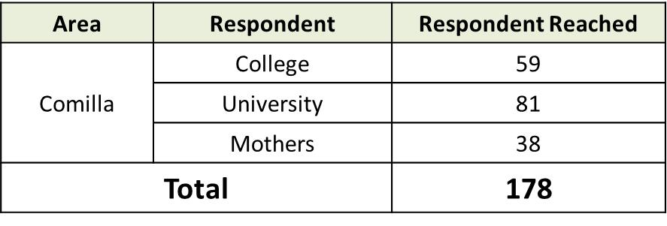

Table 05: Respondent reached

In the above table we can see the total number of respondent we reached in the survey time. But, not everyone known about the MOJO Pitha Utshob promotional activities. So, in the below table I will show the details about the respondents number of how many respondents were knew about the program.

3.13 Data Analysis

In this data analysis part, I will try to go into the depth of the survey to understand the brand awareness in Comilla through promotional activities.

Aware about the program
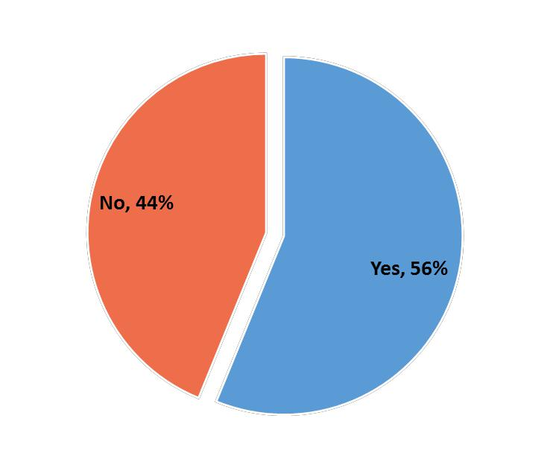

Figure 03: Aware about the program

In pie chart, we can see that the percentage of No is 44 and Yes is 56. This calculation indicates that among 178 respondents, 78 respondents were not aware of this kind of program. But, rest 100 respondents were aware of this MOJO Pitha Utsob promotional activities.

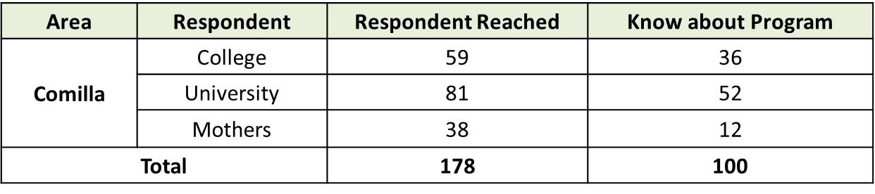

Table 06: Know about the program

Program name and Sponsorship
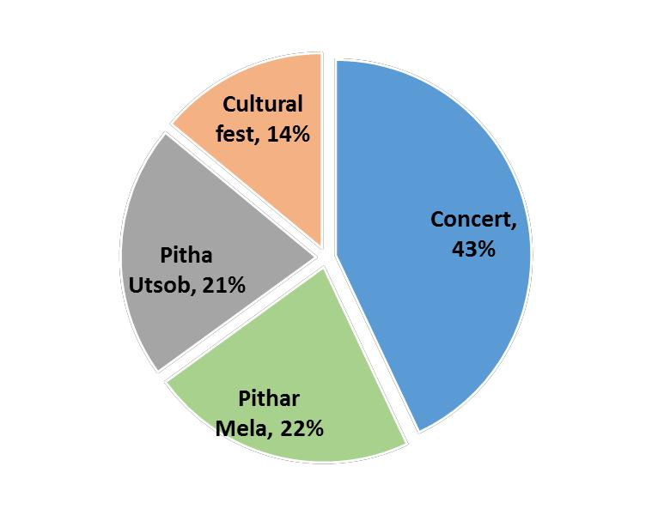

Figure 04: Program name

Through promotional activities, marketers always tries to expand the brand awareness through different types of strategies which increase the brand awareness and ensure the brand expansion. In the pie chart, we can see that there have some name which is provided by the respondents. Those names are – Cultural fest, Pitha Utsob, Pithar mela, Concert.

So, respondents were aware about these types of program. Among the 100 respondents 14%, 21%, 22% and 43% respectively said for Cultural fest, Pitha Utsob, Pithar Mela and Concert.
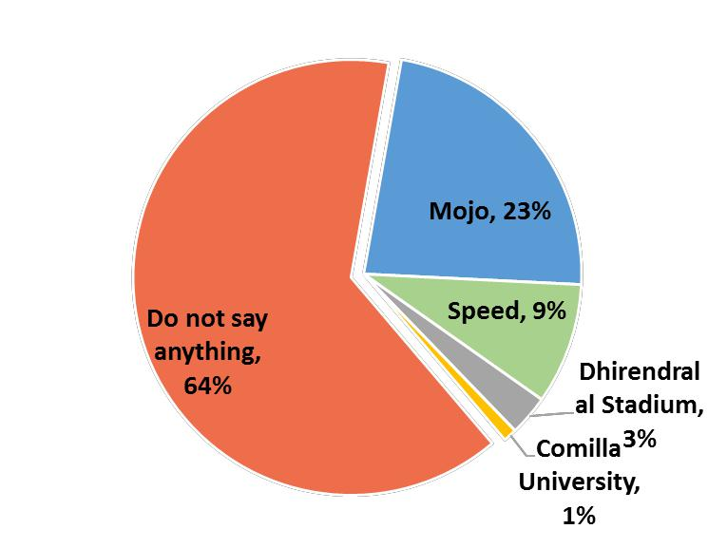

Figure 05: Sponsorship
When any kind of occasional event going to happen then there will be a sponsor to do the event successfully and promotes product of sponsored company. So, according to the survey,

R&D team asked to know about the sponsored company name who those are promoting the different types of event in Comilla.

As per the respondent’s response, 23% respondents could say MOJO, 9% was Speed, 3% was Dhirendralal Stadium and 1% was Comilla University.

So, MOJO and Speed is a very active brand in Comilla for sponsoring the different events.

But, there have some others who were sponsoring the Pitha Utsob and also concert. Those are

Comilla University and Dhirendralal stadium.

But, 64% respondents could not able to say about who were sponsoring the program or events.

3.13.3 Pitha Utsob Program

Pitha Utsob is a very popular event in winter season. This Pitha Utsob held in different places according to the respondent’s source.
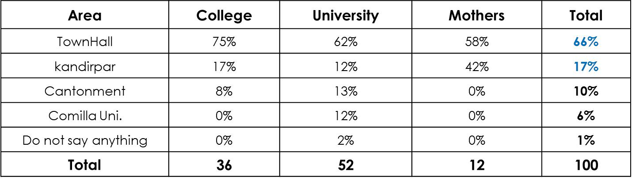

Table 07: Held in different places
According to the table, Townhall and kandirpar both are same place but known as two different names. But, here need to put in different names because respondent said. Also, there have other places like Comilla cantonment, Comilla University.

Finally, here we can summarize that specifically in three place Pitha Utsob held.

Awareness about MOJO Pitha Utshob and Sponsorship
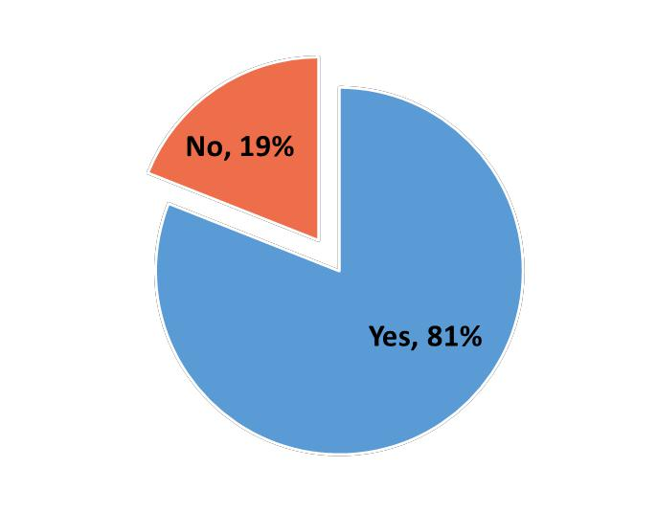

Figure 06: Awareness about MOJO Pitha Utshob

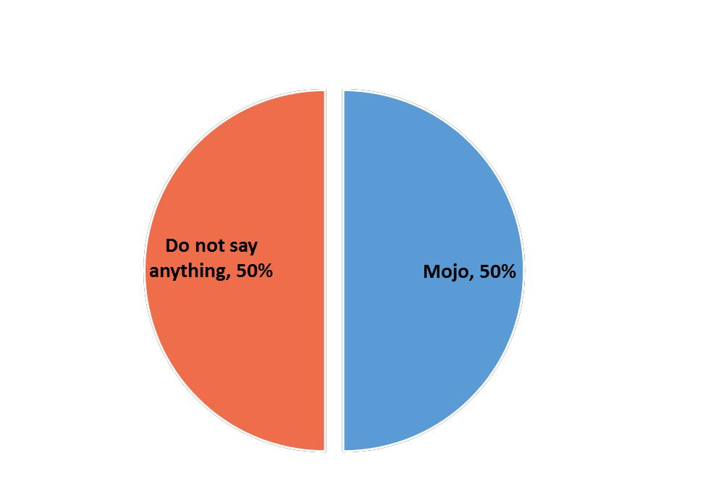
Recently MOJO Pitha Utsob held at Townhall, Comilla. Among actual 100 respondents, 81 people aware about the MOJO Pitha Utsob which indicates the 81% of total population. And, do not know about the MOJO Pitha Utsob program was 19 people of the total population.

Figure 07: Sponsorship of Program
In the above diagram, shows the awareness percentage of program sponsorship. In the questionnaire, there was a question to know about the sponsorship brand name or company. And as per the questionnaire, respondents replied 50% that they know about MOJO was sponsoring the MOJO Pitha Utshob at Townhall, Comilla. Also, 50% people were not aware who was sponsoring the MOJO Pitha Utsob at Townhall, Comilla.

Medium to know about the program
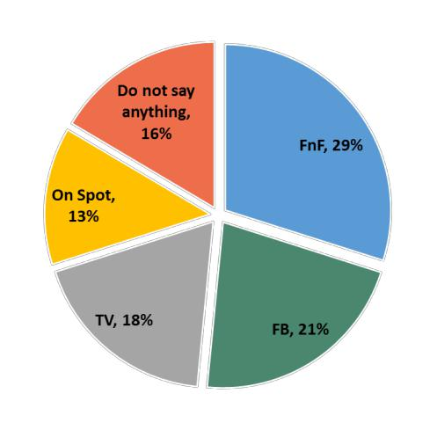

Figure 08: Medium

In survey there have a specific question to know more insight about the medium. The question was close ended and had some specific option to choose. In the end of survey, we able to get some insight about in which through the respondents were know about the program.

In the pie-chart, I will try to show the percentage how the respondents were aware about the program. So, through friends and family 29%, Facebook 21%, Television 18%, On spot 13%

. And 16% of the total respondents don’t say anything about how they know about the program.

80%
80% |  |  |  |  |  |  | 67%
60%
60% | 38% |  |  | 36%
40% |  |  |  | 36%
40% | 22% |  |  |  |  |  |  | 25% |  | 25%
 |  |  |  | 15% |  |  | 17% | 17%
20% |  |  |  |  |  |  | 17%
20% | 8% |  |  |  |  |  | 8% | 8% |  | 8%
0%
0% | FnF |  |  | FB |  |  | TV |  | On Spot | Do not say
 |  |  |  |  |  |  |  |  |  | anything
 |  |  | College |  |  |  | University |  | Mothers
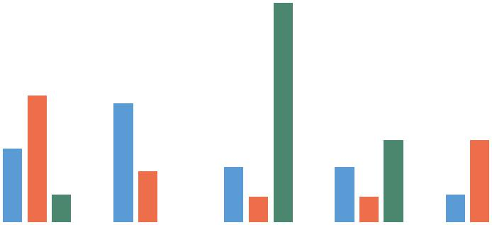
Figure 09: In bar chart (Details about medium)

The survey took place among college, university and mothers. So, in the graph, according to the respondents I showed the different medium. Through these medium they knew about the program

.

MOJO Pitha Utshob Advertising

Do not say
anything,
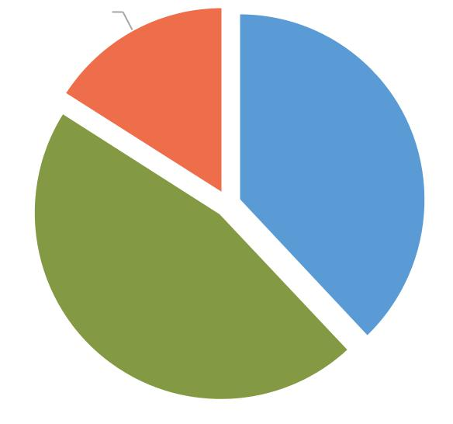
16%

Yes, 38%
No, 46%

Figure 10: Advertising

MOJO Pitha Utshob, it’s a most popular event for AFBL. For this MOJO advertising through different promotional strategies. According to the survey report, Yes is 38% and 46% is No. But, nothing say is 16%. So, according to the report, MPU advertising is not up to the mark.

Medium to know about MOJO Pitha Utshob
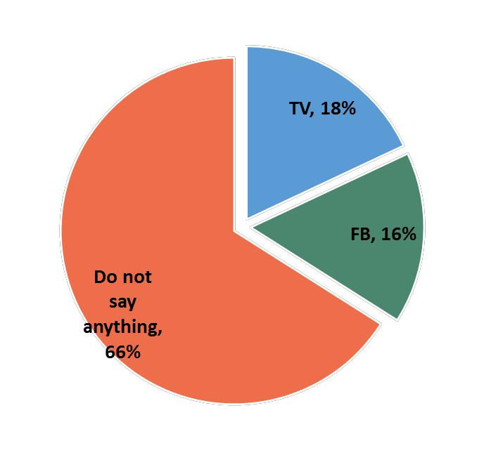

Figure 11: Medium (MPU)

MOJO Pitha Utsob is the biggest pitha utsob in Bangladesh. The MOJO team try to engage in different ways of medium with the customer or audiences. According to the respondents, they know about MOJO Pitha Utsob through Television and Facebook. The respective percentage is 18% and 16% among the total respondents.
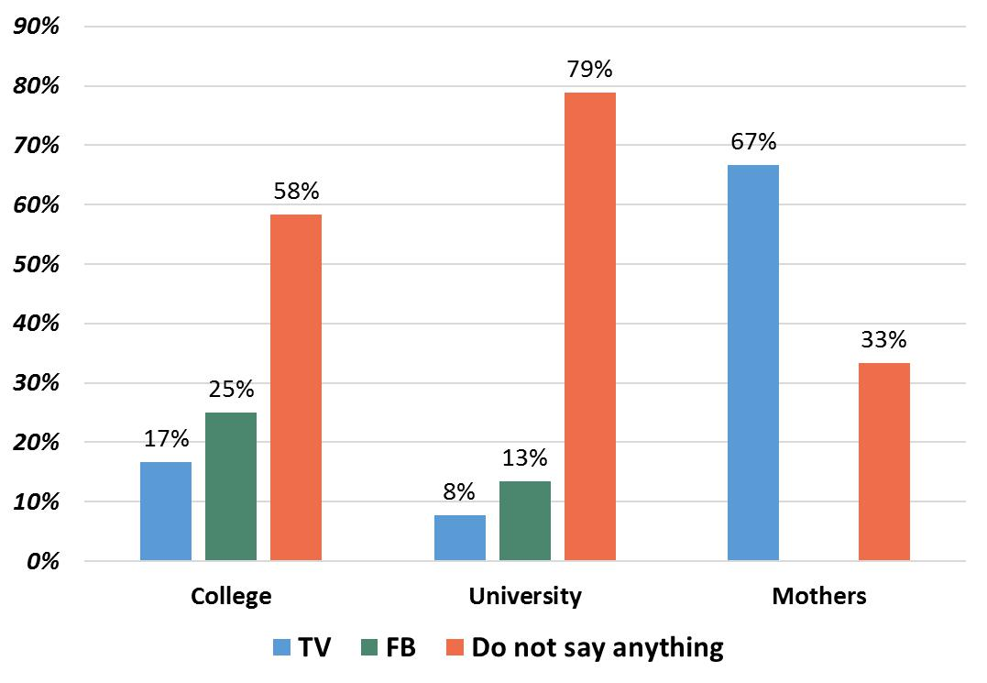

Figure 12: Medium (Bar chart)

Through bar chart I try to show the in depth of study where specifically shows the percentage among college, university and mothers respond.

Recall
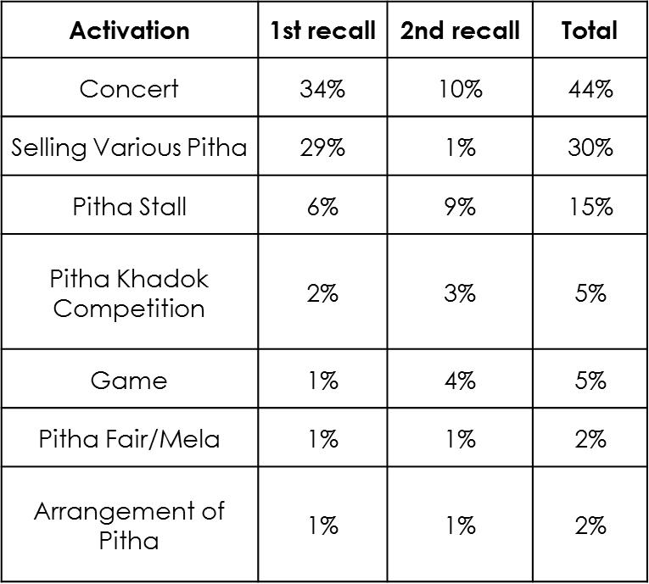

Table 07: Recall

In MOJO Pitha Utsob there had different types of activation program to engage the audience and make the utsob enjoyable. The survey is known as post-evaluation of the MOJO Pitha Utsob where research team finds the recalling status besides brand awareness of MOJO. In the table, there shows the details recalling percentage of different activations. Below, the recall table will be showed in bar chart to understand in better way.
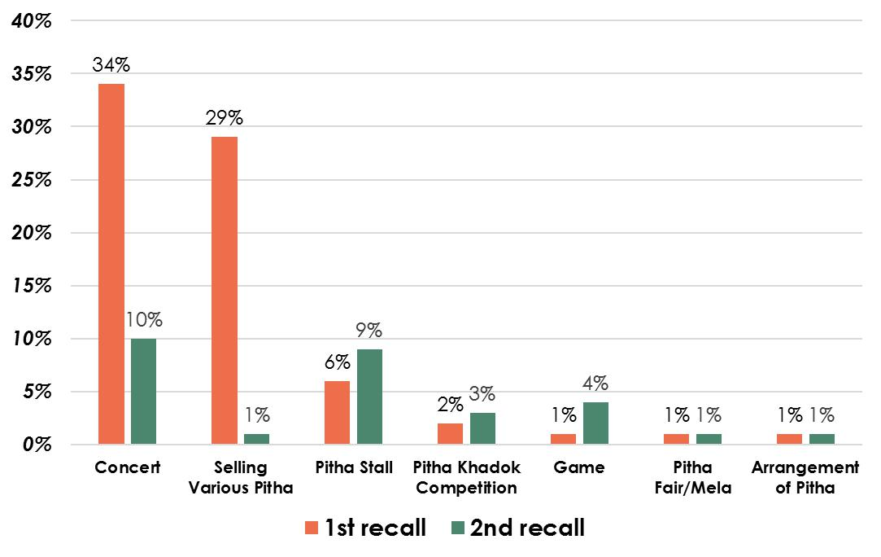

Insight of Audiences behavior

Audiences/Consumer’s Perception
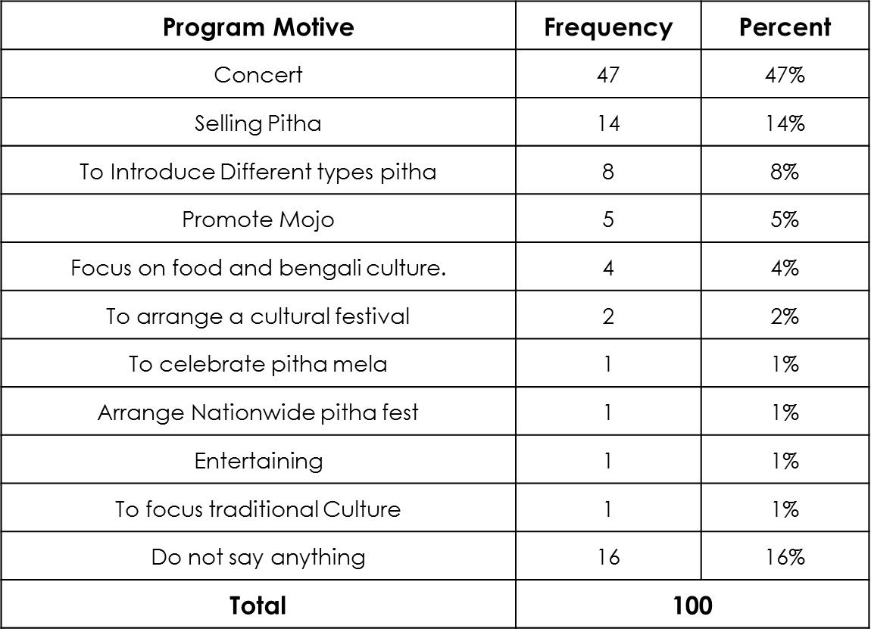

Table 08: Perception

MOJO Pitha Utsob had different types of activation program and audiences always have different perception about the MPU based on their interest. In the table, there have some perception identify according to the respondents response. Top most perception was concert, selling pitha and introducing different types of pitha and respectively the percentage was 47%, 14%, and 8%.

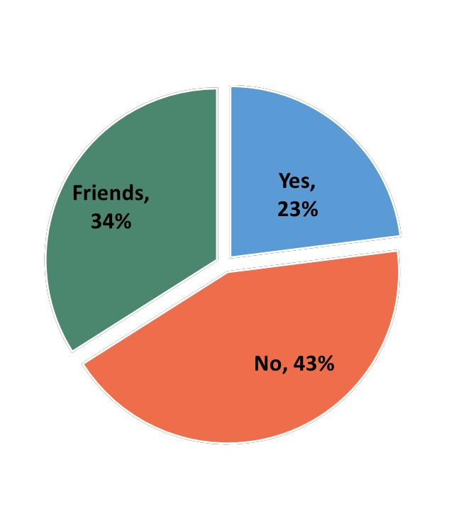
Participation in program

Figure 13: Participation

In the pitha utsob, most of the participants were friends in according to the percentage which is 34% and directly or indirectly was involved 23%. Rest of 43% were not participated in the program activation.

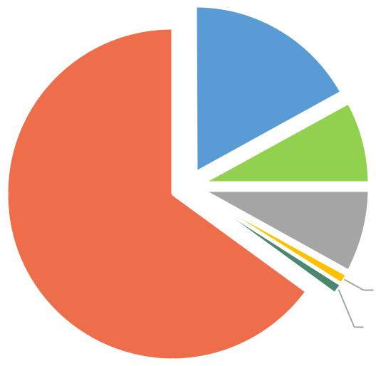
Concert,
_{17%} Different
types of
Pitha, 8%

Pitha
Fair/Mela,
1%

Figure 14: Involvement

Here is the involvement in the pitha utsob’s different activation programs.

3.11 Findings

After finishing the post evaluation research, Brand team summarize that brand awareness of social media MOJO in comilla increased than before. But, promotional strategy should more do in a better way to engage the target group. So Social media is perfect way.Beacuse by social media we can easily message our target group for our program.

Already we know about the promotional strategy instrument MOJO used in MOJO Pitha Utshob. From the respondents response, it indicates that 23% of the program in comilla sponsored by MOJO. And maximum of the different program held at Townhall. 81% of the respondents were aware about the MOJO Pitha Utshob program. Also, respondent said 50% of pitha utshob sponsored by MOJO.

According to the respondents, MOJO Pitha Utshob advertisement saw about 38% of the total population. Also among respondents, notified about the MOJO Pitha Utshob was 18% from Television and 16% from Facebook.

3.12 Limitations

There was several limitation to complete the report successfully. Some major limitations were unwillingness to response of questionnaire. Lack of communication between respondents and interviews. Also, there was lack of brand promotor. When it’s about promotional strategy then it was difficult to know about the promotional strategy. Because there was several restriction about sharing the brand promotional strategy information.

3.13 Conclusion

The soft drink producers in Bangladesh succeed mainly because of complying with the consumer’s purchasing power and delivering the message to the end users effectively. The cost sensitiveness of the local consumers makes a strong base of success for the local producers. The journey of MOJO Cola is almost 12 years and as a local brand it has to compete with some strong competitors like Coke and Pepsi. To survive in this red ocean of competition it has to be fulfilling the demand of its consumer. AFBL have to focus more on project based production process with regards to project based marketing activities. Truly they are very successful in this area. They are the most pioneer in this area.

3.14 Recommendations

After analyzing the promotional strategy of MOJO and post evaluation research to know about the brand awareness I should recommend these attempts should take in future to increase the brand awareness of MOJO and the consumer engagement through promotional strategy.

- Extend Program days.
- Need more variation in Pitha & more life on Facebook.
- May engage popular singer in concert & life through social media.

References

- Articles. (2015, July 10). Retrieved from https://jobs.telegraph.co.uk/:https://jobs.telegraph.co.uk/article/what-is-fmcg/
- Internship report. (n.d.). Retrieved from http://www.assignmentpoint.com/:http://www.assignmentpoint.com/business/marketing-business/marketing-activities-akij-food-beverage-limited.html
- Islam, D. N., & Habib, M. W. (2009). A MULTIVARIATE ANALYSIS OF THE SELECTION.
IV. Khaled, M. (2010). Increasing Brand Communication through Brand Visibility in Retail Outlets in Small Cities and Rural Areas of Bangladesh.
- Malik, P. D., & Ghafoor, M. M. (May 2013). Importance of Brand Awareness and Brand Loyalty in assessing Purchase. International Journal of Business and Social
VI. Md. Papon. (2015, April 30). Retrieved from https://issuu.com/:
https://issuu.com/md.papon/docs/competitive_analysis_in_it_business
VII. Md. Papon. (2015, 10 8). Retrieved from https://issuu.com/:
https://issuu.com/md.papon/docs/brief_overview_of_different_types_o
VIII. Morsalin, M. A. (2015, 3 28). Common Forum. Retrieved from
http://forum.daffodilvarsity.edu.bd:
http://forum.daffodilvarsity.edu.bd/index.php?topic=27754.0
IX. OJWANG, J. (2014). INFLUENCE OF PROMOTION STRATEGIES ON PERFORMANCE.
- Shojaee, S., & Azman, A. (November 2013). An Evaluation of Factors Affecting Brand Awareness.
XI. Sultana, S., & Khosru, K. H. (n.d.). Practice of using gifts as promotional materials for. Stamford Journal of Pharmaceutical Sciences.
XII. Till, B. D. (n.d.). Using celebrity endorsers effectively.
XIII. Udeshini Piratheepan, A. P. (2013). Impact of Promotional Strategies on Brand Awareness; a Study on Milk Powder Brands in Nuwaraeliya District. https://www.researc

Appendix

