Project Report

The Strategic Marketing Evaluation of
Chaldal.com

The Strategic Marketing of
Chaldal.com

Prepared For
Dr. Khandoker Mahmudur Rahman
Associate Professor
School of Business & Economics
United International University (UIU)

Prepared By
MD. Mahboob –A- Rabbani
ID -111 131 072
School of Business & Economics
United International University

April 18, 2019
Letter of Transmittal
April 18, 2019

Dr. Khandoker Mahmudur Rahman
Associate Professor
School of Business and Economics
United International University

Subject: Submission of the Report on Chaldal.com

Dear Sir:

I would like to
I would like to submit my internship report titled “The Strategic Marketing of Chaldal.com”, which has been prepared as a requirement for the completion of the BBA Program of United International University.
Chaldal.com started their journey in November as an online grocery store with a thinking of saving money and time. With that thinking till now they managed to save 114,876,820 BDT and 1,013,619 hrs.
I have followed each and every guideline that you provided in the competition of this report. Though I haven’t gone through internship, but I gathered enough knowledge about how an online grocery shop runs their activity to follow their dream. Working on their overall activities was enjoyable for me.
Sincerely,
MD. Mahboob–A-Rabbani
ID No: 111 131 072
ACKNOWLEDGEMENT

All praise to Allah, the almighty, and the merciful. Without his blessing and endorsement this report would not have been accomplished. Then I would like to thank my project Supervisor, Dr. Khandoker Mahmudur Rahman who has helped me in completing the report. I have collected essential information’s from several WebPages, and I would like to thank support manager MD. Sahadat Islam for his support. I hope that the dynamic managerial activity of chaldal.com could be anyone’s inspiration.
I also want to thank Mr. Kaiyum Hossain for his each and every email reply, which helped me a lot to clarify all of the confusions regarding this report. I prepared this report from my own point of view and findings. Then finally I should thank to all those people who is going to read this report and who will be benefited in future.

DECLARATION

I am MD. Mahboob –A- Rabbani, student of School of Business and Economics (Marketing) of United International University, Bangladesh, do hereby declare that the internship Repot on “Marketing Strategy on chaldal.com” is an original work and has not been previously submitted for any degree, diploma, title, or recognition.

________________
MD. Mahboob –A- Rabbani
ID No: 111 131 072
School of Business and Economics
United International University

Table of Contents

Table of Contents
1. BACKGROUND OF THE PROBLEM 10
1.1. Introduction: 10
1.2. Topic of the report: 11
1.3. Origin of the report: 11
1.4. Background of the report: 11
1.5. Objective of the report 11
1.5.1. General objective: 11
1.5.2. Broad objective: 12
1.5.3. Specific objective: 12
1.6. Scope of the report: 13
1.7. Methodology of the report: 13
1.7.1. Primary sources: 13
1.7.2. Secondary sources: 13
1.8. Limitations: 14
2. Organization part: 14
2.1. Overview of the organization: 14
2.2. www.chaldal.com: 15
2.3. Products of chaldal.com: 17
2.4. Target customers: 20
2.5. Delivery area: 22
2.6. Customer’s information: 23
2.7. Competitors of chaldal.com: 23
2.7.1. meenaclick.com: 23
2.7.2. shaksobji.com: 24
2.7.3. othoba.com: 24
2.7.4. Daraz.com: 24
2.7.5. shwapno.com: 25
2.7.6. khaasfood.com: 25
2.7.7. sbazaar.com.bd: 25
2.8. Comparison of Direct Fresh with others: 26
3. Organization part: 27
3.1. Situation analysis: 27
3.1.1. Porter’s five forces 27
3.2. Threat of new entrants: 27
3.3. Brand loyalty: 28
3.4. Capital requirements: 29
3.5. Government regulations: 29
3.6. Economies of scale: 29
3.7. Customer switching cost: 30
3.8. Rivalry among established companies: 30
3.9. Demand conditions: 30
3.10. Exit barriers: 31
3.11. Buyer’s power: 32
3.12. Supplier’s power: 33
3.13. Threat of substitute products: 33
3.14. SWOT analysis: 34
3.14.1. Strengths: 34
3.14.2. Weaknesses: 35
3.14.3. Opportunities: 35
3.14.4. Threats: 35
3.15. Marketing mix: 36
3.15.1. Product: 36
3.15.2. Price: 37
3.15.3. Distribution Strategy: 40
3.15.4. Promotional strategy of chaldal.com: 41
3.15.5. Sales Promotion: Sales promotion includes: 41
3.15.6. Publicity: 41
3.17. Analysis of customer satisfaction: 42
3.18. Efficiency of webpage: 42
3.19. Efficiency of App: 43
3.20. Payment System: 44
3.21. Product availability: 45
3.22. Product information on webpage: 45
3.23. Recipes: 46
3.24. Refund Policy: 46
4. Findings: 46
4.1. Limitations: 49
5. Recommendations, conclusion & references: 50
5.1. Recommendations: 50
5.2. Conclusion: 51
5.3. References: 51
APPENDIX: 53
Questionnaire survey: 53

Executive Summary

Chaldal.com has been established in 2013. The aim is to save money and save time. They do believe that time is so much valuable to Dhaka residents. And wasting that time in traffic and other hassle to just buy some groceries is not an effective thing. That is why chaldal.com started this online platform with a thinking of reaching consumers doorstep with their ordered groceries.

In order to survive, we all have to do shopping of groceries and vegetables. But sometime doing this may become disgusting, when you need to go out from your comfort zone. Imagine after a busy weekend you are thinking of sleeping for late morning, but all of that planning becomes wasted, when you need to get early and go to market. Here chaldal.com is taking a step for you, just order whatever grocery you need, and have that on your doorstep.

Chaldal.com has some strong point for what till now they are leading in the market but still they have some weak point also. As there are many competitors now, which is a threat for them, but still they have plenty of opportunities to go further. Though there are other competitors available in the market but chaldal.com has made their position in consumers mind. There interactive webpage and App for mobile platform is attracting consumers mostly. The way they are promoting and committing is a unique selling proposition. While discussing the marketing strategy I have used the porter’s five force model, SWOT analysis, marketing 4 p’s, product life cycle, promotion strategy, distribution strategy, finding and analysis, recommendations and conclusion.

BACKGROUND OF THE PROBLEM

Introduction:

Nothing remains dynamic now a day. And in business also, today a business holding the top most position doesn’t ensure that in future where it will be, they can hope but they can’t give any surety. Consumer’s choice, taste, preference etc is always changing, and based on that company needs to modify their strategy.

Chaldal.com is the first online based grocery shop successfully got the place in consumers mind. On that time thinking about buying vegetables online was unimaginable. But now there are many more strong competitors. Even Meenabazaar do have their own webpage. Shwapno and Meenabazaar achieved their position way before the thinking of chaldal.com raised. But in terms of online shopping, chaldal.com got the advantage.







And the marketing strategy of chaldal.com is the main strong point of them. Their webpage and app amazes us all. Free subscription to up-to-date price list, offering, mobile message and email marketing help them a lot in keeping good contact with consumers.
This study is focusing on the strategic marketing plan of chaldal.com. It has become one of the popular brands in Bangladesh and trying to capture major market share. Till now their achievement:




Topic of the report:
It is important to select a topic for this report. A well-defined topic reveals what readers can expect from this report. The topic has been assigned “The Marketing Strategy of chaldal.com”.

Origin of the report:
In today’s world students learning is more related to academic education, which is not enough to give a tough competition in real world with outside knowledge. Through completing this report I came to know how a company can bring up with a new idea, and can fulfill the current market need with a strategy that satisfies the organizational goal.

Background of the report:
To complete the degree and exercise practical business activity preparing this report is necessary. Students study about the organization and its activity, learns about the function of that organization. This program enables a student to develop his analytical skill and scholastic attitude. For the completion of this report I have gone through many articles, web reports of chaldal.com. I have also contacted them to clear out some of my confusions. This report would be based on chaldal.com.

Objective of the report
While completing this report students get a chance of understanding the situation closely. To make a prosperous career, this activity is considered as a mandatory program for students. Throughout this program I came to know about following things:

General objective:
The general objective of this study is to complete the report. The report will help us to know the essential information’s which we want to know from the market. For completing this report creating objective is necessary. This objective will give us proper guideline in the competition of this report.
- As it is an online based business, so physically visiting it is not possible. So need to get enough information’s available on the internet to understand about their activity.
- To find the relationship between academic education and the real practical field.
- To have a closer view, that how things are being done in practical field. How leaders do compete in the market.
- To gather more knowledge about marketing field, which will help me to build my career in this field.

Broad objective:
The broad objective of this report is top analyze and understand the current market situation and marketing plan of “chaldal.com” to find out any sectors where concentration is necessary and what different promotional strategy could be followed.

Specific objective:
Specific objective needs to be set before completing a report. So I also determined some objectives for this report. The main objective is to analyze the marketing strategy of chaldal.com.
- To understand the current market;
- To compare their market situation based on market shares;
- Who are the competitors and what is their position in the market;
- What is the pricing policy needs to be find out;
- How different their distribution strategy than others;
- What are their target customers, and how do they target them;
- To know chaldal.com as whole;
- Which promotional strategy do they follow!
- What problems they are facing now!
- What could be the steps to solve those problems!
- Identifying different promotional activities that the company offers like: email marketing, text messaging marketing, google adsense, youtube advertising, discount, free delivery, coupon, incentives etc.
- Identifying the standardization of the product.

Scope of the report:
This report has been prepared after consulting with the support team of chaldal.com. While preparing this report, I had a great opportunity to have a deep idea about the marketing strategy of chaldal.com.

Methodology of the report:
For smooth and accurate study certain rules and regulations needs to be followed by everyone. The study inputs were collected from two sources:

Primary sources:
- Marketing activities
- Phone conversations
- Online chat support

Secondary sources:
- WebPages
- Other reports
- Article

Limitations:
While completing this report I faced certain limitations:
- Sources are not available
- As it is an online business, so physically observing the activities were difficult
- Online information’s couldn’t be verified
- Source to source information varies, which is a bit confusing

Organization part:

Overview of the organization:
This section includes vision, mission and organization chart of chaldal.com.

Save money, Save time.

The vision is to be the best online and offline grocery store and earn customer satisfaction.

Their mission is to have a resourceful stock of low priced quality product and deliver it within 1 hour by your door step.



www.chaldal.com:
Online shop or Ecommerce
Chaldal.com is an online shop in Dhaka, Bangladesh. They started their journey to save time and money of the Dhaka residents, which they are doing successfully.

They do believe that time is so important to Dhaka residents, which they shouldn’t be wasting in traffic for just to buy some daily groceries. To save that valuable time of every persons, chaldal.com delivers every day needs to their customers’ door-steps across Dhaka.

Chaldal.com is a work in progress and they hope that they will get better over time. As while starting their business they were only selling grocery items, now the list is just increasing day by day.

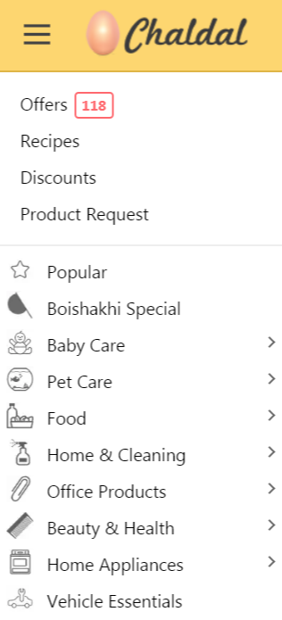

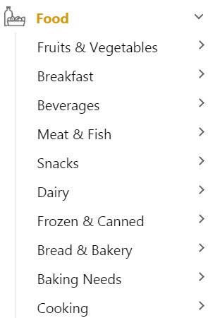





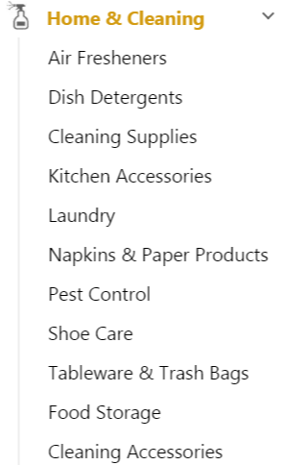



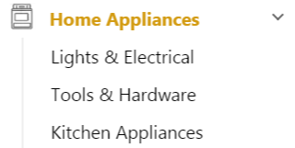

Products of chaldal.com:
Though chaldal.com is not the manufacturer or producer of these products, but they do sell varieties of product. Product category has been increased time to time, as they have started with some products focusing on a very niche market. They are specialized in delivering grocery items (vegetables) along with home and kitchen appliances. There are 9 different categories.
Chaldal.com claims that they have their own farm (leased by them), they do grow a big portion of their selling vegetables, where others are just buying them from the wholesale market.
They are charging only 20 taka on order of 300 BDT or more, and 40 taka for an order of less than 300 BDT.
Some of their products:
.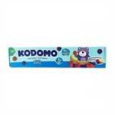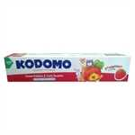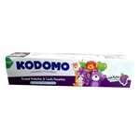

I don’t think all of the products could be added, as the numbers are huge.

Target customers:
Chaldal.com is targeting the residents of Dhaka. I don’t think people enjoy shopping of vegetables, especially from those areas, where the place remains crowd, no parking place, muddy road, needs to bargain a lot. So chaldal.com is targeting all of the peoples of Dhaka, to get their service, through which they can buy groceries from their home.
Firstly they started with vegetables, mutton and fish. Now there product category is mass. Still I don’t see any irrelevant product over there, which doesn’t suit. In future they are going to cover any product which might be needed in home and in corporate places.

In B2B business, they do offer free delivery. And special discount on bulk amount of order. Why corporate should choose chaldal.com!
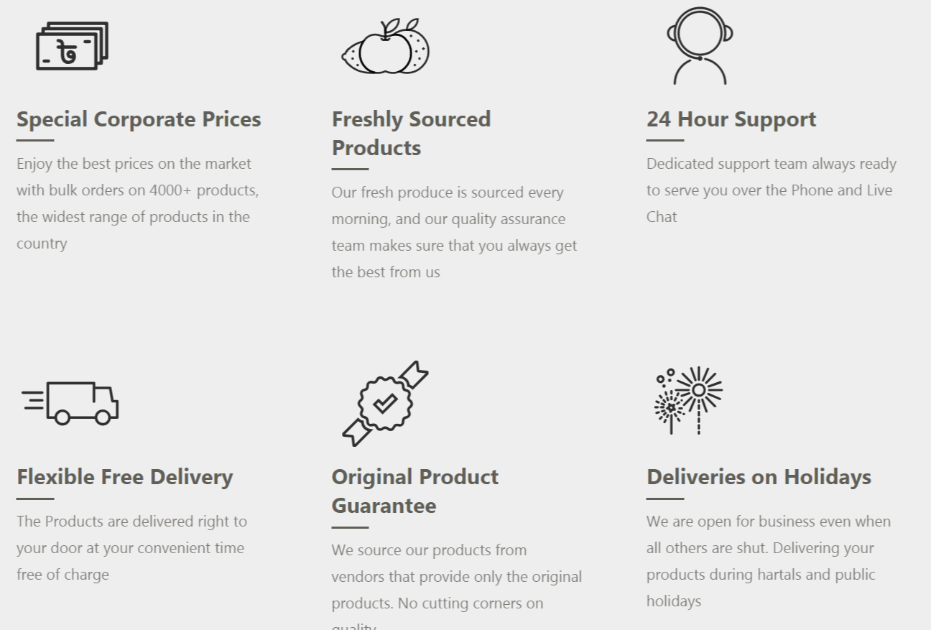

Their current clients:
- Golden Harvest
- Navana
- Navana Furniture
- Gsk
- AArong
- FoodPanda
- Best Western Plus
- Assurance Developments
- Sigma Group
- Ambala Inn
- Edison Group
- Lamudi
- German
- Goethe Institut
- Cosmos Group
- Sindabad.com
- Digicon
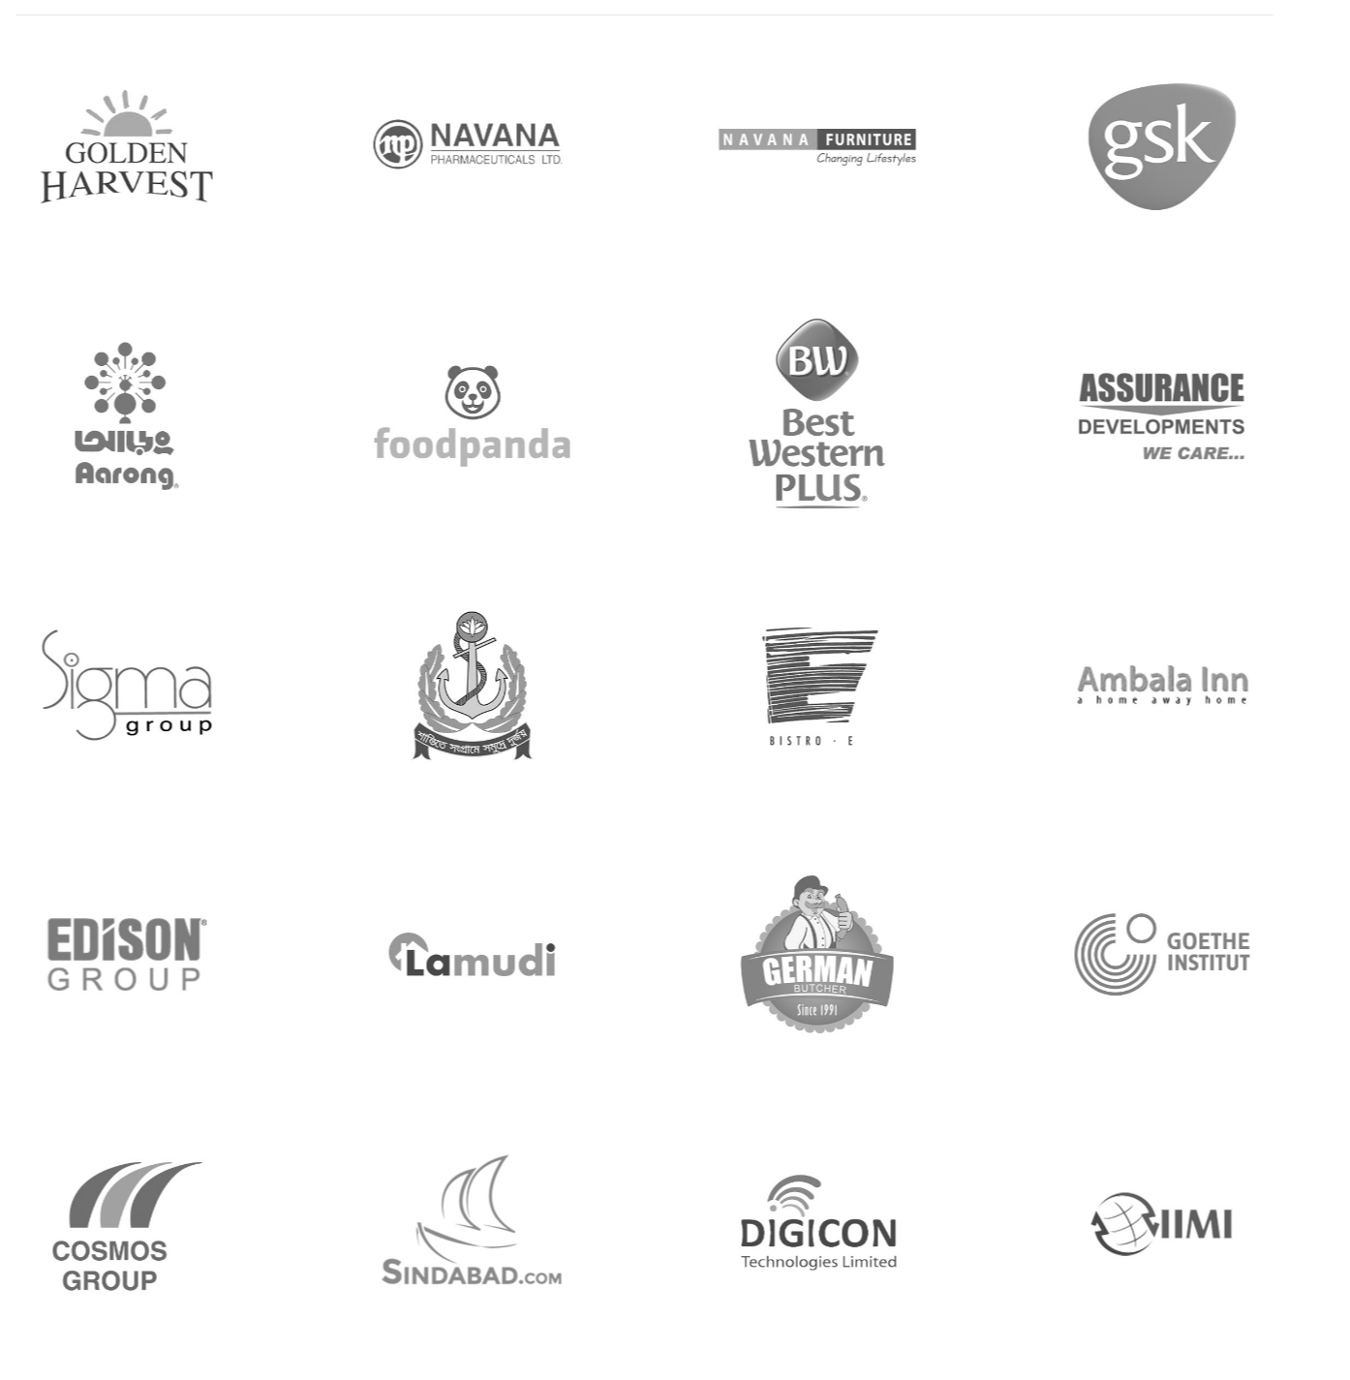

Delivery area:
Chaldal.com delivers product all over Dhaka, and they have a planning of soon taking Chittagong also on their coverage. The delivery charge is 20taka for ordering more than 300bdt products and 40 taka for ordering less than 300bdt products. They deliver from 8 am to 10 pm every day. But one can choose from available slots to find something that is convenient to him/her. A Chaldal representative will call him/her as soon as they are at customer’s house to let the customer know about his/her delivery. They also promoting by:

Customer’s information:
For an online shop, managing customer information is so important. As while registering chaldal.com gets all the essential information’s from their customers, still there resources grow day by day on your choosing, preferences, recommendations and orders.
Chaldal.com has a huge database of target customers also, whom they do text message with invitation coupon or free delivery of goods.
From my personal information I think their intelligent software does also track how much food my family is consuming, as on my regular purchasing, it comes to know how often, I am ordering what! And based on that information it is automatically prompting all of those groceries first, stock of which is coming to an end.

Competitors of chaldal.com:
Though while chaldal.com was starting, it haven’t faced any competition, but now there are many more competitors.

meenaclick.com:
- Reputed supermarket chain
- Superior customer support and value for money deals.

shaksobji.com:

Offering completely hassle-free shopping experience through secure and trusted gateways.

Shaksobji.com strongly believes in Best product, Best price and Best quality.

othoba.com:

They strive to utilize the power of the internet in its highest peak to fulfil the needs of your busy life

Daraz.com:

We have seen previously that Daraz was not interested in this sector, but now we can see that Daraz is also selling home appliances, remedies or groceries.

shwapno.com:

Motto: Everyday A Better Life

Largest grocery chain in Bangladesh

khaasfood.com:

Started journey on 2015

sbazaar.com.bd:



Comparison of chaldal.com with others:

There are some difference between chaldal.com and other brands:

Chaldal.com doesn’t have any physical store, which supposed to be a negative aspect, but it doesn’t. For this point chaldal.com comes first in terms of online shopping of groceries.

Comparing to other brand, they are fastest in terms of completing the delivery.

Comparing to others delivery rate is low.

The most interactive online shop webpage with fast online chat support response

They have their own farm and farmer, and they grow their own vegetables and meets.

As from various sources we came to know about negative consumer reviews about shwapnoiand and meenabazaar, but till now there are not such type of report about chaldal.com.

For not having a physical store, they are loosing a number of customers, but they are successfully serving to their target market.

Organization part:

Situation analysis:
Now I am going to focus on the situation of the industry based on the Porter’s five forces model:
For understanding the competition or rivalry following this five forces in the most effective thing to do. Manager follows this and decides their future move.

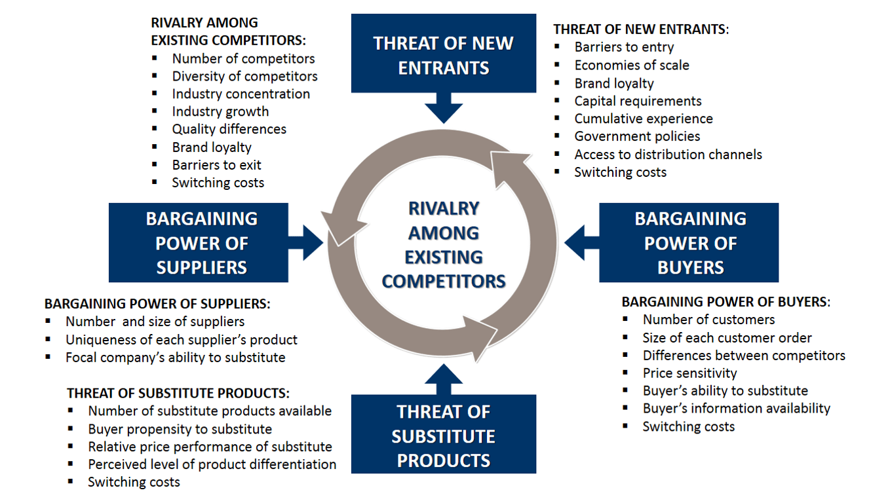

Porter’s five forces

Threat of new entrants:

While starting the business there wasn’t any competition, but now many renowned brands are giving a tough competition to chaldal.com. There are many potential competitors are looking for a chance to enter. The market is small, and the consumers could be countable. The more competitors are entering the more market shares are being divided. Entering into online shop is not that difficult, as many businesses are opening their online shopping, and opening an online shop doesn’t require a huge investment.

But chaldl.com has their own farm and own farmers, their delivery system, and low pricing policy is giving a tough competition to current competitors and is working as an entry barrier. The level of inventory chaldal.com has covering that up is difficult for a potential competitor.

There are few more barriers for new entrants:

Brand loyalty:

Chaldal.com has a huge number of loyal customers. Brand loyalty means how much the consumers of that brand is loyal to that brand. Though shwapno and meenabazaar do serves to more consumers, but consumers of chaldal.com is more loyal. Even there are so many negative reviews are available in online. Reasons why customers are loyal to chaldal.com:

Products or foods provided by chaldal.com is always qualityful, as they commit.

There advertisement policy is remarkable, they always try to be in touch with their consumers.

They get feedback after delivering the product, about their service and product’s quality.

Promotion policy is also attracting, I often find their products price lower than the physical grocery market.

Even some food or product, you can’t find in physical shops, but you can find in chaldal.com, which ensures all time availability of products.

I believe the service they are providing is the reason behind having huge loyal consumers.

Capital requirements:

Online shops like daraz.com and ajkerdeal.com doesn’t have certain positive point which chaldal.com has. Products like groceries couldn’t be always resale easily. Inventories needs to be purchased and stored. Because we can’t ensure availability of groceries in the market always, and our offered price and the current market’s offering price wouldn’t be saved. So a large amount of inventories needs to be preserved. And preserving a large number of grocery item requires specific functioning setup, which couldn’t be easily made. So arranging this much capital works as a barriers for new entrants.

Government regulations:

Comparatively this barrier is not that much strong, but still it could be considered. As opening a new business requires certain government policies to be followed. And selling food item requires some more regulations.



Economies of scale:

Achieving the economies of scale was bit easy for chaldal.com comparing to shwapno and meenabazaar. While managing too many outlets requires a lots of payment for shwapno and meenabazaar, chaldal.com doesn’t even require any physical outlet. Also by producing their own crops and vegetables they are remaining a step forward then their competitors. And now the way they are delivering products is also cost efficient than others, and for this they can offer very few delivery rate. While comparing with Shwapno, I even found certain products which are available at chaldal.com but not in shwapno.

Customer switching cost:

In terms of online shopping consumer switching cost is low, cause they don’t need to physically attend anywhere, they can check and submit their order online. But still loyal customer will never want to switch. The service provided by chaldal.com satisfies customer, and to keep that satisfaction always, consumer doesn’t want to switch.

Rivalry among established companies:

Rivalry among companies in an industry works as a barrier to new entrants, if in an industry company is making high profit by selling products or services in high price, which may make potential competitor attracted to enter to the market to make profit.

As in this industry rivalry with product price is very strong. Profit on individual unit is very low, and follows a very competitive pricing. So it is a barrier for new entrants. 

Demand conditions:

As population is increasing day by day, and serving this population is necessary. And specially for surviving food is necessary. But population of Dhaka is already over than expected, so there is no hope of product demand increasing, unless consumers shift within companies. So increasing demand of industry is not happening.

As demand is relatively static, and not increasing that much, so it will work as an entry barrier. Cause potential needs to consider the existing consumers as their target consumers who are already being served by existing companies.

Also consumer have first choosing brand. Suppose consumer will choose shwapno, meenavzaar and chaldal first. If they don’t find these companies then they will look for alternative. As long as they can find these companies serving, they won’t go to any other companies.

Exit barriers:

Exit barriers are relevant to different factors. Factors that could be emotional, economical. If exit barriers remain high, then company don’t stop activity even if it I running on loss.

The webpage that chaldal.com has worth’s a lot, but while selling it, they may not have that price, cause the name has a bangle meaning and which won’t be sold internationally.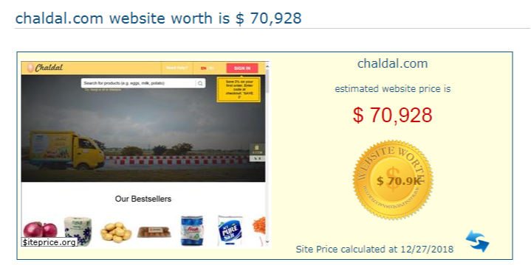

The app and the webpage couldn’t be used by any other company for any other purpose.

The fixed cost high, as chaldal.com has farm, to grow their own food, and farmers are employed over there.

Employees of company are committed to it, so emotional attachment is high, which is a exit barrier.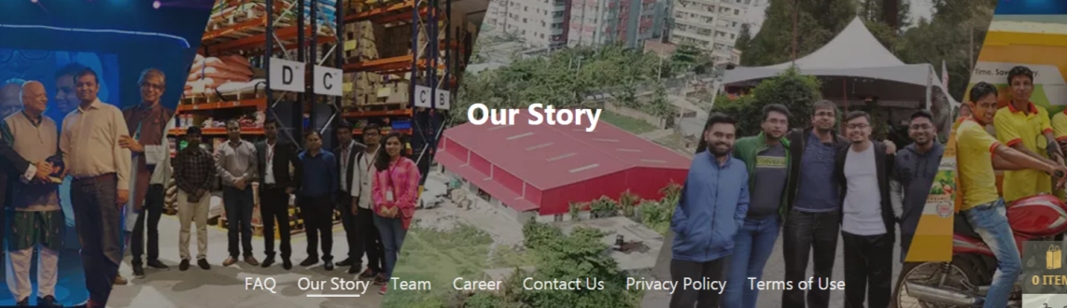

Lots of people will be unemployed if a company exits.

Buyer’s power:

In market where product price is very high, and target market is small, buyer has more power than seller over there. If an industry has several seller but few buyer then buyer will get the purchase power, and they can also give a strong bargain. But in this market buyer doesn’t have any power in pricing. As competitor to competitor price and quality of product is almost same, so buyer doesn’t get that much power in this industry.

The product chaldal.com sells, is not expensive by per piece or lot. Though there are several sellers in the market, but numbers of buyer is huge, that is the most important point of buyer for not having the bargaining power.

But corporate buyers do have certain advantages. They do have a certain level of bargaining power. As they purchase a bulk amount of products, are offered with free delivery and discounts.

Supplier’s power:

In this industry, supplier has the major power, in terms of choosing price, promotions and offer etc.

As chaldal.com is mainly selling vegetable products, And in terms of buying vegetables consumers don’t seek for substitutes.

Though buyer has the power to switch, but still they rely mostly on service that is provided by chaldal.com.

Chaldal.com has the power of changing price.

In online vegetable market the number of companies is 5/6. So still supplier ha the power in terms of modifying price.

Threat of substitute products:

While purchasing vegetables we don’t find for substitute products. Suppose instead of purchasing onion we don’t buy eggplant. So threat for chaldal.com of substitute product is very low, and also they have lots of verities in products.

So threat of substitute product is low for chaldal.com

SWOT analysis:

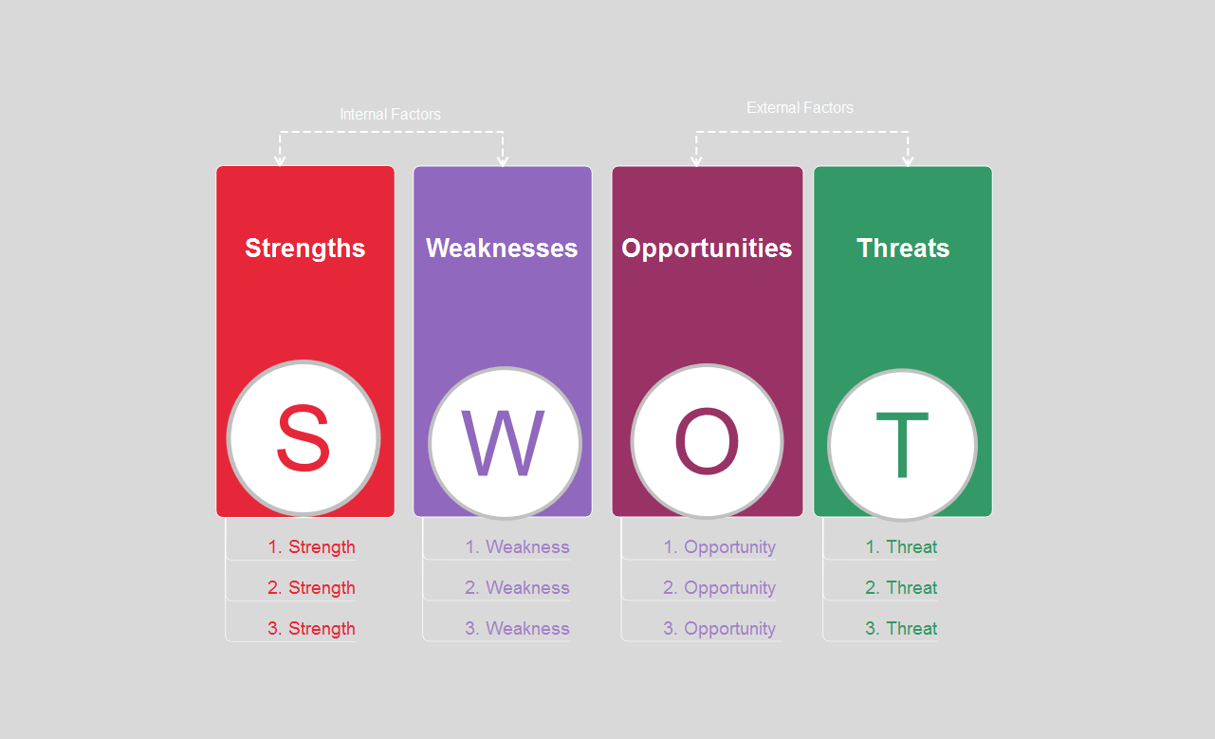

To identify the strength and weaknesses, and opportunities we have and threats for us- doing SWOT analysis in important. Evaluating a company’s strength, weakness, opportunity and threat is known as SWOT analysis.

Strengths:

What opportunity chaldal.com has over its competitor? I think the most strength will be its reputation; the name along with the webpage is their main strength.

The employees of chaldal.com is committed and dedicated.

From my personal experience I can say that, products of chaldal.com are qualityful.

They are BSTI certified.

They are able to handle their large amount of demands.

Their marketing skill is good.

Their brand name has a reputation in current market.

Their management skill is also up to the mark.



Weaknesses:

Though currently they are able to serve all over Dhaka, but demand in Chittagong is increasing of online grocery shop, and chaldal.com is still remaining lag behind.

They don’t have any outlet. So targeting those people, who wants to buy by physically evaluating, is difficult.

Still they can’t produce all vegetables which they are selling; as the market demand is huge they need to increase farm size and number of farmers.

Overcome: Within short time, they need to expand their activity to Chittagong also. As they are targeting online buyers only, and that is the difference with other competitors, so I don’t think they need to open any physical outlet. They obviously need to increase farm and farmers.

Opportunities:

In Bangladesh still online based shopping market is growing, so there are enough future ahead.

Still the numbers of competitors are few.

Diversified products could be marketed by suing the same platform

Threats:

There are strong competitors like shwapno and meenabazaar are rolling the market.

Governments do impose new rules and regulations time to time.

Even foreign companies are entering to the market.

Taste and preferences of consumers don’t remain same always, so company needs to update their strategy also time to time.

And political stability, strike, unavoidable situation also affects business.

Marketing mix:

Product, Price, Place, Promotion are the main base of marketing mix. In marketing this 4 thing is considered very importantly.



Product:

This is the most important point, because without product or service business couldn’t be formed.

Chaldal.com has some unique products, and I need to mention that they have the most verities of vegetable collection comparing to competitors.

Quality of their product is good, and gives a superior challenge to others.

Packaging and the quality of product will make consumer’s ensure about how hygienic the products are.

They ensure the quality.

Though vegetable or food doesn’t come under warranty. But still they do care for their customers. They seek for feedbacks.

Price:

To attract customers, pricing policy needs to be always identical. As the market is too much competitive, there is no scope for earning much profit from per piece.

But they are offering various promotions, discounts, they are reducing product price a bit.

And for corporate buyers, who are purchasing a bulk amount of products, pricing policy is different for them.
ITEM NAME | PRICE
Onion Indian | 28 TK
Red Tomato | 25 TK
Onion Local | 30 TK
Garlic Premium | 27 TK
Potato Seasonal | 18 TK
Coriander Leaves | 10 TK
Green Chili | 15 TK
Big Potato | 20 TK
Ginger Indian | 32 TK
Carrot | 21 TK
Red Spinach | 15 TK
Ladies Finger | 30 TK
Green Papaya | 40 TK
Potol | 40 TK
Deshi Cucumber | 29 TK
Red Potato | 15 TK
Long Big Lemon | 40 TK
Ginger Local | 30 TK
Green Capsicum | 75 TK
Round Lemon | 35 TK
Flat Beans | 30 TK
Sweet Pumpkin | 28 TK
Garlic Local Small | 16 TK
Snake Gourd | 33 TK
Sweet Potato | 19 TK
Long Brinjal Black | 26 TK
Water Spinach | 10 TK
Cucumber | 25 TK
Bitter Gourd | 40 TK
Round Brinjals Black | 55 TK
Cabbage | 45 TK
Long Bean | 35 TK
Green Banana | 35 TK
Gourd | 65 TK
Kagozi Lemon | 40 TK
Pui Spinach | 30 TK
Thankoni Pata | 10 TK
Aloe Vera | 20 TK
Kochur Mukhi | 45 TK
Beetroot | 40 TK
Bitter Gourd | 40 TK
Mini Leaves | 18 TK
Water Pumpkin | 45 TK
Lettuce Leaves | 20 TK
Sweet Pumpkin | 60 TK
Radish | 25 TK
Green Tomato | 20 TK
Round Brinjals | 50 TK
Spring Onion | 32 TK
Stolom of Taro | 60 TK
Bombay Chili | 23 TK
Baby Corn | 60 TK
Ridge Gourd B grade | 45 TK
Red Capsicum | 135 TK
Kacha Holud | 29 TK
Yellow Capsicum | 135 TK
Potato Regular | 20 TK
Betel Leaf | 120 TK
Mehendi Leaves | 60 TK
Red Cabbage | 45 TK
Betel Nut | 130 TK

Distribution Strategy:

Chaldal.com ships their product all over Dhaka by itself. They have pickup vans to carry large order, and to complete small orders, they have delivery boys. Who use cycle or motorcycle in order to deliver the product.


They are serving with 1 Hour Delivery Service to Azimpur, Badda, Banani, Banasree, Baridhara, Bashundhara RA, Cantonment, DOHS Banani, DOHS Baridhara, DOHS Mohakhali, Dhaka University, Dhanmondi, Eskaton, Farmgate, Gulshan, Kakrail, Kalabagan, Khilgaon, Mirpur, Mohakhali, Moghbazaar, Mohammadpur, Motijheel, Niketon, Nikunja, Pallabi, Paltan, Ramna, Rampura, Tejgaon, Uttara, DOHS Mirpur, Adabor, Shaymoli, Paikpara, Malibag, Gabtoli, Kallyanpur, Agargaon, Wari, Pink City, Uttar Khan, Dakshin Khan. For the rest of the Dhaka city they are currently delivering within 4-7 hours timeframe. We can also specify a convenient time and they will send the products during that time.

Chaldal.com has full time delivery boys, and it also have part time delivery boy. Students can work as a part time delivery boy over there.

There are two delivery rates: 20 / 40 Taka. And for ordering bulk amount the delivery fee in free.

Chaldal.com ships product to doorstep, it doesn’t require any help of wholesalers. And corporate buyers get extra facility. Pickup Van delivers their product without any delivery fee.

Promotional strategy of chaldal.com:

Chaldal.com doesn’t follow the traditional way of advertising, like: print media or television media.

Google adsense / adwords: It expenses huge to do advertise by google, that’s how we can see advertise of chaldal.com on various WebPages and also on youtube.

Facebook.com: It also runs facebook campaign to promote their official offer or videos.

Email marketing: Sends individual emails or bulk emails for promoting purpose.

Sms marketing: Sends bulk sms to a collected database of numbers.

Sales Promotion: Sales promotion includes:

Discount 2 – 15% on order price

Currently they have special offer on 119 products

Free delivery

Purchase one get free one

Invitation bonus: If one invites his friend, he/she will get a bonus

Chaldal.com app referring bonus

Publicity:

Customer care executives, who calls individually to convince people about their products and services

Campaign on university campus or shopping malls

Analysis of customer satisfaction:

To confirm whether the consumers are satisfied with their service, they seek for a survey each time they deliver. If one reply yes, then it is considered as a positive review, but if the consumer replies No, then that will be considered as a negative review. And a customer care executive will call the negative review provider, in order to know what was the problem, and how it could be solved.

Sometime for first delivery or large amount of order customer care executive calls especially in order to know whether everything was according to customers expectation or not.

Efficiency of webpage:

With the report of the website visitor, chaldal.com can make various decisions. Who are visiting and when visiting. Which products are getting higher view. Certain decisions could be taken:

If visitors are visiting a particular product, then chaldal.com recognizes that product as highly demanded.

If after visiting a product they don’t place the order, then chaldal.com considers the product price may be high.

Some visitor searches or Indian Onion and buys Local onion.

Sometime visitors directly come by searching keyword from google by the product name: that means visitor doesn’t have enough knowledge about the product or the competitors are charging high for that product.

Visitor’s also can live communicate with support manager through chatting.

Unique page views:







The webpage is also mobile friendly, whenever one access the webpage from mobile, the webpage automatically detects the platform, and shows content on that basis.

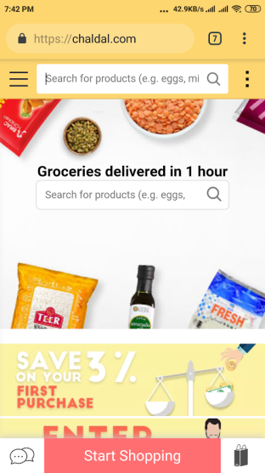

Efficiency of App:

App comes with all the benefits that the webpage has, even more;

App can monitor phone activity

App can check whether any other competitors app is being installed on phone or not

App can easily determine the customer location by GPS

App can provide notification alert popup, on price change or for new offer, which wasn’t able to do on website. This is one of the major benefits of chaldal.com: that now they can notify each of their customers who have app installed on their phone and have data access.

And app could be updated time to time which would come up with new ideas.

Customers prefer app more, than visiting webpage

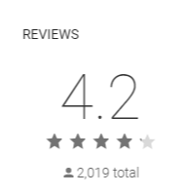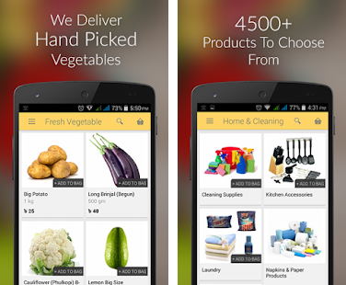

Payment System:

In terms of online shopping payment method is necessary. Supported payment methods of Chaldal.com:

Cash on delivery | 
Bkash | 
Visa | 
MasterCard | 
American Express | 

Product availability:

Their inventory management system is pretty good. As they hold their inventories in 9 warehouses among Dhaka, so they rarely go out of stock. They try their best to source the ordered product, but in case if they couldn’t manage they personally calls individuals to let customer know about available substitute products.

Product information on webpage:

Product name

Image (Available with zoom function)

Quantity

Verities

Discounted Price

Recipes:

This is an unique service they are providing, comparing to their competitors. They have a collection of recipes, which users can access freely, and while following the recipe they have an option to order relevant products directly, which may be needed in terms of making the food.

Refund Policy:

A customer may get refund within 7 days on unopened or spoilt packaged products. For diapers and perishable products, such as milk, fruits and fresh vegetables, they have a one (1) day return policy.

Findings:

Chaldal.com is doing its activity perfectly. For a better view from customer perspective, I did a survey. I took a sample of 32 members, and took a questionnaire survey through google form. The result is:

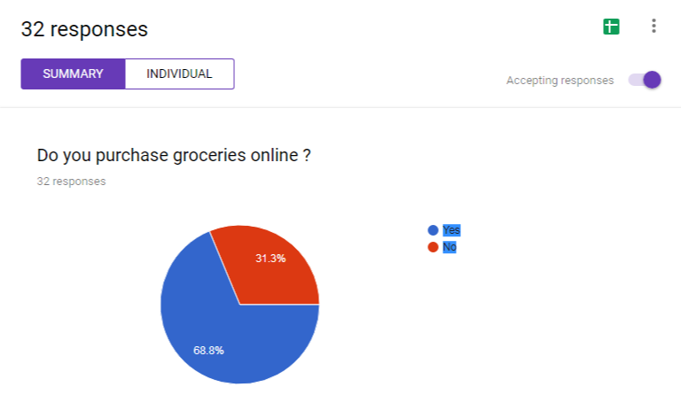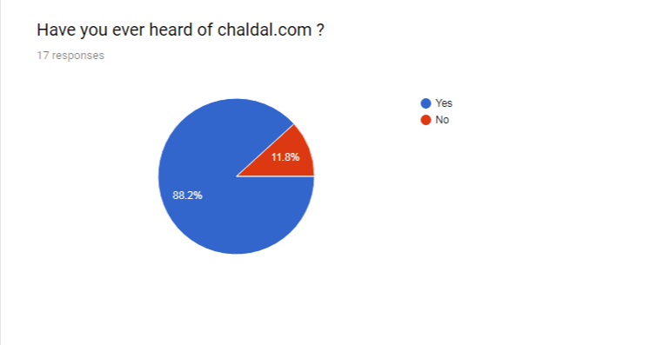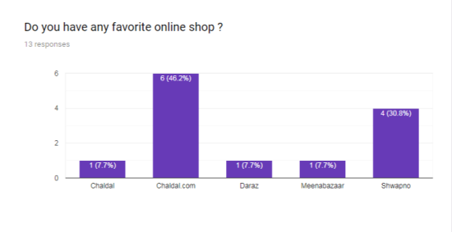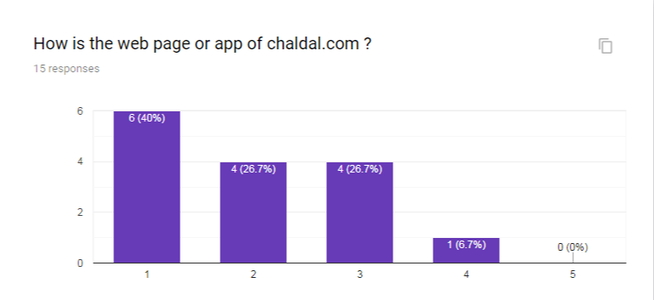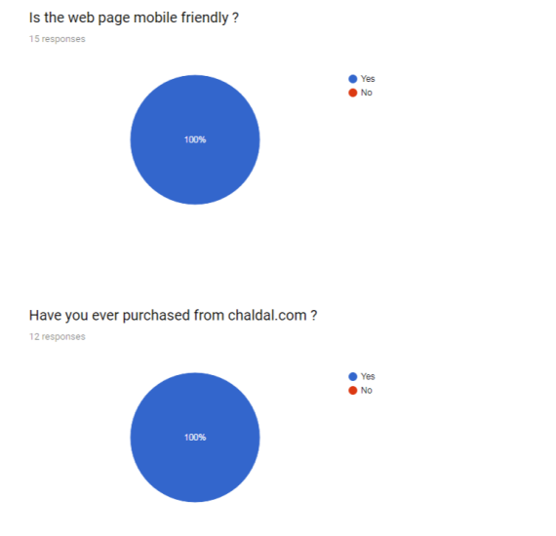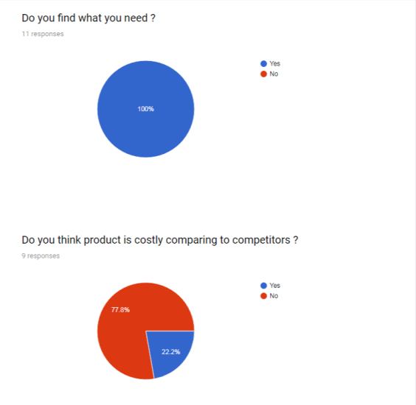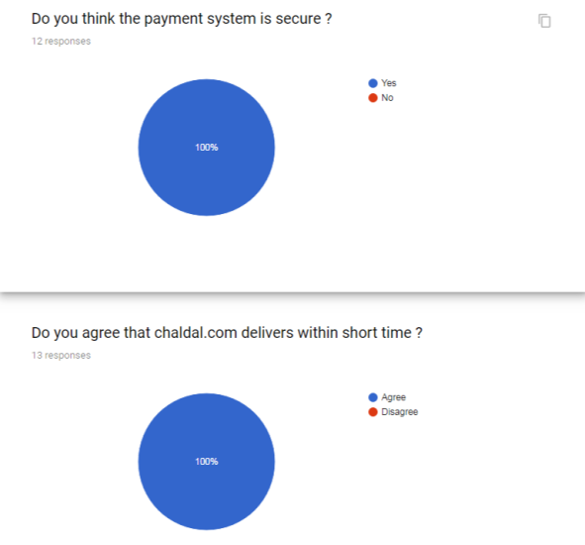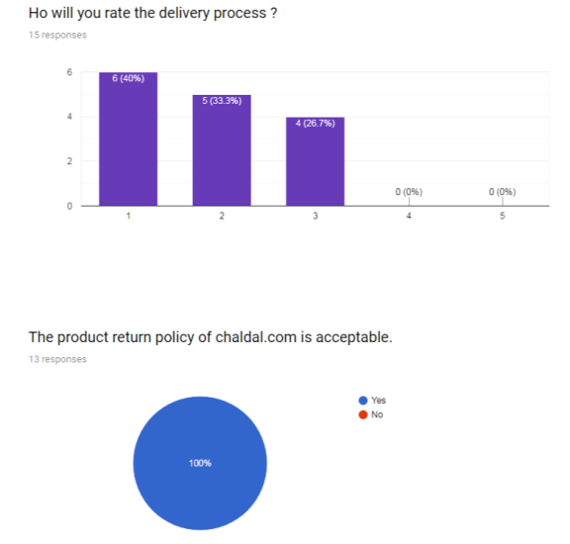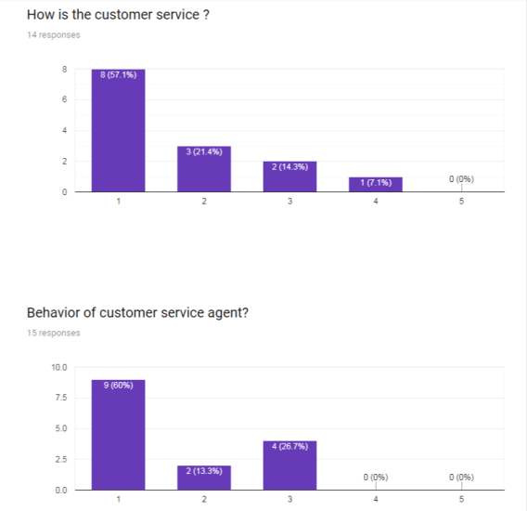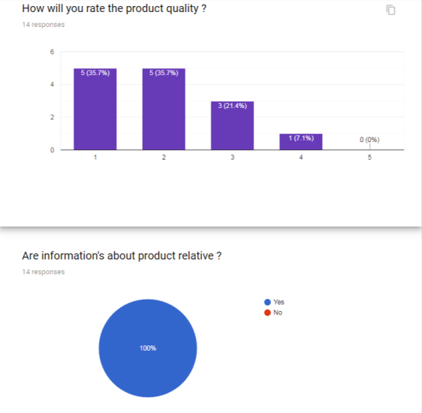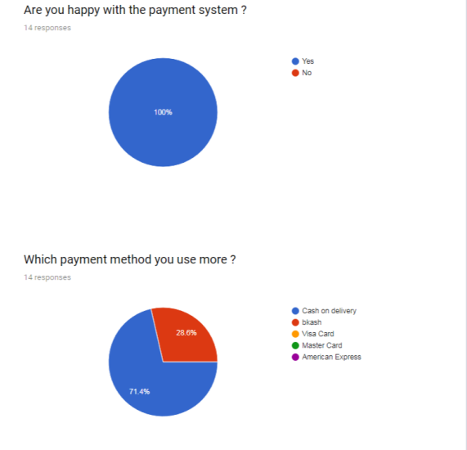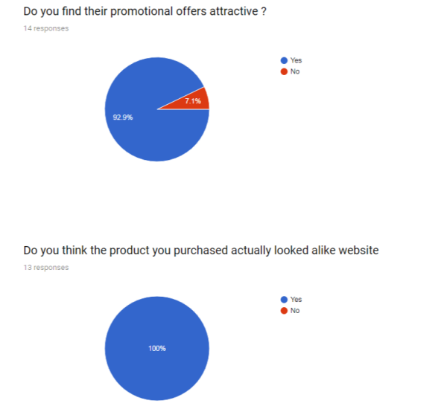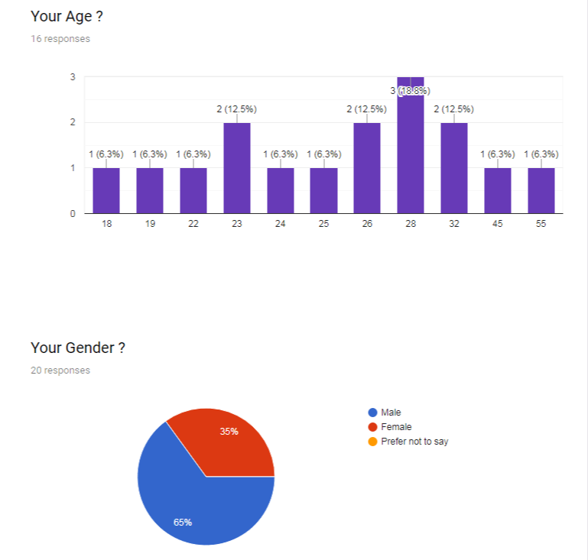

From the survey I came to know that, more than 30% people don’t prefer to purchase groceries online. And the competition could be with Shwapno, as several person selected Shwapno as their favorite shop. 10% people still haven’t heard about chaldal.com. Almost everyone liked the webpage or the app of chaldal.com. 37.5% vote on Very good & 31.3% vote on Good. Every consider the webpage as mobile friendly. Customers find their product available on chaldal.com. 30% people considers that product price of chaldalk.com is comparatively expensive. Review about product quality is also good, maximum vote remains very good – good. People find the product’s information relative, and customers are happy with the payment method. From the finding I came to know that most of the person prefer cash on delivery ,method, but some do pay through bkash. Visa, MasterCard and American express card is not that used in chaldal.com, I haven’t received any info about paying through these methods. Customers find payment system safe, specially cash on delivery is the most safe method. The delivery method, is preferred by everyone, as there is no negative review. 53% voted customer service as very good, and rest of the others also support that their customer service is good, a behavior of customer service agent is good. The review about delivery man is not also bad. But not that much people tried premium products of chaldal.com. 93% customer thinks the promotional offers of chaldal.com is attractive. People find their received product relevant to the image shown on the webpage. Surprisingly, not a single customer faced any negative experience with chaldal.com. People finds that, shopping with chaldal.com is fast. People will like to do shopping with chaldal.com again and again. People mostly prefer evening to make an order. Age group from 22 to 32 uses the webpage most, and mostly gents are more likely to use chaldal.com.

Limitations:

One of the major reasons why meenabazaar and shwapno has more recognition than chaldal.com is because of their physical shop. Because their huge outlets remaining beside main streets works as a publicity method, where chaldal.com remains lag behind.

While working on this report, I tried to find out a problem of this current situation:

“Why product price is very different- if we buy from farmer, rather than buying from these retailers”

When farmers are selling any vegetables, they are selling those on a very low rate, but when these retailers sell the same product, they are selling comparatively a very a high price. While contacting chaldal.com about this issue, they said cost incur for transportation, store and due to damage of some products, but still don’t find when a kg of potato price is 13tk from a farmer, and same potato is 32tk from shwapno. How the price on a single kg can increase that much! Till now, I am not clear about this issue, and they are not logically clarifying this.

Recommendations, conclusion & references:

Recommendations:
After studying a lot, I came up with some recommendations for chaldal.com:
- How the activities including (product collection, storing, quality management) are done needs to be more elaborately mentioned in the webpage. Curious clients won’t find essential information’s about that.
- Response of online support manager needs to be quicker.
- Rocket should be added as a payment method.
- When other retailers are offering discount on bkash payment, chaldal.com also should offer this.
- Chaldal.com needs to always check product price update of its competitors, to make sure that their product price is lower than others, as some of the reviewer said product price of chaldal.com is relatively high.
- They should go with print media advertisement, including newspaper & magazines.
- They should expand their activity to Chittagong within a very short period.
- Some food / vegetables should be offered, which are not available in Bangladesh. That will be a unique selling point for them.
- How they can offer product under lower price:
As the main issue is about transportation and storing, different growing method could be followed in order to decrease this cost. Where foreign countries are following, hydroponic & Aquaponic system for growing vegetables, chaldal.com should do that. By hiring rooftop of several buildings of Dhaka, they can easily produce a mass amount of vegetables. In that situation delivering from there, will require few transportation cost along with few storing cost.

Conclusion:

After reading the report, every reader will agree with me that, chaldal.com is doing great from their field. But things need to be modified time to time. As there are so many competitors who are consistently upgrading themselves, chaldal.com should also do so.

Customers are happy with the service from chaldal.com, though some are saying that the price is high. I completely agree with them: where chaldal.com don’t need to carry the cost of managing physical outlet the product price of it should be relatively lower.

Time to time market research will make chaldal.com more appropriate on their strategy, which will lead them to a more successful future.

References:

https://www.slideshare.net/rifatmahmud3597/presentation-on-e-business-of-chaldalcom

https://chaldal.com/t/Help

https://www.meenaclick.com/

https://www.shwapno.com/

http://shaksobji.com/

https://www.othoba.com/

https://www.daraz.com.bd/

http://sbazaar.com.bd/

https://khaasfood.com/

https://investmentbank.com/business-planning/porters-five-forces/risk-of-entry/

http://dspace.bracu.ac.bd/xmlui/bitstream/handle/10361/8483/12104043_MBA.pdf?sequence=1&isAllowed=y

https://www.export.gov/article?id=Bangladesh-ECommerce

https://bd.cloudly.io/wp-content/uploads/2018/01/Bagdoom-Case-Study1.pdf

http://dspace.bracu.ac.bd/xmlui/bitstream/handle/10361/8144/12104044_BBA.pdf?sequence=1&isAllowed=y

http://m.theindependentbd.com/post/110310

http://www.newagebd.net/article/28655/bangladesh-e-commerce-sector-to-grow-to-tk-900cr-this-year-report

https://jmustafa.com/digital-in-bangladesh-2018-report/

https://www.bagdoom.com/

https://priyoshop.com/

https://www.alexa.com/siteinfo

https://www.similarweb.com/

APPENDIX:

Questionnaire survey:

