Evaluation of Value Chain Effectiveness & Competitive Market Analysis: A Case study on Savlon Antiseptic




Evaluation of Value Chain Effectiveness & Competitive Market Analysis: A Case study on Savlon Antiseptic

Submitted To

Kawsar Ahmed, PHD
Professor- Marketing
Deputy Direct- BBA Program
United International University

Submitted By
Sumiya Israt
ID# 111 143 304
School of Business and Economics
United International University

Date of submission: 30th May 2020
Letter of Transmittal
30th May 2020
KAWSAR AHMED, PHD
Professor- Marketing
Deputy Director- BBA Program
School of Business and Economics
United International University

Subject: Request to accept my internship report.

Dear Sir,
With great gratification I am submitting my Internship Report on Evaluation of Value Chain Effectiveness & Competitive Market analysis, a Case study on Savlon Antiseptic which is a part of ACI Limited’s portfolio based on my internship period. This report has been submitted as an important prerequisite of BBA curriculum. The internship program has provided me with a chance of having a revelation to the working environment and on the internship experience in the Consumer Brands sector in a prominent conglomerate, ACI Limited. I have found the knowledge, experience to be quite interesting, advantageous & insightful.
I have tried my level best to organize an effective & creditable report. I hope you will find this report significance of all the labor I have put in it.
I welcome your entire query & take pride to answer them.

Sincerely Yours

…………………..
Sumiya Israt
ID: 111 143 304
United international University
Acknowledgement

I begin by thanking the Almighty Allah for my winning completion of the internship report, which is a important part of the BBA Program. I would like to take the opportunity to thank those people who have given me continuous support while doing my internship program.

At first It’s a gratification to convey my heartiest gratefulness and greeting to my respectable supervisor, Kawsar Ahmed , PHD, Professor- Marketing & Deputy Director- BBA Program, United International University. I deeply appreciate his cooperation, advice and guidance in preparing this report.

I would like to extend my heartiest merit to the Consumer Brands Department of ACI Ltd for allowing me to complete my internship. I would like to acknowledge and thank MD. Hamidul Islam (Head of Business) & my External Supervisor Adnan Quayum (Assistant Manager) & Miran Hossain (HR Executive), who has extended his whole-hearted collaboration for preparing the report-

I am very thankful to all of the people mentioned above for their cooperation in every step to prepare my report successfully.

Table of Content
Table of Contents
1. Introduction: 9
2. Organization Overview: 9
2.1 Company Profile: 9
2.1.1 Company Mission: 11
2.1.2 Company Vision: 11
2.1.3 Company Values: 12
2.1.4 Company Policies: 12
2.1.5 Business Units: 12
2.1.6 SWOT Analysis of ACI Limited: 14
2.1.7 Board of directors: 17
2.1.8 Executive Management: 18
2.2 ACI Consumer Brands: 18
2.2.1 Consumer Brands - Organ gram (Marketing) 20
Figure shows the organ gram of the marketing department of Consumer Brands Division. 20
2.3 Industry Background: 21
2.3.1 History of Savlon Antiseptic: 21
3.0 Objective and Methodology: 30
3.1 Objective of the report: 30
3.1.1 General Objective of the report: 30
3.1.2 Specific Objective: 30
3.2 Methodology of the Report: 32
3.2.1 Types of data: 32
3.2.2 Data Collection Instruments: 32
3.2.3 Data Collection Techniques: 32
3.2.4 Data Analysis Technique: 33
4.0 Limitations of the Study: 33
5.0 Value Chain: 34
5.1 Definition Value Chain: 34
5.2 Understanding Value Chains: 34
5.3 Components of a Value Chain: 34
3.3.1 Primary Activities: 34
3.3.2 Support Activities: 35
5.4 Value Chain of ACI Ltd: 36
5.4.1 Primary Activities: 36
5.4.2 Supportive Activities: 47
3.4.2.1.1 Executive Management 47
6.0 Market position & Competitor Analysis: 52
6.1 Result of Visits Saloons inside Dhaka: 52
6.1.1 Visited Areas: 52
6.1.2 Result of visited area by table: 52
6.1.3 At a glance & Graphical Presentation of twelve areas: 60
6.1.4 Interpretation of the Results: 66
6.1.5 Threats and potentials: 67
7. Recommendation: 68
7.1 (Re-positioning strategies): 68
7.2 Outcomes: 71
8.0 Current Market Situation & Some Temporary Strategy of Savlon: 73
8.1Big Crisis “COVID-19”: 73
8.2 Treatment: 74
8.3 Covid-19 in BD: 74
8.4 SAVLON New Strategy for Fighting with COVID-19: 75
9.0 Conclusion: 78
10. Appendixes: 79
10.1 References: 79
10.1.1 Books: 79
10.1.2 Internet: 79
10.2 Other documents: 80

Executive Summary
Advanced Chemical Industries Limited (ACI Limited), one of the leading companies of Bangladesh at present, was recognized in 1992 though it started its journey under the name of Imperial Chemical Industries in 1968. ACI limited has 6 Strategic Business Units & Joint Ventures along with numerous Subsidiaries. Among the SBUs, Consumer Brands is holding 2nd position for sales contribution. The Consumer Brands Division boasts in having an unequivocal presence in consumers' heart with the market leading brands like ACI Aerosol, Savlon, ACI Mosquito Coil & ACI Pure Spices and Flour. ACI Consumer Brands was originated in 1995 with two chief brands of the company ACI Aerosol and Savlon. Those two are the most prominent products which are market leading product. Throughout my internship period I was working for Evaluation of Value Chain Effectiveness for & Competitive Market Analysis of Hygiene product, Savlon. For that reason, I had to Analyze the business Company Overviews, Business Types, Business running Procedure, Competitors, Marketing Polices & also visit many saloons to identify the competitors of Savon, current market situation, monthly sales, leadership position, and actual market share and customers perception about Savlon.

Including twelve different place of Dhaka I have conducted a survey on saloons in five other districts. We got questionnaires from our supervisor for my survey both Dhaka and outside (outside of Dhaka covered by another group Members). I had little additional learning form the survey report of outside Dhaka, example: how to collect order, how to influence customers for buying product, push marketing theory, management process of a sales representative and current position of competitors. In addition, I tried to know about the customer’s opinion and how do they feel about savlon to supervise the brand.

In my internship period I was trying my level best to full fill my work and covered my topics. ACI received some imperative information from my findings and based on those they have taken many important decisions to manage Savlon brand in competitive market. I fell very much lucky because I can accomplish my internship with ACI and they are giving precedence to my findings, as a result I can clearly see the result of my work within a short period. All types of Observation, findings, interpretation, and suggestion I explain ornately in my report to give a perfect shape and also appendix part for making it more authentic.

Keywords: Value Chain, Competitive Market Analysis, ACI Limited, Antiseptic, Bangladesh

Introduction:

As the ultimate prerequisite of BBA program in United International University, it is must for every student to undergo a three months internship program in an organization if students are go with internship program. The Interns are required to carry a wide-ranging analysis of real world business problem in this Program, almost play role as an employee. Therefore, I choose & also get opportunities to work with ACI family. I had been placed at Advanced Chemical Industries (ACI) Limited and get the opportunity to see the overall aspects of that organization specifically the consumer brand during the internship program. Md. Adnan Quayum, Assistant Manager, Consumer Brands was my supervisor. He joined ACI Ltd as a product executive on July 1 2012. He completed his BBA in Marketing from North South University. I would like to thank Md. Adnan Quayum and give my thoroughly gratitude for all the help and guidance he has provided me in this internship period.

2. Organization Overview:

2.1 Company Profile:

Imperial Chemical Industries (ICI), is a British multinational recognized a Branch in the then East Pakistan which was converted into a company after liberation, named ICI Bangladesh Manufacturers Limited. In 1992 ICI divested its speculation in Bangladesh to the Management, when its name was changed to Advanced Chemical Industries (ACI) Limited.

Advanced Chemical Industries (ACI) Limited, presence one of the biggest conglomerates in Bangladesh with a multinational heritage operates diagonally the country through its four expanded strategic business units which was a big business operation in Bangladesh. ‘ACI Pharmaceuticals’ is devoted to improve the health of people of Bangladesh through introduction of innovative and reliable Pharmaceuticals products. They ensure their quality with Customer satisfaction.
‘ACI Consumer Brands’ is adding value to the daily life of consumers through its product line, like: Toiletries, Home care, Hygiene, Electrical, Electronics, Mobile, Salt, Flour, Foods, Rice, Tea, Edible Oil, Paints and International businesses. ‘ACI Agribusinesses’ is the largest integrator in Bangladesh in Agriculture, Livestock, Fisheries, Farm Mechanization, Infrastructure Development Services and Motorcycles. ‘ACI Retail Chain’ is the largest retail chain in the country operating through its 73 SHWAPNO outlets across the country by touching the lives of over 35,000 households each day & it’s huge. The company contributed Taka 3,625 million to the National Exchequer during FY 2017-2018 in the form of corporate tax, custom duty and value added tax.
Basic Information

Company Name | Advanced Chemical Industries Limited
Incorporate Date | 24 January 1973
Company Type | Public Limited
Managing Director | Dr. Arif Dowla
Number Of employees | 9,053
Authorized Capital | 1,500,000,000
Number Of Shares | 49,88,95,270
Face Value | 10
Address | ACI Center, 245 Tejgaon Industrial Area. Dhaka 1208
Phone | 880 2 887 8603
Fax | 880 2 8878619 & 8878626
Email | info@aci-bd.com

2.1.1 Company Mission:

ACI’s mission is to enhance the quality of life of people through responsible application of information, expertise and equipment. ACI is committed to the pursuit of excellence through world-class products, innovative processes and empowered employees to provide the highest level of satisfaction to its customers.

2.1.2 Company Vision:

To realize the mission ACI will:

- Endeavor to reach a position of leadership in each category of its businesses.

- Attain a high level of productivity in all its operations through effective and efficient use of resources, adoption of appropriate technology and alignment with our core competencies.

- Develop its employees by encouraging empowerment and rewarding innovation.

- Promote an environment for learning and personal growth of its employees.

- Provide products and services of high and consistent quality, ensuring value for money to its customers.

- Encourage and assist in the qualitative improvement of the services of its suppliers and distributors.

- Establish harmonious relationship with the community and promote greater environmental responsibility within its sphere of influence.

2.1.3 Company Values:

- Ensure Quality

- Focus on Customer

- Fairness in every where

- Transparency

- Continuous Improvement

- Innovation

2.1.4 Company Policies:

ACI has strong Quality Policy, Environmental Policy and Global Compact Endorsement.

2.1.5 Business Units:

Strategic Business Units (SBU’s):

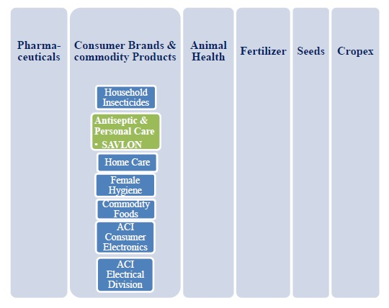

2.1.5.1 Subsidiaries:
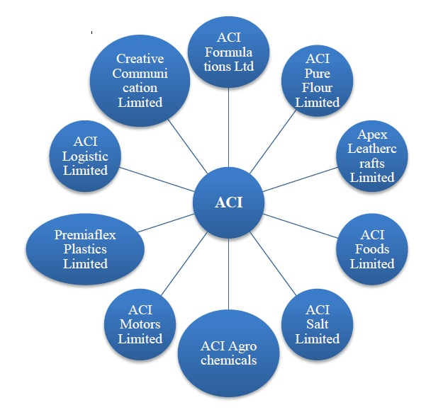

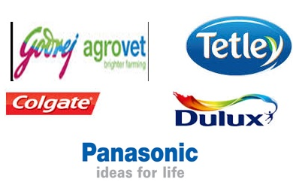
2.1.5.2 Joint Ventures:

- ACI Godrej Agro vet Private Limited
- Tetley ACI (Bangladesh) Limited
- Asian Consumer Care (Private) Limited
- Colgate
- Panasonic
- Dulux

2.1.5.3 Fundamental Departments of ACI:
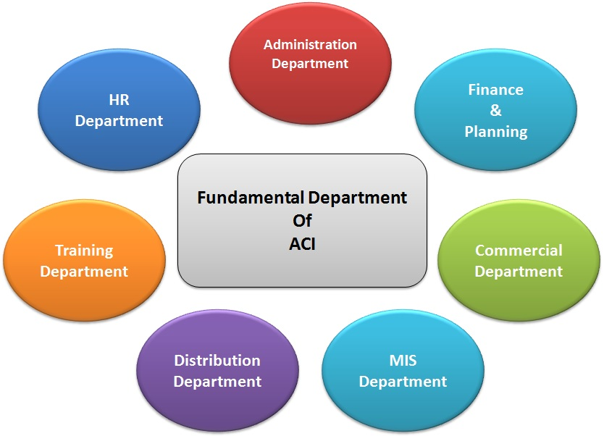

2.1.6 SWOT Analysis of ACI Limited:

It’s a known terms SWOT, SWOT is the short form for Strengths, Weaknesses, Opportunities and Threats of a company. It is an analytical Construction to comfort summarize in a quick and concise way the risk and opportunities for any Corporation across the value chain which was help every company for making their planning.
- Factors pertaining to the internal environment of the company. These are usually expressed as Strengths (S) or Weaknesses (W), those twos are internal factors of every companies.
- Factors that pertaining to the external environment of the company. These are expressed as Opportunities (O) or Threats (T), same as those two are External elements for every companies which are erected very strong impact in doing business.
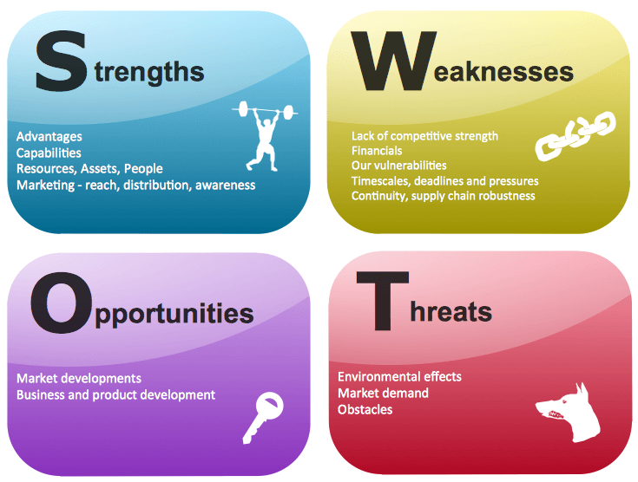

- Strength:

- ACI is painstaking as countries’ one of the leading conglomerates because of its performance & Quality & take a position in competitive market. They always try do something new for achieving customer’s satisfaction.
- Effectual, talented and truthful workforce.
- ACI has intense of customer demand of their product which helps them to inflate their business in wide range.
- Get success to achieve their Quality Management.
- Certification of Great quality products for consumers consume.
- Wide range/ many of products and services.
- Strong management in internal/External work place which help to gain the success in corporate market.
- Success to manage enough financial resources to grow the Business.
- Success to build Proprietary technology and importance patents.
- Have Ability/ Capable to take advantage of economies of scale.
- Better product quality than competitors.
- Constant Goodwill in market.
- Huge Category/ SBU’s help them to diversify their Risk & Can give backup easily in another sectors.
- Always Concerns about customer demand & need.
- Gain Customer loyalty.

- Weakness:

- Competitors get position in market for High Unit cost of ACI.
- Can’t create valuable low pack size.
- Reliance on imports Future low profit margin.
- Facing High cost when establishing new products.
- High cost means high price which became customer’s dissatisfaction.
- Their distribution Channel & sales forces are weaker then competitors. Distribution channel are not mush active like management.

- Opportunities:

- ACI as a local conglomerate has opportunity for expand its investment and has potential growth in Bangladeshi market which is a big opportunities.
- Expanding the company’s merchandise line to meet a broader series of customer stems.
- Day by day demand will be increased.
- Now have bargain power in international market as suppliers also as a buyer.
- Market is now wide than previous situation.
- Proper hiring of employee may result in higher profit & success.
- High confidence, brand name, effort, and quality gain customers belief & Value.

- Threats:

- Great Movement of competitors in Market.
- Now competitors are huge in same sector.
- Export sectors are effected by world economy.
- Decreasing day by day market growth.
- Customers have huge option so that increase their bargaining power.
- New regulatory requirements became costly.
- Increasing threats from local competitors by cutting the cost.

2.1.7 Board of directors:
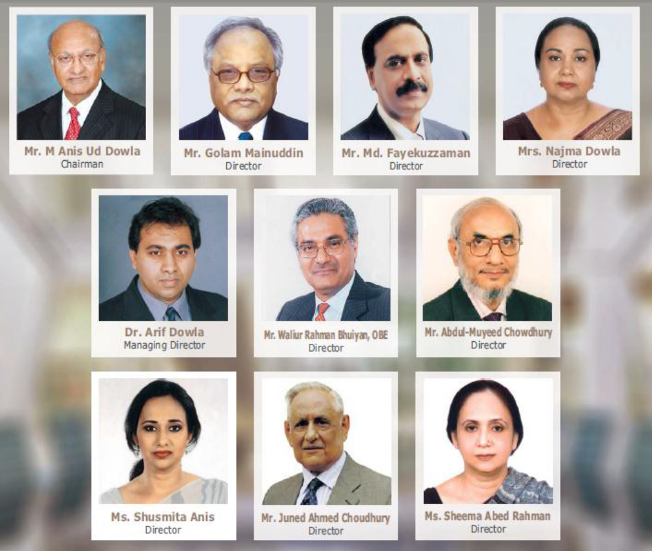

Figure: Board of Directors of ACI

2.1.8 Executive Management:

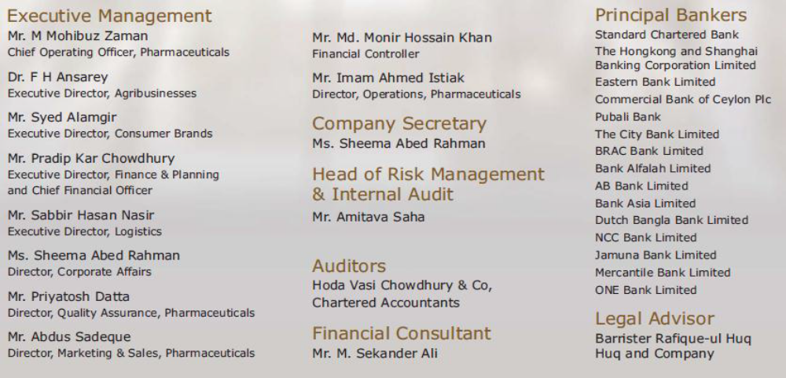

Figure: Executive Management of ACI

2.2 ACI Consumer Brands:

ACI Consumer Brands was Comes in 1995 with two essential & Major brands of the company those are, ACI Aerosol and Savlon. These are two of most valuable, prestigious & demandable products which are enjoying the leadership position in the market. & everyone knows about those brand.

The division started to take new businesses through off shore trading as well as local manufacturing. In this process ACI Consumer Brands launched many new products which are most useful in daily life and also bonded with Joint Venture business relationships with ‘Dabur India’ and ‘Tetley UK’ and attained international alliances with world renowned companies.
The Consumer Brands Division became success to set the place in consumer mind with the market leading brands like ACI Aerosol, Savlon, also ACI Mosquito Coil & ACI Pure Spices and Flour create a better position in market.
Almost gain 80% market share, ACI Aerosol and Savlon are the persistent performers in keeping the household clean and free from germs and harmful insects. The ACI mosquito coil has also emerged as a formidable opponent to both the mosquito and the competition & it also became demandable from consumers by providing effective and affordable solution to the conscious people of Bangladesh.
Now a days where ACI Pure salt is the market leader. People of Bangladesh have a belief with this brand. ACI also maintain their quality with reasonable price. Previously nobody known about this product, but now when the term comes PURE consumer can easily recall the brand name like “ACI PURE SALT”
ACI Also Launched the Sanitary napkin for female which is FREDOM. Its also captured the market nicely. This product became more demandable day by day. It almost captured the 50% of Market share.
ACI Neem Soap which was introduce in market in 2015, it provide freshness of nature with hygine.at has also a great impression in market & it’s the 1st neem soap in BD market.
In 2017 ACI launched the savlon Baby Dipper with lower cost & It became helpful for those consumers who’s are care about low lost. This Product not only give the low price but also maintain the high quality.
Also ACI launch many products in last two years such as, Washroom cleaner, Hand Sanitizer, Saving cream Etc, which are the daily uses product of human life. Those products create many values in our daily life. ACI maintain their quality with reasonable price & great distribution channel. We also got those product easily from our nearest every shop. We should face high price, product shortage if ACI not showing interest to doing business in those sectors.
At the end we can say that ACI Consumer Brand make easier our daily life lead. Without those product we should pay high, market shortage etc. So consumer brand success in market place with their well business operation & have a great position in consumer mind.

2.2.1 Consumer Brands - Organ gram (Marketing)

Figure shows the organ gram of the marketing department of Consumer Brands Division.
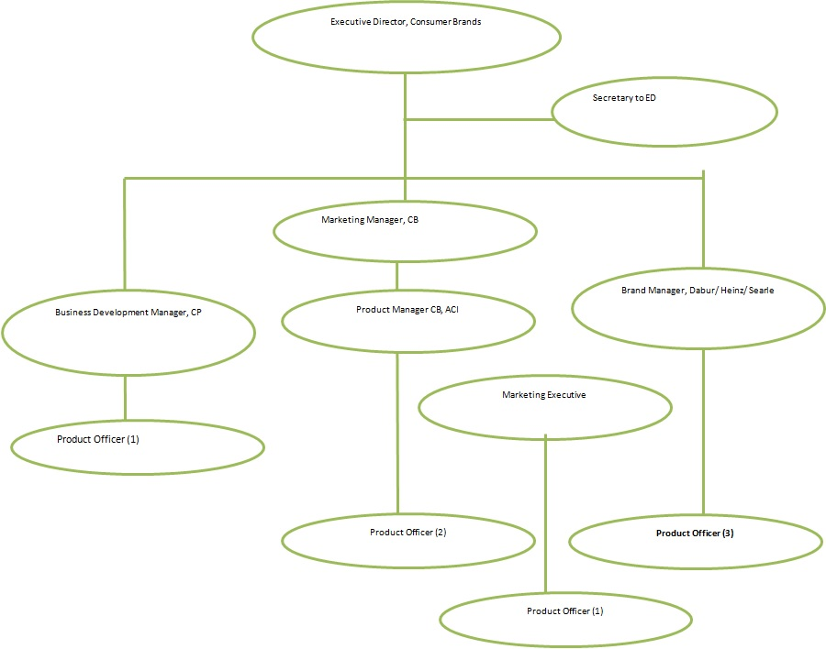

2.3 Industry Background:

2.3.1 History of Savlon Antiseptic:
ACI Limited has been manufacturing and marketing best quality antiseptic- Savlon with outstanding reputation and success for more than 25 years.
On May 22, 1992 Johnson & Johnson announced that it had acquired Savlon OTC brands from ICI. To date, Johnson & Johnson still manufactures and distributes Savlon products throughout Sub-Saharan Africa, while ITC acquired Savlon along with Shower To Shower brands from Johnson & Johnson in India. Also in 1992, ICI then sold its rights to an ICI Bangladesh Manufacturers Limited, which is now known as ACI Limited.
Savlon Antiseptic is one of the key brands in the ACI Consumer Brands portfolio. It is the brand leader of the antiseptic market and is a combination of Chlorhexidine Gluconate or Hydrochloride with Certified. Savlon’s unique features in terms of skin tolerance, efficacy, pleasant smell, cleansing property and the effective promotion gave the product market leadership. In Bangladesh Savlon antiseptic is available in two forms: liquid and cream.
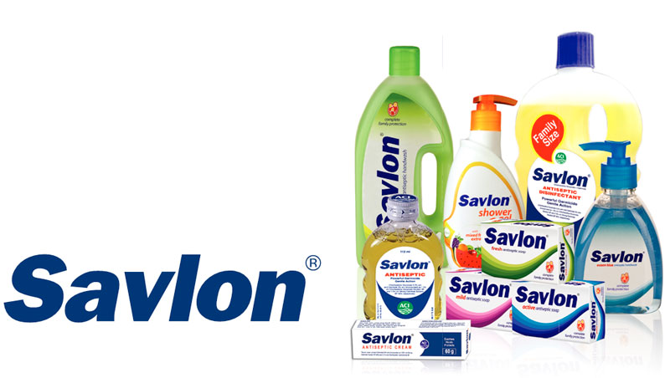

The Bangladesh marketplace for antiseptic is valued at Tk.120 million per annum in 2002. & day by day it’s increased. Savlon is now in the matured and slow growth stage. Savlon maintains about 74% of the total antiseptic market where Dettol maintains about 23% of the market. The market had a growth of 10.5% (ORG- MARG- QUEST) in 2002 where Savlon is growing at 12% on an average. But in 2002, Savlon enjoyed a growth of 20%, which is quite extraordinary.

Savlon’s main competitor Reckitt Benckiser’s Dettol maintained about 23% market share up to 2002. Dettol was once the market leader and is also available in Cream and liquid forms with different pack sizes. Dettol liquid has been available for more than 40 years. Recently Savlon’s competitors have been increased by the introduction of Kevil on (Cream and Liquid) and Hyginol from Opsonin Pharmaceuticals and Millat Chemicals respectively.

Savlon Cream was the undisputed leader of antiseptic cream market even a two years ago. At the beginning from some years Savlon Cream faced a major problem in market place, when some bad odorous product were found floating in the market and the producers of Savlon Cream were forced to withdraw their product from the market for a couple of years. Meanwhile, Hyginol and Kevilon, two new entrants entered the vacant market and took most of the market share in the barbershops, chunk users of cream, with gorgeous price and other offerings. Although later Savlon Cream reentered the market with improved quality and new packaging and rescued a important segment of the market but it is yet to regain its past dominance.
Considering the above situation, ACI Consumer Brands decided to conduct a market survey on the antiseptic cream market. The primary objective of this survey will be to get a clear picture of the buying & using pattern of antiseptic cream in the barbershops along with the profile (business, socio-economic, geographical and behavioral) of the barbers. Here special emphasis will be given to the reasons behind switching from Savlon and purchasing the existing brand. The survey will reveal how much of the market share Savlon has lost in the Cream segment and measures needed to overcome it. The secondary objective will be to know the uses pattern of liquid antiseptic in the barbershops.

2.3.2 Overview of Savlon Antiseptic:
The Antiseptic cream market of Bangladesh used to be dominated by only Savlon with a strong brand positioning. Savlon is still a market leader in some specific category as like Business to consumer (B2C). But the Business to business (B2B) market of Savlon is shaking because of a low priced antiseptic cream. This Antiseptic cream industry consists of only two products. One is Savlon and another one is Hyginol, which is the most known brand in antiseptic market.

Savlon Antiseptic has create a great impression in market & also became the market leader SAVLON has almost 74% market share with Antiseptic cream and 79% market share with In the liquid antiseptic category . The Antiseptic liquid market consists of two products. One is Savlon and another one is Dettol. Savlon is the market leader in the antiseptic liquid sector. Savlon Antiseptic Liquid is doing well in business to business sector. Those brands are captured whole antiseptic market and they doing business well.

2.3.4 Antiseptic Range:
ACI’s Flagship brands Savlon has two categories in its antiseptic range the Antiseptic creams and the Liquid Antiseptics & both are very preferable by consumers. In both categories it’s the undisputed market leader, holding 72% and 75% market shares in corresponding segments. As the competition lags furlongs in its wake the antiseptic range is still not about to give any improvement to anyone, as it strides to make the people of Bangladesh germ free.
2.2.5 Antiseptic Cream:

In the Antiseptic cream category SAVLON has 2 SKUs/ Packet in 30 gm and 60 gm pack. .Savlon Cream provides germ protection. It treats any wound in the skin and helps to heal the wound quicker by speeding-up the 3 phases of wound closing- Inflammation, Tissue Formation and Tissue Remodeling. It serves the dual purpose of soothing the skin and providing protection against germs as well. Every hospitals & salons where comes the terms Hygine they use Proffered Savlon.

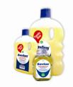
2.2.6 Liquid Antiseptics:
In the Liquid Antiseptic category, SAVLON has 5 general SKUs of differing pack sizes: 56 ml, 112 ml, 500 ml, 1000 ml and 5000 ml. 5000ml is specially design for hospital purpose. They used it many time in a days for surgery equipment wash, clean the floor. So mini size are became costly & also create a hassle that’s why this big cane 5000 ML is preferred for hospital and also industrial purpose.

Another part of the ever growing and glowing family of Savlon is its First Aid Kit & Box. As we look to fulfill your needs for personal safety and Hygiene.
2.2.7 First Aid Kit:
SAVLON has Antiseptic Bandages in the first-aid category with a 100 pcs and 40 pcs box size with attractive design for kids. Those are available in every medicine shop. The design two types of Bandage. One is for everybody which is normal looks & another is for kids. We know that kinds are not interested when occur any incident that’s why this product design with different cartoon print which attract the kids, & kids are happy to use this product.
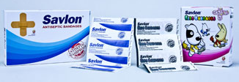
2.2.8 Competitor Analysis:

Table showing the competitors of Savlon Antiseptic cream and Savlon antiseptic liquid. There present Hyginol, Genester, Saloon as competitors of savlon antiseptics cream & Dettol, after save lotions, Fitkiri as the competitors of savlon antiseptic liquid.
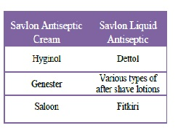

2.2.8.1 Antiseptic Cream:

The only competitor of Savlon antiseptic cream is the Hyginol. It is widely used by the Berbers, but not by the general people. Hyginol is the product of the Millat Group.


The Strategies of the Hyginol are:

- The Low Cost Strategy.
- Intensive distribution.
- Due payment.

2.2.8.2 Antiseptic Liquid:

Dettol is the main competitor of Savlon in Antiseptic liquid sector which introduces by Reckitt Benckiser in BD. Dettol is the world leader for antiseptics. It is Captured 37 countries in the world. But in Bangladesh scenario is different, here Savlon antiseptic liquid is the market leader.

Dettol is the most common name for a line of hygiene products manufactured by Reckitt Benckiser. When come the gossip about antiseptic liquid everybody also remember another brand name is DETTOL. The brand started its fight in 1933 as antiseptic liquid, but over the years, it has been extended to a number of product classes which are much valuable for consumers like soaps, liquid Hand wash, liquid Body wash, shaving Cream and plaster strips. Currently Dettol has its different alternatives available in the market. Original Soap, Skincare Soap, Cool Soap & Re-Energize Soap are the running variants of Dettol soap range.
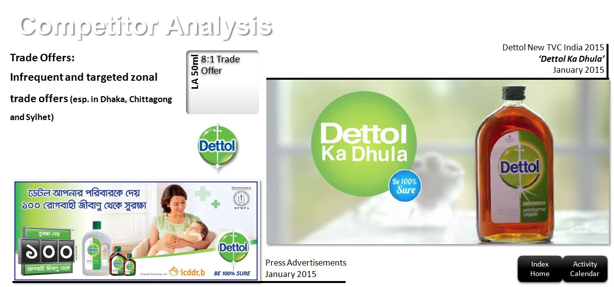

Marketing strategies of Dettol soap in Bangladesh (Recently coped) :

- Dettol is using the signage. They are providing non lit billboards to the pharmacies and the retail stores.

- Although the biggest market for antiseptic liquids is the hospitals and clinics, they are mainly targeting the general people.
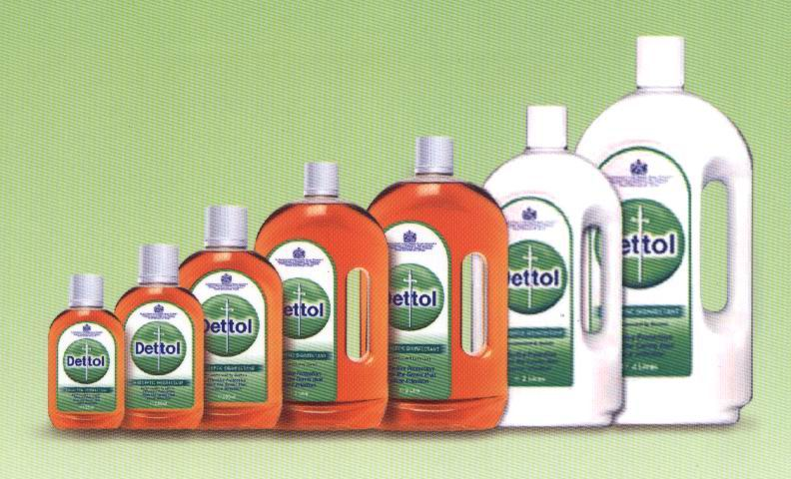

2.2.9 SWOT Analysis of Savlon Antiseptic Cream and Liquid:

Savlon Antiseptic cream and liquid is the leading brand in the antiseptic cream market. There are present some few players in the competitive market but all are very strong. Dettol has been trying to capture the liquid antiseptic market. But Savlon antiseptic liquid has captured the main market-hospitals. Because the market is not fully saturated & Savlon know the way for capturing this opportunities. In this existing market Savlon Antiseptic has some strengths, weakness, opportunities and threats as well as others competitors, such as:

2.2.9.1 Strengths:

Savlon Antiseptic Cream is the best antiseptic in terms of quality. And it has the brand name of Savlon, which is well known for protecting and fighting against germs for years. Savlon liquid Antiseptic is the number one brand in Bangladesh. It has a great brand value in terms of reasonable price, quality & availability. For its wide distribution network customer can reached easily.

2.2.9.2 Weaknesses:

For last few years, Savlon antiseptic cream has no direct marketing activities towards its targeted consumers which became a big reason of losing the market share. They place many advertisements in several magazines and business papers which are not enough for survive in this competition. But Recently they are not doing any sales promotion which are consumer targeted rather they are doing BTL promotions. They take many steps for promoting their brand in market. They clearly understand that if they do not communicate with the end consumer’s sale volume will not raise. The Sales force of ACI is not effective enough to go to the door steps of the saloons which is the main key to attract a big portion of consumers. on the other hand others competitors take many steps for capturing markets such as, gift items for retailer, give time to pay the bill, discount offer, that’s why many retailers are preferred others brand for some extra benefits.
Here is a graphical representation of SOWT analysis of Savlon Antiseptic:

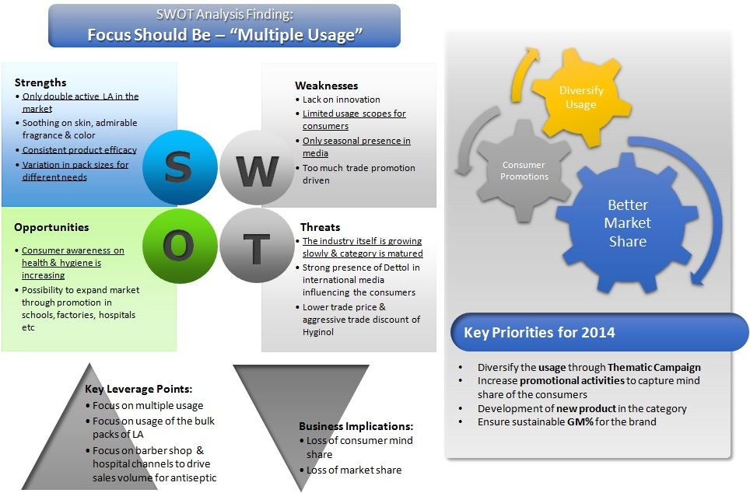

2.2.9.3 Opportunities:

Savlon antiseptic have a scope in future of capturing the market as a good competitor. Because it’s been only few years that mass saloons have accepted and started to use Hyginol antiseptic creams for their use. People are becoming more wellbeing conscious because of the increasing contamination. Now Mothers are more concerned about their kid’s hygiene, that’s why antiseptic soap have a great potential opportunities to capturing the market in wide range in future.
Now a day where COVID-19 have a wide range of risk, for realizing this risk initial steps is be clean all-time. So that hand sanitizer have also a wide market for make profitable. Because when it will be over companies can promote awareness promotion for regular use of sanitizer.

2.2.9.4 Threats:

The main competitor Dettol is the worldwide market leader of antiseptic Liquid. It is a Strong competition for Savlon antiseptic also quite tuff to fight with Dettol. Dettol Captured the maximum market share with their brand value & communication skill. Combating with Dettol original antiseptic is a great warning.

Day by day products option are increase. Hand wash is the alternative option & easy for use of soap bar. Antiseptic is a Convenience product. When people were aware of the Savlon Antiseptic, it will be easier to create a customer loyalty towards the brand. on the other hand others participants take scope steps for apprehending markets such as, gift items for retailer, give time to pay the bill, discount offer, that’s why many retailers are chosen others brand for some extra paybacks. Those reasons are savlon face in market as threats.

3.0 Objective and Methodology:

3.1 Objective of the report:

3.1.1 General Objective of the report:
- This internship report is primed primarily to fulfill the partial requirement of the Bachelor of Business Administration degree.
- To determine the market share that Savlon Cream has missing in the barbershops, reasons behind it and the ways to regain Savlon's dominance.

3.1.2 Specific Objective:
More specifically, this study entails the following aspects:
- To give an overview of ACI Ltd, essentially of Consumer Brands sector.
- To focus on Managing a Brand in a Competitive Market “Savlon Antiseptic”(Case study on Antiseptic Cream) with analyze their Value Chain.
- Comprehend their Supporting & Primary activities.
- To Identify the Firm Infrastructure where include Company Management, Finance, Legal & Planning.
- To Identify the Human Resource management (HRM) of ACI Ltd.
- To identify their technology development (IT) & Procurement process.
- To identify their inbound logistic that means Raw materials purchase to where house all procedure.
- To determine their wide operations.
- To identify outbound Logistics (Production to delivery) of ACI Ltd.
- To identify the Customer service which happened through product delivery period and after sales for getting customer satisfaction 7 make them loyal.
- To identify their marketing & sales activities. How they analyze the market, their promoting activities, sales procedure, customer service etc.
- To find out the various types of antiseptic cream and liquid antiseptic used by the barbershops.
- To find out the frequency of purchasing antiseptic cream and liquid antiseptic by the barbershops.
- To find out the different sources of purchasing antiseptic cream and liquid antiseptic by the barbers.
- To find out the preference of barbers for various pack-sizes while purchasing antiseptic cream and liquid antiseptic.
- To determine the intensity of barber’s preference for specific pack-size.
- To find out the price sensitivity of barbers while purchasing antiseptic cream and liquid antiseptic.
- To determine the intensity of barber preference for brand loyalty.
- To determine the customer preferences for any specific antiseptic cream and liquid antiseptic.
- To find out the level of emphasis given to customer choice by the barbershops in case of preferring any specific antiseptic cream and liquid antiseptic.
- To determine the intensity of quality parameters that influence barbers to purchase antiseptic cream and liquid antiseptic.
- To determine the intensity of different uses of antiseptic cream and liquid antiseptic by the barbers.
- To find out the frequency of purchasing earlier brand antiseptic cream and liquid antiseptic by the barbers to compare intensity.
- To find out the impact of any sort of promotion on barbers to purchase antiseptic cream and liquid antiseptic for their barbershop.
- To find out the TV watching habit of barbers for promotional purpose of antiseptics.
- To find out the radio listening habit of barbers for promotional aspect of antiseptics.
- To find out the newspaper reading habit of barbers for promotional purpose of antiseptics.
- To determine the profile of barbershops using leading brand of antiseptics.

3.2 Methodology of the Report:

3.2.1 Types of data:
Good research work demands that information, which is likely to have influence on the research objectives, is collected from all valid sources and is duly considered. This ensures that the outcome of the research is not biased, all the possible limitations are catered for and findings truly represent the practical market scenario. The following paragraphs show the differen^{t} types and sources of information, which were used in the process of carrying out my research.
- Primary data: For primary data gathering, I collect information from marketing principal books (also my educational knowledge), Asked from employee & supervisor of my workplace, Took help from different department such as Marketing, sales, HR, Accounts & Finance. Also I have used pre-prepared Questionnaires to conduct a consumer survey for comprehend the market position in current situation. The survey was done within a number of 357 samples. We cannot fulfill our target for survey just of our ECO give as a time schedule. If I get more 10 days we should survey on 500 samples. I have also interviewed the respondents to collect the qualitative data.
- Secondary data: I used some related journals, related websites, newspaper and some Previous works of others to get ideas as collecting the secondary data. Also get lots of ideas from company annual reports & also from my supervisor.

3.2.2 Data Collection Instruments:
For data collection, I used one to one conversation, previous record searching & structured questionnaire. I have used only one set of questionnaire for the barbers. These are included in the Appendix B of this paper.

3.2.3 Data Collection Techniques:
I used Door-to-door personal interview for data collection purpose. Both barbershop owner and barbershop employee was interviewed using door-to-door technique. Moreover, I visited 357 barbershops to collect these data.

3.2.4 Data Analysis Technique:

I used both qualitative and quantitative data analysis techniques in my study. For quantitative data analysis, I used multivariate data analysis technique.

4.0 Limitations of the Study:

- Adequate efforts have been made to prepare this report. But since ACI is a vast company, knowing its full operations is a difficult task. Therefore I had to make my report limited to Savlon Antiseptics Cream of only the Consumer Brands division.

- Also a lot of my time was spent on market visits and therefore experience about product and interaction with other employees has been limited.

- Finding out the work experience of majority of the employees would have strengthened the value of this report.

- Time limits: I had to make this report sideways with the job responsibilities of my internship. They are not give extra single day for complete the report courteously .For that cause there was create a time crisis for me.

- Maximum Saloon owners were not present at the time of the survey.

- It was a challenge to meet the managers of the clinics and the hospitals.

- Don’t have enough financial support for local convince for collecting the data.

- Faced many unexpected behavior when asked questions for survey (we also have not any ID card of ACI lt.

- When we faced embracing situation we didn’t get any support from ACI.

For those reasons we can’t get more information from market, so that those are the most barriers or lacking for us that we think.

5.0 Value Chain:

5.1 Definition Value Chain:
A value chain is a model of business that describes the full range of activities which needed for products & Services. Every company need to create a Value Chain to doing all the internal & external activities. In value chain includes Primary & Supportive activities where includes all the activities like: Raw material management, Financing, Planning, management, Distribution, Marketing & sales. Value chain helps the organization in production to sale also helps in make employee effective & efficiency, cutting production cost, market share captured as well as reach the targeted customer. In a word whole operation of a company summarized in value chain. Value-chain analyses is increase production efficiency so that a company will able to deliver maximum value for the least possible cost.

5.2 Understanding Value Chains:
A value chain help an organization in many sectors of its business that are inefficient, then implement strategies that will optimize its procedures for maximum efficiency and profitability Because of ever-increasing competition for unbeatable prices, exceptional products, and customer loyalty, companies must continually examine the value they create in order to retain their competitive advantage.

5.3 Components of a Value Chain:

3.3.1 Primary Activities:
There are present some component of primary activities, such as:
- Inbound logistics: activities like getting, warehousing, and managing inventory well.
- Operations: Process of converting in finished product from raw materials.
- Outbound logistics: Activities for delivering final product to consumer.
- Marketing and sales: Taking Strategies to enhance visibility of brand and target appropriate customers through advertising, promotion, and pricing.
- Service: Maintain products, educate consumer and enhance consumer experience—customer service, maintenance, repair, refund, and exchange.

3.3.2 Support Activities:
Support activities help to make the primary activities more efficient. When increase the efficiency of any of the four support activities, it benefits at least one of the five primary activities. Supportive activities are generally denoted as overhead costs on a company's income statement:
- Procurement: How a company obtains raw materials perfectly.
- Technological development: Used at a firm's research and development (R&D) designing and developing manufacturing techniques; and automating processes.
- Human resources management (HRM): Hiring and retaining the right person in right place in right time; and help design, market, and sell the product.
- Infrastructure: Company systems and composition of its management team like—planning, accounting, finance, and quality control.
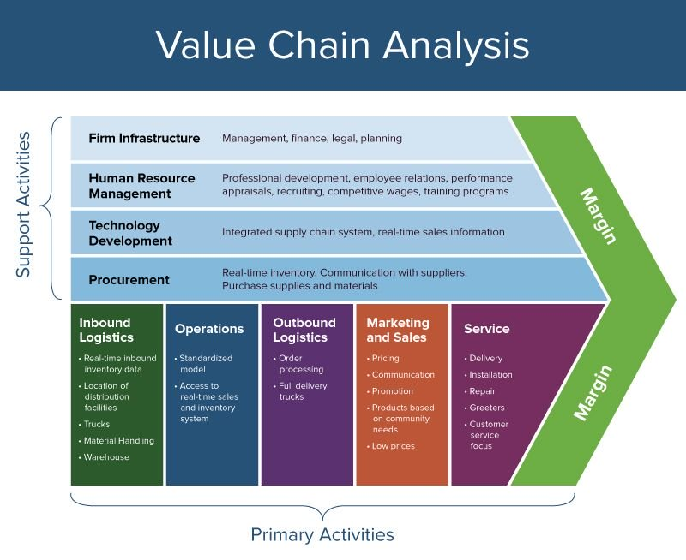

5.4 Value Chain of ACI Ltd:
For describe the Value chain of consumer Brand, ACI Ltd we should Explain About two activities which are the two component of Value Chain, Such As:
- Primary Activities &
- Supportive Activities.

5.4.1 Primary Activities:
All five primary activities are essential & those activities run Consumer Brand of ACI Ltd for adding value and creating a competitive advantage. ACI Ltd Follow a structure of Primary Activities or can say supply chain structure to manage business & Create Customer Value. We should describe the whole Supply Chain Procedure part by part to explain the Primary Activities of Value Chain of ACI ltd, Consumer Brand.
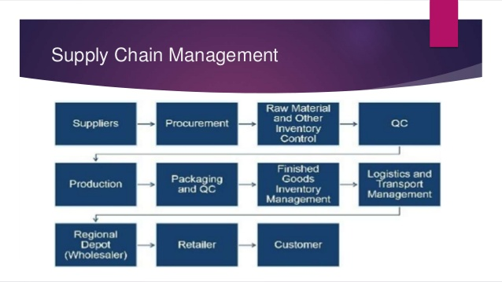
Total Supply Chain Process of ACI Ltd, Consumer Brand

5.4.1.1 Inbound logistics:
Inbound logistic includes arranging the inbound movement of materials, parts, and/or finished inventory from suppliers to manufacturing or assembly plants, warehouses, or retail stores. Here they follow a process of Value Chain, like:

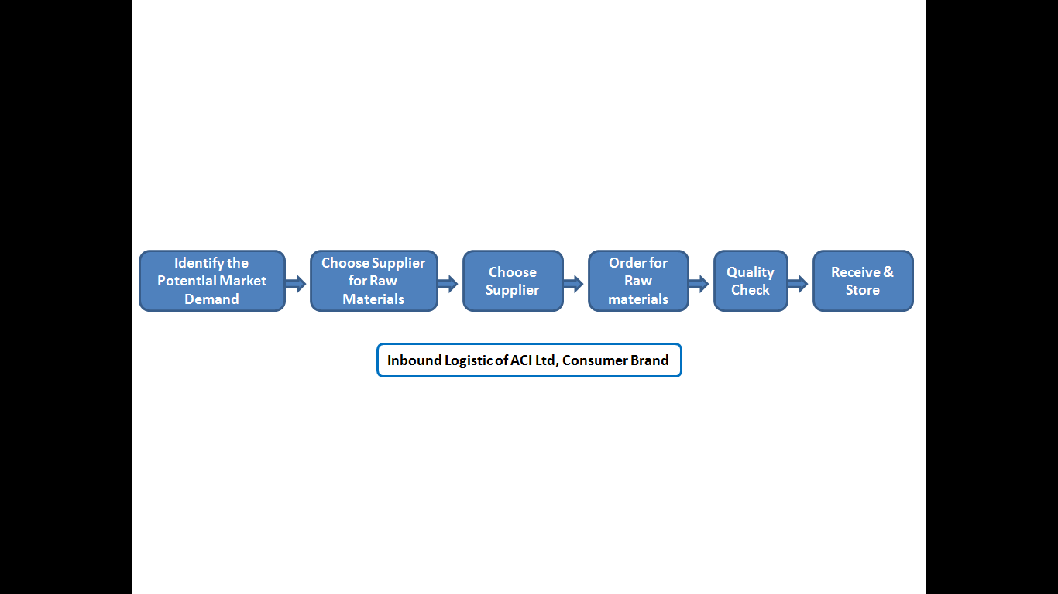

- ACI Ltd, Consumer Brand First Identify Their Potential Demand of Market through their sales team. Sales team identifies it through retailers Demand/Order.
- Every Company has more than one vendor to purchase raw materials. ACI Consumer brand has also many vendors who are the suppliers of Raw Materials. When Requirement Rise they Communicate with the suppliers for Raw Materials (Suppliers Select for a Fixed Time). Who can give the best price with a Short Period they select & place the order.
- When Suppliers Send the sample ACI checked it like QC also this checking procedure happened when the final raw Materials shipment came.
- If Pass the QC then all Raw Materials Store in Where House. Some Time it Directly Moved in to Factory.

5.4.1.2 Operations:

Concerned with managing the process that converts inputs (in the forms of raw materials, labor, and energy) into outputs (in the form of goods and/or services).
- In Operation Sector They Manufactured all the Product With maintain The Quality/Standard.
- Factory In-charge Handover the materials & Give Target for quantity of Production.
- Floor In-Charge Follow-up Whole Period of Production.
- After ending the time of Production Period they packaging all the product & Handover to In-Charge & they check all things.

5.4.1.3 Outbound logistics:
Is the process related to the storage and movement of the final product and the related information flows from the end of the production line to the end user.
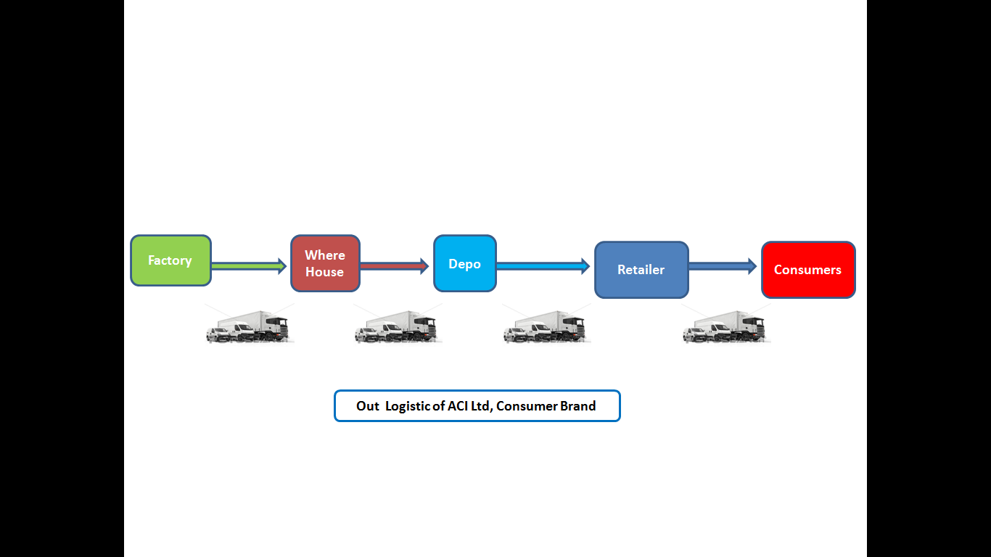

5.4.1.4 Marketing and sales:
Selling a products and processes for creating, communicating, delivering and exchanging offerings that have value for customers, clients, partners, and society at large.

For understanding marketing & sales need to describe some important things of product such as: Pricing, Communication, promotion, Products based on community needs & low price. Now we describe about the marketing mix for fulfill those criteria’s.
The marketing mix is a business tool used in marketing and by marketers. The marketing mix is often crucial when determining a product or brand's offer, and is often associated with the four P's: price, product, promotion, and place.

5.4.1.4.1 Product:

- Product Attributes:

- Product Differentiation:
Savlon Active Soap is an antibacterial soap which is produced from finest quality ingredients that makes it only among the very few Grade 1 (TFM > 78%) bar soap in the market. The soap has antibacterial agent which ensure that it will be protect from all germs & it’s safe. Another shop are help for clean the hand & body but savlon antiseptic soap here create the product differentiation that is , it not only clean the hand or body instantly but also protect from germs for a long time. ACI successfully doing this & distribute in whole Bangladeshi market.

- Product Classification:
As a product, Savlon classified in 3 levels:
- Core Benefit: it is the fundamental level. Benefit or the service that the consumer is really buying, or got the exact things from product which consumer want. For Savlon, the core benefit is Cleansing with germ protection.
- Actual Product: The tangible and physical benefit of the product. For Savlon the actual product is the Germ Killing Property, The better Quality and well wrapping.
- Augmented Product: Sometime companies deciding to add the additional non tangible benefits with products. For Savlon Antiseptic the augmented product is: the brand value, The Culture of the Savlon Brand in the Consumer Observance is the augmented product for Savlon.
- Branding:

Branding is a big fact for every products & services, the product contains the brand name of Savlon Antiseptic and the slogan of the brand is: Complete family protection. Everyday protection from germs.is the slogan of Savlon Antiseptic soap.

- Packaging and Labeling:

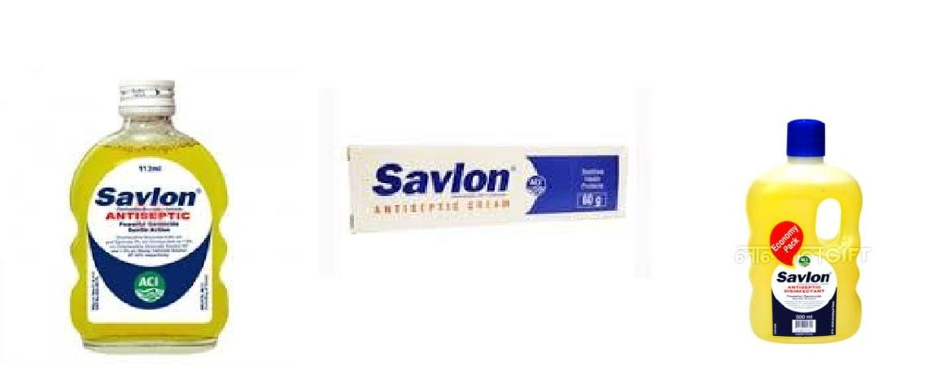
For promotional activity the packaging of Savlon soap has a foremost role. As it is an impulse product, people will buy it for its quality as well as its packaging. Its packaging carry: Company Logo, Brand name, Product Name, and Brand Mnemonic. Also has Product descriptor, Branding evidence, Product name, Product descriptor, Description of procedure of use, Notice against contact, Declaration of Price, Use of Product, Manufacturer and Marketer’s name, Barcode, Legal copy, trademark, etc., Best before/date coding, Weight declaration/quantity on its body, which helps customer to get the actual description of product.

- Production:

TABLE 6: Production of Savlon Antiseptics (Cream and Liquid)
Particulars | LA– 56ml | LA-112ml | LA–1L | LA–5L | HC–5L | AC-15g | AC-30g | AC-60g
Batch Size | 2000 L | 2000 L | 2000L | 2000L | 2000L | 400 kg | 400 kg | 400 kg
Avg. Output/ Batch | 35,000 | 17,000 | 2,000 | 400 | 400 | 26,000 | 13,300 | 6,650

5.4.1.4.2 Price:
The various prices of Savlon Antiseptics according to the pack size are shown in table:

Product | Pack Size | DP | TP | MRP
Savlon Antiseptic Cream | 30 g | 21.40 | 22.30 | 25.00
Savlon Antiseptic Cream | 60 g | 29.35 | 30.30 | 34.00
Savlon Antiseptic Liquid | 56 ml | 25.50 | 26.50 | 30.00
Savlon Antiseptic Liquid | 112 ml | 34.80 | 36.00 | 40.00
Savlon Antiseptic Liquid | 500 ml | 108.50 | 112.00 | 125.00
Savlon Antiseptic Liquid | 1 liter | 191.00 | 197.00 | 220.00
Savlon Antiseptic Liquid | 5 liter | 615.50 | 635.00 | 710.00
Savlon HC | 5 liter | 1562.40 | 1607.40 | 1740.00

5.4.1.4.3 Place:

ACI ltd has a wide distribution network for this they doing their business well. They are almost cover whole Dhaka city, also most of the outside district of Dhaka. But till can’t cover whole the country. They have not any distribution network in many city in outside of Dhaka because of these people are not familiar with those types of product because of they are not so much educated. Those people are used powder alternatives of paste. So it’s simple that they are not educate about any hygiene product. But on the other hand Savlon cover those areas which are more profitable & have access to distribute the products, Such as:

Distribution points (Regional):

Savlon set their distribution points in, Dinajpur, RangpurF aridpur, Jossore, Khulna, Maijdi, Sreemangal, Sylhet, Chittagong, Bandarban, Cox’s Bazar, , Bogra, Rajshahi, Maymensingh, Tangail, Gazipur, Dhaka, Narayangang, Comilla, Kustia,

At first they manufacture/ready the product in factory, then half products are send in to distribution points, retailers are got the products from distribution channel and they get the product from distribution point. Another half quantity company store in their depo. ACI has their own vehicle which are distribute the local retailer shop. They collect the required product from depo.

The distribution flow is shown by a flow chart below. And the distribution channel is shown by a map bellow:
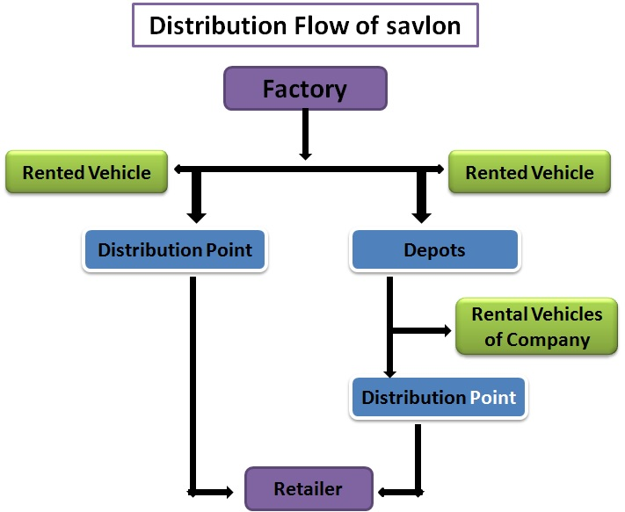

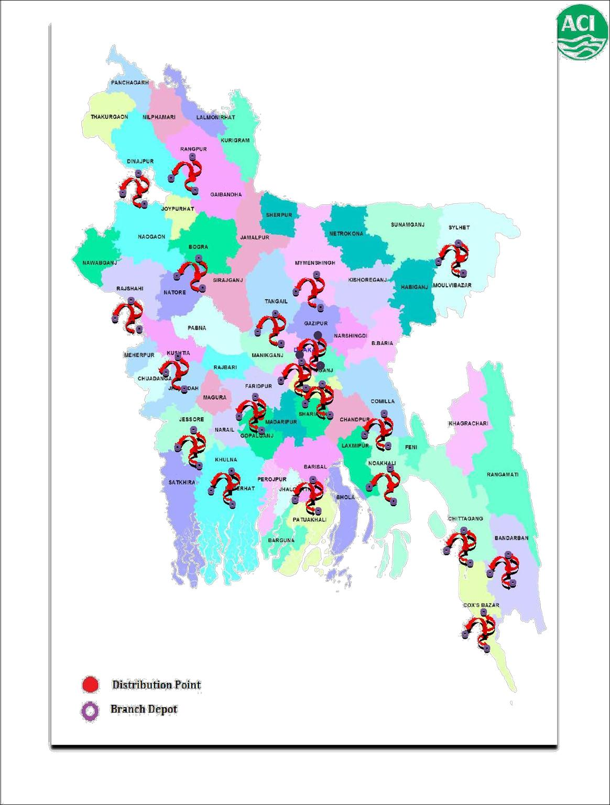

5.4.1.4.4. Promotion:

Savlon cant published anytime any add for their promotion in any TV channel because of when Savlon want to publish any types of add they want to need permission from Bangladesh Drugs Administration & it’s quite tuff & have to face lots of procedure which are so tuff. Recently they published a billboard add and as early as possible they will Published their TV commercial. Savlon Antiseptics have not any recent TV commercial or any kind of sales promotion. For past few years ACI is doing BTL (Bellow the Line) promotion in many district and in many areas. Their most of the advertise are targeted the customers not the consumers. They offered the retailers various types of trade offer & commission. The target is that, soap is a moderate to low involvement product. Because of maximum time consumer purchased the product which suggest the retailer, that’s why ACI try to increase the retailers to enforce the customer to buy Savlon.
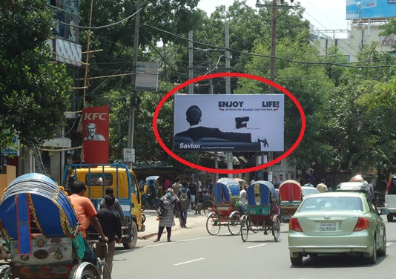
Recent Billboard Add:

Others Promotional activities:
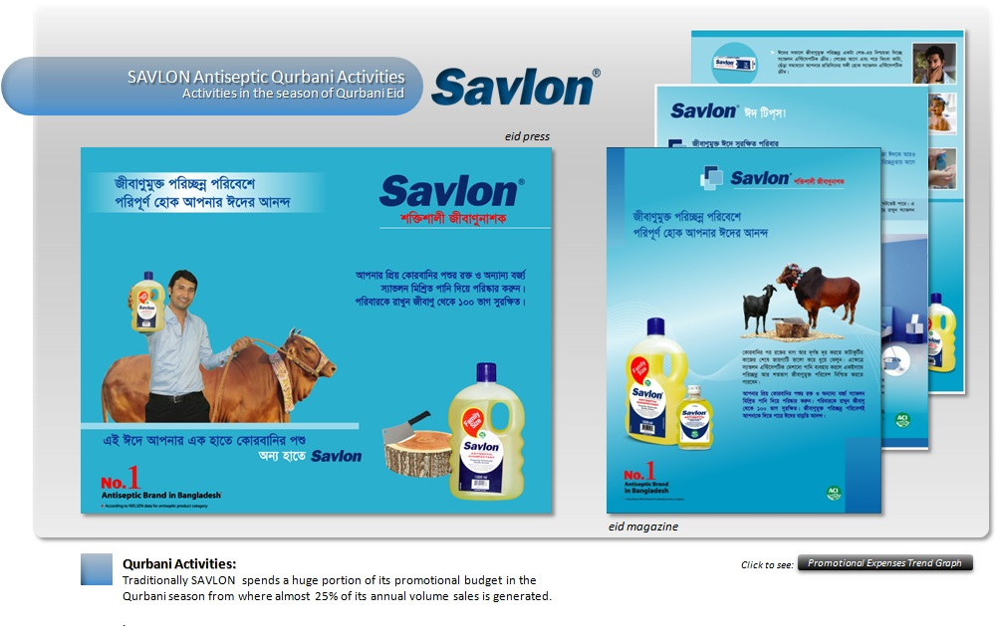
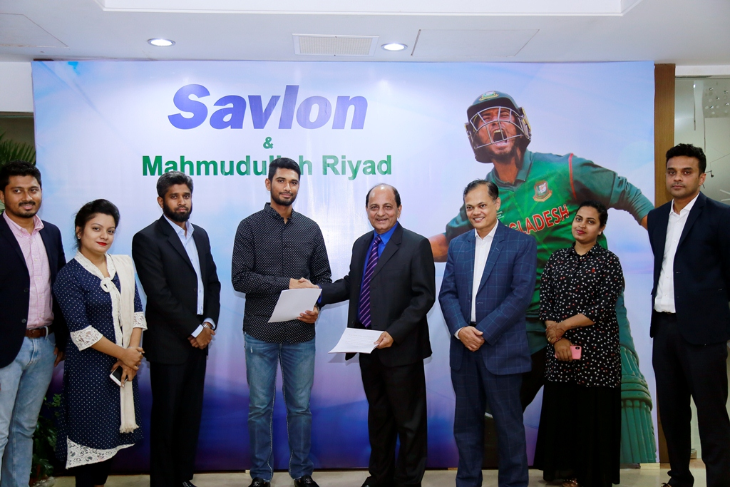

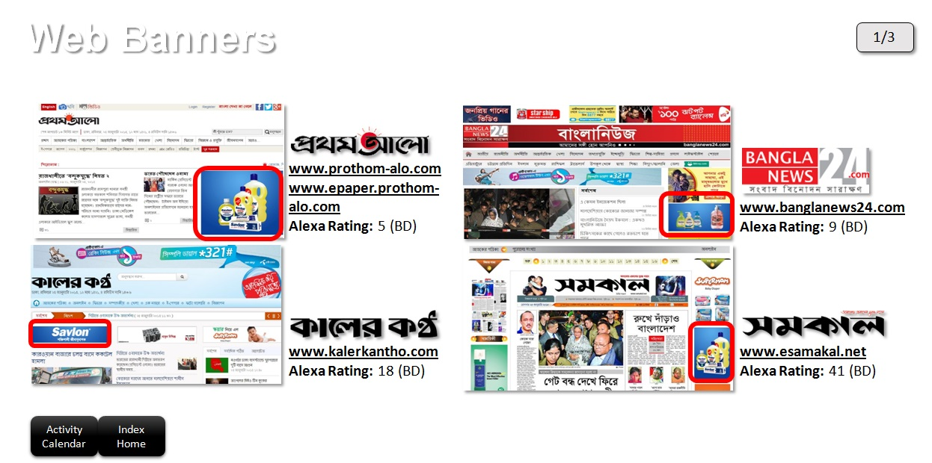

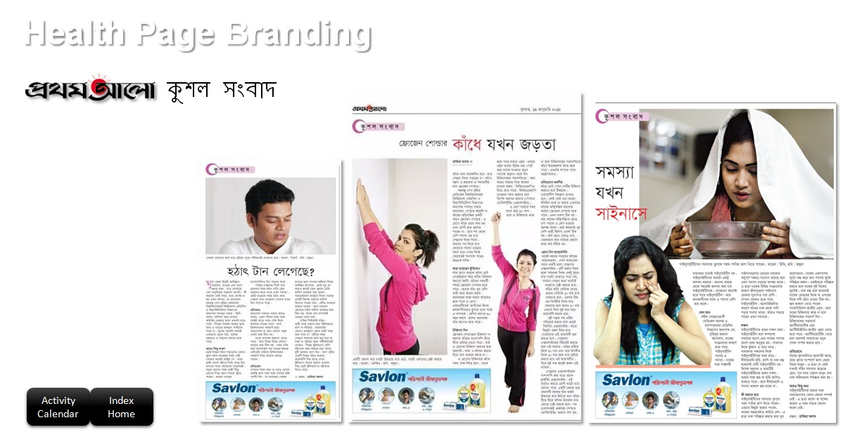

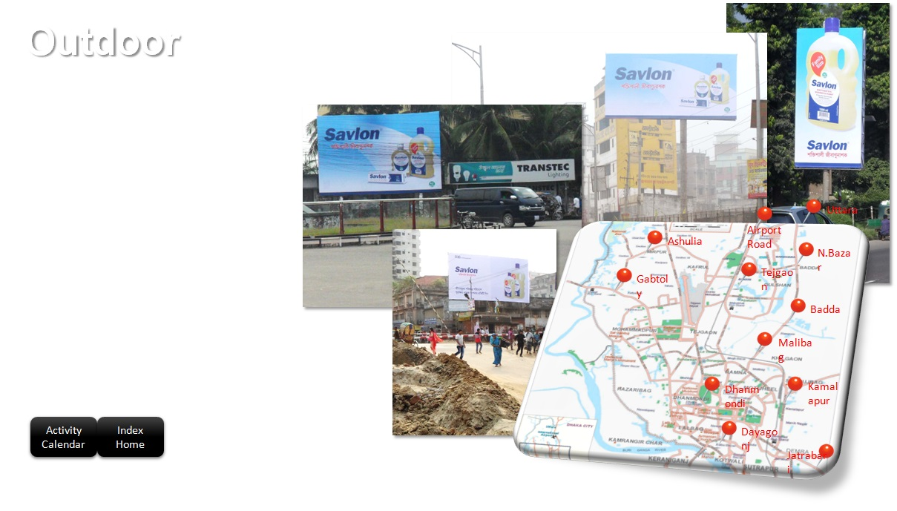

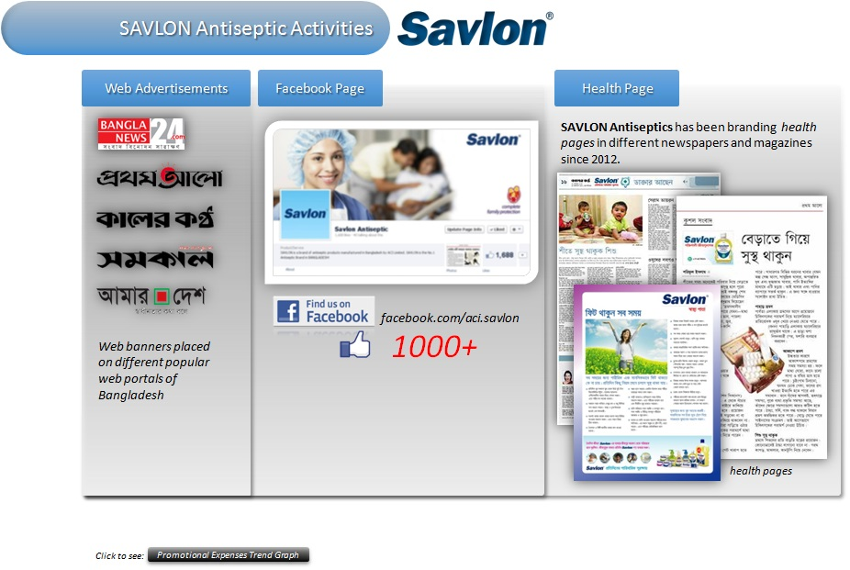

5.4.1.5 Service:

Service where included Delivery, repair, installation, greetings & after sale service, those all are not applicable for Savlon. For service section they just focus on frequent delivery get customer satisfaction. For handling there on time delivery they work hard on their supply chain process, which we describe in supply chain part. ACI give more focus on product manufacturing to deliver the final product to final consumers.

5.4.2 Supportive Activities:

For creation value need to build up the supporting activities where include Firm Infrastructure, Human Resource Management, Technology Development & Procurement. Savlon, ACI Ltd also has those things & they build that segment for run the company smoothly.

5.4.2.1 Firm Infrastructure:
In firm Infrastructure Company set their Management, Financing, and planning .Savlon, ACI Ltd has also their management team, financial planning & Resource, Mission, vision & Goal as planning. Now we describe the While firm infrastructure of Savlon, ACI Ltd.

3.4.2.1.1 Executive Management:

Figure: Executive Management of ACI

5.4.2.1.2 Financing:
Now ACI Ltd have total 1,800,000,000 capital & total 55, 88, 95,270 shareholders. Shareholders are a big source of managing capital on the other hand bank loan also helps to manage the big size of capital in any emergency situation.

5.4.2.1.3 Legal:
ACI always follow their principle for run the business. They have their policies/ principle & they do their all work & procedure on the base of those policies.

5.4.2.2 Human resource Management:

ACI have a different Human resource Management department whose are manage every things for hire t to fire the employee. For manage their whole procedure they have a planned structure for manage the employees.

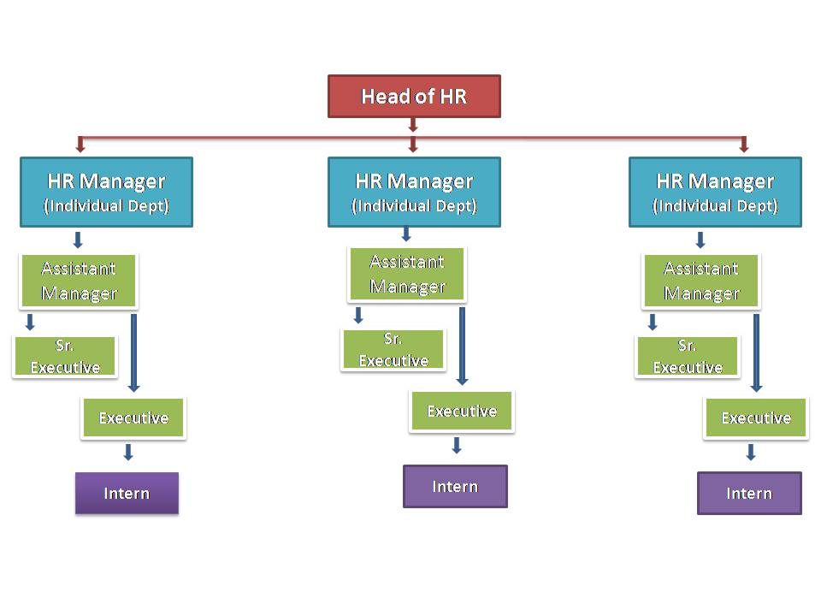

5.4.2.2.1 Vacancy Analysis:
HR teams identify the need of recruitment of new employee through management. When product line, outlet, sales volume 0r new project increase then also need to hire more employee for run the business. When raise the need of new employee management employee knock the HR department then they doing the other procedures.

5.4.2.2.2 Job Vacancy Declaration:
After recognize the need they try to hire the employee from two ways, such as:
- Internal Recruitment.
- External recruitment.

5.4.2.2.3 Recruitment:

1st they try to hire employee internally through reference or promoting any employee. If they can do it or have chances then the hiring procedure is complete otherwise they go for new recruitment process that’s means external recruitment. When need external or new recruitment they follow a sequence, Such as:
- Vacancy announcement.
- CV Collection.
- CV filtering.
- CV Short listed.
- 1st Interview.
- 2nd interview.
- Selection
- Appointed.

5.4.2.2.4 Performance Appraisal:
Every fiscal year & Middle of the year HR team analyzes the performance of all employees. Through that they identified the effective, efficiency on the other hand week employees. On the base of this analysis employee get promotion also demotion.

5.4.2.2.5 Training:
Base of performance appraisal HR Team arrange a training season in every year. This training season for not only those employee whose are week but also some season for those employee how are doing well. They arrange training program for make the employee more effective & efficiency.

5.4.2.2.6 Promotion & Fire the Employee:
In every year employees get promotion, financial & mental motivation. On the other hand some employees are fired whose are failed to raise their performance after different types of motivational program, training program.

5.4.2.3 Technology Development:
If we say about anything of technological development ACI have a good IT department backup who’s are mange all the technological issues. They try to update their system every time.

5.4.2.4 Procurement:
For understanding the procurement of Savlon, ACI Ltd we will understand the supply chain part of ACI Ltd. They have a different purchase department for all kind of purchasing issues. When any demand/ Requisitation come from ay department they are starting their procedure. Procurement department complete their purchasing procedure by following some steps. Now we will describe the steps through chart.

5.4.2.4.1 Need Recognition:
1st Procurement department Need of purchase through Management, Tally software, sales team. Then they find the quantity that how much quantity need to purchase.

5.4.2.4.2 Quotation Collection:
Then they call all the vendors/Suppliers & collect the price (new quotation needed if the purchasing gap 5 to 6 months). Procurement department describe the entire requirement to vendors & asked for a best price from market.

5.4.2.4.3 Negotiate with vendors:
Then comes the negotiation part, when all the vendors submit their quotation. Procurement department try to collect the best price with other benefits, such as Quality, deadline, smooth delivery.
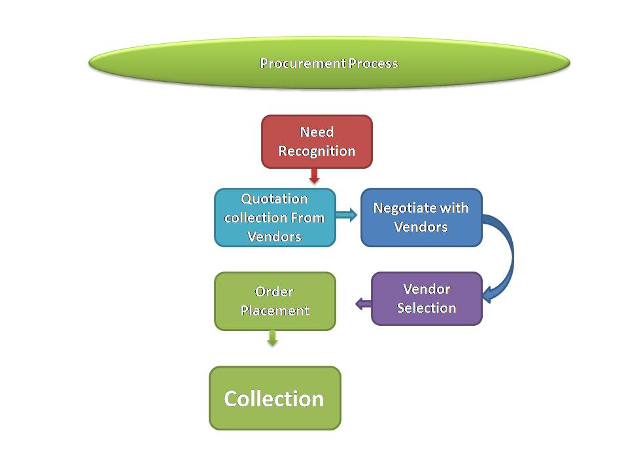

5.4.2.4.4 Vendor Selection:
Who can give the best price with others benefits they select this vendor with management concern.

5.4.2.4.5 Order Place:
After selection of vendor they place the order with a deadline & follow all the procedure for got the products/raw materials timely.

5.4.2.4.6 Collection the purchasing materials:
Procurement department finished their responsibilities with handling the all purchasing materials to stock management/ Factory.

6.0 Market position & Competitor Analysis:

For market & competitor analysis we are visiting different places inside & outside Dhaka with a standard question for survey. Everyone help us & try to help their best. The result is we get a scenario of antiseptic market which will help savlon team to applying any marketing or selling strategy for gain the more market share.

6.1 Result of Visits Saloons inside Dhaka:

6.1.1 Visited Areas:

- Nawabazar, Tatibazar, Patuatuli.
- Armanitola, Kosaitoli, Taramosjid, satroja.
- Babubazar, Badamtoli.
- Chakbazar, Bro/Chotokatra.
- Lokkhibazar, Akrampur, Dholaikhal.
- Jatrabari, Sanirakhra, Dhonia.
- R.K mission Road (Near motijil)
- Komolapur, Motijil.
- Mirpur 10- 12 (Pollobi)
- Uttor/ Dakkhin Khan.
- Muhammadpur.
- Bongshal.

6.1.2 Result of visited area by table:

- Red Table indicate that maximum market share & saloons captured by Hyginol.
- Blue Table indicate that maximum market share & saloons captured by Savlon.
- Green table indicate that Maximum saloons used Hyginol but they uses antiseptics savlon more than Hyginol when comes quantity.

- When we visit those Ares we try to found some things which are help to manage a brand in a competitive market, those things are:

- Price charged for shaving for identifying the category of the saloon for identify saloons category.
- Antiseptic Cream preference.
- Amount of tubes used per month or week.
- Antiseptic Liquid preference.
- Amount of usage per month or week.
- Most preferable Newspaper
- Favorite TV channel (if have any)
- Preferable merchandise which will motivate them (Barbers)
- purchase or use Savlon again and again (if already a consumer)
1. Report on Nawabazar, Tatibazar, Patuatuli:
Number of saloons  Visit | Numbers of saloon who are use S,H,B  Out of 12 | Most popular news paper in this area | Categories of saloons  Out of 12 | Quantities of Uses Savlon, Hygynol or both(Monthly) | Number of saloon who are uses (Liquid Savlon or Others) | Preferable gifts
12 | Savlon: 3  Hyginol: 5  Both: 4 | Bangladesh Protidin,  Jugantor,  SokalerKhobor | High: 2  Middle: 10  Low: 0 | Savlon: 17  Hyginol: 41  Both: 26  Total: 84 | Savlon: 6  Others: 6 | Sign board  Towel  Product  self

2. Armanitola, Kosaitoli, Taramosjid, satroja:
Total saloons | Numbers of saloon who are use S,H,B  Out of 14 | Most popular news paper in this area | Categories of saloons  Out of 14 | Quantities of Uses Savlon, Hygynol or both(Monthly) | Number of saloon who are uses (Liquid Savlon or Others) | Preferable gifts
14 | Savlon: 11  Hyginol: 2  Both: 1 | Bangladesh Protidin, | High: 4  Middle: 10  Low: 0 | Savlon: 83  Hyginol: 17  Both: 12  Total: 112 | Savlon: 5  Others: 9 | Sign board  Product  Decoration

3. Babubazar, Badamtoli:
Total saloons | Numbers of saloon who are use S,H,B  Out of 8 | Most popular newspaper in this area | Categories of saloons  Out of 8 | Quantities of Uses Savlon, Hygynol or both(Monthly) | Number of saloon who are uses (Liquid Savlon or Others) | Preferable gifts
8 | Savlon: 0  Hyginol: 8  Both: 0 | Bangladesh Protidin, | High: 0  Middle: 5  Low: 3 | Savlon: 0  Hyginol: 91  Both: 0  Total: 91 | Savlon: 0  Others: 8 | Sign board  Product  Decoration  Apron

4. Chakbazar, Bro/Choto katra:
Total saloons | Numbers of saloon who are use S,H,B  Out of 8 | Most popular newspaper in this area | Categories of saloons  Out of 8 | Quantities of Uses Savlon, Hygynol or both(Monthly) | Number of saloon who are uses (Liquid Savlon or Others) | Preferable gifts
8 | Savlon: 3  Hyginol: 4  Both: 1 | Bangladesh Protidin,  Kalerkontho | High: 0  Middle: 8  Low: 0 | Savlon: 19  Hyginol: 33  Both: 6  Total: 58 | Savlon: 2  Others: 6 | Sign board  Product  Towel  Apron

5. Lokkhibazar, Akrampur, Dholaikhal:
Total saloons | Numbers of saloon who are use S,H,B  Out of 26 | Most popular newspaper in this area | Categories of saloons  Out of 26 | Quantities of Uses Savlon, Hygynol or both(Monthly) | Number of saloon who are use(Liquid Savlon or Others) | Preferable gifts
26 | Savlon: 3  Hyginol: 19  Both: 3 | Bangladesh Protidin,  Kalerkontho  Jugantor | High: 0  Middle: 24  Low: 2 | Savlon: 15  Hyginol: 137  Both: 11  Total: 163 | Savlon: 5  Others: 21 | Sign board  Product  Towel  Apron  Self

Number of saloons  visit | Numbers of saloon who are use S,H,B  Out of 12 | Most popular news paper in this area | Categories of saloons  Out of 12 | Quantities of Uses Savlon, Hygynol or both(Monthly) | Number of saloon who are uses (Liquid Savlon or Others) | Preferable gifts | Most viewed TV Chanel  (C)
12 | Savlon: 7  Hyginol: 4  Both: 1 | Bangladesh Protidin,  ProthomAlo | High: 3  Middle: 9  Low: 0 | Savlon: 41  Hyginol: 34  Both: 6  Total: 81 | Savlon: 5  Others: 7 | Sign board  Decoration  Product | News C  Sports C
6. Jatrabari, Sanirakhra, Dhonia:

7. R.K mission Road (Near motijil):
Number of saloons  visit | Numbers of saloon who are use S,H,B  Out of 12 | Most popular news paper in this area | Categories of saloons  Out of 12 | Quantities of Uses Savlon, Hygynol or both(Monthly) | Number of saloon who are uses (Liquid Savlon or Others) | Preferable gifts | Most viewed TV Chanel  (C)
10 | Savlon: 7  Hyginol: 3  Both: 0 | Bangladesh Protidin,  ProthomAlo  DoenikEttafak | High: 3  Middle: 7  Low: 0 | Savlon: 35  Hyginol: 25  Both: 0  Total: 60 | Savlon: 2  Others: 8 | Sign board  Product | News C  Sports C  Star Plus
8. Komolapur, Motijil:
Number of saloons  visit | Numbers of saloon who are use S,H,B  Out of 12 | Most popular news paper in this area | Categories of saloons  Out of 12 | Quantities of Uses Savlon, Hygynol or both(Monthly) | Number of saloon who are uses (Liquid Savlon or Others) | Preferable gifts | Most viewed TV Chanel  (C)
14 | Savlon: 8  Hyginol: 5  Both: 1 | Bangladesh Protidin, | High: 1  Middle: 12  Low: 1 | Savlon: 37  Hyginol: 33  Both: 3  Total: 73 | Savlon: 5  Others: 9 | Sign board  Towel  Product | News C  Sports C  Star movie

9. Mirpur 10- 12 (Pollobi)
Number of saloons  visit | Numbers of saloon who are use S,H,B  Out of 12 | Most popular news paper in this area | Categories of saloons  Out of 12 | Quantities of Uses Savlon, Hygynol or both(Monthly) | Number of saloon who are uses (Liquid Savlon or Others) | Preferable gifts | Most viewed TV Chanel  (C)
25 | Savlon: 11  Hyginol: 13  None: 1 | Bangladesh Protidin,  Jugantor  KalerKontho | High: 2  Middle: 19  Low: 4 | Savlon: 89  Hyginol: 67  Both: 0  Total: 156 | Savlon: 8  Others: 17 | Sign board  Towel  Product  Aprons | Hindi C  Sports C
10. Uttor/ Dakkhin Khan:
Number of saloons  visit | Numbers of saloon who are use S,H,B  Out of 12 | Most popular news paper in this area | Categories of saloons  Out of 12 | Quantities of Uses Savlon, Hygynol or both(Monthly) | Number of saloon who are uses (Liquid Savlon or Others) | Preferable gifts | Most viewed TV Chanel  (C)
12 | Savlon: 17  Hyginol: 23  Both: 6 | Bangladesh Protidin,  Amader Somoy | High: 5  Middle: 40  Low: 1 | Savlon: 90  Hyginol: 134  Both: 36  Total: 260 | Savlon: 7  Others: 39 | Sign board  Aprons  Product | News C  Bangla C  Sports C

Number of saloons  visit | Numbers of saloon who are use S,H,B  Out of 12 | Most popular news paper in this area | Categories of saloons  Out of 12 | Quantities of Uses Savlon, Hygynol or both(Monthly) | Number of saloon who are uses (Liquid Savlon or Others) | Preferable gifts | Most viewed TV Chanel  (C)
18 | Savlon: 5  Hyginol: 11  Both: 2 | Bangladesh Protidin,  ProthomAlo  Jugantor | High: 0  Middle: 14  Low: 4 | Savlon: 17  Hyginol: 45  Both: 8  Total: 70 | Savlon: 9  Others: 9 | Sign board  Product  Towel  Aprons | News C  Star Movie  Sports C  Star Plus
11. Muhammadpur, Tajmohol, Nurjahan Road:
12. Bongshal:
Number of saloons  visit | Numbers of saloon who are use S,H,B  Out of 12 | Most popular news paper in this area | Categories of saloons  Out of 12 | Quantities of Uses Savlon, Hygynol or both(Monthly) | Number of saloon who are uses (Liquid Savlon or Others) | Preferable gifts | Most viewed TV Chanel  (C)
12 | Savlon: 5  Hyginol: 6  Both: 1 | Bangladesh Protidin,  Jugantor | High: 2  Middle: 8  Low: 2 | Savlon: 20  Hyginol: 24  Both: 3  Total: 47 | Savlon: 4  Others: 8 | Anything  Sign board  Towel  Product | News C  Sports C  Movie C

6.1.3 At a glance & Graphical Presentation of twelve areas:

- Areas of visit: 12
- Total Saloons: 205
- Number & Percentage of saloon who are use Savlon, Hyginol, Both or None:
- 81 (39%) Saloons are using Savlon out of 205.
- 103 (50%) Saloons are using Hyginol out of 205.
- 20 (10%) Saloons are use both out of 205.
- 1 (1%) Saloons are use nothing out of 205.

- Quantities & Percentage of Uses Savlon, Hygynol or both Antiseptics Cream of 205 Saloons (Monthly Base):
- Total: 1255 pieces.
- Savlon: 463 pieces. (37%)
- Hyginol: 681 pieces. (54%)
- Both: 111 pieces. (9%)

- Number & Percentage of saloon who are use (Liquid Savlon or Others):
- Savlon: 58 Saloons used Savlon Liquid out of 205 (28%)
- Others: 147 Saloons used others liquid out of 205 (72%)

- Number & Percentages of uses Savlon Liquid, Quantity (ml) Monthly of 205 Saloons:

- Numbers & Percentage of saloons Categories(High, Medium, Low) Out of 205 Saloons:
- High: 22 saloons out of 61 (10%)
- Middle: 166 saloons out of 61 (81%)
- Low: 19 saloons out of 61 (9%)

- Number & Percentages of of uses news paper category of 205 saloons:

- Number & Percentages of Saloons who are want Towel, Sigb Board, Others, Anythings, Nothings as Promotional gift:
- Towel: 72 Saloons want out of 205.
- Sign Board: 33 Saloons want out of 205.
- Others: 26 Saloons want out of 205.
- Anythings: 37 Saloons want out of 205.
- Notthings : 37 Saloons want nothing out of 205.

- Remarks:
- It is remarkable that there is no sales guy (SR) seen in saloons of the BABUBAZAR & BADAMTOLI area. There I visited total eight saloons where 100% markets captured by HYGINOL because the sales representative was not available there. On the other hand, SR of HYGINOL they easily captured the market & they are providing HYGINOL regularly.
- We think that 78% market share of antiseptics cream & 77 % market share of antiseptics liquid capered by savlon on the base of company internal information. But when I complete my survey inside Dhaka then I found that Market share of antiseptic cream is 39% & antiseptic liquid is 34%.That mean Hyginol is now captured more market share than Savlon.
- In CHAKBAZAR, CHOTO/BORO KATRA there I found the same problem, that is the absent of SR. Some saloons owner are complained that they never seen the SR of Savlon for a long time.
- Some saloons used HYGINOL because of bad impact of savlon which was faced before.
- Some saloons owner thinks that for one shave they need more savlon than Hyginol and Hyginol can create more babbles than savlon.
- Which saloons are loyal with savlon they use savlon for some several reason such as (Word of mouth, Preferred from others, brand, Customers demand)
- Savlon SR are avoid some store & rote before long time so that if any saloon want to purchased they can’t because of this time Hyginol SR push them to purchased Hyginol by offering low price, gift, due payment.
- In Mirpur 10- 12 + Pollobi more number of saloons use Hyginol.
- But when talk about uses of quantity then Savlon used more in this area than Hyginol.
- That means maximum market share captured by Hyginol but there uses of savlon is high than Hyginol.
- Some saloons used HYGINOL because of bad impact (Smell) of savlon which was faced before.
- Price is very important for some people that are why they use Hyginol.
- Some conflicts have been creating between SR and saloons owner before so that both fell uncomfortable for give order or received order. So that both are avoid one to another.
- SR or Hyginol create a good relationship with customers so that many saloons buy Hyginol on the base of personal relationship with SR.
- Saloons owner are given many complain about SR through Video Clip.
- Maximum saloons purchased antiseptics cream from third party, but they said they are not get services from Savlon SR. But they get proper response from Hyginol SR.
- Many saloons owners are purchased any types of antiseptics creams from Shanghor, chockbazar & Nayabazar or nearest wholesale market.

6.1.4 Interpretation of the Results:

After analyzing the whole results, can be said easily that the target consumers of Savlon Antiseptic cream are less familiar then the Hyginol and Dettol in Dhaka. But outside of Dhaka savlon is more familiar than others competitors. It is generally because of the popularity of the brand & Customer Belife. People consider Savlon much better in hygiene, and freshness. Also they prefer the fragrance of the Hyginol more attractive. There is a huge difference in the visibility of the Hyginol in the stores. People said they find Savlon more available in the stores. But they have a complain that Savlon sales force s rarely seen in to the direct consumers.

There present some major reason for which savlon face problem about increasing sale, and competitor are take advantages to capture maximum market share, Those are:
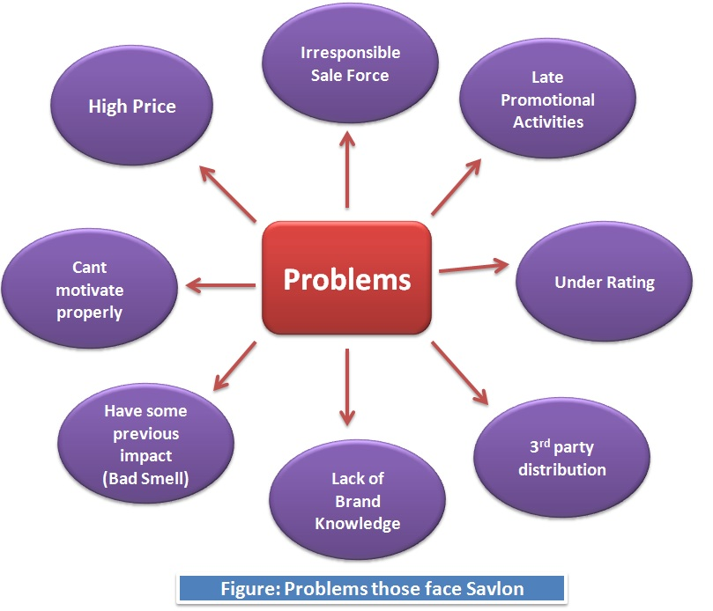

6.1.5 Threats and potentials:

Threats:
- Changing Perception: Lots of saloons are using Hyginol. For that reason, they have gained usability with Hyginol. It has made some of them that Hyginol is made for the saloons as it creates more bubbles. They also think that the Hyginol has a better fragrance.
- Increasing profit of the competitor: Hyginol is increasing their profit. So, it is making them possible to be able to expand their business.
- Availability/Visibility at the final consumers (Saloons): Now a days customers have much option to buy, Customer choose the product when they aware about it.
Potentials:
- Usage: Got the result from survey, now customers for Antiseptics are raised day by day.so the market size is a great potential for Savlon Active Soap & others Hygiene Products.
- Medical Perception: People perceive Savlon is more medically recommended and safe tousle as an antibacterial soap, also have the same perception about all Hygiene product of Savlon.
- Skin care: People rated Savlon more preferable than Hyginol for Brand Name, Value & positioning.
- Brand Value: Savlon has a strong brand value.

The consumer survey conducted to see the consumer mind set for the antiseptic soap, shows us that In terms of Antiseptic Soap, Cream & Liquide Customer preferred Savlon than others brands. Savlon Get a belief of Customers that’s mean success to set Brans positioning.

For brand name & value Savlon get a high demand from market for their antiseptic soap but the popularity of the Dettol original soap is very much high because of it also doing business for long time, maintain their product quality as well also lack of communication with the consumer, Savlon Active Soap is losing its marketplace.

7. Recommendation:

(Re-positioning strategies):

1) Should more focus on their planning which is the part of Inbound logistic. They should make a proper plan of product delivery. They can arrange a meeting with field level sales man like training. Educate them how to behave more politely with customer.
2) According to 1st recommendation they should focus more on Marketing & sales. Make the sales smooth through late payment procedure like Hyginol. They should give the product to barbers with due system who’s are not able to pay instantly. For that they should also focus on their supporting activities.
3) Keep the Current Marketing Strategy: they should take some marketing strategy for this current situation. They should published more TVC add. Now a day were everybody concern about hygiene, Savlon should target this situation for set the brand image in consumer mind. They can donate their hygiene product for those people whose are not able to buy those products.

Positive Sides of keeping the current marketing strategy:
- Antiseptic is not an impulse product. Consumers habitually ask for a specific brand while buying antiseptic cream.

- Savlon is a well-known brand, so its help the retailers to convince the customer to buy this product.

- The fragrance, and the quality of the Savlon soap is known to the people which also a positive site.

Limitations of the current marketing strategy:

  - Savlon Antiseptic cream does not interconnect with their end consumers properly. It’s one kind of their failure. People do not have proper idea about the existence of their product.

  - The competitor sales the product directly to the saloons, on the other hand Savlon antiseptic cream is sold to the retailers.

- If Savlon Antiseptic can Re-Position their branding strategies; they can overcome the market of antiseptic cream again. Saloons of the country are not properly conscious about the existence of the Savlon Antiseptic Cream. There is no one who doesn’t know about the Savlon Antiseptics Cream. Still there are some saloons who think that Hyginol is made for the saloons, as it makes more bubbles. These saloons are actually not aware of the use of the antiseptics. They are concerned about the smoother shave.

- If Savlon Antiseptic visibility could become more attractive to the consumers, through special promotional activities such as :

  - Point Of Purchase advertisements should be increase the market share of Savlon.

  - Social awareness advertisement.

  - Social media ad: Face book, twitter

  - Sponsorship for reality shows, campaigning and social work shops targeted to the parents and children.
  - More effective distribution is required.

- Saloons are getting our product at the M.R.P. from the retailers. On the other hand, saloons are getting Hyginol at a very cheaper rate. So, if our sales force goes directly to the saloons, the saloon s will get the product in a cheaper price.

- Savlon liquid antiseptics are the market leader. But there are lots of clinics who don’t use any of the liquid antiseptics. They actually rely on the Hydrogen Peroxide and the other so called germ killers. For that reason, we need to convince the clinics of the rural and the semi urban areas that they need liquid antiseptics for the 100% safety. Our Sales force must go to each and every hospital and the clinic.
- According to the Institutional Sales Manager of the ACI, consumer brands, there are only four hospitals that use hospital concentrate. For that reason, we need the use of lots of branding tools to make the use of Savlon Hospital Concentrate a trend for the Hospitals. Because it’s really a specialized product for the hospitals.

A figure for a recommendation is shown below:



Educating the Berbers by effective communication



More
Sales

Making more intensive distribution

Positive sides of using third-party distributer are:

- Local distributers are well informed about their market situation like stores and consumer size. So they can properly trace them & reach them.

- Third-party distributer is cost effective for everybody. If they use third-party distribution they can easily reach the customers which are not fulfill till now.

- Thus ACI can use this cost cutting way by third party distribution. It may save huge salary, transportation cost of internal sale force if not use third party for distribution.

7.2 Outcomes:

On the basis of our market survey and recommendation, ACI CB (Savlon Department) should take some decision for increasing Savlon antiseptics’ sales thus compete with their competitors. They took some decision in order to deal with the problem which we found out from our survey such as irresponsible SR, High price, Promotional Activities, etc. For solving these problems they recently published their Bill Board Add, improved their packaging especially for saloons, for example with new packing saloon owners can get four tubes (60 Gram) of cream in one pack. Moreover, with this pack saloon owners can buy 60 gram tube 25 to and that is low price than Hyginol. Savlon also decide that they will give towel, aprons, sign board etc to saloons owner as gift for promotional activities. Savlon also offer Trade offer such as gets one free with sixteen packets.As early as possible savlon will hire 30 cycle SR just for Savlon antiseptics cream. Then they will deliver the product door to door (Saloons) and it should increase sale and help to compete with Competitor (Hyginol).
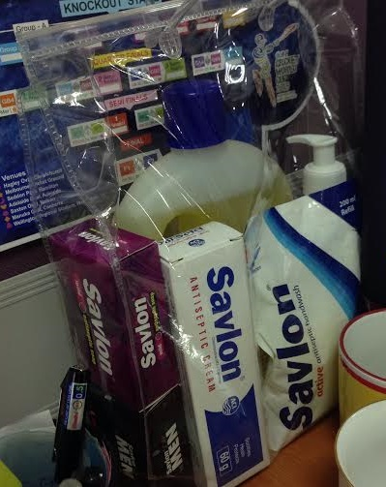
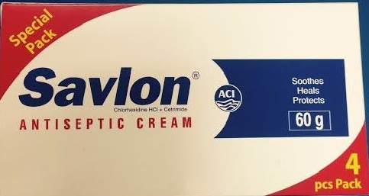
New packet: 4 pieces 60 gm tube by 100 TK. Package offer: Savlon Family protection

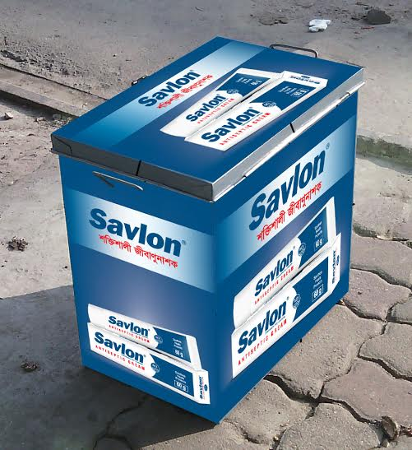
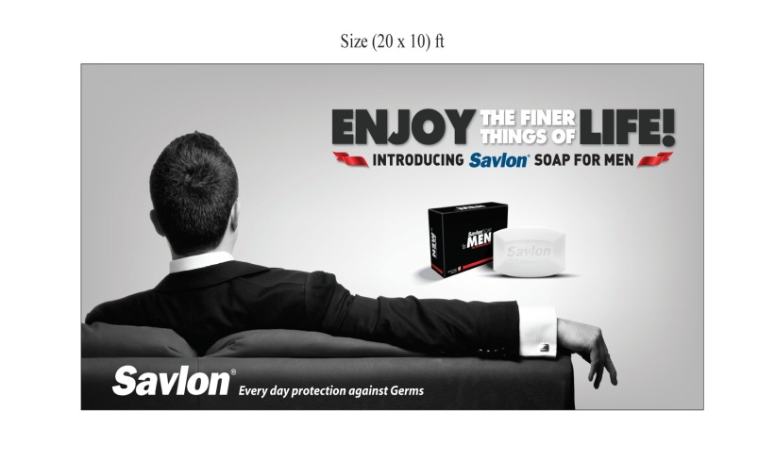
Bill Board: Box for Cycle Van SR:

Sponsor for promotional activities of Dhaka University MBA association (DUMA):
ACI limited sponsored for a program of Dhaka University MBA association in 22 May 2015 as a promotional activities, the program started at 3.00 pm to 11.30 pm. in program they include culture program, reunion, speech season & ending with concert.
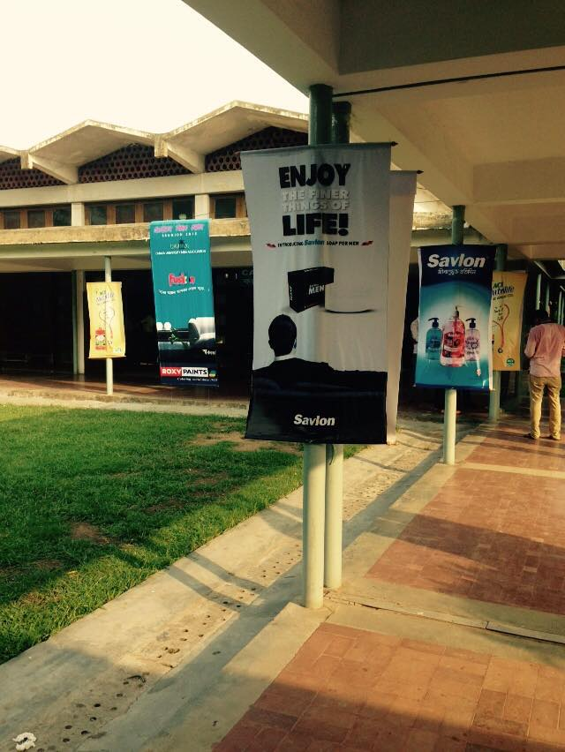
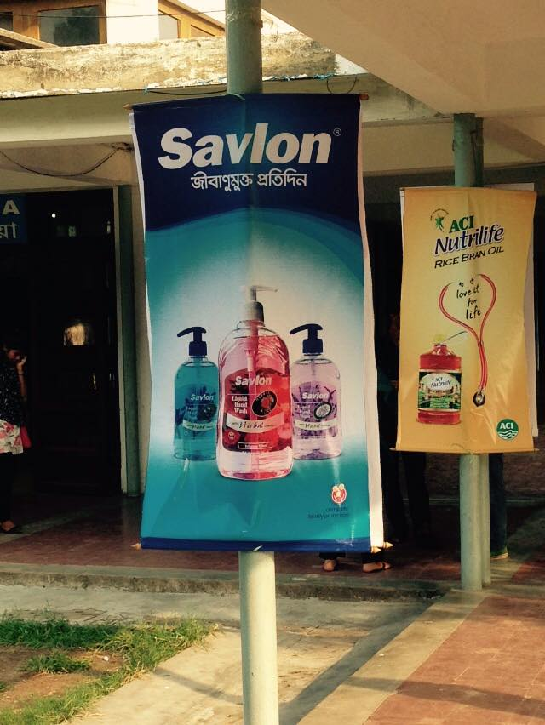

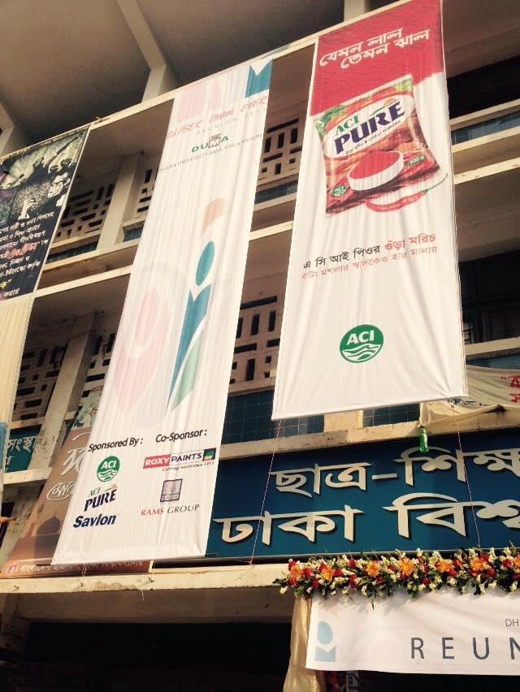

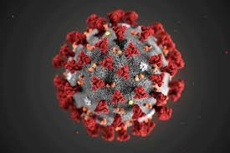
8.0 Current Market Situation & Some Temporary Strategy of Savlon:

8.1Big Crisis “COVID-19”:

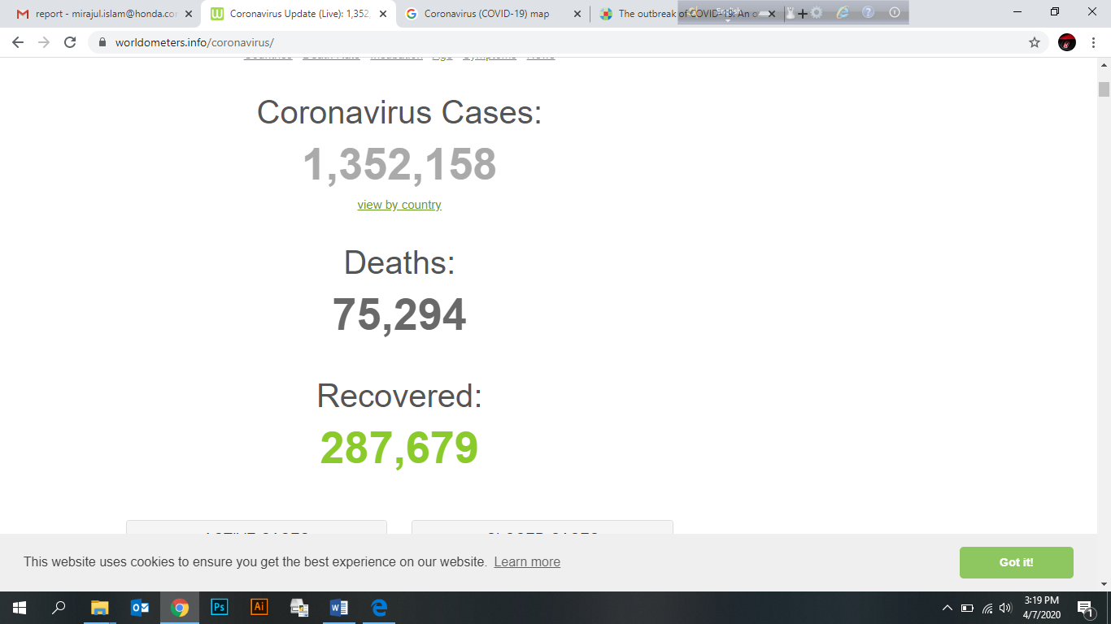
WHO regarding the current outbreak of coronavirus disease (COVID-19) that was first reported from Wuhan, China, on 31 December 2019. It’s a dangerous virus which Expand from china to whole world. Its carry form person to person by hand, mouth & eyes. 1st its catch in china but now a days its capture almost whole world just because of irresponsibility’s of people & their lacking in awareness. From 8th march Bangladesh also face this virus & almost 17 people lose their life. Total 168 people victim in BD & only 33 person’s car recover from this virus. Here given the worldwide summary of Victim, Death & Recovered for Covid-19.
In late December 2019, a previous unidentified coronavirus, currently named as the 2019 novel coronavirus#, emerged from Wuhan, China, and resulted in a formidable outbreak in many cities in China and expanded globally, including Thailand, Republic of Korea, Japan, United States, Philippines, Viet Nam, and our country (as of 2/6/2020 at least 25 countries). The disease is officially named as Coronavirus Disease-2019 (COVID-19, by WHO on February 11, 2020). It is also named as Severe Pneumonia with Novel Pathogens on January 15, 2019 by the Taiwan CDC, the Ministry of Health and is a notifiable communicable disease of the fifth category. COVID-19 is a potential zoonotic disease with low to moderate (estimated 2%–5%) mortality rate. Person-to-person transmission may occur through droplet or contact transmission and if there is a lack of stringent infection control or if no proper personal protective equipment available, it may jeopardize the first-line healthcare workers. Currently, there is no definite treatment for COVID-19 although some drugs are under investigation. To promptly identify patients and prevent further spreading, physicians should be aware of the travel or contact history of the patient with compatible symptoms.

8.2 Treatment:
Bad luck it that currently, there is no validated treatment for COVID-19 till now. The main strategies are symptomatic and supportive care, such as keeping vital signs, maintaining oxygen saturation and blood pressure, and treating complications, such as secondary infections or organs failure. Doctors suggest that this virus expand person to person as germs, so the 1st steps is using all types of Hygiene product like: Hand wash, Hand Sanitizer, Savlon, Dettol, Hexisol in washing hand, bath, cleaning home. By using those Hygiene product Virus will be removed from us.

8.3 Covid-19 in BD:
Bangladesh 1st faced this Life killer in 8 March, 2020.Doctors Fin out the Reasons that how it enter in BD & the result is when Some Visitors come in Bangladesh from Italy those visitors are carry this virus in BD.Now a days it presence got every in in BD. Government Lockdown Whole BD from 25th March to Till now. People can’t came out in their daily life, all are locked in home. Here Given the last one month scenario of COVID-19 effect ion BD.
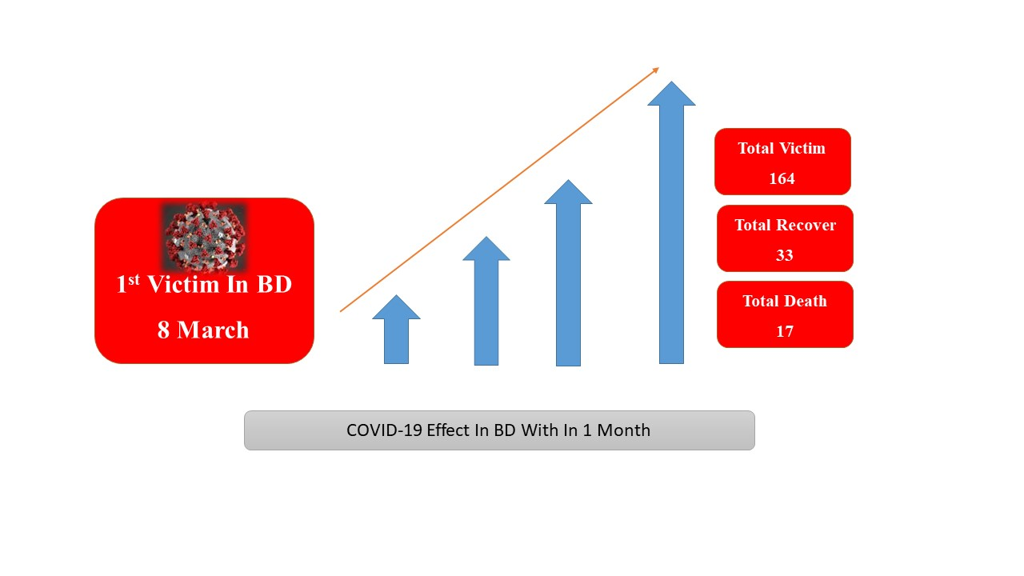

8.4 SAVLON New Strategy for Fighting with COVID-19:

Now a day when everybody concern about COVID-19, Its Create a big impact on whole BD as well as whole World. Till Now we have not any vaccine for fighting with this life killer virus. We can’t just aware from this virus. Only one situation that is stay home & be hygiene. Doctors give some suggestions those are can save us from COVID-19, Such as:
- Stay Home
- Washing Hand
- Use Hand Sanitizer
- Use Hygiene Liquid for cleaning Home, Hospital, and Road.
- Use Mask.
Savlon have a greater opportunities for capturing the whole market share & customers belief. Now the most demandable product is Savlon liquid, Hexisol, Anticeptic soap Etc.Thats why Savlon increase their production but can’t meet up the demand of market. Because of now Demand is much more than production & supply. Also ACI bound to supply all the hygine product to Government Sectors, Hospital & offices then they can supply to mango people. It’s totally unethical but for political pressure they are bound to doing this. Also price are increased, almost double. Price are increased by retailer, they doing their unethical business for the crisis situation. Retailers are show only one reason that is Stock empty, no delivery.
Savlon Increase their digital marketing now with social awareness add, post. They try to rise their production, also they are open to produce all types of hygiene produces. Try to make their delivery chain more strong in this critical situation. They always show their price chart through digital media for broke the syndicate market business.
Now all the antiseptic company tests all types of awareness add through TV channel. Savlon also telecast their TVC almost in every Bangladeshi channel from last 10 days.All are try to aware & educate the people about Hygine.

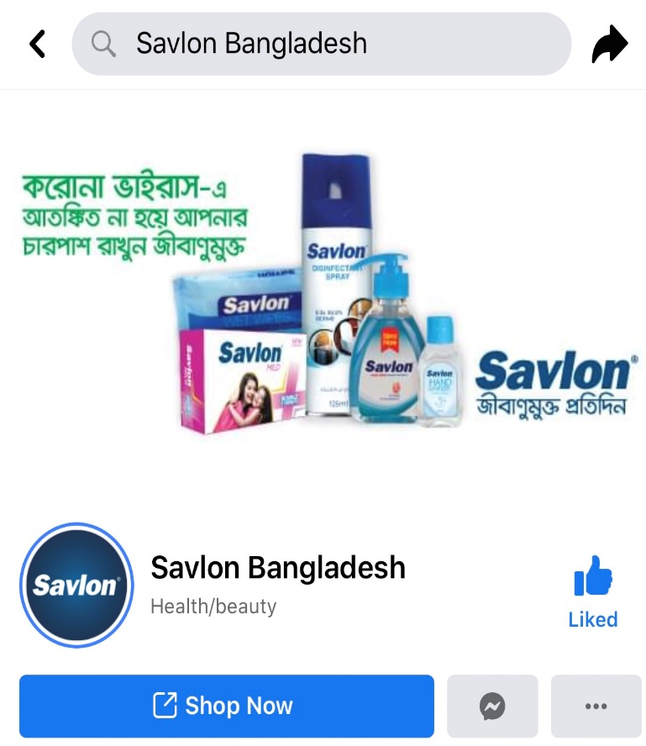
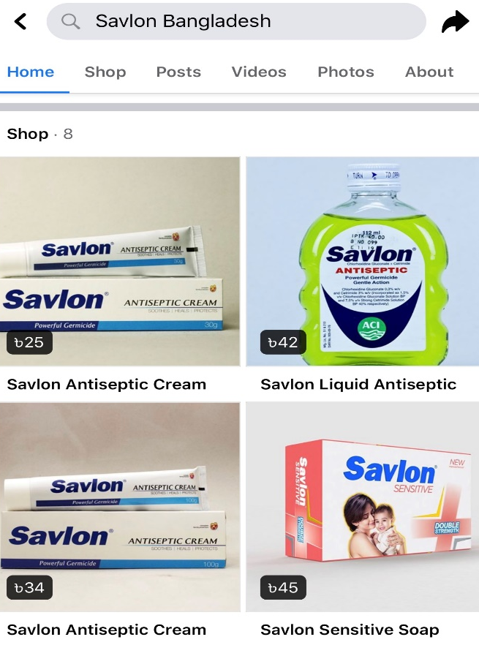
Some Digital Marketing In current situation:
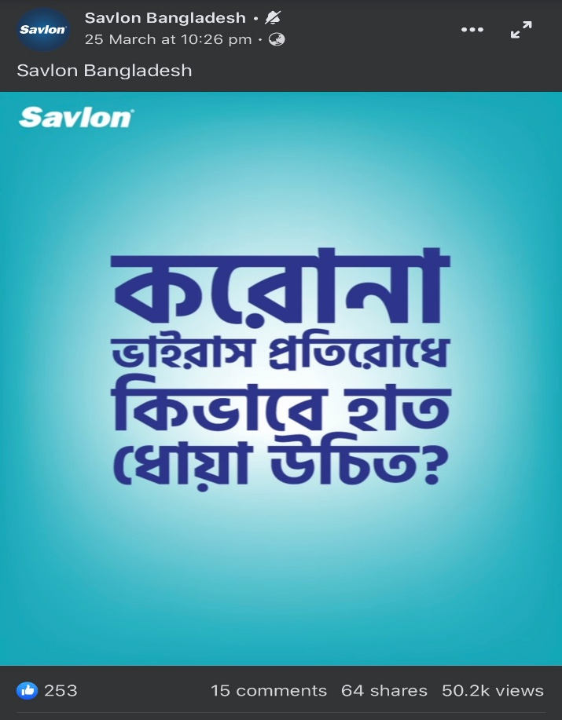
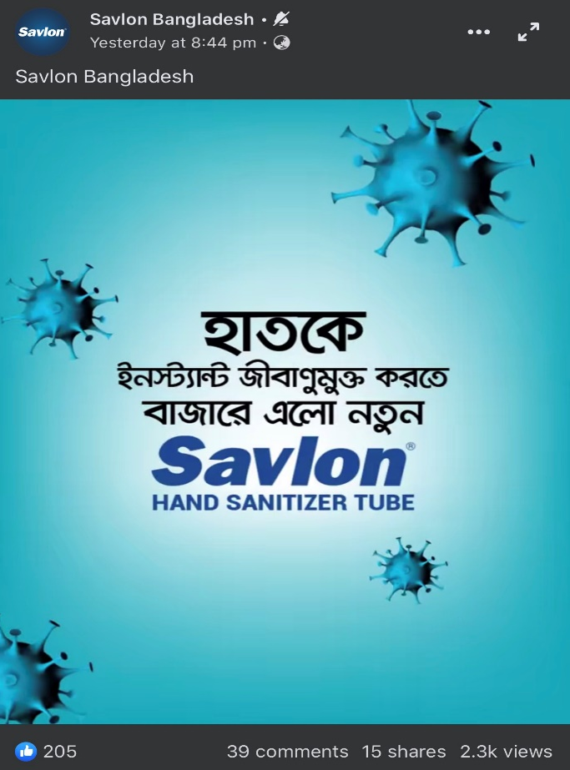
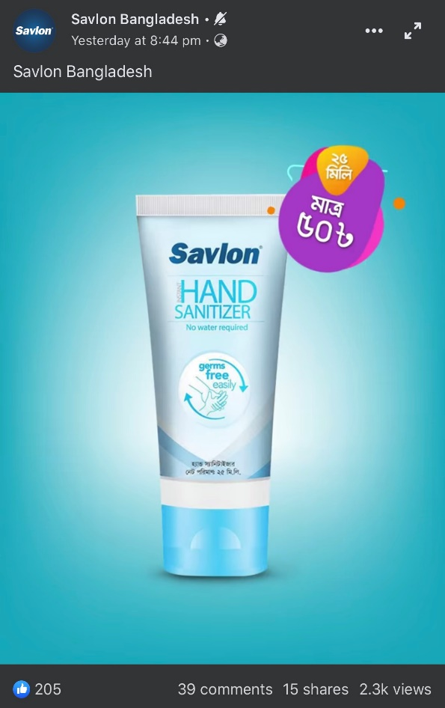
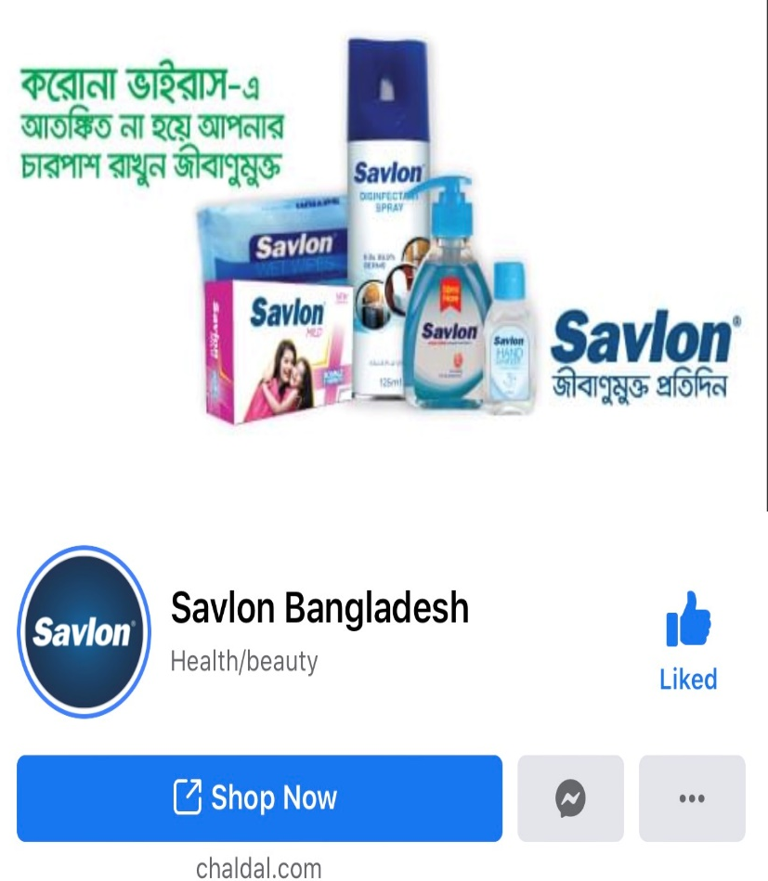

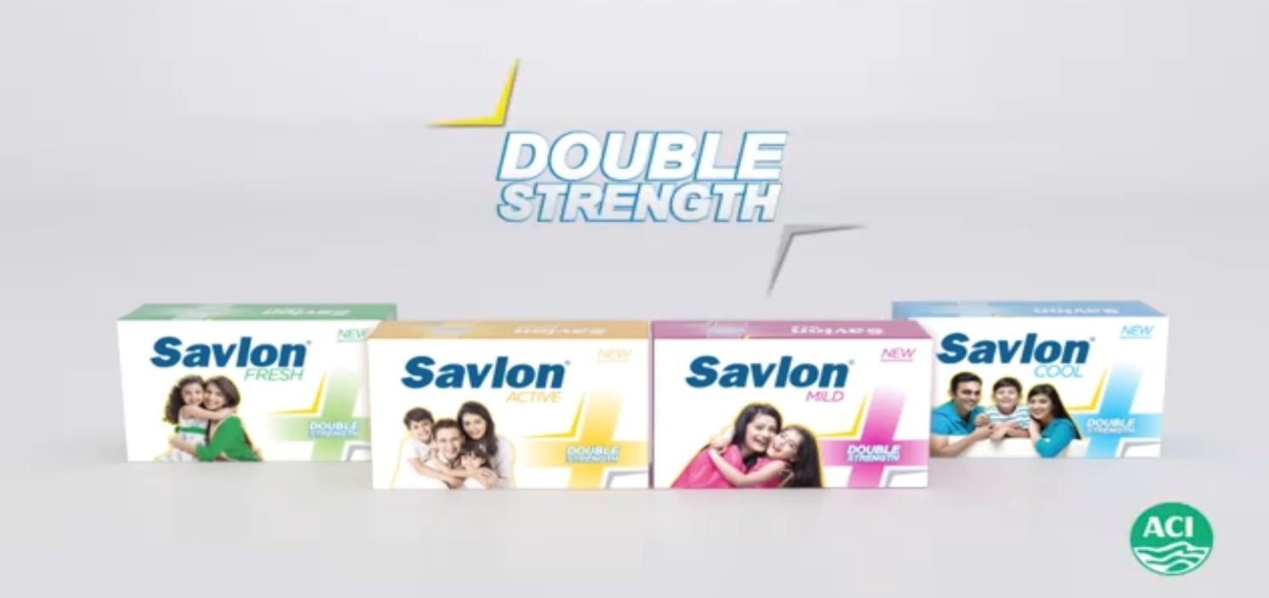

9.0 Conclusion:

In a nut shall I want to say that, Savlon is one of the strong brands in Bangladesh which has 79% market share of cream and liquid both according to NIELSEN Research result. Whereas from my study I found that Savlon acquire only 39% inside Dhaka and outside of Dhaka 63% that mean total 49% share in whole Bangladesh. Different between the percentages created because of the pattern of my study. In my study I survey only twelve different place of Dhaka and five others district on saloons and hospital only. On the other hand NIELSEN done their research based on not only these two but also Retail store, Super shop, Pharmacy etc. around the country.
Savlon established their proper VALUE CHAIN, for that they work on an organized way. Its help to make their operation smooth, Quality management, perfect planning, customer satisfaction & engagement. Also they have a strong supply chain management which helps then for run their business properly in a competitive market.
“Savlon is a valuable, familiar, and loyal & success full brand in Bangladesh, we fell proud for work with this brand & we also enjoying. Ones upon a time we fill our maximum sale target by savlon, now we face some problem about product and our lickings, if we can overcame those things then we believe that competitors are nothings for savlon & capturing hundred percent market share will quite possible for us” that think many sales person of Savlon.

People from all social economic classes are becoming more heath conscious day by day. Now people because more aware about Hygiene for the pollutions which is in everywhere it’s called COVID-19 Thus the antiseptics category is being accepted generally.it almost take the 200 + people life in last two months, also attack more than 12,000 people. This fear is creating the perfect opportunity for brands of antiseptic creams and liquids to enter and grab seats in the market & customers became more aware about Hygiene. ACI Ltd. can get better insight and formulate better plans regarding Savlon Antiseptic cream and liquid. Adequate effort was provided so that maximum accuracy could be attained.

10. Appendixes:

10.1 References:

10.1.1 Books:
- Kotler, P., & Keller, K. L. (2009). Marketing management. Upper Saddle River, N.J: Pearson Prentice Hall.
- Aaker, D.A. and Keller, K.L. (1990), “Consumer evaluations of brand extensions
- Kotler, P. and Armstrong, G. (2011). Principles of Marketing. N.J: Pearson Prentice Hall.

10.1.2 Internet:
- http://www.aci-bd.com/ [Accessed 15th October, 2019]
- https://strategicmanagementinsight.com/tools/value-chain-analysis.html [Accessed 12th October, 2019]
- https://en.wikipedia.org/wiki/Value_chain [Accessed 16th October, 2019]
- Chen and Liu (2004), “Positive brand extension trial and choice of parent brand” Journal of Product and Brand management, Vol. 13, pp.25-36. [Accessed 12th November, 2019]
- http://brandeo.drupalgardens.com/content/brand [Accessed 13th November, 2019]
- https://www.aci-bd.com/ACILtd/2014/ACIAnnualReport2013.pdf [Accessed 7th December, 2019 ]
- http://www.aci-bd.com/our-businesses/antiseptics.htm
- https://www.who.int/bangladesh/emergencies/coronavirus-disease-(covid-19)-update
- https://journals.lww.com/jcma/FullText/2020/03000/The_outbreak_of_COVID_19__An_overview.3.aspx
10.1.3 Personal:
- Rezwan Ullah Khan, Assistant Brand Manager, Savlon, Consumer Brands, ACI Limited.
- Adnad Quayum, Sr.Product Executive, Savlon, Consumer Brands, ACI Limited.
- Ataur Rahman, ASM, Narawangong, ACI Limited.
- MD. Mamnur Rashid Sarkar ASM, Nannu Mia, SR, B. Baria, ACI limited.
- Md. Nurul Islam (ASM), Mr. Koddos (Supervisor), Chittagong, ACI limited.
- Md. Aminul Haque Akon (ASM), Delwar Hossain Fakir (GSM), Camilla, ACI Limited.

10.2 Other documents:
Serve Question (Saloons):
Consumer Behavior Identification for Saloon

Area: Date: …/……/2019
- Name of Saloon:
- Address:

- Image no:
- Price Range:
- Saloon Category: High, Medium, Low
- Which Antiseptic Cream is used in the saloon?
          - Savlon
          - Hyginol
          - Others
- Reason/s for usage?
=>
- Amount of usage (Monthly)?
- Which Newspaper/s or Magazine/s?
- Will gift from ACI Savlon motivate you to choose Savlon over Hyginol or whatever you are using currently?
- Amount of usage of Antiseptic Liquid if any?
- ½ liter
- 1 liter
- 2 liters
- Other

- Is there any TV in the Saloon? Which Channel is most preferable?
=>
Sample Picture of saloons visit, ASM, SR (Inside/ Outside Dhaka):
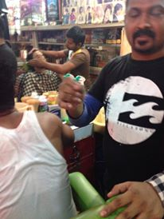
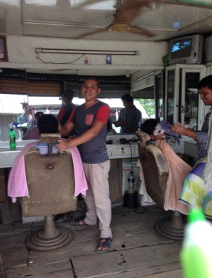
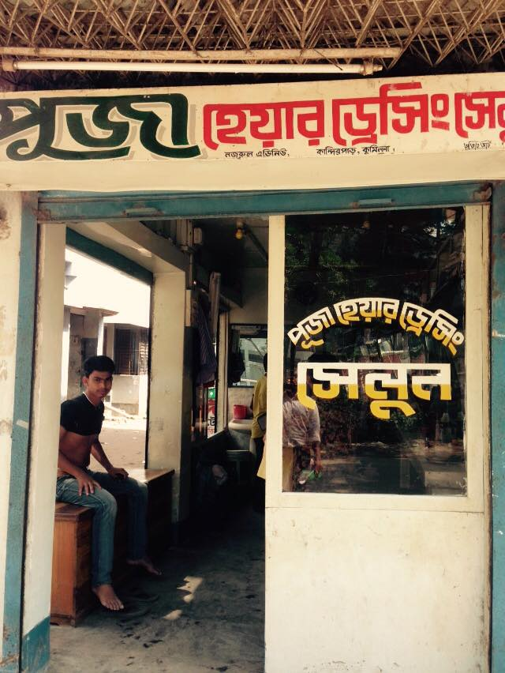
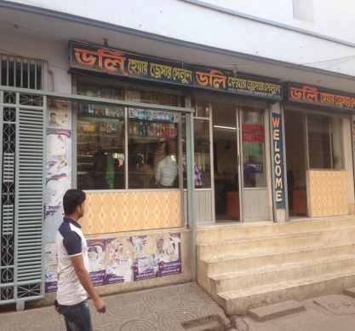

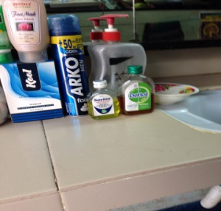
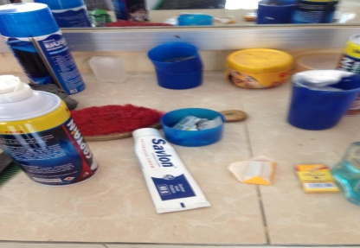
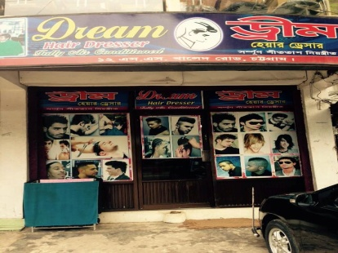
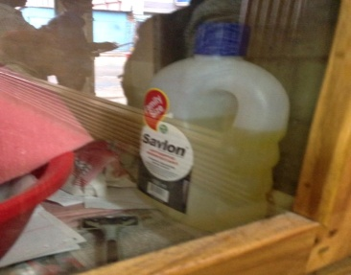

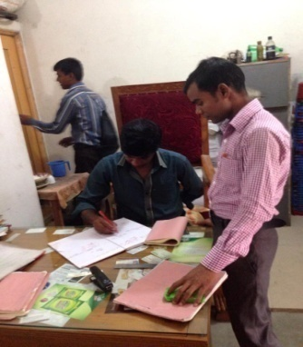
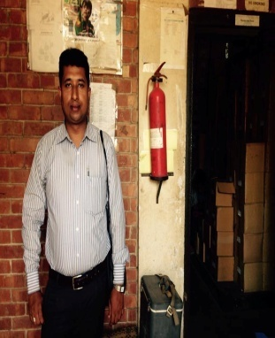
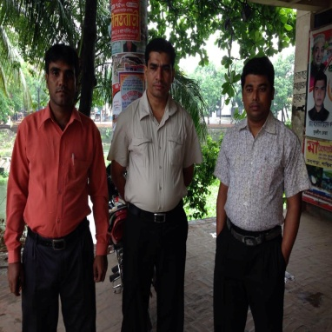
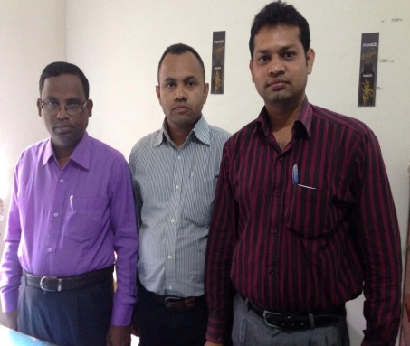
Area sales Manager (ASM), Sales Representative (SR), Store house:

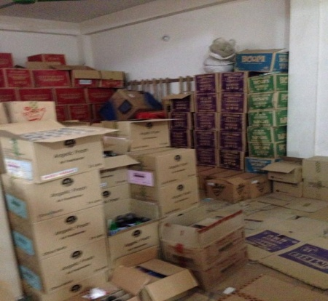
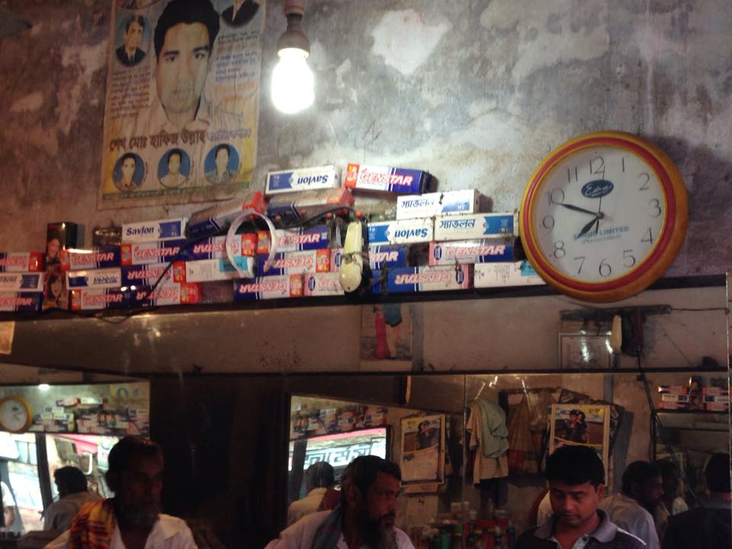
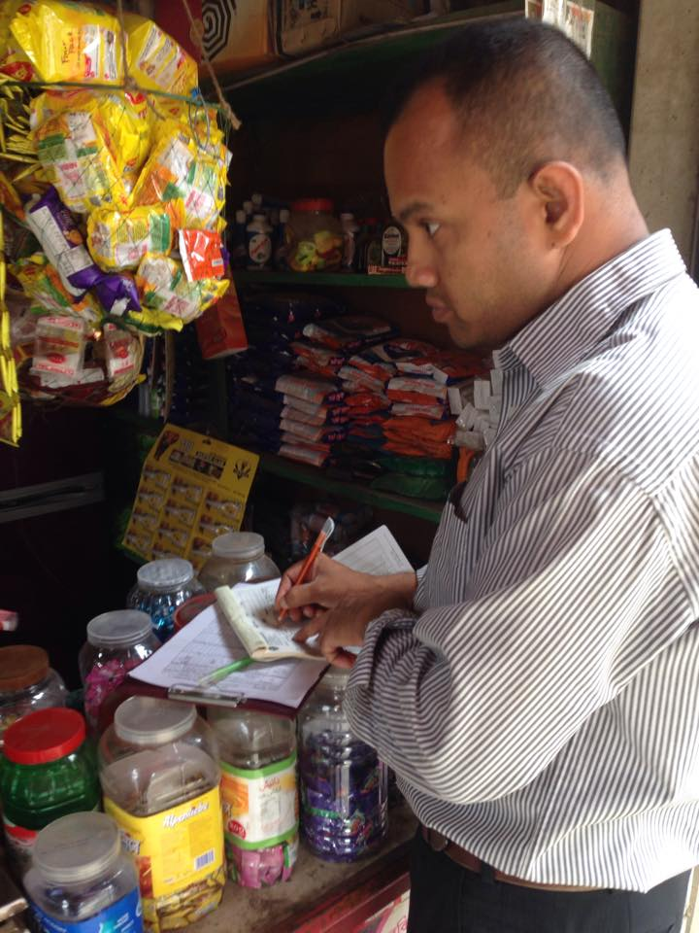

Visited Areas & Districts:
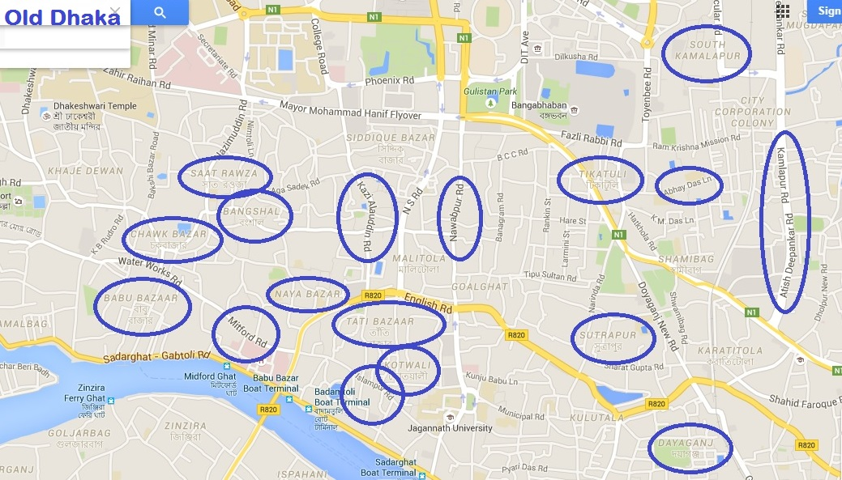

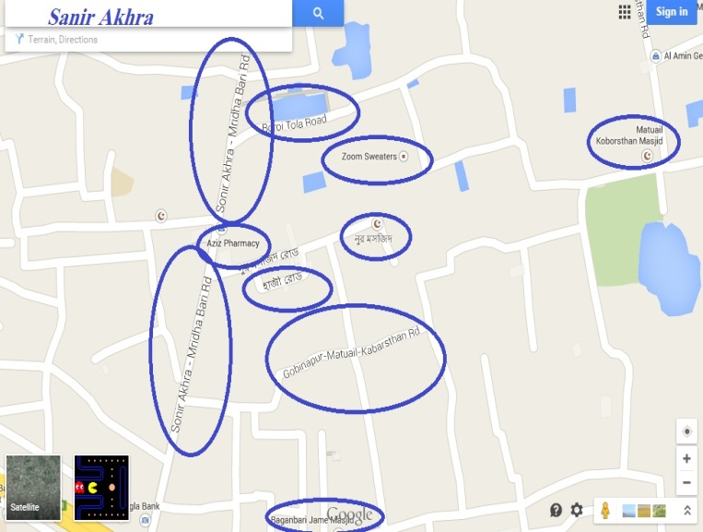
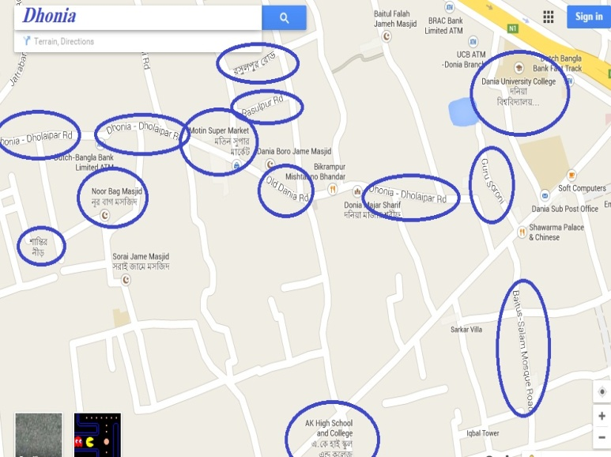

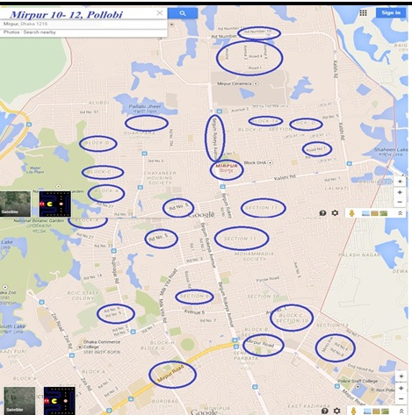
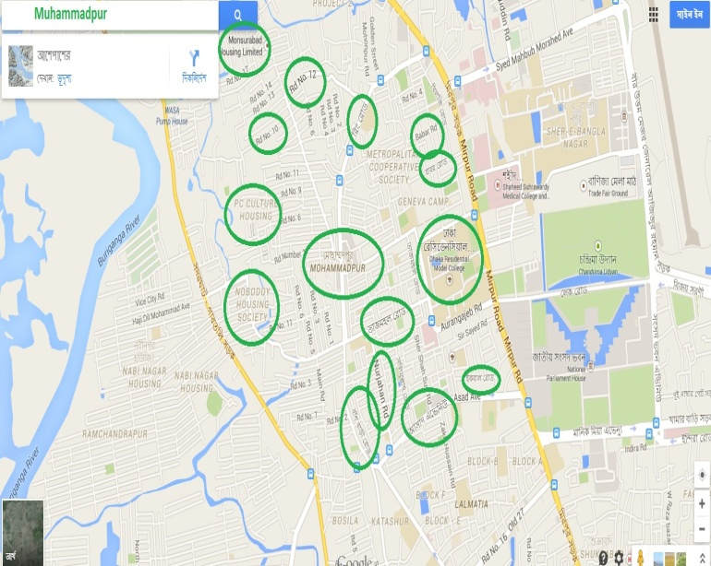

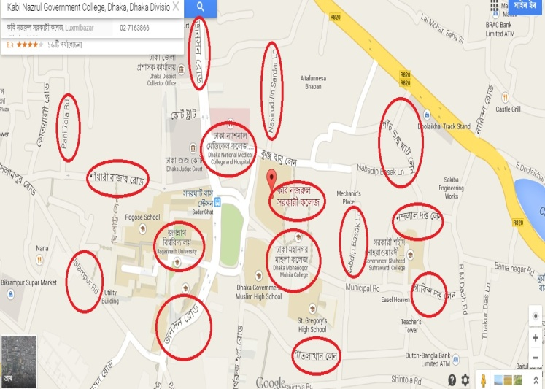
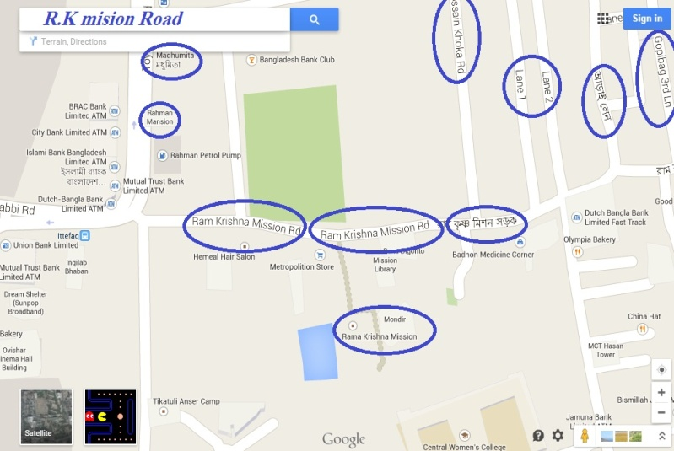

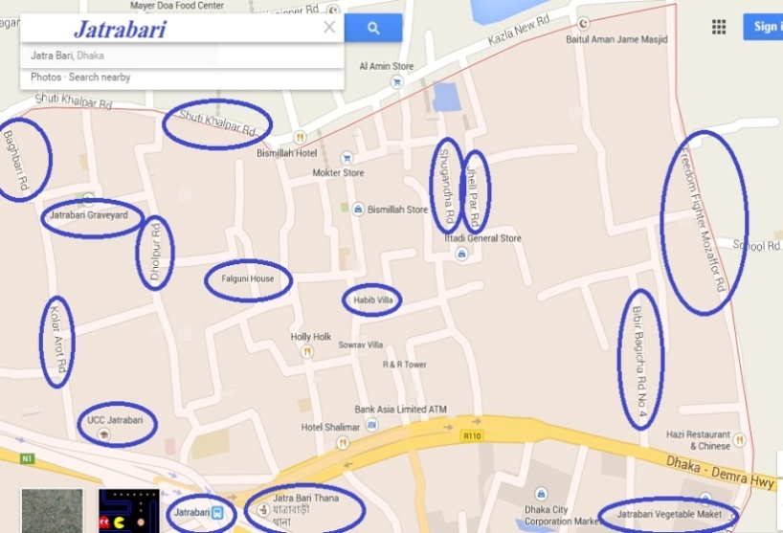
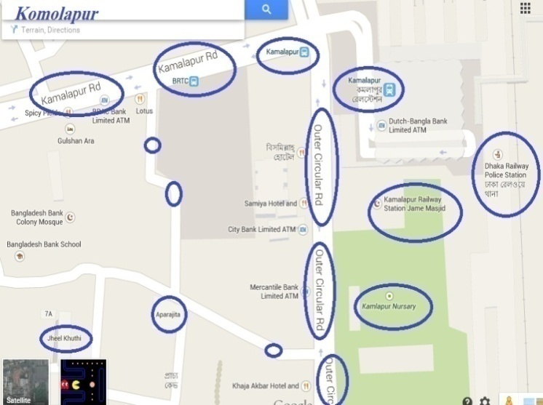

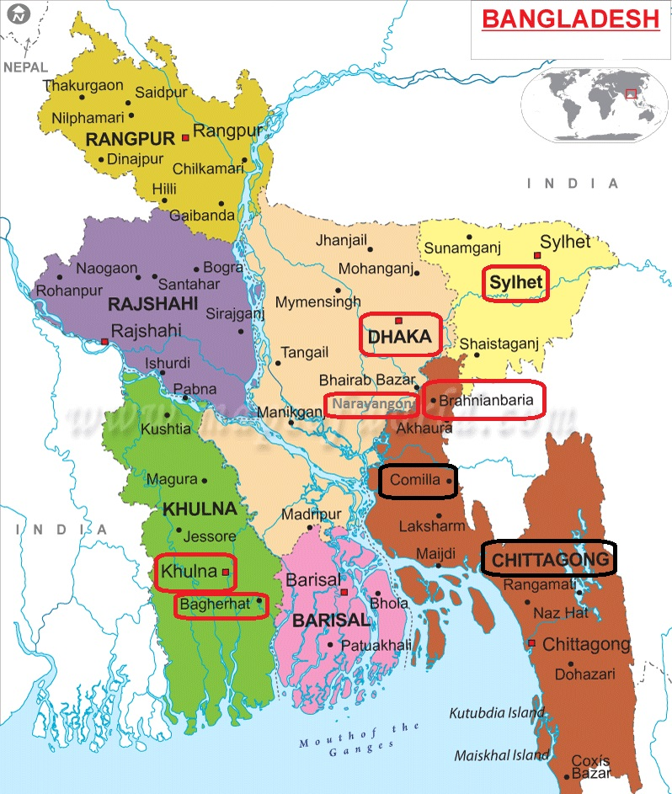

Database of visited saloons in Dhaka:
Name | Address
B. Baria Saloon | Noya Para, Bornomala School Road, Sonir Akhra, Dhaka-1236
Mosarrof Hair Dresser | 555 Donia, Gol Barir Mor, Dhaka-1236
Sumon Hair Saloon | 556 Donia, Sonir Akhra, Dhaka
Smart King Saloon and Gents` Parlour | 563 MM Tower, Donia Bazar Road, Jatra Bari
AJU Life Care Saloon | 661, Dholaipar Bazar Road, Donia-1236
Anamika Hair Saloon | 223 Purbo Dholaipar, Jatrabari, Dhaka-1236
Pipasha Saloon | 175 Purbo Dholaipar, Dhaka-1236
Grooming Gents` Parlour | 93 West Dholaipar, Shempur, Dhaka-1236
Hollywood Gents` Parlour | 274 South Jatrabari, Dholaipar
Apon Saloon | 242/1/D Jatrabari, Sheikhpara, Dhaka
Shamol Babur saloon | 249/D Sheikhpara, Jatrabari, Dhaka
Basudeb Saloon | Sheikhpara, Jatrabari, Dhaka
Shakhkhor Hair Dresser | Sec: 6/B, Mirpur
Modern Hair Saloon | Sec: 6/A, Mirpur
Define Hair Cutting Saloon | Section- 6, Avenue-5, Store-7/8,Mirpur, Dhaka-1216
The Dhaka Saloon | House-46, Av-5, Block-A, Sec-6, Mirpur, Dhaka-1216
Rose Style | House-40, Av-5, Block-A, Sec-6, Mirpur, Dhaka-1216
Babul Hair Dresser-1 | Section- 6,Block-D, Road-6,Cholontika Mor, Mirpur
Babul Hair Dresser-2 | Sec-7, Cholontika Mor, Road-7, Mirpur
Ratul Hair Dresser Saloon | Sec-7, Road-2, Mirpur, Dhaka-1216
Sud Saloon | Road-9, Block-A, Mirpur Bus Stand
Kustia Saloon | Sec-7, Road-4, Pollobi, House-52, Mirpur
Liton Saloon | Road-3, Sec-7, Mirpur, Dhaka
Shopon Hair Dresser | Road-5, Sec-7, House- 841, Mirpur, Dhaka
Purnima Saloon | Road-4, Sec-7, Mirpur
Bismillah Saloon | Road-4, Sec-7, Mirpur, Dhaka-1216
Shagotom Saloon | House-703, Road-4, Mirpur, Dhaka-1216
Apurbo Hair Dresser | Mirpur Share 11, Sec-7
Shourov Saloon | Sec-7, Road-5, House-1070, Pollobi, Mirpur
Ma Saloon | Sec-7, Road-11, Mirpur
Pollobi Hair Dresser and Gents` Parlour | 6/12, Pollobi, Mirpur Sare 11, Dhaka
Asa Hair Dresser Saloon | 5th Lane Molla Market, Road-12, Dhaka-
Paris Hair Cut Saloon | Road- 12, Shujat Nagor, Dhaka-1216
Imran Saloon | Road-12, Shujat Nagor
Super Gents` Parlour Saloon | Road-12, Shujat Nagor
Maricom Saloon | Road-4, Sec-7, Mirpur, Dhaka-1216
Marlin Hair Dresser | 30 MSPCC Market, Mirpur Pollobi
Gillette Gents` Parlour | Block-B, 61/3, Road-4, Sec-12
Nayon Saloon | House-3, Road-6, Mirpur B/A, Mirpur 10
Bilash Hair Dresser | Bismillah Complex, Shah Mazar Road, Azampur, Dakkhin Khan
Barisal Hair Dresser | Mollapara, Dakkhin Khan
Nadia Saloon | Dakkhin Khan, Madrasa Market, Dhaka-1230
New Super Star Hair Cutting | Dakhan Bazar, Madrasa Market
Model Hair Style | Dakkhin Khan Bazar, Dhaka-1230
Uttom Hair Style | Moushahba Shah Bazar Road, Dakkhin Khan
Bismillah hair Saloon | Uttor Khan Mazar Chourasta
Dinajpur Hair Dresser | Chalabon Choitir Mor, Dakkhin Khan
Vola Hair Dressers | Chalabon , Dakkhin Khan
Chadpur Saloon | 644 Ashkona, Dakkhin Khan
No Name | Uttor Khan, Shah Mazar Road
Chogir Hair Dresser | Balur Math, Super Market, Uttor Khan
Tangail Saloon | Vuiyapara, Bashtola, Uttorkhan
Nafiz Hair Saloon | Vuiyapara, Shah Kobir Mazar Road, Uttor Khan-1230
Jononi Hair Saloon | Uttor Khan Mazar Road, Uttor Khan-1230
Monpura Hair Saloon | Shah Kobir Mazar Road, Chalabon, Dakkhin Khan
Dada Hair Dresser | Showdagorpara Dakkhin Khan
No Name | Ponditpara, Dakkhin Khan
Magnet Hair Style | Vobadiya Bazar, Uttor Khan
No Name | Johura Center Market, Uttor Khan, Shah Kobir Mazar Road
Ma Hair Dresser | MollaBari, Dakkhin Khan, Dhaka-1230
Smart Hair Cutting Saloon | Shamolbag, Uttorkhan, Dhaka-1236
GM Saloon | Dakkhin Khan Bazar, Dhaka-1230
Fashion Hair Dresser | Uttorkhan, Uttor, Dhaka
Bondhu Mitali Saloon | Ashkona, Dokkhin Khan
Joy Hair Saloon | Gaowaer, Dakkhin Khan
Gillette Barber Home | Dakkhin Khan Kosai Bazar
Kakoli Hair Dresser | Dakkhin Khan, Kosai Bazar
Dalas Hair Saloon | 243 Shohid Lotif Road, Mollartek, Dakkhin khan
Shoronika Hair Dresser Saloon | 12/6 Master Shekandar Market, Ashkona, Uttora
Opurbo Hair Saloon | Prembagan, Dakkhin Khan
Jononi Hair Dresser | Mohila College Road, Dokkhin Khan
No name | Gaowaer, Dakkhin Khan Road
Shojib Hair Dresser | East Gaowaer, Dakkhin Khan Road, Uttora
Shagorika Saloon | Gaowaer, Dakkhin Khan Road
Tip Top Saloon | Noyapara, Aamtola
Vai-Vai Saloon | Noyapara, Aamtola
Baba Lokhnath Hair Dresser | Noyapara, Aamtola, Dakkhin Khan
uttom Hair Dresser | Noyapara Aamtola
Joyita Saloon | Ashkona Medical Road, Dhaka-1200
Popy Hair Dresser | Shekhandar Market, Kosai Bazar
No Name | Shekhandar Market, Kosai Bazar
Kolpona Hair Dresser | Mollartek, Dakkhin Khan
Mohsin Awliya Saloon | Dakkhin Khan
Ma Hair Style | Ashkona Bazar Golam Shorif Market
Vai-Vai Saloon | City Market, Ashkona, Dakkhin Khan
Anik Hair Dresser | 127 South Komolapur, Dhaka-1217
SK Hair Cut | South Komolapur
Modern Saloon | 102 South Komolapur
NK Mahadi Saloon | 15/1 South Komolapur, Dhaka-1217
Sathi Hair Style | North Komolapur Arafat Bording, Dhaka
Hossain Hair Style | 16 South Komolapur, Dhaka-1217
Dokkhin Komolapur Digital Saloon | 17 South Komolapur, Dhaka-1217
Chittagong Saloon | 103 South Komolapur, Dhaka-1217
Mama-Vagina Saloon | 104 South Komolapur, Dhaka-1217
No Name | South Komolapur
Vai-Vai Saloon | 20/21 North Komolapur Tara Market, Dhaka
No Name | Club Para, Motijhil
Ma-Babar Asirbad | 21/21 North Komolapur, Tara Market, Dhaka
Chadpur Hair Dresser | 28/B North Komolapur, Dhaka-1217
B.Baria Saloon | 81 North Komolapur
Himel Saloon | 12, RK Mission Road
Mou Hair Dresser | 13 Rk Mission Road
Aporupa Hair Cutting Saloon | 158 RK Mission Road
Up to Date Hair Dresser | 58 RK Mission Road, Gopibag
Style Zone | 85 RK Mission Road, Gopibag
Bristy Hair Cutting Saloon | 91/B RK Mission Road, Gopibag
Mayer Asirbad | 91/B RK Mission Road, Gopibag
Nomita Saloon | 87/A RK Mission Road
No Name | 86/A RK Mission Road, Gopibag
Noborupa Hair Dresser | 89/6/b Rk Mission Road, Gopibag
Baba Lokhnath Saloon | 4 no Champatoli
Boishakhi Saloon | Champatoli
No Name | 6/3B Showarighat
Vai-Vai Saloon | Showarighat
Saloon Hair Star | Showarighat
Abul Kasem Saloon | 59/2 Churihatta
Opurbo Hair Dresser | Churihatta
Dulal Hair Dresser | Debidasghat Chokbazar, Shoawarigaht
Prodip Hair Dresser | Babubazar, Jumrail Lane, Dhaka-1100
Hollywood Saloon | 69/5 Babubazaar
Century Hair Dresser | 41/2 Adel Complex Market Islampur
Bangladesh Hair Dresser | Badamtoli
Bondhu Hair Dresser | Shahjada Lane, Badamtoli
Promise Hair Dresser | Shahjada Lane, Badamtoli
Rahul Hair Cutting Saloon | 201 Shahajada Lane, Badamtoli
No Name | Jumrail Lane, babubazar
Mona Hair Dresser | 103/1 Sutrapur
Lotus Hair Dresser | 13/1 Nobodip Basok Lane, Lokkhibazar
No name | Ray Shaheb Bazar
Youth Hair Dresser | 30 No Lokkhibazar
SR Hair Dresser | 30 Ekrampur, Lokkhibazar
No Name | 87 Patlakhan Road, Lokkhibazar
Shanto Hair Dresser | 6 No Nasiruddin, Shordar Lane, Ray Shaheb bazar
Nikita Hair Dresser | 5 Vi ghat Lane, Dholai Khal, Rokonpur
New Golden Hair Dresser | 8/1 Essor Das lane. Bangla Bazar
Lokhnath Hair Dresser | 142 Nasiruddin Sordar Lane, Ray Shaheb Bazar
Style Hari Dresser | 96/1 Nasiruddin Sordar Lane, Ray Shaheb Bazar
Anamika Hair Dresser | 93/1 Nasiruddin Sordar Lane, Ray Shaheb Bazar
Hira Hair Dresser | 27/28 Lokkhibazar City Corporation Market
Shopon Hair Dresser | 29, Ram Das Road, Ekrampur
No Name | 29, Ram Das Road, Ekrampur
Ma Hair Dresser | 35 Hemondro Das Road, Sutrapur
Modern Saloon | 30/2 Hemondro Das Road
PM Hair Dresser | 53 Hemondro Das Road
Shohag Hair Dresser | 5 Hemondro Das Road, Bangla Bazar
Doli Hair Dresser | 34/1 Poridash Road, Banglabazar
Doli Hair Dresser | 33/1 Poridash Road, Banglabazar
Choton Hair Dresser | Jhonson Road, 50/1
Badhon Hair Dresser | 112/2 Rishi Kesh Das Road, Ekrampur
Loknath Hair Dresser | 161 Nasiruddin Sordar Lane
Hair Fashion | 1 no Nondo lal, Datta Lane, Lokkhibazar
Playboy Hair Dresser Saloon | 32/33 Lokkhibazar
Sagor Hair Dresser | Basa Bari Lane, Naya Bazaar, Dhaka-1100
Saloon Hair Dresser | Kobiraz Goli, Tati Bazar
My Choice | Shudhan Nagor, Tatibazar
Raton Hair Dresser | 57 Tatibazar, Dhaka-1100
Saloon | 52 Goyalnogor, Tatibazar
Bipasha Saloon | Radhika Morbasath Lane, 19 Tatibazar
Sun Badh Saloon | 8 no Tatibazaar
Pooja Hair Dresser | 2 no Tatibazar
Badshah Saloon | 2 no Panitola
5 Star Saloon | 4 No Patoyatoli, Dhaka-1100
King Hair Dresser | 5 No Patoyatoli, Shodorghat, Dhaka-1100
7 Star Saloon | Patoyatoli, Dhaka-1100
Mahfuz Hair Dresser | 9 no Abul Hasnat Road, Dhaka-1100
Star Hair Dresser | 10/2 Abul Khoyrat Road, Dhaka-1100
Arif Stylish Hair Dresser | 2 no Nurbox Lane, Dhaka-1100
Azmeri Hair Dresser | 17/B, Nurbox Lane, Dhaka-1100
Alifa Hair Dresser | 8/1 Nurbox Lane, Dhaka-1100
Imran Hair Dresser | 3 No Kazi Nuzrul Siddiki Lane, Kosaitoli, Dhaka
No name | 90/2 KP Ghosh Street, Kosaitoli, Dhaka-1100
New Dhaka Saloon | 31/3 Syed Awlad Hossain Lane
Sujon Hair Dresser | 33 Syed Awlad Hossain Lane
Style Hair Dresser | 12/ 2 Syed Awlad Hossian Lane
Nayon Hair Dresser | 12/2 Kosaitoli, Dhaka
Bikrampur Saloon | 61 Becharam Douri, Armanitola, Dhaka-1100
AJX | Satroza, Dhaka-1100
Rana Hair Dresser | 26 KP Ghosh Street, Arranitola, Dhaka-1100
Hair Saloon | Hosnidalan Road, Dhaka-1100
Star Saloon | Nazimuddin Road
Relax Hair Dresser | Nazimuddin Road
Sath Rong Gents` Parlour | 71/1 Nazimuddin Road, Changkharpool
Sath Rong Gents` Parlour | 77/AD Nazimuddin Road Changkharpool
Sath Rong Gents` Parlour | 92 Nazimuddin Road Changkharpool
Nayon Hair Dresser | 10/12 BCC Road, Kaptan Bazar
Alif Gents` Parlour | 72 BCC Road, Taherbag
No Name | 157/ Bonogram Kaptanbazar
Shokal Shondha Saloon | Opposite of 158 Bonogram 2nd Floor
Friends Hair Cutting | 23 Joykali Mondir,wari
No Name | 24 Joykali Mondir
Super Hair Dresser | 11/A Folder Street, Wari, Dhaka-1203
Akash Hair Dresser | 45 number tikatoli
Pace Hair Dresser | 12 KM Das Lane, Tikatoli
Madhobi Hair Dresser | 57 Kaptanbazar
Relax Hair Dresser | Complex Market, Kaptanbazar
Asa Hair Dresser | 41 City Corporation
Peacook Hair Dresser | 41 City Corporation
Alif Saloon | 94 BCC Road | Vai Vai Salon | 240, Kashem Market, Meradia
Vai Vai Salon | 240, Kashem Market, Meradia | Vola Hair Dresser | 745/A, Noyapara, Meradia
Vola Hair Dresser | 745/A, Noyapara, Meradia | Play Boy Hair Dresser | 4/2, Sipahibag
Play Boy Hair Dresser | 4/2, Sipahibag | Hridoy Hair Style | 232, Noyapara, Meradia
Hridoy Hair Style | 232, Noyapara, Meradia | Super Cut Hair Saloon | 9/2, South Banasree
Super Cut Hair Saloon | 9/2, South Banasree | Hrittik Hair Dresser | Opposite of Dosh Toila Building
Hrittik Hair Dresser | Opposite of Dosh Toila Building

………………………..0………………………
Thank You

