Report on Retail Management System

Retail Management System

Submitted to:
Dr. Mohammad Badruddozza Mia
Associate Professor
Dept. of Business Administration

Submitted by:
Mushahique Ahmed Khan Majlish
Id: 111151163
Major: Management Information System (MIS)
Trimester: 151

School of Business and Economics
United international university

Date of submission: 10 / 02 /2020

Letter of transmittal

10th February, 2020

To
Dr. Mohammad Badruddozza Mia
Associate Professor
United International University

Subject: Report on the process of making a retail management system of a super shop.

Dear Sir,
It is my immense delight to present my report on retail management system of a super shop.

In this report, I have followed the guidelines that were provided from our university, and I have also applied some of concepts and skills that I acquired from my courses. The provided contents here are all my own, though some information has been taken from different sources to facilitate my report.

Finally, I would love to express my gratitude for your support to guide me for this report.

Yours sincerely,
Mushahique Ahmed Khan Majlish

Certification of similarity index

Declaration of the student

I hereby declare that this project work is solely done by me. My supervisor for this project is Dr. Mohammad Badruddozza Mia, Assistant professor, United International University. This project is completed for the fulfillment of my undergrad degree, BBA in MIS from United International University.

Mushahique Ahmed Khan Majlish
01673340508

Acknowledgement

It is of great pleasure and I express my gratitude to my honorable supervisor Dr. Mohammad Badruddozza Mia to provide me with this topic.

My honorable supervisor helped me from time to time on different issues regarding the report.

I also want to pay my gratitude to my supervisor for giving the greatest opportunity to work on such a project that will be very helpful in the future.
.

Thank You

Executive Summary

This report reflects the process that I used to make a prototype of retail management system which can be used in a super shop. I have included all the steps to make the system in this report by providing screenshots. The super shop ‘Cart & Carry’ that I referred here is a fictional one. All the other characters that I used for ‘customers’ and ‘employee’ are also fictional.

The project is done using Microsoft Excel to create a flat file database and then Microsoft Access to create a relational database which is then shaped to a retail management system.

Table of Contents

Letter of transmittal-------------------------------------------------------------------------- 3
Certification of similarity index----------------------------------------------------------- 4
Declaration of the student----------------------------------------------------------------- 5
Acknowledgement--------------------------------------------------------------------------- 6
Executive summary------------------------------------------------------------------------- 7
Table of contents-------------------------------------------------------------------------- 8
List of Equations----------------------------------------------------------------------------- 10
List of Abbreviation-------------------------------------------------------------------------- 11

CHAPTER I: INTRODUCTION----------------------------------------------------------- 12
I.1 Background of the study---------------------------------------------------------- 12
I.2 Statement of the Problem---------------------------------------------------------- 12
I.3 Objectives of the Study------------------------------------------------------------ 12
I.4 Theoretical Framework and Research Hypotheses------------------------ 13
I.5 Scope and limitations of the Study--------------------------------------------- 13
I.6 Definition of key tems-------------------------------------------------------------- 13

CHAPTER 2: Description------------------------------------------------------------------ 14
2.1 Part-1 ---------------------------------------------------------------------------------- 14
2.2 Part-2 ---------------------------------------------------------------------------------- 16
2.3 Part-3 ---------------------------------------------------------------------------------- 20
2.4 Part-4 ---------------------------------------------------------------------------------- 27
2.5 Part-5 ---------------------------------------------------------------------------------- 29
2.6 Part-6 ---------------------------------------------------------------------------------- 33
2.7 Part-7 ---------------------------------------------------------------------------------- 39
2.8 Part-8 ---------------------------------------------------------------------------------- 43

CHAPTER 3: Conclusion ------------------------------------------------------------------ 48
Reference ------------------------------------------------------------------------------------- 49
Appendix-A: ---------------------------------------------------------------------------------- 49

List of equations

- Total: [Quantity]*[Retail Price]
List of abbreviations

- CustomersNum- Customer Number
- EmployeeNum- Employee Number
- OrderNum- Order Number

Chapter-1: Introduction

- Background of the report

This report states the process of making a Retail Management System of a super shop. It helps to keep record of the customers, the order and the employees.

A Retail Management System helps to power the day-to- day activities of a super shop.

l.2 Statement of the Problem

Although the retail management system I developed primarily solves some of the issues related to the operation of a super shop. The system is merely a proto-type , a few other functions can be included in it such as inventory management, the discount and change option to make it a fully acceptable retail management system.

I.3 Objectives of the report

The main objective of the report is to reflect the process that I used to create the Retail Management System.

I.4 Theoretical Framework and Research Hypotheses

The theoretical framework that I used is that I assumed there are unlimited inventory of a product and there are a fixed number of employees.

I.5 Scope and limitations of the System

The scope of the system is that it is a functional prototype of a retail management system that can primarily be used in a super shop to keep track of the amount received by the sold inventories. And also keep record of the customers, the orders and the employees.
The limitation of the system is that it lacks some of the retail management system properties such a inventory tracking, discount and changes. Another limitation of the system is that it cannot calculate the total if customer chooses different products in one order, the cashier has to make a new order for every different product chosen by a customer and then calculate the total.

I.7 Definition of key terms
- Relational Database - A Relational Database is a type of database where the data can be connected in different ways without changing the database.

- Flat File- Flat File is a database the data cannot be related and there are no folders, the data can be stored in text format only.

- Query- A query returns data or information from the database
Chapter-2 Description

At this Chapter I showed the entire process of making the retail management system. This chapter is divided in eight parts to show the process step by step.

Part-1: Flat File Database

First I started making a flat file database to store the employee information using Microsoft excel.
The Steps include:
- Cells A1-K1 were merged and centered with the title: Employees for Your Cart & carry. Font color and size was changed.
- Cells A2-K2 were entered with headings- No., Title, First Name, Last Name, Gender, Job Position, Salary, Address, City, State and Postal Code.

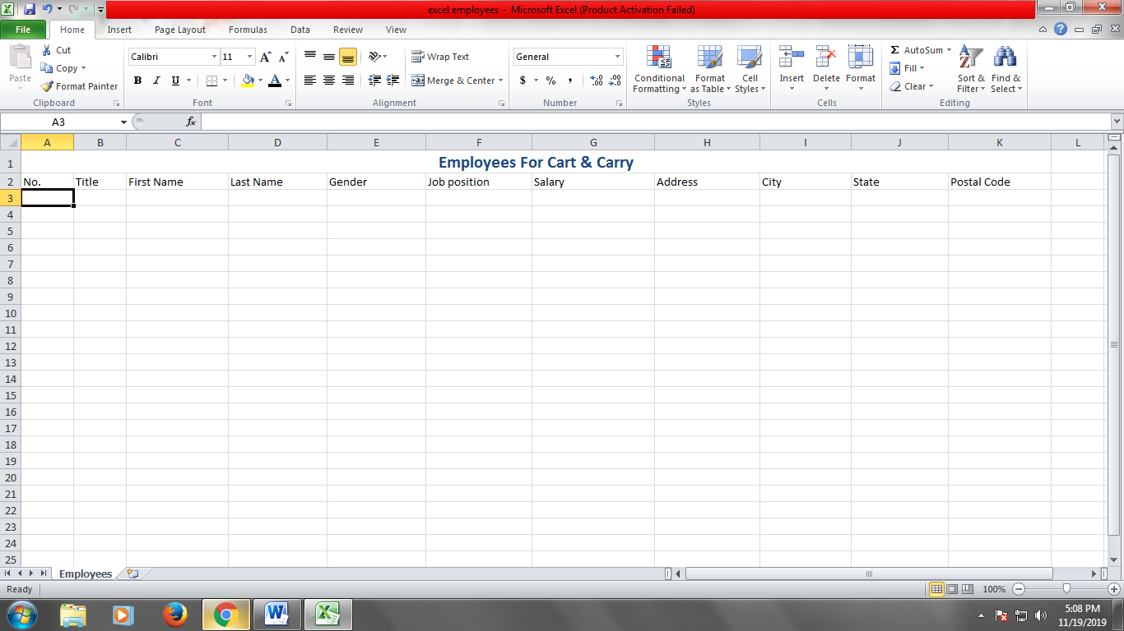

- From row-3, employee information was entered.
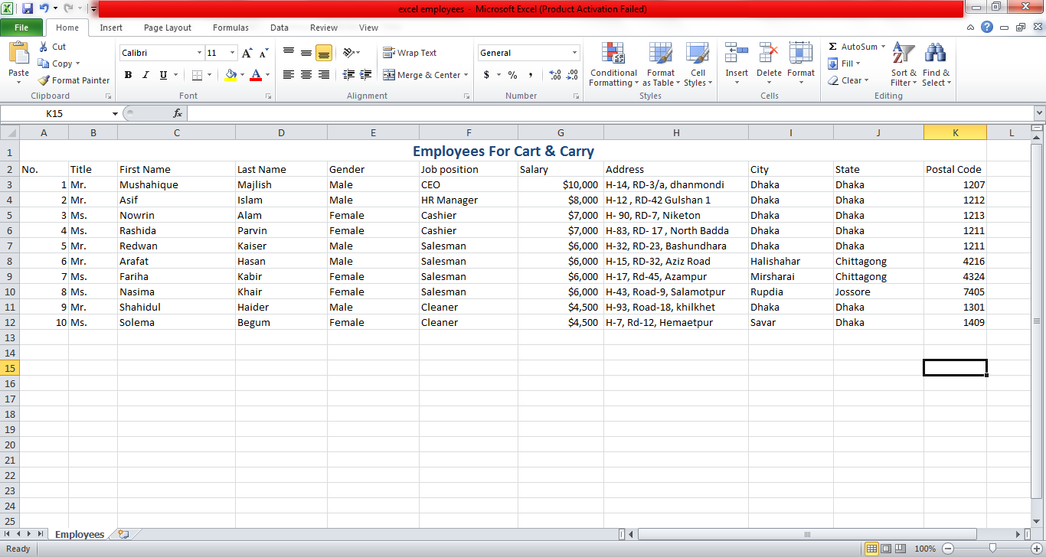

- Cells A2:k12 were selected, then under Formulas Tab- the define name option was selected. Under the Name cell- ‘empolyeelist’ was typed. It will be used later in the project. And the file was saved.
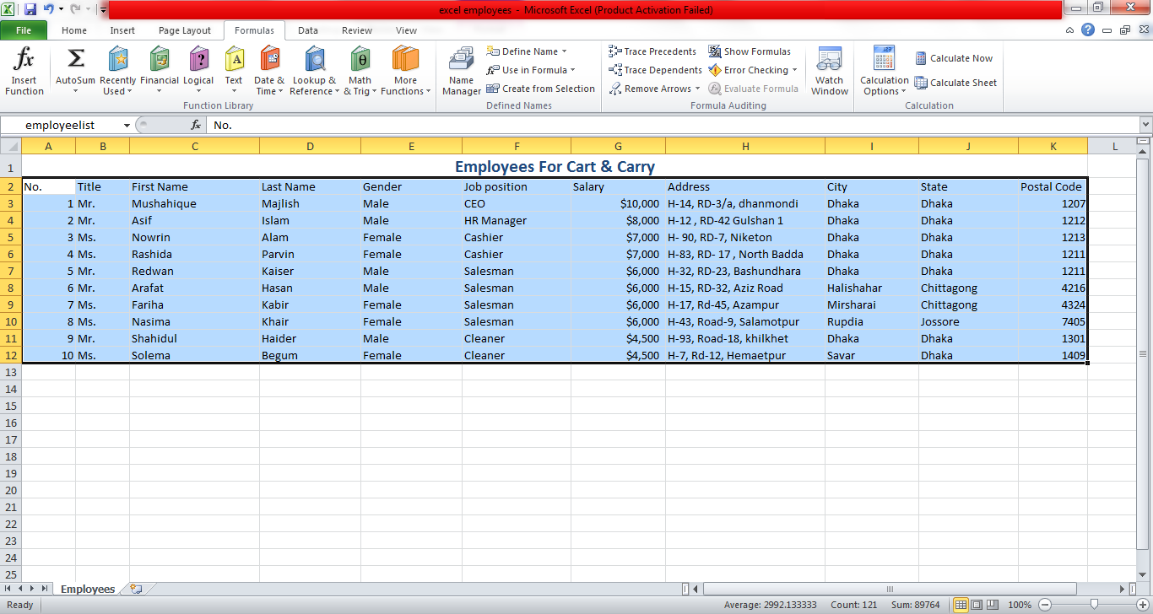
Part -2: Importing data

- Microsoft Office access was opened and a black database was created.

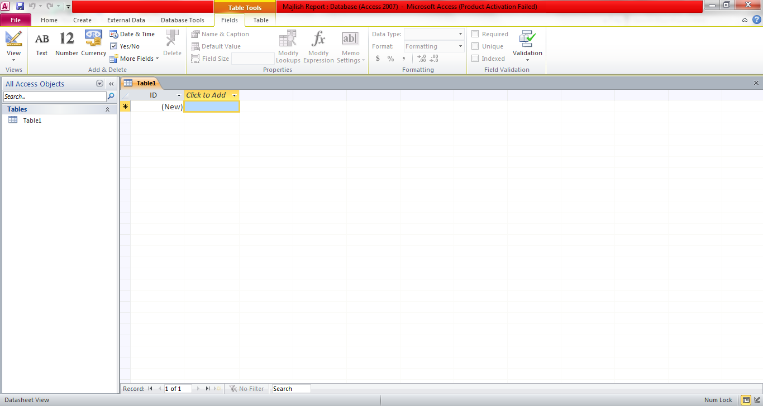

- Excel data was imported using the External Data tab. The file was browsed from part 1 and uploaded.
- Under the ‘Get External Data’ window, the first bullet point was selected. 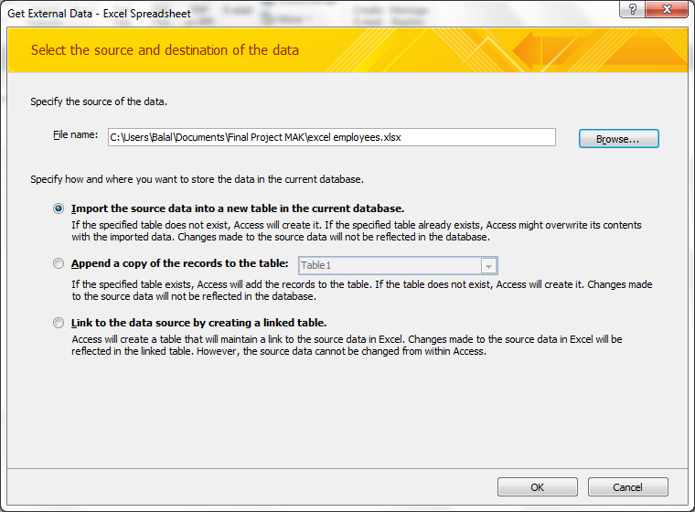

- In the import Spreadsheet window:
a. Under ‘Show Named Ranges’ radio button. The range ‘employeelist’ ,was selected which was created earlier.
b. the Checkbox ‘First Row Contains Column Headings’ was selected .
c. Under the ‘No’ column in the table. Under Field Options, the Field Name was changed to ‘EmployeeNum’.
d) The ‘Choose my own primary ‘key’ radio button was selected. Under the pull-down, select ‘EmployeeNum’ option was checked .
f) For the Import to Table text field, ‘EmployeesTable’ was entered.
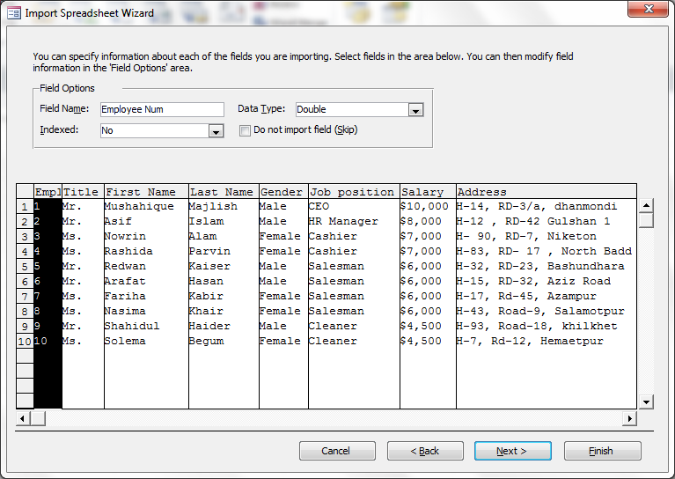

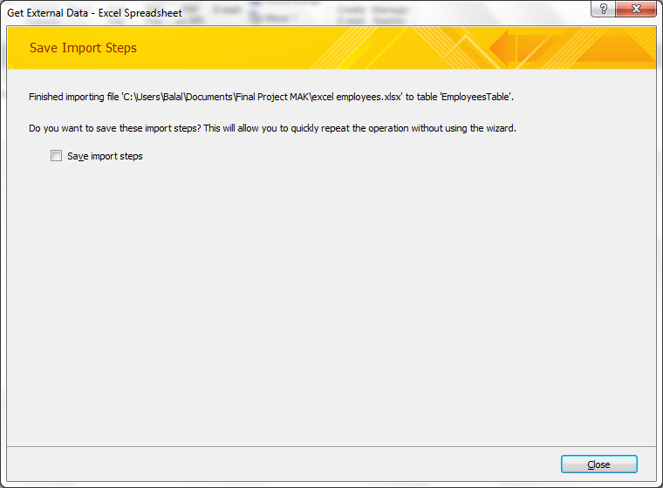

- Under the Design View. The rows- Gender and Salary were deleted.
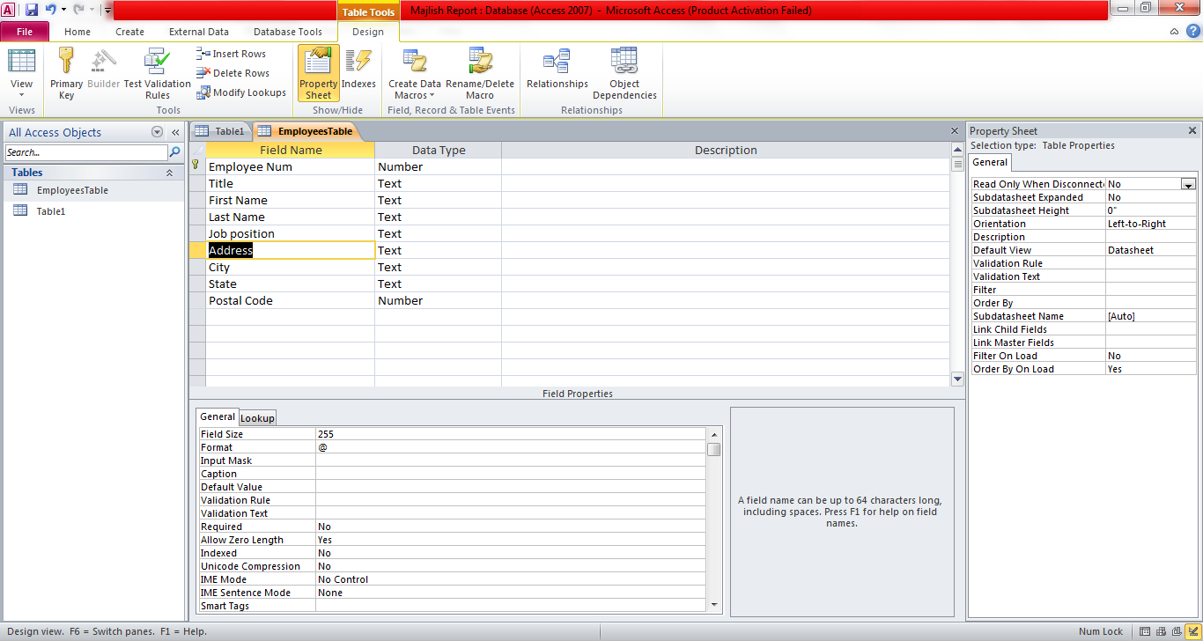

- A New Field was added named Employee Status. And under the lookup wizard the options full-time, part-time and on time was added.
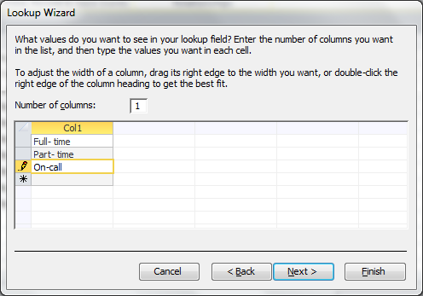

- Under the ‘Datasheet View’ the Employee Status was selected fpr each employee using the pull-down.
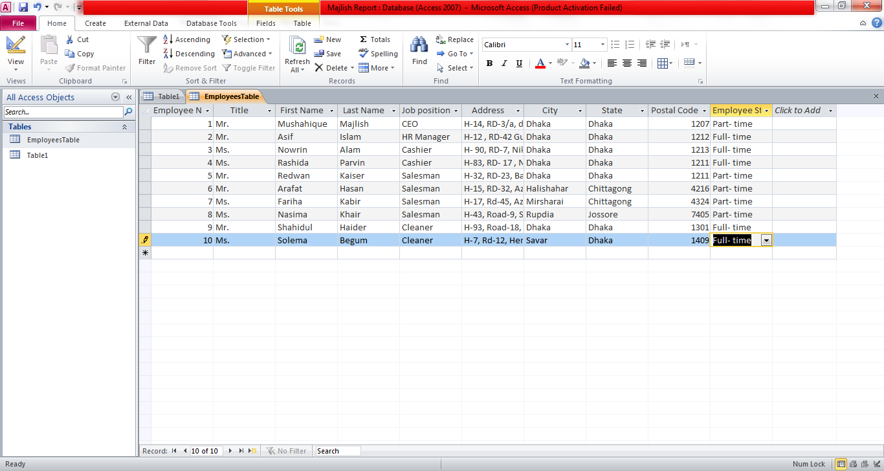

Part: 3 Database Tables

In this part, I created three more database tables for storing customer, product and order information.
- Customer Table
A new table was created under the Design View. And the following fields were created- CustomerNum, CustomerName, Address, City, State, Telephone, Fax

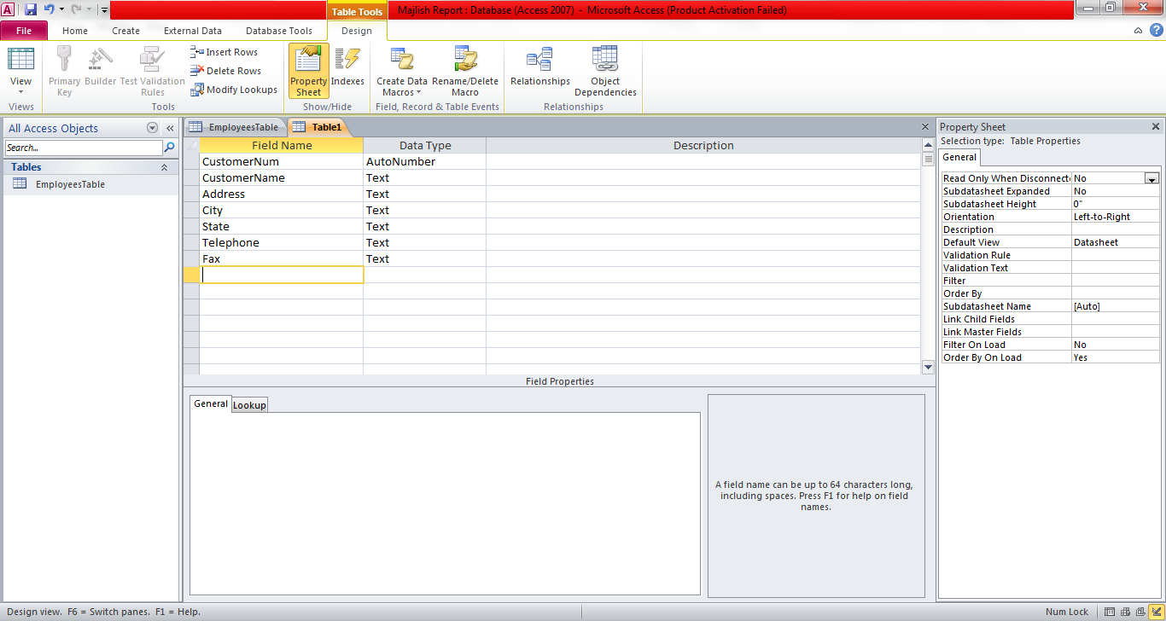

The ‘CustomerNum’ Field was made a primary Key.

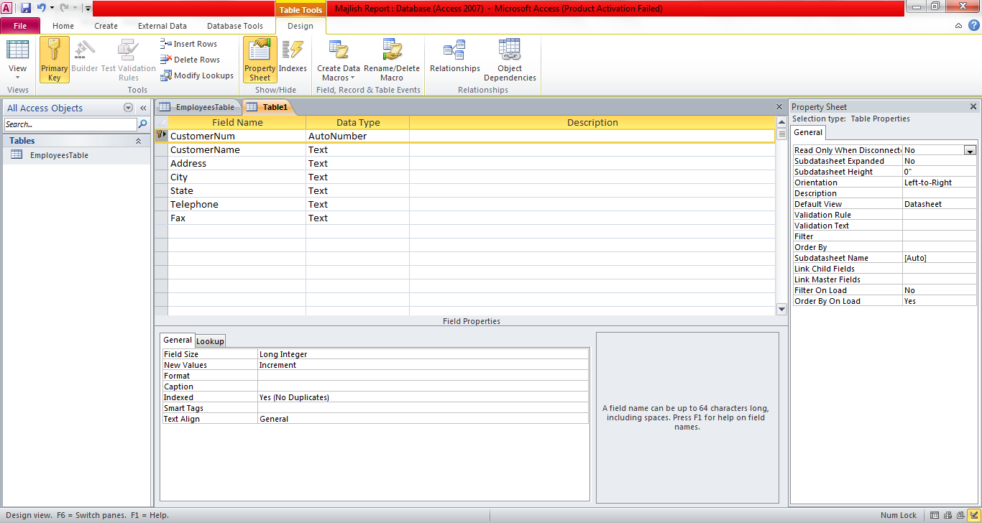

Information was entered to create the input mask for the Telephone and Fax field.

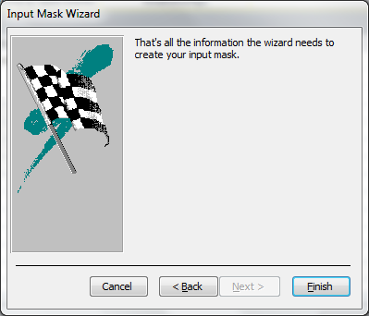

Finally, ten customer information was entered.

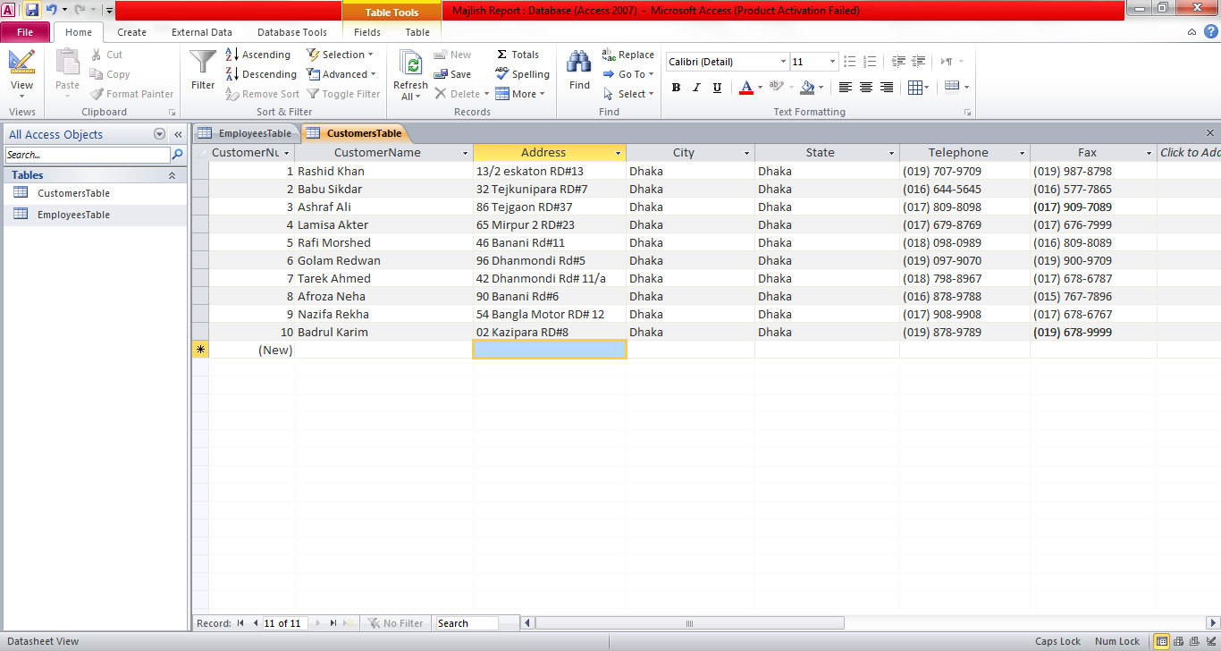

- Products Table
For the Products Table, A table was created under the Design View and three fields were entered-ItemNum, ItemName and Retail price. The ItemNum was made Primary Key. It was then saved and named Products Table.
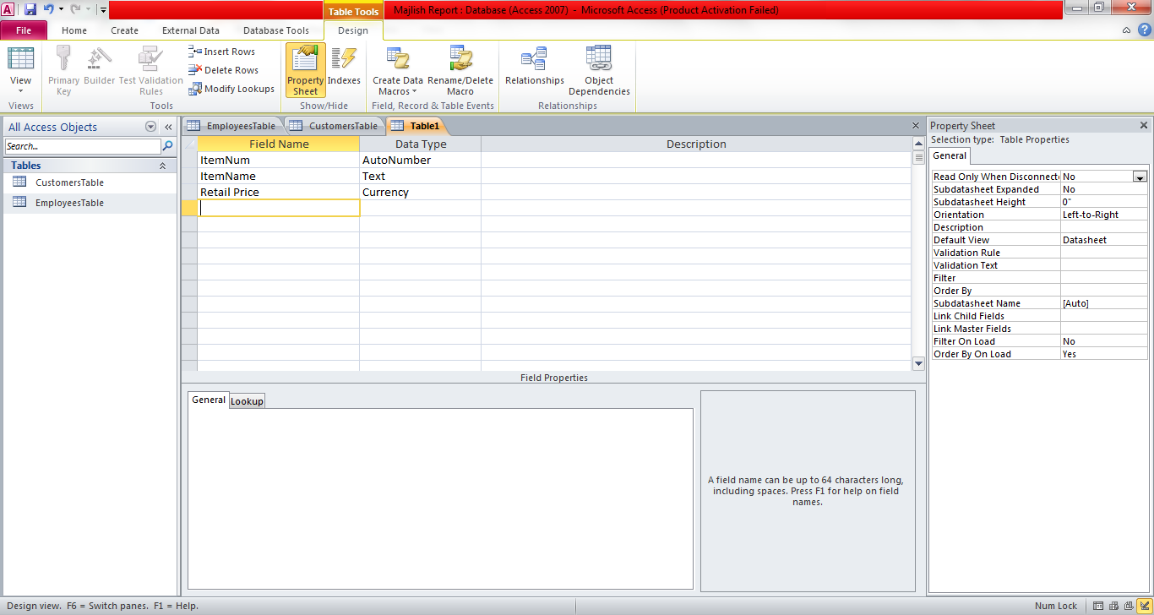
Ten product inputs were given along with their price.
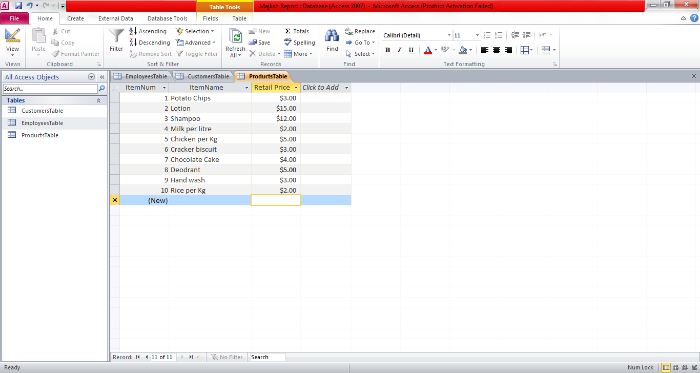

- Orders Table

A new table was created under the Design View and the following Fields were entered- OrderNum, OrderDate, ItemNum, Quantity, CustomerNum and EmployeeNum. The ‘OrderNum’ field was set as primary Key. The table was saved as OrdersTable.

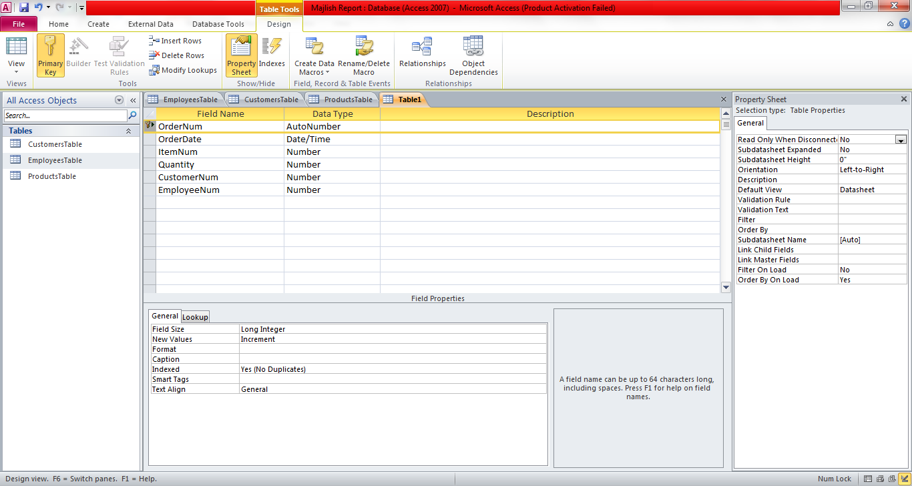

The Lookup Properties were set for the fields- ItemNum, CustomerNum and EmployeeNum. The Bound Column, Column Count and Column Width for each field were specified.
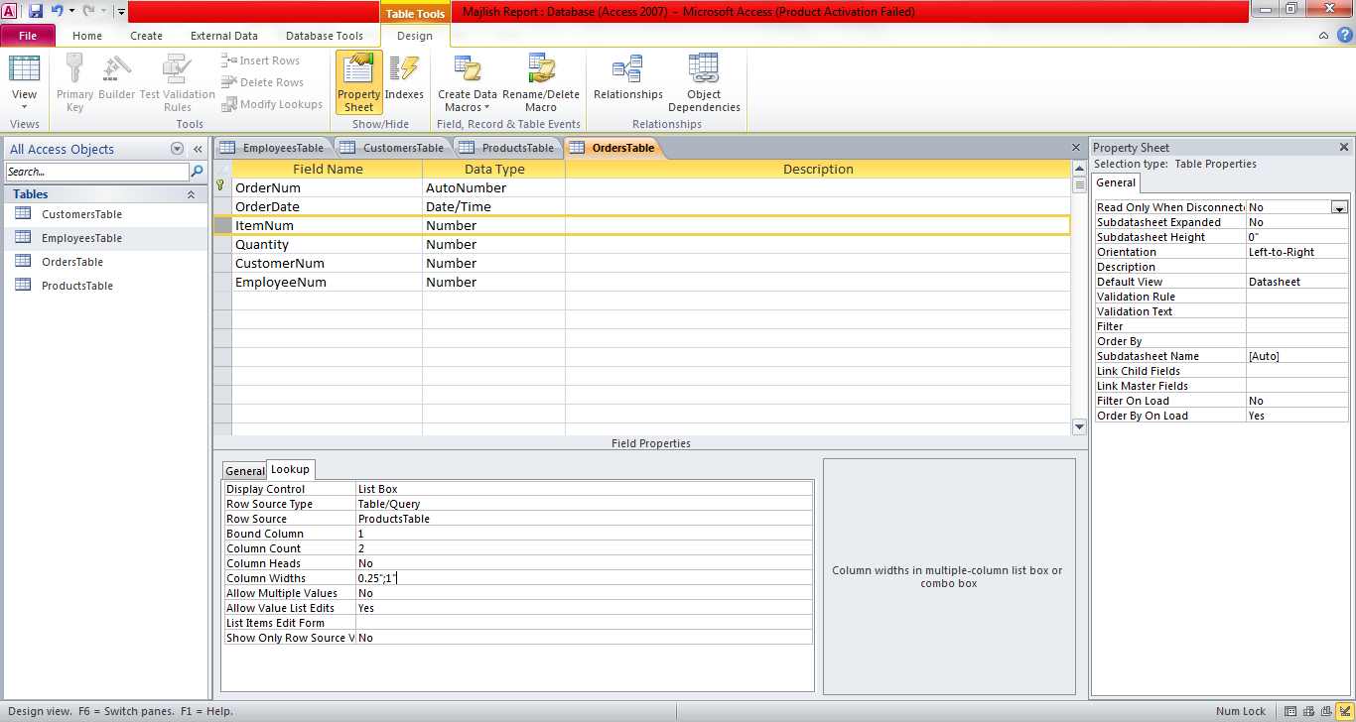

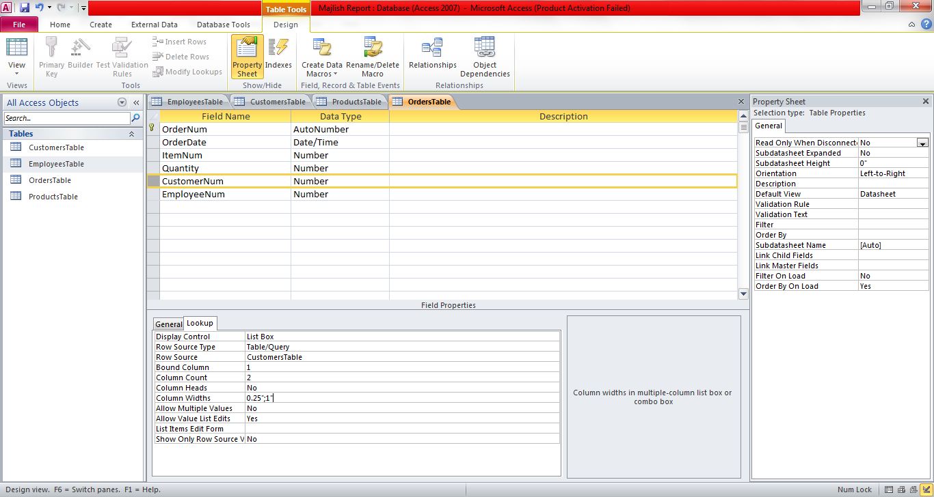

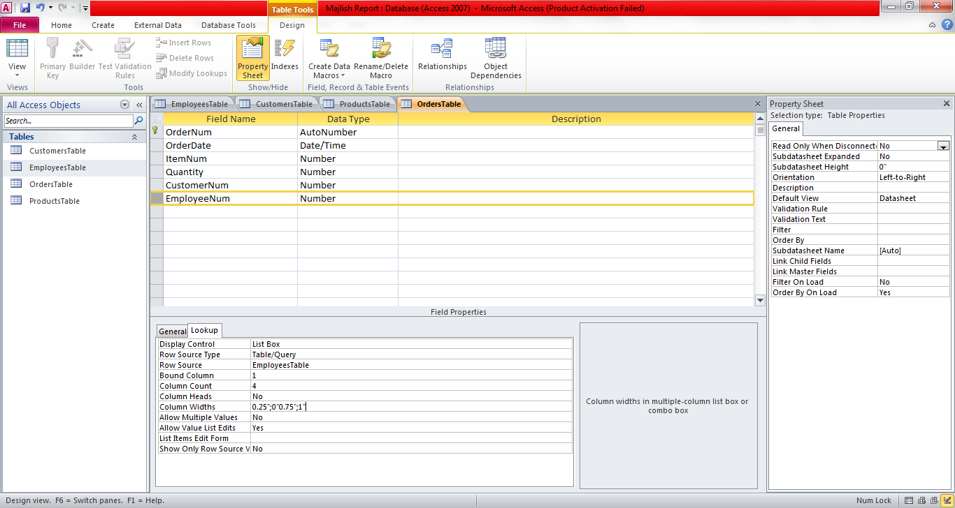

Seven Order Inputs were then listed in the table in the Datasheet View. And the tables were saved.

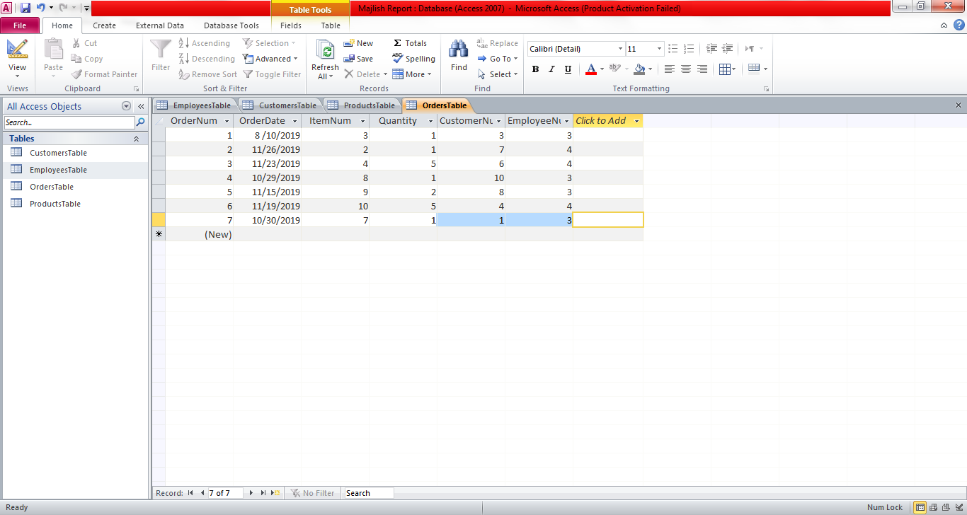

Part-4: Table Relationships

After creating the tables, I will now set up relationships between the tables including Enforcing Relationship Integrity. It is used to maintain consistency between the tables.
Under the ‘Database Tools’ the ‘Relationship’ option is selected and ‘Show Table’ button is clicked.
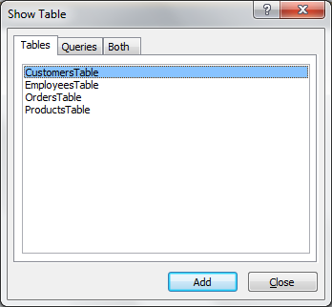
Then the Table is arranged in the following format.
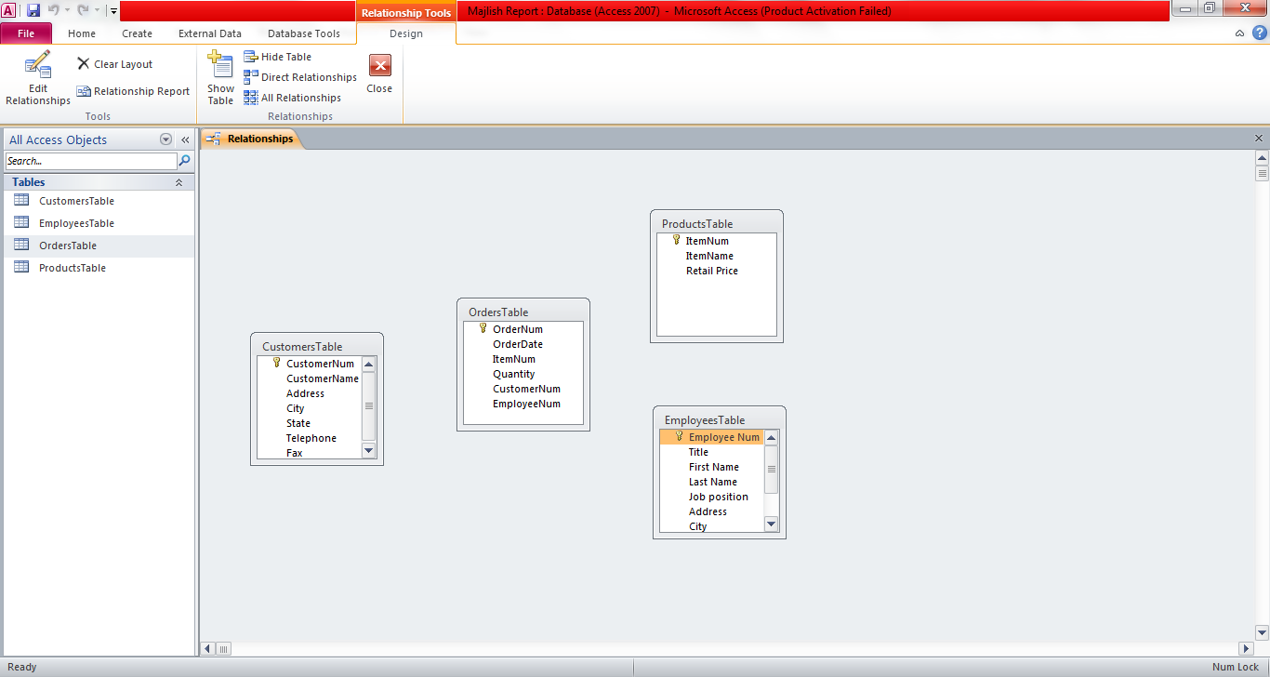
Then the Relationships between the tables are set by clicking on a field in a table and dragging it to the next table, then checking the ‘Enforce Referential integrity’ box and then clicking in the ‘Create’ button.

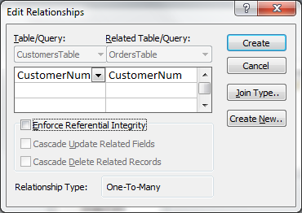

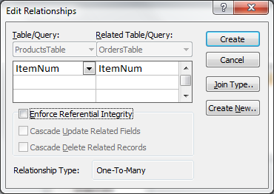

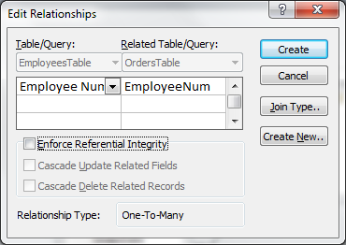
After completion, the tables will show like this:

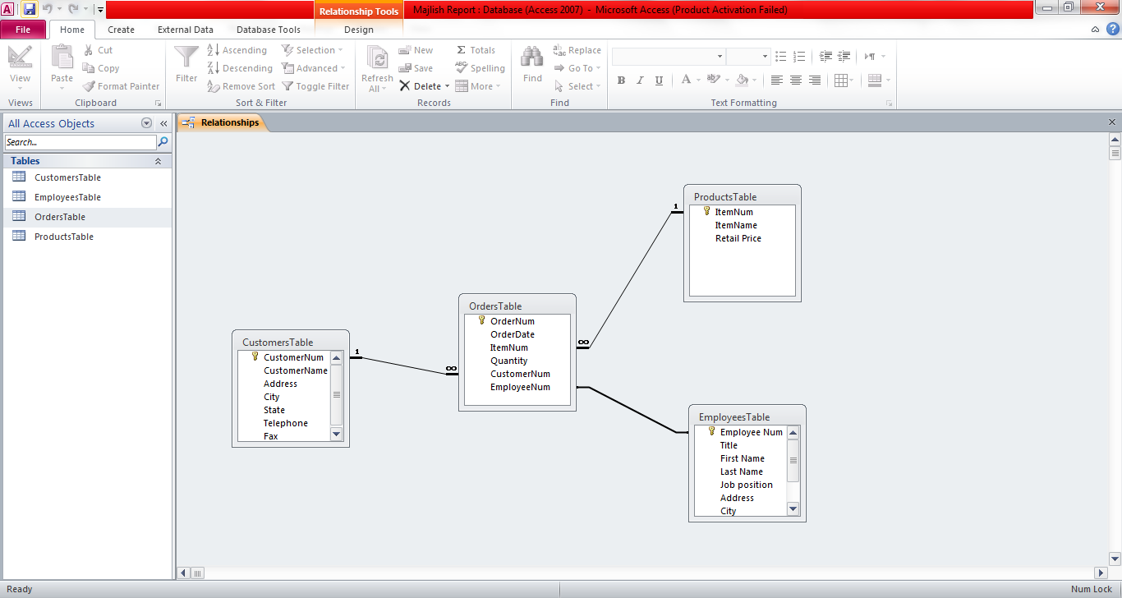

Part 5: Database Normalization

Database normalization is a process which reduces data redundancy and helps to improve data integrity by using the three normal forms (1nf, 2nf and 3nf) in a relational database.

Here, I used the Table Analyzer wizard under the ‘Database tools’ tab to first normalize the ‘Orders Table’.

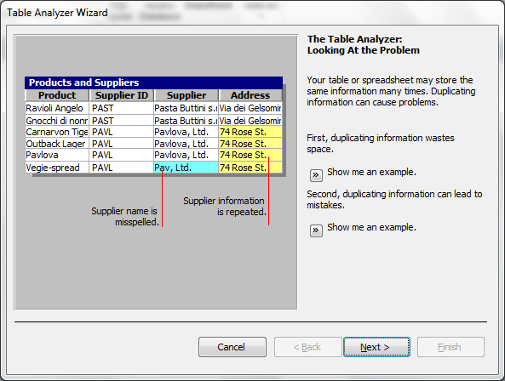

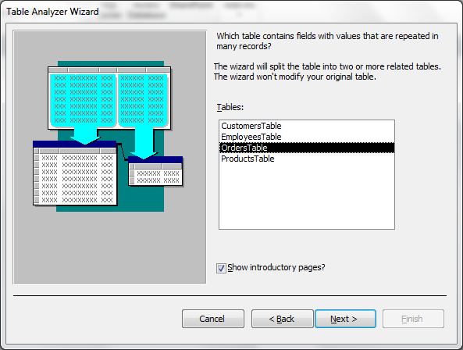

Here I allowed the wizard to decide what fields go in what table.

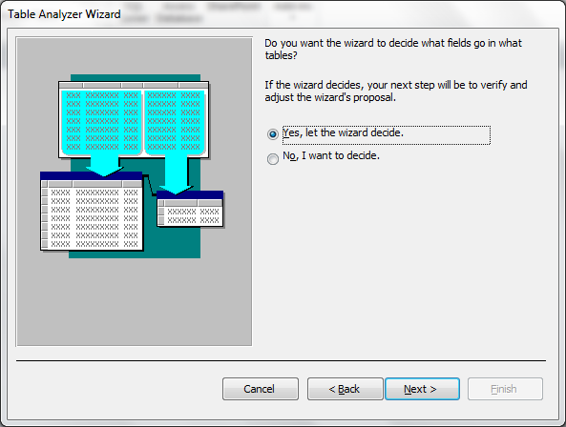

The wizard recommended not to split the ‘OrdersTable’.

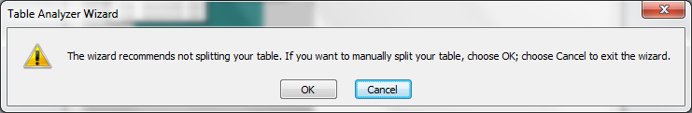

Then, I followed the steps for the customers table and named the three tables- CustomersTable1, CustomersTable2 and CustomersTable3.
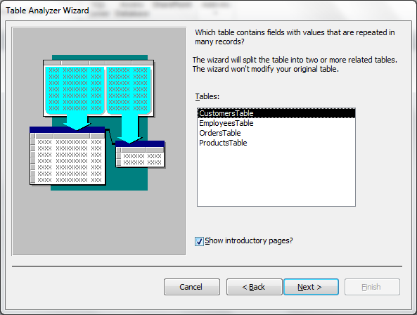
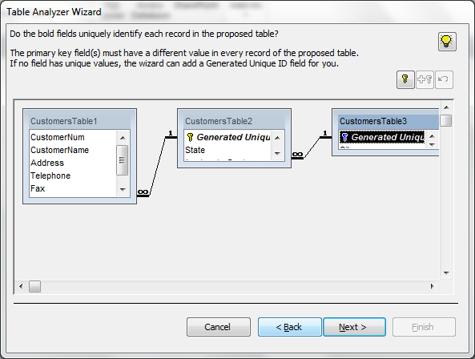

Finally the table is normalized.
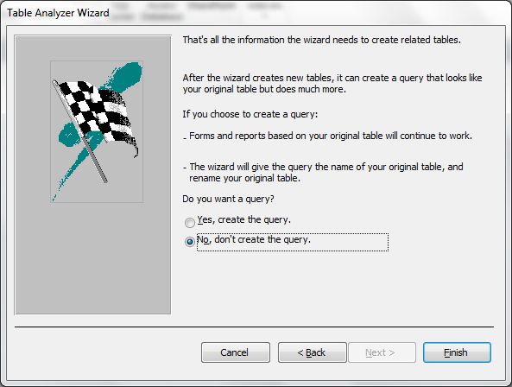

Part 6 : Data Input Form

At this part, I made two forms-
- For adding new customers
- For adding new orders
Input Form for Customers:
The ‘Form Wizard Option’ is clicked under the ‘Create’ Tab.
Then inputs are provided in the ‘Form wizard’ until the form is created.
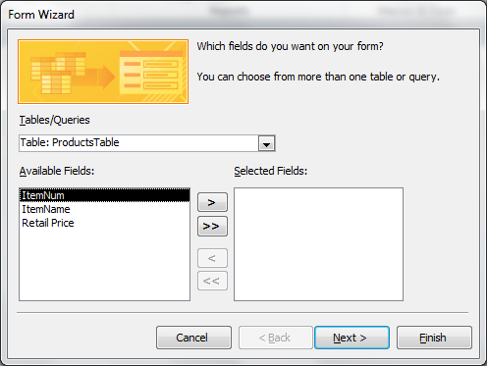

The customers form:
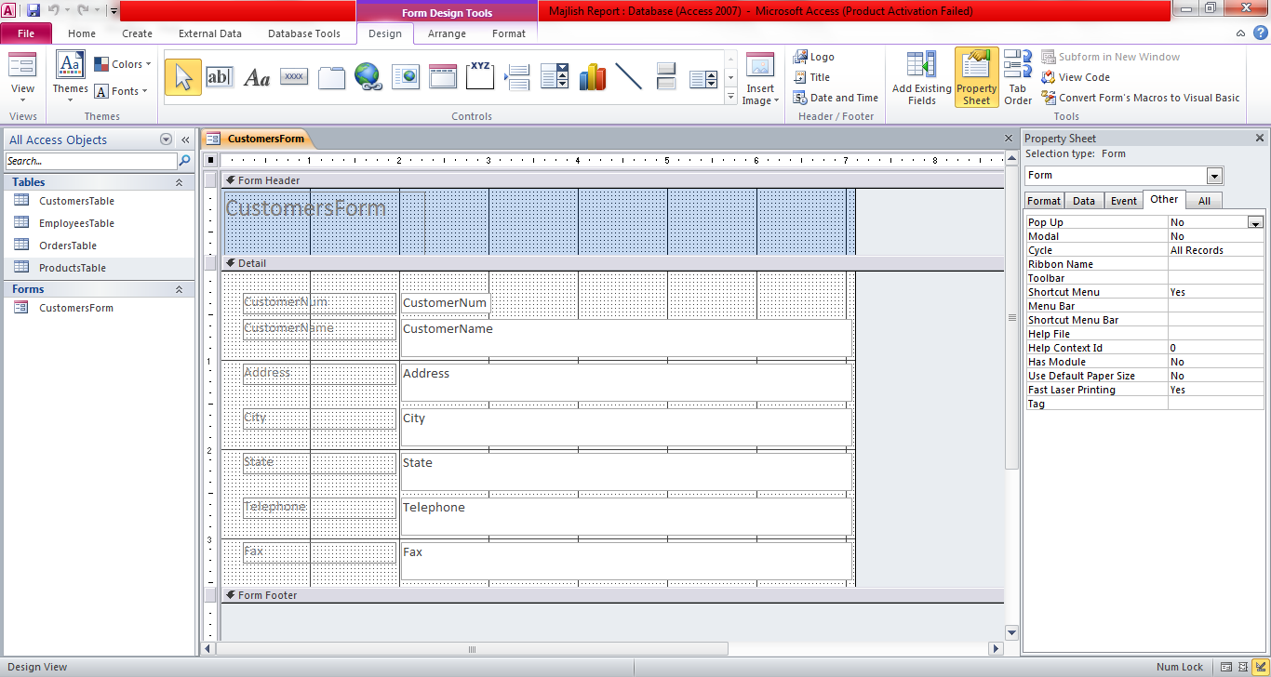

In the property sheet, under the format and data tab, the settings for CustomerNum and CustomerName fields are changed.
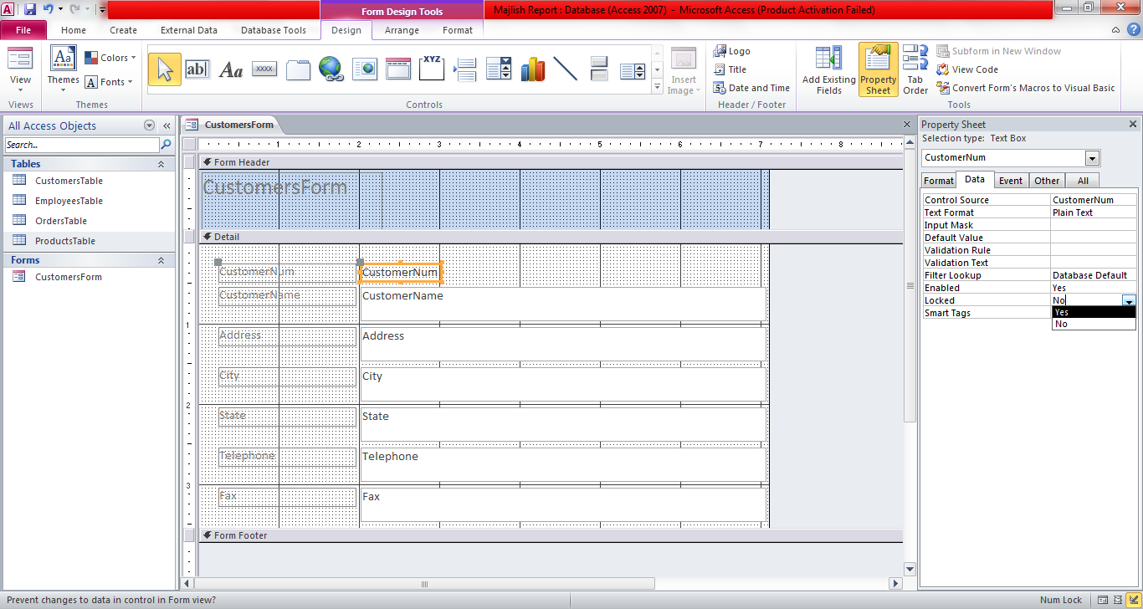
Customer Form (Form View):
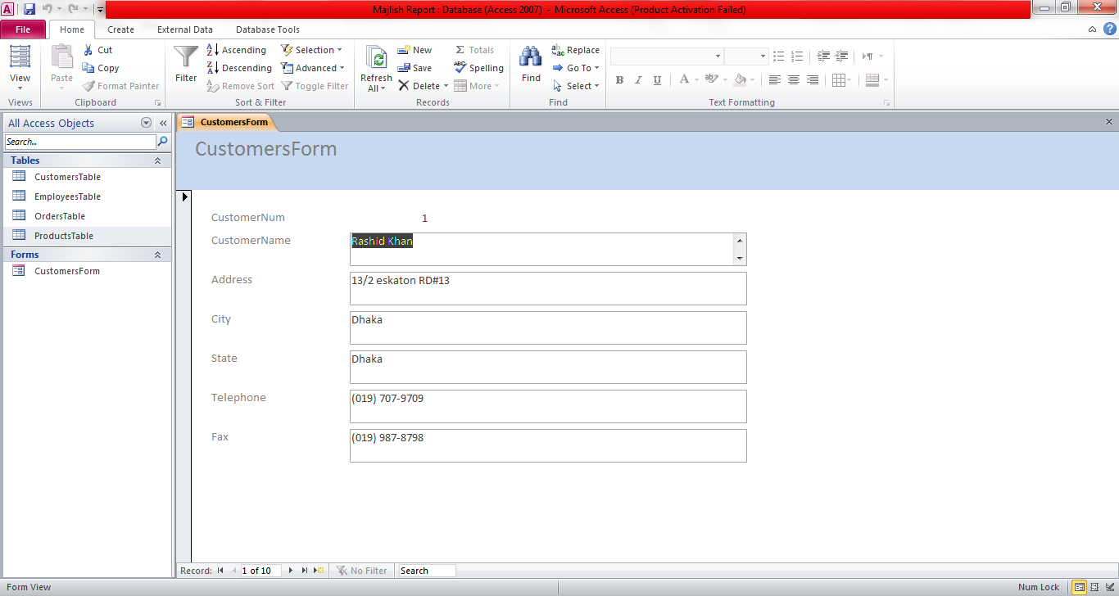

Input Form for Orders:
The ‘Form Wizard Option’ is clicked under the ‘Create’ Tab.
Then inputs are provided in the ‘Form wizard’ until the form is created.
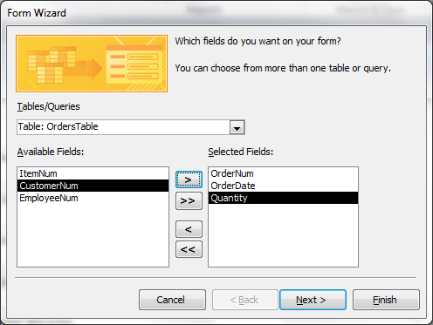
Orders Form:
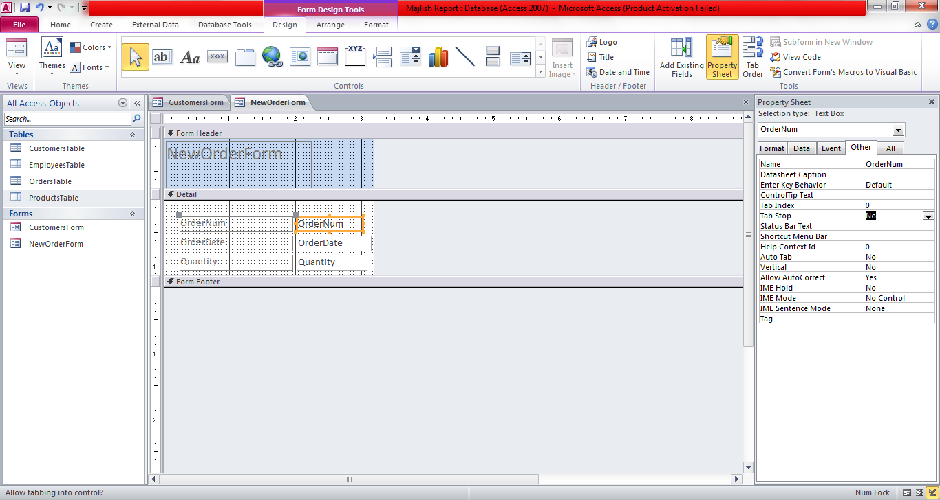
For the Customer Name, Customer Number, Employee Name, Employee Number and Item field the Combo box Wizard is used to create a combo box:

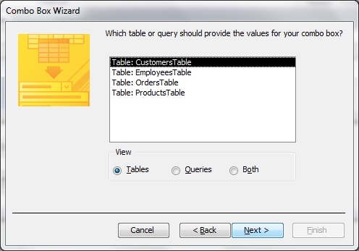

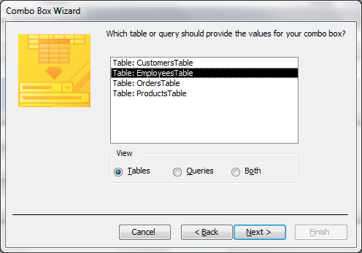

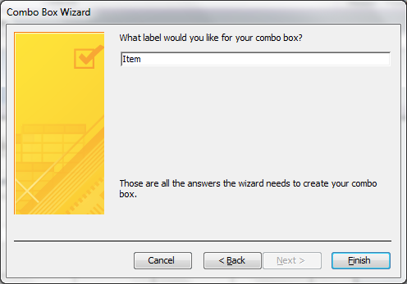

Orders Form (Form View):
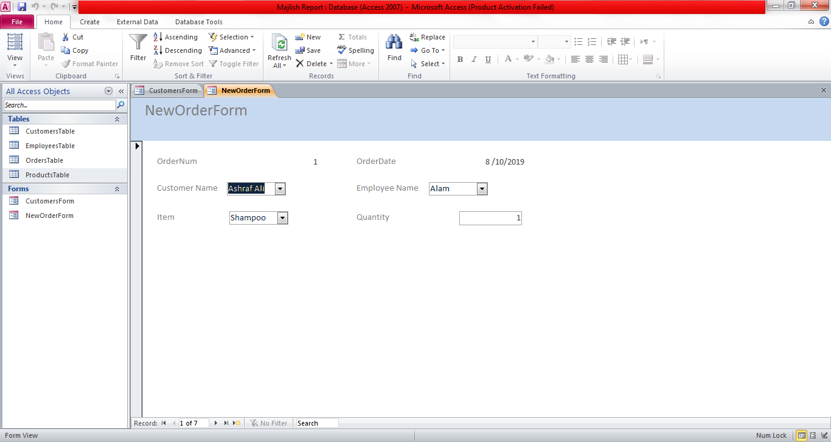

Four more orders are added using the ‘New (blank) record icon’ at the bottom of the form.

Part 7: Building Queries:
At this part I created two queries which will contain a formula and extract data and sort the resulting information from a minimum of two tables.
First I used the ‘simple query wizard’ to create a query. And named the query ‘Orders for December query’.
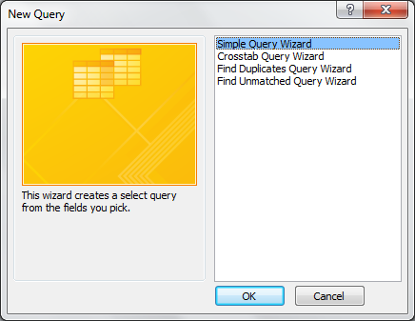
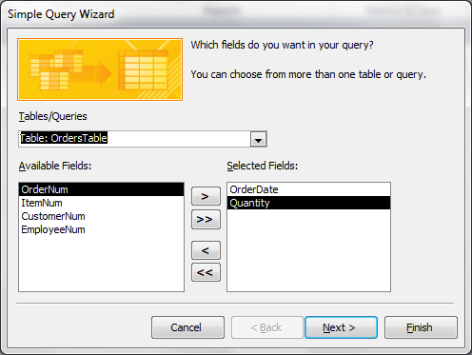
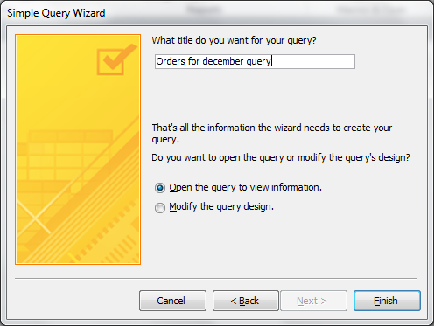

Design View (Query):

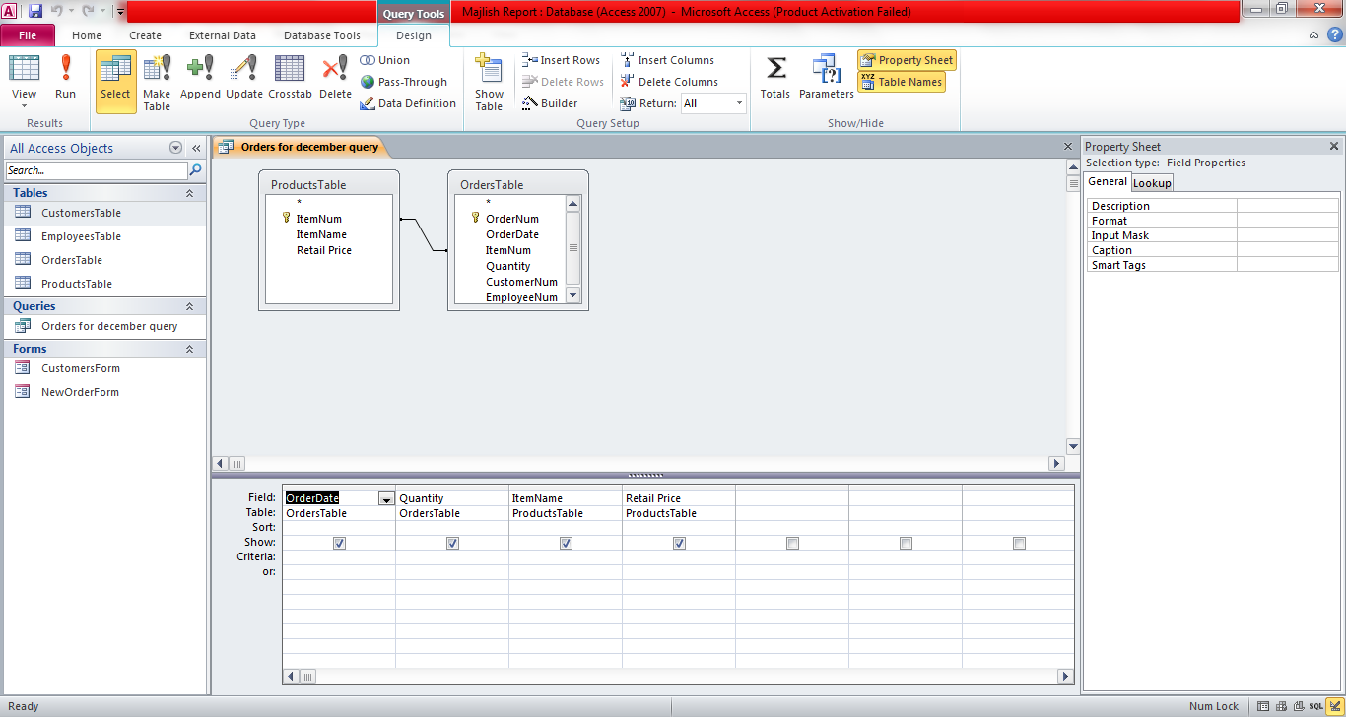

Inputs provided in the Order Date column in the ‘sort’ and ‘criteria’ row.
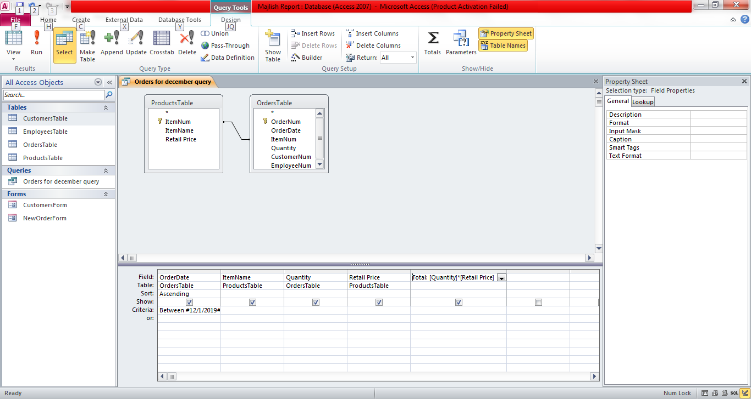

Query (Datasheet View):

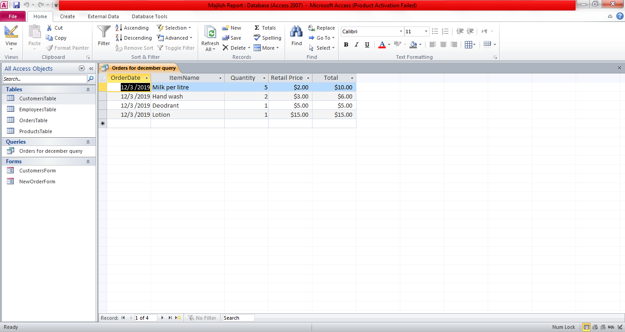

Another query is created to list orders by customers and named ‘Orders by customers query’.
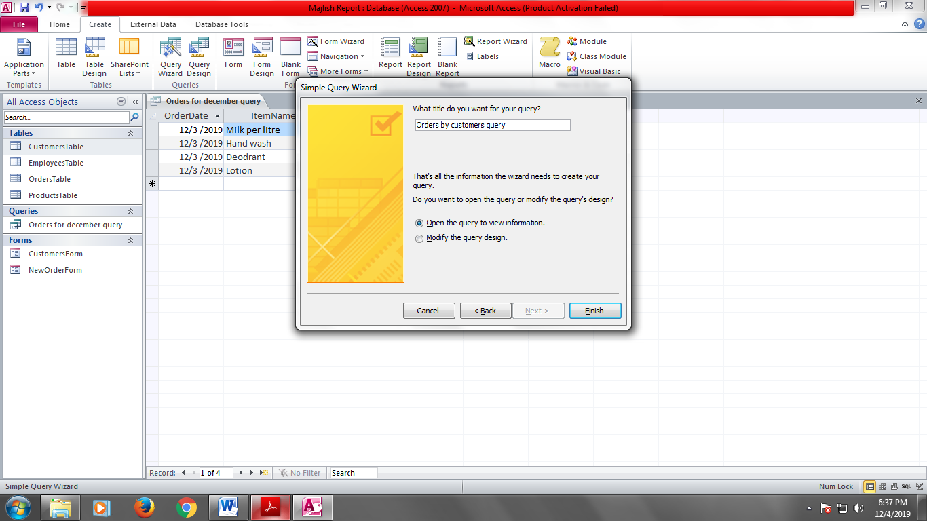

Query (Design View):

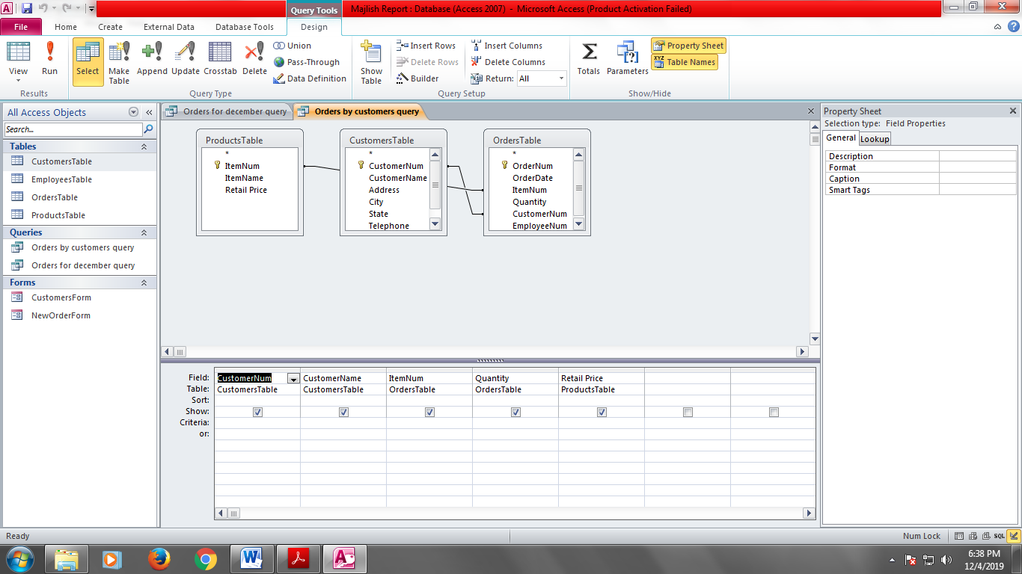
Query (Datasheet View):

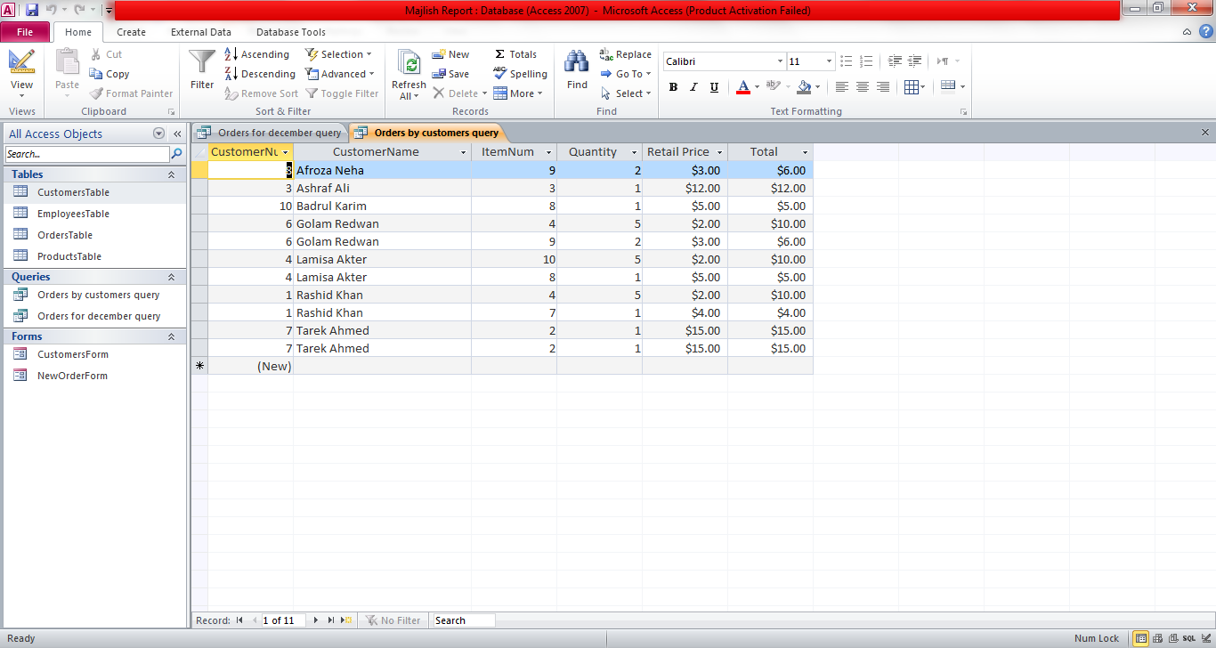

Part-8: Account Receivables Report

At this part, I created a report which displays the total amount received by collecting data from at least one field of each of the three tables. This part also includes some formulas that I added to calculate- Total, Running Total and Grand Total.
At first, under the ‘Create Tab’ I selected the ‘Report Wizard’ option. Then went through the input until a report is displayed in the ‘Design View’.

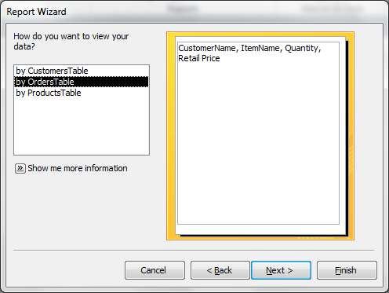

Report in Design View:

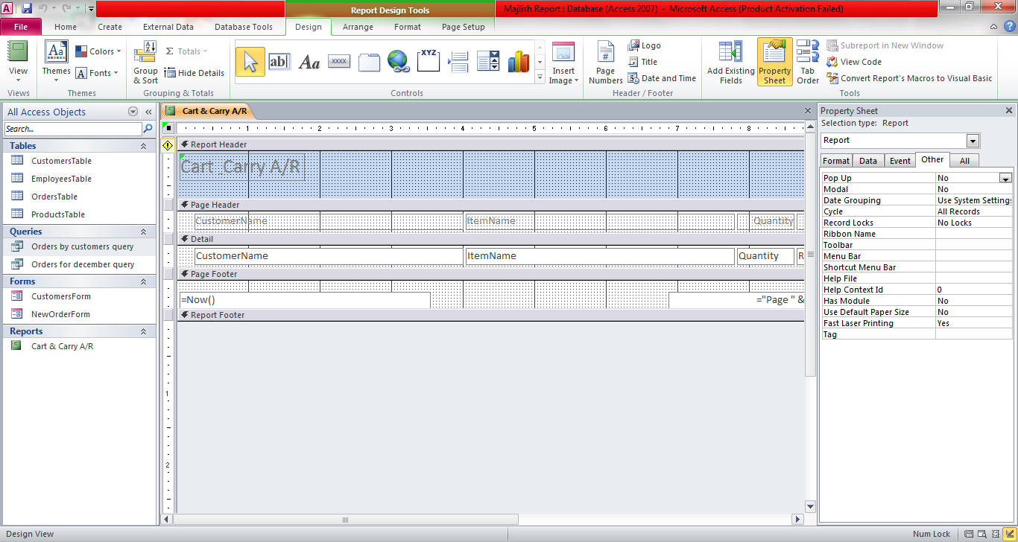

Then I added a ‘Label’ and named it ‘Total’. Later Added a ‘Text Box’ and include the totals formula ‘= [Quality]*[Retail Price]’ in the property sheet under the ‘data’ tab. And set the format as ‘currency’.
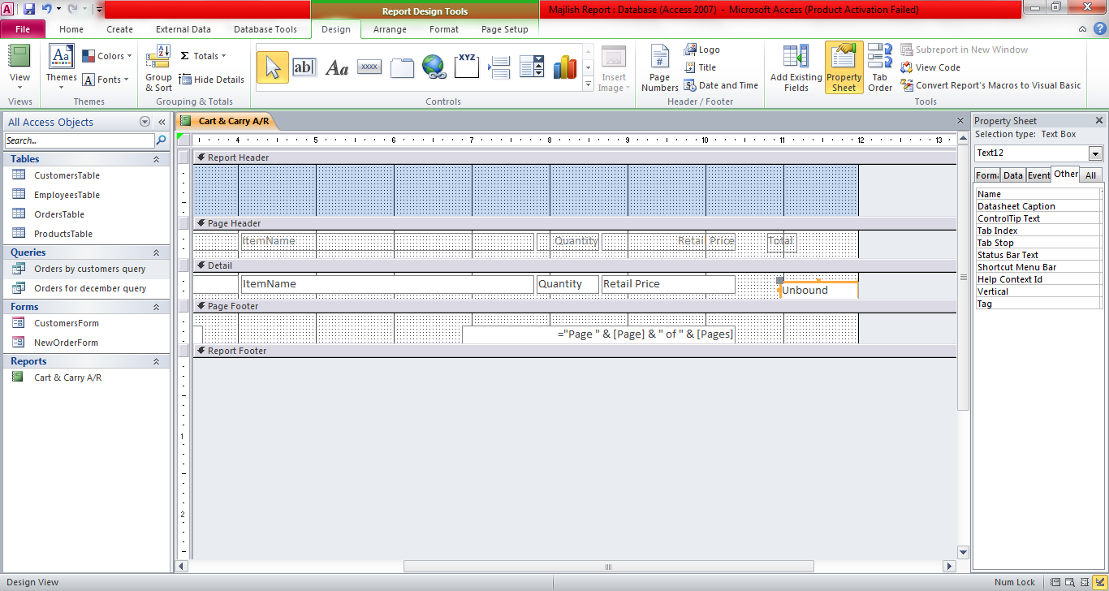
Repeated similar steps for the ‘Running Total’ . Then set the ‘Running Sum’ in the ‘data’ tab to ‘over all’.

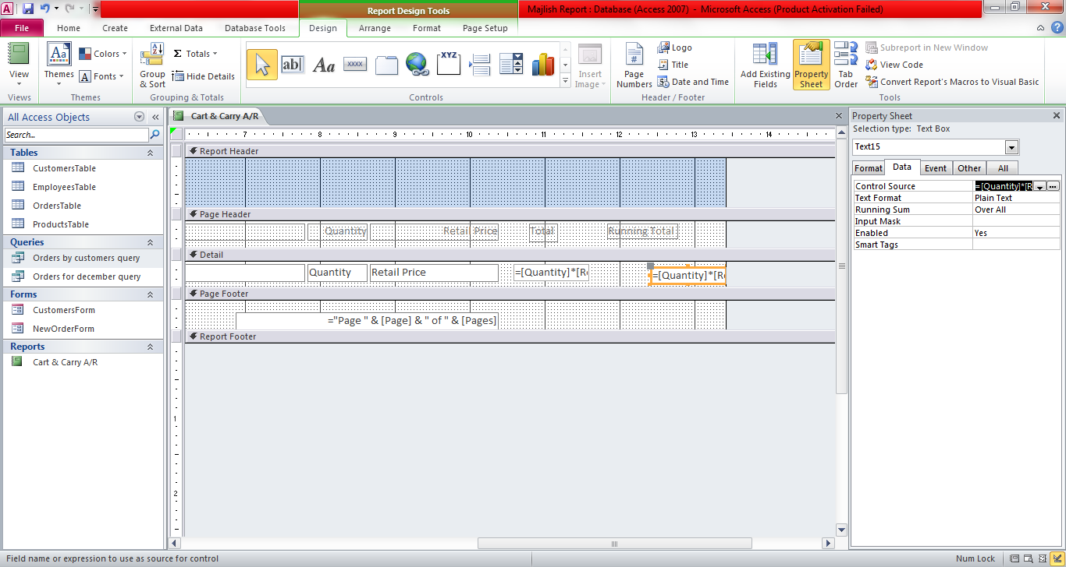

Then set a ‘Text Box’ at the page footer for ‘Grand total’. Inputted the ‘Control Source’ property in the ‘data’ tab.
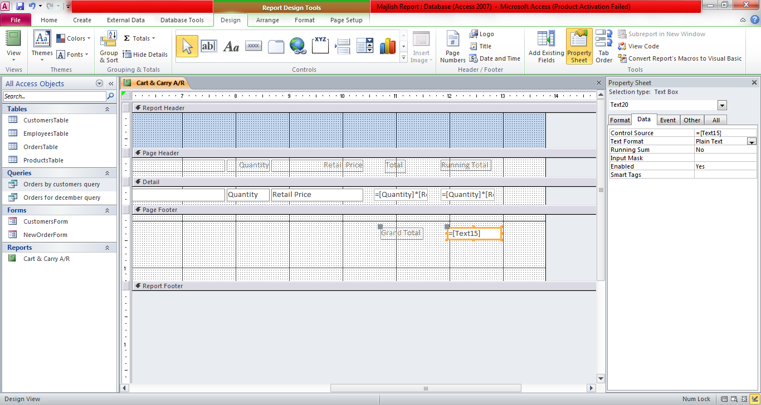

Edited the ‘Report Header’.

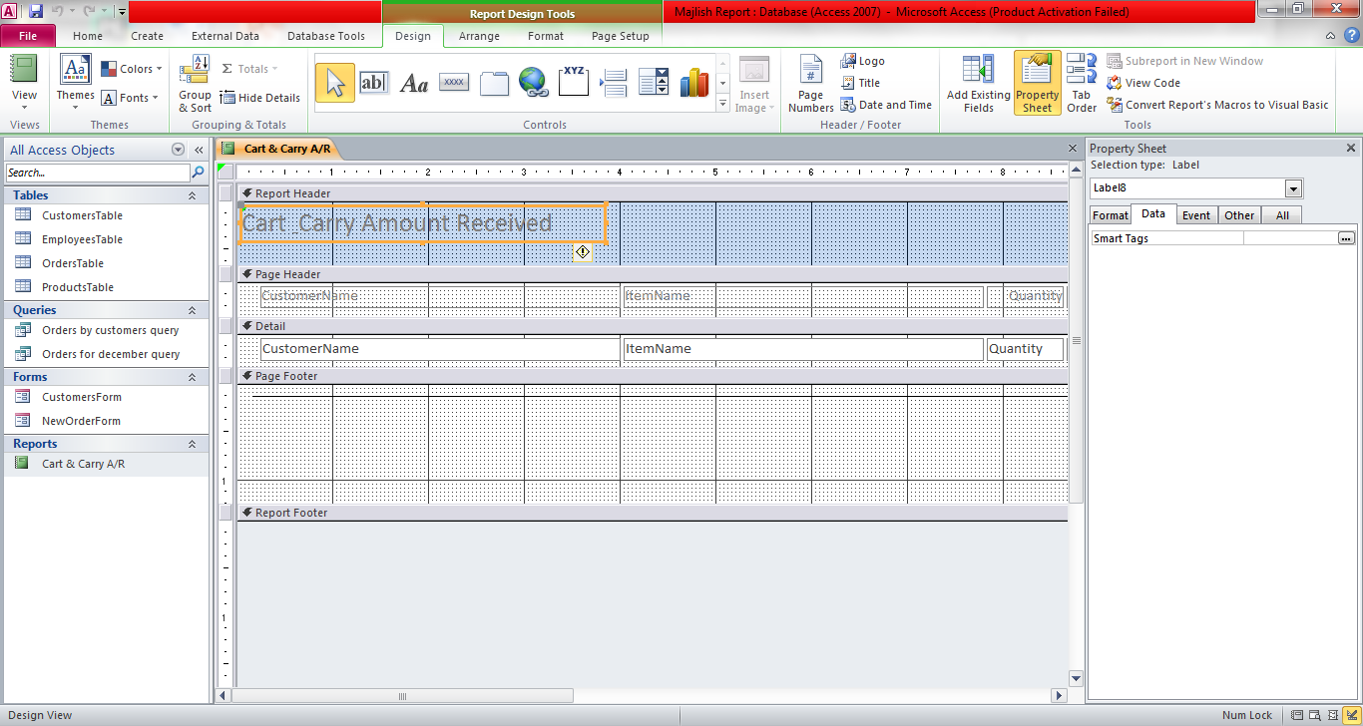

Report in ‘Report View’:

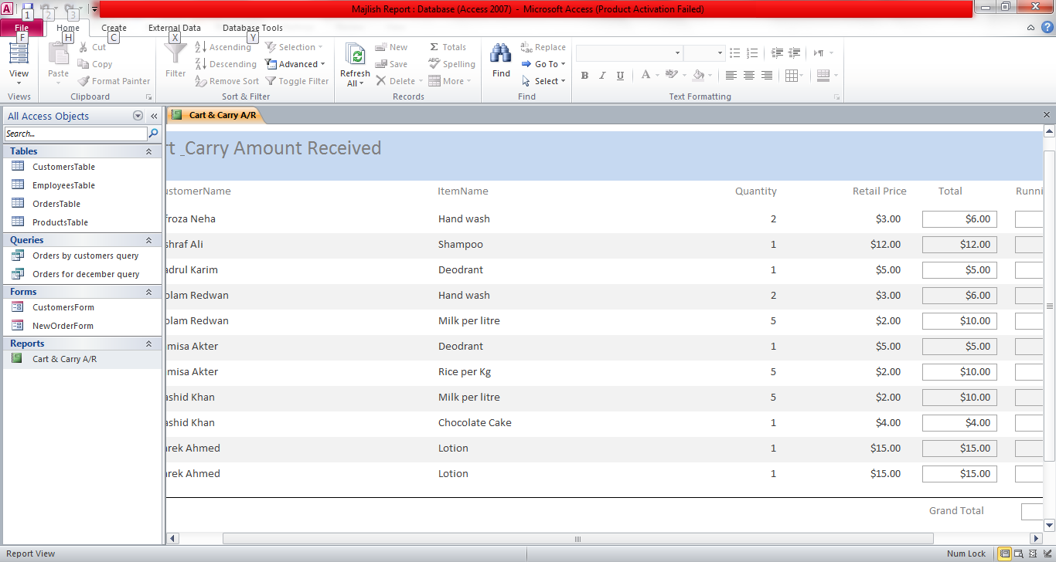

Chapter-3 Conclusion

At the present world most organization needs the presence of a database to support their activities. Database is a medium to protect delicate data, access them quickly, and can be used to make real-time decisions.
The Retail Management System that I developed can be used in a super shop which is a retail organization. This system also creates a database which allows the organization to function. The database in my system provides details about customers, orders and employees. Using these details the user can find out the revenue amount and other necessary information which can later be used to make decisions.

An organized database can undoubtedly be a valuable asset to the organization.

Reference:

https://www.mcstech.net/normalizing-tables/
https://officetutorial.net/access/normalizing-table-creating-editing-and-deleting-table-relationships/496/
https://www.youtube.com/watch?v=r1cQ3dsN9mI
https://www.youtube.com

Appendix- A: [null]

[Blank]

