Project Report on
Comparative Financial Performance Analysis between Two Non-Banking Financial Institutions:
IDLC Finance Ltd. & LankaBangla Finance Ltd.

Comparative financial performance analysis between two non-banking financial institutions:
IDLC Finance Ltd. & LankaBangla Finance Ltd.

Course Title: Project

Supervised By-
Md. Ali Ashraf
Associate Professor
School of business and economics
United International University

Submitted By-
Sarah Afreen
ID: 111 131 553
BBA
Major: Finance
Date of Submission: 4th March 2018


United International University

Letter of Transmittal
4th March, 2018
Md. Ali Ashraf
Associate Professor
School of business and economics
United International University
Subject: Submission of Project Report on “Comparative financial performance analysis between two non-banking financial institutions; IDLC Finance Ltd & LankaBangla Finance Ltd.”
Dear Sir,
With due respect, I would like to apprise you that It is a great pleasure for me to submit the report on “Comparative financial performance analysis between two non-banking financial institutions; IDLC & LankaBangla Finance Ltd” as it is a fulfillment of partial requirement to accomplish BBA degree. In the preparation of this report, I have studied several articles and gathered information on book building method in Bangladesh perspective. I have tried my level best to make this report substantial and communicative. I hope that it will fulfill my degree requirement. So, I therefore, request and hope that you would be kind enough to accept my report and oblige thereby.

Sincerely Yours,
Sarah Afreen
ID: 111 131 553
BBA (Finance)
United International University

Acknowledgement
First of all, I would like to express my gratitude to Almighty Allah to enabling me to complete this report on ‘‘Comparative financial performance analysis between two non-banking financial institutions; IDLC Finance Ltd & LankaBangla Finance Ltd’’.
I take this opportunity to disclose my insightful thankfulness and deep honors to my guide Md. Ali Ashraf (Associate Professor, School of business and economics) for his special guidance, monitoring, constant encourage, and thoughtful advice throughout the course of this project. Without his guidance and cooperation, it would be very hard for me to submit this report. I am thankful for the other members who helped to complete this report by providing their valuable information in their respective fields. This report is not free from limitations and errors. There might still be some minor typing mistake despite my utmost care. I do apologize for this.

Table of Content
1 Introduction 2
1.1 Background of the Study 2
1.2 Problem Statement 3
1.3 Research Objectives 4
1.4 Significance of the Study 4
1.5 Scope of the Study 4
1.6 Limitations of the Study 5
2 Literature Review 7
2.1 Non-Banking financial institutions (NBFIs) 7
2.2 The difference between NBFI & Banking institutions 7
2.3 Picture of financial system in Bangladesh 8
2.4 Overview of NBFI sectors in Bangladesh 9
2.5 Product & services of NBFIs: 10
2.6 Role of NBFIs in Economic Development & its growth overtime in Bangladesh 11
2.7 Company overview; 15
2.7.1 IDLC Finance Ltd 15
2.7.2 Mission & vision: 15
2.7.3 Company organism 16
2.7.4 Products & services: 17
2.7.5 Capital structure 21
2.7.6 Shareholders structure 21
2.7.7 Risks 22
2.7.8 Financial highlights: 23
2.7.9 Lankbangla Finance Ltd 24
2.7.10 Mission 25
2.7.11 Vision 25
2.7.12 Organism of company 25
2.7.13 Product & Services 26
2.7.14 Capital Structure 27
2.7.15 Shareholder Structure 27
2.7.16 Risks 28
2.7.17 Financial Highlights 28
3 Methodology 30
4 Findings of the Study 32
4.1 Ratio Analysis 32
4.1.1 Liquidity Ratio: 32
4.1.2 Solvency Ratio: 35
4.1.3 Profitability ratio: 40
4.1.4 Market Prospect Ratio: 44
4.2 DU Pont Analysis: 49
4.3 Linear Regression Analysis 50
5 Recommendations 55
5.1 Conclusions: 56
6 References: 58

Executive Summary
The analysis applies performance evaluation and comparison of two branded non-banking financial institutions of Bangladesh; IDLC Finance Ltd & Lankabangla Finance Ltd. This measures how well a company is performing comparing with other. In this determination the most used elements are the balance sheet and income statement account. Balance sheet displays the financial situation and income statement account displays the net profit or net loss of a bank.
Ratio analysis, the utmost widespread movement to appraise a company’s performance over years. In this project report financial statements of the two NBFIs of past five years (2012-2016) were studied. And then substantial comments were given. The financial performances are evaluated through ratio analysis, Dupont analysis and a hypothesis test. Under ratio analysis liquidity ratios, solvency ratio, profitability ratio, market prospect ratio these are evaluated and also tested the significant relationship between liquidity & profitability.
The study found that the performance of Lankabangla finance ltd. is better than IDLC Finance ltd. in some aspects. Conversely, IDLC Finance ltd also has some advantage over Lankabangla finance ltd. in different aspects. So, overall which one is better, difficult to say? Each one has its own strengths and flaws. That’s why some suggestions are given. However, the results also show these two NBFIs are refining overtime noticeably in ratio analysis during the retro under the study.

Chapter 1

Introduction



Introduction

Non-Bank Financial Institutions (NBFIs) play an important character by offering various financial services that cannot be offered by the banks always. To satisfy the changing demands of customers NBFIs offer more many-sided products and services financial markets. Bangladesh Bank supervise them by ensuing a risk-based supervisory system. Credit rating is the key diffident criterion in NBFIs' performance measurement system. It gives a proposition of how an institution is expected to perform in the future and whether it is well placed to repay its debts and meet its overall financial obligations. The purpose of this report is to evaluate the financial performance of two NBFIs to know which of these is performing better. The well-known brand names in non-banking financial institutions industry of Bangladesh which are selected to analyze for the report; IDLC Finance Ltd & LankaBangla Finance Ltd.

Background of the Study

The financial institutions have been playing vital roles for economic development through the flow of funds directly but still banks are given more priority in this division. As non-Bank Financial Institutions (NBFIs) those are playing a substantial role that encounter the additional financial requirements of several sectors of an economy and therefore subsidize to the economic development of the country as well as to the excavating of the country's financial system. Goldsmith (1969) says that, development in a country starts through the improvement of banking institutions. As the development method continues, NBFIs become noticeable along with the banking sector. Today more people are interested in NBFI. This is because of the fact that comparing to the banks, NBFls process the customer request for credit faster. Moreover, some clients do not be eligible for bank finance because of the organization's specific rules. The NBFI take advantage of this. Furthermore, bank finance frequently asks for collateral security and even more security deposit is asked when equipment is financed. On the other hand, NBFls, as they finance equipment and machineries on lease, in most cases they do not ask for additional security. Lots of clients favor leasing on account of the tax advantage Moreover, Leasing offers opportunities for higher returns to the NBFI.
Financial market is highly competitive in Bangladesh. Recently the total number of NBFIs is 29 which is huge for Bangladesh. Day by day the competition is getting intense among the institutions. The condition of NBFIs is more multifaceted than banks. To get positive feedback from the customers, improved feature is greatly essential. So, this is the reason why financial performance of two well-known brands of NBFIs; IDLC Finance Ltd & Lank Bangla Finance ltd of Bangladesh is about to compare in this report.

Problem Statement

The analysis of financial statements of different NBFIs shows some facts such as their main challenge is they don’t collect customer deposits like bank. For bank main source of cash is customer deposit. And for this in spite of huge loss banks can survive. Assembling funds for their actions is the prime issues for Non-Banking Financial Companies. Other problems are as follows:
Sources of fund: The major sources of funds of NBFIs are line credit from banks and deposits from public are. Though Bangladesh bank restricted that NBFIs can gather public deposit for less than 6 months that makes patchy competition between banks and NBFIs.
High Cost of fund: NBFIs have higher cost of fund because as per Bangladesh Bank, department of statics, the weighted average interest rate for all banks is 8.47 percent on deposit and 13.80 percent on lending in December 2012. On the other hand, the deposit interest rate of NBFIs ranges from 14 percent to 16 percent and lending interest rates ranges from 21.5 percent to 18 percent. Thus, the weighted average cost of fund for NBFIs would be at least twice that of banks.
Asset Liability Mismatch: NBFIs face problem while managing the mismatch between their asset and liability.
These are the reasons why analyzing financial statement is necessary before going to involve any financial activities with them.

Research Objectives
- Broad objective
Analyzing the financial performance of IDLC finance ltd and Lankabangla finance ltd to identify which one is performing better and more solvent.
- Specific Objective
- For presenting the over view of two well-known NBFIs (IDLC & Lankabangla) of Bangladesh
- To know about the impact of NBFIs in Bangladesh
- To identify the relationship that exists between liquidity or profitability
through linear regression model
- To suggest remedial measures of IDLC Finance Ltd & LankaBangla Finance Ltd

Significance of the Study
“Findings of this study” can enhance to the current part of the literature and can give out as an initial idea on which future lessons can be completed. On the realistic aspect, this study may possibly simplify decision makers of LankaBangla Finance Limited and IDLC finance Limited to emphasis on the main financial actions that may magnify the NBFI ranking and financial performance sites relating with other NBFIs. Such information should assist the management of this NBFI in creating suitable financial strategies for aligning the mandatory deliberate financial performance.

Scope of the Study
This report covers a transitory overview of IDLC Finance Ltd. & Lankabangla finance ltd and description about their main activities. The report also highpoints the financial performance of IDLC Finance Ltd & Lankabangla Finance Ltd for five years. The financial time period under the study is 2012 to 2016. The main information is taken from the annual reports of these institutions to make report. Other journal and articles were also cooperative to make this report going forward.

Limitations of the Study
There are some limitations of the report and therefore it may want some vital data. In preparing the report I faced some difficulties which are as follows:
- Policy of not to reveal some complex data and information for obvious reasons
posted as difficulty to prepare more informative report.
- The data is collected from the secondary causes hence the dependability of the data is
questionable.
- Only a small sample of two NBFIs of five years data has been considered in this study due to short of time.
- For the lack of practical knowledge, some deficiencies may be available in this paper
which is also a limitation.

Chapter 2

Literature Review



Literature Review

Non-Banking financial institutions (NBFIs)
Non-banking financial institutions provide bank related services but are not considered fully as banks. Even they are not controlled by banking regulatory agency. They provide services such as investment, market brokering, insurance, micro loans etc. Alan Greenspan(American economist) said "As they provide multiple alternatives to transform an economy's savings into capital investment act as backup facilities should the primary form of intermediation fail."

The difference between NBFI & Banking institutions
In Bangladesh now, different commercial banks and the non-banking financial organizations are operating their business. So, these often confuse people about the differences of these two sectors as the activities of these two sectors are similar from the outlook. Here are some highlighted points that differentiates NBFIs from banking institutions.
Differences:
- NBFIs can’t accept demand deposits
- NBFIs don’t issue cheques on itself
- They don’t form part of any settlement system
- Bank commonly issues different types of credit cards, NBFIs don’t.
- Deposits of NBFIs are rated unlike banks
- NBFIs can’t create credit through multiplier financial activities unlike banks.
- NBFIs directly communicate with banks and government not with public.

Picture of financial system in Bangladesh

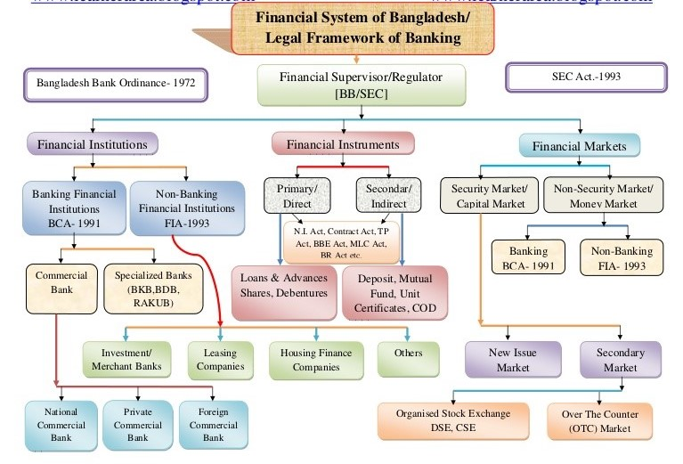

Overview of NBFI sectors in Bangladesh

The non-bank financial institutions functioning in East Pakistan were the Industrial Development Bank of Pakistan, Equity Participation Fund, Pakistan Industrial Credit and Investment Trust Corporation, Investment Organization of Pakistan, National Investment Trust and insurance companies. Such institutions established in Bangladesh in the 1970s include the House Building Finance Corporation (1973) and the Investment Corporation of Bangladesh (1976). These institutions protracted their business in industrial, commercial, housing financing and in the stock market activities. To participate in the inter-bank money market transaction, they must be accepted by the Bangladesh Bank.
“In the beginning, NBFIs were announced in our financial system under the Companies Act, 1913 and were controlled by the provision relating to Non-Banking Institutions as restricted in Chapter V of the Bangladesh Bank Order, 1972. But this controlling agenda was not sufficient and NBFIs had the opportunity to continue their business in the line of banking. Later, Bangladesh Bank publicized an order titled “Non-Banking Financial Institutions Order, 1989” to certify enhanced guideline and also to reduce the haziness regarding to the suitable areas of business of NBFIs.”-Bangladesh bank website. But the instruction did not cover the wide variety of NBFI activities. The statutory liquidity requirement which to be retained with the central bank was not reference to anything. To eliminate the regulatory insufficiency and also to explain an extensive variety of actions to be covered by NBFIs, a new act titled ‘Financial Institution Act, 1993’ was enacted in 1993. In Bangladesh the first private sector of NBFI were Industrial Promotion and Development Company (IPDC), which in progress its set-up in 1981. Since then the number has been growing and in December 2011 it reached at 31.
At present in our country the processes of NBFIs in Bangladesh are controlled by the Bangladesh Bank. The funding of specialist to involve in borrowing from the general public is normally based on such factors as lowest capital requirement, quality of management, obedience with the anxious by-laws, guidelines, and protocols, and constancy of financial standing. These institutions can grant loans to their members and the general public up to a certain amount and may also engage in trust functions with prior permission of the central bank. They are not allowable to involve in foreign exchange transactions.

Product & services of NBFIs:
Lease Financing
- Capital Lease: a long-term solution which later imitates.
- Operational Lease: short term source for holding leasing equipment.
- Leveraged Leases: The presence of three groups; a lessee, a lesser and a funding source for a bulk amount of transaction.
- Synthetic Leases: lease which is not shown as liability rather considered as income expense.
Home Loan and Real Estate Financing
The loan mostly mid to long-term in nature that includes house loan and real estate financing.
Short Term Loans
Major features are revolving short term facility, usually less than a year.
Corporate Finance
Merger and Acquisition help find appropriate organization for best possible synergy, conduct valuation of companies.
Merchant Banking
For early investors it allows to open an account with it for proving help to buy and sales of shares. Under investment banking it also provides underwriting where the payments are guaranteed in case of financial loss or to admit taking financial liabilities with a contractual agreement.

Securities Services
Brokerage Services Provide services for Trade Execution (Dhaka and Chittagong Stock Exchanges), Pre -IPO private placement, Asset allocation advice, Opportunities for trading in different financial instruments.

Role of NBFIs in Economic Development & its growth overtime in Bangladesh
A country’s development hinges on its growth of all economic objects. The financial system of a country plays an energetic role for its economic success. At primary stage, generally banks play a vital role for mobilizing funds but for pledging a solid stable financial system, the presence of both banks and non-banks are essential. Moreover, NBFIs increase influence to the economy in such a method that improves the flexibility of the financial structure to economic crisis. These Non-banks suggest various of products and services to alleviate the financial intermediation break and that’s works as balancing role for banks.
The following ways NBFIs help economy;
- For keeping a stability between intra-regional income and asset distribution, NBFIs utilize its resources by altering savings into investments.
- As commercial banks don’t sanction long term credit to business industry, mega projects and infrastructures that enhance economic development, depend on NBFIs.
- In macroeconomic policy, creating more job facilities in country is listed in the major objectives. So, by lending various credits in projects and various work for developments, it creates employment indirectly.
- Their purpose is, growing long-term capital creation of industrial and other sectors by enhancing capital stock. This mainly indicates the GDP growth of a country.
- NBFIs are very substantial part of monetary market of a country. They underwrite public issues and corporation which helps to collect fund for startup companies.
- As government tools, NBFIs can progress the typical living of the masses with their actions. Some NBFI’s fascinate foreign allowances in majority amounts from various countries and donor agencies which will help in improving the economic development of the country.

Growths overtime In Bangladesh (From Bangladesh Bank annual report 2015-2016);
Structures of NBFIs overtime
Content | 2012 | 2013 | 2014 | 2015 | 2016
No. of NBFIs | 31 | 31 | 31 | 32 | 33
Government- owned | 3 | 3 | 3 | 3 | 3
Joint-venture | 10 | 10 | 10 | 10 | 11
Private | 18 | 18 | 18 | 19 | 19
New branches | 8 | 7 | 7 | 15 | 22
Total branch | 169 | 176 | 183 | 198 | 220

Asset Liabilities and deposits of NBFIs;
(In billion Taka)
Contents | 2012 | 2013 | 2014 | 2015 | 2016
Total assets | 33.9 | 436.3 | 520.05 | 611.0 | 672.8
Total liabilities | 274.3 | 350.4 | 424.24 | 509 | 572
Liabilities-assets ratio | 82.2 | 80.3 | 81.5 | 83.3 | 85
Total deposit | 145.4 | 198.3 | 238.5 | 318.1 | 351.4
Deposit as % of  total liabilities | 53 | 56.6 | 56.2 | 65.5 | 61.4

From the graph, it can be seen that the growth of total asset has been increasing as well as liabilities. Total deposits in 2012 rose to 351.4 billion taka from 145.4 billion taka. So, all the information shows that NBFIs of Bangladesh is rising time to time. This is a good indicator as they contribute in economic development. It can be said that, higher the growth of NBFIs, higher the economic development.

Company Overview

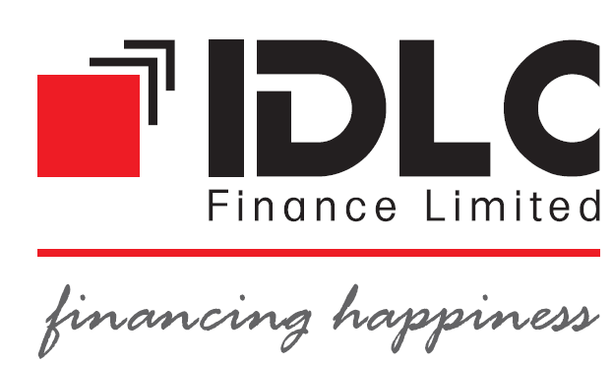

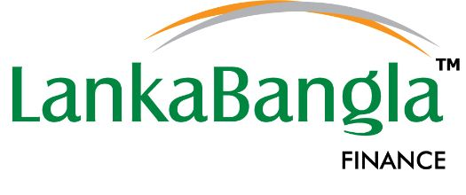

Company overview;

IDLC Finance Ltd

IDLC Finance Limited which includes in investment banking, discretionary portfolio management, and margin lending activities in Bangladesh. In 1985, it was the first leasing company of the country with multinational collaboration. International Finance Corporation (IFC) of the World Bank Group was the main support. Before 2007, the company was recognized as Industrial Development Leasing Company of Bangladesh Limited. In2007, the name was changed to IDLC Finance Limited.
IDLC is the registered member of Dhaka Stock Exchange. Five Bangladeshi financial institutions like The City Bank Ltd, Sadharan Bima Corporation, Mercantile Bank Ltd, Eskayef Bangladesh Ltd, Reliance insurance Ltd and the general public hold 52.7% shares of the company. It grips a durable and expanded balance in its segments such as SME, retail, corporate and capital market. IDLC offers various financial solution and services to its customers according to different requirements. It offers small and medium enterprise (SME) finance products, like SME loans/leases, seasonal and women entrepreneur loans, etc.
IDlC is really valued by its clients, employees and supervisors for its specialized pool of capitals, succeeding work atmosphere. With the profit presentation over the last some years, the company has constantly proved model commercial supremacy and strict legal obedience.

Mission & vision:
IDLC’s mission is to focus on quality growth, superior customer experience and sustainable business practices and their vision is to become the best financial brand in Bangladesh.

Company organism
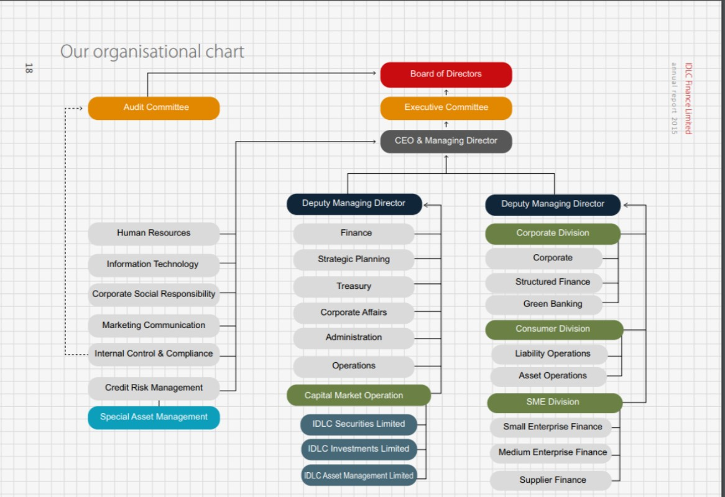

Products & Services:
Small and Medium Enterprises
• Small Enterprise Finance
o Small Enterprise Loan/ Lease
o Seasonal Loan
o IDLC Purnota - Women Entrepreneur Loan
o SME Shachal Loan
o SME Surakkha
o Revolving Short Term Loan
o Commercial Space Loan
o Commercial Vehicle Loan
o IDLC Udbhabon
o SME Deposit

• Medium Enterprise Finance
o Medium Enterprise Loan/ Lease
o Commercial Vehicle Finance
o Machinery Lease
o Healthcare Finance
o Revolving Short Term Loan
o SME Deposit
o Commercial Space Loan
o Commercial Vehicle Loan

• Supplier and Distributor Finance
o Factoring of Accounts Receivable
o Bill/ Invoice Discounting
o Work Order Financing
o Distributor Financing

Corporate Division
• Corporate Finance
o Lease Financing
o Term Loan Financing
o Commercial Space Financing
o Project Financing
o Short Term Loans (to meet working capital requirements)
o Specialized Products (for meeting seasonal demand)
o Green Financing

• Structured Finance Solutions
o Structured Finance Solutions/ Arrangement of Funds:
o Loan/ Lease Syndication
o Syndicated Fund raising for Bonds (Zero Coupon and
Coupon Bearing)
o Commercial Paper
o Preference Shares
o Projects/ Infrastructure Finance
o Foreign Currency Loans
o Structured Solutions
o Private Placement of Equity Refinancing of Special Funds

Consumer Finance
Loans
• Home Loans
• Car Loans
• Personal Loans
• Loan against Deposit

Deposit
• Flexible Term Deposit Package
• Regular Earner Package

Treasury
• Overnight Borrowing/Placement
• Term Deposits
• Bonds
• Debentures
• Commercial Paper
• Preference Shares
• Equity Investments
• Treasury Bills/Bond

Corporate Advisory/ other services:
• Merger and Acquisitions
• Joint Venture Matchmaking
• Balance Sheet Restructuring
• Feasibility Study
• Securitization of Assets
• Working Capital Syndication
Capital Markets
• IDLC Securities Limited
Products
o Cash Account
o Margin Account through IDLC Investments
o Limited and other enlisted merchant banks
o Easy IPO
o Premium Brokerage for High Networth
o Individual (HNIs) and institutional and
o foreign investors
Services
o Trade execution through the Dhaka and
o Chittagong stock exchanges
o Custodial and CDBL services
o Bloomberg terminal for foreign clients
o Research and Advisory Services
• IDLC Investments Limited
Products
o Margin Loan
o Discretional Portfolio Management
Services
o Corporate Advisory
o Issue Management
o Underwriting & Research

Capital structure
The Board of Directors in its 241st meeting held on 18 February 2016 accepted the offer for increasing the existing authorized capital at Taka 1,000 crore from Taka 400 crore. Then, all the essential agreement from the monitoring authorities have been attained. And paid up capital is 2,513,671,870crore.

Shareholders structure
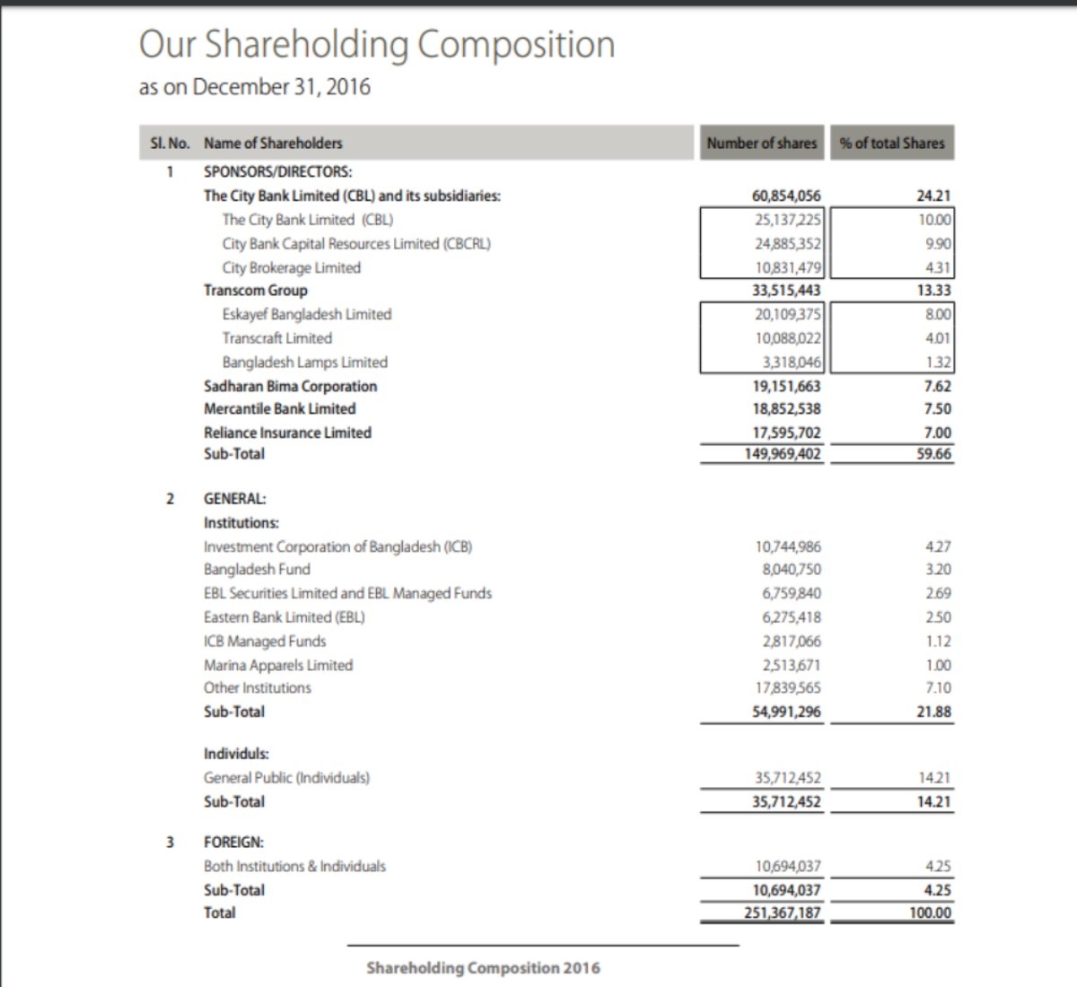

Risks
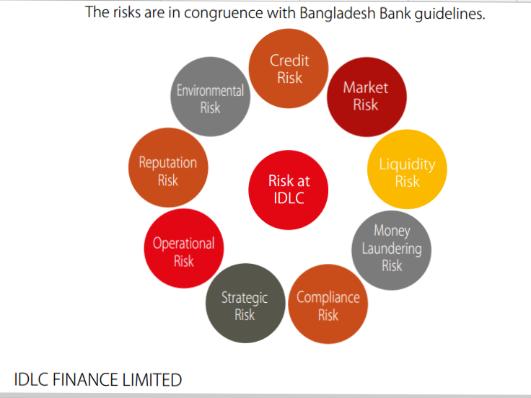

Risk Management and Control Principles
The 5 columns which backs IDLC’s method to achieve a suitable stability between risk and return include the following:
1. Defending IDLC’s fiscal asset by monitoring risk revelations and avoiding potential risk concentration at the level of distinct revelations, at definite portfolio levels and at a total from-wide level across all risk sorts.
2. Shielding their status through a complete risk culture categorized by a general and combined view of risk, performance, payment by ensuring thorough obedience with their standards and philosophies, particularly their code of conduct.
3. Whole management responsibility whereby business management, as different to risk control, own all risks assumed throughout the firm and are responsible for the continuous and active management of all contacts to ensure the right balance between risk and return.
4. Independent regulatory functions which observe the eﬀectiveness capabilities of business’s risk management and also oversee risk- taking activities.
5. Complete and clear risk revelation to senior management, the Board of Directors, shareholders, officials, rating agencies and stakeholders.

Financial highlights:
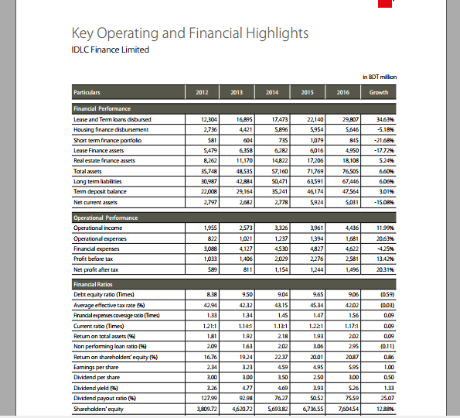

Lankbangla Finance Ltd
In 1997 LankaBangla Finance Limited was established. AT first they were a joint-venture financial organization with multinational association having license from Bangladesh Bank under Financial Institution Act-1993. Recently LankaBangla is the country’s protruding provider of united financial facilities including Corporate Financial Services, Personal Financial Services, SME Financial Services, Stock Broking, Corporate Advisory and Wealth Management Services.
In spite of having many number of products and services, they are the only financial institution in Bangladesh which activates credit cards; Mastercard & VISA. They also act as a third party for card dealing out facilities in many banks. They are also giving upper mark broking facilities with upgraded research and customer service through LankaBangla Securities ltd.
For upgrading business, it tries to unique positioning itself and they are providing durable value to its clients. Some important information they attach in balance sheet for their clients and communities for their beneficiary.
The past few years, LankaBangla Finance ltd received the national award for Best Published Accounts and Reports which is declared by the Institute of Chartered Accountants of Bangladesh (ICAB). And also received “Category Winner – Financial Service Sector” and “Overall Winner” for the “Best Presented Annual Report and SAARC Anniversary Award for Corporate Governance Disclosure 2014” from South Asian Federation of Accountants (SAFA, An Apex body of SAARC). This is absolutely a great achievement and it is a replication of moral practices, true compliance and a great team work.
LankaBangla follows sharing management & stick to this industry finest applies in all activities. Swelling stakeholders’ value is a natural pouring force for the people at LankaBangla. Their long-standing sustainability efforts are creating environmental and social value while we step ahead. By implementation high decent values, control & clearness, they vision to raise large. Their philosophy is humble: “We imagine our success being the growth partner of our enterprising clients. We are committed to change the lives of the ordinary”.

Mission
- Be a growth partner for our customers
- ensuring financing and superior experience
- Maintain a culture of meritocracy in the DNA of the company
- Be sustainable and ensure quality returns to our valued
- Shareholders Uphold efforts to develop our community

Vision
To be the most preferred financial service provider in creating, nurturing and maximizing value to the stakeholders, thereby, “GROWING TOGETHER.”

Organism of company
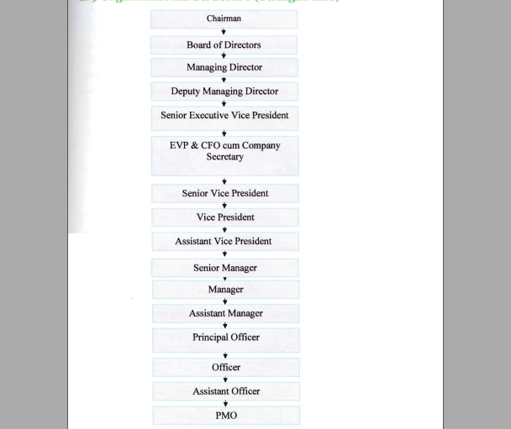

Product & Services
Personal Financial Services
- Home Loan
- Loan Against Property
- Auto Loan
- Personal Loan
- Doctors Loan
- Personal Loan for Landlady/Landlord
- Marriage Loan
- Travel Loan
Corporate Financial Services

- Corporate & Institutional Services
- Factoring & Commercial Business
- Project & Structured Finance Unit
SME Financial Services

- To create women empowerment, employment and reduce poverty it provides SME though lower risk and less return for bringing diversification in Bangladesh industrial sector.
Deposit Schemes

- Double Money
- Triple Money
- Senior Citizen
- Classic TDR
- Earn First
- Periodic Return Term Deposit
- Shohoj Sanchoy
- Quick Sanchoy
- Money Builder Term Deposit

Capital Structure
The company increased its authorized capital from 3,000 million to 10,000 million in its 100th board meeting held on 26 July 2016 and by passing a special resolution in its 8th Extra Ordinary General Meeting (EGM) held on 24 October 2016. Issued and paid up capital is 2,767,399,490 million.

Shareholder Structure
LBFL has a total 12,314 shareholders with 86.67% domestic holding and 13.37% foreign holding. Details of shareholding structure are as follows:

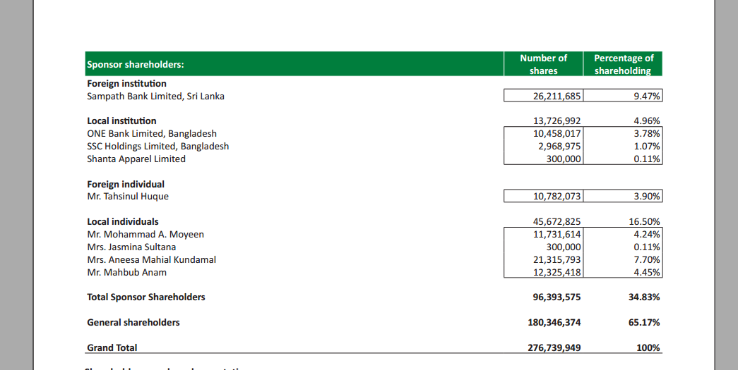

Risks
The key elements of enterprise-wide risk management strategy are:
- Risk craving: Risks are managed by board of directors through strategic business goals and returns are calculated from the compensation of risk taken.
- Risk outlines: Risk management outlines for all kinds of risks are standard,
all-inclusive, and reliable.
- Holistic risk management: Risks are managed holistically, with a view to understand the potential interactions among risk types.

Financial Highlights

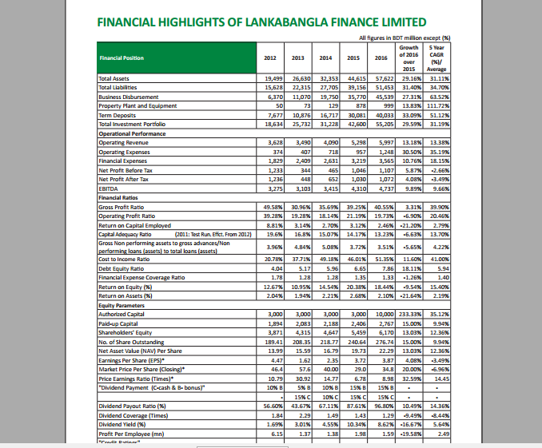

Chapter 3

Methodology



Methodology

- Sources of data:
All data are collected from secondary resources. I collected information from the yearly reports of Lankabangla Finance Ltd & IDLC Finance Ltd. Journals, various publications, yearly reports and numerous books on Finance and Banking are used to formulate this report. Major information of “Finding & Analysis” is taken from the yearly reports of these NBFIs (2012-2016).
- Sources:
- Yearly reports of Lankabangla Finance Ltd & IDLC Finance Ltd. 2012-2016
- Related paper and magazines
- Related references
- General report
- Websites

- Data Analysis Method:

- Ratio analysis is used to interpret the situation of the performance with the help of graphs, MS Excel, MS Word.
- Dupont analysis is used to understanding deeply the specific ratio Return on Equity (ROE). This one analysis can interpret overall company performance at a glance.
- Simple linear regression model is used to find the significant relationship of these two NBFIs; whether the relationship between liquidity and profitability exists or not. A well-known statistical package like ‘Statistical Package for Social Sciences’ (SPSS) V20 is used to observe the data. Data were analyzed by using Correlation technique; regressions & descriptive statistics.

Chapter 4

Findings of the Study



Findings of the Study

Ratio Analysis
Comparison of Financial Performance Analysis between IDLC Finance ltd. & Lankabangla finance ltd over past five years (2012-2016);

Liquidity Ratio:

- Current Ratio = Current Asset/ Current liability
- Quick Ratio = (Cash and equivalents +Short term securities+ Accounts receivable) /Current liabilities)
Liquidity Ratio
NBFIs | 2012 | 2013 | 2014 | 2015 | 2016
IDLC
Current Ratio | 1.26 | 1.26 | 1.29 | 1.26 | 1.28
Quick Ratio | 0.21 | 0.27 | 0.22 | 0.21 | 0.14
Lankabangla
Current Ratio: | 1.68 | 1.67 | 1.32 | 1.16 | 1.12
Quick Ratio | 0.14 | 0.12 | 0.14 | 0.19 | 0.18

Liquidity ratio graphs with interpretation: Liquidity ratios indicates how much a company is capable to pay its debt responsibilities and margin of safety. The ratio can be measured by two variables; Current ratio, Quick ratio.

Interpretation: Comparing with these two NBFIs, the performance of IDLC is better than Lankabangla. Lankabangla’s current ratio is somehow stacked between 1.26 %to 1.28%. Where IDLC’s shows up with various results though in 2016 their ratio went down to 1.12%. In 2012 IDLC’s current ratio was higher 1.68%. But from the graph Lankabangla’s ratios are kind of predictable.

Interpretation: Quick ratio measures company’s short-term liquidity. For quick ratio 1:1 is okay which means company can pay its debt obligations with existing funds on hand. But here the ratios are lower than 1:1. Which means they are depending on other assets or inventory to pay debts. Now when it comes to comparison lankabangala has less quick ratio then IDLC but it does not mean they are going to default but their instant liquidity is lower than IDLC to pay its short-term debt. In 2013 IDLC has 27% which means it had 27% liquid asset to pay its current liabilities. In 2012 & 2016 the percentage of Lankabangla’s quick ratio was same. So, from the graph we find that IDLC finance ltd. is more liquid than Lankabangla fianance ltd.

Solvency Ratio:
- Debt to Equity = Total Liabilities / Shareholders' Equity
- Financial coverage Ratio = EBIT/Interest Expense
- Debt to asset =Total Liabilities/ Total Asset
- Non-Performing Loans(NPL) ratio= Total NPL/The total amount of outstanding loans
Amount in %
Solvency Ratio
NBFIs | 2012 | 2013 | 2014 | 2015 | 2016
IDLC
Debt to equity | 8.38 | 9.50 | 9.04 | 9.65 | 9.06
Financial  coverage ratio | 1.33 | 1.34 | 1.45 | 1.47 | 1.56
Debt to asset | 89 | 90 | 90 | 91 | 90
NPL | 2.09 | 1.63 | 2.02 | 3.06 | 2.95
Lankabangla
Debt to equity | 4.04 | 5.17 | 5.96 | 6.65 | 7.86
Financial  coverage ratio | 1.78 | 1.28 | 1.28 | 1.35 | 1.33
Debt to asset | 0.80 | 0.84 | 0.86 | 0.88 | 0.89
NPL | 3.96 | 4.84 | 5.08 | 3.72 | 3.51

Solvency ratio graphs with interpretation: The ratio indicates how much a company is capable to meet its long-term debts. The ratio counts the size of a company's after-tax income, not non-cash depreciation expenses. To analyze how much a company is solvent these variables are helpful such as debt to equity ratio, debt to asset ratio, financial coverage and for banks or non-banking institutions NPL also.

Interpretation: Lower debt to equity ratio means more solidity of a company. Higher ratio directs risk to investors and creditors. If the debt is higher or company having large amount of leverage it might be unable to make payments as debts must be repaid. Comparing from the graph Lankabangla is in a good position comparing with IDLC. In 2012 the D/E ratio was lowest in Lankabangla 4.04%. In 2015 IDLC had 9.65% D/E ratio which was comparatively highest ratio within the sample. So, the comparison shows Lankabangla is less risky NBFI than IDLC.

Interpretation: The ratio is used to regulate how simply a company can pay their interest expenses on outstanding debt. Evaluating a coverage ratio might be complicated as it depends mostly on how much risky the creditor or investor is ready to take.
If the ratio is less than 1 that means the company is not capable enough to pay its interest. From the graph it can be seen that all ratios are more than 1. Which means they are capable to pay interest in their own manner but it comes to comparison IDLC takes the first position. IDLC is generating enough money for their interest payments. In 2016, IDLC’s interest coverage ratio was 1.56% and the comparatively Lankabangla’s highest score was in 2012 1.78%. In 2016, Lankabangla’s ratio was 1.33%.

Interpretation: The ratio measurers how much a company’s asset is financed by its creditors rather than investors. The company with higher ratio indicates more leverage this means more risk to invest or giving loan. In the term of comparison, from the graph IDLC is in risky zone. The ratios of Lankabangla are comparatively lower. Which means Lankabangla is comparatively less risky than IDLC in long term. IDLC’s 90% assets are financed by debt where Lankabangla’s 89% in 2016. IDLC’s lower D/A ratio was 89% in 2012.

Interpretation: When loans are not repaid regularly for at least 90 days it become non-performing loan. The ratio depends on what kind of borrowers a bank or non-banking institution has. The major income of these institution comes from loan repayment. The high ratio directs an institution engaging towards failure that arises risk. So, comparing with these two NBFIs from graph Lankabangla is in risky zone than IDLC because IDLC has lower NPL ratio. In 2014, Lankabangla had 5.08% NPL which was comparatively very risky. Though it managed to drop down the ratio from 5.08% to 3.51% in 2016, still IDLC is a step ahead in this regard.

Profitability ratio:
- Return on Asset(ROA) = (Net Income + Interest Expense) / Average Total Assets
- Return on Equity(ROE) =Net Income/ Shareholder's Equity
- Return on Capital employed(ROCE) = Net Operating Profit/ (Total Asset-current Liability)
- Cost to Income ratio = Operating cost/ Operating profit

Amount in %
Profitability Ratio
NBFIs | 2012 | 2013 | 2014 | 2015 | 2016
IDLC
ROA | 1.81 | 1.92 | 2.18 | 1.93 | 2.02
ROE | 16.76 | 19.24 | 22.37 | 20.01 | 20.87
ROCE | 25.75 | 24.89 | 25.57 | 25.54 | 25.52
Cost to Income | 72.52 | 65.80 | 59.19 | 54.29 | 61.04
Lankabangla
ROA | 2.04 | 1.94 | 2.21 | 2.68 | 2.10
ROE | 12.67 | 10.95 | 14.54 | 20.38 | 18.44
ROCE | 22.78 | 10.06 | 18.59 | 30.18 | 33.89
Cost to Income | 26.23 | 60.54 | 96.76 | 85.21 | 10.55

Profitability ratio graphs with interpretation: In general profitability ratio measures a business earning compared to its expense and other relevant cost incurred. The ratios under profitability are; ROA, ROE, ROCE and Cost to Income.

Interpretation: This ROA ratio is analyzed to know how company is effectively using its assets to generate profit and sales. So higher the ratio higher the profitability. ROA is most useful ration for comparison of businesses. Higher ratio directs higher profit comparing to others. In this regard, Lankabangla’s has higher ROA on an average but in 2016, IDLC was able to cross Lankabangla with 2.10% ROA. In 2015 Lankabangla had higher ROA 2.68%. If we compare last two years 2015-2016, IDLC’s ROA is growing at its increasing rate unlike Lankabangla.

Interpretation: ROE indicates each taka of profit of a common shareholder’s equity produces. Higher ROE ratio attracts more investors because it indicates that company is using investors’ money effectively. An average of five to ten years ROE can give a brief information of company growth. IDLC has higher ROE than Lankabangla on an average. From 2014-2016, IDLC’s ROE was in predictable manner where Lankabangla’s ROE was moving to up down and instable. So, it can be said IDLC is using its investors fund more wisely than Lankabangla.

Interpretation: It is a long-standup ratio because it displays how efficiently assets are managed with a view to attention of long term financing. It notifies investors how each amount of capital employed generates profit. Higher ratio would be for a company. From the graph (2013-2016) Lankabangla’s ROCE ratio grows at an increasing rate from 10.06% to 33.89%. Where IDLC (2013-2016) maintains a straight line of ROCE. In 2016, Lankabangla’s ROCE was highest in past five years and that is 33.89%.

Interpretation: The ratio gives clear idea to investors how an organization is running by comparing cost to income. This ratio is very important for banks and non-banking financial institutions. Lower the ratio more profitable an organization would be. In 2014 & 2015 Lankbangla has higher C to I ratio but in 2016 it managed to drop down its C to I ratio at 10.55%. 2013-2016 was less profitable for Lankabangla unlike IDLC.

Market Prospect Ratio:
- Earnings per share(EPS) = (Net income- preferred dividend)/ the average number of shares of common stock outstanding
- Price earnings ratio (P/E) = Stock price /earnings per share
- Dividend payout ratio (DP) = Dividends per share/ EPS.
- Dividend yield ratio (DY) = Dividend per share/ price per share.

Amount in %
Market Prospect Ratio
NBFIs | 2012 | 2013 | 2014 | 2015 | 2016
IDLC
EPS | 2.34 | 3.23 | 4.59 | 4.95 | 5.9
P/E(Times) | 13.25 | 11.15 | 7.41 | 9.70 | 9.66
DP | 127.99 | 92.98 | 76.27 | 50.52 | 75.5
DY | 3.26 | 4.77 | 4.69 | 3.93 | 5.26
Lankabangla
EPS | 4.47 | 1.62 | 2.35 | 3.72 | 3.8
P/E(times) | 10.79 | 30.92 | 14.77 | 6.78 | 8.98
DP | 56.6 | 43.67 | 67.11 | 87.61 | 96.80
DY | 1.69 | 3.01 | 4.55 | 10.34 | 8.62
Market prospect ratios graph & interpretation: These ratios are cast-off to narrate with stock prices as well as other financial procedures like earnings and dividend rates. Investors use market prospect ratios to analyze the trends of share prices. The ratio includes- EPS, P/E, D/P, DY.

Interpretation: EPS measures the amount of income generating from each common stock. To earn dividend or sell them at a higher price in future, shares are normally purchased. EPS ratio of a company is highly valued by shareholders because dividends and growth of stock in future hangs on the earnings of the company. EPS figure is very important for common stockholders because the payment of dividend and increase in the value of stock in future largely depends on the earnings of the company. So higher EPS is better in this manner. EPS of IDLC is better than Lankabangla. In 2013, Lankabangla’s EPS drop down badly to 1.62% where IDLC’s EPS is growing at increasing rate. 2016 IDLC had higher EPS 5.9%.

Interpretation: The ratio compares between earnings per share and market price per share. Investors use this ratio by predicting future earnings per share to know what a fair value of a stocks should be in market. High P/E ratio usually indicated positive future performance so that investor’s wants pay more for share. The condition of IDLC is more favorable than Lankabangla. Though in 2013 the P/E ratio of Lankabangla achieved highest ratio 30.92% but it couldn’t maintain it. Comparing with Lankabangla, IDLC’s graph is more consistent and easy to predict. In 2016, IDLC’s P/E ratio was 9.66% and LankaBangla’s 8.98%.

Interpretation: The ratio shows the percentage of distributed dividend from net income to shareholders. Investors expect to see a fixed stream of sustainable dividends from a company, the dividend payout ratio analysis is more important than weather it is high or low. As Investors are mainly concerned with sustainable trends, Lankabagla and IDLC both follow the same trend but when to compare Lankabangla has higher DP ratio from 2014-2016. As the debt level is comparatively lower than IDLC so it manages to distribute more dividend to its shareholders. In 2015-2016 their DP ratios were 87.61% & 96.80 % respectively.

Interpretation: The ratios calculates what amount of dividend is given to shareholders respective to the market value per share. From the graph, LankaBangla’s DY ratio in 2015-2016 years was 10.34% & 8.62% percent. Comparatively IDLC’s DY is lower than Lankabangla but it does not completely describe the performance of a company but yes it attracts investors from outside. Because dividend policy of different companies is different. In 2016 IDLC’s DY ratio is 5.26%.

DU Pont Analysis:
DuPont analysis is characterized in measured form by the ensuing calculation:
ROE = Profit Margin $×$ Asset Turnover Ratio $×$Equity Multiplier.
Amount in %
IDLC | ROE | PM | Asset  Turnover | EM
2012 | 15.47 | 12.50 | 13.18 | 9.38
2013 | 17.55 | 12.95 | 12.90 | 10.50
2014 | 20.26 | 15.63 | 12.91 | 10.04
2015 | 18.46 | 15.50 | 11.18 | 10.65
2016 | 19.68 | 18.36 | 10.66 | 10.06

Lankabangla | ROE | PM | Asset Turnover | EM
2012 | 32 | 57.96 | 10.93 | 5.03
2013 | 10.38 | 14.63 | 11.50 | 6.17
2014 | 14.02 | 17.82 | 11.30 | 6.96
2015 | 18.87 | 22.37 | 10.32 | 8.17
2016 | 17.38 | 19.73 | 9.43 | 9.33

The analysis called Dupont elasticities a wider interpretation of the ROE of an organization. It highpoints an organization’s strong and weak zones where the chances of improvement. For example, if stockholders are unhappy with lower ROE, with the help of this analytical formula a company can measure whether the lower ROE is due to low profit margin, low asset turnover or poor leverage. Less ROE may not always be an anxiety for an organization as it may also happen due to normal business operations.
Interpretation: In 2012, ROE of IDLC & Lankabangla was 15.47% & 32% respectively. But the asset turnover and equity multiplier both are higher than Lankabangla. Higher asset turnover means IDLC is effectively deploying its assets to generate profit. But higher EM means higher financial leverage. Which means IDLC is using more debts than equity. In 2016, the ROE of two NBFIs IDLC & Lankabangla was 19.68% & 17.8 % respectively. But Lankabangla has higher PM 19.73% and lower EM 9.33%. So, in 2016 lower equity return should not a tension for Lankabangla.

Linear Regression Analysis

Exploring the relationship between profitability & liquidity of these two NBFIs
Hypothesis: Liquidity affects profitability.
Null hypothesis: Liquidity does not affect profitability.
For this, variables are assumed; Dependent variable: Profitability (ROA) and Independent variable: Liquidity (CR)
So,
Profitability = f (Liquidity)………………………. I
The Information are collected from IDLC’s past five years (2012-2016) ratio calculation.

Descriptive Statistics
 | Mean | Std. Deviation | N
ROA | 1.2720 | .01304 | 5
CR | 1.9720 | .13809 | 5

ANOVAª
Model |  | Sum of Squares | df | Mean Square | F | Sig.
1 | Regression | .001 | 1 | .001 | 23.366 | .017^{b}
1 | Residual | .000 | 3 | .000
1 | Total | .001 | 4

Coefficientsª
Model |  | Unstandardized Coefficients |  | Standardized Coefficients | t | Sig. | 95.0% Confidence Interval for B
 |  | B | Std. Error | Beta | t | Sig. | Lower Bound | Upper Bound
1 | (Constant) | 1.097 | .036 |  | 30.186 | .000 | .981 | 1.212
1 | CR | .089 | .018 | .941 | 4.834 | .017 | .030 | .147
a. Dependent Variable: ROA

Null hypothesis is rejected. As 95% significance level p<0.05, there is a significance relationship between ROA & CR in IDLC’s last five years operation. P =.017

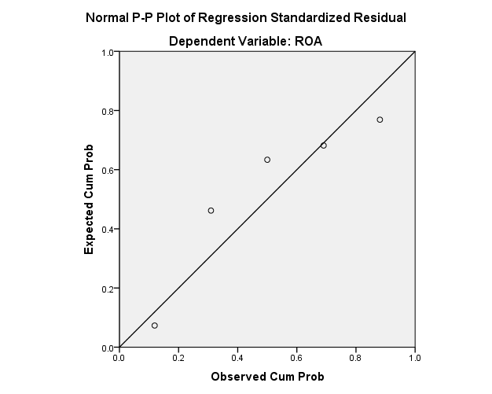

The second linear regression analysis collecting data from Lankabangla finance ltd.’s annual report of past five years (2012-2016)
Hypothesis: Liquidity affects profitability.
Null hypothesis: Liquidity does not affect profitability.
For this, variables are assumed; Dependent variable: Profitability (ROA) and Independent variable: Liquidity (CR)
So,
Profitability = f (Liquidity)………………………. I

Descriptive Statistics
 | Mean | Std. Deviation | N
ROA | 2.1940 | .28876 | 5
CR | 1.3900 | .27074 | 5

ANOVAª
Model |  | Sum of Squares | df | Mean Square | F | Sig.
1 | Regression | .141 | 1 | .141 | 2.196 | .235^{b}
1 | Residual | .193 | 3 | .064
1 | Total | .334 | 4
a. Dependent Variable: ROA
b. Predictors: (Constant), CR

Coefficients
Model |  | Unstandardized Coefficients |  | Standardized Coefficients | t | Sig. | 95.0% Confidence Interval for B
 |  | B | Std. Error | Beta | t | Sig. | Lower Bound | Upper Bound
1 | (Constant) | 3.158 | .660 |  | 4.783 | .017 | 1.057 | 5.259
1 | CR | -.693 | .468 | -.650 | -1.482 | .235 | -2.182 | .796
a. Dependent Variable: ROA

Null hypothesis is accepted. As 95% significance level p>0.05, there is no significance relationship between ROA & CR in Lankabangala’s last five years operation. P =.235

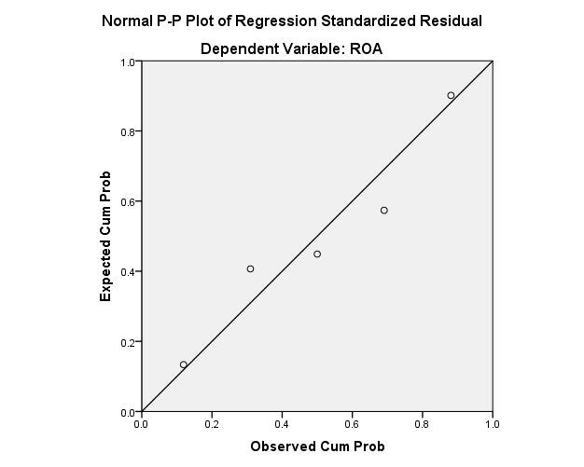

Chapter 5

Recommendation and Conclusion



Recommendations
- Lankabangla Finance ltd. is not as liquid as IDLC Finance ltd. To increase its liquidity, it can do such things like –
1. Using sweeping accounts to earn interest on excess cash balances.
2. Monitor overhead cost to check if there is any chance to reduce them.
3. Monitor account receivable to ensure receiving prompt payments.

- IDLC fiancé ltd. has higher debt to equity ratio and debt to asset ratio than Lankabangla finance ltd. IDLC should try to increase their sales & revenues and reducing other operation costs. The left amount of cash would be helpful to pay off the current debts. Another way to seek reducing interest expenses if possible. The percentage of debt is higher in IDLC. This should be in their concern.
- Interest coverage of Lankabangla Finance ltd. is lower than IDC Finance ltd. So Lanbangla should generate more money to meet up its interest obligations.
- NPL ratios are not good according to financial statements of Lankabangla finance ltd. To reduce this Lankabangla can do several things. Such as-
1. Evaluating any potential risk that may cause the borrower to default before going into any loan agreement.
2. Observe borrower’s background, credit standard before going into any agreement.
3. In case of mortgage and pledged loans it may depreciated over time. If borrower in case quit to repay the rest of the amount during repayment session, it can maximize its loan amount as a caution before going into a loan agreement.

- Lankabangla should be more analytical about their market prospect ratios.
- For the long-term sustainability both company should engage in corporate social responsibility beside their main business.

Conclusions:

In both developed and developing countries NBFls have fully-fledged considerable popularity. These organizations support for simplifying extended investments and financing which has become a challenging factor banking segments. As the growth of NBFIs are rising their types of offering products and services are also increasing for individuals and companies.
IDLC Finance Ltd. and Lankabangla Finance Ltd. these two are the most popular brand names in the non-banking financial sectors of Bangladesh. In this report the performance of these two NBFIs during 2012-2016 have been analyzed and compared. Through this, various positive and negative sides or it can be said financial strength and weakness of them came out. But this is noticeable that both institutions are walking towards higher growth along with their own flaws. Some suggestions are given to the management of Lankabangla Finance Ltd & IDLC Finance Ltd to focus and solve the problems. If management takes effective measures to solve this problem then each of these NBFIs can achieve their visions from their present places.

Chapter 6

Reference



References:

Annual Report of IDLC Finance Limited from 2012-2016
- Annual Report of LankaBangla Finance Limited from 2012-2016
- Bangladesh Bank Annual Report
- National accounting books 2016 by Bangladesh Bureau of Statistics
- Banking Law and Practice by Syed Ashraf Ali & R A Howlader
- Websites;
- https://www.scribd.com/doc/298233982/Overall-performance-of-NBFI-in-Bangladesh
- https://ideas.repec.org/a/rss/jnljef/v2i4p1.html
- http://www.assignmentpoint.com/business/banking/the-performance-analysis-of-non- banking-financial-institutions-in-bangladesh.html

- https://journals.abc.us.org/index.php/abr/article/download/3.10Hassan/223

- https://rassweb.org/admin/pages/ResearchPapers/Paper%201_1497043575.pdf

