

United International University

Internship Report

On

HRM practices of Eastern Bank Limited

Submitted To:
Farhana Rashid
Assistant Professor
School of Business & Economics
United International University

Submitted By:
Shanjida Mostafa Nira
ID: 111-151-557

Date of Submission: 8th February 8, 2020

HRM practices in Eastern Bank Limited



Acknowledgement

It is always a matter of pleasure to remind the faculty members of the School of Business & Economics, United International University, who guided me throughout my journey in completing Bachelors of Business Administration degree with clear theoretical understandings of the subjects

My cordial thanks go to Farhana Rashid, Assistant Professor, School of Business & Economics, United International University. Without her proper guidance it would be impossible for me to give this report an executive and professional look.

My heartfelt thanks goes to my honorable supervisor, Eastern Bank Limited for his deliberate guidance, inspiration and sharing of information which not only helped me in completing this report but also helpful for shaping my future career.

I would also like to thanks some recognizable personnel from HR department of Eastern Bank Limited.

Letter of Transmittal

8th February 8, 2020
Farhana Rashid
Assistant Professor - HR
School of Business & Economics
United International University

Subject: Submission of internship report.

Dear Madam,

With due respect I would like to express my enormous pleasure to submit the internship report on “HRM practices of Eastern Bank Limited” which you assigned me to work on.

This report is carefully made with due details on how Eastern Bank Limited communicate their brands, products, and services make HR practices on the basis of my experience of working with their Human Resource team.

If you have any queries please contact me on: +8801706302579 or send me an email at: Nira15uiu@gmail.com

Yours Sincerely,
Shanjida Mostafa Nira
Student ID: 111-151-557
School of Business & Economics

Executive Summary

Executive Summary It is a story of success, it is a story of rebirth and regeneration, it is a story of hope and aspiration, it is a story of tenacity and resolve, and it is a story of passion for performance of Eastern Bank Limited, better known for its acronym EBL. With a humble beginning in 1992, EBL moved forward with a small yet confident stride and a pledge to impacting lives positively. Today EBL stands for service excellence, product innovation and world class banking experience. The most awarded bank in the country, EBL is also the first bank in the country to be rated by the world’s top rating agency Moody’s and was awarded Ba3. The rating has been reaffirmed for the past three consecutive years.

About Bank we are able to say it's miles an organization in which the people are agreeing to take economic deposits from the general public and make a credit score for the reason of giving loan to the human beings can be executed straight or secondarily via the capital markets. Usually Bank regulatory depends at the economics situation of the us of a. In Bangladesh, Banking Sector is going through incredible reorganization due to the economic law and advancing of the monetary gadget. We can see that presently our Banking industry turning into the full-size finishing touch sight because of input several new Banks together with high improvement via increasing technological development, proper credit management, strong overall performance stage with the patron pride. This Report has been made primarily based on “Human Resource Management Practices of Eastern Bank Limited” who performs the vital position & the most crucial component for the company & business. So because of this significance of management machine in human aid of banking zone has been elevated swiftly global. Human resource is the handiest powerful manner to increase the fee of capital, land, approach for adding right cost of business. As a end result, human aid management practices within the corporation considering fundamental a part of the Bank. In today’s competitive global we're dealing with vigorous competition in every step of our life including a new technology. Currently all the company hiring, retaining and preserving the quality employees rather than thinking fulfillment of earnings. Efficient human resource only via too wealthy the company vision.

TABLE OF CONTENT
Prefatory
 | Present condition of Banking Sector | 5-6
Chapter: One
Introduction
1.1 | Introduction | 8
1.2 | Origin of the Report | 8
1.3 | Objectives | 8
1.4 | Purpose of the report | 8-9
1.5 | Scope | 9
1.6 | Problem statement | 9
1.7 | Methodology | 9-10
1.8 | Limitations | 10
Chapter: Two
Literature review
2.1 | Literature Review | 12
Chapter: Three
Organizational Overview
3.1 | Background of the organization | 14
3.2 | Vision of Eastern Bank Ltd | 14
3.3 | Mission of Eastern Bank Ltd | 14
3.4 | Values | 14-15
3.5 | Corporate Information | 15
3.6 | Organization Structure/ Hierarchy of the organization | 16
3.7 | Products & Services | 17-18
3.8 | Bank Operational Area | 19
3.9 | List of Branches | 20
3.10 | Achievements | 20-25
Chapter: Four
Human Resource Practices At Eastern Bank Limited
4.1 | Management and Appointment | 27
4.2 | Recruitment Procedure | 27-29
4.3 | Flow chart of recruitment process | 30
4.4 | Probation and Confirmation | 30
4.5 | Resignation | 31
4.6 | Gift or Benefits Offered to Employees | 31
4.7 | Training and development policy | 31-32
4.8 | Training Authority | 32
4.9 | Retirement | 32-33
4.10 | Retirement Benefits | 33-34
4.11 | Pay and Allowances | 34
4.12 | Increment | 34-35
4.13 | Bonus Policy | 35
4.14 | Provident Fund | 35
4.15 | Gratuity | 36
4.16 | Medical Benefits | 36-37
4.17 | Leave Rules & Regulations | 37
4.18 | Promotion Policy | 37-38
4.19 | Disciplinary Action | 38-39
4.20 | Disciplinary Authority | 39
4.21 | Suspension | 39
Chapter: Five
SWOT Analysis
5.1 | SWOT Analysis | 41
Chapter: Six
Supplementary Part
6.1 | Findings of the Report | 43
6.2 | Recommendations | 44
6.4 | Conclusion | 45
 | Reference | 46
 | Appendix | 47

HR Acronym

Words | Meaning
Pay | Means the amount drawn monthly by an employee as the pay which has  been sanctioned for the post held by him substantively
The Bank | Eastern Bank Limited
Rules | Eastern Bank Limited (Employees) Retirement and  Retirement Benefit Rules.
Board of  Directors | Board of Directors of Eastern Bank  Limited.
Employees | Only for the purpose of this rules, an employee shall mean  and include every confirmed and permanent employee of the Bank in any Grade appointed directly by the Bank and exclude a probationer, casual
Management | The management of the Eastern Bank Limited
Benefit | The financial benefits payable to an employee and other privileges such as  house accommodation, transport facility, leave preparatory to retirement etc.
Gratuity Rules | Employees with the approval of the Board of Directors.
Service | Includes the period during which an employee is on duty on sanctioned  Leave and on deputation elsewhere with the expressed approval of the Bank.
Provident Fund | Eastern Bank Limited Employees Provident Fund.
Family | Includes wife/wives or husband, children wholly dependent upon the  Employee.
Re-employment | Employment on contract basis after normal retirement

Prefatory

Present condition of Banking Sector:

Bangladesh is known to be as heavily populated countries in this world and bulk of people are till now many people not included with the banking service properly. For this reason, Bangladesh is facing obstruction in progressing with the financial status. So as to avoid with this type of difficult scenario, Bangladesh Bank which is the central Bank of Bangladesh, has been decided to implement and promote the banking services among the rural people by promoting agent banking service in the areas under central financing. Now the current situation is mobile operator can play important role and to motivate the rural people to avoid financial risk in their daily life. Also, top banking service can work together to build unified platform and to provide effective service to the rural people in Bangladesh. Being a part of this modernization Bangladesh wants to be developed in banking sector by giving the idea about mobile banking to the rural people with this effective step rural people will be benefitted with the better, secure.

Banking sector is dominating since the birth of Bangladesh. Dominance power of the banking system helps to economic growth of a country. On the other hand, with the enormous ups and downs the banking sector of Bangladesh travelled a journey where the country faced several traumas. For the improvement, a number of steps have been taken by the concern authority to make this sector more productive.

Capital adequacy of bank, streamlining guidelines for rescheduling of various types of loan, tightening provision for non-performing loan, strengthening disclosure and improving accounting system etc objective can play to become more efficient. Over the years this sector has improved remarkably. Though earlier in this sector has not achieved its goal satisfactorily as like today. Right now still its need to be constructed by the Central Bank in some areas to make it healthier more.

Bangladesh Bank increased his observation because of large financial regulatory on Sonali Bank Limited, BASIC Bank limited & also on fourteen bank and financial institution, state owned and private to improve their governance and also to mitigate the financial trauma.

In recent years some negativity showing has been observed that the state owned bank profitability is not up to the mark. In private commercial bank it’s positive but low. For non- performing loans (NPL) has similar performance which has been observed though the rate is still high 21.82%. On the other side private commercial Bank and foreign commercial bank has increased. So for high NPL state owned Bank has to keep high provision thank profit. Government has to insert wealth into these Banks to keep them going. So the capital adequacy ratio to be raised to 12.5% of their risk oriented weighted assets by 2019 will change for the SCB challenging for the SCBs. In 2015 capital adequacy of SCB was only 6.2%.
Due to political interference, bad assets and inefficiency are the reasons for lower profit in SCB. For public sector sluggish environment is the reason less profit which reflected high volume of liquidity in the Bank. The advance deposit ratio has been little over 70% in 2015 and also Bank is allowed to lend up to 80%.

In spite of anemic performance of the sector, governance still remains distant from the reality. The authorities slow to take money action. The hallmark group has not returned their money till now. The Banking sector even unwilling to take this misappropriates money which is creating more problems in the sector. This shock is creating more challenges and further reforms the said sector. The Commission can perform by seeing the emerging need and in order to build up more transparent and responsible banking system.

Because of changes during the 1990s, 2000 and subsequently banking division made significant progress. However, this segment should plan for the up and coming age of worldwide administrative system and meet rising customers need. The up and coming days banking industry should accomplish the capacity of ingest stuns emerging from money related and financial pressure, improve hazard the executives and administration and reinforce Bank straightforwardness and divulgence. Along these lines, if the area needs to accomplish bigger job to contribute with steady and sound macroeconomics. Therefore, the financial area needs to experience the excruciating way of stricter approach.

Chapter: One
Introduction

1.1 Introduction

Human resource management is the function of within an organization that focuses recruitment, management and providing direction for the people who work in the organization. Human resource management can also be performed by line manager.

Employees are the core resource of any organization, without them one cannot run their organization and human resource is conducted with the growth of development of people toward higher level of competency, creativity and fulfillment. It keeps employees become well more responsible person and then it tries to create a climate in which they contribute to the limits of their improved their abilities .it assumes that expanded capabilities and opportunities for people with directly improvement.

Eastern Bank Limited always determinate what jobs need to be done and how many types of workers will be required. So establishing the structure of the bank, it assists in determining the skills, knowledge and abilities of job holders. To ensure appropriate personnel are available to meet the requirements set during the strategic planning process. This bank believes that the quality of work comes from quality workers

1.2 Origin of the Report

As a student of BBA it’s mandatory to engage in an organization as interns to know more about the corporate world to increase more business knowledge. A report is a representation of that learning which I have learnt as an intern. The allotted proposition recommended by the guide teacher the topic of my report is “Human Resources Management Practices of Eastern Bank Limited” and I have accomplished my task with National Bank Limited. In this report I have written the analysis findings and achievements which is consisting with my research, findings, and achievements. This document “Human Resources Management Practices of Eastern Bank Limited” is arranged under the supervision and guidance of Lailun Nahar kanta, Senior Principal Officer.

1.3 Objectives
The objective of the study can be broadly being classified under two branches as General objectives and specified objectives. Achievement of the specified objectives will automatically lead to the achievement of general objectives and the study has been completed keeping in mind.
The general objective is to prepare and submit a report on the topic “Human Resources Management Practices of Eastern Bank Limited” within the specified time. It will help to achieve a broad objective of synchronizing academic knowledge with the practical experience in professional sector.

1.4 Purpose of the report
Main objective in this study is organize a report on “HRM practices of Eastern Bank Limited’’
- Increasing knowledge about the function of human resource.
- Getting clear idea about HR practice process of Eastern Bank Limited Process
- To know in depth about human resource management of Eastern Bank Limited.
- Find out the problem of human resource division in Eastern Bank Limited
- Efficiency of HR practices and limitation in the Eastern Bank Limited limitations

1.5 Scope
The scope for this report basically surrounded with Eastern Bank Limited. In this report mostly focused on practical observation. There was interview and secondary data sources from EBL and also from other Bank. Report scope was not that much easy going, only bank branch and field operations of the bank could use for this paper. As I was doing internship in Eastern Bank limited, Head Office, Human Resource Division, so for that reason scope of the study was only restricted to the Human Resource Division of Eastern Bank Limited.
When I started doing report this area I have focused on area which are as follows:
    - Acquirement of employee or employer
    - Development of employee or employer
    - Facilities, benefits and compensation

1.6 Problem statement
Our commercial banking system facing increased competition for their business in upcoming days. Even in getting appropriate people for appropriate post is becoming a challenge. The people who work in an organization Human Resource Management is for them. The Manager, employees, project officer, field workers, coordinators and staffs are the part of human resource management. In the meantime, organization run by this people and they are main „‟resource‟‟. Bank needs the people to manage the organization properly.
- Establishing superior management in the organization
- Best performance for best result
- Appropriate resource mobilization and funding for the organization

1.7 Methodology
Nature of the study: Exploratory
Sources of information: For collecting data and information I have adopted variety of data collection procedures. These are empirical reasoning; interviews, observation and experience. This study has been conducted mainly on the basis of both primary & secondary data. To some extend primary data are used and these are collected from relevant journals, magazines newspapers etc. and also from publication of professional institutes. Observation techniques also have been used in case of necessity. However, data used in this study has been further analyzed and processed for the purpose of the study. For secondary data I investigated some pdf documents, records. On the other hand, primary data has been collected by the interview with the several interviews with various types of employees of Eastern Bank Limited.

- I have asked many questions to my Supervisors and some banker HR implementation, which can be referred to as interviews.
- I have read some books, manuals, reports which have provided me empirical support.
- So, it is empirical reasoning.
- I have also used my experience which I have gathered during the course of my internship in Banks.

Besides The details of these sources are highlighted below:

The Primary Sources of Data:

- Interview with the branch manager, operation manger and also with the employees, discussion session with HR division which is in the Head office

The Secondary Sources of Data:

- Annual Report of Eastern bank limited
- HR division, each employee’s job description.
- Websites, journal, books manuals and related books.

1.8 Limitations
All the officers of Eastern Bank Limited were very cooperative and helpful. But as it’s a financial organization, so they had too busy with many responsibilities. For this reason, they couldn’t manage proper time for serving the information to me properly and to get clear knowledge. Furthermore, they have to deal with a very competitive environment which is based on money related activities. Task and limitations related with each other, every task has some limitation and problem. Though I didn’t face any serious problem, but therefore some limitations in the period of making report which are as follows: -

- Lack of analytical ability and rational thought was the first limitation that I faced during accomplish my task
- As the time was not sufficient so I had to equalizer with the quality. I couldn’t go more depth of the organizational HR procedure which is seemingly a limitation.
- Lacking of recent data and information also not disclosing the human resource division data because of confidentiality was another drawback. This data could helpful to complete my report properly.
- Lastly Limited time where I have to draw the whole HR procedure of Eastern Bank limited within one month, which was tough for me because it’s a big organization. So one month is tough to understand whole procedure with proper way.

Chapter: Two

Literature Review

Understanding the antecedents to and outcomes of customer satisfaction is a critical issue for both academics and bank marketers which are previously identified service quality expectations, disconfirmation and performance. (Ahmad and Kamal, 2002). Non risk rated deposit insurance ignores the potential loss of a valuable bank charter due to insolvency and effecting optimal financial policy (Alan j Marcus, 1984). Global bank played a significant role in the transmission of the 2007 to 2009 crisis to emerging market economies. (Nicole and linda,2010) A fiercer level competition is becoming the most influential factor in the structure and activities of the banking system around the globe (sudinnorafifah and planisek, 1994). Bank can establish, maintain and enhance ongoing long term multi service partnership with corporate clients where the partnership phase can be changed anytime (Mosad,1996). Competitive pressure from other European countries, regulatory form, large scale consolidation, European have changed substantially the banking environment with potentially offsetting effects. (angelini and Nicole,2003). Online banking is the newest and least understood delivery channel for retail banking and cutting edge technology Online. (Adel ,2001). Virtual banking system exists in the form of ATM, phone banking, home banking and internet banking. (shayoi, yuanhuaiqing and ada, 1999). European union bank strategies similarities with post-merger performance. European Union Bank‟ has strategic similarities on post-merger performance. Domestic deals which is costly and dissimilar in terms of their loan earning cost, deposit and strategies also for cross border merger. (yener and david, 2008). Rural and financial banking have been center of development from last few decades (Jacob,2003)

Chapter: Three

Organizational Overview

3.1 Background of the organization

Eastern Bank Limited (Bengali: ইস্টার্ন ব্যাংক লিমিটেড) is a private commercial bank headquartered in Dhaka, Bangladesh. It was established on August 8, 1992, as a public limited company with limited liability under the Bank Companies Act of 1991. Its share are listed in the Dhaka Stock Exchange and the Chittagong Stock Exchange. The bank provides products and services in retail banking, corporate finance, asset management, equity brokerage and security. It has 85 branches and 200 ATMs in Bangladesh and employs around 3000 employees. Eastern Bank Limited is going to open its first overseas full-fledged branch in Calcutta, India. Presently, EBL has a subsidiary in Hong Kong and a representative office in Myanmar. This branch in India will be its first foreign branch outside of Bangladesh. EBL opened its first representative office on the Chinese mainland in Guangzhou on September 29, 2019.
Company’s board of directors: Our desire has consistently been to contribute definitively to monetary development of the nation and to the general public we work in. Creating positive and feasible effect for our customers and workers is our need. The Board is driving the bank from the front and working energetically to maintain corporate culture and qualities to build up an obligation of trust with the general public we serve.

3.2 Vision of Eastern Bank Ltd

To become the most valuable brand in the financial services in Bangladesh creating long-lasting value for our stakeholders and above all for the community we operate in by transforming the way we do business and by delivering sustainable growth.

3.3 Mission of Eastern Bank Ltd

• We will convey administration greatness to every one of our clients, both interior and outside.

• We will guarantee to boost shareholders\' esteem.

• We will continually challenge our frameworks, methods and preparing to keep up a firm and expert group so as to accomplish administration greatness.

• We will make an empowering domain and grasp a group based culture where individuals will exceed expectations.

3.4 Values

Service Excellence | - We enthusiastically drive client charm.  - We use consumer loyalty to quicken development.  - We put stock in change to acquire auspicious arrangement.
Commitment | - We know our roadmap.  - We believe in continuous improvement.  - We do our task before we are told. We share business plan.
Openness | - We share marketable strategy.  - We support two-way correspondences.  - We perceive accomplishments, commend results.
Integrity | - We state what we have faith in.  - We regard each relationship.  - We are against maltreatment of data power.
Trust | - We care for one another.  - We share information.  - We enable our kin.
Responsible Corporate Citizen | - We are charge tolerating resident.  - We advance insurance of the earth for our offspring.  - We comply with all laws, rules, standards, assessments and estimations of the land.

3.5 Corporate Information

Name of the Company | Eastern Bank Limited
Company Logo | 
Establish | 8 August 1992
Activity Starts | 1992
Line of Business | Banking
Number of Employees | 3000
No. of Branches | 85

Exhibit 3.5: Eastern Bank Ltd at a Glance

3.6 Organization Structure/ Hierarchy of the organization


Chairman |  | Board of Directors |  | Advisor

Administrative Managing Director

Deputy Managing Director

Managing Director

Senior Executive Vice President

Executive Vice President

Senior Vice President

Vice President

Senior Assistant Vice President

Assistant Vice President

Senior Principal Officer

Principal Officer

Executive Officer

Officer

 |  | Junior Officer
Management Trainee officer |  | Junior Officer

Assistant Officer
Trainee Assistant

3.7 Products & Services

Product of Eastern Bank Limited:

- Deposit Products:
- Current Account (CD)
- Fixed Deposit Account (FDR)
- Savings Account (SB)
- Short Notice Deposit (SND)
- Monthly Savings Scheme (MSS)
- Pension Savings Scheme (PSS)
- Millionaire Deposit Scheme (MDS)
- Millionaire Gold Deposit Scheme (MGDS)
- Monthly Income Scheme (MIS)
- Super Double Benefit Scheme (SDBS)
- Wage Earners Pension Savings Scheme (WEPSS)

- Remittance Products:
- Wage Earners Welfare Deposit Scheme
- Overseas Employment Loan Scheme
- Special Interest Rate Deposit and Loan

- Retail/ Consumer Loans Products:
- Personal Loan
- Home Loan
- Car Loan
- Business Loan
- Industrial Loan
- Working Capital Loan

- Loan and Advanced Products:
- Overdraft
- Project Finance
- Working Capital Financing
- Syndicated Loan
- Packing Credit
- Loan Against Export Bill & Loan Against Trust Receipt

- Others:
- Education Deposit Scheme
- Medicare Deposit Scheme
- Monthly Earning Scheme
- Marriage Savings Scheme
- Rural Deposit Scheme
- Double Benefits Scheme

Services of Eastern Bank Limited
- Export Services
- Import Services
- Remittance Business
- Dual Currency VISA Credit Card
- SWIFT Service
- Small and Medium Enterprise (SME) Banking
- Locker Services
- Internet Banking
- ATM Services
- Western Union Money Transfer Services
- Card Services

3.8 Bank Operational Area

Eastern Bank Limited is a complete service Bank with a various array of all-inclusive range of suspiciously tailored financial services and customer friendly simple banking products and services geared for the needs of all customer’s segments. EBL operations consist of:

- Real Time on line banking
- Credit Card
- Debit Card
- ATM
- International Trade finance
- Commercial Banking
- Investment Banking
- Investment Banking
- Project Finance
- Syndication Loan
- Mortgage Loan
- Hire Purchase
- Retail Banking
- Foreign Remittance

3.9 List of Branches

There are total 85 branches of Eastern Bank Limited situated in 34 districts in Bangladesh.
Division | Number of Branches
Dhaka | 42
Chittagong | 26
Rajshahi | 3
Sylhet | 6
Khulna | 3
Barisal | 2
Rangpur | 2
Total | 85

3.10 Achievements

DHL - Daily Star Business Award
Eastern Bank Ltd was recognized as the Best Financial Institution in 2010 at the DHL-Daily Star Bangladesh Business Awards.


Corporate Governance Award
Our system of corporate governance provides the basis for the responsible management, transparency of processes and compliance to regulatory bodies with a focus on sustainable value creation. Our continuous effort to adopt and adapt to international best practices in corporate governance has been recognized by Institute of Chartered Secretaries of Bangladesh (ICSB). We have got recognition for last three consecutive years at the ICSB National Award for Corporate Governance Excellence award.


ISO Certification
Our relentless effort to upgrade and update on every account of standardization is reflected in our Operations department's recent ISO 9001: 2015 certification.
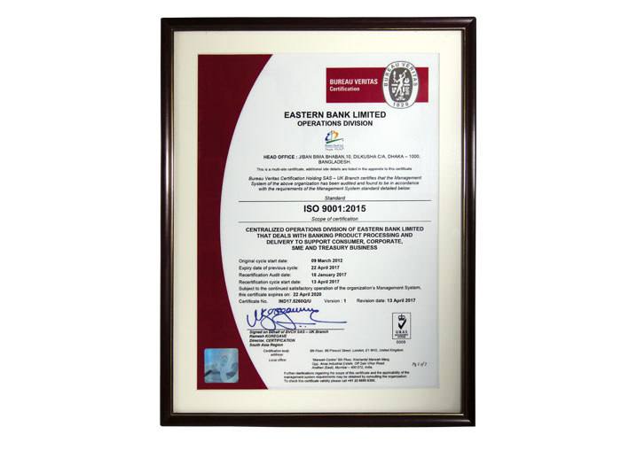

Moody's rating
The rating by a top global agency like Moody's in March 2016 was a high point in our journey to excellence. Moody's assigned us Ba3 rating with stable outlook. The rating is equivalent to country sovereign of Bangladesh. EBL is the first company in the country to achieve this commendable feat. Moody's reaffirmed EBL the Ba3 rating in 2017 and 2018.
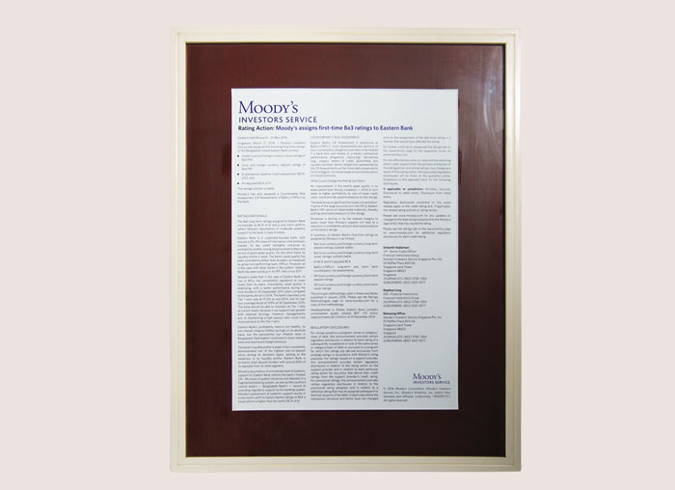

PCI DSS Certificate
PCI DSS certificate has been awarded to EBL in 2016 and reaffirmed in 2017 by global leader in cyber security NCC Group of UK is a testimony to our emphasis on card security.
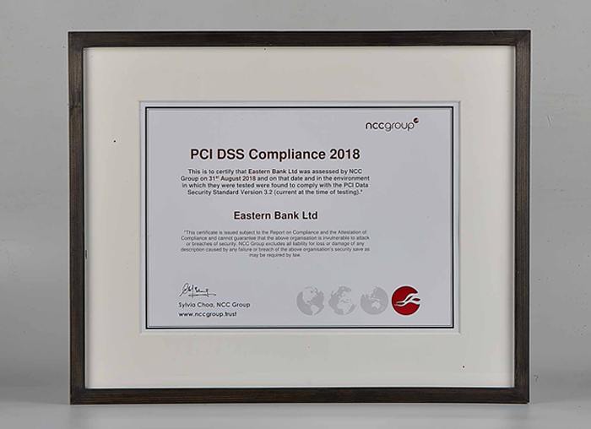

Euro money Award
In 2016 the jury of Euro Money Awards for Excellence conferred the Best Bank in Bangladesh for its professionalism, prudence, and growth. It also referred EBL's depleting NPL ratio as mark of health. In 2017 and 2018 EBL adjudged the Best Bank in Bangladesh making the tally to three consecutive years. After the introduction of the coveted Euro money award for Bangladesh in 2013, EBL is the most successful bank to win maximum number of awards


A Leader in Retail Banking
In retail banking EBL has emerged as an undisputed leader. The Asian Banker International Excellence in Retail Financial Services award has adjudged EBL as the Best in Retail Bank in Bangladesh for the last six consecutive years from 2013-18.
The London-based International Finance magazine in 2018 awarded EBL for the Best Credit Card Offering in Bangladesh.


Best Transaction Bank in Bangladesh
EBL has been awarded at the prestigious Asian Banker Business Achievement Awards 2018 held in Beijing. EBL is the only bank from Bangladesh to win Best Transaction Bank in Bangladesh Awards in two categories of Best Cash Management and Trade Finance.
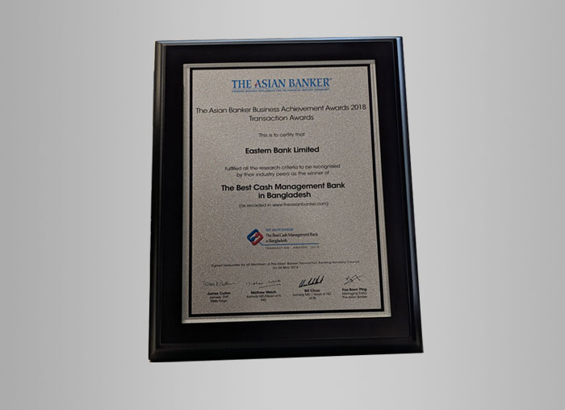

IFC Award
In 2017 IFC of World Bank group recognized us as the Best Issuing Bank Partner and Best Trade Operations Issuing Bank Partner in South Asia.
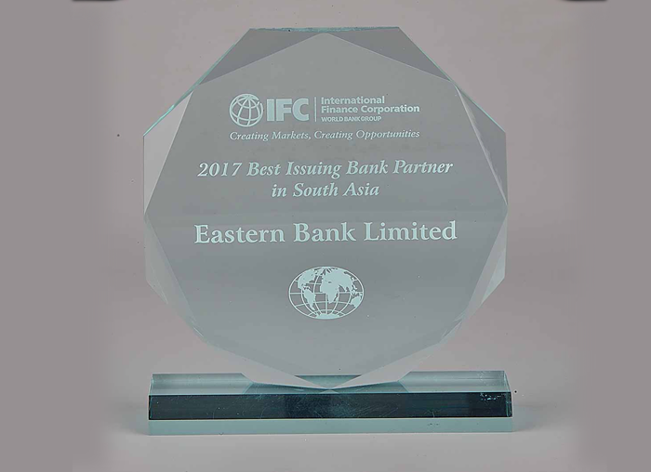

Asia money Award
EBL has been awarded the Best Corporate and Investment Bank for 2017, 2018 and 2019 by Asia money.


Superbrands Award
EBL has been recognized as a 'Superbrand' of the country for the year 2018-2020 by the Superbrands Bangladesh.
EBL also received the Superbrands of Bangladesh award in 2009 for the period 2009-2011.


Chapter: Four
Human Resource Practices At
Eastern Bank Limited

4.1 Management and Appointment


SEVP &
Divisional Head
Recruitment
Development
Human Resource Division
Office Admin
HR Operation

4.2 Recruitment Procedure

A foundation or an association can't be prevailing without giving appropriate support of the client and customers. For bank it's considerably progressively significant as far as administration. So for serving Valuable support of the purchasers they generally procure ingenious official to keep up the standard of the bank. EBL accepts by paying adequate pay and payments to their staff to get most extreme administrations out of them. Therefore, bank authority must be cautious in enlisting the opportune individual for the correct activity.

The obligation of top managerial staff to break down the labor prerequisite of the association consistently and fix up the quantity of staff official, administrators and number of official every class. on the off chance that the bank request any brief or lasting post for the association, the top managerial staff suggests the responsibilities and furthermore subsidize for a long time. Eastern Bank Limited can't figure out how to pay for keeping up additional labor. EBL must perceive the significance of labor estimation and as needs be an outline they for the contracting individuals. At the point when they requiring, it’s should be audited and overhauled now and again for growing the business. Still, professionals will take the edge to fill up posts lying vacant within the approved chart or organogram. For the justification they can take initiative and can revise the chart for justification of the post. The organogram has to be revised time to time.

Recruitment through Advertisement

At the point when an association needs individuals they give promotions in the media, it's likewise called the piece of the enrollment. Right kind of ability is the primary article to the enlistment strategy. EBL consistently pursues the notices print, on the web. The office will deal with all issues identifying with enlistment and determination of staff.



Fig: Job Circular of Eastern Bank Limited for Trainee Assistant Officer

Regarding recruitment of Probationary Officer, the criteria has been set as under: -

- He/She should be a resident of Bangladesh.
- Candidates must be Masters/BBA from an all around rumored University having three first Divisions/Class or CGPA-3.00 out of 4.00 where appropriate (no third Division/Class is adequate).
- Preference will be given to those having MBA/BBA in Accounting, Finance and Banking, Marketing, Management and different business situated subjects and Masters with Honors in Economics, English, Statistics, Mathematics and different business arranged subjects.
- His/Her age must be between 21 to 30. These conditions might be loosening up capable in unique cases to be recorded as a hard copy.
- He/She should be physically fit.
- The newcomer be required to get full therapeutic assessment from the Doctor, selected by the Bank. The expenses of the Doctor be paid by the Candidate. Be that as it may, any expenses for Pathological/different administrations required by Doctor for full restorative assessment be paid by the forthcoming worker.

Meeting Performance
Like other bank EBL likewise keep a similar principle for trial official that they must be probation for one year. After the hour of probation, their exhibition will be examined by the Management and spot the report to the Managing Director. In the event that the competitor found appropriate for the post, they will be affirmed. In the event that they got unfitting their trial period might be additionally broadened or their administrations will-be ended by the power. Determination Committee will consider the candidate’s appearance, character, imparting capacity, good judgment, habits, general and presence of mind and grant checks exclusively which will be totaled and arrived at the midpoint of for deciding meeting execution score. The accompanying basis for meeting might be pursued:
- Appearance and Personality: 5
- Expression and Presentation limit and habits: 5
- General information: 5
- General and presence of mind: 3
- Assessment: 2
- Composed Test: 5
It's compulsory to for the all candidates to endeavor the composed test which is 60 imprints test. The test ought to contain with general information and numerical predisposition. EBL take the assistance of outside specialists for setting the inquiries, regulating the assessment work and denoting the contents. Going with least characteristics of 60% will qualify the up-and-comer.

4.3 Flow chart of recruitment process

4.4 Probation and Confirmation

Here are the rules that EBL follow for the probationary officer

- Entry level officials a will be on post-trial supervision for at least one year. Thereafter the probation time frame, the executive’s advisory group will assess their exhibition and they will display a report. On the off chance that they discover the official is reasonable they will affirm the person in question else they move or can end

Also they have that decides for staff that in the event that they enlist any sub staff they can be involved as ordinary representative in the event that they complete 8 years of consistent assistance in the Bank by observing their records and instructive capability.

4.5 Resignation

For acquiescence EBL allows sees three months ahead of schedule of the end. Its appropriate forever one of the staffs here they likewise referenced if the overseeing executive neglects to give the composing reports to them, overseeing board of trustees at risk to pay the pay a sum equivalent their essential pay three months‟ compensation. It's additionally appropriate for the trial official if there any disciplinary activity inferred on an official or if any official utilizing any gear which has a place from the bank they can't leave without the authorization of the position

4.6 Gift or Benefits Offered to Employees
It is an offense to request, request or acknowledge to serve a worker, anything of significant worth from anybody as an end-result of any business, administration or secret data, either previously or after an exchange is talked about or finished.
Special material of ostensible worth, for example, pens, pencils, scratch pads, key chains, schedules and comparable things and so forth and endowments of sensible incentive on wedding are excluded. At whatever point any circumstance emerges as to issues concerning things of significant worth, a representative must make complete honesty to the administration and get the executives' composed reaction.

Things Offered by Employees
Representatives will not, for the benefit of EBL straightforwardly or by implication give, offer or guarantee anything of significant worth to any individual, business substance, association, open authority, and ideological group to impact the beneficiary. Typical strategic policies of offering dinners; excitement limited time blessings and so forth are absolved. Representatives will not, for the benefit of EBL legitimately or by implication give, offer or guarantee anything of significant worth to any individual, business element, association, open authority, and ideological group to impact the beneficiary.

4.7 Training and development policy

In each all-around presumed association preparing is extremely normal practice to put new representative into administrative duties after procedure of preparing and advancement. We realize Training implies familiarizing everybody with the specialized part of the activity so his specialized aptitudes will be overhauled. It's a customer arranged occupation, so preparing isn't sufficient for explicitly who needs human connection and social ability in this preparation gives people discernment, frame of mind, qualities and desires, so that and representative or manager can build up there with the most recent update. HR create expertise and information for better exceptional of employment duties. Its grips with on - the-work and shaped preparing programs.
Here is the EBL training programs
- Orientation Training
- In-House Training
- Job Specific Training
- Need based Local/Foreign Training
- Peer or supervisors' coaching
- E-Learning: Online Training & Evaluation

Direction Training: for the fresher, Eastern Bank Limited has direction inside preparing project to give them the general perspective on the bank and furthermore present them with the hierarchical culture.

- Job explicit preparing: this is preparing where Norm of the bank is to prepare them by friend or directors' instructing. Representatives must endeavor this preparation to know the set of working responsibilities and pursue on the hands on preparing.

- Need based preparing: this preparation can be either Foreign or nearby. In the wake of breaking down worker’s whole among aptitudes and information and competency required for the present job.

Basic training program:

- Joining/ Participating in orientation with different Departments
- Foundation Course
- Attachment with SME Unit Offices & Branches
- Organization of Development Program
- Attachment with different departments
- Information Technology Training
- On job hands-on training according to Job Description

4.8 Training Authority

The Managing Director has the ability to choose issues identifying with preparing of the representatives of the Bank. For preparing/instruction inside or outside the nation, the choice might be made by Managing Director in interview with Heads of the Divisions/Deputy Managing Directors.

4.9 Retirement
An official earned Regardless ability and information all through of his working life. At that point a specific opportunity later opportunity arrives when capacity to perform decrease very. Where it's an ideal opportunity to resign of a senior official will supplant new official to work with more quality and additional energy to improve the nature of the executives of the organization. The standards might be known as the "Eastern Bank Limited" (Employees) retirement and Retirement Benefit Rules, 1993.It will come into power on the double and will be esteemed to have produced results from the date of initiation of the Bank. A worker of the Bank will resign on accomplishment of the age of 58 (fifty-eight) years which is considered as should be expected retirement Voluntary

Retirement:
Any worker of the Bank may pick to resign from the administration of the Bank whenever after he/she has finished least 10(ten) long periods of administration in EBL pulling out recorded as a hard copy to the Overseeing Executive in any event 60 (sixty) days before the date of his planned retirement
• Typical Retirement: A representative of the Bank will resign on achievement of the age of 58 (fifty-eight) years
• Constrained Retirement: Constrained retirement doesn't involve Age. A worker might be expelled from the administration of the Bank for his submitting any unfortunate behavior subsequent to fitting in with rules and methods gave in law.
• Early Retirement: A representative of the Bank may settle on early retirement recorded as a hard copy to the Overseeing Chief with or without demonstrating any ground thereof whenever during his administration in the Bank. There is no bar of earlier notification or length of administration for it. Be that as it may, alternative for early retirement, once practiced will be conclusive and unavoidable.

4.10 Retirement Benefits

Voluntary Retirement:
- A worker whose willful retirement has been acknowledged by the Bank will be qualified for the accompanying retirement benefits
- Tip according to Tip Rules will be paid, determined at (one) months fundamental compensation (prompt a month ago's essential compensation) for each finished long periods of administration in the Bank.
- He/she will be qualified for installments acceptable to him/her according to Fortunate Store Rules of the Bank.
- The concerned worker will be qualified for benefits under Superannuation Reserve Plan.
- The concerned worker will be qualified for benefits under Representatives Welfare Plan

Normal Retirement:
- A representative who has resigned at the age of 58 (fifty-Eight) years in common course will be qualified for the accompanying retirement benefits: -
- Leave preliminary to retirement for 03 (a quarter of a year) with pay, stipends and different offices in full which he/she was profiting from the Bank before continuing to such leave. The leave preliminary to retirement will not be charged from his leave account.

- Leave preliminary to retirement for 03 (a quarter of a year) with pay, recompenses and different offices in full which he/she was benefiting from the Bank before continuing to such leave. The leave preliminary to retirement will not be charged from his leave account.
- Fortunate reserve both possess and Bank's commitment payable according to opportune store rules.
- The concerned worker will be qualified for benefits under Superannuation Reserve Plan.
The concerned employee shall be entitled to benefits under Employees Welfare Scheme.

Forced Retirement

An employee who has been put to forced retirement as a measure of lesser punishment for committing any misconduct shall be entitled to the following benefits
Banks and his own contribution to the Provident Fund if he is otherwise entitled to them as per existing Provident Fund Rules.
- Gratuity benefit if admissible as per existing Employees Gratuity Rules of the Bank.
- Benefits from Superannuation Fund Scheme.
- Benefits under Employees Welfare Scheme.

Early Retirement
Employees of the Bank who applied for Early Retirement and accepted by the Management shall be entitled to the following retirement benefits
- Salary and Allowances for 4(four) months (Calculated at immediate last month’s pay).
- Provident Funds both own and Bank’s contribution shall be paid as per Provident Fund Rules.
- The concerned employee shall be entitled to benefits under Superannuation Fund Scheme.
- The concerned employee shall be entitled to benefits under Employees Welfare Scheme.

Employee Benefit and Service Rules

4.11 Pay and Allowances

The accomplishment of EBL in sound progressing and store preparation just as other speculation will rely upon productive and successful help rendered by capable and eager administrators, officials and staff. Right now the current compensation scale comprehensive of different advantages for various class of officials and staff can be considered as reasonable and fair. These might be explored at regular intervals relying upon the advancement, development and circumstance in the Bank. As indicated by worker The bank is paying current sum isn't that adequate like for trial official they are paying tk30000/ -, first official tk 32000/ - Senior Executive Vice PresidentTk.1,63,900/ -, Deputy Managing Director Tk.2,25,000/ - , Additional Managing Director Tk.3,05,500/ -
4.12 Increment
Like other association EBL has some addition administers too. Their Annual addition fixed based of 10 years, the essential pay would increment by around 100% of the beginning compensation. This guidelines survey each following two years. They have stamping framework for this augmentation, workers increase happened premise of imprints got. Up to 19 no augmentation, from 20 - 28 evaluating scale ordinary addition, 29-40 reviewing scale is considered as extraordinary addition. All the augmentation will be endorsed by the Board/Committee However, the Board may perceive the extraordinary exhibition of any individual officials as store assembly, advance recuperation and advance organization and grant additional money or additional addition or a letter of appreciation. If there should be an occurrence of advancement of a worker compelling from first January an employee would get his normal annual increment, if otherwise in order, with effect from first day of January every year.

- All special increment shall be approved by the Board/Committee on the basis of Company's Financial Performance and Policy which shall be reviewed every year.
- List of all officers who obtained less than 40 Marks shall be reported to the Board every year for appropriate action/decision.

4.13 Bonus Policy
Bonus is an extra payment in addition to fair and reasonable normal salary. It is an incentive payment not a routine salary. Therefore, it must be strictly linked only with effort and profitability of the Bank. Two Festival Bonus every year, pay dividend 7%- 9% only one Festival Bonus/ no Incentive Bonus.
- Bonus always on the basis of the Basic Salary
- Nevertheless, even if net profit not enough to pay minimum dividend as mentioned at Eastern Bank Law under serial no. b (1) Board shall consider the matter every year.

4.14 Provident Fund
For each business association a Provident Fund is a legitimate element which is made by to give long haul advantage to the laborers and workers. Business contributes with the store dependent on fixed level of the regularly scheduled compensation move costs. Then again, workers are to make store comparable sum or more to the reserve each month. Fortunate Fund Administered by a Board of Trustee Comprising both Board Members and Executives. The Fund will be regulated by these Rules or by such different Rules as might be encircled every now and then. The care, the executives, speculation and control of the store will be vested in the Trustees.
- There shall be at least 6 (six) Trustees of the Fund out of which 3 (three) will be nominated by the Board of Directors and the remaining 3 (three) Members of the Fund shall be nominated by the Management.
- The custody, management, investment and control of the fund shall be vested in the Trustees.

- There shall be at least 6 (six) Trustees of the Fund out of which 3 (three) will be nominated by the Board of Directors and the remaining 3 (three) Members of the Fund shall be nominated by the Management.

4.15 Gratuity
Gratuity is the part of the salary that an employee received from his or her employer. This is another form of benefit for the employees. Eastern bank has their own rules which are called the “Eastern Bank Limited Employees Gratuity Rules”. These Rules has been activated from November 01, 1988

Eligibility
For this gratuity employees who has been in their service for a minimum period of 12 (twelve) years without any break, they will be eligible to have the benefit under the gratuity scheme. But sometimes Gratuity can be approved to an employee under this condition

- In case of sudden death during in the service
- In capability of mental and physical permanently.
- Any special case

Disqualification
The following categories of employees will not be eligible for the Gratuity: -

- Those who are dismissed from the service of the Bank.
OR
- Those who leave or discontinue their service without the permission of the

Amount Payable
One-month basic salary for each completed year of service on the basic pay drawn by the employee.

Payment of Gratuity
- The Gratuity will be paid to the employee concerned.
- In case of his/her death the Gratuity has to be paid
- The person(s) nominated by death
- His/her legal heirs in the absence of any nomination.

4.16 Medical Benefits
The benefits are over and above the normal monthly allowance. It is not mandatory by any law but EBL Board only introduced such benefits to ensure that all employees dedicate themselves to EBL for its continuous growth, better clientele service and good health. Obvious monthly medical allowance does not cover the expenses for hospitalization for major illness where prolong hospitalization are necessary including surgery.

Rules & regulations
Employee all confirmed employee who is in the permanent payroll. The facility also covers their wife and maximum two dependent children.

Declaration
A specimen copy of declaration form is required to be filled and signed in duplicate by individual employee. The first copy of the declaration form should be forwarded to Head Office. Administration Division for their record and the second copy should be retained by the branch which should be kept in the personal file of concerned employee. Please note that only wife and two children whose names and particulars will appear in the declaration form will be eligible for this facility.

The scheme:
The organization will pay at actual all charges incurred in the hospitals for the under noted purposes only which will include rent for cabin/ward, operation charges, all pathological and X- ray charges. Doctor's fees and cost of medicines:
- Accident cases requiring hospitalization but only when going/coming from office and on official duty.
- Heart diseases requiring hospitalization.
- Major surgery requiring hospitalization.
- Major diseases/ailment i.e. Requiring hospitalization for problem in Kidney, Heart,
- Gastroenteritis, Brain, Eye, Ear, Nose, Lever, Lungs, Spine as well as other vital organs.
- Hospitalization on account of maternity requiring surgical operation only.
For the cases of hospitalization and surgery has to be referred and recommended by a recognized specialist not below the rank of Associate Professor and should be approved by the Management before the admission/surgery.

4.17 Leave rules & regulations
The following leave Rules and Regulations shall be followed by NBL. These rules shall be followed strictly without any exceptions and any deviation shall be reported to Board/ Committee properly for necessary information & consideration.
- Any Important Issues for leaving.
- Leave has to be earned by duty only.
- The period spent on tour will be counted as duty.
Leave application will be addressed to the competent authority and it must be submitted. No employee shall be allowed any leave unless the leave application is forwarded timely to the leave sanctioning authority.
4.18 Promotion Policy
Advancement intends to next higher post ought to be taken care of cautiously and reasonably as a result of in one hand its significance in looking after officials/officials and staff ethics and then again the future development of the Bank. Not with standing, advancement can't be asserted as an issue of right. It is the obligation of Management to guarantee that one gets an upward lift just based on the presentation at the interim of sensible timeframe. It must be an acknowledged as a rule that advancement ought to be carefully based on merit. Be that as it may, by and by, it has been discovered hard to quantify legitimacy and advancements, all around, have been occurring based on rank.

Non-Graduate candidates will not be considered for promotion beyond Principal Officer

- For preparing the eligible list for promotion of promote Officers to the next higher grades, the cumulative points with the ratings, academic degrees’ professional degree, professional training etc. shall be the basis. Officers having higher academic degrees would get priority over the other in the eligible list. Around three years of complete service may be fixed to make a person eligible for promotion. Promotions also depend largely on the availability of post.

There are also some other factor plays for promotion

- Greater importance should be attached to merit, though measurement of merit of an individual is a difficult job with subjective judgment. By involving Seniority or length of service should not guide promotion to higher post.
Also part one and Part two examination of the Institute of Bankers and trained by their Training institute may be considered to have acquired relatively more technical competence. Therefore, passing of this examination may be given some weight at the time of promotion.
Therefore, the superior is in a better position to evaluate their merits. EBL should therefore, install a well- designed system of grading and train the ACR writing officers and executives. The grading should contain items which are very much relevant for evaluating the performance of an executive/officer. For Probationary Officer, after successful completion of Probation period of one year he/she will be confirmed as Executive Officer.

4.19 Disciplinary Action
Anyone doing anything harmful to the interest of EBL will be penalized. Disciplinary action will be taken also if found guilty of misconduct or disloyalty, whether executive, officer or staff is subject to disciplinary action if there is sufficient evidence that he has misconducted his duty to EBL by reason of inefficiency, mental, inability, physical infirmity or any other reason like conviction by a court corruption. Like fraud, forgery, commercial bribery etc. and misuse of official power will be another ground for penal measure.

In EBL “Misconduct” will cover the follows
- Disobedience to Lawful or order of the authority.
- Bank property or business property Theft, fraud or dishonesty. Damage or loss of goods or property.
- Late coming and early going on habitual basis.
- Absence from duty without obtaining prior permission. Indecent or Unsystematic behavior when on duty.
- Striking picketing and agitation surrounded by the Bank, Distribution of hand bills, pamphlets or posters inside the Bank premises.
- Leaving the seat or place of work without permission on duty hours.
- Unapproved use of Bank’s property.
- Absenteeism work show-down or undue delay in the discharge of duty.
- Negligence of duty, Habitual Negligence of duty.
- Break of Bank’s regulation, standing orders, instruction, rules, procedure etc.

4.20 Disciplinary Authority

The Managing Director is the answerable for taking care of the Disciplinary cases identifying with official and officials will be inspected and chose by the Policy and Regulations Committee/Board and those identifying with staff. Overseeing Director will have the ability to suspend any one if circumstance requests prompt activity. The move made by the Managing Director ought to be accounted for to the Committee for its endorsement. The Committee/Board will be the incomparable position to choose what activities call for punishment. Disciplinary activities will be started by the Managing Director when occasions of unfortunate behavior or different offenses submitted by official/official are taken to his notice.

4.21 Suspension
During the suspension period, the Bank may consider giving the suspended employee subsistence allowance. If he is honorably acquitted, he should be given full pay.

Enquiry Procedure

The troubled employee should be given an opportunity to explain his conduct and his explanation should be examined and evaluated objectively without any basis. If the authority is not satisfied with his written explanation, he should be charge-sheeted with reasonable opportunity to the concerned employee to defend his innocence. If charges are provided, the competent authority will impose the punishment.

Review & Appeal
On whom penalty has been imposed shall have the right to submit an application to the punishment awarding authority to review his punishment. He can also make an appeal to the next higher authority for reconsideration of his punishment order. The review petition or appeal must be filed within one month from the date on which the incumbent is informed of the punishment order.

Chapter: Five
SWOT Analysis

SWOT Analysis of the “Eastern Bank Limited”

Strength:

- Open HR Manual: the HR Manual is open for all the representative of EBL which gives them by and large comprehension of the terms and states of the association. This HR Manual is transferred in the inside site of EBL.

- Solid Holding and Belongingness: The workers of EBL have a solid feeling of responsibility towards association and furthermore feel pleased and a feeling of belongingness toward EBL.

- Obligation Specialist: As of late EBL has selected an obligation specialist to guarantee the great qualification for all the representatives.

- Unified Banking: Incorporated financial methods the center elements of business facilitated by the administrative center give an enormous impact for lessening the interior clashes among the branches and Administrative center

Weakness:

- Set of working responsibilities: Expected set of responsibilities in EBL has not been at this point sorted out

- HR Bookkeeping: HR Bookkeeping has not yet been built up by EBL which is a solid device for coordinating the advantages of each new enlistment, computing turnover, and so forth.

- Pay and Advantages: Pay and Advantages is given by EBL through two diverse programming named EZHR and Flex solid shape which are inflexible to utilize and have a few confinements.

Opportunities:

- MIS: HRD of EBL has set up new MIS and utilizing it in different labor announcing.

- HRIS: HR Data Framework will expand very soon by EBL.

- Compensation Review: EBL is going to lead a pay study in the year 2016.

- Learning and Advancement: EBL will use its fullest limit of learning and improvement program by building up a library, organizing broad preparing module very soon.

Threats:

- Competitive Salary: The compensation bundle of EBL isn't as serious as the market requests, Visit Worker Turnover: so the turnover pace of EBL is expanding step by step.

Chapter: Six

Supplementary Part

6.1 Findings of the Report

- Eastern Bank Limited has their own training center which is situated at Gulshan where they only provide theoretical materials, not with the practical one like showing videos, also no pre and post evaluation or survey takes in the training session.
- In performance appraisal they don’t follow updated version properly
- When the customer wants to open an account specially for business purpose they don’t take details about their financial condition that whether they have loss or any debt
- The bank has online service. But the service system is slow which interrupt during transition hour
- The entire employer is very knowledgeable, but they are totally unaware of the philosophy behind the work or task.
- The Bank should follow their specific objective properly.

6.2 Recommendation

When I have started writing this report I found some important issue which is considered to more construct. Not huge number of challenges has been found but some significant things of the organization which is actually help an organization to become more productive. The recommendation part has been focused on this issues where they need to be improve more

- The external recruitment and selection process of EBL should be improve by giving more information about them in online. Their providing information is not enough for knowing about their activities or their aim.
- A mid-level manager gets only 120 per hour. It needs to increase to 200 takas per hour.
- They should ensure about the satisfaction of employee’s demand by providing salary scale.
- They should give 80% money of actual work hour for overtime.
- Every year they can arrange a reward giving program for outstanding performance which help to encourage the employee.
- They can provide life insurance or group insurance for get rid of the risk. They can also provide health insurance.

6.3 Conclusion

Eastern bank limited maintain conventional banking system for their making policy and for their procedure. There are lots of commercial bank and public Bank we have in this country in this competitive environment eastern bank is competing successfully with all of them. Eastern bank limited is not only doing competition successfully but also its contributing in our economy sector their SME loan Industrial loan and also several loan helping the general people to create more opportunity to them from the last twenty-seven years they are paying to the society. They have made many funds in export and import business. It obvious clear that Eastern bank limited created 85 branch overall Bangladesh. Increased so many sources which created a portfolio in the development less the amount of loans and losses, more income are the factor which played vital role behind every banking success.

Reference

- HR Manual of Eastern Bank Limited.
- https://www.ebl.com.bd/profile
- Banking in Bangladesh, (2010) [online] Available from https://en.wikipedia.org/wiki/Banking_in_Bangladesh
- Fahmida, k (2015), Banking Sector for sustainable growth, 5th Feb, supplementary part -5 citing electronics of information [WWW] Daily star ,http://www.thedailystar.net/supplements/25th-anniversary-special-part-5/banking- sector-sustainable-growth-212689
- Mahmood, R., & Khan, S. M. (2014). Impact of service marketing mixes on customer perception: a study on Eastern Bank Limited, Bangladesh. European Journal of Business and Management, 6(34), 164-167.
- Direct Information Collected Through Interview Session :
- Lilun Nahar kanta, SPO
- Shahidul Islam, Customer Service Manger
- Kazi Sunny Ahomed, Trainee Assistant Officer
- Bappa Dey, Assistant Officer

Appendix

Questionnaire

- What type of criteria national bank follows for hiring new employee or fresher?
- Executive, officer, staff in terms of recruiting what is the steps bank follow for them?
- What is the duration for probationary officer? Tell us about the details of probation period.
- If employee is unwilling to work with organization or if authority found that person is not appropriate for the post, how bank handle with this kind of issue?
- How they follow the rules for employee, employer, staffs of national bank, does anyone break the rules what type of punishment procedure they follow?
- In occasion or as part of the good performance, appraising do they provide any special gift or benefits to the employee and employer?
- For employee, employer improvement, how the Bank provide training to them?
- What is the facility for retired employer? How bank providing the facilities to them?
- Increment” with this service, how national bank deal with it?
- Is there any special bonus for employee? How they follow the bonus policy?
- In Gratuity, provident fund, how they reserve it for employer?
- When any staffs, employer or employee faces any accident how bank provide them medical benefit? If an employer or employee needs to take in abroad for treat how this Bank deal with it?
- Can everyone enjoy the transport facility of national bank ltd? If there is any specific requirement for giving transport facility to the employee or employer?
- An employee or employer in a year how many times they can take leave? Is this paid or non-paid?
- What is the rules regulation for taking dispensation?
- How many days they consider for maternal leave?
- What are the criteria, eligibility for promotion? If organization wants to transfer any employee how they deal with this issue?
- Tell us about the disciplinary action?
- How many days an employer can be suspended?
- “Performance appraisal” how they deal with it?

