Internship Report
On
General Operation of Agora Limited

Sabrina Shahrin

This report is submitted to the school of Business and Economics, United International University as a partial requirement for the degree fulfillment of Bachelor of Business Administration

Internship Report
On
General Operation of Agora Limited

Submitted To
Mohammad Tariq Hasan, PhD
Associate Professor (Accounting) &
Deputy Director (BBA Program)
School of Business and Economics
United International University

Submitted By
Sabrina Shahrin
ID: 114143020
Major: Accounting Information System
Registration Trimester: Fall-2025


School of Business and Economics
United International University

Date of submission: 24th November, 2025

Letter of Transmittal
To
Mohammad Tariq Hasan, PhD
Associate Professor (Accounting)
& Deputy Director (BBA Program)
School of Business and Economics
United International University

Subject: Submission of Internship Report on “General Operation of Agora Limited”

Dear Sir,
It is with great pleasure that I submit my internship report on the general operations of Agora Limited conducted at its Head Office under the Accounting Department. This report has been prepared as part of the requirements for the completion of my internship program at United International University.

During my internship, I had the opportunity to gain practical knowledge about accounting procedures, financial reporting and the overall operational framework of a leading retail company. I have tried my best to analyze and present my findings in a clear and structured manner.

I sincerely hope that this report meets your expectations and provides valuable insights into the operations of Agora Limited. I am grateful for your guidance and support throughout this internship period.

Thank you for your consideration.

Yours sincerely

Sabrina Shahrin
ID: 114143020
Major: Accounting Information System
United International University

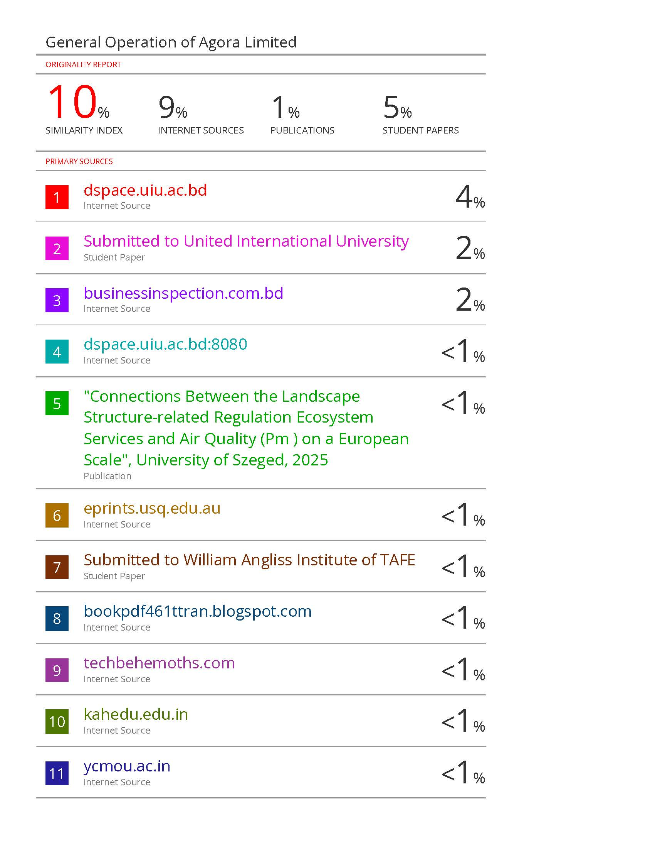Certification of Similarity Index

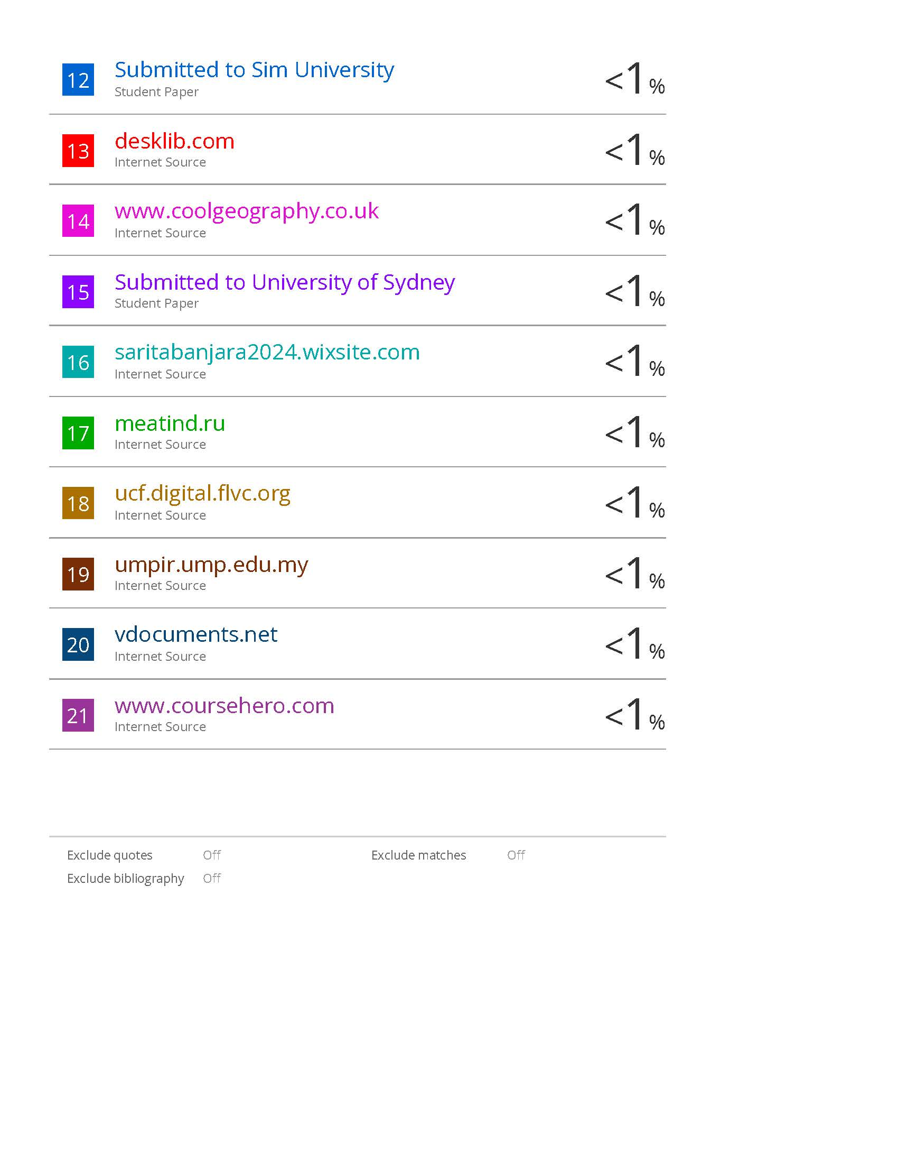

Declaration of the Student

I, Sabrina Shahrin, hereby declare that this internship report titled “General Operation of Agora Limited” is my own original work and has been prepared under the supervision of Mohammad Tariq Hasan, PhD, Associate Professor (Accounting) & Deputy Director (BBA Program), School of Business and Economics, United International University.

I further declare that this report has not been submitted previously, in full or in part, for any other academic degree or program at any institution.

I take full responsibility for the content and authenticity of this report.

Signature: ____________________

Name: Sabrina Shahrin
ID: 114143020
Date:

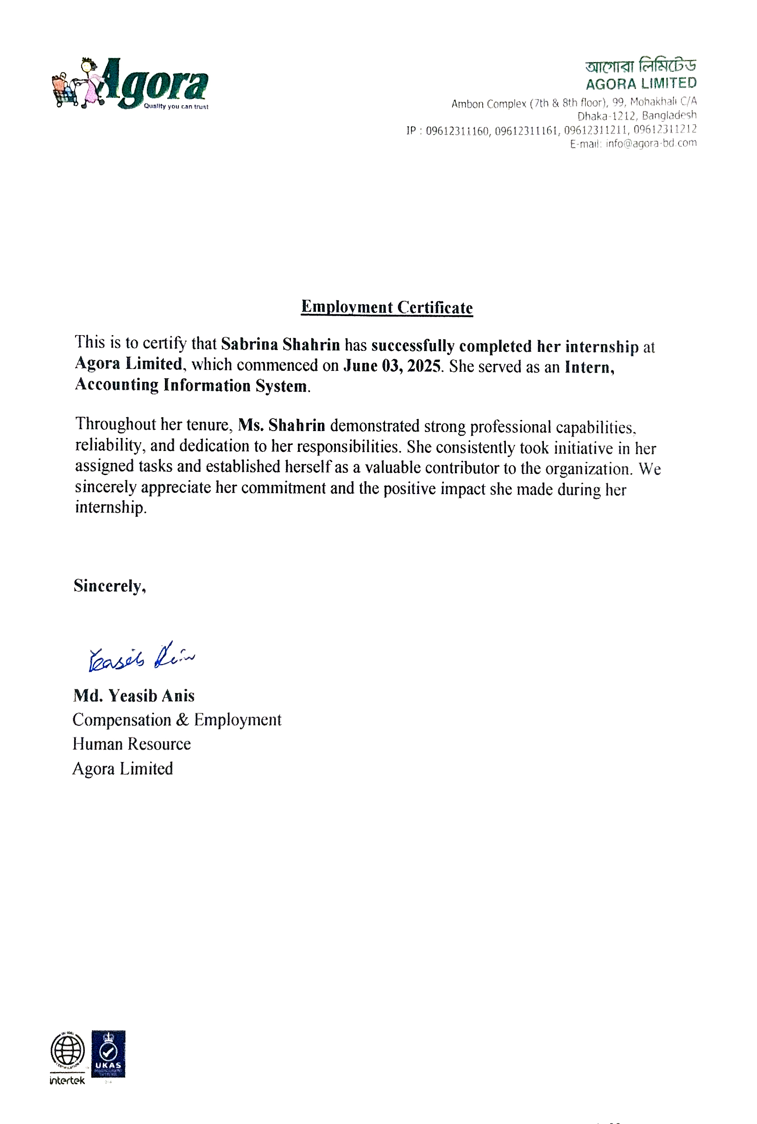Corporate Evidence

Acknowledgement

First of all, I would like to express my gratitude to Allah Almighty for giving me the strength, patience and guidance to successfully complete my internship.

I would like to extend my sincere thanks and appreciation to Mohammad Tariq Hasan, PhD, Associate Professor (Accounting) & Deputy Director (BBA Program), School of Business and Economics, United International University, for providing guidance, support and constructive feedback throughout the preparation of this report.

I am also extremely grateful to Agora Limited, especially the Head Office Accounting Department, for giving me the opportunity to undertake this internship and for their generous support, guidance and training during my practical experience.

Finally, I would like to thank my family and friends for their encouragement and support throughout this journey.

Sabrina Shahrin
ID: 114143020

Executive Summary

This internship report is prepared based on my internship experience in the Accounting Department at the head office of Agora Limited. The main objective of the report is to present a detailed analysis of the general operations, financial processes and accounting system of the company. During the internship, I got the opportunity to get directly acquainted with various accounting activities at the head office. These include recording daily transactions, managing Accounts Payable and Accounts Receivable, Payroll process and preparing monthly, quarterly and annual financial reports. In addition, I observed the process of ensuring transparency of financial activities through the use of various internal control systems, accounting policies and software. This report presents in detail the departmental structure of the company, operational policies and the process of cooperation of the accountant with other departments. It also includes observations, experiences and some recommendations during the internship. In short, this internship helped me gain theoretical knowledge as well as practical experience, which will contribute significantly to my academic and professional development.

Keyword: Internal control, reporting, accounting, Agora, Bangladesh

Table of Contents

Letter of Transmittal iii
Certification of Similarity Index iv
Declaration of the Student vi
Corporate Evidence vii
Acknowledgement viii
Executive Summary ix
Table of Contents x
List of Figures xii
List of Tables xiii
List of Acronyms & Abbreviations xiv

CHAPTER ONE: INTRODUCTION 1
1.1 Background of the Report 2
1.2 Objectives of the Report 3
1.3 Rationale of the Report 4
1.4 Scope and Limitations of the Report 4
1.5 Definition of Key Terms 5

CHAPTER TWO: COMPANY AND INDUSTRY PROFILE 7
2.1 Company Analysis 8
2.1.1 Overview and History 8
2.1.2 Trends and Growth 9
2.1.3 Products / Services / Customer Mix 11
2.1.4 Company Operations 13
2.1.5 SWOT Analysis 14
2.2 Industry Analysis 16
2.2.1 Industry Specification 16
2.2.2 Industry Size, Trends and Maturity 17
2.2.3 Industry SWOT Analysis 18

CHAPTER THREE: GENERAL OPERATIONS OF AGORA LIMITED 20
3.1 Procurement and Inventory Management 21
3.2 Sales and Revenue Recognition 23
3.3 Payment and Cash Management 26
3.4 Cost Control and Expense Management 27
3.5 Internal Control and Audit Process 29
3.6 Use of Accounting Software and Systems 30

CHAPTER FOUR: INTERNSHIP EXPERIENCE 32
4.1 Position, Roles and Responsibilities 33
4.2 Training and Development 33
4.3 Contribution to the Organization / Management 34
4.4 Evaluation 34
4.5 Applicable / Transferable Skills 35

CHAPTER FIVE: CONCLUSION AND KEY FINDINGS 36
5.1 Findings 37
5.2 Recommendations 38
5.3 Key Learnings 39
5.4 Conclusion 40
References 41

List of Figures

Figure 2.1: Trend of Agora Limited 10
Figure 2.2: Growth of Agora Limited 11
Figure 2.3: Industry Analysis 16
Figure 3.1: Procurement and Inventory Management 21
Figure 3.2: Sales and Revenue Recognition 23
Figure 3.3: Payment and Cash Management 26

List of Tables

Table 2.1: Trend of Agora Limited 10
Table 2.2: Growth of Agora Limited 11
Table 3.1: Procurement and Inventory Management 21
Table 3.2: Sales and Revenue Recognition 23
Table 3.3: Payment and Cash Management 26
Table 3.4: Cost Control and Expense Management 28
Table 3.5: Internal Controls and Audit Processes 29
Table 3.6: Use of Accounting Software & Systems 30

List of Acronyms & Abbreviations

BDT = Bangladeshi Taka
IT = Information Technology
SWOT = Strengths, Weaknesses, Opportunities and Threats
TBS = The Business Standard
GDP = Gross Domestic Product
USD = United States Dollar
ERP = Enterprise Resource Planning
POS = Point of Sale
VAT = Value-Added Tax
SME = Small and Medium Enterprises

CHAPTER ONE: INTRODUCTION

1.1 Background of the Report
1.2 Objectives of the Report
1.3 Rationale of the Report
1.4 Scope and Limitations of the Report
1.5 Definition of Key Terms

1.1 Background of the Report
In today's world, business is a competitive and rapidly changing field. Due to technological advancements, changes in market structures and diversity of customer needs, business organizations now have to rely on more efficient and transparent financial management than ever before. In this context, the role of accounting is immense. Accounting is not just a means of keeping track of income and expenses, but it is also an essential element in evaluating the financial performance of an organization, formulating future plans, controlling the budget and making financial decisions.

As a business administration or accounting student, acquiring only theoretical knowledge is not enough; gaining practical experience in how an organization's financial activities are managed in real life, how policies and processes are implemented in practice is very important. This is why the internship program has been included as an essential part at the university level. Through the internship program, students get the opportunity to work in a real work environment and can connect theoretical knowledge with practical experience. In this context, I completed my internship at the Accounting Department of the Head Office of Agora Limited, one of the well-known retailers in Bangladesh. Agora Limited started its operations in 2001 as a pioneer in modern retail business in Bangladesh. The company has created a strong position in the market by providing safe, quality and fair priced products to consumers. Currently, they are operating multiple outlets in different parts of the country including Dhaka and Chittagong. Agora Limited's Head Office is the center of the entire organization's administrative and financial activities. From here, all the company's financial planning, budget preparation, financial documents related to purchase and sale, payment processing, cost control and internal audit activities are conducted. The accounting department mainly coordinates these activities and plays an important role in maintaining the financial discipline of the organization.

During the internship, I was involved in various tasks of the accounting department such as daily voucher entry, expense verification, bank reconciliation, supplier payment processing and assisting in the preparation of financial reports. Through this process, I gained practical experience in the organization's internal financial procedures, use of accounting software and preparation of reports according to policies.

The objective of this report is to present a realistic and analytical picture of the general operations of Agora Limited, especially the working pattern of the accounting department, management process and financial control system. In addition, this report includes observations during the internship, experiences gained, lessons learned and some relevant recommendations for the future. Thus, this report will serve as an informative document for students, researchers and business professionals where the real picture of the accounting management and general operations of a successful retail organization is reflected.

1.2 Objectives of the Report
The main objective of this report is to present a clear idea of ​​the general operations of Agora Limited, especially the working pattern of the accounting department and the financial management process. The main goal of this report is to analyze and present the organization's financial policies, internal control systems and how daily accounting activities are carried out through practical work experience during the internship.

The specific objectives of the report are:
- To gain an idea about the overall organizational structure and business operations of Agora Limited.
- Observe and analyze how the accounting department of the organization conducts daily financial activities.
- Gain practical experience with the accounting software and reporting systems used by the organization.
- Understand the process of collecting, processing and analyzing financial information.
- Evaluate the effectiveness of the organization's internal control system and financial oversight process.
- Enhance professional skills by combining theoretical knowledge with practical application.

1.3 Rationale of the Report
The necessity or rationale for preparing this report is important in many ways. In today’s world, accounting is not limited to preparing financial reports; it is one of the main foundations for an organization’s strategic decision making. Accurate and timely financial information plays a vital role in an organization’s sustainable growth, profit growth and risk management. Agora Limited occupies an important place in the retail market of Bangladesh. It is instructive for business students to understand how their financial management, especially the skills and policies of the accounting department, contribute to the success of a large retail business organization.

This report analyzes that real context, which will not only increase the intern’s personal knowledge, but also serve as a reference for other students and researchers in the future. In addition, the report can also be a reflective document for Agora Limited, which will be helpful in identifying development opportunities in their internal operations.

1.4 Scope and Limitations of the Report
1.4.1 Scope of the Report
This report is mainly prepared on the general activities, policies and procedures of the Accounting Department of the Head Office of Agora Limited. Here, the daily work of the accounting department such as
- Voucher preparation and record keeping
- Payment processing and bank reconciliation
- Cost control
- Financial report preparation and
- Internal audit activities are analyzed.

In addition, the overall administrative structure of the company, operational activities and the process of using accounting software are also included in the report.

1.4.2 Limitations of the Report
Like any internship report, this report also has some limitations:
- The internship period was limited (about 3 months), due to which it was not possible to observe all the departments of the organization in depth.
- Due to the confidentiality of the company, it was not possible to access many financial information and documents.
- There was no opportunity to directly observe the accounting activities of other branches outside the Head Office.
- Due to time and data constraints, it was only possible to conduct detailed analysis on certain activities.
- Due to lack of experience as an intern, it was difficult to understand the technical aspects of some processes in depth.

1.5 Definition of Key Terms
Some important terms or key terms used in this report are explained here with their definitions for easy understanding by the readers:

1. Accounting:
Accounting is a process through which information related to the financial activities of an organization is collected, classified, analyzed, summarized and reported. It helps in showing an accurate picture of the financial condition of an organization and plays an important role in decision making.

2. Financial Statements:
A document published in the form of a summary of the financial position, income and expenditure and cash flow of an organization at a specific time is called a financial statement. There are mainly three statements in it
- Income Statement
- Balance Sheet
- Cash Flow Statement.

3. Voucher:
A voucher is a document that confirms that a financial transaction has taken place. For example: payment voucher, receipt voucher, etc. In the accounting department, each transaction is recorded through a voucher.

4. Journal Entry:
The record through which a transaction is included in the account book for the first time is called a journal entry. It is the first step in the accounting process and through which debits and credits are reconciled.

5. Ledger:
A ledger is a book or digital record where all the transactions of an organization are stored in a classified manner. The information required for preparing financial reports is collected from it.

6. Cash Flow:
The process of cash inflow and outflow of an organization over a specific period of time is called cash flow. It is helpful in assessing the liquidity position and financial stability of the organization.

7. Accounting Software:
A digital platform or software used to store, process and generate accounting data is called accounting software. For example: Tally, ERP, SAP, or Agora Limited's own system.

8. Financial Report:
This is a document that provides information about the financial activities, profit and loss, assets and liabilities of the organization. This report helps management, investors and other stakeholders in making decisions.

CHAPTER TWO: COMPANY AND INDUSTRY PROFILE

2.1 Company Analysis
2.1.1 Overview and History
2.1.2 Trends and Growth
2.1.3 Products / Services / Customer Mix
2.1.4 Company Operations
2.1.5 SWOT Analysis
2.2 Industry Analysis
2.2.1 Industry Specification
2.2.2 Industry Size, Trends and Maturity
2.2.3 Industry SWOT Analysis

2.1 Company Analysis

2.1.1 Overview and History
Agora Limited is one of the pioneers of the modern retail industry in Bangladesh. Agora has played a significant role in shifting the shopping habits of the people of the country from the traditional market system to the modern superstore culture. The company has become a symbol of trust in the retail market by delivering safe, quality and reliable products to the consumers.

Agora Limited was first established in 2001 as a subsidiary of Rahimafrooz Group, one of the leading business groups in Bangladesh. Rahimafrooz Group is a well-known name in the business world of Bangladesh, which is successfully operating in various sectors of energy, automotive, electrical and consumer products. It was their initiative that the first modern chain superstore was launched in the country, which was named Agora.

Initially, Agora started its operations with only two outlets in Dhaka. Then, gradually increasing their service quality, product diversity and customer satisfaction, the company expanded its branches to different parts of the country including the capital. Currently, Agora Limited is operating multiple superstores in different cities including Dhaka, Chittagong, Sylhet and thousands of customers are receiving their products and services every day.

The main objective of Agora Limited is to create a reliable, transparent and quality shopping environment for consumers. The company procures products directly from local farmers, producers and suppliers so that consumers can purchase fresh and safe food products at fair prices. In addition, they manage operational activities through modern supply chain management, cold chain technology and IT based accounting and management systems.

The corporate office of the company (Head Office) is located in Dhaka, from where all administrative, financial and strategic decisions are made. Under the Head Office, various departments such as Accounting and Finance, Supply Chain, Marketing, HR and Operations departments work in coordination to keep the activities of the company running.
Agora Limited's journey is not just a business entity, but also an important step in establishing a culture of modernity and security in the retail market of Bangladesh. Through this, they have created a new trend in the retail market of Bangladesh by providing customer trust, fair prices and quality products.

2.1.2 Trends and Growth
The retail market in Bangladesh has grown rapidly over the past two decades and Agora Limited has been one of the pioneers of this change. Since the opening of its first branch in 2001, the company has continuously expanded its scope, services and product diversity. Nowadays, there has been a huge change in consumer buying behavior quality, safety and health awareness are now the top priorities of the customers. To meet this demand, Agora Limited is always adopting new trends and technologies to improve its services.

Although initially limited to Dhaka, Agora now operates multiple outlets in other cities besides the capital, including Chittagong, Sylhet. Due to the increasing trend of online shopping among modern consumers, Agora has launched a digital ordering and home delivery service called “Agora Online”. The company works directly with local farmers and producers, ensuring transparency in the supply chain and fair prices for farmers.

New products and brands are constantly being added to meet the changing needs of consumers especially healthy and organic food products. The use of modern software in accounting and inventory management, customer loyalty programs and online reporting systems has enhanced Agora's operational efficiency. As a result of this continuous growth and change, Agora Limited has solidified its position as one of the leading companies in the retail market in Bangladesh.

Table 2.1: Trend of Agora Limited
Year | Revenue (BDT Crore) | Net Profit (BDT Crore) | Number of Outlets
2020 | 2,500 | 120 | 15
2021 | 2,850 | 135 | 18
2022 | 3,200 | 145 | 22
2023 | 3,600 | 160 | 25
2024 | 4,000 | 180 | 28
Note: Revenue and profit figures are hypothetical and can be replaced with actual annual report data.

Figure 2.1: Trend of Agora Limited

Revenue has increased steadily from 2020 to 2024. The revenue growth in 2023 and 2024 is particularly significant compared to last year, which is due to the company's market expansion and product diversification. Net profit is increasing consistently, which is an indicator of effective cost control and operational efficiency. The increase in profit margin indicates the company's business stability. The number of outlets is increasing, which is strengthening the company's market presence. The customer reach is increasing through the opening of new outlets. The launch of e commerce platforms and the increasing importance of private label products have strengthened the company's competitive position in the market.

Table 2.2: Growth of Agora Limited
Year | Revenue Growth (%) | Net Profit Growth (%) | Outlet Growth (%) | Employee Growth (%)
2020 | 12.5 | 18.75 | 25 | 10
2021 | 11.1 | 15.8 | 12 | 8
2022 | 13.3 | 18.2 | 14 | 9
2023 | 11.8 | 15.4 | 9 | 7

Figure 2.2: Growth of Agora Limited

Revenue growth of around 11.13% and net profit growth of 15.18% is seen every year. This indicates that the company is growing steadily and maintaining profitability. Although outlet growth is slightly lower, the number of employees has increased in a controlled manner. Indicates that efficiency and human resource management are effective.

2.1.3 Products / Services / Customer Mix
Agora Limited offers a complete lifestyle shopping experience to its customers. The company has embodied the concept of “One Stop Superstore”, where all daily essentials are available under one roof.

1. Products
Agora’s products are mainly divided into the following categories:
- Fresh Food: Vegetables, Fruits, Fish, Meat, Dairy Products, etc.
- Packaged and Processed Food: Rice, Pulses, Oil, Spices, Noodles, Sauces, Beverages, etc.
- Household Goods: Cleaning Products, Cosmetics, Personal Care Items, Kitchenware, etc.
- Bakery and Ready-Made Food: Homemade Bread, Cakes, Pastries, Salads, Snacks, etc.
- Offers and Promotional Products: Special Discount Packages, Festival Offers and Loyalty Program Products.

2. Services
Agora focuses on providing quality customer service, not just selling products.
- Customer Support Desk
- Online Order and Home Delivery Service
- Corporate Supply Service
- Customer Loyalty Card (Agora Club)
- Special Offers and Promotions

3. Customer Mix
Agora Limited primarily targets middle class to upper middle class urban customers. However, in recent years, the company has broadened its customer base to include the younger generation, working people and online users. Customer segments are generally:
- Family based buyers
- Single Working Individuals
- Corporate buyers
- Online customers

This diverse range of products, services and customer base has made Agora Limited a sustainable brand in the retail market of Bangladesh.

2.1.4 Company Operations
The operations of Agora Limited are mainly conducted at three levels:
(a) Head Office (main administration),
(b) Outlet Operations and
(c) Supply Chain and Distribution Center.

Each level is interrelated and the operations of the entire organization are managed through an integrated system.

1. Head Office Operations:
The administrative and financial operations of the entire company are managed from the Head Office. These include
- Budget preparation and financial planning
- Accounting and audit activities
- Human resource management
- Marketing and strategic planning
- Procurement and supply chain supervision
- Management Information System (MIS) management

2. Outlet Operations:
Daily sales, stock management, customer service and cash operations are conducted at each of Agora's outlets. Store managers and supervisors ensure daily sales targets, inventory control and customer satisfaction.

3. Supply Chain and Logistics:
Agora manages its supply operations across the country through its own logistics team and distribution center. The main responsibility of this department is to procure products from suppliers, check their quality and reach the outlets on time.

4. Information Technology & Digital Operations:
Agora uses modern IT systems in all their financial and operational activities. Accounting, inventory and sales management are done through ERP software. In addition, customers can place orders online through the “Agora Online” platform.

5. Marketing & Customer Relations:
Agora builds long term relationships with customers through various promotional activities, festival offers and loyalty programs. Brand awareness is also increased through social media and digital marketing.

2.1.5 SWOT Analysis
SWOT analysis is an important management strategy through which the Strengths, Weaknesses, Opportunities and Threats of an organization are determined. Through this analysis, the organization gets an idea of ​​its internal and external environment and helps in formulating future strategic plans. The SWOT analysis of Agora Limited is as follows:

Strengths
- Agora Limited has built a strong brand identity and trust among the customers as the first modern superstore chain in Bangladesh.
- The organization follows strict quality control in providing fresh, safe and quality food products to the customers.
- The management team of Agora Limited consists of experienced and skilled professionals who manage the operations while maintaining corporate discipline.
- Agora has created a “One Stop Shopping” experience by providing all types of daily necessities to the customers under one roof.
- The company has its own distribution center and logistics support, which helps in maintaining product supply and quality.
- Sales, accounting and stock management are automated through ERP and inventory management software.

Weaknesses
- The prices of some products are higher than those in the local market, which makes lower middle class buyers lose interest.
- Currently, Agora is mainly urban centric their presence in rural or small towns is limited, thus limiting market expansion.
- The online ordering and delivery service is not yet fully modern and effective, thus lagging behind its competitors.
- There is variation in customer service quality across outlets, which can affect the brand image.
- Operational costs are relatively high due to rent, utilities and employee expenses.

Opportunities
- As online shopping becomes more popular, Agora can expand its digital sales channels.
- A large portion of Bangladesh’s retail market is still rural Agora can expand its customer base by setting up new outlets there.
- Procuring products directly from farmers will reduce middlemen and make product prices more competitive.
- The increasing demand for healthy and organic products has created opportunities for Agora to create new product markets.
- By collaborating with international retail brands, Agora can improve both product diversity and technology.

Threats
- Competitors like Meena Bazar, Shwapno, Unimart, PrinceBazar and Carrefour have established a strong position in the market.
- Fluctuations in the market prices of products and economic downturns can reduce the purchasing power of customers.
- Transportation crises, seasonal problems, or political unrest can disrupt the supply chain.
- The growth and promotion of alternative organizations in the market are making it difficult to retain customers.
- New laws or restrictions related to VAT, taxes and food safety may impact Agora’s operations.

2.2 Industry Analysis

2.2.1 Industry Specification
A super shop is a self-service store where a variety of food, beverages and household products are available under one roof and are usually arranged according to categories. The super shop industry in Bangladesh is growing rapidly. This growth is driven by socio economic development, urbanization and the purchasing power of the middle and upper middle class population. Following the Western concept, Rahimafrooz Superstores Ltd. launched the first super shop in Bangladesh, ‘Agora’, in 2001. The following year, Gemcon Group started ‘Meena Bazar’. In 2006, “Shoppno” entered the Bangladesh market with the support of ACI Limited. Currently, Shoppno is the country’s leading super shop chain serving more than 40,000 customers daily through more than 185 outlets. Out of these, 61 outlets are operated by Shoppno itself and the rest are operated through franchises.

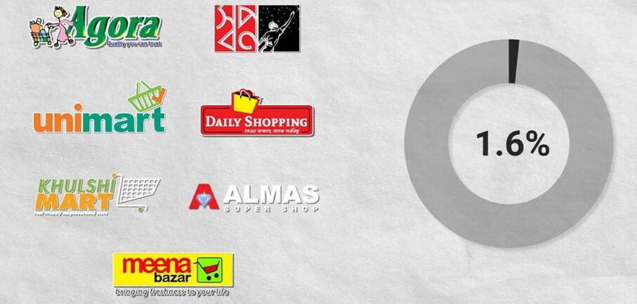
Figure 2.3: Industry Analysis

Gemcon Group’s ‘Meena Bazar’ operates 18 outlets in Dhaka, Chittagong and Sylhet, while Rahimafrooz’s ‘Agora’ has 18 outlets in different parts of the country. According to a report in the Daily Star in 2020, Gemcon and Rahimafrooz were in talks to acquire all of Agora’s outlets. United Group’s ‘Unimart’ operates 3 outlets in Gulshan, Dhanmondi and Wari in Dhaka and 2 Express outlets at United Hospital and United International University. On the other hand, PRAN RFL Group’s ‘Daily Shopping’ operates 51 outlets in Dhaka. There are also some smaller supershop chains in Dhaka, such as ‘Almas’ with 4 outlets and ‘Prince Bazar’ with 2 outlets. Most of the supershops are located in cities and urban areas, such as Dhaka, Chittagong, Narayanganj, Rajshahi and Sylhet.

According to TBS, the retail market in Bangladesh is worth about $16 billion in 2020. Of this, the superstore industry accounts for only 1.6% or about $256 million. This is less than in neighboring countries. For example, in Sri Lanka, superstores account for 43% of the retail market, compared to 8 9% in India and more than 50% in Myanmar and the Philippines in 2020. Although the superstore industry in Bangladesh is still small, it is set to grow rapidly. According to a January 2020 report by the Daily Star, the annual growth rate of the superstore industry is about 24% and according to TBS, at least 10% of Bangladesh’s retail sales will be through superstores in the next seven years.

2.2.2 Industry Size, Trends and Maturity
The retail market in Bangladesh is one of the largest and fastest growing sectors of the economy. It is a significant contributor to the country’s GDP and generates significant employment in both urban and rural areas.

1. Industry Size
The total size of the retail market in Bangladesh is estimated at US$ 80 billion (according to various studies), which is growing at an average rate of 8–10% per year. Although about 90% of this market is still operated by traditional retailers, the share of modern chain superstores is gradually increasing. The presence and popularity of modern superstore chains (such as Agora, Meena Bazar, Shwapno, Unimart, etc.) has increased significantly, especially in cities like Dhaka, Chittagong, Sylhet and Khulna.

2. Industry Trends
The changes and trends in the retail industry in Bangladesh are as follows:
- Rise of e commerce: Online shopping is now increasingly popular. Platforms like Daraz, Chaldal, Evaly (formerly) and Agora Online have brought about major changes in consumer behavior.
- Increased consumer awareness: Consumers are now more aware than ever about product quality, safety, shelf life and hygiene.
- Expanding middle class: Rising incomes and improving living standards have increased the purchasing power of the middle class, creating new opportunities for the modern retail market.
- Increased demand for healthy and organic products: Consumers are now turning to organic, chemical free and ecofriendly products.
- Technology driven management: Most modern retail organizations are using ERP, POS and data analytics to increase operational efficiency.
- Customer experiential marketing: Not just selling products, but also improving the customer experience is now a major area of ​​competition.

3. Industry Maturity
The retail industry in Bangladesh is now in the Growth to Maturity Stage. The modern superstore culture is already established in big cities, but it is still in its infancy in rural areas. As competition in the industry increases, businesses are now emphasizing brand loyalty, technology and customer relationships. At the same time, government food safety policies, product quality control and VAT management are making the industry more regulated and professional. All in all, the retail industry in Bangladesh is a fast growing, promising and maturing sector where Agora Limited is playing a pioneering role.

2.2.3 Industry SWOT Analysis
To understand the current status and future prospects of the retail industry in Bangladesh, an industry-based SWOT analysis is presented below:

Strengths
- As a country with a population of over 170 million, Bangladesh has a large and growing consumer base.
- Increasing income and improving living standards are increasing the interest of consumers in modern retail stores.
- Continuous economic growth (6–7%) has given a sustainable foundation to the retail market.
- Due to increasing urbanization and lack of time, people are now turning to “One Stop Superstores”.
- The use of modern accounting software, POS systems and e commerce platforms is making the industry more efficient.

Weaknesses
- Limitations in storage and transportation systems are a major challenge for the industry.
- Many establishments are struggling to remain profitable due to rising store rent, electricity and labor costs.
- Mismanagement by some establishments has created distrust among consumers, which is a challenge for the entire industry.
- There is a shortage of trained retail management personnel and experts.
- There is a lack of separate regulatory framework and government incentives for the retail industry.

Opportunities
- More than half of the country's population lives in rural areas where access to modern superstores is still limited.
- Retail establishments can expand their market by increasing the use of online platforms.
- Increasing health awareness has created growth potential in new product categories.
- Interest from international retail brands can strengthen the industry technologically and managerially.
- Digital Bangladesh and SME Development Projects can provide infrastructural support to the industry.

Threats
- Competition between local and foreign brands is increasing day by day.
- Increasing cost of living can reduce the purchasing power of buyers.
- Disruptions in transportation and supply chains can negatively impact sales.
- There is a risk of losing the market if you cannot keep up with the changing habits of online shoppers.
- New VAT tax structures or food safety laws can create obstacles in some business models.

CHAPTER THREE: GENERAL OPERATIONS OF AGORA LIMITED

3.1 Procurement and Inventory Management
3.2 Sales and Revenue Recognition
3.3 Payment and Cash Management
3.4 Cost Control and Expense Management
3.5 Internal Control and Audit Process
3.6 Use of Accounting Software and Systems

The general operations of Agora Limited are mainly managed through a well-organized management structure, where each step including purchasing, supply, inventory control, sales, revenue collection and financial reporting is completed under the prescribed policies and procedures. This chapter explains in detail two important aspects of the daily operations of the company procurement and inventory management and sales and revenue recognition.

3.1 Procurement and Inventory Management
Table 3.1: Procurement and Inventory Management
Year | Number of Suppliers | Total Inventory Value (BDT Crore) | Inventory Turnover (Times)
2019 | 350 | 150 | 6
2020 | 370 | 160 | 6.5
2021 | 380 | 175 | 7
2022 | 400 | 190 | 7.2
2023 | 420 | 210 | 7.5

Figure 3.1: Procurement and Inventory Management

The number of suppliers increased from 350 to 420 from 2019 to 2023, indicating the stability of the supply chain. An increase from 6 to 7.5, indicating improved inventory management efficiency and stock optimization. Stock levels have increased due to new private labels and outlet growth, but management is effective due to good turnover.

3.1.1 Brief description of procurement process
Agora Limited follows a well-organized procurement system for supplying its products. The company mainly procures products from three sources
- Local producers and farmers (fresh items such as vegetables, fruits, meat, fish),
- National level branded suppliers (consumer goods such as Nestlé, Unilever, Square, etc.) and
- Own production and Bakery department (e.g. cakes, bread, pastries, etc.).

The purchasing process is generally completed in the following steps:
- Determining product demand and creating requisition
- Collecting quotation from supplier
- Price and quality verification
- Product order approval (Purchase Order)
- Receiving and verifying goods (Goods Receiving Note)
- Bill verification and payment processing in the accounting department

This entire process is completed digitally through the ERP (Enterprise Resource Planning) system, so that every purchase related transaction can be recorded and tracked accurately.

3.1.2 Inventory Management
Inventory management is one of the most important activities of Agora Limited. Because, it is directly related to the availability, quality and sales activities of the product.
The main functions of inventory management are
- Stock Level Monitoring: The stock level of the product is determined on a “minimum–maximum” basis at each outlet, so that there is no shortage or excess stock.
- Following the FIFO method: Agora follows the “First In First Out (FIFO)” method in inventory management, so that old products are sold first and the risk of expiry is reduced.
- Product Receiving and Quality Control: All products received at the Distribution Center (DC) are verified for quality, weight and packaging.
- Stock Reconciliation: Physical stock reconciliation is done at the Head Office and outlet level every month.
- Damaged or Expired Product Management: Damaged products are recorded in the “Damage Register” and properly disposed of or returned.

3.1.3 Supply Chain and Logistics Support
Agora Limited operates its own Distribution Center (DC), where products are received from suppliers, stored and delivered to outlets. The logistics team regularly transports products as per the demand of the outlets and Cold Chain System is used to control the quality and temperature of the products (especially in the case of dairy products and frozen products).

3.1.4 Involvement in the Accounting Department
The Accounting Department verifies each purchase order and inventory transaction. Bill payment is approved along with the Purchase Order, Invoice and Goods Receiving Note. Thus, financial transparency is maintained in the purchasing process.

3.2 Sales and Revenue Recognition
Table 3.2: Sales and Revenue Recognition
Year | Total Sales (BDT Crore) | Revenue Recognition Method | Number of Outlets
2019 | 1,200 | Point of Sale (POS) | 20
2020 | 1,350 | POS + ERP | 25
2021 | 1,500 | POS + ERP | 28
2022 | 1,700 | ERP based | 32
2023 | 1,900 | ERP based | 35

Figure 3.2: Sales and Revenue Recognition

Migration from POS to ERP system, which has enabled more accurate and real time revenue reporting. Revenue is also increasing with the growth of outlets, which proves the success of market expansion. ERP and digitalization have made the revenue recognition process transparent and fast.

3.2.1 Summary of Sales Activities
Agora Limited's sales activities are mainly conducted through two channels:
- Outlet Sales (In store Sales)
- Online Sales (Agora Online Platform)
Sales transactions are completed through the POS (Point of Sale) system at each outlet. Daily sales data is automatically transferred to the ERP system of the Head Office, where the Accounting Department completes Revenue Recognition.

3.2.2 Steps in the Sales Process
The sales process is generally completed in the following steps:
- Customer selects the product.
- Product barcode is scanned and entered into the POS system.
- Payment is accepted through cash, card or mobile banking.
- Invoice is issued.
- Sales data is recorded in the daily sales report.
At the end of each day's sales, the "Daily Sales Summary" is sent to the Head Office and the Accounting Department verifies it and updates the revenue account.

3.2.3 Revenue Recognition Policy
Agora Limited follows the revenue recognition policy as per International Accounting Standards (IAS 18 / IFRS 15). That is, revenue is recognized only when
- The sale is completed,
- Ownership is transferred to the customer and
- Payment is confirmed.

3.2.4 Sales Promotion and Discount Policy
Agora Limited regularly runs promotional offers, loyalty points and festival discounts to attract customers. The amount of this discount is recorded in the “Sales Discount Account” and reconciled by the Accounts Department at the end of the month.

3.2.5 Use of Sales Reports
Head Office analyzes daily and monthly sales reports to assess sales trends, popular products and outlet performance. This information helps in future budgeting and product planning.

3.3 Payment and Cash Management
A major part of Agora Limited’s financial operations is payment and cash management. It is essential for the smooth running of the organization’s daily operations.

Table 3.3: Payment and Cash Management
Year | Total Cash Transactions (BDT Crore) | Bank Transfer (%) | Petty Cash (%)
2019 | 400 | 70 | 30
2020 | 450 | 75 | 25
2021 | 500 | 78 | 22
2022 | 550 | 80 | 20
2023 | 600 | 85 | 15

Figure 3.3: Payment and Cash Management

Increased use of bank transfers over cash transactions, indicating the development of digital payments. The use of petty cash has decreased, which has reduced the risk of errors and fraud. Digital payments and ERP integration have made the payment process faster and more secure.

3.3.1 Payment Process
Supplier Payment: Payment is made to the supplier for all purchase transactions after verification of Purchase Invoice and Goods Receiving Note. Payment is made through bank transfer (T/T), cheque, or using online banking. Every payment is recorded in the ERP system, which is monitored by the accounting department.

Salaries and Other Expenses: Employees’ salaries are paid through bank transfer on a monthly basis. Daily expenses of the office and outlets such as electricity, water, internet, etc. are also paid regularly.

Cash Transaction: Cash collected from cash sales at the outlets is deposited in the Head Office every day. Every cash transaction is recorded in the POS and Cash Book.

3.3.2 Cash Management
Agora Limited follows the following policies to ensure efficient management of cash funds:
- Cash Limit: A daily cash transaction limit is set at each outlet.
- Cash Collection and Security: The delivery team and security team collect cash regularly and deposit it safely at the Head Office.
- Cash Flow Monitoring: The accounts department regularly monitors the cash flow so that liquidity is maintained.
- Audit and Verification: Cash audits are conducted on a monthly or quarterly basis. Any errors or irregularities are resolved promptly.

Thus, Agora Limited's cash management helps the organization maintain liquidity, run operational activities and ensure financial transparency.

3.4 Cost Control and Expense Management
Cost control is very important to ensure the profitability and performance of the organization (Christensen, 2022). Agora Limited ensures financial efficiency by monitoring and controlling the expenses of various sectors.

Table 3.4: Cost Control and Expense Management
Year | Total Expenses (BDT Crore) | Major Expense Head | Cost Reduction (%)
2019 | 1,100 | Procurement
2020 | 1,180 | Logistics | 3
2021 | 1,250 | Payroll | 4
2022 | 1,330 | Marketing | 5
2023 | 1,400 | Utilities | 6

Total expenses have increased but expenses have been reduced in certain departments. Cost control is effective especially in logistics, marketing and utilities. Cost control and budget audit have played an important role in increasing the profitability of the organization.

3.4.1 Cost Classification
Agora Limited’s expenses are generally divided into the following main categories: Cost of purchasing, transportation and supply of products. Operating expenses of outlets and Head Office such as salaries, electricity, water, maintenance. Advertising, promotional offers, discounts, etc. Daily cash usage such as petty cash, stationery and incidental expenses.

3.4.2 Cost Control Methods
- Budget Setting: Annual and monthly budgets are prepared for each department.
- Variance Analysis: The accounting department analyzes the difference between actual expenses and budget.
- Reduction of unnecessary expenses: Unnecessary or excessive expenses are identified and reduced.
- Approval Process: Any major expense or purchase is made through a prior approval process.

3.4.3 Cost Monitoring and Reporting
Cost reports are prepared on a monthly basis, which are reviewed by the Head Office management. Cost decisions are made based on Cost Benefit Analysis and Historical Data. By controlling costs, the organization is able to increase profit margins.

3.5 Internal Control and Audit Process
Internal Control System is very important to ensure the financial stability and transparency of Agora Limited. It is helpful in preventing errors, irregularities or fraud (Bubilek, 2017).

Table 3.5: Internal Controls and Audit Processes
Internal Audit Frequency | Key Control Measures | Major Findings | Actions Taken
Annual | Segregation of duties | Minor errors | Corrective actions
Semi annual | Approval limits | Low compliance in some outlets | Staff training
Quarterly | Inventory checks | Stock mismatch | Improved ERP integration
Quarterly | Authorization controls | Payment delays | Streamlined workflow
Quarterly | Audit trail & reporting | No major issues | Standardized processes

The audit process has been shifted from annual to quarterly from 2019 to 2023, which has increased the strength of controls. Stock matching issues and payment delays have been appropriately addressed. Internal controls and audit processes are ensuring the financial stability and accountability of the company (Hasan & Chakraborty, 2011; Hasan, Molla, & Khan, 2019).

3.5.1 Main Elements of Internal Control
Purchases, payments, expenses and major transactions are always done with the approval of higher officials or management. The same person cannot simultaneously handle purchases, cash management and account maintenance (Hasan et al., 2019; Hasan & Rahman, 2020). For example, the responsibility of approving payments and issuing checks is handled by a different person. All transactions are recorded through appropriate documents such as Invoice, Purchase Order, Goods Receiving Note etc. Locks, security systems and specific departments are used for the safety of cash, stock and valuable equipment.

3.5.2 Internal Audit
Internal audit is conducted on monthly or quarterly basis at both Head Office and outlets. To ensure cost control, transparency of cash transactions, inventory management and accuracy of accounts. After the audit, the report is submitted to the management and necessary corrective actions are taken.(Hasan & Chakraborty, 2011; Hasan et al., 2019) Risks in transactions and financial processes are identified. After the audit report, necessary policy changes, control tightening and training are provided. Thus, internal control and audit process helps the organization to maintain financial stability and transparency.

3.6 Use of Accounting Software and Systems
Agora Limited's financial operations are managed using ERP (Enterprise Resource Planning) and accounting software, which ensures fast, accurate and transparent accounting for the organization (Ashif, Mahmud, & Hasan, 2013).

Table 3.6: Use of Accounting Software & Systems
Software/System | Purpose | Key Benefit | Observation
POS System | Sales recording | Accurate daily data | Manual ERP integration
ERP System | Inventory & Finance | Real time tracking | Integration with POS
Payroll Software | Employee salary | Reduced manual errors | Timely salary payment
Reporting Tools | Financial dashboards | Faster reporting | KPI monitoring
Full ERP Suite | End to end accounting | High efficiency | All departments integrated

Decision making is fast and accurate as all financial and operational data is integrated into ERP. Sales information is available instantly due to the use of POS. Payroll software is helping in paying salaries to workers on time. The use of software has reduced manpower costs, automated processes and improved reporting.

3.6.1 Software and Systems Used
Manages all purchase, sales, payment, inventory and human resource information in an integrated manner. Records daily sales transactions at the outlet in real time. Makes revenue, expense, cash and financial reporting easy and automatic.

3.6.2 System Benefits
- Accurate accounting: Reduces human errors through automated transaction entry.
- Quick access to information: The accounting department can easily generate various types of reports, such as sales, cash flow, cost analysis, monthly profit and loss.
- Data security: Data backup and security are ensured using ERP and accounting software.
- Real time Monitoring: Instant monitoring of transactions from Head Office to outlet level is possible.

3.6.3 Reporting and Analysis
Through the use of software, management can easily analyze budget vs actual expenditure, product demand, popular products and outlet performance. The accounting department helps management in taking important decisions.

CHAPTER FOUR: INTERNSHIP EXPERIENCE

4.1 Position, Roles and Responsibilities
4.2 Training and Development
4.3 Contribution to the Organization / Management
4.4 Evaluation
4.5 Applicable / Transferable Skills

This chapter details personal internship experience, responsibilities, training and professional skill development. This is the most personal and important part of the report, reflecting the knowledge learned and acquired during the internship.

4.1 Position, Roles and Responsibilities
As an intern, my position was “Accounting Intern” and my main responsibilities were:
- Recording daily sales, cash collection, payments and inventory transactions.
- Ensuring correct entry of transactions in the ERP system.
- Verifying Purchase Order, Invoice and Goods Receiving Note.
- Preparing documentation in the accounting department for payment approval.
- Monitoring stock levels in the Distribution Center and outlets.
- Record and report on spoiled or expired products.
- Collect cash from outlets and record it accurately.
- Prepare daily sales and cash reports and submit to Head Office.
- Prepare balance sheets, budget analysis and other financial documents.
- Assist in internal control and audit processes.

By performing these responsibilities, I as an intern became familiar with the company's accounting operations and financial processes.

4.2 Training and Development
During the internship, I got the opportunity to acquire various training and skills. The main topics are:
- Learned to use ERP and POS systems.
- Daily transaction entry, reporting and analysis skills have increased.
- Learning the importance of internal control and risk management.
- Gaining practical ideas for cost control and cost reduction.
- Time management, teamwork, communication and office ethics.
- Experience in coordinating and supporting officers and colleagues at different levels of the accounting department.
- Applying academic knowledge to real world official processes.
- Familiarity with real time accounting, stock, cash and sales processes.

4.3 Contribution to the Organization / Management
My activities during the internship have directly or indirectly contributed to the general operations and management of Agora Limited. The main contributions are:
- Increased transparency in the accounting department by accurately recording daily sales, payments and cash transactions.
- Assisted in controlling stock at outlets and Distribution Centers by monitoring and reporting on stock levels.
- Assisted in controlling costs and expenses, which made it easier to analyze budget vs actual costs.
- Assisted in reducing risks and facilitating regular audit activities by assisting in internal control and audit processes.
- Assisted in preparing reports for the accounting department, which helped the management in taking quick decisions.
Thus, my activities during the internship have helped in keeping the organization efficient and financially sound.

4.4 Evaluation
The internship experience is evaluated both personally and professionally:
- Opportunity to apply theoretical knowledge from the university in a real office environment.
- Experience in understanding various accounting functions, control systems and audit processes.
- Increased time management, teamwork and communication skills.
- Familiarity with new software and internal processes was sometimes challenging.
- Problems were resolved through regular reviews and peer support.
The internship was a successful and learning experience, which increased both professional skills and practical knowledge.

4.5 Applicable / Transferable Skills
The skills acquired during the internship are applicable to any professional work in the future. The main skills are:
- Transaction records, budget vs. actual cost analysis, inventory monitoring.
- Use of ERP, POS and accounting software.
- Experience in automated processes in reporting and data analysis.
- Complete transactions within a specified time.
- Work in coordination with multiple responsibilities.
- Effective coordination with colleagues and management.
- Increase teamwork skills through reports and information sharing.
- Identify problems and apply solutions in real life office situations.

In short, this internship gave me the opportunity to gain professional skills, use of software, understand accounting procedures and gain practical experience, which is extremely valuable in my future career.

CHAPTER FIVE: CONCLUSION AND KEY FINDINGS

5.1 Findings
5.2 Recommendations
5.3 Key Learnings
5.4 Conclusion

5.1 Findings
The results achieved through the internship at Agora Limited are as follows:
- Practical experience in daily transactions, sales, purchases, cash collection and payment processes.
- Familiarity with entry, reporting and audit processes in the accounting department.
- Detailed knowledge of internal control systems and audit processes.
- Understanding the process of identifying risks and taking corrective action through regular audits.
- Monitoring and reporting of stock at outlets and distribution centers.
- Supporting role in stock control and reducing the risk of inventory depletion or loss.
- Understand the importance of budget vs. actual cost analysis and cost control.
- Learn how to reduce costs and ensure the financial sustainability of the organization.
- Generate quick and accurate reports using ERP, POS and other accounting software.
- Acquire practical skills in software for data analysis and decision making.
- Gain practical experience in time management, teamwork, communication and official discipline.
- Enhance skills in problem solving, decision making and professional behavior.

5.2 Recommendations
Based on the internship experience and observations, the following recommendations are made to make Agora Limited’s operations more efficient and transparent:
- Regular internal training and updating of control processes.
- Stricter adherence to segregation of duties, so as to reduce risks and irregularities.
- Use of new modules or updated software in ERP and POS systems.
- Save time and effort by automating data analysis and reporting.
- Reduce costs through regular stock checks and reduction of unnecessary stocks.
- Use of more modern technology in inventory control, such as real time scanners.
- Regular and practical training for new hires and interns.
- Enhance skills in software use, financial analysis and internal control.
- Regular budget analysis to reduce costs and increase the profitability of the organization.
- Monitoring of small expenses at the outlet level and planning for cost reduction.
- Regularly sharing internal audit reports and results of activities with management.
- Quickly implementing necessary changes based on audit results.
- Effectively involving interns in new ideas, problem solving and improvement of activities.
- Increasing creativity of the organization along with gaining professional experience.

5.3 Key Learnings
The key learnings gained from the internship experience at Agora Limited are as follows:
- Opportunity to apply academic knowledge to real official accounting activities.
- Practical understanding of daily transactions, sales, payments, stock and budgeting processes.
- Importance of control systems and audit processes in the company.
- Understanding of risk identification, reporting and corrective action processes.
- Use of ERP, POS and other accounting software.
- Enhanced data analysis, reporting and decision making skills.
- Time management, teamwork, communication and official discipline habits.
- Practical experience in problem solving, decision making and professional behavior.
- Insight into accounting department operations, budgeting, cost control and stock management.
- Understanding how different departments work together for the proper functioning of the organization.
- Increased confidence to work in a real office environment.
- Understanding of professional ethics, sense of responsibility and the value of collaboration.

In short, this internship not only gave me the opportunity to understand the functioning of the accounting department, but also provided me with important lessons in professional skills, software usage, practical experience and work culture.

5.4 Conclusion
The internship experience at Agora Limited was a very educational and fruitful time for me. This experience not only gave me an opportunity to understand the operations of the accounting department, but also enhanced my professional skills, software usage, time management and teamwork skills. The main conclusions of the internship are Familiarity with the daily operations of sales, purchasing, cash management, stock and budgeting. Participation in regular reporting and internal control processes of the accounting department. Improved time management, communication and problem-solving skills by working in an official environment. Understanding the importance of professional ethics and sense of responsibility. Use of ERP, POS and other accounting software and data analysis. Gaining practical knowledge of software in reporting, decision making and cost control. Understanding the importance of accounting department activities, budget, stock and internal control to contribute to the organization's operations. Overall, this internship has given me the opportunity to combine my academic knowledge with real official experience. It has made my professional life more organized and confident. The skills and experience gained through the internship will be very helpful in any professional work in the future.

References
Ashif, A. S. M., Mahmud, M. T., & Hasan, M. T. (2013). AIS Requirement and Capacity, an Understanding of AIS Alignment: Evidence from Bangladesh. International Journal of Applied Research in Business Administration and Economics, 2(6), 22-31.
Bubilek, O. (2017). Importance of internal audit and internal control in an organization-case
study.
Christensen, L. (2022). Internal audit: A case study of impact and quality of an internal control
audit. International Journal of Auditing, 26(3), 339-353.
Hasan, M. T., & Chakraborty, M. (2011). Evaluation of Auditors' Compliance with ISAs: Evidence of Bangladesh. hypothesis, 21.
Hasan, M. T., Molla, M. S., & Khan, F. (2019). Effect of Board and Audit Committee Characteristics on Profitability: Evidence from Pharmaceutical and Chemical Industries in Bangladesh. Finance & Economics Review, 1(1), 64-76.
Hasan, M. T., & Rahman, A. A. (2020). The Role of Corporate Governance on the Relationship Between IFRS Adoption and Earnings Management: Evidence From Bangladesh. International Journal of Financial Research, 11(4).

Online Sources:
- Agora Superstores. About Us. https://agorasuperstores.com/
- Agora Limited Annual Report, 2024. (Head Office Publication)
- Horngren, Charles T., Sundem, Gary L., Elliott, John A. Introduction to Financial Accounting. 11th Edition, Pearson Education, 2019.
- Bhattacharyya, Asish K. Financial Accounting for Business Managers. 5th Edition, Prentice Hall, 2018.
- Khan, M.Y. & Jain, P.K. Management Accounting. 6th Edition, McGraw Hill, 2020.
- Online Resources on Inventory and Cash Management, Investopedia. https://www.investopedia.com
- Internship Handbook, Department of Accounting, United International University, 2025.

