







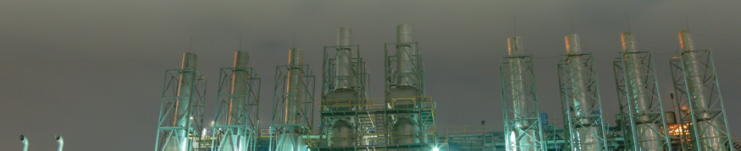

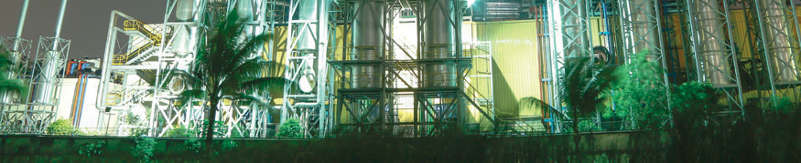






UNITED POWER GENERATION &
DISTRIBUTION CO. LTD.


Internship Report on
Operating Performance of
united power generation & distribution COMPANY
LIMITED during covid-19

Supervised by
Dr. Mofijul Hoq Masum
Associate Professor
School of Business and Economics

Submitted by
Afrida Anwara Palki
ID: 111 183 067
Bachelor of Business Administration (BBA)
Date of Submission: 28th March 2022

Acknowledgment
I wanted to start by expressing to god my sincere thanks for granting me the courage and composure to finish the task in the allotted time. For my study, I used resources from a variety of sources that dealt specifically with project assessment and implementation. Numerous authors whose ideas and contributions to this report have influenced my thought are expected to owe me a tremendous intellectual debt.
My supervisor, Dr. Md. Mofijul Hoq Masum, Associate Professor, School of Business & Economics, United International University, has provided me with all the advice and support I needed, and I would like to sincerely thank him for that. His sincere, persistent, helpful, and invaluable counsel and encouragement to write original reports enabled me to address all the issues that came up while I was studying and to successfully finish the United Group internship program.
The theoretical information acquired in educational institutions is thought to be validated by practical experience in the field. I was chosen to begin my internship at United Group in order to finish the comparison of the two. It felt like the fulfillment of a long-cherished dream. Furthermore, I want to give a special thanks to the people of the finance & accounts department, United group who helped me with the preparation of this study by giving me important information.
Finally, I wish to thank my parents and friends who have supported and encouraged me throughout my study. Despite my best efforts, the report might contain some errors. I apologize for any errors that were not intentional.

Letter of Transmittal
28th March 2023
Dr. Mofijul Hoq Masum
Associate Professor
School of Business & Economics
United International University
Dhaka, Bangladesh.

Subject: Submission of Internship Report on “Operating performance of UPGD during
Covid-19”

Sir,
I am Afrida Anwara Palki bearing ID number: 111183067 at United International University. I am delighted to inform you that I have completed an internship report on the operating performance of UPGD (United Power Generation & Distribution) during the Covid-19 pandemic. Throughout my internship at United Group, I made an effort to gather all the relevant data and information from various sources. I believe that this report is comprehensive and will prove to be beneficial. The report provides an overview of the financial performance of United Power Generation & Distribution.

Although there may have been some challenges due to time constraints and other reasons, I have made every effort to ensure that the report is accurate and includes relevant data from all available sources. It would be kind enough if you accept my report.

Sincerely
Afrida Anwara Palki
Id: 111 183 067

Declaration
I, Afrida Anwara Palki, declare that the internship report mentioned "Operating performance of UPGD during Covid-19" was entirely formed by me following the fulfillment of my 4 months internship at United Group, which is situated in Madani Avenue.

I further declare that this report was prepared only to meet my academic obligation and not for any other reason. Any errors discovered should be disregarded because they were not done on purpose.

Afrida Anwara Palki
ID: 111 183 067
BBA
School of Business & Economics
United International University

Contents
Acknowledgment iii
Letter of Transmittal iv
Declaration v
Abstract viii
List of Acronyms ix
CHAPTER 1 1
INTRODUCTION 1
1.1 Introduction of the Study 2
1.2 A Brief Introduction of the Organization 3
1.3 The Objective of the Study 3
1.4 Rational of the Study 4
1.5 Scope of the Study 4
1.6 Limitations of the Study 5
6
CHAPTER 2 6
METHODOLOGY OF THE STUDY 6
2.1 Data Design 7
2.1.1 Primary Source 7
2.1.2 Secondary Source 7
2.2 Sample Design 8
2.3 Analytical Tool 8
CHAPTER 3 9
ORGANIZATIONAL BACKGROUND & INDUSTRY PERSPECTIVE 9
3.1 Industry Scenario 10
3.1.1 Background of Industry 13
3.1.2 Contribution in Economy 16
3.1.3 Scope 17
3.2 Historical Background of Organization 18
3.2.1 Vision 19
3.2.2 Mission 19
3.2.3 Management and Focus 20
3.3 Operational Activities of UPGDCL 21
3.3.1 Subsidiaries of UPGDCL 22
3.3.2 Financial Performances 23
3.4 SWOT Analysis 24
26
CHAPTER 4 26
FINDINGS AND ANALYSIS OF THE STUDY 26
4.1 Summary of Financial Statement 28
4.2 Ratio Analysis 29
4.2.1 Liquidity Ratio 32
4.2.2 Profitability Ratio 33
4.2.3 Activity Ratio 36
4.2.4 Debt Ratio 38
4.2.5 Market Ratio 39
4.3 Common Size Analysis 42
4.3.1 Horizontal Analysis 42
4.3.2 Vertical Analysis 44
CHAPTER 5 46
CONCLUSION AND 46
RECOMMENDATIONS 46
Conclusion 47
Recommendations 48
INTERNSHIP EXPERIENCE AT “UNITED GROUP” 49
APPENDIX 50
References 50

Abstract
This report assesses United Power Generation & Distribution Ltd.'s operational performance. A wide range of financial ratios was examined to assess United Power Generation & Distribution's (UPGD) performance throughout the trying COVID-19 year, combined with non-financial performance indicators, to give a thorough picture of the business' overall performance throughout the pandemic. It is crucial to remember that this analysis had both a scope and certain restrictions. The results and perceptions of numerous researchers who have thoroughly investigated this subject are included in the literature review. A variation of financial and non-financial key performance indicators (KPIs) is shown in the analytical section of the report using well-interpreted graphs and charts. Finally, the report concludes with recommendations on remedial estimates that the company can implement to improve its performance.

Keywords: Financial operation, financial performances, UPGD, United Group, Covid-19, Pandemic.

List of Acronyms
Acronym | Word
BBA | Bachelor of Business Administration
SoBE | School of Business & Economics
UG | United Group
UPGD | United Power Generation & Distribution
F&A | Finance & Accounts
FA | Financial Analysis
GPM | Gross Profit Margin
ROA | Return On Asset
GL | General Ledger
EBIT | Earnings Before Interest and Taxes

Table: 1

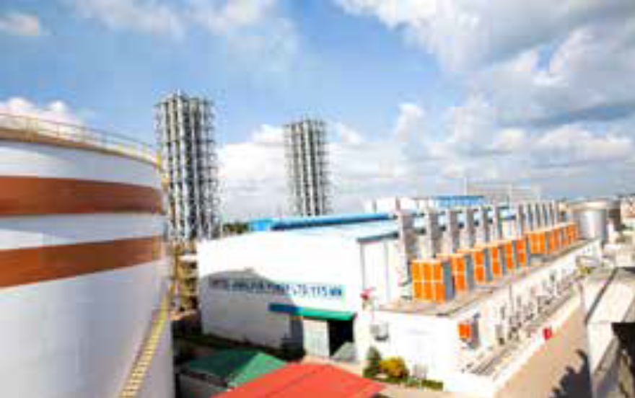

CHAPTER 1

INTRODUCTION

INTRODUCTION

Introduction of the Study
This report is prepared for the fulfillment of completing all credits under the (Bachelor of Business Administration) BBA program of United International University. The topic of the report is the “Operating performance of United Power Generation & Distribution Co. Ltd during COVID-19”. This report is being assigned by the honorable faculty “Md Mofijul Hoq Masum” Associate Professor of the Department of Business Administration, United International University.
A company’s operating performance is measured in terms of how effectively it uses its resources. Assets and equity sources can be used to quantify it. We know that COVID started in December 2019 in China and spread all over the world. Every country declared a lockdown to control the situation so; Bangladesh also declared it on March 2020. All types of production, export-import, and everything collapsed for a while; it had a great impact on the power sector of Bangladesh also. During those time period, all types of business sector's performances got down rapidly. Here, I have analyzed the pre and post-COVID-19 impact on the operating performance of UPGD.
This report provides students with the opportunity to apply their academic learning to practice and gain practical experience. Through the report, students can gain an understanding of the current business environment and utilize various analytical techniques to solve business problems. The competitive nature of the educational environment of the world, particularly in Bangladesh, is unquestionably true. Numerous crucial conditions are produced by the global market as it is today. Merely possessing theoretical knowledge is inadequate for solving or identifying such problems. Consequently, an individual or student can't engage in operations or hold a job in a fiercely competitive business world without practical knowledge of the current organizational landscape.

A Brief Introduction of the Organization
As an intern at United Group, I have focused on the power generation sector and conducted research for this report. United Group is a major industrial conglomerate in Bangladesh, with operations spanning various sectors.
United Power Generation & Distribution Company Limited (UPGD) is a prominent power generation and distribution company based in Bangladesh. It was established in 1997 and has been listed on the Dhaka and Chittagong stock exchanges since 2005. UPGD is a subsidiary of United Group, a diversified business group operating in various sectors in Bangladesh.
The company owns and operates two power plants. The first one is located in the Dhaka Export Processing Zone (DEPZ), with a total capacity of 57.5 MW. This plant supplies electricity to both the DEPZ and the national grid. The second power plant is located in the Narsingdi district, with a total capacity of 200 MW, and supplies electricity to the national grid.
Apart from power generation, UPGD also has a distribution license for the Dhaka North area and is responsible for distributing electricity to over 2.5 million customers. The company is committed to providing reliable and uninterrupted power supply to its customers and has implemented modern technologies and management practices to ensure efficient and sustainable power generation and distribution.
UPGD has received several awards for its outstanding performance in the power sector, including the "Best Power Generation Company" award at the Bangladesh Business Awards in 2020. The company's success is attributed to its dedicated workforce, innovative approach, and commitment to excellence in all aspects of its operations.

The Objective of the Study
    - Broad Objective
- To analyze and evaluate the corporate performance of the Company during Covid-19.
- To meet the academic requirements for the BBA program and obtain the BBA program certification.
- To know the type of financial statement system proceeded by united group.
    - Specific Objective
- To describe the function in Accounts and finance, the procedures, the organization, and the laws and regulations.
- To find out key details about the FA system and the audit's internal and external environments about United Group.
- To find out the scope and limitations of FA in the United Group.
- To conduct a comprehensive analysis of the financial ratios and financial performance of the company.
- To identify the challenges faced by the company during the COVID-19 pandemic and analyze its impact on the business.
- To examine the measures and strategies adopted by the company to overcome the challenges and sustain its operations during the pandemic.
- To provide an overall assessment of the company's standing position during the pandemic, taking into account both financial and non-financial performance indicators.

Rational of the Study
The fundamental reason for this study is to discuss the Operating performance of United Power Generation & Distribution Company Ltd. Research tactics use a variety of ways to eventually dissect data on a given subject. The information obtained during the process may come from primary or secondary sources, and the final analysis may be qualitative or quantitative. I used primary and secondary sources to compile the data for this report. Discussions include the Operating Performances & Analysis that identifies, improves, and controls various functions and resulting outcomes of United Power Generation & Distribution during Covid-19.

Scope of the Study
In this report, the financial operations of UPGD & analysis will be presented to get practical experience working at United Group, which aids in Operating performance & Analysis. Through conducting a performance evaluation during my internship, I had the opportunity to see how they maintain their account and finance department. This observation aids in my quest to learn a wide range of information and gain real-world experience.

Limitations of the Study
There are some limitations of the study which I faced during preparing this report.
- As the accounts and finance department is so extensive, it was challenging to cover all the information during the 4 months of my internship period.
- The subject matter is broad in scope; so I work very hard and put much effort into the study still certain limitations are available there.
- Many of the records were not permitted to be shared because of confidential issues.
- For performance analysis, secondary data have been used.
- The department provided me with some information but it is insufficient.
- Non-financial data could not study properly because of the company’s privacy and secrecy.



CHAPTER 2

METHODOLOGY OF THE STUDY

2.1 Data Design
Primary data and secondary data are two different types of data. The first-hand information is what the researcher gathers. Examples of primary data include in-person interviews, statistics, artwork, surveys, observations, experiments, etc. Secondary data are those that have been obtained by others. Secondary data examples include reports and statements, journal articles, print media, books, newspapers, websites, etc. Websites, publications, and statements are used in this study as secondary data, while in-person interviews and statistical data are the study's primary sources of information.
Data collection from primary or secondary sources may be used, and the final analysis may be qualitative or quantitative. In order to get the information for the research, I combined primary and secondary sources. I spoke with employees and managers who were knowledgeable about the company to gather the primary sources of information. I also gathered secondary sources of information from the United Power Generation and Distribution (UPGD) official website, company annual reports, audit reports, newspapers, etc.
This report is being created to provide a general overview of United Power Generation and Distribution under United Group’s operations, divisions, and roles. So, here are the points-

2.1.1 Primary Source
- Direct conversation with the department's officers.
- Close communication with my supervisor.
- Direct communication with my colleagues and employees of United Group.
- Operational activities are closely inspected.

2.1.2 Secondary Source
- Annual report of United Power Generation and Distribution (UPGD).
- Collected from the official website of United Group Ltd.
- Various newsletters of United Group Ltd.
- Audit reports of United Power Generation and Distribution (UPGD).
- The previous financial condition of the company.

2.2 Sample Design
Various significant financial records from United Power Generation and Distribution (UPGD) for the four years (2019-2022) are used as the sample for the analysis. The 12 relevance of accounting data is taken with the specific quantities for the four years (2019-2022), comprising the assets, liabilities, operational profit, and ratios of UPGD.

2.3 Analytical Tool
The most pertinent financial information for the United Power Generation and Distribution (UPGD) for the last four years (2019-2022) is presented in this report's analysis & results section in the form of a table with specific values. The financial information for each year (from 2019 to 2022) is shown in the table. The sums of each financial data item are then calculated independently for each year (from 2019 through 2022) and shown in the table. The scatter plot then displays each financial data point over the subsequent four years with the specific amounts.
For this report, financial ratio analysis formulas will be used as the primary tool for analysis and discussion. Microsoft Word and Microsoft Excel will be used to create the report, and pie charts and bar graphs will be created using Microsoft Excel.



CHAPTER 3

ORGANIZATIONAL BACKGROUND & INDUSTRY PERSPECTIVE

ORGANIZATIONAL BACKGROUND & INDUSTRY PERSPECTIVE

3.1 Industry Scenario

United Power Generation & Distribution Company Limited (UPGDCL) is a company that was previously known as Malancha Holdings Limited (MHL) and was established on January 15, 2007, as a private limited company. From Malancha Holdings Limited, the Company's name was changed to October 1st, 2009, United Power Generation & Distribution Company Ltd. On December 22, 2010, UPGDCL was subsequently transformed into a public limited company.
The company's first power plant, which is located in the Dhaka Export Processing Zone, was where it began conducting business on December 26, 2008. (DEPZ). The second power plant was later installed to increase production capacity, and it began operating commercially on August 12, 2009, at the Chittagong Export Processing Zone (CEPZ). As a result, starting in December 2013, UPGDCL has raised its production capacity from 85 MW to 154 MW.
Exhaust gas boilers (EGB) are used by UPGD to provide steam for nearby companies in DEPZ and CEPZ in addition to producing electricity, further increasing the efficiency of the power plant. The current steam production capacities for UPGD DEPZ and UPGD CEPZ are 8 TPH and 12 TPH, respectively.

UPGDCL holdings comprise the following –
Company | Name of the Plant | Installed Capacity (MW) |  | Ownership of UPGDCL | Commercial Operation Date (COD) |  | Contract Expiry
GAS BASED: 480 MW
United Power Generation & Distribution Co Ltd. | DEPZ Plant | 82 |  |  |  | 26th Dec, 2008 | Year 2038
United Power Generation & Distribution Co Ltd. | CEPZ Plant | 72 |  |  |  | 12th Aug, 2009 | Year 2039
United Energy Ltd. | Ashuganj plant | 53 | 99% owned |  |  | 22ndJune, 2011 | 22 June 2019 (extension under renovation)
United Energy Ltd. | Sylhet plant | 28 |  |  |  | 21st Oct, 2013 | Year 2043
United Ashuganj Energy Ltd. | Ashuganj plant | 195 | 92.41% owned by UEL |  |  | 8th May, 2015 | Year 2030
Leviathan Global BD Ltd. | KEPZ plant | 50 | 75% owned |  |  | Expected soon | Year 2048
HFO BASED: 415 MW
United Jamalpur Power Ltd. | Jamalpur plant | 115 | 99% owned |  | 22nd June, 2019 |  | Year 2034
United Anwara Power Ltd. | Anwara plant | 300 | 99% owned |  | 21st Feb, 2019 |  | Year 2034

Table: 2

Today UPGDCL owns and manages 08 power plants dispersed across the nation with a total installed capacity of 895 MW, or roughly 4.08% of the nation's total installed capacity and 9.44% of the nation's total private power generation.
The establishment of a long-term, sustainable framework that aids in the eradication of poverty is the most essential contribution that electricity offers to economic progress. For long-term, sustainable economic growth, there must be access to power at a fair price and in accordance with environmental standards.

The Bangladeshi government has created a thorough power-generating strategy to guarantee the expansion of the power sector over the long term as well as the general growth of the national economy. The total installed electricity generation capacity for FY 2021–22 (from January 2022 to February 2022) was 22,066 MW, or 25,284 MW when captive and renewable energy sources were included. The government announced that all citizens got access to energy in March 2022.
Individual energy consumption has increased to 560 kWh. A total of 4.19 billion users and 6.19 lakh kilometers have been added to the electrical distribution network, respectively.

Energy Generation (National) by Fuel |  | Energy Generation (National) by Sector
Natural Gas | 66.44% | Public | 40.02%
Hydro | 1.14% | Private | 47.39%
Power Import | 8.50% | JV | 4.10%
Renewable Energy | 0.29% | Power Import | 8.50%
Coal  Liquid Fuel | 5.31%  24.33% | Total Net Generation: 42,395 kwh
Total Net Generation: 42,395 kwh







Table: 3
ENERGY GENERATION BY SECTOR

8.50
4.10
Power Import (%) JV (%)
Private (% )
Public (%)
40.02
47.39
Energy Generation by Fuel
24.33
5.31

0.29
8.50
Liquid Fuel (%) Coal (%)
Renewable Energy (%) Power Import (%) Hydro (%)
Natural Gas (%)
1.14
66.44

Figure: 1 Figure: 2
In FY 2021–22 (till January 2022), the grid-based installed capability was 22066 MW, of which 1,244 MW came from joint ventures, 9,481 MW from the private sector, 9,996 MW from the governmental sector, and 1160 MW from power imported from India.

3.1.1 Background of Industry

United Power Generation & Distribution Company Limited (UPGD) is a Bangladesh-based power generation and distribution company that was established in 1997. It is a subsidiary of United Group, a diversified business conglomerate that operates in various sectors such as energy, telecommunications, and real estate.
UPGD has emerged as a major performer in the power sector of Bangladesh, a country with a growing demand for electricity due to its expanding economy and population. The company's initial focus was on power generation, and it built its first power plant in the Dhaka Export Processing Zone in 1999, with a capability of 57.5 MW. In 2012, the company expanded its generation capacity by building a second power plant in the Narsingdi district, with a capacity of 200 MW.
In addition to power generation, UPGD also obtained a distribution license for the Dhaka North area in 2011. The license allowed the company to distribute electricity to more than 2.5 million customers in the area. UPGD has been investing in modern technologies and management practices to ensure efficient and sustainable power generation and distribution.
UPGD's success can be attributed to its commitment to providing reliable and uninterrupted power supply to its customers, adopting innovative approaches, and investing in the professional development of its workforce. The company has received several awards for its performance, including the "Best Power Generation Company" award at the Bangladesh Business Awards in 2020.
In summary, UPGD has grown to become a leading player in the power sector of Bangladesh, with a focus on power generation and distribution. The company's success is rooted in its commitment to excellence, innovation, and sustainable business practices.

The list of concern companies of United Group is given below-
Power Generation
- United Power Generation & Distribution Company Limited
Manufacturing
- United Lube Oil Limited
- United Engineering & Power Services Limited
- United Polymers Limited
- United Sulpho-Chemicals Limited
- Comilla Spinning Mills Limited
- Gunze United Limited
- Moulvi Tea Garden
Port & Shipping
- United Land port Teknaf Ltd.
- United Shipping & Logistics Services Ltd.
- United Tank Terminal Ltd.
Real estate
- United City
- United Property Solutions Ltd.
- Neptune Commercial Ltd.
- IPCO Hotels Ltd.
- Meghbon Condominium
- Neptune Land Development Ltd.
- Gulshan Centre Point
- Uttara Centre Point

Education
- United International University
- Sir John Wilson School
Healthcare
- United Hospital Ltd.
- United College of Nursing
Technology
- Orange Solution Limited
- Orange IT Limited
Service
- UNIMART
- Chef's Table
- United Makkah Madina Travel Assistance Co. Ltd.
- United Securities Ltd.
- United Energy Trading Pte. Ltd.

United Group (UECL)

Type | Private
Industry | Conglomerate
Founded | 1978
Headquarters | Dhaka, Bangladesh
Key people | Moinuddin Hasan Rashid (Group Chairman and Managing Director)
Products | Power, manufacturing, healthcare, education, real estate, shipping, retail services^{[1]}
Total assets | BDT 300 billion (USD 3.53 billion) ^{[2]}
Number of employees | 8700+^{[2]} (2019)
Website | united.com.bd

Corporate Office: United House,
Madani Avenue, United City,
Dhaka-1212
Cell: +8802 55052000
Office: +880 9666700900
Email: info@united.com.bd
Web: www.united.com.bd

Fi

Figure: 3

3.1.2 Contribution in Economy
Among all the concerns of United Group, the company gets more revenue from the power sector. While the world economy was recovering from the COVID-19 epidemic, the Ukraine crisis posed a threat to the global economy. The disruption of the supply chain caused by war is driving up the price of commodities and hampering economic growth. International groups updated their predictions for inflation and economic growth.
Bangladesh's economy has had rapid growth over the past ten years, achieving benchmarks of 7.0 percent in the financial year 2015-16 and 8.0 percent in FY 2018. The GDP increased by 6.94% in FY 2020–21. The GDP growth for FY 2021–22 was 7.25 percent, 0.31 percent higher than the prior fiscal year, and 0.05 percent more than the target rate, according to BBS's preliminary predictions. In the medium term, GDP growth rates are anticipated to reach 7.5% in FY 2022–2023, 7.8% in FY 2023–2024, and 8.0 percent in FY 2024–2025. According to BBS, per capita GDP and national income will rise from $2,462 and $2,591 in FY 2020–21 to $2,723 and $2,824 in USD, respectively, in FY 2021–22. Consumption increased from 74.66 percent of GDP in the previous fiscal year to 78.44 percent in 2021–2022. The governmental investment made up 7.62 percent of gross investment during the fiscal year 2021–2022; private investment made up 24.06 percent of GDP. Bangladesh's export growth is nevertheless moving in the correct direction. For the fiscal year 2021–2022 (July 2021–March 2022), a total of US$ 66,898.70 million was spent on imports (C&F). When compared to the sum spent on imports during the same period the year prior, this implies an increase of 43.84 percent. From the fiscal year 2020–21 to the following year, the trade balance deficit increased from US$ 12,359 million to US$ 22,306 million (July 2021-February 2022).
Bangladesh's income distribution has advanced from low to lower-middle income, and the Perspective Plan 2021–2041 anticipates a change to upper-middle income by 2031 and high income by 2041. To fulfill the rising demand for electricity and energy needed to finish important socioeconomic activities, this advancement is crucial.

3.1.3 Scope
The scope of the report is engaged with getting practical work experience in United Group Ltd. which helps in learning the Financial Analysis System. There are a lot of prospects for the FA system that have been shown in this report. During my internship period, I got an opportunity to observe how they are maintaining and analyzing their financial system by conducting accounts and financial operations. This observation helps me in gathering vast knowledge with practical life experiences.

3.2 Historical Background of Organization

Incorporated as a Limited Company | 15 January 2007
UPGDCL DEPZ has entered into a power supply agreement with BEPZA for supply to the DEPZ | 6 May 2007
UPGDCL DEPZ had been entered into a power supply agreement with BEPZA for supply to CEPZ | 16 May 2007
UPGDCL had become a licensed commercially Independent power producer (CIPP) | 23 October 2008
UPGDCL DEPZ had entered into a Gas supply agreement with TGTDCL | 16 November 2008
UPGDCL DEPZ had been achieved commercial operations | 26 December 2008
UPGDCL DEPZ entered into a power supply agreement with REB | 9 May 2009
Converted from a private limited company to a public limited company | 22 December 2010
Acquired consent from BSEC | 9 December 2014
Listed in Dhaka Stock Exchange | 19 March 2015
Acquisition of (99%), shareholdings of United Energy Ltd. (UEL) | 1 July 2018
CSE decided to include UPGDCL in the CSE Shariah Index | 17 July 2022

Table: 4

3.2.1 Vision
Be the most efficient and environment-friendly power Generation Company in Bangladesh

3.2.2 Mission
Energy is life,
- Expanding its power generation capacity to meet the growing demand for electricity in Bangladesh.
- Improving its operational efficiency through the use of modern technologies and management practices.
- Ensuring customer satisfaction by providing reliable and uninterrupted power supply and maintaining a high level of service quality.
- Contributing to the development of the energy sector in Bangladesh through innovation and collaboration with other stakeholders.
- Being a socially responsible organization by implementing sustainable business practices and supporting the communities where it operates.
The company holds some core values that it abides by, including:
- Excellence: UPGD is committed to achieving excellence in all aspects of its operations, from power generation and distribution to customer service and employee development. The company continuously strives to improve its performance by adopting modern technologies and best practices, and by investing in the professional development of its workforce.
- Integrity: UPGD values honesty, transparency, and ethical conduct in all dealings with stakeholders, including customers, suppliers, employees, and shareholders. The company adheres to high ethical standards and compliance with laws and regulations.
- Customer satisfaction: UPGD places a high priority on meeting the needs and expectations of its customers by providing reliable, safe, and affordable electricity services. The company is committed to listening to customer feedback and addressing their concerns promptly and effectively.
- Social responsibility: UPGD is committed to being a socially responsible organization that contributes to the well-being of the communities in which it operates. The company supports different social initiatives, including education, health, and environmental sustainability.
- Teamwork: UPGD values collaboration and teamwork as essential elements for achieving its goals. The company encourages a culture of open communication, mutual respect, and shared responsibility among its employees and stakeholders.

3.2.3 Management and Focus

Board of Directors
Name | Post
General Md. Abdul Mubeen, SBP, ndc, psc (Retd.) | chairman
Moinuddin Hasan Rashid | Managing director
Hasan Mahmood Raja | Director
Ahmed Ismail Hossain | Director
Khandaker Moinul Ahsan | Director
Akhter Mahmud | Director
Faridur Rahman Khan | Director
Abul Kalam Azad | Director
Malik Talha Ismail Bari | Director
Nasiruddin Akhter Rashid | Director
Wasekul Azad | Director
Fahad Khan | Director
Nizamuddin Hasan Rashid | Director
Khondaker Zayed Ahsan | Director
Md. Abul Hossain (Nominated Director, ICB) | Director
Lt. Gen. Sina Ibn Jamali, awc, psc (Retd.) | Independent Director
Prof. Mohammad Musa, PhD | Independent Director
Dr. Muhammad Fouzul Kabir Khan | Independent Director
Mostak Ahmed, FCA | Company Secretary
Table: 5
The organization's main objective is to be better by serving as a substantial source of high-quality energy and improving the power energy situation of Bangladesh and beyond. There are some other objectives of the company-
- Expand the nation's power generation capacity and aid in achieving GoB's Vision 2041 in a timely, safe, and cost-effective manner while keeping up with the nation's rising electrical demand.
- Develop a culture of safety that keeps the number of casualties at zero at all times.
- In the foreseeable future, increase electricity generation capacity.
- Perform above and above all stakeholders' expectations to get their respect and trust.
- Use capital, equipment, materials, and human resources effectively.

3.3 Operational Activities of UPGDCL
The fact that UPGDCL, the leader among Bangladesh's private sector power operators, maintained "single-minded" concentration on the tasks at hand and a "positive instinct" is truly astounding for the Group as a whole. Notwithstanding the hard COVID-19 pandemic, we expanded the positive circle that encircled all of our endeavors. Meanwhile, the company continued to pursue its strategy of sustainable expansion and value enhancement through concurrent acquisitions, which it put into action last year. by Sections 228 and 229 of the Companies Act, 1994, subject to Ho's approval.
The total generating capacity of UPGDCL at this time is 895 megawatts (MW). 3,790,696 megawatt hours (MWH) were produced during the year, with a 60% capacity utilization rate.
Generation capacity of UPGDCL
Year 2013 | Year 2019-20 | Year 2022-23
DEPZ 86 MW | DEPZ 86 MW | DEPZ 86 MW
CEPZ 72 MW | CEPZ 72 MW | CEPZ 72 MW
 | UEL 81 MW | UEL 81 MW
 | UAEL 195 MW | UAEL 195 MW
 | LGBDL 50 MW | UJPL 115 MW
 |  | UAnPL 300 MW
 |  | LGBDL 50 MW
Total 158 MW | Total 480 MW | Total 895 MW
Table: 5

3.3.1 Subsidiaries of UPGDCL

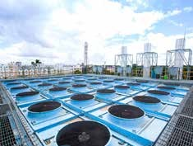
United Energy Ltd (UEL) – gas fired
- The combined installed capacity of 81MW
- Sylhet Plant – 28 MW
  - Commercial Independent Power Plant (CIPP)
  - 3 Rolls-Royce Norway B35:40V20AG2 engines
- Ashuganj Plant – 53MW
  - Quick Rental Power Plant (QRPP)
  - 14 MWM Germany TCG2032V16 engines

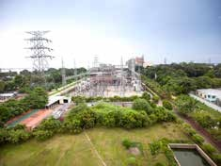
United Ashuganj Energy Limited (UAEL) – gas fired
- Combined Cycle modular plant 195 MW
- 20 Wartsila 20V34SG engines
- 20 ME Energy’s Waste Heat Recovery
Boilers
- 01 Triveni Turbine Ltd.’s steam turbine of 16.1
MW capacity

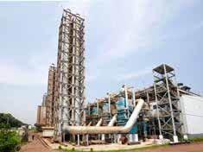
Leviathan Global BD Ltd (LGBDL) - gas fired
  - Capacity 45 MW
  - 05 Wartsila Finland 20V34SG engines

United Jamalpur Power Ltd (UJPL)
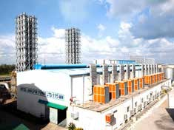
- HFO fired
  - Combined Cycle Modular Plant 115 MW
  - 12 Wartsila20V32E engines
  - 12 Alfa Laval Aalborg’s Waste Heat Recovery
Boilers
  - 01 Triveni Turbine Ltd.’s steam turbine of
7.5 MW capacity

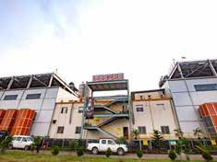
United Anwara Power Ltd (UAnPL) - HFO fired
- 17 Alfa Laval Aalborg’s Waste Heat Recovery
Boilers
  - Combined Cycle Modular Plan 300 MW
  - 17 Wartsila’s 18V46 engines

3.3.2 Financial Performances
The Finance Department is the center of United Group. It is one of the most crucial departments, and the team members are giving it they're all for sustainable management and long-term growth. This division is responsible for raising capital, and performance, managing it, and coming up with actual investment plans. This department assures that the company's operations adhere to efficient financial management and control systems.

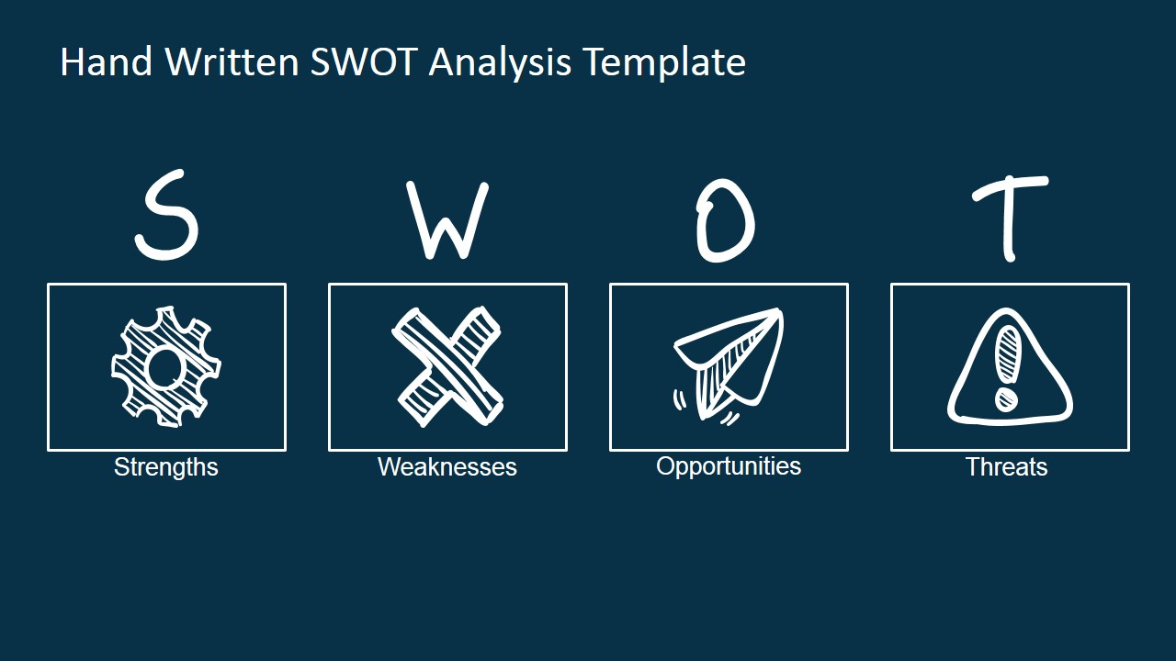
3.4 SWOT Analysis

A company, project, or product's strengths, weaknesses, opportunities, and threats are assessed using the SWOT analysis, a strategic planning technique. SWOT is an acronym for Strengths, Weaknesses, Opportunities, and Threats.
Strengths: These are the internal factors that an organization excels in, such as a strong brand, innovative products, talented employees, or efficient processes.
Weaknesses: These are the internal factors that an organization needs to improve upon, such as poor management practices, outdated technology, or limited resources.
Opportunities: These are external factors that an organization can take advantage of to grow its business, such as new market trends, emerging technologies, or strategic partnerships.
Threats: These are external factors that can negatively impact an organization's business, such as economic downturns, competition, changes in government policies, or natural disasters.

Strength  - It is the most profitable and powerful concern of United Group.  - UPGDCL generates and supplies electricity to other energy companies,  - It has many subsidiaries in Bangladesh.  - UPGDCL has enough cash & equivalents to meet operational expenses. | Weakness  - The company has strong competitors.  - Natural calamities have the potential to disrupt the operation of UPGDCL.  - The website does not update on regular basis.  - As the company has so many directors, decision fixing can take time.
Opportunity  - Comprehensive market effort.  - Services for a contact center and helpline in multiple languages  - More subsidiaries will start very soon, so the company will have more opportunity  - Training for more profitability | Threats  - Well-known competitors.  - Competitive market.  - The competitors' extensive promotional efforts.  - Diverse industry developments necessitate prompt answers in order to be sustainable.

Table: 6

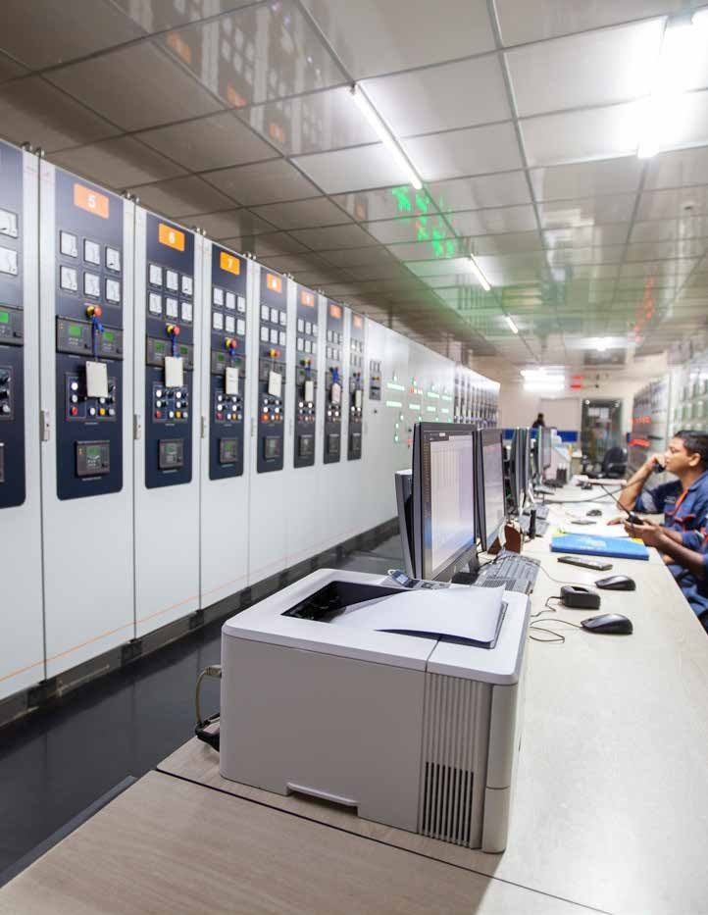

CHAPTER 4

FINDINGS AND ANALYSIS OF THE STUDY

FINDINGS AND ANALYSIS OF THE STUDY
The power sector of a country is a part of. Without it, no industry can run its operation prospectively. Before continuing, I want to draw attention to a few problems with the Bangladeshi economy and its effects on the world. 2020 was a critical year for Bangladesh since the COVID-19 Epidemic caused economic instability. During COVID, the production of power and energy also faced a problem, as exports and imports were off, and employees could not work properly then. Here, I'll detail and clarify the important concepts mentioned in this report. I've also explained the ratios I used. Together with some other pertinent information regarding UPGDCL. I will discuss the operating performance of the company during the last four years. It will cover the COVID-19 period also.

4.1 Summary of Financial Statement

Particulars | 2022 | 2021 | 2020 | 2019
Balance Sheet
Total non-current assets | 40541672722 | 42645100689 | 20937335440 | 20441424783
Total current assets | 45668681403 | 25028248790 | 15140234544 | 21590583232
TOTAL ASSETS | 86210354114 | 67673349480 | 36077569984 | 42032008015
Total equity | 33197681279 | 33090999670 | 29851211097 | 30087737747
Total non-current liabilities | 6008537507 | 5275136779 | 4107019595 | 7062476681
Total current liabilities | 47004135328 | 29307213031 | 2119339292 | 4881793587
Total liabilities | 53012672835 | 34582349810 | 6226358887 | 11944270268
Total Equalities and Liabilities | 86210354114 | 67673349480 | 36077569984 | 42032008015
Income Statement
Net revenue | 49435163297 | 30580520521 | 10094032945 | 11253361366
Gross profit | 10165863381 | 11812779438 | 5851776819 | 7121024511
Income from operation | 10162262805 | 11680372544 | 5786302648 | 7832647376
Profit before tax | 10157320826 | 11104955052 | 5932005597 | 7881068694
Less: Provision for Income Tax | 2024428 | 9219956 | 146781950 | -26040669
Net profit after tax | 10155296398 | 11114175008 | 6078787547 | 7855028025
Cash flow statement
Net cash flows from operating activities | 1093082883 | 15749629568 | 6981669660 | 7732159293
Net cash used in investing activities: | 6331826426 | 748713863 | 1113480654 | 59490243916
Net cash flows from financing activities | -7677567558 | -15601601439 | -11000322324 | -66220853600
Net increase in cash and cash equivalent | -252658249 | 896741992 | -2905172010 | 1001549609
Cash and cash equivalent at beginning of the year | 1482743529 | 586001536 | 3322180442 | 2297488160
Cash and cash equivalent at end of the year | 1230174686 | 1482743528 | 417010049 | 3299042119

Table: 7

4.2 Ratio Analysis

By comparing the firm's financial data to that of competitors, financial ratios can be used to evaluate trends in other businesses. Ratio analysis is the process of calculating and comparing ratios derived from statements. Financial ratios can be expressed in percentages or times per quarter. Ratio analysis is a famous tool for financial analysis. Ratio analysis can be used to draw conclusions about a variety of topics, such as operational efficiency, profitability, and financial health of a firm. It helps to identify if a company's management has effectively utilized the firm's resources to increase investor wealth while ensuring a just return to its owners and the best possible use of the company's resources. Ratio analysis is also useful for inter-firm comparison and provides the necessary information to compare the effectiveness of several departments. It helps to identify reasons for differences in comparison and take immediate action to make them consistent if the results are poor. Additionally, ratio analysis gauges operational efficiency by measuring different activity ratios.
Liquidity Ratios
- Current Ratio (Times)
- Quick Ratio
Activity Ratios
- Inventory turnover
- Average collection period
- Average payment period
- Total assets turnover
Debt ratio
- Debt ratio
- Times interest earned ratio
- Fixed-payment coverage ratio
Profitability Ratios
- Gross profit Margin
- Net Profit Margin
- Operating Profit Margin
- Earnings per share (EPS)
- Return on total assets (ROA)
- Return on equity (ROE)
Market Ratios
- Price/earnings (P/E) ratio
- Market/book (M/B) ratio

United Power Generation & Distribution Company Ltd
Ratio Analysis
Ratio Type | Ratio Name | Ratio Value
 |  | 30-Jun-22 | 30-Jun-21 | 30-Jun-20 | 30-Jun-19
Liquidity | Current ratio | 0.97 | 0.84 | 7.14 | 4.42
Liquidity | Quick (acid-test) ratio | 0.88 | 0.70 | 6.52 | 4.20
Activity | Inventory turnover | 9.21 | 4.56 | 3.19 | 3.77
Activity | Average collection period | 180.90 | 64.04 | 98.59 | 89.84
Activity | Average payment period | 191.36 | 161.90 | 32.97 | 37.66
Activity | Total assets turnover | 0.57 | 0.45 | 0.28 | 0.27
Debt | Debt ratio | 61.49% | 51.10% | 17.26% | 28.42%
Debt | Times interest earned ratio | 19.90 | 12.00 | 17.09 | 15.82
Debt | Fixed-payment coverage ratio | 8.48 | 7.51 | 5.39 | 6.25
Profitability | Gross profit margin | 20.56% | 38.63% | 57.97% | 63.28%
Profitability | Operating profit margin | 20.56% | 38.20% | 57.32% | 69.60%
Profitability | Net profit margin | 20.54% | 36.34% | 60.22% | 69.80%
Profitability | Earnings per share (EPS) | 17.52 | 19.17 | 11.53 | 16.40
Profitability | Return on total assets (ROA) | 11.78% | 16.42% | 16.85% | 18.69%
Profitability | Return on equity (ROE) | 30.59% | 33.59% | 20.36% | 26.11%
Market | Price/earnings (P/E) ratio | 13.58 | 12.43 | 20.75 | 15.98
Market | Market/book (M/B) ratio | 4.08 | 4.09 | 4.13 | 3.72
Table: 8

4.2.1 Liquidity Ratio
Liquidity ratios are a key indicator of a company's financial performance since they reveal how well it can repay the borrowing. It is an indicator of how well a business can fulfill its immediate obligations. A ratio greater than 1 often denotes that a business can adequately satisfy its current obligations. A ratio of 2 or higher, on the other hand, denotes a stronger liquidity situation for the business, where it has the ability to double its ability to pay its existing creditors.
Current Ratio
The capacity of a business to satisfy its short-term financial obligations is gauged by the current ratio, a financial ratio. We can calculate the Current Ratio by subtracting current liabilities from the current assets
The financial stability and liquidity of a corporation are both strongly correlated with its current ratio. To obtain a thorough view of the company's financial success and stability, it should be utilized in conjunction with other financial measures and indicators.
𝑪𝒖𝒓𝒓𝒆𝒏𝒕 𝑹𝒂𝒕𝒊𝒐 = 𝑪𝒖𝒓𝒓𝒆𝒏𝒕 𝒂𝒔𝒔𝒆𝒕𝒔 /𝑪𝒖𝒓𝒓𝒆𝒏𝒕 𝒍𝒊𝒂𝒃𝒊𝒍𝒊𝒕𝒊𝒆𝒔
Quick Ratio
Quick Ratio is also referred to as acid test ratio. A business can pay off its short-term obligations right away without depending on the sale of goods.
Quick ratio= (Current asset- Inventory) / Current Liabilities

Liquidity ratio comparison
Ratio name | 2022 | 2021 | 2020 | 2019
Current ratio | 0.97 | 0.84 | 7.14 | 4.42
Quick ratio | 0.88 | 0.70 | 6.52 | 4.20
Table: 9

Figure: 4
Upon examining the data, it appears that UPGDCL's liquidity was stronger in 2019 and increased further in 2020. However, in 2021 and 2022, the company's liquidity declined significantly, likely due to the impact of COVID-19. It is important for the company to be vigilant and take appropriate measures to avoid the current ratio falling below 1, which can lead to severe liquidity problems within the company.

4.2.2 Profitability Ratio
The profitability ratio is a company's capacity to make a profit from its activities. By comparing a company's sales or earnings to its costs or assets, these ratios gauge its profitability.
Gross Profit Margin
A financial measure called gross profit margin is used to evaluate how profitable a business is in comparison to its sales revenue. A high gross profit margin means that the business is making more money per dollar of sales, which shows that it is efficiently controlling expenses and charging competitive prices for its goods. A low gross profit margin, on the other hand, might indicate that the business is incurring more costs or charging lower prices, which could have a detrimental effect on its profitability.
Gross Profit Margin = Gross profits / Sales
Operating Profit Margin
The operating profit margin is the profit generated by its operations relative to its revenue. Overall, the operating profit margin is an important financial metric that can help investors and analysts evaluate a company's profitability.

Operating Profit Margin= Operating Profit/sales

Net Profit Margin
A company's profitability is measured by its net profit margin, which is the proportion of revenue left over after all costs, such as taxes and interest, have been paid.

Net Profit Margin= Earnings available for common stockholders/ sales

Ratio name | 2022 | 2021 | 2020 | 2019
Gross profit margin | 20.56% | 38.63% | 57.97% | 63.28%
Operating profit margin | 20.56% | 38.20% | 57.32% | 69.60%
Net profit margin | 20.54% | 36.34% | 60.22% | 69.80%
Table: 10

Figure: 5
For the last four years, the UPGDCL had a significantly different ratio, which is declining. We can see the profit margin of UPGDCL is poor in recent years than the previous years. Before and in the beginning phase of the Pandemic, the gross, operating, and net profit of the company was better than after the pandemic. That means, COVID-19 had a great impact on the company’s profit. In 2019 and 2020, the net profit margin was higher than the operating and gross profit. In 2021, the gross profit was higher than the net and operating profit. Lastly, all profit margins were equal in 2022. Though the company is stable in this situation, the revenue generation is less than the before years.
Return on Total Assets (ROA)
A financial ratio called return on total assets (ROA) gauges a company's profitability in relation to its total assets. It is computed by subtracting the company's total assets from its net income (profit). ROA, which is calculated as a percentage, reveals how well a business is turning a profit from its assets.
ROA= Earnings available for common stockholders/ Total assets
Return on Equity (ROE)
A financial ratio called return on equity (ROE) assesses how much profit a business makes in comparison to the amount of stock invested by shareholders. In other words, it determines how well a business generates profits by leveraging the equity of its owners.

ROE= Earnings available for common stockholders/ Common stock equity
Ratio name | 2022 | 2021 | 2020 | 2019
ROA | 11.78% | 16.42% | 16.85% | 18.69%
ROE | 30.59% | 33.59% | 20.36% | 26.11%
Table: 11

Figure: 6

4.2.3 Activity Ratio
The activity ratio, sometimes referred to as the asset turnover ratio is a financial metric that assesses how well a business uses its assets to produce income or sales. This ratio shows how frequently a company's assets are used to produce revenue during a specific time frame. Activity ratios assist analysts and investors in assessing how well a company uses its resources to produce sales and profits. While a low ratio suggests that the company may be inefficient in using its assets, a high ratio shows that the organization is employing its resources effectively to create revenue. Inventory Turnover
The inventory turnover ratio evaluates the efficiency of managing inventory by comparing the cost of goods sold during a specific period with the total inventory available. It indicates the number of times the average inventory of a company is sold and replaced within a given period or the number of cycles of the company's inventory over a period.
Inventory Turnover= Cost of goods sold/ Inventory

Ratio name | 2022 | 2021 | 2020 | 2019
Inventory Turnover | 9.21 | 4.56 | 3.19 | 3.77
Table: 12

v
Figure: 7

UPGDCL’s inventory turnover ratio during the past four years has been 3.77, 3.19, 4.56, and 9.21. However, the company has the highest inventory after the pandemic. The ratio has risen with time, reaching 9.21 in 2022, which significantly grew because the corporation was able to sell more of its inventory over these years.
Total assets Turnover
Total assets turnover is an activity ratio that measures how efficiently a company uses its assets to generate revenue. It indicates the amount of revenue a company generates per dollar of assets. The total assets turnover ratio is calculated by dividing a company's net sales by its total assets.
However, a very high total assets turnover ratio may also indicate that a company has low levels of assets, which may negatively impact its ability to support operations and growth. On the other hand, a low total assets turnover ratio may indicate that a company is inefficient in utilizing its assets to generate revenue.
Therefore, it is important to compare a company's total assets turnover ratio to the industry average and to its historical performance to gain a better understanding of its efficiency in utilizing its assets to generate revenue.
Total Asset Turnover = Sales / Total Assets

Ratio name | 2022 | 2021 | 2020 | 2019
Total assets Turnover | 0.57 | 0.45 | 0.28 | 0.27
Table: 13

Figure: 8

4.2.4 Debt Ratio
It's important to note that what constitutes a high or low debt ratio can vary depending on the industry and the company's specific circumstances. Some industries, such as utilities or telecommunications, may require a higher level of debt financing to support their capital-intensive operations.
Therefore, when analyzing a company's debt ratio, it's important to compare it to other companies in the same industry or sector and to consider other factors such as the company's cash flow, profitability, and ability to service its debt.

Debt Ratio = Total liabilities / Total Assets

Ratio name | 2022 | 2021 | 2020 | 2019
Debt ratio | 61.49% | 51.10% | 17.26% | 28.42%
Table: 14

Figure: 9

4.2.5 Market Ratio

Market ratios, also known as valuation ratios, are financial ratios that provide insights into the market's perception of a company's stock price. These ratios are used to assess whether a company's stock is overvalued or undervalued based on various market metrics. Here are some of the most commonly used market ratios.
Price-to-Book (P/B) Ratio
This ratio measures the market's valuation of a company's assets. It is calculated by dividing the company's current stock price by its book value per share.
P/B Ratio = Stock Price / Book Value per Share
Dividend Yield
This ratio calculates the proportion of an organization's return on investment that is distributed to shareholders in the form of dividends. It is computed by subtracting the current stock price from the company's yearly dividend per share.

Dividend Yield = Annual dividend per Share / Stock price

Market Capitalization
This ratio represents the total value of a company's outstanding shares of stock. It is calculated by multiplying the company's current stock price by the number of outstanding shares.
Market capitalization = Stock Price x number of outstanding shares

Market ratios are commonly used by investors and analysts to compare companies within an industry or sector and to identify potential investment opportunities. However, it's important to use multiple ratios and to consider other factors such as a company's financial health, growth prospects, and competitive position before making investment decisions.

Price/ earnings (P/E) ratio
The price-to-earnings (P/E) ratio is a financial metric used to evaluate a company's stock price relative to its earnings per share (EPS). Here are a few key points that explain the P/E ratio:

Definition: The P/E ratio is calculated by dividing a company's current stock price by its EPS. The EPS is calculated by dividing a company's net income by its outstanding shares.

Types of P/E ratio: There are two types of P/E ratios: forward P/E and trailing P/E. Forward P/E uses estimated earnings for the next 12 months while trailing P/E uses actual earnings from the previous 12 months.

Interpretation: A high P/E ratio can indicate that investors have high expectations for a company's future growth potential, while a low P/E ratio can suggest that investors have lower expectations. However, it is important to compare the P/E ratio of a company to its industry peers or historical averages to determine if it is overvalued or undervalued.

Limitations: The P/E ratio has some limitations, including that it does not take into account a company's debt or cash levels, which can impact its valuation. It also does not provide information on a company's growth prospects or its ability to generate future earnings.
P/E Ratio = Market Price per Share / EPS
A high P/E ratio may indicate that investors are optimistic about the company's future earnings potential and are willing to pay more for the stock. Conversely, a low P/E ratio may indicate that investors have lower expectations for future earnings growth and are less willing to pay a premium for the stock.
However, it's important to note that the P/E ratio should not be used in isolation and should be considered in the context of other factors such as the company's financial health, growth prospects, and competitive position before making investment decisions. Additionally, P/E ratios can vary greatly across different industries and should be compared to companies within the same industry or sector for a more meaningful analysis.

Ratio name | 2022 | 2021 | 2020 | 2019
Price/ earnings (P/E) ratio | 13.58 | 12.43 | 20.75 | 15.98
Table: 15

Figure: 10

The P/E ratio was 15.98 times in 2019 and increased further to as high as 20.75 times in the following year, which is a very good thing. However, in 2021 it declined to 12.43 times which is an alarming signal for potential investors. Then, it increase to 13.58 times in 2022. So, we can see that after COVID the ratio straightly declined due to the pandemic's effect.

4.3 Common Size Analysis
Trend analysis is the process of gathering data and looking for patterns or trends in the data. The word “Trend Analysis” has more clearly defined meanings in various academic disciplines. Whilst trend analysis is frequently utilized to forecast the future. It could be applied to estimate hazy historical events. Investors, creditors, managers, and executives are among the internal and external users of financial statement information. Knowing financial statements is crucial since these users must assess the data in order to make business decisions. There is numerous way to analyze financial statements. I will discuss the vertical analysis and horizontal analysis. I have got this brief horizontal and vertical analysis from my officials.

4.3.1 Horizontal Analysis
This analysis provides insight into a company's performance and helps identify areas that may require attention or improvement. Horizontal analysis can be conducted on income statements, balance sheets, and cash flow statements, and is useful for both internal management and external stakeholders such as investors and creditors.

Horizontal Analysis | 2021-22 | 2020-21 | 2019-20 | 2018-19
Financial Performance
Revenue | 758% | 431% | 75% | 95%
Gross profit | 152% | 192% | 45% | 77%
Operating profit | 155% | 193% | 45% | 96%
Profit before tax | 143% | 166% | 42% | 89%
Net profit after tax | 143% | 166% | 46% | 88%
Financial Position
Paid-up capital | 60% | 60% | 45% | 32%
Shareholders’ equity | 118% | 118% | 96% | 98%
Non-controlling interest |  | 8% | 12% | 100%
Total equity | 122% | 121% | 100% | 101%
Total non-current liabilities |  | -25% | -42% | 100%
Total current liabilities | 34911% | 22156% | 1509% | 3607%
Total non-current assets | 369% | 393% | 142% | 137%
Property, plant & equipment | 346% | 372% | 121% | 134%
Total current assets | 608% | 288% | 135% | 235%
Total assets | 471% | 348% | 139% | 178%

Table: 16

4.3.2 Vertical Analysis
A financial analysis technique called vertical analysis, also known as common-size analysis, involves expressing each line item on a company's financial statements as a percentage of a base item. This allows for easy comparison of the relative proportions of different items within a single financial statement.
Here are a few key points that explain vertical analysis:
Definition: Vertical analysis is a technique used to evaluate a company's financial performance and health by expressing each line item on its financial statements as a percentage of a base item.
Base item: The base item used for vertical analysis varies depending on the financial statement being analyzed. For example, the base item for vertical analysis of an income statement is typically revenue, while the base item for vertical analysis of a balance sheet is typically total assets or total liabilities and equity.
Percentage calculation: To perform vertical analysis, the percentage of each line item is calculated by dividing the line item amount by the base item amount and multiplying by 100.
Benefits: Vertical analysis helps to identify trends and patterns in a company's financial statements and enables easy comparison of the relative proportions of different line items. It can also highlight areas of financial strength and weakness, and help with forecasting future financial performance.
Limitations: Vertical analysis has some limitations, including that it does not take into account changes in the base item or overall financial statement. It also does not provide information on the absolute dollar amounts of line items, which may be necessary for some financial analyses.

Vertical Analysis | 2021-22 | 2020-21 | 2019-20 | 2018-19
Financial Performance
Revenue | 100% | 100% | 100% | 100%
Gross profit | 21% | 39% | 58% | 63%
Operating profit | 21% | 38% | 57% | 70%
Profit before tax | 21% | 36% | 59% | 70%
Net profit after tax | 21% | 36% | 60% | 70%
Financial Position
Paid-up capital | 7% | 9% | 15% | 11%
Shareholders’ equity | 38% | 48% | 81% | 70%
Non-controlling interest | 1% | 1% | 2% | 1%
Total equity | 39% | 49% | 83% | 72%
Total non-current liabilities | 7% | 8% | 11% | 17%
Total current liabilities | 53% | 43% | 6% | 12%
Total non-current assets | 47% | 63% | 58% | 49%
Property, plant & equipment | 45% | 60% | 53% | 49%
Total current assets | 53% | 37% | 42% | 51%
Total assets | 100% | 100% | 100% | 100%

Table: 17

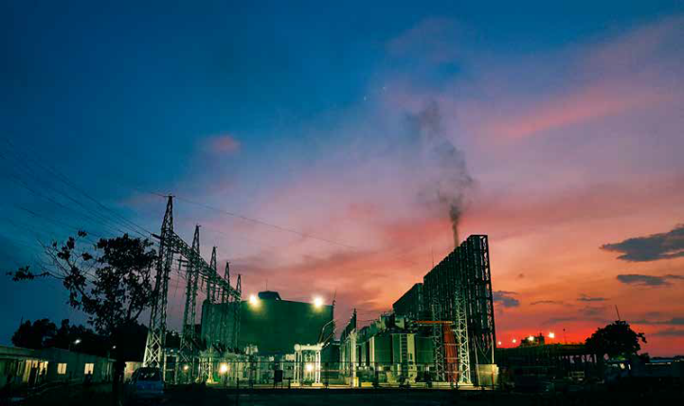

CHAPTER 5

CONCLUSION AND

RECOMMENDATIONS

Conclusion

The report primarily examines the operational performance of UPGDCL before and after the outbreak of COVID-19. It highlights several indications of the adverse effects the pandemic had on the company, such as employee absence, power and energy production, and a general collapse of operations. Even now, the company is still dealing with the repercussions of the pandemic. However, if the management takes necessary measures to address these issues, the negative impact can be mitigated, and the company can regain its success.
In summary, my internship experience at United Power Generation and Distribution (UPGDCL) has been invaluable, providing me with ample opportunities to learn and grow. I am confident that the knowledge and skills I have gained during this internship will serve me well in my future career. The company's reputation has been built on the hard work, discipline, and strategic leadership of its management team. While there were some limitations to obtaining internal information, they were taken into account to ensure that the research results were not compromised. Ultimately, UPGDCL's success will be determined by the commitment, dedication, and dynamic leadership of its management team, and I believe they will continue to thrive in the future and supply energy to the masses with pride.

Recommendations

As a prominent conglomerate in Bangladesh, the United Group holds significant influence, and its subsidiary, United Power Generation and Distribution (UPGDCL), plays a crucial role in the power industry. Despite the challenges posed by offering recommendations for such a sizable company, I have formulated some suggestions as part of this consultancy project.
- COVID-19 impacts should be overcome as soon as possible so that the company’s profitability increases more than in previous years.
- To improve the ROA, it is important to closely monitor the management of assets.
- While UPGDCL is currently performing well, it is crucial to evaluate its management of debt to mitigate potential financial risks in the future.
- To alleviate the burden of debt in the long run, UPGDCL, being a progressive company, should consider investing in more profitable ventures.
- UPGDCL should lower its Days Payable Outstanding to maintain a good working relationship with its creditors, and suppliers, who can run the company by supplying premium raw materials, enabling them to advance their products in comparison to rivals in the market.
- Should give more concerned with the analytical part for their financial betterment.
- The finance manager of the firm should focus on its liquidity to assess its profitability.
The ratio analysis indicates that there is a decrease in the gross profit margin of UPGDCL after the COVID-19 pandemic. Even though the company's sales are increasing, the profits are not increasing at the same rate.

INTERNSHIP EXPERIENCE AT “UNITED GROUP”
I joined United Group as an intern on 23rd October 2022. My appointed intern period was 3 months. I completed my intern period successfully, but after that, the management extended my intern period for two more months. However, I am still working there.

The first and foremost important learning of my internee is Time management, how to be on time. Straight after student life, it is very tough to sit in a place and work from 9 am to 6 pm. It taught me to be patient also. Then, strictly follow rules and regulations of a company. United group is a very conservative company. There are many extra rules for females also; I have to obey those things accordingly.

Though I have worked in the finance and accounts department, there were different groups or teams for different work like, payment team, treasure, disbursement, VAT team, Tax team, etc... Among those, I have worked under the payment team and VAT team. I worked as a VAT registrar so learned how to register for VAT, the rules of VAT, and made note sheets for different concerns. Then, cross-checked amounts prepared bills, and did bank reconciliation. During my internship, I gained valuable insights into the process of creating financial statements and preparing presentations. I also had the opportunity to observe how the company interacted with other businesses to make contracts. Additionally, I learned how to effectively communicate and handle different types of customers with varying needs.

However, I recognize that four months is a relatively short amount of time to fully understand how a company operates and its role in society. Nevertheless, I feel that I have gained a sufficient amount of knowledge and recognize the importance of dedication and hard work in achieving organizational goals.

Beyond the work, I thoroughly enjoyed the learning experience and found the people to be supportive and friendly toward me.

APPENDIX

References
- The following website was accessed on 20th January, 2023:
https://www.united.com.bd/
- The following website was accessed on 25th January, 2023:
https://www.united.com.bd/power/
- The following website was accessed on 30th December, 2022:
https://www.unitedpowerbd.com/annual-report/
- The following website was accessed on 12th March, 2023:
file:///C:/Users/User/Desktop/10164029.pdf
- Garrison, R.H., Noreen, E.W. & Brewer, P.C. (2010), Management Accounting, NY: McGraw-Hill Irwin, 13th Edition.
- The following website was accessed on5th February, 2023:
http://dspace.uiu.ac.bd/
- Innocent, E. C., Mary, O. I., & Matthew, O. M. (2013). Financial ratio analysis as a determinant of profitability in Nigerian pharmaceutical industry. International journal of business and management, 8(8), 107.
