

AN INTERNSHIP REPORT ON
The Evaluation of Accounting Software of Rokkhi Limited



BBA in AIS Program
School of Business and Economies
United International University
United City, Madani Ave, Dhaka 1212

Submission Date: 07 January 2021

AN INTERNSHIP ON
The Evaluation of Accounting Software of Rokkhi Limited

SUPERVISED BY

PROF. DR. FARID A SOBHANI
PROFESSOR
SCHOOL OF BUSINESS AND ECONOMICES
UNITED INTERNATIONAL UNIVERSITY

PREPARED BY

MAHEDI HASAN RIAD
ID: 111 161 293
BBA in AIS Program
UNITED INTERNATIONAL UNIVERSITY

Letter of Transmittal
2th January, 2021
To,
Prof. Dr. Farid A Sobhani
Professor
School of Business and Economics
United International University

Subject: Submission of internship report.
Dear Sir,
With due respect and admiration, I am delighted to state that, I am submitting my internship report on “The evaluation of Accounting Software of ROKKHI LIMITED: A Startup Company.” I have effectively completed my three months’ internship in ROKKHI LIMITED and during my internship program, I have practically performed the software system of ROKKHI LIMITED under the supervision of Asif Hasan, Consultant Finance and Accounts, ROKKI LIMITED and have gathered the information of the ways the company uses different software.
Since I am working a startup company called ROKKHI LIMITED where I used to work in Accounts and finance department. My concern through this report is their Accounting Information system, how they managed. After three months of my observation period, I observed and worked their accounting and finance department. They used to manage their all accounting and financial transactions through a software called “Wave Software.” During formulating this report, I always make sure that this report must be informative and resourceful for that reason, all the information is collected from own experiences and from other reliable sources.

I would like to take this opportunity to thank you for all the support and guidelines that you have provided, which I hope to continue getting in the future.


Sincerely yours,
Mahedi Hasan Riad
ID: 111 161 293
BBA Program
United International University

Declaration of Student
I hereby declare that the internship report titled, “The evaluation of Accounting Software of ROKKHI LIMITED: A Startup Company” submitted as a partial requirement completion of the degree of bachelor of business administration (BBA), has been prepared by myself solely.
The report was conducted under the guidance of Prof. Dr. Farid A Sobhani, Professor, School of Business and Economics (SOBE), United International University.

I have tried to provide relevant information from different creditable sources to make the study more relevant and stronger. This report has been prepare completely based on my internship experience at ROKKHI LIMITED.



Mahedi Hasan Riad
ID: 111 161 293
School of Business and Economics
United International University

Acknowledgements
I have incurred many debts of gratitude over the three months while preparing this report. The successful accomplishment of this project work is the consequence of the contribution of number of people who gave their valuable time form their busy schedule to guide me in doing my internship report. Here I would like to extend my heartiest gratitude to all those who have given the time and effort share their thoughts and suggestions to prepare the report and help me directly or indirectly contributed to the completion of the report.
In the first place, I would like to thanks Almighty Allah for all strength and with the help of Almighty Allah and my parents’ blessings I have successfully done my three months long internship at ROKKHI LIMITED.
Secondly, I would like to thanks my profound respect to my academic supervisor Prof. Dr. Farid A Sobhani, Professor, School of Business and Economics (SOBE), United International University, due to his generous and gracious guidance. I am also grateful to his for helping me to understand some miniature issues as well as those issues, which I have failed to understand during the preparation of the report.

At the same time, I also pay my heartily gratitude to S.M. Kamarujjam, Chief Administrative Officer, ROKKHI LIMITED, who has appointed me with such important topic and extended his helping hands by showing the right and effected path to me. A very special gratitude goes to my organization supervisor Asif Hasan, Consultant Finance and Accounts, ROKKI LIMITED, who helped me during my work tenure and made my experience an unforgettable one. He helped me to gain more practical knowledge which made my internship journey more fruitful.

Furthermore, I would like to thank all the department officers for assisting me and giving me the guideline and suggestions for the last three months.

Finally, I want to thank all other interns from different distribution points for sharing their experiences and give my special thanks to ROKKHI LIMITED who has given me fastidious prospect to do internship in this organization to fulfill my internship.

Executive Summary
Just assume that here is a time machine, suppose we entered and go back 10 years before. What we will see? On that time, we did not understand the importance of technology that much. But Last 3 or 4 years we actually saw how quickly technology developed. Day by day every sector is going to be technology based and most of the cases they provide their services through online. Like, Ten minute school they share their study material through online by millions of students door. Sebaghor they provide online medical treatment through doctor consultation. Uber, Pathao they share online transportation services. Food panda, Pathao food, they deliver the ordered food to individual door to door. Same as ROKKHI LIMITED is also a technology based online application where people can control their apartment or building security. The software developers thought that some new technology should be introduced in the building sector. Since many incident arise with apartment or building security often.
ROKKHI LIMITED is a Startup Software development company where they develop building security software. It was started 2019 in Bangladesh. If I share about the company life cycle, currently ROKKHI LIMITED is grabbing in introductory level. They are introducing their application and services to their targeted customers and now it’s occupying people attraction and popularity gradually. Here in this report I will share my experience that how ROKKHI LIMITED as a startup maintain their Accounting Information system.
As I have completed my internship under Finance and Accounting department as an Accounts intern at ROKKHI LIMITED. Therefore, while I was preparing the report, I had tried to bring possible information regarding Finance and Accounting department and its works.
First of all, I have provided the introduction of my report. After that I share about the background of Rokkhi ltd. Later on I have discussed about objectives and methodology and also scope and limitation that I faced during my analysis period. Likewise, I discussed about Accounting Information System and its practice in Bangladesh. After that I shared about the company profile, aim, organogram and their product and services. Later on I have discussed how the company is using their accounting practices by using a software called Wave software, its implication in the company. Last but not the list I share some recommendation end of me.
Table of Contents
Letter of Transmittal iii
Declaration of student iv
Acknowledgements v
Executive Summary vi
List of Table and Figure ix
CHAPTER ONE 1
1.1 Background of the study 2
1.2 Objectives of the study 3
1.2.1 Major Objectives 3
1.2.2 Specific objectives 3
1.3 Rationale of the study 4
1.4 Methodology of the study 5
1.4.1 Source of information 5
1.4.2 Data Collection Process 5
1.4.3 Types of Data: 6
1.5 Scope of the Study 6
1.6 Limitations of the Study 7
CHAPTER TWO 8
2.1 History of the Organization 9
2.2 Organization Overview 10
2.3 Objective 11
2.4 Mission 11
2.5 Vision 11
2.6 Organogram 12
2.7 Product and service 12
2.7.1 Service features 13
2.8 SWOT analysis of ROKKHI LIMITED 15
18
CHAPTER THREE 18
3.1 Accounting Information System 19
3.1.1 Advantages of Accounting Information System 20
3.1.2 Disadvantages of Accounting Information System 21
3.1.3 Accounting Information System in Bangladesh 22
3.2 Accounting Information System of “Rokkhi Limited (Startup Company)” 23
3.2.1 Wave software 23
CHAPTER FOUR 33
RECOMMENDATIONS 33
& 33
CONCLUSION 33
Recommendations 34
Conclusion 35
References………………………………………………………………………………………………………………………………………36

List of Tables and Figures
Figure 1: Company organogram 12
Figure 2: List of services 13
Figure 3: Software use in Bangladesh 22
Figure 4: Inventory sheet 24
Figure 5: Sales Estimate 25
Figure 6: Sales Invoice 25
Figure 7: Purchase Bill 26
Figure 8: Chart of Account (Wave Software) 27
Figure 9: Journal Transactions 28
Figure 10: Financial Statements 29
Figure 11: Software Dashboard (Graphical presentation) 30
Figure 12: Expense breakdown 2020 of Rokkhi Limited 31

CHAPTER ONE
INTRODUCTION

1.1 Background of the study
Since Bangladesh is a developing country. The population is much larger than the size of Bangladesh. The total population is 164,689,383 According to 2020. (Bangladesh population: worldometer, 2020) If I share specifically about Dhaka, capital city of Bangladesh which is densely populated. In Dhaka current area population in 21,006,000, according to 2020 where the total size of Dhaka city is only 306.38 square kilometers to cope with the pressure of overcrowding, people are being built many more buildings and apartments for human habitation. On the other hand, people safety and security is also very important. (Bangladesh metro area population , 2020) That is why people hire guards and maintain their security stuff manually. Since the technology system is developing day by day that’s why developers introduce something new and share technology based building and apartment security management through an application.
In Bangladesh ROKKHI LIMITED is the first startup company who introduce the idea and based on this idea they run their company as startup their tag line is “Your lifestyle partner”. ROKKHI LIMITED started their journey in 2019. ROKKHI is a digital stage, a one quit working framework, of high rise or gated network that empowers correspondence between buildings or network the executives, security staff and condo inhabitance particularly to invigorate private security and smooth out regulatory administration works by preparing cloud based advancement utilizing a solitary portable application. (Rokkhi , 2019) ROKKHI LIMITED maintain their Financial and accounts related each and every data through cloud based software called “Wave Software.”

This report has been setup as a prerequisite for the culmination for the BBA program under department of business administration, United International University. Depending on y three months in length internship program in ROKKHI LIMTED I have arrange this report and have exploited some viable data which I have gathered from my daily works in the organization. In my report I have focused on their system software in Accounting. As I have work under Finance and Accounts department so most of the time I have to deal with different software Like, Wave software. Jira Software. This report will help to understand the application of software uses in an organization.


1.2 Objectives of the Study
Objectives refer that some significant goal we set during the internship period which we supposed to accomplish when we complete this report. In every reports objective of the study is very vital part, because the entire report is formulated by those objectives. Objective of the study consist two broad part those are: Major objectives & Specific objectives.

1.2.1 Major Objectives
The major objective of this study are-
To know as a startup company how they manage their Accounting Information System and also to pick up practical experience by performing job obligations and learning procedures. So that through this experience I enhance my skill set which making a significant contribution in organization success.
To achieve the Bachelor of Business Administration (BBA) after the completion of internship program and the submission of the report.

1.2.2 Specific Objectives
The specific objectives of the study show the core purposes for what the report is being prepared and analyzed on the title “The evaluation of Accounting Information System of a startup company: ROKKHI LIMITED”
- To know Accounting Software of Rokkhi Limited;
- To evaluate the effective of the accounting software;
- To know the drawbacks of the software;
- To know how to prepare different types of statements using the software;
- To suggest recommendations for improvement.

1.3 Rationale of the study
I worked as an intern at ROKKHI LIITED where I was working department of finance and accounting. I did my level best to complete this report properly. In this report I tried to share all related information of my topic “The evaluation of Accounting Information System of a startup company: ROKKHI LIMITED.” This report is an Exploratory report because in this report I share qualitative and quantitative both information.
The study rationale is a bunch of reasons or consistent establishments that can disclose to the reader that, why their research is necessary to contribute in the same research field. Since this report purpose is to understand the evaluation of Accounting Information System of a startup company: ROKKHI LIMITED, so it’s important to understand the Accounting Information System. Accounting Information System is viewed as one of the most significant frameworks of any association. Its points are to give essential data to the administrators at various level. Accounting Information System is basically a computer based and the purpose of this system is to collect or record data to see the impact of the organization. The basic purpose of accounting information system is to record the daily transaction which happened in the organization, so that the organization can report, monitor, control and also can take important decision. Through the accounting information system any organization can prepare financial statements based on financial data.

1.4 Methodology of the study
Methodology of the study refers that the way of collect the information, tools and techniques and analyze the data. The decision of a successful and proficient strategy for research contemplate is extremely obligatory to think of nature of data and information. I tried some consecutive technique and method for exercises to complete this report effectively. In my internship report I have collected the data based on my own experience by my own observations through my three months’ length internship period. While doing this report I collected data from different sources which is vital that I gather from directly from the organization (ROKKHI LIMITED). And also some information I collect from some subsidiary sources.
There are three manners by which I have assembled the report method which are given below:

1.4.1 Source of information
To absorb the different modules of research in a rational and reasonable way I have selected general techniques which refers the research design. In this way it guarantees the user of the report that they will viably address the exploration issues. Also it incorporates a few procedures of the report like, collection of data, types and analysis.

1.4.2 Data Collection Process
From various reasonable sources the information of this report are collected. Based on the sources of data collection process can be separated into two broad parts. They are described in underneath

Primary Source:
- From the observation and academic knowledge
- From formal and informal conversation with the ROKKHI LIMITED heads and employee.
- From personal working experience of different software in ROKKHI LIMITED.
- From several weekly and monthly reports and publications.

Secondary Source
- From the ROKKHI LIMITED official records.
- From the website of the company.
- From different articles published on Accounting Information System.
- From the website of Wave software.
- From different papers of ROKKI LIMITED.

1.4.3 Types of Data:
Basically I have prepared this report by using both Qualitative and Quantitative data. The rough and characteristics of data is defined as qualitative data. Mostly through discussing any thought it arrange and shows information. By observing, taking individual interviews, discussing with management group this sort of data is gathered, while doing this report I have also tried to gathered the information through this way. On the other hand, quantitative data is basically the numerical data. As I have worked under accounts department and my report is based on that so I have gathered some quantitative data as well.

1.5 Scope of the Study
This report encourages me to comprehend the unmistakable continuous experience about the activity of software system of ROKKI LIMITED and also unequivocally express how other companies like this company commit this activity. It likewise encourages me to track income, expenses, as well as for making any strategic financial decision it will help to access financial situation easily.
Also while doing the internship, when they trained me they have basically trained me for “Wave software and jira software” activities, which is very significant for me as well as, for that I have learned how to do software works easily rather than manually for that reason it has become easy for me to do my report based on that particular thing.
Another scope which I have gotten, as I have done my work under a startup company and have gathered experience. It also helps me to build my communication skill stronger, because for preparing this report I have to do communication with my senior.

1.6 Limitations of the Study
The issues or challenges that the investigation creators experienced while setting up the study is the limitation of the study or report. As per various sorts of report limitations may fluctuate. The creator typically presents his or her mistakes because no report is perfectly organized or doesn’t catch every single imaginable viewpoint. In this report, I confronted a few constraints while doing this report. They are recorded underneath:
- Within the three month of my internship program the report was created, so it was very difficult to prepare such long report within this short time.

- As I have started my internship during the pandemic situation of Covid-19, so it’s very challenging to there and do my job properly. Since six days’ full time office so it’s also tough to manage some time for make this report.

- As I know and have experienced about Quickbooks software but in my organization they use Wave software which is totally new for me so using this software is very complex task, also describing it in the report is also a difficult thing to share.

- Since it’s a software there is lots of features where we do our task and also many information or access restrictions that’s why I didn’t share many things in this report properly.

- In my organization ROKKHI LIMITED, it’s a startup company that’s why they engaged less amount of activities. So, I faced information deficient.

- Since it’s a Startup company I feel they are not that much organized like others. So for me it’s really hard to collect the information and share proper output in this report.

CHAPTER TWO
COMPANY PROFILE

2.1 History of the Organization
The advantages out of the ongoing remarkable development of science and innovation has improved the nature of living in Bangladesh in numerous perspectives. Yet, our general public could infer more advantage out of this innovative forward leap by the use of the information and aptitude focused for undiscovered existing social issues. The idea of Rokkhi is actually developed around two events. The founder of Rokkhi Md. Abrar Masum Shanto thought if there is something introduce digitally which helps to building security. Because he was faced in this particular area there is some lacking, so there is a right time to do something and introducing something new for building management. He shared his personal experience that the First one he faced that one of his neighbor once paid his service charge then he lost his receipt after that the building caretaker claimed that he had not paid the service charge. After this incident founder thought that all of this record can be managed digitally very easily, then there will be no problem with receipt. And the Second one was when the founder of Rokkhi was a student in BUET he used to do a lot of tuition. So once while doing tuition, he went to a student’s house and waited for a long time, the guard was calling on their intercom they didn’t pick up. Also after facing this incident founder thought only when we are at home get our notification by intercom that we know which guest is coming to us. But we need to know this even when we are out of the house for our own security. So these two incident helped a lot the development of the Rokkhi’s idea and they started from there. With this setting in view, a couple of years back, a gathering of skilled, unique youthful business people, moved on from lofty instructive foundations, have met up under the banner of Rokkhi. Afterward, a couple of expatriates, leaders in their innovation areas, joined up in the journey, adding abundance of industry experience to the partner. (Rokkhi , 2019)
Since in 2018, Rokkhi Ltd has been providing their services to its clients. Basically they started to make new innovation in IT sector. Rokkhi Ltd is registered as a private Limited Company under the companies Act 1994 on 2019. In addition, its central command is in Dhaka, Bangladesh with its subsidiaries in UK and Australia. Rokkhi is an individual from Bangladesh Association of software and information services (BASIS).

2.2 Organization Overview
Bangladesh a densely populated country, is one of the fastest-growing development economies on the world. (Wikipedia: Economy of Bangladesh, 2020)
With the financial progression, the way of life has been improved fundamentally, which brought about huge urbanization, and the real estate emerged as a crucial sector of the economy. With the critical improvement of the way of life, high rise apartments, town house or gated community living has gotten a staple of modern life in Bangladesh. For example, the population of 20 million (roughly) and the all-out number of building is 800k (approximately). Besides, countless such ongoing projects portray picture of this always developing interest.
Rokkhi Ltd is a youthful and dynamic startup company specializing in science and security innovation area. The name of Rokkhi represent the sense of security through its smart technology solution. The organization targets giving a vigorous security framework to gated networks with simple administration. Besides its flagship devices, exploiting arising advances, Rokkhi additionally offers tailor called IOT and programing based creative answer for convey extraordinary results for its customers.
Since Rokkhi founder saw there is no management system in the building security. Still they manage the information manually. In that case it’s a question of security threats. Like, manual statement may be lost, there is huge gap difference between actual amount and given amount lots of security issue that was engaged a building. From that thought Rokkhi limited Made a digital platform where customer easily manage their building security.
Since the technology system is developing day by day that’s why developers introduce something new and share technology based building and apartment security management through an application. So finally in Rokkhi Ltd their service is to share a digital platform where people manage their building security. So all those happen with the help of an Application called Rokkhi App the tagline is “Your Lifestyle Partner”
Rokkhi is a smart apartment management and security software. Through this app here store all kinds of building management and security data in the cloud, so that the land or house owner or committee members can easily monitor everything in his or her building through their mobile or laptop. What we do now through this app we maintain digitally rather manually. On the other hand, Rokkhi also develop a verity of IT devices that make building security much stringer. Rokkhi also work with police verification format for land owner’s tenants which obviously digitizing and land owner can easily do NID verification of tenants. If someone use Rokkhi he or she never have to pay bill to people, they have to pay through his or her mobile through Rokkhi apps. The process is efficient, convenient and appropriate.
In Rokkhi Limited they have some support which they received from others companies and consultancy farm such as Scitech Consulting and Solution, dkode Technologies, ThatQuick, Security 360 etc. they are the partners of Rokkhi Limited.

2.3 Corporate Objective
Rokkhi establishing a symbol of security and to become your digital lifestyle partner.

2.4 Mission
At Rokkhi, their mission is to furnish a computerized familiar object with a helpful administration capacity to the individuals by utilizing robust and secure technologies. Rokkhi will probably lead the security arrangement stage furnishing occupants and the executive’s boards with additional control and guarantee greater responsibility of the security individual. Rokkhi needs to consolidate comfort and security for its clients.

2.5 Vision
Our vision is to turn into a one-quit working framework and way of life accomplice for security arrangement and the board. We visualize to set up our worldwide presence in computerized security framework.

2.6 Organogram
Branding
R&D
Training

Technology
Marketing
Logistic Support
Sales
Design & Development

Figure 1: Company organogram

2.7 Products and Services
In Rokkhi Limited their main focus is to introduce digital building management system through a mobile App so that people can use easily. Since Rokkhi limited is a software development company they introduce and provides different types of security ensuring product through their IoT team. But right now their main target is introducing Rokkhi Application so that people know about this application and make their life easy. So Rokkhi provide product and services both but right now they deal with their services mainly.
Rokkhi is an advanced security management solution for gated premises guaranteeing greatest security and consolation to occupants, guards, management panel and guests. Rokkhi gives an exact arrangement of reason and continuous information to profitable clients. Rokkhi facilitate the issues and addresses it right away. The entirety of that is required is a smartphone- that is it. Rokkhi goes past the security of a structure. The stage can be utilized to speak with the administration council and notify a complaint. Tenants may talk among themselves about a typical warry through this application. They can even purpose issues at that stage and everybody stays educated. The application makes it simpler for the management committee to inform inhabitants about a potential force blackout or support work ahead of time.

2.7.1 Service Features
Rokkhi can improve security and access principles inside a gated network by preparing cloud-based innovations to smooth out both security and administrative management capacities utilizing a solitary versatile application. Rokkhi gives a start to finish security framework that is actually strong and guarantees information security. In Rokkhi Application there are many features which helps to user to manage their building and apartment security management. (Rokkhi, 2020) Since it’s a mobile based app, so it’s easy for every user who knows about how to run smartphone they also to run this application easily. People should use this service because it’s safe and concrete, low monthly charge, also time saver as well.

Figure 2: List of services

Visitor Management
At the point when a guest goes to your home, you will get a full-screen notice on your phone that shows the guest’s all important data including his photograph, regardless of whether you are at home or in office or somewhere else. Additionally, you can likewise permit or deny his entrance progressively from anyplace.

Child Security Management
Guardians will get calmed as Rokkhi will assist with guaranteeing that their kids don’t venture out unaccompanied. In this way, at whatever point their kids will attempt to go out, gatekeeper will bar them and call their parents on the double utilizing the Rokkhi application.

Household Stuff Management
You will get informed with respect to the section and leave season of your regular service laborers and you can likewise screen their month to month participation utilizing Rokkhi application.

Vehicle Management
Vehicle or leaving the board won’t be a problem any longer. You will be told each time your vehicle leaves or enters the structure. What’s more, safety officers will likewise have the option to locate the unfilled parking garage effectively utilizing the application.

Parcel Management
The safety officer will send a notice when any bundle or letter is gotten. You would likewise be informed about what sort of bundle it is, the place where it has come from and who is accepting it.

White-list
Rokkhi clients can favor access of their standard visitors in advance by adding their name and telephone no. In the rundown for more accommodation.

Digital Notice Board
Utilizing the Rokkhi application advisory group can send general or earnest notification like a force blackout, water deficiency, lift support, and so on to all level occupants just inside a couple of moments.

Bill and payments
Apartment panel can without much of a stretch track and screen various sorts of apartment charges like utility bills or service charges and can send the online receipts to the level tenants and furthermore tell them if there are any duty.

Community Expenditure Management
Utilizing the Rokkhi application, the structure board of trustee’s can without much of a stretch screen and deal with all costs caused for the turn of events and upkeep of the whole apartment.

Community meeting and voting
From taking significant choices to fix and educate the following gathering date to all advisory group individuals just as unknown democratic everything should be possible simply utilizing the Rokkhi application.

Digital Complaint Box
Level inhabitants or occupants can present their complaint or proposals to the advisory group whenever from anyplace and the board can likewise answer about their objections through the application.
Rokkhi has coordinated effort with other business and gives focus ordinary or on demand proficient administrations like water tank cleaning, Lift and generator upkeep, electric and plumbing needs on every day, week after week or month to month premise.

2.8 SWOT analysis of ROKKHI LIMITED
SWOT analysis is a simple concept but the outcome is more effective and powerful. Basically SWOT helps us to develop business method that means after analyzing SWOT it indicates which strategy should business follows. SWOT refers Strengths, Weaknesses, Opportunities and Threats. (Liveplan: SWOT analysis , 2018)
Now I discuss about the SWOT analysis of Rokkhi. Since SWOT is an essential arranging that will assist Rokkhi with recognizing their inside and outside variables.

Strengths
- Rokkhi Limited is a first company in Bangladesh who introduce Rokkhi app where people can control digital apartment security and management in one platform.
- Rokkhi introduce many features which Unprecedented and developed.
- Since Rokkhi is a mobile based application so it’s really user friendly for the customer.
- Rokkhi pressure their customer data manage their services through cloud support that’s why there is no information misuse issue, so people can trust.
- Rokkhi share real book information access.
- Time deliverer and entirely reasonable cost regardless of pay class.
- Since Rokkhi is a digital platform, now people love to convert their lifestyle from manually too digitally that’s why customer relation rate is high.
- One-stop solution for a building complex or gated community.

Weaknesses
- Not completely computerized at this point, so preparing and manual intercession are essential.
- Educating the market is troublesome, accordingly requires extra expense and assets.
- Reaching out objective client is intense for some segment factors.
- Unified decision is needed for client procurement.
- Lead time is little bit longer.

Opportunities
- In a real sense no presence of direct rival with such holistic arrangement.
- Substantial market size as far as worth.
- Current market development is upward and huge.
- Immense opportunity to get market as a sole player.
- Huge extent of business broadening.

Threats
- Many indirect rival exist.
- A couple are arising with a little piece of our product.
- Market compression out of Corona virus pandemic.

CHAPTER THREE
FINDINGS & ANALYSIS

In Rokkhi Limited, I was signed for 3-month internship so that, I gather practical experience. I worked as an intern in department of Finance and Accounting where I maintain their accounts like, their daily income, expenditure, and also manage their inventory through a software. I have learned lots of things and my learning process still on going. Since Rokkhi Limited is a startup company, so their organization structure is not well build like others but they trying to make it. Like others company Rokkhi has several departments based on two broad team one is Business development team where people worked on market development. And the other team is IoT (Internet of Things) team or Tech team where they worked on technology or software development stuff. In Business Development team they designed with different department such as, Finance and Accounts department, Human Resource department, Marketing department and Operation department. Every department done their daily task really well. Since I worked there as Intern in the department of Finance and Accounts I learned and practice lots of practical work through my assign department. In my three-month length internship period I observed so many things and also I have talked with different persons to know all the process and based on that findings I have prepared my report. Since in this report I worked on Accounting Information System of a startup company that’s why in findings part I will share about how Rokkhi Limited (startup company) manage their Accounts through software (AIS)

3.1 Accounting Information System
An organization or business use a structure to gather, store, oversee, measure and report all the financial information and this information can be utilized by the accounts, experts, business investigators, administrators, chief financial officers, controllers, auditors and tax offices. Basically this is a computer based technique for following accounting movement related to data innovation of Generally Accepted Accounting Principles, with present day data innovation assets.
Today, when we allude to AIS, we typically mean a mechanized accounting system, since computer and computer programming that help us measure bookkeeping exchanges have gotten moderately cheap. The advantages of utilizing a modernized bookkeeping framework exceed the expense of buying one, and practically all organizations, even little one, can stand to and do utilize a mechanized bookkeeping framework. This is not to imply that paper based or manual bookkeeping frameworks and cycles have vanished. Most organizations have some type of both non computerized and automated frameworks.
Extraordinarily Prepared accountants work inside and out with accounting information system to guarantee the most elevated level of exactness in an organization’s financial transactions and record keeping, just as make monetary information effectively accessible to the individuals who
Honestly need admittance to it-all while keeping information flawless and secure. Accounting information system is a method of following all bookkeeping and business action for an organization. Generally, this system framework by and large comprises of six essential parts, such as, individuals, systems and directions, programming, data foundation innovation, and inside controls. AIS basically shows the conversion of data into information. (Investopedia: Accounting Information System , 2020)

3.1.1 Advantages of Accounting Information System
Accounting Information System is also known as the computerized system of keeping accounting information. At some stage, everybody should utilize this kind of framework to oversee and shows their records. The advantages of accounting information system are given below:
- For small medium organization using the procedure of accounting information system will minimize the time. Doing a work by manual process is very time taking rather using software
- Software using activity is less errors than manual. Calculation of income, expense, reconciliation, VAT, adjustment is quite tough if it done manually, people can do mistake. Using software these calculation has become error free and accurately.
- Through using software, the outcome of the accounting statement like Profit loss, Balance sheet and Cash flow statement is more accurate if you input proper bookkeeping or journal entries.
- Numerous web based accounting systems empower computerized invoice, credit, receive payment which will eliminate time spent making manual invoices, credit notes and receipts.

3.1.2 Disadvantages of Accounting Information System
For any organization since quite a while ago run achievement, a feasible bookkeeping data framework is fundamental. There would be zero chance to choose how well the organization is performing without the techniques for checking the occasions that occur. Accounting Information System which is utilized to monetary record in a specific business. Storing, entering processing, distributing of information cane done by this framework. Yet, while executing this framework there are a few restrictions moreover:
- As this is completely mechanized framework there will be consistently a danger of losing data or information. It is very conceivable to misfortune all the information in the system. In this framework organization store their monetary data for quite a long time. If an accident occurs, it makes a significance detriment to the company.
- Most of the data required manual contribution of information, so it can be incorrect if it doesn’t check appropriately. In the event that any errors occurred it will be difficult to discover.
- Accounting Information System is hard to learn and also time consuming. As this framework is completely modernized and the parts which is utilized for data framework is little bit troublesome, on the grounds that everybody doesn’t utilize this appropriately. To get them or to prepare them it will require some investment.
- To work effectively in Accounting Information system, any company have to purchase the software which is costly. Other than there is also maintenance, customization and training cost. It’s must that need a professional one who maintain the software properly which is also costly.
- To stay in contact with the most recent pattern organizations frequently changes their business design which can affect the bookkeeping framework. Accounting Information System should be re-examined frequently, in order to mindful of the changes. Yet, this reconsidered takes additional time and costly as well.

3.1.3 Accounting Information System in Bangladesh
Accounting Information System is the utilization of various accounting software, with the goal that any organization can take care of their responsibility easily. In the world of accounting software, small business is one that can use out of the container programing without required broad customization. “An effective accounting information system is essential to any organization’s long run success” (Das, 2008)
There are diverse sort of Accounting software required for different kind of organization. Beforehand, in Bangladesh no organization don’t utilize any software, they don’t think about the utilization of those accounting software. Gradually the implication of accounting software has imposed in different small, medium and also large company. Now I would like to share about some software which many company use in Bangladesh for manage their accounts.

Figure 3: Software use in Bangladesh

In Bangladesh many company manage their accounts through that software not only accounting but also Management, Costing, Sales, CRM, and ERP etc. With the help of those software organization run smoothly. Right now most of the startup company try to manage their accounts and management through software for ease to maintain.

3.2 Accounting Information System of “Rokkhi Limited (Startup Company)”
Rokkhi Limited is a Startup company. Since they are new in the market but they try to maintain their accounts and management through several software. Since I am finance and Accounting intern in this organization that’s why I deal with their accounts where includes their daily expenditure, income, purchase, sales also their inventory management, and petty cash management etc. Every accounts related data they manage in a software called “Wave software”

3.2.1 Wave Software
Wave is an online based accounting stage only intended for entrepreneurs, specialists, and experts. Wave’s product gives highlights including bookkeeping, invoicing, charging, payment tracking, payroll management, finance management, master card preparing, and receipt filtering. Since Rokhhi Limited is a startup company and wave is design for entrepreneurs and also for a small company that’s why Rokkhi limited use this software for manage their accounts. In wave software user get huge opportunity and also this software is not that much complex. As we know that if a company use any software for the company the spent lots of money for purchasing the software in this case there is no money hassle because wave software is completely free for users. Since its features simple that’s why organization doesn’t need any professional for run the software. That’s why Rokkhi Limited use this software. Wave software is free and comparatively less risky for data error, in wave software data will be secure. (Wave Accounting , 2020)
Encryption: Communication between you, wave and your bank or visa organization is ensured by up to 256-cycle SSL encryption. This is a similar degree of encryption utilized by the best interest banking and shopping applications.
Password and Account protection: wave utilizes a world chief in internet banking to oversee financial balance and secret phrase information. This organization is trusted by a portion of the world’s greatest banks.
Read only security: The organization wave makes with your monetary foundations is perused as it were. As such, it’s not possible for anyone to utilize wave to get a cash in your record.
Finally, in those reasons Rokkhi Limited Chose Wave software to maintain their finance and accounting related stuff.
(Wave help center , 2020)
In Wave software it includes many features such as:
3.3 Sales
In sales feature it includes many other components like, Estimate, Invoice, Customer statement, Customer list, Product and service. Now the question is how it will manage? Well, I discuss about sales function of wave software-
- Inventory: So, first of all select the product and service option for create inventory. On inventory sheet software require some product and service related details, cost price and sales price and also tax rate. After inputting all the details then save the sheet which means your inventory or products and services were saved in inventory then whenever your sale or use those inventory then inventory reduce, though as a user you should also update the use product or sale products details from those particular inventory chart, then it works. In tha’s way I was maintain Rokkhi limited inventory with the help of this wave software.
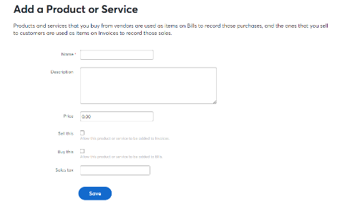

Figure 4: Inventory sheet

- Estimate: After update the inventory, if company need to sale some products or take sales order from those particular inventory then first need to make an estimate for those selected ordered products details with including price and other cost.
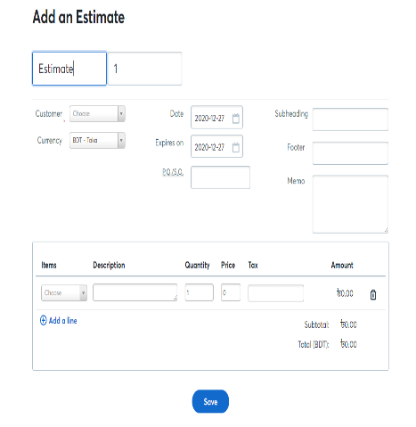

Figure 5: Sales Estimate
- Invoice: After the sales estimation, we make invoice for our respected customer where include product details, price if any due then it also includes in invoice. Through software usually we share the product invoice through individual customer personal or particular organization email.
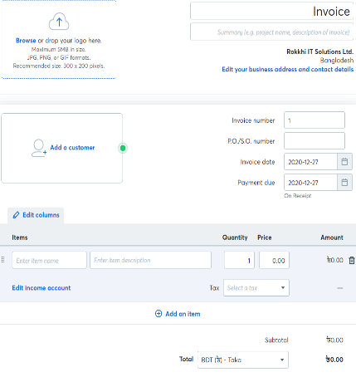

Figure 6: Sales Invoice
In this procedure Rokkhi maintain their sales and invoice through wave software. After receiving email, if any customer wants to share feedback, he or she can give us through the email. In this feature we also store the customer feedback.

3.4 Purchase
In purchase feature it also include some additional components like bill, receipt, vendor list, product and service. Purchase also manage by the software after procurement.
- Inventory: Here we include again inventory like sales because here we also need the inventory list to know about purchase update of the company. When those purchase product is use from the organization then also update the sheet as well because based on these inventory data company calculate what they need and what’s company’s in hand.

- Bill: we added those particular products in inventory after that create a bill for those purchased products with required quarries then with the help of the software, automatically comes a receipt and then sent to the buyer through email. In this feature we also reserve the vendor list and contact for further communication.
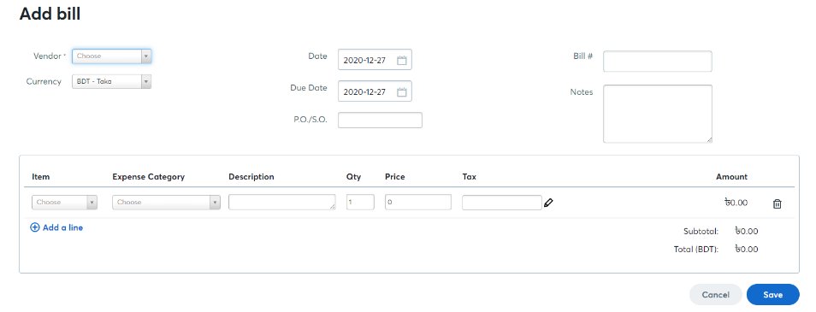

Figure 7: Purchase Bill

3.5 Accounting: There is a features called accounting where includes some other function Like, Transaction, Reconciliation, Chart of Accounts.
- Chart of Accounts: Before starting using this software, first of all I need to create chart of accounts. It’s important for using this software because through this option we categorize the data and save it with different code and different section based on the nature of data like, Asset, Liability, Expenditure, Income, Equity etc.

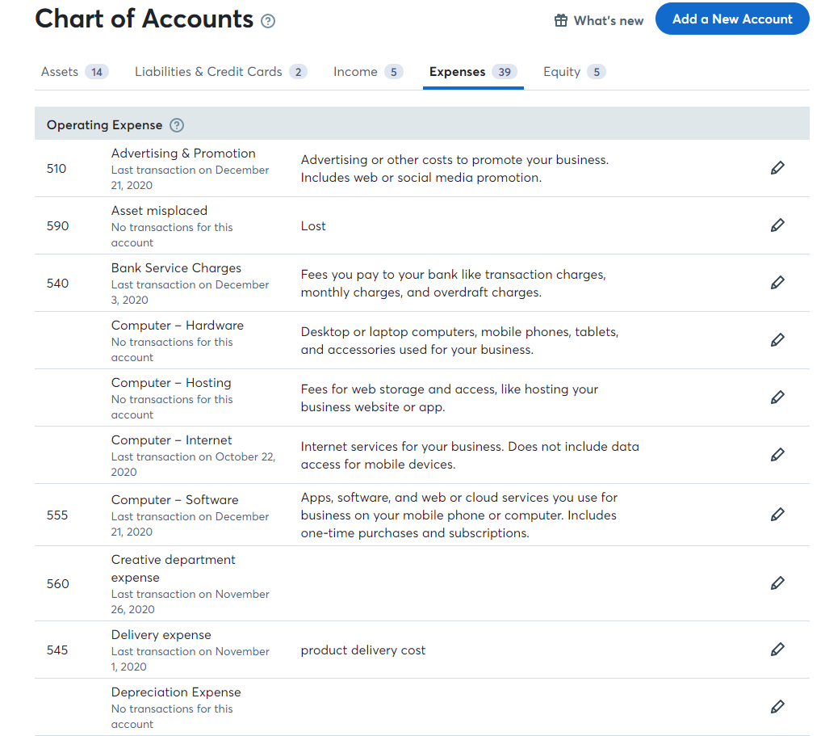
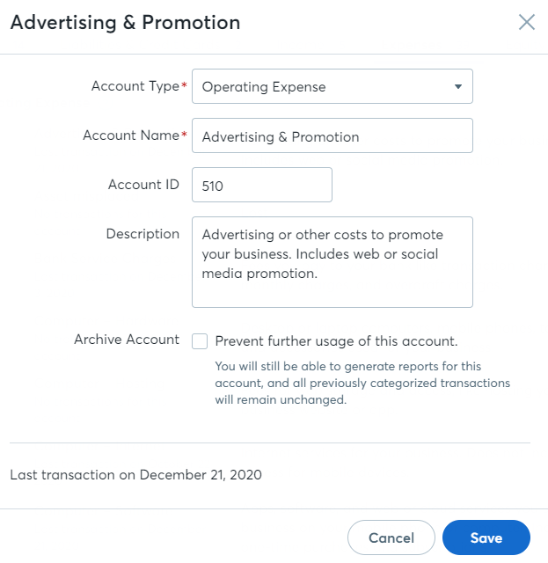

Figure 8: Chart of Account (Wave Software)

- Transaction: Without categorizing the data, no one can maintain any software. After making the chart of accounts we input data or bookkeeping the entries properly which means gives journal properly, otherwise the result will show the wrong output. That’s why people need to know about the sense of accounting specially journal. Because based on those journal data software calculates the final results.

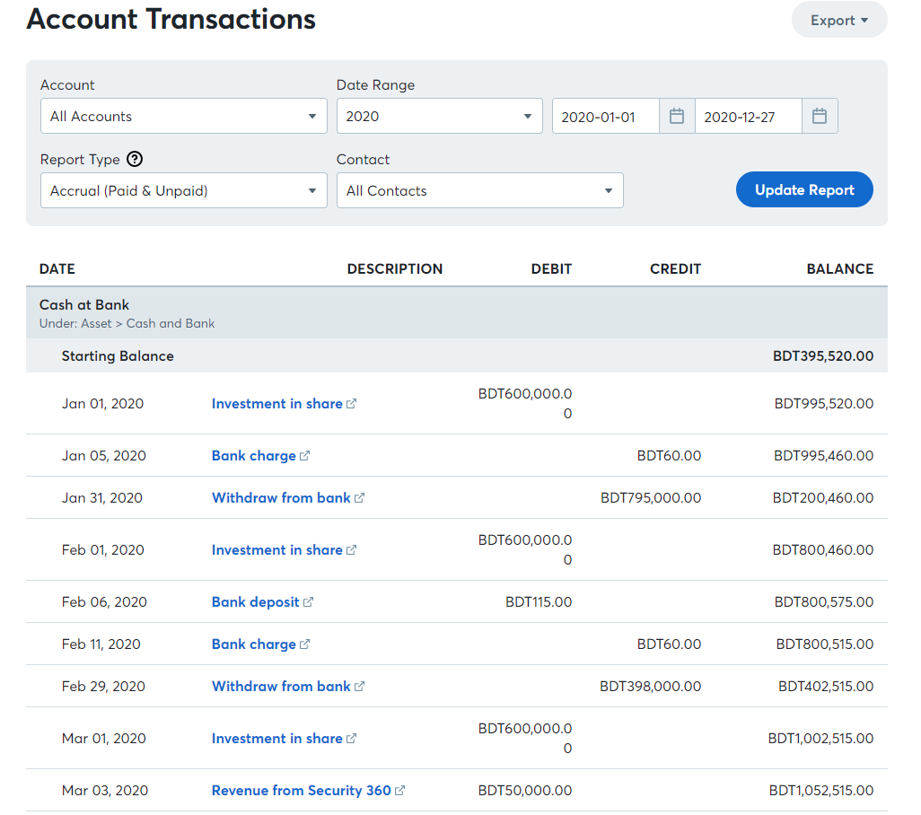
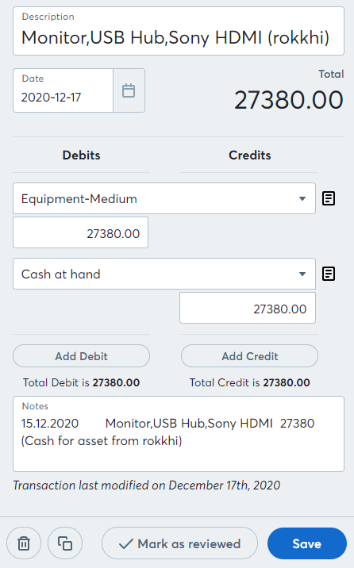

Figure 9: Journal Transactions
- Reconciliation: Then in reconciliation part software calculate the bank related transactions. So that company identify the difference between bank and cash transaction for reducing the errors. In Rokkhi we collect the month end bank statements then match with the software transaction maintain the bank reconciliation.

3.6 Reports
Financial statement analysis can benefit organizations from numerous points of view. It furnishes interior and outer partners with the opportunity to settle on educated choices in regards to contributing. Financial statement analysis likewise gives loaning organizations an unbiased view of a business financial health, which is useful for settling lending decision. Finally, financial statement analysis helps with matters of corporate governance as well. In organization life cycle Rokkhi Limited is now in introductory stage that’s why their financial statement still in negative balance because still they are spending their capital to grab the place in market and they expect after one year they reached their aim.
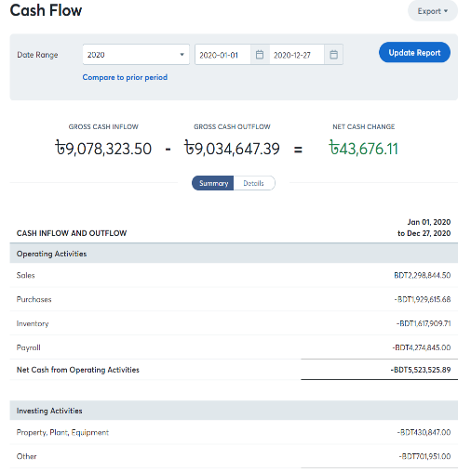
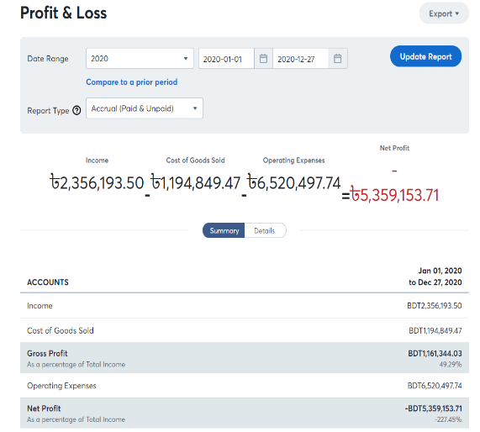

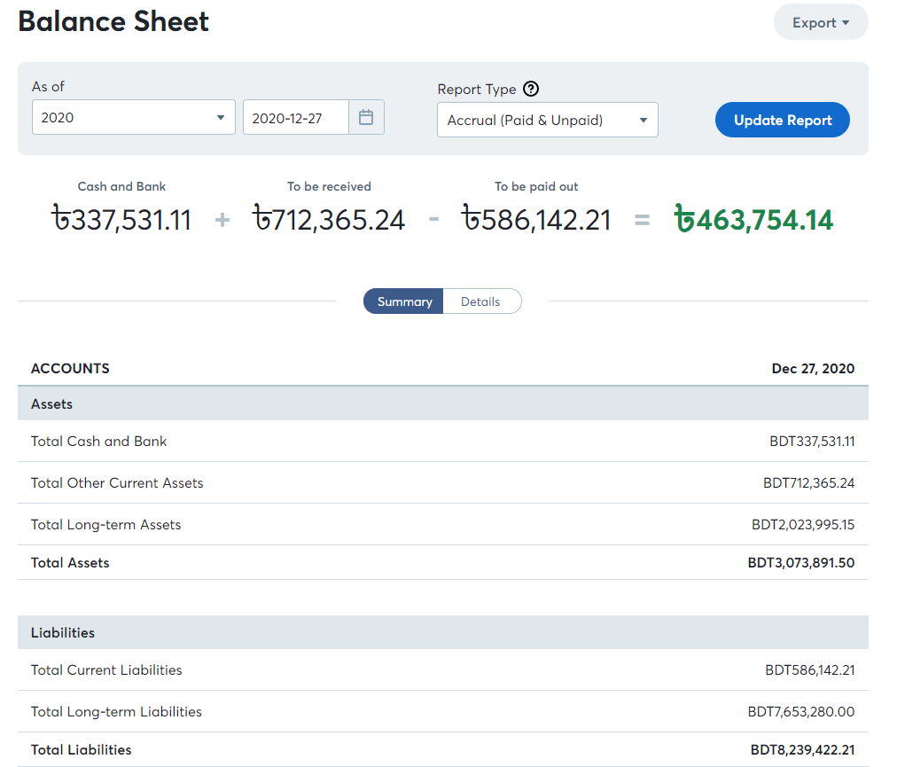

Figure 10: Financial Statements

In this portion wave software share their all financial reports and results. As we know in accounting there are three types off report represent the organization overall financial condition like, profit and Loss statement, Balance Sheet statement and Cash flow statement. Same as after given the proper input of transaction entry then wave software share the automatic output. When we check those report for analyze then we open this report option and collect the require findings through those reports. In this process rokkhi maintain their financial statements and reports.
So those are the core features of wave software where a startup or a small entrepreneurship business can easily manage their accounting sector. In this software there is a dashboard. In dashboard it’s basically the short brief about the organization financial situation graphically. It looks appealing, anyone can easily get about it. In short if someone wants to know about the company at a glance then this dashboard is adequate.

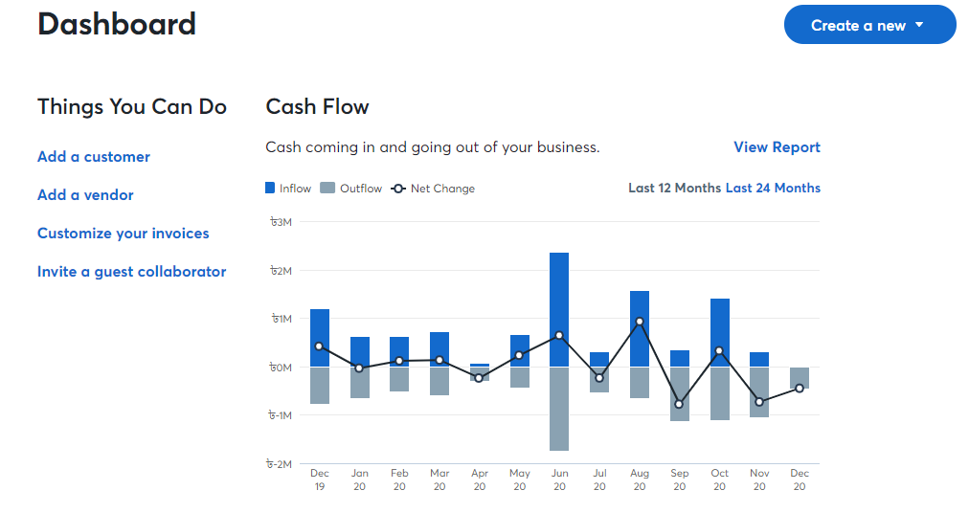

Figure 11: Software Dashboard (Graphical presentation)

3.7 Overall Accounts expenditure findings
Rokkhi Limited updated their daily expenditure through this wave software. In Rokkhi as an intern I manage their daily expenditure and update to the software. After my observation I separate the total expenditure based on different expense category such as Sales and wages, cost of goods sold (Covid-19 product), advertising and promotion, Meals and entertainment, Rent expense, Conveyance and others expense. Since it’s a startup company and their source of finance is in loan from other support organization as partners. Since they are new in the market that’s why they need huge promotion and advertisement for grab their targeted customers. That’s why 10.4% of the total cost has been spent on advertising expense. 15.5% of the total cost on covid-19 products for sale. Rokkhi Limited offer every employee lunch and two times snacks as well that’s why 8.7% of the total cost has been spent on meals and entertainment expense. And 55.4% of the total cost has been spent on salary and payroll purposes and 6.9% is for conveyance and others and rest is for rent expense. So this is all about the core expenditure ratio of Rokkhi Limited. (Database of Rokkhi (Wave Accounting software), 2020 (Updated))
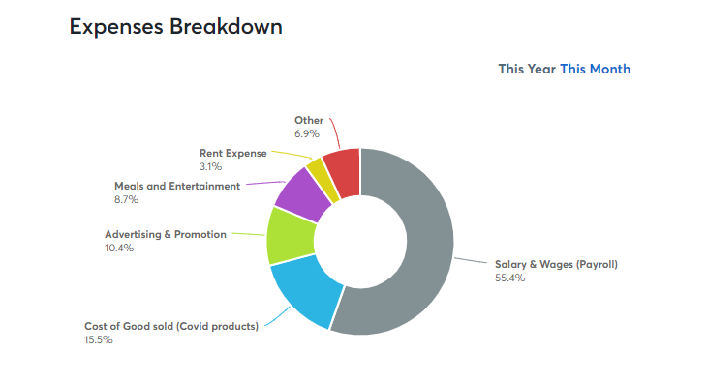

Figure 12: Expense breakdown 2020 of Rokkhi Limited

3.8 Advantages of wave software
I used to work with Quickbooks software but wave software is totally new for me. Since Rokkhi limited maintain wave software that’s why as an Accounting intern I have to learn it. In this three month I learned and practice this software practically. Through my practice and working period I observe some good points about this software, which I share below-

- Free software which is easy to create and run, very affordable. (Wave Accounting review, 2013-2020)
- Basic and quick information selection process and obviously cloud based.
- Financial reports are in depth enough that’s why In-depth and comprehensive financial reports for better for decision making.
- Saves time taken for endorsement of invoices and money distributions.
- Reduce manual paper work cost.
- This software is links to bank accounts that’s why bank reconciliation is also well maintained.

3.9 Disadvantages of wave software
In this world everything has two sides, while using this wave software I faced some problems as well. As a new user it’s really tough to identify the issues. Now I Share about the drawbacks of this wave software.
- Since it’s a free software, there is a high chance to insecurity.
- It does not handle inventory well at all.
- Some features design is unclear to understand.
- Though software is free but to run this software needs a professional one which is costly.
- In Wave software sometimes it didn’t match with the pattern of organization dealings. So that time it’s hard to manage (Wave Accounting review, 2013-2020)

CHAPTER FOUR

RECOMMENDATIONS

&

CONCLUSION

Recommendations
After 4 years of academic study with accounting, I learn lots of things based on my learning areas I have share something. And also a couple of proposal or recommendations are recorded underneath based on my practical work experience by working in Rokkhi Limited and from the academic knowledge of Accounting for the improvement of the organization as well.
- In software it required proper documents and data. Since Rokkhi limited is a startup company, that’s why I faced lots of disorganized data which is really hard to manage that’s why I recommend to Rokkhi limited that manage all data and documentation properly so that near future those sort of issue will never happen.

- Wave software is a free software which is good. Though it’s a startup but when this company expend their business then my recommendation is company should move the software free to paid, for the future betterment of Rokkhi limited.

- Since Rokkhi limited maintain their accounts through software so company should hire a professional to maintain the software or after hiring an employee company should give proper training so that individual assigned person manages everything properly, which also well for the company.

- Rokkhi Limited is a software company. Their business is developing software but in my internship period I faced they do others business also though it’s also technology based. While doing the reconciliation I faced some problem that all the financial inflow came from several sources which is not a part of Rokkhi limited directly which create conflict while manage the accounts. That’s why my recommendation is if they use different Bank account for this several sources then it will be beneficial for the company.

- As a startup company their variable and others expense is not worthy at all which can hamper their business for the long run. That’s why my recommendation is they should minimize their expense sector at a minimum portion.

Conclusion
Accounting is the foundation of any business. As known to every organization requires accounting for maintain their finance and accounts. A few organizations feel free to enlist workers as their accountants and afterward there a few organizations which outsource their accounting. There are few company who additionally put resources into administrations gave to them by software for their accounting purposes. Accounting software is essentially computer based intended for you to record and handle all your accounting exchanges effortlessly. While a company maintain their accounts through software or computer based that means they follow Accounting information system through AIS company convert their accounts data to information for understand easily. The accounting software in Bangladesh accessible in the market can be utilized as some assistance or as an accounting advise tools. If there are certain transactions that are not clear for the accountants, at that point the accounting software in Bangladesh can be incredible assistance. “The accounting software in Bangladesh can easily manage all reports as well as booking for the business.” (Accounting software in Bangladesh , 2018)
That is Why Rokkhi limited maintain their accounts through wave software. They try to change their accounting system manually to digitally. They change the way they maintain their accounts properly right now each and every documents they maintain and preserve. Right now their accounts are much more organized and appealing as well. Since software share financial statements automatically which helps to know the situation easily. As a startup company Rokkhi limited manages their accounts through that means day by day Bangladesh also switch AIS based accounting. The purpose of preparing this report is to analyze the concept of accounting information system and to analyze the evaluation of Accounting Information System in Rokkhi limited. And also share some proposal as recommendation to improve their Accounting Information System.
As an accounting student I believe to know about Accounting information system is very important because world is changing. Everything run with the help of technology. Those days many students want to get familiar with the accounting software and become completely understand with it so, they don’t need to text their brain with any sort of computation.

References
Accounting software in Bangladesh . (2018). Retrieved from Troyee web site : https://troyee.com/
Bangladesh metro area population . (2020, june). Retrieved from macrotrend web site : https://www.macrotrends.net/cities/20119/dhaka/population
Bangladesh population: worldometer. (2020, june). Retrieved from worldometer web site: https://www.worldometers.info/world-population/bangladesh-population/
co...LT, n. E.-o. (2001). japan.
Company, M. (2014). Bangladesh.
Das, S. (2008). Accounting Information System of the Financial Institutions in Bangladesh. Accounting Information System of the Financial Institutions in Bangladesh.
Database of Rokkhi (Wave Accounting software). (2020 (Updated), December 29). Retrieved from Wave apps website : https://accounting.waveapps.com/dashboard/business/12515564/#/
https://www.worldometers.info/world-population/bangladesh-population/. (2020). Retrieved from www.worldometers.info.
Investopedia: Accounting Information System . (2020, May 10). Retrieved from Investopedia : https://www.investopedia.com/articles/professionaleducation/11/accounting-information-systems.asp
Liveplan: SWOT analysis . (2018, April 18). Retrieved from Liveplan web site : https://www.liveplan.com/blog/what-is-a-swot-analysis-and-how-to-do-it-right-with-examples/
pen, h. t. (2014). America.
Rokkhi . (2019, January ). Retrieved from Rokkhi web site : https://rokkhi.com/blog/about-us/
Rokkhi . (2019, January ). Retrieved from Rokkhi web site : https://rokkhi.com/blog/about-us/
Rokkhi. (2020, January ). Retrieved from Rokkhi web site : https://rokkhi.com.bd/
Wave Accounting . (2020, 12 25). Retrieved from Waveapps website : https://www.waveapps.com/
Wave Accounting review. (2013-2020). Retrieved from TrustRadius web site: https://www.trustradius.com/products/wave-accounting/reviews?qs=pros-and-cons
Wave help center . (2020, December 16). Retrieved from Wave: website: https://support.waveapps.com/hc/en-us/articles/115004085146-Is-my-information-secure-
Wikipedia: Economy of Bangladesh. (2020, December 28). Retrieved from Economy of Bangladesh: https://en.wikipedia.org/wiki/Economy_of_Bangladesh#:~:text=In%20the%20first%20quarter%20of,7.3%25%20real%20GDP%20annual%20growth.&text=The%20financial%20sector%20of%20Bangladesh,the%20world's%20fastest%20growing%20economies.

