Internship Report
on
developing and managing a consumer brand:
a study on farm fresh of akij food & beverage limited (afbl)
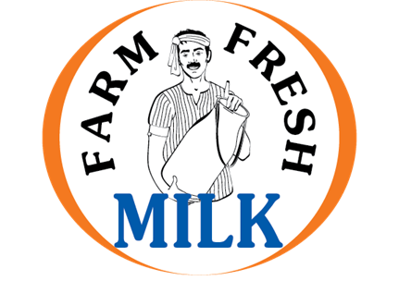

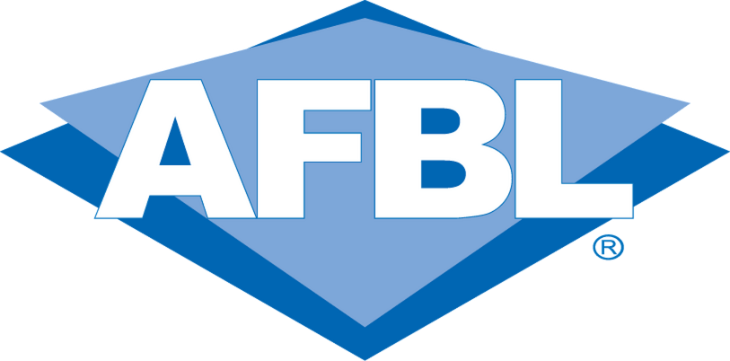
Brings Quality in Life



Internship Report
On
Developing and Managing a Consumer Brand:
A Study on Farm Fresh of Akij Food & Beverage Limited (AFBL)

Submitted to

Muhammad Hasan Al-Mamun
Assistant Professor, School of Business & Economics
United International University

Submitted by

Md. Iqbal Mahmud
ID# 111 142 158
BBA Program
School of Business
United International University
Trimester: Fall 2018

Date of Submission:

January 12, 2019

Acknowledgement

At first, I would like to convey my cordial gratitude to almighty Allah for giving me the strength and the self-possession to terminate the assigned job within time. Then I would like to thank my respected supervisor Muhammad Hasan Al-Mamun, Assistant Professor, School of Business & Economics, United International University, due to his gracious guidance. I am very grateful to him for guiding me in every situation.
At the same time, I also pay my heartily gratitude to Mrs. Tuhin Sultana, Brand Manager of Akij Food & Beverage Limited (AFBL), Mr. Abdullah All Kafe, Senior Executive Brand, Mr. Redwan Noor Ullah, Senior Executive Brand, B, Mr. Rezaul Karim, Senior Executive, Brand Marketing, of Akij Food & Beverage Limited (AFBL), Who extended their helping hands to me to gather practical knowledge & harmonize it with my theoretical learnings on Brand management.
Finally, I humbly appreciated the assistance of the entire work force of Brand Department at Akij Food & Beverage Limited (AFBL), for their time to help me out to know many things. However, there might be some errors or mistakes. As you know I am still in the process of learning, I hope your kind consideration in the years to come.

Letter of Transmittal
January 12, 2019
Muhammad Hasan Al-Mamun
Assistant Professor
School of Business and Economics
United International University
Subject: Submission of the Internship Report on Developing and Managing a Consumer Brand: A Study on Farm Fresh of Akij food & Beverage Limited (AFBL).
Dear Sir,
It is a great pleasure for me to submit my internship report on “Developing and Managing a consumer Brand: A Study on Farm Fresh of Akij food & Beverage Limited (AFBL)”. I have completed my internship period at Akij Food & Beverage Limited (AFBL) from 10th October 2018 to 10th January 2019 as a part of my BBA Program. It was a great experience to harmonize the theoretical and practical knowledge. I have tried my level best to explain my learnings and experiences briefly in this report.
I hope that my report will fulfill your expectations and my academic requirement and aid you in getting a clear idea about the project in hand.
Sincerely,
……………………….
MD. IQBAL MAHMUD
ID: 111 142 158
BBA Program
United International University

Executive Summary
Branding is a very important term in marketing. But it’s not an easy task to distinguish a brand from the competing commodities. It’s a very tactical and long-term process. This report tells all about developing and managing a consumer brand. During my internship period I got involved with the Brand Farm Fresh at Akij Food and Beverage Limited (AFBL). Where I had the opportunity to study and practically observe their branding practices and promotional activities across the company. Therefore, I intensified my report on the title ‘Developing and managing a consumer brand: A Study on Farm Fresh of Akij Food and Beverage Limited (AFBL)”.
Akij Food & Beverage Ltd. (AFBL) is a successful unit of Akij Group, which started its operation about a decade ago in the year 2006. AFBL manufactures a wide range of Snacks and Beverage items and Farm Fresh is one of their major brands which includes all dairy products. To be the leading food & Beverage brands excelling in product quality, social, technical & marketing creativity is the vision of AFBL. They also have specific mission. Goals, objectives based on clarified mission. In FMCG industry, they have many strengths including good reputation. According to Porter’s five forces theory, the analysis revealed that the FMCG market is very competitive; AFBL is doing fine through perfect use of strengths and opportunities. For this report, all the information has been collected from different primary and secondary sources. In this regard one-to-one interview and observations of works are done to collect data. And findings say that AFBL has big amount of budget for Farm Fresh every year only for branding purpose. Their R&D and Brand department play a great role here. After developing a product, they focus on developing brand strategy including STP and Marketing Mix program development; they do every possible thing to create a desired position in consumers’ minds. Their brand team runs all the types of campaigns over the year. Among ATL campaigns they have they have many popular Radio, TV programs and TVCs. Farmer is the one of their best TVC till now. Among BTL campaigns they have many sponsored events, including a signature campaign “Farm Fresh Children’s Day”. They have many digital contests and communication plans based on various occasions under the TTL campaigns. Even after the campaigns AFBL measure the brand equity performance and takes further decisions.
Key Words: Consumer Brand, Brand Performance
Contents

Introduction 1
i. Topic in Hand: 1
i. Context of the Study: 2
Organizational Background and Industry Perspectives 4
i. Organizational Background 4
ii. Industry Perspectives 7
Objective and the Methodology of the study 11
i. Objective of the study 11
ii. Methodology of the study 11
Findings of the study 13
Limitations of the study 31
Recommendations & Conclusion 32

Introduction

Topic in Hand:
A brand refers to an identity of a product or service, which is publicly distinguished from other products or services so that it can be easily communicated and usually marketed to the consumers.
Originally, the term "Brand" was used for referring to the mark that cattle ranchers “Branded” on their cattle, the idea of a brand has evolved to encompass much more than just a name or a symbol. Your brand, a vital part of your brand identity, is defined as a name or a type of product manufactured by a particular business. A brand identity is made up of what your brand says, what your values are, how you communicate your concepts, and the emotions you want your consumers to feel when they interact with your business. Essentially, your brand identity is the personality of your business and a promise to your consumers.
As Jeff Bezos says, “Branding is what people say about you when you’re not in the room." (Kathryn Wheeler, 2015)
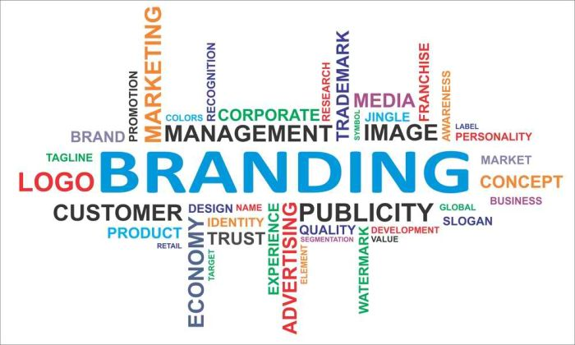
For example, when you hear the name Coca-Cola, you probably picture its well-known logo, but you also might think of the polar bear, the color red, its “Open Happiness” campaign, or the classic ribbon-like imagery featured on its pet bottle or cans. All of these aspects are what make up the Coca-Cola brand, not just the logo of the business.
So, it can say undoubtedly that Branding is a very important term in marketing. But it’s not an easy task to distinguish a brand from others. It’s a very tactical and long-term process. This report is all about developing and managing a consumer brand.

Context of the Study:
A strong brand is invaluable as the battle for customers intensifies day by day. It's important to spend time researching, defining, and building your brand. After all, your brand is the source of a promise to your consumer. It's the centerpiece of your marketing communications and an identity you do not want to be without. Lots of promotional campaigns are lunched to brand a product. More the campaigns are unique, quicker the establishment is possible in the market.
Food industry is a rapidly growing sector than others in Bangladesh. By employing a significant portion of the labor force in the country. Between 2004 and 2010, the food processing industry in Bangladesh grew at an average 7.7 percent per annum. According to Bangladesh Bureau of Statistics, in its 25006 Economic Census, there were approximately 246 medium-sized food processing industries employing 19 percent of the industrial manufacturing workforce in Bangladesh or 8 percent of the total manufacturing labor force. The food industry employs 2.45 percent of the country’s total labor force and its share in the GDP was 2.01 percent in 2010. There are also numerous small-scale factories and domestic units engaged in food processing throughout the country. According to some industry analysts, the food processing sector in Bangladesh is a 4.5 billion US Dollar industry. In 2010, Bangladesh exported over $700 million worth of processed food and beverages, over 60 percent of them were shrimp and fish products.
Akij Food & Beverage Limited (AFBL) is one of the major concerns of Akij Group which has many Consumer Brands of Food and Beverage items in the market. We know, Branding can be applied to the entire corporate identity as well as to individual product or service name. There are some regular branding practices in FMCG industries. To create a brand identity for a particular product a like Farm Fresh, the brand team of AFBL need to do lots of things with the collaboration of R&D (Research and Development) team. It includes researching the audience, making value proposition, to know the competition in the market, deciding brand name, logo, symbol, color, theme, lunching campaigns, advertisement and many more. They also need to know what to avoid and what to do, to monitor the brand in proactive way. For being involved with Farm Fresh, here among all the brands of AFBL I am going to discuss about it. Farm Fresh mainly contains all the dairy products of Akij Food & Beverage Limited (AFBL). In food industry dairy is one of the growing fields. It mainly refers healthy food items for the consumers. Dairy products have higher demand to the health-conscious people as well as who like to cook various recipe, so, it has also demand in the restaurant industry. Arong Dairy and Pran Dairy are holding the most of the market share in Bangladesh. Farm Fresh is in third position now. So, Farm Fresh is trying hard to go to the top through their innovation in branding. In this report I will try to present the whole branding activities to develop and manage the brand “Farm Fresh” of Akij Food & Beverage Limited (AFBL).

Organizational Background and Industry Perspectives

Organizational Background

Akij Food & Beverage Ltd. (AFBL) is a successful unit of Akij Group, which started its operation about an era ago in the year 2006. AFBL manufactures a wide range of Snacks and Beverage of both National & International Market alike. AFBL is a Project worth $70 million & is founded by the Parental Company Akij Group. It started its production at 400 bph in the carbonated soft drinks line which is known as CSD line and 300 bph in the juice line. In a span of one and a half years they have increased their capacity to 1800 bph amazingly. At present their capacity one is at the ground-breaking rate of 1900 bph. So, in approximately three years’ time their capacity has increased three folds, which is a great thing. And during this same period most of their brands became either number one or are almost on the verge of becoming number one in their respective categories. AFBL is very quality conscious so, most of their machineries have been imported from world famous brands as Crones, Tetra Pak, Alfa Laval, Sipa, Risky to achieve and ensure the best quality.
AFBL: Vision, Mission, Goal & Objective:
Vision of AFBL
To be the leading food & Beverage brands excelling in product quality, social, technical & marketing creativity; and service to the customers through the skills and commitment of employees.
According to Late Mr. Sheikh Akij Uddin regarding Akij Food and Beverage Limited (AFBL)-
“We will manufacture and introduce those high-quality products in the market that we ourselves and our family will always use; we will not just produce products for the consumers in the market and let our family consume other foreign products” (Regan Rose, 2013).

Mission of AFBL
To deliver quality food and beverage to the market thus bring quality to the life of the consumers by fulfilling their needs.
Goal of AFBL
To gain profitability by means of acquiring the market share and create strong brand position in consumers’ mind.
Objective of AFBL
The main objective of the company is to increase the market share in related diversified. Products in Bangladesh assure the potential customers of the quality and durability of the products.
AFBL: Morale, Ethics & Values:
- Believing in quality and excellence in service.
- Believing open communication, personal responsibilities, integrity, and active participation;
- Supporting the creative diversity and share of ideas.
- Building culture of learning based on leadership, teamwork, accountability, and co-operation.
Business Philosophy:
Akij Group diversified their business in Food & Beverage industry because in Bangladesh there are about 18 corers people. It is undoubtedly a large market size to serve and food is required continually for the population. (AFBL) always try to serve quality food for their target market.
In soft drink industry, we know there are many local & foreign companies. (AFBL) want to be local unique soft drinks producer with the same quality of foreign company. For this purpose, AFBL produces CSD for young target group who like to live stylist life.
Main slogan of AFBL is “Brings Quality in Life”. Its more than a promise and they try harder to keep it. (AFBL) has its own marketing & sales department in AFBL chamber. The functions of this department are very wide and dynamic. Main functions performed by this department are:
- Product development
- Raw material sourcing
- Find out or create market for its product
- Price set up
- Packaging development
- Developing communication strategy
- Preparing sales forecast
- Maintain sales management in the field
- Keeping record of sales and stock
- Collection & analysis of competitors information
Beside these, it performs a number of activities to conduct their day-to-day business. Under marketing & sales department, a Brand team performs the key role of pure marketing.

AFBL BRANDS:
- Cola -MOJO
- Cloudy Lemon- Lemu
- Orange CSD Drink- Twing
- Clear Lemon -Clemon,
- CSD Alternative -Speed, Houston, Hero (Discontinued)
- Spicy Drinks -Aafi Jeera Pani, Clemon Masala
- Mineral Water- Spa, Rivera, Aafi
- Fruit Drink- Frutika (Mango, Red Grape, Apple, Orange, Pineapple. Guava,), Aafi (Mango drink; orange drink)
- Dairy -Farm Fresh UHT milk, (Including Mango flavored milk, Chocolate flavored milk), Farm Fresh Pasteurized Milk, Farm Fresh Ghee, Farm Fresh Butter, Farm Fresh Yoghurt (Sweet, sour, low fat).
- Malt Beverage -Wild Brew
- Snacks -Cheese Puffs, Aafi Chanachur, Afi puffed rice
- Fruit Bar - Aafi Mango Bar

Industry Perspectives
- SWOT Analysis of AFBL

SWOT analysis is basically a scan of the internal & external environment which is an important part of strategic planning and decision making for an organization. The word ‘SWOT’ contains four factors- Strengths, Weaknesses, Opportunities, and Threats. Among these the internal factors are Strengths(S) & Weaknesses (W) and the external factors are Opportunities (O) & Threats (T).
Strengths and Opportunities represents positivity, in the other hand Weaknesses and Threats represents negativity.
The SWOT analysis provides important information which is very helpful to allocate the resources perfectly by considering capabilities to achieve the competitive environment.
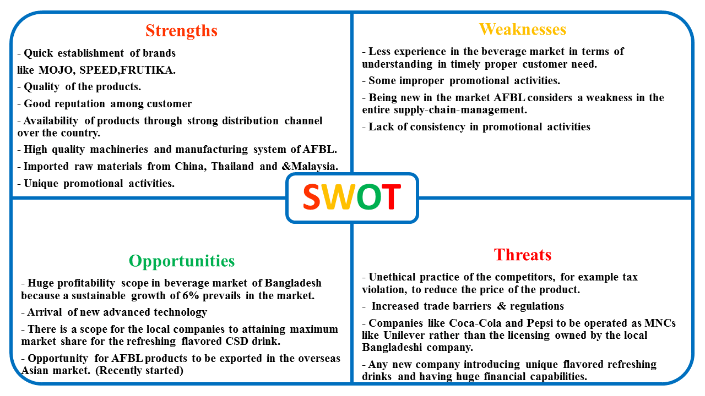
The following diagram shows a SWOT analysis of AFBL.

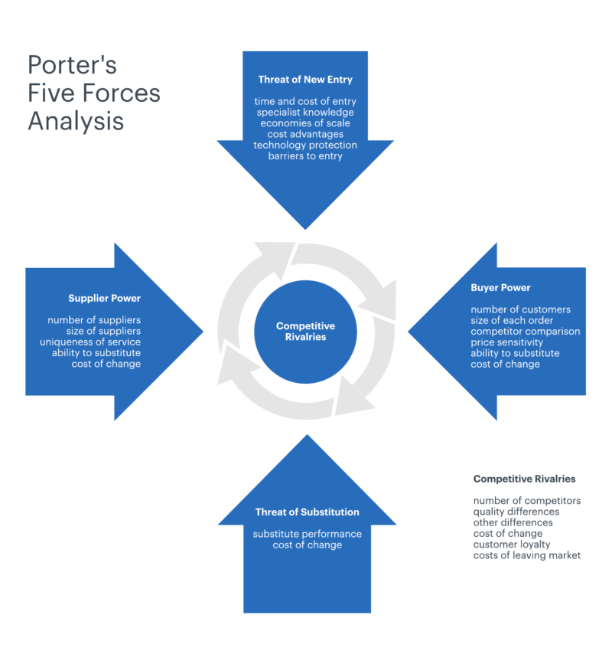
- Competitor Analysis of AFBL:

Porter’s Five Forces Model Analysis on AFBL
Criteria | High | Moderate | Low
Competitive Rivalry Between existing competitors | 
Threat of New entrants
Threat of Substitute Products
Bargaining power of Suppliers
Bargaining power of Buyers

Reasons:
- Competitive Rivalry Between Existing Competitors:
From previous discussion you know that there are some international giants as well as strong local competitors in the market so the competitive rivalry is very high.
- Threat of New Entrants:
As there are already some international giants as well as strong local competitors in the market, the possibility of entering new competitors is very low.
- Threat of Substitute Products:
In FMCG sector, already there are many substitute products of AFBL. But some competitors still didn’t bring substitute products, so it’s a high threat of arising more substitute products in the market.
- Bargaining Power of SUPPLIERS:
As the existence of competitors are very high in the market, the Bargaining power of Suppliers should be very high, but AFBL manage to collect their raw materials by their own, for example they have their own mango pulp factory for making fruit drinks, in some cases when they import, they maintain a very strong relationship with the suppliers which makes task easier.

- Bargaining power of Buyers:
The existence of many substitute product provides many options to the consumers. They can switch products for any reason. So, consumers have high bargaining power in their hand.

Objective and the Methodology of the study

Objective of the study
Broad Objective:
The main objective of the study is to know the branding practices of AFBL through which a brand is developed and managed.
Specific Objective:
For being involved with Farm Fresh during my internship period, I am going to discuss about this particular brand through the report. Most importantly I am going to describe branding initiatives and activities of Farm Fresh at AFBL.

Methodology of the study
The study is exploratory and descriptive in nature. For Data collection it has employed both primary and secondary sources.
Primary Sources:
- One to one interview was conducted for gathering information from different people of brand department in different time.
- Interviews with the people related with Research and Development (R&D) Department.
- Communication with Media, trade and creative department of AFBL.
- Direct Observations of regular activity and cases.

Secondary Sources:
- Information collected from Company Websites.
- Information collected from Facebook profile of AFBL and Farm Fresh.
- Various publications in online.
- Brand related information from the Text book.
- Data from different official sources and records.
Research Approach: One to one Interview and Observations of daily tasks.
Types of Questions: Open ended questions
Sample Size: 7 Persons
Mode of Collection Data: Convenience sampling technique was used to select sample
Methods of Data Collection:
I have tried my hardest to do a qualitative research where it took me one to one interview from many higher executives of AFBL. I focused my full study on the most preferred brand Farm Fresh of AFBL. I talked to them several times during my internship period. I also visited market to generate vital information. The study is enhanced through interviews of 7 resource persons. Among them one was manager, one assistant manager, two senior executives were from core brand department, rest of them were from Digital Media, Trade and R&D department. Afterwards, all collected data have been summarized, organized and finally prepared for report purpose.

Findings of the study
Farm Fresh- A Brand of AFBL
Among all the eight brands of AFBL, one of the major brands of AFBL is Farm Fresh. It contains basically all dairy products such as Farm Fresh UHT milk, (Mango flavored, Chocolate flavored), Farm Fresh Pasteurized Milk, Farm Fresh Ghee, Farm Fresh Butter, Farm Fresh Powdered Milk, Farm Fresh Yoghurt (Sweetened, sour, low fat).
Initiation:
The brand entered the market in September in 2007
Ranking:
3rd (Among dairy brands)
Tagline: “Farm Fresh Khao Agiye Jao” (present)
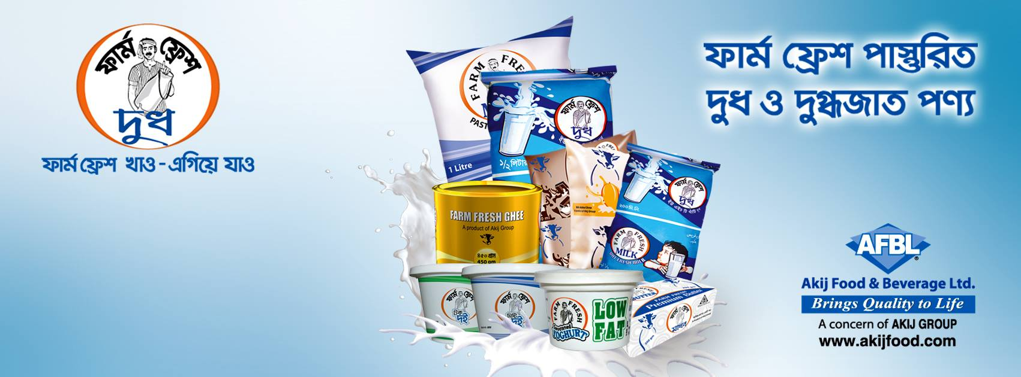
USP: Farm Fresh Collect the organic pure milk from the farmers and hand over its products to the consumers after processing with the best possible way.

- Both Brand and R&D department play a great role to develop and manage a consumer brand of a company. According to my observation and information, at AFBL their total sequential branding practices look like this-
  - Product development process: To develop a product, everything goes through 6 steps of process at AFBL.

Step 1: Idea Generation
The process begins with ideas of various sources. It included suggestions of dairy products from R&D specialist, consumers, sales force, suppliers, retailers, independent inventors etc. Here dairy products were just an idea for them.
Step 2: Screening
Here the best and potential ideas were chosen from various ideas. The potential products were selected first like pastoralized and UHT milk, ghee, yoghurt, butter etc. which can meet company objective.
Step 3: Business Analysis
Then overall business was analyzed to evaluate those product’s potentiality in the market, growth rate, strengths, financial and technical requirements etc.

Step 4: Development
It included the conversion process, by which those selected products were developed. This was the visible form of the idea of dairy products. UHT milk, ghee, yoghurt, butter etc. achieved their physical existence.
Step 5: Test Marketing
The intension of this step is to gauge customer reaction. Here some of those dairy products were marketed silently to know how those products will perform in real life.
Step 6: Commercialization
The final stage where the product was available for full scale marketing. Finally, all those products were ready to be marketed with promotional campaign.
  - Segmentation, Targeting & Positioning (STP):
Segmentation(s):
Geographic
Continent | Asia
Country | Bangladesh
City | All Major Cities of Bangladesh
Size/Population | Approximately 6 cores
Demographic
Gender | Female
Age | Basically 30-40
Income | Minimum 5000
Occupation | Any
Psychographic
Social Class | Middle class, Upper middle class
Life style | Health Conscious, fantasy on making different recipe
Behavioral
User Status | Potential users, Regular users
Benefits | Better service and quality
Attitude | Positive

Targeting (T):
Target Market
- Urban
- Semi urban
Target Market Segmentation
- Women who are Conscious of their children’s health as well as Like cooking.
More specific target:
- Mid aged Women (Focused 30-40 years old)
Positioning (P):
Farm Fresh for long run creates a certain position in the consumer’s mind through indicating pure milk products. Its brand positioning has always been as a fresh and pure source of Milk which inspire women to choose this brand for their children as we as themselves to cook. This Brand includes some POD, POP and benefits of the products for a daily healthy life around its brand image.
Point of Difference (POD):
- Attractive brand name & easy to pronounce
- Indicates purity
- Packaging and style
- Better and Enriched
Points of Parity (POP):
- Consistency in taste for some products
- Properly delivered
- Strong Brand image
Benefit: The benefit that consumer perceives are-
Functional: Fresh and Pure
Emotional: Energy to go ahead.
  - Marketing Mix (4ps): Product, Price, Place, Promotion

Product: Farm Fresh has the highest number of SKU’s among all brands of AFBL
Farm Fresh SKU’s (Stock Keeping Units)
SKU | Code
Farm Fresh Pasteurized Regular 1000ml Poly Pack | FPOP
Farm Fresh Pasteurized Regular 500ml Poly Pack | FPHP
Farm Fresh Pasteurized Regular 200ml Poly Pack | FPQP
Farm Fresh Flavored Mango 200ml Poly Pack | FMQP
Farm Fresh Flavored Chocolate 200ml Poly Pack | FCQP
Farm Fresh Flavored UHT Mango Milk 200 ml | FFCMHQT
Farm Fresh Flavored UHT Chocolate Milk 200 ml | FFMMHQT
Farm Fresh Yogurt Sweet 500gm Box | FYSHB
Farm Fresh Yogurt Sour 500gm Box | FYUHB
Farm Fresh Yogurt Sweet 100gm Cup | FYSMC
Farm Fresh Yogurt Sweet 100gm Cup Low Fat | FYLMC
Farm Fresh Ghee 900gm Tin Box | FGO
Farm Fresh Ghee 450gm Tin Box | FGH
Farm Fresh Ghee 200gm Tin Box | FGQ
Farm Fresh Ghee 1000gm Bulk | FGB
Farm Fresh Butter 200gm Box | FBQ
Farm Fresh Butter 50gm Cube | FBM
Farm Fresh Butter 5000gm Bulk | FBB
Farm Fresh UHT 500g | FFHT
Farm Fresh UHT 200g | FFQT

Price:
Competitive Price: As the dairy market is very price sensitive, the price is close to the competitors’ price
Market Oriented Price: Farm Fresh considers the market-oriented price using a single price in all area.
Product | Size | MRP(Tk)
Farm Fresh 200ml UHT | 200ml | 22
Farm Fresh 500ml UHT | 500ml | 45
Farm Fresh Chocolate Milk 200 ml-UHT | 200ml | 20
Farm Fresh Mango milk 200 ml-UHT | 200ml | 20
Farm Fresh 200 ml Pasteurized | 200ml | 16
Farm Fresh 500 ml Pasteurized | 500ml | 35
Farm Fresh 1000 ml Pasteurized | 1000ml | 65
Farm Fresh Chocolate Milk 200 ml | 200ml | 20
Farm Fresh Mango Milk 200 ml | 1200ml | 20
Farm Fresh Ghee 200gm Tin box | 200gm | 225
Farm Fresh Ghee 450 gm Tin box | 450gm | 430
Farm Fresh Ghee 900 gm Tin Box | 900gm | 870
Farm Fresh Ghee 1000gm Bulk | 1kg | 770
Farm Fresh Yogurt Sweet 500 gm box | 500gm | 80
Farm Fresh Yogurt Sweet 100 gm cup | 100gm | 20
Farm Fresh Yogurt Sour 500 gm Box | 500gm | 70
Farm Fresh Yogurt Low Fat sweet 100 gm Cup | 100gm | 20
Farm Fresh Butter 50 gm | 50gm | 40
Farm Fresh Butter 200 gm | 20gm | 160
Farm Fresh Butter 5000 gm | 5kg | 3100
Place:
Coverage
Region | Area
Dhaka South | Dhaka – 1, Dhaka – 3, Zinzira, Narayanganj
Dhaka North | Dhaka – 2, Dhaka – 4, Gazipur, Narshingdi
Mymensingh | Mymensingh, Tangail
Chittagong | Chittagong – 1, 2, 3
Comilla | Comilla, Chandpur, Noakhali
Sylhet | Sylhet, Moulavibazar
Jessore | Jessore, Khulna, Kustia
Barisal | Barisal, Faridpur
Bogra | Bogra, Rajshahi, Rangpur, Dinajpur

Promotion:
- Advertising:
Farm Fresh creates a positive brand image in target consumers mind through their advertising campaign strategies in order to win long-term customers. For any kind of advertising issue of Farm Fresh, Mediacom Ltd and Adcomm Ltd (agency) work most with AFBL. For any promotional campaign of Farm Fresh, AFBL generally use three types of advertisement tool- newspaper, billboard, and electronic media advertisement.
- Direct Marketing:
This is the era of internet, Farm Fresh gives special importance to promote the campaign through their Facebook page, YouTube, and official website.
- Sales Promotion:
Farm Fresh gives short term incentives to both retailer and consumer. For example, free sample to customer at different sponsored event or campaign, Point of Sales Material POSM (Point of sales material): poster, sticker, buntings, Milk Boxes, Recharge cards PVC, vinyl sticker, dangler as display, 3 or 4 Farm Fresh Product free per case to retailer etc.
- Personal Selling:
Farm Fresh generally avoids this promotion but they count corporate selling as personal selling for example providing Farm Fresh to super shop of ACI (SWAPNO) as well as in many renowned hotels.

- Public Relation:
Public relations (or PR) involve a sustained attempt to develop reputation as a business by using the media to help create the image company desires. It is a way of keeping the business in customers’ eyes.
Farm Fresh relates a large number of interested public by the following:

- Press relations with local newspapers like, Prothom Alo, Dhaka Tribune, Somokal, Kaler Kontho etc.
- Sponsoring big events and charitable donations.
- Cosponsoring events related with children.

Touch point
 | Visual | Operational | Both
TVC
RDC
Digital Engagement
BTL Activity
Retail Branded
Logo

  - Connecting Brand Equity with Promotional Campaign:
There’s no common viewpoint to conceptualize or measure brand equity. It generally focuses the branding role in marketing activities. Farm Fresh from its inception came up with extensive advertisement targeting mainly mid aged people of the country which results in better brand equity in the previous years in spite of having international giants in the same market. Rather than conventional promotional mix, Farm Fresh categorized all its promotional activities into three basic campaigns.

- Campaign Mode: ATL, BTL & TTL
ATL (Above the Line): Above the line marketing includes mass marketing strategies which are largely untargeted and are focused on building the brand. It basically covers TVC, RDC, SMS integration etc.
- Farm Fresh’s ATL Promotion:
Radio:
They don’t have many radio programs but they use this platform mainly for RDC in different promotional campaign.
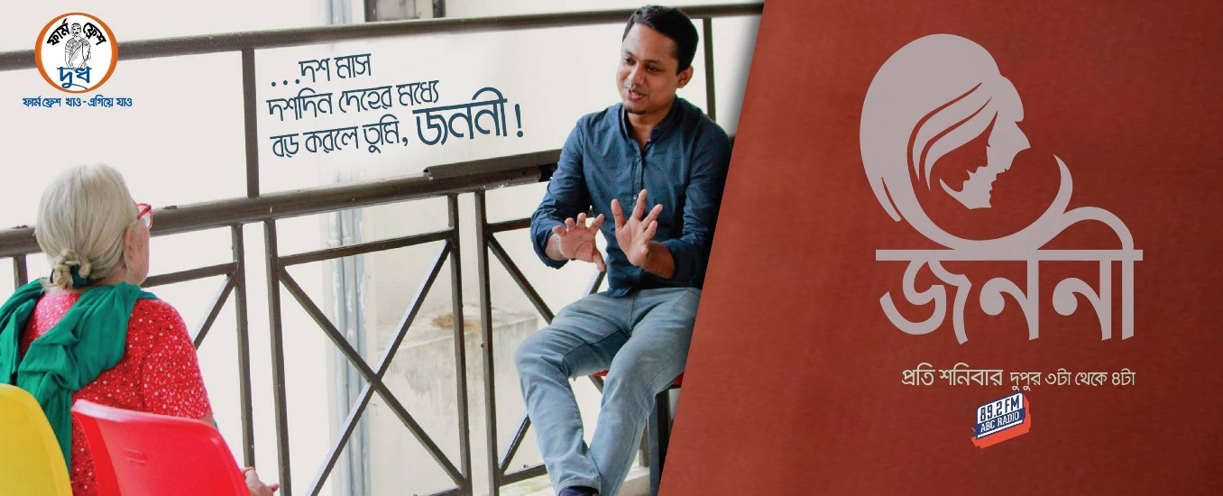
- They had a program in ABC Radio called ‘Janani’ which is based on mother’s story, was one of the popular radio programs.

- Farm Fresh also make a Radio program at ABC radio with the, Fresh Mom n Me participants. Though it’s a digital contest run through the Farm Fresh Facebook page of Farm Fresh, the top participants get this opportunity to go on air at ABC radio.

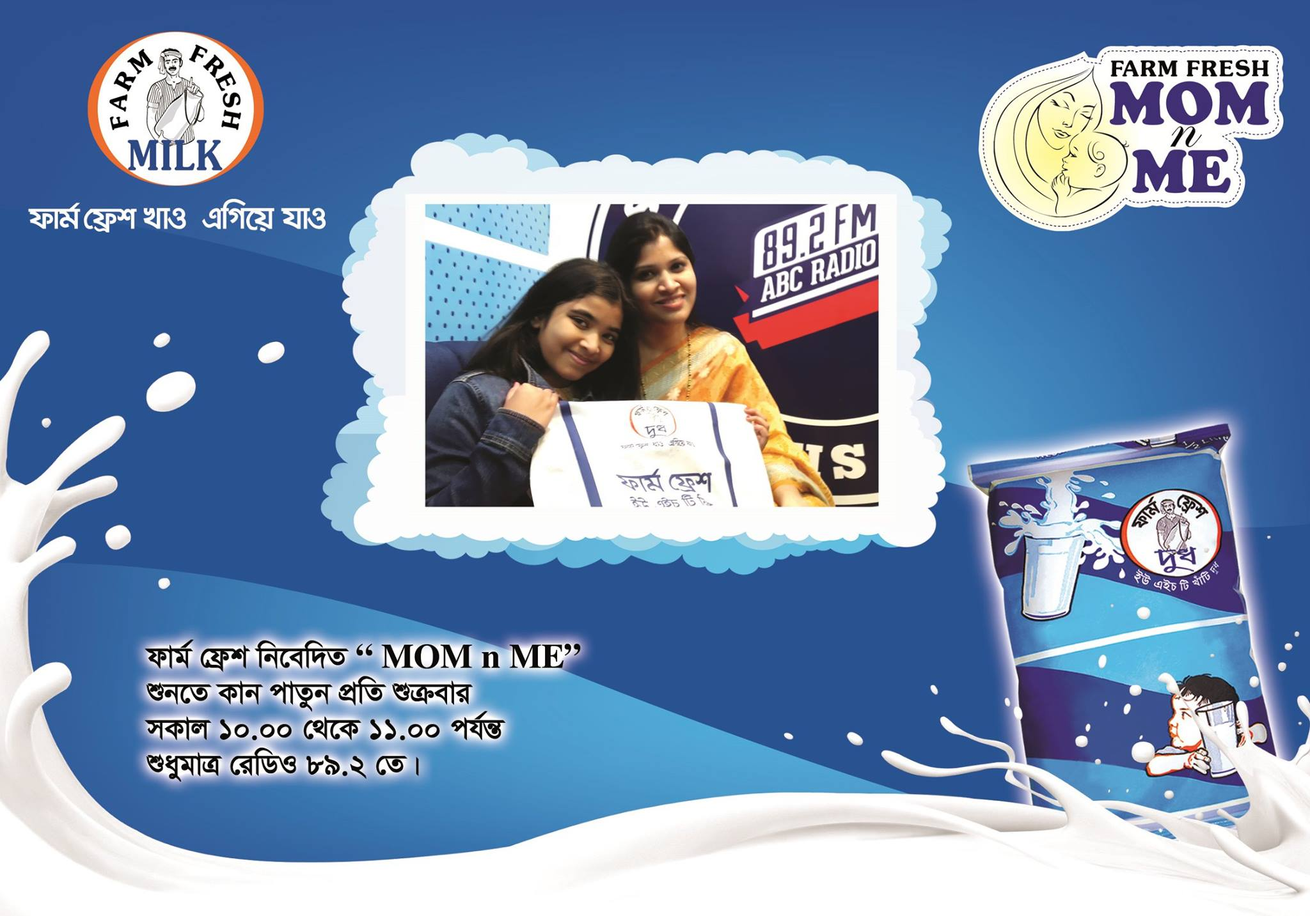
Television:
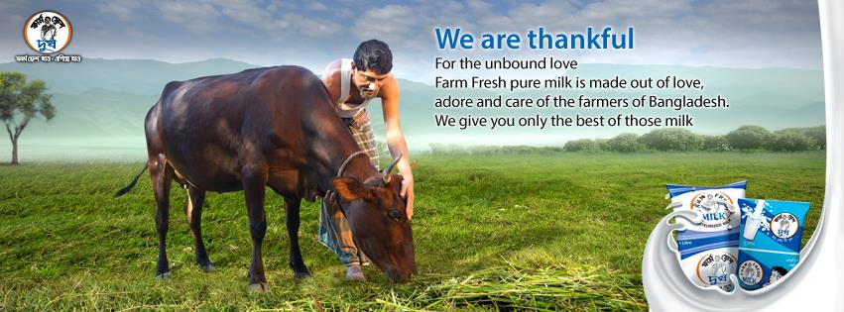
- In 2017, Farm Fresh made a TVC called FARMER, which shows an emotional attachment of Farmers and their Cows including caring, nursing, loving scenarios. And how milk is finally collected from them and hand over to the Mothers.

This year, in 2019 another huge budgets spending TVC is under planning. Probably this shoot will take place in South India.

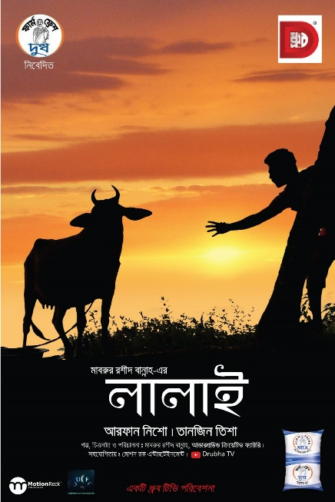
- Thematic campaign- Farm Fresh launched two TVC in 2013 & 2015, both were thematic campaign, which represented a connection to go ahead from exciting childhood to their goals and dreams with Farm Fresh.
- Farm Fresh used to sponsor many dramas and other Programs in different occasions in different TV channels. Where Farm Fresh ad and logo were shown and the name is announced to seek the attention. Some popular TV programs are mentioned bellow,
- Farm Fresh Presents Dramas- Harmonika, Surasur, Lalai, Sikkhito Bouta, Long Live Fazlul, Miss you Baba etc.
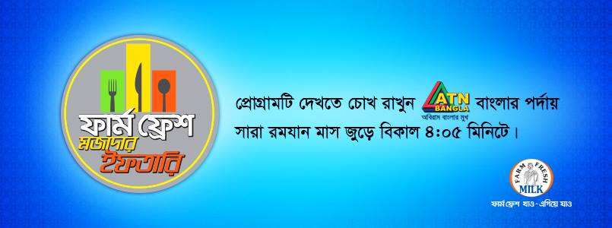
- And In every Ramadan, they also lunch a program called Farm Fresh Mojadar Iftar.

BTL (Below the Line): Below the line marketing include direct marketing strategies directed to specific target groups and focused on conversions rather than building the brand. It includes all kinds of Campaign, outdoor advertising, Direct mail, sponsorship, public relations and in store promotion.
- Farm Fresh’s BTL Promotion:
Farm Fresh’s signature campaign:
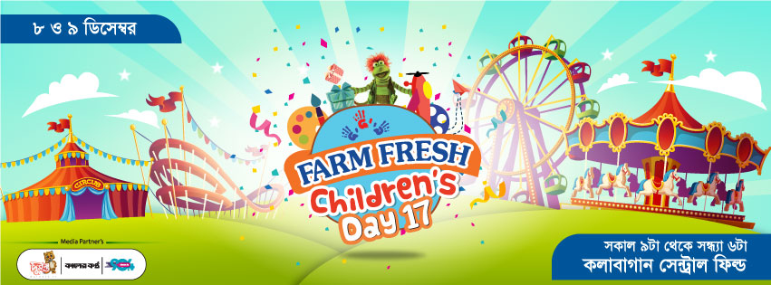
Farm Fresh Children’s Day: In every year Farm Fresh celebrates the International Children’s Day. This program includes a lot of arrangements to entertain the children with their family. To connect the people with the brand it continues for 2 days long, and it offers kids play zone, circus, sisimpur, bioscope, 9D movie, kids book stall, art competition, hand writing competition, nutrition booth, game zone, fun ride zone, photo zone, puppet show, cultural show and many more. It also offers open cooking stage for the mothers.

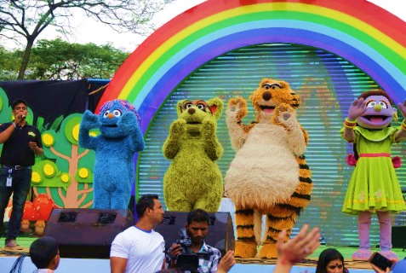
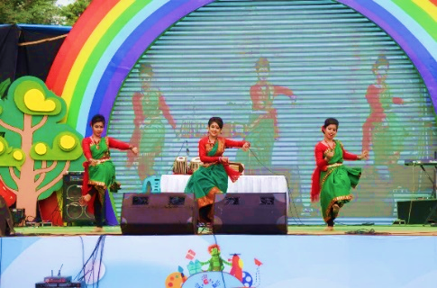
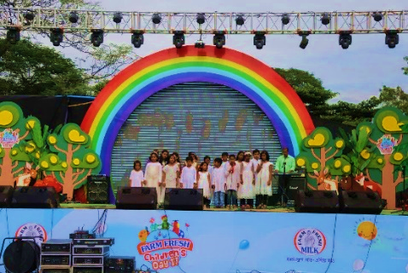

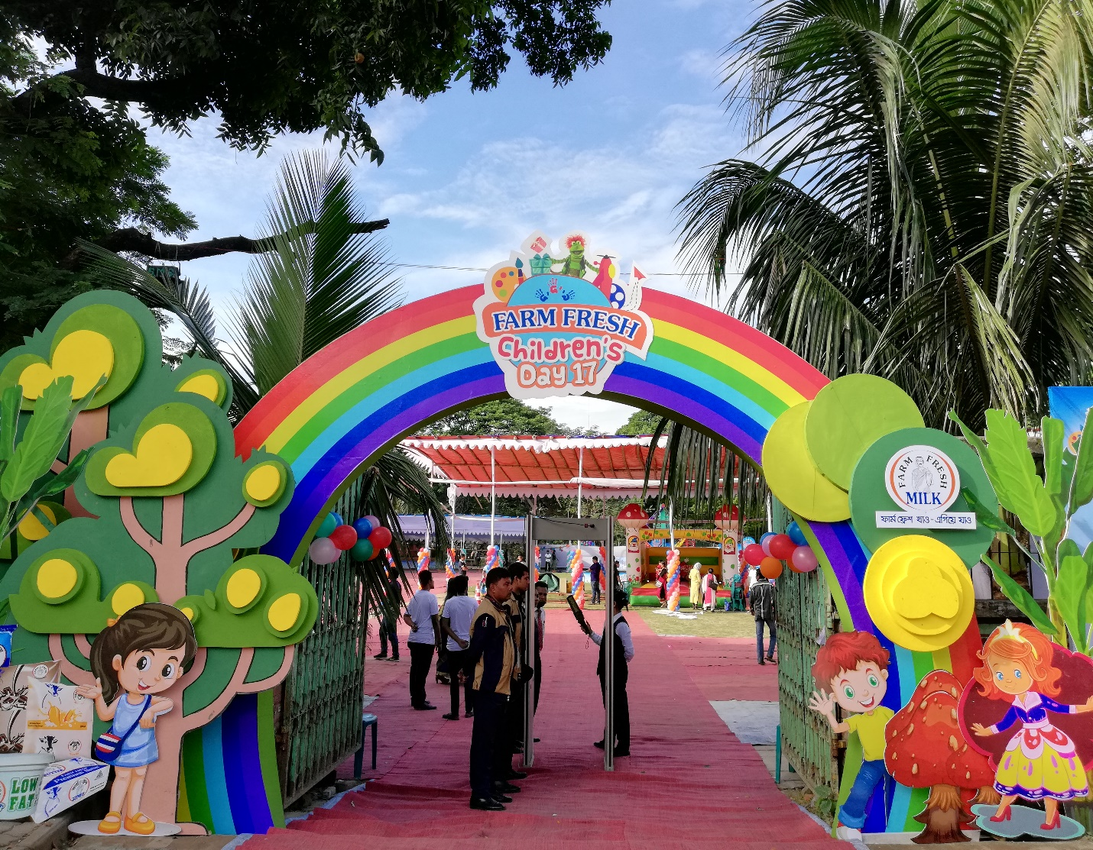
Sponsored event:
Farm Fresh often gets sponsorship proposal across school-college-varsity program, event, and campaign. In that case Farm Fresh extracts some promotional advantages like-
- Banner, poster promotions
- Digital Promotions (promotional videos, posts, links)
- Pre-event campaigns (online & offline like road show strategy + volunteers T-shirt, ID card etc.)
Some of the remarkable sponsored events of Farm Fresh’s are-
- Farm Fresh Presents 4th UCMAS Bangladesh, Abacus & Mental Arithmetic National Competition-2018. Which took place in: Institution of Diploma Engineer, Kakrail.
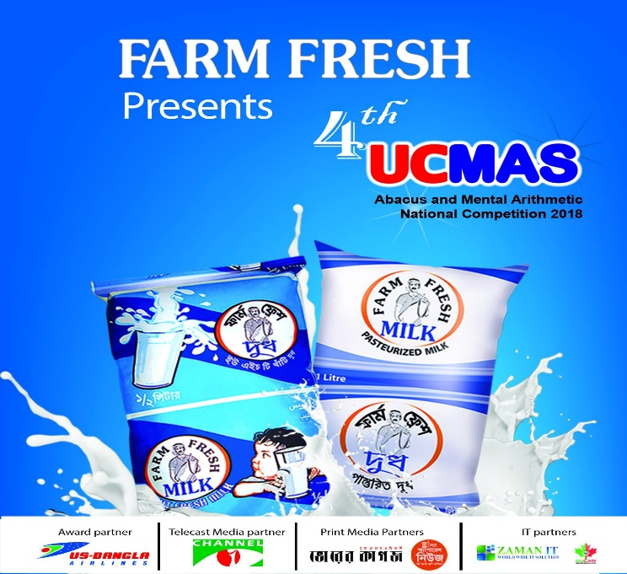
- Farm Fresh-SAGC, 2nd science festival 2016 at SAGC Premises.
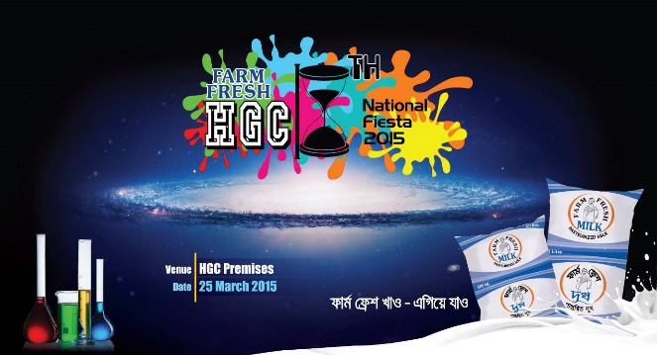
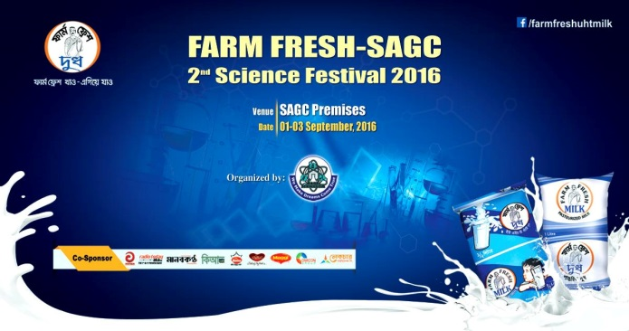
- Farm Fresh HGC, National Fiesta 2015 at HGC premises.
- Farm Fresh Presents Euhssian Science AND Technology Fair’09, organized by Euhssian Science AND Technology Club at BUET Campus.
- Farm Fresh Presents the Biggest 10th English debate Tournament 2013, hosted by Rajuk Uttara Model College.
- Frutika Islamic Genius powered by Farm Fresh. A competition based on Islamic knowledge. Where Farm fresh becomes partner as a co-sponsor every year.
TTL (Through the Line): Through the Line marketing involves marketers to create marketing campaigns which include both ATL & BTL strategies. Considering that both ATL and BTL activities, all TTL strategies lead to better brand visibility and brand recall. It includes Digital marketing (Facebook, You tube, Google Display Network-GDN, Local Display Network-LDN).
- Farm Fresh’s TTL Campaign:
It basically contains Digital Campaigns of the brand. Over the year Farm Fresh launches many digital campaigns. Some of them are mentioned bellow.
Digital Contest:
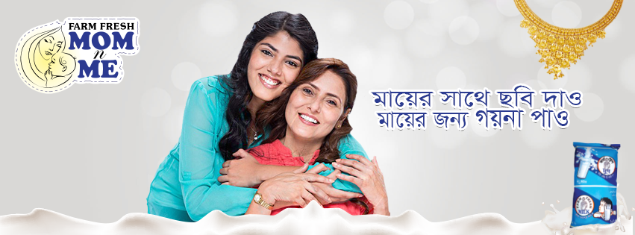
- Farm Fresh Mom n Me: In every year Farm Fresh celebrates the International Mothers’ Day through an event called Farm Fresh Mom n Me. They aroused the craze on their Facebook page by inspiring to upload a picture with their mom, where children and mother cheer with each other. Top best picture holders are rewarded.
- Cricket Trivia: Where many cricket related questions are asked over the running cricket series. Top correct answers are selected to reward. This contest generally inspires the social media user to comment their answers on that particular post. It’s a good way for customer engagement.
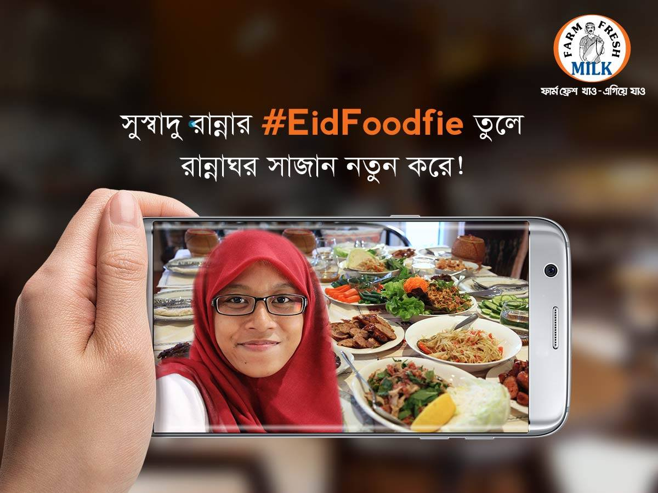
- Farm Fresh #EidFoodfie Contest: Where they inspire people to took pictures (Selfie) with their Eid food and upload it on Farm Fresh’s facbook page. The best pictures are selected and rewarded.

- Profile picture frame campaign: This type of posts are created in different national days, which inspire people to change their profile picture with Farm Fresh logo frame.
- Online Video Campaign (OVC): Farm Fresh also make many OVC’s regarding hot topics or upcoming campaigns, which are also boosted to engage customers.
- Others: Over the year Farm Fresh promotes many static pictures, loop video, GDN (Google Display Network) to get impression, reach and views. For that it connects with Facebook, Farm Fresh page, Instagram profile and some online news portal like, Dhaka Tribune, Kaler Kantho, Prothom Alo, Bdnews24 etc.
Significance: For investing huge money on promotional campaign like around 5 cores every year, no doubt Farm Fresh is in the mind of people in Bangladesh. So, Farm Fresh is now going to enter in the Powder Milk market to compete with many international giants. Farm Fresh has twenty SKU’s (Stock Keeping Units) so, it’s easy to capture the market by targeting more specifically which is a threat for the competitors.
Farm Fresh tries its best to build their brand equity arranging more promotional campaign, reaching more customer and customer interaction over the year. Its brand department executes all the work order, budget, Standard Operating Procedure and Gantt chart to shape the campaign more effective extracting value from the customer.

  - Measuring Brand Equity Performance:
To access the health of the brand, Farm Fresh provides timely, accurate and actionable information to Brand Department for taking short term tactical decision and long-term strategic decision. Farm Fresh generally measures its brand equity in 4 ways:
Target market survey: In every year R & D department people visit different area of coverage (School, College, and Varsity) to survey on almost 1500 respondents about the brand preference relating to Farm Fresh. Following chart represents 3 consecutive recall of competitive brand as brand equity.
Retailer Survey: Business developer of Panthopath AFBL office basically runs the survey on retailer to know the product availability, sales volume, consumers demand, market position etc. As an Intern I too was assigned for market visit for a specific area.
Post evaluation Campaign: Farm Fresh’s event Management team executes the evaluation by employing third party to know whether the campaign could generate long-term effect on consumers mind or not. Moreover, every month it monitors the total views, like, impression, reach through its digital media department.
Focused Group Discussion: Farm Fresh here call the quantum research agency to have a discussion with focused group where each participant gives actual information about the product, liking, disliking and preference. Being present Farm Fresh’s Branding people also observe the discussion without letting them know.

Positive aspects from findings:
- AFBL’s target is all about Bringing quality in life of customers. This is a never-ending commitment. It does not just happen. They make it happen through innovation, extending the product category, using high quality technology and environment friendly machineries.
- Farm Fresh ensures the freshness and purity of their products through innovative operations and modern technologies like Tetra Pak Automation Services.
- Besides pasteurized and UHT Milk Farm Fresh also focuses other dairy products like ghee, butter, yogurt etc. which has high demand in restaurant industry.
- As most of the people of Bangladesh are price sensitiveness, Farm Fresh here serves them better in term of lower cost.
- Besides Chocolate and Mango Milk Farm Fresh is going to bring more flavored UHT Milk like, Elachi Milk, Strawberry Milk, Coffee Milk etc.
- By introducing specific SKU it’s easy to capture the market.
- To build Brand equity, Farm Fresh invests a lot in sales promotional activities like different discounts and combo offer for its customers.
- Farm Fresh always keep active in digital media thorough the TTL campaign, where they offer many different digital contests, games, activities for greater engagement of customers.

Problem Identification from findings:
From the survey we come across that in spite of huge investment in Promotional campaign the brand equity of Farm Fresh is downward relative to Arong and Pran Dairy which is a great threat for the brand Farm Fresh. Following reason can be portrayed as an identification of the problem
- Competitor’s introducing different SKU’s like Farm Fresh, which is a threat.
- Farm Fresh’s distribution channel is comparatively weak to make available it’s all SKUs.
- AFBL focuses more to its CSD (Carbonated Soft Drinks) products than dairy.
- The service offering Aladdin for home delivery service of AFBL product is not well known to the customer.
- International Giants like Nestle, Arla Foods, and New Zealand dairy still didn’t bring any dairy products in the market. But if they enter here, it will be a big threat.
- Research department covers only 1500 respondent every year which is quiet small sample size to know the customer as a whole.

Limitations of the study

Though I knew and had access to much information, but there are still some important things which I couldn’t get hold of and they didn’t prefer to disclose. Certain limitations while conducting the study are as follows:
- Inadequate information of related field
- Work pressure of executives restricted this report from being more detailed and analytical.
- Lack of integration among all departments.
- Time consuming as there was less information in web search and the tenure of the internship program was very short to observe everything.
- Competitors’ information could not be gathered due to their privacy policy
- Confidentiality rule of the organization hindered the study.

Recommendations & Conclusion

Food and beverage industry are mostly fast-growing sectors in Bangladesh. As a result of intense competition companies now are recognizing the importance to improve their brand equity through different promotional campaign. For 12 years long Farm Fresh has been providing its customer a belief of pure and fresh source of dairy product. But as a whole, it has some drawbacks too. With the analysis of findings of this study and Following related recommendations, the equity Gap can be abated and make the customers buy.

- Segmentations and Targeting should be done more specifically for all the SKUs of farm Fresh.
- R&D dept. should focus more to the dairy products besides of CSD products.
- Distribution channel should be strong to make available all the SKUs in the specific target market.
- Farm Fresh should increase its signature campaigns like Farm ‘Fresh children’s day’.
- For online delivery through Aladdin, All AFBL products including Farm Fresh give small percentage of discount per quantities to the customer. So, this delivery service should be highly promoted to the big buyers.
- Farm Fresh can make many combo packs with its dairy products, which can create demand to the consumers.
- FGD survey may work better for blind test of 3 competitive brands and rate them in different criteria like mouth feel, sugar amount, taste and flavor.
- Close ended survey through Google form in Digital platform or dedicated brand promoter can contribute positively to create vital and meaningful information for R &D dept. Thus integrating “Voice of Mothers” Farm Fresh can capture their states and unstated needs or requirements in all business decisions.

References

- Books:
- Keller, K. (2013). Strategic brand management: Global edition. Pearson Higher Ed.

- Websites:
- Lake, L. (2018). How to Identify and Develop Your Brand Strategy. Retrieved from https://www.thebalancesmb.com/how-to-develop-your-brand-strategy-2295187
- Wheeler, K. (2015). The Beginner's Guide to Developing a Remarkable Brand Identity. Retrieved from https://blog.hubspot.com/agency/develop-brand-identity
- Nichols, T. (2015). 7 Important Strategies For Effectively Branding Your Product. Retrieved from http://www.exactdrive.com/news/7-important-strategies-for-effectively-branding-your-product
- Bangladesh Food beverage Industry. (2016, September 14). Retrieved from http://rimexbd.com/index.php/2016/09/15/bangladesh-food-beverage-industry/
- Akij Food & Beverage Ltd – Just another Akij Group Website Word Press site. (2009). Retrieved from https://www.akij.net/akij-food/
- SWOT Analysis: What, Why and How to Use Them Effectively. (2017, October 11). Retrieved from https://creately.com/blog/diagrams/swot-analysis-what-why-how/
- Rose, R., & Rose1990. (2013). Akij group. Retrieved from https://issuu.com/rose1990/docs/akij_group/3
- Porters Five Forces Framework, AI and Profitability in the OR – OR LINK. (2018). Retrieved from https://myorlink.com/porters-five-forces-framework/
- Marketing Activities of Akij Food and Beverage Limited. (2017, August 24). Retrieved from http://www.assignmentpoint.com/business/marketing-business/marketing-activities-akij-food-beverage-limited.html
- Farm Fresh. (2018). Retrieved from https://www.facebook.com/farmfreshuhtmilk
- Chapter 10 Learning Objective 01/02 Branding and Category Management (2013). Retrieved from http://www.cengage.com/resource_uploads/downloads/0176503935_339962.pd

……… The End …

