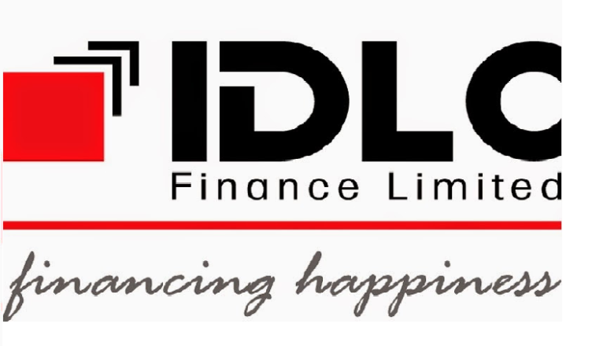

Internship Report
On

Operational strategy of Special Asset Management Department & and HR procedure of IDLC Finance Limited

  - 

Internship Report
On
Operational strategy of Special Asset Management Department and HR procedure of IDLC Finance Limited

Submitted to:
Ms. Farhana Rashid
Assistant Professor
United International University

Prepared By:
Sarah Tabassum Priety
ID- 111 123 029
United International University
Date of Submission –16th May, 2018
Letter of Transmittal

16th MAY 2018

To
Ms Frahana Rashid
Assistant Professor
United International University

Subject: Submission of internship report on IDLC Finance Limited (SAM)

Dear Madam,
With due respect, it is my great pleasure to submit my internship report on “Operational strategy and procedure of Special Asset Management Department of IDLC Finance Limited”. I have completed my internship from IDLC finance limited, a well-known non-Banking financial institution in Bangladesh.

My main inducement was to prepare this term paper according to your instructions while considering the guidelines of the Program. I made good efforts to study related materials, documents, observe operations performed in Special Asset Management of IDLC and tried my best to enrich this report by providing what I have learned throughout the internship program and compiled this report as per the requirements. I hope that I have been able to relate the fundamental things with the realistic applications considering my level of experience and competency.

Hence, I am hoping that you will appreciate my instructive and comprehensive approach. Thank you for encouraging me to work on this interesting topic. Kindly accept my report and oblige thereby.

Sincerely yours,
Sarah Tabassum Priety
ID: 111 123 029
United International University
Acknowledgement

At first I would like to take this opportunity to convey my gratitude to them, whose collaboration and blessings were highly important to bring this report in light. And would like to show my appreciation to:

Ms Frahana Rashid
Assistant Professor
United International University

Mr. Dewan Ishtiak Ahmed
Senior Manager
Special Asset Management
IDLC Finance ltd

Sultana Razia
Assistant Manager
Special Asset Management
IDLC Finance ltd

Tanjeel Islam Khan
Officer
Special Asset Management
IDLC Finance ltd

Mr. Khaled shah nawaz
Deputy manager & HRBP
IDLC capital market operation

Concurrently , also like to thank my all other colleagues of IDLC Finance Limited who helped me to learn the intuition & situation of the current business world.

Executive summary:

IDLC starts its journey on 1985.In the perspective of non-banking financial history of Bangladesh, IDLC Finance is the largest financial institution. SAM Special Asset Management and CD Consumer Division of IDLC Finance established as one of the beginning divisions and play a vital role apart from the all departments. With its brunches and departments along with skilled and experienced employees ,SAM became one of theinnovator department of the institution.

Maintaining assets of consumer division is SAM departments main role. SAM and credit risk management (CRM) department of IDLC finance limited works together always. Sustaining the reward above the risk is the main purpose of these two departments of IDLC. The main role of SAM is to ensure the collection of the money where the money is overdue or normal with not only efficient but also effective manner. To build a cost effective Collection process, which is error and risk free, pro-active, and information based SAM is always oblidge.

This report contains a descriptive study of Special Asset Management of IDLC Finance and some of the main issues of Non-Performing Loan. Special Asset Management works relatively with the Consumer Division of IDLC Finance Limited .Moreover report also shows the challenges, recovery plan, and observed present development of the Special Asset Management. Some statistical illustration of the performance of SAM also elaborates on the report. The main findings of this report is to find out effectiveness and efficiency of SAM through analyzing the NPL growth relating with the financial industry in Bangladesh.

During the internship program, I got the opportunity to work closely at SAM . While preparing the report lots of challenges I faced and tried to construct this report with the amount of resources I had. The report contains a comprehensive explanation about Special Asset Management of IDLC Finance. It also explores to explain the overall guiding principles and course of actions of SAM and its competence descriptively and figuratively. I have built-in some findings, regarding on the issue of NPL. Lastly, some recommendations also given for any further research regarding this topic.

TABLE OF CONTENTS
CHAPTER 01:

  - Introduction ………………………………………………………………………………1
  - Origination of the report ………………………………………………………………….1
  - Objective of the report ……………………………………………………………………2
  - Methodologies …………………………………………………………………………....2
  - Limitations of the report ………………………………………………………………….3

CHAPTER 02:

2.1 company overview ………………………………………………………………………...4
2.2 Mission …………………………………………………………………………………….5
2.3 Vission ……………………………………………………………………………………..5
2.4 Core values ………………………………………………………………………………...6
2.5 key informations…………………………………………………………………………....6
2.6 Companys philosophy ……………………………………………………………………..7
2.7 Product & services …………………………………………………………………………8
2.8 Management structure of IDLC Finance ltd ……………………………………………….9
2.9 Idlc securities ltd …………………………………………………………………………...10
2.10 TIE Ratio of idlc finance ………………………………………………………………….11
2.11 liquidity ratio ……………………………………………………………………………...12
2.12 Location in MAP…………….………………………………………………………….....13
2.13 Branches of idlc finance ltd………………………………………………………………..14
2.14 SME , CRM division………………………………………………………………………15

CHAPTER 03:

3.1 Types of loans……………………………………………………………………………….20
3.2 Loan disbursement process………………………………………………………………….22
3.3 Regular activities performed by SAM……………………………………………………....24
3.4 Operation strategies of SAM……………………………………………………………….25

CHAPTER 04:

4.1 Job responsibilities as an intern……………………………………....……………………..26
4.2 Significant contribution……………………………………………………………………...29

CHAPTER 05:

5.1 HR Functions……………………………………………………………………………......32
5.2 HR Organogram of IDLC Capital market……………………………………………….....32
5.3 CV selection process…………………………………………………………………….......33
5.4 Recruitment assessment sheet………………………………………………………………34
5.5 IDLC Recruitment & selection process……………………………………………………..36
5.6 Performance appraisal form…………………………………………………………………39
5.7 learning outcomes and experience ……………………………………………..…………...43
5.8 IDLC ………………………………………………...……………………………………...46
5.9 Expectation and actual experience…………………………………………………………..51
5.10 Interaction with supervisor and co worker..…….………………………………………….53

CHAPTER :06

6.1 Findings……………………………………………………………………………………..64
6.2 Recommendations…………………………………………………………………………..66

CHAPTER:07

Conclusion……………………………………………………………………………………….68
References ………………………………………………………………………………………70

Chapter 1: Introduction

1.1 Introduction
The financial sector is an important part of a country as it has a significant role in the economic development. The fundamental shift of private sector has appeared as an engine of economic growth and development along with the public sector in Bangladesh. As a consequence, IDLC Finance Ltd, the largest multi-segment Non-banking financial institution has achieved noteworthy growth in all areas of business. It has expanded its area to Consumer, SME, Corporate, Retail and Capital market segments. Three subsidiaries were also commenced by this institution which has fortified its existence in the countries emergent financial market. On the local markets IDLC Finance Limited is one of the blue-chip companies of Bangladesh. Which promises to sustainable practices and strong financial performance?

1.2 Origination of the report
The completion of internship is an important part of the Bachelors Program as it serves the causes of practical direction in the related area. I was blessed enough to complete my internship from IDLC Finance Limited, the largest Non-Banking Financial Institution which provided me with a real life practical knowledge. Among many company I decided to work on Special Asset Management Department (SAM). All the way through the report I made an effort to find out the actual explanation and operation of SAM from the perspective of Bangladesh, procedure and policy of SAM, challenges faced by SAM in IDLC Finance Limited. I tried to make the report more informative and consistent in order to represent the Special Asset Management Department of IDLC.

1.3 Objective of the Report
Exploring the facts of different types of collection strategies are objectives that are being followed by Special Asset Management of IDLC Finance Limited after financing and the efficiency of the collection process. Beside this, in this report there are few secondary objectives that come similarly to the core objective. They are,

- Identify the overall activities of SAM

- Perceive present growth of IDLC in terms of Consumer Division to Identify the reason behind Non Performing Loan

- Analyze the NPL trend forecast and draw the conclusion for IDLC Finance Limited in the context of Bangladesh.

1.4 Methodologies
This report is completed on the foundation of
- primary
- secondary data that I collect during my internship period.

Primary Data:
- My own work experience
- conversation with the respective officials
- IDLC Finance Limited yearly report

Secondary Data:
- IDLC WebPages’
- Bangladesh Bank Website
- Financing Ministry of Bangladesh Website
- Bangladesh Bureau of Statistics Website
- Other Financial Institution Websites

  - Limitations of the Report

Special Asset Management is a newly formed department at IDLC Finance Limited. I have faced some obstacles since not getting direct information regarding SAM to prepare complete report. This are the list of some problems that I have confronted while doing the report.

- Non-availability of most recent and earlier information about Special Asset Management.
- Organizational restriction of disclosing confidential and delicate information due to business secrecy.
- To come up with the necessary information provide too little time period.

For this limitations, I was not able to conduct more thoroughly and detail oriented study and include that in my report. In spite of all of these limitations, I have tried my best to come up with the appropriate information’s in order to make the report more informative and logical.

Chapter 2: The Organization (IDLC)

2.1 Company Overview
IDLC Finance Limited, the first leasing company of Bangladesh, was established in 1985. Its birth was actually a collaborative effort between several local and multinational financial institutions e.g. International Finance Corporation (IFC), German Investment and Development Company (DEG), Kookmin Bank, Korea Development Financing Corporation, The Aga Khan Fund for Economic Development, The City Bank Limited, IPDC of Bangladesh Limited, SadharanBima Corporation. With the evolution of this company the initial foreign shareholding of 49% was gradually being withdrawn. The local sponsors were taking the shareholding positions of the company and finally in 2009 there was no foreign shareholding of the company.

About the Company:
IDLC Finance Ltd. is the first ever leasing company in Bangladesh. Although the company started its journey as a leasing company, with the passage of time it has successfully diversified its products and services by penetrating into different untapped client segments. Now IDLC Finance offers a wide range of loans, deposits and capital market products and services to the 11 corporate, consumer and SME client segments. The company is armed with two of its wholly owned subsidiaries – IDLC Investments Ltd. and IDLC Securities Ltd. to perform its capital market operations successfully and efficiently. Today, this is the leading multi-product Non-Banking Financial Institution in Bangladesh with 27 branches and over 800 staff spread all over the country. The company has an Authorized Capital of BDT 4,000,000,000/- (400,000,000 shares of BDT 10 each) and Paid up Capital of BDT 2,513,700,000 (251,370,000 ordinary shares of BDT 10 each). Throughout its journey IDLC has always thrived to provide its clients the best financial solution effectively, efficiently and ethically. The company has been awarded the “A+” rating by Credit Rating and Information Services Ltd. (CRISL), the highest rating for any financial institution, sofa. The IDLC Group has always been a standard bearer for the financial sector in terms of corporate governance and statutory compliance. The Group is highly respected by its clients, peers, employees and regulators for its professional pool of resources, its progressive and enabling work environment, and its strong ethical practices. In 2010, the IDLC Group committed to sustainable business by becoming a member of the Bangladesh CSR Centre, the United Nations Global Compact (UNGC), and finally, the United Nations Environment Program Finance Initiative (UNEP FI). It has also been awarded the first prize for the “Best Published Accounts: by Institute of Chartered Accounts of Bangladesh (ICAB).” With its diverse and multitude products and services the company is catering the diverse and unique financial needs of both individual and SME businesses. With its skilled and competent employees, the company is experiencing rapid growth in its diverse clientele. Thus IDLC Finance Limited is making remarkable footprints in the economic growth of the country.

2.2 Mission

IDLC Finance Limited focuses on superior growth, excellence customer experience and justifiable business practices.

2.3Vision

IDLC Finance Limited believe that they will be the highest ranking nonbanking institution soon .

2.4 Core values

- Concerned about ethics
- Focus on customer
- Equal opportunity for organization
- Trust and respect towards others
- Passion to become best
- Simplicity, accessibility.
- Eco & environment friendly

2.5 Key information’s
- Credit rating- AAA
- Net profit after tax: 2.28 billion (BDT) 28% increase
- Customer advances: BDT 71.5 billion (BDT) 15% increase
- Nonperforming loans (NPL): down to 2.77%
- Total branches: 39
- Total employee: over 1400
- EPS (Earning per share): 7.08 BDT
- Return on Asset: 2.60%
- Return on equity: 21.15%
Source: IDLC website: http://idlc.com/

2.6Company Philosophy-The Backbone of IDLC
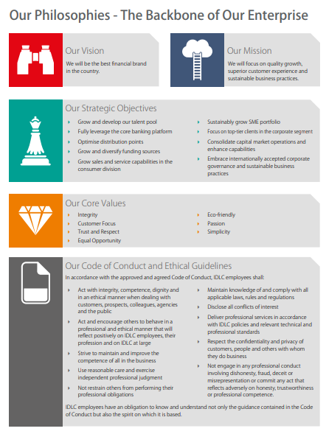

2.7Products&Services
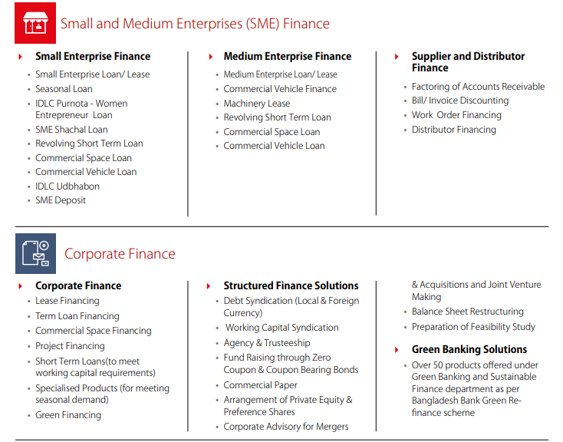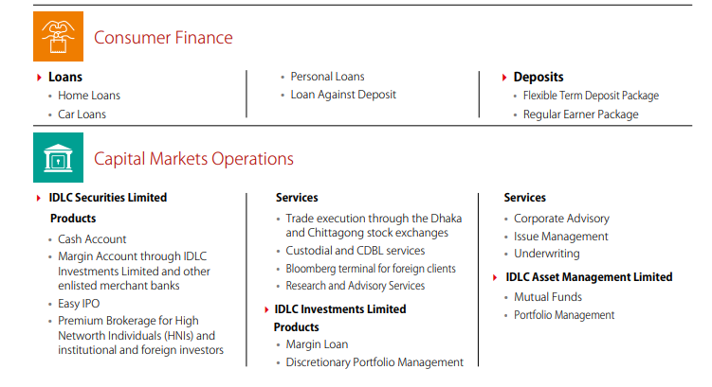

2.8Management structure of IDLC Finance Limited:

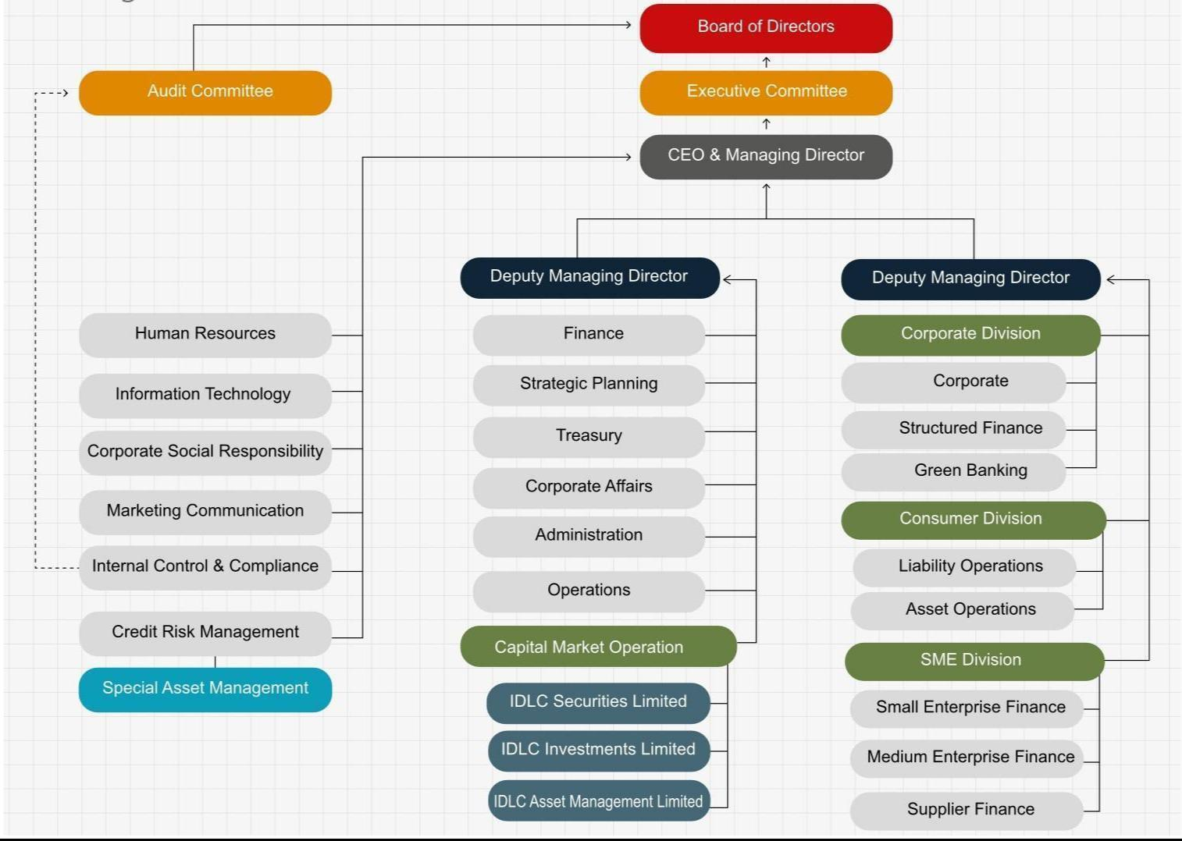

Main Board of director split the IDLC Finance in two categories one is Audit committee and the other one is Executive committee. The audit committee mainly focused on the assessment programs, interior control frameworks and techniques, bookkeeping strategies and other money related issue. On the other hand Executive committee surely concentrate on run the business smoothly and the command accordingly through the chain to compete in the market strategically.

2.9IDLC Securities Limited:

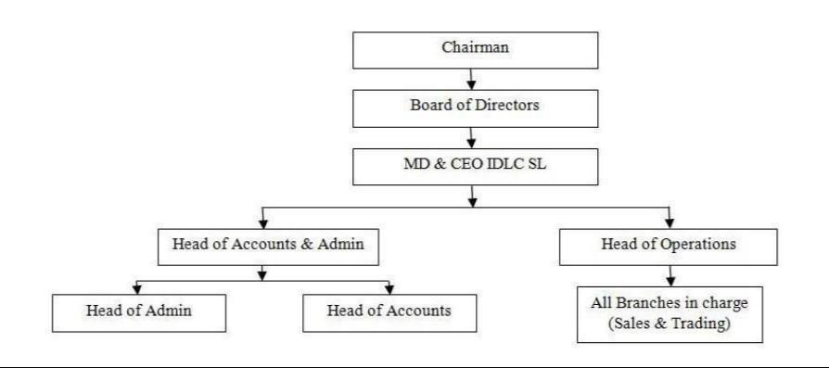

IDLC Securities Limited Organ gram (IDLC Annual report 2017, page: 300)

IDLC securities offer standard international brokerage services to local individual, institutions and foreign investors. It trade execute in Dhaka and Chittagong Stock Exchange Limited.
IDLC securities believe they exclusively arrange for the clients to keep their shares in safe custody of their vaults. IDLC securities charge 40% nominal brokerage fees, CDBL charge at actual, research service upon subscription and custodial service at actual.

2.10TIE ratio of IDLC Finance (Last 5 years):

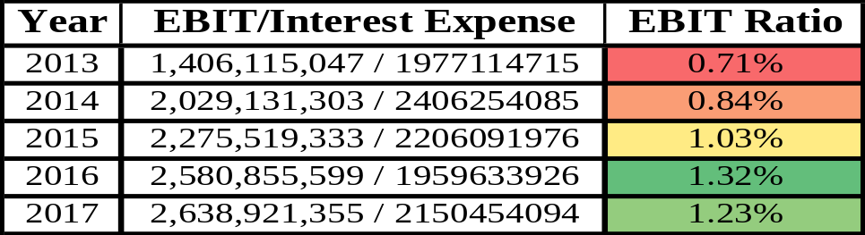

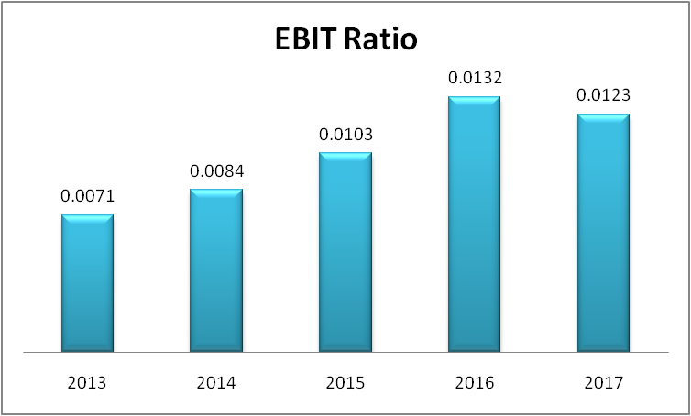

TIE ratio of IDLC Finance is above 1 in last 3 years which is good and shows the enough credibility to financing to the personal, home and car loan. Though TIE ratio, year of 2017 is bit downward than year of 2013 but still can give a fruitful result.

2.11Liquidity ratio of last 5 years of IDLC Finance Limited:

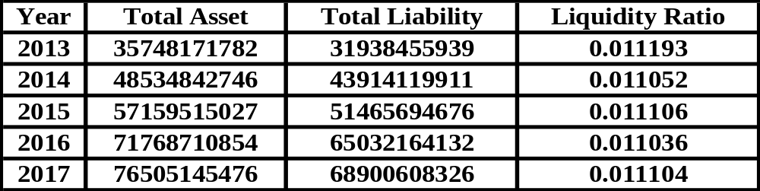

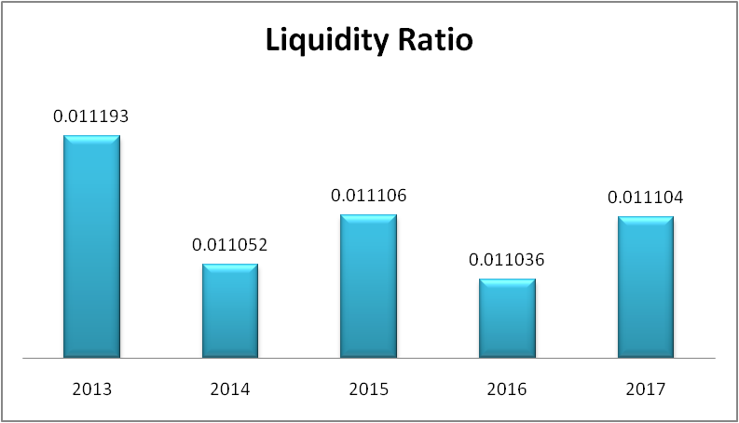

Liquidity ratio of IDLC Finance Limited is surrounding between 1.10 to 1.12% approximately. From 2013 to 2017, the liquidity ratio is above 1% and which is good compared with the industry analysis. So overall, IDLC Finance Limited has the strong availability to perform lease and show the creditworthiness.

2.12Analysis of total selling loan provision of IDLC Finance Limited:

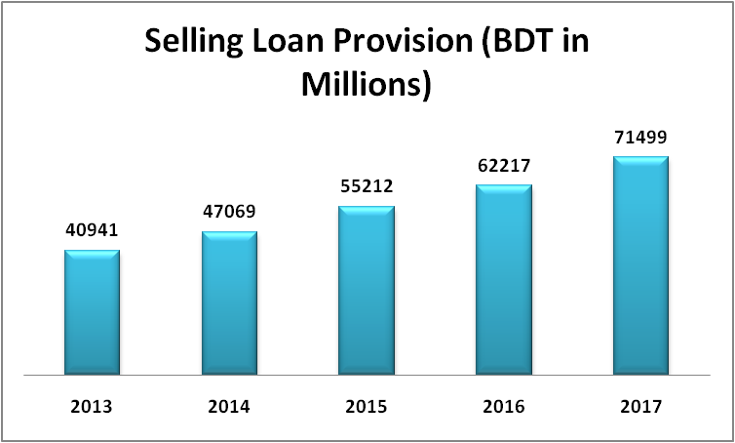

According to the trend analysis, consecutively selling of loan amount is gradually increasing in IDLC Finance Limited. As we can see, during the period of 2013 the total sell of loan was 40,941 million BDT, which stood in last year 2017, is 71,499 million in BDT. The future prediction of 2018 is the total selling loan will hit to the Eighty thousand approximate.

2.12 Location of the corporate head office and branches of the IDLC Group

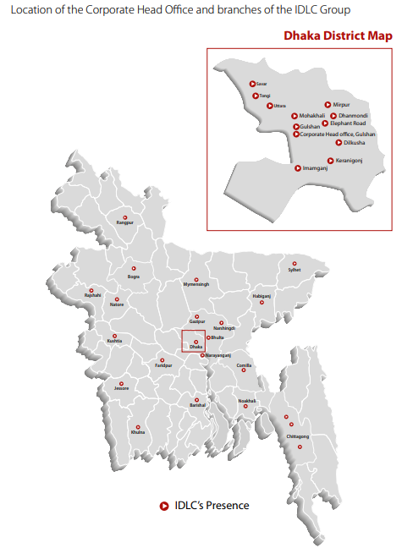

2.13Branches of IDLC Finance Ltd:
Name of the Branches | Locations
Dilkhusha Branch | Puranapaltan, Dhaka-1000
Gulshan Branch | 57 Gulshan avenue, Dhaka-1212
Dhanmondi Branch | Dhanmondi 14/A, Dhaka- 1209
Uttara Branch | Paradise tower, sector 3, Dhaka-1230
Mirpur Branch | Sector 10, Dhaka- 1216
Chittagong Branch | Agrabad commercial area, chitt-4100
Nandankanon Branch | Guha road, chitt-4100
Narayangonj Branch | Sattar tower, Tanbazar
Narsingdi Branch | 382 kalibari road, Narsingdi
Savar Branch | Savar new market, holding no-3
Keranigonj Branch | South keranigonj, Dhaka-1310
Bogra Branch | Sairul complex, Bogra-5800
Sylhet Branch | 982 Sylhetdarga gate, Sylhet-3100
Comilla Branch | 437 Nazrul avenue, Comilla-3500
Gazipur Branch | Rahmat tower, joydepur, Gazipur-1700
Imamgonj Branch | 57-58 Mitford road, Dhaka-1100
Tongi Branch | Banesa complex, Tongi gazipur-1710
Jessore Branch | Rashid center, jessore-7400
Khulna Branch | Syed alihossain tower, Khulna-9100
Natore Branch | Lily plaza, Natore-6400
Bhulta Branch | Hazi A aziz supermarket, Nar-1460
Habigonj Branch | Sanker city, Habigonj-3300
Kushtia Branch | Momtaz tower, Kushtia-7000
Mymensingh Branch | Swapnaneer tower, Mymensingh-2200
Rangpur Branch | Paper palace tower, Rangpur-5400
Chowmuhani Branch | N S Sbhaban, Noakhali-3821
Elephant road Branch | Elephant road 1205, Dhaka Bangladesh
Rajshahi Branch | Shaidullah tower, Rajshahi-6100
Barishal Branch | LL tower, Barishalsadar Road
Faridpur Branch | Hafeez building, Faridpur-7800
Source: IDLC Annual report 2017
2.14 Business Overview

IDLC has divided its business into below four segments.

SME Division:
SME Division is the core business segment of IDLC Finance Limited. Their main task is to provide loan Small loans like : SME loan, woman entrepreneur loan, supplier finance, startup loan, and Medium Enterprise. They provide different categories of services based on their customers need like term loans, working capital loans, lease financing etc.

CRM Division:
Credit risk means the possibility that a loan borrower will fail to meet the term and conditions established between him and the organization. It is the default risk that arises as the borrower might not be able to repay back the loan amount with interest.
To minimize the risk or to control the risk, financial institutions now have Credit Risk Management department. If the credit analysts see that there is a high default risk in giving a client loan, they would demand a higher interest rate from the borrower. If the borrower has a steady income flow or good security backup known as collateral, then he/she is likely to bear a lower interest rate.
Like most of the popular financial institutions IDLC also has an efficient and strong credit risk management department for consumer division. In short it is called CRM-CD.

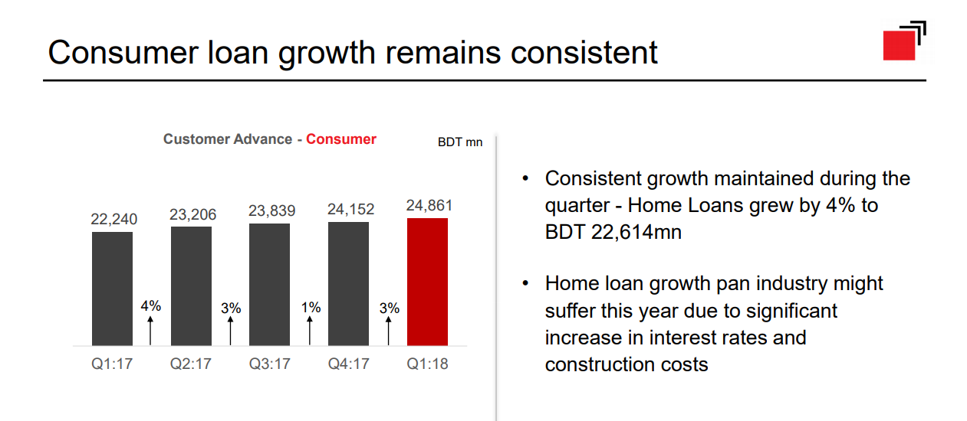

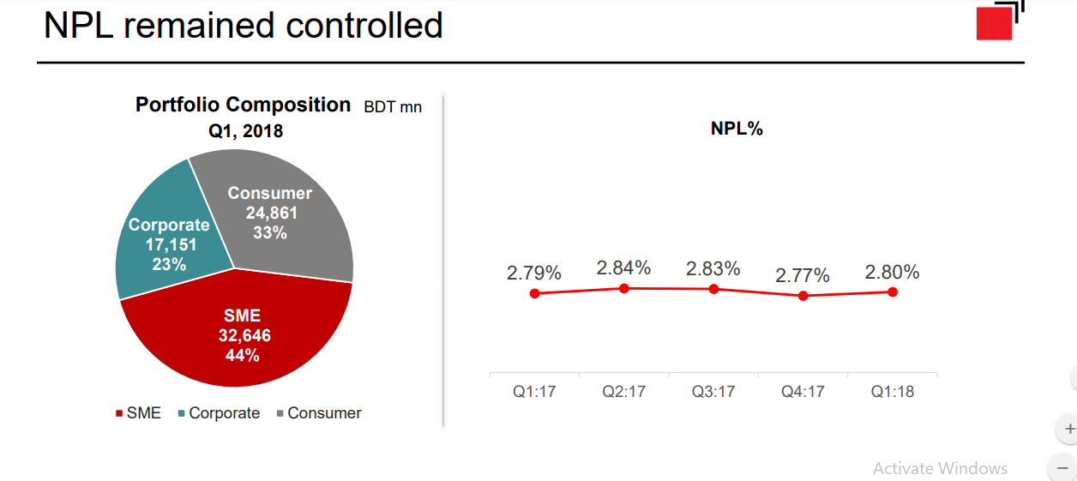

Division:
At IDLC to perform and monitor all the activities of CRM they have divided the CRM process into 3 departments.
Basic overview of these three departments will be look like below:

In my internship period I have got the opportunity to work with the CRM-CD department. Therefore, in the next chapters of this report I will basically focus on the work of CRM-CD department.
Processes:
The whole process is divided into several steps of CRM-CD.
1. Credit Appraisal
2. Credit Sanction
3. Credit Documentation
4. Credit Administration
5. Disbursement
Credit Evaluation:
This is the initial stage of a loan sanction or rejection. In this step IDLC gather all require information of a client and then screen those very carefully. For example,
- Address Verification
- Bank Statement Verification
- NID/Passport/Certificates Verification
- Rent Verification in case of landlords
- Salary Certificates
- Verification of Co-applicant, Personal Guarantor
Customer Point Verification (CPV):
Some few more steps to crosscheck that all the information gathered about the client is correct. IN CRM-CD this verification part is done by three third party vendors, they are
- Brisk
- CBC
- Active
These three third party companies basically do the Customer Verification Point (CPV) and then send the verification reports to IDLC.
After all kind of verifications is done analysts go for the credit appraisal where they ensure that the client has the ability to meet the obligations of IDLC. It requires collateral or guarantees from a client in order to minimize the risk. The appraisal is not only made on collateral, it also depends on the amount of loan, the source of repayment, the specific industry from where the client has come.
Moreover, CRM department also check the previous records of the client if he/she has taken any loan from another financial intuition or not. If there is any previous credit record, analysts will also look onto the records.
In case of businessman and corporate people CRM needs to check the business expertise, background information of the shareholders and company.

Credit Sanction and Disbursement:
After verifying all the documents the analysts either sanction or reject the file for loan. Most of the cases if the client’s bank statement is not properly maintained or income source is not secure then the loan is rejected or backed. In some cases, even the client’s attitude and behavior also can be a reason for rejection.
After the sanction the file will be sent to the customer service department and from there the client will be informed about all the terms and conditions about the loan. If the client is okay with all the term and conditions, then he will sign the sanction letter and also fill the fees.
Then the file is submitted to the Head of sales and marketing team. After the final verification the file goes for the loan disbursement department

Chapter 3

Analysis Part (About SAM)

Special Asset Management
Special Asset Management (SAM) Department of IDLC mostly deals with the collection of loan and handling default customers. Moreover they also maintain a caring and friendly relationship with their customers. They also regularly update customer loan information and help their customers to pay their installment amount on time without facing any problems. Before going to describe operation strategy of SAM, we have to look at the loan category and loan disbursement process of IDLC Finance Limited that will help us to understand their activities more easily.

3.1 Types of Loan

IDLC Finance Limited usually offers three types of loan to their customers. The main segments of their loan are,

- Consumer or Retailer Loan

- SME Loan and

- Corporate Loan

Consumer Loan is for individuals who have needs for loan. The number of this loan are more than 60% of the loans are disbursed in this segment. The consumer loan is divided into three categories.

They are,
- Home Loan

- Car Loan

- Personal Loan

SME loan is offer to the small and medium enterprises that helps those businesses to expand or to carry out their day to day activities. Corporate loans are offer to large organization. The amount of this loan is huge but the number of loan is low. But this loan is more secure than other categories and provides more return.

3.2 Loan Disbursement (paid out) Process

Like all other financial institutions, IDLC Finance Limited also follows some steps to handover loans to its customers. Now I am going to briefly describe that process. First of all a RM (Relationship Manager) find out customers.

- Then RM offer their products to customers based on their needs
- If customer accepts a product, final settlement is done
- Arrange the loan procedure
- Then ready the customer file
- The file handover to CRM (Credit Risk Management) Department
- CRM department judge the customers based on CRG report, ration analysis, make customer 6c etc.
- After that report pass to the Management for approval
- If approved by management, then the file goes to CAD (Credit Administration) Department
- CAD prepares the loan documents and collects customer sign

- Finally disbursement loan handover to customer

Loan Disbursement Process


RM (Relationship Manager) finds out customer

Product offer

Convince the target customer

Final settlement

Arrange the loan

Properly file ready

Handover to CRM (Credit Risk Management

Evaluate customer (CRG report, Ration analysis, 6C)

File goes to management for approval

Handover to CAD (Credit Administration), they

prepare the document as per the management

approval and collect sign of the customer

Disbursement check handover to customer





3.3 Regular Activities performed by SAM

- Follow up (Overdue customer & exhausted Post Dated Installment cheque)

- See to customers to collect deposited cash / cheque but this service is not available now, but in some cases it can be provide.

- Give collection related information to customers.

- provide letter/ sms to overdue customer.

- Meeting & discuss the issue , advice the customers who are defaulter.

- If customers address or information changes then update it immediately.

- For residual cheque& hand over to Customer Services Department need to keep the avail record.

- Went to the address of the overdue customers house, shop or office where customers accounts settled in Software.

- Inform customers about their dishonored cheque, Late payment Interest .

- Collection & monitoring of overdue amount and appear charge.

- Audit some unpaid outstanding, tolerance the significant information to determine the execution to be taken.

- Inter branch communication

- Serving legal notice/Final reminder/Termination letter to overdue customers.

- File Suit in the Court of Law under NI act.

- For legal correspondence need to attendant the court.

- Regular follow up & co-ordinate with lawyer regarding litigated accounts Invitation for auction. When customer gives their payments their case will be with drown.

3.4 Operation Strategies of SAM

The intention of SAM is to obtain payments at the appointed time to diminish the risk and write-off expenses as well as maintaining the customer's concern through providing a standardized service.

First of all, the SAM team checks and remind every customer on a daily basis whose EMI date is approaching. Then they supervise the loan account that could not pay within their allocated time. Those loan accounts are listed as overdue clients.

Therefore for approaching the clients and to collect the overdue amount the team need to go through the following steps accordingly in general-

- Provide text messages and Email.
- Call to give them Soft Reminder
- Visiting to communicate with them
- Provide Hard letter of issuance
- Provide Legal notice
- Prepare case filing report
- (Auction)of their property.

Phone Call, text messages and Email are normally sent to the customers regular basis before their installment expiry dates a reminder to pay the monthly installment. SAM requests the customers about cheque exhaust. Send their cheque to any branch or directly at SAM. But if customer didn’t give cheque for any reason then they can give cash payments to IDLC via 10 bank accounts. Where they have to first Fill up slip by providing IDLC account number and customers identification number then after providing cash mail the picture of this slip to the junior officers.

Chapter 4
Duties Performed

4.1 Job Responsibilities as an Intern:

The assignment that I have undertaken is the exploration on Special Asset Management of defaulter clients of IDLC Finance Limited, and also some HRparts. I mainly focused to cover the whole procedure of sanctioning loans until the settlement process that will also help me to get the idea of leasing procedure. However, often it seems quite difficult to find the accurate system of the procedure of all process as it might risky for the company to share it all. All the office staff is very helpful to share the ideas and information, which are available. The objectives will try to convince through the reports mainly to review the main activities of Special Asset Management Department and describe the loan disbursement process. Focus of SAM department is to collect the regular payment by lot cheques or cash. Lastly, I face few problems related to my work, as I never get these types of experiences directly on my under graduation period. I never directly faced with any default clients those are listed on non-performing loan file. Theory related knowledge is almost very different on the practical work of financial activities. The job/ responsibility that I have to handle some description of it is highlighted in down below.

- Group skills: Here I have learn team skills as all the tasks are separate from different divisions. Each had different team of subordinates ,staffs and managers as well as different types of target that need to achieve. Such experiences has sharpened my talent to work in a group environment.

- Communication skill: Though I was working there , I have successfully dealt with people from various back grounds and class. This improve my communication skill largely. Not just I had to communicate with the customer, but also with my coworkers and superior executives. They were always caring, encouraging and flexible with my work.

- Practical knowledge: 3months of internship, I gain practical knowledge about banking , HRM and financing through different academic courses from my 3months internship program.

- Modern plan :Financing system of twenty first century is highly modern technology based. As IDLC Finance Ltd it also maintains every single steps with philosophy , rules of society & culture, environmental policies. The regular most user-friendly software that uses IDLC Finance is ORACLE BL Publisher.

- Attention to factors: Documentation and handling many important documents known as data entry . at the very first stage we have been taught to do error free work where simple error can be a major issue. My 3 months internship taught me how to work well organized and competent way. It also improved my work capability and treat me how to work in under pressure.

- Capability to work in under pressure: Some time have to complete files in to a specific deadline. It also taught me to give priority my workload and work error free.

- Following policy: Like all banks and NBFI, IDLC Finance Ltd. is also a strict follower of Bangladesh Bank rules and regulations. Thus, before conducting any task I remained alert so that each action was following the policy. Such policy also enriched my knowledge about the banking sector.

- Personal development: In my internship, I had to interact with different people from the diversified customers to the support staff and superior authority. While doing this, it helped me to grow as a sincere human being , and a groomed person : by formal dressed, punctuality, more confidential , focused, patience. And also help me learn about different policies of corporate work and how I can handle this.

As an intern in, there has some fix works that every intern have to do, Besides these core works of intern there are some side daily works as well which are undertaken almost in every company. The main core works of SAM are-

- Opening Oracle BL publisher software where keep updated of every clients profile

- Maintaining PDC general which shows the clients monthly EMI/payment is up to date or they are being listed on overdue

- Find customer role of their current status and collect their phone calls for further contact

- Checking settlement account balance to have a look of their available current balance, if the current balance exceeds the regular EMI then the monthly payment will take from his account. Moreover, if the clients give monthly EMI/lot cheques, the extra amount will add on his available current balance

- Furthermore, we have to maintain the client’s amortization schedule of their monthly fix installment. If the client wants to know of his liquidation time of sanctioned loan, by observing the amortization schedule we can confirm his monthly installment

- Regular payment also changes because of the fluctuations of interest rate which is not constant and we also make confirm about the installment to the clients by observing the amortization schedule

- There is also overdue statistics where defaulter clients are listed. If we see any default clients those are listed on overdue we keep forwarding them to Junior officer and they take care of them of giving them reminder.

Finally, we have to follow the PDC General where shows the client cheque is available or not, where they are cash payer or deposit payer. On which bank they are dealing with, activation date of EMI, expiration date etc.

Observations during Internship

The working environment of IDLC is excellent and friendly. They treat interns as a member of
IDLC. They leave the work decision of interns on themselves. They did not put extra work loads or pressure to the interns. Advisor assign few responsibilities and regular work which make interns more responsible and dedicate toward their work. They helped me to prepare this report by providing information and valuable suggestion. Without their support it would be quite difficult for me to submit this report on time.

4.2 SIGNIFICANT CONTRBUTION

My contributions at SAM ( CRM-CD)in IDLC Finance Limited includes:
- Fresh Perspective:
My supervisor, Mr. Tanjeel vai encouraged my participation and valued my input in all the discussions. As I had no prior training, I had an open mind and I was able to give him my honest opinion which he took very seriously while finalizing and implementation strategies.
- Confidentiality and Due Diligence:
This was a more passive task but nonetheless very important. As I was working at CRM-CD, I came across many confidential information such as client information, their bank balance and others. Therefore, I had to be very cautious regarding with whom I shared this information with.
Reporting and follow ups:
At the end of each day, I used to send emails like: Sanction files list, Rejected files list, CPV daily requests, CPV exception reports keeping the concerned persons in the email. This helped them to keep up-to-date with the activities and they could take cautious and necessary steps required to complete their job. For example: From the rejection email, the RMs and STMs (Sales Team Managers) could know which files are being sent back to them and the credit analysts could know the status of their rejected files.





Chapter 5
HRM of IDLC Finance Ltd.

5.1 HR Functions

Here I would like to add some of the HR parts, because besides working in SAM department I also worked in HR department, and collect some of the information from authentic sources:

Here the hr functions handle many necessary functions of organization. Human resource specialist and managers are responsible of the key functions of hr department. Hr functionality not always needs large number of hr employees to be efficient. Depending on the size of employees , small organization can function quite well with small number of hr employees instead of an entire department .the following steps are necessary to support the companys workforce.
- Labor law compliance
- Record keeping
- Recruitment
- Selection
- Hiring & training
- Job analysis, job design, Performance management
- Pay roles
- Incentive
- compensation
- Labor/employee relations.
- Position classifying
- Identify conduct problems, performance problems
- Policy development
- Leave transfer program

5.2 Team HR- Organogram at IDLC Capital Market

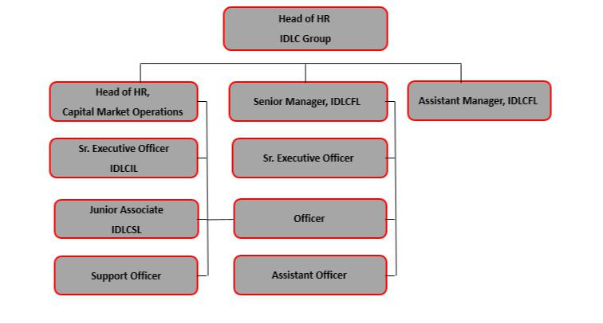

5.3 Recruitment process
IDLC gives all participants equal rights .They are not biased and provide the employees desire opportunities. They do merit based recruitment :

Recruitment proposal

Collection of CV

Selection of CV

Processing for interview

Organizing written test, presentation etc.

Interview

Finalization of recruitment.

5.3 Selection of CV

 | Position |  |  | Preliminary Screening |  |  | Final Screening
 | Non-Management Position |  |  |  |  |  | Concerned HRD officer
 | Non-Management Position |  |  |  |  |  | Concerned Department/ Division
 | Management Trainee/ |  |  |  |  |  | Concerned HRD officer
 | Assistant Manager
 | Assistant Manager |  |  |  |  |  | Concerned Department/ Division
 |  |  |  | Concerned Officer of |  |  | Head of Department
 | For Above Assistant |  |  | HRD Department/
 | Manager Position |  |  | Division |  |  | Head of HRD

5.4 Recruitment Assessment Sheet

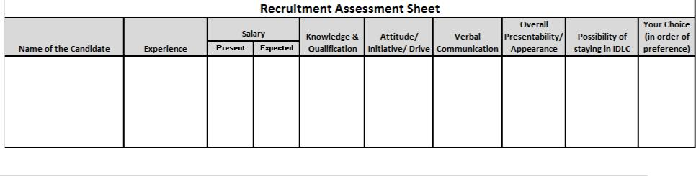



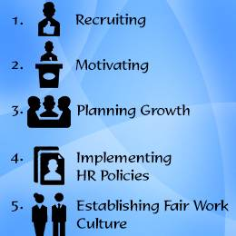

5.5 IDLC Recruitment & Selection Process

- Step 1: first identify the Recruitment Need Assessment and also memo generate.

- Step 2: CV Collection: By Advertisement (Printing or Web), Open Source, Internal Recruitment, external recruitment, and Collect from the Existing Market.

- Step 3: Slotting the collected CV’s for required position.

- Step 4: First take Interview /or written test

- Step 5: Then Second Interview

- Step 6: Focus on Credit check of the primary selected candidate.

- Step 7: Final negotiation with the candidate about salary or other issue

- Step 8: Provide the approval memo for the selected candidate.

- Step 9: Finally provide candidate the Letter of Joining.

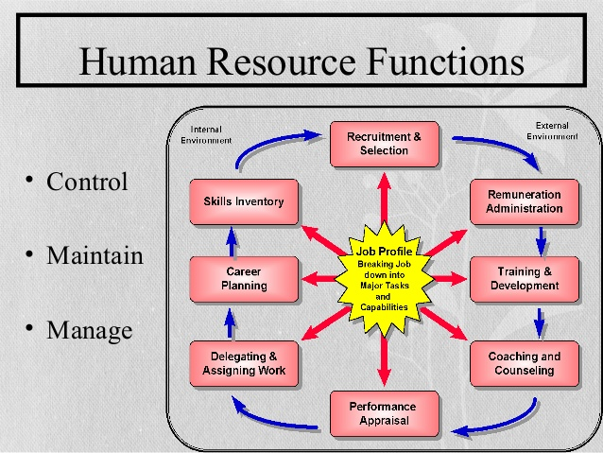

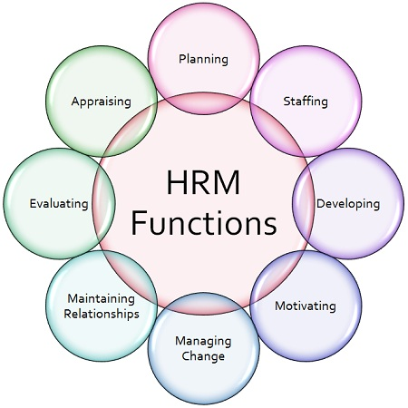

5.6 Performance Appraisal Form

Name:
Designation:
Date of Joining:

Employment Record in IDLC:
Previous Working Experience:
Education/Professional Degree:

Performance Level:
Outstanding (O)
Very Good (VG)
Good (G)
Reasonable (R)

Unsatisfactory (UN)

Criteria to be Judge:
Result of Work
Working Capability
Personal Qualification
Behavior
Leave Taking Behavior
Sincerity
Accuracy of work
In-depth Knowledge

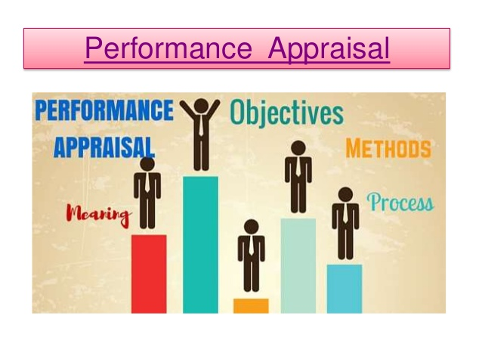

Compensation & Benefits

- IDLC ensured tobe more Competitive in the Market with handsome benefits& compensation to the employees.
- IDLC conduct salary survey to benchmark the market trend.

Various new policies / benefits

- Home Loan, Transport Loan, Personal Loan, Loan against PF

- Hospitalization Scheme, Life Insurance, Terminal Benefits

- Leave Privilege

- Spot Award

- Education Support Scheme, Welfare Fund

Leave Privileges
- Annual Leave:
For 25 working days includes 15 calendar days

- Mandatory Leave
Leave Accumulation allowed up to 90 working days.

- Casual Leave:
For 5 working days

- Prolonged Sick Leave: First 30 days with full pay&
Next 30 days with half pay
Above 60 days & up to 180 days without pay.

- Maternity Leave:for 6 months

Gratuity

Completed years of service as confirmed | Payment of gratuity for each completed
employee | year of service
5 years & above, up to 10 years | 1 (one) month basic
10 years & above, up to 15 years | 1.5 times of basic
15 years & above | 2 times of basic

5.7 Learning Outcomes & Experiences Gained

By doing internship at IDLC finance limited, I realized that the things we learn in classroom and learning something by actually doing it is very different. Working here gave me a taste of how corporate life actually is and it has made me more confident, punctual, resilient and adaptive. My supervisor was very cooperative in case of sharing knowledge and helping me in every aspect of my learning process. He helped to develop my skills that are going to help me mold and foster my professional career. The skills that I have learned through working at IDLC Finance are:

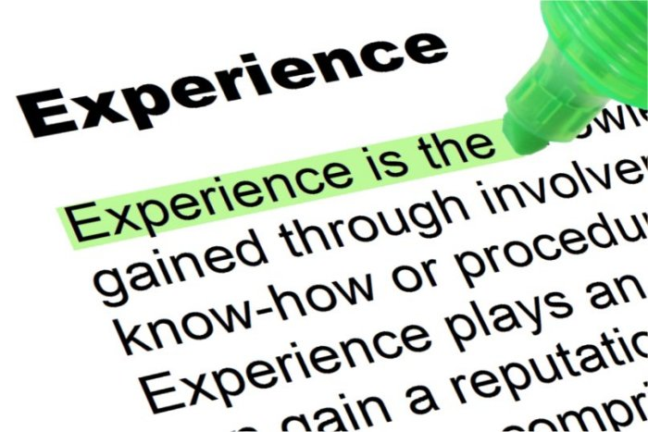

- Ability to work under pressure and Multi-tasking skill:
Everyone says that one of the most challenging thing that employees face initially is working 10 to 6 and sometimes for even more hours. Initially, I also faced difficulties in getting habituated in working for such long hours but after somedays I adjusted with time. Sometimes I had to work till 7.30pm as well and these long hours of work made me used to this corporate culture. Besides, my fellow intern finished her internship one month before I finished and thus I had to do the work of two people for one whole month and I managed it smoothly. I realized that, if you work efficiently, it was possible for one intern to do the work of two interns and still finish it on time as I still could finish my task by 6.30 pm most of the days. These situations made me develop multi-tasking skill and helped to cope well with work pressure.

- Communication Skill:
During my internship I had to communicate both verbally and electronically with a lot of people from different teams and departments on a regular basis. I had to communicate with RMs, third party vendors, Branch representatives, SAM team members and the people of my team. As a result, it has enhanced my communication skills to a great extent and was able to build a good relationship with many people from IDLC.

- Corporate Culture:
My internship in IDLC Finance Limited exposed myself in a very rich corporate culture. I got the opportunity to work with a bunch of qualified and experienced people and learn the ins and outs of a corporate culture. Surely this will help me in my future life.

- Microsoft Excel:
I maintained a quite number of excel workbooks and I had to use V-Lookup, Filtering, formatting table and other excel tools. As a result, skill of using excel improved and also I learnt many things and shortcuts that helped me a lot in doing works. My typing speed also got faster due to this.

- Working in team:
I had to work with another intern and for finishing my task accurately and on time, we had to coordinate and divide tasks among ourselves. Such experience has sharpened my ability to work in a team. Moreover, the analysts work depended on the works I am doing and therefore the whole process was like a chain. Thus, it helped me to play in team together.

Interview Skill:
My internship interview was very intense and it was 15 minutes long. In my interview I was asked numerous questions starting from introducing myself to my skills, excel knowledge, my knowledge on the world and Bangladesh economy and the current top news. My department head tried to make me nervous to test my interview skills and after acing, it gave me confidence to face future interviews and taught me how to handle it.

CEO MR. ARIF KHAN
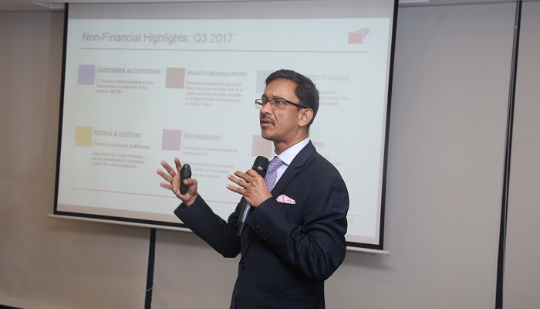

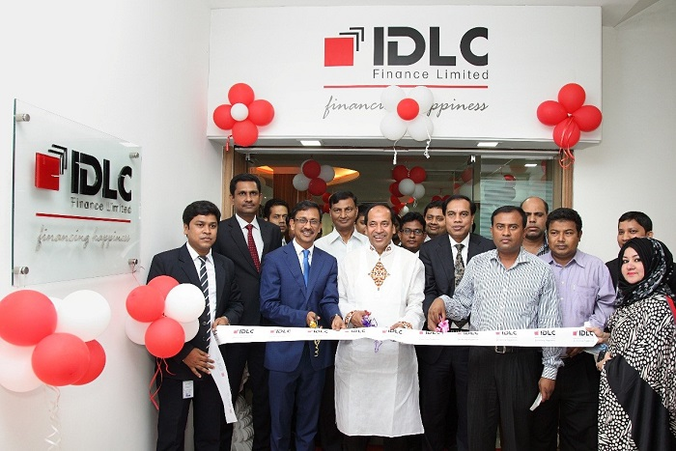

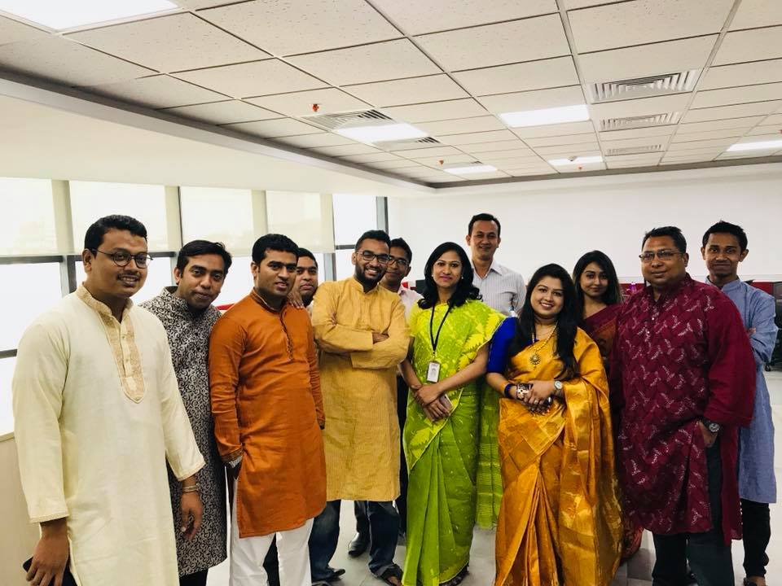

ME WITH SAM DEPARTMENT

AWARD GIVING CEREMONY:

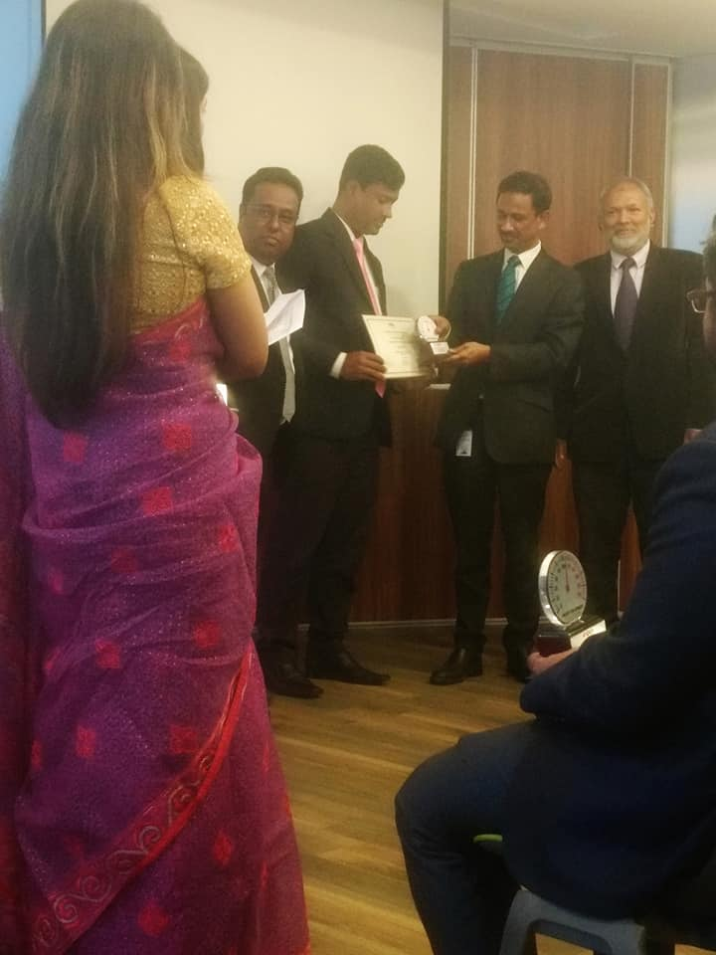

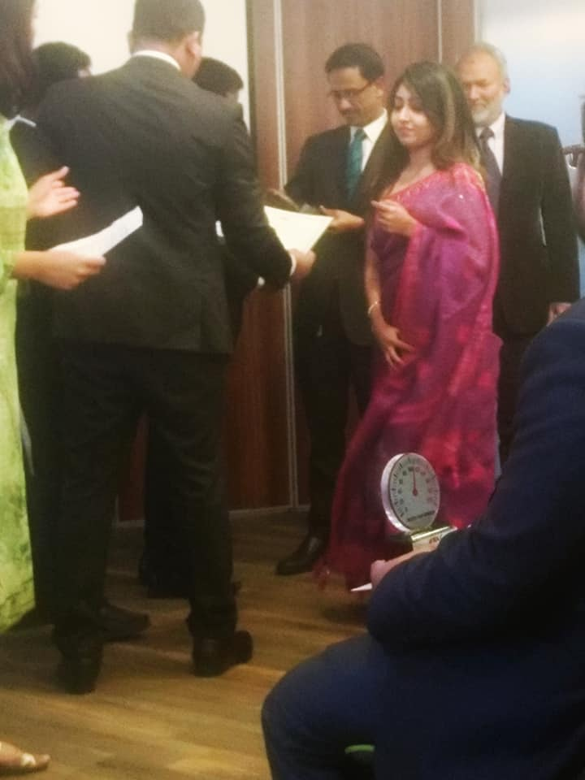

Welfare activities
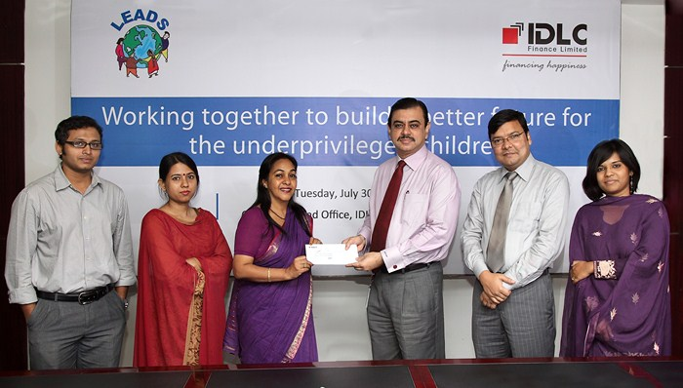

5.9Expectation and Actual
Experience

Since it was the first time in my life I got the opportunity to have a taste of the corporate culture and IDLC being one of the leading NBFIs of our country, I was very excited and had many expectations. Through working here in some cases I got more than what I expected and in some other cases it couldn’t live up to my expectation. Therefore, if I reflect on what I was expecting and what I experienced, I would say that it is a mixed feeling.

Firstly
being an intern, I didn’t expect that I will be able to create a bond with so many people and will stay connected to them even after my internship. Before joining here, I thought that I will be only talking about work related matter but my supervisor and colleagues used to chit-chat with me regarding my future plans and even my interests such as travelling, different cuisines and recent movies besides work related matters.

SECONDLY
I never expected to meet any top level employee or anyone from the management team of IDLC during my internship tenure. However, I got to meet the CEO, Mr. Arif Khan and the DGM Head of SAM as they visited our branch for an award giving ceremony for rewarding the Best performers of SAM and I got go meet them which was a big thing for me.

I never expected that I would get so attached to these people in just 3-months and I would miss the office and its people after the completion of my internship. But now I am missing the lively environment of the office and its people a lot.



being an intern, I didn’t expect that I will be able to create a bond with so many people and will stay connected to them even after my internship. Before joining here, I thought that I will be only talking about work related matter but my supervisor and colleagues used to chit-chat with me regarding my future plans and even my interests such as travelling, different cuisines and recent movies besides work related matters.

I never expected to meet any top level employee or anyone from the management team of IDLC during my internship tenure. However, I got to meet the CEO, Mr. Arif Khan and the DGM Head of SAM as they visited our branch for an award giving ceremony for rewarding the Best performers of SAM and I got go meet them which was a big thing for me.

I never expected that I would get so attached to these people in just 3-months and I would miss the office and its people after the completion of my internship. But now I am missing the lively environment of the office and its people a lot.

CONTRBUTION

My contributions at SAM ( CRM-CD)in IDLC Finance Limited includes:
- Fresh Perspective:
My supervisor, Mr. Tanjeel vai encouraged my participation and valued my input in all the discussions. As I had no prior training, I had an open mind and I was able to give him my honest opinion which he took very seriously while finalizing and implementation strategies.
- Confidentiality and Due Diligence:
This was a more passive task but nonetheless very important. As I was working at CRM-CD, I came across many confidential information such as client information, their bank balance and others. Therefore, I had to be very cautious regarding with whom I shared this information with.
Reporting and follow ups:
At the end of each day, I used to send emails like: Sanction files list, Rejected files list, CPV daily requests, CPV exception reports keeping the concerned persons in the email. This helped them to keep up-to-date with the activities and they could take cautious and necessary steps required to complete their job. For example: From the rejection email, the RMs and STMs (Sales Team Managers) could know which files are being sent back to them and the credit analysts could know the status of their rejected files.

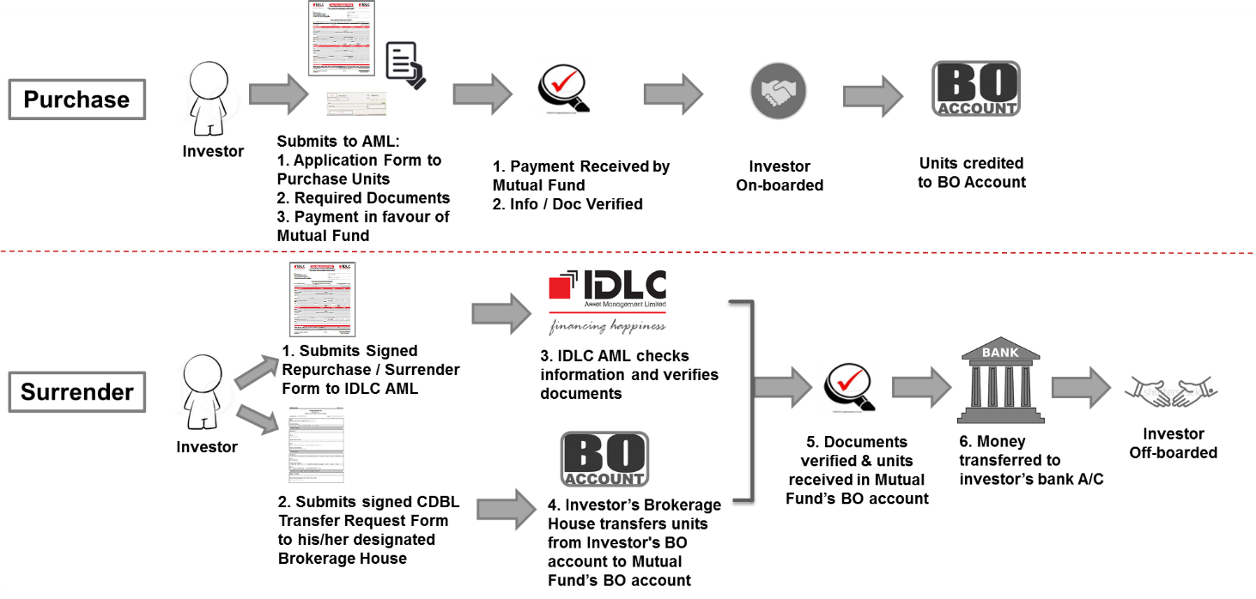

In a short span of three months, I believe that I have learned significantly about how the consumer loans in Bangladesh are designed. I also learned about the different compensations plans for different industries and organizations through the application of different customers. Most importantly, I learned and got a clear understanding of the functions and business practices of the Banks and Non-banking financial institutions in Bangladesh. I believe that this knowledge would definitely help me to take my next big step towards my career.

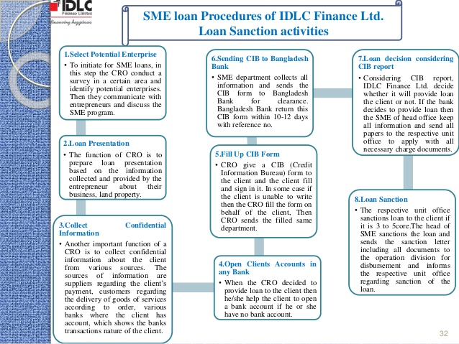

BANKS THAT HAVE IDLC ACCOUNT

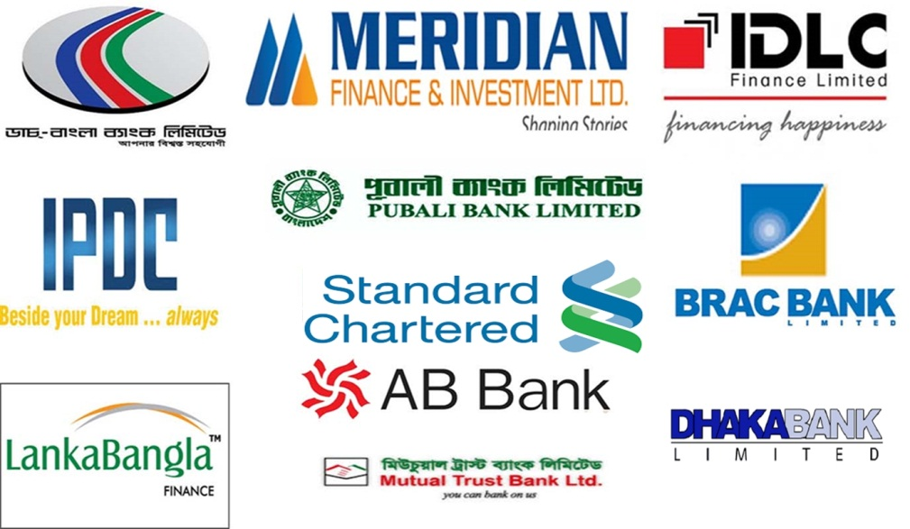

According to the trend analysis, consecutively selling of loan amount is gradually increasing in IDLC Finance Limited. As we can see, during the period of 2013 the total sell of loan was 40,941 million BDT, which stood in last year 2017, is 71,499 million in BDT. The future prediction of 2018 is the total selling loan will hit to the Eighty thousand approximate.

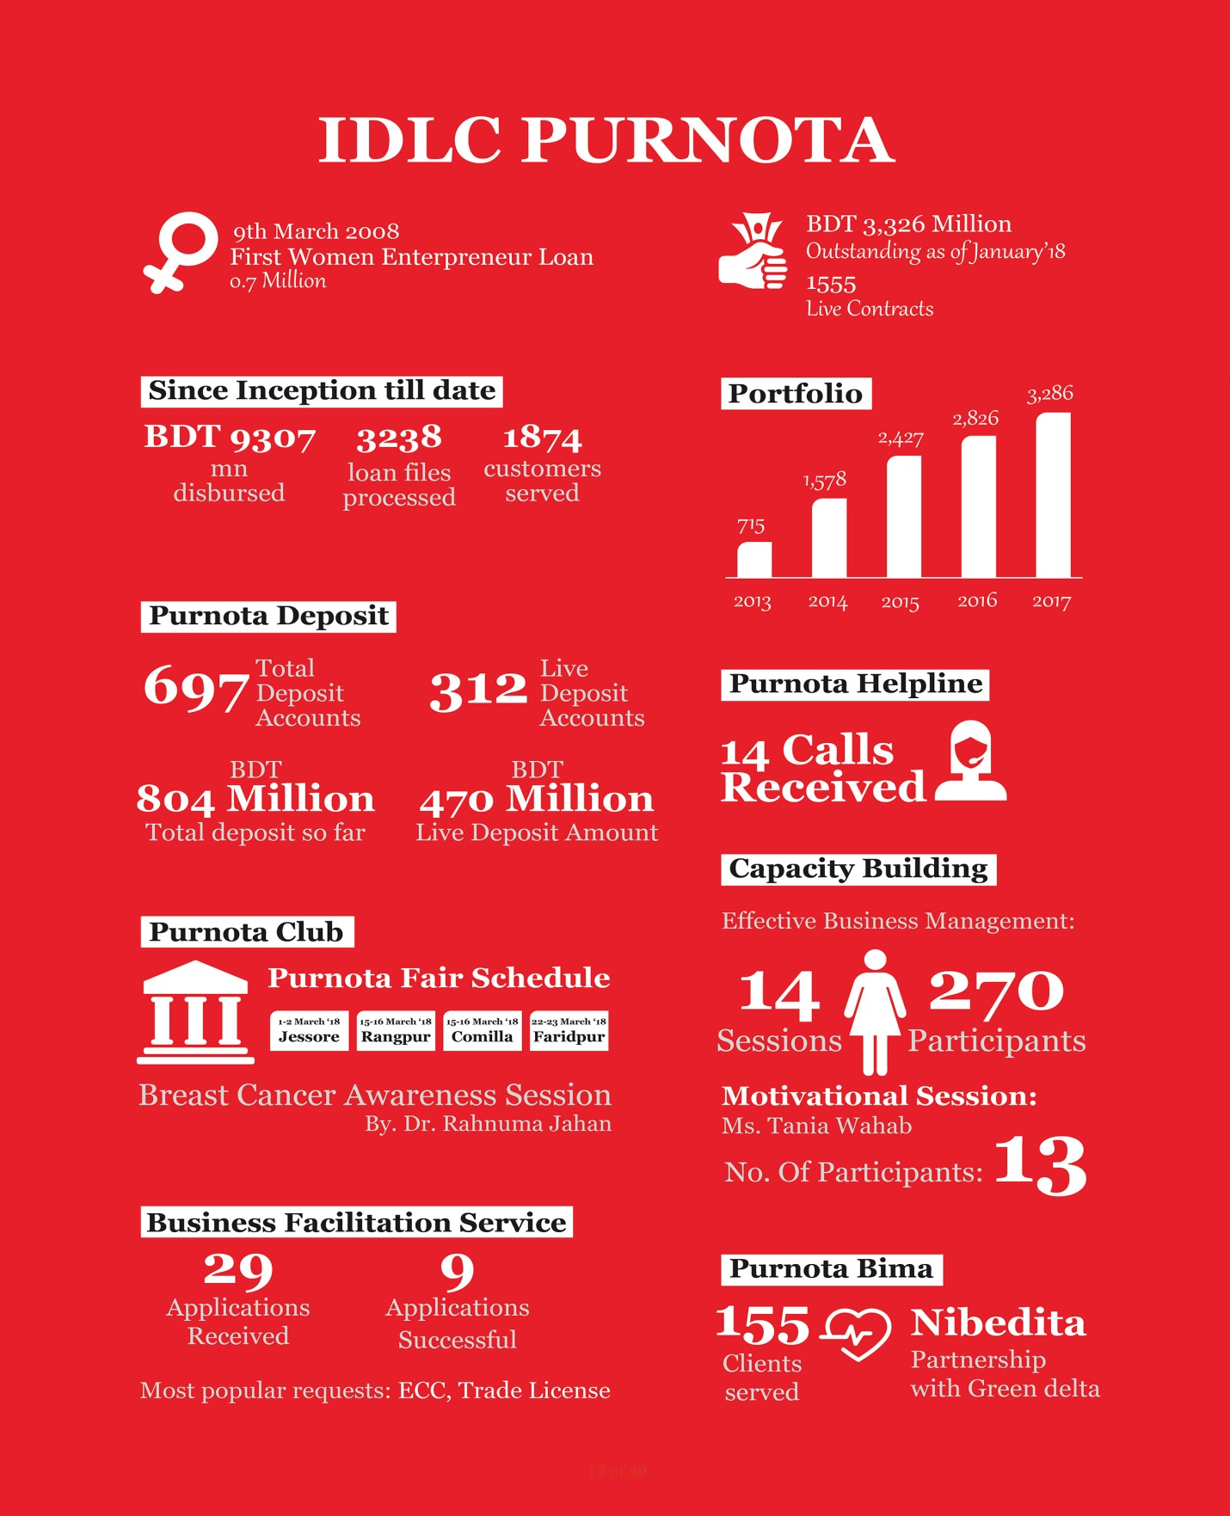

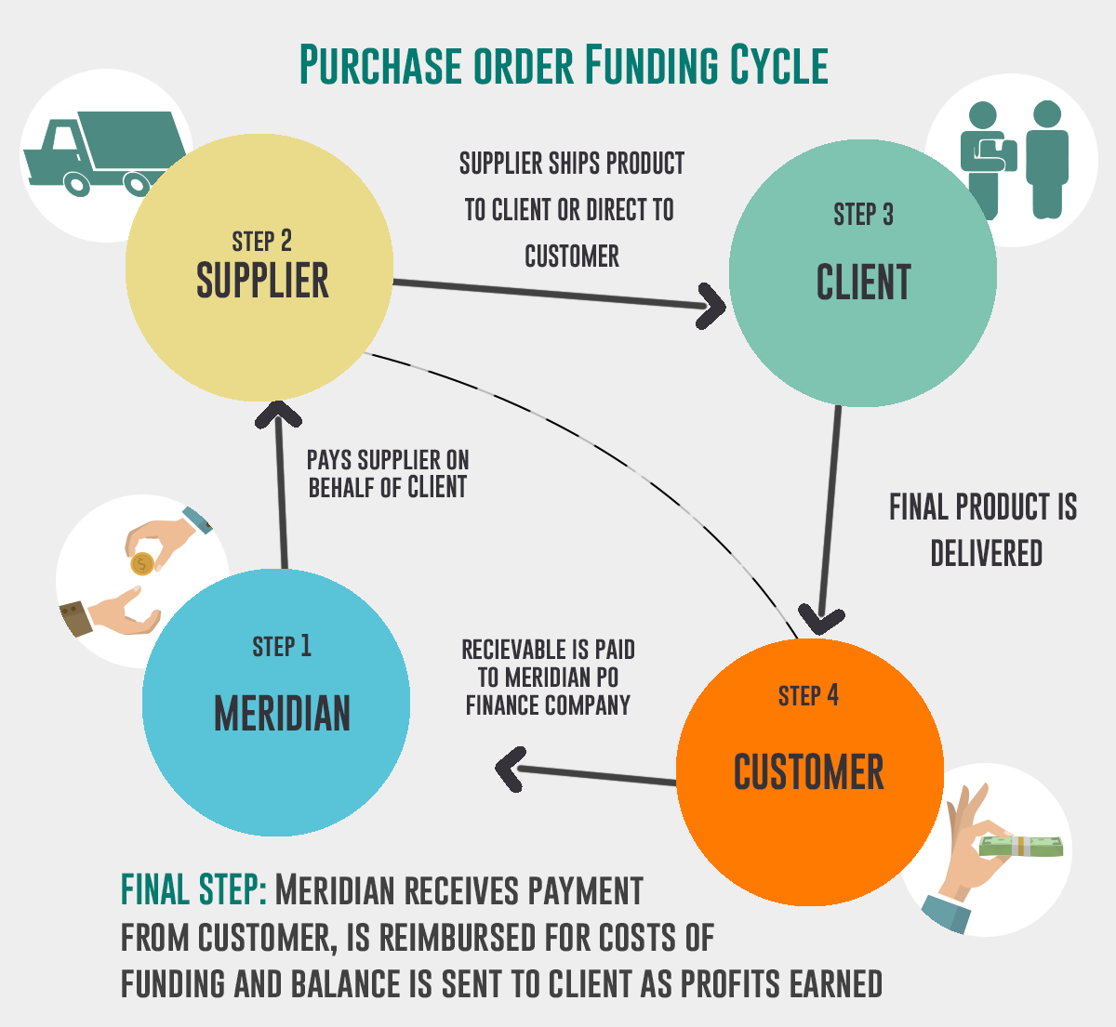

The intention of SAM is to obtain payments at the appointed time to diminish the risk and write-off expenses as well as maintaining the customer's concern through providing a standardized service.

First of all, the SAM team checks and remind every customer on a daily basis whose EMI date is approaching. Then they supervise the loan account that could not pay within their allocated time. Those loan accounts are listed as overdue clients.

Therefore for approaching the clients and to collect the overdue amount the team need to go through the following steps accordingly in general-

- Provide text messages and Email.
- Call to give them Soft Reminder
- Visiting to communicate with them
- Provide Hard letter of issuance
- Provide Legal notice
- Prepare case filing report
- (Auction)of their property.

Phone Call, text messages and Email are normally sent to the customers regular basis before their installment expiry dates a reminder to pay the monthly installment. SAM requests the customers about cheque exhaust. Send their cheque to any branch or directly at SAM. But if customer didn’t give cheque for any reason then they can give cash payments to IDLC via 10 bank accounts. Where they have to first Fill up slip by providing IDLC account number and customers identification number then after providing cash mail the picture of this slip to the junior officers.

Job vacancy advertisement in BD Jobs

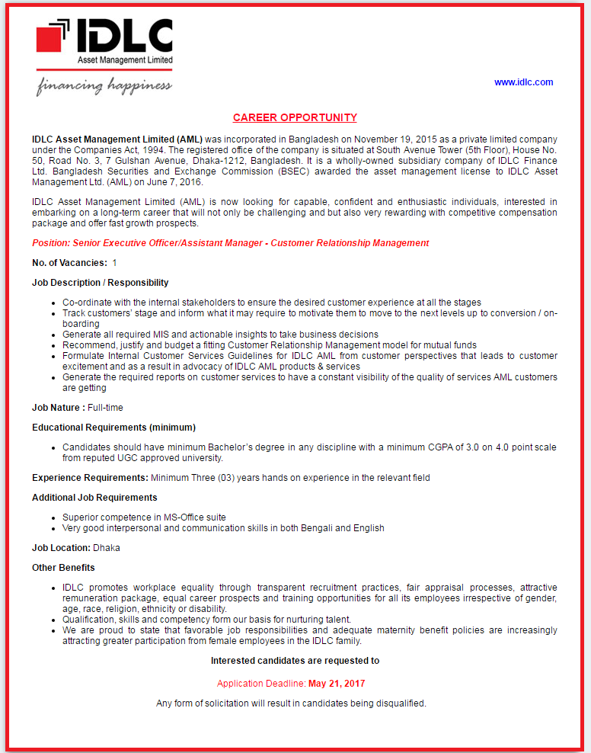

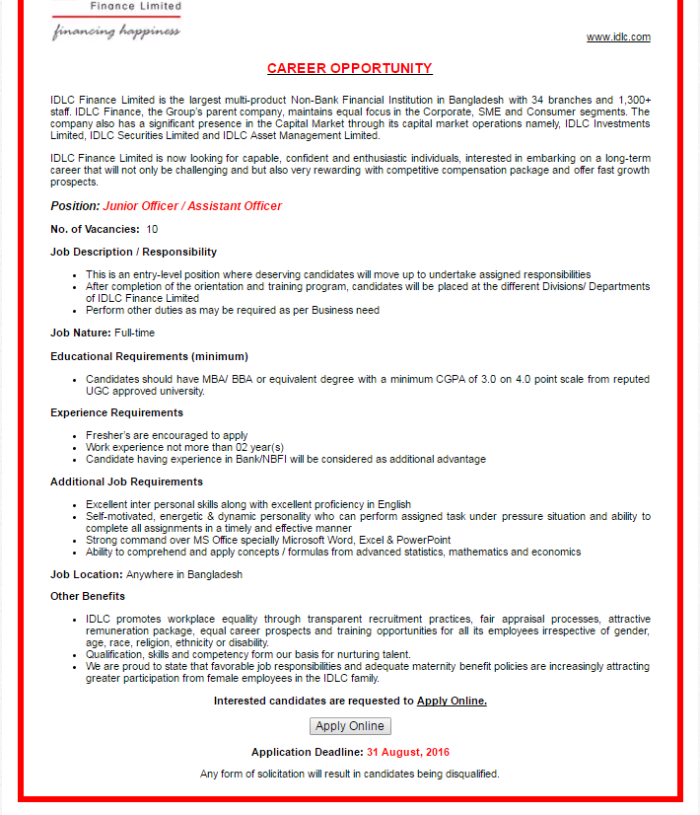

5.10 Interaction with Supervisors and Co-workers

In IDLC Finance Limited, my internship supervisor was Miss sultana , an assistant manager of SAM AND MR Tanjeel . At my first day of internship, I was a bit nervous as it’s a new place surrounded by all the new faces and I have never been to a situation like this before. He made sure that I work at ease, asked me for tea, showed me my designated desk and introduced me to the Officer and the Senior trainee officer who were there to guide me with my work. He informed me about the 4 cluster manages and which desks and divisions they were looking. Besides, he was the one explaining me about the cut-off time that I had to keep in mind while giving the receiving seal. He was very helpful and I could go to him with any problem and he would help me in every possible way. My supervisor also guided my thoroughly about my future career plans and encouraged me to give interviews and look for jobs during my internship period. From this company, I got his endless support and guidance from everyone. Shaker bhaia, yeamin bhaia , jabber bhaia, kibria bhaia helped me a lot by teaching me the complicated processes, helping me out whenever I faced difficulties and by teaching me excel tricks and shortcuts necessary to complete the work efficiently. He also taught me to analyze Bank Statements and used to crack jokes to keep the work environment light. My department senior manager MR. Dewan has always been good and supportive towards me. He always used to ask about my whereabouts and also gave me important insights about my career path and motivation to do well. In IDLC, to keep the environment friendly and minimize the power distance, the culture was to address each other by bhaia and apu instead of addressing them by Sir or Ma’am. Everyone in this organization was co-operative and this made working here easy. I still am in touch with many people of the organization and they always try to help me and motivate me regarding my career paths.

Chapter 6
Findings &Recommendations



6.1 Findings
By observing the trend forecast, it can be said that the measures SAM follows are efficient except it can be more effective if some issues can be dealt more cautiously.
I have found some rationale behind the Non-Performing Loan (NPL),

- One of the reasons of NPL is the increasing number of customer in consumer division. As the number is increasing the number of NPL increases as well.

- Another reason is the high employee turnover rate in IDLC during the last two years. The employees‟ compensation is not satisfactory especially for entry level and mid-level recruits. As a result IDLC loses talented and experienced as well as well-trained employee. Moreover the change of the management committee can also be a reason for NPL.

- Fluctuation of interest rate is also a setback. When the interest rate increases IDLC need to increase the rate higher than the market rate to maintain the profitability as the cost of fund is higher at IDLC .Therefore some of the customer become displeased and try to ignore the regular payment.

- The fixed interest rate of IDLC is also another explanation of NPL growth. At present the interest rate is way lower at market than IDLC. Therefore the clients become dissatisfied though they willingly took the finance at the rate. However IDLC is now converting those loans rate by approving submission of request.

Some customer's unwillingness to pay is also a reason for NPL. Family problem, bad investment and business, poor business practices, social unrest, unanticipated tragedy or loss in business etc.



6.2 Recommendations:
Here some recommendation based on the findings of the report that have explored whole areas where solution and recovery needed to enable the services to a greater efficiency level and hence smoothing the operations.

- When clients come to give cheque they have to wait because officers were busy with other works where clients become angry so they should be more concern about this matter.

- Update of PDC should have synchronized among all of the braches of SAM that can easily found of each branch’s default clients.

- During the pick hour often server of Oracle BL publisher and the system became down, which do not give the highest efficiency level. That should be change and need to speed up the server.

- Not only give concentration to the overdue customers of three month. There should also give the immediate focus of one-month default clients.

- SAM team only present on Dilkhusha Branch, I would say SAM department should engage in each branches all over the country.

- There should open a short training program for the borrowers about the company policy and regulations.

• Customer's past behavior regarding loan payment regularity should be scrutinized carefully before the loan sanctions.

• Proper client selection, reasonable interest rate for the clients who are in a bad position, arranging workshop for the client about the ethical aspects.

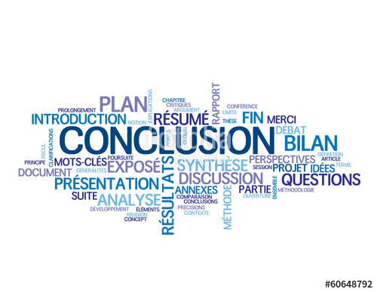

Chapter 7: Conclusion

IDLC Finance Limited is setting a remarkable mark the economic development of bangladesh. IDLC Finance Limited is doing a great job in the financial sector of our country. IDLC finance is worth place for Finance, Accounting & hrm graduate to do his/her intern .By doing internship here one will get opportunity to understand hr and finance related work . The term “SAM” is explained in details along with the roles and responsibilities of the Special asset management Department, where I was assigned. Moving forward, the report also gave depth analysis of the roles and responsibilities, significant contributions, learning outcomes and challenges faced during the three month’ internship period and how in the coming years, this journey would help to plan my future career.

My internship experience was really valuable for me and I would not want to do it any other way. But if I have to redo this internship for some reason once again, I would re-do this internship in the same department and preferably under the same supervisor but with more ambition and dedication. Initially, I thought I would be made to do menial work or treated as a mere support staff but throughout my internship tenure, I realized what an important and significant role I’ve had to play. With all these learnings and experience, I would be able to make a proactive approach towards my work and ask for more challenges and responsibilities unlike before when I waited to be called and asked by my supervisor to do something .I would ask my Department Head to give me the opportunity to apply the knowledge I got from higher level courses even more so that my concepts get clearer and I would give some focus on communicating even with people of other departments.

.
References

IDLC Finance Limited. (n.d.). About Us: IDLC Finace Limited. Retrieved December

2017, from idlc.com: http://idlc.com/

Sharmin, B. (2012). Analysis of collection procedure of Retail Loan. Dhaka: BRAC University. https://thefinancialexpress.com.bd/

https://www.bb.org.bd/econdata/index.php

http://quotes.wsj.com/BD/XDHA/IDLC

https://www.ceicdata.com/en/indicator/bangladesh/non-performing-loans-ratio IDLC Finance Limited, Annual Report-2017. http://www.investopedia.com/terms/g/grossmargin.asp

The Global Economy. (n.d.). Retrieved December 2016, fromwww.theglobaleconomy.com:

http://www.theglobaleconomy.com/Bangladesh/Nonperforming_loans

