

United International University

Internship Report on “Impact of ERP on Energypac’s Performance”

Submitted by:
Sojib Roy
ID:111171248

Submitted to:
James Bakul Sarkar
Associate Professor
School of Business & Economics
United International University

Date of submission: 11th September, 2022

Letter of Transmittal
11th September 2022
James Bakul Sarkar
Associate Professor,
Department of Accounting
School of Business
United International University
Dhaka, Bangladesh
Subject: Internship Report on “Impact of ERP on Energypac’s Performance”
Dear Sir,
It gives me great pleasure to submit the Energypac Electronics (EELL) internship report as per your instruction. I expect that this report will be thorough and informative. For me, working at EELL was a motivating experience. My vast knowledge and experience from my internship will be very helpful to me in my future professional life. With my limited knowledge, I have done my best to write a report that is worth reading.
I am transmitting this report to your concern. Hopefully, you will find the report informative, and your acceptance and appreciation will surely inspire me. For any further explanations about the report, I will be gladly available to clarify the ins and outs.
Yours Sincerely,
Sojib Roy
ID: 111 171 248
September 11, 2022

Acknowledgment

First, I would like to express my gratitude to the Almighty Allah for enabling me to complete the report in due time.
I would like to express my sincere gratitude to my dedicated faculty James Bakul Sarkar for his support and guidance, which enabled me to prepare a well-executed report. My gratitude towards my parents is everlasting; without their help and support throughout the journey of my life, this would not have been possible at all. My utmost thankfulness goes to my supervisor Md.Injamamul Huq, the Accounts Payable Officer at Energypac Electronics Limited, for giving me in-depth knowledge about an electrical home appliance company (EELL).
I have tried my best to prepare this report according to the given instruction. I hope that I have been able to portray the picture of what I have experienced and learned during my internship period.
Finally, I would like to thank EELL (Energypac Electronics Ltd) for allowing me to do my internship there and helping me prepare the report.

Table of Contents
Letter of Transmittal 2
Acknowledgment 3
List of Tables 5
List of Figures 5
Executive Summary 6
Chapter 1 7
1. Introduction 7
1.1 Energypac Group 7
1.1.1 Vision, mission, objective 8
1.1.2 Corporate Departments 9
1.1.3 Details of the product lines and services 9
1.1.4 Operation details 13
1.1.5 Corporate Social Responsibility 13
Chapter 2 15
2. Internship experience/ observation details 15
2.1 Job responsibilities 15
2.2 Functions of the department 17
Chapter 3 18
3. Internship outcome/Issue Analysis/Empirical Analysis 18
3.1 Analysis of industry/markets (in which your company operates) 18
3.2 Finding peer group/ main competitor(s) (e.g., based on their market capitalization or asset size) 18
3.3. Trend analysis 19
3.4.1 Energypac with Integrated Software: 24
3.4.2 SAP (Systems Applications and Products in Data Processing) 24
Chapter 4 29
4. Discussion & Conclusion 29
4.1 Discussion 29
4.2 Conclusion 29
References: 31

Table no. | Description | Page no.
Table 1.1.1 | Corporate Information | 8

List of Tables

List of Figures
Figure no. | description | Page no.
Figure 1.1 | Company logo | 7
Figure 1.2 | Corporate departments | 9
Figure 1.3 | Luminaries | 9
Figure 1.4 | Ceiling fan | 10
Figure 1.5 | Green solution | 11
Figure 1.3 | Professional lighting | 12
Figure 2.1 | BiznessROOTS | 15
Figure 2.2 | SAP software | 16
Figure 3.1 | Trend Analysis of Energypac Electronics Limited | 18
Figure 3.1.1-3.1.8 | Graphs of all trend analysis | 19-22
Figure 3.2 | Post incoming payments on SAP software | 24
Figure 3.3 | Enter general ledger account document | 24
Figure 3.4 | Enter incoming invoices | 25

Executive Summary
As a part of my internship program, I joined Energypac Electronics Limited on 8thMay 2022. This report focuses on my experiences, learning, and the people I have met and communicated with throughout the full-time internship program at Energypac Electronics Limited. This report covers all the parts from starting to ending the internship at Energypac Electronics Ltd. In these three months, what type of work I was given and how the task, in my view, helped me to learn new skills are given in this report. The main agenda of this report is to give a picture of how the company Energypac Electronics treats an intern and how an intern contributs to the organization. This report covers how to work with colleagues and the interactions with Line managers. I was assigned to work in the Accounts & Finance department. The report also describes my learning experiences and day-to-day tasks during the period. The primary tasks were creating bills, input of collection entry to SAP software, creating money receipt& helping other colleagues and the whole department etc. I believe the best part about Energypac Electronics Limited is their work culture, their office enviorment and this program allowed me to get used to thework life and how works are done here. I still believe I can further improve my communication, analytical and technical skills before joining a full-time job, especially given how important communication plays in such an organization. Overall, this program will go a long way in understanding where I stand currently and help me improve. Moreover, there are further growth opportunities if I plan to apply for a permanent post at the organization.

Chapter 1

1. Introduction

1.1 Energypac Group
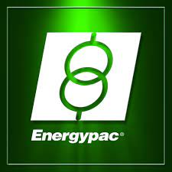
Founded in 1982, Energypac has made every effort to become a pioneer in the power sector in Bangladesh. Energypac has become prominent in the engineering and electronics industries due to its unwavering commitment over the last three decades.
We have broadened the scope of our offerings in order to better meet the needs of a wider range of clients and offer whole power solutions that cover generation, transmission, distribution, protection, and control. The business is dedicated to offering top-notch goods and services in design, production, and testing to the regional market and has a strong global network. We take pride in upholding a good rapport with our clients. During crucial stages including investment decision-making, feasibility studies, material and equipment selection, types of machinery procurement, equipment installation and commissioning, and after-sales service, we are step-by-step and ready to give our support.

Figure 1.1 Company logo
Energypac has advanced technology advancements and cutting-edge production since 1992, thanks to its highly qualified employees and cutting-edge machinery. Our goal has always been to deliver the best possible service to the country.
In Bangladesh, Energypac Electronics manufactures cutting-edge low-voltage electrical products. High-quality electrical wiring accessories, top-tier lighting and luminaries, and energy-efficient ceiling fans are part of our exclusive line of products. Legrand, the global specialist in electrical and digital building substructures, has an official representative in Bangladesh; Energypac Electronics specializes in professional lighting and Green Energy (renewable energy) solutions and manufacturing the most delicate electrical products.
Energypac Electronics was founded in 2005 to provide Bangladesh with the most dependable, efficient, and professional electrical solutions. The company is exceptionally proud of its status as a forerunner in industrial technology. Energypac Electronics produces high-quality low- voltage electrical products with advanced manufacturing equipment and fully equipped research and development facilities.
The organization is dedicated to researching, developing, and producing highly efficient and environmentally friendly products for the country's booming electronic industry. Our internationally certified products meet the highest quality standards while consuming less energy, ensuring a brighter future. Energypac is confident that its ongoing efforts to popularize greener electronics will help save the environment and improve the country's residents' living standards.

1.1.1 Vision, mission, objective
Mission: Energypac’s mission is to provide its consumers with nothing short of perfection through their products and services.
Vision: Energypac’s vision is to inspire the art of innovation in Bangladesh for generations to come. Provide best in class end-to-end engineering solutions ensuring highest value addition to those they associate.
a) Sustainable Growth
b) Popularize green electronics
c) To utilize the most advanced manufacturing equipment to produce high-quality, low voltage electrical products
Objective:The company is committed to doing research, creating highly effective solutions, and manufacturing environmentally friendly goods for the rapidly expanding electronic industry in the nation. Our products are certified globally and satisfy the highest quality requirements while using less energy, assuring a better future.
Corporate Information

Company Name | Energypac Electronics Limited.
CEO and Managing director | Engr. Nurul Akter
Legal Status | Private Limited Company
Turnover | 5 billion
Website | www.energypacelectronics.com
Hotline | 16591
Numberofbranches | 12
Table 1.1.1 Corporate Information

1.1.2 Corporate Departments

Figure 1.2

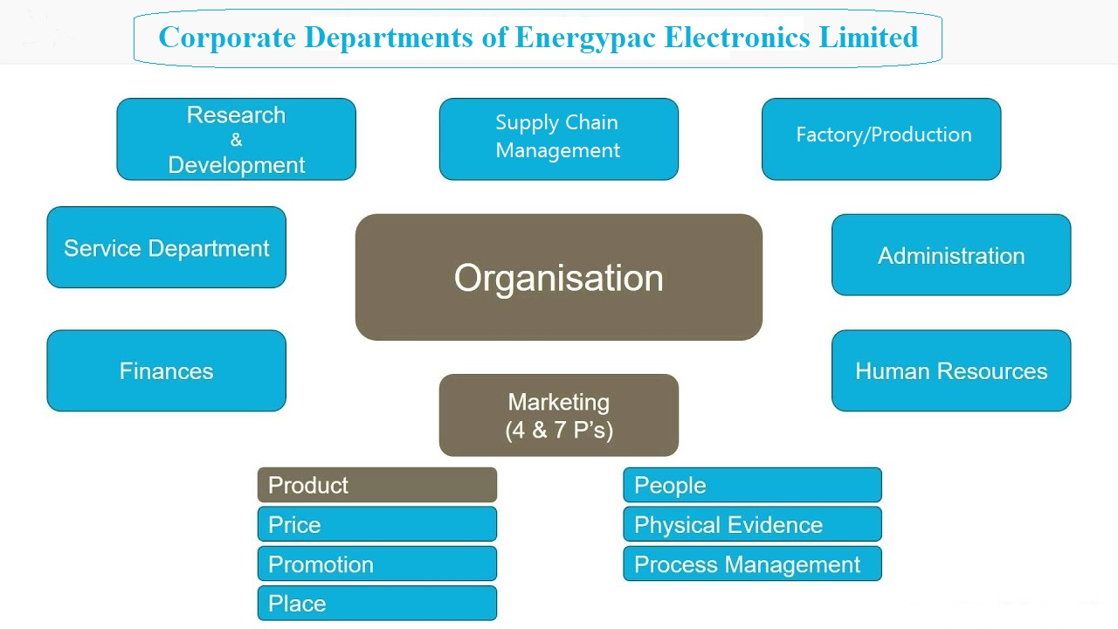

1.1.3 Details of the product lines and services

Luminaries

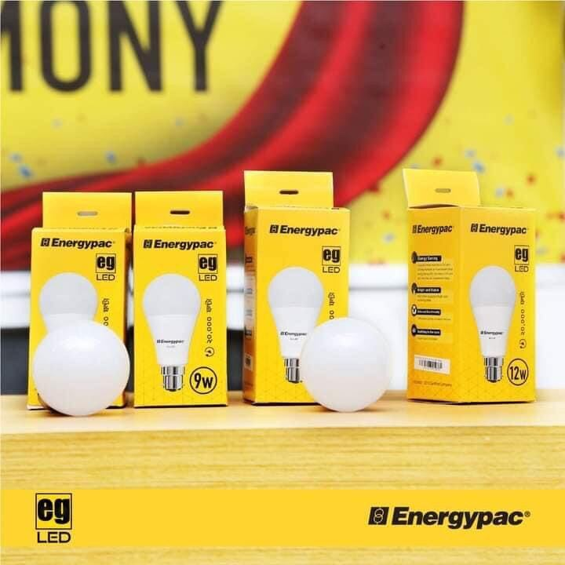
Energypac Electronics Limited produces and imports the most energy-efficient and long-lasting Luminaries products for the country. Now they have six categories of Luminaries products. Of the six categories of luminaries, they produce three categories in the country, and the other three categories they import from china. Their product lines of luminaries are:
● Led Bulb People
● Led Bulb Power
● Led Tube Light.

Figures 1.3 luminaries
● Slim Panel Light
● Led Downlight
● EG Led Light
● Backup Led Bulb
Protection Devices:
Energypac has solid and durable protection devices. Their product lines of protection devices are:
● Legrand MCB
● Energypac MCB
● Sassin MCB
● Legrand RCB
● Legrand ACB
● Legrand SPD
● Sassin RCB
Ceiling Fan
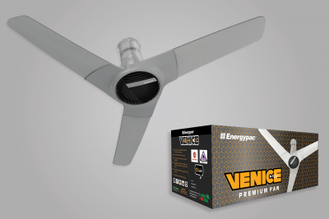
Energypac Electronics Limited produces three types of ceiling fans. Energypac Ceiling Fan is one of the most popular ceiling fans in the country. They are:
● Ceiling Fan Regular
● Ceiling Fan Deluxe
● Venice Premium Fan.

Figure 1.4 Ceiling fan

Wiring Accessories
Energypac Electronics produces five categories of wiring accessories and imports three categories of wiring accessories. They produced:
● EG series Switch and Socket
● EG-2 Series Switch and Socket
● Venice Premium Line Switch and Socket (New)
● Piano Series Switch and Socket
● Elegant Series Switch and Socket
● Extension Socket
Energypac also imports some wiring accessories they are:
● Belanko Series Switch and Socket
● Legrand Series Switch and Socket
● Legrand Mallia Switch and Socket

Green Solutions
The Energypac Green Division is a green energy consulting firm that offers original, cutting-edge green answers to the nation's energy problems. Solutions for solar energy.
Renewable energy is not an alternative source; it is a primary source of energy. With a team of specialists in renewable energy, Energypac has ten years of experience in solar solutions. Numerous government and non-government projects have been performed by Energypac.
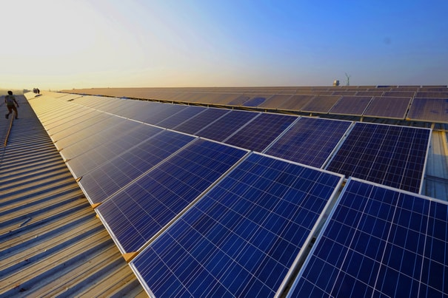
Energypac Electronics' green solutions are:
● SOLAR GRID TIE Solution
● SOLAR OFF-GRID Solution
● Grid-Tie with Backup Solution
● Solar Pump Solution
● Solar Mini-Grid/ Nano Grid Solution
● Solar Thermal Solution

Figure 1.5 Green solution
● Solar Street Light Solution
Energypac Electronics Ltd. has aspired to bring environmentally friendly, high-quality products to the country since its inception. The following are some of the features of ENERGYPAC's energy efficiency:
● Green Lighting Solution
● Green Cooling Solution
● Green Drive Solution
● Green Automation Solution
● Green Renewable Energy Solution
● Green Management Solution
Solution Coverage:
▪ Corporate Office Banks
▪ Retails Stores & Showrooms
▪ RMG & Other Small to Medium Size Factories Hotels & Resorts
▪ Hospitals & Clinics
▪ Schools, Universities & Other Academic Institutions
▪ Residence

Professional Lightings

Energypac Electronics Ltd. has been creating commercial lighting solutions for a while and has amassed a wealth of industry knowledge. They are also working to improve our knowledge of home wiring accessories to have more security, lower our energy bills, and have more control over our surroundings.
Energypac has introduced ground-breaking, up-to-date, and decorative lighting systems for a wide range of commercial, industrial, residential & specialized applications. The arrangements they are offering are reasonable, environmentally friendly, and energy-efficient, reducing the load on the national electric grid in a variety of ways, includingthrough the product itself, such as Energy Saving luminaires (T8, Induction, LED, Electronic Ballast, and so on), and through the installation system, such as Timer, Light Dimmer, and Sensor.

Figure 1.6 Professional lighting

ServicePAC
ServicePac is a new product from Energypac. This is a subscription-based electric solutionservice. That focuses on giving corporate solutions and routine electrical safety cheek to corporate clients.

1.1.4 Operation details
Major products of EELL are electric cables, distribution board, large and medium transformer, switchgear, substation equipment, electric arc welding machine, enameled ware, insulator, industrial fan, heat and speed control system, magnetic contactor, parceling bright connector, different connecting equipment, main switch, electric iron and soldering iron, ceiling fan, table fan, tube light, filament bulb, light fittings, table lamp, different laps, distribution board, electric meter, switch, plug, water heater, fluorescent light ballast, light & fan controller, torchlight, refrigerator, lift equipment, extension cord, and energy-saving lamp, etc.
Major importers of electrical products are the USA, Canada, Australia, Mexico, Italy, Hong Kong, and some Middle East countries. Major exporters of these products are China, India, Germany, Japan, Taiwan, South Korea, and Vietnam. Under-invoicing during the import of finished electrical products, a lack of advanced technological and technical knowledge, a lack of IP protection, a lack of infrastructure to enter the export market with electrical goods, and quality flexibility imported low-quality products are some of the major issues confronting the Bangladeshi electrical sector. We also propose some actions to keep this sector competitive and to expand into the export market. Government has to play an active role in making it one of the fastest-growing and most significant export-earning sectors of Bangladesh.

1.1.5 Corporate Social Responsibility
In the new era of business maintaining corporate social responsibilities are very important to maintain goodwill in a market. It helps the organization to sustain itself in the competitive market also helps to have a competitive advantage over the market competitors. Although the organization Energypac Electronics limited also maintains some CSR for their betterment of the business and the society.
Build customer loyalty:
In any business, customer loyalty is very important. Because every business is depending on the trust of the customer. Here the organization EELL has always maintained the trust of the customers and successfully created a customer base. This will help them to build a strong relationship with the customers in the long run. The organization also follows some ethics through the process of maintaining customer loyalty.
Improve the efficiency of the workers:
Employees are the main resource of an organization. So, if any organization can improve the efficiency of the workers, they will be able to gain more profit. The organization is always concerned about their organization and tries different types of training programs and brings new technologies to increase the productivity of the workers. They also design different schemes to motivate the employees from a different perspective.

Ensure safety and security in the workplace:
The organization always maintained proper care of the safety measures in the workplace and also in the factory so that the workers can work in a safe environment. On the other hand, this has helped the workers to improve the efficiency of work. When organizations provide the proper safety measures life fire extinguisher, emergency exits, first aid team for any kind of emergency the organization is always ready to solve.

Chapter 2

2. Internship experience/ observation details
2.1 Job responsibilities
I worked as an intern in the Finance and Accounts department in Energypac Electronics Limited. In the Finance and Accounts department, everyone has some particular tasks to perform. During my three months’ internship period, I have done some of the functions to help the department's members. Such as:

- I worked on a project with my supervisor which was to match customer transactions. As in 2019, EELL changed their software where the whole company inputs information of all transactions of every customer, vendor and employees and technically everything. The new software is called SAP and the previous one was BiznessRoots in short “BizRoot”. While shifting, some customer record got mixed up and does not match with both of the software’s. Therefore, I had to check each customer account whose opening balance and ending balance didn’t match and then I had to find out the reason behind this miss match.
- The input of collection entry to SAP software: While the sales department made a sale, I needed to collect cash or cheque and put the entry to SAP software.
- Creating money receipt: While collecting the cash, I gave the money receipt to the salesperson.
- Input the customer's advanced payment: While some distributors make advance payment for the goods, I give input in the SAP.
- Generating acknowledgment slip for Sales and Retail & Distribution Department: While salesperson is using a sales book to track their sales, I input in the SAP while give or return from the customers.
- Creating MIRO of Vendor Invoice: MIRO (Movement in Receipt Out) is used for posting foreign & local vendor invoices. When goods/services received from vendor, finance and accounts department use MIRO to enter to SAP
- Creating a Bank Deposit Slip for the company: In working days, I needed to create a customer deposit cheque.
- Checking the petty cash transaction: Energypac Electronics has ten branches with a factory. Every week, from different branches, the accountant’s sends the petty cash expense document to the head office. As I am in the head office, I need to check and calculate any paper errors.
- Posting of creation, settlement, the interest of RL, LTR, UPAS loans to SAP to help treasury dept.
- Assigned to the documentation of the vendor payments papers.
- Checked weekly vehicle fuel and other expenses.

Figure 2.1 BiznessROOTS

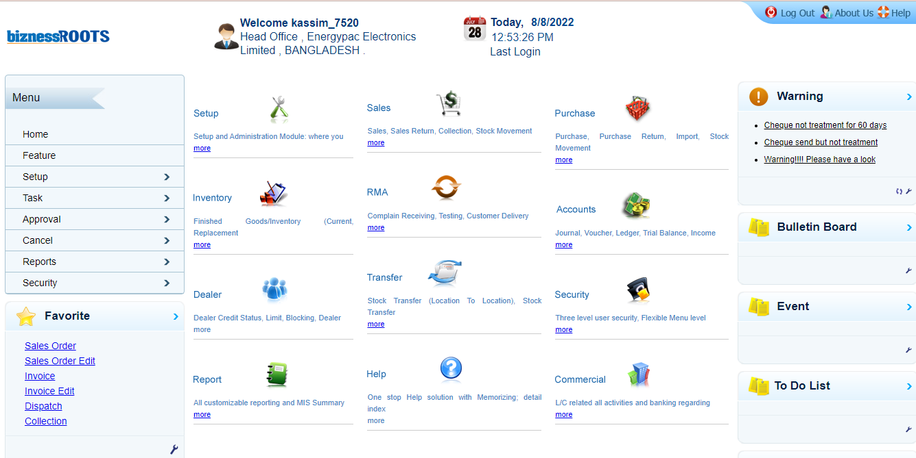

Figure 2.2 SAP Software
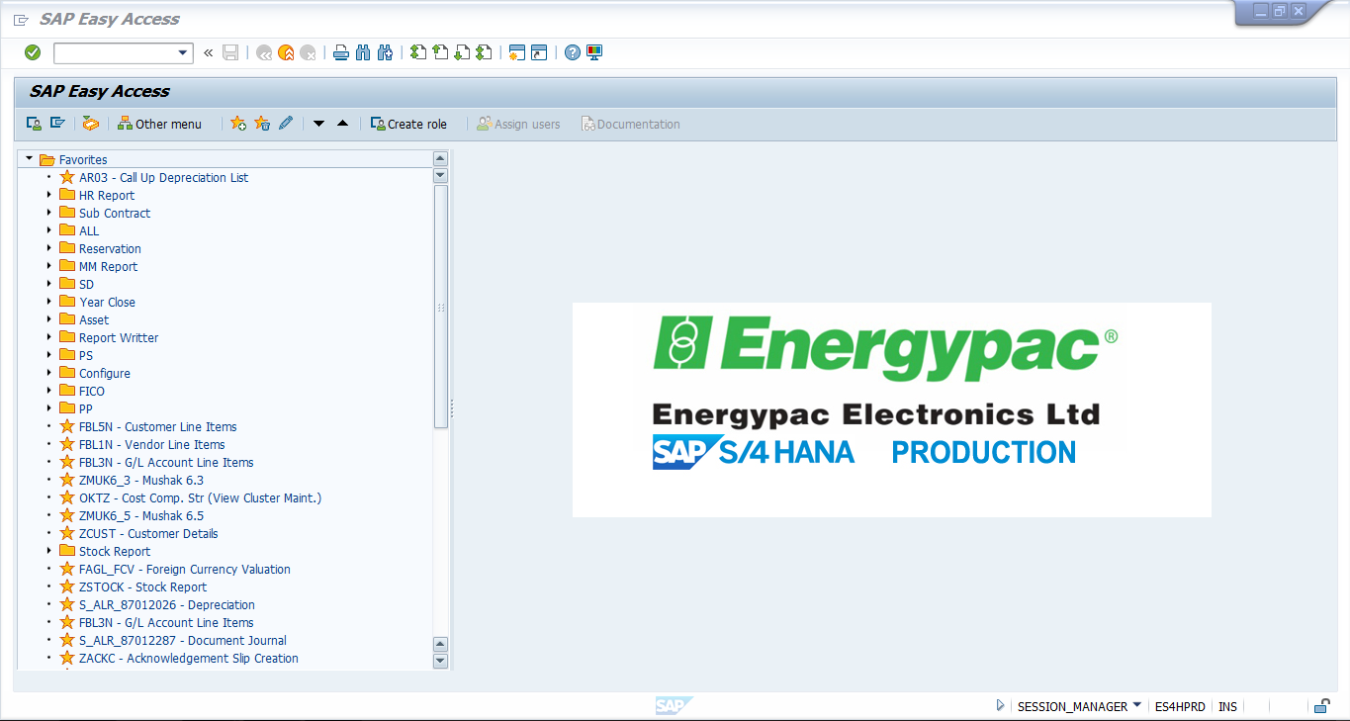

2.2 Functions of the department
This division is liable for guaranteeing ideal and most effective employments of the organization's assets through different controlling and observing exercises. It is headed by the Chief Financial Officer and comprises of the Audit, Credit, General Banking, Cost & Budget & Vat -Tax.
They are in charge of managing cash flows in the finance and accounts division. They are in charge of ensuring that everything runs well. What they do generally is described below:

- The general banking division creates and maintains records of company transactions through SAP software.
- Internal Audits do an audit before they pay for anything to find whether the expense is irregular or not.
- The Cost & Budget dept. maintain the budget accordingly.
- Treasury Dept. maintain liaison with the bank to have a more flexible interest rate while taking a loan from a bank.
- The department of VAT prepares and submits Income Tax Return and Withholding Tax Return to the appropriate authorities. It also guarantees tax and VAT deduction at sources in accordance with the VAT Act and income tax legislation.

Chapter 3

3. Internship outcome/Issue Analysis/Empirical Analysis

3.1 Analysis of industry/markets (in which your company operates)
Energypac Electronics manufactures cutting-edge low-voltage electrical products. Our premium line of products includes premium lighting and luminaries, premium electrical wiring accessories, and energy-efficient ceiling fans.Energypac Electronics operates in electronics manufacturing industry. One of Bangladesh's most significant economic sectors is electrical. It has been designated as a "booster sector" in Bangladesh's National Industrial Policy from 2010 and a "push sector" in the SME Policy Strategy from 2005. To meet the local demand of 20 thousand crore taka per year, this industry currently produces export equivalent products worth roughly 15 thousand crore takas. In Bangladesh, there are 75 different types of electrical items produced by roughly 2500 electrical firms.
Among the items in this category are electric wires, distribution boards, large and medium transformers, switch gear, sub-station tools, electric arc welding machines, unglazed ware, insulators, industrial fans, heat and speed control structures, Parceling bright connectors, various connecting equipment, main switch, electric iron and shouldering iron, tube lights, filament bulbs, light fittings, table lamps, and various types of lamps.The top importers of electrical goods are the United States, Canada, Germany, Australia, Mexico, Italy, Denmark, Hong Kong, France, and Finland (which Bangladesh does produce). The top exporters of these commodities are China, the United States, Germany, Japan, Singapore, South Korea, Taiwan, Mexico, the Netherlands, and Malaysia.
The main difficulties facing Bangladesh's electrical industry include, among others, a lack of advanced technological and technical know-how, a lack of an IP protection mechanism, a lack of infrastructure to sell electrical items abroad, and quality flexibilities on imported low-quality goods.

3.2 Finding peer group/ main competitor(s) (e.g., based on their market capitalization orasset size)
There are several companies in this sector. Some companies are well known to the people of the country and even internationally. As Energypac manufactures electronics such as professional lighting, fan, green solution etc. in this industry Energypac’s main and first competitor is Super Star Group comparing to market capitalization or assets size. Other than Super Start Group there are other companies which are direct competitors of Energypac such as Pran RFL Group (Click, Blaze, Vision), Transcom (Transtec), and Jamuna Electronics. ACI (Sparkle), PASHA, BRB, Paradise Group, Tongi National Electric, Conion, etc., are the most popular companies of the electronics industry in our country. Out of all these companies, Energypac Electronics is one of the most popular companies in the market.3.3 Identify a particular topic and analyze it using pertinent methodologies with the aid of appropriate theory or literature.

3.3. Trend analysis
For Energypac Electronics I have done the trend analysis. It's crucial to compare accounts from different years when examining a company's financial statement in order to spot any trends. You can convert the dollar amount of each account into a trend % for simpler comparison. You may quickly ascertain whether an account has increased or declined each year relative to the base year using trend percentages. In this post, we define trend percentages, explain how to calculate them, and give some instances of trend percentage computations.
I have done 8 accounts comparisons over the last 5 years.
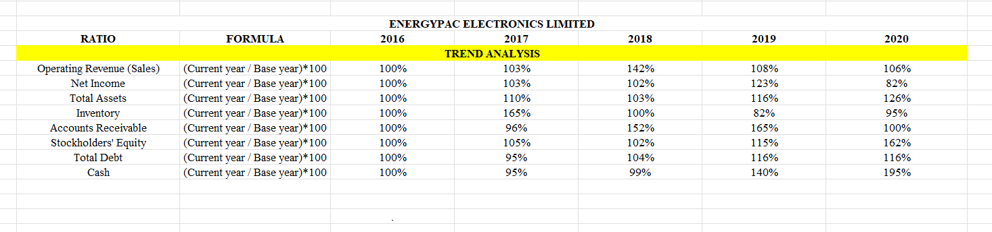

Figure 3.1 Trend Analysis of Energypac Electronics Limited

Trend analysis includes calculating trend percentages. The practice of evaluating present trends in order to forecast future ones is known as trend analysis and is regarded as a sort of comparison analysis. Trying to determine whether present market trends, such as increases in a particular market sector, are likely to continue as well as whether trends in one market area could influence trends in another are examples of this. A trend analysis may need a lot of data, but there is no assurance that the results will be accurate.

- Operating revenue (sales)

Figure 3.1.1

Here we can see in the year 3 which is fiscal year 2018-19, sales revenue was the highest. It was way above the trend line which explains the company had their best sales in the fiscal year 2018-19.

- Net Income

Figure 3.1.2

When it comes to net income, they have a stable profit line till 2018-19 and then it went up in 2019-2020 but after that year it dropped down to 82% in 2020-2021 fiscal year. It shows how he covid situation affected the company’s financial situation.

- Total assets

Figure 3.1.3

Total assets were rising till 2017-18 and in 2018-19 it decreased a bit. After that it again went up. Which shows they have a quite stable growth line of total assets.

- Inventory

Figure 3.1.4

Their inventory over the years had quite a journey. In the year 2 which is fiscal year 2017-18, they had the highest inventory but after that it started to decrease and again went up in 2020-21 fiscal year. We can say it was because of the covid situation.

- Accounts Receivables

Figure 3.1.5

As we can see in the chart in the year 4, accounts receivable was very high. As of course we all know when we sell something on account that’s when accounts receivables account is created. So, in the year 2019-20 it shows the effect of covid situation as mor people were buying on accounts.

- Stockholder’s equity

Figure 3.1.6

Stockholder’s equity was moderately stable, but it increased in the year 2020-21 which is a good thing for the company.

- Total Debt

Figure 3.1.7

Total debt was higher in the last two years. Which shows the effects of covid-19 again. Their total debt increased in the year 2019-20 and 2020-21.

- Cash and cash equivalent

Figure 3.1.8

During 2017-18 and 2018-2019, company’s cash in hand was less than other years compared. But in the last year the company had more cash in hand than other years.

3.4.1Energypac with Integrated Software:
Energypac has been trying to be up to date with the pace of new technology. It is important to go with the flow to become a leader & beat its competitors. The company has been using Accpro accounting software in its accounting & finance department that records and processes accounting transactions inside functional modules, for example, accounts payable, receivable, loan, journal, financial statement, etc. it is easy to use but it was not integrated among other departments like HR, SCM so employees need to manually request other departments for any information, that was time-consuming. Therefore, in 2018 the company parallelly installed SAP software with Accpro & trained all its employees about it to run smoothly. after 6 months Accpro was uninstalled & SAP runs with full fledge.

3.4.2 SAP (Systems Applications and Products in Data Processing)
ERP software is essentially a tool that unifies a company's information database, automates daily tasks, and separates the business activities of the accounts & finance, supply chain management, human resources, and sales departments. The ultimate goal of using this application is to streamline processes and give employees more flexibility with their work and time so they can concentrate more on analytical duties. These goals might lead to an increase in revenue margins and efficiencies while enhancing internal communication. ERP programming is exceptional since it tracks numerous or the entirety of the various parts of a business. It's a start to finish arrangement with features, such as:
- Accounting & Finance
- Supply Chain Management
- Human resource management
- Corporate sales
- Retail sales
- ICT
- Customer relation management
- Admin

Figure 3.2 Post incoming payments on SAP software
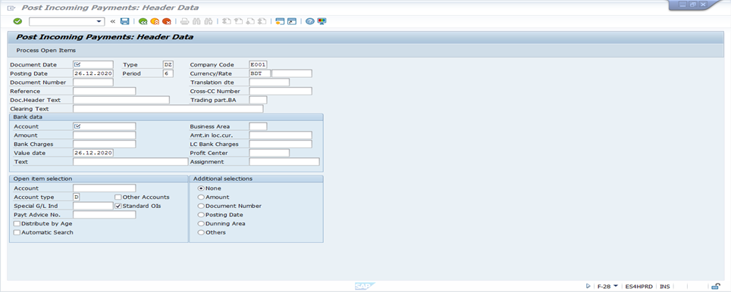

Figure 3.3 Enter general ledger account document
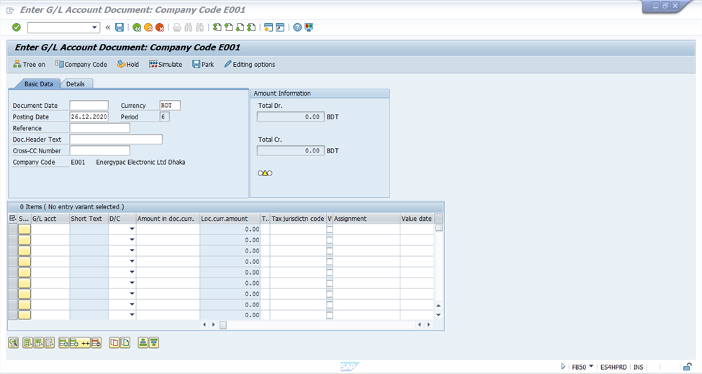

Figure 3.4 Enter incoming invoices
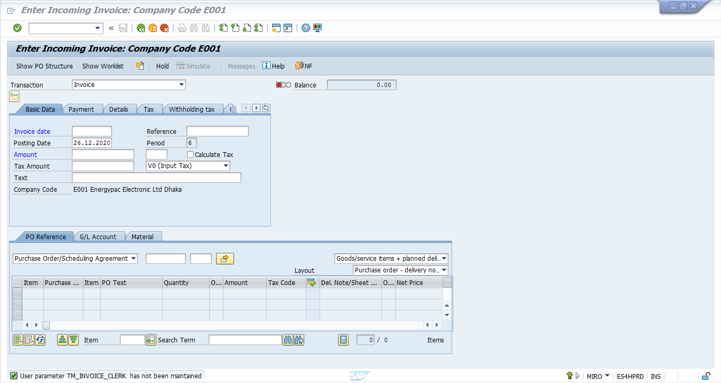
ERP software is an asset for most organizations that are interested in work with flexibility. They make your business show smoother to bringing together and ensuring your data, automation of processes, and creating reports. The advantages of ERP frameworks in a company improve daily operations and long-term planning with these and many more features. Some of the biggest ERP advantages of using this kind of programming include the following:
1. Focused IT Costs
Although ERP software is a significant investment, it can reduce IT expenses and boost efficiency. One can concentrate all of these costs into one ERP framework rather than spending money on several frameworks that all require dedicated employees, infrastructure, and supports.
2. Absolute Visibility
This advantage of ERP is one of the best-sellingpoints for the product. ERP software allows overall access to each significant process in business by making information from each office effectively open to the authorized employee and senior management.
3. Improved Reporting and Planning
Alongside improved visibility, better knowledge is a significant favorable position of ERP programming. Executing an ERP across offices signifies that an organization has a solitary, bound together detailing a framework for each cycle. The framework can promptly create valuable reports and investigations whenever needed. It enables to investigate and think about capacities across divisions, without any hassles of numerous bookkeeping pages and excel sheets.
Perhaps it goes best while preparing reports for the accounts department. Standard financial reports,budget,collection,loan etc.
4. Flexible Modularity
How the software is put into use is another factor. On-premises and cloud deployments are the two main methods. An on-premises system necessitates the purchase and installation of physical software on all workstations and servers. An ERP software controls the entire software suite entirely off-site with a cloud-based solution. ERP software hosted in the cloud has grown in popularity over the past few years, and this trend is anticipated to continue.
5. Adaptable Modularity
The modules of ERP software today are probably its biggest benefit. Most ERP suppliers offer a few applications that can be used individually or in combination depending on business requirements. Every application is created with the flexibility to work with the larger suite in the event of unique scenarios. ERP software that runs on the cloud has gotten more and more popular, and this trend is expected to continue.
6. Improved Efficiency
Alongside diminished IT and preparing costs, an ERP can decrease the time and exertion needed by employees to complete their everyday exercises. The framework moreover can help in the reception and requirement of industry best-practice measures, adjusting all activities across the endeavor.
Modern technologies like robotic process automation (RPA), artificial intelligence (AI), machine learning, and others support the automation and intelligent suggestion features included in many ERP software packages. This sophisticated feature may control company processes including demand forecasting, creating purchase orders, and following the progress of goods from production to delivery.

7. Customer Service
An organization likewise gets ERP framework benefits, if they don't have any acquaintance with it. Through the start to finish following and understanding offered by an ERP framework, one can give better client connection from showcasing computerization completely through late-stage client care.
Generally, forward-thinking ERP suites likewise uphold internet business reconciliation. This implies a business will be better ready to deal with electronic request preparation and customer collaborations.
8. Standardized Business Processes
Most ERP frameworks are created by industry best practices. These dependable cycles carry significant advantages to the table for organizations, everything being equal. It likewise permits organizations to normalize their cycles and frameworks, which further improves profitability and productivity. After shifting from AccPro to SAP it improved the profitability and the productivity of the company.
These cycles convey steady outcomes that permit you to consistently improve how you work for your association. What's more, because numerous cycles are robotized, mistakes and expenses are incredibly decreased. Therefore, there's less contact and improved collaboration between offices.
9. Improved Supply Chain Management
For organizations that manage the moving of actual stock and creation, an ERP framework reinforces the production network of the executives in an assortment of ways. This improvement brings about low lead times, more on-time conveyances, and numerous different advantages that upgrade the general activity and achievement of your business. Through a very much planned ERP stage, the store network can turn out to be better and more responsive utilizing improved interest estimating, stock administration, acquirement, and that's only the tip of the iceberg. A smoothed-out store network additionally encourages fabricating advancements, which can assist with diminishing expenses and create energizing new items that give a business the serious edge it needs to remain ahead.Besides, an ERP system can dramatically improve profitability and reduce overages involving inventory and production. Instead,then depending on "best guess" projections for future volumes, stock levels can be optimized with unified visibility into sales, production, and delivery schedules.

Chapter 4

4. Discussion & Conclusion

4.1 Discussion
Now the question is, Is ERP(SAP) better than AccPro?In actuality, it depends on business requirements. When more is needed than what a simple accounting system can provide, such as basic financial data capture and reporting, an ERP is the only option.
An ERP will empower far more integration of business activities into a single framework, including viewpoints, for example, inventory and distribution center administration, client relationship the executives, production network, and so on Every one of these perspectives is as of now unrealistic through a standalone accounting solution.
Also shifting from AccPro to new ERP system which is called SAP was very much needed for the company. The build capacity of AccPro was decreasing day by day as more people had the access over the software due to work purposes but AccPro had a limit, so it used to hang a lot. Which made the company’s progress slow and if we compare the trend analysis, we can see the company had a positive impact on its sales, assets, inventories etc. after and during the fiscal year 2018-19. As the new software made the work to go smoothly and the efficiency of people and all the process was improved.
Sometimes companies think that setting up an ERP is going to cost them a lot. But in the long run, it brings a lot more benefits such as more sales, easy communication, improved reporting, data security, availability to access control, real time data collection and many more.
Also, before setting up an ERP a company needs to understand what they are expecting their software to do for them and find the best fit for them. Also educating their employees and users how to run the software via various training session.

4.2 Conclusion
Briefly put, this internship has been a fantastic and fulfilling experience. I can say that working at Energypac Electronics has taught me a lot of things. The technical components of my work are not perfect, but with more time, they could be. Considering I had no prior experience at all, I think my time spent in the accounting and finance department was well worth it and helped the department's employees with their everyday tasks. The necessity of time management abilities and self-motivation is one of the two key things I've gained from the internship. Also, I want to thank my supervisor for making this internship so smooth for me. I got to learn so many things from her and got the chance to have real life experiences through her help.

References:
Energypac Electronics Limited. (n.d.). Annual Reports. Energypac.com. Retrieved August 15, 2022, from https://www.energypac.com/epgl/vision-mission-values/
Energypac Group. Energypac Electronics. (n.d.). Retrieved August 16, 2022, from https://www.energypacelectronics.com/energypac-group
Green solutions. Energypac Electronics. (n.d.). Retrieved August 16, 2022, from https://www.energypacelectronics.com/green-solutions
Group, P.-R. (n.d.). Investor relation - Rangpur Foundry Ltd. Retrieved August 15, 2022, from https://rangpurfoundry.com/investor.php
Professional Lighting. Energypac Electronics. (n.d.). Retrieved August 16, 2022, from https://www.energypacelectronics.com/professional-lighting

