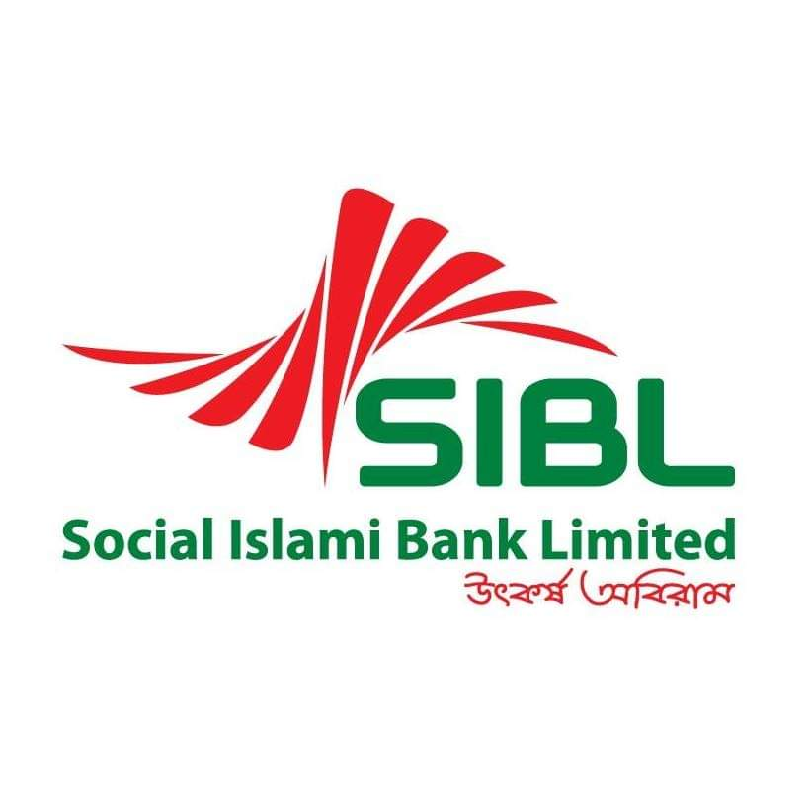

AN INTERNSHIP REPORT
ON
“Investment Activities of Social Islami Bank Limited”
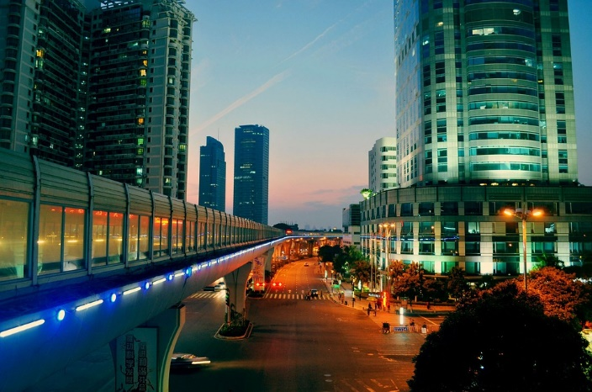


UNITED INTERNATIONAL UNIVERSITY
Internship Report
On
Investment Activities of Social Islami Bank Limited

Submitted to
Lamia Alam
Assistant Professor
School of Business & Economics
United International University

Submitted by
Tithi Alam
111161012

Submission Date: 15th February 2021

LETTER OF TRANSMITTAL

15th February 2020
Lamia Alam
Assistant professor
School of Business and Economic
United International University

Subject: Submission of Internship report on “Investment Activities of Social Islami Bank Limited.
Dear Madam,
I would like to thankful for your support to prepare my Internship Report on “Investment Activities of Social Islami Bank Limited”. The report is a prerequisite for completing my Bachelor of Business Administrative at United International University. Working in a Bank it was a great experience for me. The internship program has allowed me to enrich my theoretical knowledge through practical exposure of financial activities of some business.
I, hope, you will assess my report considering the limitation and mistake of the study and I would also like to thank you for your continuous guidance and support.

Sincerely yours
Tithi Alam
ID: 111 161 012
Program: BBA
United International University

DECLARATION

This is Tithi Alam, the student of Bachelor of Business Administration, student ID: 111161012, hereby declare that the internship report entitled “Investment activities of Social Islami Bank Limited” has been prepared by me under the supervision of my supervisor, Ms. Lamia Alam (Assistant Professor), School of Business and Economics, after the successful completion of three months Internship program in Social Islami Bank Limited.
I would also like to confirm that this internship report is only prepared and submitted for my academic purpose, not for any other purpose. And it is a requisite for the completion of Bachelor of Business Administration at United International University. I express my sincerest gratitude for having been given the opportunity to prepare this report and I enjoyed doing so.


………………………..
Tithi Alam
ID: 111 161 012
Bachelor of Business Administration
United International University

ACKNOWLEDGEMENT

Frist of all I remember Almighty Allah for making me successful to prepare this report. I am grateful to the Social Islami Bank Limited authority that has helped me by updating desired information. It has been a special ninety days’ work experience at Social Islami Bank Limited, where I received the opportunity to apply the knowledge that I had accumulated over the past four years. At the outset, I would like to thank and convey my gratitude to honorable Supervisor Ms. Lamia Alam for her continuous supervision, support and utmost care regarding the completion of my internship report.
I also express my cordially thanks to all the teachers, colleagues, of Social Islami Bank Limited, who has provided me necessary information & excellent guideline to know about Social Islami Bank Limited and prepare this report. I am very grateful to Md. Fazlul Haque FAVP & Operation Manager and Chowdhury Brinta Sharif Ali senior officer, Vatara Branch for his necessary cooperation to carry out my assignment in a proper way. I thank the bank manager who helps me to do internship in his branch and provide me a fair idea about practical knowledge of banking activities. I will show appreciation to everyone who helps me to perform all the official activity of The management of this Branch had been extremely helpful in providing necessary documents, annual report, statements, voucher etc.
Finally, I would like to thank United International University for giving the opportunity to experience self-development through practical experience.

EXECUTIVE SUMMARY

The Social Islami Bank Limited is a well-established bank in Bangladesh. This report mainly focuses on Investment Activity of SIBL. This report is divided into different category that are- investment procedure of SIBL, Mode-wise investment in SIBL, Classified and Unclassified investment procedure, and provision classified investment in SIBL. This report is mainly based on secondary data and some information are given by bank’s executive personnel. SIBL deposit amount is upward trending in year 2015 to 2019 amounted 13857 to 267829 (tk. In million) respectively but the deposit growth rate was fluctuating over the 5 years. On the other hand, the investment amount also increased over the 5 years. The bank invests in different modes and they invested more in Bai-Muazzal over the year. On the other hand, SIBL invested the least in Musharaka mode. In classified investment, the investment trend is fluctuating in recent years that’s why SIBL opened new schemes like Zakat Fund, Hajj scheme, Student Scheme, Young star scheme etc. so that they can improve their investment procedure. Nowadays SIBL is incorporating technology into their services that involve customer interaction. So now SIBL is more connected to the customer and provides the client with better services in different investment modes.
Table of Contents
LETTER OF TRANSMITTAL I
DECLARATION II
ACKNOWLEDGEMENT III
EXECUTIVE SUMMARY IV
CHAPTER-1 1
Introduction 1
INTRODUCTION 2
1.1 Background of the Report 3
1.2 Significance of the Report: 3
1.3 Objective of the Report: 3
1.4 Methodology of the Report: 4
1.5 Scope of the Report: 4
1.6 Limitation of the Report: 4
CHAPTER- 2 6
OVERVIEW OF SIBL 6
2.1 History of SIBL: 7
2.2 Definition of Islamic Banking: 8
2.3 Vision of SIBL: 9
2.4 Mission of SIBL: 9
2.5 Commitments of SIBL: 10
2.6 Values of SIBL: 10
2.7 Products of SIBL: 11
2.8 Strategic Objective of SIBL: 12
CHAPTER- 3 13
Investment Activities & Procedure 13
3.1 Investment: 14
3.2 Islamic Banking: 14
3.3 Conventional Banking: 14
3.4 Moods of Investment of SIBL: 15
3.4.1Trading modes (Bai-Mechanism): 15
3.4.2 Leasing mode (Ijarah mechanism): 19
3.4.3. Share Mechanism: 20
3.4.4Quard: 21
3.5 Investment Policies of SIBL: 21
3.6 Steps in Investment Procedure: 22
3.7 Recovery step of SIBL: 24
CHAPTER- 4 26
Findings & Analysis of Mode Wise Investment Performance 26
4.1 Year Wise Deposits & Growth Rate of Deposit of SIBL: 27
4.2 Year Wise Investment & Growth Rate of SIBL: 28
4.3 Trend of Mode Wise Investment from 2015 to 2019: 29
4.3.1: Investment in Bai-Murabaha: 29
4.3.2 Investment Income from Bai-Murabaha: 30
4.3.3 Investment in Musharaka: 31
4.3.4 Investment Income from Musharaka: 32
4.3.5 Investment in Mudaraba: 33
4.3.6 Investment Income from Mudaraba: 34
4.3.7 Investment in Bai-Muazzal: 35
4.3.8 Investment Income from Bai-Muazzal: 36
4.3.9 Investment in Hire-Purchase SirkatulMeelk: 37
4.3.10 Investment Income from Hire-Purchase SirkatulMeelk: 38
4.3.11 Investment in Quard: 39
4.3.12 Investment Income from Quard: 40
4.3.13 Investment in Bai-Salam: 41
4.3.14 Investment Income from Bai-Salam: 42
4.3.15 Investment in Staff Loan: 43
4.3.16 Investment in Ijarah: 44
4.3.17 Investment Income from Ijarah: 45
4.3.18 Investment in Visa Card: 46
4.3.19: Classified Investment as a Percentage of Total Investment: 47
4.3.20 Unclassified Investment as a Percentage of Total Investment: 48
4.3.21 Classification of Classified Investment: 49
4.3.22 Provision Classified Investment: 50
CHAPTER-5 51
Findings, Recommendation & Conclusion 51
5.1 Major Findings: 52
5.2 Recommendations: 52
5.3 Conclusion: 53
References 54
Bibliography 54
Appendix 55
Appendix A 55

CHAPTER-1

Introduction

INTRODUCTION

The entry level position that a company offers to the next producer, called an intern, is an open door for a particular company or association to work for a fixed amount of time. Internships are usually new students or substitutes and most temporary posts last between one and a quarter of a year. The entry level setting can be low maintenance or full time, where temporary or unpaid work can be paid. Temporary employment should provide the employee with reasonable skills, knowledge and experience in the current work environment and knowledge of that particular industry so that the industry reaps the benefits that arise. Cultures from the work of the substitute student. Thus, the entry-level setting can really activate the information that the students have collected during their time in a college and retrieve the information by crossing a number of different specifications. Joining a united international university (uiu) has consolidated the start-level placement program into their business graduate education program, allowing alumni to share their knowledge and ideas for study rooms. -Coordination with internship application and skills created in a familiar climate.
In this regard, I was posted to the Vatara Social Islami Bank Limited (SIBL) branch, having completed the full BBA course for three (3) months of the internship program (Policies & Practices of Investment Activities of Social Islami Bank Limited) and I encourage them, leaders, to present my useful teaching at different types of levels. This prolific vision of activists is a delight. I include my internship report for these levels, based primarily on SIBL's investment activities.

1.1 Background of the Report
This report is mandatory for me to complete postgraduate studies. I had a great opportunity to complete my internship program at Social Islami Bank Limited, which is the main bank in Bangladesh. I have the best opportunity to get a deeper understanding of all the banking activities carried out by Social Islamic Bank Limited. When I work here, I have a deep sense of responsibility. I get the real timing of corporate practice around the world and how to work with customers. I know how to manage the investment. So I choose to report on my investment in SIBL

1.2 Significance of the Report:
An internship report has been prepared, which is largely dependent on the student's activity through the internship program. Social Islami Bank Limited is one of the largest Islamic banks in Bangladesh. The purpose of the Islamic banking system is to:
- Creating an Islamic economy in society through a well-designed system for monitoring Islam.
- Moreover, Islam has the best guidance for using money through separate guidelines.
The internship program is a very important part for a recent graduate student in Bangladesh. It benefits more from a good job.

1.3 Objective of the Report:
The BBA program provides a level of experience for a student that a business graduate should have, but whose position in the work environment may be completely different from that described in the BBA program textbook. Work experience is fundamental to the full transfer of that knowledge and so an internship is essential to complete our undergraduate program. The following objectives may be listed for the specific purpose of the study:
- Discover the different investment methods.
- Learn how to analyze investment activity.
- To evaluate SIBL investment performance
- Detects banking problems and investigates investments.
- To make recommendations from the bank

1.4 Methodology of the Report:
In this report, focus on the investment activities of Social Islamic Bank Limited. As a result, I am gathering some information on the subject. The reporting method largely covers the required data and covers the sources. Two sources for data collection
- Primary source
- Secondary sources

1.5 Scope of the Report:
The report is largely based on the Islamic Social Bank's limited investment activity. The report covers the organization, background, operations and performance of the bank. To get acquainted with the whole banking system, my schedule was divided into different categories.

- At the same time, know the flow of investments.
- Learn how to maintain the investment process.
- Get a good idea of the Islamic banking system

1.6 Limitation of the Report:
Every report has some limitations because when we prepare a report, I do not know most of the information. The boundaries of rea are as follows:
- Some information has been blocked to maintain the privacy of the organization.
- 90 days is not enough to gather and understand all the activities related to investing.
- Lack of collaboration from the source
- In many cases, the most up-to-date information may not be available.
- All explanations and theories of the study findings are based on the reviewers' own observations.
- Bank executives are unable to provide sufficient time for their work.

CHAPTER- 2

OVERVIEW OF SIBL

2.1 History of SIBL:
Based on the Sharia Principal, established in 1995, Social Islami Bank Limited is the country's leading financial institution. Working closely with our esteemed customers and partners to provide one-stop access to state-of-the-art innovations. Our amazing mess management has made us unique in the industry. We run business groups with our messengers to help them grow productivity. We continue to be willing to serve with 3125 employees in 164 branches and 54 sub-branches across the country.
Similarly, there are 140 agent banking outlets to provide financial services to the farthest part of it, a strong belief in building a caring society is that SIBL is the foundation of all exercise can not only take our people to an impartial and impartial stage. So we are very busy with CSR exercise on a compassionate basis, for example, we work from poverty to strong families. Compared to other people, Progress Banks are profitable and are the milestone for being the kindest and complete bank in the country (AN OVERVIEW OF SIBL, 2020).
COMPANY AT A GLANCE
Name of the Company : Social Islami Bank Limited
Industry : Financial Services
Legal Form : Public Limited Company
Chairman : Prof. Md. Anwarul Azim Arif
Managing Director & CEO : Mr. Quazi Osman Ali
Company Registration No : C-28763 (44)/95
Authorized Capital : BDT 10,000,000,000
Paid Up Capital : BDT 8,933,413,560
Number of Branch : 164 Branch
Registered office : City Center ( Level- 19,20,21,22,28 & 29), 90/1
Motijheel C/A, Dhaka- 1000
Website : www.siblbd.com
Email : info@sible-bd.com

2.2 Definition of Islamic Banking:
Islamic finance refers to a system of banking or banking activities that is consistent with the meaning of Islamic law (Shariaha) and its application of commonsense through the advancement of Islamic finance cases. Shariaha approves payment of instalments for cash (Riba, usury) lease for clear terms, just as these standards were used when opposing its standards (haraam, prohibited) in the institutions that provide the source or business or administration. The reason for a prosperous economy in the past was that in the late twentieth century, various Islamic banks were established within Muslim groups to apply this standard to private or semi-private business organizations. The World Islamic Banking Conference, held in Old Bahrain in 1994, is a milestone where Islamic banking and world currencies are seen as the largest and most important social relations at world level. As defined by the Malaysian Islamic Banking Act, an Islamic bank is “an organization that conducts Islamic financial business, an Islamic financial business means a banking business whose points and operations do not into any part of Islam. No.” According to Dr. Ziauddin Ahmed, “Islamic banking is fundamentally a regulatory concept and can be seen as a fundamental banking policy in terms of Islamic debt settlement philosophy”. It is the definition of dodges and its actions in the monetary frameworks of Islamic banking and mediation and its exchanges that reflect dodges and their actions that explain the goals of the Islamic economy. On the other hand, it is a financial framework based on the activity of stakeholders and key elements, promising justice and equality in the economy and unfortunate economic and exchange Islamic change. That is why Islamic banks are named as regular profit partners and unfortunate banks (Definition of Islamic Banking, 2020)

2.3 Vision of SIBL:

“Working together for a caring society”

As SIBL strives for greater consistency, it is striving to become the country's leading Islamic bank, providing a staple of value-added and manageable items to meet the needs of its customers. Shariah’s rules are in line with the best use of the state-of-the-art innovation system while conducting its business in a non-judgmental manner, as well as developing a vibrant, truly ancient culture that relies on sound cameras, regulation, public order and reasonable measures.

2.4 Mission of SIBL:
- Establish three divisional banking models
- Switch to a profit bank run by service-based technology
- Luath Fast, accurate and satisfying courier service

- Sustainable and sustainable growth strategy Optimum return on shareholder’s equity.
- Incorporating Islamic Banking Product Innovation
- Attract and maintain high-quality human resources.
- Empowering the truly poor families and creating opportunities for local income
- Supporting social welfare groups through fundraising and raising social services

2.5 Commitments of SIBL:

- To the shariah
- To the regulators
- To the shareholders
- To the nation
- To the customer
- To the employees
- To the other stakeholders
- To the environment.

2.6 Values of SIBL:
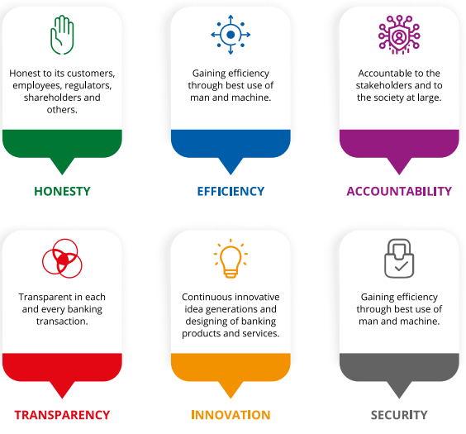
SIBL has 9 feathers to represent its core values a comfortable and safe flight in the country’s economy that connects it to the global sky by passing the territorial border. The 9 feathers:
- HONESTY:
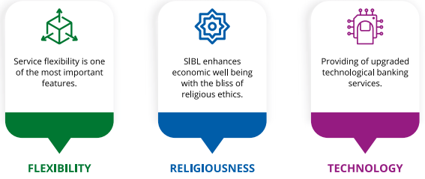
- To be honest is ordained by the scripture- we stick to this value in all our service provision.
- EFFICIENCY:
- Efficiency implies perfection in any job done- we strive to render full satisfaction with it.
- ACCOUNTABILITY:
- To be accountable is to be responsible and above any suspicion- we are dutifully there.
- TRANSPARENCY:
- Remaining transparent in all acts is a virtue that’s builds trust- we adhere to it.

- INNIVATION:
- Our minds and eyes are open to the evolution in quality of life to innovate further benefits for the service takers.
- SECUTITY:
- Customer must secure with all our products and services- we keep on ensuring it.
- FLEXIBILITY:
- Flexibility leads to better understanding and greater satisfaction- we pursue the quality.
- RELIGIOUSNESS:
- SIBL enhances economic well-being regarding the bliss of religious ethics.
- TECHNOLOGY:
- Modern life is technology dependent- we keep looking for the latest development to provide the best in ease to our clients.

2.7 Products of SIBL:
- Bai-Murabaha
- Bai-Muajjal
- Hire Purchase Under SirkatulMeelk
- Musharaka
- Bai-Salam
- Documentary Bill Purchase
- Quard
- SIBL Employee’s House Building Investment Scheme
- SME & Agriculture Finance
- Women Enterprise Finance
- Retail Finance
- Family Empowerment Islamic Micro Finance

2.8 Strategic Objective of SIBL:
All kind of organization have some objective, so that, also SIBL has some strategic objective which is implied their organization. Those are given bellow:
- Transformation into a service-oriented technology-driven profit earning bank.
- Ensuring fast, accurate and best-in-class customer with customer’s satisfaction.
- Balanced and sustainable growth strategy. Optimum return on shareholder’s equity.
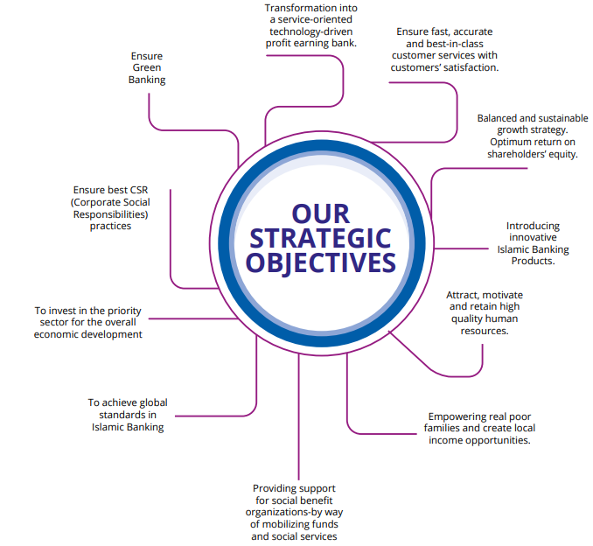
- Introducing innovative Islamic Banking Products.
- Attract, motivate and retain high quality human resources.
- Empowering real poor families and create local income opportunities.
- Providing support for social benefit organizations-by way of mobilizing funds and social services.
- To achieve global standards in Islamic Banking.
- To invest in the priority sector for the overall economic development.
- Ensure best CSR (Corporate Social Responsibilities practices).
- Ensure Green Banking.

CHAPTER- 3

Investment Activities & Procedure

3.1 Investment:
Investment is made to get valuable assets or to make money or profit We have Thanksgiving Day, which means that the holiday season is in full swing When a person buys something as good as an investment, it is not his intention to eat good but for future use. Investing today affects the interest rate on some assets - time, money or effort - in the hope that you will make more money before investing in the future (JAMES CHEN, 2020).

3.2 Islamic Banking:
Islamic banking refers to a bank or banking system that adheres to the principles of Sharia (Islamic law) as well as applies it to the development of the Islamic economy. Friendship is not a relationship. However, these policies are being used as a basis for real estate and economics. In the past, many Islamic banks were established in the late twentieth century to provide more facilities for Muslims, although the function of Islamic banks was exclusively for Muslims (Shari'ah Rulings, 2020).

3.3 Conventional Banking:
The activity of this bank is based on the relationship between investors and banks. Similarly, between the recipient and the traditional bank they offer low interest rates to clients, and they pay high interest rates. The main financial benefit of a traditional banking system is to increase the wealth of the people through interest (Da Jia Qian, 2019)

3.4 Moods of Investment of SIBL:
Some popular modes of SIBL’s Investment are discussed below.
SIBL operates its investment activities mainly through 3 modes:
Leasing Modes
Trading Modes
Share Modes

1.Mudaraba
2. Musharakha
- Bai-Murabaha
- Bai-Muajjal
- Bai-Salam
1.Hire Purchase
2. Hire Purchase under SirkatulMeelk
3. Bill Purchase

3.4.1Trading modes (Bai-Mechanism):

(I) Bai-Murabaha:
Meaning:
The words "Bai" and "Murabaha" come from the Arabic words Murabaha "and" Bai ". The word" Bai "means to buy and sell and" Murabaha "means to sell in cash". BaiMurabaha therefore means a sale that is paid for in cash or on a fixed date in the future or within a set time period. In short, it is a sale of money on the date.
Definition:
Bai-Murbaha is an agreement between a buyer and a seller in which the seller sells certain things permitted under Islamic Sharia and land law to the buyer at a price and the profit is agreed upon. to prove in the future. The profit margin or margin profit can be set at a flat rate or as a percentage of the value of the product. If Bai-Murbaha banks receive goods according to the indenture of the buyer, keep them in charge and sell the goods to the customers in equal parts or at the same time.
Features of Murabaha Financing:
- Customers are allowed to place an order for customers to purchase certain bank items, which confirm its specifications and promise to make the same purchase from Murabaha Bank, as the price and the receiving consensus benefits.
- Customers are obliged to promise to buy from a bank.
- The guarantor is permitted to take bail as alignment to ensure the performance of the undertaking or to compensate for the loss.
Types of Murabaha:
A) Ordinary Bai-Murabaha:
If there are only two sides, the seller and the buyer, when the seller is an ordinary trader who buys goods in the market and promises to buy from them without relying on any other order and sells them to the buyer for value and profit. , Then called for general by-sale
B) Bai-Murabaha on Order and Promise:
If there are three parties, then the buyer, the seller and the bank, as an intermediary between the buyer and the seller, where the bank, after receiving the order from the buyer, will buy the order and take the previous action for the purchase. The sale of goods and purchases of goods from the bank, which is ordered and agreed upon at the price, is called the "Bai-Murabaha Order", which is often referred to as Murabaha.
(II) Bai-Muajjal:
Meaning:
The words "bai" and "Muajjal" come from the Arabic words "Ajal" and "bye". The word “bye” means to buy and sell and the word “immortal” means a specific time, so “bye-bye” means the sale for which payment is made at a specified time. In the future. In short, it's a credit sale.
Definition:
Bai-Muajjal is an agreement between the buyer and the seller in which the seller sells certain goods to the buyer at a certain price in the future at a certain price (permitted by Sharia law and the laws of the country). . Or the seller can also sell the goods he / she has purchased within a specified period of time with a specific quota and according to the buyer’s instructions and specifications.
From the bank's point of view, Bai-Muajjal is considered as an agreement between the bank and the client in which the bank sells certain goods to the client, which are purchased at the buyer's order. and purchased at a special price. Fixed future date of one lakh rupees or fixed allowance.
Features of Bai-Muajjal:
- It is permissible for a specific buyer to place a purchase order by purchasing a specific item and to be responsible for purchasing from Bai-Mujal Bank late in sale at a certain price.
- The customer is allowed to guarantee the purchase from the bank, such as be satisfied with the promise or accept the loss caused by the breach of the promise without an excuse.
- The promise is that the money or mortgage guarantee is approved to accept the loss.
(III) BAI-SALAM:
Meaning:
Bai-Salam is a combination of two Arabic words "Bai" and "Salam" "Bai" means to buy and sell while "Salam" means prepaid. "Bai-Salam" means the transaction has already been completed. This is a type of hanging sale where money can be paid first and goods can be distributed later.

Definition:
This is the export price Bai-Salam is a term for accounting for sales in which the buyer pays in advance, but the delivery in the future is delayed for some time. Generally, the seller is a person or business and the buyer is a bank
The components of Bai-Salam:
- The contract parties are Seller and Buyer
- The price and the merchandise
- The specifications of the contract.
Features of Bai-Salam:
- A product is sold equal to the rights of the seller The products are not sold for permission as per the rules of Bai-Salam Sharia.
- Productivity is not hampered by a lack of funds to meet the direct needs of retailers. For example, industrial and agricultural products are purchased under Bai-Salam.
- It is possible to get a mortgage guarantee from the seller (supply, partial supply, bad quality) to protect the investment from any disaster.

3.4.2 Leasing mode (Ijarah mechanism):

(I) Hire purchase /Ijarah:
The word Ijarah is derived from the Arabic works "Ajr" and "Ujrat" which means judgment, refund, pay or rent. It is the exchange of value or judgment, refunds, salaries, a good service rent. The method of leasing a bank’s associated assets by creation, acquisition or constitution is called HPSM (Ijara).
(II) Hire Purchase Under Shirkatulmelk:
Lease purchases from both banks and customers provide equity in equal or unequal installments for the purchase of property, construction, plant, transport, etc., and the distribution of profits under the contract. For their benefit, the buyer, part or parcel of the property rented by the bank for a nominal fee per unit for a specified period.
Stages of Hire Purchase under ShirkatulMeelk:-
Thus Hire Purchase under Shirkatul-Meelk Agreement has these three stages:
  - Purchase under joint ownership
  - Hire and
  - Sale and /or transfer of ownership to the other partner Hirer.
(III) Bill Purchase:
Purchasing a Commercial Finance Invoice allows a seller to pay financially and immediately in lieu of a drawing sale document under a credit letter. Buyers will send sales documents to the bank on behalf of the bank seller.

3.4.3. Share Mechanism:
(I) Mudaraba :
This term refers to a form of business agreement in which one party contributes taxes to the other and personal efforts. The maximum portion of the benefit is determined by agreement between the two.
Important Features:
- Banks provide capital like Sahibal –Mall with clients who invest in their business and expertise.
- Customers want regulation and control.
- Benefit Rite according to contract.
- The bank bears only the loss (if any).
(II)Musharaka:
The terms "Shirkat" and "Musharakah" are derived from the Arabic words "Shairkah" and "Sharika". The word "shirkah" means a partnership between more than one partners. Thus, the district "Musharaka" and "Shirkat" means a partnership established between two or more partners with the aim of a commercial enterprise participating in both the capital and the management where the profit can be shared between the partners according to the ratio of agreed profit and loss. If a loss suffered, must be borne by the partners at the capital ratio.
Basic rules of distribution of Profit:
- Individual profits and company benefits must be determined and not capital based.
- It is not possible to negotiate an agreement for a group of participants or the level of benefit associated with this connection.
- If both partners believe that each will receive a percentage benefit based on the percentage of their income whether they both work, this can be waived.
Basic rules of distribution of Loss:
- "Losses are spread directly according to the ratio of the investments, and profits are apportioned according to the participants' consent."
- Therefore, the loss will always depend on the investment ratio.
Powers & Rights of Partners in Musharakah:
- The right to sell property belongs to any Shirkah representative and everyone has the right to buy and sell for commercial purposes.
- The right to buy or otherwise deposit cash or credit with Shirkah funds to invest in the transaction.
- The right to hire people if needed.
- The right Shirkah deposit and company assets matter where and when needed.
- Right to use Shirkah funds or assets in Mudarabah.

3.4.4Quard:

It is a form of financial loan with the stipulation of returning the principal in the future without any increase in it.

3.5 Investment Policies of SIBL:

- SIBL is based on the commercial bank sharahi, so it strictly follows Sharia's principles when making investment decisions.
- SIBL invests in the voluntary work of banks.
- SIBL is investing in domestic priorities.
- Investing in the sales department.
- Investment in foreign trade (import / export).

3.6 Steps in Investment Procedure:
All investment has a procedure. So that SIBL also follow some procedure those are given bellow:

- Selection of the Customer:
When a customer wants to lend the money then the customer must agree with the bank’s rules and regulation. The bank usually analysis the following 5C’s of the customer-

- Character
- Capacity
- Capital
- Collateral
- Condition
- Application Stage:
At this stage, the bank will gather the necessary information about the customer. For this reason, the bank informs the customer of the customer’s view of providing it and eliminates it accordingly. Providing important consumer information will help you get started with an investment proposal. The required documents are:
- Copy for commercial license.
- Short Pro-Forma Success Report
- Certified copy of business contract
- Certified copy of Memorandum of Association (MOA)
- Certified copy of e-TIN
- Tenders for the proposed money
- Appraisal Stage:
It is the most important stage because of here the bank evaluates the customer business. These following contents are presented in this appraisal stage-
- Customer information
- Owner’s information
- List of partners
- Purpose of investments
- Other liabilities of the customer
- Previous banker’s information
- Business type

- Sanctioning Stage:
At its stage, the bank formally approves the investment proposal and provides the client representing the letter of acceptance. On the other hand, the customer received a sentence of condemnation. SIBL compiles the following items for the sanction letter-
- Investment limits
- Mode and amount of investment
- Purpose of investment
- Period of investment
- Rate of return
- Securities
- Cash/goods
- Collateral
- Documentation:
SIBL check the following documents of the customer:
- Tax payment certificates
- Stock report
- Trade license
- Vat certificates
- Liability statement from different parties
- Receivable from different customer
- Disbursement Stage:
In this stage the bank decided to pay the money and the customer takes the fund.
- Monitoring Stage:
In this monitoring stage bank always focus on the customer monthly stock report and contact with the customer because of their minor investment.
- Recovery Stage:
This is the final stage of the investment process and the bank wants to repay the loan on time if the lender fails to repay the bank will take steps to repay the money.

3.7 Recovery step of SIBL:
The following methods are used for recovery of the investment-
- Persuasive recovery:
Somehow the lender does not pay the borrowed amount of investment time, so the first step of the bank is to communicate with him personally and create a force for the loan repayment.
- Voluntarily recovery:
Some steps are following in the voluntarily recovery
- Building task force
- Arranging seminar
- Waiver of interest rate
- Legal recovery:
At this stage, the bank will take the necessary legal action against the borrower if the lender does not follow the above procedure and has not paid the installment

CHAPTER- 4

Findings & Analysis of Mode Wise Investment Performance

4.1 Year Wise Deposits & Growth Rate of Deposit of SIBL:
Year | 2015 | 2016 | 2017 | 2018 | 2019
Deposit (Tk in millions) | 138537 | 178864 | 203126 | 224339 | 267829
Growth Rate | 27.05% | 29.10% | 13.58% | 10.44% | 19.39%

Interpretation: Here we can see that, the SIBL deposits amount 2015 to 2019 day by day increases which is 138537 to 267829 (Tk. In million). But the deposit growth rate was fluctuating 2016 to 2018 which is 29% to 10%. In recent year it was little bit increases in 2019 which is 19%.

4.2 Year Wise Investment & Growth Rate of SIBL:
Year | 2015 | 2016 | 2017 | 2018 | 2019
Investment (Tk in millions) | 134117 | 174196 | 210045 | 238654 | 264269
Growth Rate (%) | 24% | 29% | 20% | 14% | 11%

Interpretation: In this graph show that the investment was rapidly increases 2015 to 2019 which is 134117 to 2642269 (tk. In million). On the other hand, the investment growth rate will only increases in 2015 to 2016 which is 24% to 29%. And the growth rate is decreases 2016 to 2019 which is 29% to 11% continuously.

4.3 Trend of Mode Wise Investment from 2015 to 2019:

4.3.1: Investment in Bai-Murabaha:
Year | 2015 | 2016 | 2017 | 2018 | 2019
Total Investment Under all Modes (Tk in million) | 123630 | 167003 | 202682 | 230435 | 252038
Investment in Bai-Murabaha Modes (Tk in million) | 3929 | 3924 | 4453 | 3889 | 4111
Investment in Bai-Murabaha (%) | 3% | 2% | 2% | 1.68% | 1.63%

Interpretation: In this investment modes the bank SIBL minimized their investment. Only in year 2015 the percentage was higher which is 3% and now the growth rate was unstable of 2015 to 2019.

4.3.2 Investment Income from Bai-Murabaha:
Year | 2015 | 2016 | 2017 | 2018 | 2019
Total Income Under all Modes (Tk in million) | 15288 | 16883 | 18497 | 24956 | 27797
Income in Bai-Murabaha Modes (Tk in million) | 195 | 119 | 120 | 195 | 206
Income in Bai-Murabaha (%) | 1% | 0.7% | 0.6% | 0.8% | 0.7%

Interpretation: This graph is show that, the amount of investment income from Bai-Murabaha was decreases in 2015 to 2017 which is 1% to 0.6%. in year 2018 slightly increases which is 0.8% on the other hand year of 2019 will deceases which is 0.7%.

4.3.3 Investment in Musharaka:
Year | 2015 | 2016 | 2017 | 2018 | 2019
Total Investment Under all Modes (Tk in million) | 123630 | 167003 | 202682 | 230435 | 252038
Investment in Musharaka Modes (Tk in million) | 494 | 394 | 406 | 347 | 286
Investment in Musharaka (%) | 0.40% | 0.24% | 0.20% | 0.15% | 0.11%

Interpretation: Above graph shows that; this investment mode trend is shown that this is downward mode under the musharaka investment. This investment increases in 2016 to 2017 which is 394 to 406 (Tk. In million). And the growth rate randomly decreases in 2015 to 2019.

4.3.4 Investment Income from Musharaka:
Year | 2015 | 2016 | 2017 | 2018 | 2019
Total Income Under all Modes (Tk in million) | 15288 | 16883 | 18497 | 24956 | 27797
Income in Musharaka Modes (Tk in million) | 51 | 38 | 31 | 38 | 32
Income in Musharaka (%) | 0.33% | 0.23% | 0.16% | 0.15% | 0.12%

Interpretation: We can see above this graph the modes of musharaka investment income trend fluctuating 2015 to 2019 which is 0.33% to 0.12%.

4.3.5 Investment in Mudaraba:
Year | 2015 | 2016 | 2017 | 2018 | 2019
Total Investment Under all Modes (Tk in million) | 123630 | 167003 | 202682 | 230435 | 252038
Investment in Mudaraba Modes (Tk in million) | 4526 | 6890 | 6593 | 2062 | 2213
Investment in Mudaraba(%) | 3.67% | 4.12% | 3.25% | 0.89% | 0.87%

Interpretation: Above graph show that the amount of mudaraba investment modes increase in 2015 to 2016 which is 4526 to 6890 (Tk.in million). And the amount will decrease in 2017 to 2019 which is 6593 to 2213 (tk. In million). And the percentage of investment decrease 2017 to 2019 which is 3.25% to 0.87%.

4.3.6 Investment Income from Mudaraba:
Year | 2015 | 2016 | 2017 | 2018 | 2019
Total Income Under all Modes (Tk in million) | 15288 | 16883 | 18497 | 24956 | 27797
Income in Mudaraba Modes (Tk in million) | 238 | 236 | 160 | 974 | 238
Income in Mudaraba (%) | 1.56% | 1.40% | 0.86% | 3.90% | 0.86%

Interpretation: Above graph is show that this modes investment income growth rate will higher increases in 2017 to 2018 which is 0.86% to 3.90%. And more decreases in 2018 to 2019 which is 3.90% to 0.86%. which is more impact in SIBL.

4.3.7 Investment in Bai-Muazzal:
Year | 2015 | 2016 | 2017 | 2018 | 2019
Total Investment Under all Modes (Tk in million) | 123630 | 167003 | 202682 | 230435 | 252038
Investment in Bai-Muazzal Modes (Tk in million) | 77429 | 103157 | 126947 | 157974 | 175173
Investment in Bai-Muazzal (%) | 62.63% | 61.76% | 62.63% | 68.55% | 69.50%

Interpretation: Here we can see that the amount of investment is Increasing over the year. Compare to year 2015 the total Investment was 2.5 time higher on 2019. Since 2016 the rate is going to increasing trend. In 2019 it was 175173 (tk.in million) which is 69.5% of total investment. So that the bank should focus on it.

4.3.8 Investment Income from Bai-Muazzal:
Year | 2015 | 2016 | 2017 | 2018 | 2019
Total Income Under all Modes (Tk in million) | 15288 | 16883 | 18497 | 24956 | 27797
Income in Bai-Muazzal Modes (Tk in million) | 8829 | 10118 | 11235 | 15878 | 18264
Income in Bai-Muazzal (%) | 58% | 60% | 61% | 64% | 66%

Interpretation: The Graph Show that The Investment income in Bai-Muazzal modes Was increase from 2015 tk. 8829 million to tk.18264. The percentage of total investment income are also increase year over year.

4.3.9 Investment in Hire-Purchase SirkatulMeelk:
Year | 2015 | 2016 | 2017 | 2018 | 2019
Total Investment Under all Modes (Tk in million) | 123630 | 167003 | 202682 | 230435 | 252038
Investment in Hire-Purchase SirkatulMeelk Modes (Tk in million) | 28686 | 39236 | 50888 | 54779 | 56906
Investment in Hire-Purchase SirkatulMeelk (%) | 23.20% | 23.49% | 25.49% | 23.77% | 22.57%

Interpretation: Here We can see that the investment amount increase over year. On 2015 it was 28685 million tk. and 2019 it’s become tk. 56906 million. Although the investment amount is increase but the percentage of total investment is decreasing since 2019.

4.3.10 Investment Income from Hire-Purchase SirkatulMeelk:
Year | 2015 | 2016 | 2017 | 2018 | 2019
Total Income Under all Modes (Tk in million) | 15288 | 16883 | 18497 | 24956 | 27797
Income in Hire-Purchase SirkatulMeelk Modes (Tk in million) | 2693 | 3876 | 4865 | 6276 | 6379
Income in Hire-Purchase SirkatulMeelk (%) | 18% | 23% | 26% | 25% | 23%

Interpretation: Above the graph show that the investment amount is increasing. In 2015 the investment amount was 2693 million tk and now 2019 its 6379 million tk. And the present of total income increase 2015 to 2017. After 2017 percentage of total income are decreasing.

4.3.11 Investment in Quard:
Year | 2015 | 2016 | 2017 | 2018 | 2019
Total Investment Under all Modes (Tk in million) | 123630 | 167003 | 202682 | 230435 | 252038
Investment in Quard Modes (Tk in million) | 6044 | 9867 | 9231 | 6850 | 8648
Investment in Quard(%) | 4.88% | 5.91% | 4.55% | 2.97% | 3.43%

Interpretation: In the graph we can see that the investment is increasing 2015 to 2016. But after 2016 the percentage of the investment are decreasing 2016 to 2018. It shows the fluctuating investment Activiti in Quard.

4.3.12 Investment Income from Quard:
Year | 2015 | 2016 | 2017 | 2018 | 2019
Total Income Under all Modes (Tk in million) | 15288 | 16883 | 18497 | 24956 | 27797
Income in Quard Modes (Tk in million) | 766 | 557 | 582 | 534 | 533
Income in Quard(%) | 5% | 3.30% | 3.14% | 2.14% | 1.92%

Interpretation: Above the graph show that compare the 2015 the total investment income was decreasing on 2016. And it is remaining quit similar after 2016. But the percentage of total investment income are decreasing rapidly over the year 2015 to 2019.

4.3.13 Investment in Bai-Salam:
Year | 2015 | 2016 | 2017 | 2018 | 2019
Total Investment Under all Modes (Tk in million) | 123630 | 167003 | 202682 | 230435 | 252038
Investment in Bai-Salam Modes (Tk in million) | 340 | 500 | 596 | 775 | 931
Investment in Bai-Salam (%) | 0.28% | 0.30% | 0.29% | 0.34% | 0.36%

Interpretation: Here We can say that the total investment is increasing. Total investment was 340 (million in tk) on 2015 and 2019 it’s become 931(million in tk). And the percentage of total investment are increasing every year.

4.3.14 Investment Income from Bai-Salam:
Year | 2015 | 2016 | 2017 | 2018 | 2019
Total Income Under all Modes (Tk in million) | 15288 | 16883 | 18497 | 24956 | 27797
Income in Bai-Salam Modes (Tk in million) | 13 | 40 | 57 | 69 | 84
Income in Bai-Salam (%) | 0.085% | 0.24% | 0.30% | 0.27% | 0.30%

Interpretation: Above the graph show that the investment income is increasing every year. Compare to 2015 the investment income gets 5 time higher on 2019. It’s become 84 million tk in 2019 from 13 million tk in 2015. And the percentage of income in Bai-Salam are increasing every year, except 2018.

4.3.15 Investment in Staff Loan:
Year | 2015 | 2016 | 2017 | 2018 | 2019
Total Investment Under all Modes (Tk in million) | 123630 | 167003 | 202682 | 230435 | 252038
Investment in Staff Loan Modes (Tk in million) | 1758 | 2223 | 2463 | 2385 | 2431
Investment in Staff Loan (%) | 1.42% | 1.33% | 1.21% | 1.03% | 0.96%

Interpretation: Here we can see investment are increasing in 2016. after 2016 the investment quite similar in every year. And the percentage of total investment are decreasing every year.

4.3.16 Investment in Ijarah:
Year | 2015 | 2016 | 2017 | 2018 | 2019
Total Investment Under all Modes (Tk in million) | 123630 | 167003 | 202682 | 230435 | 252038
Investment in Ijarah Modes (Tk in million) | 146 | 327 | 436 | 660 | 609
Investment in Ijarah (%) | 0.12% | 0.20% | 0.21% | 0.28% | 0.24%

Interpretation: Above the graph show that 2015 to 2018 the investment and the percentage of Ijarah investment are increasing. but in 2019 the investment and the percentage of Ijarah investment are decreasing.

4.3.17 Investment Income from Ijarah:
Year | 2015 | 2016 | 2017 | 2018 | 2019
Total Income Under all Modes (Tk in million) | 15288 | 16883 | 18497 | 24956 | 27797
Income in Ijarah Modes (Tk in million) | 16 | 27 | 42 | 55 | 79
Income in Ijarah (%) | 0.10% | 0.16% | 0.22% | 0.22% | 0.28%

Interpretation: Here we can see that the investment 2015 to 2019 was 16 million, 27 million, 42 million, 55 million, 79 million tk. Its increasing by a huge ratio. And also the percentage of the income of total investment are increasing.

4.3.18 Investment in Visa Card:
Year | 2015 | 2016 | 2017 | 2018 | 2019
Total Investment Under all Modes (Tk in million) | 123630 | 167003 | 202682 | 230435 | 252038
Investment in Visa Card Modes (Tk in million) | 275 | 481 | 682 | 711 | 727
Investment in Visa Card (%) | 0.22% | 0.29% | 0.33% | 0.31% | 0.28%

Interpretation: Above the graph show that the investment is increasing 2015 to 2016. After 2016 the investment is quite similar. And the percentage of the total investment are 0.22%, 0.29%, 0.33%, 0.31% and 0.28%. that percentage are increase 2015 to 2017. After 2017 the percentage are decreasing.

4.3.19: Classified Investment as a Percentage of Total Investment:
Year | 2015 | 2016 | 2017 | 2018 | 2019
Classified Investment (Tk. In million) | 5150 | 7738 | 17223 | 18301 | 17434
Total Investment (Tk. In million) | 134117 | 174196 | 210045 | 238654 | 264269
Classified Investment (%) | 3.84% | 4.44% | 8.20% | 7.66% | 6.59%

Interpretation: Above graph is shows that the classified investment as a percentage of total investment. This investment is increase over the year 2015 to 2018 which is tk. 5150 million to tk. 18301 million except the year 2019 the amount was 17434 tk. in million.

4.3.20 Unclassified Investment as a Percentage of Total Investment:
Year | 2015 | 2016 | 2017 | 2018 | 2019
Unclassified Investment (Tk. In million) | 128969 | 166512 | 192882 | 215691 | 242355
Total Investment (Tk. In million) | 134117 | 174196 | 210045 | 238654 | 264269
Unclassified Investment (%) | 96.16% | 95.59% | 91.83% | 90.37% | 91.71%

Interpretation: In this graph we see that the unclassified investment rate only increase in year 2015 to 2016 which is 96.16% to 95.59%. and over the year 2016 to 2016 to 2019 is decreases.

4.3.21 Classification of Classified Investment:
Year | 2015 | 2016 | 2017 | 2018 | 2019
Sub standard | 640 | 313 | 1805 | 6459 | 6584
Doubtful | 92 | 1354 | 1419 | 7387 | 2825
Bad & Loss | 4415 | 6017 | 13939 | 16914 | 16493

Interpretation: In this graph shows that the classification of classified investment. Over the year we see that the “Bad & Loss” are upward compare the Substandard & Doubtful. Which is fluctuating over the year.

4.3.22 Provision Classified Investment:
Year | 2015 | 2016 | 2017 | 2018 | 2019
Provision for Classified Investment (tk. in million) | 1673 | 1765 | 3474 | 6398 | 7595

Interpretation: This graph is shows that the provision classified investment. Which is increases in year 2015 to 2019 the amount was 1673 to 7595 (tk. In million). We say that it’s a down performance of the management of SIBL.

CHAPTER-5

Findings, Recommendation & Conclusion

5.1 Major Findings:

- SIBL Deposit amount is increases day by day 2015 to 2019 which is 138537 to 267829 (tk. In million). But the deposit growth rate was fluctuated year 2016 to 2018 which is 29% to 10%. In recent year it little bit increase in 19%.

- SIBL Investment amount also increases in year 2015 to 2019 which is 134117 to 2642269 (tk. In million). The growth rate is decreases year 2016 to 2019 which is 29% to 11%.

- In the investment modes the SIBL minimized their investment. The growth was unstable of 2015 to 2019 which is 3% to 1.67%. and it is effected the SIBL.

- Among the investment modes of SIBL the amount is highest on Bai-Muazzal mode. Hire purchases and Murabha is a second position.

- In the status of bad investment part their Bad/Loss is very higher in year 2018 which is 16914 and on the year 2019 its decrease slightly which is 16493. This is occurring because of their down policy system.

- SIBL investment procedure is moderate in overall year 2015 to 2019.

5.2 Recommendations:
The following recommendation may be suggested for the overall Social Islami Bank Limited:
- SIBL grows its investment plans on a day-to-day basis but now their investment growth rates have changed so that they need to improve their messenger service.
- SIBL should pay more attention to their investment growth rates which fall from 2015 to 2019.
- SIBL has further developed its ever-growing scheduled investments.
- SIBL should invest more in profitable businesses so that they can make more money
- SIBL should focus on their monitoring system so that they can reduce their bad or bad investment.
- SIBL bad status investment is increases year by year because of their bad policy. If they recover on it then they should repair their loan with in a period of time.
- SIBL customers should be properly monitored as their funds are used properly.

5.3 Conclusion:

Social Islamic Bank Limited is a banking business that is expanding to provide business banking services to customers as well as providing access to microcredit and SME funds to the millions of people in the country. As part of corporate responsibility, it plays a vital role in assisting bereaved members of the community in any related welfare work. They focus on the reputable, fast and professional services offered to their customers. They believe in developing close relationships. Therefore, they are committed to providing high-quality banking services and the best return on equity investment to ensure the financial security of investors and to bring their new Islamic banking products up to date. Into their existing and prospective employees. "It then came to our notice that we were struggling with two heads to meet and provide financial support to poor families. “They believe that their service has little value in strengthening the end results of equality for people in society.

References

- AN OVERVIEW OF SIBL. (2020, 12 12). AN OVERVIEW OF SIBL. Retrieved from AN OVERVIEW OF SIBL: https://www.siblbd.com/about/profile?fbclid=IwAR2Ul-
- Da Jia Qian. (2019, 03 3). Faculty of Business. Retrieved from 2Faculty of Business: https://mfpc.org.my/wp-content/uploads/2019/03/3-14_Original-Research_Paper-1_Conventional-Banking-Islamic-Banking.pdf
- Definition of Islamic Banking. (2020, 12 11). Definition of Islamic Banking. Retrieved from Definition of Islamic Banking: https://www.assignmentpoint.com/business/banking/definition-islamic-banking.html
- JAMES CHEN. (2020, 10 22). investopedia. Retrieved from investopedia: https://www.investopedia.com/terms/i/investment.asp
- Shari'ah Rulings. (2020, 11 11). Islamic Banking. Retrieved from Islamic Banking: https://www.islamic-banking.com/explore/islamic-finance/islamic-banking

Appendix

Appendix A
