
INTERNSHIP REPORT ON
Marketing of Financial Services: A Case Study on IFIC Bank PLC

sUBMITTED BY: MD. WALIULLAH EAMIN
sTUDENT ID: 111201181
Submitted on: 28/9/2023
cOURSE CODE: INT 4399
SUBMITTED TO: MUHAMMAD HASAN AL-MAMUN
ASSISTANT PROFESSOR, MARKETING
SCHOOL OF BUSINESS & ECONOMICS
uNITED INTERNATIONAL UNIVERSITY

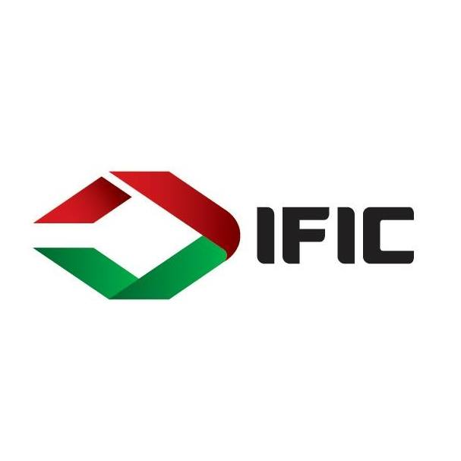
"Marketing is the creative use of truth"-Philip Kotler

LETTER OF TRANSMITTAL
October 10, 2023

Muhammad Hasan Al Mamun,
Assistant Professor, School of Business and Economics, United International University

Subject: Submission of the Internship Report titled “Marketing of Financial Services: A Case Study on IFIC Bank PLC”

Dear Sir,
It is a great honor for me to present my internship report titled "Marketing of Financial Services: A Case Study on IFIC Bank PLC " The report was written using information obtained during my internship at IFIC Bank PLC and conceptual understanding gained from my academic studies. I tried to present the findings of the report in the most succinct and presentable manner.

If you think, any part of the report requires more clarification; I will be ready to provide such clarifications with pleasure.

Sincerely Yours,

MD. WALIULLAH EAMIN
Student ID: 111-201-181
BBA Program
School of Business and Economics
United International University (UIU)

Executive Summary
IFIC Bank PLC is one of the first generation commercial banks of the country. It was founded as a financial institution and joint venture company in cooperation with the Bangladesh Bank. IFIC Bank achieved the prestigious honor of being the largest bank in Bangladesh with 1300+ branches and sub-branches across the country. Its key strengths include the long-term reputation and credibility earned in banking industry, the largest banking network with 1300+ branches & sub-branches, innovative unique products like Aamar account that provides both saving & loan facility in one account, and the huge number of poor working people under Shohoj account who has 99% loan returning record. The main objective of this study was to evaluate various aspects of services marketing as they are practiced by IFIC Bank PLC. The bank is found to follow a full market coverage strategy in terms of various units of geographical location: urban, suburban, and rural areas. Such targeting strategy is supported by extensive network of 1300+ branches and sub-branches across the country. The bank likes to position itself as a quality financial service provider to the stakeholders through integrity, fairness, innovation and commitment. IFIC Bank follows an intensive distribution strategy in making their banking services available to their target markets. The bank is found to be using value-based pricing as a guiding principal in managing prices of the various financial services provided. Promotional mix of the bank is well integrated and primarily consists of mass media advertising, door-to-door marketing, leaflets, social media marketing (facebook, linkedIn, Instagram), and sponsorships of the relevant events. As a marketer of services, the bank recognizes the need to integrate people, process, and physical evidence to the elements of traditional marketing mix (product, price, place, and promotion) and the bank is also continuously engaged in process development and medication, training and development of the correct mix of people to provide the needed services, and managing physical facilities and support items to ensure continuous customer engagement and satisfaction.

Key Words: IFIC Bank PLC, Financial Services, Banking, Marketing

Table of contents
Chapter 1:Introduction……………………………………………………………………………………6
Chapter 2:Organizational Background & Competitive analysis of IFIC Bank…………………………..10
Chapter 3:Objective & Methodology…………………………………………………………………….16
Chapter 4:Findings of the Study………………………………………………………………………….19
Chapter 5:Recommendations & Conclusion …………………………………………………………….35

CHAPTER 1
INTRODUCTION
The term “service” is defined by Valarie Zeithaml in 2018 as “Services are deeds, processes, and performances provided, coproduced, or co-created by one entity or person for and/or with another entity or person”. Though the emphasize of marketing was on products initially but it has become equally significant to practice marketing in the services as the service industry has started to expand globally. The biggest multinational companies globally like Apple, Microsoft, IBM, DHL who are serving the services started to understand the importance of marketing in the service industry and focused on the integration of marketing in their service planning, promoting and delivery. But the product marketing and service marketing was not the same. Although customers’ need identification is the starting point of both product marketing and service marketing,the marketing of services is different from the product marketing as service possess characteristics of intangibility, inseparability, perishability and variability. Traditional marketing requires 4p to take into consideration (product, place, price and promotion). But services marketing requires 7p(product, place, price, promotion, people, process and physical evidenced) to take into consideration as it possesses the risk associated with it. Service marketing is the process of promoting and showcasing the benefits of the intangible goods delivered by a company to meet the customer’s need. The customer has a fear of being deceived since it has no tangibility that means it cannot be seen, touched or tasted. Similarly, services can not be returned after they are rendered as the production and consumption are simultaneous. Likewise, service cannot be stored like product as it perishes. Therefore, the marketer has to take different marketing strategy emphasizing on 7p for service than that of product. In services marketing, marketer has to focus on relationship than value. Customer service is really important part of the service marketing. Since service is intangible, the customers experience may vary from person to person. There will be some customers who will be dissatisfied with the service, some may not understand how to use the service when some customers may not be even aware of the procedure to consume the service. As a result, there should be a dedicated customer service and issue resolution department that can address the complaint of the customers, listen the problem that the customers are going through regarding the service and try to solve the issue as earliest as possible. As a result, the dissatisfied customers can also be turned into satisfied customers. In marketing it is called, customer initiated touch point where the customer initiated the communication with the organization from interest or dissatisfaction. If the company can understand the pain point of the customer and alleviate the problem, chances are very high that this customer will stay in a long run with this organization. Besides, customer initiated touchpoint is the most effective touchpoint in marketing.
Service has several branches of its own such as financial services, medical services, transportation services, educational services etc. Among the broader horizon of services, financial service is the focal point of the report. Financial service can also be classified into two parts: (a) banking financial service, (b) non-banking financial service. Banking financial services implies all the financial services that the bank performs. Pay order, fund transfer, different savings, current, deposit accounts maintenance, loan and asset management, locker facilities are some of the notable services that the banks provide to the customers under the banking financial services. On the other hand, non-banking financial services are such that the banks do not perform usually. For example, insurance, lending, investments are some of the core activities that the non-bank financial organizations perform. IDLC, IPDC, Lanka Bangla Finance are some of the popular NBFIs in Bangladesh. Under the non-banking financial service, non-banking mobile financial service is another popular segment in both domestic and globally. According to SSRN, there are 61 banking institutions currently working whereas the number of non-banking financial service institutions working now are 21 in total in Bangladesh. Within these two broad financial service segments, specifically banking financial service is the topic that will be discussed in this report.
The banking sector in Bangladesh started its journey with 6 nationalized commercial banks, 3 state owned specialized banks and 9 foreign owned banks in 1971. Agrani Bank, Sonali Bank, Rupali Bank, Basic Bank, Bangladesh Development Bank and Janata Bank are the six state owned specialized bank in Bangladesh. After the inception of banking in Bangladesh, nearly a decade there were only state owned, foreign commercial banks but there were no private commercial banks. The concept of private commercial bank in Bangladesh was introduced by Arab Bangladesh (renamed as AB Bank Limited) in 1982. Following the footprint of AB bank, five commercial banks including IFIC Bank started their journey within one year. A massive growth of branches of nationalized commercial banks were the highlight of the next decade 1973-83. After half a century, banking in Bangladesh is now divided into two segments called scheduled and non-scheduled banks.
As of 2023, there are 61 scheduled banks which are working under the supervision of Bangladesh Bank who are empowered by the Bangladesh Bank order 1972 and bank company act 1991. Among these, there are 33 commercial banks, these are fully owned by the private sector of the country. Besides, 08 Islamic Bank is also operating side by side the conventional banks in Bangladesh. Although there are different types of banks operating banking financial services in the industry, the commercial banks is the area to look at in this report. But commercial banks are also plenty in numbers in Bangladesh. So, I will solely focus on one commercial bank named IFIC Bank plc in this report.

CHAPTER 2
ORGANIZATIONAL BACKGROUND &
COMPETITIVE ANALYSIS
OF IFIC BANK
The journey of IFIC Bank is a story of evolvement. Despite being one of the earliest banks in
Bangladesh banking industry, it started its journey as a joint venture. In its continuous journey of growth, it stepped into many business functions including foreign exchange business, joint venture exchange company and many more. The journey of IFIC as a commercial bank that started back in 1983 being a trailblazer in banking industry of Bangladesh has now reached the milestone of “largest bank in Bangladesh”. The timeline of IFIC’s journey till date:
In 1976 : The formation of IFIC Bank
It was founded as a financial institution and joint venture company in cooperation with the Bangladesh Bank.
In 1980: Footprint at foreign exchange business
After four years of the start of the journey, IFIC Bank entered on a segment of the business called foreign exchange. It was one of the earliest steps of their business operation expansion.
In 1982: Maiden joint venture at overseas
IFIC had the honor of setting up it’s inaugural joint venture in Maldives in association with Bank of Maldives. After a decade, the share of IFIC in this joint venture ultimately sold to the Maldives government.
In 1983: Inception as a complete bank
Finally, the inception of IFIC as a commercial bank took place back in 1983. It was one of the first movers in Bangladesh banking industry.
In 1987: Opening of first overseas branch
In Karachi, Pakistan the bank opened it’s first ever overseas branch which was a milestone for them.
In 1993: Opening of second foreign branch
Following the trend of overseas branch opening, the second overseas branch were opened at Lahore, Pakistan which facilitated the authority to expand their operation in Pakistan.
In 1994: Establishment of maiden joint venture in Nepal
In order to perform banking operation in Nepal, IFIC Bank has set up their first joint venture in Nepal called Nepal-Bangladesh Bank Limited.
In 2003: Start of NDLC-IFIC Bank
This time not any joint venture rather IFIC Bank set up a completely new bank named NDLC-IFIC Bank which was merged with MCB bank afterwards.
In 2005: The start of online banking
To keep the pace with the contemporary banking practice, IFIC Bank acquired MISYS for performing online banking activities in real time.
In 2007: Launch of Visa credit card
IFIC introduced visa credit card to their customers to give a new experience this year.
In 2010: Inauguration of off-shore banking unit
In continuance of the practice of exploring new opportunity, the authority set up their new off shore banking unit.
In 2011: Beginning of IFIC Money Transfer
They created a wholly owned a subsidiary exchange entity known as IFIC Money Transfer Limited (UK)
In 2012: Reaches the milestone of 100th branch of the bank
With the inauguration of Tejgaon-Gulshan link road branch, IFIC marked its 100th branch milestone.
In 2013: Landmark of deposit over 10,000 crore BDT
In only 20 years of its journey, the bank reached a significant landmark of BDT 10,000 crore+ in deposit which reflects the reliance and trust of the customers on IFIC Bank.
In 2014: Offered mobile banking service
The mobile banking service of the bank was offered in 2014 .
In 2016: Inauguration of IFIC Tower
IFIC Bank shifted to its own registered office IFIC Tower situated at Purana Paltan, Dhaka.
In 2017: Aamar account & One stop service model
IFIC launched their flagship innovative product Aamar account that contains combined benefits of saving & current accounts. In home loan segment, IFIC became market leader. For the first time in Bangladesh, introduced one stop service model which means customers can get all the banking service in one counter.
In 2019: Launched IFIC Aamar Bank (Digital Banking Platform)
Likewise other banks, IFIC launched its own digital banking platform called “IFIC Aamar Bank”. It was a must to launch their own app as it had become the point of parity in the industry already.
In 2020: Launched IFIC Shohoz Rin
IFIC Shohoj Rin, an asset product from bank’s perspective, has been launched. The number of IFIC branches crossed 150 whereas uposhakha around the country stood at 285.
In 2022: Milestone of 1000 Uposhakha
With the inauguration of Mujibnagar uposhakha located at Meherpur, IFIC reached the milestone of 1000 uposhakha around the country.
In 2023: Largest bank In Bangladesh
IFIC Bank achieved the prestigious honor of largest bank in Bangladesh with 1300+ branches and sub-branches across the country.
Competitive Analysis:
The competitive analysis part comprises with the strength, weakness, opportunity and threat evaluation of IFIC bank. The swot analysis:

Strengths  1.The long-term reputation and credibility earned in banking industry  2.Largest banking network with 1300+ branches-sub branches  3.Innovative unique products like Aamar account that provides both saving & loan facility in one account  4. Huge number of poor working people under Shohoj account who has 99% loan returning record  5. Highest number of ATM facility all around Bangladesh. | Weaknesses  1. Mobile banking app performance is not up to the mark  2. Dependence on ‘word of mouth’ instead of creative marketing strategy.  3.Absence of digital marketing tools integration such as google ads, SEO.  4. Less collaboration with organizations from other industries.
Threats  1. Number of commercial and foreign banks are increasing.  2. Frequent changes in rules and regulations from Bangladesh Bank.  3. Similar type of retail banking products offered by NBFIs, stock exchanges etc. | Opportunities  1. Increasing awareness of people about depositing money in the banks  2. IFIC can go for own mobile banking service likes that of UCB’s Upay, Islami Bank’s Cellfin,  Brac Bank’s Bkash etc.  3. Collaboration with other industries to expand the business.  Example: Eastern Bank Limited with GoZayaan

CHAPTER 3
OBJECTIVE AND
METHODOLOGY
OF THE REPORT
Objective of the Study:
Broad Objective:
The objective of the study is to evaluate an overall view of the marketing practices in IFIC Bank PLC.
Specific Objective:
• To appreciate the corporate evaluation of IFIC Bank PLC.
• To evaluate the relative strengths and weaknesses of IFIC bank comparing to other commercial bank.
• To evaluate the STP process of IFIC Bank.
• To summarize the practices related to the development and implementation of the service marketing.
• To come up with certain recommendations for the purpose of improving the performance of IFIC Bank PLC.
Methodology of the study:
From my academic learning, I have learnt different research techniques in the research process in order to collect qualitative and quantitative data from “Business research methodology and Marketing research” courses respectively. In this study I had the opportunity to embroil my learning in relevant field. The methodology of the study is given below:
Types of data used: In this study, Qualitative data is mainly used.
1. Primary data: Primary data is the first-hand data collected by the researcher according to the objective of the research. It is also called raw data.
2. Secondary data: Secondary data refers to the already existing data collected by the researcher/organization earlier.
Types of methods used in data collection:
For primary data: I have followed several primary data collection methods to acquire the raw data so that it meets the objective of the report.
• Conversation: In order to collect the primary data, I had conversation with the employees of different levels (Trainee Assistant Officer, Customer Service Officer) of the branch.
• Observation : As I had the opportunity to work alongside the Trainee Assistant Officer, Direct Sales Officer I observed how they practiced the marketing activities served the customer and collected data to use in this report.
• Depth interview: I had personal interview with TAO, CSO, CSM of principal branches to know about the products, strengths, weakness, opportunities of IFIC Bank and took their recommendations and suggestions on their areas of improvement.
For secondary data: In order to collect the secondary data about IFIC Bank, I have gone through several sources of secondary data such as website, textbooks, social media and news portals which are mentioned below:
• IFIC Website: URL https://www.ificbank.com.bd/
• IFIC social media (Facebook, Instagram, Linkedin) :
Facebook: https://www.facebook.com/IFICBankPLC
Instagram: https://www.instagram.com/ificbankplc/
Linkedin: https://www.linkedin.com/company/ificbankplc/
• IFIC YouTube channel: https://www.youtube.com/@FICBankPLC
• Marketing textbook: Some of the textbooks are used such as Services Marketing: Integrating Customer Focus Across The Firm, Services Marketing: An-Asia Pacific and Australian Perspective
• News portals: Some of the news portals used in this report are BYJU’s, Unacademy etc.

Chapter 4
FINDINGS OF THE STUDY
STP process of IFIC Bank PLC: The term STP refers segmentation, targeting and positioning. The STP process of IFIC Bank is described below:
Segmentation: Dividing the market into subgroups who share common needs called segmentation.
Geographic segmentation:
Region:Urban, Sub-urban, rural all around Bangladesh
Demographic segmentation:
Gender: Male and female
Life cycle stage: Bachelorhood, honeymooners, parenthood, solitary.
Age: 18-60
Psychographic segmentation:
Personality: Risk averse individuals, money savers
Behavioral segmentation:
User status: Existing, potential users
Targeting: Among different groups or segments choosing the most attractive segments to target as the target customers of the company.
Target market: The mass people of Bangladesh who need the quality banking service and eligible for banking service.
Positioning: Creating a distinctive image in the minds of the target customers about the company by which customers differentiate the company from others.
IFIC position itself as a quality financial service provider to the stakeholders through integrity, fairness, innovation and commitment
Since IFIC Bank PLC is a services organization, their marketing practice is evaluated under the lens of 7p. The findings are described below:
Product: The term product implies goods or services made to satisfy the need of the target customers.
The products of IFIC can be divided into two broad categories:
Asset products & loan products

Loan products are the products under which bank takes the loan from the customers as deposit. Savings account, DPS are the examples of loan product. Some of the loan products of IFIC bank are given below:

1.IFIC Aamar account: IFIC Aamar account is a flagship product of IFIC Bank where customers can enjoy both deposit and loan facilities in the same account. The core benefit of this account is the reduction of the account operating cost of the customer.

Key features:
1. Debit and credit card functions both can be served in a single card.
2. Duel currency facility is available in the debit card.
3. Unlimited number of transactions can be conducted in account overdraft facility to credit worthy individuals.
4. The cash withdrawal facility from all bank’s ATM all around the country.
5. It is a current account that provides interest to all type of individual customers.
2. IFIC Shohoj account: This product was designed in order to connect the unbanked population of Bangladesh with the banking system who have been relying on intermediaries for ages.
Key features:
1. Minimum account opening balance is 10 taka so it is also called the ’10 taka account’.
2. Source of fund is not required.
3. Nearly zero account maintenance fee.
4. Digital banking enrolment is free.
5. Deposit account providing the facility of slab wise interest.
Deposit amount | Rate of Interest
Tk 5000-25000 | 2.75%
Tk 25001-100000 | 3.75%
Tk 100001-500000 | 4.00%
Above 500000 | 4.25%

Other services: Apart from these flagship products, IFIC has many other types of accounts and other services.
• IFIC Aamar Bari
• IFIC freelancer account
• IFIC Aamar Rin
• Fixed deposit( Fixed deposit receipt, Monthly income scheme)
Place: Place refers the distribution channels through which the organization wants to sell their products/services and how it would be delivered to the customers. There are usually three types of distribution:
1. Intensive distribution
2. Selective distribution
3. Extensive distribution
IFIC bank has been following different distribution channels to reach out to the customers continuously since its inception in banking industry.
The distribution channels include:
1. Branch-Uposhakha (sub-branch networks)
2. ATMs
3. Online banking platforms
4. Mobile apps
With over 1300+ branches and sub-branches IFIC has become the largest banking network in Bangladesh. There are precisely 187 branch and 1121 sub-branch all through the country to provide the customers prompt and hassle-free quality customer services.
Furthermore, IFIC bank card users enjoy the facility of cash withdrawal from all bank’s ATM booth that supports VISA card throughout the country.
Besides, the collaboration between IFIC bank and Bkash enable their customers to transfer the money from bank account/ card to their bkash wallet anytime instantly without any charge.
IFIC bank also offers digital banking facility to its customers through “IFIC Aamar Bank” app.
Using the app the valued customers can open their account, know about currency rate, branch locations, fund transfer facility and many more.
Pricing : Price is the monetary value of a product that has to be paid by a customer to purchase the product/service of a company. Pricing is considered to be a vital deciding factor on customer's purchase behaviour. IFIC Bank found to follow four pricing strategies to keep their existing customers delighted and attract the target customers.
Competitive pricing: In a saturated industry like banking, it is a must to set a competitive price for the product so that customers can't switch to other brands easily. The average visa debit card fee ranges from taka 600-850 taka among different commercial banks in Bangladesh. IFIC charges 345 taka(twice) for Aamar account which is 690 BDT annually which is a very commensurate price in the industry and mostly similar to the price of the competitors. It attracts the target customers who are willing to pay a little less than the customers to switch to our brand.
Psychological pricing: This strategy implies setting a price by altering slightly so that it plays on the psychology of consumers. IFIC doesn’t communicate the charge of the visa card to 690 annually. Instead, they communicate the debit card charge 345 BDT twice a year. It gives customers the feeling of winning the pricing battle whereas the price remains equal or almost equal to the competitors.
Penetration pricing: IFIC bank implement penetration pricing strategy in one of their flagship products called Shohoj Account. The unearthed bank people who think banking is costly are the target people. The insolvent working people can open an account only in 10 tk. It is well below than the market standard price of account opening. Generally, it costs 100-500 taka to open a retail/savings account or make initial deposit of 500-1000 taka when someone opens an account. IFIC sets the price very low initially to attract a completely niche market that has been untouched by the competitors. The core objective of penetration strategy is to acquire new customers and increase market share. After introducing it, they have already acquired more than 30 thousand new account holders opening Shohoj account. But once they will have a large customer base, they will start to increase the product price.
Value based pricing: Value based pricing implies setting the price of a product/service based on the perceived value of the product or service by the customers. For example, the price of Aamar account is higher than students savings account as it provides more facility such as dual currency, high interest rate, higher cash withdrawal facilities etc. As a result, customers themselves can perceive how much price can be justifiable for a product and IFIC set the price according to it.
Promotion: The term promotion refers the process how the company communicate with target customers about the products ,offers and persuade them to purchase their products or services.
The promotional mix, a tool of integrated marketing communication, has been using by IFIC continuously. The promotional mix of IFIC bank is described below:
Advertising:
Media advertising specially television commercial (TVC) has always been a priority for IFIC to deliver their marketing message to the mass people. Creating brand identity and developing brand equity is the main motto of the advertising. They emphasized to communicate their USP such as one stop service (all types of banking service available in a single counter), Amar protibeshi (As IFIC has over 1300+ branches and sub-branches, customers get IFIC banking facilities close to their home; they termed IFIC as the neighbor of customers), all features in one account (debit & credit account facilities) to their mass audience through advertising.
IFIC bank uses places the marketing message at the beginning and in the end of the
advertisement to ensure primacy and recency effect.
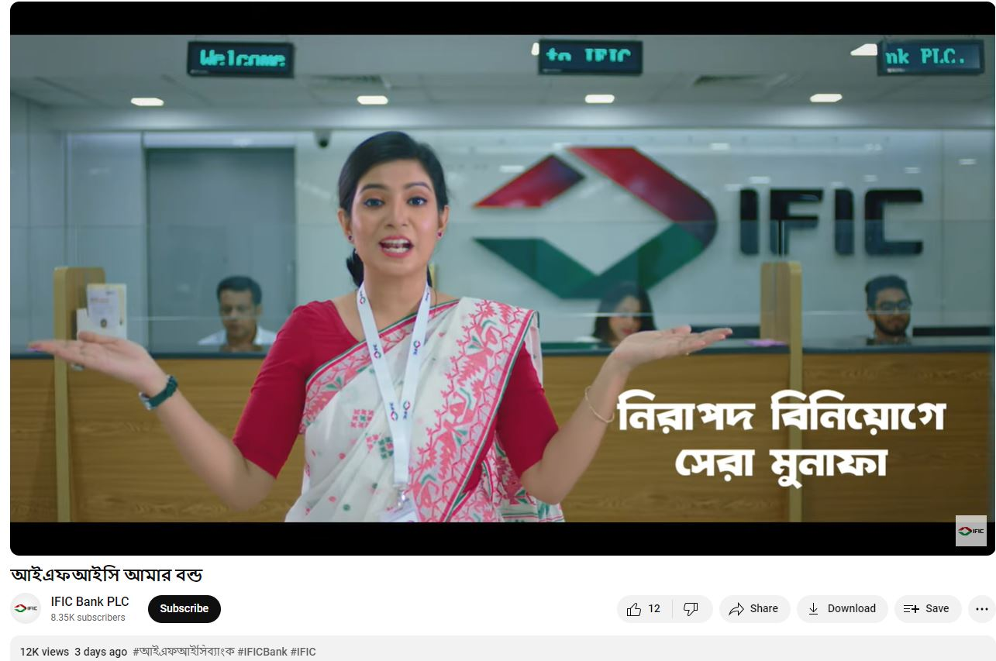
Photo: IFIC AAMAR BOND COMMERCIAL
Direct Marketing: IFIC Bank follows various medium of direct marketing in their marketing plan. The followed direct marketing methods are described below:
A) Telemarketing:
A dedicated telemarketing teams are assigned to approach the lead (actual and potential customers) about the services offerings of IFIC Bank to either transform them into new customers or to convince them about the new offerings to avail. Once the approached customer is convinced to visit the branch to and avail the service, the telemarketing team contact with the branch officials and send them the details of the customers and what services they are interested to avail. After that, the branch officials serve the customers and complete the remainder of the process.
B) Door to door marketing:
There is a team called DST that implies “Direct sales team” at IFIC bank assigned to do door to door marketing. The DST representatives follow two ways to generate the leads either collecting the information of the potential clients by himself or using the reference of the existing customers. Firstly, they set a meeting and fix and visit the client’s workplace. Secondly, inform the services and suggesting which service will be convenient for them the most. If the customers are willing to open account and visit the branch, the DST representatives and TSO (Transaction Service Officer) assist them to open the account.
C) Leaflet handouts: Leaflet handout is another traditional direct marketing tool to attract the customers directly. IFIC Bank has been using this direct marketing tool for different service products such as Aamar account, Shohoj account, Aamar Bhobishawt etc.
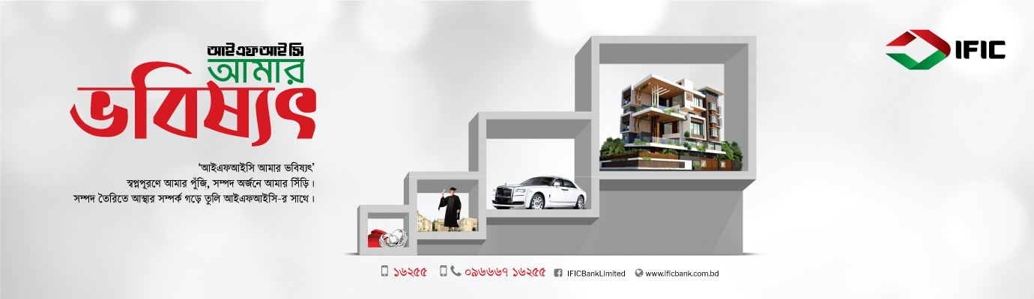
Photo: IFIC AAMAR BHOBISHAWT LEAFLET HANDOUT
Digital Marketing: Digital marketing has been an indispensable part of the marketing practices of IFIC.
A) Social media marketing: IFIC bank is promoting their products and delivering the customers in all the available social media platforms including Facebook, Instagram, Linkedin etc. Facebook:
The active presence of the bank in facebook reflects on the active engagement of the customers with 1.6 million likes and 1.7 million followers following the IFIC Bank facebook page. The followers get the latest update of IFIC Bank’s services, different CSR activities, new branch opening etc. time to time in the facebook page. Besides, customers can directly contact with the bank to resolve their queries contacting through the inbox option of their facebook page.
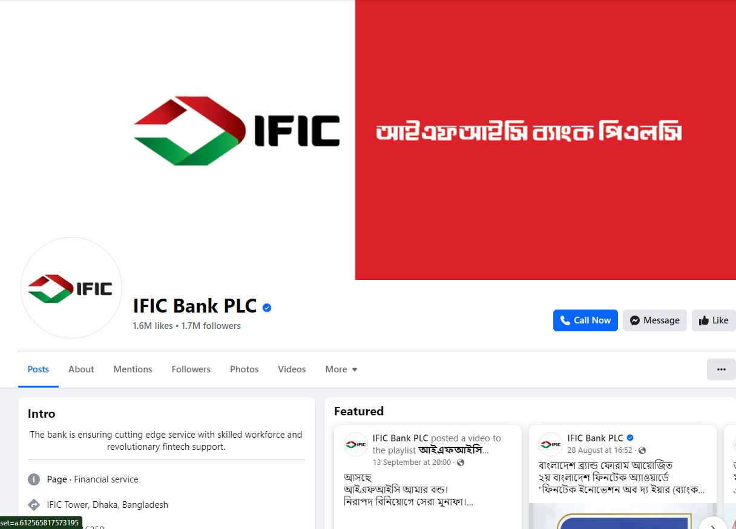
Instagram:
In order to connect the existing and potential customers, IFIC mark their presence on popular social media site Instagram as well. As the Gen Z and millennials, influencers are mostly active on Instagram; IFIC left no stone unturned to reach out to them using the Instagram platform. As of now more than 700 posts are on their Instagram page regarding their services.
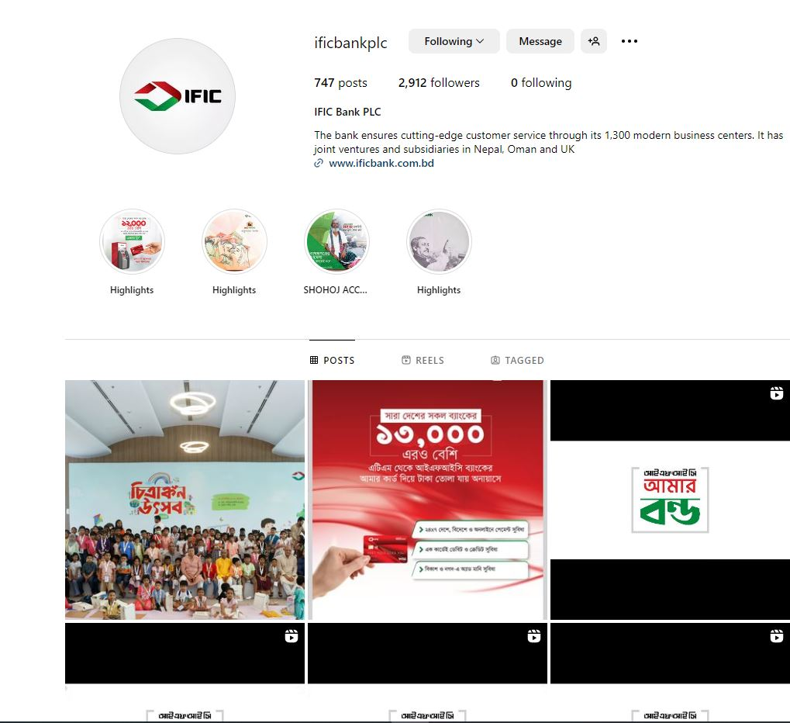
Linkedin:
Linkedin is the most popular professional site in Bangladesh and across the globe. People from banking and other industries are active on this platform. As a result it is very impactful to reach out to the retail and corporate client in this platform. In addition, IFIC Bank also posts circular for the vacant positions on linkedin and hire competent candidates through this platform. More than 12000 people are connected to their platform now.
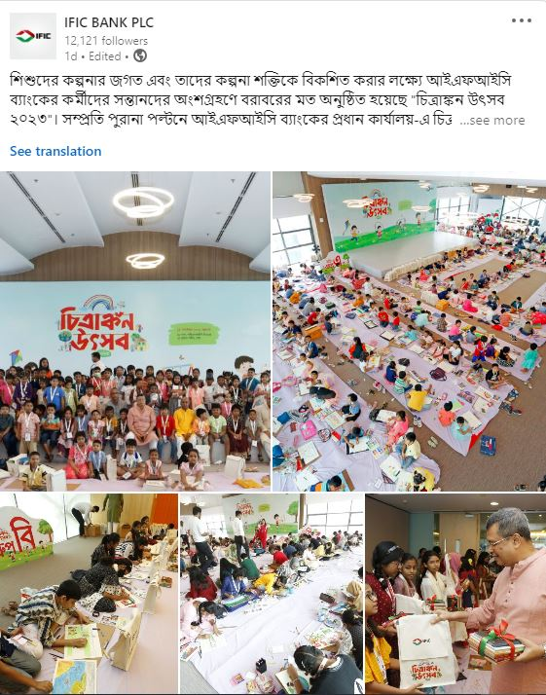
B) Website: Website is an integral part of digital marketing nowadays. IFIC has their own website with the url : https://www.ificbank.com.bd/
A person can get a holistic idea about IFIC Bank PLC regarding their journey, different banking services, currency rate, job openings, annual report, news and reports, board of directors and many more from IFIC’s website. So, their website is playing a pivotal role in positive branding of the organization every now and then. The website is also creating a good first impression about the bank and credibility about the bank to its customers. Effective SEO increases the possibility to increase traffic to the website from customer’s click at Google, Bing and other seach engines who seek for banking services.
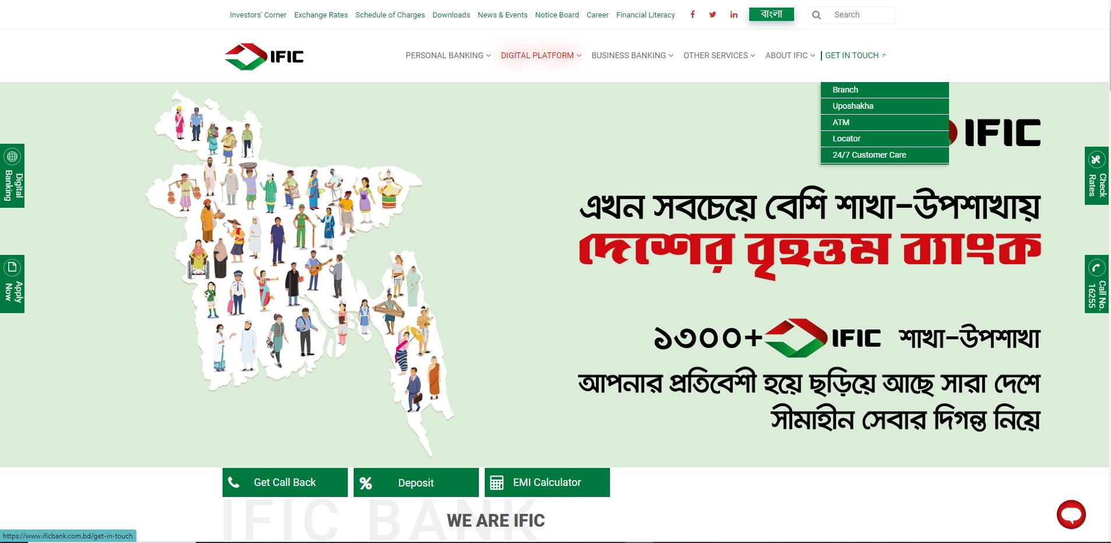
Photo: LANDING PAGE OF IFIC BANK PLC WEBSITE
Publicity: One of the most engaging promotional strategy for marketing is publicity. IFIC Bank also use this strategy in two ways:
a) Press release
b) Review/User Generated Content (UGC)
Press release: The short, compelling story about the events, product launch is given to media personnel to cover in the mainstream media to increase goodwill and awareness among the mass people; also known as press release is the main way how IFIC Bank PLC conduct publicity. The journalists are also usually invited to cover such events in order to cover it and publish it on their platform.
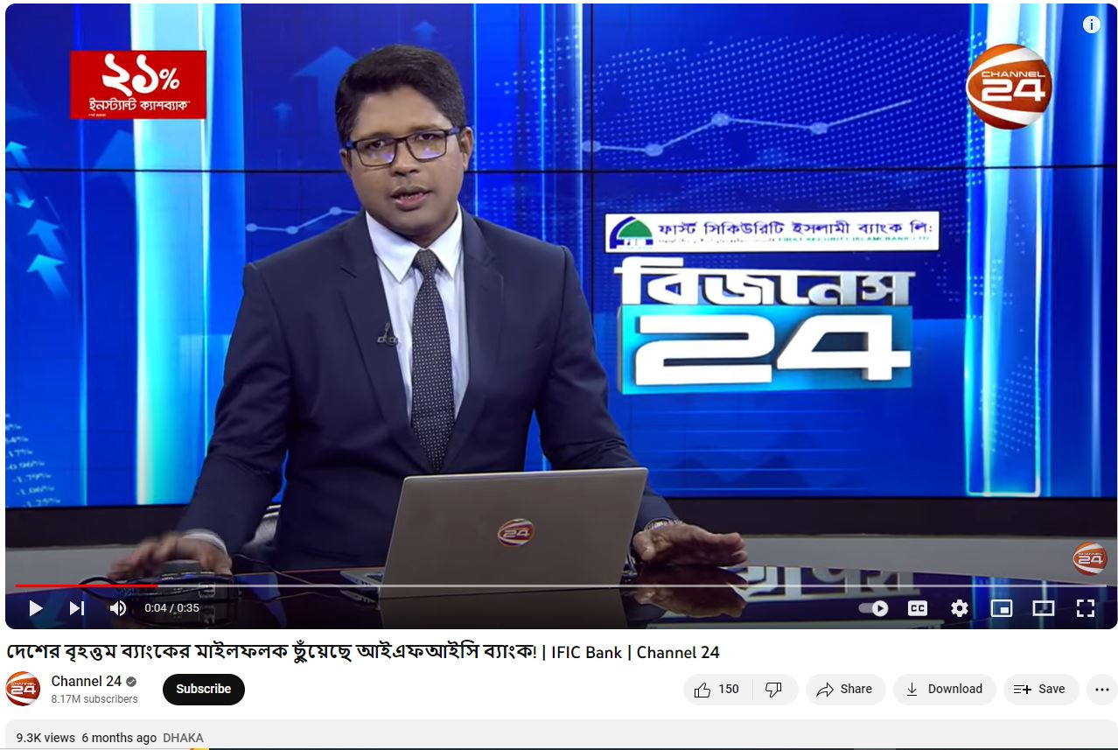
Photo: MEDIA COVERAGE OF LARGEST BANK MILESTONE OF IFIC BANK
User generated content: User’s review about the sevices is another form of publicity. It can be either positive or negative. Generally, customers give their review on their own accord when they are delighted or dissatisfied on using the service. But publicist himself or the assigned personnel can do publicity on behalf of the company hiding their identity. IFIC’s publicity is usually done by the customers in the form of review in different banking and card users’community, word of mouth and electronic word of mouth.
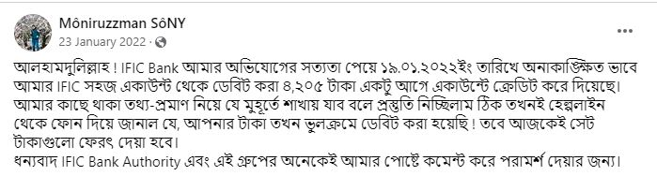Photo: CUSTOMER’S POSITIVE REVIEW ON DISPUTE SETTLEMENT BY IFIC
Personal selling: The practice of personal selling is mostly visible in IFIC Bank. The transaction service officer who are the frontline service provider in the bank usually influence and encourage the customers to open account with IFIC Bank. For example: when a customer comes to clear the clearing cheque of a different bank, the TSOs encourage to open an account with IFIC Bank stating the facilities the customer will receive at IFIC. Besides, the existing customers are also approached for availing new service which will be beneficial for him. When customers receive quality services from the officers, gets acquainted and rely the bank, they not only expand their service receiving spectrum also influence their acquaintance to engage with IFIC Bank.
People: All human actors who play a role in service delivery and influence the buyer’s perceptions are called people. People are of two types:
1. Internal : People inside the organization who are involved in service delivery. Example: employees.
2. External : People outside of the organization who are involved in service delivery As service is intangible, perishable so it is a must to provide quality customer service. Example: customers.
At IFIC, every transaction service officer goes through training on how to provide the best and quality service to the customers in a prompt, error-free way with friendly behavior. In addition, all customers are equal; the officers are instructed to follow this. In order to prepare the officers competent, three training is provided to each Transaction service officers.
Process: Process includes the mechanisms, procedures and flow of activities by which the service is delivered to the customers.
The process of service delivery in banking industry is an important determining factor of customer’s satisfaction. IFIC introduced the ‘’one stop solution” service delivery for the first time in Bangladesh. It implies that a customer can get all type of service in one counter. The customer doesn’t need to move from one counter to another. All the 27 types of banking service including account opening, fund transfer, pay order, currency endorsement, deposit, cash withdrawal etc is available in a single counter. As a result, the service delivery is fast and time saving for the customers.
Furthermore, IFIC bank follows “checker-maker” policy to provide customer error free service. Under this policy, no service will be provided without the approval from both the checker and maker. It has been initiated so that even if the maker makes any mistake, the checker can correct it.
For example: ABC company requested for 30 lakhs taka home loan and the bank officer approved it either by being biased or mistakenly, it will not be approved because the higher officer (maker). He will thoroughly review the process, evaluate the loan disbursement eligibility of the loan taker. If any discrepancy found, the maker will cancel the loan request.
Physical evidence: The setting in which the service is provided and where interactions occur between the company and the customer, including any physical elements that aid in the execution or communication of the service.
The intangibility nature of the service makes people hesitate to avail the service of an organization. So physical evidence is a must to create credibility among the customers. IFIC Bank has its own registered head office named IFIC Tower at Purana Paltan. The principal branch and other branch, sub branches customers believe that, since the bank has its own office; it will not scam. In micro level, the deposit slip copy, cheque book, cards all are the physical evidence of micro level service that are the evidences of their service. As a result, customers can continue banking with IFIC Bank confidently.
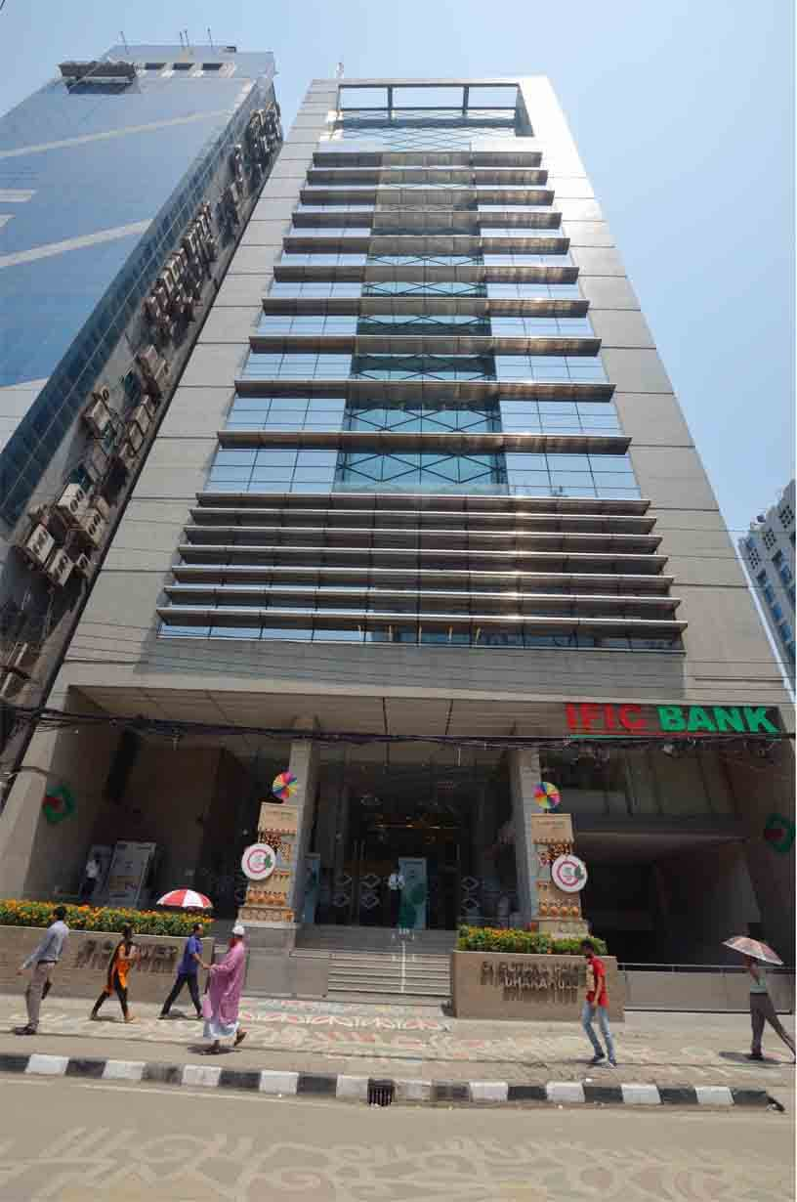
CHAPTER 5
RECOMMENDATIONS AND
CONCLUSION
Improvement is a continuous process and IFIC bank has also some areas to improve to satisfy the customer’s need more specifically. The recommendations for IFIC Bank are given below:
•Corporate collaboration: IFIC bank should increase corporate collaboration with other organizations so that the card user amount increases significantly. For example: Eastern Bank Limited, Standard Chartered bank, City bank users collaborate with the leading online based travel agency in Bangladesh “ShareTrip”. As a result, the customers of these banks get 5%-upto 10% discount when they use the credit (in some case some debit card also eligible) card of these banks. This is why, the travel enthusiasts take the card facility of these banks to make payment while purchasing air tickets or booking hotels and packages.
• Using SEO and SEM: The Search engine marketing and Search engine optimization both are absent in the practice of IFIC marketing practices. In this era, without using captivating keywords it is difficult to accumulate organic traffic on the website, so IFIC should initiate the use of SEO to ensure traffic on their website. Additionally, the paid form of marketing SEM should also use to attract the selected audiences and get immediate results.
• App development: The most concerning factor for IFIC Bank. Majority of the customers are dissatisfied with the “Aamar Bank app”. Customers said, if the fund transfer is unsuccessful, it takes 3 days for them to get notified about it whereas others bank inform them the update instantly or within two days. The app is now under maintenance but they should fix the problems as early as possible so that customers won’t decide to switch to competitors. If the app become smooth in operation, IFIC customers will not only be satisfied but delighted because they are satisfied with all other services.
• Website development: The IFIC website is well in use but it doesn’t give the premium feeling like that of City Bank, Brac Bank, Eastern Bank etc. So, the website should be designed such a way that it gives an eye-catchy, premium feeling which will attract the customers to explore the website and customer’s average stay time will be increased.
•Card segmentation: Besides Visa card, IFIC should inaugurate the Mastercard, American Express (Amex) card option for the users so that the enthusiasts customers who are willing to take the Mastercard, Amex card, they can also have it. In addition, the segmentation of Gold, Platinum, signature card should be introduced to reach all the different segments of customers.
Conclusion
After 46 years of its foundation, the bank is now at the ‘’maturity’’ period according to the industry life cycle. In maturity lifecycle, the banking industry is much more saturated. This is why, not many banks can survive in the competition and it has even become difficult to occupy the market share. In this regard, it is high time the bank focused on improve their marketing integrating digital marketing and 360 degree marketing strategy, follow diversification strategy to serve new products in new markets and most importantly continue providing quality services to keep their existing customers delighted and also bring new customers in their network consistently from the competitors’ banking network. Therefore, understanding the significance of service marketing IFIC Bank should integrate marketing in their company’s planning process, keep dedicated digital marketing team, collaborate with marketing and creative agency to sustain a positive brand image in the minds of the customers and increase persuasiveness for a long run.
References:
1. (Services Marketing: Integrating Customer Focus Across the Firm, 7th Edition, 2018, p. 04)
2. https://www.geeksforgeeks.org/difference-between-seo-and-sem/
3. https://www.facebook.com/IFICBankPLC
4. https://www.instagram.com/ificbankplc/
5. https://www.linkedin.com/company/ificbankplc/
6. https://www.ificbank.com.bd/
7. https://www.youtube.com/@FICBankPLC
8. https://businesspostbd.com/opinion/evolution-of-the-banking-sector-in-bangladesh-23065

