Internship Report On
THE INTERNAL CONTROL AND COMPLAINCES OF
Abdul Monem LTD

Submitted To:
LAMIA ALAM
Assistant Professor- AIS
School Of Business and Economics

Submitted By:
Shagufta Islam Rasha
111153180

Submitted On: June 20, 2020
.

United International University

Letter of Transmittal

June 20, 2020
LAMIA ALAM
Assistant Professor- AIS
School Of Business and Economics (SOBE)
United International University

Dear Mam,
Here is the assigned internship report on “Abdul Monem LTD” where I tried to exhibit the role of and internal Audit department in a multiple sector oriented organization. I have enclosed all the essentials that should be included in this report. However, being a student and in a route of acquiring my skills, there is more to my learning curve so, I hope that you will be generous enough to accept the shortcomings of this report.
Thank you for giving me such an opportunity to work with something remarkable. I will be honored to supply you any extra data, in the event that fundamental.
Sincerely yours –

Shagufta Islam
ID: 111153180

Acknowledgement

It is of extraordinary delight for me to precise our profound sense of appreciation to our honorable course administrator Lamia Alam for selecting me a topic on “THE INTERNAL CONTROL AND COMPLIANCE OF ABDUL MONEM LTD” as part of my internship report in the progression of completion of my BBA program.
My honorable course administrator helped me when needed on diverse issues with respect to the report. I moreover took the assistance of course materials given by my honorable course coordinator, content and reference books.
I appreciate the solidarity, unconstrained workability and group soul of my office superiors. Without co-operation and bolster from each other it would not be conceivable to create such an ingenious report.
I also give my regards to those who aided me with the collection of numerical data by presenting useful information.
At last I need to pay my appreciation to my course coordinator for giving the most noteworthy opportunity to work on such a challenging report that will be exceptionally accommodating within the future.
Table of Contents
Letter of Transmittal iii
Acknowledgement iv
EXECUTIVE SUMMARY vii
Chapter 1 INTRODUCTION 8
1.1. Background of the Report 9
1.2. Objective of the Study 9
1.3. Methodology 10
Sources of Data 10
Data Processing and Analysis Method 10
1.4. Scope of the Report 11
1.5. Limitations 11
Chapter 2 PROFILE OF ABDUL MONEM LIMITED (AML) 12
2.1 About Abdul Monem LTD 13
2.2 Corporate Profile 13
2.3 Origin and Expansion 14
2.4 Company Mission & Vision 15
2.5 Company Values 15
2.6 Chain of Command 16
2.7 Time Line & Business Units of AML 17
2.8 AML Partners 20
Chapter 3 : OVERVIEW OF AUDIT AND INTERNAL CONTROL & COMPLIANCE 21
3.1 What is 'Audit'? 22
3.2 Internal Control & Compliance: 22
3.3 Objectives of Internal Control and Compliance: 23
3.4 Elements of Internal Control and Compliance: 23
Chapter 4 : INTERNAL CONTROL & COMPLIANCE (IC&C) IN ABDUL MONEM LIMITED 24
4.1 Internal Control & Compliance Process in AML 25
4.2 Current Structure of Internal Control & Compliance Department: 27
4.3 Regular Responsibilities of Internal Control & Compliance Department: 28
4.4 Brief Information Regarding Internal Control and Compliance Operating Guideline of IC&C Department: 29
4.5 Capital and Revenue Expenditure Processing Procedure in IC&C 31
4.6 Responsibilities of IC&C Department in case of Various Expenditures: 32
4.7 Other Relevant Activities: 34
Chapter 5 : FINDINGS & ANALYSIS 35
5.1 Observed Challenges in the Organization 36
5.2 Some Observations by Checking Expenditure Documents 36
5.5 My experience in AML 37
Chapter 6 RECOMMENDATION AND CONCLUSION 39
6.1 Recommendations 40
6.2 Conclusion 41
Chapter 7 References xlii
Chapter 9 Appendix xliii
Questionnaire xliii
Image attachments xliv

List of Table and figures
Figure 1: Comany Overview 13
Figure 2: Monem Business District 14
Figure 3: Values of AML 15
Figure 4: Chain of Command of AML 16
Figure 5: Partners of AML 20
Figure 6: Internal Control Process 22
Figure 7: AML IC&C Process 25
Figure 8: Current Structure of AML IC&C Department 27
Figure 9: Capital and Revenue Expenditure Processing Procedure In IC&C 31

Table 1: Documents Checked My IC&C 29

List of Acronyms
- IC & C | Internal Control and Compliance
- AML | Abdul Monem Limited
- MRE | Material Receiving Entry
- MRR | Material Receiving Report
- QC | Quality Control

EXECUTIVE SUMMARY
A healthy internal auditing program illustrates its presence at the starting and finishing of frequent improvement of every aspect of the company. At start, internal audits categorize opportunities for upgrading and at last internal audits offer a tool for observing the implemented upgrade in order to sustain its benefits for the long term. The following report gives an overview of Audit, internal auditing and Internal Control and Compliance(IC&C) of Abdul Monem LTD along with a scenario of my practical experience as an intern. We the people of Bangladesh are no stranger to fact that one of the most successful construction companies which stands strong is the Abdul Monem LTD (AML). The report mainly contains six chapters which starts with the introduction to my reasoning of this report. The second chapter gives the wide overview of AML in the light of success and accomplishment. The third chapter explains the meaning of audit and theoretical knowledge about it as this was my daily task for 10 weeks as an intern in AML. Then in chapter four the main discussion starts where the activities of an Internal Audit department are dissected- what the organization should do and what I did on behalf of them. The later chapter number five gives us the findings and analysis that I have found during my time in AML that are the constraints despite enormous success. The last chapter gives few solutions to the constraints that would help AML climb the last steps towards triumph in its path towards fame and being at the top of the industry. I have also tried to focus on the lesson learned from the internship program here I described about the skills I have acquired from the organization which is vital part of the report. In conclusion it summarizes the entire journey of my internship in the light of AML’s Internal Control and Compliance department. So, a matter of great importance that nourishment of impartial judgment and neutrality is very much essential for smooth running of the organizational internal control and compliance activities and its overall prosperity. Thus, nothing in the world is perfect and success has no limit, so if AML works harder and adapt with the changing environment surrounding us there will be no looking back and an unlimited counts of achievements.

INTRODUCTION

Many a times we have seen that what is written the books are not what is going on in the real world. Thus this report is the compilation of Internal Auditing of a multi-dimensional company in Bangladesh. A real world experience draws a practical picture of what is exactly going on the surroundings. Although we have a single subject based on auditing it is not enough to give you the actual idea. Thus I have tried to make possible the link between academic knowledge and real world experience by finding much data in the present time. To achieve that objective I have chosen Abdul Monem LTD to showcase the current scenario on their vast activities.

Background of the Report
Auditing is the procedure of inspecting an organizations financial record to regulate whether they are on point and in compliance of appropriate rules & regulation within accounting standards. For this report we are concerned about the active role of internal auditor in an organization. Hence I have selected to discover as much material as conceivable from the company that I have completed my internship in arrange to depict the total situation of inner control and compliance (ICAB, 2019).

Objective of the Study
Main Objectives: To have an evaluation approximately on duties and responsibilities of “Internal Control & Compliance” (IC&C) unit of Abdul Monem Ltd and analyze the significance of internal auditor for maintaining a stable and growing organization in a dynamic environment.
Other objectives:
- To comprehend the total internal auditing in an organization
- To find the gaps of the Standard and the practices in the organization
- To identity the core and specific role of internal audit
- To know about effective internal control and compliance in real world

Methodology
Methodology is the method of hypothetical examination of the approaches connected to a field of ponders. It incorporates the hypothetical examination of the body of strategies and philosophies related with a department of information.

Sources of Data
Usually we can collect data from two sources which are primary and secondary and I tried to collect information through both.
- Primary Sources
Many of the information were collected via interview with different IC&C (Internal Control & Compliance) members, surveillance, and by partaking in the several audit programs.
- Secondary Sources
The secondary knowledge was collected from numerous blogs, the IC&C Handbook, presentations, audit reports and several other relevant documents.
Both primary and secondary data sources have been used in the preparation of this study. Primary data points, such as casual and structured interactions with staff and direct observation when operating, have been very useful in drafting this study. Secondary data sources have played a robust role in effectively completing the study.

Data Processing and Analysis Method
Data Processing: A chain of steps performed on information to confirm, organize, change, coordinated, and extricate information in a fitting yield shape for consequent utilization. Strategies of preparing must be thoroughly recorded to guarantee the utility and judgment of the information.
Data Analysis: includes activities and strategies performed on information that offer assistance, depicts realities, identify designs, create clarifications and test theories. This incorporates information quality affirmation, measurable information examination, modeling, and translation of investigation results.
Once the data is gathered I ensured that it is correct and used properly in our report in specified headings.

Scope of the Report
The following report has been prepared through widespread discussion with the respected faculty, Audit department members and the organization that I have done my internship from. The process and guidelines given in books has also helped us find out what the company is following in terms of their internal auditing. During the preparation of the report, I had the privilege to work there as audit intern and enlighten myself. I also gained proper facts and practical view of the internal control and compliance of Abdul Monem LTD over the years to make the company competitive and groom along the dynamic environment.

Limitations
In the making of the report few obstacles where identified which are as follows:
- Time management issues as three months are not sufficient to comprehend the complete actions of a multi-sector company.

- Limitation of data collection as I was only an intern in the organization.

- Access to knowledge, access to tools, access to editing, analysis and advice by established organizations and participants due to confidentiality is also an issue.

- Although I am not unaware of making reports, I had no past practice of internship. So naivety is another constriction of the study.

- As internal audit is very new in our country thus appropriate material about the topic was difficult to acquire.

PROFILE OF ABDUL MONEM LIMITED (AML)

About Abdul Monem LTD
Abdul Monem Limited is the perfect picture of prominent diversified business conglomerates of Bangladesh which was established in 1956. This Company has experience of changes over the millennium. Today, in the dynamic world of business and technology, AML is challenged to shapes shift accordingly. The company is highly experienced for over 50 years in accomplishing that is in the past and is sure to be the same in future. Initiated as a Construction Contractor in 1956 then diversified to food sector and never looking back again. Abdul Monem Ltd.’s pride are brands like AM Construction, Coca-Cola, Igloo, Igloo Sugar and AM Asphalt & Ready Mix Concrete Ltd. that are the jewel of the crown it beholds. (AMLBD, 2020)

Corporate Profile
The organization profile is being summarized below:

Figure 1: Comany Overview

Origin and Expansion
Abdul Monem LTD was initiated by MR. Abdul Monem in the year 1956. It first started with the area of civil constructions and later advanced its branches ranging from Infrastructural Development to Fast Moving Consumer Goods (FMCG) and Business Process Outsourcing (BPO).
Mr. Abdul Monem, founder chairman and managing director of AML, had nothing, to accomplice what he has now as he only had 70 TK when he first came to Dhaka. After working as a government officer for 3-4 months under the government’s construction and building office, he knew it was not for him so he left the job to form his own empire in construction business.

Figure 2: Monem Business District
Beginning as a closed cooperation, AML has upgraded into a multidisciplinary, modern day business group. AML’s main focus is on developing competencies to inject power and charisma to all there stakeholders. AML consists of 10,000 talented and expert workforce engaged in differentiated business operations to achieve major milestones in business elaborations.
AML passionately expanded its activities with the motto ‘Touching Lives… Building Capabilities…!’ AML claims its reign in the private entrepreneurship in Bangladesh by investments in many different sectors discussed later. With the leading hero Mr. Abdul Monem, the company has remained adamant about eco-friendly and quality s and services, security and on time deliveries which earned its name and gave it an international benchmark.

Company Mission & Vision
Vision
“Optimum use of valuable resources including human to create value-added products and services aimed at contributing to the economic, social and environmental progress and prosperity of Bangladesh.”
Mission
“Our Mission defines our Roadmap. We excel to develop and deliver value added goods and services to our esteemed customers, consistently outperform our peers, build enduring relationship with our business associates and stakeholders, provide a dynamic and challenging environment for our employees and aim to achieve incremental growth of our business thereby having a positive economic and social impact on the community and the nation.”

Company Values
Their fundamental philosophies and morals are motivated by three features. They are:
People – Prosperity – Progress

Figure 3: Values of AML

Chain of Command
Chain of Command is an official progression of specialist that orders who is in charge of whom and whose consent must be inquired. It demonstrates the names and occupation titles of the entire workforce in an organization, signifying how they are associated with one another. Also, it's a diagram that demonstrates the structure of an organization and the link between the different individuals, divisions, and occupations at various stages inside that company.

Figure 4: Chain of Command of AML

Time Line & Business Units of AML
The underneath SBUs have been built up over the long course of time for leveraging the quality of the parent company and to contribute to the national economy primarily by creating work openings for individual citizens.
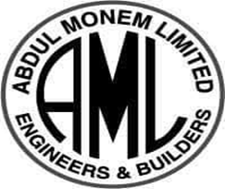 |  | Infrastructural Development (since 1956):  AML is one of the leading infrastructural developer which has been involved in many important projects since its origin. Few examples are Khulna-Mongla Highway (44 kilometer long), Gorai Bridge, Gulshan-Banani Bridge, Banani Flyover, etc.
 |  | Igloo Ice Cream (since 1964):  Igloo is the foremost prevailing choice for take-home ice cream of Bangladesh. It is prepared with the foremost updated machinery, skilled human assets and employments as it were the most excellent crude materials. Igloo never compromises with quality and taste. Igloo Ice Cream manufacturing plant, arranged in Shaympur, Dhaka, produces around 10 million liters of ice cream yearly and wins a turnover of roughly 500 center. As of late Igloo has been voted to be the No. 1 Ice Cream Brand by the Bangladesh Brand Gathering.
 |  | AM Beverage (since 1982) :  AML represents the brand Coca-Cola in Bangladesh. Coca-Cola, Fanta and Sprite have been the most common beverages to all consumers despite age. AM Beverage Limited is the authorized bottler of Coca-Cola, Fanta and Sprite, as well as Kinley Drinking Water. The bottling operation begin after takeover of the plant of K Rahman And Company in 1982. Currently it has 9 million unit case production capacity and a turnover of about 400 cores.
 |  | AM Mango Pulp Processing Unit (since 2000):  To create a affirmative effect in the agricultural sector based on local agro produce, AM Mango Pulp Processing Unit was established in the year of 2000 and it went for commercial production in the year of 2005 AM Mango Pulp Processing Unit consumes on an average 2000 Ton mango per season from Chapai Nawabganj.
 |  | Igloo Foods Limited (since 2004):  Igloo Foods Limited is a maker and advertiser of first-class brand title nourishment and potato items for shoppers all over Bangladesh..
 |  | Danish Bangla Emulsion Limited (DBEL)(since 2004):  It is a joint venture company between Abdul Monem Limited and ENH Engineering A/S, Denmark. (DBEL) has been producing bitumen emulsion of international standards by a fully automated plant for the construction of road and airfield pavement work.
 |  | AM Securities & Financial Services Ltd. (since 2004):  It is a subsidiary of Abdul Monem Group and a leading equity brokerage house in the country with a diverse clientele of institutions, high net worth individuals, foreign funds and retail investors.
 |  | Igloo Dairy Limited (since 2004):  It was established to keep up with the production capacity of Igloo Ice Cream as well as to meet existing demand for sterilized milk. With the rising demand of the milk and dairy products, the company has built the facilities to produce 14,000 liters of milk a day.
 |  | Igloo Sugar (since 2006):  It has an annual capacity of supplying over 300,000 metric tons of first class sugar and in a short span of time took the role of the 4th leading supplier of refined sugar in the market of some 1.2 million metric tons. AMSRL is the 1st ISO 22000 2005 certified processing plant and is regarded as the most cost minimizing and fine quality, skillfully managed one.
 | AM Energy Ltd (since 2007):  It is located by the river Meghna and built on 1.73 acres of land. Firstly it was designed for generating 10MW by steam turbine generator but now has 6MW capacity with 3.5MW maximum power generated. Of which 2.5MW is supplied to Abdul Monem Sugar Refinery Limited for the factory tasks and 1MW is transferred to REB-Rural Electrification Board.
 | AM Asphalt & Ready Mix Concrete Ltd (since 2010):  Abdul Monem set up AM Asphalt & Ready Mix Concrete Unit in 2010 to manufacture cement concrete, asphalt concrete those required in construction projects. The factory is located at the bank of Meghna River, East side of Meghna Bridge on Dhaka – Chittagong Road.
 | AM Auto Bricks Limited (since 2011):  AML, in 2011, introduced Auto Bricks Limited for eco-friendly brick production. The company now has a capacity to produce 25.84 million units of bricks with variety of first class pickets and medium.
 | AM Bran Oil Company Ltd.(since 2014):  It was start up with the scheme to offer the Most Healthy and Heart Friendly edible oil labeled as “Nature Fresh Rice Bran Oil” to its consumers. It is a joint-venture operation with Surin Bran Oil Co. Ltd.; Thailand.
 | Abdul Monem Economic Zone (AMEZ) (since 2015):  The economic zone is located in Gazaria, within two mouzas (Bausia and Jajira) of Gazaria upazilla under Munshiganj, covering almost 216 acres (with option for expansion up to 300+ acres) of exclusively owned land. The area is popularly known as Daudkandi.  (AMLBD, 2020)

2.8 AML Partners
"No matter what our assignment is, we consider everyone we work with, work through and work for as our PARTNERS"- AML


Figure 5: Partners of AML

: OVERVIEW OF AUDIT AND INTERNAL CONTROL & COMPLIANCE

3.1 What is 'Audit'?
Auditing is the strategy of reviewing an organizations money related record to direct on the off chance that they are correct and in compliance with any suitable rules & direction inside bookkeeping standards (TUOVILA, 2019).
Auditor can be of two kinds. They are External and internal auditor
- An external auditor is the one independent of the organization to observe bookkeeping and money related information to deliver unbiased opinion on this information. It is a legal requirement that all public companies externally audit there financial and accounting system.
- Internal auditors are the organization’s personnel to observe all accounting and financial information used to help rectify and develop inner practices such as operations, internal authority, crisis management, and governance.
In the report discussions on internal auditing is elaborated as this was the department I worked as part of my internship.

3.2 Internal Control & Compliance:
Internal control is the strategy influenced by a company's stakeholders, outlined to ensure results in the effectiveness and efficiency of tasks, the dependability of monetary detailing and compliance with appropriate rules, direction and inside arrangements. Internal controls are the guidelines and measures put forward to be executed with or without other guidelines to follow and manage specific crisis in business operation (UAE, n.d.).
The process is as follows:

Figure 6: Internal Control Process

3.3 Objectives of Internal Control and Compliance:
The main goal is to help the companies identify their strength and weaknesses on which to take appropriate action (Kinsey, 2019). Some key quality monitoring goals are as follows:
- Performance objectives: Proficiency and viability of tasks
- Information objectives: Financial and management information reliability, comprehensiveness and timelines
- Compliance objectives: Acceptance with relevant rules and regulations

3.4 Elements of Internal Control and Compliance:
All organizations are different even if the products are same thus IC&C is different in each environment. In forming the IC&C management needs to consider the cost and benefit analysis of that organization. Besides, there are few essential elements that are vital to internal control in organizations. (& Associates, 2016) These are:
A) Chain of command
B) A suitable accounting configuration
C) A comprehensive information documenting structure
D) Proper business transactions recording
E) Competent human resources
F) Actions and access taken only by authorized personnel
G) Sufficient security and shields over cash, settled resources, paper documentation and electronic information, counting back-ups
H) Regular check on documented and actual situations on all purpose

: INTERNAL CONTROL & COMPLIANCE (IC&C) IN ABDUL MONEM LIMITED

4.1 Internal Control & Compliance Process in AML
The IC&C of AML designed five steps, all of which are discussed below:

Figure 7: AML IC&C Process

- Internal Control and Compliance Definition:
It is the outline for risk valuation and audit preparation which is performed at a minimum each year in order to immense regular planning strategy (Company, n.d.). The highlights of these strategies are:
- To form an affiliation with the stakeholders and comprehend their requirements
- To put together enough facts to comprehend smooth business and elementary operation.

- Internal Control and Compliance Planning:
Here for an annual basis decisions are made on how things are going to be done. Internal control and compliance is executed for risk analysis at all levels by taking into consideration of stakeholder anticipations, present plans and expansions and previous auditing outcomes.

- Internal Control and Compliance Execution:
The two stages done before are at the company level is the base for further implication. IC&C Execution is the first step in business procedure level of the distinct yearly agenda. This stage targets on acting a single audit document from the yearly IC&C plan. At the start of the year the auditors prepare an annual audit plan and execute the plans in different intervals of time and then prepare reviews for every other carried out plan. Then all reports are merged and important steps are taken for rectifying any mistakes. This helps the control to know real outcomes and make decisions depending on it.
- Internal Control and Compliance Reporting:
Throughout the IC&C the outcomes, analysis and suggestions that auditor find out are enlighten in the report and given to the management. This report is issued to the management because of the suggestions and necessary steps to be taken by consider the risk associated.
- Internal Control and Compliance Evaluation & Transfer:
The objective here is to get reaction from stakeholders on the report created, follow-up on concurred activities, share lessons learned and guarantees information exchange, observe compliance with the IC&C strategy and IIA Standards.

4.2 Current Structure of Internal Control & Compliance Department:
Currently the Internal Control and Compliance Department consists of 5 members. There is one Assistant General Manager, FCA who is also the Head of Internal Control & Compliance Department, two Deputy Managers, one Assistant Manager and two Senior Executive. Executives report to Senior Executive, Senior Executive reports Assistant Manager, Assistant Manager Report to the Deputy Managers, Deputy Manager’s report to the AGM and AGM reports to the Board of Directors.
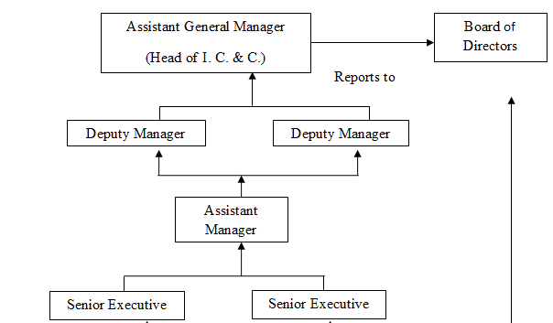
Figure 8: Current Structure of AML IC&C Department

4.3 Regular Responsibilities of Internal Control & Compliance Department:

- To conduct pre audit of all expenses out zone depot. & factory ;
- To prepare audit and managements reports monthly;
- Checking monthly sales reconciliation as per sales requisition;
- Checking monthly reconciliation among production, store received & finished
Goods;
- To calculate VAT and Tax as per Act and Rule;
- Preparation of audit work programs as per company requirements;
- To conduct physical verification of stock items, petty cash, collection & deposits;
- Checking of Raw materials, Packing and Finished product stock movement;
- Monthly physical verification of cash;
- Monthly reconciliation of bank statement and approve bank balances;
- Market verification for different purchases (if necessary);
- Monthly physical verification of Fixed Assets;
- Checking of monthly material consumption report;
- Checking of advance payment and subsequent adjustment;
- Preparation of various reports for management for different special cases.

4.4 Brief Information Regarding Internal Control and Compliance Operating Guideline of IC&C Department:
There is some specific operating guideline of IC&C department approved by Abdul Monem Limited management. For example, there are Leave Rules; Tour & Travel Rules and Capital Expenditure Rules etc. but for some special cases department follows some rules, regulation and office order from departmental head. In order to operate in full fledge few things are seen which are discussed below:
- Budget:
There is an estimation of Income & Expenditures made by Finance Department and checked by internal control and compliance department but budget is not formally executed.

- Documents Checked by Internal Control & Compliance Department:
- Requisition/Demand | - Quality Control Report
- Bills | - Purchase Requisition
- Invoice | - Attendance Sheet
- Delivery Challan | - Payroll
- Gate Pass | - Commercial Invoice
- Material Receiving Report[MRR] | - Pro-forma Invoice
- Bill of Lading | - Bill of Entry
- Taxes and Duties | - Customs Clearance Certificate etc.

Table 1: Documents Checked My IC&C

- Pay-roll:
100% pay-roll is not established for salary calculation. For example-Manual calculation is done when there is leave with or without permission.
- Physical Verification:
- Inventory verification is done in June and December closing.
- Physical verification by IC&C Department in the factories and construction sites is not
significant regularly. That is why fraud and irregularities in the factories and construction sites are very common and remarkable.
- Verification through Email or Telephone:
- Verification is done by calling or mailing respective individuals if necessary.
- Verification is done for confirming market rate if any inconsistency is detected.

- Decision Making Regarding Internal Control & Compliance:
Irregularities and fraud detection related reports are prepared by the AGM or Head of Internal Control and Compliance department with the assistance of Deputy Managers, Assistant Manager, Senior Executives and Executives. Decision regarding consequence of irregularities and fraud is taken by the respective department in which it occurred.
- Follow-up:
Monthly observation is done for the irregularities and fraud done by any department. IC&C
Department detects the fact and effects upon the fact. IC&C Department gives recommendation and warning to the respective department through email and observes whether the department is now working as per recommendation or not. If the respective department does not follow the recommendation, then it is informed to the management. Management will than take appropriate measures over the respective department.

4.5 Capital and Revenue Expenditure Processing Procedure in IC&C

Purchase
Committee for rate & quality verification as per requirement.
User Department
Factory
Head of Supply Chain
Indent / Purchase Requisition

In case of advance payment, clearance from I C & C Department and payment from Accounts Department.

Procurement Department Purchase/Supply/Work order

Store Officer

MRE
Quality Control
MRE

IC & C Department Clearance
Procurement Department (Prepare Invoice)

Accounts Department (for entry and payments)

Figure 9: Capital and Revenue Expenditure Processing Procedure In IC&C

4.6 Responsibilities of IC&C Department in case of Various Expenditures:

- Fixed Asset, Raw Material or Finished Product Purchase:
IC&C department checks
i) Purchase Requisition: The Quantity of Material, Last Purchase Rate, and Date of
Requisition.
ii) Work/Supply Order: Terms & Conditions
iii) Delivery Challan: Quantity of Material, Gate Pass, Date of Entry.
iv)Transport Challan: Vehicle Number, Carrying Cost, Name of the Material.Quantity
of Material.
v) Gate Entry/ Security Check: Seal of gate entry in delivery challan.
vi) Weight/Quantity Measurement and Quality Control Report: Quantity of Material and
number of accepted or rejected material. Quality Control Report is prepared by expert
persons in the particular material. For example, if the material or product is electrical, then Electrical Engineer prepares the QC Report and if the material or product is used for construction, then Civil Engineer prepares the QC Report.
vii) Material Receiving Entry: Quantity of material.
viii) Material Receiving Report: Quantity of Material Received and Quantity of Material
ordered.
ix) Reference Bill/Invoice: Quantity of Material, Unit Price, Total Amount.
x) Authorized signature in every documents.
- Salary Expense:
IC&C Department checks
i) In case of existing employee, IC&C Department does a cross check with previous
month‘s salary amount.
ii) In case of new employee, IC&C Department checks appointment letter, joining letter,
joining letter acceptance date.
iii) Attendance report.
iv) In case of leave, IC&C Department checks leave status with Leave Rules & Policies,
Leave application.
v) In case of any salary increment, IC&C Department checks Increment Letter.
vi) In case of transfer of any employee, IC&C Department checks Transfer Letter, Last payment certificate to confirm the employee‘s last month of salary payment in the previous work station.
vii) In case of promotion of any employee, IC&C Department checks Promotion Letter.
viii) In case of Resignation or Termination or Dismissal of any employee, IC&C Department checks Resignation or Termination or Dismissal Letter and also does a cross check with Service Rules & Other Policies.
ix) Authorized signature in every documents.

- Labor Wage Expense:
i) In case of existing labor, IC&C Department does a cross check with previous
month‘s wage amount and the wage rates of different positions of labor.
ii) IC&C Department does a cross check with working hour of an employee and the
actual payment amount considering the wage rate per hour.
iii) In case of overtime wage payment, IC&C Department checks the worker‘s overtime
hour with overtime wage payment considering the rate per hour of overtime.
iv) In case of leave, IC&C Department checks leave status with Leave Rules & Policies,
Leave application.
v) Authorized signature in every documents.

- Tour & Travels Allowance and Local Conveyance:
a) IC&C Department checks whether employees follow the Tour and Travel Policies of
the company in case of Hotel Bill, Transportation Bill. For example, any employee
above the position of Executive Director will get the facility to travel in air for
company‘s purpose.
b) If any employee leaves his or her work station, IC&C Department checks Movement Pass Order for giving clearance for payment of Travel Allowance.
c) In case of Local Conveyance Payment, IC&C Department checks the Movement Register. For example, if any employee goes to the bank in office hour for official purpose, he has to entry his name, designation, phone number, purpose of going, out time and in time in the Movement Register. IC&C Department also checks slab for transport medium as per designation.
d) Authorization and recommendation by Superior.

- Fuel Cost:
i) In case of using light vehicle, IC&C Department checks whether quantity of octane or CNG is exceeded over the authorization as per designation slab.
ii) IC&C Department checks fuel bills with entitled rules and policies.
- Depot Expenses:
Abdul Monem Limited has several Depot offices which takes advance for Depot Expenses by showing their expense areas such as Salaries, Operations. IC&C Department checks whether Depot incurred monthly expenses as per approval or not.

4.7 Other Relevant Activities:
Some other related activities in Abdul Monem Limited and they are
- Good experience of course navigating in all matters in respect to internal control and compliance and facilitate the possibility of work with the outside auditors, inside consulting tasks, and supervisors, as suitable.
- Confirm the presence of a positive ethics in IC&C process methods, in accordance with the Standards of the Institute of Internal Auditors, (IIA).
- Supporting continuous efficiency improvements of internal control and compliance activities by operating a professional record player function
- Maintain the guidelines and techniques of the organization appropriately and also look into whether those are followed by other sectors correctly or not.
- Habituated with development of a long term and annual internal control and compliance plan, using a risk oriented methodology.
- Quality assurance of the internal control and compliance functions via factory visits and regular obedience reporting.
- Experience of operating ERP software module.
- Customer service and different program verification many times.
- Special assignment assigned by management.

: FINDINGS & ANALYSIS

5.1 Observed Challenges in the Organization
- Abdul Monem Limited has minimum written rules, regulations and policies for the conduct of internal control and compliance department. For example how much an employee can sign or who has the signatory authority of such specific amount of papers is not clarified.
- Abdul Monem Limited management has shown less responsibility and accountability for executing policies and procedures due to work overload especially from the construction sector.
- Proper budgeting for future income and especially expenses are not done accurately,
- This organization does not follow payroll system 100% because calculation of “leave with permission” is done manually.
- There is shortage of employees in internal control and compliance in comparison to the work load.
- There is less internal and external training and development facilities offered to internal control and compliance department in order to cope up with updated standards and any kind of changes.
- There are no proper mechanisms for measuring performance appraisal among employees.
- There is only corporate head office internal control and compliance employees exist but no fixed employees set in the factory, depot and in construction sites or for any other sectors.

Some Observations by Checking Expenditure Documents
The following findings are generally found during checking bills in the Internal Control & Compliance Department at the Corporate Head Office which comes from factories and construction sites for getting clearance for payment.
i) Sometimes capital expenditures in the factories and construction sites are not incurred
with the prior approval from Head Office.
ii) Sometimes material is purchased exceeding the quantity written in the purchase requisition form.
iii) Sometimes the ordered weight or quantity of material or product is mismatched with the
receiving weight or quantity.
iv) Entertainment expense is done by factories and construction sites without explaining the
purpose and number of participants in the documents.
v) Sometimes the purpose of Transportation cost, Hotel Rent etc. are not written in the bills
sent to Head Office.
vi) Sometimes the terms and conditions in the work order are not followed.
vii) Sometimes authorized signature is not found in the relevant documents of an expense.
viii) All the relevant documents are not attached with bills for clear evidence.
ix) Sometimes photocopied documents are attached with bills instead of original documents.
x) Sometimes the summation of the amounts in bills is miscalculated.
xi) In case of over duty payment, the details of over duty are not written in the bills.
xii) Sometimes incentives are taken by workers in the factories and construction sites without
explaining the reason of taking such incentives in the bill.

5.5 My experience in AML
At first, I found out about AML from the LinkedIn where internship circular was given for an audit intern. I was prompt to apply and got the call on 5th January, 2020 to attend the interview on 7th January, 2020. I was first assessed on written exam on accounting basic knowledge and later with oral interview. Within few hours of this rigorous process, I was informed of being selected as the audit intern. After 2 days on 11th January, 2020 I joined there and started my 10 weeks long journey in the corporate world.
On the first day I started with normal procurement department purchase bill and it went on up to checking letter of credit procedure of AML and many others types of work. The experience on the organization I have gathered while working was vital. I had the chance to view at the several internal control and compliance activities of Abdul Monem Limited at an arm’s length and have educated myself about various activities of controlling and maintaining rules and regulations within the organization. Overall, the whole program helped me both understanding the internal control activities and making the report smoothly required by the management.
Few of my important learning are as follows:
- Knowledge about IC and C and External Audit
- Risk Assessment and IC and C Plan
- Business Risk Mitigation through IC and C: I learned how to reduce business risk for an organization by maintaining proper internal control and compliance procedure throughout the working period.

- Practical Cases: I have a good experience to deal with practical instant cases throughout my personal learning knowledge and academic knowledge implementation.
- Effective Reporting: I have a good experience in gathering data practically and also make an effective report from those data practically collected. As a result my reporting has a great acceptability to my management and also to outsiders of the company.
- Follow-up of Action Point: I have learnt how to follow up in the action point. I have a good knowledge about at what point of time I have to raise my writing towards any misuse of compliance.
- Multi Type Work: It is required that an internal control and compliance employee will deal with various sectors and departments of an organization. The variety of task I have performed in the control and compliance was not of the same taste; however, I felt that I have achieved some more dimensions while I was working on the various sectors of the organization and with various people. These multi-dimensional and multi-location strands of work may result as treasure in my upcoming career.
- Group Tasks: It makes things easier to anyone even it is hard for a single person to do. In internal control and compliance department of AML every group, sector, department, division are reliant so it was a lifetime chance for me to educate myself about these things in the right manner here.
- Socialization in Workforce: From the first moment I joined, AML was nothing but home to me. I was helped at all stages. This enhanced my KSA and the strength of implementation of my theoretical knowledge in workplace. This made me ready to cope up with any sort of specialized jobs in the similar atmosphere in coming days.
- Communication Skill: AML gives really friendly corporate surroundings while there's continuously a chance to examine work issues with the seniors. This aided me to learn a few inter personnel communication abilities as I was locked in within the group discussion.
- Corporate Culture Adaptability: Corporate world ventures multi-dimensional societies and it was no special case in AML. Mixing in with the culture of the organization and overseeing the individuals from diverse societies truly prepared me with mindfulness of work environment differences. Also, the corporate culture of AML was really astounding.

RECOMMENDATION AND CONCLUSION

Recommendations
Nothing is perfect; there is always room for improvements. Thus from my experience in AML, I have a few recommendations mentioned below:
- Abdul Monem Limited should form more formal rules, regulations and policies for the operation of internal control and compliance department. For better clarifications like how much an employee can sign or who has the signatory authority of such specific amount should issue an approved note from management.
- Abdul Monem Limited management should show more responsibility and accountability for executing policies and procedures.
- Proper budgeting of all future activities under formal procedures which is an important requirement. There is strong recommendation required for specific budget of that expenses estimation earlier so that result we can trace regarding how much the spending for a year should be.
- This organization should follow 100% payroll.
- The number of employees in internal control and compliance should increase in numbers for the smooth operation.
- There is more internal and external training and development facilities should be offered to internal control and compliance department in order to cope up with updated standards and any kind of changes.
- There should be more mechanisms of performance appraisal among employees.
- There should be fixed employees set in the factory, depot and in construction sites for smooth operation.

Conclusion
Abdul Monem Limited falls into the category of top notch organizations in Bangladesh which has rose to the peak of success from its starting point. It was only attainable due to its expert supervision, thriving development & enthusiastic workforce and superior worthy products. This resulted into high earning generating capacity over the history of AML. The company expects a strong internal control and compliance by preserving discipline and honesty all over the organization via skilled and devoted workforces despite few lacking. Among the recommended areas, executing budget in the organization and establishing rules and policies in the internal control and compliance department are crucial for the efficiency of internal control of the organization. Abdul Monem Limited can be more prosperous group of companies by establishing a strong internal control environment among all its business concerns. In this report, some challenges with some prescribed recommendations to improve current performance of the Abdul Monem Limited have been mentioned. It can be said that if Abdul Monem Limited takes initiative to implement those recommendations, the company’s performance and image in the industry will be widely boosted.

References
- & Associates, C., 2016. Key Components Of Internal Controls - Cerini & Associates, LLP. [online] Cerini & Associates, LLP. Available at: <https://ceriniandassociates.com/key-components-of-internal-controls/> [Accessed 18 June 2020].

- Amlbd.com. 2020. AMLBD. [online] Available at: <http://www.amlbd.com/> [Accessed 18 June 2020].

- Company, P., n.d. Compliance And Internal Control. [online] Pcisas.com. Available at: <https://www.pcisas.com/en/our-skills/compliance-and-internal-control/> [Accessed 18 June 2020].

- Icab.org.bd. 2019. ICAB. [online] Available at: <https://www.icab.org.bd/icabweb/webGeneralContent/view/429369> [Accessed 18 June 2020].

- Kinsey, A., 2019. Objectives Of Internal Control. [online] Bizfluent. Available at: <https://bizfluent.com/about-5479743-objectives-internal-control.html> [Accessed 18 June 2020].

- TUOVILA, A., 2019. What Is An Audit?. [online] Investopedia. Available at: <https://www.investopedia.com/terms/a/audit.asp> [Accessed 18 June 2020].

- UAE, C., n.d. Internal Audit | Crowe UAE. [online] Crowe.com. Available at: <https://www.crowe.com/ae/services/audit/internal-audit?gclid=Cj0KCQjw1Iv0BRDaARIsAGTWD1tPjxTY9GRe4LWAsJLCkM9SkJKFSPciSTLwMyhEuiNo32kUveiYjVoaAv7PEALw_wcB> [Accessed 18 June 2020].

Appendix

Questionnaire

- What is internal control and compliance according to your theory and practice?
- Is there any particular way that you conduct the IC&C in AML? If yes then what is the process?
- Can you break down the current structure of this department according to you?
- What are the different responsibilities that you are taking in this department to manage the day-to-day necessities of the IC&C?
- What are the operating guidelines for IC&C?
- Can you name the very frequent tasks that you do on the daily basis?
- Is there any difference in dealing with capital and revenue expenditure?
- What are the responsibilities you take in order to conduct various expenditure?
- Besides the above told activities are there any others which is essential in IC&C?
- Do you feel any challenges while performing the tasks in IC&C?
- Name a few strengths and weakness in IC&C?
- Are you happy with the process of IC&C of AML?
- Do you have any suggestions on any improvements that need to be done in the department to achieve the optimum efficiency?

Image attachments
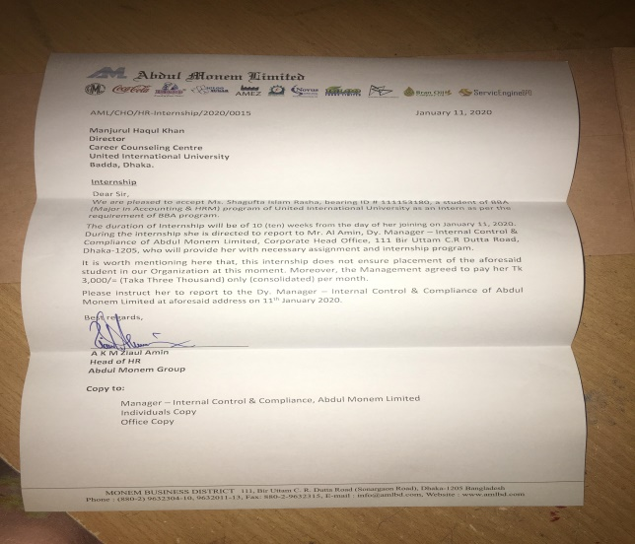
INTERNSHIP APPOINTMENT LETTER MY DESK AT AML

AUDIT TEAM MEMBER AND OTHER DEPARTMENT INTERNS
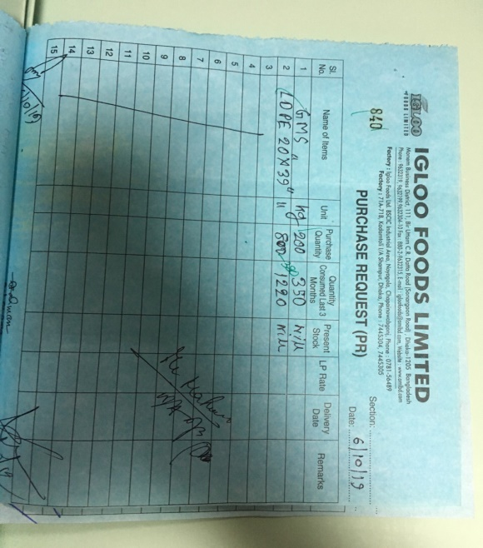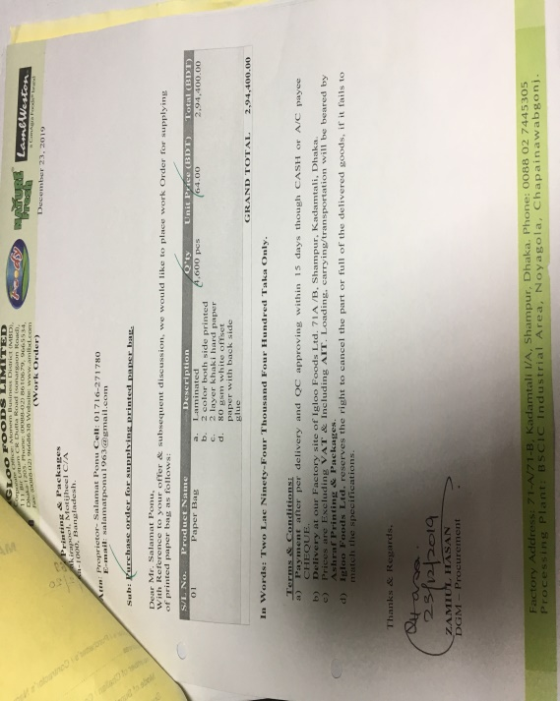
MANUAL PURCHASE ORDER PURCHASE ORDER
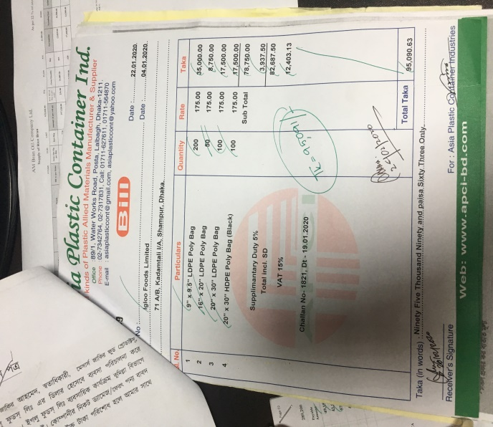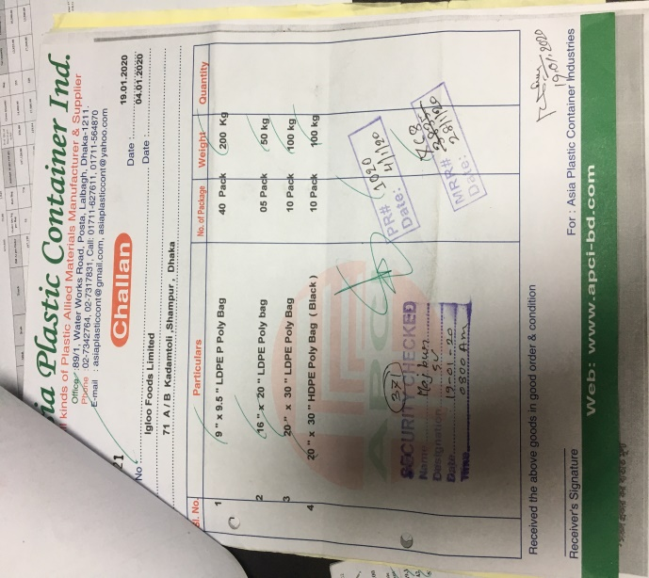
BILL CHALLAN
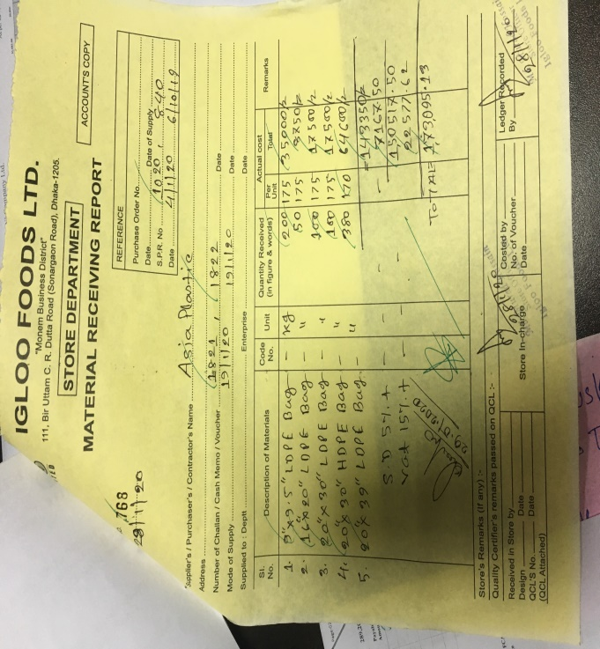
Manual Material Receiving Report

