B2B E-commerce in Small Business: A case of ShopUp Platform

Nazmul Haq Ahmed Sami

This internship report is submitted to the School of Business and Economics, United International University as a partial requirement for the fulfilment of Bachelor of Business Administration Degree.

B2B E-commerce in Small Business: A case of ShopUp Platform

Submitted By
Nazmul Haq Ahmed Sami
ID: 111161035
BBA (Major in Marketing)
School of Business & Economics
United International University

Supervised by
Dr. Kawsar Ahmmed
Professor
School of Business & Economics
United International University

Date of Submission: 11/06/22

Letter of Acknowledgment

For a business graduate student, internship is a must, and it is the most significant requirement to complete my BBA program. Making of this report has been one of the most significant academic tasks I have ever had to face. First and foremost, I want to express my gratitude to Allah for completing my entire report on time.
Next, without the support, patience and supervision of the following people, this study would not have been completed. My deepest gratitude goes out to my honoured internship supervisor, Prof. Dr. Kawsar Ahmed, UIU Business School. Without his cooperation and assistance, this report may not be possible to complete. His superb guiding style was easy for me to understand. His instructions instilled in me a desire to complete my assigned task with zeal and commitment.
I must express my gratitude to all of my faculty members for assisting me in finishing all of the BBA Program Courses. It is to them that I owe my deepest appreciation. Then I'd like to thank Mr. Tavir Sarwar, (Entrepreneur, and Operation) for his selfless support and guidance during my internship period.

Letter of transmittal

11 June 2022

Dr. Kawsar Ahmmed
Professor
School of Business & Economics
United International University

Subject: submission of Internship report on “B2B E-commerce in Small Business: A case of ShopUp Platform”
Dear Sir,
I am honoured to represent the internship report on B2B Ecommerce in Small Business: A case of ShopUp Platform, which is an important component of my BBA program. I was sent for interning at ShopUp's headquarters, where I saw and researched several practical aspects of the new company.
I'd want to express my gratitude for the opportunity for interning at ShopUp, which has increased my practical knowledge of the Bangladeshi e-commerce business. For writing this report, I have tried my hardest to maintain a devoted effort.

Please accept this report and share your useful feedback, I will be really grateful to you.
I will be happy to respond to any questions you may have in this regard.

Yours Faithfully
Nazmul Haq Ahmed Sami
ID No. 111 161 035
Major in Marketing
School of Business & Economics
United International University

Executive summary

B2B e-commerce or business-to-business electronic commerce is an online sales portal where the sale of goods or services happens between businesses. B2B e-commerce is used to improve the efficiency and effectiveness of a company's sales activities. As an alternative way of receiving orders using human assets by telephone or e-mail, here orders are taken digitally that in turn reduces the overhead costs. This study highlights the issue of B2B e-commerce in the Small Business sector of Bangladesh with the case of ShopUp Platform.

The E-commerce sector in Bangladesh is rapidly expanding. There are currently a number of E-commerce businesses operating in our country. In Bangladesh, ShopUp is Bangladesh's leading full-stack B2B commerce platform for small businesses. The goal of ShopUp is to enable small businesses by using technology to supercharge businesses with easy access to B2B sourcing and last-mile logistics.

An analysis of the E-commerce industry in Bangladesh is done through the specification of the industry, industry's size, trend, and maturity, technological factors, political, legal, and regulatory factors, industry rivalry, and SWOT analysis. Based on the analysis, several challenges and opportunities are identified. Considering their aspects some strategies are suggested to meet the challenges and opportunities in the E-commerce sector in Bangladesh.
Establishing and retaining one's position in a competitive market is quite tough. Cross-departmental cooperation and performance of activities, as well as their accountability, are a must for ensuring customer satisfaction. Therefore, in general, some suggestions for the E-commerce sector in Bangladesh and particularly for ShopUp are forwarded so that customers are treated properly.

Keywords: Technology, B2B E-commerce, small businesses, ShopUp, Bangladesh
Table of Contents
Letter of Acknowledgment 3
Letter of transmittal 4
Executive summary 5
Chapter One 8
Introduction 8
Introduction: 9
Significant/Motivation of the study: 10
Objective of the study: 10
General objectives: 10
Specific objectives: 10
Scope and limitation of the study: 10
Scopes 10
Limitations 11
Chapter Two 12
ShopUp: An Overview and Analysis 12
Overview and History 13
Mission: 14
Organization Basic Principles: 14
Organizational Structure: 15
Operational Culture: 16
Project Finance: 16
Customer mix: 16
Product Mix: 17
Service Quality: 17
Chapter Three 19
Analysis of the E-commerce industry in Bangladesh 19
Specification of the industry: 20
The industry's size, trend, and maturity: 20
Technological Factors: 20
Political, Legal and Regulatory Factors: 21
Industry Rivalry: 21
SWOT Analysis: 21
Strengths: 22
Weakness: 22
Opportunity: 23
Threats: 23
Challenges and Opportunity: 23
Challenges: 23
Opportunities 24
Strategies to meet the Challenges and Opportunities: 25
Chapter Four 27
Internship Experience 27
My internship experience was as follows: 28
Position Description: 28
Schedule of Employment: 28
My Working Schedule: 28
Remuneration: 29
Work Place: 29
Recommendations and Conclusion 29
References: 30
Appendices 31

Chapter One

Introduction

Introduction:
E-commerce is a term that refers to online transactions. A new epoch of technological communication has had a significant impact on business. Bangladesh's rise in the e-commerce sector has accelerated all of the country's potential. The aggregate investment environment in Bangladesh is shifting as a result of this. As our country is the world's most densely populated country, with 160 million people living in a small area. Consumer buying behaviour has evolved dramatically as a result of rising living standards and fast-paced city life.

ShopUp began its journey in 2016, and since then, it has made significant progress in the industry. The idea came from some folks who had embedded ShopUp and are the founders of this burgeoning company. ShopUp is a well-known name among micro-entrepreneurs in the e-commerce industry; there are also others who have enlisted for the corporate brand name Shopfront Limited.


Figure1: Logo of Shopfront Limited

Shopfront Limited is Bangladesh's largest FinTech E-Commerce company, with the ability to generate millions of micro-business owners. Initially, ShopUp focused on providing industry stakeholders with access to finance options that were specifically developed for them. In a short period of time, ShopUp has expanded to encompass a variety of services. ShopUp also serves as a distribution channel, and it aspires to provide service to customers all over the world, rather than limiting its offerings to E-commerce merchants. ShopUp aspires to create a single platform that is accessible throughout Bangladesh, allowing consumers to easily access all of the tools they require to conduct their everyday business.

Significant/Motivation of the study:
An internship is a set time of job experience that allows you to get real-world experience and understanding about the workplace. Because I chose for my internship, I did a ShopUp at the Mohakhali Head Office, I wrote this report on the HR management of this branch's Mokam department. This report contains a full summary of all HR management responsibilities E commerce's implementation of the team. As a result, this internship will assist me in better understanding company culture while also assisting me in completing my graduation. In this report, I discuss my internship DOHs of Head Office in Mohakhali, where I worked as a ShopUp intern. Because I work in the HR Department, the theme is the title of my report "The Responsibility of HR Management."

Objective of the study:

General objectives:
The overall goal of this report is to learn how general e-commerce activities and services are implemented, as well as to get experience with various function activities at ShopUp.

Specific objectives:

The study aimed at obtaining the following specific objectives
• To be familiar with ShopUp’s policies, culture, and legal concerns.
• To find out whom this company's key competitors are.
• To provide a feasible method for improving the ShopUp's subsist limitation.
• To learn how to obtain more timely information and improve service.

Scope and limitation of the study:
Every academic and professional has some reporting scope and limitations. The following are the report's scope and limitations:

Scopes
- HR Management is one of the upcoming issues.
- My respected University supervisor and also ShopUp Company are extremely cooperative in terms of data collecting and interpretation
- Problems and queries are really real and connected difficulties, so it is beneficial for future career advancement.

Limitations
It is really tough to learn everything there is to know about a company in such a short amount of time, especially because my working period is only three months long. There are several restrictions, which are listed below:

- As an intern, I have restricted access to obtaining specific information.
- Employees are unable to provide accurate information on the company's internal operations.
- As a result of the company's lack of data sources, data collection is tough.

- Because the agreement was secret, it was impossible to compile the report while collecting data.

Chapter Two

ShopUp: An Overview and Analysis

Overview and History
Bangladesh's e-commerce industry is booming, and the country's web population has been steadily increasing in recent times. The journey of peregrination began in 2016, and the company has grown steadily since then. The company's creator is still working hard to establish this position in the e-commerce industry. It provides an internet vendor stage where they can conveniently conduct business.

Economic Globalization Environment: ShopUp creates both a global and a national economic situation. FinTechplatform, which is centered on e-commerce sales and credit evaluation for small business owners, raised USD $1.62 million (SGD 2.23 million) on November 12th, 2018.
As a result, the global economy continues to expand.

Bangladesh's Economy: Upscale the platform presently contains 28000 micro, small, and medium businesses, with the majority of them being led by women. From 2008 to 2017, there was a 35 percent growth, bringing the total to 18.1 million.

Buying and selling items through the internet is what online commerce is all about.
B2B (business to business), B2C (business to consumer), C2C (consumer to consumer), and C2B (consumer to business) are all examples of this type of business (Business to Consumer).
It primarily deals with internet purchases.E-commerce is a web-based business model that occurs when a customer purchases anything from an online retailer-commerce facilitates the growth of internet businesses and can be classified as follows:
- Online Promotion
- Online advertising
- Online Shopping
- Delivery of goods
- Product service
- Payment in online
- Billing in online
ShopUp has an internal vision that is shared with its employees to help them feel more connected to the firm.
It has no public mission statement, but it does have a simple vision of becoming a "Unicorn."

This unicorn is a startup that is privately held and valued at minimum $1 billion (Wikipedia)
Our ShopUp is the first company to request to be included in Unicorn in Bangladesh, as there is currently no "Unicorn" in the country. ShopUp has already put in place the next level, such as F-commerce, in order to make the lives of their sellers easier.

Mission:
ShopUp missions are:
- To occupy micro-entrepreneurs in order for them to be faster and better.
- To make it simple and easy for entrepreneurs to obtain access to a variety of services.
- To serve as the best distribution route for a large corporation.
- To build a link between large corporations and small business owners.
- To have a significant beneficial impact on the economy through empowering and financing young people.
- To bring together individual teams and departments in order to carry out the larger projects.

Organization Basic Principles:
At ShopUp, upper administration and all workers place a huge emphasis on the company's core values. The following are the Values:

- Merchant First
- Think 10X
- Pace over perfection
- Own Your Number
- Disagree and Commit

Organizational Structure:
The following is ShopUp's current organizational structure or chain of command:

Figure3: Organizational Structure of Shopfront Limited

The above diagram depicts how the basic ShopUp Hierarchy may differ from the hierarchical functions of particular departments. At the moment, ShopUp has twelve departments.
These are the departments:

- Commerce- Supply Offline
- Commerce- Demand Online
- Credit
- Finance and Accounts
- Tech, Product and Data Science
- Human Resource
- Information Technology
- Administration & Procurement

Operational Culture:
ShopUp has a fantastic corporate culture. Employees at ShopUp enjoy their employment because of the amicable work environment. Anyone can approach the chief officers without fear of being judged. The ideals of an organization are developed and passed down through the generations. Employees and upper management support a pleasant relationship as if employees can feel free to express their creative ideas.

ShopUp is an e-commerce platform for small businesses that relies heavily on social media to attract customers and sell their wares.

Project Finance:
Project finance is a unique strategy for funding large-scale corporate projects because it is centered on timing. ShopUp, as a startup, strives to provide a broad range of services, including short-term debt financing. However, obtaining a loan is difficult because it necessitates a large number of documents as well as time. ShopUp offers a microfinance loan available for its dependable vendors:

- ShopUp must complete a series of steps that they may do from the comfort of their own home in order to obtain a financial loan in just a two or more clicks.
- When acquiring a micro loan from ShopUp, no security or bank statement is required.
- It only requires that they start the delivery process with ShopUp.
- It pays back debt interest by taking a little amount from each sale.
- As a result, the seller does not need to be concerned about meeting the last time.
- As a result, the seller is able to pay as they sell.
- The team will use Redx (delivery) for making out vends, buyer happiness, parcel revocation, and other tasks.
- So, they have more options when it comes to repaying their loan.

Customer mix:
So here, ShopUp’s customers are retailers like mudi Dokan, Seeds and vegetable stalls, Agro basis works stall or shop, and by redX, the customers are general people of countrywide in Bangladesh as well. By their Mokam Lifestyle division, the fashion houses and many more cloths houses are also the customers of ShopUp. These are the basic customer mix for ShopUp looking beyond the present transaction and considering what needed to not only sell an item is, but also to keep the customer's loyalty for future purchases.

Product Mix:
Mokam, RedX and Baki are the products of ShopUp. Here Mokam has its 10-12 divisions called Mokam Fresh, Mokam Lifestyle, Mokam Agro, Mokam self-service, Mokam Chickens, Mokam Eggs, Mokam seed and vegetable and so on. These divisions are doing their business operations individually. Baki is one of the products of Shopup; RedX is the product of ShopUp as well.

Service Quality:
In Bangladesh, 4.5 million neighborhood mom-and-pop stores, also known as mudi dokans (grocery stores), operate, accounting for 98 percent of the retail industry.
The majority of these small businesses struggle to get supplies from several distributors and wholesalers. According to a recent study, credit sales to end customers account for 73% of these shops' revenues, while just 27% of small firms in Bangladesh have access to formal finance to sustain their liquidity. These small business owners face challenges in running their day-to-day operations due to a lack of product availability, lack of transparency in pricing, and inefficient delivery systems.

ShopUp aspired to shorten the lengthy process by developing a B2B (business to business) platform that connects producers to wholesalers, wholesalers to retailers, and retailers to consumers.

Between April and August 2020, the number of neighbourhood stores transacting weekly on the ShopUp platform increased by 8.5 times.

ShopUp's last-mile logistics team, RedX, has partnered with these businesses and has grown to become the country's largest last-mile delivery service provider, processing 13 times more parcels per day than in April. It has accomplished the seemingly impossible job of getting the great majority of the population on the digital platform. Last-mile logistics, digital credit, and business management solutions are among the services it provides.
The Honorable Prime Minister named ShopUp "The Best Startup of the Year 2019 in Bangladesh." It is now working with 655,000 SMEs and micro, small, and medium firms (MSMEs) to help them grow and, as a result, play a key role in the development of Bangladesh's economy.

Chapter Three

Analysis of the E-commerce industry in Bangladesh

Specification of the industry:
The need to customize the things they want to buy has become a big concern in recent years, as the variety of options and the need to feel special has sparked the urge to modify the products they want to buy. One of the most significant challenges that businesses have faced is the rising demand for personalized products. Companies must implement systems that give customers exactly what they want, or allow customers to modify the products they wish to buy, in order to respond adequately to customer demands. Here a study attempts to see if CMS platforms and low-cost software are a good fit for businesses that want to sell their items online but also want their customers to be able to buy them. With this in mind, and assuming that content management systems (CMS) will be used to develop not only websites but also e-commerce and e-business platforms, it created a research project to see if low-cost or free CMS can be used to develop e-commerce platforms that allow live product customization.

The industry's size, trend, and maturity:
Size: Bangladesh's e-commerce market is now estimated at $2.0 billion, and it is growing at a 50% annual rate.
Trend and Maturity: When looking on the e-commerce market in Bangladesh and taking into account its rapid growth (estimated to be 100% by the end of 2016) as well as the rapid global retail strategy shift, it is apparent that digital will be the next big thing in merchandising.
As a growing and increasing market, Bangladesh is very likely to be extremely profitable and long-term for Analyze.
In this regard, a rapidly growing and developing market such as Bangladesh is extremely profitable and long-term viable.

Technological Factors:
The advancement of the information and communication technology (ICT) is a critical aspect in ecommerce's growth. For example, advancements in content digitization, compression, and the promotion of open systems technology have opened the path for the consolidation of communication services into a single platform. Entrepreneurs' ability to get their enterprises off the ground faster is being aided by social media, mobile, and cloud technology. Furthermore, technological advancements are allowing entrepreneurs to launch firms from the comfort of their own homes.

Political, Legal and Regulatory Factors:
As a powerful representation of globalization, electronic commerce is fast expanding. The rapid growth of e-commerce presents a significant opportunity for the development of local and international trade in LDCs like Bangladesh. Infrastructure, culture, and mindset, on the other hand, are key impediments to e-commerce. Except for a few minor flaws, Bangladesh's government has made strides in creating an e-commerce-friendly climate. It's worth noting that e-commerce success isn't solely dependent on availability and connectivity. The ability of an entrepreneur to take advantage of the e-commerce revolution is also dependent on information technology. To start, maintain, and grow e-commerce, proper awareness-building activities among the general public and business community are essential. This research focuses on evaluating the elements of the e-commerce ecosystem to gain the most accurate image of the current situation, and then identifying some areas for improvement based on the evaluation for deploying e-commerce in Bangladesh.

Industry Rivalry:
There are many companies performing e-business in Bangladesh. E-commerce retail businesses are known for being aggressive and fiercely competitive. Because of the vast number of competitors in the market, there is a lot of competition. The number of local and international brands in the ecommerce sector has increased, resulting in increased rivalry.

SWOT Analysis:
There are numerous e-commerce companies in Bangladesh, however ShopUp is a new e-commerce company. ShopUp features a lot of different sections, but it also has some limitations.

The following is ShopUp's SWOT analysis:

Strengths:
  - Ensuring product quality
  - Useful payment methods
  - Human resource committed line
  - Diversified business line
  - Fantastic working environment
  - Strong team bonding
  - Ability to perform with a huge pressure.

Weakness:
  - A number of rivals in the e-commerce industry
  - Lack of image in the e-commerce sector
  - Keeping suppliers is very difficult
  - Customer trust issue because it is an e-commerce firm
  - Management system is lacking because it is a startup company

Opportunity:
  - There's a good chance you'll be able to take over the market and grow it.
  - Advantage over competitors in the market because ShopUp is concerned about product quality • Market capture because it works with a variety of products

Threats:
  - There is a lot of rivalry, including Daraz.com.bd, Khass food, and Evaly.com.bd.
  - Different entrants into the business
  - Changes in government rules and regulations

Challenges and Opportunity:

Challenges:
Bangladesh has a lot of potential for e-commerce, but it also has a lot of drawbacks. Bangladesh is a developing country where the bulk of the people live in rural areas. We have yet to efficient to provide the most up-to-date internet technologies to every part of our territory. Although the platform exists only in cyberspace, however, the majority of our region's clientele are unfamiliar with the concept of e-commerce, and those who are are wary of placing for online purchases, credit/debit card information is required.. The following are the primary e-business platform firm limits that governments and entrepreneurs can overcome for immediate and long-term success.

Issue of Customer Satisfaction

The majority of our country's customers are wary of using e-commerce since they are unsure if they will obtain genuine or counterfeit goods. This perception has developed in the hearts of customers for a variety of reasons. The vast majority of e-commerce stores in our country limited product presentation and explanation choices. As a result, customers are irritated when they order and not receive the product they expected. It's likely that the color of that particular piece has been changed, or that the size has changed, as is frequent with online clothes stores. As a result, customer satisfaction suffers, and customers lose interest in making online transactions.

Difficulties in access to the internet

Bangladesh is a country that is still developing. Rural areas are home to the majority of our country's inhabitants. They don't have access to the latest internet technologies. As a result, the total e-commerce market is restricted to Dhaka and Chittagong.

Fostering Customer Satisfaction

Despite the good signals, people are becoming more acclimated to purchasing online, but trust remains a key worry. Loyalty in the online business environment differs from trust in our everyday lives. A gentleman remembers the name of the place where a salesperson welcomes and assists customers with their purchases in a regular business. Customers depart the store once they have completed their vital purchases. Consumers may be unaware of the store's reputation, location, or proprietor. Clients have no idea what their motivations are or if the things are going to be presented to them. Because e-commerce is invisible or virtual, it is far more difficult to establish and maintain a business brand.

Delivery Time

The first that the most serious problems in the e-commerce industry is product delivery delays. Apart from the world of online meal delivery, every online purchase of any commodity takes at least 2-3 days to reach at the consumer's location, which is inconvenient.

Opportunities
The majority of Bangladesh's regions do not see quarterly growth percentage of more than 30%. The expected growth rates for 2015 and 2016 are significantly higher, presenting a compelling case for increased market share and company progress in this category. The percentage of purchases made via mobile that are made over the net is 5%, whereas the percentage of transactions made via mobile is 23%.

The condition in Bangladesh with regard to delivery

The e-commerce industry in Bangladesh now employs roughly 50000 people. (In 2017, e-commerce will help national economic development.) each day, about 20,000 people come to see the exhibit, and every month, 5-6 lakh people visit from all across the country.

Customers' Profiles

With 75 percent of consumers being men, the internet based e-commerce service is predominantly used by the younger generation (Rise of the Digital Consumer Class Time to Make for Bangladesh in E-space, 2020). About half of e-commerce customers are between the ages of 26 and 30 (Rise of the Digital 22 Consumer Class Time to Make for Bangladesh in E-space, 2016). Young people (44%) and undergraduates (33%) are also big users of e-commerce products and services (Rise of the Digital Consumer Class Time to Make for Bangladesh in E-space, 2016). The most popular things in this market are fashionable clothing and electronic devices.

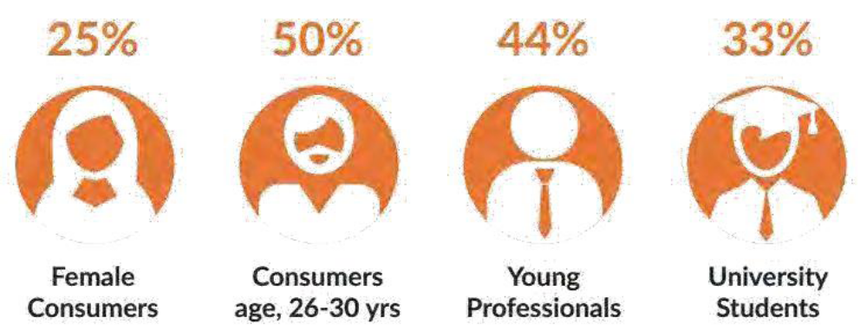

Traffic on the Internet

The three most important zones in Bangladesh are the key sources of consumer traffic. Dhaka division accounts for 34% of overall e-commerce traffic, Chittagong division accounts for 29%, and Gazipur district accounts for 15%. (Youths are the most active in Bangladesh e-commerce, 2016). The remaining 20% of traffic comes from different parts of Bangladesh, with Khulna accounting for the most.

Strategies to meet the Challenges and Opportunities:
Bangladesh's E-commerce business is entering a new era. The social media platform has evolved into a business environment, similar to the e-commerce industry.
While working on this paper, I learned a lot of new things about online business as well as industrial life. This e-commerce business focuses on both items and services.
ShopUp has a significant presence on Facebook, Instagram, YouTube, and other social media platforms.

There are several opportunities as well as risks from competition. ShopUp, on the other hand, makes effective use of its capabilities in order to outperform its contender in the future business days. ShopUp focuses on developing client relationships in order to acquire market share in the near future. As a result of its dynamic supply chain management, this organization ensures consumer satisfaction through timely delivery. ShopUp is primarily focused on improving their customer loyalty program. As a result, it wants to see a greater development of the e-commerce industry, as well as other business catering sectors, in the future. ShopUp is a newcomer to the e-commerce industry. It is impossible to be perfect in all departments and in procurement in a short period of time.

Chapter Four

Internship Experience

My internship experience was as follows:

When I was an intern, ShopUp provides numerous opportunities for hands-on learning. The organization is cutting-edge, and the surroundings are tastefully designed. I work in a few different zones under the HR department in Mokam.

Position Description:
I was working in a start-up company provides me with a lot of opportunities and experience. One of the most important departments in HR department is joining/recruiting team. As a result, I had to work cautiously and properly.

The main responsibilities of HR team in Mokam are:

- Recruiting and hiring new personnel is a must.
- Organize training and development programs.
- Manage and improve communication by keeping track of staff performance.

- Control the company's and organization's culture.
- Make your workplace a safe and welcoming place to work.

- Handle squabbles, disciplinary proceedings, and firings.

- Adapting to new technology and trends

Schedule of Employment:

I started my internship 01th November and will be finished 01th February

My Working Schedule:
Saturday to Thursday: 10.00 am – 8.00 pm- 09 pm
Lunch Hours: 1.35 pm – 2.35 pm

Remuneration:
When I was intern, I was paid monthly and received a monthly pay of BDT 6000.

Work Place:
ShopUp HQ, House no-112,Road no-06,Mohakhali DOHS, Dhaka-1206.

Recommendations and Conclusion
So, Bangladesh is experiencing a new era of E-commerce development nowadays in business platform. Here the social media platform has evolved into a business environment, similar to the e-commerce industry also. While I was working on this paper, I learned a lot of new things about online business as well as corporate life. This e-commerce business focuses on both items and services. ShopUp is widely used on Facebook, Instagram, YouTube, and other social media platforms as well. ShopUp must enhance their management system and address several issues with their delivery method. ShopUp's mixed product items propel them to the top of the E-commerce business in a short period of time as we can see. There are several opportunities as well as risks from competition for ShopUp as well.

However, ShopUp makes effective use of its capabilities to outperform its competitors in the future business days. ShopUp is a new company in the e-commerce market. It is impossible to be perfect in all departments and in procurement in a short period of time. ShopUp focuses on developing customer relationships in order to acquire market share in the near future. Due to its dynamic management system, this organization ensures consumer satisfaction through timely delivery as well. ShopUp is primarily focused on improving their client loyalty program. As a result, it wants to see a better development of the e-commerce industry, as well as other business catering sectors, in the future. Here one more thing I can include that is ShopUp should focus on improving product quality and hiring the best staff and service providers in order to rise to the top of the market. The Bangladesh government has been extremely helpful and cooperative in assisting them in growing their business.

References:
Raka, F. F. (2018). Contribution of ShopUp in the e-commerce industry.
Ashraf, S. S. (2017). Barriers in growth of Daraz Bangladesh from customer’s point of view: how to make the online shopping experience better.
Hasan, M. (2019). Internship Report on daraz. com. bd.
Lipu, F. M. (2018). A Novel Approach of Supply Chain Management in E-Commerce Business Considering Bangladesh.
Ahmed, U. (2019). SWOT Analysis of Marketon Global Ltd
Md. Shakibur Rahman Size, trend and maturity of E-commerce Industry
Saha, R. (2019). Financial performance analysis of JMI Syringes &Medical Devices Ltd.
B2B e-commerce. Retrieved from https://en.wikipedia.org/wiki/B2B_e-commerce

Appendices

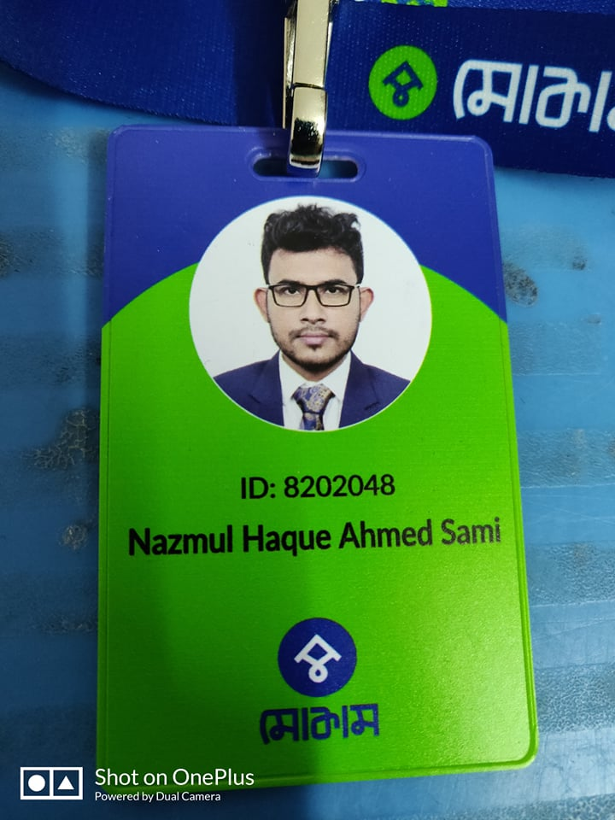
Figure 1: ID card
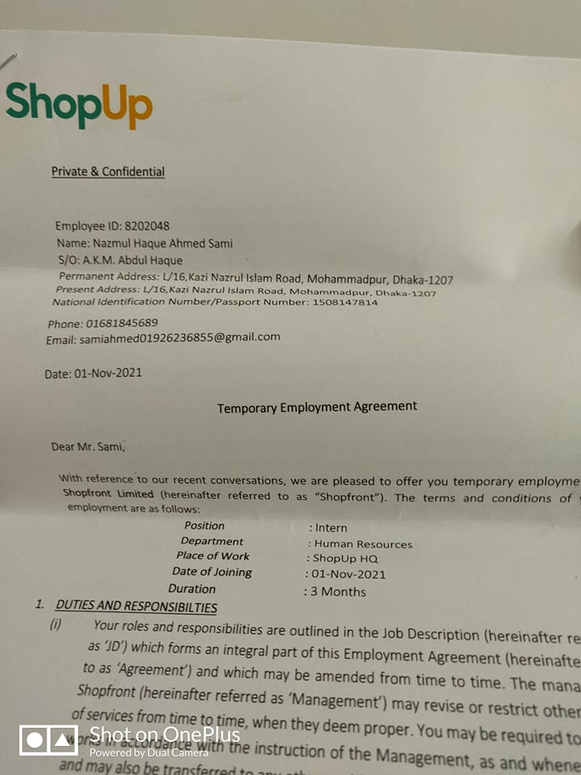
Figure 2: Joining Letter

