Internship Report
On

Recruitment and Selection Process of Square Food and Beverage Ltd



Submitted By
Jahan Ara Tasnin
ID-111141201
School of Business & Economics
United International University

Submitted To
Dr. Abu Zafar Md. Rashed Osman
Associate Professor
School of Business & Economics
United International University

Submission Date
December 26, 2018

Letter of Transmittal
December 6, 2018
Dr.Abu Zafar Md.Rashed Osman
Associate Professor
School of Business & Economics
United International University

Subject: Submission of Internship Report

Dear Sir,
I would like to inform you that it is my pleasure that I am submitting my internship report to you. The entire journey of my internship programme under your supervision was very much accommodating. It has been a great accomplishment for me to successfully finish my assigned tasks timely and with proper guidance which enrich my professional knowledge.
The internship report is based on the topic of “Recruitment and Selection Process of Square Food and Beverage Limited” which I found a worthy one because it is the combination of my academic knowledge and practical experience.
It would be my pleasure if you find this report useful and enough instructive for the related field.

Sincerely yours

Jahan Ara Tasnin
Id-111141201
School of Business and Economics
United International University

Acknowledgement
At first, I want to thank my Allah for giving me the opportunity that I was able to finish my internship programme at my desired place at a very well condition. Next, I want to thank my respected faculty member and supervisor Dr. Abu Zafar Md. Rashed Osman for his continuous effusive effort and support which made me able to complete my internship report.
Now I would like to mention the names from my organization who helped me to understand the organizational environment and practical scenario of the working process. I am grateful to Mrs. Tahmin Begum, Senior Executive, HRD, SFBL my organizational supervisor that she made it easier for me to understand everything with her vast knowledge on HRM.
Last but not the least I want to mention those names who were very much cooperative and supportive during these three months period. I want to thank Mr. Abhishek Nandi-Executive-HRD SFBL, Mr. Moonzur Hossain, Executive of HRD, SFBL, Farhana Parveen, Executive of HRD, SFBL and Mrs. Naznin Akhter. Office Assistant, HRD, SFBL for their heartiest support and guidance. They always helped me when I faced any problem by showing me the right way of doing that task.

Executive Summary
Square Food and Beverage is one of the largest and leading FMCG (Fast Moving Consumer Goods) company in Bangladesh. This report consists of job responsibilities I was given during my three months internship program in Human Resource Department of Square Food and Beverage ltd. A detail about the company, how Human Resource Department works, a survey about the job performance of the employees, and my observation about how this company works are included in this report. Also, I gave a description of my critical observation about the activities of HR Department including recommendations to change some of their HR related actions. During my internship period, I got involved with different types of jobs assigned by my supervisors and got a chance to enhance my experience as well as learnt difference between academic life and professional life. Through data analysis, I concluded that job satisfaction and quality of work are strong predictors of job performance thus organization must nurture these factors sincerely to improve job performance.

Table of Contents
1 Chapter 1 1
1.1 Introduction: 1
1.2 Origin of the report: 1
1.3 Objective of the report: 1
1.4 Methodology: 1
1.5 Scope of the report: 2
1.6 Limitation: 2
2 Chapter 2 3
2.1 Objective of the project: 3
2.2 Sources of data: 3
2.3 Human Resource Management: 3
2.4 Recruitment and Selection Process of SFBL: 4
2.5 My duties and job responsibilities at SFBL: 6
3 Chapter 3: 11
3.1 About Square Food & Beverage Limited: 11
3.2 Background of the company: 12
3.3 Mission: 12
3.4 Objectives: 12
3.5 Products of SFBL: 13
3.6 Operational Network Organogram: 21
4 Chapter 4: 24
4.1 Descriptive Statistics Table 24
4.2 Frequency Table 24
4.3 T-Test 26
4.4 Correlations 27
4.5 Regression 27
5 Chapter 5: 28
5.1 Recommendation: 28
5.2 Conclusion: 28

Chapter One: Introduction

Introduction:
In this era of business everything is changing so fast and dynamically that every organization needs to have quality manpower for sustaining in the market. To be effective and efficient every organization is adopting different types of strategies. In an organization manpower is the most important element which comes first for achieving the competitive advantage in the market. Through proper hiring, training and guidance organization able to achieve its goal with sustainable growth.

Origin of the report:
For the students of BBA there are two options to complete their graduation program after finishing the 120 credits of 123 credits. The options are internship program and project. I have chosen internship program to complete my 123 credits. This report is based on my internship program. The topic is the recruitment and selection process of SFBL as I have done my internship in SFBL as a HR intern. The purposes of this report are:
- To complete my BBA program
- To understand the actual working environment
- To relate my academic knowledge with the practical work
- To experience the job responsibly
The experience of my internship will definitely be helpful for me to start my career in near future. This report is the total summary of my whole experience and my observation which is mainly about the HR practices of SFBL, the recruitment and selection process.

Objective of the report:
This report has two objectives:
1. Primary objective
2. Secondary objective
The primary objective of the report is to provide knowledge and adequate information regarding the recruitment and selection process which is followed by HRD of SFBL. The secondary objective is to gather the knowledge of practical works and relate it with my theoretical knowledge and gaining the insight view of the HR activities of recruitment and selection process and build a rationale view about the HRM activities of an organization.

Methodology

From the very beginning some systematic procedures are followed to complete this report.
Selection of the topic
For the selection purpose of my report topic I discussed with my supervisor Mr. Rashed Osman at the beginning of starting of internship. He suggested me to prepare this based on the recruitment and selection process of SFBL and helped me several times to arrange my collected information and prepare a good report.
Sources of data:
The sources are both primary and secondary. Primary data was collected by interviewing my organizational supervisor of SFBL Mrs. Tahmin Begum about several topics related to my job duties and responsibilities. On the other hand, secondary data was collected by the website of SFBL, previous records, and textbook.

Scope of the report:
During my internship program I had the opportunity to learn about how to apply the theoretical knowledge about HRM to the HR practical activities. By the time of accomplishing my report I learnt about the culture of SFBL, HR practices of SFBL mainly learned a lot of recruitment and selection process.

Limitation:
This report is prepared on my personal experience at the same time with the contribution of the other staffs of SFBL. All the members of HR team were very supportive but sometimes they were busy with their work so that they seemed quite unwilling to provide some information. That was challenging for me to get that information. Some information was confidential so they did not share those for the sake of the organization policy. Last but not the least the time was very short. Within only three months it is very difficult to know every situation that may arise while working in a large organization.

Objective of the project
This project has two objectives:
- Primary objective
- Secondary objective
The primary objective of the project is to provide knowledge and adequate information regarding the recruitment and selection process which is followed by HRD of SFBL. The secondary objective is to gather the knowledge of practical works and relate it with my theoretical knowledge and gaining the insight view of the HR activities of recruitment and selection process and build a rationale view about the HRM activities of an organization.

Sources of data:
The sources are both primary and secondary. Primary data was collected by interviewing my organizational supervisor of SFBL Mrs. Tahmin Begum about several topics related to my job duties and responsibilities. On the other hand, secondary data was collected by the website of SFBL, previous records, and textbook.

Chapter Two: Literature Review

2.0 Human Resource Management:
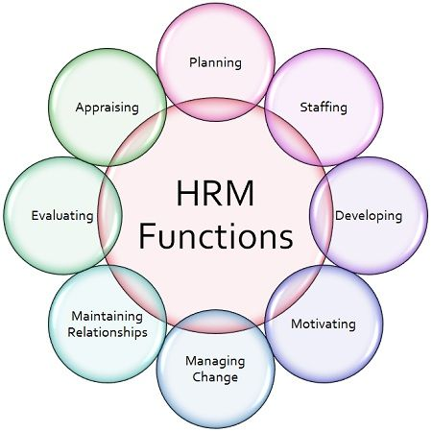
In this modern world HRM has become a very popular term in the corporate world. By doing proper human resource management an organization can achieve its success. It’s very difficult to go to the peak of success in the industry with a weak human resource department.
Human Resource Management process combines several tasks. It is the planning, organizing, controlling, communicating, developing, directing as well as motivating the employees to accomplish the goal. As we know that human resources are the most important resource for an organization the proper management is very necessary to maintain the resource.
Human resource management has some functions. Every function is equally important to get the best result from employees. The functions are shown in the diagram:

2.1 Recruitment and Selection Process of SFBL:
Conducting proper recruitment and selection processes are the basement of having the strong resources in an organization. As an intern of SFBL, I observed that they follow and maintain a systemized process while recruiting. There are also some factors which they consider at the time of CV screening. The factors are:
- Experience of the candidate
- Educational qualification of the candidate
- Age
- Background record
These are the basic factors of the candidates SFBL consider at initial stage. The total process of recruitment and selection is conducted by several steps. i have found the total number of steps is 12. The steps are-

- Hiring requisition:
This is the first step of every hiring. The department which needs new employee in the team will give a requisition to the HRD. There are the details of the department name, position name, number of vacancies, job descriptions of that position.

- Approval of hiring requisition:
After getting the requisition HRD will get the approval of top-level management to start the procedure. They start the process when Managing Director gives the approval by signing the requisition form. They kept the original copy of the form to keep the record.

- Circulation of the job:
SFBL hires new employees by both the internal source and external source. They hire from their existing employees if they are qualified for the position and willing to switch the departments or positions. This is known as the internal source. The external sources are bdjobs.com, posting ad on LinkedIn, Prothom Alo newspaper,

- Potential CVs:
CV screening leads to get the CVs of potential candidates. The candidates of DU, NSU, East West University with high experience and with the sound background get priority at the time of shortlisting CVs, but it is mainly depending on the position of the job.

- Written test:
Every candidate has to go through attending a written test before interview. The total mark is 100. There are two sections of the test. One is subjective part and other one is objective part. Subjective part requires to write elaborately according the question about the technical knowledge of the task. Objective part is the combination of both mathematics and English.

- Interview:
The candidates who pass in the written test are asked to attain an interview. Sometimes there are direct interviews occur. Hiring top level personnel does not require any written test rather there is just an interview session. The interview is conducted in two session. At first there is a panel interview. And then the selected candidates from the panel interview are being interviewed by the Head of the Department or HR Department for the final selection.

- Selection:
After finishing interviews, the interviewers discuss among themselves and take the decision of selecting the best candidate for the position. If in any case they could not able to think any of them are appropriate for the position the whole process will restart.

- Medical test:
The selected candidates are required to bring their medical certificate for the next procedures. They just need to show that they are in a good health condition and do not have any serious illness that they can work safely.

- Recruitment proposal:
Recruitment proposal is the list of those selected candidates. This list consists of the details of the employee name, age, qualification, Salary details, supervisor details, joining date, job location. This proposal also needs approval by General Manager-HRD and Managing Director.

- Offer letter and appointment letter:
Getting the approval of the proposal HR Executive prepares the offer letter as well as the appointment letter. Job offer letter specifies all the detail about the job duties and responsibilities, salary, location, terms and conditions of working. Appointment letter describes the joining date, salary, work station, Reporting personnel information and other necessary terms. Then HR Executive handover these letters to the new employees for joining.

- Joining and Orientation:
At the time of joining employees submit all the necessary documents. They must have to submit the clearance certificate from the previous organization then. Without this the procedure of their joining will not complete and they cannot start working. An orientation program is also arranged for the new joiners and then get their initial training session from different departments like sales, marketing, HR. Then they are placed to their designated place.

- Create personal file manually and in HRIS:
This is the last step of recruitment and selection of SFBL. They manually maintain a personal file for every employee which consist of all the documents of the employee. After that they create ID number for the employee and an account of that employee in the HRIS. Then keep all the record in the software.

These are the steps of every recruitment of SFBL. They strictly maintain each of the stages. In these three months of my internship I have noticed that no matter what is the position is they are always stick to the procedures of hiring.

2.2 My duties and job responsibilities at SFBL:
It is really grateful for me to get internship opportunity at Square Food and Beverage Limited for which I was waiting for. My three months internship program started from 8th June to 10th October. I was an intern of Human Resource Department of SFBL as my major Is Human Resource Management and it’s compulsory for the completion of my BBA program. By working there, I gained a lot of practical knowledge which I could able to relate with my academic knowledge and the Knowledge of these HR practices will be very helpful for my career in HR.
During this internship period I have done so many tasks which are assigned by my supervisor of the organization. Apart from this I have also done the other related tasks which are given by the other HR staffs. There are different types of jobs. Some jobs are done periodically and some jobs are done daily basis. The following tasks are those which I used to as an intern of SFBL:

- Collecting CV:
There is a mixed approach in case of collecting the required CVs for different positions in Square Food and Beverage Ltd. The CV of the interested candidates are usually collected from the different market source like bdjobs.com and the candidates who are interested for the position can drop their CVs by themselves in the of CV box of the 11th floor of Rupayan Centre, the office of SFBL. The CVs are from many different positions like Sales officer, Territory Sales Officer, Lab Analysts, Site Engineer, Divisional Sales Manager, Regional Sales Manager, Area sales Manager, Executive of Quality Control, Production, TSD, Senior Office assistant, junior accounts officer etc.

- Screening CV:
In SFBL I have done nine position cv screening. The positions are Territory sales manager, Area sales manager, Regional Sales manager, Divisional Sales manager, Brand Executive, Mechanics and Electricians, Production Executive, Quality Control executive. There are four issues we consider mostly at the time of cv screening. Those are age, educational qualification, experience and location. In SFBL the sales officer turnover rate and the territory sales officer turnover rate are higher than any other positions. So basically, it is required to hire new employees to fill up those vacant positions. That’s why SFBL collect a huge amount of CV in every one and half month due to recruit new sales officers. For the position of sales officer SFBL mainly consider 2 or 3 years of experience in a well-known organization with minimum qualification of HSC. On the other hand, junior accounts officer needs to have graduated from a reputed university holding CGPA 3.00 or above 3.00 and the birth year should be below 1990.

- Making Interview calls and training calls:
During my internship period I made a lot of phone calls to the candidates for the purpose of written examination, interview, training call, confirmation call. After CV screening I made a list of those shortlisted candidates then called them for their participation and note down their responses. The written exam and interview session mainly take place at the Rupayan Centre in Mohakhali at 11th floor as well as sometimes at the Corporate Head Quarter which is the Square Centre. For the SO position training calls were given to the selected candidates.

- Manage the interview and training room:
After the written exam it’s time for interview session and while fixing the date I had to book the meeting room for taking interview. At the time of training I was also the of consideration that whether on that day any trainer is free or not who will provide the necessary training to the SO.

- Creating interview attendance sheet:
I have maintained the candidate’s attendance in the time of both written exam and interviews. At first, I made the attendance sheet for the candidates who were called for the exam or interviews which was kept for the record purpose. When it was time for interview I put the time slot for each candidate and the day of interview I arrange their waiting place and communicate with them.

- Making Candidates summary:
In SFBL I used to make summary for the candidates who are invited to give the interview. The number of copies of the candidate’s summary is dependent on how many interviewers will take the interview. The candidate summary contains each of the candidate’s name, address, age, educational qualification, working experience, total year of experience. After preparing this sheet I handed over those to the interviewers so that they could have clear idea about the interviewee.

- Preparing Recruitment proposals:
SFBL follows a very strict rules at the time of recruitment to keep all the records of the employees. After the interviews my supervisor used to give me the list of selected candidates for the position as well as a sample of recruitment proposal and the details of their salary and reporting details. Then I made the proposal using that necessary information.

- Maintaining attendance:
At the SFBL there are two types of system used for maintaining attendance. The employees put their fingerprints for their attendance purpose and the machine keep the records of all the employees in and out time. There is also an attendance khata kept for the staffs for maintaining their in and out time purpose.

- Making individual employee file:
One of the very crucial tasks of the HR department of SFBL is keeping the record of all employees. They keep the record both in manually and HRIS software. I have prepared files for the new employees. In every file there is all the necessary documents of an employee. The documents are filed in a sequential way according to the checklist. The following checklist is maintained to prepare employee file individually. Then after preparing file all the information should be updated in the HRIS software. At first, they create an employee ID number and then they input all the information of that employee and keep record.

- Create leave and tour file:
In SFBL there are so many tours conduct for the market visiting purpose. That is why it is necessary to keep the proper records of the tour. There is a tour slip and also a leave form for those who want leave in the time of their need. I collected those tour and leave slips and update individual information in the HRIS daily basis.

- Data entry of outside visit:
When any employee goes out before ending the official working hour then they need to get the gate pass. The gate pass is given by a slip called outside visit. There is mentioned the exit time, purpose of visit, expected time of return and actual time of return. When an employee does not back office on that day the information is updated in the HRIS.

- Prepare job offer letter and appointment letter:
During my internship I learned how to prepare job offer letter and appointment letter for the candidate. After the interview job offer letters provided to the selected candidates and then they are given appointment letters. Before preparing the letters, my supervisor gave me the sample for both and marked the points where I should make the changes and I collected the details of the candidates from the CVs.

- Prepare transfer letter:
During the time of my internship program I saw several transfers of employees of SFBL. The transfer mainly happens to the Sales Officer, Territory Sales officer. I was given a sample of transfer letter by my supervisor to prepare them according to the transfer proposal. In transfer proposal there is the details about the existing market, region, reporting boss as well as the new market, region and the reporting boss.

- Prepare latecomers report:
In every morning at 8.45am the report of latecomers must be prepared to keep record on daily basis. The office hour starts from 8.30am. There is 5 minutes grace time for considering emergency. So, after 8.35am it counts as late for work. It is done by the attendance system and prepare a excel sheet to keep the record as hardcopy.

Chapter 3: Company Overview

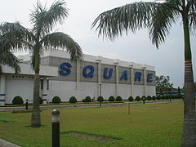

2.3 About Square Food & Beverage Limited:
Square food and Beverage LTD. is one of the largest and leading manufacturers in our country. It has four brands with more than 40 products. There is one of the most important factors behind this rapid success and sustainable growth of this company is its highly productive and efficient human resources. It always tries to maintain product quality that is why it is considered as one of the popular and known company to the people of this country.
Who doesn’t hear about the name of Radhuni and Ruchi. These are the product of Square food and beverage. But the success is not come in a easy way. SFBL has made the revolutionary changing in food category. Being a Asian country and Bengali we love to eat spicy food. It is a tradition we use various kinds of spices rather I should say “Masala” while we making any curry. That’s the beauty of our food. Besides there is a heritage connection with spices. Previously we only depend on various spices powder which is blended manually. But gradually due to globalization and busy schedule it is very difficult to manage pure spices in the form of powder. To overcome this crisis, some local company launched open masala which is unhygienic for health. SFBL was the only one company who had taken bold steps on that time. First time in Bangladesh; SFBL launched basic spices with a good quality and attractive packaging facilities. Gradually they were focusing other instant product under Ruchi brand. Now Radhuni is the market leader of spice category in Bangladesh market. This is the initial insight of launching Radhuni product.

2.4 Background of the company:
Square group significant a reputation of fame and prosperity not solely in Bangladesh however additionally some other countries in this world. Square isn’t simply a name in Bangladesh. It’s associates icon in business. The journey of Square wasn’t bed of roses that finishes at some extent of success. This company is currently blooming solely due to troubled and hardship. It’s currently one amongst the leading producing firms in Bangladesh that has product and services each. Square is currently a gaggle of prescription drugs, toiletries, garments, textile, data technology, health product, food product, and hospital - with a mean annual turnover of quite Tk 6,000 large integer and personnel of around 33,000 people. Samson H Chowdhury is the founding father of this square group. It had been established in 1958 with its 1st company named square pharma drugs Ltd. He named it sq. as a result of it signifies accuracy and perfection which means quality. Currently the Square Company is therefore huge that it includes textiles, hospital, prescription drugs, toiletries, media com, client product etc.
Square consumer product Ltd. has started its journey in 2000 as a member of square group. Among a brief time it created a powerful foothold within the market with four brands over forty products through its quality product and customer services in our country. It had obtained the international quality normal ISO 9001 due to its quality management. With the advanced technology, human resources sturdy and powerful and robust} commitment to quality of product and services it's set strong position within the business. In 2010 the corporate achieved ISO 22000 for its food safety management system. In 2014 it reinvented as square Food & beverage Ltd. from square group Ltd. it's currently U. S. Food and medicines Administration qualified. SFBL has introduced three in style brands within the market named Ruchi, Radhuni and Chashi. It’s production area unities that are set at Pabna and Dinazpur.Currently SFBL has close to concentrating 2500 staff and because of its working surrounding and extremely impelled staff it’s lower turnover rate.
SFBL will conjointly such a big number of different programs and activities like Radhuni Kirtimoyee Sommanona that is organized for self-developed and booming girl to reward them each year. Additionally, as recently it organized International folks Fest and classical music competition to save lots of ancient cultural aspects of Bangladesh.

2.5 Mission:
SFBL’s vision is to be the world class manufacturers in Bangladesh by ensuring intrinsic quality products and customer services with state-of-the-art technology and motivated employees.

2.6 Objectives:
There are few objectives of SFBL. It includes:
• Provide the very best of what the consumer wants.
• Explore new segments of market and to cater to it.
• Assure intrinsic quality of hygienic food products
• Enhance consumer standard of food habit
• Ensuring that products are available at consumer’s doorsteps.
• Enhance the skill and strength of the organization that will contribute of company’s increasing growth.

2.7 Products of SFBL

Radhuni:
It is the leading brand of this company. It has more than 80% market share over the competitors. It drew the attention of housewives by producing such products that saves time and convenient for them, such as Turmeric powder, Coriander powder, Chili powder, readymade Falooda mix, Jorda mix, different types of masala, cereals, pulses etc.
Radhuni has 4 category products.

Basic Spices:
Basic spices are the pioneer of this Radhuni brand. Who doesn’t know about the brand name of Radhuni. In Basic spice category, Radhuni is the market leader.

Product Name | Product Image | Product Description
Chili Powder | 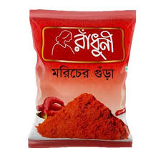 | RADHUNI Chili Powder is the basic spices of Radhuni portfolio. It is produced from the best quality of red chili. This instant chili powder makes curry in hot reddish color and super tasty. For flavor capsicum is blended in this red chili powder. It is free from any artificial color.
Turmeric Powder | 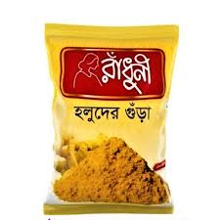 | RADHUNI Turmeric Powder guarantees the specific composition of curcumin and the turmeric’s selected for processing are finest of their kind. As a result it gives the dishes an attractive golden color.
Coriander Powder | 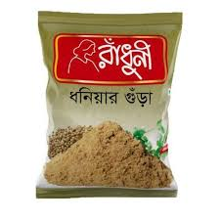 | RADHUNI Coriander Powder is the consists of the distinct flavor and fragrance that makes food very delicious and tasty.
Cumin Powder | 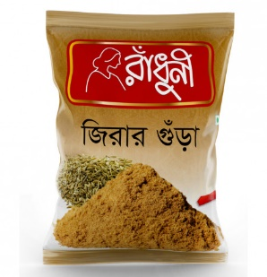 | Radhuni cumin powder is another product of Radhuni brand under SFBL. Only selected high grade cumin is used to make this cumin powder. Its natural aroma makes any dish yummy

Ready Mix:
Product Name | Product Image | Product Description
Beef Masala | 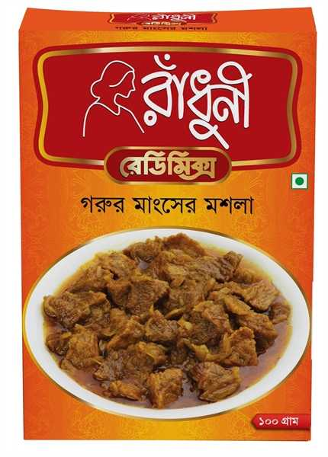 | Radhuni beef masala contains all necessary elements which is badly needed for making a perfect beef curry. To make a perfect beef curry customer need to add only onion, salt and edible oil along with Radhuni beef masala

Edible Oil:
Product Name | Product Image | Product Description
Radhuni Pure Mustard Oil | 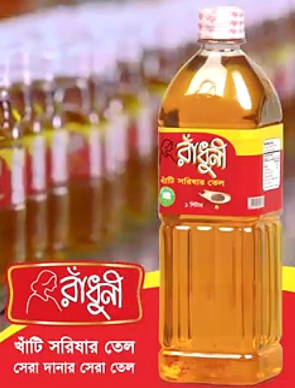 | Radhuni Pure Mustard Oil is made from hand-picked mustard seeds, guaranteeing the best quality mustard oil. It is produced in a fully automated line, starting from seed cleaning to bottling and capping. The cold press expelling technology used ensures the retention of natural flavor, pungency and essence in the product. Highly efficient filtering gives the oil an optimum color and zero solid particle content. Radhuni Pure Mustard Oil contains a large amount of mono-unsaturated fatty acid which restricts the build-up of the harmful cholesterol in blood.

Ruchi:

It produces ready to eat snacks like – chanachur, fried dal, peanut, chutney, jhuribhaja, potato crackers, jhalmuri, sauce, pickles etc. people of every ages like these products so much and that’s why is taking a strong position in the market. The plant of Ruchi is situated at Pabna.
The product range of Ruchi is basically two types:
- Munching Range
- Chewing Range
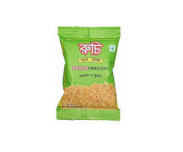
Munching Range:
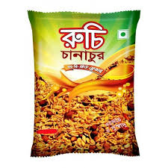
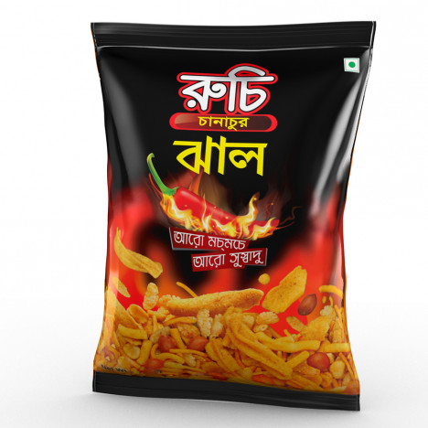

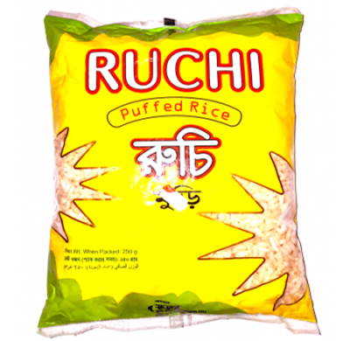
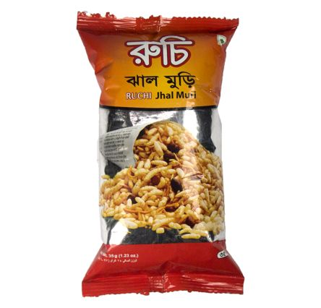
Ruchi Jhal Muri
Ruchi Puffed Rice
Ruchi Hot Chanachur

Ruchi Fried Daal
Ruchi BBQ Chanachur
Chewing Range:

Mixed with traditional spices and seasoning, the finest boroi are used to produced ruchi boroi chutney. give you the best boroi chutney. Enriched with protein, iron, sodium and other nutrients, Ruchi mango chutney gives you the palatable taste of real green mango. Ruchi mixed chutney is the best choice for the people who are looking for a distinctive taste in chutney. The combination of boroi and tamarind makes ruchi mixed chutney as a unique and incomparable product. Those who love the taste of olives, ruchi olive chutney are a right choice for them. The handpicked olive mixed with zinging spices ensures the best tasting chutney of olive. Made from the finest tamarind, ruchi tamarind chutney will delight you with its mouthwatering taste and unique aroma. You can have the lip-smacking chutney anytime, anywhere.

Ruchi Pickle and Ketchup
Garlic Pickle: The unmistakable aroma coupled with the timeless taste will make you fall in love with ruchi garlic pickle from the very first time you dip a teaspoon inside the jar.

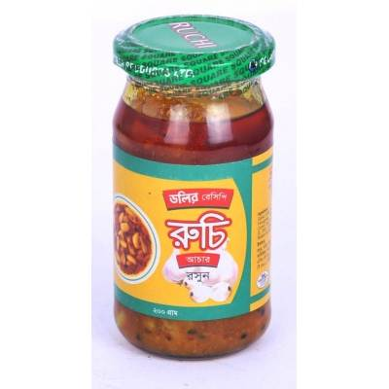
Mango Pickle: The finest mangoes from the best plantations find their place inside the ruchi mango pickle jar. Processed with traditional seasoning and spices, ruchi mango pickle is the first choice for the mango pickle lovers. The aroma and the taste give ruchi mango pickle a different place among all the other branded mango pickles.
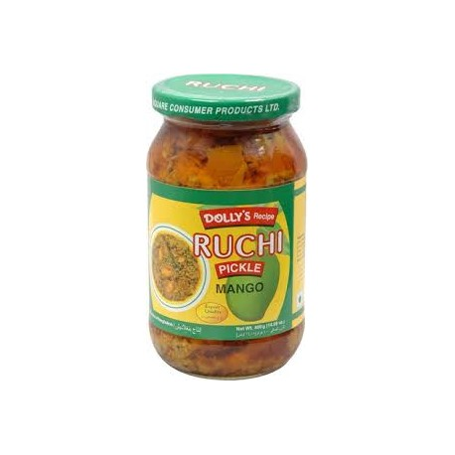
Olive Pickle: Those who desire the best olive pickle while having a meal, Ruchi olive pickle is a prime choice for them. The best quality olives with traditional spices and seasoning make ruchi olive pickle a favorite in numerous households.
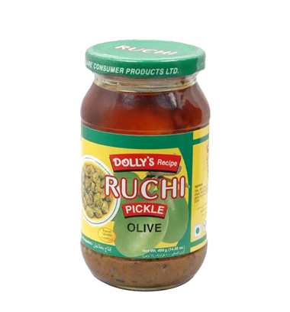

Mixed Pickle: The combination of mango, olive and garlic in ruchi mixed pickle will give your taste buds the best gift possible! you'll savor every moment you spend at the table while the best ingredients and the timeless recipe will make you stay even longer.
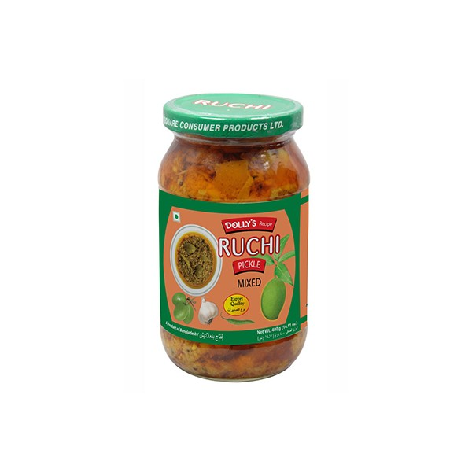
Ruchi tomato, red chili and tamarind sauce: Ruchi Hot Tomato Sauce is the perfect combo of hotness and tomato extract to make your food delicious. made from fresh Tomato Ketchup Tomatoes following a special recipe. Its spicy tomato flavor makes snacks and food tastier and mouth-watering. Ruchi red chilli sauce provides with the real hot taste of the finest red chilli. It augments the taste of snacks by many times with its uniquely great flavor. Ruchi tamarind sauce will give you the mouth-watering real sourness of the finest quality tamarinds.

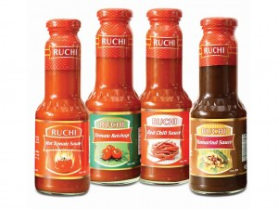
Chashi:



Recently it introduced another new brand that is Chashi, whose products are collected directly from the farmers having the indigenous essence and freshness such as minicat, Chinigura rice. Previously it collected chal from the third party but now it has own factory. The plant of Chashi is situated at Dinajpur.
Chashi Aromatic Rice Chinigura:
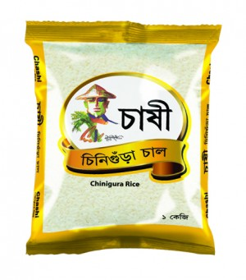
Chinigura rice is renowned for its pristine, white grains and its rich aroma. chashi aromatic rice chinigura brings you all this in a convenient package. we experience the difference between lesser, impure produce and the true taste of rural Bangladesh harvest every day. chashi has brought chashi aromatic rice chinigura to the market to remove that dissatisfaction.

Chopstick


It is the very new brand in to the market. It has different flavors of chopstick noodles such as tom yum classic, BBQ and yummy masala. The USP (Unique Selling Proposition) of this product is very praiseworthy. Maximum noodles brand offer test maker in their noodles. But this test maker is all about containing testing salt which is very harmful for health. So far, any noodles brand didn’t talk about the side effects of testing salt but for the very first time the chopstick noodles from SFBL have talked about this issue. The plant of Chopstick is situated at Pabna.

Operational Network Organogram:
Square Food and Beverage Limited has basically two offices at Mohakhali in Dhaka. One is Square Centre and another one is Rupayan Centre in 12th floor. The production factories are located at Pabna and Dinajpur. The total employees under SFBL is 2818. The large number of employees are working at their factory and the management level are basically working in the headquarters.

SFBL has several departments. They are divided according to the functions. The departments are-

The managerial hierarchy of SFBL is very well structured and maintained. The hierarchy is shown below:

Every department of SFBL strongly maintains their chain of commands.

Chapter 4: Data Analysis

A survey was conducted in SFBL about the Job Performance of employees. Questionnaire was used as the survey tool. The questionnaire was filled up by 32 employees of SFBL. The results of the survey are given below:

4.0 Descriptive Statistics Table

Table 1: Descriptive Statistics
 |  | N | Minimum | Maximum | Mean | Std. Deviation
 |  | Statistic | Statistic | Statistic | Statistic | Statistic
 | JP | 32 | 4 | 5 | 4.5781 | 0.30522
 | JS | 32 | 3.25 | 5 | 4.1367 | 0.41924
 | QW | 32 | 3 | 5 | 4.1125 | 0.53506
 | Valid N (listwise) | 32

According to the Table 1, the study shows that quality of work variable’s mean is 4.11 which is indicating strong perception of respondents due to the high level of job satisfaction. The mean value of job satisfaction is 4.13 which represents the strong employee’s perception.

4.1 Frequency Table

Table 2: Gender
 |  | Frequency | Percent | Valid Percent | Cumulative Percent
Valid | Male | 23 | 71.9 | 71.9 | 71.9
Valid | Female | 9 | 28.1 | 28.1 | 100.0
Valid | Total | 32 | 100.0 | 100.0

According to the Table 2, the study shows that most of the employees of SFBL are male and some of them are female. It shows that 71.9% employees are male while female is only 28.1%.

Table 3: Experience
 |  | Frequency | Percent | Valid Percent | Cumulative Percent
Valid | 0 to 5 years | 18 | 56.2 | 56.2 | 56.2
Valid | 6 to 10 years | 10 | 31.2 | 31.2 | 87.5
Valid | 11 to 15 years | 4 | 12.5 | 12.5 | 100.0
Valid | Total | 32 | 100.0 | 100.0

According to the Table 3, the study shows that most the employees of SFBL tend to work there up-to 10 years. The working experience of 87.4% of employees is between 0 to 10 years. After 5 years of experience the retention rate starts to fall. Only 12.5% of employees stays in SFBL in 11 to 15 years.

Table 4: Salary
 |  | Frequency | Percent | Valid Percent | Cumulative Percent
Valid | Tk. 20000-50000 | 13 | 40.6 | 40.6 | 40.6
Valid | Tk. 51000-80000 | 18 | 56.2 | 56.2 | 96.9
Valid | Tk. 81000-110000 | 1 | 3.1 | 3.1 | 100.0
Valid | Total | 32 | 100.0 | 100.0

According to the table 4, 96.8% of the employees of SFBL earn between Tk.20000 to 80000.
Only 3.1% of employees earn Tk. 81000 to 110000.

Table 5: Education
 |  | Frequency | Percent | Valid Percent | Cumulative Percent
Valid | BSc | 2 | 6.2 | 6.2 | 6.2
Valid | MSc | 2 | 6.2 | 6.2 | 12.5
Valid | BBA | 14 | 43.8 | 43.8 | 56.2
Valid | MBA | 13 | 40.6 | 40.6 | 96.9
Valid | BA | 1 | 3.1 | 3.1 | 100.0
Valid | Total | 32 | 100.0 | 100.0

According to the Table 5, 84% of employees of SFBL are BBA and MBA graduates. That clearly refers that they highly prefer BBA and MBA graduates for the organization. And left of the employees are from BSc, MSc and BA background where the percentage is only 15.5.

4.2 T-Test

Table 6: Group Statistics
 | Gender | N | Mean | Std. Deviation | Std. Error Mean
JP | Male | 23 | 4.5507 | 0.31557 | 0.0658
JP | Female | 9 | 4.6481 | 0.28191 | 0.09397

According to the Table 6, the mean value of job performance for both the male and female is much closed to each other. The mean value of male is 4.55 and female is 4.64. It means that the job satisfaction and quality of work do not affect the job performance for both the cases of male and female.

Table 7: Independent Samples Test
 |  | Levene's Test for Equality of Variances |  | t-test for Equality of Means
 |  | F | Sig. | t | df | Sig. (2-tailed) | Mean Difference | Std. Error Difference | 95% Confidence Interval of the Difference
 |  |  |  |  |  |  |  |  | Lower | Upper
JP | Equal variances assumed | .209 | .651 | -.807 | 30 | .426 | -.09742 | .12069 | -.34390 | .14905
JP | Equal variances not assumed |  |  | -.849 | 16.340 | .408 | -.09742 | .11472 | -.34021 | .14536

According to the Table 7, the study shows that job satisfaction and quality of work both are equally important for determining job performance because the t value is significant at 95% confidence level.

4.3 Correlations

Table 8: Correlations
Pearson Correlation |  | JP | JS | QW
JP |  | 1 | .408* | .372*
JS |  | .408* | 1 | .350*
QW |  | .372* | .350* | 1
*. Correlation is significant at the 0.05 level (2-tailed).
According to the Table 8, the study shows that job performance, job satisfaction and quality of work are significant at <=.05 level.

4.4 Regression Analysis

Table 9: Model Summary^{b}
Model | R | R Square | Adjusted R Square | Std. Error of the Estimate
1 | .476ª | 0.226 | 0.173 | 0.27759
a. Predictors: (Constant), QW, JS
b. Dependent Variable: JP

According to the Table 9, the study shows that the relationship among independent variable (QW & JS) and dependent variable (JP) is weak the value of R is less than .6 which is considered as the value of moderate relationship. The study also shows that the independent variables explain only 22.6% variation of dependent variable.

Table 10: ANOVA^{b}
Model |  | Sum of Squares | df | Mean Square | F | Sig.
1 | Regression | .653 | 2 | .327 | 4.240 | .024ª
1 | Residual | 2.235 | 29 | .077
1 | Total | 2.888 | 31
a. Predictors: (Constant), QW, JS
b. Dependent Variable: JP
According to the Table 10, the study shows F value is significant at < .05 level. That means independent variables rightly predicting dependent variable. So, quality of work and job satisfaction both are important factor for job performance.

Chapter 5: Recommendation & Conclusion

5.0 Recommendations

I would like to recommend some factors on the ground of my data analysis for SFBL.I also would like to mention that while working in the HR Department of SFBL as an Intern I observed there are few problems in this department. So, there are some recommendations writing below as per my observations as well.
- SFBL should highly focus on the long term retentions of their employees. For retaining the best resources they should practice some strategies. For example: They should open the lines of communication, give proper room to employees to grow, offer benefits, sometimes overcompensate the best resource.
- SFBL prioritize BBA and MBA graduates candidates for their organization. So it is highly encouraging factor for those students who wants to work in a FMCG. That’s why SFBL should make proper arrangements for attracting the best resources.
- At present the job satisfactions and quality of work for both male and female of SFBL are very close to each other which should be maintained to gain the best contributions from their employees.
- At the interview session the time should be maintained by the HRD of SFBL because sometimes it created problems for the interviewees.
- They should do proper background check about the employees while recruiting them.

5.1 Conclusion

It was totally a different experience to work as an Intern in the local one of the best FMCG Company. With its decade long business SFBL is employing thousands of people in different departments every year. Throughout in these three months, I have learnt about real life corporate culture and enhanced my experience to the fullest. Additionally, through data analysis, I would like to conclude that quality of work and job satisfaction are rightly predicting job performance and ANOVA Table 10 is demonstrating that. Hence, organization must be focused on job satisfaction and quality of work for improving job performance.

