

Internship Report on
“Key Performance Indicators followed and applied in Bank Asia Limited”

Submitted By:
Afsana Islam (Moitri)
ID: 111 141 309
BBA

Submitted To:
Md. Abul Mohaimen
Assistant Professor
School ofBusiness and Economics
United Iternational University

Date of Submission: January 26, 2019

Internship Report on
“Key Performance Indicators followed and applied in Bank Asia Limited”

Submitted By:
Afsana Islam (Moitri)
ID: 111 141 309
BBA

Submitted To:
Md. Abul Mohaimen
Assistant Professor
School of Business and Economics
United International University

Date of Submission: January 26, 2019

Letter of Transmittal
January 26, 2019
Md. Abul Mohaimen
Assistant Professor, SOBE
United International University
Dhaka, Bangladesh
Subject: Submission of internship report.
Sir,
As per your direction, I am submitting the attached report on "Key Performance Indicators followed and applied in Bank Asia Limited: A case study regarding Corporate Office”. While setting up this report, I have adhered to your guidance and rule additionally the data that I could gather from the Bank. This report has been finished by my encounters I have accomplished amid the three months of my internship period at Bank Asia Constrained, Corporate Office. I trust they will be very useful to edify my future vocation and learning too. This report has given me an opportunity to get introduced with the corporate life and people working there. Also, it has provided me the scopes to apply my learning to prepare this report.
I offer my unique thanks to you for committing your significant time, master direction and backing. I have attempted my best to finish the report fittingly however as much as could be expected with important data.
Thank you.
Sincerely,
_________________
Afsana Islam Moitri
ID: 111141309
Acknowledgement
I might want to express my most profound gratefulness to the general population who have furnished data with the likelihood to finish this report. A special gratitude goes to our respected faculty Md. Abul Mohaimen, whose magnificent way of teaching, suggestions and encouragement helped me to reach to the conclusion of this report.
Furthermore, I would also like to acknowledge with much appreciation and show my gratitude towards the SVP & Head of PMD: Khandaker Syed Nazmul Hasan who has given me the reference to get access to their information and the chance to complete my internship program at their department that is People Management Division (PMD).
A special thanks and gratitude goes to my “People Management Division” including ten employees currently working there: Mr. Rajib Kumar Dey, FAVP; Mr. Sarware Alam, SEO; Mr. Mohammad Shafkat Hossain, SEO; Mr. Md. Shamiul Islam, EO; Ms. Umme Souda Lira, SO; Mr. Humayan Kabir Chowdhury, SO; Ms. Nazma Begum, Off; Mr. L. M. Akidul Islam, JO; Ms. Sinthia Shahriar, AO; Ms. Syeda Maliha Hussain, BO. Without their significant supervision and headings it would not have been conceivable to finish this report.
I might likewise want to offer my sincere thanks and perpetual gratitude to Zahid Iqbal, FAVP of Accounts Department, for supporting me amid my temporary job program, for helping me set up this report and for giving data. Without his help I would not have the capacity to increase enough data to set up this report.
Finally my sincere gratitude goes to United International University Authority for arranging this internship program for students. It really makes students capable of doing official tasks before entering the corporate world.

Table of Contents
Chapters | Title | Page no.
 | Executive Summary | i
1.0 | Introduction | 01
1.1  1.2  1.3  1.4  1.5  1.6  1.6.1  1.6.2  1.7 | Origin of the report | 02
1.1  1.2  1.3  1.4  1.5  1.6  1.6.1  1.6.2  1.7 | Statement of the report | 02
1.1  1.2  1.3  1.4  1.5  1.6  1.6.1  1.6.2  1.7 | Objectives of the report | 03
1.1  1.2  1.3  1.4  1.5  1.6  1.6.1  1.6.2  1.7 | Scope of study | 03
1.1  1.2  1.3  1.4  1.5  1.6  1.6.1  1.6.2  1.7 | Limitation of the study | 04
1.1  1.2  1.3  1.4  1.5  1.6  1.6.1  1.6.2  1.7 | Methodology  Data Collection Technique  Sampling  - Population  - Sampling Unit  - Sample Frame  - Sampling Design  - Sample Size  - Research Questions | 04-08
1.1  1.2  1.3  1.4  1.5  1.6  1.6.1  1.6.2  1.7 | Abbreviations | 09
2.0 | Overview of the Company | 10
2.1  2.2  2.3  2.4  2.5  2.6  2.7 | Introduction | 10
2.1  2.2  2.3  2.4  2.5  2.6  2.7 | Mission Statement | 11
2.1  2.2  2.3  2.4  2.5  2.6  2.7 | Vision Statement | 11
2.1  2.2  2.3  2.4  2.5  2.6  2.7 | Activities of the Company | 12
2.1  2.2  2.3  2.4  2.5  2.6  2.7 | Organogram | 14
2.1  2.2  2.3  2.4  2.5  2.6  2.7 | Products & Services | 15
2.1  2.2  2.3  2.4  2.5  2.6  2.7 | Future Plan | 17
3.0 | Literature Review and Discussion | 18-19
3.1  3.2 | Literature Review | 18
3.1  3.2 | Discussion | 19
4.0 | Analysis and Interpretation
4.1  4.2  4.3  4.4 | Questions answers | 22
4.1  4.2  4.3  4.4 | Table with table source | 22
4.1  4.2  4.3  4.4 | Graph and Chart | 42
4.1  4.2  4.3  4.4 | Interpretations | 45
5.0 | Recommendations and Conclusion | 48-50
Appendix &Bibliography

Executive Summary

I have prepared this report on "Key Performance Indicators followed and applied in Bank Asia Limited: A case study regarding Corporate Office” to show how the KPI works in practical life of the Bank also to find out the similarities and differences from the theoretical knowledge that I have gained from our text books. A Key Performance Indicator (KPI) is a measurable value that demonstrates how effectively a company is achieving key business objectives. Organizations use KPIs to evaluate their success at reaching targets. In any case, a considerable lot of them can't be effectively estimated due to their non-deterministic or subjective nature and estimating execution is convoluted and expensive to make and assess. In Bank Asia Ltd. a yearly target is set at the beginning of each year by a conference. The same format of target is given to the 127 branches of Bank Asia Ltd. by the People Management Division (PMD and then the branch head of each branch distributes the given target to different divisions. The KPI format is same for all the branches, based on activities of different tasks the contents vary. The KPI measurement is done at the end of each year on December. The KPI format is sent to the employees according to their work title and they are given a deadline of approximately 1 month to submit the format by filling it up. The employees assess their performance by themselves first based on their tasks, and then it is submitted to the Line Manager who observes the form and sends it to the Head Office. In case of the Branch heads they also go through self-assessment and send it directly to the Head Office. Branches are under DMD (Deputy Managing Director), thus the DMD evaluates the form. Finally the MD (Managing Director) finalizes the result and adjusts his observations to give a summary of the result. For further query the MD holds a meeting with the branch managers to change the score of KPIs with deep observation.

Chapter-1:
Introduction of the Report

- Introduction
A Key Performance Indicator (KPI) also known as ‘Strategic Management’ is a measurable value that demonstrates how effectively a company is achieving key business objectives. Organizations use KPIs to evaluate their success at reaching targets. What makes business execution pointers "key" and by what means should an entrepreneur, official or director select them relies upon six factors that different compelling, esteem making KPIs:
Aligned – Make sure the KPIs align with the strategic goals and objectives of the organization
Attainable – The KPIs should have data that can be easily obtained
Acute – KPIs should keep everyone on the same page and moving in the same direction
Accurate – The data flowing into the KPI should be reliable and accurate
Actionable – Does the KPI provide insight into the business that is actionable?
Alive – The industry is always growing and changing. The KPIs should evolve as well.
Managing an account KPIs and measurements can be actualized all through any bank to gauge the execution of its representatives, its items, and its adherence to industry controls (for example consistence). Vast business banks offer a wide scope of items and administrations to the clients. Diverse KPIs must be characterized and followed at different regions all through the bank – for individual items (for example sparing plans, business loaning, retail loaning and so forth.), for back office activities (e.g., call focus, treasury, global division, and so forth.) and for overhead capacities (e.g., accounts, money, HR, ICT, and so on.).
Bank Asia includes young, vivacious, proactive, energized, result organized individuals who keep up the estimations of the relationship by following the fundamental beliefs of Bank Asia by being inventive, open, cognizant, moral, essential, eager and clear. Execution The officials System (PMS) empowers the agents to exploit their working life at the bank. The method supports in recognizing and passing on against testing destinations that influence the affiliation. It plans how to make capacities and expert practices for each laborer's present position and for the years ahead. The widened workforce is the guideline asset of the affiliation. We will turn our emphasis on how the bank sends the KPI lattice to assess every one of the workers in the coming areas.
  - Origin of the report
I have conducted this report as per our honorable instructor has required us to do so, for the purpose of learning the corporate strategies and developing my skills of understanding these strategies. It also helped me to know the real life implications of such strategies. I have tried to finish this report for the purpose of following his direction to complete this course.

Timeline | Final semester, Summer 2018 (BBA completion)
Method (in form of) | Internship at Bank Asia Limited
Tenor | 90 Days
Authorized by | Mr. Md. Abul Mohaimen
Prepared by | Afsana Islam Moitri
Report preparation period | June 11 – September 10, 2018
Report submission date | September 18, 2018

1.2 Statement of the problem
Previously not so much work has been done on this topic and the majority of the companies in Bangladesh are still unaware of the KPI system. The majority of the research work is inadequate.
The KPIs play an important role in every organization. A successful organization tries to be capable in meeting the organizational objectives successfully which can be complicated. Besides selecting the appropriate KPIs applicable for the industry the organizations need to figure out how to appraise them appropriately and accurately – the toughest step, but unquestionably the most important one.
Starting from the vision of the organization differentiating it down to mission statements breaking them down to goals with the aid of several governance umbrellas, RACI charts and balance scorecards an organization sets SMART objectives for each employees according to their position. While compiling the several questionnaires gathered from several departments of Bank Asia, it was apparently visible to me that setting KPI for the employees in the HR management module was the main challenge in implementing strategic management for People Management Division.
1.3 Objective of the Report
After the finish of studies, when an understudy is prepared to apply what s/he has realized and make sense of if the profession way s/he is on is the correct one. Completing an entry level position is an extraordinary method to investigate the profession one is keen on. The drive of a temporary position is to convey reasonable information that empowers her/him to put everything s/he learned without hesitation:
Test the waters – to see what the job and the work-setting is like and to gain knowledge into what a vocation in that field involves.
Gain experience – to gain the required involvement and to assemble continue along with increasing communication, organizational and teamwork skills
Make Helpful Connections – to help make useful connections who can give accommodating data and who can help control amid profession. One can utilize them as references for future employments.
1.4 Scope of the study
There is some confidential information about the KPI measurement of Bank Asia Ltd. So, the scopes were limited for me to get enough information. The principal extent of this report is to have down to earth understanding about how the performance is measured, whether KPI is being used by the bank and how KPI is used in Bank Asia Ltd. The scope of the report was to get a real-life exposure. We got the opportunity to observe and communicate about KPIS they follow to measure performance of each employee.
The study is limited to Bank Asia Corporate Office only. The scope of this report covers the implementation of online KPI system migrating from paper-based KPI system throughout Bank Asia. The Corporate Office comprises of 36 units/departments/divisions encompassing over 600 employees. The implementation of key indicators in accordance with the position of the Corporate Office employees mainly contributed to this report. The planning of this report offers an extraordinary chance to have an inside and out learning of key execution pointers rehearsed by the bank. This report has been made dependent on the experience assembled amid the time of 3 months entry level position. It was an immense open door for me to for all intents and purposes find out about KPI and its usefulness in Bank Asia Ltd. I also learned about some of the activities of the Human Resource Department such as: leave related activities, recruitment process, insurance related works, training activities and so on.
1.5 Limitations
The study was not free from limitation. Some limitations and problems have encountered which are as follows:
- Confidentiality of information: important information such as weight distribution on several key indicators, KPI forms of several key personnel has been concealed. To provide recent information support from various sources is essential.
- Time Constraint: On occasion the concerned staff did not give enough time because of surge saving money hours. In this way, I confronted a few issues to comprehend few points of explicit undertakings. Actually three months is too short to even think about learning about the entire KPI substance for various work titles.
1.6 Methodology
How I have gathered the necessary information depends on the two sources of data collection the two types of data sources are: Primary data and Secondary data. The primary data has been collected through discussion with the employees of the organization, and the secondary data has been collected from their websites and E-mails. The main source of data was primary data sources though secondary data sources were also utilized
- Primary sources:
I had a direct discussion with the FAVP (First Assistant Vice President) Mr. Zaid Iqbal of Accounts Department, FAVP (First Assistant Vice President) Mr. Rajib Kumar Dey of PMD, EO (Executive Officer) Mr. Md. Shamiul Islam of PMD about the KPI process of Bank Asia Ltd. The primary data collection technique includes:

- Discussion with the authorities of Bank Asia Restricted.
- Informal meeting and individual discussion with representatives.
- Direct involvement in the activities of the Human Resource Department.
- Personal observation on the effects of KPI for each employee.

- Secondary sources:
The secondary sources include:
- Annual report of Bank Asia Restricted

- Online information from the site of Bank Asia Restricted.

- Relevant Diaries and research papers.

- Relevant document examine as given by the officers concerned.

1.6.1 Data collection technique
Collecting necessary data was not easy at all. For this approach I used both the primary and secondary data collection technique. At first I started to discuss with my supervisors about their bank and their KPI system. And with the passage of time I gathered some ideas about the people of the bank, about the culture of the bank, about their working environment, about the total population of the corporate office, about different branches etc. but I failed to collect the in individual KPI samples because of confidentiality. I could manage some KPI forms for different work titles which can be used as samples. Because the KPI format is same for all the branches the only difference is based on the contents of the KRAs (Key Result Area).
1.6.2 Sampling

Population: A population, in key performance indicator is a discrete group of people or employee that can be identified by at least one common characteristic for the purposes of data collection and analysis. To gather information about a large population, data is usually gathered from a sample. There are total 37 branches of Bank Asia Limited situated at Dhaka district in Bangladesh. All the employees working in each branch are my population for the individual KPI.

Sampling Unit: With regards to Key Performance Indicator, an inspecting unit is a distinct individual. The term examining unit alludes to a particular incentive inside an example database. For instance, on the off chance that you were directing examination utilizing an example of association representatives, a solitary association worker would be an inspecting unit. For my report I have taken a few examples of individual KPIs dependent on various assignments.

Sample Frame: A sampling frame is the source material or device from which a sample is drawn. It is a list of all those within a population who can be sampled, and may include individuals. Following is a KPI form for individual employees of Bank Asia Ltd.
`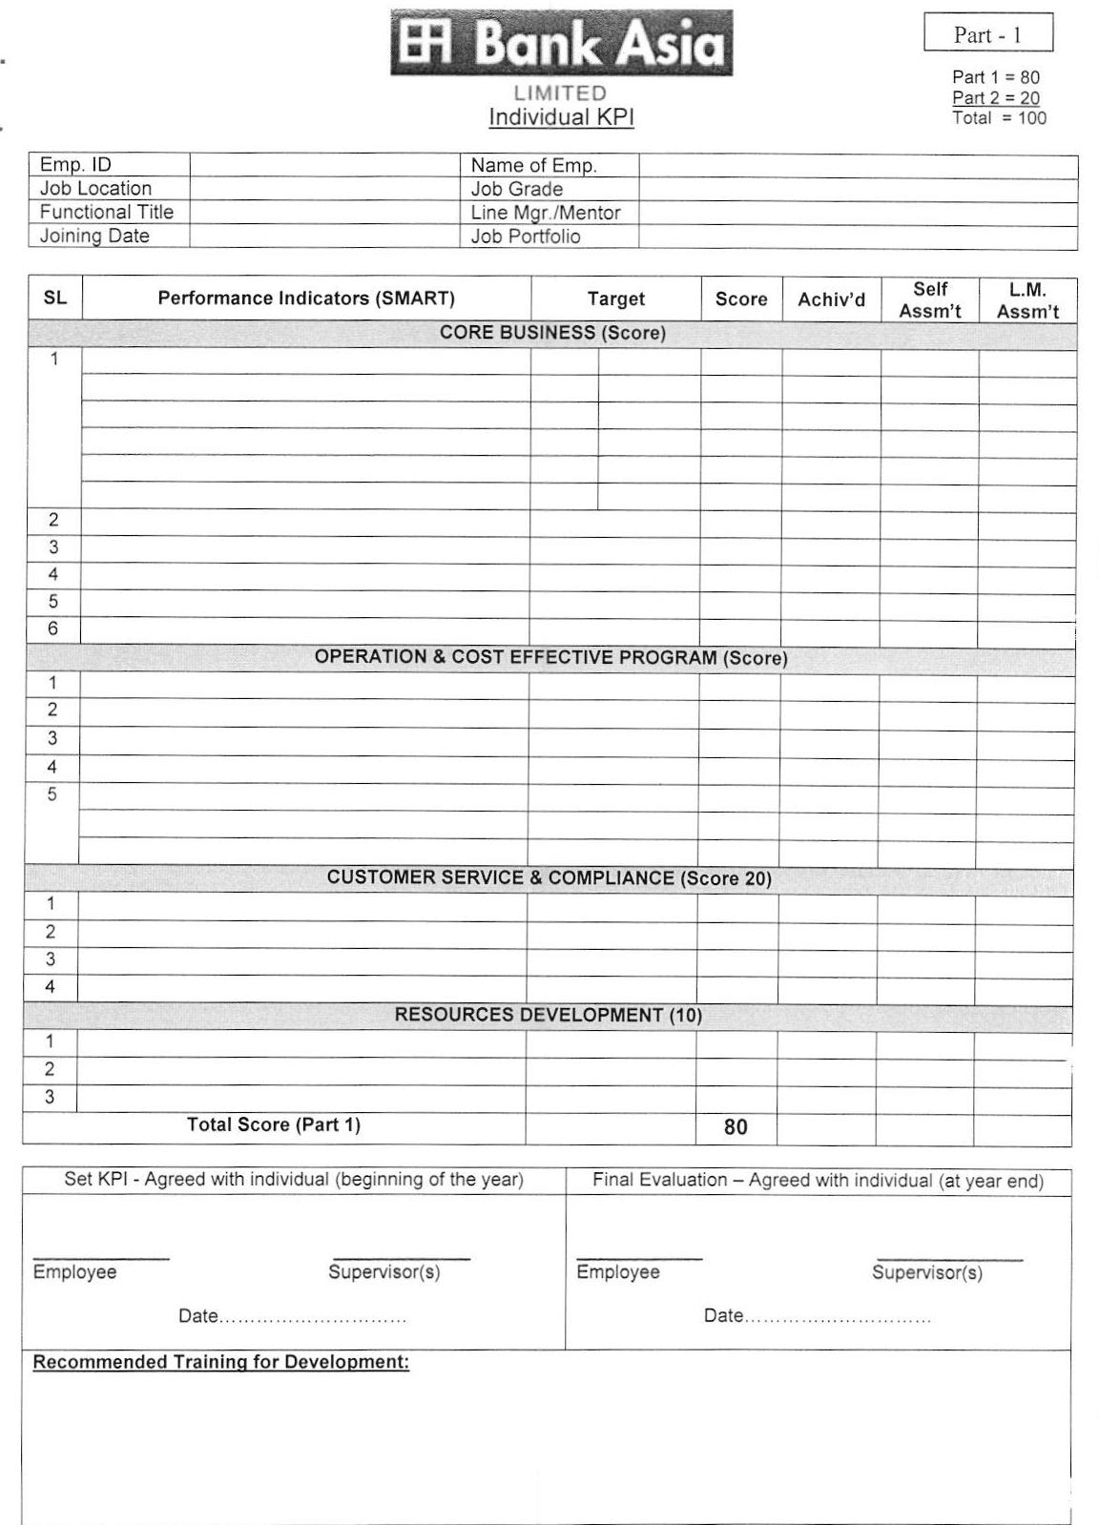
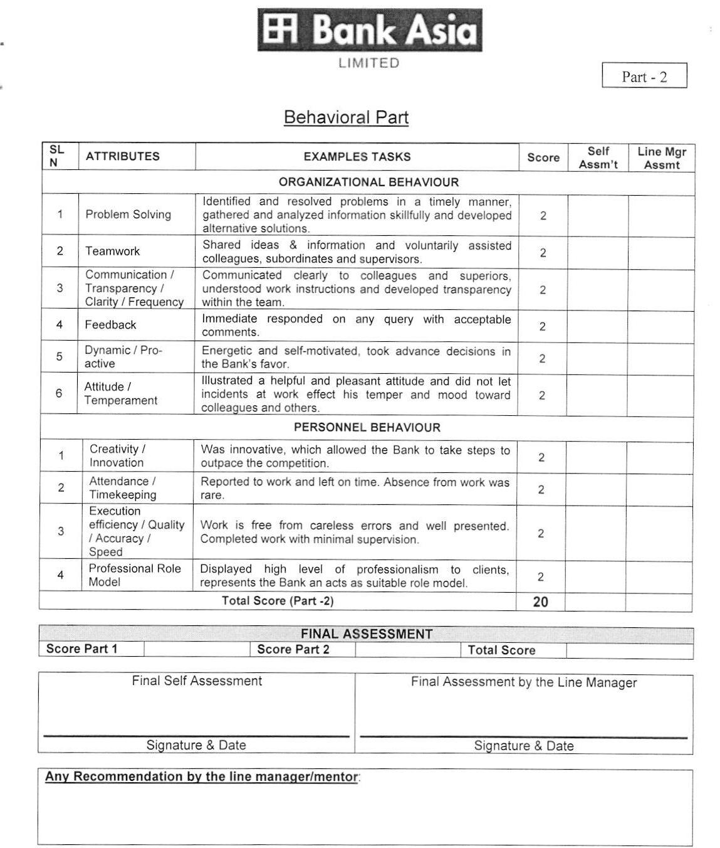

Sampling Design: Examining strategy alludes to the guidelines and methods by which a few components of the populace are incorporated into the example. The best example configuration relies upon overview targets and on study assets.
Sample Size: Sample measure assurance is the demonstration of picking the quantity of perceptions or duplicates to incorporate into a factual example. The example estimate is a vital component of any exact investigation in which the objective is to make surmising’s about a populace from an example.
Research Question: It means an answerable inquiry into a specific concern or issue, in my report the concern is on KPI. It is the first active step or initial step in a research project. There are three types of research questions, they are: Descriptive, Observational-Relational, and Causal. The research questions that I have prepared are more of the descriptive type of questions as the questions describe the conditions that are happening in Bank Asia Ltd or that exists in the Bank. Some of the following questions were asked for my query:
Describe your key responsibilities that reflect your performance
Where do you fit in your organization? (EDMPDCA)
Who is responsible for setting your KPIs: Board or Management?
What Government frameworks were followed when setting up your KPIS?
What measure or formula if followed to calculate KPI Score?
Did they brief you thoroughly regarding your responsibilities leading you to your objectives?
How do your objectives align your organizational objectives?
What does your Bank attain if you perform successfully?
How does this achievement contribute to the Bank’s mission?
How does this serve the Bank’s vision?

1.7 Abbreviations
Abbreviations are shortened form of words or phrases. In the whole report the following abbreviations can be found. The abbreviations also include many short forms of words that are used in Bank Asia Ltd.

KPI: Key Performance Indicator | FVP: First Vice President
KRA: Key Resource Area | AVP: Assistant Vice President
BAL: Bank Asia Limited | FAVP: First Assistant Vice President
PMD: People Management Division | SEO: Senior Executive Officer
HOD: Head of Division | EO: Executive Officer
HOB: Head of Branch | SO: Senior Officer
MD: Managing Director | Off: Officer
DMD: Deputy Managing Director | JO: Junior Officer
SEVP: Senior Executive Vice President | AO: Assistant Officer
EVP: Executive Vice President | BO: Banking Officer
SVP: Senior Vice President | TO: Trainee Officer
VP: Vice President | GB: General Banking

Chapter-2


Company Overview

2.0: Overview of your company

Bank Asia has been moved by a social occasion of viable business visionaries with saw staying in the overall population. The organization of the Bank contains a gathering driven by senior intermediaries with numerous long periods of contribution in national and widespread markets. The senior supervisory gathering is competently maintained by a social occasion of specialists tremendous quantities of whom have presentation in the overall market.

It set accomplishment by verifying the business assignments of the Bank of Nova Scotia in Dhaka, first in the keeping cash history of Bangladesh. It again reiterated the execution by obtaining the Bangladesh exercises of Muslim Business Bank Ltd.

In the year 2003 the Bank again went to the spotlight with oversubscription of the First closeout of supply of the offers of the Bank, which was a record in our capital market's history and its offers bearings great premium.

The preferred standpoint and hazard advancement has been striking. Bank Asia has been viably appreciating the adjacent cash grandstand similarly as outside cash promote without displaying the Bank to powerless positions. The Bank's enthusiasm for Treasury Bills and distinctive securities went up unmistakably opening up open entryways for improving pay with respect to a daily practice of enduring advance charge decline.

Bank Asia Constrained started its organization with a fantasy to serve people with present day and imaginative dealing with a record things and organizations at moderate charge. Being parallel to the front line development the Bank is advancing online keeping cash with included movement stations like ATM, Tele-setting aside extra cash, SMS and Net Saving cash. In addition, as a noteworthy part of the bank's obligation to give all bleeding edge and regard included dealing with a record organization concerning the most flawlessly awesome standard in a globalize world.

2.1: Introduction
Bank Asia Ltd. Is third era bank and planned business Bank in the private division which built up on 27th November in 1999 under the saving money organization act 1991 and join in Bangladesh as an open constrained organization under the organization demonstration 1994 to complete managing an account business in Bangladesh. Bank Asia has been propelled by a gathering of fruitful business people. The administration of Bank comprises of a group driven by senior financiers with tremendous involvement in national and worldwide market. Inside a short time allotment Bank Asia can uncover its self-nearness and developed its own circumstance in the market as one of the fundamental creating neighborhood private bank at present it has 50 branches wherever all through the Bangladesh. Since its introduction in 1999, it set an accomplishment by acquiring the Bangladesh undertakings of the Bank of Nova Scotia of Canada, first in the keeping cash history of Bangladesh. Again in 2002 the bank picked up the Bangladesh exercises of Muslim Business Bank Ltd. (MCB). In the year 2003, the bank opened up to the world by offering offers to the general monetary expert and in 2004 the recorded itself with the stock exchange.

Slogan of Bank Asia Ltd: “For a better tomorrow” does not have to confined with the limited service rather enhanced existing service and brought up new services in order to their existing and potential clients for made the life more easier

2.2: Mission Statement

- To assist in bringing high quality service to our customers and to participate in the growth and expansion of our national economy.
- To set high standards of integrity and bring total satisfaction to our clients, shareholders and employees.
- To become the most sought after bank in the country, rendering technology driven innovative services by our dedicated team of professionals.

2.3: Vision Statement

Bank Asia's vision is to have a poverty free Bangladesh in course of a generation in the new millennium, reflecting the national dream. Our vision is to build a society where human dignity and human rights receive the highest consideration along with reduction of poverty.

2.4: Activities of the Companies

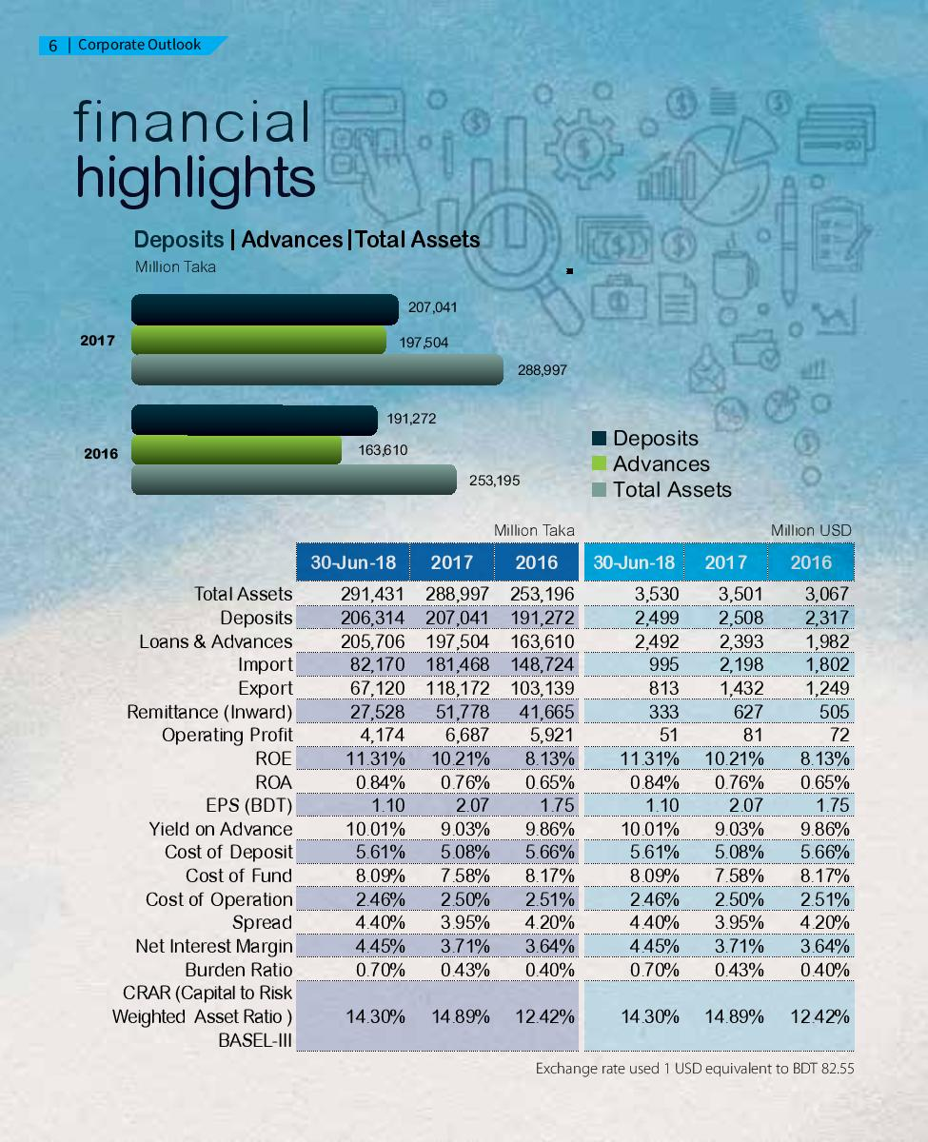

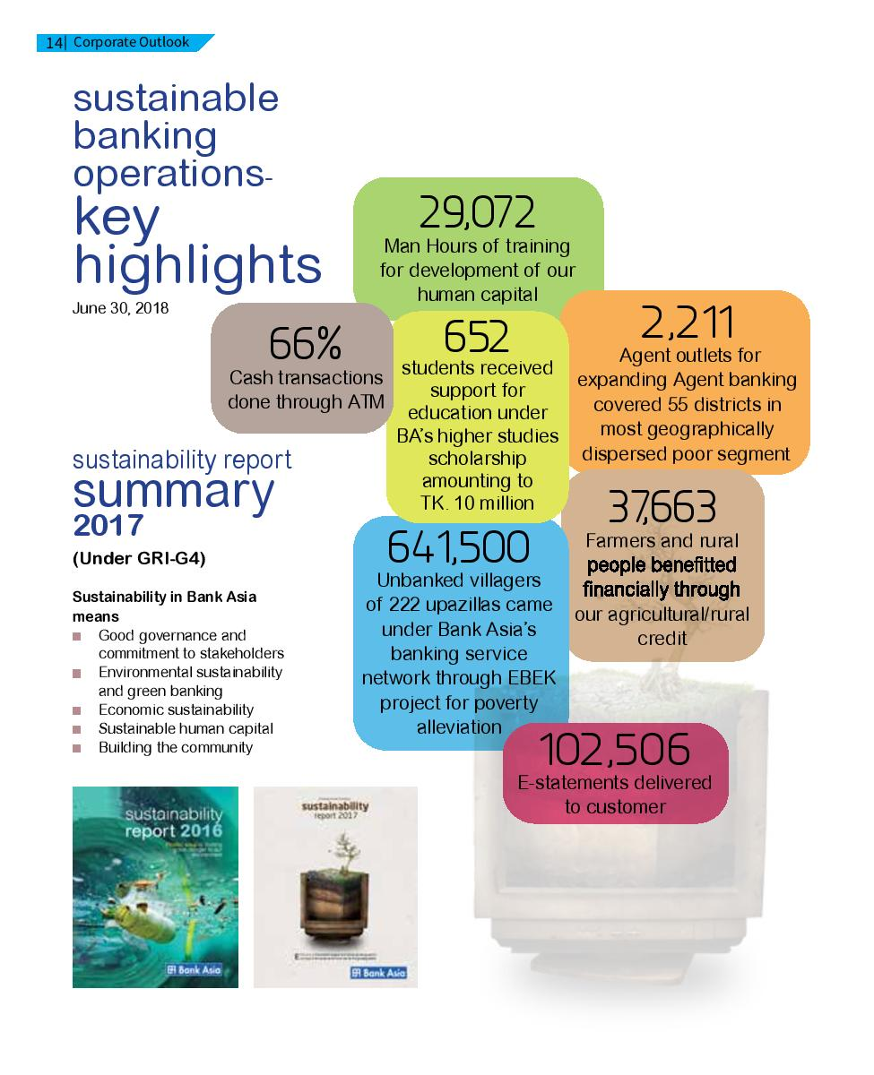

2.5: Organogram

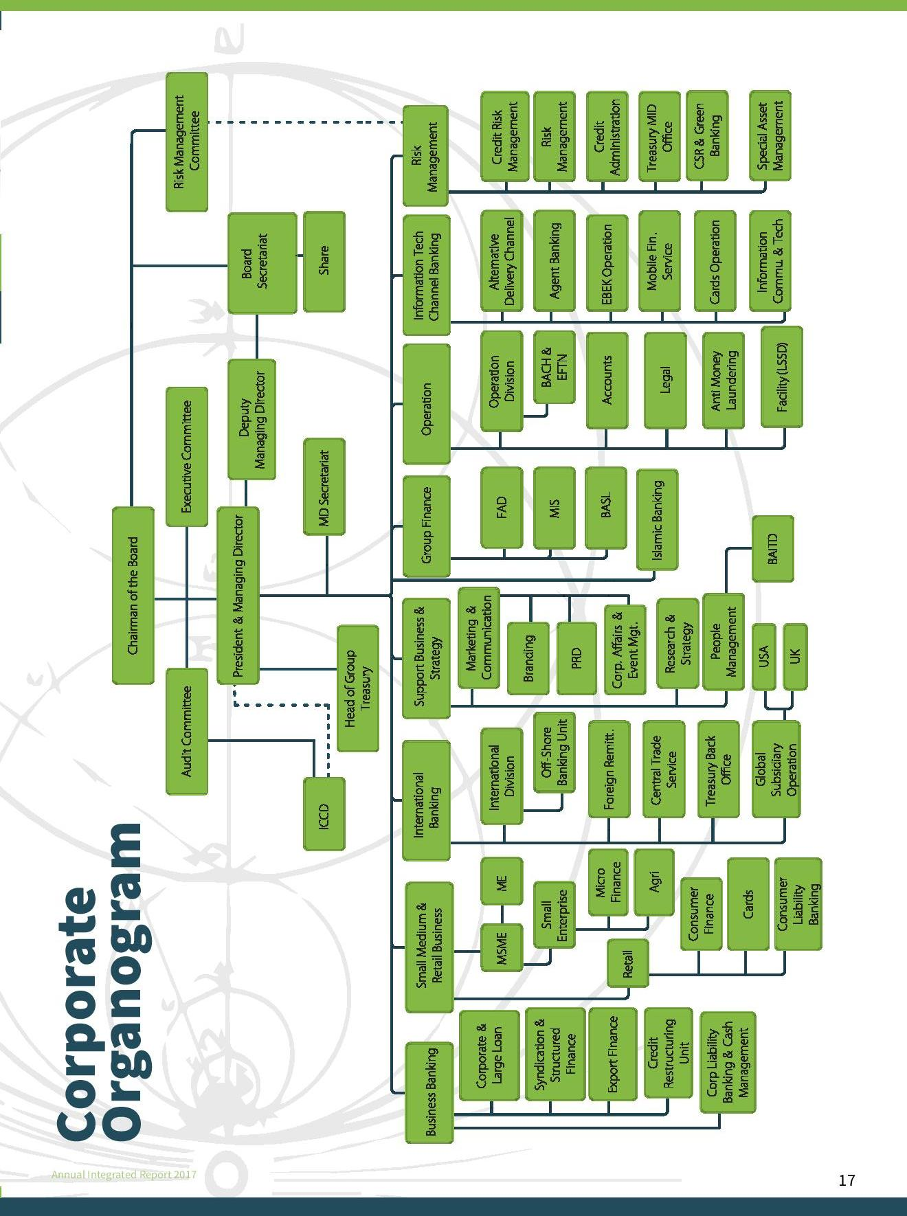

2.6: Products and services


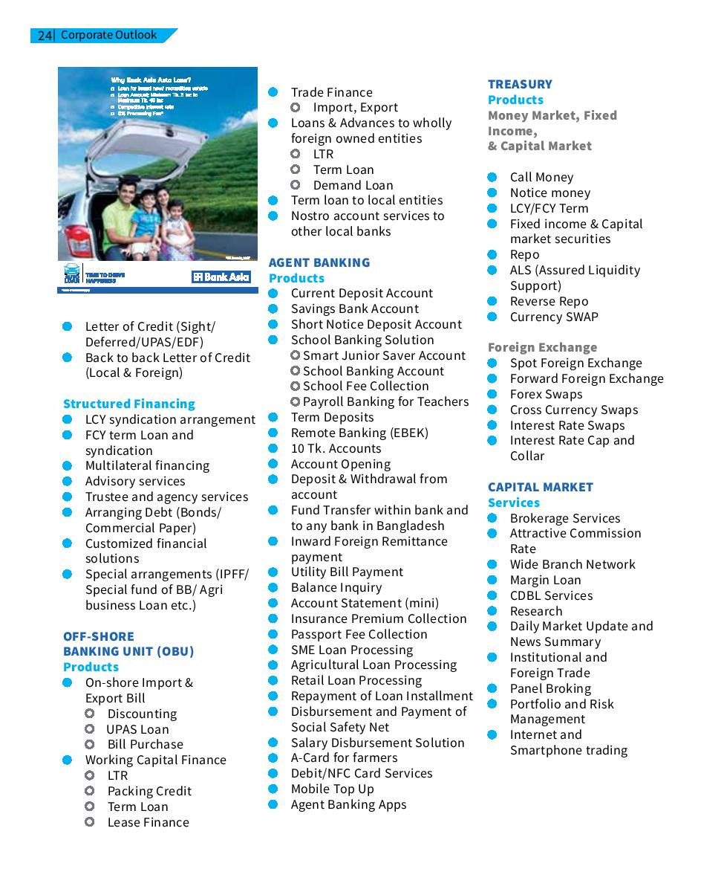

2.7: Future Plan

• Giving complete consideration to the client

• Recognizing client genuine necessities

• Enhancing client administration quality

• Making upbeat association with the client

• Giving significance even to littlest question

• Pulling in new worth through higher arrangements and advantage

• Making picture through serve the best organization and thing

• Accomplishing corporate target through joint exertion

• Spot customer premium and satisfaction as first need and give changed setting aside some cash things and organizations

• Value expansion to the partners through achieving greatness in keeping money tasks

• Maintain high moral standard and straightforwardness in dealings

• Be a consistent establishment through holding fast to every administrative prerequisite

• Contribute altogether for the improvement of the general public

• Guarantee larger amount of motivation and respectable work environment for our human capital and esteem perfect work-life balance

• Committed to secure the earth and make strides toward environmental friendliness

Chapter-3
Key Performance Indicator of Bank Asia

3.1: Literature Review

The lack of proper categorization of performance indicators impedes frequent and widespread use of performance metrics by the facility management industry. The purpose of this paper is to identify Key Performance Indicators (KPI’s) and categorize them into specific aspects of facility performance measurement. A qualitative approach, based on the literature, is adopted, which identified KPI’s based on a literature search. The KPI’s were, then, arranged into three major categories, based on their purpose and content: financial, physical, and functional. This categorization may offer a more practical use by facility management practitioners. Examples of the indicators identified, with their description, units of measurement, and literature sources are presented. Future research should focus on further analysis of KPI’s in order to generate a more concise list of indicators that exhibit wide applicability and valid categorization. The KPIs play an important role in every organization. A successful organization tries to be capable in meeting the organizational objectives successfully which can be complicated. Besides selecting the appropriate KPIs applicable for the industry the organizations need to figure out how to appraise them appropriately and accurately – the toughest step, but unquestionably the most important one. Bank Asia Limited began its administration with a dream to serve individuals with present day and inventive keeping money items and administrations at reasonable charge. Being parallel to the forefront innovation the Bank is putting forth web based managing an account with included conveyance stations like ATM, Tele-saving money, SMS and Net Banking. What's more, as a major aspect of the bank's responsibility to give all cutting edge and esteem included managing an account administration with regards to the absolute best standard in a globalize world. KPIs help an organization, department, team or manager react instantly to any events that might impact the business. In addition, these indicators can be used to set targets throughout the business to deliver the strategic goals. KPIs help businesses to focus on a common goal and ensure that it is aligned within the company. Hence it is very important that companies know what exactly to measure. When composing or building up a KPI, we have to think about how that KPI identifies with a particular business result or goal. KPIs should be tweaked to the business circumstance, and ought to be produced to help accomplish the objectives.

3.2: Your discussions

KPI or Key Performance Indicator is an important measurement for Bank Asia Limited to measure the performance of each employee. Based on KPI their promotion is decided, their salary increment is decided, their bonus is distributed, and their designation is assigned.
Key Performance indicators for Bank Asia Limited evaluate the workforce in terms of their contribution to the business growth. The objectives of the performance evaluation are as follows:
- Redesign and promotion evaluation
- Performance bonus of the employees
- Annual salary increments of the employees
- Streaming excellent pool of talents
- Plan for training according to the gap

The board of directors arranges a meeting in the beginning of every year on January to implement KPI based performance evaluation system in order to stimulate individual performance and thereby team performance across the bank in terms of objectives standard. To this effect the bank circulates sample KPI to all Head of Branches/ Centers/ Windows/ Division/ Departments on June and receives the developed KPIs of all concerns under their disposal where “Target” and “Score” columns were filled. Then all the Head of Branches/ Centers/ Windows/ Division/ Departments are requested to fill the remaining columns, i.e. – “Achieved”, “Self-Assessment”, “Line Manager Assessment” of the KPI were individual performance achievement over the year will be depicted and a hard copy will be sent to HRD not later than January. While assessing the individuals the followings need to be ensured:
- KPI must be aligned with business parameter and growth during the year.
- Corporate office individual’s KPI should be aligned with Divisions/ Departments/ Unit’s Business/ Action plan for the year.
- Individual KPI should be harmonized with his/her contribution to the business growth with emphasize on quantitative measures rather qualitative
- Unbiased and impartial assessment.
All Head of Branches/ Centers/ Windows/ Division/ Departments will submit KPI of individuals who working under their delegation for at least three months, for less than three months, the KPI should be concurred by the individual’s previous HOBs/HODs.
The process for KPI measurement in Bank Asia Limited is very simple but very important too. In Bank Asia Ltd. a yearly target is set at the beginning of each year by a conference. The same format of target is given to the 127 branches of Bank Asia Ltd. by the People Management Division (PMD and then the branch head of each branch distributes the given target to different divisions. The KPI format is same for all the branches, based on activities of different tasks the contents vary. The KPI measurement is done at the end of each year on December. The KPI format is sent to the employees according to their work title and they are given a deadline of approximately 1 month to submit the format by filling it up. The employees assess their performance by themselves first based on their tasks, and then it is submitted to the Line Manager who observes the form and sends it to the Head Office. In case of the Branch heads they also go through self-assessment and send it directly to the Head Office. Branches are under DMD (Deputy Managing Director), thus the DMD evaluates the form. Finally the MD (Managing Director) finalizes the result and adjusts his observations to give a summary of the result. For further query the MD holds a meeting with the branch managers to change the score of KPIs with deep observation.

Chapter-4: Analysis and Interpretation

4.0: Questions answers:

- Describe your key responsibilities that reflect your performance.
Answer: Govern Accounts department control the cost of operation.
- Where do you fit in your organization? (EDMPDCA)
Answer: Evaluation, direction, planning and monitoring, implementation.
- Who is responsible for setting your KPIs: Board or Management?
Answer: The management.
- What Government frameworks were followed when setting up your KPIS?
Answer: RACI Chart and SMART goals or objectives.
- What measure or formula if followed to calculate KPI Score?
Answer: $100\%+\left[\frac{Result}{Target}\right]*100\%$ and $100\%+\left[\frac{Target}{Result}\right]*100\%0$
In case of the first formula the calculation of the actual result is higher than the target, achievement is better and for the second one the calculation of the actual result is lower than the target, achievement is better.
- Did they brief you thoroughly regarding your responsibilities leading you to your objectives?
Answer: Yes, every KPI is set based on understanding and acceptance.
- How do your objectives align your organizational objectives?
Answer: By achieving my goals the organization generates profitability to support broader financial inclusion.
- What does your Bank attain if you perform successfully?
Answer: Better cost to income ratio and optimized cost leads to maximized profit.
- How does this achievement contribute to the Bank’s mission?
Answer: This achievement adds to the bank by passing on sublime help of the customers and to appreciate the improvement and augmentation of the national economy.
- How does this serve the Bank’s vision?
Answer: It serves the Bank’s vision by building a strong team knowing their performance and its disadvantages and advantages through which they provide the society where human dignity and human rights receive the highest consideration.
4.1: Table with table source
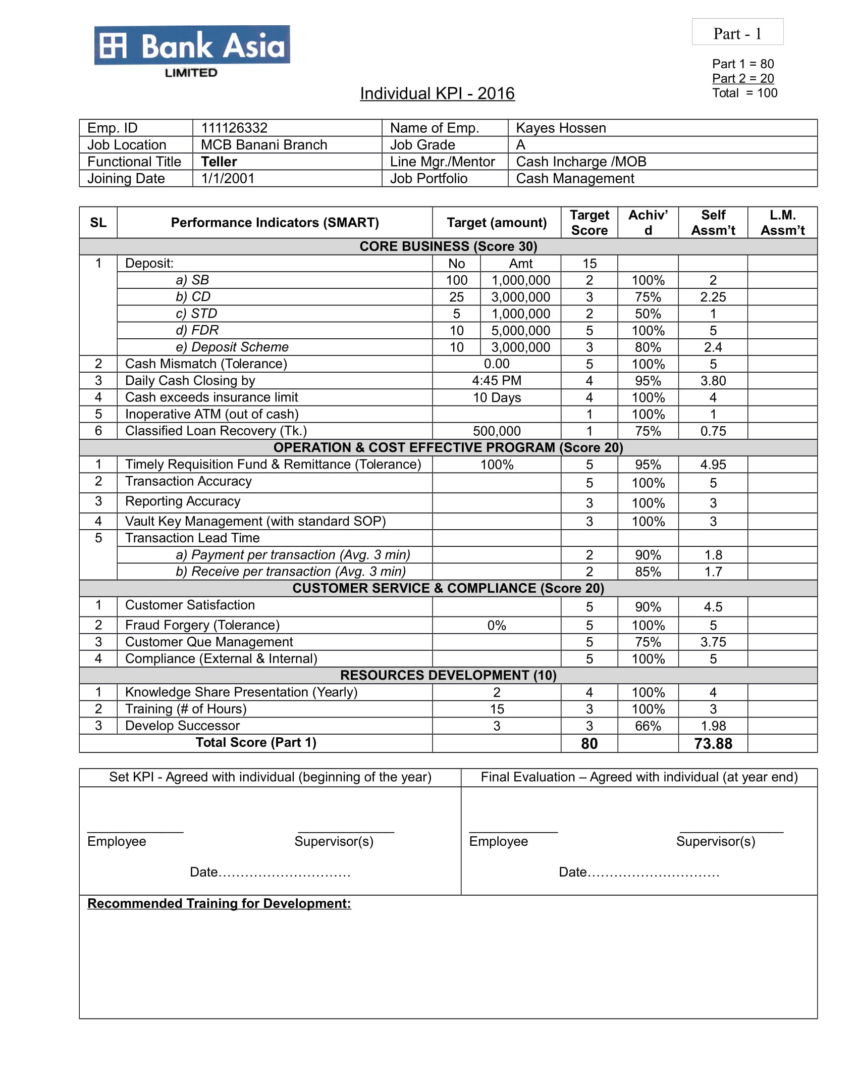

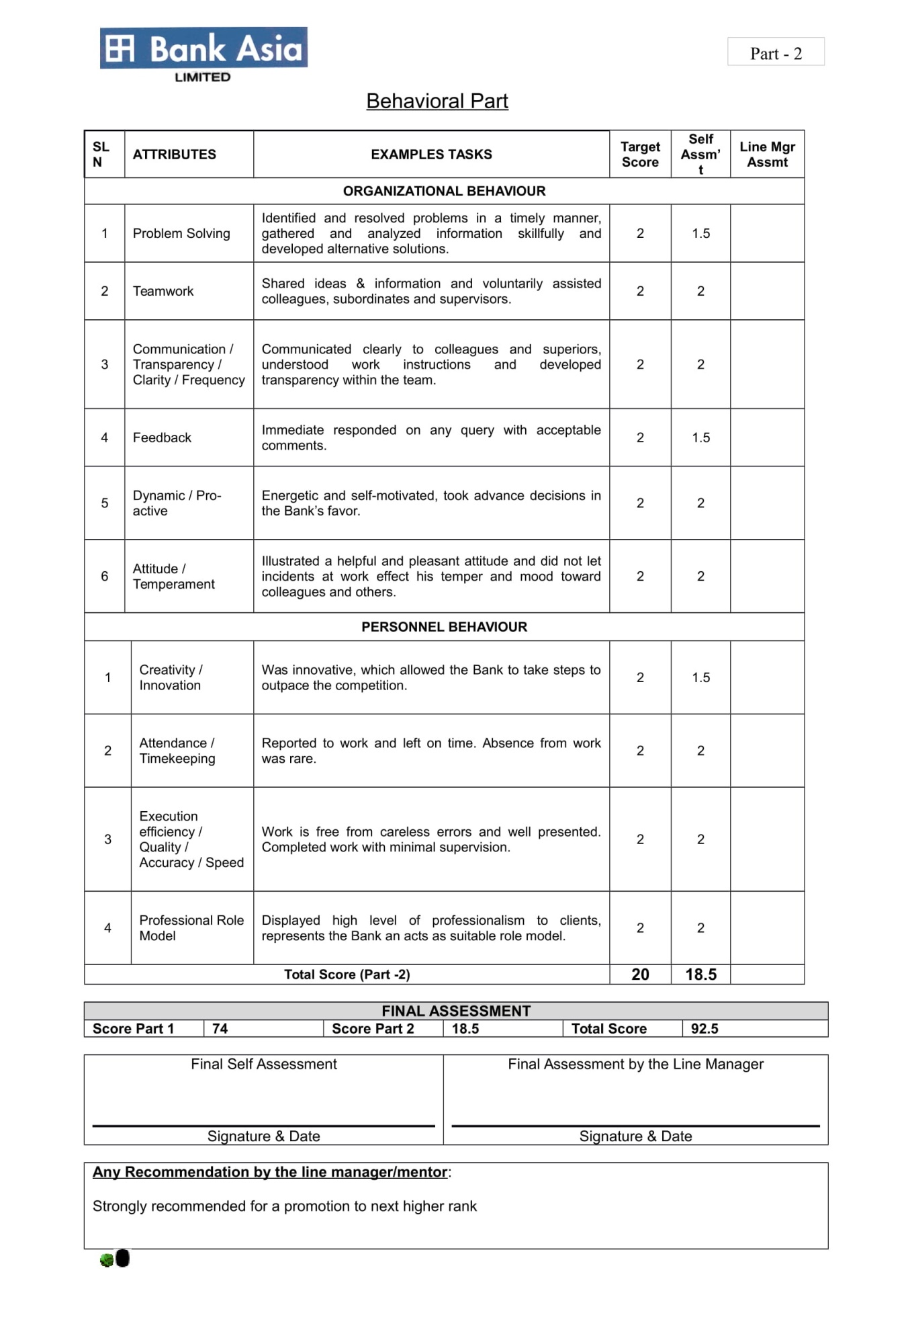

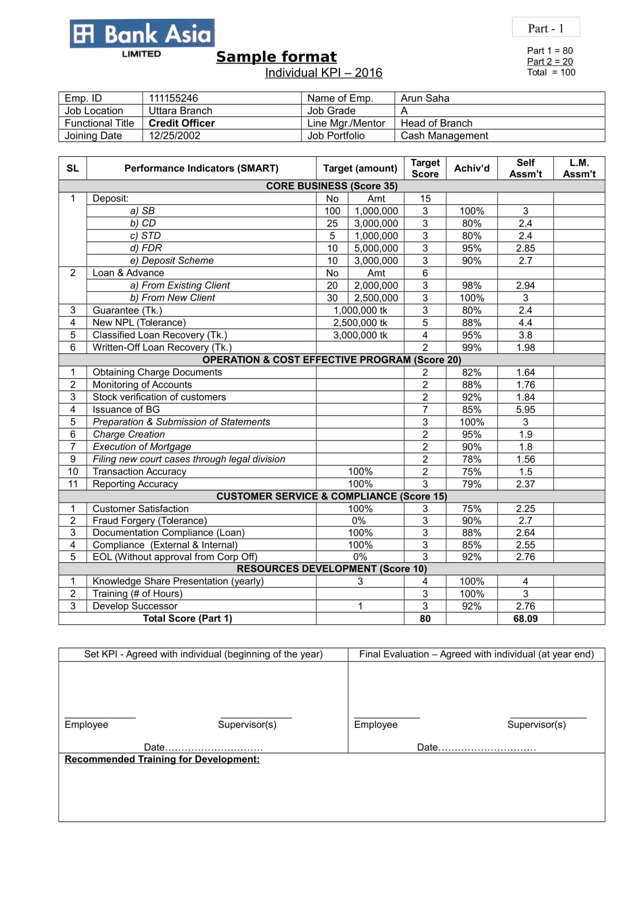

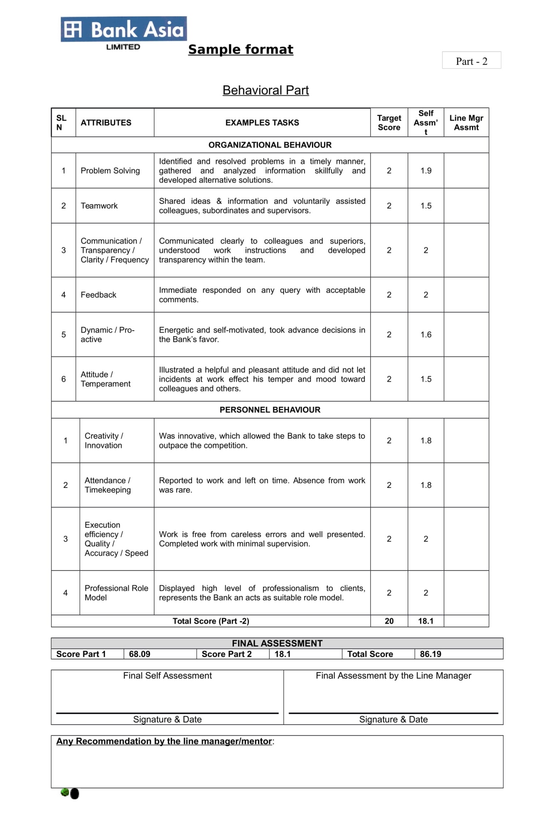

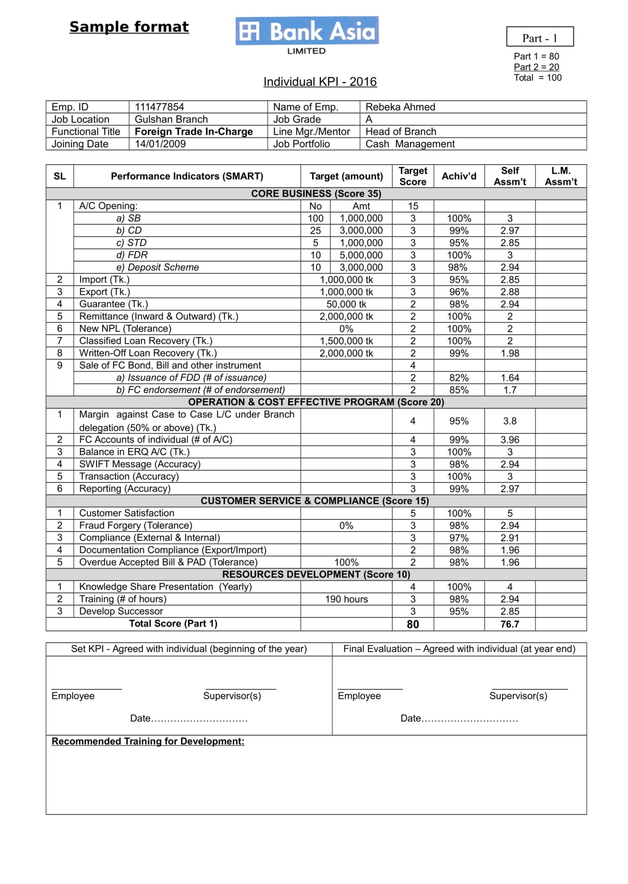

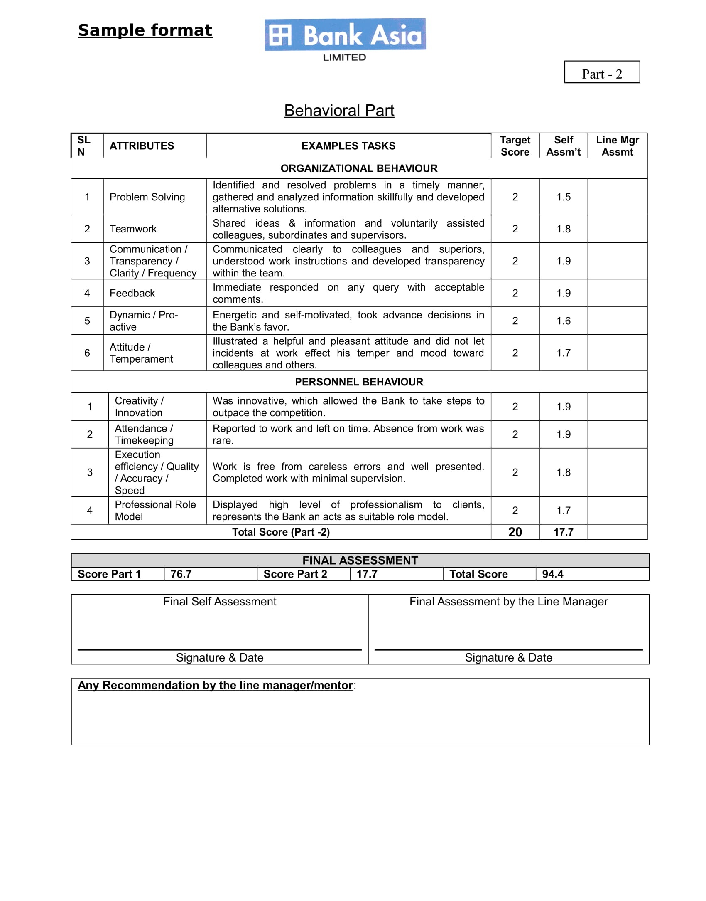

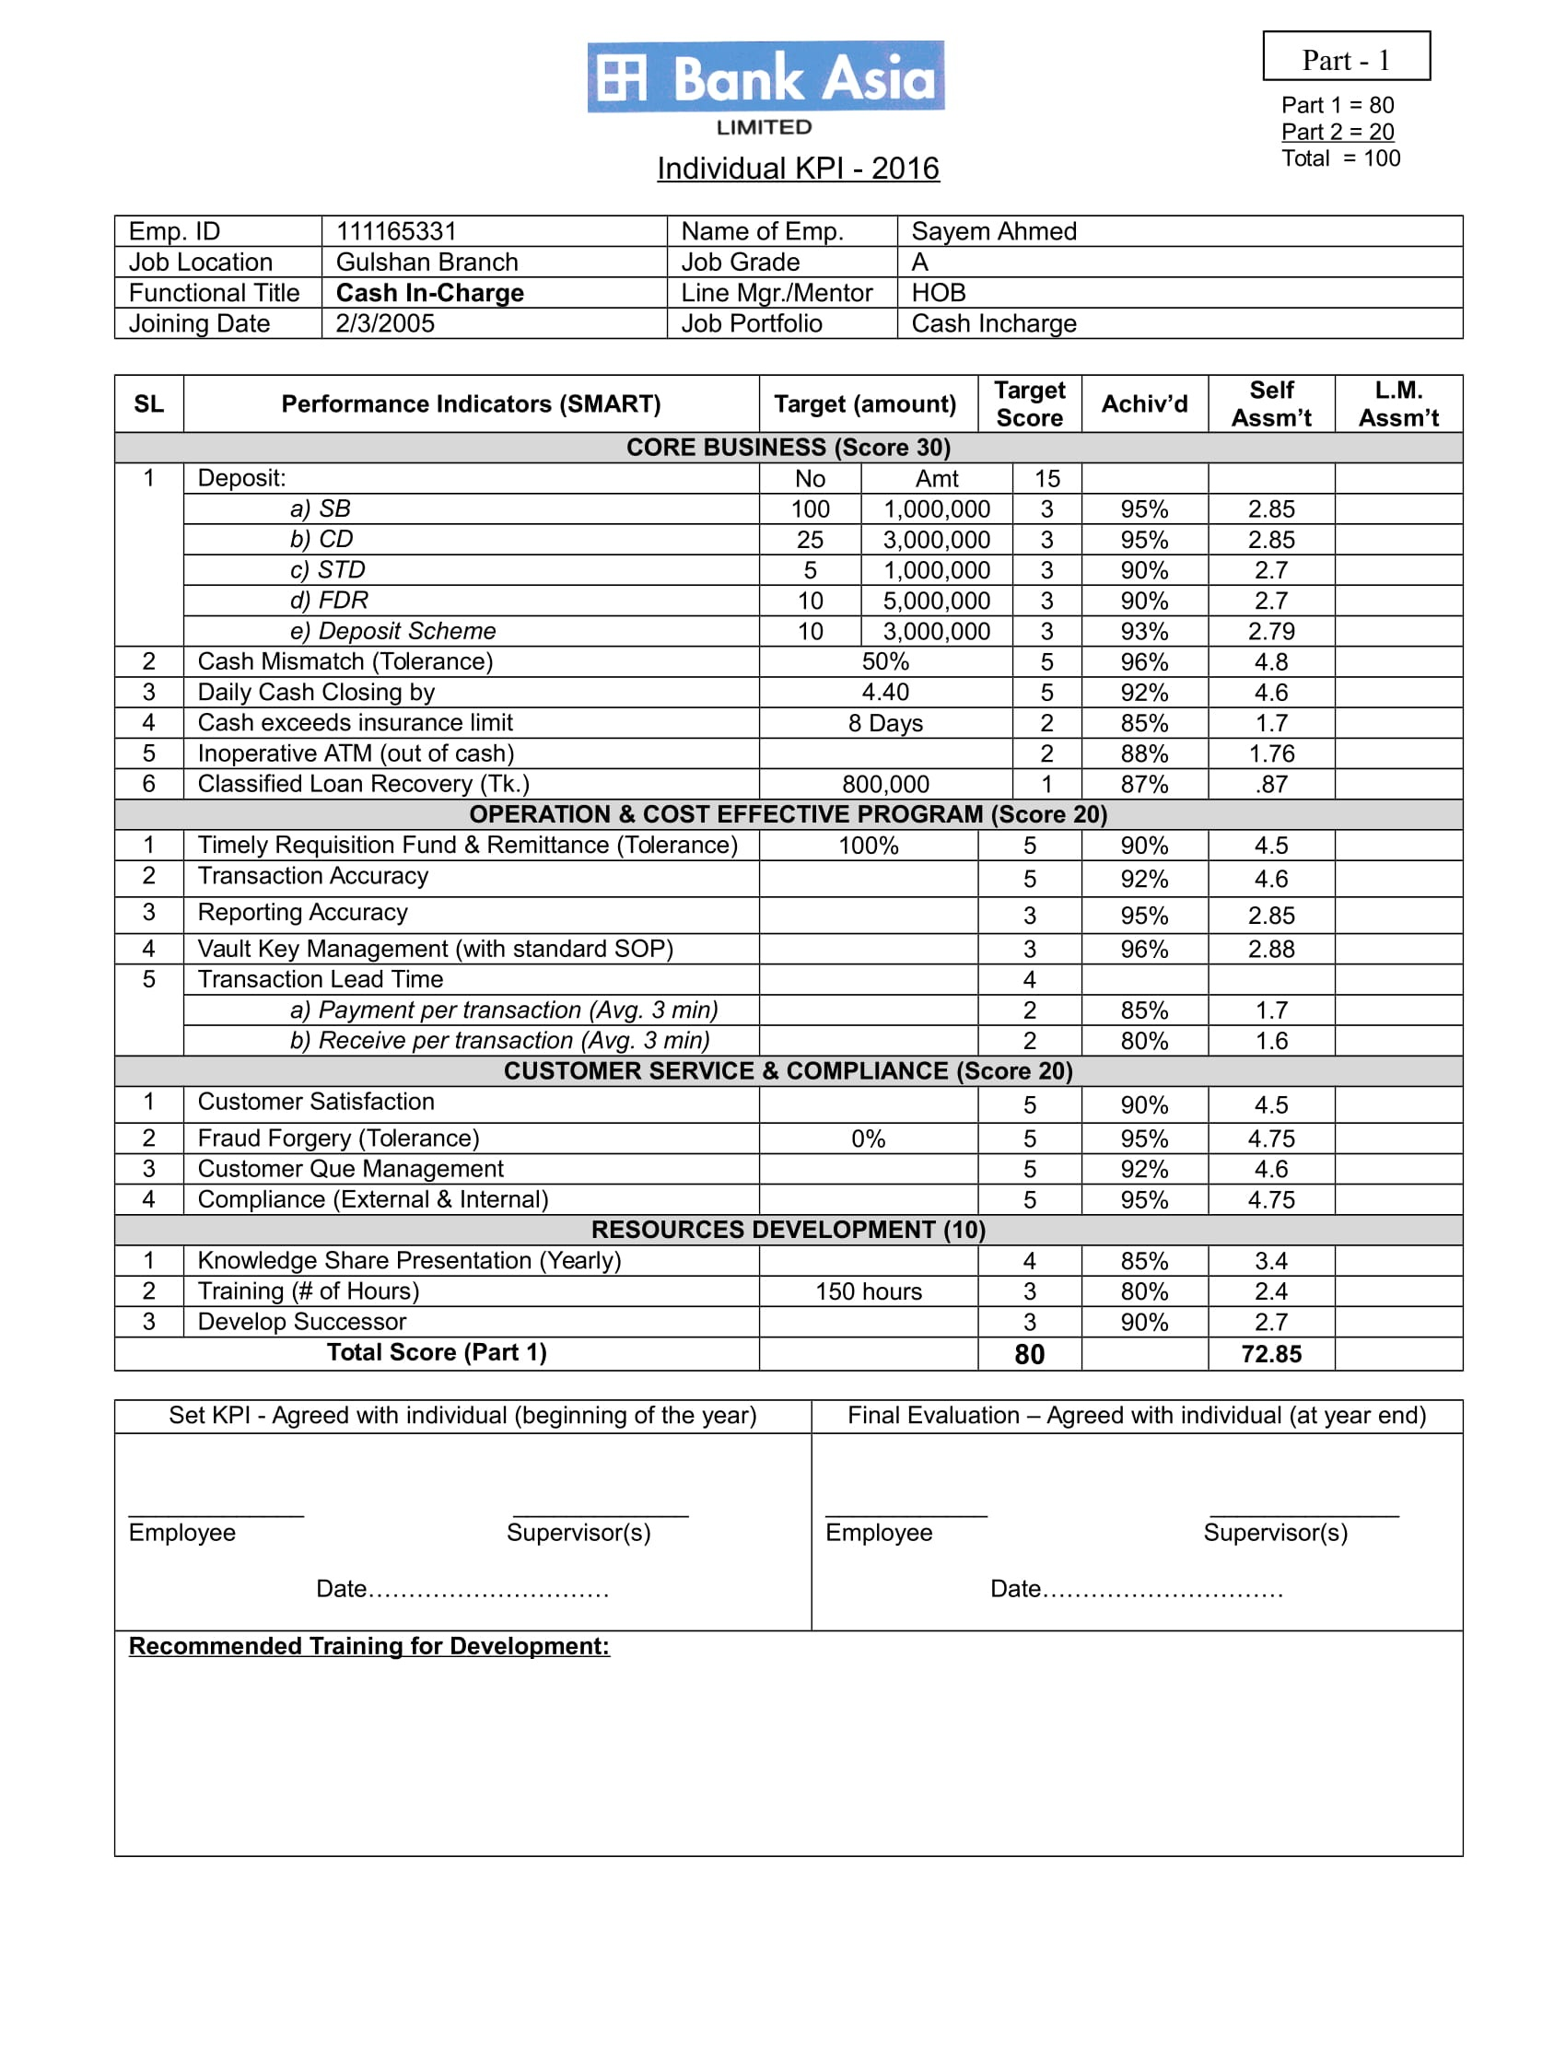

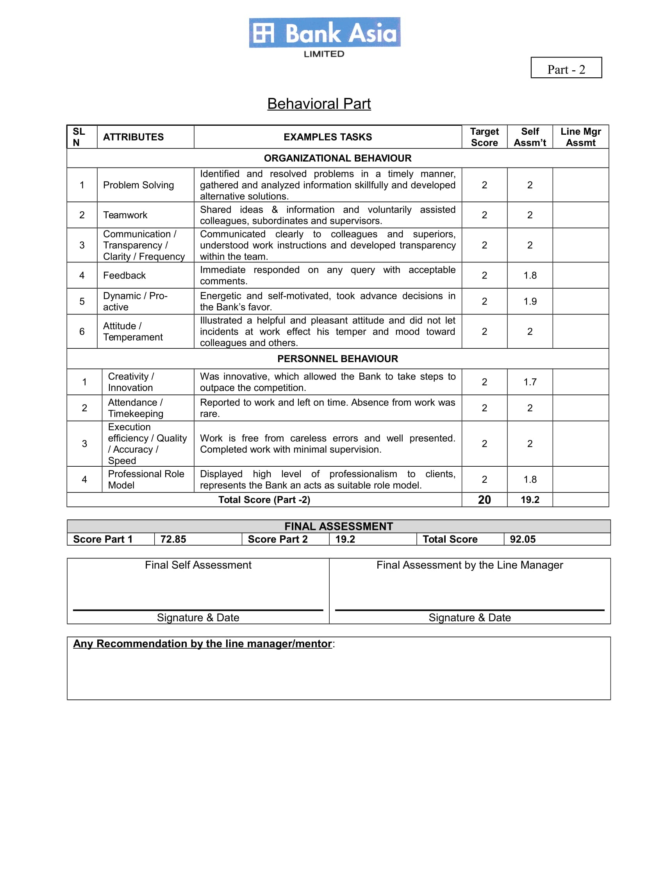

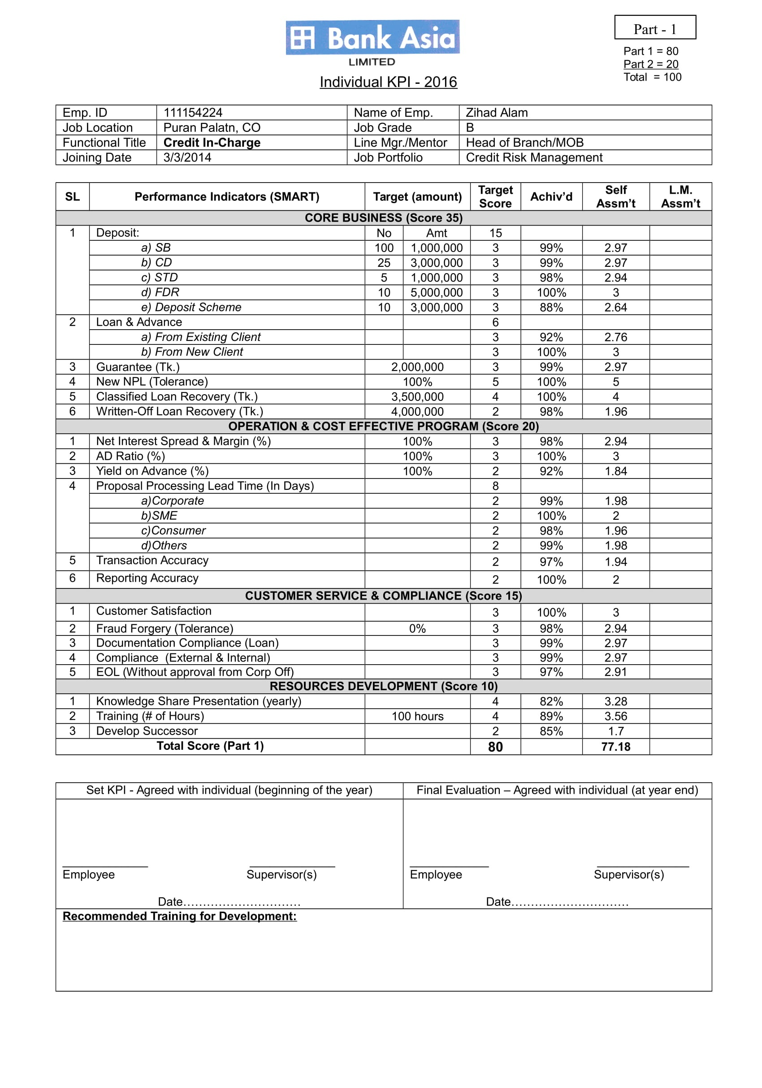

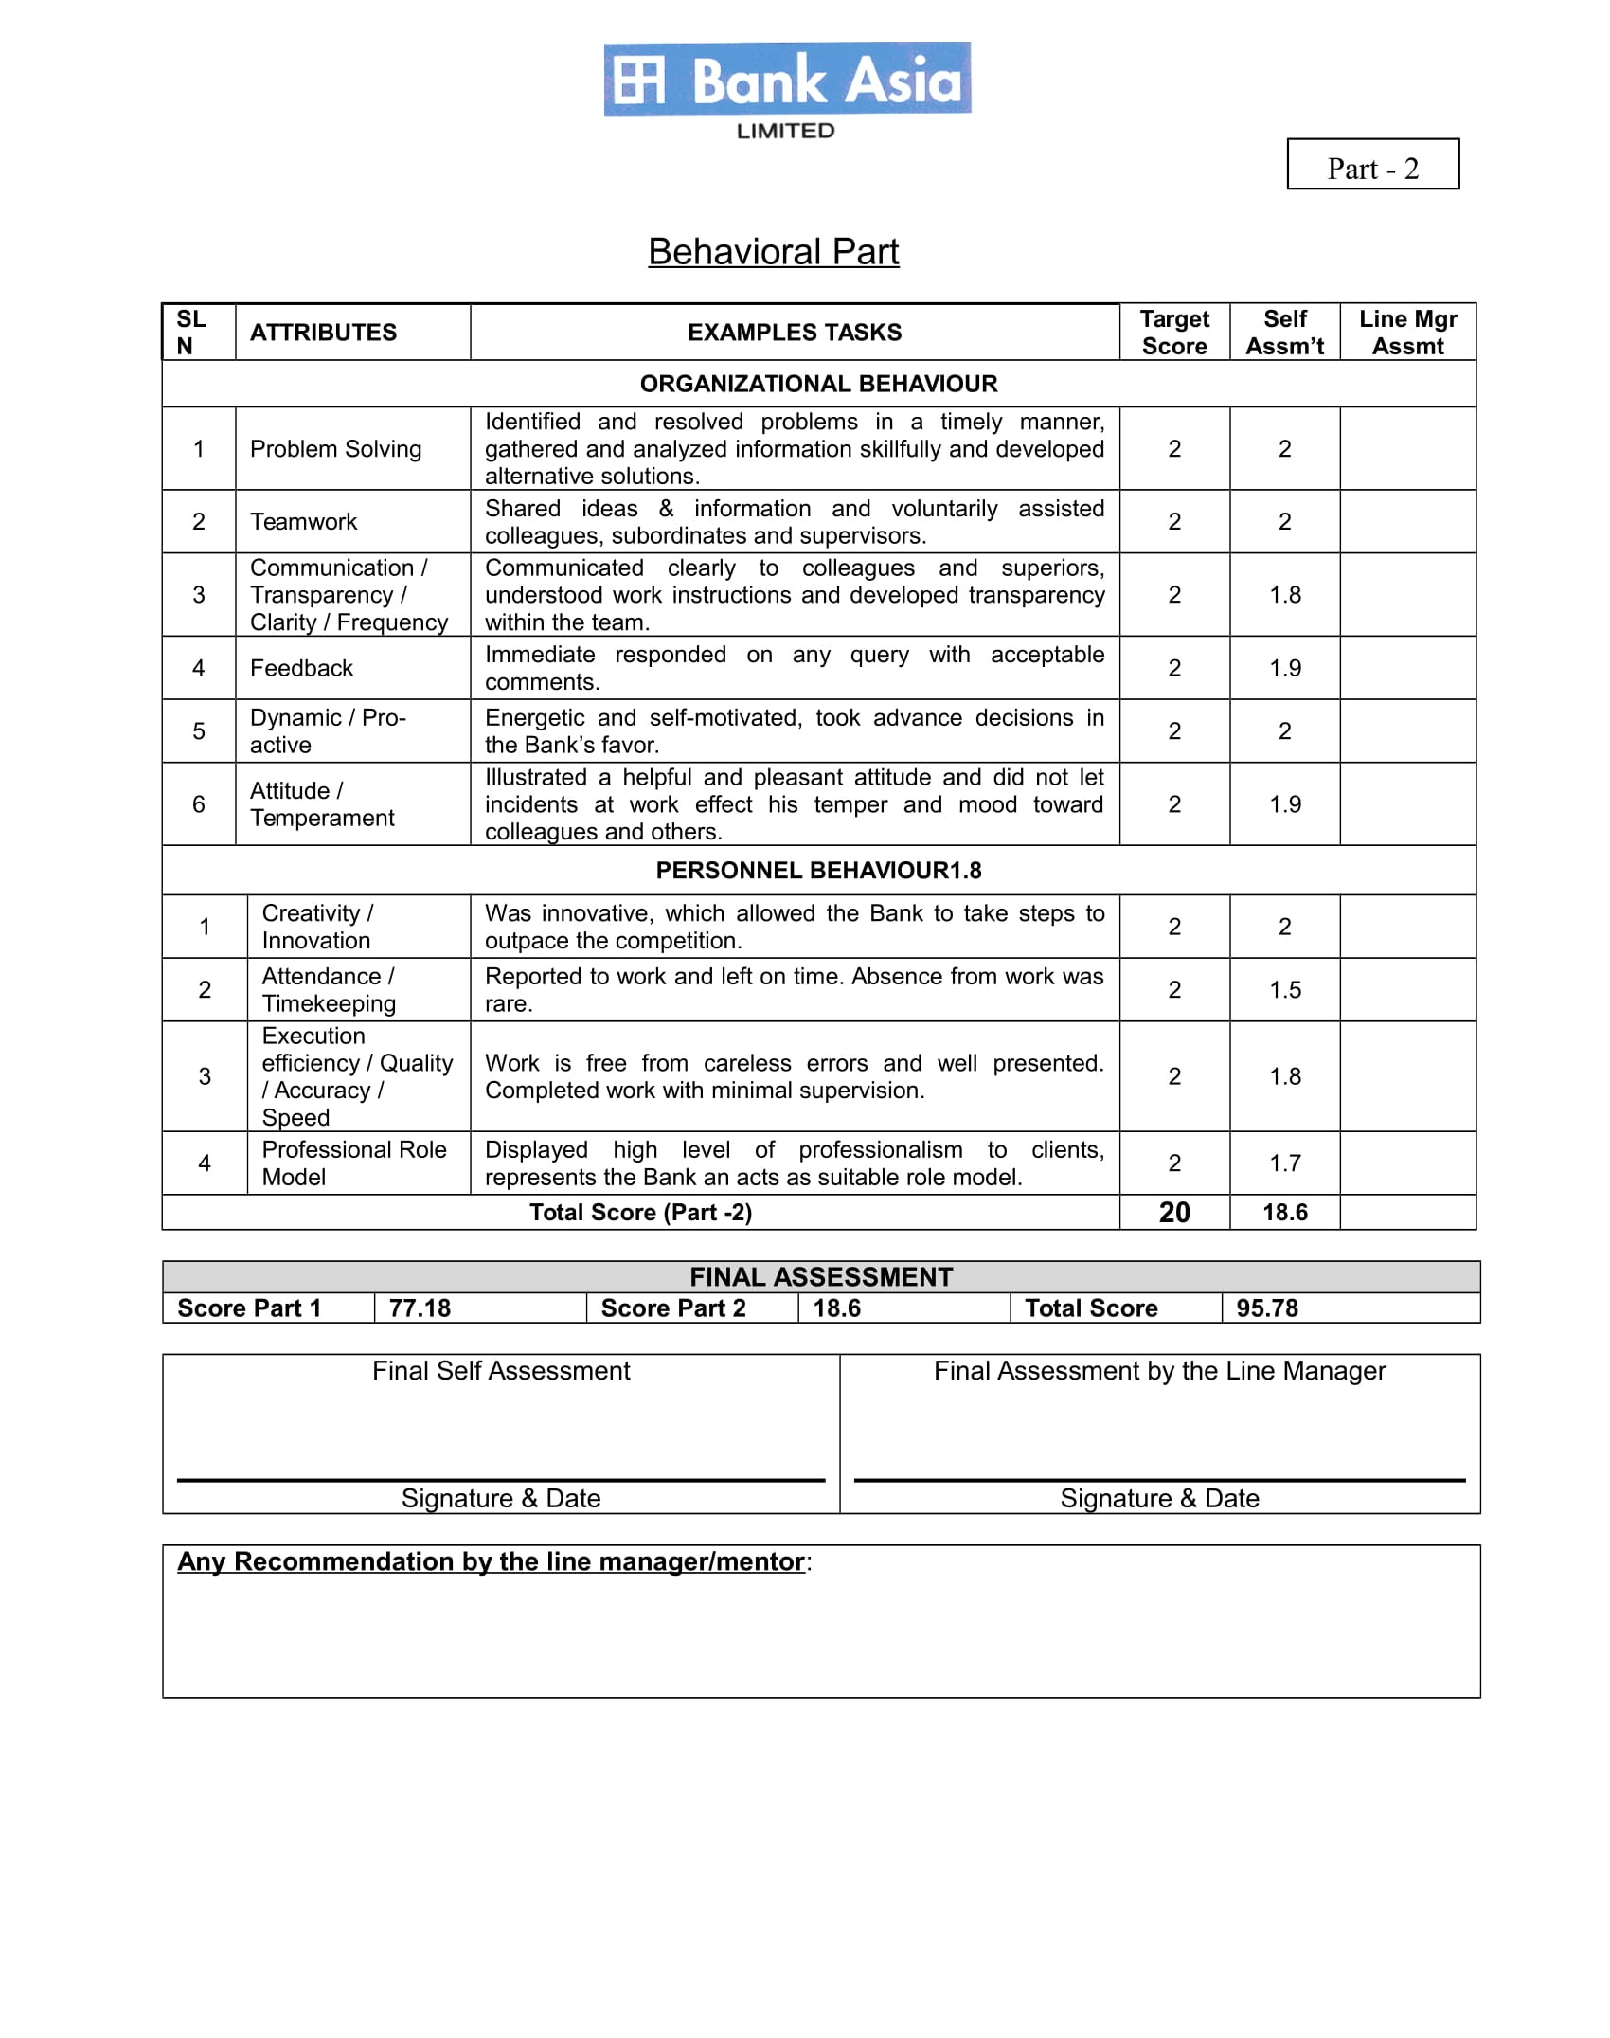

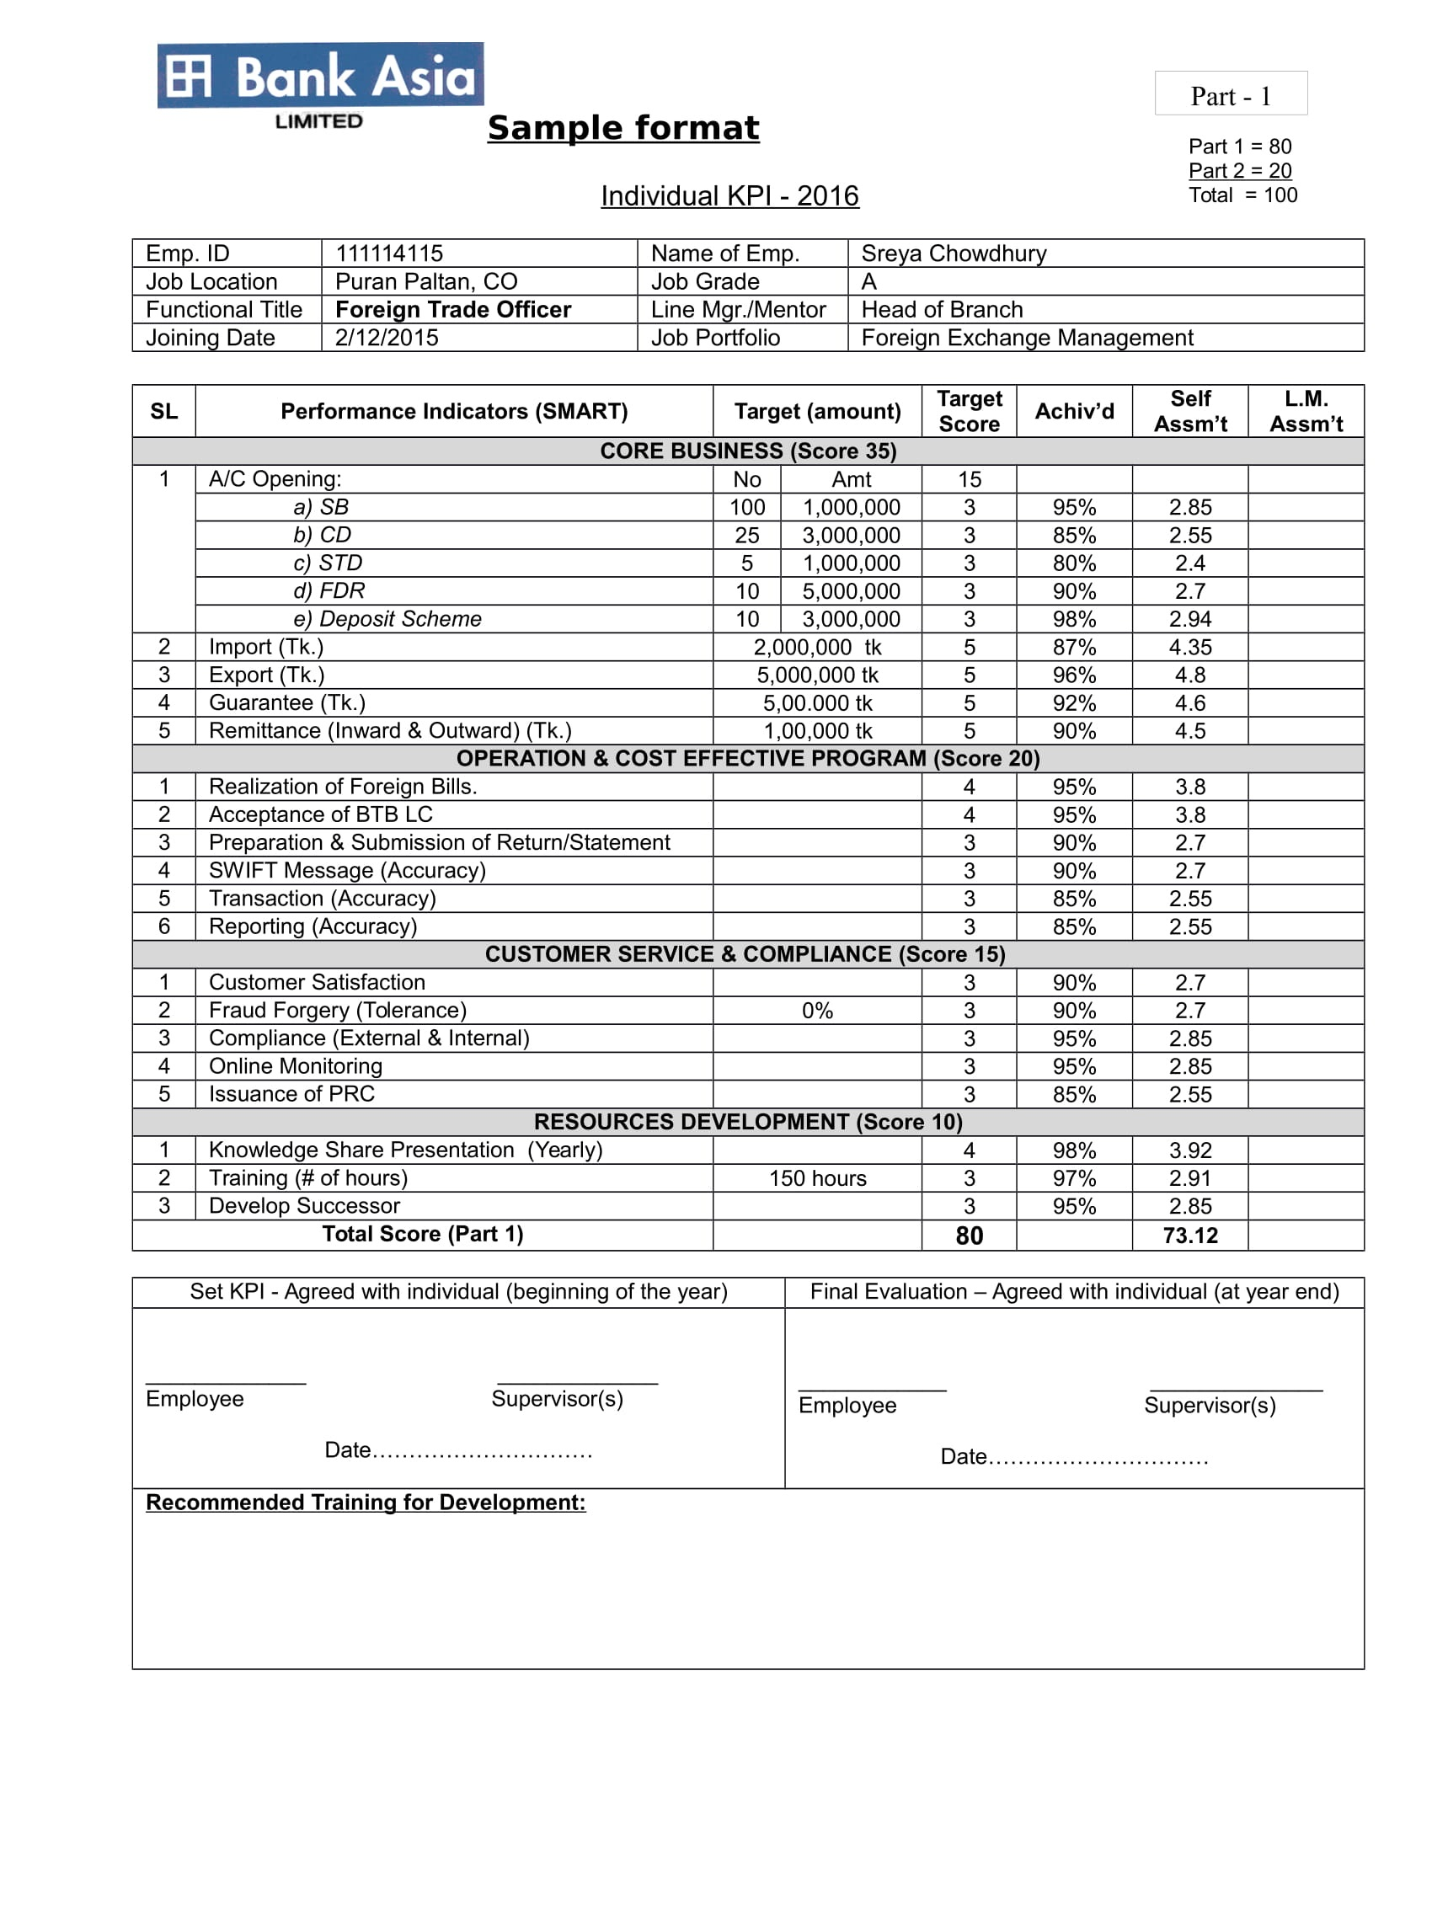

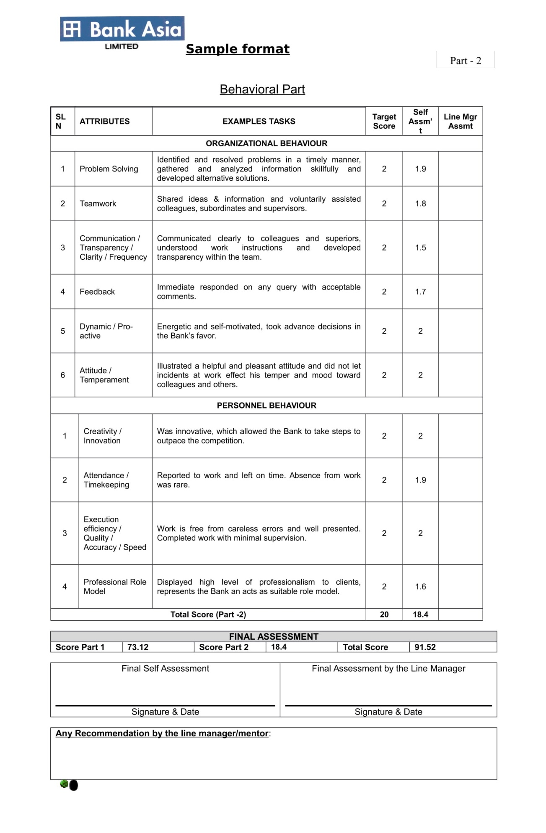

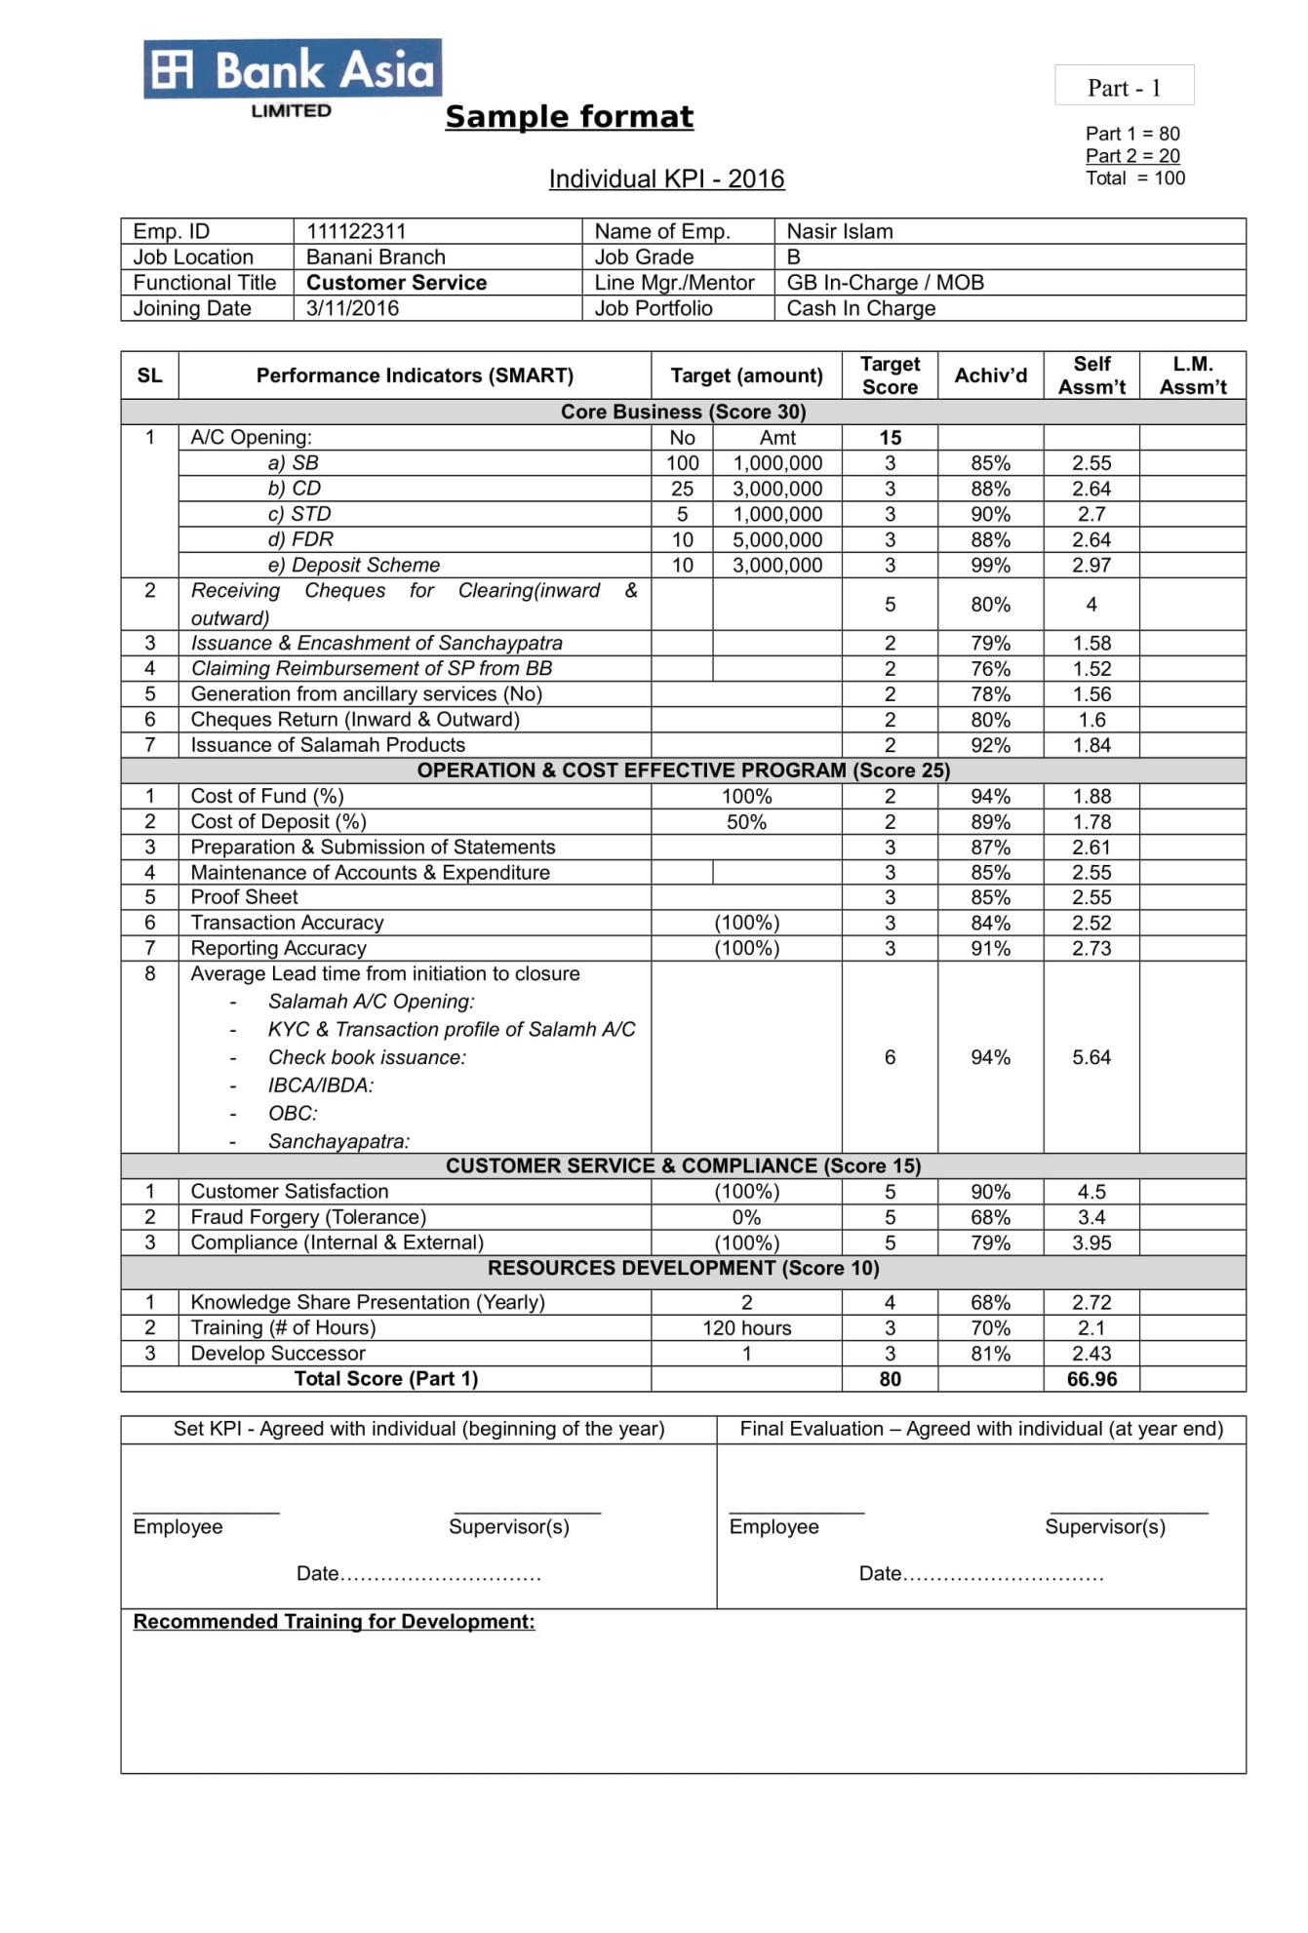

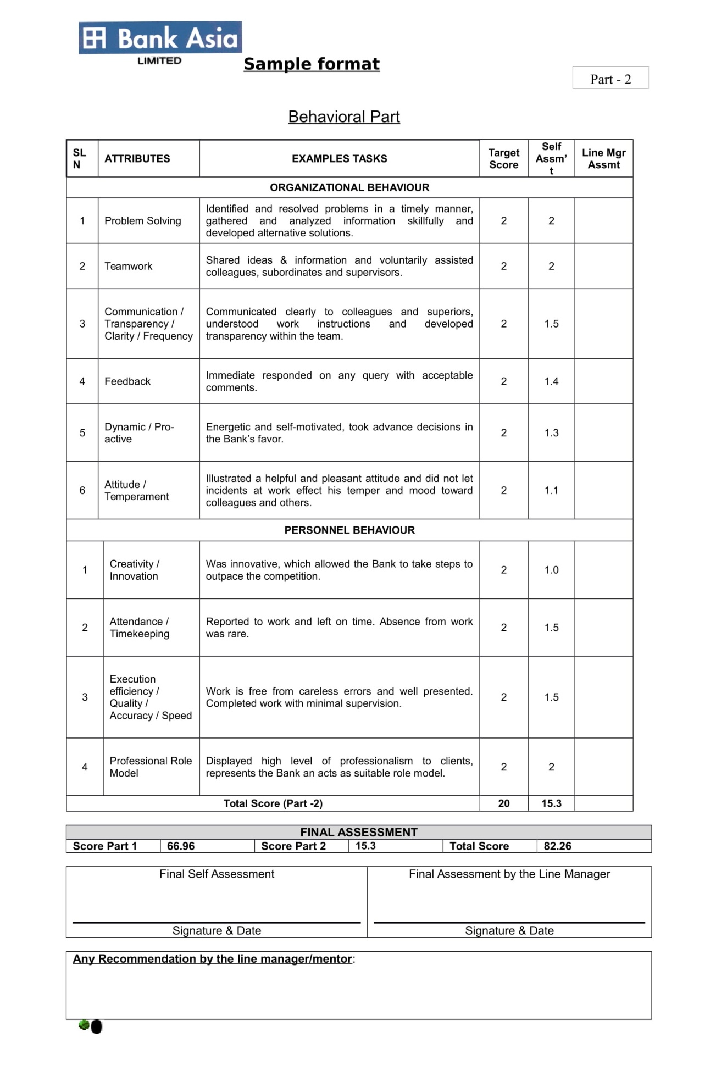

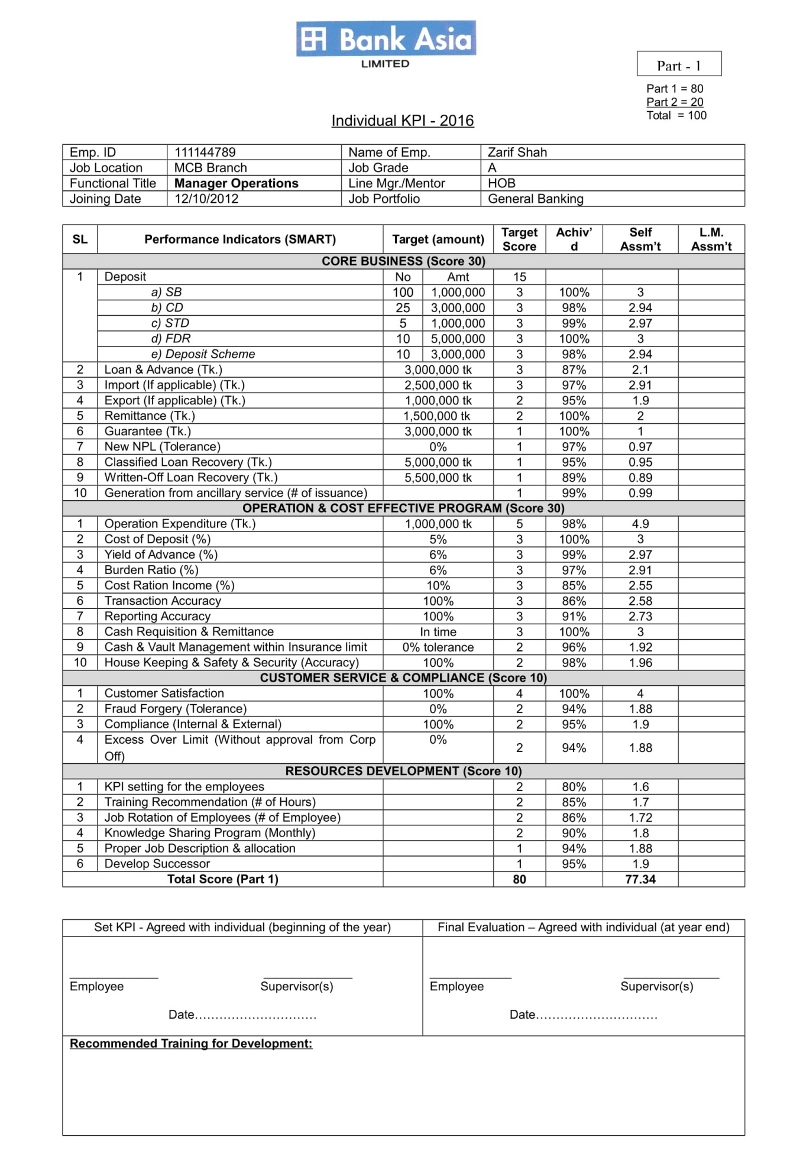

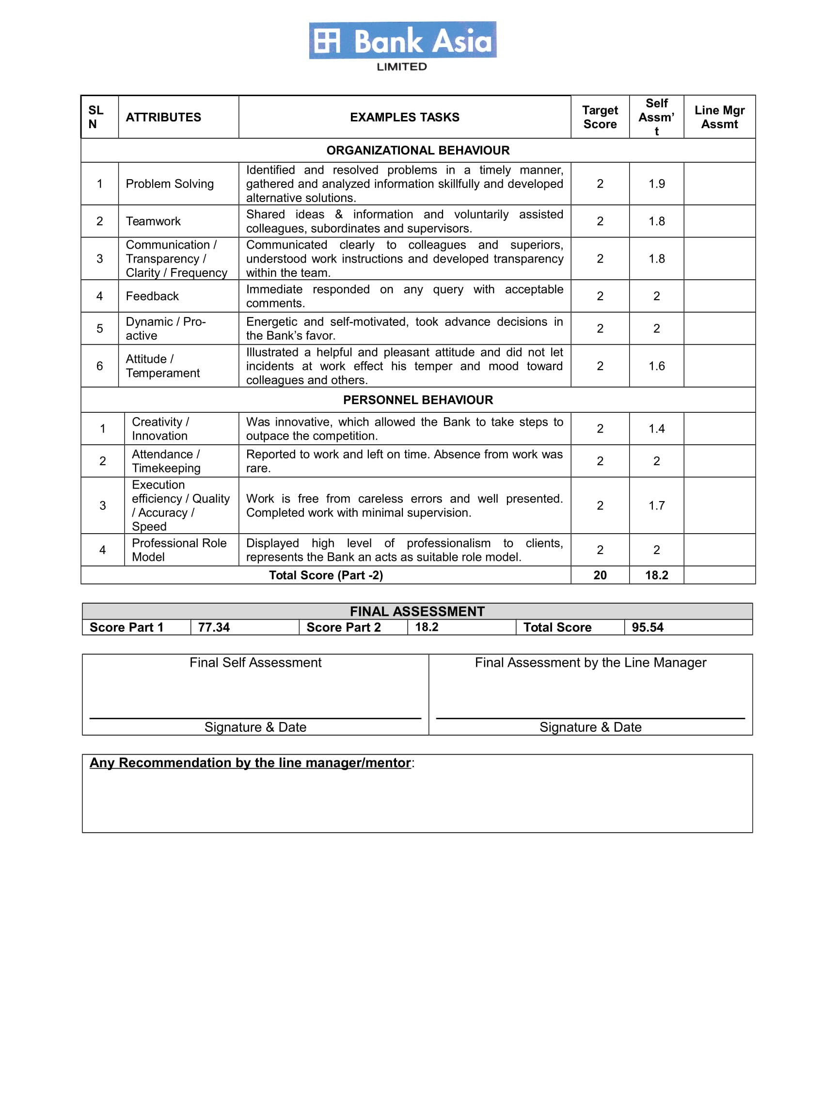

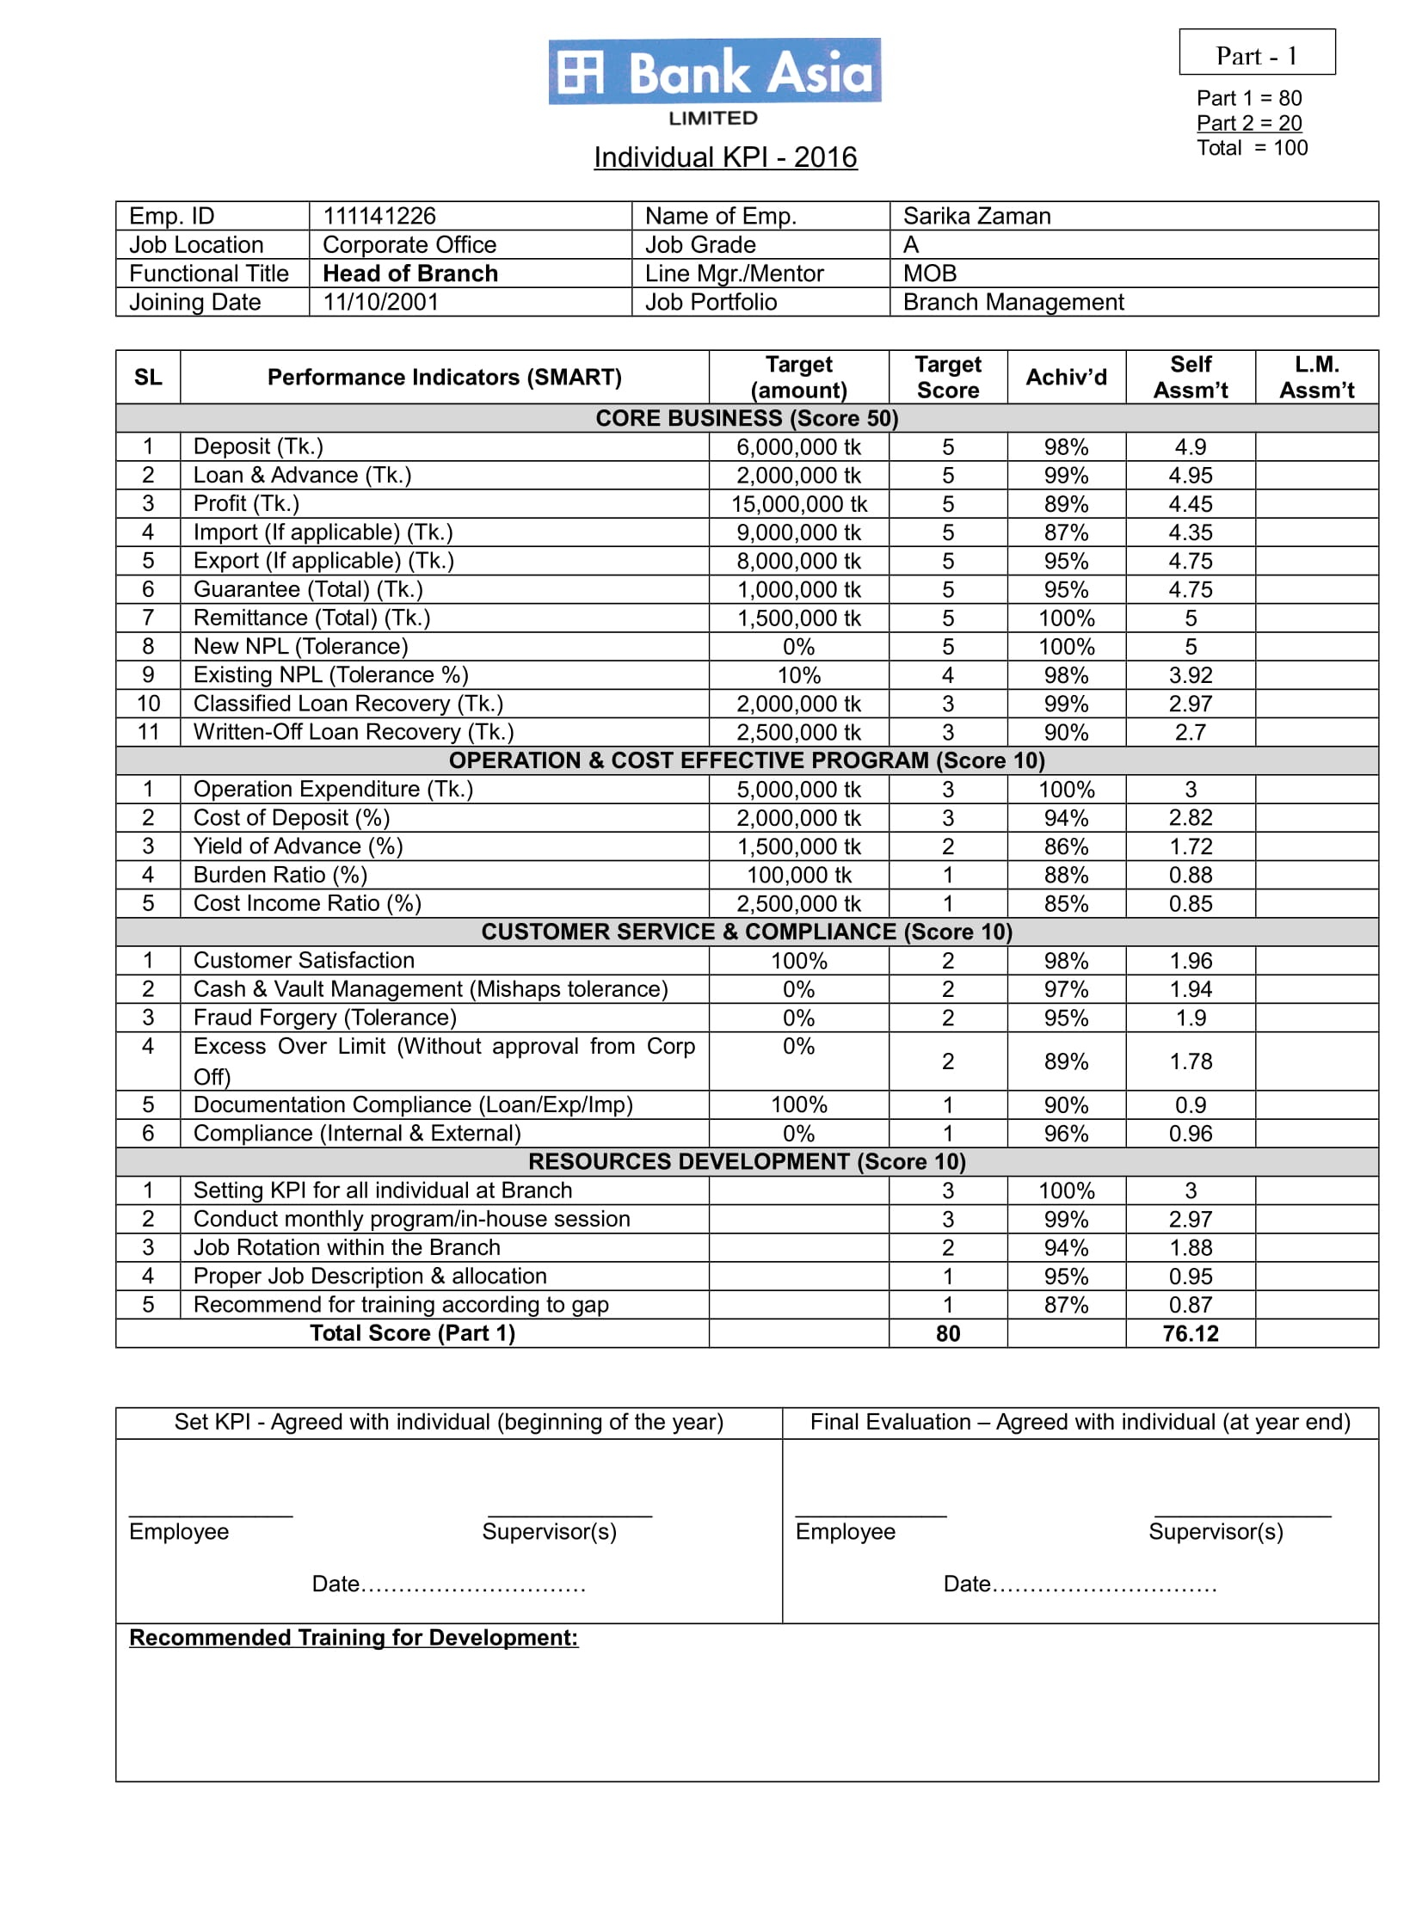

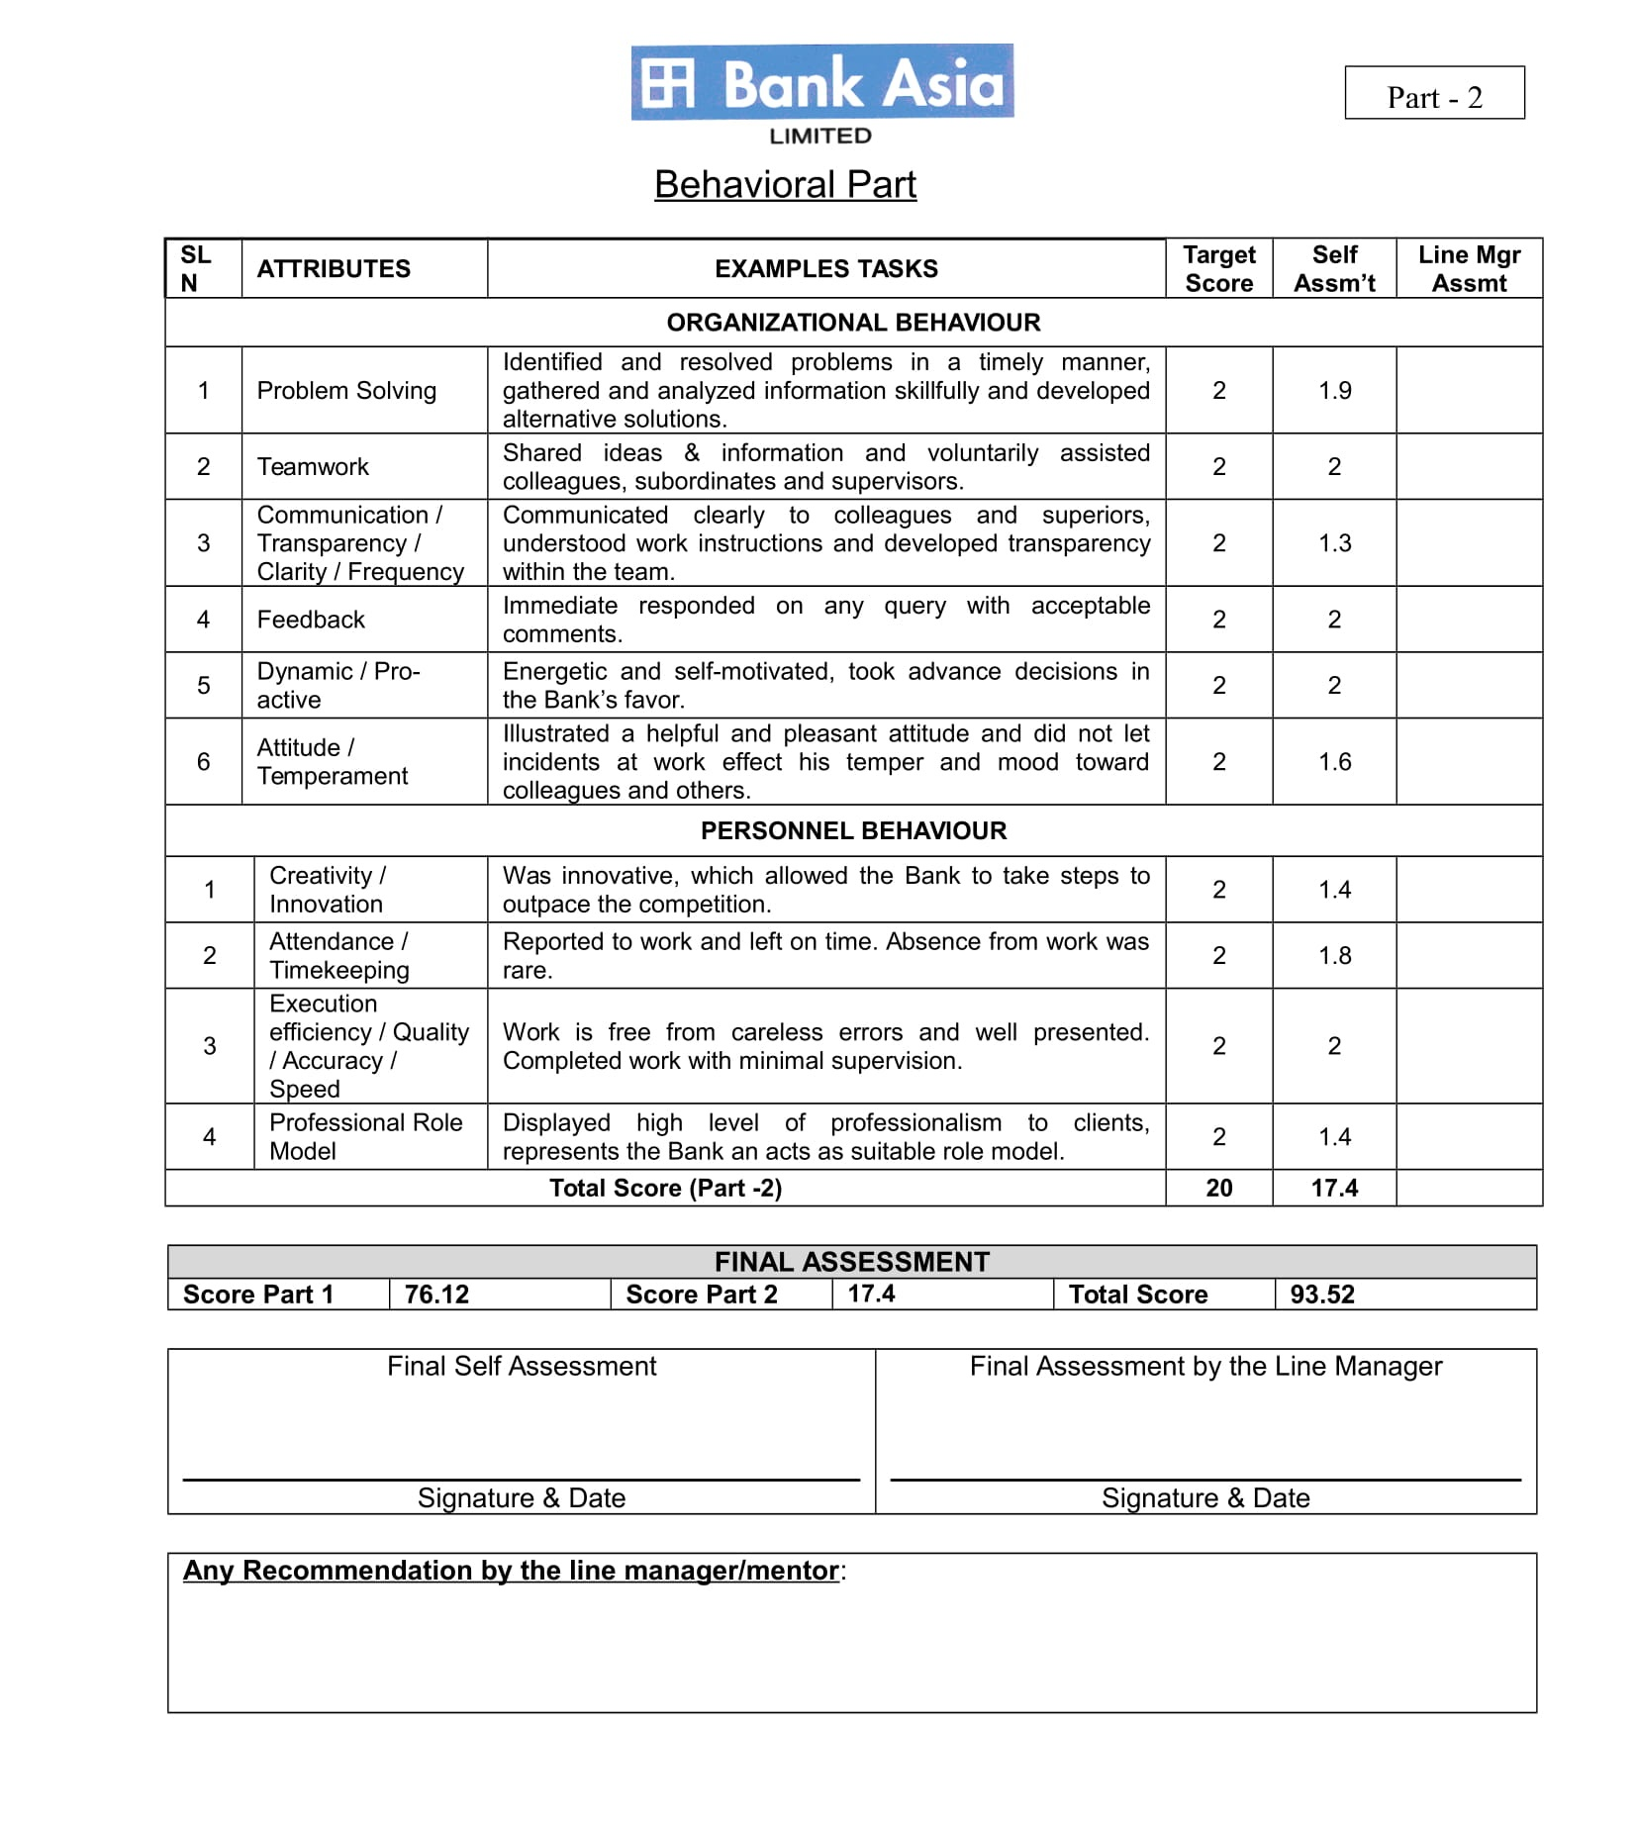

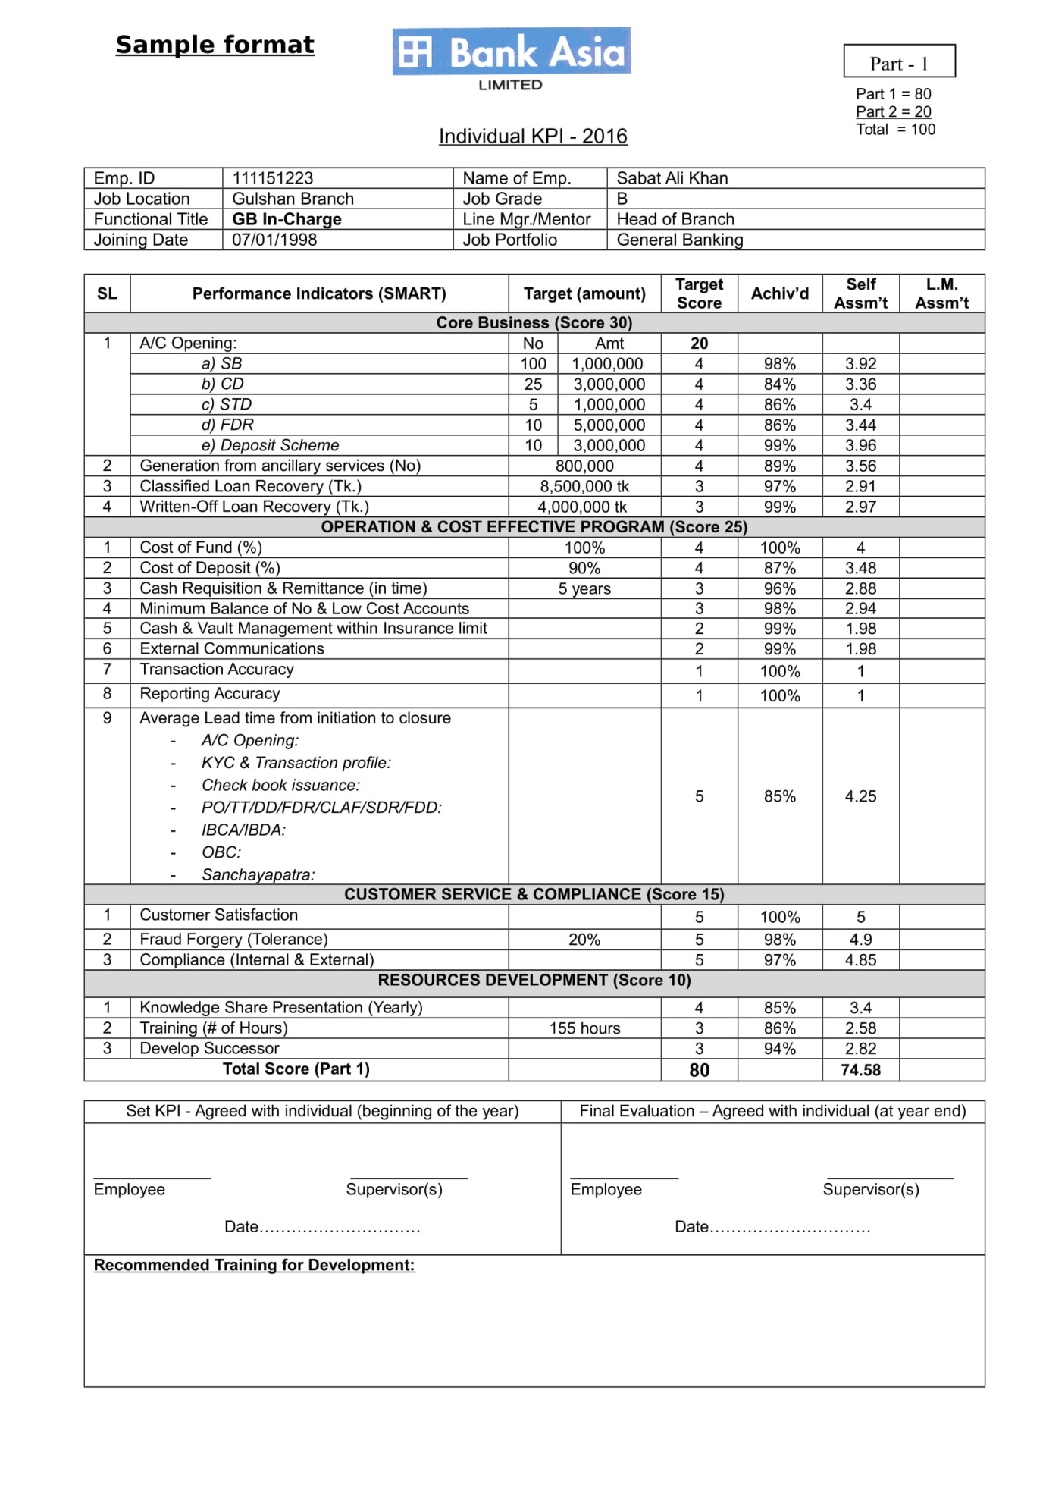

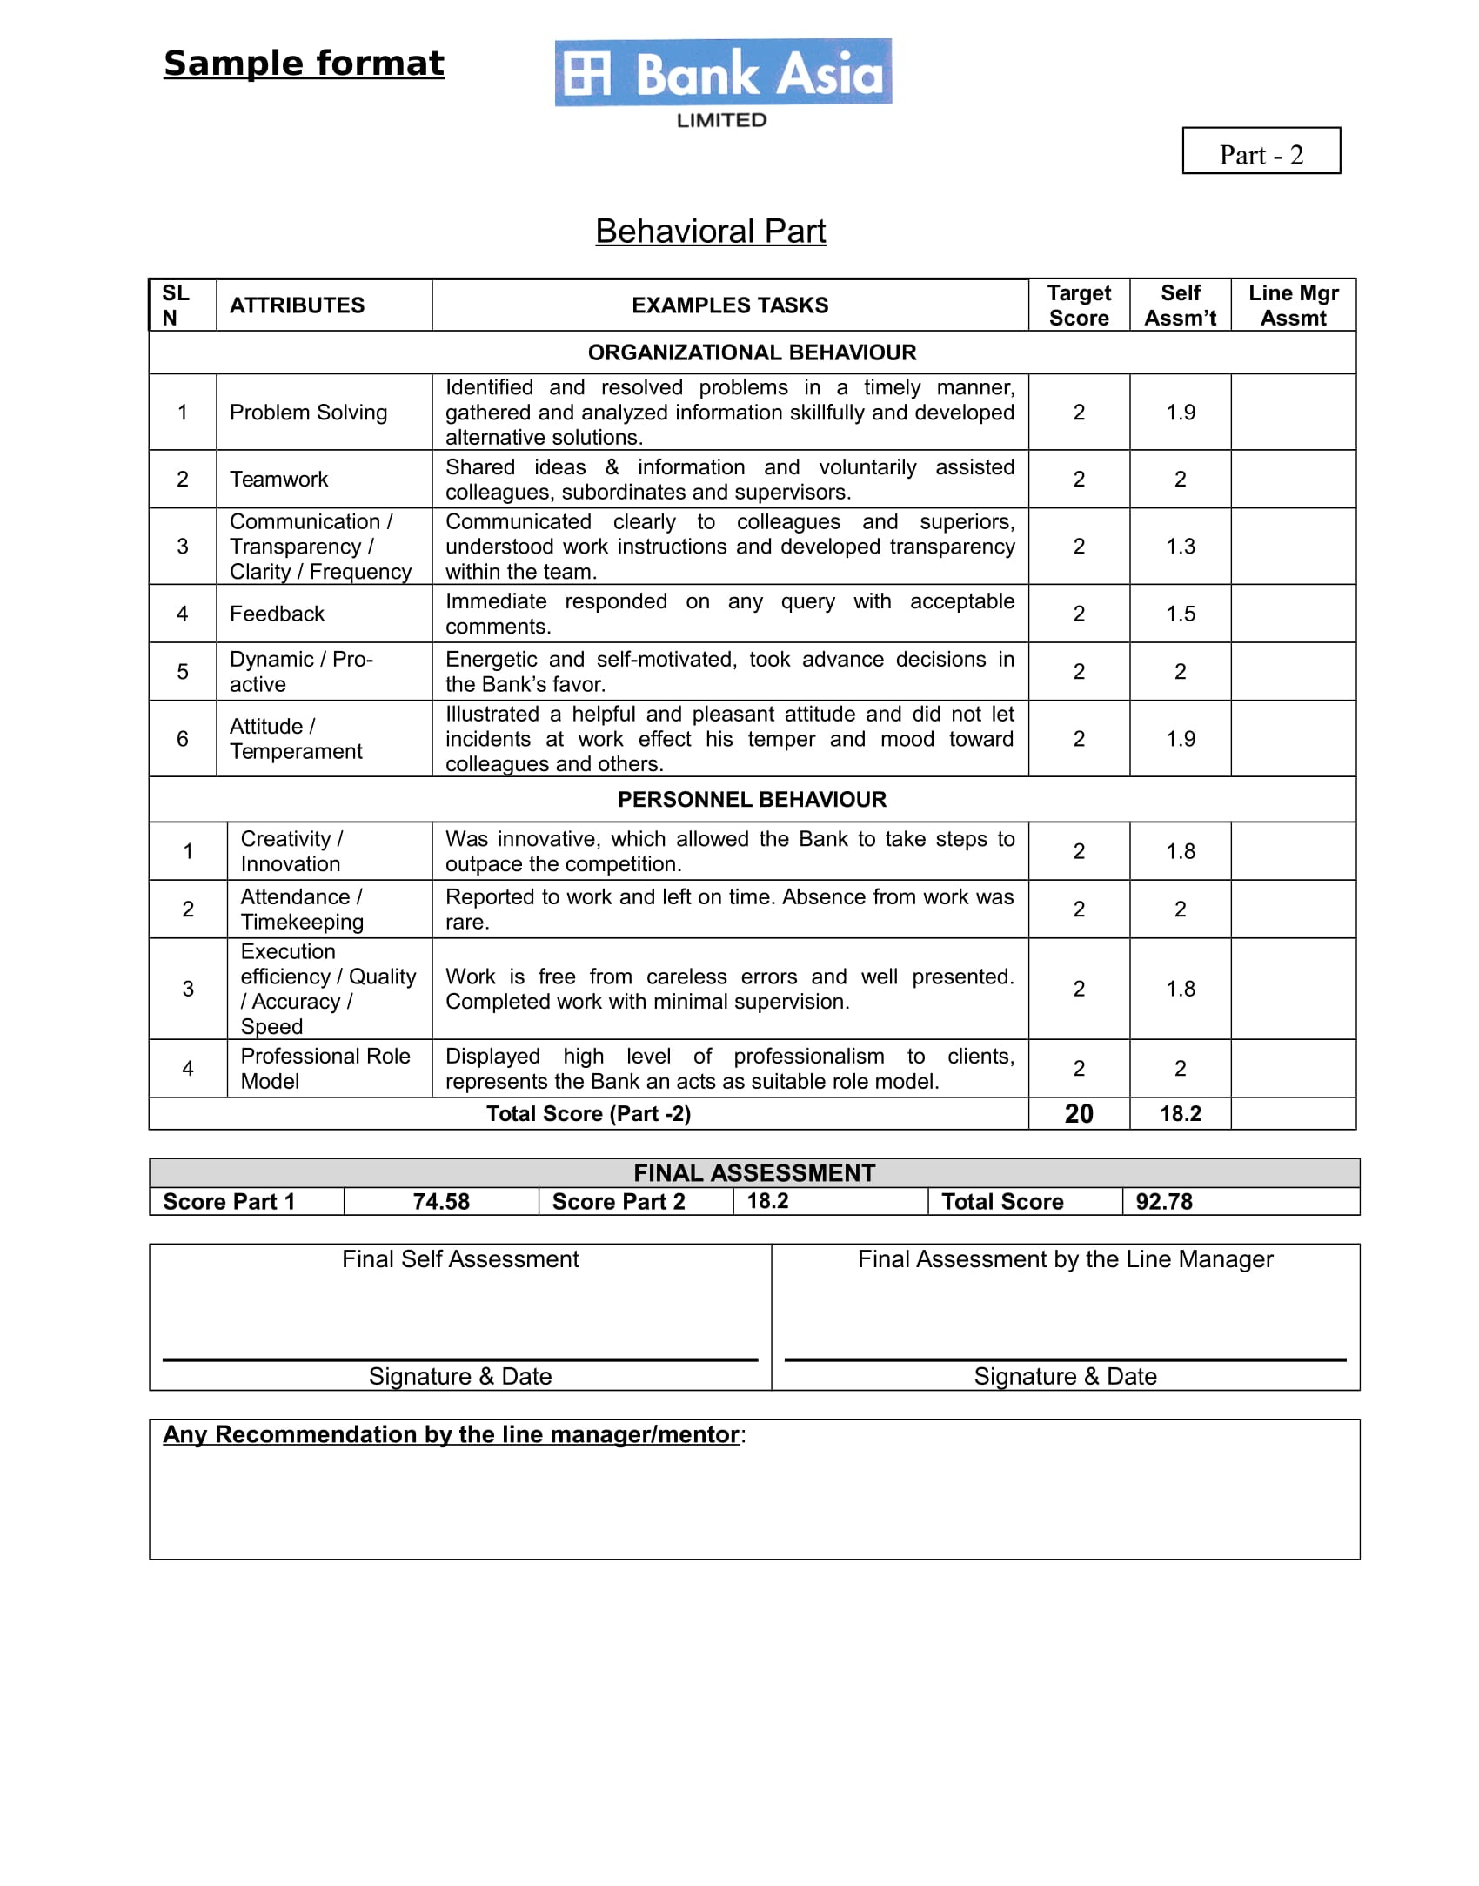

4.2: Graph and Chart

4.3: Interpretations
The above are the individual KPI forms used in Bank Asia Limited, for measuring the performance of the employees according to their job title. There are in total of ten forms with ten different designations as my sample. The KPI forms for all the employees are same but the only difference lies in the contents or in the KRAs that stand for Key Result Area. The ten different forms are for Cash Officer, Credit Officer, FT- in charge, Cash- in charge, Credit- in charge, FT Officer, GB Officer, MOB, HOB, GB-in charge. These are used as my sample, other forms are of the same pattern but the KRAs are different based on the different activities of the employees.
On the top there are some boxes indicating about the employee, like his/her information. That include: employee ID, employee Name, Job Location, Job Grade, Functional Title, Line Manager/ Mentor, Joining Date, and Job Portfolio.
The forms include two parts: the first part in based on “quantitative performance” which carries a total of 80 marks and the second part is “behavioral performance” which carries 20 marks. Finally the marks are added to get the total mark of 100.
Part 1: quantitative performance is divided into 7 columns that are, Serial Number, Performance Indicators (KRA), Target amount, Target Score, Achieved percentage (actual %), Self-Assessment, and Line Manager Assessment. The performance indicators are different for individuals according to their various tasks. For example, the performance indicators or the KRAs for cash officer are different from the performance indicators of credit- in charge because the activities of the positions are different from each other. In the Target Amount column targets are set in the beginning of each year by a conference. For measuring the achievement of these targets the nest column is given, that is target score. In this column different marks are set to see who gets how much score for each of the KRAs he/she is assigned to. To be more specific on the scores this target score assigns the standardized numbers to get the actual score one gets. The next column defines the Actual Achievement in terms of percentage. Here, their actual achievement is compared to the target amount and shown in percentage form. This actual % helps to get the actual score by multiplying the target score with the actual % an employee has achieved. In other words it can be shown as: Target Score * Achieved % = Actual Score. This result of actual score is shown in the next column that is “Self-Assessment”. All the employees get the opportunity for self-assessment. After the employees are done with their self-assessment their immediate line manager then assesses them in the last column. But due to confidentiality of information this column could not be filled.
Part 2: behavioral performance is the second part of the form which carries the other 20 marks and includes six columns. These are, Serial no, Attributes, Example Tasks, Target Score, Self-Assessment, Line Manager Assessment. The target score is set at the beginning of each year, by providing 2 marks for each KRAs and summing up to 20 marks. And by the self-assessment column the actual marks that they got can be seen. Finally the line manager can change the marks of self-assessment by his perspective of how well he/she knows the employees as it cannot be measured accurately, it is totally qualitative in nature.
Finally, after the calculation of both the first part and the second part or Quantitative performance and behavioral performance the final score is calculated by summing up the total marks gained out of 80 in the first part and the total marks gained out of 20 in the second part. The final mark will be out of 100. This is the KPI score for each employee which helps to measure the performance of the individual employee.
In the forms there are some calculations based on assumption. The names used for employees are imaginary due to the confidentiality of the KPI information of BAL.

Chapter-5: Recommendations and Conclusion

Recommendations:

- KPI is not a key indicator of performance. Company measures performance through some indicators which are important, but they are not the key performance indicators. A company might have to measure many critical aspects to get an accurate result. But mostly only the usual indicators are used to measure the performance. For this problem the performance of the company should not be based only on KPI but also on other factors like critical situation, culture, current market position etc.

- KPI only measures the average performance of an individual not a team. But if a team execute a process or a set of process, it will be hard to measure their performance with general KPI theories. Moreover, in a team an individual might be a specialist in a particular task, as a result the output of the team work will be good. But in that case KPI will fail to provide effective result. For this reason KPI should also be used for team performance rather than individual performance for a specific outcome.

- Companies prepare KPIs according to their departments and designations. Every designated employee does different work. So, they need to prepare different measurement techniques. As a result too many KPI charts make a mess. Moreover, KPIs are too submitted within a month or two, which get very difficult to follow if there are too many KPIs. For this reason, there should be different KPIs for only different set of tasks.

- Sometimes KPI doesn’t provide a desire result or the employees might not believe the standard range is well enough which the KPI results are compared, it might demotivate all the employees. Rather improving their performance to achieve the standard result, they will believe that it is impossible to reach there and the KPI will fail. For this problem, the KPI standard should be set based on employee’s productivity.

- Unorganized KPI can be a threat. If the KPI gets to lengthy and vague the result will completely be the opposite of expectation. So KPI should always be clean and specific. The KRAs should be organized and related to their tasks.

- KPIs are sensitive in terms of reference. Sometimes data related to KPI cannot be collected for some sensitive reasons, i.e. if an employee want to publish something for which he need a sign from his superior, he might not get that in time because of the problems of his superior. As a result the employee will get the blame as per as the result of KPI. So it is to be recommended that, enough time should be provided for the accomplishment of a task and also proper source should be justified.

- Standards of KPI might change; it is not stable all the time. The productivity of an organization might vary every single month, i.e. sometimes there are more employees in leave on day, sometimes there is less. As the performance is measured to the usual standard, the KPI will fail to provide the accurate result. This problem can be solved if KPI measurement is done at least once in every week due to the instability of performance of each employee.

- KPIs are usually done annually but a company’s performance doesn’t change every year, it changes every day. So, to get the accurate result KPIs should be done every day which is also very difficult.

Conclusion:
KPIs help an association, division, group or supervisor respond in a flash to any occasions that may affect the business. Furthermore, these markers can be utilized to set focuses all through the business to convey the key objectives. KPIs help organizations to concentrate on a shared objective and guarantee that it is adjusted inside the organization. Thus it is imperative that organizations recognize what precisely to quantify. When composing or building up a KPI, we have to think about how that KPI identifies with a particular business result or target. KPIs should be altered to the business circumstance, and ought to be produced to help accomplish the objectives. Managing an account KPIs and measurements can be executed all through any bank to gauge the execution of its representatives, its items, and its adherence to industry controls (for example consistence). Substantial business banks offer a wide scope of items and administrations to the clients. Diverse KPIs must be characterized and followed at different regions all through the bank – for individual items (for example sparing plans, business loaning, retail loaning and so on.), for back office tasks (e.g., call focus, treasury, global division, and so on.) and for overhead capacities (e.g., accounts, fund, HR, ICT, and so on.). Bank Asia contains youthful, vivacious, proactive, energetic, result situated people who maintain the estimations of the association by following the core values of Bank Asia by being inventive, open, deferential, moral, straightforward, enthusiastic and straightforward. Execution Management System (PMS) bolsters in distinguishing and conveying against testing objectives that sway the association. It designs how to create abilities and authority practices for every worker's present position and for the years ahead. The broadened workforce is the fundamental resource of the association. We will turn our attention on how the bank conveys the KPI framework to assess every one of the representatives in the coming areas.

Appendix

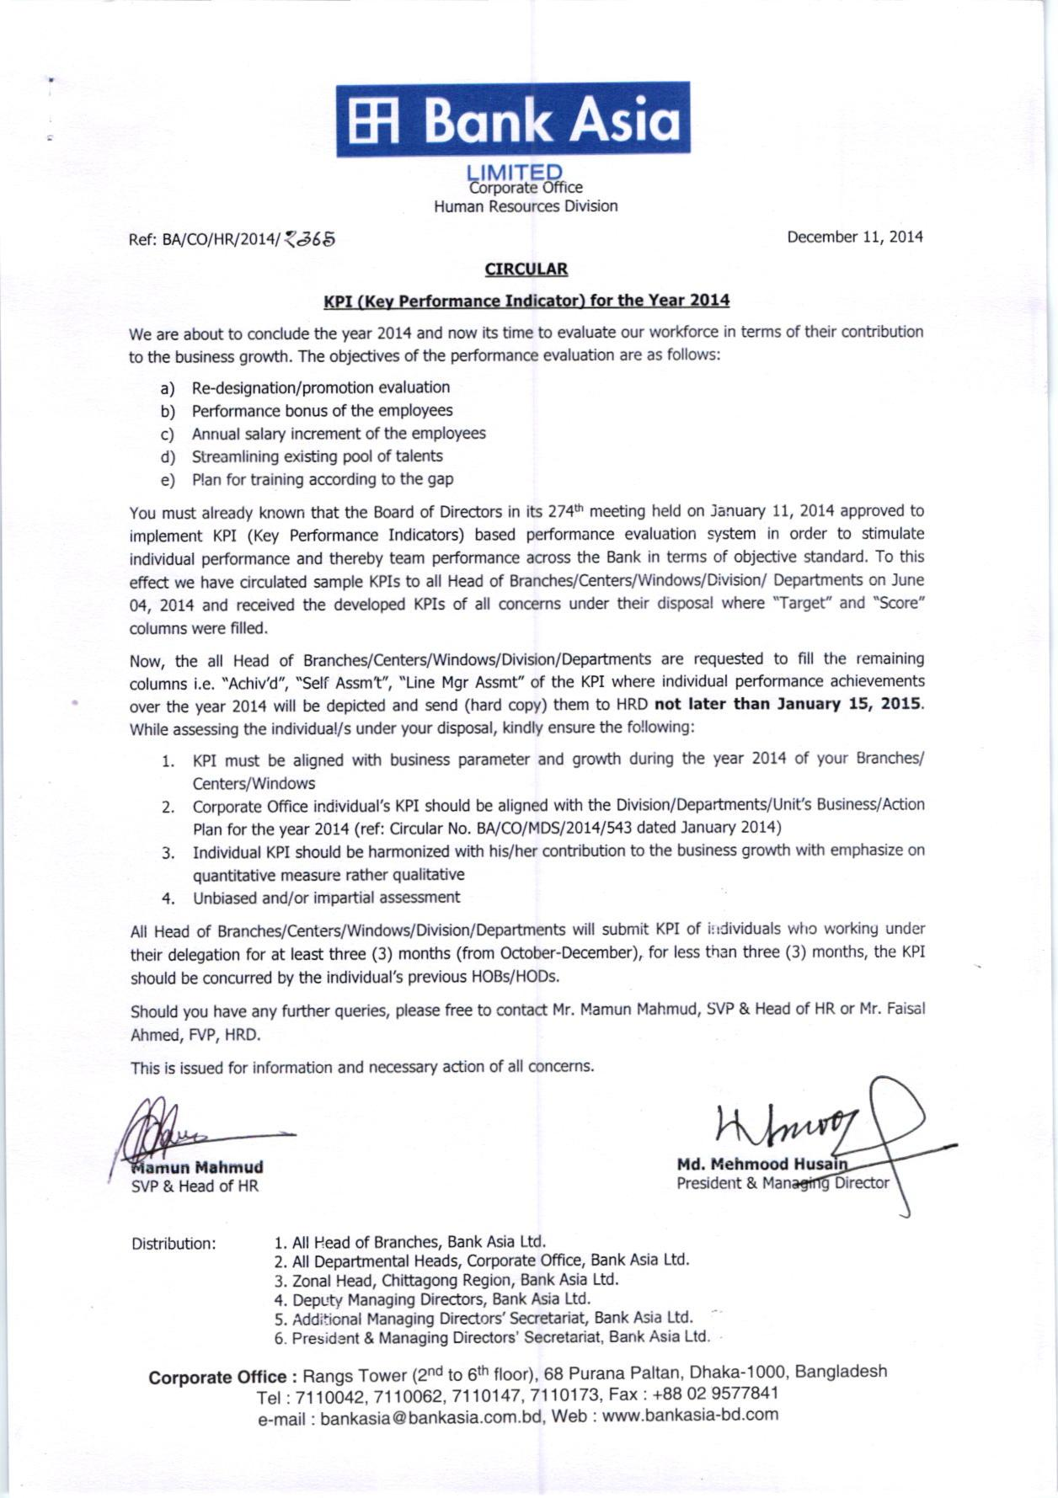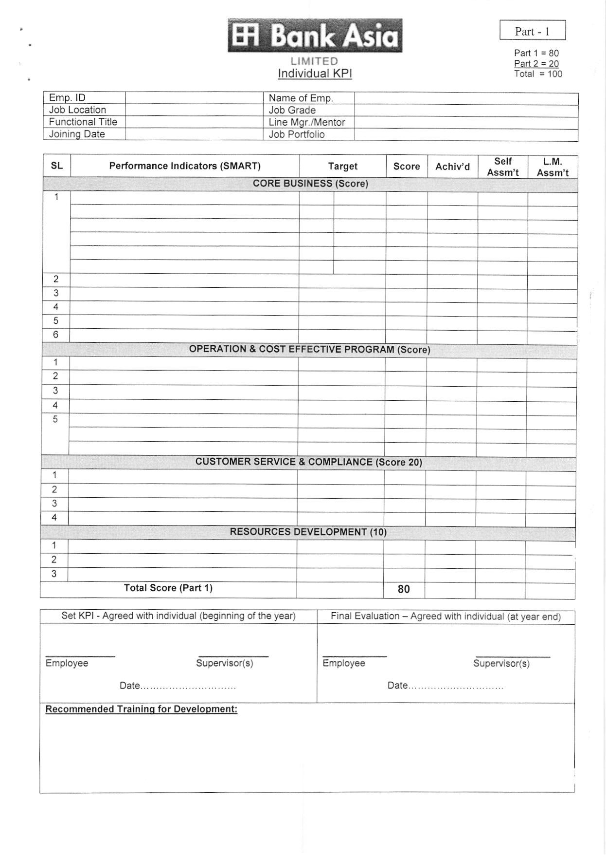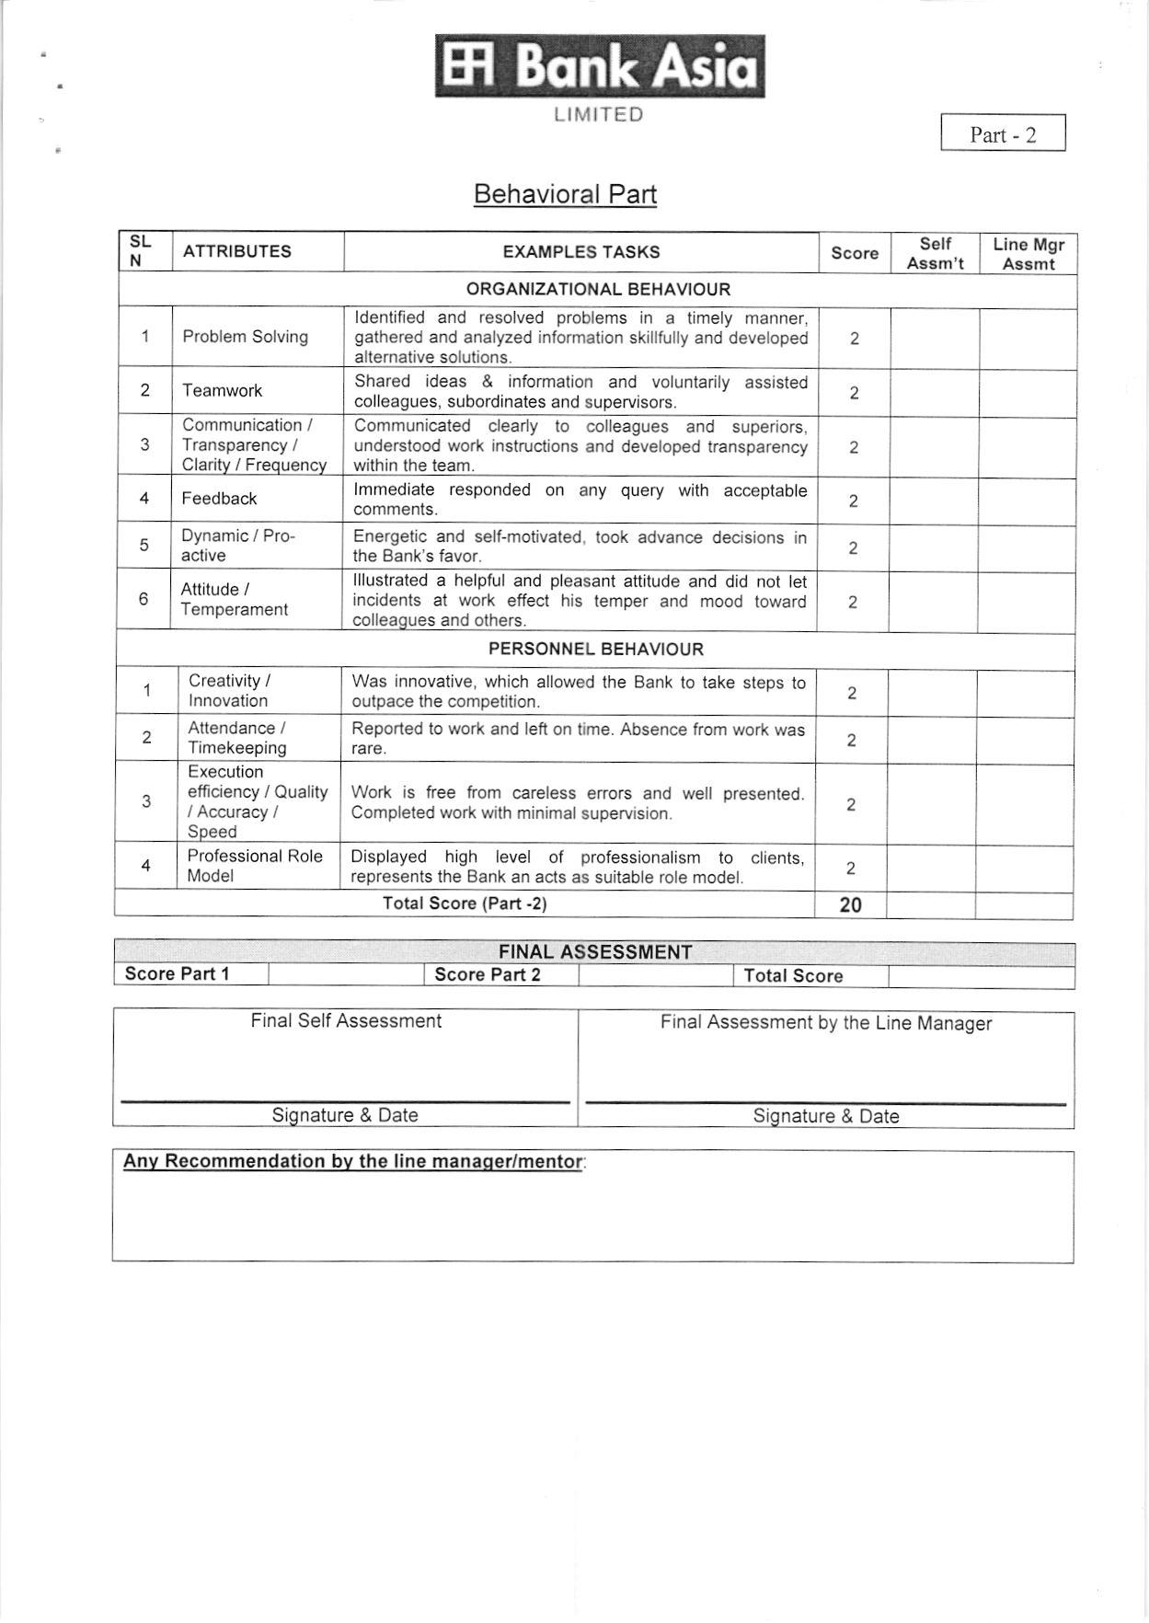

Bibliography

Bibliography

Assignment Point. (n.d.). Business Objective and Strategies of Bank Asia Limited. Retrieved October 28, 2018, from assignmentpoint: http://www.assignmentpoint.com/business/banking/business-objective-and-strategies-of-bank-asia-limited.html
Bank Asia Ltd. (2016). Corporate Report. Dhaka: Nabila Nasir.
Bank Asia Ltd. (n.d.). Vision. Retrieved November 15, 2018, from Brac Bank: http://www.bankasia-bd.com/home/vision
Bank Asia. (n.d.). Mail. Retrieved December 25, 2018, from Bankasia-bd: https://mail.bankasia-bd.com
BanksBD. (n.d.). Bank Asia branches in Dhaka. Retrieved October 18, 2018, from Banksbd.org: https://www.banksbd.org/balb/branches/dhaka.html
Change Factory . (n.d.). Common mistakes with KPIs. Retrieved September 14, 2018, from changefactory: https://www.changefactory.com.au/our-thinking/articles/common-mistakes-with-kpis/?fbclid=IwAR0UtLsazFQc2Kvwdx_ixXghkp0ltGvPenakl184UY7DSATqP06ApvT04As
Chron. (n.d.). Purpose of Internship. Retrieved September 3, 2018, from Chron: https://work.chron.com/purpose-internship-8335.html
James Kirkpatrick Library. (n.d.). Reseaech Questions. Retrieved September 23, 2018, from libraryguides: https://guides.library.ucmo.edu/c.php?g=695854&p=4934956
Lavy, Sarel. (n.d.). Natural Built Virtual. Retrieved October 16, 2018, from Texas A&M University: http://symposium.arch.tamu.edu/2011/presentations/literature-review-measuring-building-performance-u/
ResearchGate. (n.d.). Limitations. Retrieved September 24, 2018, from ResearchGate: https://www.researchgate.net/publication/220892272_Limitations_of_Performance_Measurement_Systems_based_on_Key_Performance_Indicators
Stat Trek. (n.d.). Statistics Dictionary. Retrieved September 22, 2018, from stattrek: https://stattrek.com/statistics/dictionary.aspx?definition=sample%20design

