

Internship Report
on
“Talent Acquisition & Selection Process of GPH Ispat Ltd.”

Submitted To:
Name: Shayla Khanam
Designation: Assistant Professor
School of Business & Economics
United International University

Submitted By:
Name: Tasnima Tarannum
ID: 111 183 069
Major: Human Resource Management.

Date of Submission: 17th June, 2023.

Table of Contents
Letter of Transmittal iv
Acknowledgement v
Executive Summary 1
Introduction 3
Chapter 02 4
Objective of the Study 4
2.1 Primary Objective 5
2.2 Secondary Objective 5
Chapter 03: 6
Methodology of the Study 6
3.1 Type of Data: 7
3.2 Sample Size: 7
3.3 Sampling Technique or procedure: 8
3.4 Data Collection Process: 8
3.5 Data Analysis Technique: 8
3.6 Limitations: 9
Chapter 04 10
Organizational Background and Industry Perspective 10
4.1 Historical Background of the organization 11
4.1.1 Mission and Vision of GPH Ispat Ltd. 12
4.1.2 Values of GPH Ispat Ltd. 13
4.1.3 Strategic Objectives of GPH ISPAT Ltd. 14
4.1.4 Certification 14
4.1.5 Corporate Information 15
4.1.6 Current Product & Services of GPH Ispat Limited. 15
4.1.7 Associates and Sister Concern of GPH Ispat Ltd. 17
4.1.8 Historical Achievements 17
4.1.9 SWOT Analysis of GPH Ispat Ltd. 18
4.2 Current Industry Scenario 19
Chapter 5 21
Findings of the Study 21
5.1 Human Resource Department of GPH Ispat Ltd: 22
5.1.1 HR practices of GPH Ispat Ltd 22
5.1.2 Recruitment Process of GPH Ispat Ltd. 24
5.2 Selection Process of GPH Ispat Ltd. 28
5.3 Recruitment & Selection Process of Different Designations 32
5.3.1 Market Development Officer (MDO) 32
5.3.2 Territory Sales Officer/ Senior Territory Sales Officer 33
5.4 Challenges of Both Parties 34
5.5 Findings: 35
5.6 My Job Responsibilities: 36
Chapter 6 37
Conclusion and Recommendations 37
6.1 Recommendations: 38
6.2 Conclusion: 38
Chapter 7 40
Appendix 40
a. References 41
b. Questionnaire 42

Letter of Transmittal
June 17th, 2023
Ms. Shayla Khanam
Asst. Professor, School of Business and Economics,
United International University.

Subject: Submission of the report titled “Talent Acquisition & Selection Process of GPH Ispat Ltd.”
Honorable Ma’am,
With the utmost respect, I would like to say that I have written my internship report on “Talent Acquisition & Selection Process of GPH Ispat Ltd.” by the grace of Almighty Allah, which is a requirement of the BBA program of United International University (UIU). I had a great time during my internship. I was given the chance to concentrate entirely on the recruitment field during this internship. The information gathered in the internship report as a whole demonstrates the learning outcomes of my experiences working as an HR intern at GPH Ispat Ltd, as well as the theory I learned from the book, the company's website, online searches, and the outcomes of the interviews I performed.
I am confident that the knowledge and experience I have gained while preparing this report will be extremely beneficial to me in my future endeavors. Your sincere approval of this endeavor would be appreciated.
Kind Regards,
Tasnima Tarannum
ID: 111183069
Major: HRM.

Acknowledgement
I want to start by expressing my sincere gratitude to the Almighty Allah, the most merciful and generous, for his kindness and for providing me with the chance to successfully finish the internship and to complete the internship report on time.

At first, I would like to share my heartfelt thanks to Ms. Shayla Khanam, Assistant Professor, School of Business and Economics, United International University, for her sincere and invaluable guidance and assistance in preparing this internship report. Furthermore, without the direction and the report structure, it would be impossible for me to finish such an extensive document on time.

Next, I want to express my sincere gratitude to my respected supervisor, Farhana Parven, Assistant Manager, HRBP-Sales & Marketing at GPH Ispat, for her immense passionate and intellectual support over the past three months. She guided me through the daily tasks involved in all HRM activities. Without her, it would be quite challenging for me to fully understand the human resources procedure and the real-life work culture. Additionally, she provided me with all the data I needed to finish the report.

I would want to express my gratitude to all of my peers and colleagues who assisted me in finishing my internship report. They provided me with all the assistance I needed anytime I struggled to understand a concept.

Executive Summary
The study examines the recruitment and selection of employees within the framework of GPH Ispat Ltd, a prestigious manufacturer. The two major objectives of this academic internship report are to complete a prerequisite for the BBA degree and to get a deeper understanding about HRM theory and its practical implementations. The secondary goals encompass my knowledge of the hiring and screening procedure and how the organization handles the entire hiring and screening process is discussed at the beginning of the introduction.
According to the methodology, this study relies on primary data such as practical experience, in-person conversations, direct observations etc. and websites, previous studies, associated research papers, and other publications that were collected through a qualitative interview with my supervisor Farhana Parven, HRBP-Sales & Marketing, from the Human Resources (HR) department of GPH Ispat Ltd serve as secondary data. The information was gathered using a pre-designed questionnaire and analyzed with the help of reading materials, on-the-ground knowledge, and previous trends. There were constraints on the study, including data confidentiality, time restraints, and insufficient data.
There are seven chapters in the entire report. Introduction, Scope of the Study, Objectives of the Report, Report Methodology, and Limitations of the Report are all covered in the first chapter. I have provided report's literature review in the second chapter. It discusses the recruitment and selection processes, their significance, how they might aid in the growth of an organization, and other topics. To provide the reader a comprehensive understanding of the organization, I have included an overview, corporate information, products and services, mission and vision of GPH Ispat Ltd. in the third chapter.
The recruitment and selection procedure are the focus of the fourth chapter, including how it is carried out, how long it takes, a sample job posting, difficulties that employees encounter, etc. Chapter 5 provides a detailed explanation of what I discovered regarding the method, the issues, and the obstacles that arise in the process. The conclusion of this chapter comprises general observations and my experience during my internship time frame. I have also included my recommendation and remedies to the difficulties in this chapter. References and appendices utilized in the internship report are included in the last chapter.


Chapter One
Introduction

Introduction
Human Resources Management is the sum of a few discrete tasks carried out within the company that enables the most efficient use of people, or employees, to fulfill both group and individual objectives. Over the years, the field of HRM has transformed. Modern management requires that organizational leaders cope with surroundings that are more dynamic and complicated, as well as with precise, well-defined human resource planning. Consequently, human resources management is now more of a strategic role than merely an administrative one.
The 7 core practices of human resources management are:
- Human Resource Planning
- Training and Development
- Recruitment and Selection
- Performance Management
- Employee Relations
- Employment Law and Compliance
- Compensation and Benefits
- Administration, Payroll & HR Systems.

The process of hiring and selecting employees is regarded as the first phase of human resource management. It involves following a regular step-by-step process to identify job openings, determine the ideal role, examine applicants, screen, short listing, and hire the most suitable candidate for the job.
The selection and hiring procedures of GPH Ispat are observed to be quite organized. One of the main responsibilities of the HR Division is the hiring process. The organization's recruitment process entails coming up with strategies for inviting in possible applicants, screening them, selecting and interviewing the shortlist of prospects, and then employing the individuals and integrating them into the organization's environment. Job postings are published on company websites and in social sites for prospective candidates. The candidates submit their resumes in response to the opening.

Chapter 02

Objective of the Study

2.1 Primary Objective

The major purpose is to finish the academic internship report, which is required for the BBA degree. The three credits assigned for this internship are for understanding the academic consequences of the learnings. I attempted to identify the various applications of HRM ideas and knowledge in the workplace using what I learned from the BBA degree as a whole and in particular the Human Resources courses.

2.2 Secondary Objective

- To discuss about the Recruitment activities of GPH Ispat Ltd.
- To determine the primary steps in GPH Ispat Ltd.'s recruitment and selection process.
- To learn more about the issues that arise with GPH Ispat Ltd.'s recruitment and selection procedures.
- To provide some recommendations that would improve the recruitment and selection process of GPH Ispat Limited.
- Learning about the corporate work ethics and professionalism management at the corporate office of GPH Ispat Ltd.
- To be aware of how the company's HR Division evaluates the organization's future needs, handles any unforeseen circumstances that may develop in day-to-day business operations, and manages the hiring process.

Chapter 03:

Methodology of the Study

The complete internship report serves as an overview for the knowledge I gained throughout my internship at GPH Ispat Ltd. This report was written after carefully examining the data and facts from study and on-the-job experience. The process for data gathering, sampling, and analysis is outlined below:

3.1 Type of Data:

The majority of the primary data came from collective job experience and academic know-how. To understand the organization's historical backdrop as well as the industrial environment, secondary data was utilized.

- Primary sources:
- Observation of the practical recruitment and selection process that takes place at the corporate office.
- In-person discussions with the Chief People Officer, Assistant Manager, Senior Executive and other executives. I frequently surveyed employees during work breaks using my prepared questionnaire in order to understand more about their work, workplace culture, and departmental policies, limitations and suggestions for improvement. Those interactions with them were used to acquire qualitative data, which was then developed and applied to this study.
- Personal findings and job-related insights aided in recognizing various components of the study.

- Secondary sources:
I gathered information for the secondary data from sources such as the company's official website and web portal, Google, Google Scholar, HR regulations, in house software called Human Resource Information System (HRIS), several magazines, and numerous online newspapers.

3.2 Sample Size:
As I worked in the Dhaka Corporate Office of GPH Ispat Ltd, here I got chance to work with Chief People Officer & Assistant Manager-HRBP only. The other HR departments of GPH Ispat works from the head office which is in Chittagong. So, basically an in-depth interview was conducted with my supervisor Farhana Parven, Assistant Manager, HRBP of GPH Ispat Ltd.

3.3 Sampling Technique or procedure:
The most senior member of the department working on that team is my supervisor and HRBP from the HR department. Also, previously she worked in Chittagong head office with all the HR departments, she could therefore provide more details regarding the prior working practices compared to the current situation. She gave an overall view of the how the day-to-day activities run, opportunities and challenges impacting the department, as well as relevant details.

3.4 Data Collection Process:
I primarily focused this report on my own experiences. For that objective, I conducted a qualitative analysis of the primary and secondary data collected. My supervisor, other employees, and those who work at GPH Ispat Ltd. provided me with some of the initial information for my primary data collection. Personal interviews with my supervisor provided me with the remaining data. I have created a questionnaire with both open-ended and closed-ended questions that will be sufficient to gather information from many angles. By doing the interview, qualitative data was gathered and used in this study. I've used up three months of my internship because it's difficult to arrange set hours for the interview. To gain insight on the subject, I have asked many questions throughout different days in accordance with the scenario.

3.5 Data Analysis Technique:
Since the information was qualitative, I used a variety of reading sources, specialty knowledge, and historical trends to examine the responses. As a result, I have provided the opinions together with evidence from my research. Then, I combined all of my professional experiences into this report by writing down each experience one at a time.

3.6 Limitations:

I was unable to explore more for details because I was an intern at the company. I was unable to fully grasp all of the activities. Additionally, I had some trouble writing the report. For instance,
- Maximum HR departments and activities are done from the Chittagong Head Office Branch, that’s made tough to explore more information.
- The privacy of information was a major issue. Regarding revealing any sensitive information, there are strict rules.
- There wasn't enough recent data available.
- Inadequate written documentation that could be beneficial.
- It is rather challenging to carry out such research in just 90 days. More time would give my research more insightful details.



Chapter 04

Organizational Background and Industry Perspective

4.1 Historical Background of the organization

One of Bangladesh's leading integrated steel producers, GPH Ispat Limited is a steel company that converts iron ore into steel and is involved in the production and trade of M. S. Billet and M. S. Rod. In addition to producing structural bars, the top provider of low, medium, and low alloy steel billets in Bangladesh is GPH Ispat Limited. With its top-notch products, it ensures a very bright economic future. Modern economies depending on railroads, cars, girders, bridges, and a variety of other steel goods were made possible by technological advancements in the steelmaking industry.


God-Fearing, Plain Living, and High Thinking is referred to as GPH. The company was founded on May 17, 2006, and it started operating in 2008 with this idea in mind. It was set up as a public limited company in 2012. The company started its expansion project at Sitakunda Chittagong in collaboration with Primetals Technologies, a joint venture between Siemens VAI and Mitsubishi Heavy Industries as the equipment supplier, in 2016. The 0.8 MTPY steel manufacturing facility cost the corporation about $200 million in total. The new mill uses a ladle furnace, a Quantum electric arc furnace, a three-strand, high-speed continuous billet caster, and a bar and section mill. For the first time ever, a rolling mill utilizes Win Link Flex technology. For the expansion project, through 12 financial institutions, the capital market, and retained earnings, the company raised a total of US$154 million. For the new factory, it purchased 8.85 acres of property close to its old steel mill. It received term loans of $95 million from the ODDO BHF Bank of Germany and $44.2 million from the World Bank, which were disbursed through commercial banks at the instruction of the Central Bank of Bangladesh. Beginning in September 2020, it began selling goods from its new plant to domestic and international markets. The company announced the new expansion plant's start-up production on June 21, 2021, and released the best "GPH Quantum" steel on the market. In its manufacturing plant, GPH can produce long steel items with a class-4 steel guarantee and strengths ranging from 300 MPA to 900 MPA. Additionally, GPH Ispat began producing GPH QUANTUM B600C-R Steel Re-bar in Bangladesh for the first time. The world's best Quantum Electric Arc Furnace technology is used in the production of GPH QUANTUM B600C-R to ensure that the product meets the BDS ISO 6935-2:2021 requirements for high strength and maximum safety. Integrated Management System (IMS) certifications for the Quality Management System (ISO 9001:2015), Environmental Management System (ISO 14001:2015), and Health and Safety Management System (ISO 45001:2018) are held by GPH Ispat Limited.
GPH is dedicated to preserving natural resources, advancing technology, and promoting the health and welfare of the employees and surrounding areas. It has a zero-discharge system to provide complete water recycling and a rainwater harvesting system to utilize water in the manufacturing process. Additionally enhanced to meet World Bank requirements, it lowers annual energy consumption by 2,26,800 MW of electricity and 26.46 million m3 of natural gas. Through the use of environmentally friendly production techniques, GPH demonstrates its commitment to society. By exporting MS Billet to industrialized nations like China, GPH Ispat Limited is now present not only on the map of Bangladesh but also on a worldwide scale, which has expanded the economic opportunities for the nation.

4.1.1 Mission and Vision of GPH Ispat Ltd.

Mission: “To provide the foundation for building the infrastructure of Bangladesh towards High-Income-Country (HIC) with the true GPH philosophy.”

Vision: “The trusted brand of Bangladesh leading the steel sector with innovative products leveraging cutting edge technology.”

4.1.2 Values of GPH Ispat Ltd.



Since the beginning of our business, GPH Ispat Ltd. have made it a point to base all they do on these five values which is in short called as “AGILE”:

4.1.3 Strategic Objectives of GPH ISPAT Ltd.

- GPH ISPAT Ltd. wants to establish the highest possible standards for the ISPAT industry in Bangladesh by prioritizing customer satisfaction.
- Their motto is "COMMITTED TO STRENGTH."
- The primary goals of GPH ISPAT LTD's strategy are to assure success.
- Satisfaction of all employees leads to strong performance, accurate and prompt information delivery, and the development of cutting-edge value propositions for the market.

4.1.4 Certification
The Integrated Management System (IMS) of ISO 9001: 2015, 14001 & 45001:2018 certification is being processed by GPH Ispat Limited, an ISO 9001:2008 certified business, as part of a continued effort to ensure the company's sustainable growth.

4.1.5 Corporate Information

Company Name: | GPH Ispat Limited
Date of Incorporation: | May 17, 2006
Commencement of Business: | August 21, 2008
Conversion of Public Limited Company: | December 18, 2009
Registered Office: | Crown Chamber, 325 Asadgonj, Chattogram-4000, Bangladesh.
Factory: | Masjiddah, Kumira, Sitakunda, Chattogram, Bangladesh
Dhaka Office: | Hamid Tower (3rd & 11th Floor), 24 Gulshan C/A, Circle- 2, Dhaka-1212.
E-mail: | info@gphispat.com.bd
Website: | www.gphispat.com.bd

4.1.6 Current Product & Services of GPH Ispat Limited.

The new mill from GPH Ispat produces its products using a "Quantum electric arc furnace" (the first time this technology has been utilized in steel mills in Asia), a ladle furnace, a three-strand, high-speed continuous billet caster, and a bar and section mill. As a result, the rebars and billets are pure, highly high-quality quantum tech products. Billets and rebars are the two products that GPH Ispat Limited produces.
GPH Quantum Rebar:
- GPH Quantum B500DWR Rebar (Available sizes-8mm, 10mm, 12mm, 16mm, 20mm, 22mm, 25mm, 28mm, 32mm, 40mm & 50mm).
- GPH Quantum B500CWR Rebar (Available sizes-8mm, 10mm, 12mm, 16mm, 20mm, 22mm, 25mm, 28mm, 32mm, 40mm & 50mm).
- GPH Quantum B420DWR Rebar (Available sizes-8mm, 10mm, 12mm, 16mm, 20mm, 22mm, 25mm, 28mm & 32mm).
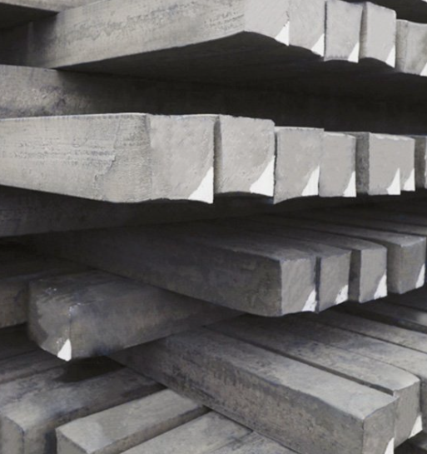
- GPH Quantum B600C-R Rebar (Available sizes-16mm, 20mm, 22mm, 25mm, 28mm, 32mm, 40mm & 50mm).
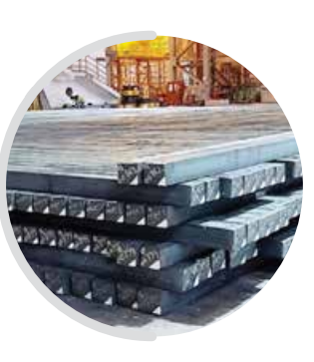
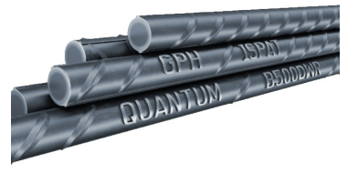

GPH Billets:

The Quantum Electric Arc Furnace (QEAF) produces continuous cast billets using cutting-edge PRIMETAL technology. The CCM is a high-speed caster with a casting velocity of six meters per minute, and the M-EMS is installed in the CCM. The billets are sliced into the appropriate sizes using a diagonal shear cut and loaded onto a tilt-over cooling bed (TOCB). The coils are then stacked on a TOCB cradle in the billet storage yard in accordance with their grades and sizes.

4.1.7 Associates and Sister Concern of GPH Ispat Ltd.
- Jahangir & Others Limited.
- Brothers Corporation (Trading Firm).
- Nirnoy Enterprise (Trading Firm).
- Brothers Electronics (Trading Firm).
- Indo Steel Industries Limited (Manufacturing of Rod).
- Ahad Corporation (Trading Firm).
- Chittagong Capital Limited (Corporate member of Chittagong Stock Exchange).
- GPH Power Generation Limited (Producer of electricity from natural gas).
- GPH Engineers & Development Limited (Developing Company).
- Metal Trade International (Trading Firm).
- GPH Ship Builders Limited.

4.1.8 Historical Achievements

- 2006- as a Private Limited Company was incorporated.
- 2008- started the factory's commercial operations with an annual production capacity of 84,000 MT for MS Billet and 120,000 MT for MS Rod.
- 2009- become a public limited company. Increased Authorized Capital from 1,000,000,000 to 2,500,000,000 Tk.
- 2012- MS Billet's production capacity was raised from 84,000 MT to 168,000 MT. Appeared at the first public offering (IPO). Listed on the Chittagong Stock Exchange Ltd. and Dhaka Stock Exchange Limited.
- 2015- increased the authorized capital from 2,500,000,000 to 10,000,000,000 Bangladeshi Taka.
- 2016- 03[R]:02 Right Share issued. The production capacity of MS Billet (840,000 MT) and MS Rod, Medium Section Products (Steel Beam, Angle, Channel, Flat Bar, etc.) (640,000 MT) per year was increased as part of a large-scale expansion of production using the most cutting-edge technology in the world.
- 2020- the new expansion plant's hot commissioning process began. produced and sold trail items as of September 7, 2020. 25,000 MT MS Billet will be exported for the first time on October 13, 2020, to the People's Republic of China. Bangladesh's first-ever bulk cargo billet export.
- 2021- On June 21, 2021, the new expansion plant began commercial production. Developed and marketed the world's best "GPH Quantum" steel.
- 2022- Commenced the first production of "GPH QUANTUM B600C-R" Steel Re-bar in Bangladesh.

4.1.9 SWOT Analysis of GPH Ispat Ltd.

By examining an organization's organizational strategies as a whole or by specific departments, SWOT analysis examines the company's strengths, weaknesses, opportunities, and threats. Overall, it assists a company in making better judgments and achieving success in more of its operations. Following is the conclusion of the GPH Ispat Ltd. SWOT analysis.
Strengths:
- A welcoming and well-communicated workplace,
- The manager of the concerned division is involved in the recruitment and selection process, which includes screening CVs, developing interview questions, reviewing prepared scripts, etc.
- Well-structured training programs
- The data is protected in the HR Division via HRIS.
- They receive qualified CVs the majority of the time.
- No unfairness exists during written exam & interview.
- Select the most qualified candidates.

Weakness:

- A simple online advertisement is insufficient to find the ideal applicant.
- Market Development Officer and Territory Officer positions cannot be held for an extended period of time. They hire a significant quantity of MDO and STO/TSO to address this issue. It incurs significant expenses.
- The HR department doesn't properly follow CV banks.
- Decision making process always time consuming.
- There are few HR departments.
- Insufficient employees in the HR department,
- The HRIS software is not up to the mark. Employees faces difficulties while using this software.

Opportunity:
- HR division focuses of team work.
- The majority of CVs are from reputable universities.
- The emergence of new technologies and introducing new HR strategy,
- An appealing opportunity for career development for new employers.
- More effective use of human resources.

Threats:
- Potential labors are shortage in GPH Ispat Ltd.
- The development of new companies in this particular industry
- Changing labor-force requirements.

4.2 Current Industry Scenario

Individuals, executives, and organizations must be adaptive, resilient, and receptive to new ideas in order to win in the complicated business environment of today. Re-skilling and up-skilling will be essential for it. They think that the best technology can create items of the highest caliber. The countries greatest "Quantum Electric Arc Furnace and Winlink" technology is being used by GPH Ispat to produce high-quality steel products in accordance with the GPH's vision and goal. Additionally, GPH introduced the greatest steel in the world—"GPH Quantum"—to Bangladesh.
GPH Ispat intends to play a significant role in Bangladesh's progress toward becoming a middle-income nation. Regarding this, there is no room for sacrificing product quality in order to sustain any physical assets growth in the nation. Without a doubt, the country's export basket did not include heavy industrial goods like MS products. By exporting its MS Billet product, GPH Ispat has created a market for the mild steel products it produces in its factory using the most recent Quantum Electric Arc Furnace technology. However, exporting such goods would not be feasible without government assistance because the world's steel industry is extremely competitive. In addition, they are lacking their ability to compete on the international market because they must make payments two separate freight expenses - one for the import of raw materials and another for exports. Despite the fact that the global market is unfamiliar with Bangladeshi products, they also need to invest in openings there. In order to take advantage of the export potential in this case, GPH Ispat asks the government for cash assistance against the exports of MS products.
Value Added Tax (VAT), Corporate Tax, Source Tax, Supplementary Duty (SD), Customs Duty, and other Registration Fees made comprised GPH's BDT 4,422.33 million contributions to the national exchequer in 2021–22.
Over the span of the year, GPH Ispat has employed a sizable number of employees directly and indirectly. 439 fresh employees, both technical and nontechnical, were hired in various departments during the fiscal year 2021–2022. In addition to the numerous individuals who depend on GPH for a living by working as suppliers, contractors, retailers, wholesalers, and other business associates, the company has 2,122 permanent workers as of June 30, 2022.

Chapter 5

Findings of the Study

In this chapter, we'll learn exactly how GPH Ispat Ltd. executes the recruiting and hiring of new employees, including how they go about it and other details.

5.1 Human Resource Department of GPH Ispat Ltd:
GPH Ispat Ltd. employees in the human resources department do not all work in the same place. It is divided into two distinct areas.
- Head office Human Resource, Chittagong: Doing work for management and non-management employees. All the HR departments are basically operating from here.
- Corporate office Human Resource, Dhaka: Here basically all type of recruitment & talent acquisition, selection activities are done.

5.1.1 HR practices of GPH Ispat Ltd

There are four teams that collaborate in HRD:

Recruitment and Selection
• Training and Development
• Performance appraisal
• Compensation system
• Grievance procedure
- Recruitment & Talent Acquisition Team
The entire recruitment-related work, including designing interview questions for candidates, building interview candidate databases, and entering data on candidates who were chosen for interviews and those who were hired. maintaining and updating personnel databases, processing files, updating personal files, reviewing personal file documents, checking references, and sending emails and making phone calls to clients and applicants. The activities include updating external resumes and creating final settlement data.

- Training & Performance Development Team
The development team's tasks include creating employee KPI, job descriptions, organizational diagrams, succession planning for employees, performance evaluation and management tasks, training and development programs, calculating employees' behavioral and official performance, and updating the database with information about their current employment status.

- Operation & Payroll Team
Operation Team manages all aspects of discipline, payroll, policy creation, employee interviews, and personal file and document checks. They also provide staff with necessary items like SIM cards, computers, mobile phones, modems, and other office supplies.

- ER & Admin Team
This team's primary areas of responsibility include providing guidance on proposed and current regulations, developing incentives packages, acting as a union representative, drafting new contracts, and abiding by all applicable laws.

We will first learn about their "Recruitment Process" that GPH Ispat Ltd. practice.

5.1.2 Recruitment Process of GPH Ispat Ltd.

The majority of organizations adhere to a certain hiring procedure that comprises planning, strategies, resourcing, shortlisting, and evaluation among other steps. The similar procedure is used by GPH Ispat Ltd.
One of the key functions of the human resources department is recruitment. Recruitment is the process by which a firm finds its employees, are perhaps the most critical
tasks any organization faces. Without the right people, no firm can function effectively. For a
recruitment program to be successful, managers should cooperate with the human resources
staff to define needs and predict vacancies. This recruiting may be done by internal or
external. (Gary Dessler-Human Resource Management-12 Edition)
Recruitment is the process by which a firm finds its employees, are perhaps the most critical
tasks any organization faces. Without the right people, no firm can function effectively. For a
recruitment program to be successful, managers should cooperate with the human resources
staff to define needs and predict vacancies. This recruiting may be done by internal or
external. (Gary Dessler-Human Resource Management-12 Edition)
Recruitment is the process by which a firm finds its employees, are perhaps the most critical
tasks any organization faces. Without the right people, no firm can function effectively. For a
recruitment program to be successful, managers should cooperate with the human resources
staff to define needs and predict vacancies. This recruiting may be done by internal or
external. (Gary Dessler-Human Resource Management-12 Edition)
Recruitment is the process by which a firm finds its employees, are perhaps the most critical tasks any organization faces. Without the right people, no firm can function effectively. For a recruitment program to be successful, managers should cooperate with the human resources staff to define needs and predict vacancies. This recruiting may be done by internal or external. (Gary Dessler-Human Resource Management-12 Edition)
One of the vital responsibilities of the human resources department is recruitment. Here is the recruitment procedure used by GPH Ispat Ltd. –

Between the grade and level of management and non-management employees, HR manages the hiring and selection process. The management level has three grades or divisions. Below are these:
1. Entry level
2. Mid-level
3. Top management level.

Human Resources Department receives a manpower requisition form by the appropriate inquisitors to start this process. Here those steps are followed,

- Receiving Man Power Requisition: A supervisor from the corresponding division sends a manpower requisition form to HR first. The supervisors raise the manpower requisition to specify which department, location, and position require people. After that, the HRD receives the requisition.
- Analyzing the Requisition: After receiving the requisition, HRD team members assess if they actually require manpower or not. In a nutshell, they assess the necessity. The manpower requisition form is reviewed by HR personnel, processed for approval, and then approved by the Director. The requisition will be approved by the Director if, after considering everything, they determine that the hiring is necessary and supported by HRD.

- Preparing Job Description: After analyzing the manpower requisition, HRD prepares the Job description for the certain position. In job description they mention the Position title, Division, Job Location, Departments, Reporting relationship, Key Job Responsibilities, Educational Qualification Requirement, Specialization, Work Experience Requirements etc. Then they create advertisements in different medium to attract potential candidates. Here are some key responsibilities of Territory Sales Officer/Sr. Territory Sales Officer given below from the job description,

- Prepare daily, weekly and monthly sales and collection plans for a designated area and achieve Sales & Collection targets.
- Assess existing dealers, maintain and develop relationships and motivate them to enhance sales and collection.
- Find traders with good reputations and appoint them as dealers or channel partners for gap/priority markets.
- Establish sales targets with dealers and ensure the achievement.
- Recommend market development action plans for designated area/territory
- Ensure proper visibility of the company's POSM and outdoor advertisements including signboard, shop branding, billboard, building painting, wall painting etc.
- ·Ensure optimum customer service through professional handling of complaints as and when required.
- Maintain regular communication with trade channels and influencers, build cordial professional relationships and promote GPH Ispat.
- Prepare necessary daily, weekly, and monthly reports and submit them to senior management.
- ·Any other tasks as and when required by the management.

Job
Description
Of
GPH Ispat Ltd.

- Making a Pool of Candidate: They create advertisements for each position open at the management level if HRD approves the request for new employees. HRD will prepare an advertisement, post it on several job sites, and submit it to other external means of hiring. According on the type of job, HR will post advertisements in the number of media it chooses. If the position is extremely rare, HR will look to print media, specifically newspapers. In addition to placing job ads online, advertisements are also occasionally published for a limited time in newspapers. Following the specified period, candidates will send their CVs to job postings by mail and HR offices within this time. After that point, HR no longer receives any applications from applicants.

- Short listing: After receiving all applications, the focus of this step is to limit the pool of candidates. Based on the required qualifications, experience, etc., short lists are made.

- Notifying the Candidate: Following the shortlisting, HRD contacts the candidates by phone or SMS to schedule an initial interview. In the event of junior or entry-level positions, calling

and texting the shortlisted candidates for the interview and making a confirmation call before to the interview are required. In case of senior position Email Invitation have to send.

5.1.3 Sources of Recruitment
In GPH Ispat Ltd. there are two sources of recruitment:

Source of Internal recruitment:

      - Company’s own website. (https://www.gphispat.com.bd/career/why-gph)
      - By promoting a particular person, they also fill a position that was open.
      - Sometimes current employees of GPH Ispat Ltd. refer candidates for open positions.
      - From internship student.
      - Transferring a certain employee from Chittagong office to Dhaka office or vice versa is one of the ways that GPH Ispat Ltd. sources employees.
      - The employee of Relatives.

Source of External recruitment:
      - BDJobs.Com.
      - Social sites such as Facebook, LinkedIn etc.
      - Advertisement in the newspaper.
      - Campus Recruitment.

5.1.3.1 Campus Recruitment:

I was given the opportunity to assist with employee recruitment while I was an intern at GPH Ispat Ltd. The GPH Ispat Ltd. staff members were extremely pleased for my participation in campus recruitment.
University Of Liberal Arts Bangladesh (ULAB) Job fair:
I along with my supervisor, other employees of GPH Ispat Ltd. attended a career fair in ULAB on February 25th, 2023. The fair officially opened at 9:00 AM. completed at 5:00 PM. My responsibilities included representing GPH Ispat Ltd. and gathering CVs from recent graduates and potential candidates. Those who come to drop off their resumes at the GPH Ispat Ltd. booth have been informed about GPH Ispat Ltd., job responsibility, job vacancy, working facilities and other information.

5.2 Selection Process of GPH Ispat Ltd.
The selection process includes the arrangement of specific advances that are used to decide who should be hired. The selection procedure starts once enrollment is closed, depending on whether there are enough people who are eager and willing to participate in the activity. The goal of the selecting session is to learn more about a potential participant and gauge how much they can contribute to the activity. HRD conducts the candidate selection process after finishing the entire recruitment procedure. The steps that GPH Ispat Ltd. follows are listed below:
- Written Test: Candidates without experience must take a written test, but candidates with three years or more of expertise need not take a written exam; they only need to attend the initial interview. The type of question is determined by the position's features: typically, the written test consists of a mix of multiple-choice and narrative-style questions, and HR exclusively reviews all multiple-choice responses. Only specific departmental head are responsible for checking all of the answers of the specific department related part. While the specialized portion of the written answer sheets is examined by managers from a different department, HR also reviews the non-specialized portion. HR completes the arrangement of scores obtained in written tests. The selection and calling of candidates for subsequent tests is the responsibility of HR based on the presentation of written examinations. The next choice test is open to competitors who passed the composed tests or received a 60% score.

- Initial Interview: Only those candidates who got 60% score in the written test will have to face the interview board. In interview board generally 2 to 3 interviewer remains. One from the Assistant Manager or Manager level, HR Officer, Head of certain department are present on the interview board. Here candidates are being interviewed & evaluated on the basis of some basic criteria set by the HR. Those candidates who match the criteria & gets highest marks in this initial interview will be send for the final interview. Here is an image of interview assessment sheet used in GPH Ispat Ltd. 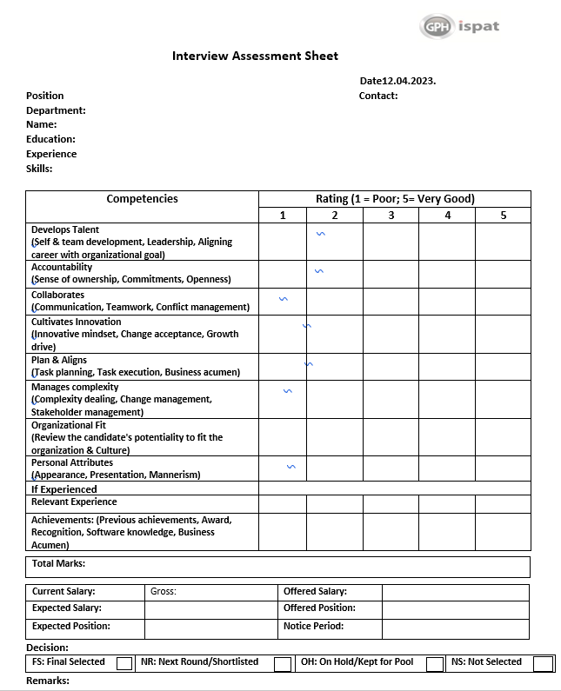

- Final interview: Qualified candidates will be invited for the final round interview after passing the earlier phases. The Head, general manager, AGM, of the relevant department and one HRBP manager conduct the final interview, who will once again assess the applicant's knowledge, skills, experience, competences, attitude, and knowledge of their current employer company, among other things. Here, the applicant is given information on the job responsibilities of the certain position, the working station area and the difficulties he or she must overcome.
The interview panel members assign a ranking to each applicant based on who is most like them. The results of viva and their assessment of a suitability of the candidate for the role serve as the basis for preliminary selection. Salary is one of the topics covered in this round of negotiation along with others. If an applicant is already employed someplace else, GPH Ispat Ltd. tries to hire them at their present wage. However, they offer them a 25% wage rise.

- Offer Letter or Appointment letter: The management of GPH Ispat Ltd. issues a confirmation letter and mails it to the selected candidate. They can also confirm the joining over the phone. The selected candidate is then issued an appointment letter for regular job as well as contractual employees. The letter of appointment must contain:
- Job title,
- Grade and salary
- Nature of appointment.
- Name of section or department.
- Effective date of appointment.
- Probationary period, conditions of confirmation and notice period.
- Ending date of employment.

When providing the agreement letter, HR will broadly give the officer a briefing regarding the business, its methods, remuneration, and terms and conditions, as well as on qualified lead benchmarks and pertinent information

- Release Order Collection: When meeting with HR at GPH Ispat Ltd., individuals who have been employed from another organization must present HR with a letter of release, clearance, or acceptance from the HR director of their prior organization. Without an official discharge request being filed by the former association's human resources department, employees' joining won't be acknowledged in any way.

- Pre-joining document: Before joining, the candidate provides the following papers. The following documents are handled by officers of the human resource division:

- 4 Copies of Passport-size Photographs
- Photocopies of all educational certificates.
- Photocopies of all training certificates
- E-tin certificate,
- Photocopy of NID
- 1 Copy Passport size picture, Photocopy of NID of nominee
- 1 Copy passport size picture & photocopy of NID of spouse.

5.3 Recruitment & Selection Process of Different Designations
Following the shortlisting of CVs, the Assistant Manager of HR-recruitment asks the Intern to review the CVs to see if any are overqualified or underqualified. Following that, the applicants are requested to participate in a phone interview, if they are available or not, their preferred location etc. are asked. Then, HRD mails or sends a message of confirmation to each candidate. The intern then creates a schedule of potential applicants. Then HRD mails the schedule, which includes the day and time, to the department head. This method is applied to applicants at all levels, from upper management to non-management.

5.3.1 Market Development Officer (MDO)
Following the arrival of all applicants, HRD begins the written exam that has been prepared by the employees of the respected unit on the scheduled interview day. Following the test, all exam papers are given to the authorized experts for examination.
Only those candidates who receive 60% or more will be given the opportunity to face the initial interview. Candidates will be given the opportunity to attend a viva based on their performance. The viva will be taken by AGM, HRBP, Assistant manager of respective departments & the remaining steps follow the same procedure as before. Only finally selected candidates will face an another and last interview taken by the Head of Sales & Marketing. Depending on respective Heads suggestion HRBP will go for further procedure. Here is an image of Facebook advertisement for asking CVS for the position of Market Development Officer,
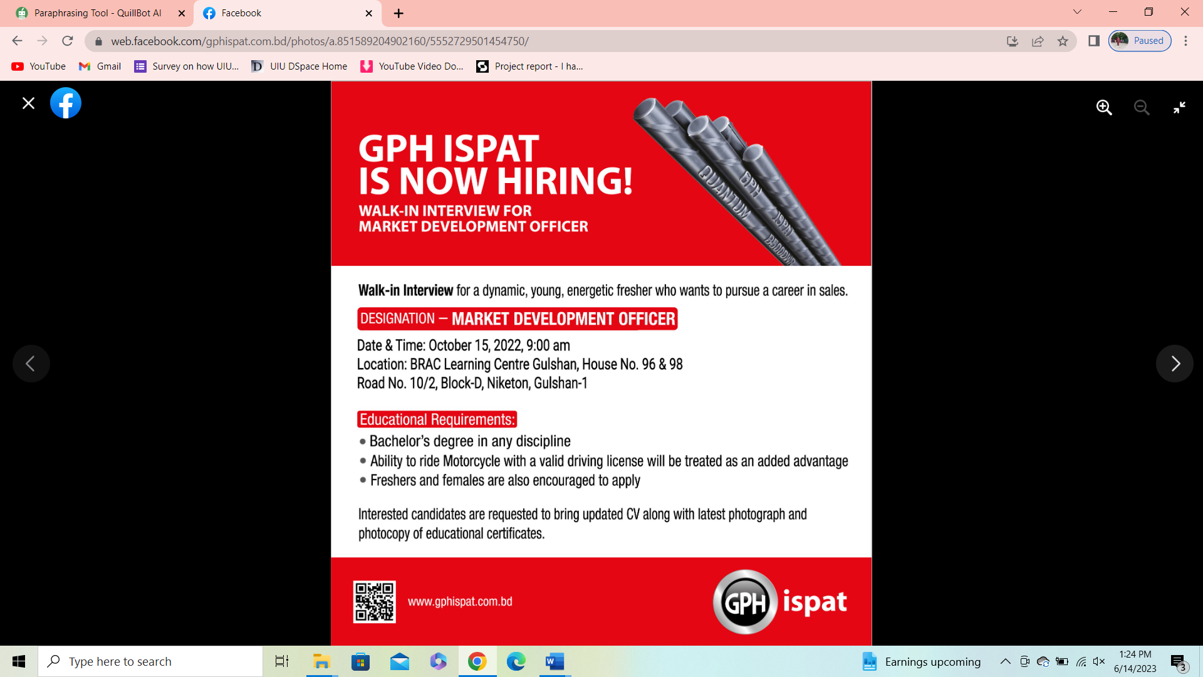

5.3.2 Territory Sales Officer/ Senior Territory Sales Officer
Through an email sent by HRD, a panel of recruiters will be assembled and told to participate in an interview. Members of the interview panel will send HRD a second email to confirm their attendance on that day. The short-listed candidates will be reached by phone to arrange an interview for a specific day after a corporate message is sent to all applicants. On the day of the interview, the HRD will present the job description once each candidate arrives. Then there will be a written test. After conducting the written test, the interview will be done in accordance with the timetable. The applicants will show up to the interview panel one by one.
For example, the interview will be conducted in front of the Head of Sales & Marketing, Head of Brand & Communication, AGM, HRBP of the relevant unit or department. To hire the best qualified candidates for the role, they will take as much time as is necessary to assess each applicant. They will talk about a variety of topics, including pay, the location of the job, skills, and competencies.
And the recovery process is the same as for any other role. The prospective applicant will be told to send pre joining documentation by email and will be instructed to appear for joining on a certain date.

5.4 Challenges of Both Parties

Both HRD and applicants confront some obstacles like as:
- As we all know GPH Ispat Ltd. is one of the leading & growing manufacturing industry in Bangladesh. Getting quality full personnel for both management & non-management is quite tough which is a big challenge for the organization.
- The lack of a documented policy for the "Recruitment and Selection" process is another major obstacle for the recruitment team. So, it can be challenging at times to complete the process in a systematic manner.
- When GPH Ispat Ltd. conducts written tests and interviews for candidates in their Dhaka office, there isn't a suitable setup for this. Limited seating arrangement, less waiting room space make the process more complicated. This is a challenge for both parties.
- The recruitment employees occasionally face difficulties while trying to hire top officers. Candidates can decide not to join at the last minute because they may have a better offer elsewhere.
- Less employees of HR department in Dhaka Office are one of the biggest challenges of GPH Ispat Ltd. For this reason, all of the working pressure fells upon the designated person and sometimes she faces difficulty to complete the tasks smoothly.

5.5 Findings:

I directly worked with the recruitment tasks while completing the internship program, and I saw certain issues with the overall procedure. These are-
- There are fewer employees than necessary in the HR departments. GPH Ispat Ltd. employs 2122 people throughout its two offices. But there are fewer people in the HR division. It is challenging for them to update every employee's file when anything changes for all employees, such as an increment. The updating of all employee data is too difficult for HR staff. The workload is immense. Sometimes employees get bored and efficiency drops.
- One of the biggest issues is the slow hiring process. They take too long to hire people. For instance, it may take two weeks or longer for them to inform applicants of their selection for the following round after the written exam and initial interview. A slow hiring process may cause potential candidates to lose out.
- The recruitment and selection process are not covered by a written policy, as was previously stated in the analysis section. Therefore, there are no strict regulations to follow. This frequently leads to miscommunication and complicates the procedure.
- Top-level management's lack of responsiveness is another issue. The qualified candidates must get confirmation from the HRD regarding the date of the final interview after the first-round interview and written test are over, obtaining a date from upper management is quite difficult because they are constantly busy with other tasks. As a result, they sometimes lose qualified candidates.
- They have a company website and a HRIS database; however, they are not maintained and are also quite slow. Employees occasionally have trouble accessing information on websites and databases, and recruitment database systems are out of date.
- Candidates often fail to show up for their final interview, which might lead to issues in the future.
- The job posting makes no indication of the wage scale. The wage structure outlined in the advertisement streamlines the procedure because there is no need to discuss salary with the applicant, saving time.

Despite the fact that there are the stated issues. The workplace has a great working atmosphere, helpful supervisors and managers, and it is comfortable for female employees to work there.

5.6 My Job Responsibilities:

As a HR Intern in GPH Ispat Ltd. Farhana Parven, Assistant Manager HRBP-Sales and Marketing, was the person I report to. She gives me all of my tasks and oversees them. I mainly assisted her with a variety of things. My usual activity was-

- Depth work in their recruitment and selection program.
- Collecting CV of the candidates provided by my supervisor and printing them as per need.
- Create a short list of candidates based on the position criteria.
- Create a schedule for the applicants written test & interview.
- Calling & giving text shortlisted candidates for the interview and confirmation call before interview. (Junior / Entry Level)
- Email Invitation for Seniors.
- Preparing assessment sheet for the interview and before interview printing assessment sheets, CV, attendance sheet, candidate information form.
- Conducting written tests and scheduling candidate interviews
- Data entry of applicants' resumes who are chosen for interviews and those who are hired.
- Conducting joining of Employees.
- Leave application collection and manage them.
- Assisting my supervisor to prepare employees’ monthly records for Payroll.
- Maintaining and updating the human resources database, processing files, reviewing and updating personal file information, and keeping track of personal file information.
- Assisting the HR department when they are loaded with tasks.
- Appointment letter distribution.
- Bank account opening related tasks such as providing bank opening form, distributing checkbooks & Cards.
- Providing Admin team Official ID card & Business Card requisition list.

Chapter 6

Conclusion and Recommendations

HR practices of GPH Ispat Ltd
• Recruitment and Selection
• Training and Development
• Performance appraisal
• Compensation system
• Grievance procedure
HR practices of GPH Ispat Ltd
• Recruitment and Selection
• Training and Development
• Performance appraisal
• Compensation system
• Grievance procedure
HR practices of GPH Ispat Ltd
• Recruitment and Selection
• Training and Development
• Performance appraisal
• Compensation system
• Grievance procedure
HR practices of GPH Ispat Ltd
• Recruitment and Selection
• Training and Development
• Performance appraisal
• Compensation system
• Grievance procedure
HR practices of GPH Ispat Ltd
• Recruitment and Selection
• Training and Development
• Performance appraisal
• Compensation system
• Grievance procedure
HR practices of GPH Ispat Ltd
• Recruitment and Selection
• Training and Development
• Performance appraisal
• Compensation system
• Grievance procedure

6.1 Recommendations:
- Hire capable and efficient employees for HRD to reduce the workload.
- The hiring process should be completed on schedule to avoid losing potential candidates.
- They need to increase the number of recreational activities because this will encourage them to work more and more effectively.
- There should be a written policy covering the "Recruitment and Selection" procedure.
- The pay scale should be specified in the job posting. Many people are unaware of the pay structure of the companies, and occasionally they apply for jobs with the greatest salaries. If so, GPH Ispat Ltd. frequently loses a competent workforce.
- HR recruitment and selection procedures should be developed in a way that draws in more capable employees for the benefit of the business. Employees that are young, vibrant, and enthusiastic always contribute significantly to the office's overall atmosphere. They should create the policies to hire younger, more capable workers.

6.2 Conclusion:
One of Bangladesh's top steel producers, GPH Ispat Ltd., with its finest products, provides an extremely strong future and economy. In addition to focusing on financial results, GPH also makes investments in technology, employee growth and well-being, community well-being, and the sustainability and conservation of natural resources to ensure that we are future-ready. GPH Ispat Ltd is succeeding in its business activities, but it needs to improve its recruitment and selection processes because a company only grows when it has talented people working for it. Organizations need effective recruitment and selection processes in order to choose and hire efficient employees. During my internship, I saw a number of issues with the process that are hindering it as a whole. In this report, I've done the best I can to describe the recruitment and selection practices employed by GPH Ispat Ltd., including the methods used to find candidates and make workforce placements. In this report, I simply summarize my HR course knowledge and attempt to comply with the company's approaches, procedures, and systems. Despite their success in business, they ought to pay greater attention to the recruitment process and they need to hire people who are more savvy, enthusiastic, and skilled than those of their closest competitors.
It is an honor for me to get the chance to work for GPH Ispat Limited. They have excellent employees that provides services, a welcoming yet structured work ambiance, and they are established all of which enable employees to do their task in an organized and comfortable workplace. The superiors are highly communicative, cooperative, and cordial.

HR practices of GPH Ispat Ltd
• Recruitment and Selection
• Training and Development
• Performance appraisal
• Compensation system
• Grievance procedure

Chapter 7

Appendix

References
GPH Ispat Ltd. (n.d.). Retrieved June 15, 2023, from https://www.gphispat.com.bd/
GPH Ispat. (n.d.). GPH Ispat | Chittagong. https://www.facebook.com/gphispat.com.bd
GPH Ispat Ltd. (n.d.). Retrieved June 15, 2023, from https://bd.linkedin.com/company/gph-ispat
Career at GPH. (n.d.). Career at GPH. https://www.facebook.com/people/Career-at-GPH/100089109684843/
GPH Ispat - Wikipedia. (2006, May 17). GPH Ispat - Wikipedia. https://en.wikipedia.org/wiki/GPH_Ispat
Comparative Study of overall Human Resource Practices between BSRM & GPH Ispat Ltd. (n.d.). In Studuco. Retrieved June 15, 2023, from https://www.studocu.com/row/document/university-of-chittagong/career-management/project-report/32613215
Dessler, G. (1994). Human Resource Management. Pearson Education Inc.

Questionnaire

As part of my study on the "Talent Acquisition and Selection Process of GPH Ispat Ltd.," I would like to ask you a few questions that will help me learn more in-depth information about that topic. Please assist me by responding to the following inquiries,

Name:
Position:
Department:

- How many employees does GPH Ispat Ltd. currently have?

- Do you follow recruitment and selection process?

- What procedures do you use in the recruitment process?

- Is the procedure managed according to any framework?

- Can you briefly explain the whole process?

- How do you source potential candidates?
- How many days later you conduct the recruitment and selection process?
- How many days does it take to complete the whole process?

- Is there a policy directing the entire procedure?
- Does HRD complete both the Managerial and Non managerial recruitment and selection process?

- Do you face any problem to complete the process?

- What difficulties do you and the applicants experience during the process?

