Internship Report
On

General Banking & Credit Management of National Bank LTD,
Mohammadpur, Branch.



Prepared By
Md. Samiul Hasan Khan

This report is submitted to the school of Business and Economics, United International University as a partial requirement for the degree fulfillment of Bachelor of Business Administration
Title of the report
General Banking & Credit Management of National Bank Limited, Mohammadpur Branch.

Submitted to:
Name: MD. QAMRUZZAMAN
Designation: Associate Professor
Major: Finance

Submitted by:
Name: Md. Samiul Hasan Khan
Id: 111 153 127
Major: Finance
Trimester: Summer 2020

School of Business and Economics

United international university
Date of submission: November 02, 2020

Letter of transmittal
Date
To,
MD. Qamruzzaman
Associate Professor
Faculty of Finance
BBA Program,
UIU Business School
United international University, Dhaka
Subject: Submission of Internship Report
Dear Sir,
It’s my great pleasure to submit the internship report on “General Banking & Credit Management” of National Bank LTD, Mohammadpur Branch, as a requirement for the completion of my Bachelor in Business Administration Program. In my internship period I have observed every department of National Bank LTD, Mohammadpur Branch.
I enjoyed preparing this report. Which enrich my practical knowledge of the theoretical concept. I tried my best to reflect my practical operational experience and relevant information in aspects of National Bank LTD, Mohammadpur Branch.
I am very much glad that you have given me the opportunity to prepare this report for you & hope this report will meet the standards of your judgments.
Sincerely Yours,
Md. Samiul Hasan Khan
ID: 111 153 127(BBA Program)
United International University

Certification of similarity index
This is to certify that the Internship Report on “General Banking & Credit Management of National Bank LTD” in the bona fide record at the report is done by Md. Samiul Hasan Khan as a partial fulfillment of the requirement of Bachelor of Business Administration (BBA) degree from work carried out successfully

………………………
Signature
MD. Qamruzzaman
Associate Professor
Faculty of Finance
BBA Program
UIU Business School
United International University

Declaration of the student

I would like to confirm & declare that the work presented in this internship report has been carried out by me and has not been previously submitted to any other University/ Collage/ Organization for an academic qualification/ Certificate/ Diploma or degree.
I am Md. Samiul Hasan Khan hereby declare that the internship report entitled “General Banking & Credit Management Practices of National Bank LTD”, is solely prepared by me after three months of my internship in National Bank LTD, in Mohammadpur Branch.

I also would like to confirm that the report is prepared exclusively for academic purpose not for any other purpose.

………………………
Md. Samiul Hasan Khan
ID: 111 153 127 (BBA Program)
United International University

Acknowledgement
I am very much glad to get this opportunity, and I am very much grateful to have the chance to complete my internship program with National Bank LTD. I am also grateful to the persons whose ideas books provides me necessary support to write this internship report.
I am greatly appreciated and inspired by Md. Qamruzzaman Ph. D, Faculty of Finance, BBA Program, United International University, to write this internship report on “General Banking & Credit management” of National Bank LTD. I would like to thank Md. Ashraf Uddin Branch Manager to give me an opportunity to gain some practical knowledge by working in his Bank. Special thanks to Md. Farukh Vice Precident of National Bank, Mohammadpur Branch. I would like to thank Md. Nazrul Islam First Executive Officer National Bank Credit and Risk Management Mohammadpur Branch, for his helping attitude and providing necessary information to prepare this report. I would also like to thank Md. Rafiul Karim First officer of National Bank Mohammadpur Branch to help me and give me proper instruction and guideline while working in general Banking activities.
Moreover I am very thank full to all the officers and stuffs of National bank LTD Mohammadpur Branch who supported me throughout my internship program. The report would not be possible without their support and helps.

Abstract/ Executive summary
This internship report is prepared as a representation of the BBA program of United International University. This report is on “General Banking and credit management” of National Bank Limited. This report desire to assist the reader in detailed understanding the General Banking activities and provides basic knowledge about credit management of a bank. The purpose of this report is to have an idea about the general banking and credit management of a bank.
In this report, First of all discuss about the history and growth, overview products operations and SWOT analysis of National Bank Limited.
Secondly I have provided the organizational part of national Bank Limited
And Finally I have tried to give a view of m internship experience in National Bank Mohammadpur Branch.
I tried to discover system of National Bank Limited and also tries to describe then elaborately.

Table of contents for Internship
Table of Contents
Letter of transmittal ii
Certification of similarity index iii
Declaration of the student iv
Acknowledgement v
Abstract/ Executive summary vi
Table of contents for Internship vii
CHAPTER I: INTRODUCTION 1
1.1 Introduction: 1
1.2 Background of the Report 1
1.3 Objectives of the Report 2
1.4 Motivation of the Report 2
1.5 Scope and limitations of the Report 2
1.6 Definition of Key terms 3
CHAPTER II: COMPANY PREVIEW 4
2.1 Company Analysis 4
2.1.1 Overview and history 4
2.1.2 Trend and growth 6
2.1.3 Product/service mix 13
2.1.4 Operations 21
2.1.5 SWOT analysis 21
2.2 Industry analysis 22
2.2.1 Specification of the industry 22
2.2.2 Size, trend, and maturity of the industry 23
2.2.3 External economic factors 23
2.2.4 Technological factors 24
2.2.5 Barriers to entry 24
CHAPTER III: INTERNSHIP EXPERIECNE 25
3.1 Position, duties, and responsibilities 25
3.2 Training 26
3.3 Contribution to departmental functions 28
3.4 Evaluation 30
3.5 Skills applied 30
3.6 Application of academic knowledge 30
CHAPTER IV: CONCLUSIONS AND KEY FACTS 31
5.1 Recommendations for improving departmental operations 31
5.2 Conclusion 31

CHAPTER I: INTRODUCTION

Introduction:
We are living in an era of modern technology. Since the dawn of civilization Bank existed. People are dependent on bank from the beginning of development of society. Banks plays a big roles in developing society. Banks takes deposits from the depositors and lends loan which is the pillar of an economic growth. The main job of Banks is the creating proper distribution of money and paddle the cycle of economy.

Background of the Report
Bank can keep the cycle of an economy active. The main reason of doing my internship was it was one of the courses to complete my BBA degree. The main objective of this course is to teach students is relate the theoretical knowledge with the practical work environment. Which will fulfill the student’s knowledge and help to understand relevance of theoretical relevance with practical work.
I have choose this Bank sector because a bank does all the necessary activities to keep activate the economic growth cycle. There are a lots of banks in our country. National Bank is one of the oldest bank of our country. It was established in on March 28, 1983. National Banks is one of the successful bank of our country and it also have a lot of glorious moments. National Banks has a lot of experiences on banking sector, for this reason I have choose national Bank For my Internship course. I have tried to gain maximum knowledge about banking sector from National Bank and I have tried to gain knowledge about the banking activities.
Since I am a Finance student I have tried to highlight the General Banking activities and Credit Management of National Bank LTD on this report.

Objectives of the Report
The main reason of this report is the completion on my internship course. There is other reason such as,
- Relating the theoretical knowledge with the practical work
- Understanding the banking environment
- Understanding the Banking sectors
- Understanding a banks way to taking deposits and lending policy
- Understanding a banks contribution in economic growth

Motivation of the Report
The main motivation of this report is to create a depiction about my internship experiences. In undergraduate program I have gain a lot of theoretical knowledge and internship is the final leap of this undergraduate BBA program. Basically in internship program a student gets practical expectances and learns work environments.
I have complete my internship course by working in National Bank LTD, Mohammadpur Branch. I worked almost in every sector of in that bank. I have worked in general Banking Activities, Credit Department, Foreign remittance, Cash department. In this report I have tried to spectacle the General Banking & Credit Management of National Bank Limited.

Scope and limitations of the Report
An internship programs consistency is only for three months. This is very short period of time to gain proper experiences and knowledge. The main Limitations are given below:
- Since I was not permanent employee they did not share much information
- I was not provided all the information for security purpose of the Bank
- As I was not permanent there they did not train me.
- They did not provide proper time as they had very tight schedule
I was very hard and challenging for to gain knowledge, experiences and create a depiction of then on my report within a short time.

Definition of Key terms

General Banking:
General Banking is the day to day activities of a bank such as collecting deposits, creating bank account for the customers etc.
Credit Management:
Credit Management is the key function of a Bank. By lending credits a bank earns its revenue which helps to run and bear day to day expenses of bank. Managing credit is not a easy tasks for a bank. It takes a lot of time, sincerity risk and so on.

CHAPTER II: COMPANY PREVIEW

Company Analysis
I have selected National Bank LTD for my internship learning and experience. It is one of the largest and oldest Bank in our country. This bank has operating in our country since 1983.

Overview and history
National Bank Limited has its prosperous past, magnificent present, imminent future and under handling tasks and exercises. Set up as the primary private part bank completely claimed by Bangladeshi business visionaries, NBL has been prospering as the biggest private area Bank with the progression of time in the wake of confronting many anxiety. The individuals from the directorate are imaginative finance managers and driving industrialists of the nation. To stay up with time and in congruity with public and global monetary exercises and for delivering every cutting edge administration, NBL, as a money related organization, robotized every one of its branches with PC systems as per the serious business request of time. Also, considering its inevitable future, the framework of the Bank has been revamping. The desire for all class finance managers, business visionaries, and the overall population is substantially more to NBL. At present, we have 204 branches. What's more, our viable and broadened way to deal with take advantage of the market lucky breaks is going on a ceaseless cycle to oblige new clients by creating and extending rustic, SME financing and seaward financial offices.
The development of National Bank Limited in the private division was a significant occasion in the Banking field of Bangladesh. At the point when the country was in the hold of serious downturn, the administration took the farsighted choice to permit the private part to restore the economy of the nation. A few unique business people approached for building up and manage an account with a proverb to rejuvenate the economy of the nation.
National Bank Limited was born as the first hundred percent Bangladeshi owned Bank in the private sector. From the very inception, it was the firm determination of National Bank Limited playing a vital role in the national economy. We are determined to bring back the long forgotten taste of banking services and flavors. We want to serve each one promptly and with a sense of dedication and dignity.
The then President of the People's Republic of Bangladesh Justice Ahsanuddin Chowdhury inaugurated the bank formally on March 28, 1983, but the first branch at 48, Dilkusha Commercial Area, Dhaka started commercial operation on March 23, 1983. The 2nd Branch was opened on 11th May 1983 at Khatungonj, Chittagong.
At present, NBL has been carrying on business through its 203 branches and Agri Branches spread everywhere on over the nation. Since the earliest reference point, the bank has applied a lot of accentuation on abroad activities and took care of a sizable quantum of homebound unfamiliar settlement. It has attracting courses of action with 415 reporters 75 nations of the world, just as with 37 abroad Exchange Companies situated in 13 nations. NBL was the main homegrown bank to build up office plans with the world popular Western Union so as to encourage fast and safe settlement of the important unfamiliar trades earned by the exile Bangladeshi nationals. This has implied that ostracizes can dispatch their well-deserved cash to the nation without hardly lifting a finger, certainty, wellbeing and speed.
NBL was additionally the first among homegrown banks to present global Master Card in Bangladesh. Meanwhile, NBL has likewise presented the Visa Card and Power Card. The Bank has in its utilization the most recent data innovation administrations of SWIFT and REUTERS. NBL has been proceeding with its little credit program for dispensing of insurance free horticultural advances among the helpless ranchers of Barindra region in Rajshahi locale for improving their work.
National Bank, has now acquired strength and expertise to support the banking needs of the foreign investors. NBL stepped into a new arena of business and opened its Off Shore Banking Unit at Mohakhali to serve the wage earners and the foreign investors better than before.
Since its initiation, the bank knew about agreeing to Corporate Social Responsibility. Toward this path, we have remained related with the improvement of instruction, medical services and have supported wearing and social exercises. During seasons of catastrophic events like floods, twisters, avalanches, we have stretched out our hand to relieve the sufferings of casualties. It built up the National Bank Foundation in 1989 to stay engaged with social government assistance exercises. The establishment runs the NBL Public School and College at Moghbazar where present enrolment is 1140. Other than granting the grant to the exemplary offspring of the representatives, the bank has additionally expanded monetary help for their training. It likewise gave monetary help to the Asiatic Society of Bangladesh at the hour of their distribution of Banglapedia and recognition of 400 years of Dhaka City.
The Transparency and responsibility of a money related organization are reflected in its Annual Report containing its Balance Sheet and Profit and Loss Account. In acknowledgment of this, NBL was granted Crest in 1999 and 2000, and Certificate of Appreciation in 2001 by the Institute of Chartered Accountants of Bangladesh.
The bank has a solid group of profoundly qualified and experienced experts, along with a productive Board of Directors who assume an indispensable function in defining and actualizing approaches.

Trend and growth
National Bank is operating on our country since 1983. During this long period of time it has faces a lot of ups and downs. We are going to see the last five year trend of National Bank LTD.
First we are going to see the trend of Deposits & Loans Advances.
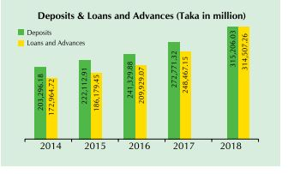
We see in the picture that the Deposit in 2014 was 2039618 million taka. And in 2018 it increased to 31520603 million taka. The deposits increased every year. Loans also increased as well as deposits. We see that the in 2014 loan amount was not as same as deposits in 2014 but in 2018 the loan amount increase to almost as deposits.
Import and exports is one of the main activity of a banks. Customer use banks to do there import export transaction for better experience and safety.

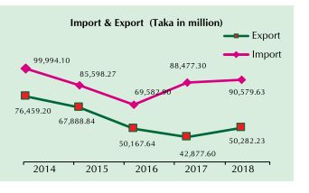

In the picture we see that the import and exports decreases bit. In 2014 the import was 99994.10 million taka and in 2018 it decreased to 90579.63 million taka. In 2016 the import was the lowest. The exports also decreases, in 2014 exports was 76459.20 million taka but in 2018 it was 50282.23 million taka.
Net assets value per share determines the company’s value on each share.

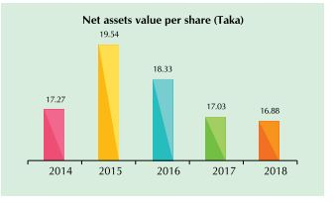

We see that in 2014 the NAVPS 17.27 taka. It increased a lot in 2015 to 19.54 taka. After that it decreases every year. In 2018 it was the lowest 16.88 taka per share.

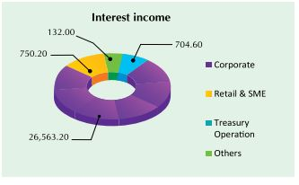

Here is the interest income in 2018.

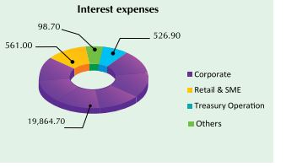

Here is the interest expense in 2018.

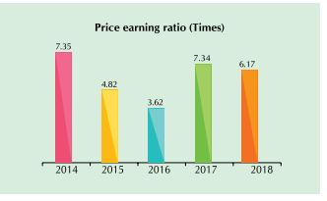

Price earnings ratio determines the company’s position in market that how much investors are willing to pay for one share. We see that the PE ratio decreases each year to 2016. But in 2017 it increases, in 2018 the ratio is 6.17.

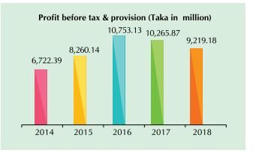

We see that the profit before tax and provisions increases and then again decreases. In 2016 it was the highest. And in 2018 it was 9219.18 million taka.

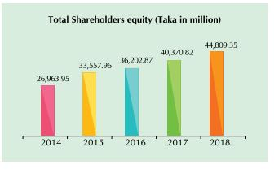

Shareholders equity is the amount that shows how the company has been financed with the help of common shares and preferred shares. We see that Total shareholder’s equity increases each year.
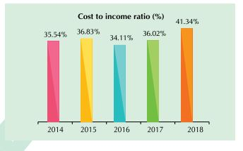

The cost to income ratio shows the cost ratio of the company. It says that how much the company spends each years from its income of each year.

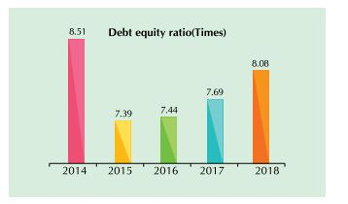

Debt to equity ratio says the debt of the company in respect of its equity. We see that in 2014 the ratio is 8.51.

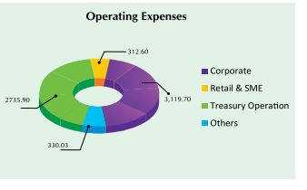

Operating expenses shows how much the company incur expenses to maintain it operation in each sector.

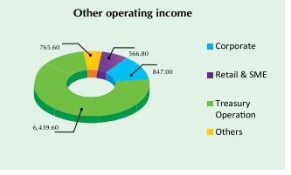

Operating income shows how much the company earns from its operation.

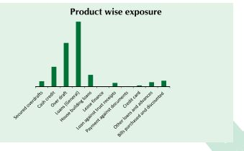
Product wise exposure shows the market needs of each product of the company.

Product/service mix
National Bank provides a lot of product and services on its different sectors. In general banking national bank offers great services and some beneficial schemes for mass customers.
In general banking national Bank offers
- Savings Deposits
Saving Deposits is the basic service of National Bank LTD. Customers can save their money in there saving account and withdraw any time. To create a new account the customer must deposits Tk.4000/- for urban area and Tk.1000/- for rural area. Customer gets 2.50% interest on any amount deposited in savings deposits account. There is no charges up to deposits of Tk.10000/-. But after that customer must pay maintenance fee which is realizable half yearly basis. Tk.10000/- –Tk.25000/- is Tk.100/-, Tk.25000- – Tk.2 lakh is Tk.200/-, Tk.2 lakh to Tk.10 lakh is Tk.250/- and above Tk.10 lakh its Tk.300/- quarterly.

- Current Deposits
Current deposits is another general services of National Bank Ltd. On current deposits customers do not get any interest. There is a charge for maintenance of current deposits Tk.300/- realizable quarterly every year.

- Foreign Currency Deposits
Another services of national bank Ltd is foreign deposits. Both resident and non-resident can get the facility of this account. They offer different facilities to resident and non-resident customers.
For resident
- No initial deposits will be required.
- Interest will be offered 1.75% for US Dollar Account, 3.00 % for EURO Account and 3.25% for GBP Account.
- They will get interest on daily product basis on the credit balance (minimum balance of US$ 1,000/- or GBP 500/- at least for 30 days) maintaining in the account.
For non-resident
- The Account can be opened for One month, Three months, Six months and One Year through US Dollar, Pound Starling, Japanese Yen and Euro.
- The initial minimum amount of $1000 or 500 Pound Starling or equivalent other designated currency.
- Interest is paid on the balance maintain in the Account. This interest is tax free in Bangladesh.

- NBL Monthly Saving Scheme (NMS)
NMS is National Banks one of the popular scheme. National Bank Ltd offers its customers to deposits any amount in monthly installments for 3 (Three) years, 5 (Five) years, 8 (Eight) years and 10 (ten) years. The interest rate is fixed at 8%. Customer can deposit Tk.500/-, Tk.1,000/- , Tk1,500/-, Tk.2,000/- ,Tk.3,000, Tk.5,000/- , Tk.10,0000/- , Tk.20,0000/- ,Tk.30,0000/- ,Tk.50,0000/- each month for consecutive years. National Banks allows its customers to open more than one NMS Scheme account at a time. National Bank Ltd also make a schedule for the better understanding of the scheme.
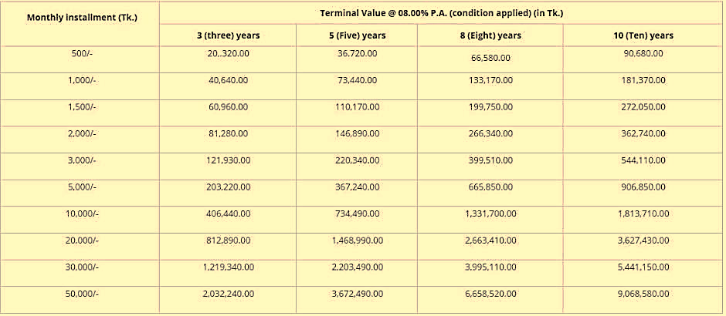

This schedule helps customer to understand about the deposits and return at the end of the scheme.

- Monthly Earnings Scheme (MES)
MES is another popular scheme of National Bank Ltd. In this scheme customers gets an amount every year. Customer will get 8.10% interest each on deposited amount. The minimum deposits for it is Tk.100000/- and customer can deposit up to Tk.1 Crore. Customer can deposit any amount that is multiple of Tk.100000/-. Customer can open MES for 1 years, 3 years and 5 years.

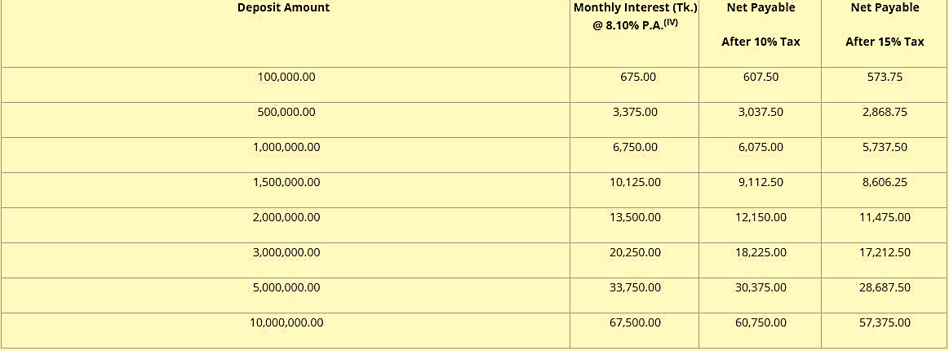

This schedule shows the amount customer can deposits and the return of interest customer will get in each month.

- Double Benefit Account (DBA)
National Bank Ltd offers its customers a different types of beneficial scheme. That is Double Benefit Account (DBA). If a customer open this account the bank will return the double of the deposited amount after 9 years and with the interest of 8.01% (condition applied). The Bank offers some extra benefit for that account also.

- Deposit of Tk.100,000/- and its multiple without any upper limit shall be acceptable under this scheme.
- Bangladeshi citizen aged 18 years or above can open this account either singly or jointly.
- Minor citizen of Bangladesh can also open this account. In that case, his/her legal guardian will operate the A/C.
- One customer can open more than one DBA with same branch or any branches of NBL.
- Locker facilities can be availed at 50% rent for the first year subject to the availability of locker facility in the respective branch.

- Millionaire Deposits Scheme (MDS)
Another attractive scheme of National Bank Ltd is Millionaire Deposits Scheme (MDS). Customers can open this account single or jointly. On this scheme the customers deposits a fixed amount for 4 years, 6 years, 9 years or 12 years. The customer will get 8.00% interest and in the end of the last year of scheme customer will get Tk.1 Million.

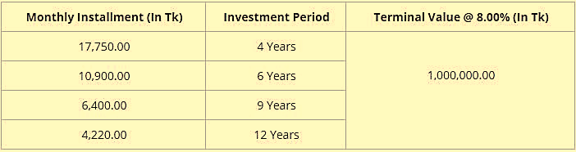

- Shadhinota-By monthly Scheme ( SBS)
This is a 2 (Two) years scheme. Customer can deposit minimum Tk.50000/- and get a return of 8.10% interest in every two months. Bank will provide this for 2 years and the initial deposits will be repaid after the expiry of two years. Customer can withdraw deposits at any time there will be no penalty for early encashment from the Bank. Bank provides some special facility on this scheme too. That is customer can have credit facility up to 80% of the deposited amount and the interest rate will be the scheme interest rate + 2.5%.

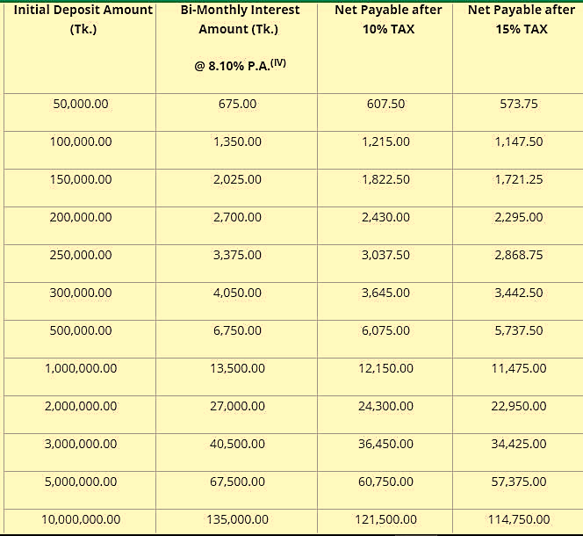

The schedule shows the Deposits amounts and the return in two months.

- Century Deposits Scheme (CDS)
This is a 100 days scheme of national Banks. the minimum amount deposits for this scheme is Tk.50000/- after 100 days the depositors will get a return of 8% interest rate. This scheme expires and automatically renews after 100 days.
Interest calculation is at actual basis (i.e. 366/360). Depositors also gets credit facility up to 80% of the deposited amount. The bank will not impose any charges on this scheme only government charges will be imposed. Depositors can link any account of National Bank Ltd in any branch.

- Shonar Bangla Amanot. (SBA)
This is a 45 days scheme of national Banks. the minimum amount deposits for this scheme is Tk.50000/- after 45 days the depositors will get a return of 8% interest rate. This scheme expires and automatically renews after 100 days.
Interest calculation is at actual basis (i.e. 366/360). Depositors also gets credit facility up to 80% of the deposited amount. The bank will not impose any charges on this scheme only government charges will be imposed. Depositors can link any account of National Bank Ltd in any branch.

As like in general banking products National Bank Ltd also offers some products in credit also.
- Overdraft
A credit facility offered by National Bank Ltd for the corporate customers to maintain their day to day operation. Bank provides facility against deposits mortgage properties. The bank impose minimal charge for maintaining a overdraft account. The interest rate for the overdraft credit is 13% to 16%.

- Lease Financing
National Bank Ltd also provides lease financing facility which helps customers to increase his/her business operations. National Bank provides easy installments policy for clients for the repayment of loan.
Areas National Bank Ltd provides the lease financing,

- Capital machinery.
- Different types of equipment.
- Gas, Diesel generator, and Power-plant.
- Medical equipment.
- Lift or elevator.
- Information Technology equipment.
- Construction equipment.
- Consumer durables.
National Bank also provides more facilities with this credit facility,
- Competitive monthly rental.
- Tax benefit.
- Fast processing.
- Easy handover after leasing period.

- House Building
National Bank also provides credit facility for houses apartments and construction. The bank offers up to 70% of total construction or Tk.75,00,000/- which is the highest of total construction cost. Grace period available up to 9 months in a flat purchase or 12 months in construction. There is no application or processing fee for the credit facility. The interest rate is competitive and changes over the condition.

- Small Medium Enterprise
National Bank Ltd offers this credit facility to support small business and enterprises. NBL divided this facility in two parts. One is Festival Scheme another is Small Business Scheme. For Festival Scheme NBL allows maximum Tk.3 lakh and for Small Business Tk.5 lakh. National Bank Provides 3 Months (Festival Scheme) and 5 years (including 1 month grace period (Small Business Scheme)). NBL also provides Collateral fee in advance. Any genuine and small businessmen/ entrepreneurs/enterprise having honesty, sincerity, and integrity.

- Consumer Credit scheme
NBL also offers credit facility for the retail customers. Bank offers this credit facility for Electronics consumer products and Computer or Computer accessories. NBL provides fast processing, competitive interest rate, no application or processing fee, easy monthly installment.

- Trade Finance
National Bank Ltd also provides credit facility for all business transactions. Such as in the industrial sector for export-import purpose as working capital, packing credit, trade finance, Issuance of Import L/Cs, Advising and confirming Export L/Cs. - Bonds and Guarantees. The interest rates is 13% to 14.50%. Bank impose low services charge for this credit facility.

- Agriculture Finance.
As our country is developing country, the economy mostly depends on the agricultural productivity. Realizing the importance National Bank Ltd organizes a credit facility to increase the productivity and reduce the unemployment problem and increase the self-employment. Credit for development of Crops and cultivating of fishery, poultry and animals and buying of agribusiness apparatuses and water system types of gear, Credit for development of Pulse, Oil Seeds, Spices and Maize under Concessional pace of premium, Credit for sun powered home framework, sun oriented water system framework and Bio-gas plant under Refinance Scheme of Bangladesh Bank.

National Bank Ltd also provides credit facility for Daridro Mukti. To increase living standard of rural areas NBL provides this credit facility. ‘Daridra Mukti’ is mainly aimed to small entrepreneurs and professionals, cottage and handicraft industries, and marginal & landless farmers. These entrepreneurs, professionals and farmers can open their Bank Account by depositing only Tk.10.00. Potter, metal forger, angler, tailors, blossom vender, vendor, natural product dealer, vegetable-merchant, cart puller/van puller, little and bungalow ventures, weavers, pastry kitchen thing makes, minimal finance managers and ranchers of the under-advantaged territories, and political dissidents and their kids are qualified to appreciate this without security and effectively accessible credit office. The maximum amount is Tk.100,000/-.

Operations
National Bank Ltd has 200 branches all over the country in 63 districts. National Bank Ltd is one of the oldest Bank in Bangladesh. Since the establishment of National Bank Ltd, it is maintaining a hassle free operation and trying to provide best banking experience to its customers. NBL always tries to provide simple and easy general banking experience to its customers. National Bank Ltd provides both long term and short term credit facility to its customers and also contribute to small credit facility for improving SME in Bangladesh.

SWOT analysis
SWOT means companies Strength, Weakness, and Opportunity & Threats. Here we will see National Banks SWOT analysis to understand its current situation.

Strength:
- Reputation: National Bank is one of the oldest bank in Bangladesh. National Bank has great reputation and one of the best banking facilities and growth in deposits and credit.

- Facilities: National Bank provides a lot of facilities to its customers. NBL has 31 ATM booth all over the country and 12 in Dhaka districts.

- Team Work: NBL has good team work among its branches and employees. Customers can get banking services from any location.

- Organized: NBL is successfully organized so that customer does not get confused and gets the best banking experience.

- Technology: National Bank has the updated technological support to serve customer as soon as possible.

Weakness:
- Agency problem: When a customer comes to bank the first person he/she sees thinks he can do the job well. When the pressure increase it becomes to difficult to serve all the customer, but NBL tries to serve as soon as possible.

Opportunity:
- Online Banking: as national Bank has technological advantages it can give its customer better online baking experience, where customer can get any facility from anywhere.

- ATM: National Bank Ltd also can increase the number of ATM it has as the customer is increasing day by day.

Threats:
- Competition: There is a lot of banks in Bangladesh, it is very competitive for National Bank Ltd. Competitive Banks are carrying out aggressive campaign to attract more customer an comes up with new banking facilities.

Industry analysis
As a developing economy Bangladesh has encouraged to develop its banking industry to promote economic growth. The banking industry has increased so much over the last decades.

Specification of the industry
Banking is one of the oldest industry in our country. As a developing economy Bangladesh has encouraged to develop its banking industry to promote economic growth. Over the last three decades or so the country has seen spectacular expansion of the banking industry. The banking industry in Bangladesh has even gone a step further by promoting financial inclusion of the very poor in rural areas of which microfinance and microcredit are the policy instruments to achieve that objective. This has helped to expand the monetization of the rural economy, and as a consequence it has become more market-oriented. Such market orientation of the rural economy also facilitated continuous resource transfer from rural areas to urban areas. Now the biggest threat to achieving sustained economic growth has become the banking industry itself, especially the state-owned banks. This is despite Bangladesh adopting internationally recognized banking practices such as Basel III Accord.

Size, trend, and maturity of the industry
The size of banking industry is not small, because banks are the organization that keeps the economy running. Currently there are 60 banks in Bangladesh. Bangladesh's financial framework is currently confronted with a moderate movement banking emergency basically at the administration run banks alongside some private area banks. The circumstance is definitely not improving generally because of exceptionally quick credit development and state coordinated loaning and advance rebuilding. This raises the danger of a credit crunch. Six state-possessed business banks represent just about a fourth of all bank resources in the nation. The administration selects their CEOs and board individuals and frequently impacts them to exercises with deplorable impacts.

External economic factors
Commercial banks have been assuming a significant function in the financial improvement of Bangladesh. They give investible assets to both the public area, and extraordinarily the private area. Further, banks have assumed a critical function in regard of the four significant drivers of monetary development in Bangladesh as talked about above.
The financial area, notwithstanding, is confronted with different difficulties, which incorporate among others, feeble administration, helpless administration, absence of solid initiative, and rebelliousness with moral guidelines prompting different kinds of banking tricks, for example, tax evasion and Non-Performing Loans (NPLs).
Bangladesh is an import-subordinate nation. It needs to import crude materials, extras and hardware to encourage advancement of the modern area, including the RMG area. Banks have been encouraging installment, account and danger the board administrations to the area.

Technological factors
All banks in Bangladesh have made generous interests in innovation stages and frameworks, assembled different dispersion stations, including an electronically connected branch organization, robotized phone banking, web banking and banking through cell phones to offer its clients helpful admittance to different items. All things considered, the banks have been effective in creating imaginative item includes, lessening working costs, improving client support conveyance and limiting inborn dangers. IT encourages all our center business cycles and segments, and serves to help, support and develop change and acknowledgment of our key goals at gathering and specialty unit levels.

In Bangladesh, banks have set up their huge ATM and POST networks for giving ATM admittance to 24 hours for their clients. Adjacent to offering admittance to ATM network the nation over, they are likewise giving similar admittance to their clients worldwide through the organization of VISA/MasterCard. They are additionally setting up and extending their own ATM/POST organization.

Barriers to entry
The normal hindrances to passage are Brand Loyalty, Absolute Cost Advantage, Economies of Scale and Government Regulations. In Bangladesh, the topic of Brand Loyalty is fairly apparent in the financial business. An individual who is a dependable client of a nearby or government claimed bank typically doesn't settle on a record in a global bank, whatever rewarding the advantages appear. This makes hindrances for new contestants. No bank appreciates an outright cost advantage, because of the divided idea of the business. "Divided" industry and its ascribes will be examined in the accompanying segment. The greater part of the administration banks and some neighborhood banks appreciate size of economy; because of the way that they have been working together for a significant long time, and they have branches everywhere on the nation. The global banks are likewise on the way toward accomplishing size of economy. The expanding number of branches bolsters this announcement. Government guideline is very strong towards the development and activity of new banks. So this factor is certifiably not a huge passage boundary in this area.

CHAPTER III: INTERNSHIP EXPERIECNE

Position, duties, and responsibilities
As in intern I had to work many position and I had different types of duties while working in general banking and credit management. In general banking I worked in cash department and account opening department. In credit department they gives credits to depositors and manages loan and investment risk.

Cash Department:
The main responsibility for cash department is to receive deposits and pay on withdrawals of depositors. Another main responsibility of cash department is to calculate daily transactions and vault reserve. After the calculation the amount must be registered in vault registered book.

Account Opening:
In account opening department the responsibility is to help customer with proper information and create new accounts on customer’s preferences.
The department also does keeps records of every customer transaction statements. Customers can create 10 types of accounts.
- Savings Deposits
- Current Deposits
- Foreign Currency Deposits
- NBL Monthly Savings Scheme (NMS)
- Monthly Earnings Scheme(MES)
- Double Benefit Account (DBA)
- Millionaire Deposits Scheme (MDS)
- Shadhinota-By monthly Scheme ( SBS)
- Century Deposits Scheme (CDS)
- Shonar Bangla Amanot. (SBA)
The department also investigate doubtful account and transaction to prevent money laundering activities.

Credit Department:
Credit department gives loan and manages risk of credit. Credit department offers 7types of loan facility.
- Overdraft
- Lease Financing
- House Building
- Small Medium Enterprise
- Consumer Credit scheme
- Trade Finance
- Agriculture Finance.
Credit departments gives credit and takes mortgage.

Training
During three month internship period I have learn a lot of things. My first duties was in cash department. I have worked there for 1 (one month). In cash department they receive deposits and pay on withdrawals. When a customer want to deposit money on his/her account he must fill a voucher. Which is call deposit voucher. Depositor have to fill two pages of it. Each page contain same information. One is Bank copy and another is Depositors copy.
In voucher needed information is,
- Account Name
- Account Number
- Date
- Amount
- Bank name
- Branch Name
- Depositors address, phone & signature
After receiving the copy and deposited money the bank authorizes and save it in depositors accounts. When any depositors want to withdraw money from the bank they have to issue check. A valid check contains,
- Account number
- Names
- Amount
- And accounts holders signature.
If the account holder withdraw money by himself he have to write self in name section and if he pays it to other individual then there should be individuals name and when withdrawal the individual must submit photocopy of his/her National Identity Card. Then the bank confirms account holder by calling that account holder issued the check.
General Banking:
After that I have worked in general banking department. There I have learned how to create account how to keep every data safe and how to close account.
A customer can create many types of account. Most accounts demands same types of information. All the schemes demand same information.
If a customer want to create Savings deposits account then he must submit following documents.
- Photocopy of National Identity Card(NID)
- Photocopy of Tax registration (if the individual is a tax payer)
- 2 Copies of Passport size photo (that should be recent photo)
- Nominees NID
- Introducer name address & existing account number in the bank
- Introducer signature
- Customer income source
- Customers documents for address verification(Copies of household utility bill)
For Current account no individual can create any current only business organization can create current account. For current account business organization must submit following documents
- Trade license of the Organization
- Address verification
- Tax payers number
- All partners and individuals NID copy and Passport size photo
- Copy of deed of partnership
And for schemes the customer submit same documents as savings deposits accounts.
After that I worked in Credit Department for one month.
In credit department I have learned risk management of loans and loan giving procedure.
A customer can get many types of loan. Mostly all loans contains same types of information. Customer have to mortgage something valuable for the loans. Customer can get 80% loan in mortgage assets value. If a customer takes business loans he must submit business transactions statements. The authority will annalise the statement and do audit in the business transaction. Mostly bank requires 6 months transaction. For risk management the bank authority always keeps information about the business or customer.

Contribution to departmental functions
In National Bank Limited there is many department. As an intern I have worked in cash department general banking and credit department.

Cash department:
- In cash department I have talked to customer over phone to verify the checks which were submitted for withdrawal of money.
- I also signed money which was given back to Bangladesh bank for replacement.
- I calculated deposits and registered it in registered book.
- I counted deposits that were deposited by depositors

General Banking:
In general banking sector I did several works.
- I have fill up many types of forms and vouchers. They have three types of forms. One for Savings Deposits account and one for Current deposits accounts and other is for the scheme accounts.
In savings deposits accounts,
- I fill up accounts number which was automatically generated by server name Temonas/ T24. I filled up customer information in the bank copy.
- I also attach customer photo there. I filled up both debit voucher and credit voucher on behalf of VIP customers.
In current deposits accounts,
- Collect customer information,
- Verified information by senior authorized officer
- Fill up the form
And for scheme accounts,
- I fill up the form
- Inform customer about the scheme process
I have also registered email, letter that comes to bank in inward registered book. I have registered letter that has been sent to customer. I have gave statements of account holder that were authorized by the personnel.
Credit Department:
In credit department I did the following activities,
- Calculated total lending
- Calculate bad debts
- Calculate and sort the high value risky loans
I have visited their lending process one day.
- First we collected the deeds of lands that customers giving mortgage
- Then we visited the land for its verification
- We make a deed with the customer in presence of advocates
- The loan amount transferred to saving account by authorized personel

Due to their confidentiality they did not allow me to work deep in credit department.

Evaluation
While working in National Bank I have faced both Negative and positive situations. Positive situations I faces is the employees are so friendly they have very helpful attitude. Whenever I face any problem and ask them they help me, they taught me solving problems.
Problems I face is as they had their own work pressure they were not able to teach me a lot. When they gets free times they tries their best.
Due to Covid-19 situation I was not able to get access in every department of the bank.

Skills applied
As I am extrovert it became easy for me to communicate with the customer. As I have knowledge about Microsoft word excel PowerPoint, I was able to apply there while working with credit department.

Application of academic knowledge
I applied academic knowledge while working with Credit department. I have applied academic knowledge while analysis risk on credit department.

CHAPTER IV: CONCLUSIONS AND KEY FACTS

Recommendations for improving departmental operations
I hope this statement will help NBL to develop their banking services.
The recommendation given below
- NBL should concern about their alignment for department so it becomes easier for customer to find out their facilities.
- They need to make loan facility easy
- They need to make account opening system much easier so that customer gets positive overview about NBL
- NBL should arrange a reception desk so that customer get basic information there
- NBL should make more scope for intern student so that they can work and learn more.
- NBL should provide minimum remuneration to intern so that the feel motivated to work more.

Conclusion
The banking industry is a promising business sector for a country. This sector is becoming worse day by day. As a result the economic condition is deteriorating. It is also bad for the investors who are depositing money in the bank. More time consuming paperwork’s and hard loan giving policies discouraging investors. So the government should make it easy for investor and help them for getting better baking facilities.
National Bank always tries to provide customer fast and secure services. It uses various types of technology so that customer get faster service. As a result national bank is relatively in a completive position in Bangladesh.

