

A PROJECT REPORT ON

THE BRANDING AND PROMOTIONAL ACTIVITIES PERFORMED BY BANGLADESHI MOBILE FINANCIAL SERVICE PROVIDER: A STUDY ON BKASH LIMITED

September 25, 2019
UNITED INTERNATIONAL UNIVERSITY
DHAKA, BANGLADESH
A PROJECT REPORT ON
THE BRANDING AND PROMOTIONAL ACTIVITIES PERFORMED BY BANGLADESHI MOBILE FINANCIAL SERVICE PROVIDER: A STUDY ON BKASH LIMITED
SUPERVISED BY
DR. MD. SHARIFUL ALAM
ASSOCIATE PROFESSOR,
SCHOOL OF BUSINESS AND ECONOMICS
UNITED INTERNATIONAL UNIVERSITY

PREPARED BY
Shuvo Saha
ID: 111 142 139
BBA PROGRAM
UNITED INTERNATIONAL UNIVERSITY
UNITED INTERNATIONAL UNIVERSITY
Letter of Transmittal
To
Dr. Md. Shariful Alam
Associate Professor
School of Business & Economics
United International University (UIU)
Subject: Submission of Project report.
Dear Sir,
You will be happy to know that I have prepared my project report on “The Branding and Promotional Activities Performed by Bangladeshi Mobile Financial Service Provider: A Study on bKash Limited”.
bKash Limited is a mobile financial services provider led by the bank in Bangladesh that operates under license and approval from the Bangladesh Bank as a subsidiary of BRAC Bank Limited. bKash offers secure, convenient and simple ways to make payments and money transfer services via mobile phones to non-bank and Bangladesh banks. Currently, bKash is one of the world's leading providers of mobile financial services. bKash was born as a joint venture between BRAC Bank Limited, Bangladesh and Money in Motion LLC in the United States in 2010. In April 2013, International Finance Corporation (IFC), a member of the World Bank Group, became a member of Financial Partner and in March 2014, the Bill and Melinda Gates Foundation became the company's investor. In April 2018, Ant Financial (Ali Pay), a subsidiary of the world-famous Alibaba group, became a bKash investor. The ultimate goal of bKash is to ensure that the people of Bangladesh have access to a wider range of financial services. Its goal is to serve the low-income masses of the country to achieve wider financial inclusion by providing convenient, affordable and reliable services.
I want to ensure you that all the information of this report are relevant to my field of study and have not taken from any one report that published before. Moreover, I have followed all the guidelines to complete the report according to your advice and I’m am highly appreciated that all your guidelines are proved highly important to prepare the report.
I therefore, pray and hope that your honour would be kind enough to accept my project report.
Your obedient student,
Shuvo Saha,
ID: 111 142 139
BBA Program
School of Business and Economics
United International University

Acknowledgement
At very beginning of the report, I want to thank my parents for making me able to complete the report as well as for providing the cost to compete my degree in Bachelor of Business Administration (BBA).
Secondly, I want show my gratitude and heartfelt appreciation to my course faculty as well as my project supervisor Dr. Md. SharifulAlam, Associate Professor, School of Business & Economics, United International University (UIU) for sharing his valuable time and provide me effective report format/outline as well as his valuable advices. All of his efforts helped me to prepare the report in this short period of time.

Thirdly, I want show my gratitude and heartfelt appreciation to NazmulKabir, and Belal Ahmed, General Manager, Planning & Business Development, bKash limited for sharing their valuable time and effort to deliver sufficient information for the project. Without their valuable information on bKash the report could not be such successful one.

Last but not least, I would love to thanks all my friends who spends a lot of time to gather information and made me able to understand several concept that were unclear to me before. All of their contribution helped the report an informative one. No words can reward them for their contribution.

Summary
bKash Limited is a limited liability company specially created to provide mobile financial services in Bangladesh. Its mission is to provide customers with an accessible, adequate, affordable and consistent financial service. The main objective of development is to guarantee broad financial services to the people of Bangladesh. In addition, it is very difficult for people in rural areas to have access to conventional financial services. That's why he's particularly interested in low-income groups across the country. bKash has come up with some products and services to make people's lives easier. Well, bKash has established his own identity and has grown. It is very good news that bKash now serves 3 lakhs of large customers group through 2 lakhs of its agents and successfully covers 64 districts. Now people can easily send money, pay bills, shop through development. bKash believes that customers/customers are the power of it. Thus, they are committed to providing quality services to their consumers. Although development is growing rapidly at the same time, the market is becoming more competitive. Therefore, bKash is trying to promote the brand by using various promotional activities to increase customer loyalty and increase customer base.
The report has in total of four chapters but has focused in a single purpose which is how bKash, the largest mobile financial service of Bangladesh, has become so popular. We know that to be a well-known brand, promotion of the product and services plays a vital role.In fact, Promotion is a key element in conveying the benefits of a product or service to customers. Well-designed branding and promotion strategies ensure long-term success, attract more customers and ensure business profitability. Therefore, analysing the Branding and Promotion strategies of bKash can deliver the true essence of how the company have become so successful in these years. The report also includes few recommendation at the end of the report that may help bKash to improve its position more in the up-coming days.

Table of Contents
chapter one: Introduction
1.1 Background of the report 2
1.2 Scope of the report 2
1.3 Methodology of the report 3
i. Primary Sources: 3
ii. Secondary Sources: 3
iii. Data analysis: 3
1.4 Objectives of the report 3
a. Primary objectives: 3
b. Specific Objectives: 3
1.5 Limitations of the report 4

chapter two: Overview of bkash
2.1 An Overview of bKash 6
2.2 History and Background of Mobile Financial Service (MFS) in Bangladesh. 6
2.3 Advantages of bKash 7
2.4 Organogram of bKash 8
2.5 Products and Services of bKash 8
a. Cash Out 9
b. Cash In 9
c. payment 9
d. Send money 9
e. Interest on savings 9
f. International Remittance 9
2.6 Key players and Major Competitors of Mobile Financial Service 9
a. Rocket 10
b. MCash 10
c. Nagad 10
d. Ucash 11

Chapter three: literature review
3.1 Literature Review 13
3.1.1 Strategy 13
3.1.2 Branding Strategy 14
3.1.3 Promotional Strategy 15
3.1.4 Promotional Mix 16

Chapter four: Analysis and findings
4.1 Customer coverage portfolio of bKash 19
4.2 The Promotional Activities performed by bKash 19
4.2.1 Promotion and Branding through Enhancing Relationship: 19
4.2.2 Promotion and Branding through development activities: 21
4.2.3 Promotion and Branding through festival offers: 22
4.2.4 Promotion and Branding through vacation tour offer: 22
4.2.5 Promotion and Branding through billboard advertisement: 23
4.2.6 Promotion and Brandings through TV Commercials: 24
4.2.7 Promotion and Brandings through agent branding: 25
4.3 SWOT analysis on bKash: 25
4.3.1 The strengths of bKash: 25
4.3.2 The weaknesses of bKash: 26
4.3.3 The opportunities of bKash: 27
4.3.4 The Threats of bKash: 28

Chapter Five: Recommendations and conclusion
5.1 Recommendations 30
5.2 Conclusion 31
Reference

Chapter one: Introduction of the report

1.1 Background of the report
The project report is a pre-requirement of achieving Bachelor of Business Administration degree from United International University. The report is prepared on my self-observation of bKash and the field I studied is named “The Branding and Promotional Activities Performed by Bangladeshi Mobile Financial Service Provider: A Study on bKash Limited”.
bKash Limited is a limited liability company specially created to provide mobile financial services in Bangladesh. Its mission is to provide customers with an accessible, adequate, affordable and consistent financial service. The main objective of development is to guarantee broad financial services to the people of Bangladesh. In addition, it is very difficult for people in rural areas to have access to conventional financial services. That's why he's particularly interested in low-income groups across the country. bKash has come up with some products and services to make people's lives easier. Well, bKash has established his own identity and has grown. It is very good news that bKash now serves 3 lakhs of large customers group through 2 lakhs of its agents and successfully covers 64 districts. Now people can easily send money, pay bills, shop through development. bKash believes that customers/customers are the power of it. Thus, they are committed to providing quality services to their consumers. Although development is growing rapidly at the same time, the market is becoming more competitive. Therefore, bKash is trying to promote the brand by using various promotional activities to increase customer loyalty and increase customer base.

1.2 Scope of the report
The report is prepared to describe the promotional activities of bKash to the market analyser in order to provide idea of how a Bangladeshi mobile financial service provider utilizes strategies to promote its brand and products to attract customers. There are various ways to promote a company’s products and services. Moreover, Understanding the importance of promotion and marketing strategies is very important for small and medium enterprises. Promoting an organization is an active process that requires careful consideration to get the best results. Anyone can take full advantage of their workforce and develop strategies to promote and grow their business. Marketing and promotional strategies go hand in hand. The marketing of a brand or product implies different aspects of the production, promotion and sale of the product to customers. Promotion is a key element to help a customer benefit from any product or service. Well-planned marketing and promotional strategies guarantee long-term success, attract more customers and ensure company profitability. Any reader of the report, students as well as faculties of various university can learn and compare with their educational learnings with my practical observations if they carefully go through my piece of study.

1.3 Methodology of the report
A reporting methodology section describes in detail how the study is conducted, the methods used, and the reasons for choosing these methods. The methodology of this report are:

Primary Sources:
- Through formal and informal communication with the bKash personnel.
- From the online website of bKash.
- From the personal observation of bKash.

Secondary Sources:
- From the daily newspaper, books and from other several published contents of bKash.
- From the google searching previous promotional activities of bKash.
- From several blogs that have articles on bKash.

Data analysis:
The report is an exploratory one that made of qualitative data rather than using quantitative data. All pictures, writings and techniques are used through using Microsoft Word.

1.4 Objectives of the report
The objective of the study is to create an overall plan and a development framework to establish guidelines and standards for more effective and comprehensive pedestrian planning at different planning levels, based on the creation of conceptual plans.

Primary objectives:
The primary objective of the report is to achieve the BBA degree from United International University.

Specific Objectives:
The specific objective of the study are:
- To analyse the company, bKash
- To list the competitor of bKash.
- To analyse the promotional activities performed by the bank.
- To recommend few ideas for the betterment of bKash.

1.5Limitations of the report
The limitations of the study are the characteristics or design methodologies that influenced or disrupt the interpretation of the results of the research. While preparing the report, I have also faced several limitation that has influence on the study outcome.
- Small duration of project program: The project program is only four months in duration. In this short period of time, it was hard to prepare and gather so many information in this study.
- Confidentiality: A lot of information of bKash that were highly relevant to my study was found very confidential for what I could not present them.

Chapter two: Overview of bKash

2.1 An Overview of bKash
bKash Limited is a subsidiary of BRAC Bank Limited. It was created for the first time in 2010 as a joint venture between BRAC Bank Limited in Bangladesh and Money in Motion LLC in the United States. In April 2013, the International Finance Corporation (IFC) became a financial partner of the World Bank Group. The Bill and Melinda Gates Foundation became the company's investor in April 2014. Follow bKash Limited goal of ensuring access to a wider range of financial services for the general population of Bangladesh. bKash focused on service to low-income people in general in the country by providing reliable, convenient and affordable services.
More than 70 out of 100 people in the country live in rural areas where access to formal financial services is difficult. But it is the people who most need these services, both to receive funds from distant family members, and to have access to financial instruments to improve their economic situation. Less than 15% of Bangladeshis are connected to the formal banking system, while over 68% have a mobile phone. These phones are not just talking devices, but can and should be used for more useful and sophisticated processing tasks. bKash was designed primarily to use these telecommunications devices and networks to securely extend financial services to the remote masses of Bangladesh. bKash has the largest number of agents throughout the country, with over 160,000 agents providing a continuous service to all the services offered by bKash.

2.2History and Background of Mobile Financial Service (MFS) in Bangladesh.
The second half of 2011 marked a milestone in Mobile Financial Service (MFS) for Bangladesh. The previous ad hoc authorizations of the Bangladesh Bank have been replaced by a series of guidelines that provide fundamental regulatory certainty to promote market development. Suppliers have responded positively with five banks that have implemented active implementations. The three largest were launched in 2011 and early 2012, just when the guidelines of Bangladesh Bank were finalized and made public. At the end of the first quarter of 2012, BRAC Bank introduced bKash and DBBL introduced Rocket, which have the largest number of registered customers and agents, experienced the fastest growth. These two players also signed respectively 3 and 4 MNO partners. Bank Asia is distinguished by the fact that it offers an alternative mobile phone technology that does not require an MNO agreement but allows transactions through a smartphone using Internet applications. Distributions focused on mobile account creation and basic P2P services have grown faster so far. Previous licenses offered to banks and their MNO partners exclusively for foreigners Remittances have not increased much, a model compatible with international experience.
The MFS market is in its infancy, as new suppliers try to stabilize their technology, build agent networks and acquire new customers. It implies a complex, a series of sequential activities that include: (1) agent research and training, (2) marketing to draw attention to the service, (3) customer acquisition through customer knowledge processes (KYC) and account opening, helping at the same time, new clients begin to negotiate. Today, the most active implementations are trying to expand their customer base in 2012. For example, BRAC Bank / bKash and DBBL point to multiple growth in 2012, which could lead to their combined customer accounts between 2 and 3 million a year and maybe more. It is expected that other suppliers entering the market can also grow and offer more alternatives and competition. It is still too early to learn about MFS in Bangladesh in the next year.

2.3 Advantages of bKash
bKash is dedicated to expanding the financial inclusion network of the population of Bangladesh by facilitating the transfer of money via mobile phones. bKash provides mobile financial services that allow customers to send, receive and pay money from their mobile phone. Send and receive money or make payments as soon as possible! bKash lets you send money to anyone who uses the advanced technology available on your mobile phone. The recipient will receive money immediately, no matter where it is. BKash payments also make life easier for you, you don't have to go home or anywhere else to get money when you have to buy something and be out of money. Even if you don't have the required amount on your bKash account, another person can easily send you the amount if necessary.
The advantages of using bKash are:

2.4 Organogram of bKash
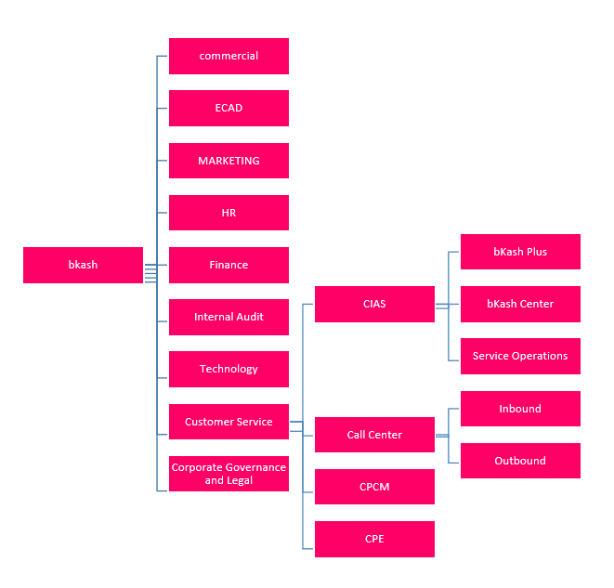

2.5Products and Services of bKash

bKash offers the following products and services to all users,

Cash Out
Users can withdraw money from their accounts with bKash agents and ATMs. bKash only charges avery low service fee.

Cash In
You can load money into your bKash account through one of the bKash or ATM agents. This process is free.

payment
bKash is available in most markets. Buy transmission time Mobile phone users need regular transmission times. BKash allows users to do it. Buy the transmission time directly from youraccounts.

Send money
The money can be transferred from one account to another practically through bKash. The cost is conveniently low and allows users to send money easily.

Interest on savings
Users can earn up to 4% interest each year on their bKash account.

International Remittance
bKash established a relationship with Western Union and Master-card to receive money from foreign countries, which allows the rural population to receive money directly from relatives living in other countries.

2.6 Key players and Major Competitors of Mobile Financial Service
The key competitor of bKash in Bangladesh are:

Rocket
The Dutch Bangla Bank Limited of Bangladesh is a pioneer of the Bangladeshi Mobile Banking. It is the first bank to offer banking services through a variety of mobile phones. The Rocket is a bank-free banking process that provides financial services to non-bank communities in an efficient and cost-effective manner. Provide banking and financial services such as payroll payments,cash withdrawals, cash income, commercial payments, utility payments, public donations,and remittances, cash withdrawals from vending machines using mobile technology devices or mobile phones, called rockets.

MCash
MCash of Islami Bank Bangladesh Ltd. is an authoritative application for your daily financial transactions. It provides a wide range of mobile banking services and more. Customers can use the service and charge their mCash account through a bank transfer service.

Nagad
To lead the country's thriving digital financial services (DFS) revolution, Nagad is a post office company in Bangladesh that facilitates people's daily transactions. The Nagad brand is operated by Third Wave Technologies Limited (TWTL).
The central idea of ​​the service is to increase the possibilities. According to the World Bank's 2017 Global Findex Report, only 50% of Bangladesh's mobile banking accounts and/or financial institutions were in 2017, of which only 21.2% had mobile money accounts. This has led to a large number of people who need to be united and they need reliable services to meet their financial needs. With a large number of basic services, such as capital inflows and outflows, P2P remittances and mobile device recharge, Nagad's goal is to improve people's lives by providing financial flexibility.

Ucash
UCash is a complete mobile financial service of United Commercial Bank Ltd. (UCBL). UCBL has been authorized to manage and offer the Mobile Financial Services (MFS) in Bangladesh by the central bank of the country. UCBL firmly believes in the concept of “financial inclusion” and everyone should be able to use banking services. UCash has launched its services throughout Bangladesh to provide banking services to the vast majority of the country's non-banking population. UCash intends to familiarize the banking industry with those who have previously been unable to use banking services. UCash will promote the economic development of non-banking people by providing fast, secure and fast banking products and services.

Chapter Three: Literature Review

3.1 Literature Review
The literary review is one of the part of research paper where author tries to make easier to understand the basic understandings of the concept of that research. The literature review is an academic document that includes current knowledge, including substantial results and theoretical and methodological contributions to specific topics. According to Baglione (2012), “the literature review is a secondary source and does not report on new or original experimental works”. Such comments are often associated with academic literature and can be found in academic journals and should not be confused with book reviews that may also appear in the same publication. The literature review is the basis for research in almost all academic fields. A small-scale literature review can be used as part of a peer-reviewed journal article that presents new research to position current research within the relevant literature and provides basic information to the reader. In this case, it is usually reviewed before the work method and results in the section. My report is about branding and promotional activities of bKash which is a mobile financial service provider in Bangladesh and therefore, branding and promotional strategies have been discussed here so that readers of the report can easily understand the concepts.
(Source: Wikipedia &Baglione, L. (2012). Writing a Research Paper in Political Science. Thousand Oaks, California: CQ Press)

3.1.1 Strategy
The word "strategy" comes from the Greek word "stratçgos"; stratus (meaning the army) and "needle" (meaning command/action). A strategy is an action taken by a manager to achieve one or more goals of the organization. The strategy can also be defined as “the overall direction established for the company and its various components, with a view to achieving an ideal state in the future. The strategic outcome of the detailed strategic planning process.
A strategy can also be defined as the knowledge of the target, the uncertainty of the event, and the need to consider the possible or actual behavior of others. A strategy is a decision model in an organization that can show its goals and objectives, simplify policies and key plans to achieve those goals, and defines the types of business, economic, and humanitarian organizations that a company must conduct. And its contribution to shareholders, customers, and society as a whole.

One strategy is to integrate organizational activities and use and allocate scarce resources in the organizational environment to achieve current goals. When planning a strategy, it is important to remember not to make a decision in a vacuum, and any action by the company may be met by the reaction of interested people, competitors, customers, employees or suppliers.

3.1.2 Branding Strategy
As the name implies, branding strategy is a long-term plan for successful brand development to achieve specific goals. A well-defined and well-executed brand strategy affects all aspects of the company and is directly related to the consumer's demanding, sensitive and competitive environment.
Short-term operations and strategies that run a business today are easy to carry on, but it is a big mistake in brand building. Brands cannot be created overnight, so the brand strategy should focus not on short-term strategies but on long-term goals and sustainable growth.

It is true that it is difficult for managers to remain strategic when data is under pressure and now requires measurable growth and positive MOI. But the best brand leaders will fight short-term concerns because they know that myopia is a brand killer.
Thomson Dawson, Managing Partner at Pool Brand Innovation, describes the problem well in an article written earlier this year for Branding Strategy Insider. He writes: "Brand Manager and Agent plans for customers powered by Strategy. This is because creative summaries are usually control documents based on project management of 80% of the daily processes of marketing departments and advertising companies. Not a collection of ideas, but a forum for brand managers and theirs. Communication partners are the limit assigned to them Focuses on the best ways to manage processes and budgets. When they approach strategic and creative decision-making, they usually don't think in the long run. It is easy to see how confused it is. "
Instead of focusing on short-term strategies, Dawson allows teams to design sustainable structures that "connect with brand strategies and brand information," calling on people to be brand architects. He is absolutely right. Without a clear brand foundation on the basis of a clear strategy, the chances of success for a brand are reduced. However, it is difficult to follow this strategy by being attracted to the temptation of short-term attention.

3.1.3 Promotional Strategy
Promotional activities are marketing attempts to inform, convince or remind consumers and B2B users to influence or respond to buy the promotional products or services. Most companies use promotions. Business goals are broad, as well as promotion strategies. The goal is to act by the person or organization of the target market. The purchase of a promotional item from a profit-making company is the promotion the buyer wants.

The promotional objectives include customer loyalty, awareness, information, increased product use and identification of potential customers, as well as educating key customers is necessary to "co-create" paid services. Each promotional campaign can achieve one or more of these goals:

- Identify target customers: promotions help customers discover. For example, you can list a website as part of a promotion.

- Provide information: the dissemination of information is more common in the early stages of the product life cycle. An information promotion can help in the financial situation of a customer, describe why a product is better, explain why the product is better, inform the customer about new low prices or explain where the offer can be won.

- Invite consumers to try a product: promotions are always used to encourage people to try a new product or create nonsense by using an existing product. Sometimes free samples are offered.

- Increasing awareness: all companies in general, companies fail because people don't know if they exist or what they do. Large companies often use catchy slogans to increase brand awareness.

- Increased amount and frequency of use: promotion is often used to encourage people to use the product more often and more often.

- Inform the customer: for service products it is often important to teach the potential customer the reasons why a certain part of the service is provided. In services, service providers work together with customers to offer the service.

3.1.4 Promotional Mix
The combination of traditional advertising, sales promotion, personal sales, social networks, public relations, and electronic commerce used to promote a product is called a promotional Mix. Each company creates a unique promotional mix for each product. But the goal is always to convey the company's message effectively and efficiently to the target audience. These are the elements of the promotional mix:

- Public relations: a link between organizational objectives and important aspects of public interest and the development of programs designed to be understood and accepted by the public. Public relations can be lobbying, advertising, special events, internal publications and media such as a company's internal television channel.

- Personal sale: personal presentation to a potential buyer usually from visiting door to doors of customer to introduce with the product or service.

- Social networks: use of social media platforms such as Pinterest, Facebook, Instagram, Twitter, and various blogs to generate comments about a product or company. The skills and knowledge necessary to generate information and defend the business from problems (such as making "viral" videos) are different competencies linked to traditional advertising. Promotional strategies, such as paying celebrities to wear a specific clothing line and posting these images on Twitter or Instagram (a form of advertising) require different types of planning and experience than traditional advertising.

- Sales promotion: marketing activities (other than public relations, traditional advertising, social networks, personal sales, and electronic commerce) that stimulate consumer purchases, including demonstrations, exhibitions & shows, coupons and samples, and other types of efforts for selling products and services.

- Electronic commerce: use of a company's website to generate sales through online orders, interactive components & information, such as games and other elements of the website. Website development is mandatory in today's business world. Understanding how to develop and use a website to generate sales is essential for every seller.

- Traditional advertising: any form of non-personal promotion paid by an identified sponsor, transmitted through traditional media.

Ideally, marketing communications for each element of the promotional mix (personal sales, traditional advertising, sales promotion, public relations, social networks, and electronic commerce) should be integrated. In other words, the message that reaches the consumer must be the same, whether it comes from an advertisement, a field vendor, a magazine article, a blog, a Facebook message or a coupon in a newspaper supplement.

Chapter Four: Analysing the Branding and Promotional Strategy of bKash

4.1Customer coverage portfolio of bKash
Total Coverage portfolio of bKash, 2018
Type | Number nationwide | Additional details
Agents | 170,000+ | Country wide coverage
Subscribers | 27,000,000+ | Country wide coverage
Full service branches | 150+ | BRAC Bank branches
Mobile banking offices (bKash Plus centre) | 100+ | Country wide coverage
Merchants | 40,000+ | Country wide coverage
ATMs | 300+ | Only BRAC Bank ATM booths can be used to cash out from bKash. Available in major cities in Bangladesh.

4.2 The Promotional Activities performed by bKash
After nine years of development, there are now 1.5 agents in development, which is about one in every village in rural Bangladesh. "It guarantees access to experts in the most remote areas of the country". The administration was promoted on 21 July 2011 It currently has about 3 million registered customers. Furthermore, 98% of Bangladesh customers use bKash. In recent years they have acquired a huge brandings through its promotional activities that have allowed them to progress. Some of their promotional strategies are described below.

4.2.1 Promotion and Branding through Enhancing Relationship:
bKash Limited, the country's largest mobile financial services provider, has signed an agreement with OTBI in July 2019. Under this agreement customers will be able to pay for their development by scanning the QR code in the development app or by dialling USSD * 247 # at all OTBI stores.
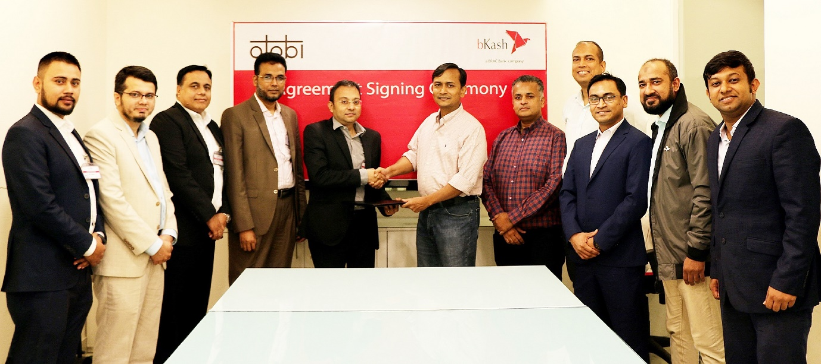
Readymade garments workers will earn a salary in their mobile through bKash. The four plants - Infinity Company, Best Wool Sweaters Limited, Renaissance Group, and Snotex Group - have signed an agreement with the development of the largest mobile financial services provider in the country, in order to pay their workers.
The documents were exchanged in June 2019 by Kamal Kadir, general manager of the development of a local hotel, EnamulHaque Khan, general manager of the Ananta company; SM Khaled, general manager of the Snowtex group; Muhammad AlamgirKabir, director of the Renaissance group, and Siamul Hassan Siam, director of Best Wool Sweaters Limited.
Under this agreement, 4,000 employees of Ananta Companies, 3,000 employees of Snowtex Group, 1,000,000 of Best Wool Sweaters Limited, and 3,000 of Renaissance Group will receive a salary.
Currently, over 170,000 clothing companies in the country distribute wages to around 2 lakh workers through development. As this pay distribution system gains security and popularitythrough development, more and more mills are entering, including these four major apparel exporters.
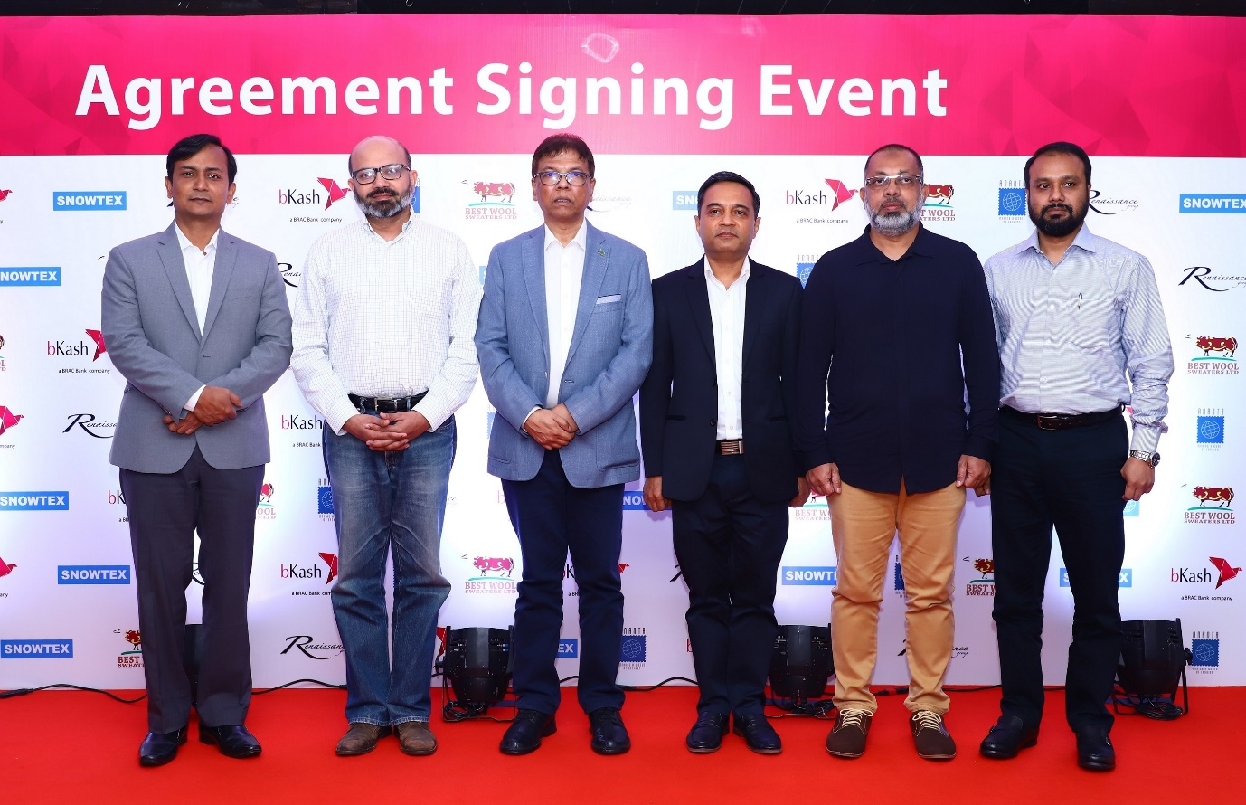

3.2.2 Promotion and Branding through development activities:
bKash in association with BishwoShahittoKendro expanded the book reading program in Kushtia in 16th July 2019 to enlighten future generations by reading books.
The program was held at the Mohini Mohan Vidyapith Auditorium, where books were delivered to students from various schools in the district, including Mohini Mohan Vidyapith, Milpara Girls High School, Mir Mosharraf Hossain High School, Kushtia High School, and SirajulHaque Muslim School.
bKash has been supporting BishwoShahittoKendro's "National Book Enrichment Program (Reading Book)" since 2014 and has contributed more than two broken books to the program. This year, 40,000 books have already been distributed. The books should be distributed in 400 schools throughout the country.
In the last 40 years, BishwoShahittoKendro has carried out various awareness programs for students of schools and universities to build an enlightened society. The National Enrichment Program (Reading Books) is the most important program of the organization and is enjoying great success. Currently, the book reading program involves approximately 200,000 students from 2,000 educational institutions across the country.
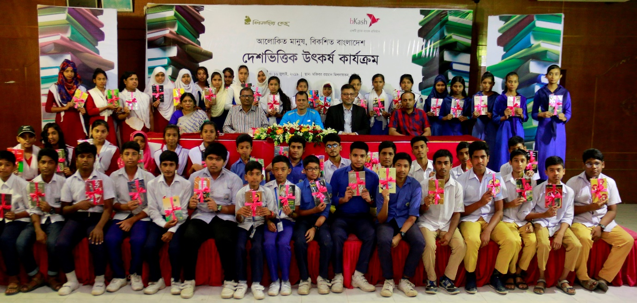

3.2.3 Promotion and Branding through festival offers:
bKash Limited, the largest provider of mobile financial services in the country, offers up to 20% cash payment through bKash for purchases at selected Ramadan and Eid-ul-Fitre from their authorized stores on May 2019. This year, bKash offers several offers in different segments to celebrate Ramadan and Eid.


3.2.4 Promotion and Branding through vacation tour offer:
As a part of promotion and branding, bKash announced that those who wish to book hotels and buy airline tickets can benefit from discounts of up to 60% if they make purchases from selected partners via mobile banking. bKash launched the discount offer in collaboration with 21 hotels, resorts, and two online ticketing sites. Partner organizations include Grand Sultan Tea Resort and Spa, Ocean Paradise Hotel and Resort, Cox Today Hotel, Sairu Hill Resort, November Eco Resort, Royal Tulip Sea Pearl Beach Resort and Spa, Sea Crown Hotel, Prassad Paradise, Brac CDM Rajendrapur, Greenview Resort and Convention Center, Nokkhottrobari Resort, Sreemangal Inn Hotel, Swiss Valley Resort, Nishorgo Eco Resort, Beach Way Total Hotel, gozayaan.com and ticketshala.com.


3.2.5 Promotion and Branding through billboard advertisement:
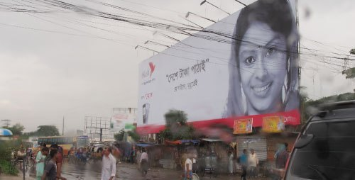
Billboard advertisements are the best way to communicate with customers in Bangladesh. Currently, bkash has 2450 billboards across the country. This will allow them to reach more people. All billboards have an excellent display level and are located in the important areas of the country. They cover every Bangladeshi thana through these billboards. On top of that, bkash message is a stable game on the board. Here are some pictures of the bkash billboard:

3.2.6 Promotion and Brandings through TV Commercials:
A total of 28 TV commercials are broadcast in Bangladesh till 2018. These commercials use multiple innovative ideas to promote its services and products to potential and existing consumers through TV advertising. Generally in this TV commercials, bKash shows the quality of its services, the increasing number of customers, and various precautions to avoid the fraud performed by unethical person through phone call. Here are some ads for development:
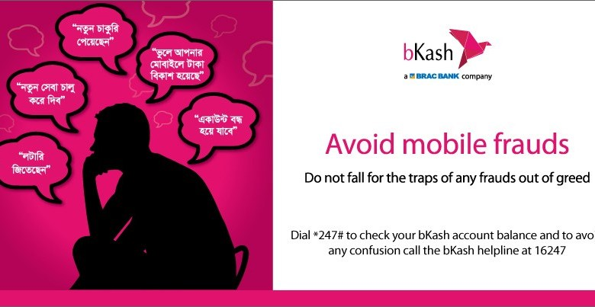
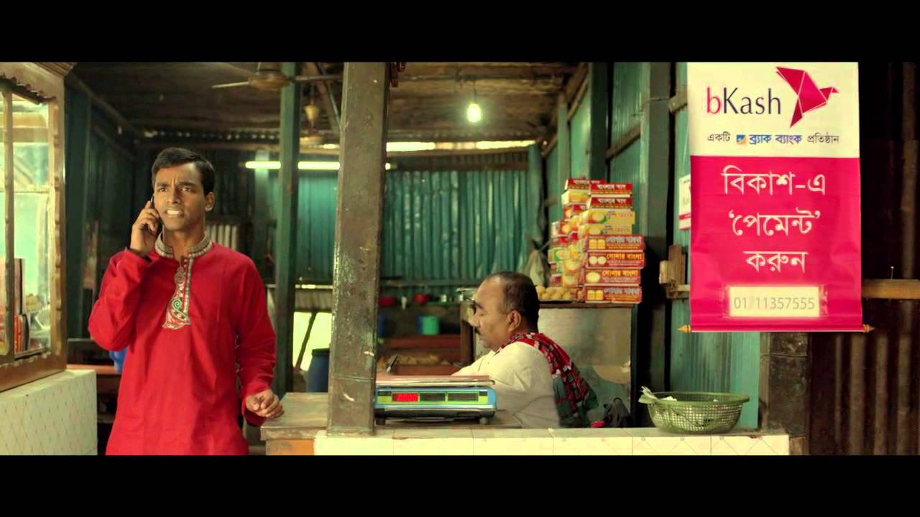

3.2.7 Promotion and Brandings through agent branding:
bKash has a total of 85,000 agents throughout Bangladesh. bKash guides the way of different product promotions through these agents and provides them several bKash brochure. These brochures include posters, festoons, with the promotion usually printed on the brochure. All these agents inform their clients about the new bKash promotional offer given by bKash so that the customers can increase the knowledge of the bKash and can learn about the new bKash offers.
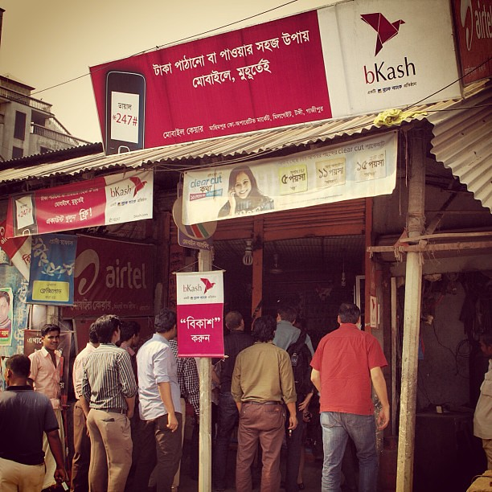

3.3 SWOT analysis on bKash:
SWOT analysis is a strategic planning tool that identifies the main strengths, weaknesses, opportunities, and threats that lead to evidence-based analysis, new perspectives and new ideas. A SWOT analysis is designed to provide a realistic, data-driven view of the strengths and weaknesses of an organization, its initiatives or a sector. The organization must maintain an accurate analysis by avoiding preconceptions or areas of darkness and focusing on the actual context. The information that is generated through SWOT, are highly important for organizations to take into consideration.

3.3.1 The strengths of bKash:
- Using the solid and extensive mobile network of four giant mobile operation companies (Airtel, Banglalink, Grameenphone,andRobi), bKash offers its services to a wide range of customers in the Bangladeshi market.
- Under the large subsidiary of the BRAC Bank, bKash is the leading provider of mobile financial services in Bangladesh.

- bKash is the market leader for mobile money transfer service in Bangladesh at this current moment.

- bKash has the best technical support that allows you to serve its customers as quickly as possible.

- Business and environmental management regulations: BkashMfs operates in an environment subject to numerous government regulations and orders. In the field of innovative technologies, companies must respond to the environment by establishing close relationships with lobbyists and political networks.

- Product quality and service quality can help Bkash to further increase its market share, as current customers are very loyal. There is sufficient evidence to prove it with products and services of this quality, Bkash can participate alongside other global players. on the international market competition

- The first-mover advantage: Bkash has an advantage for the first player in the number of segments. He has made innovations and technical experiences in various fields. Leadership and management solutions and strategies help Bkash to provide unique solutions for the development of unclassified markets.

3.3.2 The weaknesses of bKash:
- Recently, online shopping has earned high popularity in Bangladeshi market. bKash still does not offer online customer service which is a major weakness for the company.
- The company does not provide any protection to the field agent, so the local businessman does not feel safe to take the development agency.

- The absence of a local agent is a major weakness of bKash Limited. They have only 1,600 authorized field agents across Bangladesh.

- Project management of bKash overemphasizes internal delivery, not the interests of external stakeholders. This approach can lead to poor public relations and negative customer reactions.

- The culture of Bkash seems to be still dominated by territorial wars within different sectors, leading managers to keep information safe. According to this case, emerging markets can seriously hamper future growth, as information on isolated islands may cause markets to lose opportunities

- I think Bkash lacks key & innovative talents, especially in the areas of technology and digital conversion. Bkash is committed to reorganizing processes based on the development of artificial intelligence (AI) and machine learning.

3.3.3 The opportunities of bKash:
- Online shopping is gaining tremendous popularity in Bangladesh. Therefore, if the company can provide a transaction system to buy and sell from online, it can make significant profits.

- One of the current challenges of the Multilateral Fund is to limit the entry of high-level talent into the market due to limited budgets. The expansion of the international market can help develop the international talent market. This can help attract talent to the local market and expand into new areas of innovative technology.

- By developing a joint venture with two large international money transfer companies, bKash can offer a more complete international transaction service.

- Developers of bKash can use the increase in disposable income to create a new business model in which consumers start paying for the use of their products. Development can extend this trend to adjacent areas of innovative technology.

- The target market of bKash Limited is generally made up of large financial service providers and people ignored for their offers. As Bangladesh is a populous country, there is a great opportunity to gain significant participation in the development market.

- The speed of machine learning and artificial intelligence is changing the technological landscape that B can use to develop these skills, thereby increasing efficiency, reducing costs and modifying processes.

- bKash value-added development can take advantage of the current online trend to reduce the number of quotes on the market and focus marketing efforts on the best performing products.

3.3.4 The Threats of bKash:
- Some banks in Bangladesh have recently offered comparable services to new offers and new facilities in the market. If bKash cannot take the essential actions to protect itself, it may lose market share.

- In the face of increasing pressure from the protesting parties and NGOs, bKash need to closely monitor the evolution of government regulations, especially in protecting the company and its labour.

- In the last 1 years, this company has faced various online terrorism and hacking-related problems in many parts of Bangladesh due to the country's poor technological security. If such incidents are not controlled by bKash, the customers will not transact their savings because of the threat of losing their money.

- Due to environmental regulations, the cost of working in developing markets is increasing, and bKash must face this expense, as the government seeks to impose higher environmental taxes to promote cleaner choices. For development MFS, this may result in higher logistics costs and packaging costs.

- bKash should prevent growing protectionism by operating in countries with different economic cycles, from data storage in the international market to the risk of diversification.

Chapter four: Recommendations and Conclusion

4.1 Recommendations
After analysing the promotional and branding strategies performed by bKash, here I would like to share some recommendations based on my academic knowledge for the betterment of bKash in upcoming years.
- At the preliminary stage, digital payments must be available in places such asonline storeshospitals, and supermarkets. However, there are some places where development payments are available in the form of "lottery tickets", but according to research, people do not find the importance of the possibility of providing development.
- The payment option must be provided in all possible nearby locations. One of the main reasons why bKash payments are not used is that people do not have enough space to use it. The digital payment option is already well known and the urban market is now quite ready to use it.
- The payment method should be simpler to use to acquire the market for all payment or transaction segments. Because of the study, I've observed that most of the people want simplification in the transaction.
- The development B application must have a QR code analysis feature that helps users manage faster development.
- One of the developments should come with a mobile application that will help people to manage development more easily. With this development application, it will be useful for organizations to create potential users for real users of development.
- bKash should focus on the high growth potential of Bangladesh since the number of mobile users in Bangladesh is around 156,469 million and 156,469 million people can be potential customers of bKash.
- In terms of brand, bKash is more visible than DBBL. bKash should focus on more innovative brand ideas and if bKash provides online payment services, it can be a great success.
- The mobile financing service is not very old technology for Bangladesh as it just began on March 31, 2011. The Dutch Bangla Bank Limited (DBBL) had introduced the first mobile financial services in Bangladesh. Many people know the MFS but have not enough proper idea of it. bKash should start a free training service for their agents so they can help customers use it effectively.

4.2 Conclusion
Multiple financing industries are growing at a fantastic rate. While it only took seven years for bKash to reach $ 5.5 million, DBBL has two million dollars in seven years. In addition, different companies may eventually increase their market share, which is why the company was at the beginning of the period. The sector has a huge open door for new entrepreneurs.
Therefore, it is a great pleasure for me to complete the report as part of the project program. The report is an imprint of my work, validity, the truth, and coordination between me and bKash Limited. I have tried my best to provide the best possible data. Usually, the officials of bKash tries to limit spreading their inside data too much to the public, I was lucky to attain necessary information for my report and I can say that it is certainly very significant successful company in Bangladesh.
In conclusion, bKash Limited is still trying to win the market, though it is the market leader with about 73% market share. However, opposition in this sector has grown rapidly. However, there are good places in this area of ​​development but there is a password in the secure place. bKash has launched a new administration to occupy the position of the market leader. Finally, I would say that if they can continue considering the needs of their customers like they do now, they have a great future ahead.

Reference
(1) Affiliation Strategy to promote bKash, bKash payment now available at all OTOBI stores, Available at: https://www.bkash.com/news/bkash-payment-now-available-all-otobi-stores.

(2) Eid and Ramadan promotion strategies, Pay through bKash, save up to 20% on Ramadan and Eid shopping, Available at: https://www.bkash.com/news/pay-through-bkash-save-20-ramadan-and-eid-shopping\

(3) BKash.Retrieved July 15, 2019, from http://fortune.com/change-theworld/bkash/

(4) BKash ranked 23rd in the top 50 in the Change the World ranking. (September 14, 2017). Retrieved July 19, 2019, from https://www.bkash.com/news/bkash-ranked-23rdfortune'stop-50-change-world-list

(5) Halim, H.A. (2017, December 09). Bangladesh digital initiative in the middle of the race. Retrieved July 19, 2019, from http://www.dhakatribune.com/bangladesh/2017/12/09/digital-bangladesh-initiativehalfway-completion/

(6) Luck changes the world. (N / A.). Retrieved July 19, 2019, from http://fortune.com/change-the-world/bkash/

(7) Islam, J. (May 7, 2017). BB plans to reduce the number of cover pages for people without a bank account. Retrieved July 19, 2019, from http://www.observerbd.com/details.php?id=72428

(8) Chen, G. (March 01, 2013). The growth of mobile financial services in Bangladesh. Retrieved July 2, 2019, from http://www.cgap.org/blog/growth-mobile-financialservices-bangladesh

(9) The latest GSMA report highlights the success of mobile money with more than 690 million accounts worldwide. (2018, February 27). Retrieved August 2, 2019, from https://www.businesswire.com/news/home/20180226005390/en/Latest-GSMAReport-Highlights-Success-Mobile-Money

(10) Payment. (N / A.). Retrieved July 20, 2019, from https://www.bkash.com/productsservices/payment

(11) Low, A. (October 4, 2017). According to the UN report, mobile payments will prevent credit cards by 2019. Retrieved August 2, 2019 from https://www.cnet.com/news/come-2019users-will-prefer-to-pay-by-mobile-INSTEAD-of-credit-cards-says-a-report /

(12) Baglione, L. (2012). Writing a Research Paper in Political Science. Thousand Oaks, California: CQ Press

