Internship Report
On
Customer Retention Management of ShopUp

Name of the student
Raka Paul
ID: 111 171 150
Bachelor of Business Administration
United International University



Internship Report
On
Customer Retention Management of ShopUp
Course code: INT 4399

Submitted To
Muhammad Hasan Al-Mamun
Assistant Professor
School of Business and Economics
United International University

Submitted By
Raka Paul
ID: 111 171 150
Bachelor of Business Administration
United International University
Date of Submission: March 28, 2023

Letter of Acknowledgment
First and foremost, I would like to thank Allah for his grace, which has enabled me to finish my internship report on schedule. From the bottom of my heart, I would like to thank my academic supervisor Muhammad Hasan Al-Mamun; Assistant Professor, School of Business and Economics, United International University, for his constant encouragement, support instruction, and constructive supervision in completing this study.
It's possible that I'll take advantage of this opportunity to express my gratitude to all of ShopUp's dedicated and kind staff members. It would be unthinkable for me to finish this temporary job without their assistance. Particular I would like to gratitude to Shahadat Hossain Mazumder, Head of Sales at ShopUp. I have gained such a huge amount from them and they generally have been so kind to me. I might likewise want to thank our respectable faculty member, for his direction and steady nature. It is impossible for me to complete this report without his assistance in monitoring what has to be done. This temporary job is the principal phase of my work life and in the wake of finishing this entry level position, I am more certain and more engaged to accomplish my vocation objectives.

Letter of Transmittal
March 28, 2023
Muhammad Hasan Al-Mamun
Assistant Professor
School of Business and Economics
United International University
Subject: Submission of Internship Report on Client Retention Management of ShopUp.
Dear Sir,
It is a great pleasure to hand in the internship report titled on Client Retention Management of ShopUp which was presented to me as part of the overall requirements for the completion of the Bachelor of Business Administration degree (BBA).
It is both an honor and a privilege to work for a renowned company in Bangladesh, where I was able to broaden and deepen my knowledge in a variety of fields in the e-commerce industry. Throughout the whole of the study, I did my very best to include as many sources of data as I could that were both relevant and informative. I did all in my ability to make this report understandable and easy to follow.
I am grateful to you for the helpful direction you have provided and the kind approach in which you have collaborated with me throughout this attempt.
I would be grateful if you would kindly accept the report and forward it to the respective department of BBA at United International University.
Sincerely Yours,

Raka Paul
ID: 111 171 150
Bachelor of Business Administration
United International University

Executive Summary
Micro-entrepreneurs are familiar with the brand name ShopUp, which is quite prominent in the e-commerce industry. In addition, a number of micro-entrepreneurs have registered their businesses under the corporate brand name Shopfront Limited. Shopfront Limited is the owner of the company that runs ShopUp. ShopUp's work in Bangladesh is driven by the goal of providing small and medium-sized businesses there with access to media. It provides simple access to B2B sourcing, steadily for the past logistics, digital credit, and business management tools, all of which assist online sellers and local stores in building, managing, and expanding their businesses. The main purpose of preparing this report is to study on the management and operational activities of ShopUp for retaining customers.
In order to fulfill the objective of the study, we drew on a variety of primary and secondary sources while collecting the necessary data and information. Based on the e- satisfaction model, ShopUp's e-commerce services and customers’ experiences will be analyzed and evaluated in this study on the basis of five criteria’s including convenience, merchandising, website design, security and service availability which were beneficial to both the business and workforce in order to increase customers’ satisfaction and retain customers over times.
According to the analysis and findings of the study, it has come to attention that there are certain areas in which the company needs modification in their operational strategies (like giving more priority to new resellers than to existing or churned resellers). It has also come to notice during the study that shop up should focus on improving their delivery time and adding more offers and discounts to influence their sales and growth of the company. To eradicate these problems, various suggestions and recommendations have been provided for ShopUp which are intended to aid in the removal of the existing obstacles they are confronted with in the advancement of their organization within the area of B2B online services in Bangladesh.
Keywords: Retention Management, shopUp

Table of Contents

Chapter 01: Introduction
1.1 Introduction of the Report 2
Organizational Background and Comparative Analysis 6
2.1 History of ShopUp 6
2.2 Mission 6
2.3 Vision 6
2.4 ShopUp Organizational Chart (Management Team) 7
2.5 Management Practices 7
2.6 Departmentalization Activities at ShopUp 8
2.7 Competitors of ShopUp 10
a) Circle BD (Reselling Platforms) 11
b) Priyo Zone (Reselling Platforms) 12
c) Care Me Bangladesh (Reselling Platforms) 12
d) Daraz Bangladesh (Reselling Platforms) 12
2.8 SWOT Analysis of ShopUp 13
3.1 Objectives of the Study 15
3.1.1 Broad Objective 15
3.1.2 Specific Objectives 15
3.2 Methodology of the Study 16
3.2.1 Sources of Data 16
a) Primary Sources 16
b) Secondary Sources 16
4.1 Findings of the Study 18
4.2 Analysis of the Study 19
4.2.1 Marketing Practices of ShopUp 19
4.2.1.1 Conveniences 19
4.2.1.2 Merchandising 20
4.2.1.3 Web Site Design 21
4.2.1.4 Security 22
4.2.1.5 Serviceability 23
4.2.2 Activities Undertaken For Customer Retention towards ShopUp 25
a) Working Plan Briefing 25
b) Preparing Daily Reports 25
c) Preparing Sales Follow-up Lists 25
d) Communication with Resellers 25
e) Telesales 26
f) Meeting with Reseller 26
g) Preparing Monthly Collection Report 26
h) Sending SMS 26
i) Daily Sales and Customers’ Feedback Report 26
j) Escalating New Lead Reseller from CEX 26
k) Work With Marketing and Communication Team 26
5.1 Recommendations 29
5.2 Conclusion 30
References 31

List of Figures
Figure2.1: Organizational Chart of ShopUp (Adnan, 2022) 7
Figure2.2: ShopUp Option on Face Book’s Page (Kreative Korals, 2018) 21
Figure2.3: Purchasing Product through ShopUp Option on Face Book 21
Figure2.4: The Checkout Procedure for ShopUp on Face book (Kreative Korals, 2018) 22
Figure2.5: Checkout Steps of ShopUp (Kreative Korals, 2018) 23
Figure2.6: Merchant Panel of ShopUp 23
List of Tables
Table2.1: Competitor Analysis 11
Table2.2: SWOT Analysis of ShopUp 13

CHAPTER 01
INTRODUCTION

Introduction of the Report
ShopUp embarked on its adventure in 2016, and since that time, the company has made great headway in the sector. The people that had originally integrated ShopUp and are now the founders of this blooming firm were the ones who came up with the concept. In the field of e-commerce, the name ShopUp is well-known among micro-entrepreneurs; in addition, there are some who have signed up for the corporate brand name Shopfront Limited. ShopUp is owned and operated by Shopfront Limited. This report is being prepared with the intention of doing research on the responsibilities and operational actions of ShopUp regarding the management of customer relationships.
E-commerce is a relatively young and rapidly expanding industry providing to the vast online consumer base. However, with tremendous power comes great responsibility. The greater information transparency of online commerce raises the prospect that a client will locate the ideal goods at the optimal price. Having access to this information, however, provides buyers greater leeway in who they choose to work with among potential suppliers. Competition has gotten more direct and sharper as the distance between businesses has reduced to the size of a mouse click. In the present period the distinction of products is smaller and less. When competing goods provide almost the same benefits to consumers, standing out from the pack requires going above and beyond for them.
The concept of customer relationship management is being adopted by the e-commerce business as a new trend in order to have a deeper understanding of their clientele. As a result of better understanding the customer, businesses are better able to provide products or services that are specifically tailored to the needs of the customer. In addition to this, companies are better able to identify their customers, as well as the sort of consumer that constitutes the company's most valued customer.
According to the result of a large number of studies, businesses have found that returning customers are their most valued clients. Because new customers often only stick around for the beginning stages of a transaction, the high costs associated with acquiring new customers might make maintaining a large number of client relationships unprofitable. The cost of providing the service only begins to decrease with subsequent transactions, at which point the client tends to purchase more and is less price sensitive (Srini S. Srinivasana, 2002).
Therefore, retaining customers is one of the most important aspects of running a successful e- commerce firm. The companies must establish a clear plan for maintaining their existing clientele. The main purpose of preparing this report to study on how ShopUp do their marketing activities to retain customers, which would help them maintain their brand's reputation while also boosting sales as well as growth of the organization and the topic is Client Retention Management: A Case Study on ShopUp.
Customer retention refers to a client's tendency to continue using the same service provider on a regular basis (Ranaweera, 2003). In addition, businesses should consider their consumers' levels of technical sophistication when making decisions regarding product development; for instance, innovations that are only available as Smartphone apps run the risk of turning off clients in rural areas, which have a low Smartphone penetration rate. On the other hand, innovations that are based on prepaid cards would be a huge hit among rural customers (Tripathy, 2020). Customers are more likely to react negatively to poor performance (dissatisfaction) than positively to good performance (satisfaction), according to the fact that their impacts are not linear and often have an asymmetric pattern (Strydom, 2020). Therefore, it might be significantly more important for the organization to direct strategic planning to qualities for which consumers are experiencing bad performance before dedicating resources to attributes for which customers are experiencing great performance.
The retention of existing customers is dependent on a number of factors, one of which is customer satisfaction; yet, contentment alone is not enough to ensure continued business. (Hennig-Thurau, 1997) Improve customer retention by focusing on developing strong, trustworthy relationships with their customers. Hennig-Thurau and Klee (1997.740) found that “focusing only on satisfied customers does not ensure customer retention.” After doing extensive field research, they developed a model that predicts that customer retention may be achieved via a combination of high levels of customer satisfaction and quality relationships. The new approach deepens the connection between satisfied customers and customer retention. For them, the most important factor is how well the relationship is seen by the consumer (Relationship quality).
Since the marketing paradigm has shifted from transactional marketing to relational marketing, customer satisfaction has become a topic that has received a lot of study attention. E-commerce is also becoming more prosperous as a direct result of the continuous technological advancements made possible by the internet. Then a new problem arises, which is the fact that because the business model is different from that of a conventional business, the manner in which the company interacts with its customers is also different. Customers now have more options than ever before, competitors are always only a mouse click away, individualized service is expected, and they have less patience than ever for delays (Korper, 2001). Therefore, the level of satisfaction that customers have with e-commerce must be distinct from that of other businesses.
A model of electronic satisfaction was established by (Anand, 2007). E-satisfaction is broken down into five main categories and eighteen other factors. There are five main settings in this model. Maintainability, accessibility, merchandising, user experience, and safety are the five facets to consider.

CHAPTER 02
ORGANIZATION BACKGROUND AND
COMPARATIVE ANALYSIS

Organizational Background and Comparative Analysis
This chapter of the report provides an overview of the organization and its present condition, as well as the competitor analysis in the E-commerce business industry in the context of Bangladesh.

History of ShopUp

ShopUp started on its journey for the first time in 2016, with “Afeef Zubair Zaman”, “Ataur Rahim”, “Siam Ahmed”, and “Sifat Sarwar” serving as the founding members. Sifat Sarwar came on board later. These are the people who first conceptualized and developed the e-commerce platform known as ShopUp. Since 2016, ShopUp has seen tremendous growth in its commercial operations, and this expansion is only accelerating day by day. ShopUp is a business-to-business (B2B) commerce platform designed specifically for Bangladesh's independent retailers and wholesalers. Through the use of technology in a variety of methods, such as making it simple to get access to B2B sourcing and last-mile logistics, their mission is to make it possible for companies to grow more quickly. ShopUp is a young company that has already had a big impact on the e-commerce industry via its provision of an environment in which Face book online merchants may conduct their operations in an effective manner.

Mission
ShopUp's work in Bangladesh is driven by the goal of providing small and medium-sized businesses there with access to media. It provides simple access to B2B sourcing, steadily for the past logistics, digital credit, and business management tools, all of which assist online sellers and local stores in building, managing, and expanding their companies.

Vision
It's possible that the majority of ShopUp's focus will be on Bangladeshi small businesses adopting technology. That it is performing so well is plausible. Small and medium-sized businesses (SMEs) in Bangladesh have flourished thanks largely to ShopUp. They want to be present in every district in the country, and they are concentrating their efforts on expanding their network. The goal of ShopUp's mission is to take the f-alternative agency to the next level in order to make the lifestyles of its sellers more delightful and to assist them in building their agency in an orderly manner.

ShopUp Organizational Chart (Management Team)
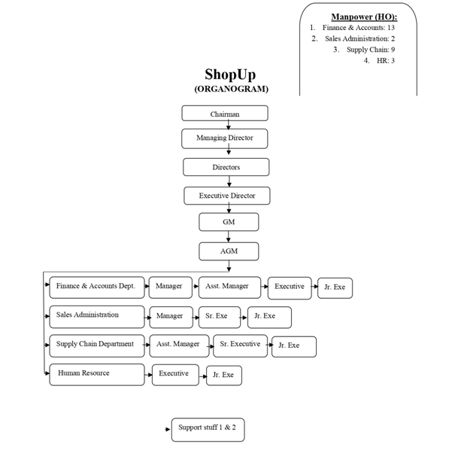
Figure2.1: Organizational Chart of ShopUp (Adnan, 2022)

Management Practices
- Empowering Staff: ShopUp constantly motivates workers to work harder than they did the previous time based on their performance. The performance of the workers is evaluated every two to three years, and depending on that evaluation, they get an increase in pay as well as a promotion within their current designation. ShopUp gives its workers the opportunity to complete home officers according on their own requirements. Government holidays are recognized, and employees are encouraged to celebrate their own, as well as other, cultural traditions while on the job. Working under inspiring management is something they always advocate for. They are always grateful for our novel suggestions. Finally, ShopUp rewards workers for going above and above.
- Training Staff: ShopUp is constantly making an additional effort to educate the job to new hires. We put in place the training of new workers throughout this time. Again, if an intern excels throughout their time with the company, they will likely be offered a permanent position. Mentoring from upperclassmen is usually done with a smile.
- Introducing new technology: ShopUp gives its employees access to a wide range of modern technology, such as computers, mobile phones, the internet, printers, scanners, etc. The vast majority of workers are Google Apps whizzes. There is also a platform known as TalentX that allows for time off. Indicating the existence of a leave-all-late-come visibility aids in facilitating subsequent action.
- Hold Meetings: From India to Bangladesh, daily sessions are done through Google Meet. The daily actions of the Reseller Department are reported to the management. In addition, monthly town hall meetings are held in which performance is examined and presents are presented to workers and staff for both regular and exceptional performance and effort.

Departmentalization Activities at ShopUp
ShopUp is made up of four separate teams that all operate in conjunction with one another. These teams are designed in such a manner that none of them are dependent on the performance of any other team. The following are the teams that are respected:
- Business Development Team: Siffat Sarwar, who serves as the Chief Operating Officer at ShopUp, is in charge of this group. This team's duties in the realm of e-commerce include acquiring new merchants, forming new partnerships, searching for chances to get financing, maintaining relationships with current partners, and looking for new prospects.
- Teach Team: This group, which is overseen by ShopUp's Chief Information Technology Officer Ataur Chowdhury, is in charge of developing any and all software solutions necessary for the business as well as its merchants.

- Product Team: Afeef Zaman, who serves as the CEO of ShopUp, is the one in charge of this group. This group is made up of two product designers, each of whom is a guru in the areas of user experience (UX) and user interface (UI). This group does ongoing study on the construction of the most effective software and procedure for constructing a pleasant experience for merchants.
- Logistics and Delivery Team: This team is the largest in ShopUp and consists of approximately 50 employees. They are in charge of delivering the products to the buyers, as well as acquiring the product from the location of the merchant, and delivering the product.
- Finance Team: The processing of merchant payments, the management of loans and official costs, as well as the management of inventories for office supplies are all the responsibility of the finance staff.
- Human Resource Team: This team is responsible for the recruitment, hiring, and dismissal of employees upon any violation of contract, as well as the evaluation of employees, the enforcement of policies and rules for better corporate citizenship, as well as the management of various events and training programs for employees.
- Customer Support Team: They are tasked with assisting both current merchants and prospective merchants with any questions they may have about utilizing the software to any of the services that we offer and are responsible for answering those questions.
- Lead Generation Team: This team is responsible for handling all of the promotional and Face book boosting requests made by the merchants. In addition to this, the team is responsible for staying current on the most recent policies and policy changes made by Face book in regard to their boosting services.

Competitors of ShopUp
In Bangladesh's business-to-business (B2B) electronic commerce market, the rivalry between competing companies is strong. For example:
As a result of the existence of a large number of distinct rivals, the market is very competitive. Circle BD, Priyo Zone, Care Me Bangladesh, and Daraz Bangladesh are just a few of the well-known reselling businesses that have recently set up business in the region.






In terms of its coverage of the B2B online business platforms in the city of Dhaka, Daraz is light years ahead of the competition when compared to any other firm that is currently operating in the market. Daraz Bangladesh has a substantial edge over its rivals in terms of both its financial resources and its workforce capabilities on account of the fact that it operates in a number of countries. Considering that the market is now growing at a pace of around 10% on an annual basis, it is reasonable to anticipate that it will see major growth in the not too away future. On the other hand, the high level of rivalry that this industry faces enables all of the companies operating in it to compete on an even playing field. As a result, an increasing number of companies are contemplating making a transition into this industry. In addition, ShopUp Circle BD, Priyo Zone, and Care Me Bangladesh are also instances of firms that operate on a global scale; nevertheless, they are not very well known in this country due to their limited presence here. Because each of the groups offers the same level of coverage over the whole of the city, they may infer that their capabilities are on par with one another.

Company | Type of Business | Country  Ranking | Audience  Total Visits | Target Customers | Marketing Channels | Annual Revenue
ShopUp | F-Commerce;  B2B Platform | 369 | 24.9k | MEs, MSMEs, F-commerce entrepreneurs | Face book; Direct, Referrals; SEO; Email | $7.0 M - $10.0M
Circle BD | F-Commerce;  B2B Platform | ___ | 19.k | MEs, MSMEs, F-commerce entrepreneurs | Website Store; SEO; Email; Social Media | Confidential
Priyo Zone | F-Commerce;  B2B Platform | ___ | 93.5K | MEs, MSMEs, F-commerce entrepreneurs | Face book | Confidential
Care Me Bangladesh | E-Commerce;  B2B and B2C Platform | ___ | 177k | Individual, Retailers, Wholesalers | Website Store; SEO; Email; Social Media | Confidential
Daraz | E-Commerce;  B2B and B2C Platform | 7 | 12.2 M | Individual, Retailers, Wholesalers | Daraz App; Referrals; SEO; Email; Social Media | $10-20M
Table2.1: Competitor Analysis

Circle BD (Reselling Platforms)
CIRCLE is a business-to-business (B2B) app, which means that it allows vendors (often referred to as "Suppliers") to offer their goods for sale to other app users ("Resellers"). CIRCLE (which includes its owner, full-time employees, subsidiaries, and affiliates, together referred to as the "Company") operates a marketplace that can be accessed via its website (www.circle.com.bd) and mobile apps (collectively, the "Platform"). The role of the Company is limited to the management of the Platform and the marketing activities associated with it, as well as the collection of payments, the administration of orders, the management of inquiries, and other incidental services to facilitate transactions between the Suppliers and the Reseller ("Services").

Priyo Zone (Reselling Platforms)
Priyo zone is a trusted reselling platform in where reselling can be done from home without any financial investment and there are more than 20,000 wholesale products. Their target customers are mainly students and housewives who can run their own business without financial risk.

Care Me Bangladesh (Reselling Platforms)
A cosmetics and personal care company from Bangladesh, Care Me Bangladesh was founded in 2010. Their adventure continues with a variety of well-known and popular cosmetic brands, in addition to appealing goods that are used on a regular basis. There are probably certain things that you have in the back of your mind that you are searching for, but no online retailer in Bangladesh has ever considered promoting them. They went through the trouble of bringing such items just with you in mind. In addition to taking individual orders, they also provide a wholesale facility. As a direct consequence of this, wholesalers are able to place orders of any quantity at the most economical price.

Daraz Bangladesh (Reselling Platforms)
Daraz.com.bd is Bangladesh's premier online shopping destination, with over 10 million items at competitive rates. As the number of stores selling goods online in Bangladesh grows each year, more and more people in the country's major cities—including Dhaka, Chittagong, Khulna, Sylhet, and others—are turning to the web to do their shopping. Daraz is a popular online shopping website in Bangladesh because it provides prompt, dependable, and hassle-free delivery of goods purchased from their site. Daraz, the most reliable online store in Bangladesh, not only promises to make shopping convenient and stress-free for locals but also offers a wealth of options for doing business with overseas merchants. Daraz's mission is to expand the reach of internet commerce throughout Bangladesh.

SWOT Analysis of ShopUp
Strength | - Created strong B2B platforms with low investment;  - An extensive distribution network;  - Unique reseller services  - Providing local support systems by Redx
Weakness | - Lack of knowledge in market research;  - Lack on fast delivery services;  - High Inventory holding period;  - Still a cash hog  - Less integrated than competitors
Opportunities | - Wide spread internet availability  - High growth of Ecommerce industry  - Technological advancements  - Concentrated population
Threats | - Technological development by competitors  - Increasing bargaining power of suppliers  - New entrants of B2B Companies  - Global pandemic and depression driving people out of business Increased delivery cost
Table2.2: SWOT Analysis of ShopUp

CHAPTER 03
OBJECTIVE AND METHEDOLOGY OF THE STUDY

Objectives of the Study

Broad Objective
The broad objective of this study is to study on the management of customers’ relationship in ShopUp (A Online Reseller Platform).

Specific Objectives
- To present a historical evolution of the organization of ShopUp. Additionally, its’ mission, vision, organization chart, management practices and departmentalization activities of ShopUp.
- To analyze the competitive dynamics of ShopUp including competitor analysis and SWOT analysis to understand existence competitors in the e-commerce industry of Bangladesh and to understand the internal situation of ShopUp.
- To clarify the various tasks and operational activities of ShopUp to get a better understand of how ShopUp practices marketing activities to retention their customers.
- To come up with some specific suggestions that can be used by the organization for the purpose of improving on customer retention management.

Methodology of the Study
In order to compile the report, both primary and secondary sources of data and information have been utilized.

Sources of Data

Primary Sources
The following are the sources from which the fundamental of primary data and have been utilized in the creation of this report:
- Observations of various marketing and operational activities of ShopUp during internship period.
- Conducting informal interviews with the supervisors and management team of ShopUp.
- Conversations and discussions with different colleagues, seniors staffs at the workplace regarding the issue of improving customer retention management.

Secondary Sources
The report also makes use of several types of secondary data. Some potential secondary sources of data are listed below:
- Internal sources:
  - Marketing and operational activities related documents and reports of ShopUp.
- External Sources:
  - Journals, articles and newspaper
  - Web-based studies and articles on a variety of topics connected to the operational and marketing activities of E-Commerce industry of Bangladesh.
  - Web site of E-Commerce Companies of Bangladesh.

CHAPTER 04
FINDINGS AND ANALYSIS
OF THE STUDY

Findings of the Study
- Less Attention on customers’ satisfaction and customer retention related work:
I have worked in sales development related to the reseller department. So, I observed that all the teams of other department are working for only increasing sales growth. But organization is not focus on after sales service-related activities which are related to the customers’ satisfaction as well as customer retention.
- Lack of Knowledge about how to deal with new reseller and churned reseller:
When I working with new reseller, it’s very difficult to control them because we have to convince them for doing business with us and also encourage them to continue the business with us. The churn reseller software can get business back into selling in no time. There are instances when they provide an explanation, and other times when they place the responsibility squarely on our shoulders, claiming that their service is substandard and the same thing that has spurred them to launch their company once again.
- More Priories on New Customers:
Since the company is new it is still trying its best to do the best in E-Commerce industry. They are following both the new comer instead of existing customers and also the previous companies’ activities.
- Less Discounts Offers and Lengthy of Delivery Time:
Some customers claimed that, Sho pup should provide fast delivery services in weekend days and also offer discount offers for increasing customer satisfactions.

Analysis of the Study
A model of e- satisfaction for shopping on an E-commerce Company was established by (Anand, 2007). Within these five key contexts, there are a total of eighteen factors that determine e-satisfaction. The model consists of five major contexts. The five contexts include:
- Convenience,
- Merchandising,
- Web-site design
- Security and
- Serviceability.
Based on the e- satisfaction model; ShopUp's F-commerce services and customers’ experience will be analyzed and evaluated in this research based on these five criteria’s. After that, we will do an analysis of the data to determine which areas of the service may be in need of significant improvements. The findings of a study conducted, which were beneficial to both the business and the workforce in order to increasing customers’ satisfaction and retain customers. As a result, exploratory research will be used to represent this research, which attempts to gain more about present challenges and lacking of marketing strategies of ShopUp.

Marketing Practices of ShopUp

Conveniences
E-commerce or F-commerce exists in part to make purchasing goods and services more convenient for consumers. To be considered convenient, a product or service must adhere to the user's expectations in terms of its use and usefulness. It also indicates that the customer's emotional aspects of perception, like enjoyment, should be met. The whole process should make it easier and faster for customers to find, purchase, or explore the goods or services that they are interested in purchasing (Anand, 2007).
ShopUp is a platform for Face book commerce that mostly works with individuals who sell on Face book. ShopUp is dedicated to making the life of online vendors simpler by providing a store management framework that is completely free of charge. ShopUp also has plans to offer a number of other sorts of fairs for its merchants, and it is in the process of preparing seminars to increase its merchants' awareness of the advantages of doing business online. ShopUp also runs a blog, which gives us helpful information on how to organize online marketing and attract users to the website. This information will have a profound impact on the development of individuals who are looking in beginning a business on the Internet but aren't familiar with online marketing and don't understand how it works and it can be found on ShopUp's blog. In addition, ShopUp is always developing new ideas and launching exciting new activities and programs for sellers to use in order to make Face book into a streamlined business platform.

Merchandising
According to (Anand, 2007), there would be a positive effect on the level of satisfaction experienced by online customers if the product assortments offered can be improved. The ability of satisfying a wide variety of consumer requirements might be increased by offering superior product assortments. On the other side, having a larger selection of items available might enhance the likelihood of a customer finding things of a higher quality. A comprehensive introduction to the items being sold is another factor that contributes to satisfied customers. The likelihood of a client purchasing high-quality goods is boosted when they have access to accurate and detailed product information.
In ShopUp, they use various online marketing. For example: online both boosting and advertising are very useful tools for them to use in online marketing. Boost communicates with its prospective clients while advertisements enhance the number of likes on the page. These capabilities are accessible to everyone who has a Face book profile and may be activated at their discretion. Increasing sales will result in an increase, and many sellers on Face book are interested in increasing the visibility of their product album in order to enhance sales. The highest demand is seen around holidays like New Year's, Christmas, and the Persian New Year (also known as eid, puja, pohela boishakh, and other similar celebrations). Promotions are a standard technique used by vendors to drive traffic to their online stores.
In ShopUp, Some merchants who are considered to be super vendors have the potential to expand their product lines by 85 tons per US dollar, whilst a regular vendor has the capacity to expand their product lines by 115 tons per US dollar. Super vendors are retailers that have established competitive prices for their wares in order to further enhance sales and benefit both firms involved. And ShopUp has been doing the same thing for merchants, but they get to choose their target customer and have all their other problems solved at the same time. Alternatively, merchants may place their ads and choose the geographic area they want to attract customers from just BDT 105 per USD. Only in this case will the boost app be activated by ShopUp.

Web Site Design
Customers will have a favorable impression of the organization and feel satisfied with their purchases if the website has been designed appropriately (Lee, 1999). A delightful browsing experience for the user may be created by providing a website that is quick to browse, well-written, and eye - catching. In addition, the consumer will spend less time and energy trying to find the desired goods or services.
The factors that have an influence in this context are the navigation structure, website design and interface, speedy presentation, personalized content, and constantly updated information (Anand, 2007).
To put it simply, ShopUp is a web browser program or software that can be used for free and is connected with Face book’s "pages" function, which allows customers to see or explore items and purchase directly from the platform much like every other online storefront there is.
The images that follow demonstrate how customers view and interact with the ShopUp software inside Face book when they visit a shop that is powered by ShopUp.
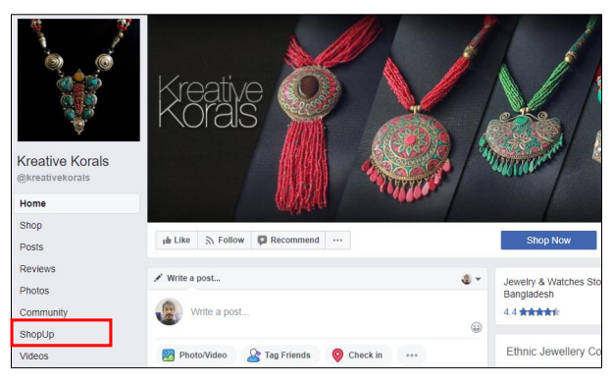
Figure2.2: ShopUp Option on Face Book’s Page (Kreative Korals, 2018)
When merchants (those who use ShopUp) integrate the service into their Face book page or store, a button similar to the one seen in the top picture (inside the red box) will appear. Customers may see what you have to offer and place an order with no initial investment in infrastructure or software by clicking the ShopUp button.
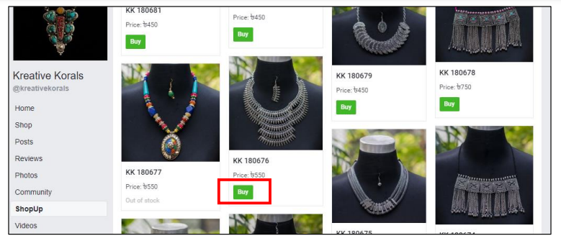
Figure2.3: Purchasing Product through ShopUp Option on Face Book
(Kreative Korals, 2018)

Security
(Anand, 2007) Conducted research on a few fundamental theories and came to the conclusion that one of the most significant factors that keep customers from purchasing online is the concern about their personal security. The certainty of one's financial situation is a major element in this setting.
In ShopUp; after the buyer has made their selection of the products and clicked the "purchase" button, as seen in the picture that is located above and labeled with a red box, the transaction is complete. When the customer clicks the "purchase" button, a new box similar to the one shown below opens. In this new box, the customer has the option to either "checkout" to complete their purchasing or "add to basket" to continue shopping for further items.
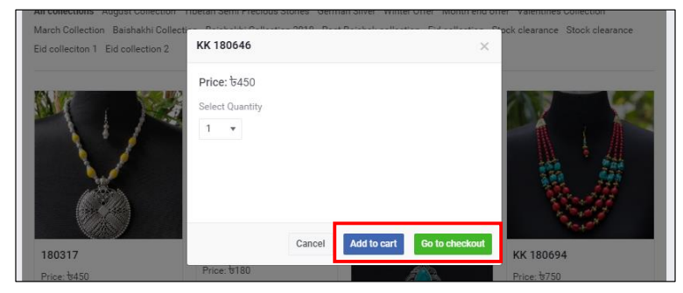
Figure2.4: The Checkout Procedure for ShopUp on Face book (Kreative Korals, 2018)
“Because the vast majority of people do not have access to credit or debit cards, cash on delivery is the payment method that is most chosen by purchasers when they shop for things online. This is done for reasons pertaining to financial security.” When a buyer selects the checkout option, they are taken to the checkout process, which is a fundamental part of the e-commerce business model. Here, the buyer provides their information, verifies that the product they have chosen is eligible for purchase, and then provides their payment information. In this scenario, customers may choose to pay for their purchases using BKash or make advantage of the "Cash on Delivery" (COD) service.
Figure2.5: Checkout Steps of ShopUp (Kreative Korals, 2018)

Serviceability
Additionally, one of the most important aspects of the environment that goes into determining e-satisfaction is serviceability. The aspects of complaints resolution, customer support, packaging, delivery time, and post services are all influential factors in this context (Anand, 2007).
When a customer completes a purchase on ShopUp, they will get an order confirmation through instant messaging or SMS, which they may then use to access the ShopUp merchant account panel, seen in the following image. Where the seller may use ShopUp's full suite of services to quickly fulfill the order and have it on its way to the customer.
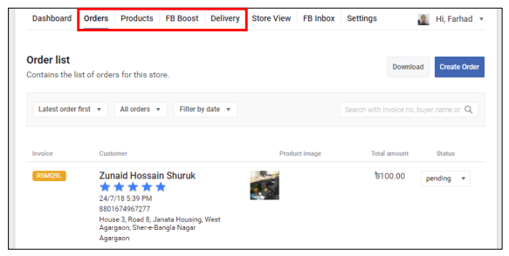
Figure2.6: Merchant Panel of ShopUp
The delivery support provided by ShopUp is very efficient and timely. ShopUp only sells items that have a total weight of up to 2 kilograms, and if the shipment weighs more than that, extra fees are applied. In order for the sellers to get delivery support, they are required to first form a distribution agreement with ShopUp and then submit a delivery request to ShopUp.
- Reliable Delivery: If the sellers make a request for delivery before twelve o'clock in the afternoon, the items will be picked up that day and delivered within forty-eight hours after the time of pickup.
- Customer Support System and Sign up: In order for vendors to take use of ShopUp's delivery and customer support system, they contact with the team of customer care of ShopUp.

Activities Undertaken For Customer Retention towards ShopUp

Working Plan Briefing
Every day morning the manager of marketing and business development department brief about their daily activity, they guide them on where to go and how to implement their sales and customer satisfaction strategy. Sometimes they research and decide where to go for a sales operation and the activities of customers’ satisfaction. Those all they can do as per his instruction.

Preparing Daily Reports
First of all they have to prepare daily report about new reseller. They have to collect the data from Meta base then they have to communicate with resellers. Also they have to solve their issue about their business.

Preparing Sales Follow-up Lists
This list contains the particulars of all of the resellers about the method in which they do business with ShopUp, and it is known as a "sells follow-up list." As a result, it is their responsibility to compile this list of reseller demands, and if they find that any resellers' demands are missing from the list, then they must add those demands to the list and verify them again. This report is something that is often prepared on a daily basis. This report is constructed using the sales data from the previous day. In addition to this, it takes into account the active churned resellers that are brought into play by telesales. During the meeting, they need to hand it over to their supervisor.

Communication with Resellers
Broadcasting on WhatsApp is within the scope of the team working in the marketing and business development department. It is comparable to delivering a message to a large number of resellers in a single minute. However, they have the perception that it is a conversation between only the two of them. Therefore, if customers encountered a problem with ShopUp of any type, they would contact the support team on the official WhatsApp number, and the support team would help them fix their issue. The fact that some of them call at any time, even late at night, is particularly aggravating since it causes tension for the other party.

Telesales
Telesales entails making calls in a business setting in order to generate revenue. The task was very difficult in comparison to the others. They are required to engage in active calling on a daily basis. They need to convince them to begin retailing items again using their app.

Meeting with Reseller
When the marketing and business development team takes meeting with churn reseller for product selling purpose. Generally; they have try to see and understand what types of quality customers need, what types of product they need and how to convince them.

Preparing Monthly Collection Report
Another activity is to preparing monthly collection report. How many reseller they can make and how much GMV (Gross Merchandise Value) they can make for their company all this think they have entry in Google sheet and reporting with their seniors.

Sending SMS
ShopUp makes use of their personal panel to ship SMS to their focused resellers, inviting them to wait any meet up consultation or supplying updates on their bought offers and product transport requests. This became an important mission to do. Because the reseller gets updates on their orders or asked offerings, they may be not able to keep music of the offerings in question. This became an easy pastime that took little time to do.

Daily Sales and Customers’ Feedback Report
This report is a document that is often prepared on a daily basis. This report was compiled using data from the previous day's sales as well as comments left by customers. In addition to that, it indicates the active resellers that phone sales provide. They are required to send it to the line manager, and the line manager is then responsible for presenting it to the senior management during the meeting.

Escalating New Lead Reseller from CEX
Customer experience support team enters all of a reseller's complaints using their order ID. Typically, resellers complain about issues with their items, such as shipping, malfunctioning products, and returns. As a result, they must escalate on a daily basis.

Work With Marketing and Communication Team
For the campaign at ShopUp, they must collaborate with the marketing and communication team. Social media may be pressured to go farther forward in the sales process as part of campaign-related tasks. The marketing and sales teams meet to discuss client difficulties, requirements, and desires. This aids in the creation of standard buyer personas that are recognizable to both teams.

CHAPTER 05
RECOMMENDATIONS AND CONCLUSION

Recommendations
By following the strategies, ShopUp can improve its online operations and services for keeping a higher level of customer satisfaction as well as customer retention:
- Providing training facility:
Some employees have no knowledge how to handle customers’ satisfaction and improving of customers experience-related tasks at the ShopUp of reseller department. In this case, the line manager for arranged a training session and line manager organized a tanning session for the new interns, they learned about the job and how it contributes to high-quality work and satisfied to the customers.
- Assigning Multi Related Task:
I have to conduct sales-related tasks at my organization. Because the department to which I've been assigned is one that focuses on improving sales abilities. However, I believe they should be able to allocate additional tasks, such as content creation, customer support systems and marketing. During that period of time, this is more efficient. It may prove to be more beneficial for keeping existing customers.
- Development of Fast Delivery Services:
ShopUp should fast delivery services on weekend days, they need to hire more delivery staffs for it. And also their product items packaging needs to being eco friendly which can be increased customer satisfactions as well as the reputation of the organization for doing CSR activities.
- Discounts Offers:
ShopUp should give some discount offers for its’ all customers, give some promo codes for online customers on occasionally. It can increase the level of customer satisfactions, attracting new and existing customers and the sales growth of the organization.

Conclusion
I worked as an intern at ShopUp, a startup firm. RLM stood for reseller lifecycle management, and that was the name of my department. As an intern, I was required to complete a variety of tasks. Due to the nature of my employment, I am required to do a number of distinct responsibilities on a daily basis. To begin, I have seen that the management has consistently given top priority to the satisfaction of their consumers regardless of the cost. They are able to assist the resellers in each and every possible way. When the resellers said that they are interested with reselling but they do not have enough knowledge of reselling, the RLM team started to train them so that they can gathered some knowledge. ShopUp's reseller platform is a fantastic option for aspiring entrepreneurs who wish to establish their own business or who currently have one that requires high-quality items. There are a plethora of things ready to sell around every corner in Bangladesh, as well as people looking to establish an internet company. However, operating a business online, such as through a Face book page, is more difficult than operating a physical store if the proprietor is unaware of correct procedures. The ShopUp Reseller platform allows a business owner to have access to thousands of items produced from all across the country at a low cost.
There have already been several success stories and delighted company owners who have improved their lives by utilizing ShopUp's unique tech solutions. Because merchants can use ShopUp to promote their items at a low cost, reaching out to customers has become easier and less expensive. ShopUp's reseller platform is a fantastic option for aspiring entrepreneurs who wish to establish their own business or who currently have one that requires high-quality items. The ShopUp Reseller platform allows a business owner to have access to thousands of items produced from all across the country at a low cost. . There is a separate app for merchants that give them all of the tools they need to run their business. There are many success stories and happy company owners who are now enjoying better lives as a result of ShopUp's innovative tech tools.

References

Adnan, M. (2022). Understanding Sales development strategies of ShopUp (Mokam) Reseller. Dhaka, Bangladesh: BBA department of AIUB.
Anand, A. (2007). E-Satisfaction – A Comprehensive Framework. International Marketing Conference on Marketing & Society; IIMK, 704.
Hennig-Thurau, T. a. (1997). The impact of customer satisfaction and relationship quality on customer retention: A critical reassessment and model development. Psychology and Marketing, 14: 737–764.
Korper, S. a. (2001). The E-commerce Book: Building the E-empire. San Diego, Calif: u.a.: Academic.
Kreative Korals. (2018). Retrieved from https://www.facebook.com/kreativekorals/
Lee, L. J. (1999). A Model of Internet Consumer Satisfaction: Focusing on the Web-site design. Americas Conference on Information Systems, AMCIS 1999 Proceedings.
Ranaweera, C. &. (2003). Some moderating effects on the service qualitycustomer retention link. . International Journal of Operations and Production Management, 23(2), 230–248.
Srini S. Srinivasana, R. A. (2002). Customer loyalty in e-commerce: an exploration of its antecedents and consequences. Journal of Retailing , 78; 41–50.
Strydom, G. E. (2020). Time lags, non-linearity and asymmetric effects in an extended service-profit chain. European Journal of Marketing, 54(10), 2343–2363.
Tripathy, A. K. (2020). FinTech adoption: strategy for customer retention. Strategic Direction, 36(12), 47–49.

