
United International University
Internship Report On
Customer Satisfaction of Grameen Bank
Submitted to:
Muhammad Hasan Al-Mamun Assistant Professor School of Business & Economics United International University

Submitted by:
Mithuin Motalip ID: 111 143 193 BBA Program United International University
Date of Submission: 26-12-2019
Customer Satisfaction of Grameen Bank



Letter of Transmittal

25 January 2020
Muhammad Hasan Al-Mamun Assistant Professor School of Business & Economics United International University

Sub: Submission of the Internship Report.

Dear Sir,
With due regard, it is extraordinary joy for me to present my report on Customer Satisfaction of Grameen Bank.
It is the outcome my internship with Grameen Bank for three months. I have tried to understand the level of customer satisfaction of Grameen Bank and in my effort to understand, I have conducted a survey and came up with some really interesting findings.
In preparing the report, I have followed the instructions given by you. I have tried to the best of my capacity to prepare a lucid and meaningful report.
Now it my pleasure to submit the report and would like to request you to accept it as a completion of partial requirement of BBA program.

Yours Truthfully,

Mithuin Motalip
ID: 111 143 193
BBA Program
School of Business and Economics
United International University

Acknowledgment

I would like to thank the Almighty for giving me mental strength and persistence for the completion of this Internship report with moral expedient, diligent work and devotion.

I am deeply indebted to my respectable Internship Supervisor Muhammad Hasan Al-Mamun, Assistant Professor, United International University, for his whole hearted guidance and supervision. His recommendations made the report meaninful. He has given me proper guidelines and timely directions so that I can prepare a good report.

I would like to give specials thanks to Md. Abdus Sabur Khan, senior principal officer, Coordinator, International Program Department, Head office, Grameen Bank. For his supports and motivation regarding the completion my internship report. I want to thank my fellow friends and colleagues for providing me required Information and valuable suggestions to complete this report from the core of my heart.

Contents
Chapter- ONE viii
INTRODUCTION viii
1.1 Origin of the Report 9
1.2 Objective of the study 9
1.3 Methodology 9
1.4 Limitations: 10
1.5 Scope of the study: 10
CHAPTER- two 11
Overview of the company 11
2.1 History 12
2.2 Mission of Grameen Bank 14
2.3 Objective of Grameen Bank 14
2.4 Vision of Grameen Bank 15
2. 5 Grameen Bank Morals: 15
2.6 Organization Nature: 16
2.7 Grameen Bank Wins: 16
2.8 Structure of Organization 17
2.9 Numbers of Branches: 17
2.10 Organogram of GRAMEEN BANK field operation 18
2.11 GRAMEEN BANK at a Glance 19
2.12 SWOT Analysis of Grameen Bank 20
2.13 The Literature Review 21
Chapter- Three 25
Findings 25
3.1 Gender 26
3.2 Age 26
3.3 Income 26
3.4 Reasons for Choosing Grameen Bank: 27
3.5 Longevity of Account in Grameen Bank 27
3.6 Service Quality Perception 28
3.7 Perception Regarding the Problem Handling Capacity 28
3.8 Perception of Employee Knowledge 29
3.9 Perception about the charges at Grameen Bank 29
3.10 Perception Regarding the Convenience of Location 30
3.11 Perception of the Employee Behavior 30
3.12 Environmental Quality Perception 31
3.13 Interest Rate Perception 31
3.14 Overall Customer Satisfaction 32
Chapter-Four 33
Recommendations 33
CHAPTER- Five 35
Conclusion 35
Conclusion 36
Bibliography: 37
Appendix-1 38

Executive Summary

The report evolved from my internship program which is done as a partial requirement of BBA program. This report is furnished based on my 3-month internship in Grameen Bank.
This report contains the real life day-to-day working experiences of different tasks in Grameen Bank, Mipur-2, Dhaka-1216, Bangladesh, Head office of Grameen Bank Bhaban. But the primary objective of the report is to evaluate the customer satisfaction of Grameen Bank. We all have some positive and negative thoughts about this bank and as a result they create some confusion for their customers. So I tried to know the real scenario and that is why I needed to conduct a survey and I talked with the customers of Grameen Bank.
The study is based on the data collected by personal interview with the customers at kolakopa, Nababjong Branch of Grameen Bank. A self-administered questionnaire has been designed for researching the customer perceptions regarding the overall satisfaction and other aspects of their level satisfaction regarding the various aspects of the organization. The sample used includes 20 people combining both female and male Grameen Bank customers.
The survey intended to evaluate customers’ perceptions regarding the various aspects of customer satisfaction and other associated issues. The questionnaire used in the survey intended to measure customer perceptions about overall satisfaction, the degree of convenience, location, the level of employee knowledge and other related issues. Most of the customers were found to be somewhat satisfied with the services provided by Grameen Bank. Some specific suggestions were made for the purpose of improving the overall performance of Grameen Bank.
Key Words: Customer Satisfaction, Grammen Bank

Chapter- ONE

INTRODUCTION

1.1 Origin of the Report

One of the inevitable aspects of modern business is being relevant to the market conditions with appropriate value proposition. Most of the people in Bangladesh live in villages and so we call Bangladesh a rural country. Most of the rural Bangladeshi people are landless and they have limited assets. Previously Bangladeshi economy was agriculture based. Now the shifts are quite apparent: Bangladeshi economy is moving toward becoming a service economy.
Grameen Bank, from its inception in 1976, tried to provide quality services to their customers (those landless people without any significant assets) and it has played a great role in poverty alleviation by its contribution in Bangladeshi economy. Throughout stimulating poverty alleviation, trade and industry, Grameen Bank tried to ensure better living standards of low income people, and overall sustainable socio-economic development in our country.
Internship is very essential part of the BBA degree. I have prepared this report on “Customer Satisfaction on Grameen Bank”. My supervisor Muhammad Hasan Al-Mamun, Assistance Professor of United International University assigned this topic.

1.2 Objectives of the study

The main objective of the report is concentrated About Customer Satisfaction on Grameen Bank. Over all, this study is to be concentrated to fulfill the following objectives.
- To study on customer satisfaction of Grameen Bank.
- To know activities of Grameen Bank.
- To evaluate the employee behavior of Grameen Bank.
- To examine interest rates of Grameen Bank.
- To evaluate how Grameen Bank provides quality services to the customers.
- To study sustainability of the impacts created by Grameen Bank.

1.3 Methodology
In order to prepare the report, I mainly worked with primary data and secondary data.
Primary sources:
- Conducting a survey for measuring the level of Grameen Bank’s customer satisfaction, Sample size : 20 people, who are all the current customers of Grameen Bank
- Observing the general activities of Grameen Bank.
- Face-to-Face conversations with my supervisor Md. Abdus Sabur Khan.
- Face-to-Face interviews Grameen Bank employees and customers.

Secondary Data:

- Officials Websites
- Different types of Newspaper, Magazine, Articles, Journals and previous annual reports.

1.4 Limitations:

To make a report meaningful and academically well-grounded, we need resources. However, I have faced some limitations to come up with a complete and perfect report. These limitations which hindered my attainment of the previously mentioned objectives are:

- All required information couldn’t be collected because of unavailability.
- Limited time, which, in turn, reduces the ability to explore in greater details both geographically and conceptually.
- Some data were difficult to get because of the confidentiality issue.
- It was not possible to consider all the macro economic factors sufficiently.

1.5 Scope of the study:
The report is mainly concerned with the evaluation of the customer satisfaction of the customers of Grameen Bank. The study intended to measure both overall satisfaction and customer satisfaction related various related issues.
Twenty existing customers were surveyed by using a self-administered questionnaire. The detailed findings of the survey will be presented with the required interpretation in the Finding Section of the report.

CHAPTER- two

Overview of the company

Grameen Bank is a microfinance organization and community development bank founded in Bangladesh. It makes small loans (known as microcredit or "Grameen Credit") to the impoverished without requiring collateral.
Grameen Bank originated in 1976, in the work of Professor Muhammad Yunus at University of Chittagong, who launched a research project to study how to design a credit delivery system to provide banking services to the rural poor. In October 1983 the Grameen Bank was authorized by national legislation to operate as an independent bank.



The bank grew significantly between 2003 and 2007. As of January 2011, the total borrowers of the bank number 8.4 million, and 97% of those are women. In 1998 the Bank's "Low-cost Housing Program" won a World Habitat Award. In 2006, the bank and its founder, Muhammad Yunus, were jointly awarded the Nobel Peace Prize.

2.1 History
Muhammad Yunus was inspired during the Bangladesh famine of 1974 to make a small loan of US $27 to a group of 42 families as start-up money so that they could make items for sale, without the burdens of high interest under predatory lending.

Yunus believed that making such loans available to a larger population could stimulate businesses and reduce the widespread rural poverty in Bangladesh. Yunus developed the principles of the Grameen Bank from his research and experience. Grameen Bank is Bengali for "Rural" or "Village" Bank.
He began to expand microcredit as a research project together with the Rural Economics Project at Bangladesh's University of Chittagong to test his method for providing credit and banking services to the rural poor. In 1976, the village of Jobra and other villages near the University of Chittagong became the first areas eligible for service from Grameen Bank.
Proving successful, the Bank project, with support from Bangladesh Bank, was extended in 1979 to the Tangail District (to the north of the capital, Dhaka). The bank's success continued and its services were extended to other districts of Bangladesh. By ordinance of the Bangladesh Government dated 2 October 1983, the project was authorized and established as an independent bank.

Bankers Ron Grzywinski and Mary Houghton of Shore Bank, a community development bank in Chicago, helped Yunus with the official incorporation of the bank under a grant from the Ford Foundation. The bank's repayment rate suffered from the economic disruption following the 1998 flood in Bangladesh, but it recovered in the subsequent years.

By the beginning of 2005, the bank had loaned over US$4.7 billion and by the end of 2008, US$7.6 billion to the poor. In 2011, the Bangladesh Government forced Yunus to resign from Grameen Bank, saying that at age 72, he was years beyond the legal limit for the position.

As of 2017, the Bank had about 2,600 branches and nine million borrowers, with a repayment rate of 99.6%. 97% of the borrowers were women. The Bank has been active in 97% of the villages of Bangladesh. Its success has inspired similar projects in more than 64 countries around the world, including a World Bank initiative to finance Grameen-type schemes.

Grameen Bank is now expanding into wealthy countries as well. As of 2017, Grameen America had 19 branches in eleven US cities. Its nearly 100,000 borrowers were all women

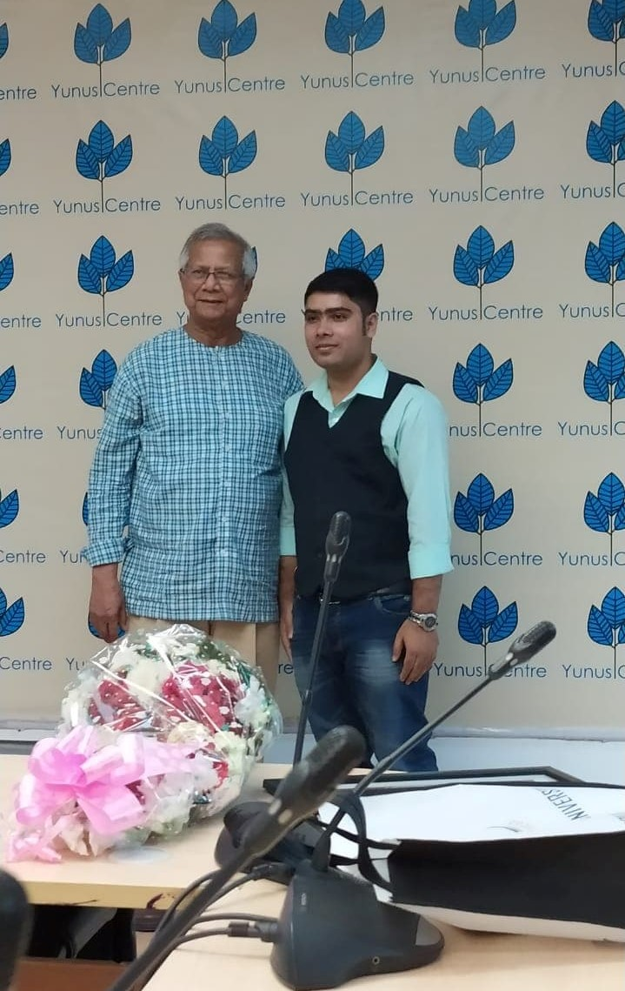

Photo: With Nobel laureate Prof. Dr. Muhammad Yunus

2.2 Mission of Grameen Bank

Mission: By providing comprehensive financial services, empowering the poor to realize their potential and break out of the vicious cycle of poverty.” The story of Grameen Bank is the stuff of legend and is closely intertwined with the history of the idea of microfinance itself.

2.3 Objectives of Grameen Bank:
The Grameen Bank believes that the best way for participants to learn about how the bank works, is through first hand exposure and observations at the field level. Through these experiences, participants are encouraged to draw their own conclusions about the effectiveness of Grameen Bank’s work and the impact it has on the poorest of the poor. The objectives of GB’s training programs are to:
- Arouse curiosity
- Stimulate interest on the subject of Micro financing
- Encourage responsibility of self-motivated learning
- Learn and share with others
- Discover individual role in the organization and the global community

2.4 Vision of Grameen Bank

Grameen Foundation vision is to enable the poor, especially the poorest, to create a world with our poverty.

2. 5 Grameen Bank Morals:

There are four Morals of Grameen bank are-
- Discipline
- Unity
- Courage
- Hard Work



2.6 Organization Nature:

Grameen Bank is a micro- credit Bank. It is an autonomous and separate Bank under Bangladesh Bank. Despite the fact that Grameen Bank authority claims it's anything but a completely bank or NGO. It is diverse in attributes. As a matter of fact, it is unique in relation to different banks and acts like NGO.

2.7 Grameen Bank Wins:
01. ICMAB Awards 2015
02. MCCI Award
03. Norway: Nobel Peace Prize: 2006
04. U.S.A.: Petersburg Prize: 2004
05. INDIA: Gandhi Peace
06. UNITED KINGDOM: World Habitat
07. MALAYSIA: Tun Abdul Razak Award: 1994
08. BANGLADESH: Independence Day Award: 1994
09. BELGIUM: King Baudouin International Development Prize: 1993
10. SWITZERLAND: Aga Khan Award for Architecture: 1989

2.8 Structure of Organization:

Head Office
40 ZONES, consisting of 5-10 Area Offices
263 AREAS, consisting of 8-12 Branch Offices
2583 BRANCHES, consisting of 50-65 centers
87,000 CENTERS, consisting of 6-8 groups
674,117 GROUPS of 5 members
The above structure is flexible and the organization is built upwards from the level of the branch according to the demand for its services (i.e. Zones, Areas and Branches vary in size)
Pilot projects and experimentation dictate the organizational structure and its evolution

2.9 Numbers of Branches:

GRAMEEN BANK provides microcredit and does social businesses in Bangladesh. Now Grameen Bank has 211 branches all over the Bangladesh. They carry out all its banking activities.
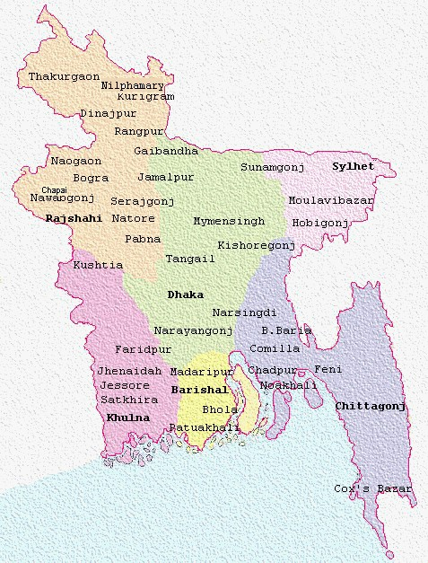

Draw: 2568 (Only district is shown above)

2.10 Organogram of GRAMEEN BANK field operation:






























Head Office
1 ZO for 6-8 area offices
1 AO for 10-15 branches
Area Office
1 Branch for 60-70 Centers
1 Center for 8-10Groups
Center
Group
Each Group consist of 5 members
Chairman
Secretary
Member
Member
Member
Branches
Zonal Office

Before going to our fieldtrip, it is essential to know about GRAMEEN BANK mission, vision and how it is performing its field level activities.

2.11 GRAMEEN BANK at a Glance

Name of the company | GRAMEEN BANK
Founder | PROF. MUHAMMAD YUNUS
Chairman | PROF. MUZAMMELHAQUE
Acting Managing Director | RATAN KUMAR NAG
Date of Inauguration | In October, 1983
Number of Branches | 2568
Number of Employees | 22000 (Approx.)
Number of Members | 7.07 million US $
Registered Office | Grameen Bank Bhaban, Mirpur-2,  Dhaka-1216
Authorized Capital | Tk. 10000000000
Paid up Capital | Tk. 734049100
Phone | +88 02 9031138 , +88 02 9007596
Fax | +880-2-9033559
E-mail | giprog@grameen.com
Website | www.grameen.com

2.12 SWOT Analysis of Grameen Bank

Strengths:
- Society Improvement
- Repayment rate is high
- Mobilization Loaning
- Women Strengthening
- Nobel prize winner organization
Weakness:
- Job Disappointed
- Money supply deficiency
- Opposition from customary Society
- Conflict in village family
- Villages people are uneducated so their idea are not always articulate
Opportunities:
- Lack of information
- Banking Consultancy administration are very poor
- Unworked and unbanked rural population
Threats:
- Local Money lenders (charging high pace of Premium)
- New access into the market
- Larger conflict and power contradiction in customary or traditional families

2.13 The Literature Review

Satisfaction:
Satisfaction has been treated as the necessary premise for the retention on customer and therefore has move to the forefront of relational marketing approaches (Rust & Zahoik, 1993) Kotler sums this up when he states: “The key to customer retention is customer satisfaction” (Kotler 199, p 20) consequently, customer satisfaction has developed extensively as a basic construct for monitoring and controlling activities in elation the so-called marketing concept. It is generally conceived as “Customers’ level of approval when comparing a product’s perceived performance with his or her expectation. While satisfaction is sometimes equated with performance, it implies compensation substitutes whereas performance denotes doing what was actually promised. Satisfaction goals are established by the customers themselves before they set out to make a purchase” (Philip Kotler).

Deﬁning Customer Satisfaction (CS):

Customer Satisfaction refers to a person’s satisfaction with a product, a service, or a supplier. Three additional remarks are in order to characterize CS in the context of retail banking (Oliver 1997, chap. 1).
First, consumption of products and services from a retail bank is an ongoing process. This implies that CS results from the accumulation of encounters with the company over time
Second, we assume that CS with a bank can become manifest as an effect, such as feeling good about the bank; cognition, such as the evaluation that the bank is doing well; and also as the absence of dissatisfaction (Westbrook and Oliver 1991).
Third, we assume that satisfaction/dissatisfaction is one-dimensional and that it ranges from very dissatisﬁed to very satisﬁed. This assumption is consistent with the one-factor theory which states that satisfaction is the opposite of dissatisfaction on a bipolar dimension but at odds with the two-factor theory, which states that satisfaction and dissatisfaction are two more or less independent dimensions. Because the literature does not provide compelling evidence for the two-factor theory, we adhere to the simpler one-factor theory of satisfaction/dissatisfaction. (Herzbergetal.1959; Yi1990).
3 Measuring CS:
Customer satisfaction is often measured using a set of items that is administered in a survey. Examples are the CS tests listed in Table 2. The tests have merits but also some drawbacks. For example, the tests 1 to 5 are not context-speciﬁc and usually fail reﬂecting all aspects of CS in all specific situations.

Measurement instruments for overall CS and overall CS/D
Instrument Scale Source Applications

1 12 Likert items reﬂecting diverse aspects CS/D Westbrook and Oliver (1991) Overall customer satisfaction measurement
(i.e., evaluations, affects, need fulﬁllment,
disconﬁrmation, and attribution
Oliver 1997) of CS/D with focal object.

2 6 semantic differential items CS/D Oliver and Swan (1989) Overall customer satisfaction measurement
(satisﬁed-dissatisﬁed,
pleased-displeased,
wise choice-poor choice, good job-poor job,
contented-disgusted, happy-unhappy)
reﬂecting aspects of CS/D with focal object

3 1 semantic differential item CS/D Tse and Wilton (1988) Overall customer satisfaction measurement
(satisﬁed-dissatisﬁed) reﬂecting CS/D with focal object

4 3 items reﬂecting level of CS/D Fornell (1992) ACSI research
CS/D, disconﬁrmation, and distance to ideal
respectively, with focal object

5 1 item reﬂecting level of CS/D Bloemer and Kasper (1995) Overall customer measurement dissatisfaction was conceived as a separate
dimension that had satisfaction
measurement dissatisfaction
was conceived as a
separate dimension that
had to be measured
using another instrument
6 7 Likert items reﬂecting CS/D Verhoef et al. (2001) Overall customer satisfaction
2006; Oliver 1993
CS/D with 7 attributes
Of focal object measurement; similar used attribute Droge 2006; Oliver 1993)

Such failure may have been the motivation behind why Oliver (1997, pp. 343–344) tended to the likelihood to modify test 1 to the exploration setting. Test 6 is setting speciﬁc, yet it reﬂects quality fulfillment as opposed to generally fulfillment. On the whole estimation instrument for by and large fulfillment with regards to retail banking isn't accessible. This roused us to utilize the deductive plan to develop a measure for CS with a retail bank and streamline.

Chapter- Three

Findings

A self-administered questionnaire was used to evaluate Grameen Bank’s customers’ perceptions of satisfaction: both overall satisfaction and satisfaction regarding specific issues related to the services provided by Grameen Bank. Some basic demographic questions were also included to evaluate the characteristics of the respondents. The subsequent sections will evaluate the customers’ responses in relation to the levels of customer satisfaction of Grameen Bank.

3.1 Gender: Customers of Grameen Bank vary in terms of gender. But the majority of the customers were found to be female.
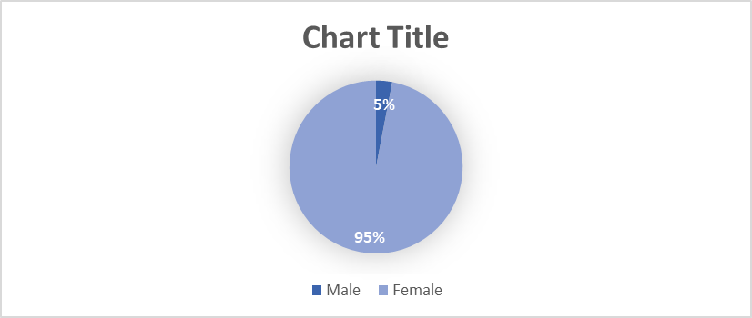
Form the graph it is apparent that 5% of the respondents are male and 95% respondents are female. So, majority of the respondents are female. Such distribution also reflects the overall distribution of Grameen Bank’s Customers, where majority of the customers are overwhelmingly female.

3.2 Age: Customers of Grameen Bank vary in in terms of age. Majority of their customers were found to be young to middle-aged.

Here modal age group was found to be hovering between 31 years to 45 years (60%). Least number of customers are coming from age group that is hovering above 46 years (10%). The other customers are coming from age bracket 18 – 30 years.

3.3 Income: Though Grameen Bank’s target customers are low-income people; there is still a variation in income across the customers they serve.

Form the graph, it is seen that 40% of the respondent’s income is between TK 10000 – 25000, 50% of the respondent’s income is between TK 26000 - 40000, and 10% of the respondent’s income is TK 41000 - 55000. So majority of the respondent’s income is in the range of TK 26000 - 40000.

3.4 Reasons for Choosing Grameen Bank: Customers of Grameen Bank vary for the reasons they choose Grameen Bank over other micro financing firm.

Form the graph, it is quite apparent that 40 % of the respondents choose Grameen Bank for better service. 25% of the respondents select Grameen Bank for location of agent services. 25% of the respondents are choosing for the personal relationships they have with the agents. 10% of the respondents’ are choosing for the reputation of mobile banking that Grameen Bank enjoys. So, majority of the respondents choose the Grammen Bank for better services.

3.5 Longevity of Account in Grameen Bank: The interviewed customers of Grameen Bank vary in terms of years they are taking services from the Bank. Majority of the interviewed customers are receiving the services from Grameen Bank for more than four years.

Form the graph, it is seen that 5 % of the respondents are taking the services from Grameen Bank for less 1 year. 15% of the respondents are taking the services for 2 years, 25% of the respondents are taking the services for 3 years. And 55% of the respondents are taking the services for 4 years and above.

3.6 Service Quality Perception: Customers of Grameen Bank were found to vary in terms of their perception regarding the quality of the services provided by Grameen Bank.

Form the graph, it is seen that 75 % of the respondents strongly agree with the fact that Grameen Bank provides quality services to customers. However, 13% of the respondents only agree with the aforementioned statement. Six percent of the respondents were neutral and another 6% disagree.

3.7 Perception Regarding the Problem Handling Capacity: Here also customers of the Bank were found to vary in their perception about the problem handling capacity of the Bank.

Form the graph, it is apparent that 60 % of the respondents are strongly agree with the fact that customers can depend on Grameen Bank in handling their problems. 20% of the respondents only agree with the aforementioned statement. However, 10% of respondents are found to be neutral and 5% of the respondents disagree with the given statement. Alarmingly, 5% of the respondents are found to strongly disagree with the fact that customers can depend on Grameen Bank in handling their problems. So majority of the customer perceive that they can depend on Grameen Bank in handling their problems.

3.8 Perception of Employee Knowledge: Interviewed customers of the Bank were found to vary in terms of their perception about the knowledge of the employees of the Bank:

Form the diagram given above, it is seen that 75 % of the respondents strongly agree with the fact that Grameen Bank’s employees have adequate knowledge. 25 % of the respondents only agree with the given statement. So majority of the respondents agree (either only agree or strongly agree) with the fact that Grameen Bank’s employees have adequate knowledge.

3.9 Perception about the charges at Grameen Bank: Here also, the interviewed respondents were found to vary in term of their perception regarding the charges at Grameen Bank.

Form the graph, it is seen that 70 % of the respondents strongly agree with the fact that charges at Grameen Bank are satisfactory enough and 20 % of the respondents are found to agree with the given statement. However, 10% Respondents are found to be neutral in their opinion.

3.10 Perception Regarding the Convenience of Location: Here the interviewed customers of the Bank vary in terms of their perception regarding the convenience of location.

Form the graph, it is seen that 70 % of the respondents strongly agree with the fact that the location of the Bank is convenient to them. 20% of the respondents are found to agree with given statement. But 10% of the respondents are however are found to disagree with the same statement.
3.11 Perception of the Employee Behavior: The interviewed customers were also founds to vary in terms of their perception of the employee behavior.

Form the graph, it is seen that 75 % of the respondents strongly agree with the fact that they are satisfied with the behavior of the employees of Grameen Bank. 25 % of the respondents are found to agree with the given statement. So, Majority of the respondents agree with the statement.
3.12 Environmental Quality Perception: Respondents interviewed in the survey were found to vary in terms of the perceptions they have about the environment in Grameen Bank.

Form the graph, it is seen that 60 % of the respondents are found to strongly agree with the fact that they feel good in the environment of Grameen Bank. 25% of the respondents are found to agree with the given statement. However, 15% Respondents are found to be neutral to the statement given.

3.13 Interest Rate Perception: Customers interviewed were found to vary significantly in terms of their perception regarding the interest rate charged by Grameen Bank.

Form the graph, it is seen that 80 % of the respondents are found to strongly agree with the fact that Grameen Bank Ltd takes low interest from the customers. 20 % of the respondents are found to agree with the given statement.

3.14 Overall Customer Satisfaction: Customers, included in the survey, were found to vary in terms of the overall level of satisfaction they have with Grameen Bank.

Form the graph, it is seen that 85% of the respondents are found to strongly agree with statement: overall, I am satisfied with the Grameen Bank. 5 % of the respondents are found to agree with the given statement. However, 10% respondents are found to be neutral in terms of the overall satisfaction.

Chapter-Four

Recommendations

The following recommendations are suggested for the purpose of improving the overall performance of Grameen Bank:

- Grameen Bank should take initiatives to make their employees efficient in handing customer problems.
- Grameen Bank can also take some steps to reduce its interest rate so that most customer remain satisfied
- Majority of the customer disagreed about statement that Grameen Bank takes low Interest form customer. So, Grameen Bank should consider about the rate of interest and should reduce the interest rate to make the customer more satisfied.
- Majority of the customer disagreed about statement that Grameen Bank customer can depend on Grameen Bank, so Grameen Bank should increase their problem solving capacity. As a result custom rely on them.
- Majority of the customer disagreed about statement Grameen Bank provides internet banking service. Grameen Bank should concern about their internet banking services.
- Majority of the customer disagreed about statement that Grameen Bank has not ATM facility. So, the Grameen Bank should go for the actions to build up ATM Facilities to their Customers.

CHAPTER- Five

Conclusion

Conclusion

Grameen Bank working with energy and action, enabling the destitute individuals to get a Microcredit. As Prof. Dr. Muhammad Yunus "Credit is a human right''. During the temporary job, I understood that destitution is really brought about by the social structure as opposed to any need of capacity with respect to the individuals. I am one of the observers who perceived how microcredit helps individuals, how the individuals get credit, how they conquer neediness and they ultimately begun to contribute to the overall economy of the country. I have also come to understand the inadequacy of microcredit and how it has upset the life of poor people. Obviously, money related guide isn't the unparalleled answer for the poverty. But Grameen Bank has come up a long way to enable the destitute people to be engaged in national economic activities and as a recognition of this contribution they were awarded Nobel Prize in peace.

Bibliography:

- Grameen Bank, 2018, Annual Report of 2017, Dhaka, Bangladesh
- Grameen Bank, 2016, Annual Report, Dhaka, Bangladesh
- Grameen Bank, Annual Report (2013, 2014, 2015) Dhaka, Bangladesh
- www.grameen.com
- http://www.grameen-info.org
- http://www.grameen.com/objective/
- https://www.google.com/search?sxsrf=ACYBGNSHdETIKtFUFOfLMcEyr0nLsVrsAg%3A1580043056899&ei=MIstXqW8NqiG4-EPkbmmUA&q=grameen+bank+vision&oq=grameen+bank+vision&gs_l=psy-ab.3.0j0i20i263.36014.40348..42101wizwjv458_0SJ0&ved=0ahUKEwillIuJp6HnAhUowzgGHZGcCQoQ4dUDCAs&uact=5

- https://en.wikipedia.org/wiki/Grameen_Bank

- Maarten Terpstra, Ton Kuijlen, Klaas Sijtsma ( 2013) How to develop a customer satisfaction scale with optimal construct validity, 5-7

Appendix-1

Questionnaires
Dear Sir/ Madam,

I am a student of BBA program at United International University (UIU), doing my internship in Grameen Bank. I am conducting a study on “An analysis on customer satisfaction on Grameen Bank”. To prepare my internship report, I need the following information. I am ensuing you that I will use this information only for my academic purpose.

Name of the customer……….

1. Gender:
a) Male b) Female

2. Age (Year):
a) 18-30 b) 21-45 c) 46- above

3. Monthly Family Income:

a) Below Tk. 10000-25000, b) TK. 26000-40,000 c) TK. 41000- 55,000 d) 56000 above

4. Why do you choose Grameen Bank?

a) Better service b) Reputation of mobile Banking
c) Location of agent service d) Personal Relationship

5. What is the longevity of your account in Grameen bank?
a) less than 1years b) 2 years c) 3 years d) 4 years above

Please indicate how you strongly agree or disagree with the following statements using the following scale:
(Strongly agree =5, agree =4, Neutral=3, Disagree=2, strongly Disagree = 1)

6. Grameen Bank provides quality services to the customer.

Strongly disagree | Disagree | Neutral | Agree | Strongly agree
1 | 2 | 3 | 4 | 5

7. Customer can depend on Grameen Bank in handling their program:

Strongly disagree | Disagree | Neutral | Agree | Strongly Agree
1 | 2 | 3 | 4 | 5

8. Grameen Bank employees have adequate knowledge:

Strongly disagree | Disagree | Neutral | Agree | Strongly agree
1 | 2 | 3 | 4 | 5

9. Service charges at Grameen Bank are satisfactory enough:

Strongly disagree | Disagree | Neutral | agree | Strongly agree
1 | 2 | 3 | 4 | 5

10. Location of Grameen Bank is convenient to me:

Strongly disagree | Disagree | Neutral | Agree | Strongly agree
1 | 2 | 3 | 4 | 5

11. I am satisfied with the behavior of employees of Grameen Bank:

Strongly disagree | Disagree | Neutral | Agree | Strongly agree
1 | 2 | 3 | 4 | 5

12. I feel good environment of Grameen Bank:
Strongly disagree | Disagree | Neutral | Agree | Strongly agree
1 | 2 | 3 | 4 | 5

13. Grameen Bank takes low interest from the customers:

Strongly disagree | Disagree | Neutral | Agree | Strongly agree
1 | 2 | 3 | 4 | 5

14. Overall, I am satisfied with the service of Grameen Bank:
Strongly disagree | Disagree | Neutral | Agree | Strongly agree
1 | 2 | 3 | 4 | 5
Acceptancelater: 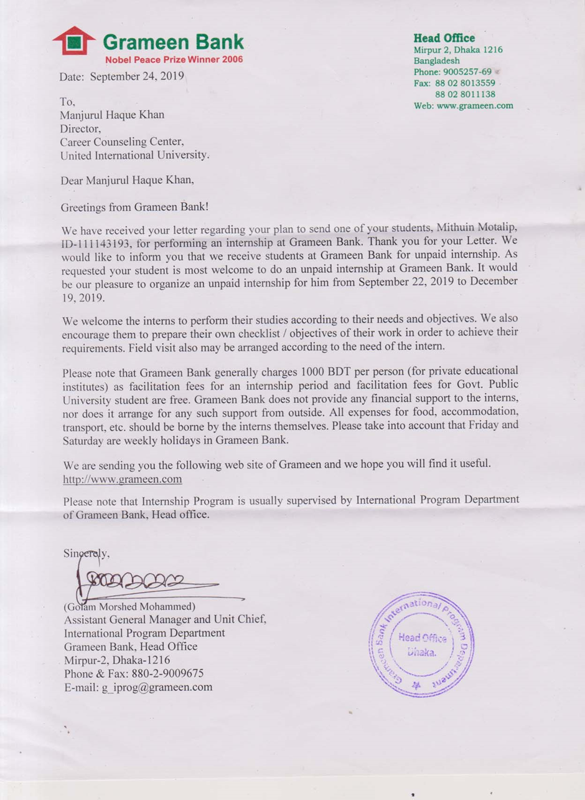

Internship Certificate:
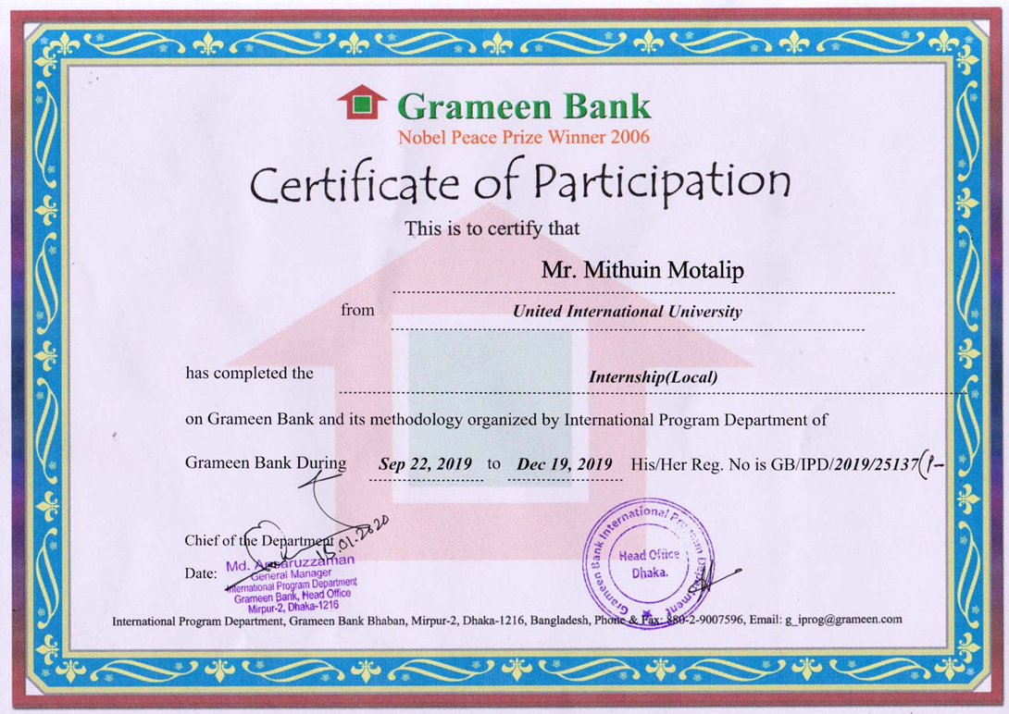





Nobel Peace Prize Winner Organization 2006

