

Project Report on
Categorization Customer Preference and
Process of Logo Design

Submitted to:
Dr. Seyama Sultana
Assistant Professor
School of Business & Economics

Submitted by:
Name |  | ID
Mehedi Hasan Shakil |  | 111 142 203

Date of Submission: 00-05-2018

Letter of Transmittal

May 20, 2018
Dr. Seyama Sultana
School of Business & Economics
United Internation University
United City, Madani Avenue, Badda
Dhaka,

Subject: Submission of Project Report

Dear Madam,
With due respect, I really pleased to inform you that this is a great pleasure for me to submit the internship report on “Logo Designing”.
In this report you have found that what I have actually assigned as my learning perspective. I have included all the elements that help me to learn something different. I try my best to make it possibly attractive as possible.
Finally, I am really grateful to you for giving me this opportunity to work on this report which I have taken this as a great opportunity for me to develop the practical and professional skills though the Internship program.

Thank you.

Yours Sincerely,

……………………………
Mehedi Hasan Shakil
ID: 111 142 203
United International University
Executive Summary

The internship report based on the Three months internship program that I had successfully completed Categorization Customer Preference and Process of logo Design. It was such a good experience to work on this topic. Because I am the student From Major marketing that broadly discuss and related with branding. As a part of marketing student, I really happy to work on this topic. In this report you can see how a logo should design and it activity to represent a brand. The procedure where you should start and ending process. The relative category to design a logo and its color choice, what should choose and what not. Everything is discussed in this project work. You can easily get the idea of designing logo that help you know about how a logo bear your brand and create own identity throughout out in the competitive market at that time.
All information I have collected from the experience of designing area and practical work. It gives a great opportunity at the same time to work on this. I have always try to focus in the real marketplace and world most famous logo. How they design their logo and how its represent their brand at the same time.

Contents
Chapter-1 5
1.1 Introduction: 5
1.2 Background of the Study: 5
1.3 Objective of the report: 5
1.4 Limitations: 5
Chapter-2 6
Literature Review 6
2.1 Relevant Other Literature (Industry Overview) 6
2.2 Theoretical Framework 7
2.3 Research question, analysis and Hypothesis: 22
Chapter: 3 25
Research Methodology 25
3.1 Methodology: 25
3.2 Data Collection Sources: 25
3.3 Secondary Sources: 25
Chapter: 4 26
Result and Discussion: 26
4.1 Factor Analysis: 26
4.2 Regression Analysis: 27
4.3 Findings: 27
Chapter-5 28
Recommendation & Conclusion: 28
5.1 Recommendation: 28
5.2 Conclusion: 28
5.3 References: 29

Chapter-1

1.1 Introduction:

The formal thing about designing a logo is that its knowns as the symbols or signature, which is actually made up of the combined by the images and text. A logo helps us to identify a brand that we like. A standard logo represents your brand. Its broadly helps customer to know what you actually represent, who you are and the value you have. Let's look at how to make a logo to represents a brand.

1.2 Background of the Study:
The study is focused on mostly on the article of various authentic sources. This report is limited only by its marketing activities, and not related with any other departmental activities. It’s actually not subjected to any personal clarifications, and confidentiality of some information was a strict requirement on organizations’ part.

1.3 Objective of the report:
The leading topic is usually to obtain info on brand practice in addition to be aware of it is magnitude of which how a brand shows it is a band model throughout the reasonably competitive current market.
Other Objectives:
- To gather information about the Process of logo design
- What does a logo mean to the customer?
- To have a clear understanding about color psychology that also related with human mind
- To learn about what you should care or not at the same time to design a logo

1.4 Limitations:
- Time Constraints: During the data collection procedure pressure was created for the limitation in time. It was unavailability of sufficient time
- Amateur: On account of deficiency of working experience, a number of glitches probably have transpired inside suitable rendering on this survey, consequently greatest hard work can be used to relieve glitches.
- Work Load: The burden of other courses during the making of this report might have deprived the full concentration that the report actually required

Chapter-2

Literature Review

2.1 Relevant Other Literature (Industry Overview)

What does a logo actually do?
A logo provides you many functions that you need all time as expected.

A logo creates your own identity from the competition in the market:
From the very basic part of a logo, it provides you fundamental functions to create your uniqueness and differentiate from other competitors. This is very important for you because in the competitive market its help you to go through research what your competitor logo looks like.

A logo describes key information about your brand:
A logo provides your customer very crucial information about your brand. It can easily communicate with the sector you belong, what kind of service you provide, your target area and your brand value throughout the existing market.
Logo Create Brand Recognition:
Logo creates a visual impact which helps to remind that brand exists. A combination of words, the logo can easily create strong visual association through customer mind.
This associations help a customer to get a reminder in their mind easily. If you think about brands like Nike, Adidas or McDonalds, whose logos you can easily remind when you hear this name from others.

2.2 Theoretical Framework

- Elements of logo Design:

A logo made by the combinations of many elements or by using a single element. Let's discuss some obvious factor that known as part of logo design process.

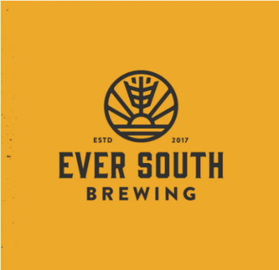
- Typography:
A logo can be made up by some typographic elements. This can be monogram style or can be single letter style and maybe abbreviation. Sometimes it’s become the full name of any business.

- Images:
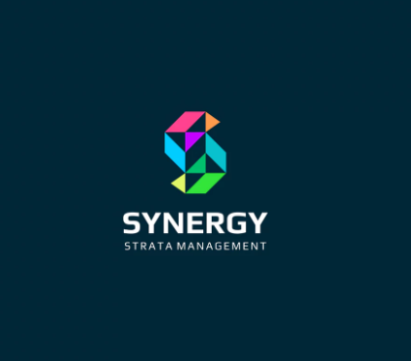
Sometimes typography made up by symbol or icon. It can be represented by geometric elements. Other times its include some decorative elements like line work or visual punctuation. it's not mandatory that only a single stand out to describe a logo alone. This logo you can find easily contains all elements like, typography with geometric elements that illustrate the view sunset with a stalk of grain upward.

- Color:
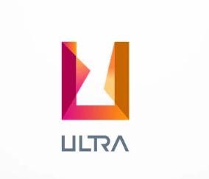
A logo can be designed by using the different color. A logo can be black and white, monochrome or multicolored. Logo design by multicolored has palettes that could be either analogous contain the perfect meaning of color that similar to hue or complimentary.

- Context:
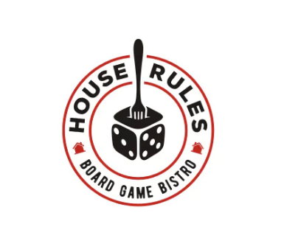
In formal cases, your custom logo is likewise characterized by context whereby it’s made use of. Function, it’s vital to contemplate if plus when trademarks are often placed. Often most people find trademarks internet, for business enterprise handmade cards, around storefronts, marketing, and advertising but it impresses. However, your business enterprise likely has precise demands. While in the model, a circular style and design are actually a fantastic accommodate to get sip coasters!

- Common way of design a logo:

When you find an idea about your brand and feeling confident, then its time convert it into a design. Many elements of shape, color, and different use of graphics to typography. Isolated each element and what it can do complete your logo design step by step.

Choose Your Design Style:
First think about a logo, the thing you think take a good design concept for your brand, because no style is perfect for everyone so you should follow right thing which one is right for your brand.
- Classic:
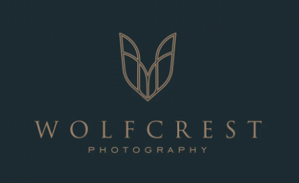
At first trendy logo looks exciting and fun but you to remember that they look outdated easily. You have to select classic style because it gives you a better power to staying and reach your target audience. This concept drives your logo into simple and it doesn't venture out into the outdated color palette, graphics elements or fonts. A classic style describes your brand as reliable and down to earth to the people.

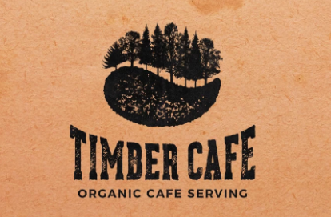
- Retro or vintage:
Nowadays there is a several reasons why retro and vintage logo trendy. its help you instantly to remind past and evoke romantic feelings of previous memory. Vintage logo describes that the history of logo, its customer and important to you, its shows that whatever you sell is done the right thing.
- Modern and minimalist:
When a brand is new in market they have to choose as modern and minimalist, that will help them to send a message how modern they are. This styles basically uses a lot of white space, minimal details, and many simple lines. A modern logo shows your audience that your brand is new and up to date and they know how to stand out.
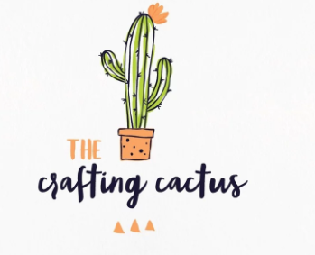
- Fun and Quirky:
When your target customer is young people you need focus on fun and quirky side o logo design. Its appears with colorful, cute and often uses of symbols or illustration that create a positive and friendly aspect of a logo.

- Types of logo:
If you take look overall style of logo you can find out many types of logo you can find when you creating your logo. you can take one of them when you design a logo and that contains all types of best elements to design a logo.
- Letter marks or monogram logos:
When your name is very long and hard to remember letter mark logo would be a great streamline for your company. There are lots of company choose their logo by initials, just like CNN, HP. This type of logos is the great choice as a minimalist logo but the problem is that they are not enough to express your brand or your business activity.

- Wordmarks or logotype:
This type of logos is very straightforward. They using their company name as their logo. You can say it’s all about typography that shows their personality and recognition. Just take a look at this logo then you can get an idea that how they look like.
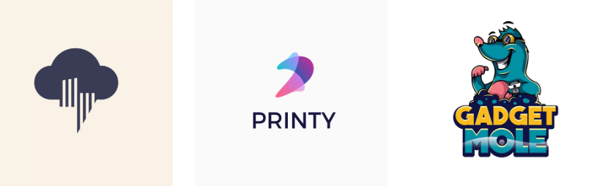
- Pictorial marks or logo symbol:
Pictorial mark logo defines that what we think or remember the name logo. The combination of iconographic images that are easily noticeable and presents your brand with the images. Sometimes you can choose anything very simple or complex, but you have to ensure to pick a symbol that creates a solid connection with your brand.
- Abstract logo marks:
A logo marks with a geometric form that maybe doesn't establish an immediate impact to connect with people but create something new with your brand. Abstract logo creates an extra benefit to your business that shows you something uniqueness. An abstract logo for your business then you must find out the meaning of different geometric shapes that would use in your logo.

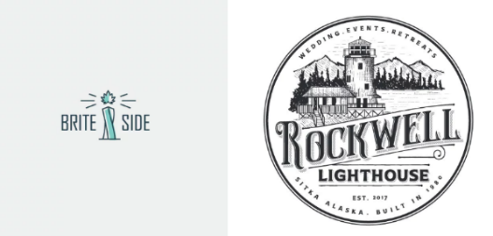
- Mascots:
This the something funny way that gives your business a unique personality. It made by colorful vibe, sometimes in cartoonish characters which represent your business in a friendly- family and acceptable way.

- Combination mark:
When a logo combines symbol with wordmarks that would easily recognizable is combination mark logo. This types logo shows brand name appears either placed next to the symbol or combine graphic elements. The customer can easily get both elements of your brand, which reminds them that something about your brand.

- Emblem:
It's almost same to combination mark logo. It’s also maybe contains word and pictorial elements. By combination of icon and images its create emblem logo.

- Choose a perfect color:
Colors have been shows you many meanings. The Psychology of color maybe complex but it’s easy understand that color shows perfect emotions that attached to them. To learn more about color theory then it must go through color psychology.
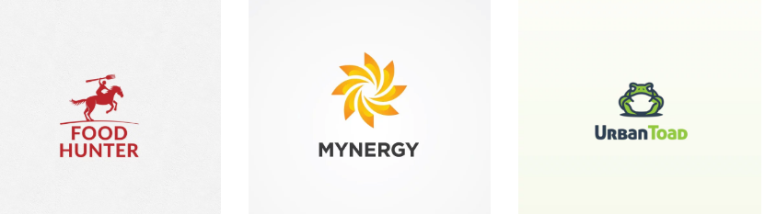
Different colors have been shows its meaning through this discuss.

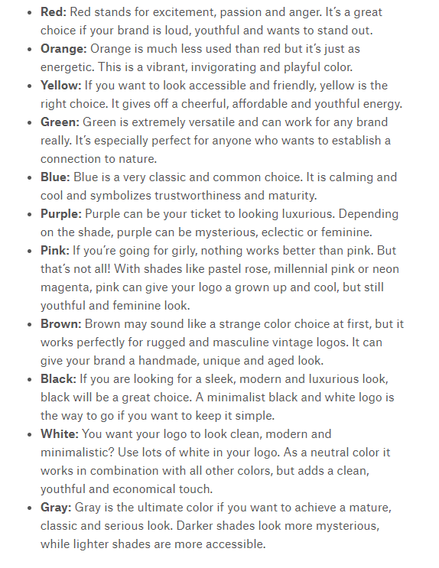

- Choose a designer:

It's really difficult to find a perfect logo designer for any specific logo designing work. This point actually helpful when you hire a graphic designer, web designer or do any types of design activity.
But sometimes it works by considering some factor to choose a designer for the logo.
- Experience:
Past work of a designer provides you a better idea about the skill level of a designer. This can give an idea that how much top-quality service he/ she can provide you. That shows you have looking a strong portfolio of a designer.
- positive Feedback:
Take a view feedback from a client of this designer. His/ her previous may be good source to get an idea about the designer. The level of dedication and quality you can check easily by this process.
- Through a design Process:
you must follow that do they follow design way to design its work. In an actual way, its take 48 hours to complete or they provide you not good work. And the cost of it. professionals maintain the quality in according with the price also.
- Published Work:
Do they publish any work or the rewards of their work? You must check them all.
- Strong Portfolio:
The strong portfolio contains different types of work with the quality. When you see a portfolio, you can get an idea about its actual clients.
- Price:
Cost of design a logo defines that what is actually you need to receive. Price can vary designer to designer, but its cant is an only requirement to design a logo. The obvious question about design is that how much it costs, actually it does not contain any fixed value. Price varies from company to company according to their needs.

- Best Customer Service:
A good designer is not all about design something good. The other way that its response time, communication ability with the time. The response from starting to end level
- Professionalism:
By together of trustworthiness, good communication level, management of time all these things go hand in hand with the name of professionalism.

- Right questions:
A designer must have the quality to ask various questions. Remember question must be relevant because the information available to design a logo. Should not no conflict of information must not contain in designing logo, its reflect on the final work of a logo design.

- Benefits of Professional logo design:
If you take look around yourself you get some iconic logo which is worldwide recognizable. The yellow McDonalds 'M', the Apple logo, which is easily recognizable and it represents its brand easily.
For this reason, a perfect logo is highly important by considering this factor:

Reason why you invest in a professional logo:

- Its create the first impression easily
- Follow conceptual and strategy of professional.
- Its help to create brand identity and makes it easier to build your brand.
- Project highly professional image
- Get the right format and variations.
- Great return on most investment.
Its helps you to achieve all facts above. So, by hiring a designer to design a logo would be a great idea and at the end of the day, you will get something unique.

- A great logo provides great impression:

You have ensured your customer makes the perfect decision about yourself at first sight. That's the main thing you need to focus. The color, size, font and the style of logo says a lot about your brand. The point is that why you need a professional to design your logo at that time. A perfect logo bears your brand message at a time. Now it's clear that to create the first impression in the world of business.
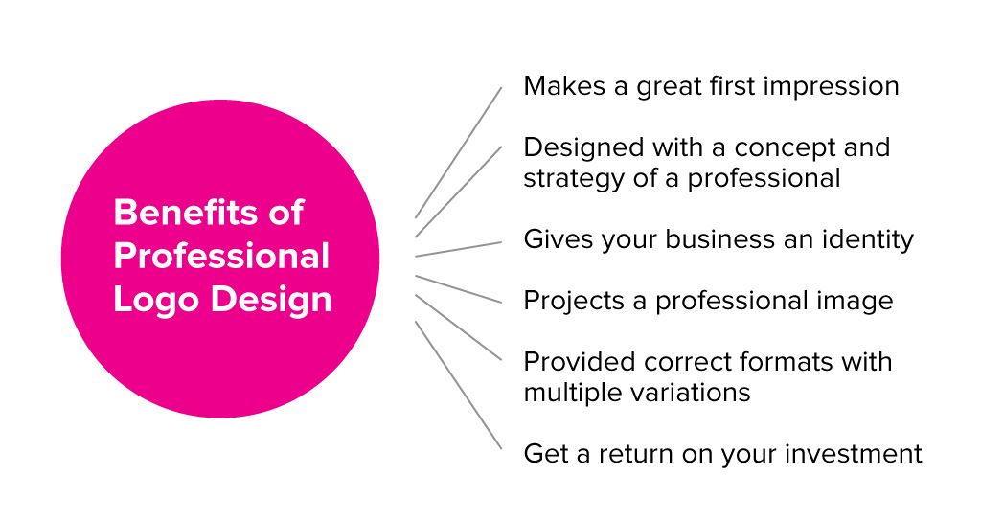
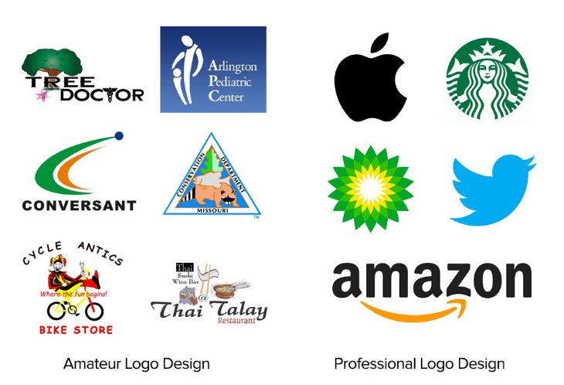

- Logo Design Mistakes that should be avoided:
As far we discussed before that a logo should be unique that differentiate your brand from others. For this reason, a logo should avoid some mistakes at the time of making.

- Typographic Chaos:
A typographic logo is the other part of logo design. Keep it simple sometimes many of brand have followed the procedure to design it. The thing is that mistake should avoid that does not use too many fonts in a single logo. Don't make it crazy or uses ultra-thin fonts. Should focus to the Spacing, Kerning, and Sizing. You needed go through research to get an idea about a right font that deserves logo design.
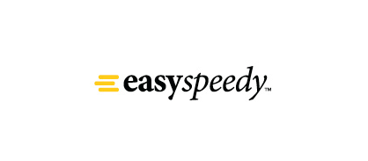
- poor Font Choice:
Designing logo by typographic, it’s should know about right typeface or font selection. It’s simply describe your brand with a perfect font choice to design. But if you choose poor font that not show your brand. By choosing a perfect typeface you need any modification at any time. So, it’s should avoid poor choice at the time logo design.
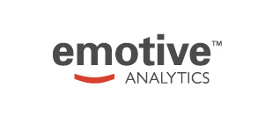
- Should not be too complex or too abstract:
Remember simple logos are easy to recall in your mind and it's memorable. Can choose it from any chaos. Be unique without any overdrawn. It needed be simple as well as versatile, that can use in many media.

- Uses of special effect or color:
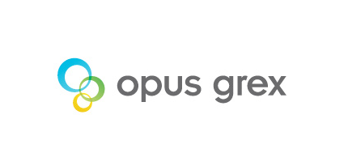
Logo always requires color. That means uses of color always obvious. The thing is you have firstly ensured the uses of black and white color. Then uses should use other colors as brand contains. Remember you not use logo in shadow, emboss or gloss up. Good logo its good by own. You may can try different variation but also using special effect should be careful.
- Using Raster Image:
A logo designed in vector graphic. For this purpose, Adobe Illustrator the software that should be used for designing a logo. It’s a vector-based design software, by using this software you can resize the logo in any shape for you use. When you scaled a logo its never be broken in a pixel. but if you use photoshop you don't get any clear view of a logo, because it's a raster-based software, which is mostly used for photo editing.
- Setting for a monogram:
The common mistake that a logo designer firstly made is that monogram logo. the this is that firstly it has been solving a problem but the thing is that it's not the permanent solution of logo design because its lost the credibility of logo design and makes it's less informative to represent a brand. By a monogram base logo, you can settle a certain situation but not the longer one.
- Copy, steal or borrowing design:
Logo designing activity always remains in creativity. you have to focus on creating something unique that gives you longer benefit and greater value to your brand. A designer can get an idea from other design but the thing is that never steal or coping from other design at all. Another point is that it should avoid using stock or clip art either.
- Getting too much client input:
As a designer, you hired by a client to design a logo professionally. Its easily expected that logo goes through a perfect way. But you have to remember that it's not mean that you bound to hear all the instruction of a client. he/ she may suggest you that where you should go but not the permit ant interference in your job. that hinders your creativity along with your capability. Remember you have been paid professionally and all the thing remain close both of you all the matter of discussion.

- Providing too many concepts
Generally, from the preceding position provides your customer having a great number of selections. That all over again suggests your customer should have an excessive amount claim above the pattern way on the challenge. When you produce 10 methods into a purchaser, by and large they're going to opt for whatever you contemplate, this ‘worst’ pattern. A superb rule is usually to solely post that you several methods you in person could possibly view earning a living for the small business. Certainly, the volume of methods people post can modify by challenge to help challenge, although when you finally think comfortable plenty of to be a custom made, most of these that you several methods really should nail bed this challenge within the scalp when.
- Not cleaning up logo files
Business logo computer files has to be among the many clearest computer files everyone by chance achieve litigant. Node tips has to be saved towards a least; curves have to be mainly because steady as they possibly can together with not having overlap. Figures has to be joined together, when an individual's business logo is certainly symmetrical, it should be wonderfully symmetrical. All the things with regards to the brought submit has to be wonderful even though negligible as they possibly can. Just imagine if ever the clientele is required to increase any business logo that can put on the side associated with a 18 wheeler. If ever the business logo has got all slips, those could these days get appears visual. Cause it to be wonderful.
- Not delivering correct files to client
Giving you the ideal information to the shopper is definitely 1 keep your shopper under no circumstances returns demanding revisions and also several editions on the custom logo. You'll find it makes a custom logo may get viewed accurately in any scenarios, that ought to often be protected using a design and style direct. Make sure you present a person's shopper three high-quality information a custom logo difference meaning furnishing your spot-color data, your absolute CMYK (no identify colors), your absolute dark colored data, including an absolute white colored (knockout) data. All these will need to frequently be in EPS, TIFF, plus JPEG models. You may produce a favicon very, if perhaps you’re sense awesome.
- A Closing Word
Those custom logo design hints have to aid you become a more effective business logo fashionable in theory, yet, it’s crucial for you to believe that whilst details that fit this description would definitely be a superior place to begin, they are able to possibly not support everyone to come back — protocols are made to get ruined & there isn't ‘right’ strategy relating to custom logo design. Draw, look into together with set up! Consequently, perform repeatedly

- Color Psychology and its branding:
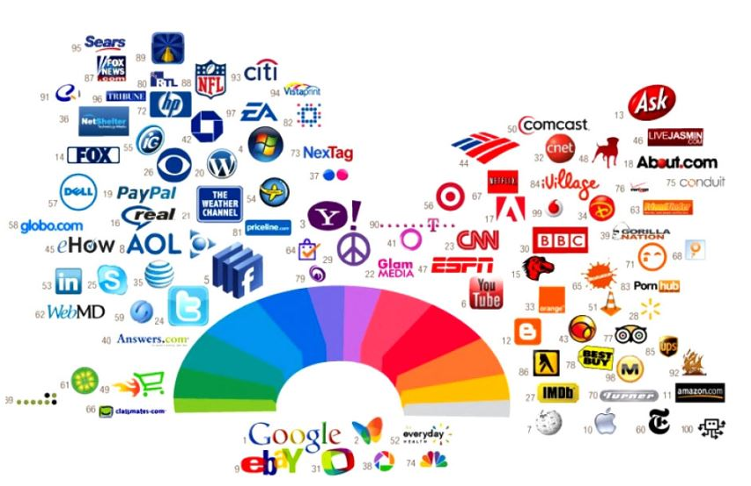

Logo design color spectrum and Emotion guideline:
If you have to take a look that most popular brand how they choose the right color to design their logo. You can see skew of blue color and red color that shows a perfect meaning of them how they choose the right color and psychology behind it.

- Red Color:
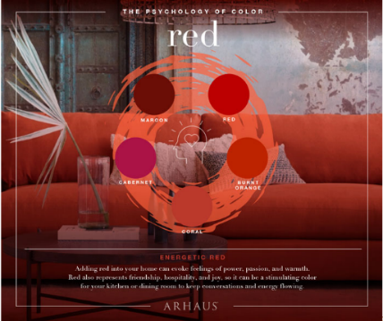
The red color indicates warmest color scheme among them. It also known for the extroverts and male. It expresses an intense that shows like fire as warm as blood. Red express passion, energy, desire, love and determination. If you remind that most country use red color as their flag color. Its related to human body that enhances human metabolism, increase blood pressure and control respiration rate. after all, if you go through this color helps to get attention easily at any time.

- Yellow color:
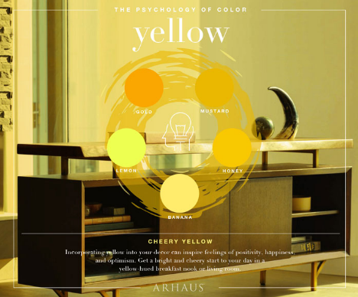
This is called vibrant color. You can see sometimes its associate with sunshine. It’s all about merriness in the world. This color embraces people with boost mental activity, makes them cheerful and generate muscle growth. To indicate attention like the color red then overusing of this color avoidable. Someone cry in the yellow colored room its look odd and distracted, which is not accepted. color of yellow makes people impatient and too yellow may cause the negative feelings that increase insecurity, fear isolation, and low esteem. So, its mandatory to keep yourself careful to get balance using this color.
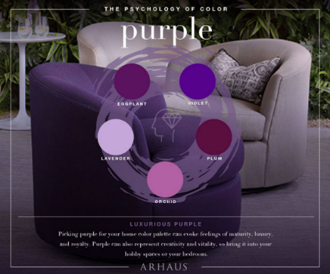
- Blue Color:
Blue is mostly shows color of the ocean and of the sky. Its shows as the soothing color that cares your heart with peace. intuition freedom, imagination. Sometimes its inspire us be loyal, be sincere, be confident and be intelligent. For this reason, its shows as the corporate color. Blues is the color that brings tranquility to the body since its mostly slows human metabolism. However, sometimes it can be dynamic effect.
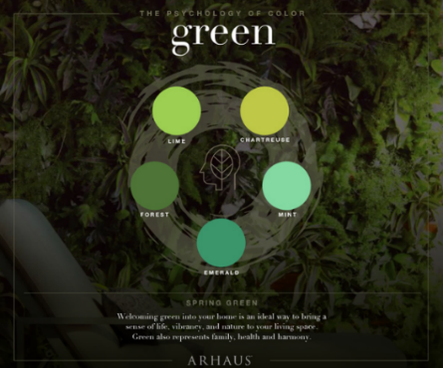
- Green Color:
Natures favorite color. you see nature have the favorite color that associated by season of spring, its known as the symbol of life, new beginning, safe environment. That will affect both emotionally along with physically, that also show it has a soothing effect on human vision. Since it known as the natural color that took part in human eyes spectrum.
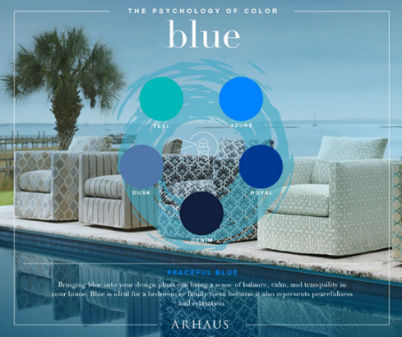
- Purple color meaning of logo design:
Perfect blend with fiery blend attributes of red and blues with ocean qualities. Mostly it’s the rare side of nature. For this as the color of scared, and precious. Violet is also get the color of passion, vitality and higher self. also, express the meaning of power novelty and luxury. When you incorporate it in your logo you get elegance and glam. that shows you luxurious effect and sense of sophistication on eyes.

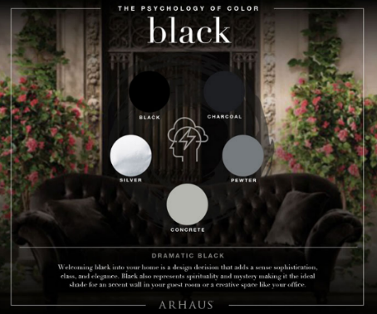
- Black color:
It really is some sort of thriller for the reason that shadows. black color would be the often known as this absence of coloration. Although it’s never ever will give you the connected with absence of inner thoughts. Returning indicates one’s toughness, luxury, in addition to authority- possibly demise, unpleasant in addition to out and out aggression. it is just a coloration status and this generally known as the corporate coloration with full confidence and many alternatives. Together with causing the opportunity connected with emotion regarding emptiness. And so, if you would like allow ones brand many fresh airs.
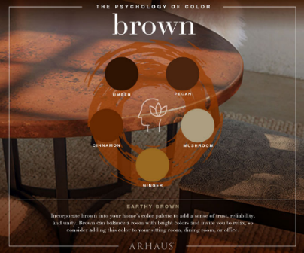
- Brown color:
Brown lightly coloring a reveal this is with oneness, have faith in plus excellence inside of a style and design. Them offers the idea with stress-free. It has the manage earthy sounds, due to this, it has the in to design.

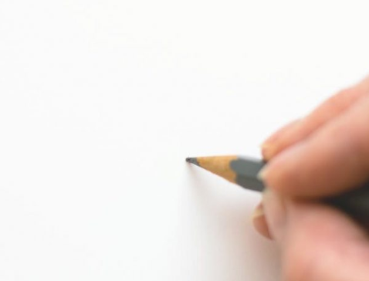
- White color:
This light coloration of this particular coloration connected with light-weight of which indicates this symbolic representation connected with purity, principle, in addition to purity. Additionally, it can do the job as a representative connected with coolness in addition to convenience. From time to time the item will give you the connected with thought understanding in addition to purifications. To develop some sort of brand with new time period you should indicate it is add having a different coloration.

- Orange color in branding:
It has the named a mix off green plus red colorization. Oftentimes it’s named made from with sugary plus sour fruit flesh together. It has the voice this is with inventiveness plus fulfillment for you to find it has the in addition to purple plus green. Them really encourages a passion with ambiance, eagerness plus enjoyment together. Records reported this it has the stimuli a starvation together. If you the following coloring around emblem it is really really observable together

- Proceed a logo by sketching:
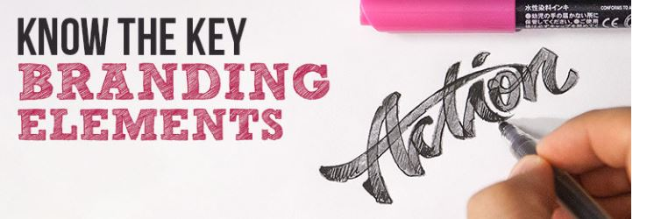
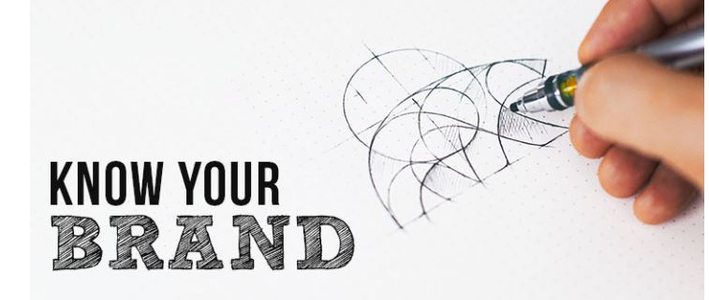
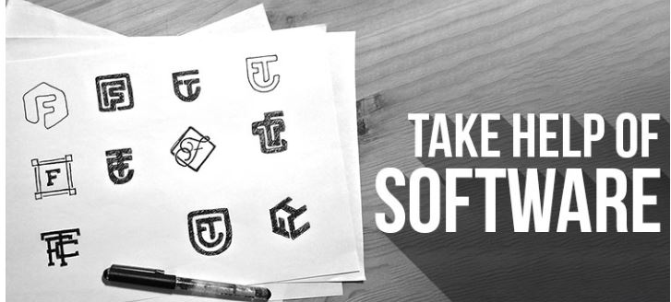
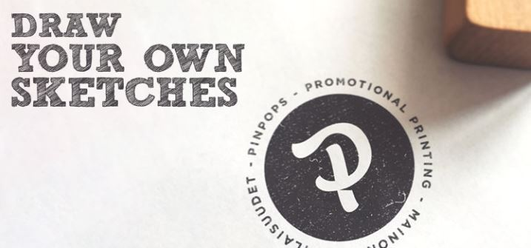
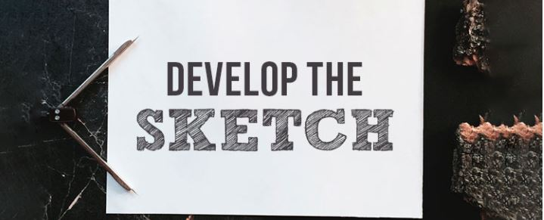

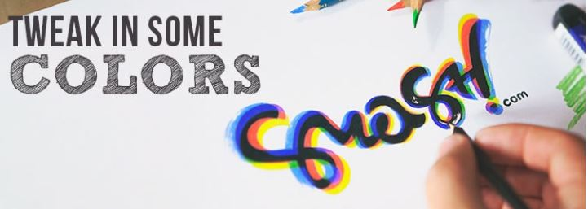

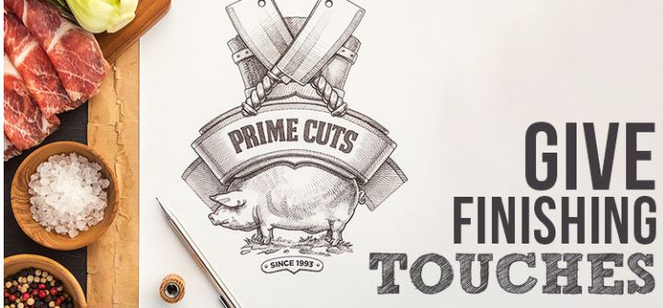

2.3 Research question, analysis and Hypothesis:

Logo Design Details
Type your Company Name exactly as you wish it to be used in your logo | Easy Bazar
Please provide a tagline or a slogan if you have one. | We provide everything
If you have a slogan or tagline, do you want to incorporate your tagline or slogan with the logo? | yes
If yes, please provide your tagline or slogan | We provide everything
Please provide your motto or mission statement | Availability of all product
Please describe your company. What type of products/services do you/will you provide? | Super shop
When you think of your business, what words come to mind (be as creative and descriptive as possible)? | Keep all types regular product to serve customer as possible in a best way.
When you think of your business do any images pop into your head, and if so what are they? | Agora, Meena Bazar
Describe your direct competition; provide addresses to their websites if available. | www.agorasuperstores.com
Are there logos and/or graphics that you really admire? Please paste in the URLs to them. Please provide an explanation as to why they appeal to you (These do not have to be businesses that are similar to yours). | www.agorasuperstores.com  its convincing, because its cope up with their brand color.
Are there logos and/or graphics that you dislike? Please paste in the URLs to them. Please provide an explanation as to why they do not appeal to you (these do not have to be companies). | No at all. It’s a logo. It’s not mandatory to like everyone, because every branded log hold a meaning.
What are the marketing and business goals using this logo; what will it accomplish? | To reach customer as soon as possible.
Describe your company/business to someone who has no knowledge of your existence. | Chain retail super shop that keep all the regular product.
Describe your target market, gender, age, geography. | Mostly family and bachelor.
What do you want your new logo to communicate about your company or products? | Yes. I want that it should fast connect with my customer
Please state your creative strategy (pointers, ideas, or buzzwords). | Green Color, combination with letter and graphics elements.
Perception
What image do you most want to project to your prospective customers/visitors (i.e. clean and simple, high tech, fanciful, elegant)? | Clean and simple
When you think about a logo for your business what images come to mind? | Which one shows the ultimate freshness
If you want your logo to be animated, please describe your idea. | No need to make it animated.
Schedule of Delivery
When would you like the logo development to start? | Within one month
What is the desired time frame for development of this logo? | May be in one month
Expected date of completion? | 23 May, 2018 – 23 June, 2018
Look and Feel
Are there any elements that you would like to see included in your logo design? | Green Color
If this is a redesign, what elements from your old identity do you like or dislike? | Green color like and red color dislike
Do you have any particular point of emphasis you want to see in the design? Please state: | No, it’s up to you
Do you have any preconceived ideas about the design of your logo? | No, it’s all about your responsibility
Are there any images or concepts you DO NOT want to see? | No
Do you want your logo to include text only, text and graphic, or graphic only? | No, text and graphics both of them.
Do you have any ideas for the style of text (font) in your logo? Please state. | No, It’s all about your choice
Do you have any sketches, samples, etc that you wish to send to us for review? Please describe method of delivery. | Yes, I have, I will provide you later.
Do you prefer icon-based logo or text-based logo or combination of the two? | No, I prefer combine elements logo
Do you have any specific themes for icon-based logo if any you would like us to consider? | No thanks.
You may want to refer to the attachment, Psychology of Color, to help you with this next set of answers. | Yes, its green that simplify freshness.
Do you have a color scheme in mind for your logo? If not, have you thought about colors and color schemes? | Mostly green color, That’s it
Are there any colors that you absolutely dislike? Please state. | Red color. Should not use at all.
Additional comments? Please state. | Keep your choice which one is best for you.

Chapter: 3

Research Methodology

3.1 Methodology:

The following methodology will be followed by study based on observation and interpretation. Data sources are scheduled on an informal discussion with different website article, real life experience and practical view point of logo design.

3.2 Data Collection Sources:
The data are collected from secondary sources.

3.3 Secondary Sources:
The secondary data were collected from the following sources:
- Internal newsletter of the company
- Various research journals of different research organizations
- Web pages
- Most popular logo around the world.
- Various books and other internal publications.

Chapter: 4

Result and Discussion:

4.1 Factor Analysis:

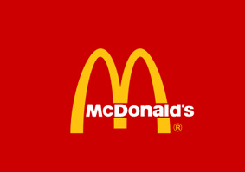
- Factor in according to designing process.

- Simple: As much as possibly make logo simple. It would be easily memorable and add a fact of versatility.
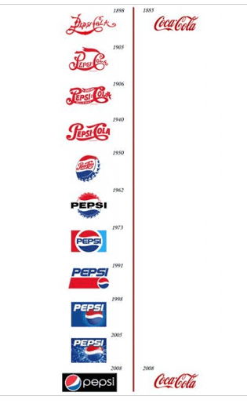
- Memorable:
The more your logo is simple the more it would memorable because an effective must be needed to be memorable to known as an appropriate logo.
- Timeless:
By the changing of time, it must be as effective after 30/40 years. The logo changing phase by the time period you have got a clear idea about logo design.

- Versatile:
Your logo must need ability to across within various mediums. logo need to be functional. For this its needed to designed in vector format, so you can be scaled it to any size. It must be work in both vertical and horizontal.
To ensure the effectiveness of a logo you should ask yourself:
- one color?
- the size of a postage stamp?
- can use as large as a billboard?
- printed in reverse color (black and white) same time?

Appropriate:
It's highly recommended that a logo need to be appropriate because it represents your brand. without an appropriate logo for company, it may fall to achieve its target audience at the same time.

4.2 Regression Analysis:

All the factors regarding logo designing have been descried already. All of them factors have been close to one another. No way to avoid them. From start to finishing touch, a perfect logo follows its procedure by logo to logo. By category they are may be different but there is no way to Denay the fact is that logo design is all about the process of maintain its rules. Category, color, quality, price, professionalism all the factors make a perfect logo by its own.

Findings:

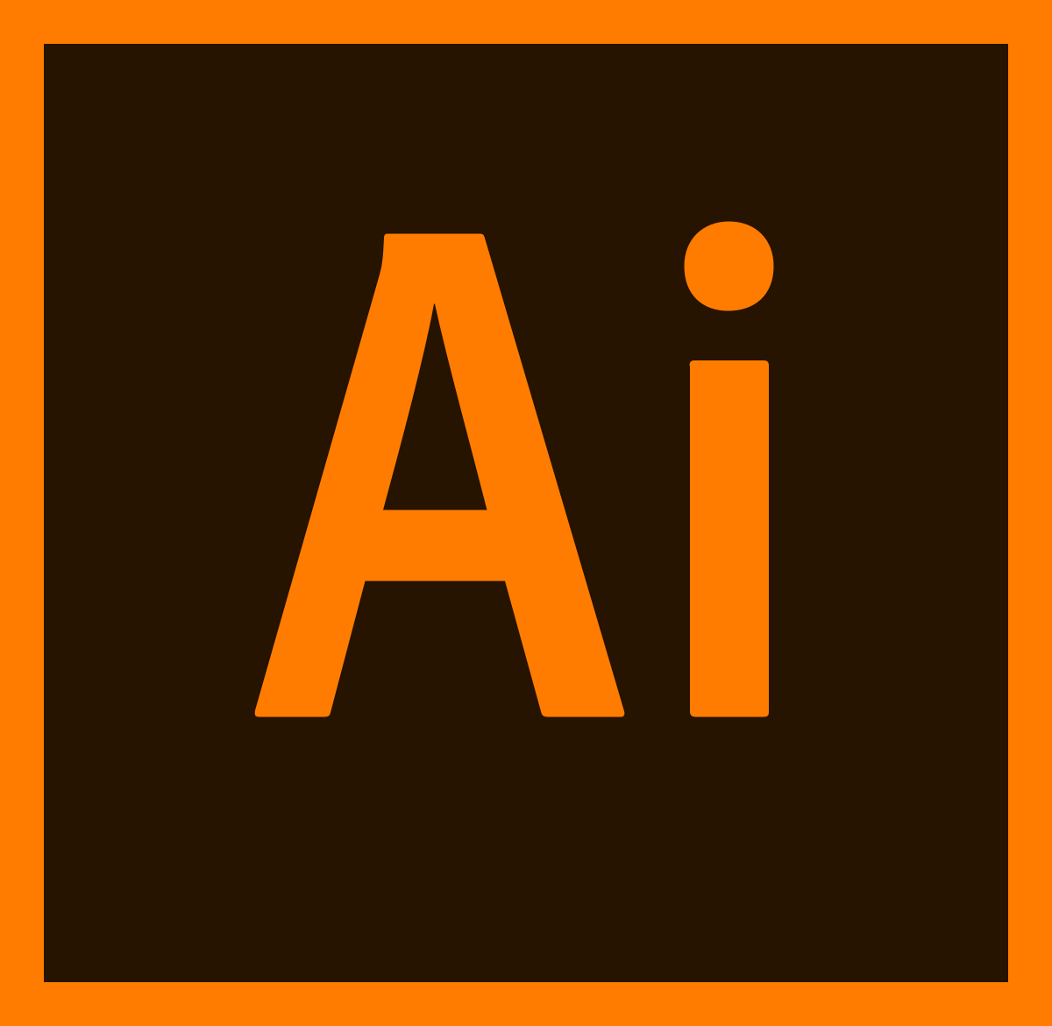
The logo process on customer preference have been described already. The thing is that it has described sequential process of designing. But its not mandatory to design to go by a rule of design. All the time the budget is not same as expected, so expected result of logo design should not be same. A logo literally gets proper picture by using the software adobe illustration, that is a vector-based software which is easy to get print and clear picture of your logo that you described to your designer. To get an expected result you have to go by the process and using the best software of logo design.

Chapter-5

Recommendation & Conclusion:

5.1 Recommendation:

In this project work I just go through some unusual circumstance that was not impressive at all. The data and information I have collection the information was not good enough to give me something authentic about logo design. For this reason, I have to recommend that to follow this such point to design logo and its relative activities and have to follow to get better idea about logo design.
- Never follow any single source to get an idea about logo designing
- The more you go through any research the more you get perfect idea about logo design.
- The rules i have been explaind its not mandatory to them step by steps
- Remember perfect logo describe your brand so its your resposibility to choose a perfect logo
- Choose a designer who know himself perfectly and have perfect knowledge abou logo design
- Always tru support designer woth your relative information that will brings you a greater benefit all the time.
- Logo represents your barnd so be humble with it.
- Choose perfect with meanigful thought.
- careful about copyrights and respect other idea and thouht.
- Remember all the information that ypu provided should be raltive with your brnad

5.2 Conclusion:

when you are done with your logo design remember that yu have created idea basis of other materials like business card, letter head, package designig and many other elemnts. That means you have use your logo among them. So spread your world about your brnad and keep a respectful thouht and got something very Unique. We have discussed many times previoulsy that a logo may be a sign or symbol but its your identity through out the competitve market. If you are careful about a logo it will be yours. at the end its means a lot to create your brand identity.

5.3 References:

- http://justcreative.com/featured-articles/#logodesign
- https://99designs.com/blog/logo-branding/how-to-design-logo/#nowthatyou
- http://justcreative.com/2010/08/24/logo-design-mistakes/
- http://justcreative.com/2018/02/19/color-psychology-in-logo-design-branding-explained/
- https://www.creativebloq.com/graphic-design/pro-guide-logo-design-21221
- https://www.johnnyflash.com/creative-and-effective-logo-designs/
- https://www.onlinedesignteacher.com/2013/12/how-to-design-logo_5.html
- http://justcreative.com/2018/02/19/color-psychology-in-logo-design-branding-explained/
- http://justcreative.com/2009/07/27/what-makes-a-good-logo/
- http://justcreative.com/2009/10/20/how-to-choose-a-logo-designer/

