INTERNSHIP REPORT ON TRAINING & DEVELOPMENT PROCESS
AKIJ FOOD & BEVERAGE LIMITED

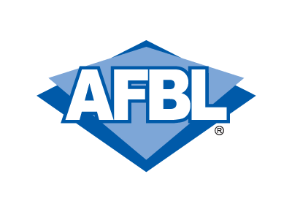

2020



UNITED INTERNATIONAL UNIVERSITY
Internship Report on
Training and Development process of AKIJ Food and Beverage Ltd

Submitted To
Ishrat Sultana
Assistant Professor
School of Business & Economics
United International University

Submitted By
Nafisha Maliha
ID: 111 152 184
Date of submission: 18th December, 2020

Letter of Transmittal

18th December, 2020

Ishrat Sultana
Assistant Professor
School of Business & Economics
United International University

Subject: Submission of Internship Report

Dear Ma’am,
This is to inform you that I, Nafisha Maliha, a student of the Business School of United International University, have, under your supervision, completed my three months Internship Program at Akij Food & Beverage Limited.
I am pleased to submit my report on Training and Development process of AFBL that you have assigned to me. I have conducted a comprehensive study on the assigned task, and thoroughly analyzed, finally prepared this report for my Internship Report. I tried my best to make ready this report fault free, but it is not possible. I hope that you will take any mistake with kind consideration.
Your acceptance and any type of appreciation would surely inspire me. I am welcome your entire interrogation & take superiority to response.

Sincerely Yours

………………
Nafisha Maliha
ID: 111 152 184

Acknowledgement
At first I would like to place our gratitude to the Almighty Allah the most gracious and merciful for enabling me to perform the job rightly and prepare the report successfully with full exertion.
I would like to express my sincere gratitude to my honorable supervisor Ishrat Sultana ma’am, Assistant Professor of BBA Program, School of business and economics, United International University, for her proper guidance and careful supervision help me to complete this report successfully within the given period of time. She has indebted me with her flawless advices and support.
My cordial thanks go to Md. Saogatur Rahman, Senior Executive, Training and Development Akij Food & Beverage Limited, he gave me in-depth details and provide information about training process of AFBL.
I am thankful to Md. Hosney Mobarak Bappy, Senior Executive, HR at Akij Food & Beverage Limited, who gave me the opportunity to conduct the employee survey at virtually. Without his generous help and patience it would be impossible for me to accomplish the task.

Table of Contents
Chapter 1 1
Introduction of the report 1
1.1 Background of the report 2
1.2 Scope of the Study 2
1.3 Objectives of the Study 2
1.4 Methodology of the Study 2
1.5 Limitations of the Study 3
Chapter 2 4
Introduction of the company 4
2.1 Company Profile 5
2.3 Vision Statement of AFBL 6
2.4 Mission Statement of AFBL 6
2.5 Goal 6
2.6 Departments of AFBL 7
2.7 Brands and products of AFBL 8
2.9 Sister Concerns of AFBL 12
Chapter-3 13
Literature Review 13
3.1 Human Resource Management 14
3.2 Managerial Functions of HRM 14
3.3 Operative Duties of HRM 15
3.5 Methods of employee Training and Development 17
3.6 Training process model- 19
20
3.7 Transfer of Training 21
3.8 A Model of the transfer process: 22
Chapter 4 23
Analysis, Interactions and Findings 23
4.1 Statements and graphical analysis of data: 24
4.2 Findings: 33
Chapter 5 34
Recommendations and Conclusion 34
5.1 Recommendations: 35
5.2 Conclusion 36
References 37
Appendix 38

Executive Summary
The main objective preparing of this report is the Training and Development process of Akij Food and Beverage Limited. Here, I am tired to relate the situation with theory based study and practical based study on the similarities and dissimilarities of the study that I found during my internship period. During my internship period I was assisted the Training and Development session of AFBL. Through there I found some barriers that I was able to overcome those and specify my findings.
In this paper there is a complete discussion about the AFBL’s Training and development practices. I mention all information that what I have done in this report. In the first chapter I have discussed about the Introduction that presents the Objective, Limitation, and Methodology of the study. In the second chapter, I have discussed about company’s (AFBL) profile, then discussed about the values, vision, mission, goals, objectives, brands and products. The third chapter has been discussed about some theoretical knowledge of human resource practices. Then I am briefly discussed about the training and development practices of current world, methods of training and development, here I am also discussed about training process model, transfer of training and transfer process model.
In the fourth chapter, represent the analysis and findings part, and also give interpret all statistical data and how AFBL trains their employees and what is their training process that is also discussed here in fourth chapter. At the end I find some findings about AFBL and give some recommendation and in the last draw a conclusion of the whole report.

Chapter 1

Introduction of the report

1.1 Background of the report
This report was prepared as partial supplement of the BBA program at United International University. In order to successfully finish the BBA program, each student will have to perform an internship program in an organization for specific period of time to learn the practical knowledge of the business world. To accomplish the aforesaid requirement, I am assigned as an intern in Akij Food & Beverage, Tejgaon at Akij House for 3 months from 4th February 2020 to 4th May 2020. The topic of my internship report is “Training and Development Practices of Akij Food & Beverage Limited”. My supervisor Ishrat Sultana, Assistant Professor of United International University has given me the permission to do the report on this topic.

1.2 Scope of the Study
This report will mainly focus on the process taken by Training &Development of Akij Food & Beverage Limited. After reading this full report, anyone can know about the "Akij Food & Beverage Limited" training process and how they can further help their employee development.

1.3 Objectives of the Study
- To explore the T & D practices of Akij Food & Beverage Limited.
- To anatomize the T & D practices of Akij Food & Beverage Limited.
- To identify the problems of training and development practices of Akij Food & Beverage Limited.
- To know the impact of training on employee’s performance, KPI and turnover rate.
- To provide some recommendations to overcome the problems of training and development practices of Akij Food & Beverage Limited.

1.4 Methodology of the Study
I have collected information through both the data sources of:
Primary data
- By taking the interview of employees of Akij Food & Beverage Limited.
Secondary data
- Website of AFBL
- Study of various report, books and class lecture.
- The training Manual of the company
- Official records

1.5 Limitations of the Study
- Some information was not provided to me because of the confidentiality of HR and the competition between other competitive companies.
- I could not visit office to take interview due to Covid19.
- Some employees were not interested to give interview.
- As I am a student I have some limitations in experience.

Chapter 2

Introduction of the company

2.1 Company Profile
In 2006 Akij Food & Beverage Ltd. has started its journey is a project worth $250 million & founded by the parent company Akij Group. In both national and international market AFBL produces wide range of first moving consumer goods like snacks, carbonated beverages, fruit drinks and other food products.

Sk. Shamim Uddin is the Director of AFBL. AFBL is endeavor to be a sustainable business through consistently manufacturing quality goods by empowered & motivated staffs with state-of-the-art technology where society will be served. AFBL has a wide range of goods of fruit drinks, soft drinks, molted drinks, drinking water ,energy drinks, milk & milk-based products, chips, mango bar and pickles brands. AFBL supports local small and medium level farmers by contract farming for milk from Pabna and Rajshahi and mango from Rajshahi and Chapainawabganj.
AFBL has accomplished many acknowledgement and certifications over the years. It has achieved Best Brand Award 4 times. National and international certificates like BSTI, HALAL, ISO and HACCP proves the quality of the company. AFBL produces best quality food goods with locally manufactured & imported raw materials and by using state-of-the-art technology machineries, which has been imported from world famous brands like Tetra Pak, Krones, Alfa Laval, Spa etc.

2.2 Values of AFBL

Integrity: Honesty, Transparency, Compliance in whatever we do we are committed, we take ownership, we are Honest, we are process-oriented and we are resilient.
Trust & Respect: Mutual Respect and trust for the opportunity to grow. We trust & respect each other’s opinion, we are open, we are positive, we are trust-worthy, and we are reliable...
Innovation: First Mover, Trained People, Export Opportunities. We drive changes, we lead the market through innovative products under efficient workforce, we will explore new horizons for our products
Customer Focus: Customer-driven- we live by and for our customer’s delight; we take extra efforts to create positive customer experience.
Team Work: One Team, One AFBL. We work together as one team to achieve our vision & mission.

2.3 Vision Statement of AFBL

“To be the most respected food & beverage company in Bangladesh by commitment to quality”.

2.4 Mission Statement of AFBL
The company will strive to be a sustainable business through:
- Consistent quality products
- Employee that is empowered & motivated
- Technology that is state-of-the-art
- Society that is benefitted

2.5 Goal
To achieve market leadership, profitability, good corporate citizenship and a sustainable growth.

2.6 Departments of AFBL
Various departments of Akij Food and Beverage Limited’s are given below-

SL. | Departments of AFBL
1. | Human Resource
2. | Admin
3. | Training and Development
4. | Business Development
5. | Research and Development
6. | Brand
7. | Sales and Trade Marketing
8. | Accounts and Finance
9. | Dairy
10. | Export
11. | Media
12. | Design
13. | IT
14. | Event
15. | Outdoor Management
16. | Corporate Sales
17. | Clemon Sports
18. | MIS

2.7 Brands and products of AFBL
Popular brands and products of AFBL are given below:
Product Category | Brand Name | Out Look& Tag Line
Soft drinks | ` | 
Soft drinks | Mojo Light | 
Soft drinks | Clemon | 
Soft drinks | Lemu | 
Soft drinks | Soft drinks  Twing | 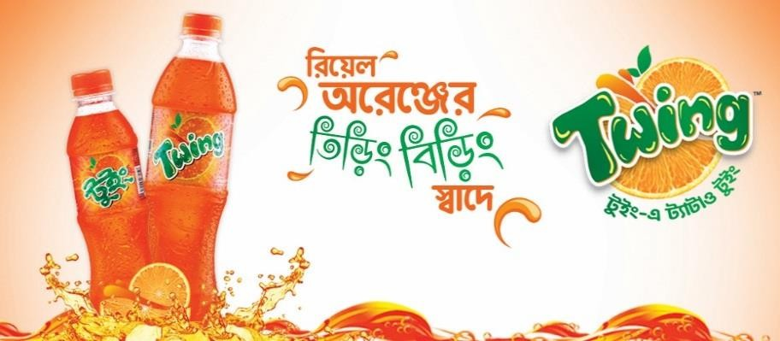
Energy drinks | Speed | 
Energy drinks | Malt Beverage  Wild Brew | 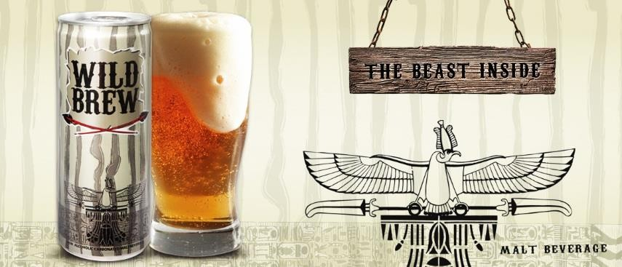
Juice | Frutika | 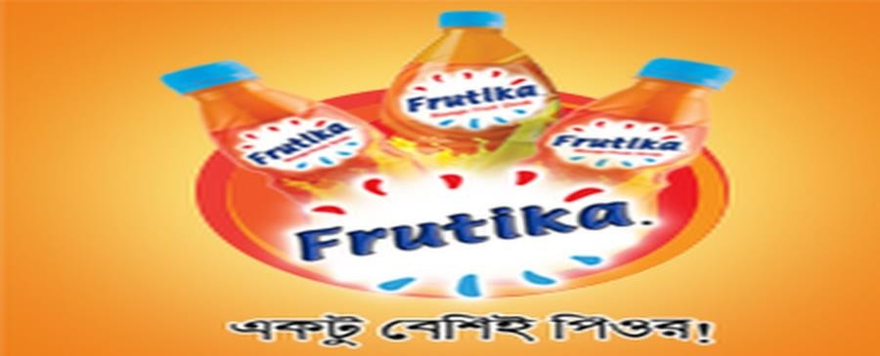
Drinking Water | Spa | 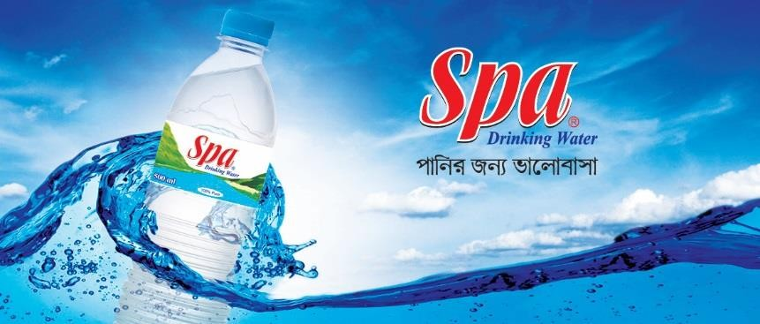
Chips | Cheese Puffs, O’poteto | 
Milk | Farm Fresh UHT  Milk | 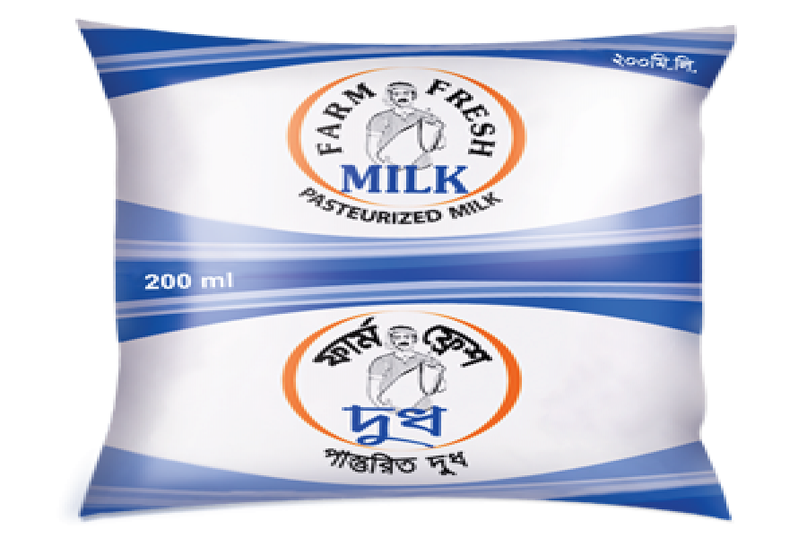

2.9 Sister Concerns of AFBL
Sister Concerns of AFBL’s are given below -
SL. | Sister Concerns of AFBL
1. | Akij Jute Mills Ltd
2. | Akij Food and Beverage Ltd
3. | Akij Textile Mills Ltd
4. | Akij Cement Company Ltd
5. | Akij Cement Ready Mix Concrete
6. | Akij Shipping Line Ltd
7. | Akij Poly-fiber Industries Ltd
8. | Akij Printing and Packaging Ltd
9. | Akij Bio Plant
10. | Akij Particle Board Ltd
11. | Akij Match Factory Ltd
12. | Akij Agro Processing Factory
13. | Akij Ocean Ltd
14. | Dhaka Tobacco Industries Ltd

Chapter-3

Literature Review

3.1 Human Resource Management
According to Byars & Rue, “Human resource management is defined as a system of activities and strategies that focus on successfully managing employees at all levels of an organization to achieve organizational goals.”
According to Leon C. Megginson “The knowledge, skills, creative abilities, talents and aptitudes obtained in the population; whereas from the view point of the individual enterprise, they represent the total of inherent abilities, acquired knowledge and skills as exemplified in the talents and aptitudes of its employees.”
According to Dunn and Stephens, “The HRM is the process of attracting, holding and motivating all manager line and staff.”

Human Resource Management functions are:

3.2 Managerial Functions of HRM

- Planning: Planning is a very important feature of an organization to set goals and targets. Guidelines and approaches are enlisted by HR to perform those goals. During the planning process the primary task is to anticipate vacancies and list the task necessities and determine the induction sources. HR supervisor makes the demand and supply forecast for every job group to consider strategic goals of the organization and each job market.

- Organizing: The next vital HR feature is to amplify and make blueprint the structure of the corporation. It includes the following:

- Manpower is grouped into positions or activities they will be performing.
- Assign different functions to different persons.
- Delegate authority according to the undertakings and obligations that are allocated.

- Directing: Manpower are encouraged and guided through directing to perform organizational targets. In this stage supervisor take numerous motivational strategies and making friendly relationship with manpower. This stage is very challenging for HR supervisor of an organization. HR supervisor must have the capacity of finding manpower desires& approaches to meet them. Motivation could be a nonstop procedure here because after fulfilling previous desires, new desire can also additionally come ahead.

Controlling: The controlling is the last function of managerial function cycle. After controlling HR again go for planning. Here the HR Manager makes an exam of outcome carried out with the requirements that have been set in the strategy planning stage to see if there are any deviations from the set requirements. Hence any deviation may be corrected on the following cycle.

3.3 Operative Duties of HRM
- Employment: Employment is the primary operative feature of Human resource management. This activity is performed via the HR supervisor for all the area of any corporation. The HR department develops manpower policies, rules, guidelines and co-ordinates with all the departments of the organization. Employment accommodates securing and employing professional who possess crucial talent that is essential for attaining the organizational target and objects.

- Training and Development: Training refers to a deliberate effort with the aid of a employer to facilitate manpower’s gaining knowledge of job-related competencies.
Training constitutes a primary notion in HR development. It is involved with developing a specific skill to a desired standard by using guidance and practice. Training is a notably useful device that can bring an employee into a position where they can do their job correctly, effectively and conscientiously. Training is the act of increasing the know-how and skill of a manpower for doing a specific job.
Development refers to the learning of KSA; it is the desired outcome of the training activities. Development implies opportunities created to assist manpower grow.

- Compensation and Benefits: A company fixed its compensation and benefit to compare other company in market. They try to set a standard compensation and benefit plan. Some compensation and benefits plan are given below:
Working hour flexibility, Education Reimbursement for children, Dental/Medical Insurance, Extended vacation, Maternal/Paternal Leave.

- Maintenance: To retain the efficient and skilled professionals in the corporation, HR manager have to ensure the employment safety of them. HR department have to provide positive working atmosphere to work precisely.
Ensuring that recreational activities won’t hamper the work process, HR manager should provide recreational activities in the workplace. HR manager should provide transportation and canteen facilities to the workforce.
Performance Appraisal: HR department can evaluate employees on the basis of their performance in the workplace. Through this function HR manager can find out the efficiency of an employee’s in the organization and can evaluate whether the workers need any improvement in other areas. Workforces who have not met the minimal requirements of the job, HR team draws certain development plans for them through the help of this function.

Ensuring Legal Compliance: This function performs an indispensable role to protect the company. The HR branch of every workplace be subject of all the legal guidelines and policies that relate to working hours, employment, working conditions, tax allowances, minimum wage etc. compliance with such laws is a very great deal wished for the existence of a company.

3.4 Training and development practice:
Training: Training refers to a deliberate effort through a company to facilitate employee’s getting to know of job-related competencies. Training constitutes a simple thought in human resource development. It is concerned with growing particular ability to a favored standard by education and practice. Training is an enormously beneficial device that can bring a worker into a function where they can do their job correctly, effectively, and conscientiously. Training is the act of increasing the understanding and skill of a worker for doing a unique job.
The goal of training:
- To develop the KSA(knowledge, skill, attitude) which is emphasized in training programs
- And apply them in their day to day activities
Development: Development refers to the learning of KSA.; it is the desired outcome of the training activities. Development implies possibilities created to assist personnel grow. Money is no longer the sole motivator at work. People who work with companies are searching for greater than simply employment out of their work.

3.5 Methods of employee Training and Development
On the job training:
Under this technique new or inexperienced personnel take a look at by using watching peers or supervisor performing the job and making an attempt to imitate the behavior.
Types of on the job training:
- Job rotation: Two types of job rotation-

- Vertical job rotation: Vertical job position is for every employee. On the basis of job position vertical job position occurs and responsibilities vary from one position to another position.

- Horizontal job rotation: Horizontal job rotation only for the outstanding performer. There are opportunities for multi skill development. For example- branch manager etc.

- Assistant to positions: Employee learns their everyday work from the assistant. In Bangladesh GP, Banglalink etc. provide this type of training.

- Committee Assignment: A given organizational problem is solved by a group of trainees by discussing the problem. This helps to boost team work. For example: cross functional team, multi- task/project team.

- Internship training: Internship is very common on the job training method. It is compulsory for student of business studies, engineering and medical. Basically students receive this training for specific period of time like 3 months or 6 months.

Off the job training:
Off-the-job training is performed in vicinity in particular distinct for training. It may be close to the place of work or away from work place.
Types of off the job training:
- Case study method: A trainee solves any problem which is associated with an enterprise given by HR supervisor. The case is evaluated and all viable solutions are come out by trainee. Trainee’s analytic and necessary thinking can be intensified by this technique.

- Simulation exercises: HR supervisor create an imaginary situation under this method and trainees are asked to act on it.

- Role play: In role play trainee is given a trouble situation and HR tell them to simulate an anticipate role of specific character in the situation. HR records whole play and gives trainee an opportunity to observe their own performance.

- Games-Based Training: Trainees compete in a sequence of decision making duties which permits them to discover a distinctive kind of strategies alternatives and experience the penalties which have an effect on the different players, but with without hazard to the person or the organization. Rules/ regulations or technology companies use game based training. For examples- Microsoft, IBM etc. companies follow this training method.

- Experimental learning: Employees who endure experiential gaining knowledge of discover methods to learn about problems and boost sensible options that last long the activities equipped at some stage in experiential mastering procedures assist to increase the standards of expertise s haring which will increase the comprehension of all personnel involved in the training.

- Outdoor training: Training is provided at out of office. A contemporary way of training.

- Practical implementation: Survival training and cross functional team.
- Theoretical: Overseas training that is theory based. This type of training provided by Google, IBM, Intel etc.

- Vestibule training: Machine based or technology based training. HR supervisor use vestibule training to train employees who deal with tools and machine. This training is provided by HR supervisor away from the actual work floor.

- Soft skill training: Soft skills are interpersonal skills hardwired to an individual's personality, and they characterize how you interact with other people in the workplace For example –leadership excellence, effective communication, team building, building powerful habits etc.

3.6 Training process model-
ADDIE Model: According to Branson, Rayner, Cox, Furman, King, Hannum, Watson, “ADDIE was created by the Center for Educational Technology at Florida State University for the U.S. Army and then quickly adapted by all the U.S. Armed Forces”. Four steps of ADDIE Model-
Step 1- Analysis phase: To identify the organizational gap, analysis phase is used. Examples of current performance gaps are low level of customer satisfaction, profitability shortfalls, high turnover rate etc. The analysis phase is also known as a Training Need Analysis (TNA). TNA actually collect information regarding the individual employee performance deficiency. In the analysis phase the cause of performance gap are identified.
TNA Form:

Job responsibility | Required skills & competencies | Actual skills & competencies | Gaps | Recommendation
Head of HR Signature
Supervisor Signature
Employee Signature

Step 2- Design phase: A vital method in the design phase is the advent of training objectives. These provide direction for what will be trained and how. Another phase of design process is finding out how the organizational constraints will be addressed via the training. Finally figuring out the elements needed in the training program to facilitate gaining knowledge of and its transfer back to the job are the key results from the design phase.
Step 3- Development phase: To meet the training objectives, HR uses the guideline from design phase to formulate an instructional strategy in development process. The instructional approach describes the order, timing and aggregate of strategies and factors to be used in the training program to meet the objectives. The training objectives provide the center attention for program improvement and the tips from the design segment set the parameters for what will and what will no longer work. Output of the phase are all of the things needed to put into effect the training program.
Step 4- Implementation phase: During the implementation phase all the previous phase of the training process comes together. Before actual delivering the training, it is useful to conduct a pilot program. If any modifications are required before training is ready to go live, HR can test training program in this phase.
Step 5- Evaluation phase: Two types of evaluation are used. First, process evaluation determines how well a particular training process achieved its objectives. In other words, did the trainer follow the suggested training process? Outcome evaluation is conducted at the end of training. This type of training evaluation uses the training objective as the standard. If the outcome evaluation is positive the process will successful. If the outcome is less than standard then again back to analysis stage and this full process will continue again.
Analysis

Design

Development
Evaluation

Implementation

3.7 Transfer of Training
This is a learning procedure by which we can ensure learning outcome. According to Simons, “There are three kinds of transfer: from prior knowledge to learning, from learning to new learning, and from learning to application.” Transfer of training is always result oriented.
Transfer

Training]]]]]]ggg
Learning 
Job Performance

We need to compare two things before training performance & after training performance. If after training performance result is positive then we call it transfer of training is successful.
Factors that influence transfer of training:
- Characteristics of Trainee: Transfer of training depends on individual trainee’s characteristics.
- Training Design: Training design depends on the nature of the organization.

3.8 A Model of the transfer process:

According to Baldwin and Ford, “It is the most commonly cited model of transfer, which defines the transfer of training as the generalization and maintenance of material learned in training to the work environment.”
Trainee Characteristics
- Motivation
- Ability
Learning Retention
Generalization
and
Maintenance

Training Design
- Create a Learning Environment
- Apply Theories of transfer
- Use self – management strategies

Work Environment
- Climate for transfer
- Management and peer support
- Opportunity to performance
- Technological support

Chapter 4

Analysis, Interactions and Findings

4.1 Statements and graphical analysis of data:
I use simple random method to get a survey, including 12 samples from AFBL management and staffs, considered whole population and using questioner method including 20 Questions,10 questions for management and 10 questions for staffs to get information about Training and Development process of AFBL .
Interview from management (trainer):
- What training method/ methods do you use in your organization?
Ans: According to employee’s need & demand and based on style preferences different combination of training methods use in AFBL.
- How do you conduct training need analysis (TNA) in your organization?
Ans: AFBL conducts TNA through annual appraisal and online survey.
In the TNA process supervisor decides which training is required for their subordinates, subordinate has also right to decide their required training needs. The person who is going to leadership position can also decide their required training needs.
- Explain the relationship between KPI and offered/provided training/workshop in AFBL?
Ans: There is a relationship between training and KPI. On the basis of KPI AFBL provides functional training like effective communication, professionalism etc. to poor performer and under succession planning AFBL provides leadership training, team building training etc. to excellent performer.
- How training impact on employee compensation package and company’s profitability & turnover rate?
Ans: AFBL provides soft skills trainings and functional trainings to their employees. Soft skills training works like catalyst and functional training increases efficiency directly to work force. Training workshop works like indirect compensation because when employees get training workshops they feel motivated. When employees are motivated their performance level increases and it also helps to increase AFBL’s productivity. More productivity leads to more profitability. Training also helps to reduce employee’s turnover rate because motivated employees are more dedicated and positive towards AFBL.
- To whom training is given more in your organization?
Ans: It depends on as per as AFBL’s requirement.

- How often training programs are conducted in your organization?
Ans: It depends on as per as AFBL’s requirement. But normally they don’t organize any training workshop at the 1st day & last 3 days of month, and date of 8 in every month.
- Training program increases of both quality and quantity. Do you agree with this statement?
- Strongly agree
- Agree
- Neutral
- Disagree
- Strongly disagree

- Is the return you get from training /workshops worth the resources and time invested on them?

- Yes
- No

- How do you collect training feedback?
- Online
- Offline
- Face to face
- Via phone conversation
- All of the above
AFBL uses all of the methods to collect training feedback based on circumstances. For COVID19 situation now they only use online method to collect training feedback.
- What are all the importance barriers for training and development in your organization?
Ans: AFBL always supports their training and development department to meet employee’s adequate training needs and demands but there are some barriers too, like-
- Time
- Negative mind set of some employees
- Availability of external training resource person

Employee’s survey-
Q1- How many training programs do you attend in a year?
Number of degree | Less than 10 | 10-20 | 20-40 | 40 to more
Number of opinion | 7 | 4 | 0 | 0
Percentage | 63.64% | 36.36% | 0 | 0

Interpretation: According to the survey, I can say that 63.64% employees attend less than 10 training programs and 36.36% employees attend 10-20 training programs in a year.
Q 2 - Does your organization conduct training programs frequently?
Number of degree | Yes | No
Number of opinion | 10 | 1
Percentage | 90.91% | 9.09%

Interpretation: According to the survey, I can say that 90.91% employees have said that AFBL organizes training programs frequently and only 9.09% employees have said that they don’t organize training programs frequently.
Q 3 - The time duration given the training period is-
Number of degree | Sufficient | To be extended | To be shortened | Manageable
Number of opinion | 5 | 1 | 0 | 5
Percentage | 45.45% | 9.09% | 0 | 45.45%

Interpretation: According to the survey, 45.45% employees have said that the time duration given the training period is sufficient and manageable. Only 9.09% employees have said that it should be extended.
Q 4 - Your job performance level is rising as a result of attendance to training program. Do you agree with this statement?
Number of degree | Strongly agree | Agree | Neutral | Disagree | Strongly disagree
Number of opinion | 2 | 7 | 1 | 1 | 0
Percentage | 18.18% | 63.64% | 9.09% | 9.09% | 0

Interpretation: According to the survey, 63.64% employees of AFBL have agreed, 18.18%employees strongly agreed, 9.09% employees neutral and disagreed that their job performance level is rising as a result of attendance to training programs.
Q 5 - The area of competence of resource person was great. Do you agree with the statement?
Number of degree | Strongly agree | Agree | Neutral | Disagree | Strongly disagree
Number of opinion | 3 | 4 | 4 | 0 | 0
Percentage | 27.27% | 36.36% | 36.36% | 0 | 0
28 Page

Interpretation: According to the survey, 36.36% AFBL employees agree and neutral and the rest of the 27.27% employees strongly agree with the statement that the area of competence of resource person was great.
Q 6 - The training program facilities were equipped with the highest standards of quality. Do you agree with this statement?
Number of degree | Strongly agree | Agree | Neutral | Disagree | Strongly disagree
Number of opinion | 4 | 5 | 0 | 1 | 0
Percentage | 36.36% | 45.45% | 0 | 9.09% | 0

Interpretation: From the survey of AFBL employees we came to know that the training program facilities of AFBL were equipped with the highest standards of quality because 45.45% employees have agreed and 36.36% strongly agreed and only 9.09% employees disagreed with this statement. That means AFBL provides best facilities to their employees.
Q 7 - How will you rate the quality of the training programs for which you have participated?
Number of degree | Poor | Very poor | Average | Good | Very good | Excellent
Number of opinion | 1 | 3 | 0 | 5 | 0 | 1
Percentage | 9.09% | 27.27% | 0 | 45.45% | 0 | 9.09%

Interpretation: According to survey of AFBL employees we see that, the quality of the training programs of AFBL is good because 45.45% rate it good, 9.09% rate it excellent. AFBL should extra focus on the quality of their training programs because 27.27% and 9.09% employees rate it very and poor.
Q 8 - What are the general complaints about the training session?
Number of degree | Takes too much time of employees | Too many gaps between employees | Training sessions are unplanned | No complaints at all
Number of opinion | 0 | 1 | 2 | 7
Percentage | 0 | 9.09% | 18.18% | 63.63%
31 Page

Interpretation: The survey is shown that most of the employees of AFBL are satisfied of their training programs because 63.63% have no complaints at all, 18.18% employees have said that the training sessions are unplanned and rest of the 9.09% said that there are too many gaps between employees.
Q 9 - Does the training help to improve employee-employer relationship?
Number of degree | Yes | No
Number of opinion | 10 | 0
Percentage | 90.91% | 0

Interpretation: According to the survey, of AFBL we see that all employees believe that training help to improve employee-employer relationship.
Q 10 - Was the training program helpful in your personal growth?
Number of degree | Yes | No
Number of opinion | 9 | 1
Percentage | 81.82% | 9.09%

Interpretation: In this survey, most of the AFBL employees believe that training program helpful in their personal growth because 81.82% employees say yes and only 9.09% employees say no in this question. 9.09%.

4.2 Findings:
- In this whole survey, I have found that employees are less motivated to attend training programs. AFBL conducts training programs frequently but maximum employees attend less than 10 training programs in a year. Because AFBL cannot motivate their employees properly.
- Some employees are not satisfied the quality of training programs.
- Sometimes AFBL training sessions were unplanned and there were too many gaps between employees.
- From the interview with trainer, I have found that there are some barriers that hinder their training sessions like insufficient time, negative mind set of some employees and availability of external training resource person.

Chapter 5

Recommendations and Conclusion

5.1 Recommendations:
- AFBL should increase the amount of incentives on the basis of attending training session so that employees can feel motivated to attend training session.
- AFBL should more focus on the quality of training program. They should hire more qualified external resource persons.
- AFBL should consultant with HR consultancy firm so that they can restructure their training session. It will also help them to reduce gap between employees.
- Sometimes employees do not want to attend training program because of their dateline, AFBL should supportive in this matter. Supervisor should extend dateline so that employees feel comfortable to attend training programs.
- Trainer should take exam after every training program so that they can test the knowledge of every trainee and also get to know the effectiveness of training program.

5.2 Conclusion
There are so many FMCG in Bangladesh and AFBL plays vital role in Bangladesh economics. After fulfilling country’s demand they export products in different countries. I got the chance of employment as an intern of AFBL HR Division in T&D Department.
In this report, I have tried my best to follow all the procedure that my instructor gave me and tried to identify all the Training & Development process of AFBL.
After joining AFBL as an intern I have discovered so many matters associated with T&D. During making this report I have faced some problem due to limitation of data. I was not allowed to access all T & D related data because the data of HR Division is very confidential. I made this report to use my academic knowledge, working experience of AFBL and help of accessible internet data. That is why I have used limited data to prepare my report. Through this internship period was one of the best learning phase of my working life, I hope this experience will help me to develop my career.

References
https://studiousguy.com/human-resource-management/
https://www.akijfood.com/
https://www.yourarticlelibrary.com/human-resource-development/methods-of-training-on-the-job-training-method-and-off-the-job-methods/32369
http://www.whatishumanresource.com/off-the-job-methods

Appendix
Questionnaires-Management
- What training method/ methods do you use in your organization?
- How do you conduct training need analysis (TNA) in your organization?
- Explain the relationship between KPI and offered/provided training/workshop in AFBL?
- How training impact on employee compensation package and company’s profitability & turnover rate?
- To whom training is given more in your organization?
- How often training programs are conducted in your organization?
- Training program increases of both quality and quantity. Do you agree with this statement?
- Strongly agree
- Agree
- Neutral
- Disagree
- Strongly disagree

- Is the return you get from training /workshops worth the resources and time invested on them?

- Yes
- No

- How do you collect training feedback?
- Online
- Offline
- Face to face
- Via phone conversation
- All of the above

- What are all the importance barriers for training and development in your organization?

Questionnaires- Employees
Q1- How many training programs do you attend in a year?
- Less than 10
- 10-20
- 20-40
- 40-more
Q 2 - Does your organization conduct training programs frequently?
- Yes
- No

Q 3 - The time duration given the training period is-
- Sufficient
- To be extended
- To be shortened
- Manageable

Q 4 - Your job performance level is rising as a result of attendance to training program. Do you agree with this statement?
- Strongly agree
- Agree
- Neutral
- Disagree
- Strongly disagree
Q 5 - The area of competence of resource person was great. Do you agree with the statement?
- Strongly agree
- Agree
- Neutral
- Disagree
- Strongly disagree

Q 6 - The training program facilities were equipped with the highest standards of quality. Do you agree with this statement?
- Strongly agree
- Agree
- Neutral
- Disagree
- Strongly disagree
Q 7 - How will you rate the quality of the training programs for which you have participated?
- Poor
- Very poor
- Average
- Good
- Very good
- Excellent
Q 8 - What are the general complaints about the training session?
- Takes too much time of employees
- Too many gaps between employees
- Training sessions are unplanned
- No complaints at all
Q 9 - Does the training help to improve employee-employer relationship?
- Yes
- No
Q 10 - Was the training program helpful in your personal growth?
- Yes
- No

