

AN INTERNSHIP REPORT ON

“Managing Customer Relationship: CRM practice of Coderstrust Bangladesh”

21st August 2020
UNITED INTERNATIONAL UNIVERSITY
DHAKA, BANGLADESH
AN INTERNSHIP REPORT ON

“Managing Customer Relationship: CRM Practice of Coderstrust Bangladesh”

SUPERVISED BY
DR. MD. SHARIFUL ALAM
ASSOCIATE PROFESSOR,
SCHOOL OF BUSINESS AND ECONOMICS
UNITED INTERNATIONAL UNIVERSITY

PREPARED BY
MD. HARUN
ID: 111143027
BBA PROGRAM
UNITED INTERNATIONAL UNIVERSITY
UNITED INTERNATIONAL UNIVERSITY

Letter of Acknowledgement

At the beginning of the report, I would like to show my gratitude to Almighty Allah for the blessings I have received so far. Also, I would like to share my gratitude to my parents for all the support they have given me to complete my degree (BBA) from United International University.

Secondly, I want to show my gratitude to my honorable marketing faculty and my internship supervisor, Dr. Md. Shariful Alam, associate professor, School of Business and Economics, United International University for continuously encouraging me to prepare the report correctly. The guidelines and advice I received from him have been so valuable and have helped me a lot in understanding the requirements of how to prepare a formal report.

Thirdly, I want to thank my leader and supervisor, S.M Towsif Ahamed Nishan, Leader, Coderstrust Bangladesh for all the help and support during the collection of CRM data for this report. Without the information, I received from him, it would be difficult to explain the customer relationship management.

Last but not the least, I would like to thank all my friends and colleagues who work with me in Coderstrust for supporting me and sharing their valuable time.

Letter of Transmittal

To,
Dr. Md. Shariful Alam
Associate Professor,
School of Business and Economics
United International University

Subject: Submission of internship report on “Managing Customer Relationship: CRM practice of Coderstrust Bangladesh”.
Dear Sir,
I am glad to inform you that I have successfully completed my internship program at Coderstrust Bangladesh and during my internship program, I have practically performed the sales CRM system of Coderstrust and have gathered information of the ways the company manages relationship with its customers through sales. Based on all the information, I also have prepared my internship report on “Managing Customer Relationship: CRM practice of Coderstrust Bangladesh”.

We know that the CRM process includes strategies and techniques to manage all our business relationships and interact with customers and potential customers. The goal of CRM is simple, which is to improve commercial relationships. A CRM system helps companies stay in touch with customers, optimize processes, and improve profitability. Therefore, as a marketing student, it was important for me to have a clear understanding of modern CRM software and, for this reason, I selected the title of the report.

I would like to declare here that all the information used in the report are collected from own experiences and from other reliable sources. Moreover, the report is prepared following the guidelines and advice that I have received from you so far.

I therefore, pray and hope, that you would be kind enough to check and accept my internship report and oblige thereby.

Sincerely Yours,
MD. Harun
ID: 111 143 027
BBA Program
United International University

Executive Summary

CRM stands for Customer Relationship Management and it suggests CRM software is a system for managing relationships with the customers. For most companies, customers are the most valuable and important resource. In the beginning, in many companies, the details about these customers, who they are, how they interacted with the organization, are distributed in many different places. It was a very difficult tasks for all of the companies. As a business grows, it quickly becomes necessary to have a central place where all this information lives. The aim of the study is to analyze Coderstrust Bangladesh's CRM sales systems and also describe the internal strengths and weaknesses and the external opportunities and threats associated with operating in Bangladesh. Coderstrust Bangladesh is actively supported by the financial progress "Danida", or the Danish global development agency, to provide small grants and education to students in developing countries who need to rethink their programming skills. To manage customer relationships and constant commitment with its customers, the company uses Zoho CRM, which acts as a single repository to increase the marketing activities, customer, promotion, sales, and customer support activities of Coderstrust Bangladesh and simplify all its policies, processes, and people on a single platform. In addition, the study examines the internal and external corporate environment of Coderstrust Bangladesh using a SWOT analysis that describes that being an international organization and the main training institution in Bangladesh, Coderstrust Bangladesh enjoys a good reputation among its competitors because it is missing of branches outside the city of Dhaka, the weakest point and opportunities can be seized by developing branches across the country, offering new and innovative courses, aggressively promoting courses on the social media platform and possibly potential external threats for Coderstrust Bangladesh this could be the growing number of training centers across the country and unstable government decisions. Finally, the study also recommends several improvements in the use of the benefits of Zoho CRM for the improvement of Coderstrust Bangladesh.
Subject Keywords

UIU | Customer engagement process
CRM | Training institute
Marketing | SWOT Analysis
Relationship Management | Zoho CRM
Internship Report | Coderstrust Bangladesh
Organizational Overview | Recommendations

List of Acronyms

UIU | United International University
CRM | Customer Relationship Management
UNDP | United Nations Development Program
BTEB | Bangladesh Technical Education Board
AI | Artificial Intelligence
B2B | Business to Business
B2C | Business to Customer

Table of Contents

Chapter One: Introduction Part
1.1 Introduction to the topic in hand 2
1.2 A brief introduction of the organization 2
1.3 Objectives of the Study 3
1.3.1 Broad Objectives 3
1.3.2 Specific Objectives 3
1.4 Rational of the study 3
1.5 Scope of the study 4
1.6 Limitations of the study 4

Chapter Two: Methodology of the report
2.1 Data Design 7
2.1.1 Data collection process: 7
a. Primary Sources: 7
b. Secondary Sources: 7
2.1.2 Types of data. 7
2.2 Analytical tools: 7
2.5 Model Specification 8

Chapter Three: Organizational Background and Industry Perspective
3.1 Coderstrust: Organizational Background 11
3.1. Mission 12
3.1.2 Vision 12
3.1.3 Focus of the organizations 12
3.2 Product or service line 13
3.3 SOWT analysis of the organization 13
3.3.1 Strengths of Coderstrust Bangladesh 14
3.3.2 Weaknesses of Coderstrust Bangladesh 15
3.3.3 Opportunities of Coderstrust Bangladesh 15
3.3.4 Threats of Coderstrust Bangladesh 16

Chapter Four: Analysis and Findings
4.1 Concepts of CRM 18
4.1.1 CRM Software 18
4.2 CRM practices of Coderstrust Bangladesh 18
4.2 Use of sales CRM Software to improve customer relationship 19
4.2.1 Extensions of the Zoho market 19
4.2.2 Artificial intelligence (AI) 20
4.2.3 Telephony 20
4.2.4 Documentation 20
4.2.5 Collaboration tools 20
4.2.6 Portals for customers and suppliers. 20
4.2.7 Price book 21
4.2.8 Campaign 21
4.2.9 Agreements/Transactions 22
4.2.10 Possible prospects 22
4.2.11Supplier Information 23

Chapter Five: Recommendation and Conclusion
5.1 Recommendations 25
5.2 Conclusion 26

Appendix 27
References 27

Chapter One
Introduction Part

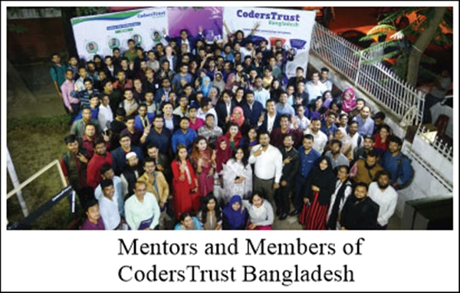

1.1 Introduction to the topic in hand
Customer Relationship Management (CRM) is the combination of practices, strategies, and technologies that companies use to manage and analyze customer interactions and data throughout the customer life cycle, with the aim of improving customer service relationships and help build customer loyalty and drive sales growth. CRM systems collect customer data through different channels or points of contact between the customer and the business, which may include commercial websites, direct mail, live chat, telephone, and network marketing. Social. CRM systems can also provide customer contact information with detailed information on customer personal information, purchase preferences, purchase history, and concerns.

In 1995, the term "customer relationship management" was coined and by 1999 e-CRM providers had already started training (CRM Software Blog). However, the meaning of CRM has changed a lot over the years. Eventually, CRM has become a term originally defined and designed to improve customer service. Today, it is related to a complete business strategy.

Additionally, CRM is the most effective way to create and maintain customer relationships. Managing relationships with thousands upon thousands of leads is not easy for any company, but like most things in today's society, there is technology to simplify the CRM process. Today, companies use CRM sales software to manage their customers and the individual relationships they have with each of them where CRM software acts as a single repository to consolidate sales, marketing, and customer service activities and streamline process, policy, and people on a single platform.

Apprehending all the benefits CRM software offers a company, the title of the report "Managing Customer Relationship: CRM practice of Coderstrust Bangladesh" was chosen because Coderstrust Bangladesh also uses CRM software called "Zoho CRM'', which is an online customer relationship management software that offers various benefits to Coderstrust Bangladesh such as a clear operational strategy, mobile workforce, effortless team collaboration, lower cost of customer analysis, longer product lead time, data-driven corporate culture, customer engagement Simple end-to-end sales process extreme and use automation to collect all the information in one place.

1.2 A brief introduction of the organization
Coderstrust is actively supported by the financial advancement "Danida", or the Danish Global Development Agency, to provide microfinance and instruction to students from developing countries who need to redesign their programming skills. It’s headquarter is located in Copenhagen, Denmark. The founders of Coderstrust are Ferdinand Kjærulff, Jan-Cayo Fiebig, Asser Smidt, and Morten Lund.

In Bangladesh, Coderstrust was established in November 2013, where it began its work in Bangladesh from March 2015, joining the Grameen Bank. It works particularly among the young generation, with the goal of connecting disadvantaged and marginalized people with school and the online job market, increasing opportunities for workers with higher incomes, and greater financial independence. Coderstrust is an institution run by highly educated and professional coaches who are highly capable of providing technical and social training to university students so that students can improve their skills and earn through independent online projects. Additionally, Coderstrust places a high priority on its students and consumers, the organization uses to maintain its relationship with its consumer through Zoho CRM software, which is very widespread among the other present CRM software.

1.3 Objectives of the Study

1.3.1 Broad Objectives
The broad objectives of the report are:
- To gain practical experience by performing job responsibilities and learning report writing methodologies.
- To achieve the Bachelor of Business Administration degree after the completion of internship program and the submission of the report.

1.3.2 Specific Objectives
The specific objectives of the report shows the core purposes for what the report is being prepared and analyzed on the title “Managing Customer Relationship: CRM practice of Coderstrust Bangladesh”.
- To analyze Coderstrust Bangladesh and its internal, external business environment.
- To analyze the Customer Relationship Management of Coderstrust Bangladesh.
- To analyse the Zoho CRM software used by Coderstrust Bangladesh.
- To suggest recommendations to improve the use of CRM at Coderstrust.

1.4 Rational of the study
The study rationale is a set of reasons or logical foundations that can explain to the reader why this study is necessary to contribute to their related research fields. Since the purpose of this report is to analyze Customer Relationship Management (CRM), it is important to understand the reasons for understanding CRM. It will help us talk about what to do next time we meet our customers. Customer relationship management software is a tool for organizing our contact information and managing relationships with existing and potential customers, current customer base, and other contacts.

As a marketing student, understanding and using CRM software can be helpful in many ways. CRM software is usually built around relationships. They will help us find all the contacts who work in the same company, as well as all the news related to the work of the company, and will show us the last person of the team who contacted them to introduce us. This will help us fully understand the contacts and know exactly what to talk about the next time we meet or send someone an email.

Furthermore, CRM software does not help to like and follow all the pages of our customers on Facebook and Twitter, since these networks are designed to build personal relationships. CRM is our best choice and our internal network can help us understand customers, customers, and our team.

1.5 Scope of the study
The scope of customer relationship management is invaluable to any organization, as it includes all the activities, technologies and strategies that an organization uses to manage interactions with existing and potential customers. The definition of customer relationship management is also its ambition: to develop and maintain mutually beneficial long-term relationships with strategically significant markets. The goal is to create long-term value for the customer and the company. Perceptions about the value of customer services, such as bonuses or exit barriers, which hinder the search for alternative sources of supply. Today's companies compete with multiple product offerings created and supplied by networks, alliances, and associations of all kinds. Customer loyalty is essential to the company's performance. This transition from the conventional approach to marketing rather than from the motivated relationship made possible by a series of changing commercial conditions. First of all, competition for the customer is becoming more intense. The geographic advantage of local and national suppliers is eroding when trade barriers are removed and geographic boundaries redefined through established and emerging trade blocs. As market access is increasingly less localized, the requirements of logistics management and distribution partnerships are becoming increasingly important. Next, the markets are becoming more fragmented. In the more developed economies, we have gone from mass marketing, always associated with the condition of demand that exceeds supply, through market segmentation, to individual marketing. This personalized marketing strategy is based on the assumption that customers will be more loyal and will speak more positively through word of mouth if the value propositions are customized to meet their particular, perhaps unique, needs. Additionally, customer’s demand are increasing as their expectations for a trustworthy product and after sales service are becoming gradually extreme. They are becoming much less tolerant of failures and comparing their experiences with the best expectations in their category. Modern CRM software is designed to meet all these conditions and can often help in more than these areas only.

1.6 Limitations of the study
The limitations of the study are the problems or difficulties that the study authors encountered while preparing the study. Limitations may vary according to different types of studies, the author usually presents his errors, because no study is perfectly perfect or does not capture all possible aspects. In this report, I faced several limitations in preparing the report. They are listed below:

- The report was created within three months of my internship program, so it was difficult to prepare such a large report in such a short time.
- The report is based solely on the Zoho CRM customer record because Coderstrust does not allow our customers to call or send emails to collect their feedback.
- Zoho CRM software is offered to several companies at the same time and different companies use CRM practice in different ways. Using Zoho CRM is also a complex task. Thus, it was difficult to explain all the ways to do sales CRM activities.
- Zoho CRM has the accuracy of features that help an organization to benefit. It was hard to focus on all the parts. Thus, for the most part, the report focuses on how CoderTrust Bangladesh maintains its sales relationship with its potential, existing, and existing customers.

Chapter Two
Methodology of the Study



2.1 Data Design
The research design refers to the general strategy that I have selected to assimilate the various modules of research in a rational and reasonable way, therefore it ensures the reader of the report that they will effectively address the research problem. Moreover, it includes several methodologies of the report such as a model for data collection, types, measurement, and analysis.

2.1.1 Data collection process: The information of this report are collected from various reasonable sources. Based on the sources of data, the data collection process can be separated into two broad parts. They are described below:

Primary Sources:
- From formal and informal interviews with the customer relationship manager of Coderstrust.
- From personal working experience of CRM software at Coderstrust.
- From several weekly and monthly marketing sales report, publications, and annual report of Coderstrust.

Secondary Sources:
    - From several marketing articles published on customer relationship management.
    - From online blogs of reputed writers.
    - From the website of Zoho CRM.

2.1.2 Types of data.
The report is prepared using qualitative data and images of sales CRM. Here, Qualitative data is defined as approximate and characteristic data. It arranges and shows all information mainly through discussing any idea. Qualitative information can be checked and recorded and is non-numeric in nature. This type of data is collected through observation methods, individual interviews, management of discussion groups, and similar methods. The data are also shown using image files to ease to learn about how the CRM software is helping the Coderstrust Bangladesh.

2.2 Analytical tools:
The report is prepared on Microsoft Word. As the report title is a discussion based topic and prepared with qualitative data, no other analytical tools are used while preparing the report.

2.5 Model Specification
The CRM practices of Coderstrust is similar to IDIC CRM model which was developed by Pepper and Rogers in 2004. According to the IDIC model, organizations should initiate four phases to establish a unique relationship with their customers. These four phases are described below:

The IDIC model was developed by Pepper and Rogers in 2004. According to the IDIC model, organizations should take four steps to establish a unique relationship with their customers:

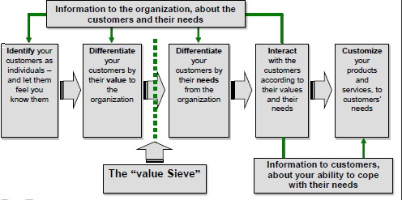

Identifying: The first phase of CRM starts with Identifying and exploring the customers of the organization.

Differentiating: At this phase, the organization separate the customers to identify which of them is more valuable and which offers more for the future. In addition, the difference allows companies to implement customer-specific strategies designed to meet the individual needs of their customers.

Interacting: Customers represent different levels of corporate value and their needs are very different from those of the company. According to Pepper and Rogers (2004), customer separation will involve a company in classifying its customers based on their values and needs. The organization should contact them to make sure companies understand customer expectations and their relationships with other suppliers or brands. Therefore, companies need to improve their interaction skills with their customers. Every continuous interaction with a customer must take place in the context of all previous interactions with that customer. However, the conversation with the customer should pick up where the customer leaves off. Effective customer interactions provide a better understanding of customer needs.

Customizing: at this stage, the product's offer is personalized and communicated to meet customer expectations. In fact, this organization must adopt an aspect of his behavior towards the organization's customers based on his needs and values. In order to engage a customer in a relationship, the company must adapt its behavior to meet the customer's expressed needs. This may involve extensive customization of a product or privatization of any aspect of its service.

Chapter Three
Organizational Background and Industry Perspective

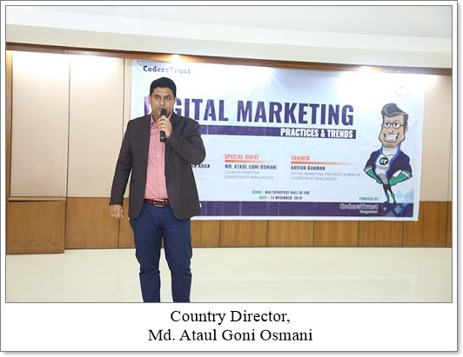

3.1 Coderstrust: Organizational Background
Coderstrust is a multinational corporation specializing in hybrid and income-generating online learning platforms, aimed at people who want to participate in multiple activities to improve their skills to work offline or make money online to work independently at home. Coderstrust Bangladesh aims to transform the social problems of access to education and youth unemployment into "investable opportunities".

CodersTrust was established by Mr. Aziz Ahmad, a global business leader. He is a Bangladeshi American. He dreams of bringing applied education to the public at an affordable cost so that people can overcome traditional professional challenges to ensure local the workforce adapts to global skill demands and helps them earn a living by learning modern digital skills. Together with the Danish military captain co-founder Ferdinand Kearwolf (Ferdinand Kearwolf), they started operations from Denmark in 2013 in the presence of Sir Richard Branson and Sir Morten Lund. Based on your own ideas and beliefs, everyone can obtain the development of IT skills. Coderstrust has set a goal to ensure that the local workforce meets global skills needs.

The headquartered of Coderstrust is in Copenhagen, Denmark. Its performance is maintained by the Danish International Development Agency, the United Nations Development Program, and a few venture capital funds around the world. Coderstrust began operations in Bangladesh in 2015 after being aware of the economic growth potential of outsourcing and developing countries. The Honorary Country Director of Coderstrust Bangladesh, Dhaka is Mr. Ataul Goni Osmani.

Currently, the institute has offices in 4 countries (Denmark, Bangladesh, the United States, and Kosovo), and 11 different countries in Europe and Asia (Bangladesh, Iraq, Jordan, Palestine, Malaysia, Bhutan, Kosovo, India, Poland) management project. , Honduras, and Kenya). In addition, Coderstrust is the only IT training center in Bangladesh that develops international skills. Coderstrust currently offers 11 courses in Dhaka, Bangladesh. The institute operates in four branches in Dhaka, They are:

In addition, Coderstrust is not only a technology company but has always been committed to improving the way people live and work in under-developed or developing countries. They see themselves as a collection of global creators and creators, architects and hackers, mentors and students. Coderstrust is the only international organization for the development of skills and its free professional training center is widely known in Dhaka, which transfers unskilled human resources to qualified independent professionals.

It works similarly to any IT Institute of the Bangladesh and its purpose is to:

- Help talented members to participate in the best free international career sites by providing the guides, support and solutions needed to increase online learning opportunities in Bangladesh.

- By providing training services and learning materials for the development of international skills, we will improve the lives of the people we deserve to achieve financial independence and thus improve economic skills.

3.1. Mission
Coderstrust's mission is listed below:
- To be the best professional consultancy organization.
- To be the only outsourced solution and support provider.
- To be the supplier of cutting-edge solutions for evolving a digitized nation.
- To be an efficient education/training provider to ensure quality and cost savings.
- To be a provider of training services for developing world-class skills
- To make paid education available and accessible on the Internet.
- Overcome the challenges of unemployment.

3.1.2 Vision
Equal opportunities for work and paid education are currently limited to people born in some developing and under-developed countries like Bangladesh, while millions of people in developing countries are denied access to education. Coderstrust believes in a company and national development with the motto "learn a skill, earn a living". As a skills development training center in Bangladesh, the institution believes that investing in the education of our young people is something that everyone will benefit from. The local and independent market will have more skilled workers, its students will increase their income and Coderstrust will earn money to expand the service to more people. Coderstrust's main visions are:

- To overcome the barriers of youth unemployment with a successful presence in the local job market and various independent websites such as Freelancer, Fiverr, Upwork, PeoplePerHour, etc. contributing online to earn money in Bangladesh by working on their own.

- To reduce obstacles and make available the outsourced education, training, and skills development for all ages and genders with high-income prospects for financial improvement.

3.1.3 Focus of the organizations
Coderstrust Bangladesh focuses on the independent training of Bangladeshi students. To ensure the reliability of its students and members and future demand for employment, Coderstrust focuses on the following criteria:

- How to start working independently;
- How to Freelance, Upwork, Fiverr;
- How to make money online in Bangladesh;
- How to get jobs at fiverr, freelancer, upwork;
- How can you be a freelance writer from Bangladesh;
- How to create an outsourcing profile as an Upwork freelance writer and get approval;
- How to create an outsourcing profile as an Upwork freelance writer and get approval;
- How to make oney from home working from home;
- How to get online outsourcing jobs in Bangladesh;
- What are the independent benefits courses;
- What are the best freelance sites;
- Resolution of requests on demand.

3.2 Product or service line
The courses of Coderstrust are listed below:

3.3 SOWT analysis of the organization
The SWOT analysis (strength, weakness, opportunity, and threat) is a structure used to evaluate a company's competitive position and formulate strategic plans. A SWOT analysis evaluates internal and external factors and current and future potential.

In addition, SWOT analysis aims to provide an accurate objectives, and data-based view of the strengths and weaknesses of the organization, its plans, or departments. Organizations must avoid preconceived beliefs or gray areas, and instead focus on the actual situation to maintain accurate analysis. Companies should use it as a guide, not as a recipe.

Before determining a new strategy, Coderstrust Bangladesh can use SWOT analysis to assess the current internal and external position of the organization.

3.3.1 Strengths of Coderstrust Bangladesh
Strength is the positive attributes or indicators and resources within the company that support successful results. The company's strengths are the tools used to resist threats and missed opportunities, so the overall importance is significant. To make a complete list of benefits, check out each functional area of ​​the organization, such as finance, manufacturing or operations, marketing, and human resources. The advantages are those characteristics of the business that can make them work more efficiently than the competition. The benefits of Coderstrust Bangladesh are listed below:

- As an international organization, Coderstrust Bangladesh enjoys an excellent reputation in other markets besides the training center in Bangladesh. It has a strong management team and people who can manage employees and customers well.

- Codertrust Bangladesh has a higher student success rate than other technical institutions in Bangladesh as the organization always guarantees quality and availability throughout the process of every stage of learning. Quality and availability have been sustained in several areas, such as highly qualified mentors, strong management team, strong student support system (e.g. student support group, talented ELMS, online student support 24/7, Facebook-based individual batch group, Success Stories group, blog, Facebook group), cooperation and collaboration with many local and global giants (United Nations Development Program (UNDP), Bank world, Robi Axiata, Rockefeller Foundation, Danida (Danish Ministry of Foreign Affairs, International Development Cooperation, etc.)).

- Codertrust Bangladesh offers a very powerful support system for students. These systems include ELMS Talents, 24/7 online student support, student support group, success story group, blog, Facebook-based personal batch processing group, Facebook group. Various support systems provide students with different types of services with no hidden costs. Plus, anyone can directly access Coderstrust Bangladesh at any time from an Internet desktop, but sometimes it's fun to spend time with classmates and freelancers. They collaborated with local universities, training centers, and even coffee shops to create a physical space where students can meet to study and earn money online.

- Bangladesh Coderstrust has considered highly qualified tutors for different courses (online and offline) based on various criteria. Bangladesh Coderstrust believes that various standards include: emergency work, technical knowledge and skills, a clear concept of each term in the field, professional experience and professional performance, consideration of teaching and training experience, professional performance and personal autonomy. Acquisitive, understanding of the knowledge of different angels, understanding of students' skills at all levels, maintaining minimal academic training, knowledge, and skills in a specific field, practical knowledge and long-term skills, industry professionals are certified according to global standards and act punctually with staff and students.

- Coderstrust is more than a technology company. Coderstrust is about people making life better and changing the way people work. It is a collective of mentors and analyzers, builders, and students from over 22 countries around the world. They help people help themselves by giving them the opportunity to financially improve their lives through education.

- Coderstrust Bangladesh is an institution registered and approved by the Bangladesh Technical Education Board (BTEB), the technical education wing of the Bangladeshi government under the Ministry of Education.

3.3.2 Weaknesses of Coderstrust Bangladesh
A business weakness is a resource or process that your business does not have but which must be successful. Weaknesses limit your company's ability to reach its full potential. The weakness lies in the internal attributes and resources of a business working against a positive outcome. The weaknesses of Coderstrust Bangladesh is listed below:

- The main weakness of Coderstrust Bangladesh is its high staff turnover rate, as the company mainly hires many entry-level employees who do not intend to stay in their jobs for long. Some of your employees may stay with your company for the long term and some may take up managerial positions. Others may enjoy working as a long-term source of additional income or as a low-stress retirement job.

- The second biggest weakness of Coderstrust Bangladesh is the high dropout rate of students due to boredom, financial or family issues, school workload, etc.

- Coderstrust Bangladesh does not promote any online service. They are not very active in digital marketing through social media and other platforms like Google Ads etc. They can promote their current and future online courses and services to students and demonstrate the benefits of taking the course and using the online services.

- There are limits to taking multiple courses for students. Students must have the necessary knowledge to take the courses. Some prerequisite courses are mandatory. The programming language is what students need to know in common to take a course on CodersTrust.

- All Coderstrust Bangladesh branches are located in Dhaka, Bangladesh. Therefore, it is difficult for rural students to come to the city leaving their parents and their studies to join the organization.

3.3.3 Opportunities of Coderstrust Bangladesh
A business opportunity that surrounds the sale or rent of any product, service, or equipment will allow the licensed buyer to start a business. A business opportunity is, to put it simply, a commercial investment in packages that allows the buyer to start a business. The opportunities for CoderTrust Bangladesh are listed below:

- Currently, Coderstrust Bangladesh offers basic and intermediate courses in IT and business to test the general abilities of the people of this country. The institution may offer a higher or advanced course level as well as an advanced course at the current level. The company has the skills to develop this opportunity as it is a global chain business.

- Many students are unavailable on campus due to regional and other factors. For them, Coderstrust Bangladesh can enhance the training system so that everyone can benefit from it. The off-campus training system is rare in Bangladesh. So this is a great opportunity to spread your business with unique character.

- Codertrust Bangladesh will soon launch its various branches across the country. They have the opportunity to serve their customers across the country. This service is not available to other online course providers. So this is a great opportunity for this organization to provide services on campus.

- Coderstrust Bangladesh is a place where students can develop their careers with great career opportunities. Often a number of professional project Coderstrusts come to Bangladesh and students have the opportunity to manage it with appropriate regulations. Students gain relevant experience in the workplace through this opportunity.

3.3.4 Threats of Coderstrust Bangladesh
Threats are external (external to the company) element that can affect a company's performance and compromise the entity's success. The most noticeable effect would be a decline in corporate sales. Often a company faces several threats in addition to the competition when handling different problems. This reduces market opportunities or leads to lower profits. Potential threats to Coderstrust Bangladesh are listed below:

- The number of training institutions in Bangladesh is increasing day by day. Many of them are privatized or nationalized. Therefore, Coderstrust Bangladesh is likely to have high pressure which could reduce profits in the days ahead.

- Codertrust Bangladesh is receiving unwanted reviews from some of its students and students from other training institutions in Bangladesh which could have a strong negative impact on the growth of the organization.

- There is no respite from Bangladesh's economic condition. However, it is slowly increasing. The economic status of the expected public of Coderstrust is low. For this reason, there is an opportunity for the public to switch from Coderstrust Bangladesh to different brands. The company is already working on that problem and will hopefully be able to solve it soon

- Every international organization affiliated with the government must respect the rules established by the government. If there is any change in these rules, it will have a negative effect on the organization. Suppose the government imposes additional VAT on Codertrust Bangladesh. So it will be very difficult for Codertrust to match this amount because the socio-economic condition of Bangladeshi students is not good.

Chapter Four
Findings and Analysis

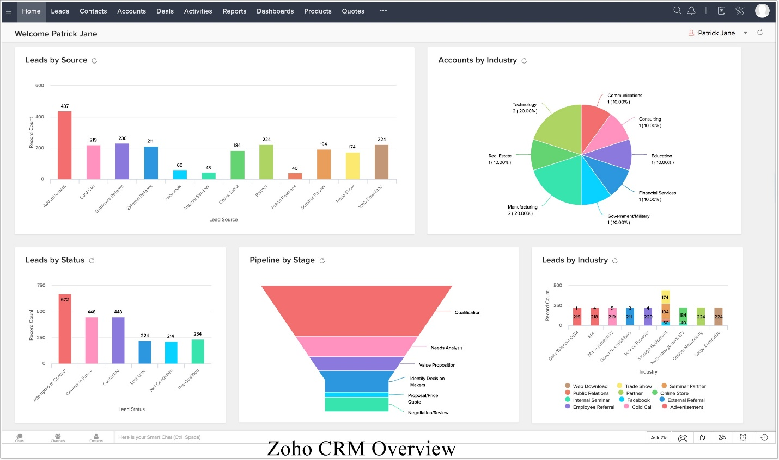

4.1 Concepts of CRM
Customer Relationship Management (CRM) is a combination of strategies, practices, and technologies used by companies to manage and analyze customer interactions and data throughout the customer life cycle, with the goal of improving relationships. Provide customer service and assistance to retain customers and promote sales growth. The CRM system collects customer data through different channels or points of contact between the customer and the company, which may include websites, phone calls, real-time chats, direct mail, marketing materials, and social media. The CRM system can also provide customer support staff with detailed information about the customer's personal information, purchase history, preferences, and purchase issues.

4.1.1 CRM Software
Customer relationship management (CRM) software refers to any technical solution that can help a company manage communication with current and potential customers. Some examples of leaders in the CRM software industry include Zoho, Salesforce, and HubSpot CRM.

Organizations use CRM solutions for a variety of reasons. However, initially, the CRM industry was mainly geared towards sales and public relations professionals, and it provided a convenient way to store information and track customer communications. Today, CRM solutions cover multiple areas of enterprise customer relationship management, marketing, analysis, communication and even light project management. Some CRM systems also have built-in chatbots and call functions, so sales representatives can communicate with customers directly from the system.

Even small businesses can afford powerful CRM software. This is due in large part to the proliferation of affordable SaaS solutions that provide many features without the hype (or solicitation) of large software deployment projects. People have a headache). Multi-layered pricing structure and a lot of competition mean that SMEs can choose easy-to-use CRM to simplify the customer relationship management process.

4.2 CRM practices of Coderstrust Bangladesh
The practice of customer relationship management is an essential part of any organization to establish itself. CRM exercises can help any employer maintain close contact with target customers, simplify strategies, and increase profitability. CRM is a powerful response method that can continue to maintain your position in the current market. Coderstrust Bangladesh also continued its CRM practice to attract former clients and retain former students. Primary responsibility for collecting various student documents from the worksheet and updating their data in ZOHO CRM. The following steps are followed to put data into Zoho CRM.

- Gather basic information from Facebook clients and websites, such as their name, phone number, and email address.
- The data puts into ZOHO CRM.
- Update student information appropriately
- Check the data to get duplicate data.
- If the data is not repeated, a green check mark is placed in the student worksheet file.
- If duplicate data are found, correct it properly.

After getting all the information correctly, the business developer will notify the sales manager. When the department manager verifies all customer data, he is authorized to work with these customers. After that, the responsibility of the business developer is:

- At first, contact these customers by calling registered customers on the site and the Facebook page.
- Greet them appropriately and ask if they are still interested in taking this course, so sign up.
- If the comments are negative, they will list them as uninteresting students in CRM and receive positive comments instead of asking about their training.
- After we have understood the students' training, ask them if they are appropriate for our courses, as most courses require specific background knowledge.
- The business developers inform them of detailed information about the course, then, if these clients show little interest in us, we present them the CodresTrust success stories and we try to give them courage.
- The developers asked them if they were interested in coming to our office so that we could present the course and the company to them in a proper way. Then they made an appointment with them and told them to come to the Coderstrust Bangladesh office.
- If they don't want to come to our office, they'll give them the right advice.
- Then they are presented at our online and offline course fees.
- Finally, they have a few days to reflect and tell them that I will call them back to understand their decision.

Whenever students come to our office, we will provide them with the appropriate consultation and let them know about past students' success stories and how they work in the freelance market. Some students say they have had financial problems and cannot pay the full entrance fee all at once. They offer the possibility of paying the registration fee in two installments, the first period before the start of the category and the last one month later. After that, students filled out the online admission form along with their personal enrollment form to fill in all their details by reference. After completing all the documents and procedures, put your statistical information on the list of winning offers and update them on the CRM, and provide them with an admission form to fill out, make a cash receipt, collect the fee admission and provide a receipt. In the final phase, places are reserved for newly enrolled students.

4.2 Use of sales CRM Software to improve customer relationship

4.2.1 Extensions of the Zoho market
Very few affordable SaaS CRMs offer many extensions and integrations, unlike Zoho. Zoho Marketplace strengthens the functionality of Zoho CRM by allowing Coderstrust Bangladesh to add free and paid extensions, many of which require no technical skills to implement. With extensions covering categories like IT and administration, finance, data analysis, productivity and marketing, Coderstrust Bangladesh can effectively create your own custom CRM.

4.2.2 Artificial intelligence
Zoho CRM is one of the few SME-centric SaaS CRMs that offer artificial intelligence technology functionality. Zia, Zoho's assistant owner of AI, offers, according to the company, "predictions about trends, anomalies, conversions, and closing deals". At an advanced level or the final subscription plan, Zia provides information on the best time to contact customers, sets automatic reminders for Coderstrust Bangladesh and analyzes the tone of customer emails to report the best answers.

4.2.3 Telephony
To simplify call dialing and automatic call recording, Zoho offers one-click dialing directly from CRM. Once Coderstrust Bangladesh has integrated telephony, every time a user views a contact card, he has the option to click to call. The telephony feature also has integrated reminders so that Coderstrust Bangladesh can set future reminders and automatic call recording simplifies viewing customer information and chat history. Call analysis and reporting complement Zoho's telephony functionality by providing a valuable display of customer feedback and customer service data.

4.2.4 Documentation
It is not a specific feature of CRM, but Zoho's online documentation is so complete, specific, organized, and easy to follow that it qualifies as a special function. Detailed guides on how to download extensions, webinars, e-books, administration and user guides, integration guides, and an active online user community make it easy to find answers at Coderstrust technical and organizational issues.

4.2.5 Collaboration tools
Zoho CRM comes with ideal collaboration tools for small teams. The integrated document management system stores music, images, documents, and videos. Access privileges make it easy to lock confidential documents and share certain items with certain team members. The calendar function is also excellent for collaboration; groups can share calendars and individuals can keep their address in CRM.

4.2.6 Portals for customers and suppliers.
Zoho CRM customer portals allow Coderstrust Bangladesh to communicate with its most valuable customers in a new way. Coderstrust Bangladesh customers, who need access to customer portals, can do things like browse product and service catalogs, view invoices, and order without contacting a seller directly. Likewise, provider portals allow the most trusted providers to communicate with Coderstrust Bangladesh directly in CRM, as well as view invoices and transactions.

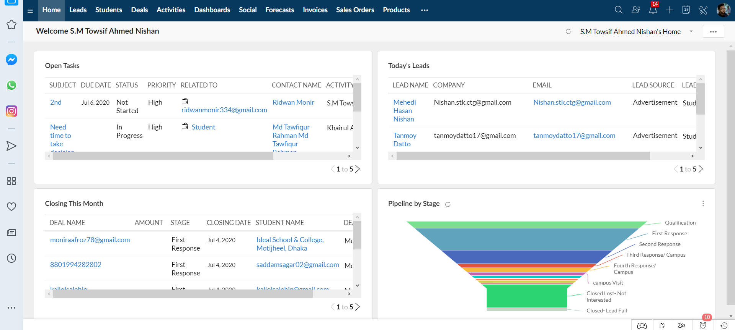

4.2.7 Price book
A price book is an agreed price for the sale of products to customers. Depending on the conditions agreed, the prices may also differ according to the customers. You can display the unit price as the manufacturer-determined price for the product and the list price as the asking price in the price table. In addition, discount ranges can be defined.

4.2.8 Campaign
Zoho CRM provides a platform to organize and record the total cost of marketing activities. It allows you to mark different stages, correlate all activities, all events, import target contacts, and calls related to the Codertrust campaign. In addition, it provides a detailed view of all the marketing activities in which a single customer is involved.
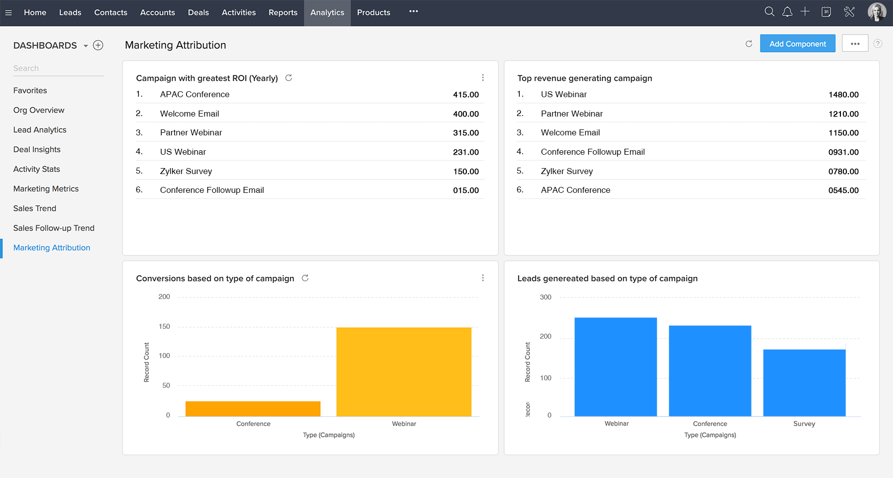

4.2.9 Agreements/Transactions
Deals/Agreements/Transactons are commercial agreements with individuals (B2C) or with organizations (B2B) that generate real revenue for Coderstrust. Go through different stages of selling, such as analyzing demand, qualification, lead, value proposition, etc., before facing a real deal, loss, or win. Leads that Show Interest in Programmers Trust activities can translate directly into opportunities that represent leads.
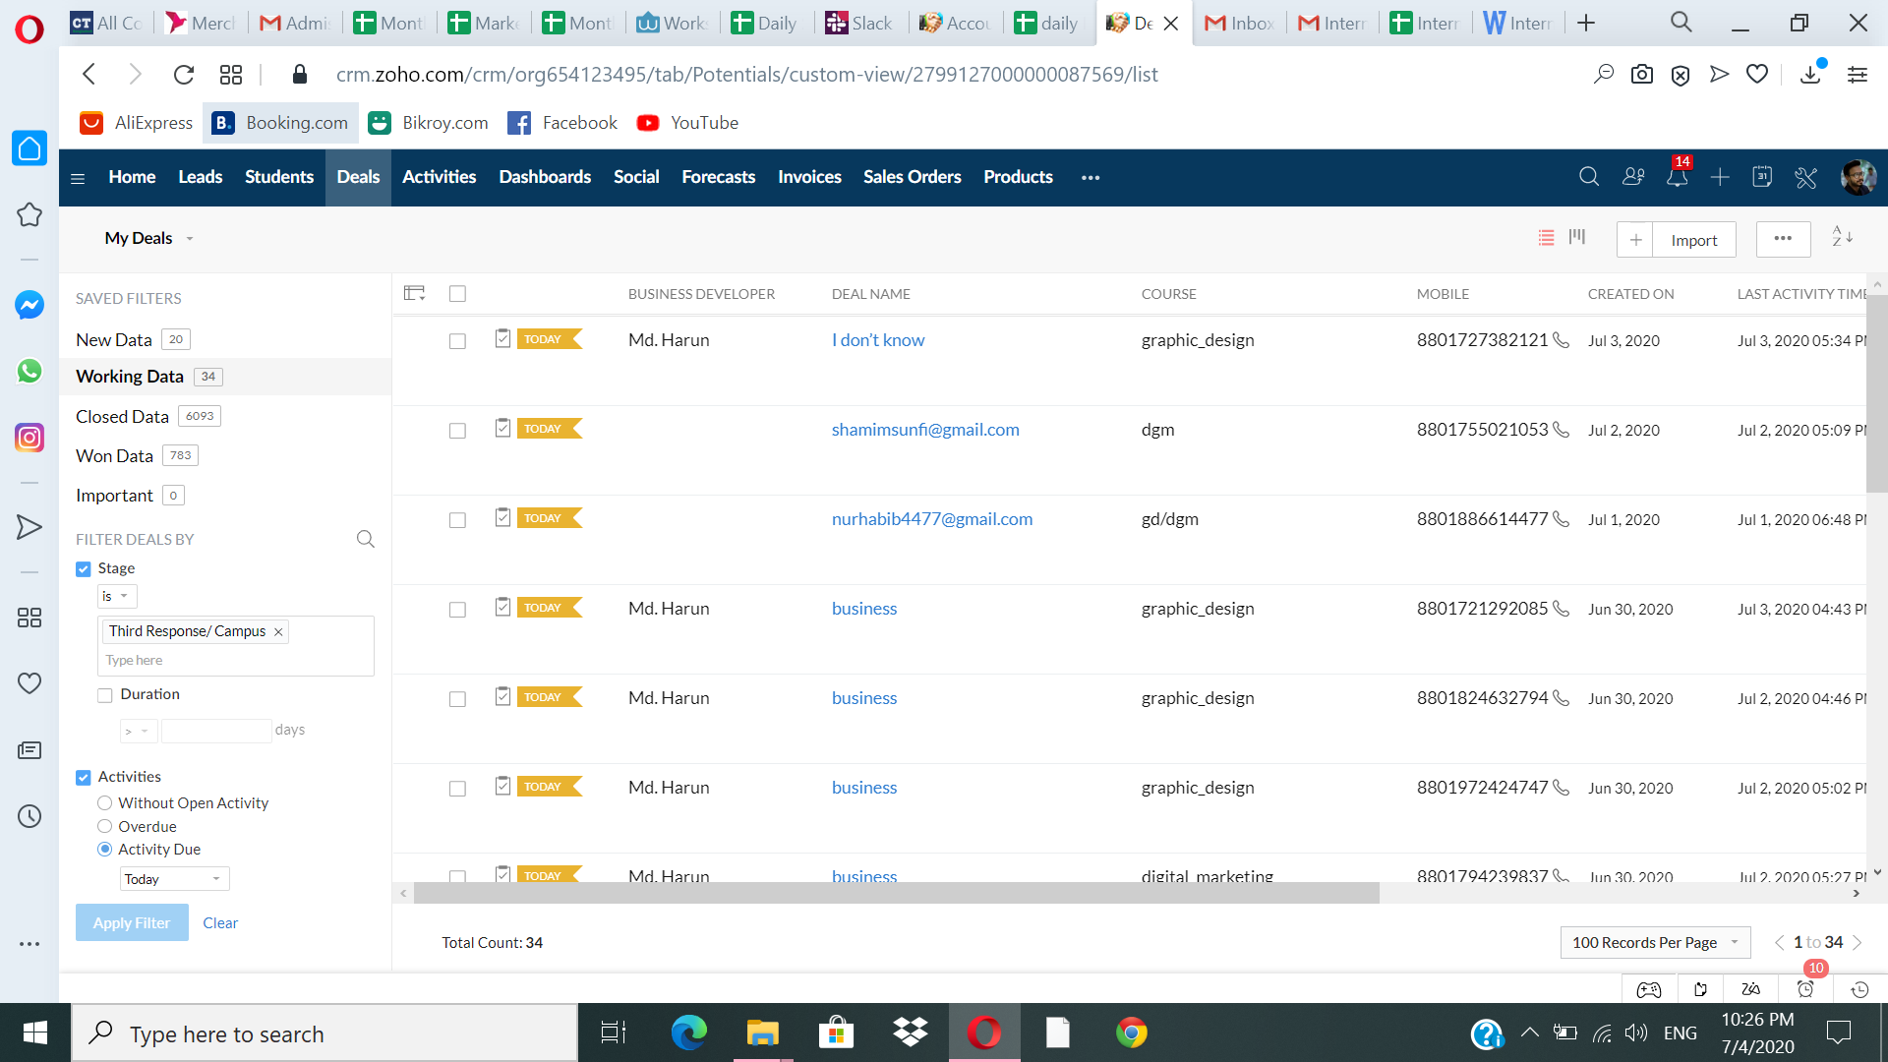

4.2.10 Possible prospects
The prospect or potential customer list helps create sales opportunities for CodersTrust. This is approximate information about individuals or representatives of organizations collected at trade shows, seminars, advertisements, and other marketing activities. Leaders will be followed by sales reps, and when eligible, they will become Contacts, Customers, and Deals (Opportunities) in Zoho CRM.

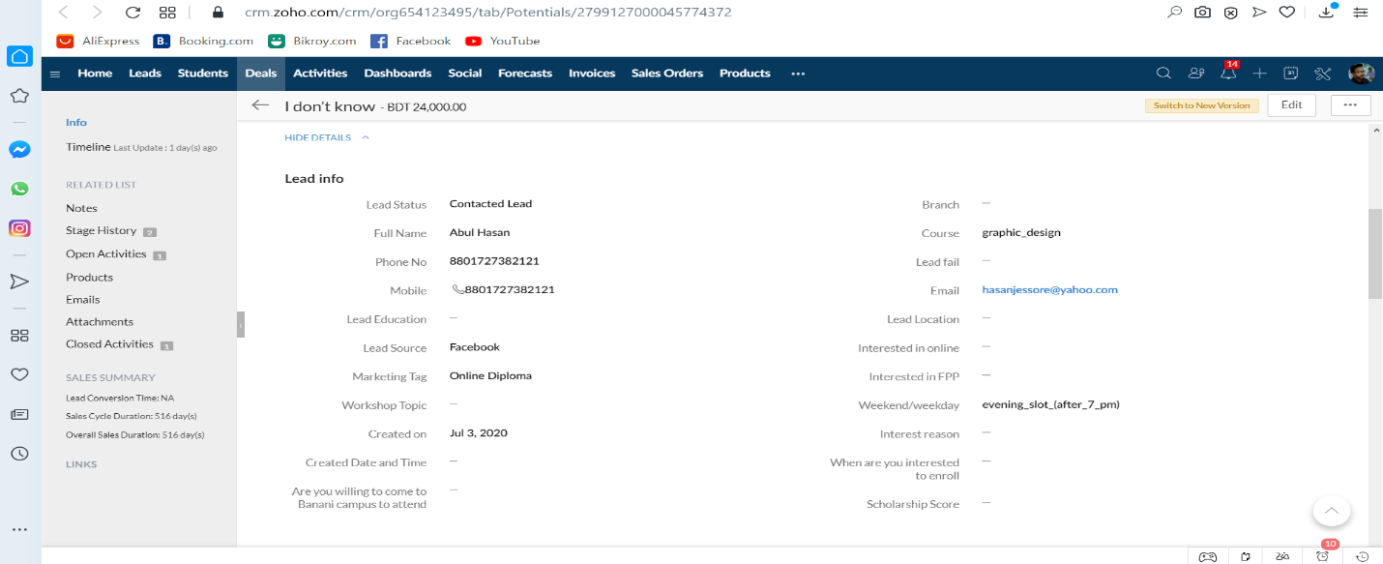

4.2.11Supplier Information
Suppliers are companies, individuals, or contractors whom the Coders Trust trusts with products and services. Supplier details stored in Zoho CRM can provide sellers or suppliers with better visibility for future product purchases.

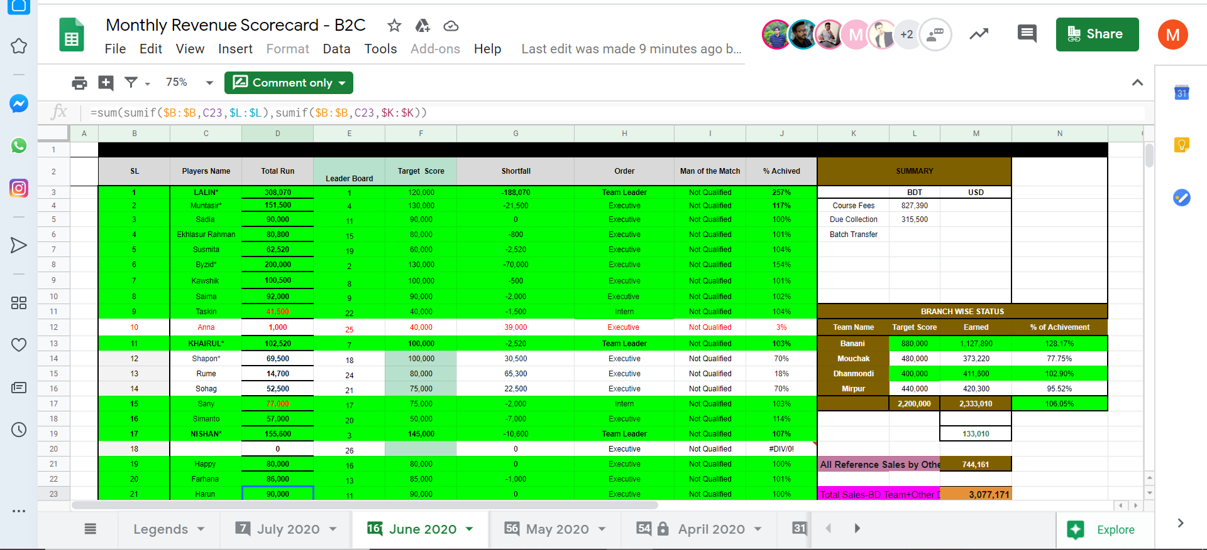

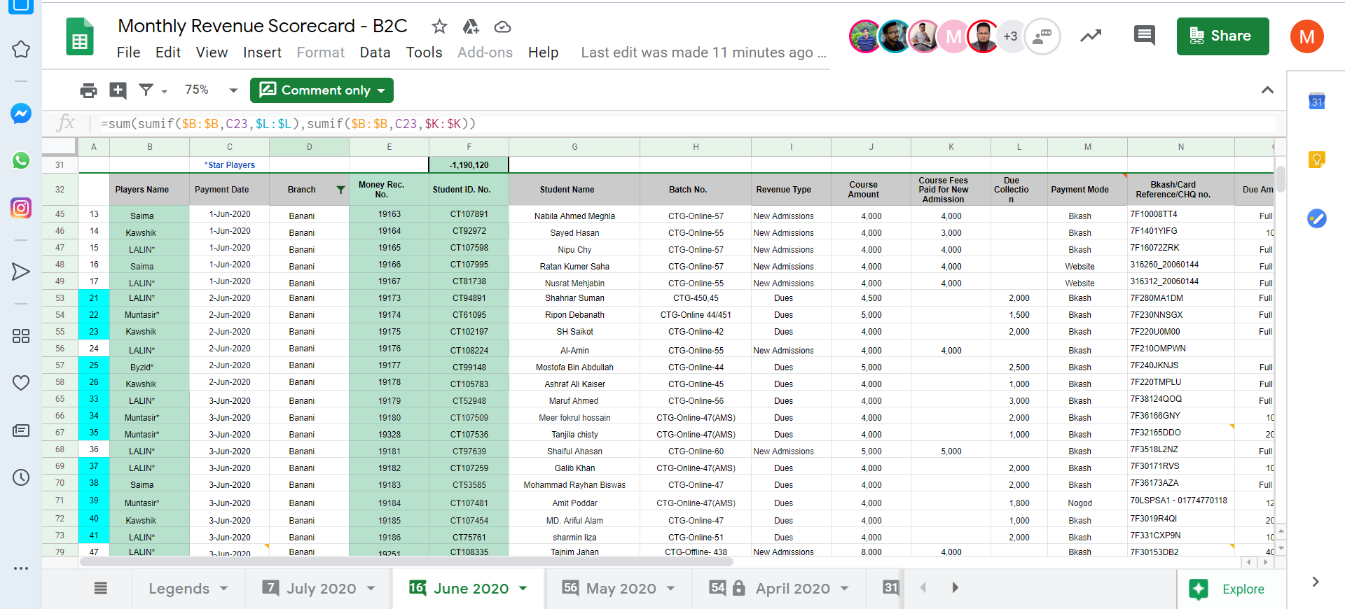

Chapter Five
Conclusion and Recommendations



5.1 Recommendations
After analyzing the customer relationship: CRM practice of Coderstrust Bangladesh, we have seen that the company using Zoho CRM, an online sales CRM software that manages the sales, marketing, and support on a single CRM platform. By using the online CRM software. Coderstrust Bangladesh is being benefitted to record possible prospect students, managing and recording current student’s details, agreements and transactions, save suppliers and mentors information, can promote campaign and portal to customers and so on. The following are some suggestions to improve the utilization of Zoho CRM software to get the maximum outcome from the online platform and to improve the Coderstrust Bangladesh’s current market position.

- Since Zoho CRM is a free online platform that involves all parts of an organization, top management must not only participate but also inspire and build credibility among others. Senior management drives the views and culture of the organization, which is why their early participation sends a positive ripple effect on the entire organization. So Coderstrust should have their leaders on board!

- In terms of skills and knowledge, employees are all different from each other. Some people want to try a crisp new system and start using it right away. Others are more skeptical about the new way of working. The CRM project manager must have strategies on how to handle both types. Something that both enthusiasts and skeptics sound like is that everyone needs training. Coderstrust Bangladesh can choose a provider's classroom type training, or they can assign a supervisor for the training. The organization should also include an introduction to its CRM system in the process of recruiting new employees. In this way, new staff will learn to use CRM from the beginning.

- To use Zoho CRM successfully, Coderstrust Bangladesh needs to define how its work processes and customer needs will evolve, the steps to be taken at each stage of the implementation, what the organization wants to achieve and how it will measure the organizational objectives, and how the CRM will complement the business development plan. To make CRM a philosophy, Coderstrust Bangladesh must change its whole way of thinking. Adopting a CRM system like Zoho CRM means they decide to make developing and maintaining a strong relationship with customers their number one priority. In other words, they must consciously engage in a customer-centric business model.

- Coderstrust Bangladesh should grab all the opportunities listed in the SWOT analysis such as expansion of branches all over the country, offering new innovative courses, promoting courses aggressively on social media platform can result in a great positive impact for the company.

- Coderstrust Bangladesh must follow customer behavior throughout the sales cycle. Before the sales call, collect the lead data on social media and identify the types of information they share through the channels. So after the sales call, sales representatives need to know what content resonates the most, how where customers click, what mobile devices they use to find content, what content they interact with, for how long, how often, who they share this content with, etc. Once the organization has this level of information, it will not only understand the current needs of its customers but will also be able to anticipate future needs, refine its contents accordingly, and confidently plan for others approach.

5.2 Conclusion
The objective of preparing the internship report is to analyze the sales CRM methodology of Coderstrust Bangladesh. Coderstrust Bangladesh was found to be using Zoho CRM software, which is online sales CRM software that manages sales, marketing and support on a single CRM platform. It supports sales management, offers useful information, integrates with social networks and facilitates team communication. Zoho CRM software is a cloud-based CRM system that offers complete mobility and access to a tailored application ecosystem. In addition, the study also includes the organizational profile of Coderstrust Bangladesh Limited and the SWOT analysis of the organization. SWOT analysis describes that being an international organization and the first training institute in Bangladesh, Coderstrust Bangladesh enjoys a good reputation among competitors, having no branches outside Dhaka city is the weakest point, and opportunities can be exploited by expanding branches all over the country, by offering innovative new courses, aggressively promotes courses on the social media platform, and finally, possible external threats for Coderstrust Bangladesh may be the increasing number of training centers across the country and unstable government decisions. However, to improve Coderstrust's sales CRM activities, several suggestions are recommended in the report.

Appendix

References

(1) Company overview. Retrieved 21 June 2020, from https://Coderstrustbd.com/about-Coderstrust Bangladesh/

(2) Services of the company. Retrieved 21 June 2020, from https://coderstrustbd.com/all-courses/

(3) Richard Culatta, 2019. 3 p's of Service Marketing. Retrieved from https://www.instructionaldesign.org/models/addie/

(4) Bhim Chimoriya, 2015. 3 p's of Service Marketing. Retrieved from https://www.wisenepali.com/2015/03/3-ps-of-service-marketing.html

(5) Bardicchia, Marco, 2020. Digital CRM: Strategies and Emerging Trends: Building Customer Relationship in the Digital Era. p. 12.

(6) Reinartz, Werner; Krafft, Manfred; Hoyer, Wayne D., 2004. "The Customer Relationship Management Process: Its Measurement and Impact on Performance". Journal of Marketing Research. 41 (3): 293–305.

(7) "CRM History: The Evolution of Better Customer Service". Www.streetdirectory.com. Retrieved 24 May 2020.

(8) Buttle, Francis; Maklan, Stan, 2015. Customer Relationship Management: Concepts and Technologies.

(9) Zeng, Yun E; Wen, H. Joseph; Yen, David C, 2003. "Customer relationship management (CRM) in business‐to‐business (B2B) e‐commerce full". Information Management & Computer Security. 11 (1): 39–44.

(10) Prasongsukarn, Kriengsin, 2006. "Customer relationship management from theory to practice: Implementation steps". Inspire Research Company.

(11) Mohammad Hossein, N., & Zakaria, N. H., 2012. Customer relationship management Benefits for Customers: Literature Review (2005-2012).

