A Study on Sensei-Wisdom: An award-winning Global Management Consultancy Organization

Supervised by:
Dr. Mohammad Shariful Alam
Associate Professor
School of Business & Economics
United International University

Submitted by:
Redoan Ahamed
111 141 294
BBA, (Marketing)

Date of Submission: July 14, 2019

United International University



A Study on Sensei-Wisdom:
An award-winning Global Management Consultancy Organization

Letter of Acknowledgement

First of all, I am expressing my sincere gratefulness to Almighty Allah for enabling me to prepare this internship report. The success of this internship report depends on the contribution of number of people especially to Mr. Kamrul Hasan, Managing Director of Sensei-Wisdom, Mr. Shafial Ferdous, Manager, Human Resource, Mr. Rashed Un Nabi, Executive, Marketing & Operation support who gave me the opportunity to discuss the matter, shared their thoughtful suggestion and allowed me to know the work and workplace better and understand the work and work processes and complete this internship report.

I would like to give my heartiest gratitude to Dr. Mohammad Shariful Alam, Associate Professor, Marketing, and School of Business & Economics at United International University for giving me an opportunity to prepare this internship report on the study on Sensei-Wisdom: An award-winning Global Management Consultancy Organization.

Finally, I would like to add few more words saying that, this report is prepared by a novice student. There could be unwilling errors and omission which are extremely belonging to me.

Certificate of Approval

This is to certify that Redoan Ahamed, bearing ID NO. 111 141 294, student of BBA major in Marketing, United International University has completed his Internship Report on the topic “A Study on Sensei-Wisdom: An award-winning Global Management Consultancy Organization”.

-----------------------

Supervisor
Dr. Mohammad Shariful Alam
Associate Professor
School of Business & Economics
United International University
Letter of Transmittal

July 14, 2019
Supervisor
Dr. Mohammad Shariful Alam
Associate Professor
School of Business & Economics
United International University

Subject: Submission of Internship Report entitled as “A Study on Sensei-Wisdom: An award-winning Global Management Consultancy Organization”.

Dear Sir,
With due respect, I would like to inform you that, it was a great pleasure for me to submit the report on “A Study on Sensei-Wisdom: An award-winning Global Management Consultancy Organization” as my internship report. While conducting the internship, I have gathered a lot of information about Sensei-Wisdom and its work procedure in corporate sectors of various departments especially its Corporate Relationship Management department. And thus prepared my internship report reflecting my learning in this whole internship period.

Therefore, I strongly believe that, this internship report will be able to meet your approval. I would genuinely appreciate to make further corrections where it seems necessary by you.

Sincerely yours,
Redoan Ahamed
111 141 294
BBA, (Marketing)
School of Business & Economics
United International University

Table of Content
Contents
Executive Summary viii
Subject Keywords ix
1. Introduction 2
1.1 Objectives of the Study 2
1.1.1 Broad Objectives: 2
1.1.2 Specific Objectives: 2
1.2 Rational of the Study 2
1.3 Scope of the Study 3
1.4 Limitation of the Study 3
2. Methodology of the Study 6
2.1 Data Collection: 6
2.2 Data Processing: 6
3. Organizational Background and Industry Perspective 8
3.1 Industry scenario and contribution in economy: 8
3.2 Background of Sensei-Wisdom: 8
3.3 Historical background of the organization - Vision, mission, management and focus of the organization. 9
3.3.1 Vision 9
3.3.2 Mission 9
3.3.3 Values 9
3.4 Services of Sensei-Wisdom 10
3.4.1 Mastery of Self through Neuro-Linguistic Programming (NLP) 10
3.4.2 Sales Excellence through Neuro-Linguistic Programming 11
3.4.3 Mindfulness based Coaching and Mentoring 12
3.4.4 Team Leadership Excellence 13
3.4.5 Corporate culture and performance assessments 13
3.4.6 Marketing and Branding 13
3.4.7 Customer Care 14
3.4.8 Sales & Negotiating Skills 14
3.4.9 Human Performance index [HPI] Facilitations 14
3.4.10 Continuous Improvement 14
3.5 Sensei-Wisdom Partners 15
3.6 Neuro-Linguistic Programming (NLP) 16
3.6.1 Physiology 16
3.6.2 Pink Elephant 17
3.6.3 Questions are the Answers 17
3.6.4 80/20 Rule 18
3.6.5 90/10 Rule 18
3.6.6 Life Timeline 18
3.7 SWOT Analysis 19
3.7.1 Strength: 19
3.7.2 Weakness: 19
3.7.3 Opportunity: 20
3.7.4 Threat: 20
3.8 Top Management Consultant and Coach 20
3.1.1 Ranjan De Silva – CEO Success Coach and Team Leadership Specialist 21
3.1.2 Kamrul Hasan – Country Director (Bangladesh), Management Consultant 22
3.1.3 Thanziza Samsudeen – Director & Senior Management Consultant 23
3.2 Competitors: 24
3.2.1 Mind Mapper Bangladesh 24
3.2.2 Bangladesh Organization for Learning and Development (BOLD) 26
3.2.3 BSHRM – Bangladesh Society for Human Resources Management 27
3.2.4 BSAHRP – Bangladesh Society for Apparel HR Professionals 29
3.2.5 Federation of Bangladesh Human Resource Organizations (FBHRO) 31
3.3 Marketing Practices of Sensei-Wisdom: 32
3.3.1 Email Marketing: 32
3.3.2 Search Engine Optimization (SEO): 32
3.3.3 Testimonial Marketing: 32
3.3.4 Social Media Marketing: 32
3.3.5 Video Marketing: 33
3.3.6 Bundle Offer: 33
3.3.7 Live Video: 33
3.3.8 Bestselling Free Book: 33
4. Findings and Analysis 35
5. Conclusion and Recommendation 38
5.1 Recommendation: 38
5.2 Conclusion: 38
6. References and Website Links 41

Executive Summary
This report gives an exposure of my experience during the internship period with Sensei-Wisdom. The topic of the report for the internship was selected by the organization. The name of the topic is “A Study on Sensei-Wisdom: An award-winning Global Management Consultancy Organization.” From the beginning, I had the passion to work in the training industry and become an international trainer. When I got the opportunity to join in the internship program in Sensei-Wisdom I took the opportunity. In Bangladesh, there are a few organizations who work in management consultancy sectors and Sensei-Wisdom get the first-mover advantage. It's a growing industry and Sensei-Wisdom started operating their journey from 2017.

The report illustrates the experience gathered in the organization to provide an overall exposure regarding management consultancy organization. The biggest challenge I faced was to collect information, and as I worked in the corporate relationship management department, my responsibility was to sell training programs to the individuals and organizations.

The report is divided into five parts. The first part covers the objective and background of the report and limitations. The second part covers the methodology of the study. In the third chapter of the report background of the organization, SWOT analysis of Sensei-Wisdom has been demonstrated. The fourth section illustrates the findings and analysis of Sensei-Wisdom. The final section covers the recommendations and the conclusion.

Subject Keywords
- Corporate Relationship Management
- Neuro-Linguistic Programming (NLP)
- Mindfulness Coaching and Mentoring
- Physiology
- Pink Elephant
- Questions are the answers
- Aha moment
- 80/20 Rule
- 90/10 Rule
- Digital Marketing
- E-mail Marketing
- Search Engine Optimization Marketing

Chapter-1

Introduction
Sensei-Wisdom is playing a vital role in the management consulting industry in Bangladesh. They started their journey in Bangladesh in 2017. From the very beginning, they are leading the market and as they have a Global reputation with Top Management Consultants they get huge exposure both in the National and Multinational organizations. Sensei-Wisdoms' mother organization Sensei International was awarded for its outstanding performance and excellent contribution to human development. In Bangladesh, Sensei-Wisdom has a great reputation and most organizations' employees were trained by the Sensei-Wisdom's consultants.

Objectives of the Study

Broad Objectives:
The broad objectives of the study are-
- To achieve the prerequisite for the accomplishment of the BBA program
- To develop an understanding of the practical consulting organization’s activities and to relate them with the theoretical knowledge acquired from the consulting industries

Specific Objectives:
Here is the specific objective of the study-
- To know the marketing activities of Sensei-Wisdom
- To identify the strengths and weakness of Sensei-Wisdom
- Identifying how is it different from others
- Ways to implicate the findings to this specific problem

Rational of the Study
With the rapid growing competition among management consulting, training & development companies as to how the management consulting companies operate their marketing and how they sale their products and services to their clients, and how client relationship can be maintained more attractive, the expectation of the client has immensely increased.

Management consulting companies are trying to elevate their traditional service to a better standard, to meet the challenging needs, demands. Besides, now they have concentrated their attention towards diversification of their products for better performances and existence. For the above circumstances, it has become necessary for Sensei-Wisdom to focus its attention towards the improvement of the marketing and focus more on its clients.

While doing the report, it was a great opportunity to have overall information of the marketing departmental work practice by Sensei-Wisdom. The MD, Managers, Executives and some valuable clients have given information to make this report. That’s why it is quite justified to make an in-depth study about its operation and evaluate the service provided by this management consulting and scope for its improvement.

Scope of the Study
In this report, I have shown the activities of a management consulting organization. For educational purpose, each student needs to work in an organization as an intern to improve the knowledge, skill and experience. After finishing the internship, an internship report should be ready on the knowledge of internship. For the accomplishment of this internship program, I have employed in the management consulting organization named “Sensei-Wisdom”. I fixed to work on the Corporate Relationship Management department of this organization. I tried to figure out marketing activities and how to attract the customers. I also learn about corporate relationship and what they do to maintain their brand image. Here, I have exercised some structures and individual experiences over management consulting organization such as Sensei-Wisdom.

Limitation of the Study
Due to the confidentiality agreement of the company, it was not possible to share many confidential things. Besides, there was a limited time for the completion of this report. Though Sensei-Wisdom is a multinational corporation and previously run by the Chairman Ranjan De Silva later on in 2017 the Managing Director Kamrul Hasan started its operation in Bangladesh, there is a limitation of information.
Besides that, the website isn’t updated that’s why I couldn’t manage to collect all the information. Then, the top-level management stays most of the time outside of Bangladesh so it was tough to know more about the organization. I tried my level best and as they communicate directly to their clients, customers, and stakeholders, there was little opportunity to collect the insights and data.

Chapter-2

Methodology of the Study

Data Collection:
The study was conducted on the employees of Sensei-Wisdom in Bangladesh. Both primary and secondary data have been used for conducting the research. There are several methods of collecting the primary data, they are as follows:
- Relevant documents study as provided by the officers concerned
- Face to face conversation with the employees
- One to One conversation with the organization’s Chairman and Managing Director
- Conversation with the participants about their experience after the training programs
Secondary data was collected in several ways; they are-
- Written testimonial from the clients
- Video testimonial from the participants who attended the previous training programs, sessions or seminars.
- It’s mother organization Sensei International’s website.
- Chairman and Managing Director’s official websites.

Data Processing:
I used Microsoft Word software and Google Form to collect the data from the employees and analyze them.

Chapter-3

Organizational Background and Industry Perspective

Industry scenario and contribution in economy:
Management consulting organizations facilitate organizations and businesses to create value, improve their performance, develop their services, solve problems, maximize growth, and finding new and better ways of doing things. They use their business skills to provide objective advice and expertise and help an organization to develop any specialist skills that it may be lacking.

In Bangladesh, there are few organizations who offer management consulting and there is a huge opportunity to be a market leader if any organizations give the best value. It's a growing industry. Though there are not huge competitions, it's tough to sell high priced services. Here, in our country, people don't love to take training and pay for this. They love to pay the lowest price and in return, they expect the highest value. For these reasons, management consulting organization face a lot of difficulties.

Mind Mapper Bangladesh, Bangladesh Organization for Learning and Development (BOLD), BSHRM - Bangladesh Society for Human Resources Management are playing a vital role in the management consulting industry. They are leading the area of human development to make individuals and organizations' employees more skillful and resourceful.

Background of Sensei-Wisdom:
Sensei-Wisdom is a joint venture of Sensei International. Sensei-Wisdom is a multi-national consulting firm which helps multi-national organizations, leaders, and top-level managers achieve success both in career and in personal life. Sensei International is an award-winning global management consultancy firm and it helps organizations to get massive and immediate results by developing human performances and through team-building and leadership training. Sensei International's headquarter is in New York and they have the client base and experiences in North America, Europe, North Asia, South Asia, the Middle East, Australia, and Latin America.

From 2000 Sensei International working in Bangladesh and “Sensei-Wisdom” launched as a joint venture of Sensei International in 2017. Sensei-Wisdom worked with- bKash, Brac Dairy, Kenpark, Brac Seeds, BSRM, BAT, Nestle, bKash, Brac Bank, Banglalink, JCI, Urmi Group, Hemas, Unilever and many other organizations in Bangladesh.

The unique and innovative Human Performance Index of Sensei-Wisdom enables leaders to measure human performance. It helps the organizations' employees and individuals to improve performance, productivity, and profit, ensuring that everyone gets a clear idea about their work and progress.

Historical background of the organization - Vision, mission, management and focus of the organization.

Vision
To help every individual release his/her ultimate potential focused on their goals and strategies.

Mission
To be the best possible global catalyst for sustained organizational and personal transformation. To help the world celebrate diversity while rediscovering its unity.

Values
The values of Sensei-Wisdom are-
- Total commitment
- Gushing energy
- Ongoing growth
- Strength and vulnerability
- Flexible friendliness
- Don’t take yourself so bloody seriously
- Empowering faith

Services of Sensei-Wisdom
Sensei-Wisdom offers training programs such as Mastery of Self through Neuro-Linguistic Programming (NLP), Advance Mastery of Self, Sales Excellence through Neuro-Linguistic Programming, Mindfulness-based Coaching and Mentoring, Team and Leadership Excellence, Corporate Culture and Performance Assessments, Performance Improvement, Team-based Project Management. It also provides in house training for the managerial level people and multi-national organizations. Besides that, it also gives training facility based on the organization’s requirements.
The signature training programs are as follows-

Mastery of Self through Neuro-Linguistic Programming (NLP)
Mastery of Self through Neuro-Linguistic Programming (NLP) is a signature program of Sensei-Wisdom. Since 1996 Sensei International started this program and this organization gave NLP training in Bangladesh, Sri Lanka, Pakistan, Malaysia, Vietnam, Indonesia, the UK and the USA. Sensei-Wisdom give training with the techniques of NLP for organizations through in-house workshops and for individuals through public events.

Neuro-Linguistic Programming (NLP) is a combination of skills that unleash the human power of both body and mind. Self-Mastery program helps individuals to know the purpose of life, create a positive mindset to achieve success both in personal and professional life, percipients also get benefits emotionally, mentally and set goals for their life to gain ultimate success.

NLP helps a person to unleash the potential and helps focus to their journey of life, increase inner power with positive energy. This program gives an exact direction how a person can maintain his or her life with his or her way and helps to transform life. Participants get a guideline how to transform life and feel positive changes in life.

The program uses proven techniques which was developed by some of the world’s foremost peak performance experts. It is proven that NLP is the most promising development of human advancement. This program is suitable for an individual who wants to maximize the potential of the mind for self-development. It is suitable for anyone who wants to transform life.

It helps to train the team members to achieve personal success through providing tools and self-empowerment from the science of Neuro-Linguistic Programming [NLP], transformational learning, transactional analysis, the teachings of M Scott Peck and Leo Buscaglia and other life sciences. Workshops are designed from 1 to 4 days based on your needs.

Sales Excellence through Neuro-Linguistic Programming
In today's competitive world without sales is too difficult to sustain in the market. To survive in the competition and be number one in the market companies invest huge money in marketing and sales. Sales professionals get extra incentives based on their own knowledge and sales skills. It's important to train the sales force to get the best outcomes from them. Otherwise, it's so tough to survive in a competitive environment and be the market leader. Sales training is suitable for sales professionals and organizations employees who feel that they need to sharpen their sales skills to take the organization to the next level.

Sensei-Wisdom offers training programs on Sales and its signature sales training program is “Sales Excellence through Neuro-Linguistic Programming” which helps the sales professionals increase their sales revenue by at least 20% and sustain it for at least 6 months after the training. This workshop also provides input on the steps that need to be taken to sustain improved results.

In today’s competitive business environment, where products and services change almost by the minute due to ever-changing customer needs and ever-advancing technology, the difference that makes the difference is the ability for all team members in the organization to be able to help their customers to make the right buying decisions.

Now it's time to go beyond the traditional selling techniques and adopt a better way to sell that includes a mindset of generosity, an appreciation of psychology and an ability to self-program the mind for success for longer periods.

Sensei-Wisdom applies the science of Neuro-Linguistic Programming (NLP) as the base in the design and execution of this program to create this unbelievable, result in an oriented and sustainable change in participants. This training program is designed for individuals from the Sales Profession such as Sales Directors, Sales Managers, Sales Executive, and other professionals involved in selling directly and indirectly.

Mindfulness based Coaching and Mentoring
Mindfulness means paying attention in a particular way: on purpose, in the present moment, and non-judgmentally. Coaching and mentoring requires that both the coach and the coachee, the mentor and the mentee are fully present to the coaching and mentoring conversation. Bringing about the relevant psychological and behavioral change through coaching and mentoring conversations. The best results are obtained when both parties are fully present in the conversation and practice non – judgmental openness in a purposeful manner.

The two-day program covers both the theoretical and practical aspects of Mindfulness-based coaching. It includes the teaching of some of the world’s best-known Mindfulness practices and techniques. The participants get the opportunity to practice mindfulness-based coaching & mentoring through role-playing.

Mindfulness-based coaching and mentoring help the coachee develop a greater sense of clarity, calm and awareness of purpose and be able to utilize more of their potential. It helps the coachees develop a greater sense of interconnectedness, cooperation, and empathy towards self and team members.

Besides, this program improves their contribution towards an effective work environment and improve the coachees' productivity, efficiency and the capacity to make more sound decisions. It helps to refine focus and mental clarity during the 3 stages of coaching namely, Preparation, Coaching, and post-coaching follow up.

Team Leadership Excellence
Team Leadership Excellence is a 2 to 4-day training. This program is designed with engaging activities, adventures, and team work to solve team and leadership problems. It helps to create an action plan which helps achieve organization’s strategic business results. Sensei-Wisdom provides team leadership workshops tailored to address the team and leadership development needs of the organization.

Sensei-Wisdom also offers team leadership coaching for senior team members and top-level management which are conducted by Sensei International consultants or training leaders to coach and set up a coaching process to create a coaching culture in the organization. It provides customized coaching sessions based on individuals and organizations' needs and preferences.

Corporate culture and performance assessments
Sensei-Wisdom have several assessment techniques which they developed to help the organizations. They help the organizations in the following areas-
- Customer reviews
- People Reviews
- Process reviews
- Inter-departmental reviews
- 360 degree assessments.

Marketing and Branding
Sensei-Wisdom helps the clients to in branding and marketing. It provides consultancy and training to gain organizations strategic business results. Sensei-Wisdom's Chairman Ranjan De Silva is a Fellow, Chartered Marketer and Gold Medalist in the charted institute of marketing UK. He uses his own techniques with NLP methods.

Customer Care
This organization helps the national and multinational organizations on customer care strategies, improve customer care processes and train leadership and the front line in delivering them in a great way. Sensei-Wisdom offers customized training to help the organizations to give their level best in customer service and to satisfy their customers with excellent services in a good manner.

Sales & Negotiating Skills
Sales and Negotiation Skills are important in every profession. Salespeople need both sales skill and negotiation skill to fulfill their target. Sensei-Wisdom helps on sales and negotiating strategies, improve customer sales, and negotiating processes and train sales leaders and teams to achieve superior sales results and negotiating wins. After getting customized training, employees feel changes in their skills and abilities. Sales and Negotiation training helps the employees to program their mind in a way to influence more target prospects and convince them to buy their products and services.

Human Performance index [HPI] Facilitations
Sensei-Wisdom helps organizations and people in performance improvement. It helps teams to identify the most important improvements based on the HPI assessment and facilitating performance improvement through resources from Sensei International or from the larger universe of resources.

Through a customized process, HPI assessment ensures the improvement of the performance of the individuals and organizations' employees. It helps the organizations to make their employees more skillful and enhance their performance.

Continuous Improvement
Sensei-Wisdom uses Kaizen based methodology to improve the performance and productivity of the organization to eliminating waste, improving results and tapping into the total resource of the organization. Kaizen method is a Japanese technique which helps individuals and organizations improve the performance level and increase productivity. Besides that, this technique helps to reduce waste and expense which creates more profit for the organizations.

Sensei-Wisdom Partners
Sensei International and Sensei Lanka jointly operates some programs with Sensei-Wisdom.
Sensei-Wisdom’s partners are-
- Sensei International and
- Sensei Lanka.

Neuro-Linguistic Programming (NLP)
Neuro-Linguistic Programming (NLP) helps individuals to bring changes in the thought process, strengthen confidence, sharpen communication skill, and develop the overall situation. NLP has all the resources to create a positive impact and change in the human brain and mind. It's a complete life-changing tool which helps individuals to feel a huge change in life. The elaboration of NLP is Neuro-Linguistic Programming. Here, Neuro means brain, Linguistic means language and Programming means how that brain language functions. It means learning Neuro-Linguistic Programming is like learning the language of our own brain and mind. Our brain has the ability to read our mind and brain takes actions based on our thinking process and what we give a command to our brain. If we give a command to our brain to think positive things our brain process in a way where we see lots of positive things and on the other hand, if we give a command to our brain to think negative things our brain process in a way where we see lots of negative things in front of us. It's like mind programming.

There are lots of amazing life-changing tools and techniques in Neuro-Linguistic Programming (NLP). They are-

Physiology
Here, Physiology means body language. We have to tell our mind that we are strong and confident. Normally, people feel then act but we have to do the opposite thing. First, we have to act then we have to feel the emotion. Smile then feel happy. If we don't smile we won't be happy. So, first, we have to smile to feel happiness.

If we bend our shoulder and think something negative, our brain will take it as a negative sign and we will be more depressed and frustrated about our current situation. On the other hand, if we straight our shoulder and feel positive with positive energy, our brain will take it as a positive sign and it will help us to be more confident.

In order to be confident we have to act like we are confident. There is a great quote, "Fake it until you make it." It gives advice if we don't feel confident we have to think and act that we are confident and very soon our brain will get a positive signal and it will help us instantly to be more confident.

Pink Elephant
Here, it is said that we have to use positive words and avoid negative words. If we focus on positive words our brain will focus on how to be more positive. On the other hand, if we focus on negative words our brain will focus how to be more negative.

For example, if we say someone, anything is okay but don't think Pink Elephant, the brain will get instruction that it has to focus more on the Pink Elephant. We have to be positive-minded with positive energy. Otherwise, our brain will think in negative ways.

Example of Pink Elephant:
- Instead of saying don't come late we have to say come early.
- Instead of saying don't fail in the exam we have to say pass in the exam.
Sometimes we have to explain the reason behind a particular thing.
- Instead of saying don't smoke we have to say don't smoke because it will create health problems.

Questions are the Answers
Here, questions are the answers mean we have to ask the right questions otherwise, our brain will give wrong instructions and treat us in a negative way. If we ask negative questions we will get lots of negative answers and on the other hand, if we ask positive questions we will get lots of positive answers.

For example, if a person asks himself why he is unsuccessful? There will be lots of lame excuses. He will get huge negative results. Such as, society didn't treat him well, his parents didn't help him, he didn't have a good childhood, he didn't get proper education, he doesn't have financial support or family support.
On the other hand, if the same person accepts reality and asks himself that everything is okay now how can I become successful? He will definitely get lots of ways to become successful in his life. Such as, he can get a higher degree, do extra work, take financial support from friends or relatives and he can start his own business or he can train himself to sharpen his skills and abilities.

80/20 Rule
There are lots of things we do in our life. Some of the things we have to do and some of them we love to do. Normally, we focus on what we have to do and we usually ignore what we love to do for various reasons.

Here, in 80/20 Rule, it suggests that we have to focus on those 20 percent things which create 80 percent impact and which has a more positive outcome. On the other hand, we have to avoid those 80 percent things which create 20 percent impact and which has a more negative outcome.

90/10 Rule
In 90/10 rule, it suggests that we have to focus on 90 percent and we shouldn't waste our valuable time and energy by thinking the 10 percent. For example, a student fails in one subject if he continuously focuses on his failure he won't pass in his other subjects. On the other hand, if he accepted that he had failed in one subject and focuses on his other subject, he will definitely pass in the other subjects.

Life Timeline
In the timeline of life, individuals have to draw a straight line of their life and on that line, at first, they put their date of birth and at the middle of that line they have to put the date of that day and at the last part of that straight line they have to assume an approximate year and date of death which day they might die. On that line, they have to draw the ups and downs of their life to show the happiness and sorrows of their life.

SWOT Analysis
SWOT Analysis is a suitable method to understand organizations Strengths and Weaknesses, and to identify both the Opportunities open to them and the Threats they face. It is a common strategic business planning tool which has four elements. In business, it helps to carve a sustainable niche in the market. SWOT Analysis helps the organizations to focus on how to overcome their weaknesses and focus more on their strengths to be the market leader and lead the market.

In this competitive time, it's important for individuals and organizations to practice their SWOT Analysis regularly with the help of professionals. From practical observation, the following Strength, Weakness, Opportunity, and Threat (SOWT Analysis) are being presented.

Strength:
- It is the one of the top management consulting organizations which operates internationally.
- An award-winning global management consulting organization.
- A good team of world class trainers from different countries.
- High digital presence.
- Does not practice any unfair business.
- Highly skilled, experienced and qualified leaders.
- Popular among top level organizations which initiates a good of sales of training programs.
- Marketing practice in the organization is proficient.

Weakness:
- Language barrier. (focused on international speakers)
- Only operate for selective segment of customers. (only for top organizations)
- Expensive services.

Opportunity:
- Can initiate new business opportunities.
- Can bring more internationally reputed speakers for training.
- Can create more trainers within the country.
- Can increase more training sessions and expand the market segment according to demand.
- Can provide in house training for organizations.
- Does provide internationally recognized speakers for training.

Threat:
- Competitors are inventing and arranging new training sessions.
- Competitors are already operating in the vast area of national market.
- Participants rely more on the local trainers due to language barrier.
- Competitors launching training within a low rate which is affordable for many organizations.

Top Management Consultant and Coach
In Sensei-Wisdom, there are top international management consultants and coaches who run the business and they also perform in the managerial role. Here are the top management consultants and trainers with their skill, experience, abilities, and professional background.
- Ranjan De Silva
- Kamrul Hasan
- Thanziza Samsudeen

Ranjan De Silva – CEO Success Coach and Team Leadership Specialist
Ranjan De Silva is a CEO Success Coach and Team Leadership Catalyst. He helps the CEO's and Senior Leaders create more aligned, passionate & emotionally engaged teams to deliver the best results. He is the Chairman of Sensei-Wisdom. Ranjan created Human Performance Index a path-breaking tool, which has a huge impact in the leadership and team-building area.

Ranjan has theoretical and practical expertise which helps him to give best value to the clients. He has 32 years of corporate experience. He was the Director of the food business of John Keells Holdings a leading Asian conglomerate and worked with Sensei International's clients over the last 15 years.

Ranjan is a co-creator of the path-breaking tool; ‘Human Performance Index [HPI], developed by a team of consultants from Sensei International. This was presented by Ranjan at the Bangalore HR summit on the 17 of December 2011 and his paper received the 2nd runner up award out of 22 papers presented.

On two secondment assignments from Sensei he led the team at Rahimafrooz Superstores Ltd. as CEO from July 2009 to July 2012 where he leads a spectacular turnaround and he also leads the team of 1700+ at Apollo Hospital Dhaka as Director of Strategy Execution from November 2012 to January 2014 taking the hospital through one of the most volatile times the country has gone through.

He has provided consultancy and training for people at all levels of organizations in over 20 countries. His signature personal transformation program, ‘Mastery of Self through Neuro-Linguistic Programming (NLP)’. He served thousands of people to transform their life.

Ranjan has the opportunity to network with management gurus of the calibre of Tom Peters, Edward De Bono, Jack Trout, Ron Kaufman, and Robert Holden, all of whom have spoken at various events organized by Sensei. His mentor, friend, and partner, Omar Khan has been a tremendous influence on his development as a world-class Team development specialist.

Kamrul Hasan – Country Director (Bangladesh), Management Consultant
Kamrul Hasan is the Managing Director of Sensei-Wisdom. he is a management consultant. He is a self-transformation coach, international speaker, and a thought leader with a mission to help those who have dreams, willingness, belief and a potential to do better in life.

His reputation is backed by his top-notch education, working experiences with internationally reputed companies, and lessons learned from training side-by-side with the leading self-transformation coaches of the world.

He has 16 years of professional experience in the area of Selling, Business Development, and Corporate Relationship Management with top multinational corporations such as Huawei, HSBC, Ericsson, BRAC Bank, Dun & Bradstreet, and ZTE.

His commitment to self-development placed him at Harvard University, the USA to learn Leadership Strategies for Coaching. He got a certification as an international coach, trainer, and speaker from John C. Maxwell, who is the global standard for speakers, coaches, and trainers.

Apart from it, Kamrul Hasan earned the rare opportunity of learning from the masters of self-transformation themselves. He got personal training from world’s leading self-transformation coaches such as Lisa Nichols, John C. Maxwell, Dr. Peter Chee, Marshal Goldsmith, Robin Sharma, and Darren Hardy.

Kamrul also completed his Training-of-Trainer program with international organizations like World Bank, IMF, and Indian Institute of Management. His professional experience took him to many corners of the globe such as Malaysia, Thailand, the USA, Singapore, Nepal, and India.

Thanziza Samsudeen – Director & Senior Management Consultant
Thanziza Samsudeen is the Director of Sensei-Wisdom and a Senior Management Consultant. She is in training and development more than 17 years. She spent her early years in different service industry and started a career in management consulting. Tanzi has a great experience and expertise as she has 22 years of professional experience. She worked in teaching, service industry, entertainment, real state, talent sourcing and consulting.

She had completed her Bachelor’s Degree in Natural Science. Besides that, she had a diploma in Psychology, an advance Diploma in Counseling and Life Coaching. She has a Master of Science in Psychology and a Master in Business Administration. She is doing her Ph.D. at University of Colombo.

She has training and facilitation experience includes participants from more than 20 countries including South Asia, Middle East, Europe. She has expertise in both indoor and outdoor training she focuses her development programs in ensuring that learnings are sustained by the organizations and participants she works with.

She had coached from executive to CEO, facilitated personal counseling, small group coaching sessions, facilitated executive coaching sessions, management counseling, personality testing, facilitating programs for large groups.

She worked with top professionals such as Tom Peters, Ron Kaufman, Bob Urichuck, Stephen Covey, Robert Holden, and Jack Trout. She uses both management and psychology in her training programs which make it more funny, effective and engaging to the participants. She always loves continuous improvement and focus on creating new training methods in her training sessions.

Competitors:
In Bangladesh, there are a few competitors of Sensei-Wisdom. The major competitors are- Mind Mapper Bangladesh, Bangladesh Organization for Learning and Development (BOLD), BSHRM - Bangladesh Society for Human Resources Management.

Mind Mapper Bangladesh
Mind Mapper Bangladesh has a great contribution. It is one of the leading consulting organization in Bangladesh. It has an excellent reputation in the Asian region. It focuses and works with the leading private, public and social organizations. Through its great reputation, it becomes a trusted organization by building a strong relationship with its clients and create a huge impact by improving their knowledge, skills, and attitudes.

Mission of Mind Mapper Bangladesh:
Mind Mapper Bangladesh continuously works to develop and improve their strategies so that it can give the best solution to its valuable clients and solve their problems. Organizations get customized solutions from them and they always stay to help and support them to get the best value.

Focus areas of Mind Mapper Bangladesh:
It offers a customized solution to ensure that their client achieves the best service and the outcome will be sustainable. Mind Mapper Bangladesh finds out customers' pain point and opportunities where customers need to focus to improve their skills and abilities. It helps the organizations to redesign and improve organizational structures. Besides that, it helps to take challenges that organizations face in a particular period of time.

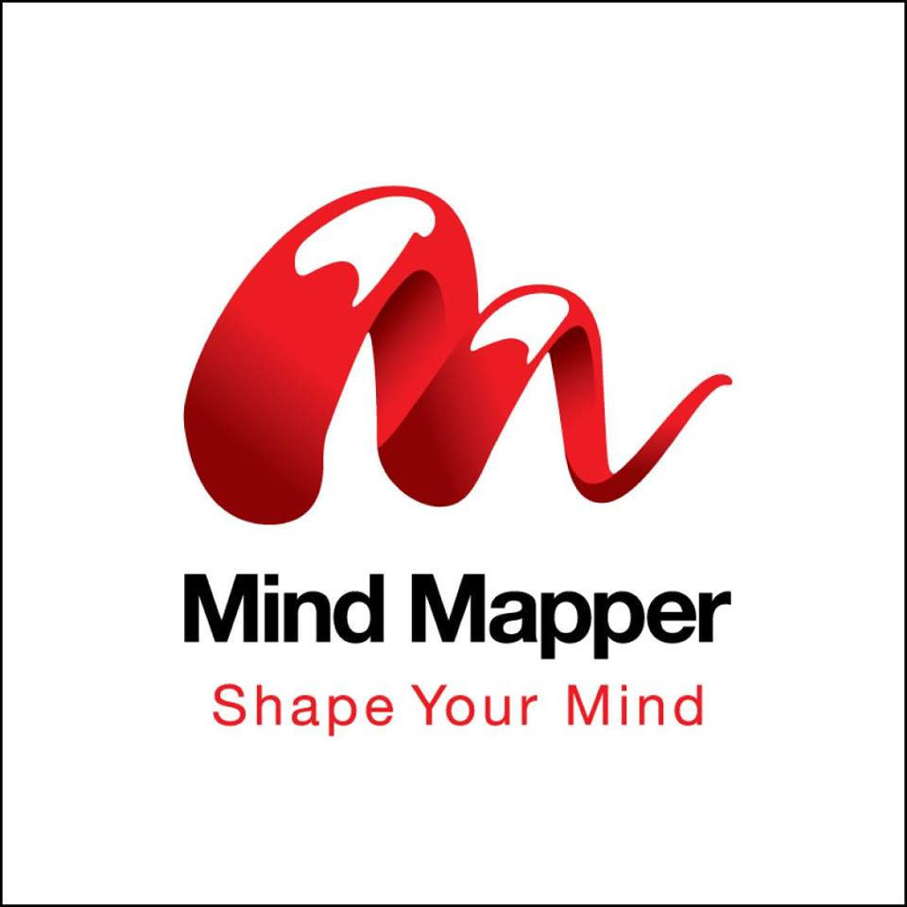
Service of Mind Mapper Bangladesh:
Mind Mapper Bangladesh helps its clients grow their businesses with the right people and the right process. Mind Mapper Bangladesh helps its clients both individual and organizational to develop their performance. Their service includes-
- Professional and Educational Programs in the area of Supply Chain Management by ISCEA, International Supply Chain Education Alliance, USA
- Business and Management Consultancy
- Supply Chain Training and Consultancy
- Soft and Technical Skills Training (Both Public and In-house)
- Executive Search

Bangladesh Organization for Learning and Development (BOLD)
Bangladesh Organization for Learning and Development (BOLD) is the leading premier level organization for personal and professional development. It provides the opportunity to get a membership facility to sharpen individuals' knowledge and skills. BOLD's vision is to be the top growing platform for developing individuals' talents and human capital in Bangladesh.

Bangladesh Organization for Learning and Development is working to turn the population into human capital. Its mission is to help and develop its members. There are several ways an individual can become a part of this organization.

Membership Categories:
- Trainers
- Consultants
- Facilitators
- Leadership and Development professionals in Human Resource departments
- Teachers at Universities, Colleges, and Schools


It provides the opportunity to develop and improve skills and abilities as professional areas and entrepreneurship sectors so that people can contribute and give their level best in their own field. Bold is creating a vibrant learning community in Bangladesh and serving its members so that they can improve their skills and develop both in their personal and professional life.

BSHRM – Bangladesh Society for Human Resources Management
BSHRM - Bangladesh Society for Human Resources Management is the Apex body of HR professionals of Bangladesh. BSHRM was incorporated with the Registrar of Joint Stock Companies & Firms under The Societies Registration Act, 1860 as a non-profit organization vide Certificate of Incorporation No. S-2657(70)/2001 on 12 December 2001.

Opportunities of Members:
It provides the following opportunities for the members:
- Networking with professionals
- Arranging various Training Programs
- Arranging Workshop and Seminars
- Arranging International Conference
- Providing Consultancy services

Objective of BSHRM:
The prime objective of the Society is to provide leadership within the communities by promoting the recognition and growth of Human Resources professionals through education, networking, shared resources and knowledge, with a commitment to such values as human dignity, rights, and development.

Vales of BSHRM:
- Valuing people as individuals
They care about the people within their organizations and their profession; they strive to help individuals reach their full potential.
- Influence
As leaders and catalysts for change, working within their organizations to ensure fair treatment of people, in line with social, business and economic trends on the work-place.
- Service
To strive and to provide their peers, business partners, clients and communities of interest with prompt, high-quality service. To encourage volunteerism to promote their profession.
- Integrity
To apply the highest ethical standards to themselves and to their profession. Opportunity to provide professional development opportunities that promotes organizational and individual achievement. Also, seek opportunities to advance the provision.
- New Ideas
To be open to and initiate new ideas; committed to being future-focused, responsive to the workplace and societal trends, and entrepreneurial in spirit.

Membership Categories:
- Life Fellow
- Fellow Member
- Associate Member
- General Member
- Student Member

BSAHRP – Bangladesh Society for Apparel HR Professionals
BSAHRP is a professional organization not for profit organization to help the Human Resource professionals those who are working in the Apparel sector. It's the dedicated forum for the HR Professionals working in Apparel Industry. It helps individuals improve their skill, create scope to share practical knowledge and ideas among members. BSAHRP offers different workshops and seminars to make their members updated and provide training on regular basis to enhance their quality of the job so that they can contribute to making a standard platform to work for the betterment of apparel industry.

Vision:
BSAHRP strives to be recognized as the pioneer Human Resource Association for pursuing excellence in Human Resource Management in Apparel sector of Bangladesh.

Mission:
BSAHRP is committed-
- To connect, educate and lead the HR professional of Apparel sector to achieve individual and organizational excellence
- To serve the Apparel HR Professionals community as a trusted platform for members' welfare and care

BSARP Aims:
- Strive for professional development and growth in the field of HR Management in Apparel sector.
- Support the Association's mission, vision for developing the HR Professionals.
- Uphold the ethics, code of documents and laws and regulations of the professions.
- Setting the benchmark for the professionals and develop accordingly.
- Get recognition from the stakeholders.
- Develop HR Matrix and professionalism for the members.
- Taking steps for better HR Education and Training for the HR Professionals of the sector.
- Taking care of the well-being of the members through programs.
- Actively participate for national policy-making related to Apparel Industry.

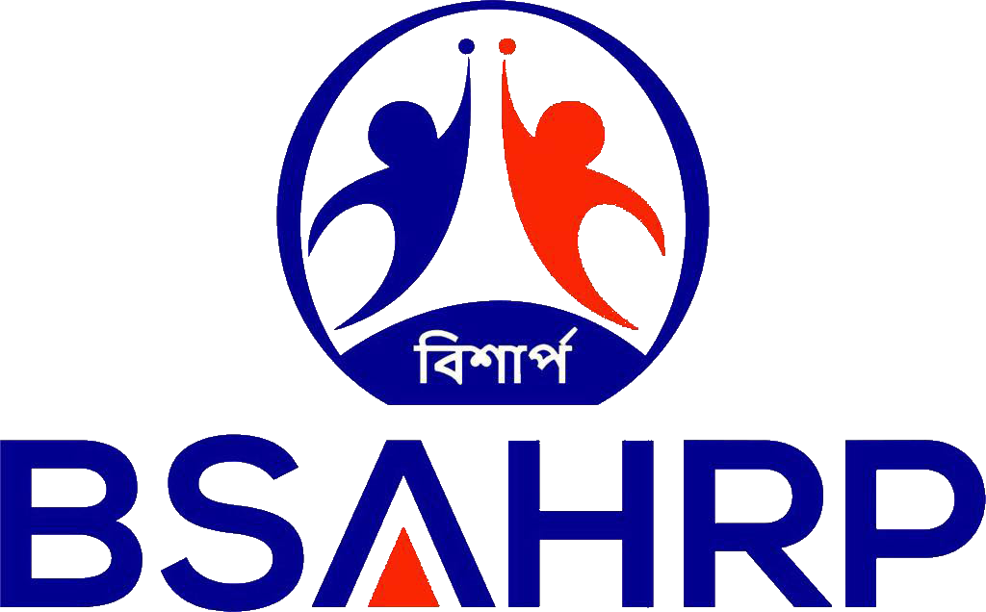
Enhancing Professional Capabilities:
- Training, Seminars, and Conferences.
- Skill Building Workshops.
- Monthly Knowledge Sharing Session.
- Periodic Summits.
- Sharing of best practices.
- Access to archived tools and resources.
- Connect with senior HR professionals.
- Research and Publications.
- HR Compass/Quiz.
- Case Studies.
- Mentoring.
- Collaboration with academic institutes and universities.
- Study Missions and Visits.
- Opportunities as Resource Persons.

Federation of Bangladesh Human Resource Organizations (FBHRO)
Federation of Bangladesh Human Resource Organizations (FBHRO) is the biggest non-profit associations and organizations engaged in human resources management and development in Bangladesh.

FBHRO is popularly known as HR Federation. It's a non-government, not-for-profit organization, FBHRO is the voice of Bangladesh’s human resource community. From influencing policy to encouraging debate, engaging with policymakers and civil society, FBHRO envisions to articulate the views and concerns related to developing the human capital of the country.


FBHRO provides a platform for networking and consensus building on human resources development issues within and across the private, social and public sectors to meet the challenges of Bangladesh becoming a middle-income country by 2021 and a developed nation by 2041.

Marketing Practices of Sensei-Wisdom:
Sensei-Wisdom mainly focuses on Digital Marketing, mostly on Social Media Marketing. In digital marketing, they are practicing the following media to reach to their target customers and attract them to buy their services-

Email Marketing:
This organization practices Email marketing to reach directly to its target customers. By using email marketing, it can reach thousands of people within a single click. On special occasions such as Eid, New Year, Bangla Noboborsho, and other significant days they send wish to their valuable clients, stakeholders, and customers. They send a monthly newsletter to ensure that everyone gets the update news of Sensei-Wisdom.

Search Engine Optimization (SEO):
Sensei-Wisdom uses SEO technique to make its website visible to its clients and the target organizations. SEO uses to improve the visibility of a website in search engines. It can be organic and paid basis.

Testimonial Marketing:
Sensei-Wisdom collects testimonial from their previous clients and participants who attended their previous programs and training sessions to promote their activities to gain new customers by showing their portfolios.

They collect both written and video testimonials and they create authenticity and credibility. Sensei-Wisdom collects testimonial from national and international colleagues, fellows, and past co-workers.

Social Media Marketing:
Sensei-Wisdom mostly practices Social Media Marketing. They gather traffic through social media sites such as Facebook and LinkedIn. It gets huge traffic and leads from Facebook.

Video Marketing:
It creates videos to promote its services and reach to the target customers by creating authenticity and credibility. It also used to engage more people to their social media sites such as Facebook, LinkedIn, and YouTube.

Bundle Offer:
Sensei-Wisdom gives bundle offers to its clients such as 15% discounts for the first 50 people, 10% discount for the second 50 people who complete registration in its programs and events. Besides that, they also provide a special offer to group registration that consists of 5-7 members.

Live Video:
Sensei-Wisdom does weekly and monthly online live program from Facebook and YouTube. Besides that, it also collaborates live program with both national and international like-minded professionals who are in the areas of Coaching, Mentoring, and Training, Human Resource.

Bestselling Free Book:
They also offer their own bestselling free book for the participants who complete their registration within the first week or a particular period of time. Sensei-Wisdom consultants have their own bestselling books which they offer to attract new customers.

Chapter-4

Findings and Analysis
I had an opportunity to work in the department of Corporate Relationship Management at Sensei-Wisdom. At Sensei-Wisdom, I had a three months long internship period. Sensei-Wisdom is the leading management consulting organization which helps the individuals and organizations to improve and develop their skills, abilities, company performance, and brand value by providing customized training, customized coaching services to the top-level management.

While working at Sensei-Wisdom, I have achieved more knowledge about coaching and mentoring programs, how to sell services to top-level management who are working in national and multinational organizations. After gathering information and collecting data from the company directors and employees - managers, executives, assistant of Managing Director I have a few discoveries. Here I'm sharing my own perspective-
- As Sensei-Wisdom fully started operating their activities in Bangladesh in 2017, it’s a new journey. They could not share most of the information as they are forming a new team.
- It was so tough to gather information as the Director and Chairman operate the whole business by themselves.
- Most of the time top-level management stays at abroad outside of Dhaka that’s why managing time with them and collecting information was a bit more challenging.
- Sensei-Wisdom has a less number of employees in their Bangladesh office and employees have to engage multitasking and they feel bored under huge pressure.
- Their website isn’t updated and that’s why it was tough to collect the exact information and learn more about the organization.
- It’s a management consulting organization but their own employees don’t get the proper opportunity to develop their skills and competencies.
- Most of the time employees don’t get the opportunity to have free time as most of them do multitasking.
- Employees usually don't get the opportunity to learn new things and develop their abilities and give their level best to the organization.
- As there are two partners in the organization, employees face difficulties to listen to directions from two leaders.
- There are two leaders in Sensei-Wisdom so employees become confused to follow to whom. Most of the time they feel upset to follow two directions at the same time.
- They don’t have a well-organized team. Employees get an online message at midnight to finish their tasks.
- They follow social media marketing mainly Facebook marketing and it’s not sufficient in this era. Their digital marketing strategy isn’t suitable.
- The decision making process is very lengthy.

Chapter-5

Conclusion and Recommendation

Recommendation:
- They mainly focus on Social Media Marketing it's not suitable. They should focus on full Digital Marketing.
- They have few employees so it's important to recruit more skilled and talented employees.
- Multitasking slows the work progress. Sensei-Wisdom should focus on employee development and skill improvement.
- More skill development workshops and training should be given to make their employees more skillful and enhance their competencies.
- The company website should be updated as people visit their website to know more about their programs and participate in the training sessions.
- Decisions should be given by only one leader. As there are two leaders, employees face difficulties.
- A well-organized team should be formed as many employees work at midnight to finish their works before the programs.
- Their marketing strategy isn't strong enough. They should focus on proper marketing.
- They should collaborate with more organizations to spread their activities and reach more people.
- They are not targeting the right people in the right way at the right time. So, they need to focus on the right people to attract more customers to buy their services.
- They should focus on the right process and maintain a monthly calendar to make the things done in time.

Conclusion:
Management Consulting Organization has a huge impact on leadership development and to create new leaders. Sensei-Wisdom is a global consulting organization has served many national and multinational organizations in different areas to improve the employees' leadership skills, team-building skills, negotiation skill, marketing, and branding. Sensei-Wisdom helps multi-national organizations, leaders, and top-level managers achieve the highest level of successes.

Sensei-Wisdom is a multi-national consultancy firm which helps multi-national organizations and top corporate leaders to develop skills, competencies and improving leadership qualities. The signature program of Sensei-Wisdom is Mastery of Self through Neuro-Linguistic Programming (NLP) which has a great impact in Bangladeshi organizations and it’s a 4-day long training program which helps an individual or organizations’ employees to understand inner potentialities, mind programming, in decision making, and mastery of self. Though there are some limitations as in our country people don’t focus on skill development, they are creating a new revolution to make people more skillful with self-mastery.

Chapter-6

References and Website Links
- Bandler, R., & Grinder, J. (1975). The Structure of Magic: A Book About Language and Therapy, Volume 1. Palo Alto, CA: Science and Behavior Books.
- Bandler, R., & Grinder, J. (1975). The Structure of Magic II: A Book About Communication and Change. Palo Alto, CA: Science and Behavior Books.
- Canadian Agency for Drugs and Technologies in Health. (2014, November 3). Neuro-linguistic programming for the treatment of adults with post-traumatic stress disorder, general anxiety disorder, or depression: A review of clinical effectiveness and guidelines. Retrieved from http://www.ncbi.nlm.nih.gov/pubmed/25473689
- Roderique-Davies, G. (2009, July). Neuro-linguistic programming: Cargo cult psychology? Journal of Applied Research in Higher Education, 1(2), 57–63. Retrieved from https://www.researchgate.net/publication/242770183_Neuro-linguistic_programming_cargo_cult_psychology
- https://sensei-wisdom.com/ Accessed on July 11, 2019
- https://www.sensei-international.com/ Accessed on July 11, 2019
- https://www.ranjandesilva.com/ Accessed on July 11, 2019
- http://www.kamrul-hasan.com/ Accessed on July 11, 2019
- http://bold.org.bd/ Accessed on August 16, 2019
- http://www.fbhro.org/ Accessed on August 16, 2019
- https://iscea-bangladesh.com/ Accessed on August 16, 2019

