Modernizing Supply Chain Practices at Bengal Group of Industries

By
Md. Ashraf Rahman
ID: 111 162 128

Department Name:
Bachelor of Business Administration
School of Business & Economics
United International University

An Internship Report
Submitted to
Abdullah Al Fahad
Lecturer
School of Business & Economics
United International University

Submission Date: October 14, 2024
Letter of Transmittal
14th October, 2024
Abdullah Al Fahad
Lecturer
School of Business & Economics
United International University
Subject: Submission of Internship Report on “Modernizing Supply Chain Practices at Bengal Group of Industries”.
Dear Sir,
I am pleased to submit my internship report titled “Modernizing Supply Chain Practices at Bengal Group of Industries.” This report takes a closer look at the current supply chain practices of Bengal Group of Industries and provides key areas to optimize the current practice and provide suggestions for the modernization of supply chain strategy for better operational efficiency.
Now that the process is over, it would be my pleasure to take this moment to thank you deeply for each and every time you have supported, guided, and encouraged me during the process. Your invaluable assistance and feedback have been key to completing this report.
Thanks for your cooperation and letting me work on this project. I hope this report meets your expectations and provides valuable insights.
Sincerely Yours,
………………………..
Md. Ashraf Rahman
ID: 111 162 128
Bachelor of Business Administration
United International University
Bona fide Certificate
This is to certify that the internship report titled "Modernizing Supply Chain Practices at Bengal Group of Industries" is the bona fide work of Fahim Iqbal, who successfully conducted the study under my supervision. I believe that this work has not been submitted to any other institution nor incorporated in any other project report, dissertation, or thesis for a degree or award previously granted to this or any other candidate.

……………………………………
Abdullah Al Fahad
Lecturer
School of Business & Economics
United International University
Acknowledgement
I wish to express my most profound thankfulness to Allah, who accorded me the opportunity to complete this report without losing my strength or direction. Firstly, I would like to thank my supervisor, Mr. Abdullah Al Fahad for his unrelenting support and following throughout this process. I would also like to thank Mr. Bhaskar Mutsuddy, a senior manager of procurement at Bengal Group of Industries, who helped me by sharing extremely valuable information. I am thankful to the hardworking employees of Bengal Group of Industries for helping me bring the quality and discipline of this report to the desirable levels.

Name: Ashraf Rahman
ID: 111 162 128
Department: Bachelor of Business Administration
United International University

Table of Contents
List of Tables iii
List of Figures iii
Executive Summary 1
Chapter 1: Introduction 2
1.1 Organization Profile 2
1.2 Key Role of SCM at BGI 3
Chapter 2: Current State of Supply Chain at Bengal Group of Industries 4
2.1 Overview of Current Procurement and Practices 4
2.2 Technology Used in the Supply Chain 7
2.3 Challenges Faced 8
Chapter 3: Need for Modernizing Supply Chain Practices 10
3.1 Digital Transformation 10
3.2 Enhancing Supplier Relationships and Collaboration 12
3.3 Sustainability and Compliance 14
Chapter 4: Proposed Strategies for Modernizing the Supply Chain 16
4.1 Implementing Advanced ERP Systems 16
4.2 Data-Driven Supplier Evaluation 17
4.3 Demand Planning and Forecasting Tool 18
4.4. Inventory Management Modernization 19
4.5 Risk management and resilience building 20
Chapter 5: Industry Examples of Modern Supply Chain Practices 22
5.1 Apex Footwear Ltd. – Digital Transformation in Manufacturing SCM. 22
5.2 DBL Group – Sustainability in Supply Chains 23
5.3 Unilever – Sustainability in Supply Chains 25
5.4 Pran-RFL Group – Supply Chain Resilience 27
Chapter 6: Implementation Plan for Modernizing BGI's Supply Chain 29
6.1 Short-Term Goals (6-12 months): 29
6.2 Medium-Term Goals (1-3 years) 31
6.3 Long-Term Goals (3-5 years) 33
6.4 Key Stakeholders and Their Roles 34
Chapter 7: Expected Benefits of Modernizing the Supply Chain of BGI SCM 36
7.1 Improved Efficiency and Cost Reduction 36
7.2 Enhanced Supplier Performance and Collaboration 37
7.3 Advantages of Sustainability and Compliance. 38
Chapter 8: Learnings from the SCM Department 41
Chapter 9: Conclusion 43
References 44
Appendices 47
1. Indent 47
2. Request for Quotation (RFQ) 48
3. Comparative Statement (CS) 49
4. Purchase Order (PO) 50
5. Invoice 51
6. Goods Receipt Note (GRN) 52
7. VAT Challan 53

List of Tables
Table 1: AI and Predictive Analytics Impact 10
Table 2: Global Focus on Circular Economy 15

List of Figures
Figure 1: Procurement Process at BGI 4
Figure 2: Blockchain Implementation Benefits 11
Figure 3: Improvement with SRM Systems 13
Figure 4: Sustainability Trends in the Supply Chain 14
Figure 5: Indent 47
Figure 6: Request For Quotation (RFQ) 48
Figure 7: Comparative Statement (CS) 49
Figure 8: Purchase Order (PO) 50
Figure 9: Invoice 51
Figure 10: Goods Receipt Note (GRN) 52
Figure 11: VAT Challan 53

Executive Summary
As an executive of the Supply Chain Management (SCM) department for Bengal Polymer Wares Ltd. (BPWL), which is the most important unit of Bengal Group of Industries (BGI), I ensure smooth procurement of crucial raw materials like PP, recycled PP, HDPE, PET, color masterbatch, resin, and packaging materials, including cartons, poly, stickers, barcodes, and spares for generators and compressors. This report explores challenges that BGI faces with respect to procurement and presents strategies for updating the way the company conducts SCM to improve efficiency.
At present, BGI operates in the plastics, textiles, and energy sectors, with a supply chain that facilitates procurement, inventory, and production cycles. For example, there are inefficiencies in areas like supplier evaluation, centralized data management, and manual processes in bill and inventory management. While the company made use of the Far Vision ERP system, processes like decision-making as well as data management were still deliberated and taken manually, resulting in delays and inaccuracies.
The report notes that for the BGI supply chain to become enhanced, global trends such as digital transformation, sustainability, and resiliency should be adopted. Advanced technologies like AI, predictive analytics, and IoT will make procurement operations intensive and streamlined with real-time information so that better decisions can be taken. It improves one’s supply chain visibility and efficiency through enhanced supplier relationships and collaboration based on data-driven evaluation and automated inventory control.
Proposed strategies are to upgrade the ERP system, develop KPIs of supplier performance and modernize inventory management with real-time monitoring. In addition to a phased implementation plan starting with short-term ERP platform upgrades on current ERP platforms, moving to fully automating and integrating with AI in the next 3–5 years. Modernizing BGI's supply chain will allow for better capacity utilization, lower operations costs, higher supplier collaboration, and sustainability. Besides designing the best procurement processes, these improvements will help BGI attain global standards and remain competitive in the market.

Chapter 1: Introduction

1.1 Organization Profile
Bengal Group of Industries (BGI) is an established conglomerate with diversified manufacturing expertise throughout the world over more than five decades. They employ more than 32,000 highly trained personnel at its head office and 28 factories. Food processing, plastics, rubber & melamine, textiles & apparel, power & energy, hospitality, building materials, infrastructure, electronics, media & entertainment are the sectors in which the company operates.
BGI is responsible for more than 60 countries for export, including the United States, Europe, and Asia, for part of the foreign currency earnings by Bangladesh. BGI's deep-rooted presence in these key sectors, as well as its strong manufacturing experience and diverse product offerings, have positioned it at the forefront of the country's economic growth.
Mission: To strive constantly to responsibly meet and exceed the expectations of our valued customers and stakeholders through excellence in quality, delivery and sustainability.
Goals: To simply become the best at what we do. Since our inception, we have been widening our horizon of operations to raise the industry standards higher and keep the bar rising! With our values strong and mission set to reach the apex of success- our aim is to lead the industry that we build together, providing worthwhile satisfaction to our customers. (Bengal Group of Industries, 2024).
Business Units: Bengal Group of Industries encompasses a comprehensive network of 26 Strategic Business Units (SBUs), distinguished for their prominence and notable contributions across various industries. Some of these are:
- Bengal Plastic Limited
- Bengal Polymer Wares Limited
- Bengal Windsor Thermoplastics Limited
- Hamilton Metal Corporation Limited
- Happy Mart
- Bengal Plastic Pipes Limited
- Bengal Cement Limited
- Bengal FlexiPac Limited
- Romania Food and Beverage Limited
- Designer Fashion Limited
- RTV
- Bengal Poly & Paper Sack Limited
- Bengal Renewable Energy Limited
- Power Utility Bangladesh Limited
- AJ Overseas Company Ltd.
- Linnex Electronics (BD) Ltd.
- Bengal Hotels & Resorts
- Euphoria Apparels Ltd.

1.2 Key Role of SCM at BGI
The success of BGI largely relies on supply chain management (SCM). Since the company is involved in many fields, it is important for the supply chain to be coordinated properly in order to buy raw materials in time, to manage inventory, to manage the relationship with suppliers, and to keep production on a smooth path. The supply chain is an integral part of optimizing operations and remaining competitive in sectors with different requirements, complexities, and demands. The flow of goods and services in BGI is ensured by SCM, which also ensures that the company’s products meet the very high standards of the international market. BGI now more than ever needs mission-critical supply chain management so that we can manage evolving customer demand and maintain operational excellence in the face of globalization and a fast-growing market need.
Supply chain modernization is obviously a necessity if Bengal Group of Industries (BGI) is to remain competitive locally as well as globally. AI and predictive analytics can help BGI save costs and improve operations across all of its diverse sectors. Sustainability is also important, but BGI aims to reduce its environmental footprint and follow global standards in the industries of plastics and textiles. It is also likely to enhance BGI’s ability to cope with the risks in the supply chain and ensure business continuity in the instance of disruption. It is consistent with BGI’s public transportation strategic goals of growth, efficiency, and long-term sustainability.

Chapter 2: Current State of Supply Chain at Bengal Group of Industries

2.1 Overview of Current Procurement and Practices
Bengal Group of Industries (BGI) operates a multi-step and structured procurement process to ensure that required material and services are procured in the most efficient, accurate, and in alignment with the company's operations standards. The flowchart below illustrates the procurement process for the BGI:
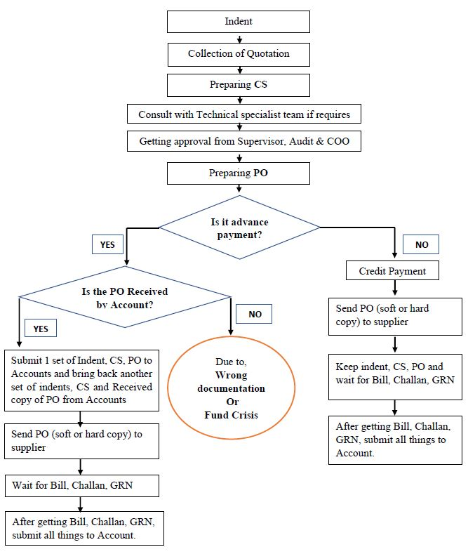
Figure 1: Procurement Process at BGI
Procurement starts with an indent or materials or services needed in the factory or other business unit. Indent is a document containing the detailed specifications regarding items, such as business unit name, address, item code, description, quantity, required delivery date, stock availability, and other information related to the previous supplier. The respective department heads scrutinize the document and then decide whether there was a need for the request and it is in agreement with the organization’s needs. When technical items are involved, a requirement of consultation with technical specialists is made so that the basic specifications can be verified. Then the accounts department checks the budgetary matters before passing the final approval.
After agreement is received on the invoice, a Request for Quotation (RFQ) is sent out to possible suppliers. The essential details of such delivery location, material costs, payment terms, warranties, and the contact details of the supplier are all included in this request. At this stage, the goal is to have competitive quotes from different suppliers to get the most cost-effective and high-quality materials. As soon as one receives the quotations, the next step is to prepare a comparative statement (CS), which compares quotes received from suppliers in terms of price, quantity, payment terms, delivery lead times, VAT, AIT details, etc. The comparative statement (CS) helps BGI to analyze the pros and cons of each supplier's offers and then make a decision.
After acquiring the supplier based on the CS findings, the procurement team might consult with technical specialists to make sure every specification and requirement has been met. A purchase order (PO) is prepared after the approval of the PO by the supervisor, audit, and chief operating officer (COO). Here is a definition of PO's; it contains very productive data like the name of the supplier, the order number, delivery address, item description, quantity, unit price, and payment terms. It is a written contract between BGI and the supplier, documenting specific purchase terms of the deal. The accounts department shares the PO to make sure funds are allocated to the right accounts and sends the PO to the supplier, or withholds if the payment method is advance or credit.
If there is an advance payment procurement, the PO is received by the accounts department, and the documentation is verified before the funds are disbursed to the supplier. In situations where the payment happens for credit, the supplier provides these materials to BGI and a goods receipt note (GRN) is created so as to prove that the materials were received in the suitable quantity and condition in accordance with the PO. The GRN contains the supplier's name, GRN number, Challan number, description of goods, and supplied quantity. This is a critical step that confirms that the delivered item meets the specifications of the PO.
In this process, a delivery challan is also meant to be accompanied with the goods shipment to capture the record of the goods shipped and provide proof of delivery. This document has the shipment date, name and address of the recipient, the sender, description of the goods, and quantity. The Delivery Challan is used to reconcile accounts payable, account for the delivery, and measure inventory.
Furthermore, the supplier issued an invoice or bill as a commercial document listing supplied goods or services, quantities, and the amounts payable. It is of fundamental importance since it registers the record for the buyer and the seller, as well as informs of the invoice number, the date, the name and the address of both of them, the description of the items, the quantity, the unit price, the total amount of payment due, and the payment terms. It is important for timely payment, elimination of delays, and accurate financial records, so this document is crucial.
In this final case of VAT payment, the corresponding Mushak form is issued most often. This form is used to provide information about the VAT registration number, date of supply, recipient and supplier details, description of the goods, amount charged with the VAT and the total amount payable. The mushak form is an important record for calculating the liability of VAT and is proof that VAT has been paid in respect of the supply of goods or services.
BGI receives goods and creates a GRN, after which the supplier sends an invoice or bill to BGI for payment. Along with the PO and GRN, everything in this invoice is accompanied by the necessary documentation. The Quality Control (QC) team validates the goods delivered as they go from one to one and ensures that the goods are of good quality. The Chief Supply Chain Management Officer (CSCMO), the purchaser’s supervisor and the internal audit department also verify these documents before forwarding them to the accounts department for processing. Releasing payment based on agreed terms is the responsibility of the accounts department. For advance payment, the payment is made before delivery; for credit payment, it is made after goods are delivered and verified.
Followed by the payment process when the accounts department is satisfied with the PO, GRN, and invoice documentation sent at the end of the month. Payments are scheduled weekly and the Chief Supply Chain Management Officer (CSCMO) makes recommendations for payments. Money is accounted for according to company protocols that the money is paid for. Once payment is done, the accounts department posts the accounts ledger to the supply chain department for record purposes.
During this procurement, any discrepancies are immediately rectified using mediation between the supply chain and the accounts department. Through this, it became standardized through all the business units that work with BGI, ensuring consistency, accuracy, and protocol compliance. This is BGI’s commitment to precision and transparency in its procurement, with documents from indents to invoices arranged systematically. This structured approach not only allows for the speedy progress of the procurement process but also allows the organization to stay synchronized.

2.2 Technology Used in the Supply Chain
The Far Vision Enterprise Resource Planning (ERP) system is used mainly by BGI to manage its procurement and supply chain functions. Far Vision is an important tool to help make your processes more streamlined: generating invoices, processing purchase orders, and keeping goods receipt notes, as well as managing supplier payments. The supply chain team can track orders status from the first indent to the last payment with this system. It is also used to store the information of the supplier, purchase history information, and the pending bills.
While the system exists, its use is, essentially, limited with regards to data integration and automation. It has helped in document generation (purchase orders, comparative statements) but a lot of analysis and decision-making is still manual. For example, suppliers are typically handled manually via email communication of RFQs, and Far Vision data is manually exported for further analysis in external tools such as spreadsheets. These spreadsheets are used by the procurement team to evaluate supplier quotations, inventory management, track performance metrics, and thus introduce inefficiencies.
In addition, Far Vision lacks sophisticated reporting and data visualization capabilities that would allow for real-time insight to proactively make decisions. The data used includes supplier performance, historical lead times, and inventory levels held in the system but are not easily accessible or analyzed without intervention. As a result, it lessens the capacity of the system to support strategic procurement decisions, including demand forecasting, supplier evaluation, and risk management.
In addition, the other operational functions, for example, production and inventory control, are not fully integrated in the system. As a result, the supply chain team often doesn’t have the essential information, like real-time inventory levels or open purchase orders. Consequently, activities of procurement occur out of sync with production requirements and the need to integrate technologies among departments becomes even more critical.

2.3 Challenges Faced
The supply chain department of BGI has many challenges that affect its operational efficiency and effectiveness. The most important issue is that there is no central supplier database. Pricing, contract terms, performance records, and delivery histories of suppliers are dispersed across numerous platforms and departments. However, these pieces of information are fragmented by the nature of this approach to data management, which makes it inefficient in terms of time and creates unreliable supplier ratings. Manual search and lack of system coordination mean that without a central system, procurement teams are unable to track supplier performance over time.
Another important problem is a lack of data-driven supplier evaluation. Today, a lot depends on comparative statements (CS) that basically depend on the basis of their price, quantity, and terms of payment. These are indeed significant factors, but the lack of a structured evaluation system measuring delivery accuracy, product quality, etc. makes it almost impossible to objectively evaluate a supplier’s reliability and efficiency. Supplier selection and retention decisions are usually made on historical relationships or experience instead of performance data details, which limits the ability of the procurement team to optimize supplier management.
Furthermore, BGI does not use a Key Performance Indicator (KPI)-based system for monitoring the supply chain efficiency. It is difficult to measure critical metrics like supplier lead times, procurement cycle times, and cost efficiency because of the lack of defined KPIs. The lack of quantitative performance metrics also prevents the company from knowing what to improve on or how close they’re getting toward efficiency goals. Without KPIs, there is a paucity of a clear framework to evaluate supplier as well as internal procurement performance for the supply chain department to improve the process of continuous improvement.
These issues are further compounded by the inefficiencies in bill management and documentation handling. Although the purchase orders and transactions are generated in the ERP system, Far Vision, much of the documentation of the supply chain process is still manual. Many times, bills, invoices, and goods receipt notes are printed and physically processed, which makes approvals and payments slow. Paper-based documentation introduces the risk of errors and misplaced documents, as well as delays in the payment process that can mitigate supplier relationships as well as extend the procurement lead time.
Another significant challenge is the lack of integrated inventory control and real-time visibility. BGI inventory management is not completely integrated with the procurement process, which means that the actual stock levels are not readily accessible to the procurement team. The separation of the inventory management of the warehouse from the procurement-focused supply chain department can have inaccurate or outdated stock information, leading to delayed decision-making.
In addition, the ERP system, Far Vision, is not being used effectively, inhibiting the department from making data-driven decisions. The system meets basic needs like generating purchase orders but lacks advanced analytical capability and real-time reporting that would help the supply chain department facilitate the task of procurement optimization. This means that analyses need to be done by the procurement team through manual data exports and by using external tools, such as spreadsheets, which means a greater chance for errors and time delays in taking the right decision.
Furthermore, the supply chain lacks integrated demand planning, which further undermines its responsiveness and alignment to general business objectives. Demand planning is independent of the procurement and the procurement team has no visibility into future production needs. Separating this advantage prevents coordinating procurement activities with the timing of real production requirements, resulting in mismatches between the supply requirements and either excess inventory or supply shortages. While not having a unified demand planning system is what is keeping the supply chain from operating as aligned with BGI’s overall goals, it is increasing the overall inefficiency of the supply chain.

Chapter 3: Need for Modernizing Supply Chain Practices

3.1 Digital Transformation
As digital transformation increases efficiency, improves agility, and helps ensure competitiveness in a volatile landscape, it is facilitating supply chain modernization globally. Driven by technologies such as artificial intelligence (AI), predictive analytics, blockchain, and the Internet of Things (IoT), supply chain management (SCM) is now at the doorstep of the fourth wave of SCM and is being impacted by the business transformation in the post-pandemic and post-COVID era.
Artificial intelligence (AI) such as automatic functions, predictive decisions, and real-time monitoring is also creating some supply chain optimization. AI-calculated algorithms, for example, can process large volumes of data, identify patterns, predict demand, and do so much more in light of the logistics. This would allow for companies to be able to better forecast so they have less excess inventory and they won’t run out of stock. For example, Amazon has AI-driven systems to calculate customer demand, manage its massive inventory, manage storage costs, make quick deliveries, and so on. In Bangladesh’s garment industry, AI is used to schedule production to best meet demand and lower lead times to give manufacturers a buffer to satisfy demand beyond its border.
AI and Predictive Analytics Impact on Inventory and Supply Chain Costs (McKinsey & Company, 2020):
Metric | Impact with Predictive Analytics
Reduction in Inventory | Up to 35%
Reduction in Supply Chain Costs | Up to 15%
Improvement in Forecast Accuracy | Up to 20%
Reduction in Lead Times | 30%
Table 1: AI and Predictive Analytics Impact
Supply chain resilience is enhanced by predictive analytics, which lets businesses see potential risks and opportunities. By using historical data, predictive analytics tools can help businesses forecast the possibility of disruption, whether that’s a supply line going down, demand hitting a new high or the situation getting backed up logistically, and then prepare to deal with that risk before it happens. McKinsey & Company (2020) report that companies using predictive analytics well within their supply chains can reduce inventory by as much as 35 percent and overall supply chain costs by as much as 15 percent. Predictive analytics has also become increasingly used in Bangladesh's textile industry, which uses it to anticipate the demand trend and production capacity to be a step ahead of the competition in the business.
Blockchain technology is making supply chains transparent and secure through real-time, immutable records of transactions along them. In particular, blockchain is useful for stakeholder tracking of goods from source material to the final consumer, and the accountability ensures that nobody is involved in cheating. Blockchain is used to verify the authenticity of drugs in industries such as pharmaceuticals to check if they comply with regulatory standards. Walmart is using blockchain to trace the origins of food products and improve food safety, as well as reduce time from farm to table. In Bangladesh, blockchain is now under experimentation in the textile and apparel sector, enabling sourcing transparency and ethical labor practices to build trust between global buyers and manufacturers.
Blockchain Implementation Benefits (Deloitte Blockchain Survey, 2021):
Figure 2: Blockchain Implementation Benefits
The Internet of Things (IoT) provides real-time tracking and monitoring of goods and assets in the supply chain. Industries like food, pharmaceuticals, and electronics all have IoT devices, like smart sensors that track location, temperature, and humidity, among other critical conditions. Shipment companies monitor shipments in real time, detect problems like delay and temperature excursion, and respond quickly to prevent waste. IoT has been adopted by shipping companies around the world, like Maersk, to improve logistics and reduce the delay in getting goods transported in a safe way. While IoT adoption is still nascent in the country, it is gaining ground, especially in logistics and transportation, where data in real time can tremendously cut down wastages and shorten delivery time.
These technologies are now increasingly being used by global companies in a variety of industries, not sparing the supply chain operations in Bangladesh, in particular in areas such as textiles, garments, and logistics.

3.2 Enhancing Supplier Relationships and Collaboration
Creating a resilient and agile supply chain hinges on building strong supplier relationships and collaboration with them. In today’s global economy, efficient cooperation between suppliers and manufacturers can help both SRM systems such as SAP Ariba, Oracle SCM, and Coupa are critical tools to manage provider relationships. It gives businesses a platform to consolidate supplier data, track how contracts are being performed and manage contracts altogether, cut down communication channels, as well as accountability. According to Schmidt and Foerstl (2021), the SRM systems serve to foster physical supplier engagement via real-time access to key performance indicators (KPIs) in order to facilitate risk management and contractual negotiation processes. For instance, global classes such as Procter & Gamble have created sophisticated SRM systems to monitor suppliers continuous performances and suppliers' international late delivery and violations of quality standards.
In industries like textiles and ready-made garments (RMG), the modernized supplier management system is spreading in Bangladesh and industries are now taking advantage of better procurement practices and better coordination with their international buyers overseas. For instance, performance metrics from the production schedules can be easily centralized, coupled with such information about suppliers as availability of certified suppliers and probability of late deliveries, and textile manufacturers are able to easily make issues with suppliers and keep production schedules under control. reduce costs, improve quality, and shorten lead times.
Improvement with SRM Systems (Schmidt and Foerstl, 2021):

Figure 3: Improvement with SRM Systems
Cloud-based platforms further facilitate collaboration between suppliers and the procurement team through real-time communication. The platforms that facilitate the exchange of production schedules, forecasts, and order updates are designed to reduce misunderstandings and improve coordination of work between the manufacturing and distribution sides of the house. A case study from Unilever showed that their utilization of cloud-based collaboration tools reduced lead time by 30% by increasing visibility across their supply chain (Waller and Fawcett, 2013). For the RMG sector in Bangladesh, especially so, such collaboration tools are essential, since the ability to communicate with suppliers in a timely manner becomes key to meeting tight global deadlines.
Also, partnering with suppliers is strategic to encourage innovation and continuous improvement. Firms, which establish close relationships with their suppliers, can work on product development, process improvements, and cost reduction efforts. As a result, Toyota’s longstanding relationships with its suppliers allowed the company to implement lean manufacturing practices and minimize waste in its supply chain. In Bangladesh, the manufacturers are getting closer with the suppliers and trying to align with global trends, complying with international standards and making them competitive in global markets.

3.3 Sustainability and Compliance
In recent years, both sustainability and compliance have become pivotal aspects of supply chain management as global corporations seek to satisfy the increasing demands of consumers, governments, and investors to adopt environmentally friendly practices and conform to regulatory norms. Today’s supply chains emphasize lowering carbon footprints, minimizing waste, and adhering to ethical sourcing norms in alignment with global sustainability missions.
One of the key strategies, companies use to reduce their environmental impact is sustainable procurement. In this approach, the selection of suppliers is done from those that follow eco-friendly practices that make use of renewable energy sources and reduce emissions generated and waste created. For instance, IKEA has adopted this sustainable procurement practice by, for example, purchasing materials from suppliers with a source of renewable energy and recycled materials. First in apparel, Patagonia is setting the standard for circular supply chains to get material back into the system by recycling and reusing. The graph below represents how LEED-certified factories have grown in Bangladesh from 2015 to 2023 (Bangladesh Garment Manufacturers and Exporters Association, 2023).

Figure 4: Sustainability Trends in the Supply Chain
As a major textile and apparel player in the global industry, Bangladesh is increasingly moving toward sustainability initiatives. The government’s demand for eco-friendly production practices has led many textile factories to adopt green production techniques to reduce water usage, energy consumption, and chemical waste. Bangladesh has been a pioneer in promoting sustainability through various progressive initiatives, including setting guidelines for sustainability and helping factories get LEED (Leadership in Energy and Environmental Design) certification, leading to the selection of Bangladesh as one of the top green factories building globally.
Circular supply chains are also on the rise around the world. A circular supply chain design markets products for reuse, remanufacturing, or recycling, reducing waste and extending the lifecycle of materials. It contributes not only to reducing environmental impact but also to reducing the raw material procurement costs. Companies like Nike, H&M and Renault have adopted circular economy practices, according to the Ellen MacArthur Foundation. The textile industry in Bangladesh is looking at circular supply chain models to minimize waste of fabric and reprocess materials as is consistent with worldwide sustainable development. The table from the Ellen MacArthur Foundation shows the benefits of integrated circular supply chains (Ellen MacArthur Foundation, 2021).
Company | Resource Reduction through Circular Supply Chain | Annual Savings
Nike | 30% reduction in raw material use | $100M annually
H&M | 25% reduction in textile waste | $75M annually
Renault | 40% reduction in waste across operations | $150M annually
Table 2: Global Focus on Circular Economy
Companies that are present in the international market should be compliant with the global environmental regulations. The Circular Economy Action Plan of the European Union and the Paris Climate Agreement challenge companies to embrace an eco-friendly setting to cut emissions and waste. Fines, trade restrictions, and damaging reputations are all the result of not complying with these regulations. Companies with sustainability-oriented supply chains not only mitigate these risks but also gain a competitive edge by attracting environmentally conscious customers and investors.

Chapter 4: Proposed Strategies for Modernizing the Supply Chain

4.1 Implementing Advanced ERP Systems
As global supply chains become more complex, ERP systems are needed that can integrate various business functions to offer real-time data and support better decision-making. Today’s ERP systems provide advanced capabilities such as inventory consolidation, live views of analytics and predictive forecasting to significantly increase the visibility and effectiveness of the supply chain.
An advanced ERP system offers end-to-end visibility that is critical to proper inventory management and procurement. But companies like Nestlé and Siemens have used their ERP systems to track materials in real time, allowing distributors to effectively allocate resources and minimize stockouts. According to Shang and Seddon (2002), organizations that introduced the ERP systems were able to achieve a 25% improvement in operational performance as a result of better integration across departments. For example, unifying procurement and production on a single platform allows firms to procure raw materials efficiently by taking into account real-time inventory levels and production forecasts.
ERP systems are also auto-inventory management through IoT integrations with ERP systems. Smart sensors and allied RFID tags can track stock levels across various locations for more accurate forecasting and reordering on time. It has special relevance to Bangladesh’s garment industry, which relies on wholesale procurement of raw materials on time. With the introduction of advanced ERP systems, Bangladesh businesses can enhance coordination between suppliers, warehouses, and production units to help material always be available when required.
Predictive analytics is another important part of modern ERP systems, which enable businesses to forecast demand and determine their procurement. ERP system’s AI analytics using discipline and provide actionable insights into supplier performance, logistics efficiency, and market trends, which, in turn, helps to anticipate demand fluctuations. When equipped with predictive analytics, Shehab et al. (2004) believe supply chain costs could be reduced by up to 15% while inventory management is improved 20% better when depending on better forecasting.
Global company examples include ERP in the global supply chain, proven to ensure that all stakeholders have live and accurate data, such as, for instance, Walmart and Unilever. With more transparent information, procurement, inventory, and production teams can work closer together, making decision-making more accurate. The use of ERP has gained recognition in Bangladesh and is being started by the Bangladesh Textiles and Garments industries. The government supports the use of ERP systems that are likely to support better running of various sectors.
Finally, an advanced and an ERP system for supply chain operations is a business strategic need for those that want their supply chain to be modernized. Procurement, production, and inventory data are all incorporated into ERP systems to help companies optimize resource allocation, deepen decision-making, and achieve real-time operational efficiency.

4.2 Data-Driven Supplier Evaluation
Companies are increasingly demanding data for evaluation of suppliers, but in an effort to increase transparency, performance, and sustainability. Modern supplier management systems are built on key performance indicators (KPIs) such as delivery times, quality of goods, cost management, and sustainability. As an example, Apple and Toyota adopted KPI-based systems of supplier evaluation to ensure complete control over their supplier technology. Schiele (2012) contends that the introduction of performance-based supplier scorecards cuts 20% supplier risk and other procurement outcomes. The KPIs typically used in supplier evaluation include:
- On-time delivery: The extent to which suppliers meet delivery schedules.
- Quality performance: defects or issues rate of delivered goods.
- Cost efficiency: The capability of suppliers to reduce cost and provide value.
- Sustainability compliance: service users; whether suppliers abide by environmental and ethical standards.
Lately, global buyers to Bangladesh's ready-made garments (RMG) sector have started to demand that manufacturers install KPI-based systems to guarantee timely deliveries and ethical production. For example, H&M and Zara have conducted supplier scorecards in their Bangladeshi operations to judge factories on efficiency, labor standards compliance, and sustainability. But the trend is helping Bangladesh's garment manufacturers keep up with international standards to continue their competitiveness in the global market.
The evaluation of suppliers requires an efficient supplier database. This data comes together to create such a system that allows procurement teams to make decisions based on the data. It makes transparency easier and also forms a central approach in which all stakeholders have access to the same facts. Sarkis et al. (2011) found that, using centralized supplier databases, companies reduced procurement lead times by 30 percent and improved supplier compliance.
Besides, artificial intelligence (AI), machine learning, and other automatic evaluation systems should be able to monitor suppliers’ performance constantly without a touch of manual intervention. For instance, AI-savvy supplier management platforms can identify patterns in transport times or quality issues or alert users to unproductive partners before damage control is required. Using automated supply evaluation systems, companies reduce supply chain disruption by 15% and have better relationships with suppliers, according to McKinsey & Company (2020).
As with any system built on data, the data-driven supplier evaluation systems also improve accountability and transparency, two characteristics very important to global buyers.

4.3 Demand Planning and Forecasting Tool
Demand planning and forecasting are indispensable tools for optimizing procurement, production, and inventory. It’s used by businesses to forecast future demand based on historical sales and customer behavior combined with market trends. This helps them to get rid of stockouts, overproductions, and excess inventory; therefore, operationally, companies become more efficient.
The demand forecasting tools can also be using big data and AI-driven algorithms to make more accurate future demand predictions. Walmart, for instance, uses advanced demand forecasting models predicting customer behavior to predict how much to order best or how much to keep in stock and change later if necessary. Accenture (2021) reports comparing the models used by companies with advanced demand forecasting tools versus companies without those tools, which found that inventory costs were reduced by 15 percent to 20 percent and that effective order cycles improved by 25 percent.
Agriculture and textiles in Bangladesh are so dependent on accurate forecasting of demand in order to match production to export needs that the lack of accurate forecasts is costly. For example, textile makers need to be sure they are not making more textile garments that won't sell abroad because of trends. As Dewan et al. (2018) show, the use of demand forecasting tools by textile companies in Bangladesh can result in twelve percent lower inventory and reduced lead time.
Demand forecasting tools also facilitate the adjustments of businesses with regard to undesirable external circumstances such as seasonal demand, economic conditions, or weather patterns. In the field of agriculture, demand forecasting may help a farmer make decisions based on what to plant and when to harvest so there will be enough to meet market demand but not so much as to glut the market. Companies can use advanced versions of these tools to begin to make more intelligent decisions about customer demand without rising operational costs.

4.4. Inventory Management Modernization
The trend to modernize inventory management in business is geared to make them more efficient, cheaper, and lend a hand to address market demand. Errors and inefficiencies in traditional inventory management methods arise from periodic stock counts and the manual data entry it must cause. But to get over these hurdles, more and more companies are adopting automated systems for inventory control, which provide stock status in real time in various locations.
Radio frequency identification (RFID) is one of the most effective technologies in modern inventory management, which allows businesses to know the real-time movement of inventory. At the same time, RFID tags deliver real-time data on stock levels so that the business can automate reordering processes and thus improve productivity and reduce the inventory lead time. According to a study by Barcoding Inc. (2019), companies that choose to implement RFID-based inventory management systems experience a considerable 20–30% reduction in holding costs and improve order accuracy to 25%.
Integrating warehouse management systems (WMS) and ERP systems is another important part of inventory modernization. It helps businesses link inventory management with procurement and sales functions—automating stock replenishment and ensuring that the materials are available when necessary for the production. For example, Amazon runs a very integrated WMS and ERP system to manage its global inventory to satisfy fast order fulfillment and low excess stock.
Modern tools of inventory management are essential in the garment and manufacturing sectors in Bangladesh. When integrated with procurement systems, WMS helps garment manufacturers monitor fabric and raw material levels and time production lines to alleviate lead times. The importance of this is crucial for industries that function on just-in-time (JIT) production models where delays in material delivery can cause massive production stoppages.
Cloud-based inventory management systems are becoming more popular, and when many are being located, inventory management systems online are gaining popularity. Centralized inventory tracking in cloud-based systems allows companies to track and manage stock for multiple warehouses, distribution centers, and those retail outlets in real time. Companies like Zara and H&M do this, integrating cloud-based systems that help optimize inventory levels worldwide so that they can satisfy customer demand without unnecessary overstock.
Modernized inventory management through RFID, IoT, and cloud-enabled systems will help businesses to improve accuracy, minimize holding costs, and be responsive to market changes. These technologies are adopted for efficiency in operations and competitiveness in global exports for industries in Bangladesh, especially those industries engaged in exports.

4.5 Risk management and resilience building
Risks are more and more managed and resilience is developed to make operations continuous in the event of disruptions present in today’s global supply chains. The geopolitical conflicts, the change in the climate and the COVID pandemic have clearly shown that robust risk management is needed for today’s business climate.
One of the main ways to deal with supply chain risks is through supplier diversification. Using materials from suppliers in different regions helps companies lower their risk exposure. Apple chose a multi-supplier approach to key components so that even if one of them was unable to continue putting production on hold due to the disruption, they were still able to do so. In a report by Deloitte (2020), they found companies with a more diversified supplier base were 30 percent less likely to experience supply chain disruptions from the COVID-19 pandemic.
Businesses actually need to have contingency plans in advance for potential risks, which makes them able to respond faster and better to disruptions. Toyota’s excellence in contingency planning is widely known, enabling the enterprise to resort to other production plants in cases of disruption. 50% of the companies were able to reduce the supply chain disruption by having well-established contingency plans, according to KPMG (2021).
Both of their industries, in particular garments and agriculture, in a local as well as global sense, are prone to risk from extreme weather events to political tensions and the rather unpredictable market demand. Resilience is developed with the help of strategies like supplier diversification and real-time risk monitoring, which allow businesses to stay stable and continue operations in the face of crisis. Disruptions occur, which can be mitigated by firms by diversifying suppliers and contingency planning, and risks can be monitored in real time.

Chapter 5: Industry Examples of Modern Supply Chain Practices

5.1 Apex Footwear Ltd. – Digital Transformation in Manufacturing SCM.
Apex Footwear Ltd. is one of Bangladesh’s leading footwear manufacturers and exporters who have initiated digital transformation in the supply chain by leveraging it to bring higher levels of operational efficiency, visibility, and agility. Due to its vast network of suppliers, production units, and distribution channels, the company needs to adopt digital supply chain management for sales to more than 50 countries.
Implementation and Digital tools:
To tie its supply chain together, Apex implemented an advanced ERP to run together its procurement, production, and distribution activities. This gives Apex the visibility of its inventory levels, production schedules, and supplier performance, which gives Apex the ability to make better decisions and to react quickly to shifts in demand. Digital tools have enabled Apex to integrate into its process to reduce manual processes, streamline operations, and coordinate interdepartmental relations.
AI also powered digital supply chain analytics found in Apex to enable supply chain planning and forecasting. They are tools that are taking advantage of historical sales data, market trends, and seasonal variations to make a true demand forecast. By doing this, the company is able to reschedule the production in real time and procure raw materials at the right time to avoid overstocking and stockouts.
Apex also implemented IoT-enabled systems for tracking shipping and distribution to match consumer demands of faster, more reliable delivery. Apex also deploys GPS and sensor-based tracking systems to trace the movement of goods from factories to distribution centers to ensure delivery accuracy and reduce the delay. With this technology, the company’s shippers can get real-time updates into the company’s ERP system and the status of all shipments can be seen by the entire supply chain team.
Benefits of Digital Transformation:
Digital transformation at Apex Footwear has made some of these supply chain benefits measureable. Apex has reduced procurement lead times by approximately 15% and improved its responsiveness to market demand through the integration of ERP systems with real-time data analytics. AI-based demand forecast tools, deployed by Apex, have helped reduce excess inventory by 20%, reducing production and storage costs.
Real-time order status updates introduced through the IoT-based logistics tracking introduction reduce the delivery delays by 25% and improve customer satisfaction. Digitizing its supply chain has made Apex capable of enhancing supplier collaboration and also digitalizing the supply chain. Now the ERP system is integrated to allow communication and coordination with suppliers, leading to a 10% improvement in supplier performance.
Impact on Bangladesh:
This adoption of digital tools by Apex Footwear is an example that other Bangladeshi manufacturers are following as they seek to modernize their supply chains. The ready-made garment (RMG) sector, in particular, can take advantage of integration of digital systems to achieve greater efficiency, demand forecasting, and collaborative supplier relationships. With its manufacturing capability steadily expanding, digital transformation will have an important role to play in improving the global competitiveness of Bangladesh.

5.2 DBL Group – Sustainability in Supply Chains
By applying its sustainability initiatives throughout its supply chain, Bangladeshi textile and apparel manufacturer DBL Group has become a model for other companies in the region. DBL Group is an integrated fashion company with more than 35,000 employees that export to large global brands, committing sustainability to playing in as a key business principle to decrease environmental impact and meet growth in demand for sustainable fashion.
Sustainability initiative and implementation:
DBL Group has introduced sustainability initiatives such as the use of renewable energy, water technology, and green sourcing of raw materials. To reduce reliance on fossil fuels, the company installed solar panels across its manufacturing plants. DBL Group's renewable energy sources contribute to 20% of the energy consumption, which is much lower to the company's carbon footprint.
DBL invested in water recycling systems that recycled up to 80% of the water used in the dyeing process in terms of water conservation. The high water consumption in the textile industry where the company operates made this initiative appropriate, giving the company an opportunity to reduce water waste and environmental impact in its operations. Moreover, the company sources organic cotton and other eco-friendly raw materials, which are certified by international bodies such as the Global Organic Textile Standard (GOTS), to maintain the company from the offer chain to attain sustainability goals.
They also have closed-loop production systems that repurpose or recycle waste materials from production processes. An example includes recycling textile scraps from production to create new products, cutting back on the use of virgin materials and keeping the waste from landfills down.
Benefits of Sustainable Practices:
Sustainability has delivered huge operational benefits for DBL Group and positive externalities for its reputation. The company has adopted energy-efficient technologies, which have reduced the energy costs by 15% and the financial benefits are long-term. DBL has implemented water recycling systems to reduce the consumption of water by 60%, increasing the company's water resilience to water scarcity in zones.
According to DBL, they have better sourcing practices, bringing better deals with the global buyers, particularly those who wish to buy good and sustainable products. Because of this, DBL Group has long-term contracts with well-known international brands such as H&M, Nike, and Adidas, making DBL Group a global brand.
Additionally, DBL Group has met its commitments to being a sustainable business by helping the local communities. The company also keeps a close relationship with its suppliers, and it plays its part in promoting fair labor practices, better working conditions, and lesser damage to the environment. A holistic approach like this has made DBL Group one trusted manufacturer in Bangladesh, receiving several awards for its sustainability, including LEED Platinum for some of the factories.
Impact on Bangladesh:
As a case lesson, it has lessons for other manufacturers in Bangladesh, particularly in the textile and garment sectors, which are being compelled by global buyers to practice the sustainable way. The Bangladesh government’s drive towards green industrialization provides an anchor of hope for Bangladeshi manufacturers to keep up with international environmental standards and remain globally competitive.

5.3 Unilever – Sustainability in Supply Chains
Unilever has bolstered its sustainable supply chain improvements, including reduced environmental footprints, ethical sourcing, and resource efficiency, in recent years. Included are its Sustainable Living Plan (USLP), ambitious goals such as reducing Unilever’s environmental footprint by up to half by 2030 and reaching 100% sustainable sourcing of its agricultural raw materials by 2020.
Sustainability Initiatives and Implementation:
Unilever has focused on three key areas of sustainability in its supply chain: activities directed towards carbon footprint reduction, waste minimization, and sustainable sourcing. To counter carbon emissions, Unilever has implemented green logistics, changing transportation routes, using electric automobiles, as well as their suppliers to cut down emissions across the supply route. Unilever (2021) reported that by switching to renewable energy sources within its manufacturing plants and using fewer emission vehicles for transportation, the company decreased its overall carbon emissions by 15%.
Unilever’s supply chain also includes another point—ssustainable sourcing. Sensing the demand for palm oil, the company has committed to sourcing 100 percent of its palm oil from sustainable sources certified by the Roundtable on Sustainable Palm Oil (RSPO). Supply chain teams at Unilever also collaborate closely with smallholder farmers across developing countries, largely on smallholder farms, to work with them to help develop farming practices that meet sustainability goals. But it helps Unilever meet its sustainability targets and it also improves the livelihoods of farmers by creating a link to the international markets.
Finally, Unilever has also practiced a circular supply chain to prevent waste. A closed-loop system adopted by Unilever brings its waste materials from production processes back to recycling or repurposing. For example, a 50% reduction in reliance on virgin plastic is achieved by recycling plastic waste from packaging into new packaging itself.
Benefits of Sustainability Practices:
Unilever has significant benefits from the adoption of sustainable supply chain practices. The major outcome is a reduction in the overall environmental impact. Unilever has also reduced its carbon footprint by 50%, in line with broader goals under the USLP through sustainable sourcing and green logistics. It has also cut operating costs, as Unilever sees operational costs reduce 10 percent on its global supply chain because of the switch to renewable energy and low-emission vehicles.
But more than just preserving Unilever’s reputation, it has strengthened relationships between suppliers and the company. In extending its presence in the supply chain, Unilever has helped smallholder farmers to become more efficient and help strengthen the supply chain by providing technical assistance and training to them. In countries like Bangladesh, where Unilever sources raw materials such as tea and palm oil, better quality products and more resilient supply chains have been what it has meant.
Unilever has also helped local suppliers promote sustainable farming in Bangladesh. The company partners smallholder tea farmers in Bangladesh in its Shakti Sustainable Sourcing Program, helping them to implement water-saving techniques and reduce pesticides. Unilever’s tea supply chain has become more sustainable and the prices it pays to farmers are higher as part of this project.
Impact on Operations:
Long-term operational resilience and cost savings have resulted from Unilever’s development of sustainability as a key pillar of its supply chain strategy. By decreasing waste and fairly sourcing raw materials, Unilever has become more operationally efficient and has more brand loyalty. Sustainability is an area that Unilever has focused on and it has been able to differentiate itself from its competitive market and respond to the growing demand of consumers for sustainable products.
The sustainability approach of Unilever can be adopted by companies across the world, including in Bangladesh. The adoption of sustainable practices in the manufacturing sector of Bangladesh will not only have an impact on the environment but also save the long-term supply chain resilience.

5.4 Pran-RFL Group – Supply Chain Resilience
As one of the leading conglomerates of Bangladesh, Pran - RFL Group has put in strong efforts to build a robust supply chain through managing risks strategically, diversifying supplies, and practicing agile operations. Pran-RFL’s supply chain is key to the company’s ability to be a significant player in the food and beverage, plastic, and consumer goods sectors, whose revenues make up a great deal of its domestic as well as international sales.
Resilience Strategies and Implementation:
To reduce the risks of a single supplier for raw material or a component, Pran-RFL Group has adopted a multi-supplier strategy. For instance, Pran-RFL’s plastics division procures polypropylene (PP) from multiple suppliers across different regions to continue production without interruption from disruptions in a single region. That includes how the company processes its ingredients at a wide farming base of local and international farmers after its food, from which the company sources its ingredients.
Relying on agile supply chain practices, the company can quickly respond to changes in demand. Since lockdowns and changes in consumer behavior occurred during the COVID-19 pandemic, a shift in demand for packaged food products arose, wherein Pran-RFL found itself at the forefront of the demand. This led the company to adjust its production schedules in real time to scale up operations at key plants so that there were no discontinuities in supply to meet the demand.
Pran-RFL has also invested in real-time risk monitoring systems that monitor and alert to potential disruptions of its supply chain, i.e., delays in shipments, changes to raw material prices and geopolitical risks. They also serve as early warnings that the company can use to take preventive action before disruptions reach critical mass.
Benefits of Supply Chain Resilience:
Pran RFL Group’s approach to supply chain resilience has ensured business continuity during several global as well as local disruptions. Pran-RFL's agile operations and diversified supplier base helped it only suffer a 5% production capacity decline during the 2020 COVID-19 pandemic compared to the industry average of 15%. The company was able to respond quickly to the increased demand for essential food products by quickly adjusting its production schedules and sourcing strategies without significant delays.
Furthermore, Pran-RFL’s multi-supplier strategy has enabled the company to cut procurement costs by 10%, taking advantage of competitive pricing from various suppliers. Supplier performance has also been improved by 15% with the early detection of potential issues so that Pran-RFL can also take action to prevent major disruptions before they occur, the company’s risk monitoring systems.
Impact on Bangladesh:
Resilient supply chain strategies of Pran-RFL Group can be instructive for other companies in Bangladesh, especially in agriculture, consumer goods, and manufacturing. However, by diversifying suppliers and implementing more agile production processes, businesses can better forecast both local and global supply chain shocks. The importance of supply chain resilience will be crucial as Bangladesh struggles to handle natural disasters and global economic fluctuations to maintain long-term sustainability and grow.

Chapter 6: Implementation Plan for Modernizing BGI's Supply Chain
BGI’s supply chain modernization strategy has to be responsive to the company’s current capabilities and future prospects for growth. The objective for this will be a phased approach and be short-term (6–12 months), medium-term (1-3 years), and long-term (3-5 years). Each phase will endeavor to improve the critical parts of the supply chain, like ERP upgrades, supplier evaluation, demand forecasting, and automation. The process involves key internal and external stakeholders playing significant roles at various stages.

6.1 Short-Term Goals (6-12 months):
1. ERP Upgrade Implementation: The first step in the modernization of BGI will be to replace its existing ERP system. BGI is currently using Far Vision with limited visibility and analytics capabilities. An upgrade to an advanced ERP such as SAP S/4HANA, Oracle Cloud SCM, or Microsoft Dynamics 365 will enable real-time combination of data across procurement, inventory, and financial functions for better decision-making.
Key Steps:
- Vendor Selection (Months 1-3): BGI will begin the process of selecting the best ERP platform for the vendor. Ease of implementation, scalability, and cost effectiveness will be the basis of the decision. That’s going to focus on ERP systems, which will provide flexibility for a growing business and real-time analytics facilities.
- Pilot Implementation (Months 4-6): First, the pilot phase will test the ERP system in a raw materials procurement process to determine the system’s effectiveness. The team will run the system on a smaller scale first to test features like inventory control, order management, and supplier performance tracking before deploying the system across all divisions.
- Training & Adoption (Months 6-12): Key personnel from different departments will be trained for. ERP training workshops will take place to familiarize BGI's procurement, inventory, and finance teams with new features, and their procurement, inventory, and finance teams will be trained on ERP. Deloitte (2022) credits comprehensive ERP training for cutting 25% down on challenges with implementation.
Such an ERP upgrade will help BGI to reduce procurement lead times and mitigate against stockouts and includes real-time data analytics and no manual interventions, as well as better procurement chain visibility.
2. Centralized Supplier Database Creation: It is important for better supplier management and more transparency to have a centralized supplier database. Currently, BGI lacks a unified set of processes for procurement and is unable to provide a consistent evaluation of supplier performance for all departments.
Key Steps:
- Data Consolidation (Months 1-6): The first step is to bring supplier data from all business units into a single database. Integrated are information (for example, supplier contracts, delivery times, pricing history) and performance metrics.
- Database Creation (Months 6-12): After implementing the ERP system, BGI will establish a central database in concert with the real-time supply platform. The use of this will enable analytics of detailed supplier performance reporting, risk factor assessments, and streamlined supplier onboarding processes that can be integrated into procurement teams.
At the end of the year, BGI will be capable of conducting centralized supplier evaluation for all units to facilitate supplier selection decision-making.
3. Basic Data-Driven Supplier Evaluation: BGI will start to evaluate basic suppliers using Key Performance Indicators (KPIs). The ERP system will be incorporated with KPIs that include on-time delivery, quality compliance, and cost performance. As Schmidt and Foerstl (2021) indicate, data-driven supplier score cards can lead to improved supplier performance of 20–30%.
Key Steps:
- Scorecard Development (Months 3-6): To develop a supplier scorecard based on specific KPIs tailored to its procurement needs, BGI will use this. As part of the contracting process, these scorecards will provide procurement teams with a clear means to evaluate current and potential suppliers against multiple items.
- Supplier Evaluation (Months 6-12): By the end of the year, BGI will be able to quantify suppliers for the first time. If suppliers don’t live up to performance expectations, they can be put on probation or replaced.
With this data-driven approach, there will be more efficient decisions about the procurement and supplier reliability will improve, as well as the risk associated with poor performance.

6.2 Medium-Term Goals (1-3 years)
1. Full Integration of Supply Chain Modules: BGI will turn its attention to the mid-term, where its supply chain modules, such as procurement, inventory, and transportation, will be integrated completely. This will facilitate seamless flow of information between departments, dissolving data silos, and improving the efficiency of operations.
Key Steps:
- ERP Expansion (Year 1): Once an ERP upgrade has been implemented, it's time to integrate all business unit and departmental information into a single platform. Full coordination among processing, inventory management, and transportation logistics will be achieved through modules for procurement, inventory management, and transport logistics that are fully connected and real-time.
- WMS Integration (Year 2): To achieve this, the ERP system will be integrated with a Warehouse Management System (WMS) to provide real-time stock level tracking, order processing, and warehouse operations. Inventory management and warehouse layout optimization can be done through WMS solutions like Fishbowl or NetSuite WMS.
- Data Centralization (Year 2-3): All procurement data—including first purchase orders and last goods receipts—will be available from a single centralized ERP interface, ensuring visibility and communication between suppliers, procurement officers, and warehouse managers.
This integration will result in better decisions, better demand forecasting, and quicker response times throughout the supply chain.
2. Implementation of Sustainability Metrics: Global supply chains are becoming increasingly sustainable. In the next 1-3 years, BGI will start building sustainability metrics into the purchase process based both on local legislation and global trends.
Key Steps:
- Sustainability KPIs (Year 1): KPIs such as carbon footprint, waste reduction, water usage, and sustainability consultants will be used by BGI to collaborate to develop. Its supply chain environmental impact will be tracked by these metrics.
- Supplier Audits (Year 2): Supply chain issues will be audited by BGI to make sure the suppliers are in compliance with sustainability standards. BGI will phase out suppliers who fail to meet these standards and seek to partner with eco-friendly and LEED-certified suppliers.
- Reporting Tools (Year 3): BGI will integrate a sustainability dashboard into the ERP system to track their performance versus sustainability goals in near real time. It will also enable BGI to show sustainability progress to international buyers.
The adoption of sustainability metrics in BGI will broaden its brand reputation and the appeal of the company in the international market among eco-friendly buyers.
3. Advanced Demand Forecasting Tools: Advanced demand forecasting tools will ensure BGI’s demand visibility and will help BGI schedule procurement, reduce costs, and eliminate overstocking or stockouts.
Key Steps:
- AI and Machine Learning Tools (Year 1): AI-driven demand forecasting tools such as SAP IBP or ForecastPro will be implemented by BGI, which will use historical sales data and real-time market trends to make an accurate demand forecast.
- Real-Time Adjustments (Year 2): By changing their demand patterns, BGI will be able to adjust their procurement orders in real time using these tools. AI-based tools can increase forecasting accuracy by 85% to 90% and reduce inventory and lead time (Accenture, 2021).
BGI will use advanced demand forecasting to decrease its inventory holding costs while managing disruptions caused by prediction inaccuracies.

6.3 Long-Term Goals (3-5 years)
1. Full Automation of Routine Tasks: BGI has its sights set on full automation of routine supply chain tasks. It will lead to automation of manual processes and reduce errors while increasing efficiency of the whole supply chain.
Key Steps:
- Automated Inventory Management (Year 3): BGI will automate inventory replenishment using the IoT enabled devices. Stock levels will be tracked in real time by sensors and RFID tags and orders will be triggered automatically as inventory nears set levels.
- Automated Procurement and Billing (Years 4-5): As part of this, routine procurement tasks like invoice generation, order confirmations, and supplier payments will be automated through robotic process automation (RPA). Forrester Research (2022) claims that RPA can cut procurement cycle times by 25% and error rates by 15%.
By automating these tasks, BGI can shorten lead times and improve accuracy, freeing up procurement teams to focus on more strategic initiatives.
2. AI-Driven Decision Making: By 3-5 years, BGI will integrate supply chain AI-based decision-making tools across its supply chain. These will analyze large datasets from many departments to make real-time procurement, supplier, and production planning recommendations.
Key Steps:
- AI Platforms (Year 3): AI tools like SupplyAI or Llamasoft will help BGI leverage their supply chain via supply chain decision optimizations. Using machine learning, these platforms find out trends, risks, and inefficiencies, which they would then offer as actionable recommendations.
- Self-Optimizing Supply Chain (Year 4-5): In the future, AI will learn from supply chain data, applying the supply chain data to adjust the procurement strategies and optimally choose the inventory level. However, leveraging such a model can lead to a reduction of 20–25% in operational costs (McKinsey, 2023).
Through AI, BGI will be able to take proactive steps in its supply chain, leading to increased agility and responsiveness.
3. Blockchain Integration for Supply Chain Transparency: In Bangladesh, while blockchain adoption is still limited, blockchain is a technology for long-term supply chain transparency and traceability. By creating an immutable record of transactions, blockchain can improve trust and accountability between BGI and its suppliers.
Key Steps:
- Pilot Blockchain Projects (Year 4): With sustainability metrics like organic certifications, BGI plans to initiate small-scale blockchain pilots to track the movement of critical raw materials to ensure authenticity and ethical sourcing.
- Global Blockchain Adoption (Year 5): BGI can roll out blockchain more extensively for end-to-end visibility of its supply chain after testing. This technology is especially powerful for industries like textiles and garments, which are under more pressure to adhere to labor and environmental standards.
Blockchain will add transparency to BGI as global buyers looking at ethical sourcing and sustainability will demand it.

6.4 Key Stakeholders and Their Roles
Successful implementation of the supply chain modernization plan will depend on the coordinated efforts of several key stakeholders:
1. Supply Chain Department Role: The AI tools and the integration of them to an ERP Upgrades and management of supplier relationships are the responsibility of the Supply Chain Department. They will be key in helping ensure that business needs and technology solutions are aligned.
2. IT Department Role: Under the hood, ERP upgrades, automation tools, and the integration of AI and blockchain technologies will be overseen by the IT Department. External vendors will be worked with closely by IT and a whole process of ensuring seamless system implementation and integration across departments will be there as well.
3. Finance Department Role: In automating billing, payments, and invoice processing, the Finance Department will take on a major role. Both of these will require involvement from them in terms of the alignment of the financial systems for the new processes of the supply chain, especially payment automation and RPA deployment.
4. Sustainability Team Role: To ensure that the sustainability KPI is tracked and integrated in the procurement process, the sustainability team will be there to do so. And they will audit suppliers and ensure they observe environmental and ethical standards.
5. External Stakeholder Role: They will also have important roles for suppliers, technology vendors, and logistics providers. To accomplish this, they must also work together with BGI to nest new systems properly, ensure transparency, and stay aligned with sustainability metrics.

Chapter 7: Expected Benefits of Modernizing the Supply Chain of BGI SCM
The modernization of supply chain management (SCM) in Bengal Group of Industries (BGI) will bring many benefits, which will change the operational capabilities of the company entirely. Using technology and processes will enable BGI to optimize procurement, increase supplier performance, cut costs, promote sustainability, and result in more agile and efficient business operations.

7.1 Improved Efficiency and Cost Reduction
The reduction of costs and improving efficiency is one of the basic benefits of BGI’s SCM modernization. Currently, BGI’s SCM processes are manual with indities, errors, and inefficiencies, leading to higher operating costs. But to modernize these processes, BGI can leverage integration of today's technological advancements, such as ERP systems, automation tools, and advanced real-time data analytics, to streamline operations, cut down on manual intervention, and better utilize resources by combining them.
Automation of Manual Processes: One of the keys to increased efficiency is automating manual processes such as data entry, purchase orders, invoicing, and inventory tracking. These processes need to be done currently by people, which is a two-step process and they are the source of delays and inaccuracies. By utilizing robotic process automation (RPA) and modern ERP systems like SAP S/4 HANA or Oracle SCM Cloud, BGI can automate ongoing tasks and reduce the amount of time required to perform these tasks. Deloitte (2021) said companies that use RPA in their supply chains cut processing times by up to 40 percent and accuracy by up to 30 percent. For instance, the inventory records and purchase orders can be automated by updating and generating them automatically by a centralized ERP system, which will immediately display stock levels, set purchase orders automatically and send automatic invoices to the suppliers. This automation will eliminate errors in order processing and will shorten task completion times by up to 50%.
Real-Time Inventory Management: A major area where efficiency will be improved is in inventory management. BGI has been facing problems in keeping the optimal stock level of raw materials like PP, recycled PP, HDPE, and PET. A lack of real-time visibility into inventory can often mean that, on the one hand, it leads to overstocking and, on the other hand, stockouts resulting in increased holding costs or production delays. With real-time inventory tracking tools powered by IoT sensors and RFID technology, BGI is now able to track stock levels better and only reorder materials when needed. JIT inventory management is implemented to ensure BGI has only the quantity of inventory required for immediate production, lowering storage costs and minimizing obsolescence risk. This has been shown to result in 25 to 35 percent lower inventory holding costs (McKinsey, 2020).
Optimized procurement processes: A reduction in procurement cycle times and costs will be achieved through modernizing the procurement process. With an integrated procurement module within an ERP system, BGI can automate purchase orders, improve supplier interaction leveraging streamlines, and directly monitor the order statuses in real-time. By doing so, BGI will be able to order more efficiently and to reduce lead times while obtaining materials at the lowest possible prices.
Moreover, BGI will be data-driven in making procurement decisions based on historical supplier performance to avoid unreliable suppliers and negotiate better contracts. Similar procurement optimizations have been implemented by global companies like Procter & Gamble, with a 15 to 20 percent reduction in procurement costs (PWC, 2021). Such cost savings could free up resources for reinvestment in growth areas for BGI.

7.2 Enhanced Supplier Performance and Collaboration
The improved performance of suppliers and collaboration is probably the biggest benefit in SCM modernization of BGI. BGI’s supply chain would be incomplete without suppliers, as their delivery of materials in time and at the right quality are critical to the company’s capability to produce in such an efficient manner. BGI can achieve better performance from its suppliers and develop stronger, more strategic partnerships by adopting data-driven supplier management practices through real-time collaboration platforms.
Data-Driven Supplier Evaluations: Now, BGI’s supplier evaluation process is primarily informal, relying on historical relationships and past performance with no quantitative measurements. BGI can measure supplier reliability more accurately by introducing Key Performance Indicators (KPIs) to evaluate them on anything from on-time delivery to price competitiveness, quality performance, and contract compliance. As an example, a supplier scorecard system within the ERP can be used to rate suppliers offering critical raw materials such as color masterbatch and resin on a monthly basis. Priority will be given to suppliers who meet and exceed performance benchmarks; those who miss will be placed on probation or phased out. A Capgemini (2021) report indicates that companies that skillfully evaluate data-driven suppliers experience a 25-30% increase in supplier performance. Through adopting evaluations similar to those, BGI will not only raise the quality and reliability of its supply chain overall but will also gain leverage in the negotiation of its contracts, negotiating better terms and pricing.
Real-Time Supplier Collaboration: Beyond data-driven evaluations, modernization of BGI’s SCM will integrate real-time communication and collaboration platforms. In fact, communication between BGI and its suppliers is often delayed or fragmented, leading to misaligned expectations and delivery delays. When supplier portals are integrated with the ERP system, BGI can permit suppliers to view real-time data on inventory levels, purchase orders, and demand forecasts to adjust their production schedules. In fact, global companies like Ford have used these same platforms, reducing lead times by 20% and increasing supplier responsiveness (Ford Annual Report, 2021). However, BGI can also have similar results by having suppliers see the exact orders that are coming and the exact delivery schedule on their own so as not to miss any deadlines or stockouts.
Long-Term Supplier Partnerships: This process will also modernize BGI’s supply chain and allow it to go beyond transactional relationships with suppliers and move to strategic partnerships. BGI can identify mutual growth and value creation by working closely with its top-performing suppliers, who together can drive cost savings and process and product innovations. For instance, Unilever Bangladesh has established successful strategic supplier partnerships to save 10 to 15% of cost through joint sourcing of eco-friendly materials and reduction of waste in the production process (Unilever Bangladesh, 2021). Similarly, BGI can collaborate with its key suppliers to co-develop innovations that contribute to efficiency and sustainability in the supply chain.

7.3 Advantages of Sustainability and Compliance.
Sustainability and compliance are fast becoming important issues for businesses seeking to compete effectively, regulatory compliance in particular, as our business becomes more and more international in scope. Modernization of SCM offers BGI a unique opportunity to perform its operations in accordance with its sustainability goals, reduce its ecological footprint and ensure local as well as international regulations.
Reduced Environmental Impact: From the sustainability perspective, the supply chain operations of BGI are among one of the most difficult problems because of the carbon footprints that come from transportation of raw materials and from energy consumption. An application of route planning tools using AI can substantially reduce the greenhouse gas emissions of BGI, as it does for energy-efficient transportation. According to a report from Accenture (2020), companies using such tools can power down their carbon emissions by 10 to 20%. For example, BGI could begin to use electric or hybrid vehicles for their transportation of raw materials, such as packaging materials and spares for preventative maintenance, to decrease its use of fuel and environmental damage. BGI will also include energy-efficient technologies in their warehouses and factories, which will reduce the total energy used by BGI in line with the national goals of Bangladesh aimed at reducing emissions in line with the Paris Agreement.
Sustainable Procurement Practices: Another key piece of sustainability is sustainable procurement. Modernizing BGI's supply chain allows it to purchase its raw materials from suppliers that are now meeting sustainability standards like the LEED certification or the Global Organic Textile Standard (GOTS). This opens the possibility for BGI to work closely with suppliers who meet these environmental standards to cut down on the use of non-renewable resources and to offer products for the environment. BGI has the opportunity to prioritize suppliers who meet these environmental standards in order to reduce its reliance on non-renewable resources and offer its products for the environment. As an example, the Bangladesh Ready Made Garment (RMG) industry spearheaded the path of sustainable manufacturing, with over 150 factories acquiring LEED and drastically cutting their water and energy usage. Applying the same approaches to packaging materials and raw inputs in its procurement can add to BGI’s eco-friendliness and also be appealing to eco-conscious consumers.
Compliance with International Standards: With increasingly strict regulations regarding environmental sustainability and labor practices, compliance with international standards such as ISO 14001, REACH, and Bangladesh’s Environmental Conservation Rules will be key to BGI’s success. By integrating compliance modules into BGI’s ERP system and integrating them to automatically monitor and track regulatory compliance, the risk of fines and penalties will be reduced. For instance, Nestlé Bangladesh utilizes automated compliance tracking systems to monitor supply chains for environmental and labor regulation adherence, reducing their risk of non-compliance by 40% (Nestlé Sustainability Report, 2022). If BGI adopts the same systems, then the supply chain of BGI will be fully compliant with all applicable laws and will continue to run without any disruption, and it will maintain its status as a brand.

Chapter 8: Learnings from the SCM Department
Working in a diversified organization like BGI provided me with a very good overview of the complexities of supply chain management. Below are some of the key learnings:
1. Efficient documentation systems: Oftentimes procurement processes involved one of the first lessons I learned—the power of having a good documented system. I found that from working and organizing Purchase Order (PO) and Comparative Statement (CS) files, the process can be very streamlined when you are dealing with document management. This helped in organizing these files systematically in descending order, thereby making sure that the crucial information is available and there is less time spent in fetching it and hence, maximizing the productivity of all units.
2. Lean procurement principles: I learned about the importance of using lean procurement processes to eliminate waste and increase value in procurement processes. Ultimately, I experienced real-life processes of procurement, such as processing purchase orders, while at the same time emphasizing efficiency and reducing waste, both of which are very crucial in the procurement process and will aid in cost-saving improvements to the organization.
3. Strategic Data Analysis: My tasks on production data analysis helped me to understand the importance of decision-making with the help of data in terms of process optimization. With pivot tables and other tools, I did a thorough investigation and analysis of procurement activities like supplier performance and expenditure pattern. The strategic data analysis that I was exposed to in BGI at this point sharpened my skills in seeing trends and opportunities for improvement, which directly helped me make forward procurement decisions at BGI.
4. Relationship Management with the Supplier: Working on supplier categorization and evaluation gave me first-hand experience in managing relationships with suppliers. I learned how to apply the ABC classification system and the Kraljic matrix to identify key suppliers in terms of strategic importance and risk level. The categorization of cybersecurity requirements into three groups helped organize procurement efforts, resulting in better SCM and decision-making about security requirements.
5. Continuous Improvement: I also understood the necessity to continuously improve supply chain management. I worked on continuous improvements by tackling backlogs and unprocessed bills and process inefficiencies to make procurement more efficient. It reinforced how critical it was to be able to take risks and create a resilient and efficient supply chain based on our ability to be flexible and learn.
Benefits from modernizing BGI’s supply chain stretch from the spectrum of efficiency to cost reduction to sustainability to resiliency. As an executive in the SCM department, I have witnessed the significance of making learnings and streamline processes and the use of data-informed insights to increase purchase effectiveness. The new modernization strategies proposed, which include the implementation of advanced analytics tools and ERP system modernization, will not only make BGI operationally more efficient but also make it consistent with the future changes in supply chain management on a global scale.

Chapter 9: Conclusion
The Bengal Group of Industries (BGI) supply chain must be modernized to achieve long-term growth and competitiveness in domestic and overseas markets. To improve efficiency, reduce costs, and become operationally agile, BGI can benefit from advanced ERP installations, automating day-to-day processes, and evaluation of suppliers on databases. With the integration of real-time inventory management, demand forecasting tools, and more integrated supplier collaboration in the procurement process, procurement has been amenable to achieving much better and more timely production with less waste. With sustainability and compliance conforming to the global standards, BGI will reduce its environmental footprint and strengthen its brand value by its values, including attracting customers and investors that are eco-conscious. BGI will implement short-term ERP upgrades, medium-term supply chain module integration and long-term automation and AI-driven decision-making to transform itself. Anticipated benefits include cost reduction, better supplier performance, better sustainability, and resilience to market changes. The impact of this modernization is comprehensive and will keep BGI ahead of the curve as a modern manufacturing leader capable of being successful in an increasingly competitive global market.

References
Accenture, 2020. Sustainability in the Supply Chain. Available at: https://www.accenture.com/us-en/insights/sustainability-supply-chain [Accessed 7 October 2024].
Accenture, 2021. Revolutionizing Demand Planning with AI. Available at: https://www.accenture.com/us-en/insights/operations/demand-planning-ai [Accessed 7 October 2024].
Apex Footwear Ltd., 2022. Digital Transformation in the Supply Chain. Available at: https://www.apexfootwearltd.com/supply-chain-digital-transformation [Accessed 7 October 2024].
Bangladesh Garment Manufacturers and Exporters Association (BGMEA), 2021. Sustainability in the RMG Sector. Available at: https://www.bgmea.com.bd/ [Accessed 7 October 2024].
Bangladesh Garment Manufacturers and Exporters Association (BGMEA), 2023. LEED Certified Factories in Bangladesh.
Barcoding Inc., 2019. The Impact of RFID on Inventory Management. Available at: https://www.barcoding.com/blog/the-impact-of-rfid-on-inventory-management [Accessed 7 October 2024].
Bengal Group of Industries, 2024. About Us. Available at: https://www.bengalgroup.com/ [Accessed 7 October 2024].
Capgemini, 2021. Data-Driven Supplier Evaluations for Improved Performance. Available at: https://www.capgemini.com/supplier-performance/ [Accessed 7 October 2024].
DBL Group, 2022. Sustainability Initiatives. Available at: https://www.dbl-group.com/sustainability/ [Accessed 7 October 2024].
Deloitte, 2020. Building Supply Chain Resilience in a Post-COVID World. Available at: https://www2.deloitte.com/global/en/pages/strategy/articles/supply-chain-resilience.html [Accessed 7 October 2024].
Deloitte, 2021. The Benefits of ERP and Automation in Supply Chain Management. Available at: https://www2.deloitte.com/insights/erp-supply-chain/ [Accessed 7 October 2024].
Deloitte, 2022. ERP System Upgrade Benefits. Available at: https://www2.deloitte.com/insights/erp-upgrade-benefits.html [Accessed 7 October 2024].
Dewan, M., Islam, M. and Uddin, M., 2018. Adoption of Demand Forecasting in the Textile Industry of Bangladesh. International Journal of Business and Management, 13(2), pp.25-35.
Ellen MacArthur Foundation, 2021. Circular Economy. Available at: https://www.ellenmacarthurfoundation.org/circular-economy [Accessed 7 October 2024].
Forrester Research, 2022. Automation in Invoice Processing. Available at: https://www.forrester.com/report/invoice-processing/ [Accessed 7 October 2024].
KPMG, 2021. The Importance of Contingency Planning for Supply Chains. Available at: https://home.kpmg/xx/en/home/insights/2021/07/supply-chain-contingency-planning.html [Accessed 7 October 2024].
McKinsey & Company, 2020. How Predictive Analytics Can Improve Supply Chain Resilience. Available at: https://www.mckinsey.com/business-functions/operations/our-insights/how-predictive-analytics-can-improve-supply-chain-resilience [Accessed 7 October 2024].
McKinsey & Company, 2020. Optimizing Inventory Management Through Digital Tools. Available at: https://www.mckinsey.com/inventory-management-tools [Accessed 7 October 2024].
McKinsey & Company, 2023. How AI Is Reshaping Supply Chain Decision-Making. Available at: https://www.mckinsey.com/supply-chain-ai/ [Accessed 7 October 2024].
Nestlé, 2021. Sustainability and Compliance in Global Supply Chains. Available at: https://www.nestle.com/sustainability-report/ [Accessed 7 October 2024].
Pran-RFL Group, 2021. Annual Report. Available at: https://www.pranrflgroup.com/annual-reports/ [Accessed 7 October 2024].
Sarkis, J., Zhu, Q. and Lai, K., 2011. An Organizational Theoretic Review of Green Supply Chain Management Literature. International Journal of Production Economics, 130(1), pp.1-15.
Schiele, H., 2012. Supplier Integration: Controlling Product Development Projects Using Supplier Scorecards. Journal of Supply Chain Management, 48(2), pp.30-38.
Schmidt, C.G. and Foerstl, K., 2021. Sustainable Supply Chain Management: A Systemic Review of the Body of Knowledge. Journal of Supply Chain Management, 57(1), pp.103-126.
Shang, S. and Seddon, P.B., 2002. Assessing and Managing the Benefits of Enterprise Systems: The Business Manager’s Perspective. Information Systems Journal, 12(4), pp.271-299.
Shehab, E., Sharp, M., Supramaniam, L. and Spedding, T., 2004. Enterprise Resource Planning: An Integrative Review. Business Process Management Journal, 10(4), pp.359-386.
Unilever Bangladesh, 2021. Sustainable Sourcing and Strategic Partnerships. Available at: https://www.unilever.com.bd/sustainability/ [Accessed 7 October 2024].
Unilever, 2021. Sustainable Living Plan: Annual Report. Available at: https://www.unilever.com/sustainable-living-plan/ [Accessed 7 October 2024].
Waller, M.A. and Fawcett, S.E., 2013. Data Science, Predictive Analytics, and Big Data: A Revolution that Will Transform Supply Chain Design and Management. Journal of Business Logistics, 34(2), pp.77-84.

Appendices

1. Indent
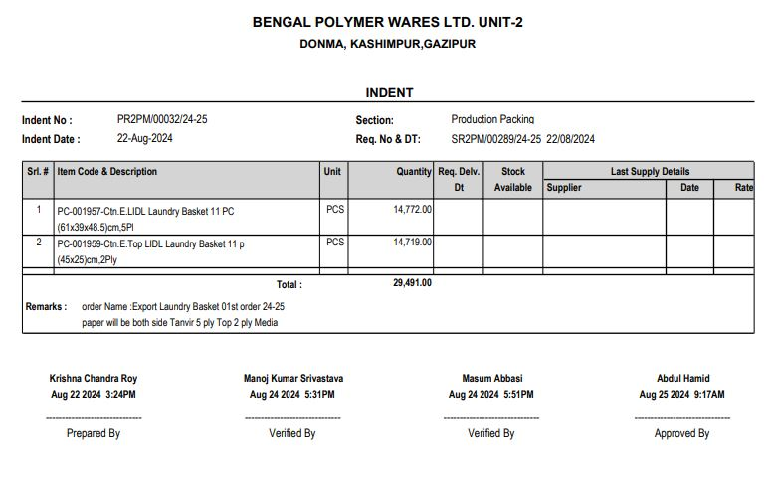
Figure 5: Indent

2. Request for Quotation (RFQ)
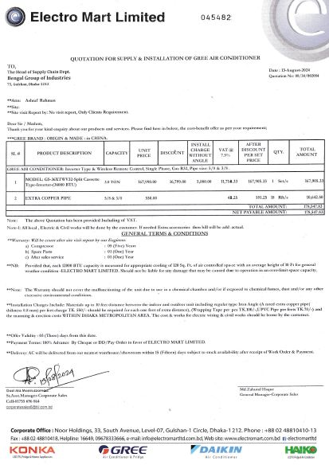
Figure 6: Request For Quotation (RFQ)

3. Comparative Statement (CS)
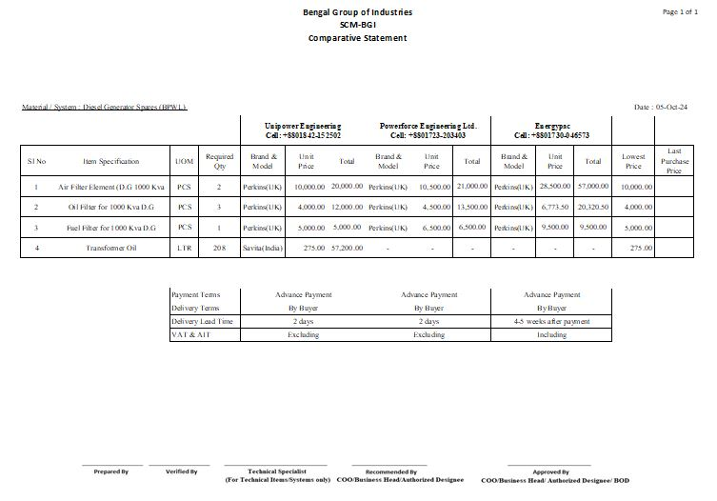
Figure 7: Comparative Statement (CS)

4. Purchase Order (PO)

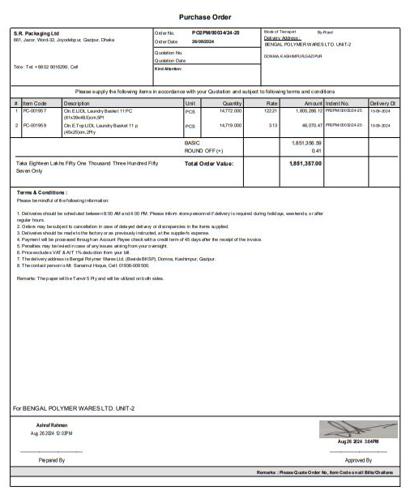

Figure 8: Purchase Order (PO)

5. Invoice
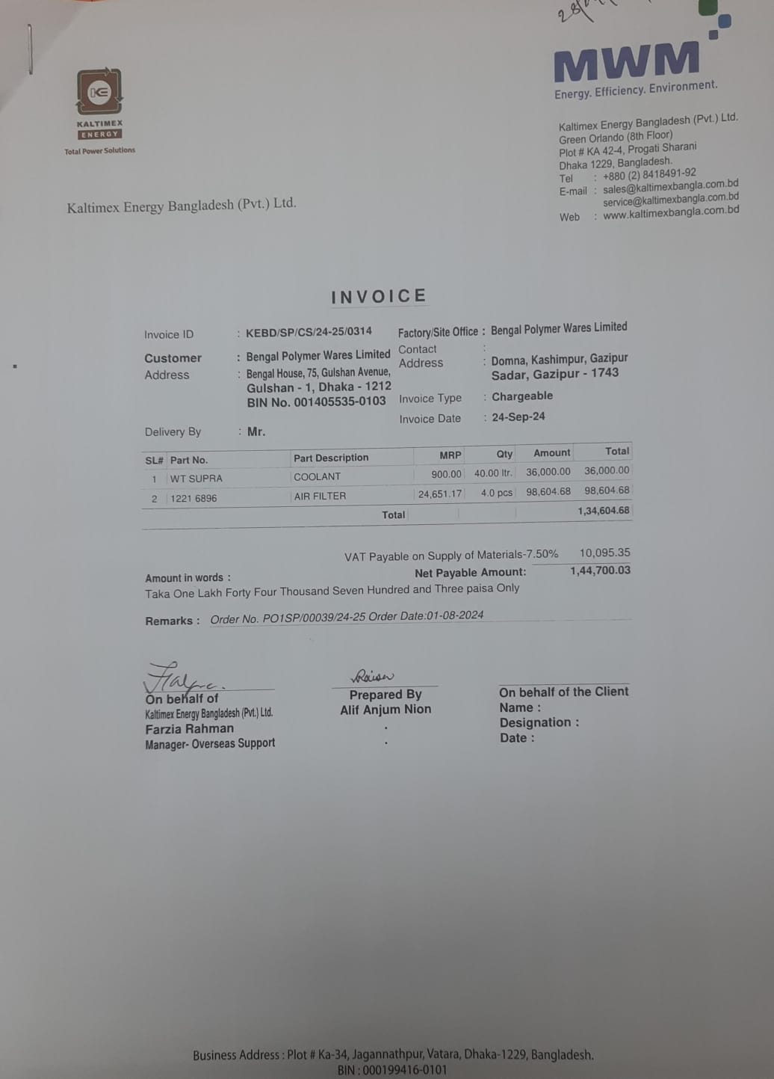
Figure 9: Invoice

6. Goods Receipt Note (GRN)

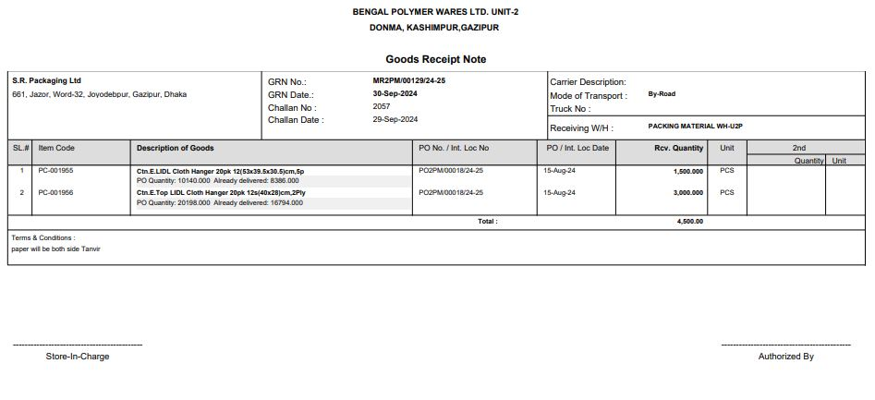
Figure 10: Goods Receipt Note (GRN)

7. VAT Challan
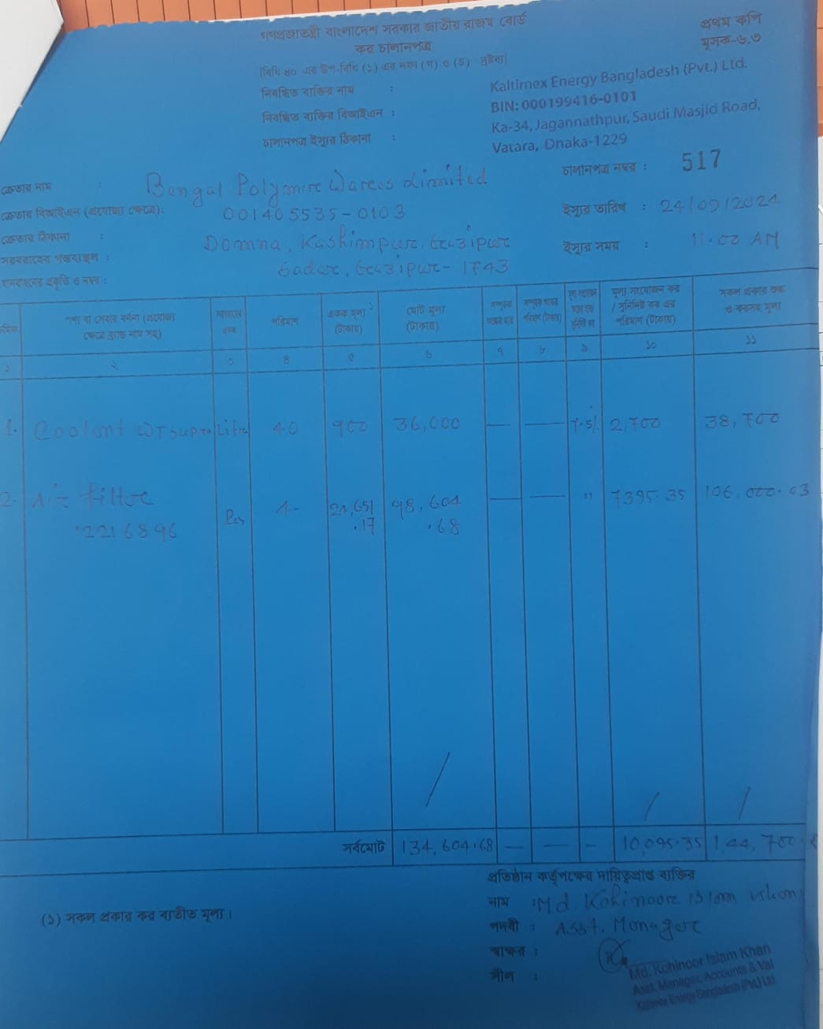
Figure 11: VAT Challan

