

A PROJECT REPORT ON

The Impact of Brand Trust on Brand Satisfaction and Brand Loyalty:
A Study on Selected Television Brands in Bangladesh

01st November 2019
UNITED INTERNATIONAL UNIVERSITY
DHAKA, BANGLADESH
A PROJECT REPORT ON

THE IMPACT OF BRAND TRUST ON BRAND SATISFACTION AND BRAND LOYALTY:
A STUDY ON SELECTED TELEVISION BRANDS IN BANGLADESH

SUPERVISED BY
Muhammad Hasan Al-Mamun
ASSISTANT PROFESSOR,
SCHOOL OF BUSINESS AND ECONOMICS
UNITED INTERNATIONAL UNIVERSITY

PREPARED BY
Md. Mahmudul Hasan Shourab
ID: 111 151 468
BBA PROGRAM
UNITED INTERNATIONAL UNIVERSITY
UNITED INTERNATIONAL UNIVERSITY
Letter of Transmittal

To
Muhammad Hasan Al-Mamun
Assistant professor,
School of business and economics
United International University
Subject: Submission of project report.

Dear Sir,

You will be glad to know that I have recently completed preparing my project report in which I have tried to collect all the information and to analyze them in a meaningful way to prepare the report on “The Impact of Brand Trust on Brand Satisfaction and Brand Loyalty: A Study on Selected Television Brands in Bangladesh”.

I, therefore, pray and hope that your honor would be kind enough to accept my project report and oblige thereby.

Your most obedient student,
Md. Mahmudul Hasan Shourab
ID: 111 151 468
BBA Program
United International University

Acknowledgement
At the very beginning to start my project report, I want to thank respectfully to my ALMIGHTY ALLAH and my parents for making me capable, and supporting me till now to complete this long term Bachelor Business Administration program (BBA) from United International University.
I want to thank my respected marketing course faculty as well as project supervisor Muhammad Hasan Al-Mamun, Assistant professor, School of business and economics, United International University for sharing his valuable time with me during the preparation of this project report. The project outline I received from him was very helpful for me to understand the basic steps of a project report. The report could not be successfully completed without his guidance and supports.

Moreover, I want to show my gratitude to Sumaiya Sultana, Marketing Executive, Samsung Bangladesh; Md. Pavel, Distributor, Sony Bangladesh; and Mahmudul Hasan, Consumer Specialist, LG Bangladesh for sharing consumer information orally from their busy time. All their information motivated me to prepare the report with proper information.

Last but not the least, I want to thank my seniors and friends who provided continuous supports and made me able to understand all the critical marketing terms used in the report that were difficult for me to understand. They also helped me in the data collection process. All their efforts are highly appreciated and without their help it wouldn’t be possible for me complete the project in the given time.
Abstract

The study is conducted to analyze the impact of Brand Trust and the impacts of it on the Brand Satisfaction on Brand Loyalty and overall brand equity. Such impacts were examined in the context of Television industry including three prominent Television brands Samsung, Sony, and LG. The study is an exploratory one where both qualitative and quantitative data are being used and the size of the sample is 51. The sampling technique is non-probabilistic in nature. Reliability considered constructs was evaluated through Cronbach Alpha values that were found to be in the acceptable range.

The study found that the Brand Trust (BT) and Customer Satisfaction (CS) have impacts on Customer Loyalty (CL). The changes is the overall Customer Loyalty can be explained the changes in both Brand Trust (BT) and Customer Satisfaction (CS) by 35.50%. The study also found that Customer Satisfaction (CS) has more impact on the Customer Loyalty because of higher Beta value. The study found that the Brand Trust (BT) and Customer Satisfaction (CS) have impacts on Brand Equity (BE). The changes in the overall Brand Equity can be explained by the changes in both Brand Trust (BT) and Customer Satisfaction (CS) by 44.30%. The study also found that Customer Satisfaction (CS) has more impact on the Brand Equity (BE) because of higher Beta value. The study found that the Brand Trust (BT), Customer Loyalty (CL) and Customer Satisfaction (CS) they all have statistically significant impacts on Brand Equity (BE).

Key Words: Brand Trust, Brand Satisfaction, Brand Loyalty, Brand Equity

Table of Contents
Chapter one: Introduction
1.1 Topic in hand 2
1.2 Context of the study 2
2. Literature Review 4

Chapter Two: Literature Review
2.1 Introduction 4
2.2 Brand Trust Literature 5
2.3 Measuring Brand Trust 7

Chapter Industry Overview
3.1 Global Origin 10
3.2 Review of the selected brands 11
3.2.1 Sony 11
3.2.2 Samsung 13
3.2.3 LG 15
3.3 Objectives of the Study 17
3.4 The methodology of the Study: 18
a. Secondary Sources: 18
b. Primary Data: 18

Chapter Four: Findings, Analysis and Conclusion
4.1 Findings of the report 20
4.1.1 Sample Characteristics: 20
4.1.2 Descriptive Statistics of the Constructs Used in the Study: 22
4.1.3 Reliability Analysis of the Constructs Used in the Study: 25
4.1.4 The Variations in Brand Trust (BT) across the Brands: 27
4.1.5 The Variations in Customer Satisfaction (CS) across the Brands: 27
4.1.6 The Variations in Customer loyalty (CL) across the Brands: 28
4.1.7 The Variations in Brand Equity (BE) across the Brands: 29
4.1.8 The Impact of BT and CS on Customer Loyalty (CL): 29
4.1.9 The Impact of BT and CS on Brand Equity (BT): 30
4.1.10 The Impact of BT, CS and CL on Brand Equity (BT): 31
4.2 Future Research Scopes 32
4.3 Conclusion 32
Reference 33
Appendix: Statistical Output 35


Chapter one: Introduction

1.1 Topic in Hand
In a growing competitive environment, the brand becomes the most valuable, the most strategic and the most important resource for society and is of great interest. The brand is one of the main tools that marketing professionals have to mitigate the sensitivity of consumer prices to market competition. Consumers tend to pay more for a brand because they achieve excellent value in a brand that no competitor can offer. Therefore, brand managers are trying to solve this problem by creating stronger brands. The common strategy used to promote the brand is to create a climate of trust between the company and the consumer. The brand trust provides a superior purpose through which it is possible to examine and evaluate the responses to consumer behavior.
Brand Trust is a key factor in the success of the company. From the point of view of marketing professionals, it constitutes a portfolio of investments in relations with the business partner; offers long-term benefits prevents high-risk actions as well as it is the cornerstone of any strategic partnership. From the consumer's point of view, brand trust is one of the essential resources of a company's customer relationship and the main reason for consumer behavioral responses (customer satisfaction) to businesses. Many researchers have stated that effective marketing of services and the provision of adequate products, tailored to the needs of consumers, can help to regain the satisfaction and loyalty of the consumers for the company's brand.

1.2 Context of the study
The project report is a pre-requirement of acquiring the under-graduation certificated from the United International University. The topic that I have prepared the report is “The impact of brand trust on brand satisfaction and brand loyalty: a study on selected television brands in Bangladesh”. According to Holbrook and Chawdhury's (2001) definition of the brand trust, the trust of a brand is "the willingness of the average consumer to rely on the brand's ability to fulfill its intended function". It can be interpreted that trust in the brand is created and developed by consumers' direct experiences through brands. The project report is to analyze the brand trust’s impact on satisfaction and loyalty of the popular TV brand’s (Samsung, Sony, and LG) consumers in Bangladesh.

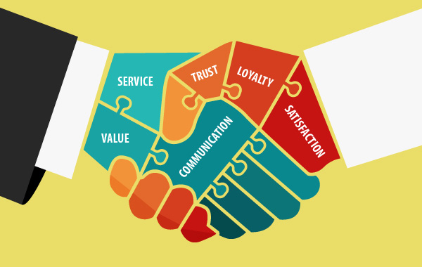
Chapter Two: Literature Review

2. Literature Review
The chapter literature review is to share several marketing concepts so that any reader who reads the report may easily understand the critical or technical terms of the report. This report is also intended to clarify theoretical justification of including the constructs considered in the study and the interrelationships among those constructs. The report is based on three marketing concepts that are Brand Trust, Brand Satisfaction and Brand Loyalty..

2.1 Introduction
According to Holbrook and Chaudhuri (2001), Munuera-Alemán, Delgado-Ballester, and Yagüe-Guillén (2003), brand trust is at the heart between the customer and brand relationship. Trust in the brand is important because it shares that the relationship between a brand and a consumer can go beyond the customer satisfaction "(Behi and Belaid (2011), suggesting that this relationship is something more than a simple transaction (Story and Hess (2005) Furthermore, trust of the brand has a positive influence on important result variables such as brand loyalty (for example, Chaudhuri and Holbrook (2001)), brand engagement (Chaudhuri and Holbrook (2002)) and Intention to Purchase (Lacey (2007)). Therefore, the trust of the brand has recently become the focus of attention of researchers and professionals (Kashyap, Li, Yang and Zhou, (2008)).
In this context, it is surprising that brand trust has no consistent concept and functionality. In contrast, the concept of brand trust remains controversial. Researchers have described the term 'brand trust' in several ways, and a consistent definition of brand trust has not been defined in previous literature till now. The main difference is in the number of trusted brand dimensions. Some authors, such as Holbrook and Chowdhury (2001), explain the brand's trust as one-dimensional, others as Lee et al. (2008) and Delgado-Ballester et al. (2003), describe brand trust as two-dimensional or three-dimensional. Also, there was a significant disadvantage of the old brand confidence scales, which researchers found to be in agreement with brand confidence but did not prove the discriminant validity of conceptually different concepts.
This project report is going to explain the concept of brand trust, brand satisfaction, and brand loyalty. Moreover, the report also share the impacts of brand trust on the brand satisfaction and the brand loyalty of customer based on some few selected television brands of Bangladesh.

2.2 Conceptualization of the Constructs
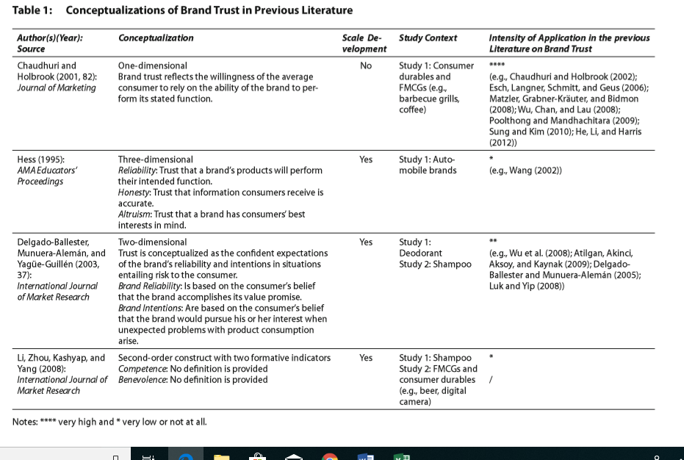
We start by discussing conceptualizations and developments on an earlier scale of brand trust. As a result, we offer an overview of the context and results of brand trust. The themes of this review of the literature on brand trust are the publications on brand trust in the marketing magazines which is recorded in the VHB-JOURQUAL, 2011 ranking.

Table 1 illustrates the different perceptions of brand trust. The table also describes the context of the study, if the measure is based on the development of the scale and until then applied by other researchers. As will be included in Table 1, there is no consistent concept of brand trust. The key difference lies in the number of dimensions they add to the brand. Some authors, such as Chowdhury and Holbrook (2001), developed a one-dimensional brand and others such as Lee et al (2008) and Delgado-Ballester et al (2003), believed to have 2 or 3 dimensions.
Numerous studies lead to greater development of brand trust. After inter-organizational and interpersonal research on trust, these studies conceptualize brand trust as multidimensional. First, Hesse's greater development (1995) includes very large levels of brand trust: reliability, altruism, integrity, and (see the limit of Table 1). However, one weakness of this expanded development is that the analysis of search and confirmation factors is extended to the same data sets. As a result, the results can be distorted upward (Baumgartner and Steenkamp (1996)). Furthermore, discriminant validators are only supposed to correlate between the same magnitudes and enter each subscale and satisfaction. There is no additional evidence to validate the discriminants. Finally, he studies the brands of a single category of very specific featured (such as automobiles) products.
Second, Delgado-Ballester et al. (2003) measured a measurement scale based on two dimensions that are subsequent intentions and reliability. However, the authors only demonstrated the validity of the brand within a continuous dimension of trust and did not study a conceptually different concept similar to loyalty to the brand.
Third, by Lee et al. (2008) Conceptualizing the trust of the brand as a second-order construct with two indicators of training, benevolence, and skills of competition (see Table 1 index). However, only nominal validity tests were performed to measure loyalty to a purchase. Accordingly, the sole validity of the discriminant was confirmed by the same magnitude, and one does not examine, but conceptually separate, the similarity of the brand's trust structure.
The multidimensional concept of brand confidence is based on the concept of interpersonal and inter-organizational trust. The Delgado-Ballester et al. (2003) justifies the adoption of interpersonal and inter-organizational beliefs in the context of the core brand, arguing that a brand can have an impact on being an active relational partner (Fournier (1998)). A comparison of the triumphs of the brand's multidimensional belief shows that everyone has a performance dimension, commonly called "Skill of competition" or "reliability" These leaders also agree with a dimension of "intention", often called "charity", "purpose" or "altruism." The dimension is limited to the customer who has the best interest of the disputing brand in case of unforeseen problems in product usage. Thus, these multidimensional counters have clearly or implicitly assumed that the brand is an active relational partner.
However, previous literature has disputed that it has a brand that can certainly be associated with being an active relationship partner. For example, to examine the differences in the interpersonal relationship and existence between consumer and brand, Bengtsson (2003) observes: "People can think and interact with each other, even though brands cannot, moreover, brands can only direct through its managers' behavior. For example, a brand may not respond uniquely to a customer's needs and, therefore, lacks one of the important qualities that characterize human relationships. "Thus, Bengtsson (2003) states that there may be consumers who do not consider their favourable brand as an active partner.”

3.1 Global Origin
Televisions are found in billions of homes worldwide. But 100 years ago, nobody knew what a television was. In fact, until 1947, only a few thousand Americans owned a television.
One of the first mechanical televisions used a rotating disk with spiral holes. This device was created independently by two inventors: the Scottish inventor John Logie Baird and the American inventor Charles Francis Jenkins. Both devices were invented in the early 1920s.\
Before these two inventors, German inventor Paul Gottlieb Nipkow had developed the first mechanical television. This device sent images via cables using a rotating metal disk. However, instead of calling the TV device, Nipkow called it an "electric telescope." The device had 18 lines of resolution.
The world's first electronic television was created by an inventor named Philo Taylor Farnsworth, 21. This inventor lived in a house without electricity until he was 14 years old. Already in high school, he began to think of a system that could capture moving images, transform those images into code and then transfer those images by radio waves to different devices.
Electronic televisions are based on a technology called Cathode Ray Tube (CRT) and two or more anodes. The anodes were the positive terminals and the cathode was the negative terminal. The "cathodic" portion of the cathode ray tube was a heated filament enclosed in a glass tube (the "T" of the cathode ray tube). The cathode threw an electron beam into the empty space of the tube (which was actually a vacuum).
In the United States, the first commercially produced televisions were based on the mechanical television system created by John Baird. These sets were shown to the public on September 1928. Anyways, it would take until 1938 to produce and market US electronic televisions. They were an immediate success after the launch.
Between 1950 and 2010, the result of niche technology, television became a vital form of home communication across the country. Many changes and improvements took place in the second half of the twentieth century to transform television. Here is a timeline:

1950: In 1955, half of the American homes bought a television. The color transmission finally arrived in the United States in 1953, when FCC approved a modified version of that created by RCA. The first color advertising was shown and in 1954 television became the main source of national advertising. Robert Adler invented the first practical remote control called Zenith Space Commander, which was controlled by remote controls wired to the sun.
1960: In the 1960s, television underwent profound changes in sales, technology, and perception of people. Before the 1960s, television was an entertainment factor and not a necessity. But when the Telstar I satellite was put into orbit in 1962, television became an important source of information.
1970: Half of the domestic TVs are color games and Sony introduces Betamax, the first home video recorder.
1980: Children born after 1979 assume that the magic box on the wall has always been like this. Few children realize that television programs were not in color until 1964. In 1986 Super VHS was introduced.
1990: 900 million television sets are used worldwide.
2000: Television signals in analog and digital format.
2010: The creation of 3D television.

3.2 Review of the selected brands

3.2.1 Sony
Sony Corporation is the division of electronic commerce and parent company of the Sony Group, which operates in the sector through its four operating components: films (films and television programs), electronics (AV, semiconductors, computer and communication products, services network, video games and medical matters), music (music publishing and record companies) and financial services (insurance and banking). This makes Sony one of the most complete entertainment companies in the world. The group consists of Sony Corporation, Sony Mobile, Sony Pictures, Sony Music, Sony Interactive Entertainment, Sony Financial Holdings, and others.

Sony, as a TV brand, gives higher priority to image quality and accuracy than other manufacturers. All the televisions in its range are well built, have good movement management and a great improvement in low-resolution content. Sony has updated most of its TVs on Android TV 8.0. This, in addition to giving the customer access to the Google Play Store with a multitude of applications, works much faster than its predecessor, Android 7.0, and solves one of Sony's biggest flaws: the responsiveness of the operating system.
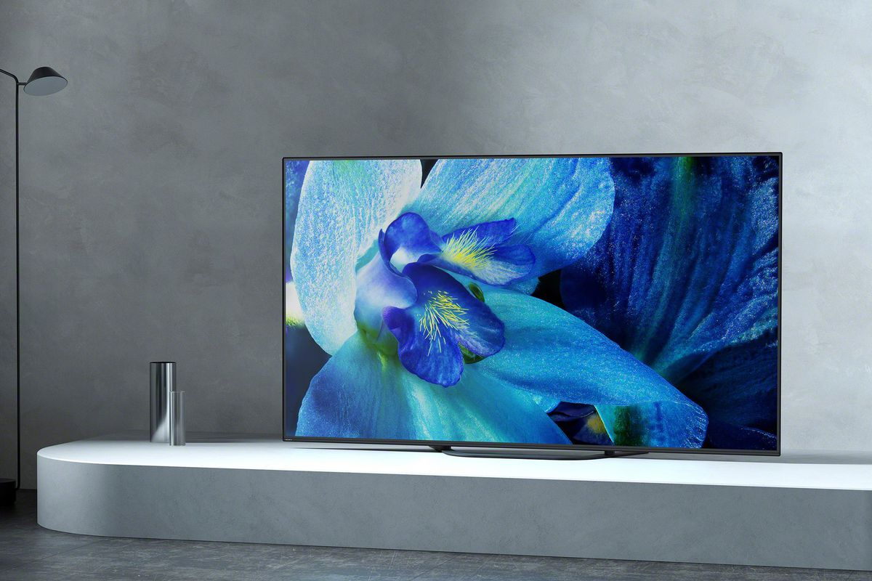
Image: Sony A9G OLED
The Sony 2018 range and the new 2019 range only contain 4k TVs and only a few models were available in sizes smaller than 55 inches, which is the trend of the larger TV models. To provide excellent image quality, Sony had introduced flagship smart television called Sony A9G OLED and this model also offers an HDR experience as close as possible to the designer's intentions.
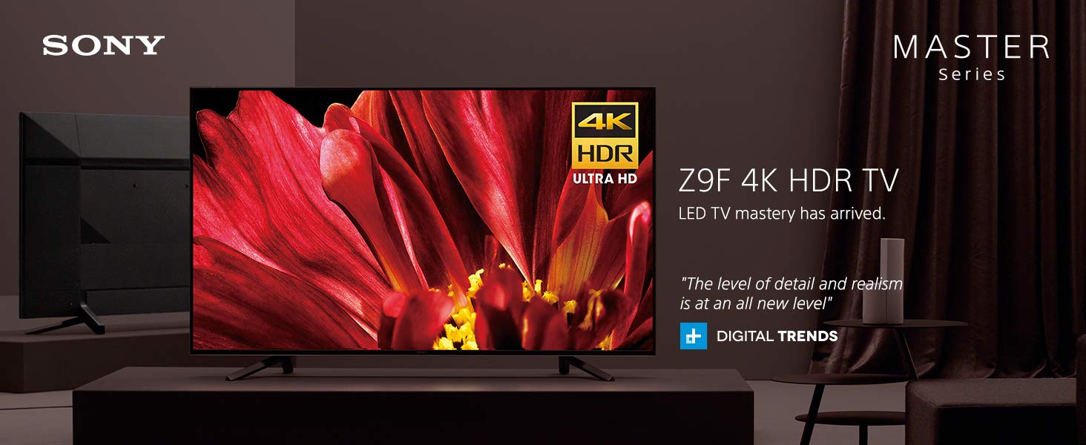
Image: Sony Z9F
However, if consumers do not want to avoid the risk of burns inherent in all OLEDs, they can choose the best Sony LED / LCD TV, the Sony Z9F, which offers excellent performance in almost all uses, including wider view thanks to the new Angle.
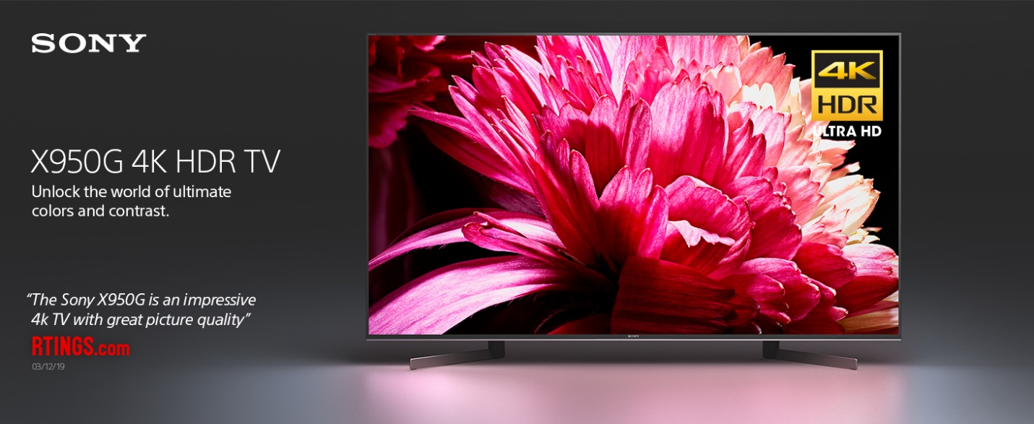
Image: Sony X950G
This new technology is also integrated into the larger variants of the new Sony X950G. This is an excellent TV available in very large sizes up to 85 "and that will delight the happiest people with their performance. Finally, from the bottom of the Sony range, the Sony X750F basic stands out for Like TV IPS with wide viewing angles and good image quality, this recommendation will continue to be updated as we test more TVs on the current line.

3.2.2 Samsung
Samsung is a worldwide renowned brand in the television industry and one of the best television brands. It is available in a variety of models, from cheap TVs to high-end 8k models. Samsung is known for its excellent image quality and extraordinary intelligence. These improvements are the result of Samsung's research in this area. Samsung's Tizen OS smart platform is one of the best-operating systems on the market. This year, Samsung introduced "Super Perspective" technology, which reduces viewing angles with lower contrast. It is included in its flagship models, namely the Samsung Q90R, the Samsung Q80R, and the Samsung Q900R 8k. In addition, another recent feature is the "Environment Mode", which shows the images on the screen.

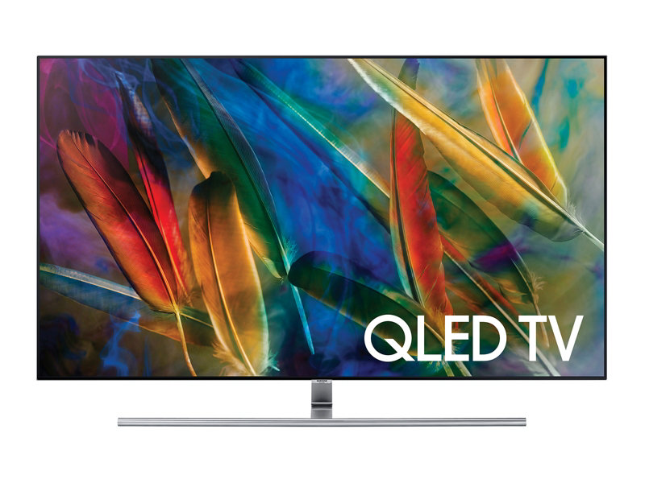
Image: Samsung QLED TV (2017)
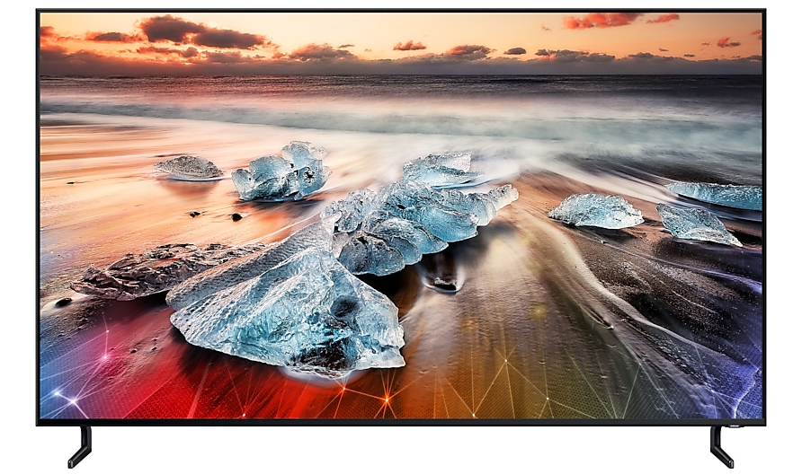
Although the transition from one year to another is generally weak, this is not always the case. In 2017, Samsung launched the QLED TV for the first time, with excellent color.
Image: Q900R 8k TV (2018)
In 2018, they launched the first Samsung Q900R 8k TV and added new technologies such as FreeSync VRR, low latency motion interpolation and automatic playback modes to the high-end TV line.

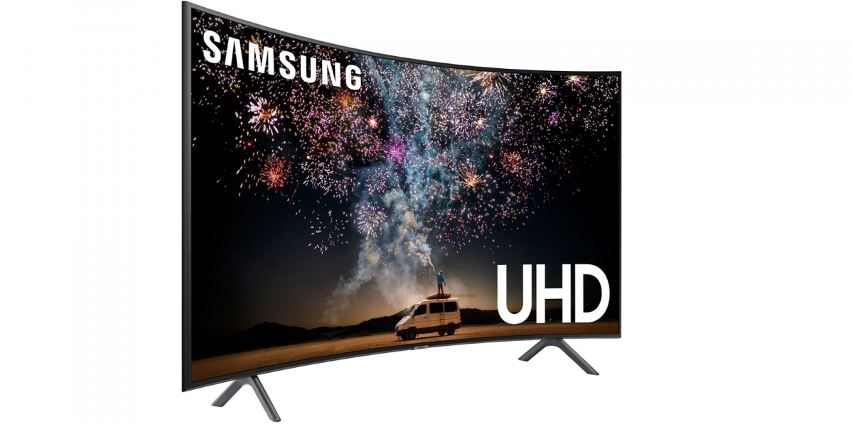
Image: Smart QLED Ultra Viewing Angle UHD (2019)
Currently, in 2019, Samsung launched "Super Perspective Ultra viewing angle" technology. However, Samsung expects to satisfy existing customers by providing, as far as possible, updates of the current set of models through firmware updates. Last year, they updated many 2018 firmware models to include support for these emerging technologies.

Samsung offers a wide range of televisions to help its consumers to meet their needs. Television with a variety of flavors and wallets. The company's flagship product is the Samsung Q90R, which offers impressive image quality, exceptional HDR performance and unique game features and performance. The QLED range also includes a new Samsung RU8000 with excellent gaming performance. Unfortunately, last year the Samsung NU8000 did not work as well due to its low light and local dimming. For those looking for a TV in the economic category, they offer the Samsung RU7100. It has dimensions ranging from 40 "to 75" and is suitable for any environment. Despite its low price, this TV still offers good overall picture quality and works on the same smart platform as more expensive models, but lacks the most advanced features of high-end models, such as cancellation of nervousness.

3.2.3 LG
LG is known for its OLED TVs because it is one of the first TV manufacturers to produce them. The picture quality of most OLED TVs is very similar because of the emissive technology that allows TVs to turn off individual pixels, thus providing perfect blacks. This almost infinite contrast ratio makes it possible to create exceptional image quality, especially in a dark room. However, LG also produces a large number of LCD TVs, mainly using IPS panels. IPS panels offer wider viewing angles than VA panels, but at the same time they do not exhibit a high contrast ratio, giving blacks a gray appearance in a dark room. The lowest range of the LG TV series is made up of cheaper TVs that are generally not able to offer high brightness and do not regularly follow our recommendations, with the exception of their wide-angle view function.

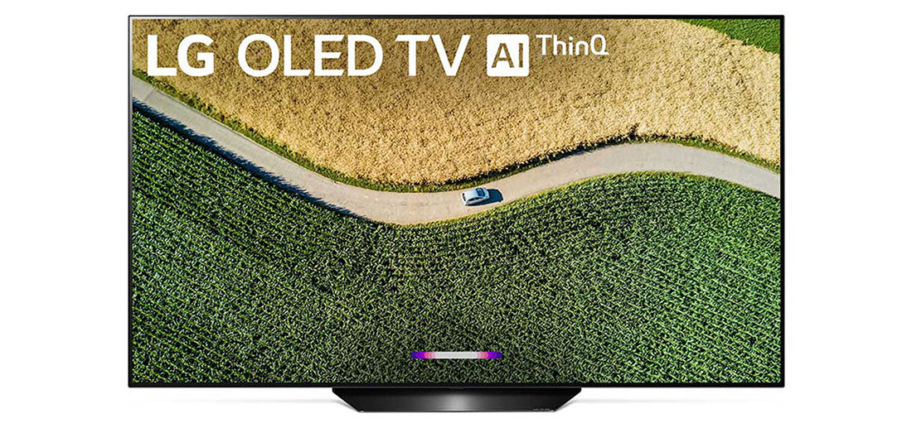
In general, LG LED TVs have a very low entry delay and wider viewing angles than other brands, thanks to their IPS displays. These features make it an excellent choice to use as a PC monitor. Unfortunately, in a dark room, blacks tend to appear gray because of the low contrast ratio. The intelligent interface of LG TV is LG's Web-OS, which is fast and easy to use and gives you access to one of the largest collections of applications available. This is one of the best operating systems for television that we have tested so far. Most high-end LGs come with one of the most advanced remotes. It allows you to navigate the menus without problems and the latest remote models also include a pointer.

Image: LG B9 OLED (AI ThinQ)
LG's high-end OLED TVs are the flagship product of the company. However, the range of LG TVs covers the entire spectrum of budgets, from cheap TVs with wide viewing angles to the most successful OLED TVs with extraordinary picture quality. In 2019 we tested the LG B9 OLED, the LG C9 OLED and the LG E9 OLED.

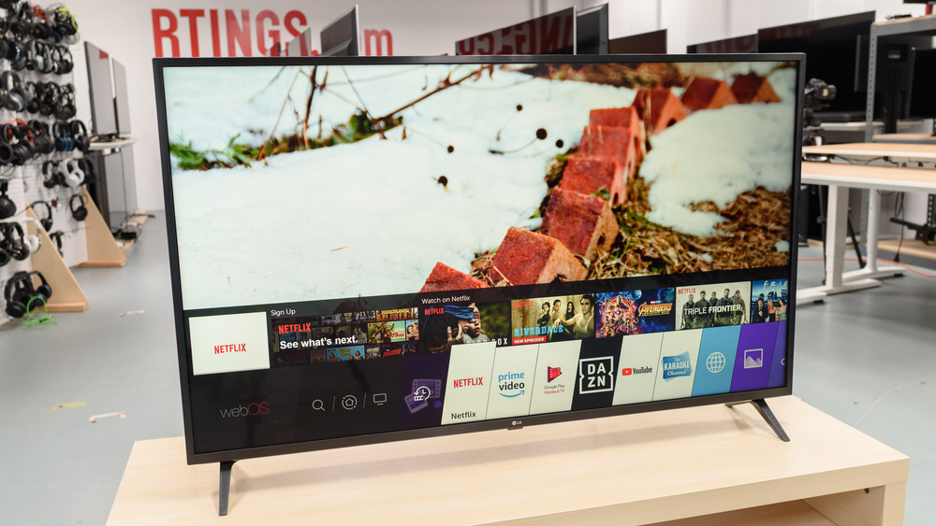
Image: LG UM7300
All have exceptional image quality, exceptional motion management and a remarkably low entry time to satisfy the players. They're also more scalable TVs than their counterparts in 2018, as they offer support for the variable HDMI 2.1 update frequency and the HDMI Forum for an almost tears-free gaming experience. Among the top models, in addition to OLEDs, there is the LG SM9500, which is an excellent 4k IPS LCD TV with wide viewing angles and excellent entry delay. Unfortunately, the performance of the darkroom is simply decent due to the low contrast ratio. The best cheap LG TV we have tested so far is the LG UM7300. It has good overall performance, wide viewing angles and an exceptional entry delay for rented readers.

3.3 Objectives of the Study
The objectives of the study can be clarified in the following ways:
- To examine the variation in Brand Trust (BT) across the brands considered in the study, in the context of smart television services in Bangladesh.
- To examine the variation in Customer Satisfaction (CS) across the brands considered in the study, in the context of smart television services in Bangladesh,
- To examine the variation in Customer Loyalty (CL) across the brands considered in the study, in the context of smart television service in Bangladesh.
- To examine the variation in Brand Equity (BE) across the brands considered in the study, in the context of smart television service in Bangladesh.
- To measure the influence of Brand Trust (BT) and Customer Satisfaction (CS) on Customer Loyalty (CL), in the context of smart television service in Bangladesh.
- To measure the influence of Brand Trust (BT) and Customer Satisfaction on Brand Equity (BE), in the context of smart television service in Bangladesh.

3.4 The methodology of the Study:
Here the data were collected from the following two sources:

Secondary Sources:
Various websites, journals, and books were used for the purpose of developing the literature review and reviewing the organizational background of the various companies considered in the study.

Primary Data:
Primary data were collected by using a self-administered questionnaire for the purpose of measuring the constructs considered in the study. Here the sample size was 51. The sampling technique was non-probabilistic in nature, restricting the generalization of the findings.

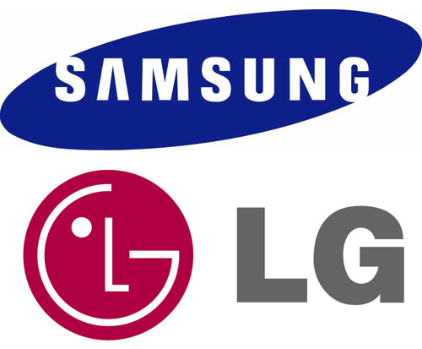
Chapter 4: Findings, Research Scopes and Conclusion

4.1 Findings of the report
The findings of the study will clarify and/or analyze the following aspects:
4.1.1 Sample Characteristics.
4.1.2 Descriptive Statistics of the Constructs Used in the Study.
4.1.3 Reliability Analysis of the Constructs Used in the Study.
4.1.4 The Variations in Brand Trust (BT) across the Brands.
4.1.5 The Variations in customer satisfaction (CS) across the Brands.
4.1.6 The Variations in customer loyalty (CL) across the Brands.
4.1.7 The Variations in Brand Equity (BE) across the Brands.
4.1.8 The Impact of Brand Trust (BT) and Customer Satisfaction (CS) on Customer Loyalty (CL).
4.1.9 The Impact of Brand Trust (BT) and Customer Satisfaction (CS) on Brand Equity (BE).
4.1.10 The Impact of Brand Trust (BT), Customer Satisfaction (CS), customer loyalty (CL) on Brand Equity (BE).

4.1.1 Sample Characteristics:
Sample characteristics will be explained in terms of the following variables:
- Gender
- Education
- Profession
- Average Monthly Family Income

- Gender: The gender distribution of the sample is shown in the table given below:

 |  | Frequency | Percent | Valid Percent | Cumulative Percent
Valid | Male | 34 | 66.7 | 66.7 | 66.7
Valid | Female | 17 | 33.3 | 33.3 | 100
Valid | Total | 51 | 100 | 100

There were 34 male (66.70%) and 17 female (33.30%) respondents taken in the sample for the purpose of conducting the study.

- Education: The education distribution of the sample is shown in the table given below:

 |  | Frequency | Percent | Valid Percent | Cumulative Percent
Valid | SSC or below | 3 | 5.9 | 5.9 | 5.9
Valid | HSC | 2 | 3.9 | 3.9 | 9.8
Valid | Bachelor | 30 | 58.8 | 58.8 | 68.6
Valid | Masters or equivalent | 16 | 31.4 | 31.4 | 100
Valid | Total | 51 | 100 | 100

There were 3 SSC or below (5.90%), 2 HSC (3.90%), 30 Bachelor (58.80%), and 16 Masters or equivalent (31.40%) respondents taken in the sample for the purpose of conducting the study.

- Profession: The profession distribution of the sample is shown in the table given below:
 |  | Frequency | Percent | Valid Percent | Cumulative Percent
Valid | Student | 28 | 54.9 | 54.9 | 54.9
Valid | Service Holder | 13 | 25.5 | 25.5 | 80.4
Valid | Business | 7 | 13.7 | 13.7 | 94.1
Valid | Others | 3 | 5.9 | 5.9 | 100
Valid | Total | 51 | 100 | 100

Maximum data was collected from the students through university premises which showed the greatest frequency of profession proved which didn’t surprise at all. The percentage of students in the study sample was 54.90%, service holders ranked second with a percentage of 25.50%, business ranked third with a percentage of 13.70% and people from other professions were of 5.90%.

- Average monthly family income: The average monthly family income distribution of the sample is shown in the table given below:

 |  | Frequency | Percent | Valid Percent | Cumulative Percent
Valid | 30,000 or below | 6 | 11.8 | 11.8 | 11.8
Valid | 30,000 - 60,000 | 17 | 33.3 | 33.3 | 45.1
Valid | 60,000 - 90,000 | 15 | 29.4 | 29.4 | 74.5
Valid | 90,000 - 1,20,000 | 9 | 17.6 | 17.6 | 92.2
Valid | Above 1,20,000 | 4 | 7.8 | 7.8 | 100
Valid | Total | 51 | 100 | 100

The range of Taka 30,000- 60,000 was the first highest range provided for this study and it proved to be the most common among the sample size. The aforementioned range had a percentage of 33.3%; while the maximum range of Taka 60,000-90,000 was the second most common, with a percentage value of 29.4%; The other ranges had close percentages with the Taka 90,000-120,000 range having a percentage of 17.6%; The Taka 30,000 or below range valuing 11.8% and the least percentage of 7.8% belonging to the lowest range of Taka above 120,000.

4.1.2 Descriptive Statistics of the Constructs Used in the Study:
The following table shows the basic descriptive characteristics of the major constructs used in this study:
 | N | Minimum | Maximum | Mean | Std. Deviation
BT | 51 | 1.4 | 5 | 3.5961 | 0.74564
CS | 51 | 2 | 5 | 3.3856 | 0.82293
CL | 51 | 1 | 4.75 | 2.6275 | 0.92652
BE | 51 | 1.25 | 4.5 | 3.1275 | 0.76383
Valid N (list wise) | 51

Here,
BT= Brand trust
CS= Customer Satisfaction
CL= Customer loyalty
BE= Brand Equity.
Now assuming 95% level of confidence, the confidence interval for each construct will be estimated here:

- For BT (brand trust), the confidence interval will be given by-
C.I. = X̅ ± D D= Z $\frac{σ}{√n}$
= 3.60±0.20 = 1.96 * $\frac{.74}{√51}$
= (3.40, 3.80) = 0.20
While measuring the brand trust (BT) level forms the simple, the mean value calculated was 3.60, with a standard deviation of .74. The low value of standard deviation proves that the data points are quite close to the mean. The standard deviation of .74 along with a confidence interval of 95% provides the data range to be within 3.40<BT<3.80.

- For CS (Customer Satisfaction), the confidence interval will be given by-

C.I. = X̅ ± D D= Z $\frac{σ}{√n}$
= 3.39±0.23 = 1.96*$\frac{.82}{√51}$
= (3.62, 3.16) = 0.23

While measuring the customer satisfaction (CS) level forms the sample, the mean value calculated was 3.39, with a standard deviation of 0.82. The low value of standard deviation proves that the data points are quite close to the mean. The standard deviation of 0.82 along with a confidence interval of 95% provides the data range to be within 3.16<CS<3.62

- For CL (Customer Loyalty), the confidence interval will be given by-

C.I. = X̅ ± D D= Z $\frac{σ}{√n}$
= 2.63±0.25 = 1.96*$\frac{.92}{√51}$
= (2.88, 2.38) = 0.25

The measurement of customer loyalty (CL) level averaged to be 2.63 and the standard deviation calculated was .92. A low value for the standard deviation is observed yet once again, providing validation for the results found. A reliability construct will be done later on to be more confident of the sample data collected. The mean of 2.93 along with the standard deviation of .92 and confidence interval of 95% shows that the sample data spreads from 2.38<BE<2.88.

- For BE (Brand Equity), the confidence interval will be given by-

C.I. = X̅ ± D D= Z $\frac{σ}{√n}$
= 3.12±0.21 = 1.96*$\frac{.76}{√51}$
= (3.33, 2.91) = 0.21

The measurement of brand equity (BE) level averaged to be 3.12 and the standard deviation calculated was .76. A low value for the standard deviation is observed yet once again, providing validation for the results found. A reliability construct will be done later on to be more confident of the sample data collected. The mean of 3.12 along with the standard deviation of .76 and confidence interval of 95% shows that the sample data spreads from 2.91<BE<3.33.

4.1.3 Reliability Analysis of the Constructs Used in the Study:
Cronbach alpha is a statistical measure of internal consistency of multiple-item scale designed to measure a construct that is of interest to the researcher.
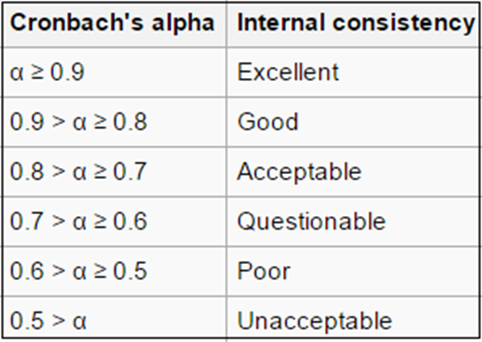

Now the given rule of thumbs will be used in evaluating the reliability of the constructs used in the study.

Construct | Items | Cronbach Alpha
- Brand Trust (BT) | I am confident in “X” ability to perform well. | 0.8416
- Brand Trust (BT) | I trust “X” | 0.8416
- Brand Trust (BT) | I rely on “X” | 0.8416
- Brand Trust (BT) | “X” is safe | 0.8416
- Brand Trust (BT) | “X” delivers what it promises | 0.8416
The Alpha value for constructing Brand Trust (BT) was calculated to be .8416 by the SPSS software. According to the rule of thumb of reliability coefficients an alpha value is 0.9 > α ≥ 0.8 which proves to have a good internal consistency. This good level of internal consistency validates the reliability of this construct used in the study.

Construct | Items | Cronbach Alpha
- Customer Satisfaction (CS) | All in all, I am very satisfied with “X” | 0.7999
- Customer Satisfaction (CS) | “X” meets my idea expectations | 0.7999
- Customer Satisfaction (CS) | The performance of “X” has fulfilled my expectation | 0.7999
The Alpha value for construct Customer Satisfaction (CS) was shown to be .7999 by the SPSS. This value, in line with the rule of thumb, which shows value 0.8 > α ≥ 0.7 that indicates the level of “Acceptable” and so is proved to have suitable level of consistency with the study conducted.

Construct | Items | Cronbach Alpha
- Customer loyalty (CL) | I will buy “X” in the next time; I buy a product of this category | 0.8535
- Customer loyalty (CL) | I intend to keep purchasing “X” | 0.8535
- Customer loyalty (CL) | I am committed to “X” | 0.8535
- Customer loyalty (CL) | I would be willing to pay a higher price for “X” over other brands. | 0.8535
The Alpha value for constructing Customer Loyalty (CL) was calculated to be .8535 by the SPSS software. According to the rule of thumb of reliability coefficients an alpha value is 0.9 > α ≥ 0.8 which proves to have a good internal consistency. This good level of internal consistency validates the reliability of this construct used in the study.

Construct | Items | Cronbach Alpha
- Brand Equity (BE) | It makes sense to buy “X” instead of any other brand, even if they are the same | 0.7500
- Brand Equity (BE) | Even if another brand has the same feature as “X”, I would prefer to buy “X” | 0.7500
- Brand Equity (BE) | If there is another brand as good as “X”, I prefer to buy “X” | 0.7500
- Brand Equity (BE) | If another brand is not different from “X” in any way, It seems smarter to purchase “X” | 0.7500
The Alpha value for construct Brand Equity (BE) was shown to be .7500 by the SPSS. This value, in line with the rule of thumb, which shows value 0.8 > α ≥ 0.7 that indicates the level of “Acceptable” and so is proved to have suitable level of consistency with the study conducted.

4.1.4 The Variations in Brand Trust (BT) across the Brands:
For the purpose of evaluating the variations in the brand trust across the brand, a one-way analysis of variance was conducted. Here, we have the following hypothesis:
 | Sum of Squares | df | Mean Square | F | Sig.
Between Groups | 3.183 | 2 | 1.591 | 3.103 | 0.054
Within Groups | 24.616 | 48 | 0.513
Total | 27.799 | 50

$H_{0 }$: $μ_{1}{=μ}_{1}=μ_{1}$
$H_{1}$: $μ_{1}{≠μ}_{1}≠μ_{1}$
Here, F= 3.103, α=0.05, Sig. =0.054
There is null hypothesis will be rejected. Because here, Sig. = 0.054 < α =0.05. So it is concluded that the relationship is statistically significant.

4.1.5 The Variations in Customer Satisfaction (CS) across the Brands:
For the purpose of evaluating the variations in the brand trust across the brand, a one-way analysis of variance was conducted. Here, we have the following hypothesis:
 | Sum of Squares | df | Mean Square | F | Sig.
Between Groups | 2.318 | 2 | 1.159 | 1.764 | 0.182
Within Groups | 31.542 | 48 | 0.657
Total | 33.861 | 50

$H_{0 }$: $μ_{1}{=μ}_{1}=μ_{1}$
$H_{1}$: $μ_{1}{≠μ}_{1}≠μ_{1}$
Here, F= 1.764, α=0.05, Sig. = .182
There is null hypothesis will be Accepted. Because here, Sig. = .182 > α =0.05. So it is concluded that the relationship is not statistically significant.

4.1.6 The Variations in Customer loyalty (CL) across the Brands:
For the purpose of evaluating the variations in the brand trust across the brand, a one-way analysis of variance was conducted. Here, we have the following hypothesis:

 | Sum of Squares | df | Mean Square | F | Sig.
Between Groups | 4.429 | 2 | 2.214 | 2.761 | 0.073
Within Groups | 38.493 | 48 | 0.802
Total | 42.922 | 50

$H_{0 }$: $μ_{1}{=μ}_{1}=μ_{1}$
$H_{1}$: $μ_{1}{≠μ}_{1}≠μ_{1}$
Here, F= 2.761, α= 0.05, Sig. = .073
There is null hypothesis will be Accepted. Because here, Sig. = .073 > α =0.05. So it is concluded that the relationship is not statistically significant.

4.1.7 The Variations in Brand Equity (BE) across the Brands:
For the purpose of evaluating the variations in the brand trust across the brand, a one-way analysis of variance was conducted. Here, we have the following hypothesis:
 | Sum of Squares | df | Mean Square | F | Sig.
Between Groups | 5.341 | 2 | 2.67 | 5.379 | 0.008
Within Groups | 23.831 | 48 | 0.496
Total | 29.172 | 50

$H_{0 }$: $μ_{1}{=μ}_{1}=μ_{1}$
$H_{1}$: $μ_{1}{≠μ}_{1}≠μ_{1}$
Here, F= 5.379, α=0.05, sig. = .008
There is null hypothesis will be rejected. Because here, Sig. = .008 > α =0.05. So it is concluded that the relationship is statistically significant.

4.1.8 The Impact of Brand Trust (BT) and Customer Satisfaction (CS) on Customer Loyalty (CL):
For the purpose of measuring the impact of brand trust and customer satisfaction on customer loyalty, a multiple regression was conducted taking Brand Trust (BT) and Customer Satisfaction (CS) as the independent variable and Customer Loyalty (CL) as the dependent variable.

Independent variables | Coefficient (b) | Beta (β) | T | Sig.
Constant | 0.241 | -- | 0.434 | 0.666
BT | 0.068 | 0.054 | 0.38 | 0.706
CS | 0.633 | 0.562 | 3.92 | 0
Dependent Variable: CL
Here F = 13.223, sig. = .000 , R2= .355

Here F = 13.223
And α = .05
And Sig. = .000
So the overall null hypothesis will be rejected. So there is relationship among Brand Trust (BT), Customer Satisfaction (CS), and Customer Loyalty (CL). And the strength of association is given by R²= .355. Here R² value means that the variation in Customer Loyalty (CL) can be explained by the variation in both Brand Trust (BT) and Customer Satisfaction (CS) by 35.50%.

Now in partial hypotheses testing, only customer satisfaction (CS) is found to have statistically significant impact on Customer loyalty (CL) (here sig. = 000 < α = 0.05). Now the relative contribution of each independent variable can be evaluated by examining the associated Beta (β) value. Here customer satisfaction (CS) has more contribution to the variation in customer loyalty (CL) due to higher Beta (β) value = .562.

4.1.9 The Impact of Brand Trust (BT) and Customer Satisfaction (CS) on Brand Equity (BE):
For the purpose of measuring the impact of brand trust and customer satisfaction on brand equity, a multiple regression was conducted taking Brand Trust (BT) and Customer Satisfaction (CS) as the independent variable and Brand Equity (BE) as the dependent variable.

Independent Variables | Coefficient (b) | Beta (β) | T | Sig.
Constant | 0.581 | -- | 1.367 | 0.178
BT | 0.376 | 0.367 | 2.752 | 0.008
CS | 0.353 | 0.38 | 2.854 | 0.006
Dependent Variable: BE
Here F = 19.126, sig. = .000 , R2= .443

Here, F= 19.126
α = .05
And Sig. = .000
So the overall null hypothesis will be rejected. So there is relationship among Brand Trust (BT), Customer Satisfaction (CS), and Brand Equity (BE). And the strength of association is given by R²= .443. Here R² value means that the variation in Brand Equity (BE) can be explained by the variation in both Brand Trust (BT) and Customer Satisfaction (CS) by 44.30%.
Now in partial hypotheses testing, both Brand Trust (BT) and customer satisfaction (CS) are found to have statistically significant impact on Brand Equity (BE) (here sig. = .008(BT), .006 (CS) < α = 0.05). Now the relative contribution of each independent variable can be evaluated by examining the associated Beta (β) value. Here customer satisfaction (CS) has more contribution to the variation in brand equity (BE) due to higher Beta (β) value = .380.

4.1.10 The Impact of Brand Trust (BT), Customer Satisfaction (CS) and Customer Loyalty (CL) on Brand Equity (BE):
For the purpose of measuring the impact of brand trust, customer satisfaction, and customer loyalty on brand equity, a multiple regression was conducted taking Brand Trust (BT), Customer Satisfaction (CS) and Customer Loyalty (CL) as the independent variable and Brand Equity (BE) as the dependent variable.

Independent Variables | Coefficient (b) | Beta (β) | T | Sig.
Constant | 0.517 | -- | 1.282 | 0.206
BT | 0.358 | 0.349 | 2.763 | 0.008
CS | 0.183 | 0.197 | 1.362 | 0.18
CL | 0.268 | 0.325 | 2.561 | 0.014
Dependent Variable: BE
Here F = 16.413, sig. = .000 , R2= .512

Here, F= 16.413
α = .05
And Sig. = .000
So the overall null hypothesis will be rejected. So there is relationship among Brand Trust (BT), Customer Satisfaction (CS), Customer Loyalty (CL) and Brand Equity (BE). And the strength of association is given by R²= .512. Here R² value means that the variation in Brand Equity (BE) can be explained by the variation in Brand Trust (BT), Customer Satisfaction (CS) and Customer Loyalty (CL) by 51.20%.
Now in partial hypotheses testing, both Brand Trust (BT) and Customer Loyalty (CL) are found to have statistically significant impact on Brand Equity (BE) (here sig. = .008(BT), .014 (CL) < α = 0.05). Now the relative contribution of each independent variable can be evaluated by examining the associated Beta (β) value. Here Brand Trust (BT) has more contribution to the variation in brand equity (BE) due to higher Beta (β) value = .349.

4.2 Future Research Scopes
There were lots of variety of respondents missed due to completing the survey without knowing the demographic elements such as age, marital status, social background, and so on. Also, the geographical location of the respondents.
The findings of the study showed that brand trust made a positive impact on Brand Satisfaction and Brand loyalty. As there were some varieties missed during the research so in the future I need to explore the varieties of the customer so that I can specifically identify the impact of brand trust on brand satisfaction and brand loyalty in a well-mannered way.
Moreover, future research can also be conducted in various other contexts and industries. Future researches can also be conducted to examine the factors responsible for the formation of brand trust.

4.3 Conclusion
The goals of the study was to analyze the variation in Brand Trust (BT), Customer Satisfaction (CS), Customer Loyalty (CL), and Brand Equity (BE) across the television brands (Sony, LG, and Samsung) to measure the Brand Trust impact on Brand Loyalty and the Brand Satisfaction. A survey questionnaire was prepared to collect 51 sample data and multiple regression analysis were conducted to find-out the co-relation between the variables. The result shows that Brand Trust have less significant impact on the Brand’s Loyalty and it impacts significantly on the Brand Satisfaction.

Reference
(1) Nicole Koschate-Fischer, Susanne Gartner, Article Name: BRAND TRUST: SCALE DEVELOPMENT AND VALIDATION, 2015; Page 171-195.
(2) M.K. Agarwal, and V.R. Rao, An empirical comparison of consumer-based measures of brand equity. Marketing letters
(3) Aydin, Serkan and Gokhan Ozer (2006), How Switching Costs Affect Subscriber Loyalty in the Turkish Mobile Phone Market: An Exploratory Study, Journal of Targeting, and Measurement & Analysis for Marketing 14, 141–155.
(4) Belaid, Samy and Azza T. Behi (2011), The Role of Attachment in Building consumer-brand Relationships: An Empirical Investigation in the Utilitarian Consumption Context, Journal of Product & Brand Management 20, 37–47.
(5) Atilgan, Eda, Serkan Akinci, Safak Aksoy, and Erdener Kaynak (2009), Customer-Based Brand Equity for Global Brands: A Multinational Approach, Journal of Euro marketing 18, 115–132.
(6) Bengtsson, Anders (2003), Towards a Critique of Brand Relationships, in Punam Anand Keller and Dennis W. Rook (eds.), Advances in Consumer Research, Valdosta, GA: Association for Consumer Research, Vol. 30, 154–158.
(7) Batra, Rajeev, Aaron Ahuvia, and Richard P. Bagozzi (2012), Brand Love, Journal of Marketing 76, 1–16. Baumgartner, Hans and Jan-Benedict Steenkamp (1996), Exploratory Consumer Buying Behaviour: Conceptualization and Measurement, International Journal of Research in Marketing 13, 121–137.
(8) Keller, K. L. (2001). Building customer-based brand equity: a blueprint for creating strong brands, Marketing Science Institute of Marketing.
(9) Bearden, William O., Richard G. Netemeyer, and Jesse E. Teel (1989), Measurement of Consumer Susceptibility to Interpersonal Inﬂuence, Journal of Consumer Research 15, 473–481.
(10) Cacioppo, John T. and Richard E. K. C. F. Petty (1984), the Efﬁcient Assessment of Need for Cognition, Journal of Personality Assessment 48, 306–307
(11) Carroll, Barbara A. and Aaron C. Ahuvia (2006), Some Antecedents and Outcomes of Brand Love, Marketing Letters 17, 79–89.
(12) George Christodoulides (University of Birmingham) and Leslie de Chernatony (Università Della Svizzera Italiana, Lugano and Aston Business School),” Consumer-based brand equity conceptualization and measurement”.
(13) Chaudhuri, Arjun and Morris B. Holbrook (2002), Product-Class Effects on Brand Commitment and Brand Outcomes: The Role of Brand Trust and Brand Affect, Journal of Brand Management 10, 33–58.
(14) Chaudhuri, Arjun and Morris B. Holbrook (2001), the Chain of Effects from Brand Trust and Brand Affect to Brand Performance: The Role of Brand Loyalty, Journal of Marketing 65, 81–93.
(15) Anton A Setyawan, Kussudiyarsana, Imronudinm, Brand trust and brand loyalty, an empirical study in indonesia consumers.

Appendix: Statistical Output
An Academic Survey
(Examining Brand Trust, Brand Satisfaction, and Brand Loyalty)

Name (optional):

Phone Number (optional):

Gender: Male Female

Education: SSC or below HSC Bachelor Masters or equivalent professional degree or above

Profession: Student Service Holder Business Others

SN | Statement | 1 | 2 | 3 | 4 | 5
BT 1 | I am confident in “X” ability to perform well.
BT 2 | I trust “X”.
BT 3 | I rely on “X”.
BT 4 | “X” is safe.
BT 5 | “X” delivers what it promises.
CS 1 | All in all, I am very satisfied with “X”.
CS 2 | “X” meets my idea expectations.
CS 3 | The performance of “X” has fulfilled my expectation.
CL 1 | I will buy “X” the next time; I buy a product of this category
CL 2 | I intend to keep purchasing “X”.
CL 3 | I am committed to “X”.
CL 4 | I would be willing to pay a higher price for “X” over other brands.
BE 1 | It makes sense to buy “X” instead of any other brand, even if they are the same.
BE 2 | Even If another brand has the same features as “X”, I would prefer to by “X”.
BE 3 | If there is another brand as good as “X”, I prefer to buy “X”.
BE 4 | If another brand is not different from “X” in any way, It seems smarter to purchase “X”.
Average Monthly Family Income: 30,000 or below 30,000—60,000 60,000—90,000
90,000 – 1, 20, 000 above 1, 20,000

Please indicate your level of agreement with the following statements. Where 1 = highly disagreed,
2 = disagreed, 3 = neutral, 4 = agreed, and 5 = highly agreed.

Frequency Table

Gender

 |  | Frequency | Percent | Valid Percent | Cumulative Percent
Valid | Male | 34 | 66.7 | 66.7 | 66.7
Valid | Female | 17 | 33.3 | 33.3 | 100.0
Valid | Total | 51 | 100.0 | 100.0

Education

 |  | Frequency | Percent | Valid Percent | Cumulative Percent
Valid | SSC or below | 3 | 5.9 | 5.9 | 5.9
Valid | HSC | 2 | 3.9 | 3.9 | 9.8
Valid | Bachelor | 30 | 58.8 | 58.8 | 68.6
Valid | Masters or equivalent | 16 | 31.4 | 31.4 | 100.0
Valid | Total | 51 | 100.0 | 100.0

Profession

 |  | Frequency | Percent | Valid Percent | Cumulative Percent
Valid | Student | 28 | 54.9 | 54.9 | 54.9
Valid | Service Holder | 13 | 25.5 | 25.5 | 80.4
Valid | Business | 7 | 13.7 | 13.7 | 94.1
Valid | Others | 3 | 5.9 | 5.9 | 100.0
Valid | Total | 51 | 100.0 | 100.0

Average Monthly Family Income

 |  | Frequency | Percent | Valid Percent | Cumulative Percent
Valid | 30,000 or below | 6 | 11.8 | 11.8 | 11.8
Valid | 30,000 - 60,000 | 17 | 33.3 | 33.3 | 45.1
Valid | 60,000 - 90,000 | 15 | 29.4 | 29.4 | 74.5
Valid | 90,000 - 1,20,000 | 9 | 17.6 | 17.6 | 92.2
Valid | Above 1,20,000 | 4 | 7.8 | 7.8 | 100.0
Valid | Total | 51 | 100.0 | 100.0

Brands

 |  | Frequency | Percent | Valid Percent | Cumulative Percent
Valid | Sony | 17 | 33.3 | 33.3 | 33.3
Valid | Samsung | 17 | 33.3 | 33.3 | 66.7
Valid | LG | 17 | 33.3 | 33.3 | 100.0
Valid | Total | 51 | 100.0 | 100.0

Descriptive

Descriptive Statistics

 | N | Minimum | Maximum | Mean | Std. Deviation
BT | 51 | 1.40 | 5.00 | 3.5961 | .74564
CS | 51 | 2.00 | 5.00 | 3.3856 | .82293
CL | 51 | 1.00 | 4.75 | 2.6275 | .92652
BE | 51 | 1.25 | 4.50 | 3.1275 | .76383
Valid N (list wise) | 51

Reliability

****** Method 1 (space saver) will be used for this analysis ******
_

R E L I A B I L I T Y A N A L Y S I S - S C A L E (A L P H A)

Reliability Coefficients

N of Cases = 51.0 N of Items = 5

Alpha = .8416

Reliability

****** Method 1 (space saver) will be used for this analysis ******
_

R E L I A B I L I T Y A N A L Y S I S - S C A L E (A L P H A)

Reliability Coefficients

N of Cases = 51.0 N of Items = 3

Alpha = .7999

Reliability

****** Method 1 (space saver) will be used for this analysis ******

R E L I A B I L I T Y A N A L Y S I S - S C A L E (A L P H A)

Reliability Coefficients

N of Cases = 51.0 N of Items = 4

Alpha = .8535

Reliability

****** Method 1 (space saver) will be used for this analysis ******

R E L I A B I L I T Y A N A L Y S I S - S C A L E (A L P H A)

Reliability Coefficients

N of Cases = 51.0 N of Items = 4

Alpha = .7500

Oneway

Descriptive

BT
 | N | Mean | Std. Deviation | Std. Error | 95% Confidence Interval for Mean |  | Minimum | Maximum
 |  |  |  |  | Lower Bound | Upper Bound | Minimum | Maximum
Sony | 17 | 3.9059 | .43656 | .10588 | 3.6814 | 4.1303 | 3.00 | 4.60
Samsung | 17 | 3.5882 | .82301 | .19961 | 3.1651 | 4.0114 | 1.40 | 5.00
LG | 17 | 3.2941 | .81889 | .19861 | 2.8731 | 3.7152 | 2.00 | 4.80
Total | 51 | 3.5961 | .74564 | .10441 | 3.3864 | 3.8058 | 1.40 | 5.00

ANOVA

BT
 | Sum of Squares | df | Mean Square | F | Sig.
Between Groups | 3.183 | 2 | 1.591 | 3.103 | .054
Within Groups | 24.616 | 48 | .513
Total | 27.799 | 50

Oneway

Descriptive

CS
 | N | Mean | Std. Deviation | Std. Error | 95% Confidence Interval for Mean |  | Minimum | Maximum
 |  |  |  |  | Lower Bound | Upper Bound | Minimum | Maximum
Sony | 17 | 3.6078 | .83529 | .20259 | 3.1784 | 4.0373 | 2.00 | 5.00
Samsung | 17 | 3.4510 | .88145 | .21378 | 2.9978 | 3.9042 | 2.00 | 5.00
LG | 17 | 3.0980 | .70479 | .17094 | 2.7357 | 3.4604 | 2.00 | 4.33
Total | 51 | 3.3856 | .82293 | .11523 | 3.1542 | 3.6171 | 2.00 | 5.00

ANOVA

CS
 | Sum of Squares | df | Mean Square | F | Sig.
Between Groups | 2.318 | 2 | 1.159 | 1.764 | .182
Within Groups | 31.542 | 48 | .657
Total | 33.861 | 50

One-way

Descriptive

CL
 | N | Mean | Std. Deviation | Std. Error | 95% Confidence Interval for Mean |  | Minimum | Maximum
 |  |  |  |  | Lower Bound | Upper Bound | Minimum | Maximum
Sony | 17 | 3.0000 | .92280 | .22381 | 2.5255 | 3.4745 | 1.50 | 4.50
Samsung | 17 | 2.6029 | 1.06088 | .25730 | 2.0575 | 3.1484 | 1.00 | 4.75
LG | 17 | 2.2794 | .65480 | .15881 | 1.9427 | 2.6161 | 1.00 | 3.50
Total | 51 | 2.6275 | .92652 | .12974 | 2.3669 | 2.8880 | 1.00 | 4.75

ANOVA

CL
 | Sum of Squares | df | Mean Square | F | Sig.
Between Groups | 4.429 | 2 | 2.214 | 2.761 | .073
Within Groups | 38.493 | 48 | .802
Total | 42.922 | 50

One-way

Descriptive

BE
 | N | Mean | Std. Deviation | Std. Error | 95% Confidence Interval for Mean |  | Minimum | Maximum
 |  |  |  |  | Lower Bound | Upper Bound | Minimum | Maximum
Sony | 17 | 3.5588 | .59640 | .14465 | 3.2522 | 3.8655 | 2.25 | 4.50
Samsung | 17 | 3.0441 | .85346 | .20700 | 2.6053 | 3.4829 | 1.25 | 4.25
LG | 17 | 2.7794 | .63666 | .15441 | 2.4521 | 3.1068 | 2.00 | 4.00
Total | 51 | 3.1275 | .76383 | .10696 | 2.9126 | 3.3423 | 1.25 | 4.50

ANOVA

BE
 | Sum of Squares | df | Mean Square | F | Sig.
Between Groups | 5.341 | 2 | 2.670 | 5.379 | .008
Within Groups | 23.831 | 48 | .496
Total | 29.172 | 50

Regression

Variables Entered/ Removed (b)

Model | Variables Entered | Variables Removed | Method
1 | CS, BT(a) | . | Enter

- All requested variables entered.
- Dependent Variable: CL

Model Summary

Model | R | R Square | Adjusted R Square | Std. Error of the Estimate
1 | .596(a) | .355 | .328 | .75930

- Predictors: (Constant), CS, BT

ANOVA (b)

Model |  | Sum of Squares | df | Mean Square | F | Sig.
1 | Regression | 15.248 | 2 | 7.624 | 13.223 | .000(a)
1 | Residual | 27.674 | 48 | .577
1 | Total | 42.922 | 50

a. Predictors: (Constant), CS, BT
b. Dependent Variable: CL

Coefficients (a)

Model |  | Unstandardized Coefficients |  | Standardized Coefficients | t | Sig.
Model |  | B | Std. Error | Beta | t | Sig.
1 | (Constant) | .241 | .555 |  | .434 | .666
1 | BT | .068 | .178 | .054 | .380 | .706
1 | CS | .633 | .161 | .562 | 3.920 | .000

- Dependent Variable: CL

Regression

Variables Entered/ Removed (b)

Model | Variables Entered | Variables Removed | Method
1 | CS, BT(a) | . | Enter

- All requested variables entered.
- Dependent Variable: BE

Model Summary

Model | R | R Square | Adjusted R Square | Std. Error of the Estimate
1 | .666(a) | .443 | .420 | .58156

- Predictors: (Constant), CS, BT

ANOVA (b)

Model |  | Sum of Squares | df | Mean Square | F | Sig.
1 | Regression | 12.938 | 2 | 6.469 | 19.126 | .000(a)
1 | Residual | 16.234 | 48 | .338
1 | Total | 29.172 | 50

- Predictors: (Constant), CS, BT
- Dependent Variable: BE

Coefficients (a)

Model |  | Unstandardized Coefficients |  | Standardized Coefficients | t | Sig.
Model |  | B | Std. Error | Beta | t | Sig.
1 | (Constant) | .581 | .425 |  | 1.367 | .178
1 | BT | .376 | .137 | .367 | 2.752 | .008
1 | CS | .353 | .124 | .380 | 2.854 | .006

- Dependent Variable: BE

Regression

Variables Entered/Removed(b)

Model | Variables Entered | Variables Removed | Method
1 | CL, BT, CS(a) | . | Enter
a All requested variables entered.
b Dependent Variable: BE

Model Summary

Model | R | R Square | Adjusted R Square | Std. Error of the Estimate
1 | .715(a) | .512 | .480 | .55056
a Predictors: (Constant), CL, BT, CS

ANOVA (b)

Model |  | Sum of Squares | df | Mean Square | F | Sig.
1 | Regression | 14.925 | 3 | 4.975 | 16.413 | .000(a)
1 | Residual | 14.246 | 47 | .303
1 | Total | 29.172 | 50
a Predictors: (Constant), CL, BT, CS
b Dependent Variable: BE

Coefficients (a)

Model |  | Unstandardized Coefficients |  | Standardized Coefficients | t | Sig.
Model |  | B | Std. Error | Beta | t | Sig.
1 | (Constant) | .517 | .403 |  | 1.282 | .206
1 | BT | .358 | .129 | .349 | 2.763 | .008
1 | CS | .183 | .135 | .197 | 1.362 | .180
1 | CL | .268 | .105 | .325 | 2.561 | .014
a Dependent Variable: BE

