“General Banking Activities of
South Bangla Agriculture and Bank Limited”

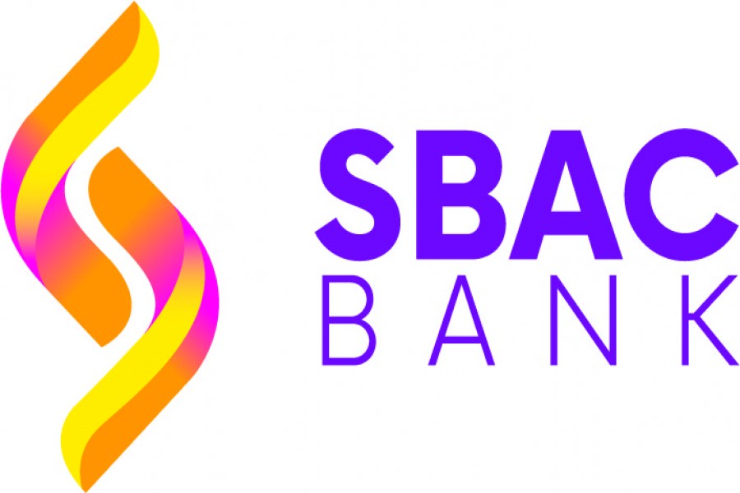



United International University
Internship Report on

“General Banking Activities of
South Bangla Agriculture and Commerce Bank”

Submitted to
SM Asif Ur Rahman
Assistant Professor
School of Business and Economics
United International University

Submitted By
Nusrat Rahman
ID: 111 151 316

Date of Submission: June 28, 2020

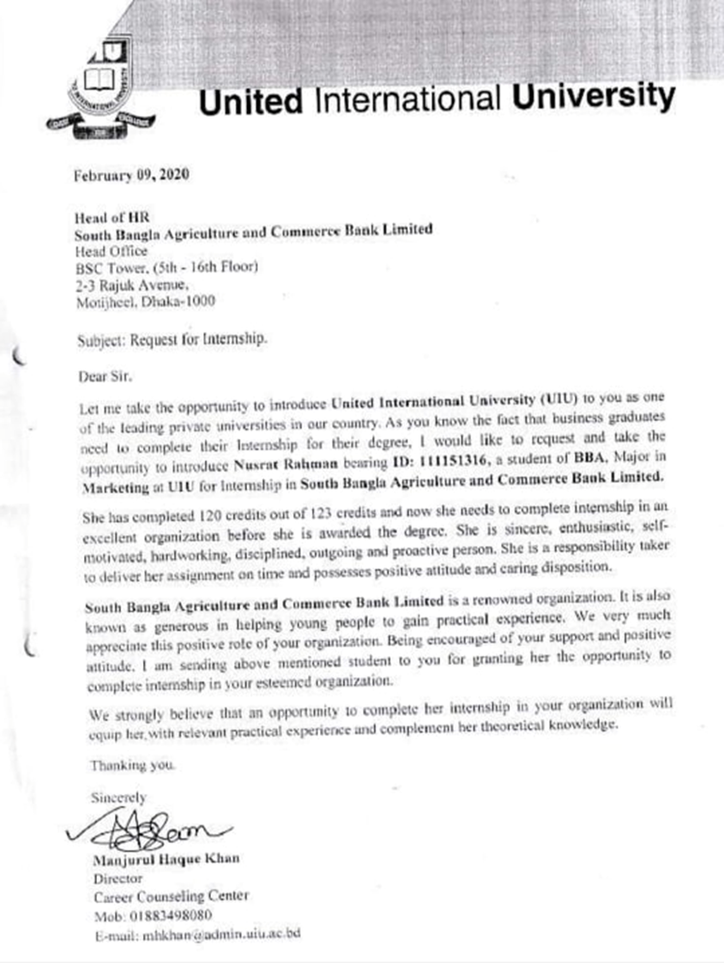
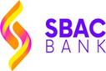

LETTER OF TRANSMITTAL
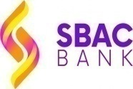
June 16, 2020
SM Asif Ur Rahman
Assistant Professor
School of Business and Economics
United International University
Subject: Submission of Internship Report.

Dear Sir,
I have a pleasure to present my internship report on the topic “General Banking Activities of South Bangla Agriculture and Commerce Bank Ltd.” for your kind assessment. It is a matter of great pleasure for me to have this scope to do a study over the “General Banking Activities” of South Bangla Agriculture and Commerce Bank, one of the popular banks in Bangladesh. So I am sure that by doing these activities I can get help to gain both knowledge and experiences and in the future it will help me a lot. In this report I have tried my utmost to present my suggestion, ideas and findings in as clear manner as I could within the limited time and available data resource. I believe that it can give a comprehensive impression about General Banking Activities of South Bangla Agriculture and Commerce Bank Ltd through the idea I have presented in this report.
Here I would like to state that there may be few inadvertent mistakes in this report. I am optimistic and fully believe that, you will be kind enough to consider my deficiency when you evaluate the paper of mine.
Sincerely Yours
Nusrat Rahman
ID: 111 151 316
United International University
Executive Summary
Modern banking represents a large scale variety of financial prospective, which includes credit, reserves, and payments and accomplishes the outspread formation of financial activities of any business institution. Bank may be financial organization which focus is to urge largest profit by money business and also as gain the highest client satisfaction so as to steer the market. South Bangla Agriculture and Commerce Bank Ltd is always focusing on customer satisfaction because of being a service centered and customer centered business organization. The function of SBAC Bank can be divided into three parts. These are: General Banking, Loan and Advances, and exchange. South Bangla Agriculture and commerce (SBAC) Bank Ltd. also invests their money in a number of financial securities and also in many projects to reduce the risk and obtain more profit.
Nowadays South Bangla Agriculture and Commerce Bank Ltd has become one of the top private banks with enormous network in entire Bangladesh. General Banking is the start line of all the banking operation among all functions. On the basis of this ground I have selected this section for my internship report. Usually the departments of General banking perform the huge functions of a bank. And in fact, a bank always does functioning with its customer money and general banking starts this process.
The activities of General banking usually refer to many types of works, within them they always need to affect the client prerequisite and their expectation. The activities of general banking are assigning to the account opening section. After opening the account they usually keep up with their application of cheque. And then they send all documents of the accounts to the head office. Head office then clarify the applications of all cheques, after that customers can collect the cheques from the account opening Bank after seven working days they send the application of cheque to the branch. According to the customer commitment, the bank have to examine many important objects at the time of opening the customer account such as the accurate certificate for opening the bank account. If there is found any inconsistency of documents, the documents will not be allowed by the general banking officer. Most wonderfully their attempt is to authenticate the applicants and the nominees and whether there are enough documents to open the bank account. Secondly, there must be proof that the person and nominees signature is real to proceed with the new account on the bank.
In this report several parts are presented in a consecutive manner. Also this report is formed with a number of chapters to talk over different parts that are relevant to the subject topic by each section.

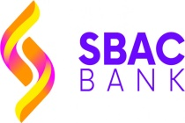
Table of Contents
LETTER OF TRANSMITTAL iv
Executive Summary v
INTRODUCTION 1-9
1. INTRODUCTION: 2
a) Origin of the Report 3
b)Background of the Study: 3
c) Literature Review: 4
d) Purpose of the study: 5
e) Scope & Limitations of the Study: 6
e) Methodology: 7
f) List of abbreviation/ technical term: 9
An Overview of SBAC Bank 10-26
2.1. Profile of SBAC Bank: 11
2.2. History of SBAC Bank: 12
2.3. Functions of various Division at SBAC Bank 13
2.4 Organizational Structure 15
2.5Organizational Chart of Satkhira Branch: 16
2.6. Products and Services of SBAC Bank: 17
2.7. General Banking: 18
Account Opening and Customer Service Section: 18
Checking of relevant documents: 19
Accepting of deposits: 20
Savings Account: 21
Features and Benefits: 21
2. Time Deposit: 21
a)Short Term Deposit (STD) Account: 23
b) Fixed Deposit Receipt (FDR): 23
Cash section: 24
Cash Receipt: 24
Cash Payment: 24
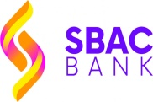
Clearing Section: 25
Dishonor of cheque: 26
Accounts Department 26
Finding and analysis 27-49
3.1Finding of the study: 28
1. Reason behind choosing SBAC Bank: 29
2. SBAC Bank maintain strong privacy policy towards the customers 30
3. The new online banking service of SBAC Bank 31
4. Reason that customers are affiliated with SBAC Bank: 32
5. Time duration of customer’s involvement with the SBAC Bank: 33
6. The office environment of The SBAC Bank: 34
7. Satisfaction with the provided service by Bank: 35
8. Best product offers that customer like the most 36
9. The service charges of SBAC Bank 37
10. The improvements that customers like to see 38
11. Review about the overall Customer Service 39
12. SBAC Bank Customer Service is better than other banks 40
Findings from analyzed data: 41
Positive findings: 41
Negative findings: 42
Result of the overview: 42
SWOT Analysis: 43
Strengths: 44
Weaknesses: 45
Opportunities: 47
Threats: 48
SUGGESTIONS AND RCOMMENDATION 50-53
4.1.FINDINGS AND SUGGESTIONS 51
4.2. RECOMMENDATION: 52
CONCLUSION 54-60
CONCLUSION: 55
Appendix 56
Bibliography: 56
QUESTIONNAIRE: 57

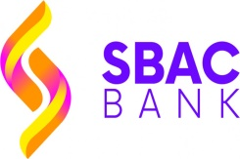

PART-1

INTRODUCTION

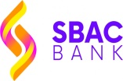
INTRODUCTION:

The banking system is generally inhabited as a dominant part in the whole economy of our country, because of it the third significant role is played in the economy. It is very much needed to have Banking institutions for the present society. Usually it performs an important role in economic development of each country. As well as it also generates a great policy for centre of money market of every country. It has always played an important role to develop the economy system in a developing country like Bangladesh. The main purpose of banking business is to collect the money from the surplus unit and lend this collected money to the deficit unit. Report is generally based on “General Banking Activities of South Bangla Agriculture and Commerce Bank Limited” and I am working on it. So my main focus is on the customer service activities and general banking activities of SBAC Bank Ltd for coming up with total dividend of the bank. Generally General Banking department performs a vital role in every bank more especially in the branches of a bank. The Bank has earned rapid essential changes over the years and earns a lot of success. Remarkably the bank has demonstrated many branches in the whole country. It can be identified that he bank is changing rapidly in many sides according to their better employment policy and build finer manager and employees in each and every branches to fill up client prerequisiteas soon as possible. Bangladesh is doing same on this ground and provides bank tutoring in every organization and also builds practice centered schooling and the Banking Sector in our country. Our banking industry facing challenges in term of different angles but its prospect is likely to be brighter in near future.
Bank they redirect and invest the funds in such ground, which are focused to expand our country’s economy and make an addition to add to South Bangla Agriculture & Commerce bank’s wealth. Banks provide required finance to organize, operate the industries, give fund to agriculture and many other sectors that can form golden opportunities for developing South Bangla Agriculture & Commerce Bank Ltd resources and provide large scale recruitment.
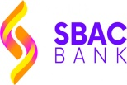
The purpose of doing this 3 month Internship in SBAC Bank is that, I can develop the particular skills and can gain potential judgment that are required of successful financial administrative or bankers. For developing my knowledge and consistency, I went to SBAC Bank, Satkhira Branch from March 01, 2020 to May 31, 2020. I prepare this report depending on my on the job practical experience when performing and observing the regular banking activities and also under the direct supervision of my academic institutional Supervisor Asif Ur Rahman sir and great guidance of the Bank’s Supervisor Mr. Shaikh Abul Fara (Sohel).

a)Origin of the Report:
This internship report is derived as an academic prerequisite of my BBA program at United International University. Since the practical adjustment is a vital part of the BBA level prerequisite, I joined with the SBAC Bank Limited to gain the real life disclosure of the function of both banking and financial organizations. As an intern I must go through a particular project, that is allocated by the concerned institution and approved by the United International University, department of School of Business and Economics consequently this internship report depending on the project that is to be submitted for evaluation to the BBA department.

b)Background of the Study:

Throughout our BBA education, we used to study our maximum courses on business studies in term of theoretical aspects. We also got few scopes to gain learning of practical knowledge about the business and its overall environment. We get to know that both the theory and practices are co-related to each other as well as these two are similarly important. Our knowledge will be fulfilled until we gain practical knowledge that is only possible by working in a practical job field. Our BBA program permits us to assess analysis and review a particular organization so that we can gain practical knowledge that facilitates the use of our theoretical knowledge; that we as students have already collected thought-out the syllabus of BBA classes. I am also assigned prepare an internship report about “General Banking Activities of South Bangla Agriculture and Commerce Bank Ltd”, as a part of our BBA program. We all know that, the functions of general banking perform a vital role in all bank and the bank plays an important role in our economy.
Since I have been working in SBAC Bank Limited, Shatkhira Branch as an Intern for a three months period, I have gather practical on the General banking activities and this report is directed to perform on the overall activities of general banking department of South Bangla Agriculture and Commerce Bank Ltd.

b)Literature Review:

Bank: A bank is a monetary or financial institution that is licensed to collect deposits and offer loans. Banks provide many other financial services like wealth management, and currency exchange, or safe deposit boxes. Banks are classified in many several forms such as the retail banks, the commercial or the corporate banks, and the investment banks. In most of the countries, banks are generally regulated or controlled by the central bank or national government.
Here I am giving some functional and structural definitions of various Authors and Economists on Bank from several angles:
“Bank is a financial intermediary institution which deals in loans and advances”---Cairn Cross.

“Bank is an institution which collects idle money temporarily from the public and lends to other people as per need.” ---- R.P. Kent.
General Banking:
General Banking department OR simply General Banking, deals with the day to day operations of collecting, paying deposits and cash, or issue of banker cheque etc. in local currency.” ---- Viqar Ahmed, Deputy Registrar at Preston Institute of Management Science and Technology.
d) Purpose of the study:
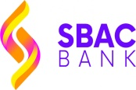
Every job features a specific aim. A study cannot achieve the goal without a particular objective. This internship program was as well coordinated to few specific objectives.
So here, I even have classified the objectives of my internship report into two major parts.
They are:
- General Objectives
- Specific Objectives

General Objectives: As an intern the main elemental objective is to complete this internship program that is compulsory for a BBA student. Besides, another primary objective is to realize empirical knowledge about various banking activities. It is relevant to indentify observing the operations generally banking activities as another general objective.
Specific Objectives:
- To acquire knowledge and know about the general banking.
- To gain better understanding about the activities of all the departments.
- To understand the procedures of latest account opening.
- To gain knowledge about customer handling.
- To know the overall banking activities of SBAC Bank Ltd
- To know various sorts of accounts and strategy which will be executed and its prospective advantages.
- To know detailed about standard quality and limitations of Satkhira branch of this bank
- Coordinating various functions of varied department
- To provide suggestions regarding various ways and means for development in policy and methods

e) Scope & Limitations of the Report:
Scope of the study:
I might attempt to observe the theoretical view of the functions general banking, the overall activities of each department and the steps of an account opening in a bank. Scope of my internship report is generally confined to the overall functions of banking of South Bangla Agriculture and Commerce (SBAC) Bank Limited. The report focuses only general banking activities of the bank.
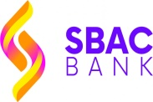
Limitation:
It is not easy to complete this report on such an elaborate subject within this limited period of time. To prepare this report I have faced some difficulties and limitations that are given below:
- The main constraint of this study was insufficiency of longer data collection to complete this type of study
- Authority restricted few issues only for the internship program
- Some information can't be provided because of security or confidentiality and other corporate constraints.
- Since the info, in most of the cases, isn’t in well arranged way, usually the bank did not give all needed information.
- I could not discuss many of the point or aspects within my present report because of limited time.
- The bank employees were unable to give me enough time as they were so much busy at their work.
- Insufficient opportunity and permission to acquire internal data.
- Shortage of stories or relevant appearance and publications.
- Not all of the clients whom I interviewed wanted to supply relevant information.

e) Methodology:
Methodology is the essential part of a study. Also it refers to the procedure of aggregation data, arrangement of it according to the relevant problems with the report. Both formal & oral discussion and direct observation, written documents of the bank & questioning shoppers were found helpful. Since it is planned during a method, it must be communicator to attain the overall objective of this report.
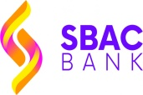
1. Research Method: I actually have used each qualitative and quantitative technique for my report. I take advantage of open ended question for interview and shut complete survey questions for this study.
2. Sources of Data: Actually I have gathered knowledge and information from each of those 2 sources. Throughout the internship program, actually I have gathered knowledge from the employees of SBAC Bank though some informations were only restricted for intern. There are 2 sources for knowledge assortment that are as follows:
- Primary Data Sources
- Secondary Data Sources
The Primary Sources of knowledge:
It includes contemporary or utterly new knowledge sources collected for a specific purpose, they are:
  - Interviews with division head.
  - A survey has been conducted to measure the satisfaction level of the clients
  - Departmental surveys.
  - Observation.
  - On the job trainings.
  - Practical operating experiences
Secondary Sources of knowledge:
It generally includes all bestowed and all printed data.
- Various research papers
- Publications
- Banking journals
- Web site of the bank
- Different Study materials
- Various text books
- The World Bank’s Security publication

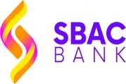
3. Sample Size: I have used a sample size of 30 people for conducting the survey.
Here, n=30
4. Sampling Technique: I have used probability sampling technique as the respondents are randomly selected.
5. Data Collection method: The methods I have used to collect data are the following:
- Interviews
- Questionnaires and surveys
- Observation
- Documents and records

f) List of abbreviation/ technical term:

SBAC - South Bangla Agriculture and Commerce
GB- General Banking
SO- Senior Officer
CO- Credit Officer
JO- Junior Officer
FDR- Fixed Deposit Receipt
STD- Short Term Deposit

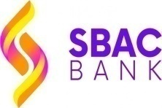
PART-02

An Overview of SBAC Bank

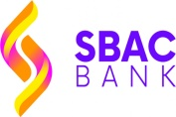
2.1. Profile of SBAC Bank Ltd:

Overview of SBAC Bank Limited:
The South Bangla Agriculture and CommerceBank Ltd. is one of the new aged full service bank. It got its license in 2013 and it began its action in 28th of April, 2013. This bank under extreme administration and few observant steps jumped to the summit only within a small period of time. Now SBAC Bank has launched 87 branches and with its head office in the leading points such as around Dhaka SBAC Bank has total fifteenth branches, in Chittagong eight branches and in Khulna it has four branches etc. SBAC bank is one of the rapidly growing banks in our country. SBAC Bank already has been operating among all direction of a standard banking such as export-import, opening LCs for client’s business, remittance settlement, and both financed and non-financed business.
Name | South Bangla Agriculture and commerce Bank
Head Office | BSC Tower, (5th - 16th Floor) 2-3 Rajuk Avenue, Motijheel, Dhaka-1000.
Date of Incorporation | 28th April, 2013
Principal Activity | Banking, Financial activity
Number of Branches | 87
Chairman | S.M. Amzad Hossain
Telephone No. | (02) 9577207-1
website | www.sbacbank.com.bd

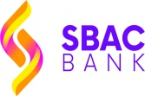
2.2. History of SBAC Bank Ltd:
South Bangla Agriculture and Commerce Bank Limited began its action at April 28, 2013 acquiring license from Bangladesh Bank with the firm devotion of fantastic customer service.
A. Mission:
The mission of SBAC Bank Ltd. is to work for providing a customer centered environment with the help of the service excellence for all of corporate, agro based SME and retail segments by twisting agriculture, industrialization, business, commerce and militarization of the foreign financing sector together to boost up emerging economy of Bangladesh with the help of advance information Technology through different compatible delivery channels.

B. VISION:
- To provide a customer-friendly environment.
- To deliver service excellence for all of our corporate, agro based, SME and retail segments Particularly Women agri and small entrepreneurs.
- To maximize shareholders’ value.
- To establish different compatible delivery channels.
- To be pro-active in fulfilling our Social Responsibilities.

C. Objective:
SBAC Bank put belief in its intransigent commitment to fulfill its clients’ needs and demands and by providing satisfaction to become the first choice of the customers in banking. By taking signal from its pool of esteemed clients, SBAC Bank also focus on its tagline “LOCAL BANK GLOBAL VISION”.
2.3. The Functions of various Department at SBAC Bank:
a. Financial Department :
- Overall financial Planning, budgeting and intense monitoring
- Paying salary
- Managing inter-branch monetary transaction
- Payment of bill
- Preparing / Reviewing the returns and reports
- Preparing the monetary reports as well as the annual reports
- Maintaining the Provident Fund and Gratuity, also the pension fund
- Resolution
b. Credit risk management or (CRM) Department:
- Management of Loan
- Disbursement of Loan
- Project assessment
- To process & approve credit or loan schemes of all the branches of the bank
- Preparing documentation and CIB (Credit Information Bureau) report
- To arrange various loan facilities
- To provide necessary reports to the authority of Bangladesh Bank as well as other required department
c. Human Resource Division (HRD):
- Employee recruitment
- Designing and execute Training & development program
- Compensation allocation, other benefit, work leave and recovery rules program
- Executing a successful technique for the placement & performance appraisal of the personnel
- Preparing necessary statements
- Providing reports to the head of Committee or Board on crucial matters
- Arranging promotional camping as well as providing handouts
d. Information Technology or IT division:
- Developing Software
- Managing network and expansion
- Reconciliation of the member banks
- Entrance of data & processing the data
- Sourcing and servicing of hardware
e. Branch control & Inspection Division:
- To controlling several activities of all the branches of the bank as well as to look for growth
- To conduct internal investigation and survey both systematically and suddenly

2.4 Organizational Structure:
Chairperson (owner)
Vice chairperson (owner)

Directors (owner)

Managing Director (MD)

Deputy Managing Director (DMD)

Executive Vice President (EVP)

Senior Vice President (SVP)

Vice President (VP

First Vice President (FVP)

Assistant Vice President (AVP)

Senior Executive Officer (SEO)
Executive Officer (EO)

First Executive Officer (FEO)
Senior Officer
Officer
Trainee Officer

Source: HRD, Head Office SBAC

2.5. Organizational Chart of SBAC Bank, Satkhira Branch:

Head of Branch (Manager)
Manager Operation

GB In charge
Cash In charge
Foreign Exchange In Charger
Credit In charge

CO
CO
SO
SO
SO
SO
JO
Cash
Officer
Sub Staff
Security Guard

2.6. Products and Services of SBAC Bank:
General Banking Foreign Exchange
- To Open Accounts
- To maintain Account
- Closing Account
- To Issue Pay order
- Offering Bank draft
- Offering Demand draft
- Fixed Deposit Opening
- Issuing L/C
- Parties to L/C
- L/C Documentary Operations
- Application for Letter of credit
- Inspection of Documents
Investment Service Other Saving Service
- Providing Loan
- Issuing LC
- Bank Draft/ Pay Order
- Bank Guarantee Issue
- Electricity/Water bill Collection
- Small Business Financing Scheme
- Housing Investment Plan
- Small Transport Plan
- Car Loan Project
- Transport Investment Plan
- Agriculture Implements Investment Plan

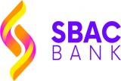
2.7. General Banking:
Functions General banking is the start line for the whole banking activities. Usually it gives regular banking service to their clients like other sections. During this department they regularly meet with their clients demand as well as fulfill clients prerequisite. It’s mostly involve opening new bank account supported the client demand, remitting funds, issuing banker's draft and paying of order etc. So it can be said that General banking is additionally is retail banking.
General Banking
Account opening section | Cash section | Bills and Clearing Section | Remittance section | Time Deposit | A/C  Section

Receiving Cash | Disbursing Cash |  | Payment Order | Demand

Account Opening Section and Customer Service:
Firstly, this department is accounts for providing service to clients who are interested in making savings on the bank or willing to open a bank account. This is the primary stage of building the banker- customer relationship. The opening of a bank account works as a binding between a banker and a customer with a legal relationship. The bankers are gracious and cordial to their clients. In addition, the officers involve in issuing new checkbooks, remitting funds as well as helping customers with opening various kinds of account and giving necessary information about different deposit plans that best meet their needs.
The steps of account opening section are following:
1.To check all necessary documents
2.To accept client deposit
3.To open the account
4. Issuing checkbook
5.To transfer the account
6.To closing the account

Figure: Steps for opening a bank account.

Checking of necessary documents:
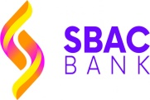
At this stage, the officers of the bank check the relevant documents and papers that are required to open a bank account. Since the requirements for the documents may be different for various kinds of bank accounts, they examine the documents and papers very carefully. In case of any kind of document missing, they gently ask the clients to give the missing documents to proceed again, Contrarily, if the documents and photographs are present, then the bankers ask the clients to give primary deposit which is compulsory for opening the account. Besides, the customer selection for opening a bank account is very much importance since there are risks of fraud customers involved in antisocial or illegal activities. Because of this, SBAC Bank gives so much importance on their customer selection very cautiously.
Accepting deposits:
Initially, all of the accounts are generally opened with a cash deposit by the clients and therefore these types of accounts are known as deposit account. Again, banker seeks deposits of money from clients having a scope with different way of regular life, engaged with several monetary movements as well as having particular budgetary status. Usually; there are one senior officer as well as one junior officer and they perform several activities in this department.
Moreover, SBAC Bank Ltd offers two major types of deposits.
1. Demand deposits
2. Time deposits
Current Account
Savings Account
Demand Deposit
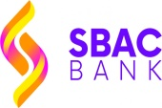
1.Demand Deposit: This is a form of deposit that is applicable to the total amount in the accounts and must be paid on demand by clients.
The bank receives this kind of deposits by opening several forms of accounts: Those are:
a. Current accounts
b. Savings Accounts
a.Current Account:
- Usually, opened by the businessmen, the government and by semi-government organizations; with valid introduction
- Provides service regarding deposits and money withdrawal
- interest should not be given for the deposited amount
- Bank overdraft is permitted in this type of account
- The minimum opening amount for this account is TK 500
- The minimum balance (TK. 500/-) must be maintained
b.Savings Accounts:
A Savings Account is meant for particular savers who desired to save lots of or a little portion of their earnings that can be used in coming future as well as also will get some profits on their savings. The customers can also deposit a small amount of money and can withdraw the money whenever they want but the entire numbers of money withdrawals during a specific period of time are bounded.
Features and Facilities:
- Bank tends to pay lucrative interest.
- Customized MICR Cheque is being offered.
- Minimal service charge for the account.
- Customers can withdraw and deposit cash from any of the branches.
- Bank takes Standing Instructions and guideline from the A/C holders of the bank.
- Interest is also payable on basis of half yearly.
- A/C Statement, Balance Confirmation Certificate is being provided without a charge twice in a year on half yearly basis.
- There are options to collect the e - Statements on a per month basis.
2. Time Deposit:
A deposit of money that is payable as per a hard and fast date or by giving previous notice may be a certificate of the deposit of money. In SBAC Bank Satkhira Branch receives time deposits through FDR, STD, and DBS Schemes. During accepting the deposits, a formal contract is fulfilled between the client and the bank. When the officer opens a bank account within a customer’s name, there a contract is arisen between the bank and the client. The new contract is going to be a legitimate one only when both parties are eligible for entering into a legal contract. The account opening begins the foundational relationship as the banker must handle different types of persons.

1.Applicant fill up the relevant application form in prescribe manner |  | 2.He/She is to required signature on speculum signature card. |  | 3. For individual information is needed by the account holder.
6. After depositing the cash one check book and one pay-in-slip book is issued. |  | 5. Issuance of deposit slip and deposit must be on made cash no check and draft is accepted. |  | 4. The authorized officer analyze the introduction and examine the documents submitted
Account is opened

Figure 5: Account opening procedure in flow chart

a) STD Account:
- The deposits must keep in the bank for minimum seven days to get interest.
- The interest rate for STD account is usually less than that of savings deposits.
- Usually in SBAC Bank, the big company and the government department or VIP clients open STD account.
- Frequent withdrawal of money is limited and needs prior notice
- The procedure of opening a STD account is likely as a savings account.

b) The FDR Scheme:
- The customers deposit a fixed amount for a specific time period at fixed rate.
- There is an option opens for the clients re – invest their principal amount as well as the interest amount.
- Loan facility is provided against FDR to meet crucial financial needs.
- The customer can take loan advantages against their FDR as a security.
- Both the Individual and the company bodies often open FDR Account
Closing Account:
A bank officer may also close an account of a customer or restrict operating his/her account in the following situations:
- Death of a customer.
- Insanity as well as insolvency of a Customer.
- If a customer is charged with fraud forgery by court order.
- Order of the cheque as well as discharge the irregular accounts.

SBAC Bank also offers various schemes. They are,
- Double benefit Schemes (DBS)
- Monthly Savings Schemes (MSS)
The Cash section:
The cash section is extremely significant for the bank because the cash transaction is held here. Cash sections represent liquidity power of the bank. In Bank Ltd, Satkhira branch, there are many techniques that are generally maintained by a bank officer from the cash section. In SBAC Bank Ltd at Satkhira Branch, there are three officers in the cash section. The various techniques are: cash payment as well as cash received.
a)Cash Receipt:
When a client makes deposit within the bank, generally the banker follow the following common safeguards..
- Their responsibility is to sum up the collected cash and also check.
- For making sure that the received amount and the number of received amount must be same.
- Another work is to examine account title as well as account number; most significantly the depositor’s signature.
- To write the rules regarding the currency at the credit voucher’s back part or pay in slip or in receiving cash book.
- To make sure deposit slip is signed by the respective officer.
b)Cash Payment:
- The branch name should be mentioned in cheque
- After the mention date is given, the cheque are required to present within the given date
- The amount of money in word as well as figure must be equal.
- The required balance of account must be available.
- Client’s signature on the specimen card and the signature on the check should be matched.

Clearing Section:
Here the officers collect all the quite cheques for clearing. This is a part of the banking service.
The four kinds of clearing cheques are given below.
- Inward cheque for clearing
- Outward cheque for clearing
- Inward collection bills
- Outward collection bills
1. Inward cheques for clearing: It refers the instruments drawn on SBAC bank that are received by any other banks from representative of another bank in the clearing house .
2. Outward cheques for clearing: Cheque that is drawn of other branch of SBAC bank Ltd is called Outward Clearing Cheque. The outward cheques for clearing are sent to the mentioned branch.
3. Inward collection bills:
Two types of clearing;
Firstly, the cheque receives from another branch of SBAC bank Ltd. The cheques are resolved by sending it to depositor’s account. Bankers authorize it as debit, also authorize sender’s branch account as credit.
Secondly, the bank collects cheque from other bank except the financial organization. These cheque are resolved by authorizing it as debit to the depositors account as well as sending DD or TT in respect to the sender’s bank account.
4. Outward collection bills: When the Satkhira branch of SBAC Bank sends the Cheques to another branch of SBAC bank, the bank will debit SBAC general (Sender’s Branch) and will credit Depositor’s A/C.
Cheque Book:
“A cheque is called a bill of exchange drawn of a specified banker and not expressed to be payable otherwise than on demand”. To take advantags in withdrawals as well as payments by customer to 3rd parties, bank offers cheque book for their customer. Usually a cheque book has 10 leaves for a bank account and for the current account it has 20/50.
Dishonor of a cheque:
If a cheque is declared as dishonored, the bank’s branch give a memo (cheque return memorandum) to the respective customer explaining one of the following reasons:
- Not arranged for
- Refer to the drawer
- Effects may not clear.
- Not received Full cover
- Exceeds arrangements
- Payment may be stopped by the drawer
- Irregular/required payee’s endorsement
- Irregular payee’s endorsement, require the bank’s confirmation
- Mismatched drawer’s signature
- In case of any differ in date/ amount/ words may require full signature of the drawer.
- Amount in words and figures differs
- Cheque is postdated / out of date/ mutilated
- Clearing stamp required cancellation
- Crossed cheque should be placed through the bank
- Moreover, bank’s discharge must be authenticated
- The cheque crossed “Account payee Only”
- Irregular/ required discharge by collecting bank
But when a cheque is dishonored because of insufficient funds, the branch charges penalty leaves of TK 50 as.
Accounts department:
The account department can be considered as the core of a bank. In Satkhira branch there is also account department as in banking business, a lot of transactions take place regularly. These transactions should be recorded properly and also systematically as the banks work with the depositor’s money. Public confidence may be hampered due to any misplace of recording as well as the bank must face a lot of problems. To avoid the mismatch the bank has separate section involve in finding mistakes in the passant vouchers/ wrong entries/ fraud/ forgery. The accounting department of SBAC bank has produced few internal reports as well as some statutory reports that are to be presented to the Bangladesh Bank Limited.

PART-03

Findings and Analysis

Finding and analysis:
In the analysis part of my internship I have presented SWOT analysis and questionnaire. SWOT analysis is important as it evaluates the strengths, weakness, and opportunity, threats of a company. To be successful it is a must to know about future opportunity and its threats and contrastingly the strengths and the weaknesses. During my internship session I get to know many things at simultaneously I have noticed many things about SBAC Bank. To understand more about this I take interview of some clients. I also take a personal interview from the employees and the manager. With the help of SWOT analysis tool I am describing about the key points so that I can make my internship report understandable for all. I have described the SWOT analysis on the basis of SBAC Bank limited, Satkhira branch.
The data collection documents had been dilapidated in a organized way and laid out in synchronizing manner and gradually located at end of this internship report. The observation is completed through analytical reviews to desire targeting significant data.
3.1Finding of the study:
Ways to find out the level of satisfaction about customer service:
- Preparing investigation on the basis of client needs and expectation
- Examining the review data
- Reviewing the findings from the inspection
- Come to a result
To find out the real outcome of the management satisfaction level of the clients of Satkhira Branch of SBAC Bank, I have prepared 12 questions. The survey has been performed by 30 clients of SBAC Bank. Majority of the clients have savings accounts and some have accounts for current transaction for their business purpose.
Additionally I have used formal and semi formal questions for interview for improving understanding. I will discuss the information elaborately that may be presented in the finding part simultaneously I give the result.
To exhibit the result I have utilized nominal scale and bar outline which I used built up as well as supporting questions to upgrade the data. I will discuss the documents while it is characterized to transit in the finding part so that I can get the result. The questions are prepared according to some unpredictable that are related with sources of satisfaction by the clients.
The questionnaire of this report is prepared depending on some factors that are associated with the satisfaction of service by the clients. Such as: The reasons behind selecting SBAC bank, whether it is the environment of the office, the privacy policy, the employees behavior or the offerings of best products and services as well as other services, rates etc. SO, the study of this survey data is described below:
1. Reason of selecting SBAC Bank:
From the table below we can understand that 25% clients are selecting this bank for close area, 04% are selecting for the tentative offers, 40% are selecting for the card facilities, 19% are selecting for the salary account, 08% are selecting for the facilities of loan credit and 03% are selecting for the best service in savings account. This data examination presents that the larger portion of the clients are selecting this bank for the card facilities and also for close area. So the service facilities need to be improved and authorized.

Chart 1: Why do you choose SBAC Bank

2. SBAC Bank maintains a strong privacy policy for their clients:
Nowadays the Clients are much more careful with the privacy of their data. 17 clients among the 30 participants meaning 52.67% respondents have said that they are strongly agree with the point of statement. (24.33%) of the participants has voted for agree on this statement and 14.33% of the participants agree with normal. 6.67% participants disagree with this statement. This analysis demonstrates that clients are happy with the privacy policy.

Chart 2: SBAC Bank maintains a strong privacy policy

3. The online banking or internet banking service of SBAC Bank:
Now in the digital modern era benefit of internet based operating an account for saving money has been including another evaluation. With the web based operating a bank account a customer can deposit money to their account staying at home. Also they can observe their statements without going to bank. This service involves bank can save time for customer service and reduce price for each client. SBAC bank has begun this online service. 14(46.66%) participants have said that internet based customer service as " Good" and 5(16.66%) participants have thought this as "Excellent". 7(23.33%) of the participants has said that this is fair and 4 (13.33% ) respondent has thought it as poor. so this survey demonstrate that that SBAC bank provide a satisfactory internet based operating an bank account administration for their customers.

Chart 3: Do you prefer the online or internet based banking service of SBAC Bank?

4. The reason behind clients is affiliated with SBAC Bank:
We can see from the below table that 17% clients are choosing SBAC bank because of having their current account, 33% are for their savings account, 15% are for the loan facilities the take, 29% are for the card facilities and 6% are for other reasons. This information examination shows that more clients are affiliated for the card facilities as well as for the savings account in this bank must be authorized.

Chart4. What is the reason you are affiliated with SBAC Bank?

5. The duration of time the customers are involved with the SBAC Bank Ltd:
The table shows that 26.66% of the participants is associated with this bank almost for more than one year. And 46.66% are for 1-2 years. 16.66% of the sample size is for 2 -3 years and 6.66% of the participants are involved for 3-4 years. Finally 3.33% clients are related with SBAC Bank for 7 years and more. This study demonstrates that SBAC Bank has earned a good reputation regarding customer service and the customers who have maintained a long relationship with SBAC BANK are responsible for it. Lastly we can see that 1-2 years of the customer service got more popular.

Chart5: What period of time you are related with SBAC Bank?

6. The environment of the office of SBAC Bank:
Among the 30 participants 15 people have rated the office environment as very good meaning that 50% customers are mainly happy and satisfied with the office environment of SBAC Bank. 10 participants that are 33.33% have rated the environment as average due to crowd place. 3 respondents that mean 10% of the total population has rated the environment as excellent and 2 participants that are 6.66% people has rated the environment as bad. Moreover, the great thing is clients are especially happy with the office environment of SBAC bank.

Chart 6: How about do you feel the office environment?

7. Satisfaction with the provided service by Bank:
Among the total sample size of 30 people 19 participants that is 63.33% are agreed with the statement. That is they are very satisfied and happy with the service provided by the bank. 5 respondents that are 16.66% have said that they are strongly agree with this statement. Some clients have said that they are disagreed with this statement that is 6 participants with the proportion of 20%. So the study demonstrates that clients are satisfied with the bank regarding the service they provide.

Chart 7: You are satisfied with customer service provided by SBAC Bank

8. The best product offerings that the clients like the most:
Majority of the clients of SBAC Bank prefer the credit card facilities. Among 30 participants 12 participants (40%) choose savings A/C as they think it is best product offering. Secondly there is 7 (23.33%) participants have said that FDR offers best product than different bank. 7 respondents (23.33%) believe that cards gives better product offerings to attract their customer. Lastly 4 respondents think that DBS service provides best product with a proportion of 13.33% among the total sample size. From this study I understand that the customers like card service and think it as a best product of SBAC Bank because of its tentative offers.

Chart 8: Which products offerings you think best?

9. Service charges in SBAC Bank:
The service charge is an important factor that's significantly related to buyer loyalties and preferences. From the survey we can see that 60% participant has rated it as moderate as well as 33.33% participant think that it is justified. According to the survey result most of the participants think the service charge is moderate and 6.66% think that it is high. So the customers have moderate feelings about the service charge taken by SBAC bank.

Chart 9: What do you think about the rate of service charges taken by SBAC Bank?

10. The improvements in service that clients want to see:
In general everyone wants a development in the financing cost. In this survey 50% respondent wants an improvement in customer service including that include ATM Booths. The 26.66% participant wants to see the fastest service and work. Then 13.33% participant wants cooperative employees. Customers also want change for A/C holder in growing interest that is 6.66% and also want less interest rate for loan holder that is 3.33%. Thus from this study I can see that customers will be happy if they are served with great customer service and fastest work.

Chart 10: What are the improvements you want to see?

11. The evaluation of overall Customer Service:
On the basis of overall customer service 53.33% participants believed that customer service of SBAC is good. Most of them admitted that the employees are both friendly and helpful. Then 20% participant rated customer service as excellent because the bank officers are very co operative. Also 13.33% participants said the service is average and 10% respondent rates the service is poor. This happens because sometimes when there is rush in the bank then the customers get low quality service. In some circumstances the customers get service gradually.

CHART: 11. What do you think about the Customer Service?

12. The Customer Service of SBAC Bank is better than any other banks:
33.33% participant is strongly agreed with this statement. The clients are strongly agreed that the customer service SBAC Bank is better than different banks. 50% of total respondent rated this statement as agree. 10% participant rated this statement as normal and finally 6.66% participants showed disagreement with this statement.

Chart 12: The Customer Service of SBAC Bank is better than any other banks.

The findings from the analyzed data:
From the total analysis of this study both the positive and the negative findings are found here. When I compare the findings I understand the satisfaction level of customer service.
The Positive findings:
- 46.66% customers are involved with SBAC Bank, Satkhira Branch from 1 to 2 years that represents that they are satisfied with money saving administrations. New customers are also choosing this bank.
- 50% of the clients are happy and said this good and 10% client is very much satisfied and they rate the bank environment as excellent.
- 52.67% of the clients believe that the privacy of the customers is ensured by this bank and they rate this as strongly agree.

Negative findings:
- 50% customer wants more improvement in the customer service
- 26.66% of the customers would like to get fastest service.
- Only 13.33% of the customers choose SBAC Bank just for DBS scheme.
Result of the Survey:
According to the findings of this study it can be found that there are more positive findings than the negative findings. That’s why we can say that a most of the clients are completely satisfied with the overall banking service gave of SBAC Bank Ltd, Satkhira Branch. SBAC bank should bring some development regarding their service to provide a competitive service and better quality service as well as superior environment to their clients. Additionally they should focus on customer's needs and demands carefully. They must think about increasing ATM booth for customer convenient. They should ensure a sound and cordial relation with their clients by offering them best service. They should also focus on some common components like: Fastest service, Good office environment, employees conduct, service charge, and ensures utility service. This should be considered as the basic components and all this factors have direct or indirect effect on the customer loyalty.

SWOT Analysis:
Threats
• The Multinational Banks
•Future Banks
•Modern Banks
•Lack of deposits creation
•Faulty culture
Opportunities
• Scope of diversification
• Product line expansion
•ATM Booths
•Credit cards facilities and mobile banking
•Online or internet banking
•Offering various schemes
SWOT
Weaknesses
- Poor promotional activities and advertising
- Unclear vision
- Low grade recruitment
- Faulty HR Department
- Discussion meeting is Centralized
- Deficit qualification
- Comparatively new branch

Strengths
- Bank reputation
- The market share & profitability
- Capital goods
- Equipment and facilities
- Outstanding Branches
- Interactive office culture
- Greater team work

Figure 6: The SWOT analysis of SBAC Bank

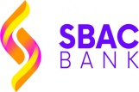
Strengths:
- Bank reputation: SBAC Bank has already established a greater reputation especially among their new consumers. In these seven years SBAC bank able to grow rapidly in earning profits as well as collection of deposits. In banking field SBAC Bank has also shown good leadership as well as strong sponsorship. The top management of SBAC Bank is marked as strength of SBAC Bank. They have heavily shown their contribution to the growth for the bank. The top management 0f SBAC Bank used to work in other reputed banks and these experienced and skilled workers help in further expansion of the bank. All of these have helped them to gain reputation in their sector.

- The market share & profitability: As we have already discussed SBAC Bank is able to create greater reputation among the newcomers in Bangladesh in banking sector. They have gained an impressive growth and profitability in these few years. Their total number of cash deposits, loan disbursement and the advances are highly increasing day by day and thus their market share and profitability is rapidly increasing.

- Strong Capital Goods: SBAC Bank huge capital goods for their business in banking industry. In these few years the potential return on investment and earning of this bank is high. In coming days the earning return will be higher and they can operate their business without any difficulty.

- Equipment & Facilities: SBAC Bank has sufficient equipment and physical facilities. To provide customer better service these facilities help operation in every department as well as in every branch of the bank. In Satkhira branch, these facilities are also used for giving customer service and also contribute in general banking department. SBAC Bank provides both computerized and physical customer service. The employees of SBAC Bank use computer internally and in every department. Every branch of SBAC Bank has internet facilities and also has telex and the fax facilities.

- Outstanding Branches: SBAC Bank has 87 outstanding branches inour country. These increasing branches actually help them to build great reputation in the banking industry. Satkhira branch is also one of these. In their excellent work environment I also get to finish my internship period with a beautiful experience. These are creating a positive image among the public and the potential customers as well as these also attract many people to SBAC bank. All these branches create indirect promotional campaign for SBAC Bank and that is also important to attract new customer.

- Interactive Office Culture: SBAC Bank is maintaining an interactive office culture. SBAC Bank has maintained a continuous friendly, interactive, informal and mutual environment unlike local organization. There is no hidden boundary or barriers in case of any interaction between the superior or subordinate. They have maintained an active and dynamic corporate culture to boost up the employee inspiration, spirit and motivation. SBAC Bank also maintains this type of environment inside every branch of the bank.

- Greater Team Work: SBAC Bank has kept an excellent team work at the mid-level as well as at the lower level. Several tasks are performed in groups consisting 2/3 people for the purpose of reducing the workload and the work completion process is enhanced. That teamwork is very useful in developing their work and process.

Weaknesses:
- Poor recruitment: The recruitment process of SBAC Bank is so upgraded. Most of the time when the bank recruit its employees for the mid-level as well as for the lower level, the recruitment is done without giving the new employees proper training. More significantly many staffs are recruited as per references or direction by the board of directors. And this is becoming a common practice in the recruitment policy of SBAC Bank. Thus the service of SBAC bank is comparatively not upgraded. In this way SBAC Bank misses the right employees for this bank.

- Low service quality: This is becoming a big problem for SBAC Bank. The service quality for customers is gradually decreasing in the whole department as well as in the branches of the bank, as the clients are increasing. Also the customer service of SBAC bank is low comparing to the Dhaka Bank, the Prime bank, the Southeast Bank the Dutch Bangla Bank etc.

- Small Size HR Department: The Human Resource department of SABC Bank, Satkhira Branch can be considered as another weak point. It is comparatively small in size than any other bank. Moreover the employees in this department are inefficient for being an officer of the Human Resource department. While recruiting this department many policies and procedures are not considered. But HR department is very crucial for all organizations and each policy and procedure should be carefully considered during this department. The bank does not follow a proper performance appraisal program and the employees’ annual performance report has not been examined yet. So the employees of the bank are not receiving the necessary feedback. The bank has not any proper set of required policies for recruitment. So this bank is following traditional policies to promote their employees and for this bank, this is very compromising issue.

- Centralized discussion and decision: At SABC Bank the top management makes all the decisions. Such as the CEO, the DMD, the board of directors and the top managers. This practice leads the bank following a top down flow communication policy. There is limited scope of following this bottom up communication in this bank. So the bank is not giving any opportunities of many bright and young ideas to be flourished due to this communication system.

- Insufficient computer operators and system operators: Now in the head office of SABC Bank and its branches, most of the system operators and computer operators don’t have any academic knowledge about the applications of computer. Satkhira branch is also facing the similar problem. So they often commit mistake to undo problem with the computer. Thus the operators of SBAC Bank are not expert to their own mistakes.

Opportunities:
- Scope of Diversification: SABC Bank can grab the opportunity of using diversification strategy that can help to expand the current line business of the bank. They can expand their line by introducing merchant banking. SBAC Bank can also minimize their risk by diversifying their product portfolio. There are many opportunities for the bank to extend their product line, because to extend their business as well as to sustain in this competitive environment, it’s very important to diversify their line. This is also important to gain competitive advantages over the competitors.

- More ATM Booths: This technology is a modern banking which is rapidly growing. There are competitor bank like DBBL, AB bank, Prime Bank, etc. who have been establishing ATM booths in the entire country. Nowadays customers want to do their transaction through ATM, SABC Bank should take this opportunity and also should take necessary actions for establishing ATM. They have very few ATM booths in Satkhira.

- Internet banking or On-line banking: SABC Bank has launched on line banking. But the bank is not taking necessary action to make their customers aware of this on-line banking service. They should promote the new service to their clients. And the bank should make sure that the consumers using this on-line service feel comfortable during taking this service. That is why the bank should make sure that their service is available and the customers know about it. This could be a forwarding step if they are being cooperative with the customers to introduce this service.

- Offering SBAC Bank’s own scheme: SBAC bank can offer new scheme or retail product that should be based on customers’ needs and demand. They can launch new saving scheme by their own as well as several pension schemes or other schemes for various profession customers. The can introduce student banking service without service charge for the students. This can attract more customers to their bank.

Threats:
- The Multinational Banks: More exposure to the multinational bank can be a future threat to all the local brands in our country. Because of strong and successful energy area, the foreign banks are investing more in Bangladesh. We already have a number of foreign banks in our country such as HSBC Bank, Standard Chartered Bank that could be a potential threat for SBAC Bank. These banks are establishing more branches all over the country. Not only these banks are establishing but also they have all the capacity of financial support that could be a big threat for SBAC bank.

- Future banks: The increase of future local private banks can be considered as another potential threat for all existing banks. It can be predicted that in the coming years there would be more branches of the local bank could have been emerged. It can be also predicted that in the near future there could be much competition, as this bank could adopt new concepts and strategies to cope up with the existing multinational banks.

- Current banks: The competitive banks to SBAC Bank such as Prime Bank, Dhaka Bank, Dutch Bangla Bank and Southeast Bank are considered as the biggest rivals. These banks are adopting aggressive campaign strategy to attract the corporative clients and the big amount depositors. SBAC Bank should conscious of these steps they are adopting in the long term as it can have a significant effect on the contemporary bank strategies.

- Lack of deposits creation: The common problem that is faced by almost all banks in our country is lack of deposit collection and it is a biggest threat for the local banks. Because of current economic downturn, the new deposits are rarely created. Thus many banks may be unable to attract the new clients for deposit creation and that’s why banks are involved in hunting or snatching away clients from each other.

- Faulty culture: Most of the local banks in Bangladesh are facing this threat. As SBAC Bank is a new organization in compare to other banks as well as Satkhira branch is comparatively new branch, the bank has very insignificant problem regarding the non-performing loan. Nevertheless, as soon as the bank is becoming older, the bank will face this type of problem and the entire system will suffer from this arising problem. So SBAC Bank must build up proactive strategies so that they can prevent this type of problem.
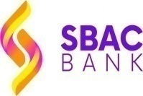

PART-04

SUGGESTIONS AND RCOMMENDATION

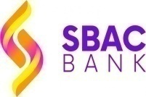
4.1. THE FINDINGS:

The below findings are found by analyzing the survey:
- It can be found from the survey that, SBAC Bank follows all the required steps during opening various types of bank accounts of the customers with bank.
- Although SBAC Bank makes decision on a centralized basis, management system is decentralized in general banking that is the general banking functions are operated by the branch wise system.
- The more a bank will impose irrelevant conditions in opening a bank account both in case of individual account and joint account, the more the customer will become disinterest in involving to the bank.
- Since SBAC Bank is relatively new, it takes high deposit costs from the client than other banks such as the City Bank. SBAC Bank used to give 7% interest on fixed deposit but now it gives 6.5% interest.
- Most of the clients of SBAC Bank believe that the terms & conditions of savings schemes of SBAC Bank are mostly reasonable.
- The number of ATM booth of SBAC Bank Satkhira branch is insuffient.
- In the General Banking department, shortage of manpower is the main problem that’s why the staff can’t the service properly and timely.
- The software SBAC bank is using for General banking isn’t up to the mark. As the software is slow the officers can’t always provide service on time.
- Most of the customers believe that opening a bank account in this bank is beneficial for them both for individuals and organizations because of many facilities.
- The SBAC Bank usually give recruitment of new staffs without required experience but those are unproductive and ineffective for general banking department.
- SBAC Bank also has customer care service call center but now this service no longer available.

4.2. RECOMMENDATION:
To overcome the problems I have recommended the suggestions in the below:
- SBAC bank has no process to provide proper information to their clients. As a result many customers complain that they did not know about when they are charged fine on DBS and so on. They should provide proper information through SMS so that customers can understand the problem

- The branch is mainly dependent on savings from the clients. But in competition such a dependency is not so good for any bank. Thus emphasis should be developed as well as dependency on other sector should be increased.

- SBAC Bank can increase the quality of its asset by offering discount on the interest rate so that the customer can make timely repayment. But this advantage should be provided only to the active clients.

- The bank should make the process of loan sanction much easier so that the customer can feel advantageous in taking loan from this bank.

- SBAC Bank does not have sufficient ATM booths in all over Bangladesh as well as Satkhira. They should start preparation in increasing the ATM booths.

- SBAC bank should ensure that customers are aware of the Online Banking as well as ensure the fastest services.

- The bank should upgrade the software used in General Banking department.

- The bank should increase the manpower should for general banking department. So they could provide fastest service to their clients.

- For general banking department SBAC Bank can follow the token service that is also followed by City bank, DBBL so that the customer lead time can be reduced.

- SBAC Bank must employ or recruit employee with required experience for the general banking department.

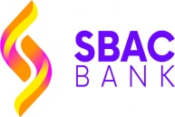
PART-05

CONCLUSION

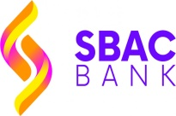
CONCLUSION:
South Bangla Agriculture & Commerce Bank Limited is a well known full service bank. It is doing it business all over the country by introducing several successful branches. SBAC has established a new extent in the ground of customer oriented and innovative banking in Bangladesh. It helps in accumulating scattered Deposit, International Trade, resource mobilization, Loan settlement and creating job opportunities etc. For greater growth and a healthy economic position, the bank should set up their own long-term profitable credit schemes specifically for the brand fresh depositors as well as schemes for poverty migration such as micro credit. I hope SBAC out more contribution to socio-economic enlargement along with the banking business.
During this 3 month period of my internship program not only I have gathered practical experiences but also I have learned to view things from the bankers view point as well as from the customers view point and perhaps got ideas about how to make a balance between this two. I desire that my internship report can give them acceptable guidelines for their business in future. I want long-term success and the stable business portfolio of the South Bangla Agriculture & Commerce Bank Limited (SBAC), Satkhira Branch, Satkhira.

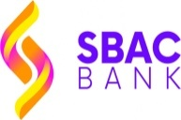
Appendix:

Bibliography:
1. Annual Report of SBAC Bank 2013, 2017
2. www.sbacbank.com
3. www.investopedia,com
4. www.bb.org.bd
5. www.bankinfobd.com
6. Prospectus of SBAC Bank

QUESTIONNAIRE:

The customer satisfaction towards the service of SBAC Bank
1. Why do you choose SBAC Bank?
- Nearby location
- Tentative offers
- Card
- Salary account
- Loan facility
- Best service
- Others

2. SBAC Bank maintains a strong privacy policy
- Strongly Agree
- Agree
- Normal
- Disagree
- Strongly Disagree

3. Do you prefer the online or internet based banking service of SBAC Bank?
- Excellent
- Good
- Fair
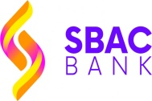
- Poor

4. What is the reason you are affiliated with SBAC Bank?
- By current A/C
- Saving A/C
- Loan
- Card
- Others

5. What period of time you are related with SBAC Bank?
- <1year
- (1- 2) years
- (2- 3) years
- (3- 4) years
- <7years

6. How about do you feel the office environment?
- Excellent
- Good
- Average
- Poor

7. You are satisfied with customer service provided by SBAC Bank
- Strongly Agree
- Agree
- Normal
- Disagree
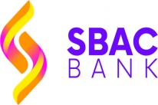
- Strongly Disagree

8. Which products offerings you think the best?
- Savings account / Interest
- FDR/Interest
- DPS/Interest
- CARD

9. What do you think about the rate of service charges taken by SBAC Bank?
- Justified
- Moderate
- Unjustified

10. What are the improvements you want to see?
- More cooperative Employees
- Increasing rate of interest for A/C holder
- Improvement in customer service
- Less interest rate for loan
- Fastest sevice
- Others

11. What do you think about the Customer Service?
- Excellent
- Good
- Average
- Poor

12. The Customer Service of SBAC Bank is better than any other banks.
- Strongly Agree
- Agree
- Normal
- Disagree
- Strongly Disagree

